Name of Journal: World Journal of Clinical Cases
Manuscript NO: 45226
Manuscript Type: CASE REPORT

Unexplained abdominal pain due to a fish bone penetrating the gastric antrum and migrating into the neck of the pancreas: A case report

Xie R et al. Abdominal pain caused by fish bone ingestion

Rui Xie, Bi-Guang Tuo, Hui-Chao Wu

Rui Xie, Bi-Guang Tuo, Hui-Chao Wu, Department of Gastroenterology, Affiliated Hospital to Zunyi Medical College, Zunyi 563003, Guizhou Province, China

ORCID number: Rui Xie (0000-0001-7970-5916); Bi-Guang Tuo (0000-0003-3147-3487); Hui-Chao Wu (0000-0003-0740-5273).

Author contributions: Tuo BG and Wu HC are the co-corresponding authors; Xie R managed the patient and collected the data; Tuo BG and Wu HC were responsible for case report design and writing.

Informed consent statement: Written informed consent was obtained.

Conflict-of-interest statement: The authors declare no conflicts of interest.

CARE Checklist (2016) statement: The authors have read the CARE Checklist (2016), and the manuscript was prepared and revised according to the CARE Checklist (2016).

Open-Access: This article is an open-access article which was selected by an in-house editor and fully peer-reviewed by external reviewers. It is distributed in accordance with the Creative Commons Attribution Non Commercial (CC BY-NC 4.0) license, which permits others to distribute, remix, adapt, build upon this work non-commercially, and license their derivative works on different terms, provided the original work is properly cited and the use is non-commercial. See: http://creativecommons.org/licenses/by-nc/4.0/

Manuscript source: Unsolicited manuscript

Corresponding author: Hui-Chao Wu, PhD, Full Professor, Department of Gastroenterology, Affiliated Hospital to Zunyi Medical College, 149 Dalian Road, Zunyi 563003, Guizhou Province, China. wuhuichao_gzzy@aliyun.com
Telephone: +86-851-28609206

Received: December 19, 2018
Peer-review started: December 19, 2018
First decision: January 6, 2019
Revised: January 21, 2019
Accepted: February 26, 2019
Article in press:
Published online:

Abstract
BACKGROUND
Ingestion of foreign bodies results in gastrointestinal perforation in approximately 1% of patients, and fish bones are the objects that most commonly lead to bowel perforation. When it does occur, the terminal ileum is the most common site of perforation, followed by the duodenal C-loop. However, involvement of the pancreas is very rare. Because clinical symptoms are nonspecific and gastrointestinal perforation may present as only odynophagia or abdominal pain, a definite preoperative diagnosis and clinical intervention may be delayed.

CASE SUMMARY
We report the case of a 32-year-old man who presented to our hospital because of abdominal pain that had worsened over 5 d. He had no significant past history except that he had eaten fish 1 wk previously. Upper endoscopy revealed an irregular submucosal tumor on the front wall of the gastric antrum. Endoscopic ultrasonography and computed tomography showed a fish bone penetrating the gastric antrum and migratingin to the neck of the pancreas. The patient underwent laparoscopic surgery and had no complications one week after the operation.

CONCLUSION
A recent history of foreign body ingestion and imaging examinations are helpful for diagnosis of unexplained abdominal pain caused by foreign bodies.

Key words: Unexplained abdominal pain; Fish bone; Gastrointestinal perforation; Pancreas; Case report

© The Author(s) 2019. Published by Baishideng Publishing Group Inc. All rights reserved.

Core tip: Only rare cases of fish bone migration to the pancreas have been described in the literature. We report the case of a 32-year-old man who presented with unexplained abdominal pain due to a fish bone penetrating the gastric antrum and migrating into the neck of the pancreas. Clinical symptoms are nonspecific so that correct diagnosis may be delayed, and imaging examination and endoscopic ultrasonography are reported to be the main diagnostic tools. Laparoscopy is an effective method for identifying and removing the fish bone.

Xie R, Tuo BG, Wu HC. Unexplained abdominal pain due to a fish bone penetrating the gastric antrum and migrating in to the neck of the pancreas: A case report. World J Clin Cases 2019; In press

INTRODUCTION
Foreign body ingestion is not an uncommon problem in clinical practice, and most ingested foreign bodies (80%-90%) pass spontaneously. Approximately 10%-20% of foreign bodies require an endoscopic procedure, and less than 1% require surgery^{[1-3]}. Fish bones are the most commonly observed foreign objects; they may cause gastrointestinal perforation due to their sharp edges, and perforation generally occurs at the ileum^{[4]}. The fish bone may also penetrate the digestive tract and pierce the liver or intra-abdominal area, leading to abscess formation^{[5]}. In such cases, unexplained abdominal pain is the most frequent clinical symptom. We present the case of a 32-year-old man who was successfully treated by laparoscopic surgery to identify and remove a fish bone that had penetrated the gastric antrum and migrated into the neck of the pancreas, causing abdominal pain.

CASE PRESENTATION
Chief complaints
A 32-year-old male presented to our hospital because of abdominal pain that had worsened over 5 d on March 5, 2018.

Personal and family history and physical examination upon admission
He had rebound tenderness in the upper abdominal quadrant, without hematemesis or black stool, and the patient had no significant past history or family history.

Laboratory examinations
Laboratory tests revealed a white blood cell count of 11.50/mm³ and occult blood in the stool, with no other main abnormalities, including amylase.

Imaging examinations
Upper endoscopy performed on March 6, 2018 revealed an irregular submucosal tumor on the front wall of the gastric antrum with an area of 1.5 cm × 1.7 cm and a depressed appearance of the mucosal surface. Endoscopic ultrasonography showed abnormal and irregular thickening of the stomach wall characterized by a hypoechoic area, and an approximately 3.5-cm linear and hyperechoic lesion protruding through the thickened stomach wall and the neck of the pancreas. Computed tomography (CT) revealed that the thickened front wall of the stomach abutted against the pancreatic body, with a laterally oriented radiopaque foreign body inside. Considering the suspicion of foreign body ingestion, the patient was questioned, and he remembered that he had eaten fish 1 wk previously.

FINAL DIAGNOSIS
Abdominal pain resulting from a fish bone penetration of the stomach and migrating into the pancreas.

TREATMENT
We wanted to cut the mucosa and remove the embedded fish bone by endoscopic submucosal dissection on March 8, 2018, but endoscopic ultrasonography showed that the fish bone was too deep to be easily removed. Finally, the patient underwent laparoscopic surgery seven days after hospital admission (March 12, 2018), which revealed a thickened peritoneum and adhesion between the gastric wall and the pancreatic neck. We carefully separated the stomach wall and the pancreas, and after identifying a penetration of the serosa of the stomach wall, we found a fish bone of approximately 3.5 cm in length pinned in the neck of the pancreas. The fish bone was successfully removed, and a proton-pump inhibitor was routinely used for five days after surgery.

OUTCOME AND FOLLOW-UP
The patient was discharged without any complications and was in good clinical condition one week after the operation, and endoscopic reexamination had not found obvious abnormality one month after the surgery.

DISCUSSION
Unintentional, unconscious ingestion of foreign bodies in adults is usually dietary. Nearly two-thirds of foreign bodies are fish bones, and 75% of ingested foreign bodies become impacted in the oral cavity and laryngopharynx. If impaction does not occur in the upper gastrointestinal tract, the majority of foreign bodies pass asymptomatically within a week^{[6]}. Perforation of the digestive tract by an ingested fish bone is extremely rare (<1%); when it does occur, the terminal ileum is the most common site of perforation, followed by the duodenal C-loop^{[4]}. Because patients usually cannot recall any recent history of foreign body ingestion and because clinical symptoms are nonspecific, gastrointestinal perforation may present as only odynophagia or abdominal pain. If the injury is not observed, a definite preoperative diagnosis is uncertain, and clinical intervention may be delayed.
Numerous reports of ingested fish bones penetrating the digestive tract and migrating to various parts of the chest, liver, or abdominal cavity can be found in the literature. These bones may be responsible for various complications, such as abscess, abdominal cavity infection, mediastinitis, and empyema^{[7]}. However, to date, only rare cases of fish bone migration to the pancreas have been described in the literature, and this injury may present as a pancreatic mass or suppurative infection of the pancreas^{[8,9]}. Laboratory analyses are nonspecific, and leukocytosis or increased blood amylase levels are observed. In our case, because of the inflammatory response and the adhesion of the surrounding tissue, perforation occurred in the stomach, where the thicker gut wall and the proximity of the omentum may have sealed the perforation; consequently, the patient did not present the classic symptoms of digestive tract perforation, and immediate correct preoperative diagnosis was very difficult. CT and endoscopic ultrasonography may be helpful for revealing the nature of foreign bodies, the location of migrated foreign bodies, and the relationship with surrounding tissues^{[10,11]}; therefore, imaging examinations can provide key information for delayed diagnosis of unexplained abdominal pain caused by foreign bodies. Laparoscopy was successfully used to identify the fish bone and extract it. In this case, the patient recovered without any postoperative complications.

CONCLUSION
Ingestion of foreign bodies is a common clinical problem, of which the fish bone is one of the most common; however, involvement of the pancreas is very rare. Perforation occurs in the stomach where a thicker gut wall and proximity of the omentum may seal the perforation, and clinical symptoms are nonspecific. Thus, a definite preoperative diagnosis and clinical intervention may be delayed. CT and endoscopic ultrasonography may be helpful for revealing the nature of foreign bodies, the location of migrated foreign bodies, and the relationship with surrounding tissues. Acute perforations usually require emergency surgery when the diagnosis becomes apparent. Laparoscopic surgery is the most effective option, and disease outcome is generally good after treatment.

REFERENCES
1 Webb WA. Management of foreign bodies of the upper gastrointestinal tract: update. Gastrointest Endosc 1995; 41: 39-51 [PMID: 7698623 DOI: 10.1016/S0016-5107(95)70274-1]
2 Ginsberg GG. Management of ingested foreign objects and food bolus impactions. Gastrointest Endosc 1995; 41: 33-38 [PMID: 7698622 DOI: 10.1016/S0016-5107(95)70273-3]
3 Schwartz GF, Polsky HS. Ingested foreign bodies of the gastrointestinal tract. Am Surg 1976; 42: 236-238 [PMID: 1267274 DOI: 10.1007/s002689900152]
4 Law WL, Lo CY. Fishbone perforation of the small bowel: laparoscopic diagnosis and laparoscopically assisted management. Surg Laparosc Endosc Percutan Tech 2003; 13: 392-393 [PMID: 14712103 DOI: 10.1097/00129689-200312000-00010]
5 Jimenez-Fuertes M, Moreno-Posadas A, Ruíz-Tovar Polo J, Durán-Poveda M. Liver abscess secondary to duodenal perforation by fishbone: Report of a case. Rev Esp Enferm Dig 2016; 108: 42 [PMID: 26765235]
6 McCanse DE, Kurchin A, Hinshaw JR. Gastrointestinal foreign bodies. Am J Surg 1981; 142: 335-337 [PMID: 7283022 DOI: 10.1016/0002-9610(81)90342-1]
7 Devanesan J, Pisani A, Sharma P, Kazarian KK, Mersheimer WL. Metallic foreign bodies in the stomach. Arch Surg 1977; 112: 664-665 [PMID: 857769 DOI: 10.1001/archsurg.1977.01370050124025]
8 Wang WL, Liu KL, Wang HP. Clinical challenges and images in GI. Pancreatic abscess resulting from a fish bone penetration of the stomach. Gastroenterology 2008; 135: 1865, 2160 [PMID: 19007782 DOI: 10.1053/j.gastro.2008.10.067]
9 Goh BK, Jeyaraj PR, Chan HS, Ong HS, Agasthian T, Chang KT, Wong WK. A case of fish bone perforation of the stomach mimicking a locally advanced pancreatic carcinoma. Dig Dis Sci 2004; 49: 1935-1937 [PMID: 15628728 DOI: 10.1007/s10620-004-9595-y]
10 Akazawa Y, Watanabe S, Nobukiyo S, Iwatake H, Seki Y, Umehara T, Tsutsumi K, Koizuka I. The management of possible fishbone ingestion. Auris Nasus Larynx 2004; 31: 413-416 [PMID: 15571916 DOI: 10.1016/j.anl.2004.09.007]
11 Eliashar R, Dano I, Dangoor E, Braverman I, Sichel JY. Computed tomography diagnosis of esophageal bone impaction: a prospective study. Ann Otol Rhinol Laryngol 1999; 108: 708-710 [PMID: 10435934 DOI: 10.1177/000348949910800717]
P-Reviewer: Kang KM, Mattar MC S-Editor: Wang JL L-Editor: Wang TQ E-Editor:

Specialty type: Medicine, research and experimental
Country of origin: China
Peer-review report classification
Grade A (Excellent): 0
Grade B (Very good): B
Grade C (Good): C
Grade D (Fair): 0
Grade E (Poor): 0

A
B
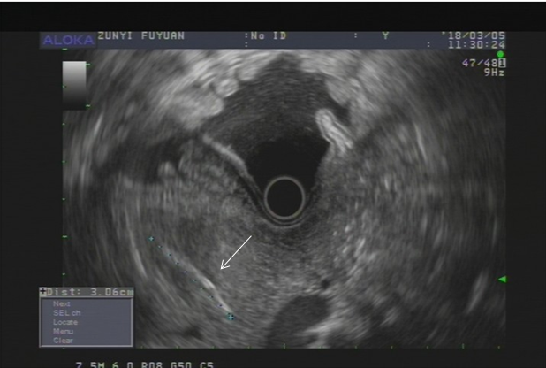
C
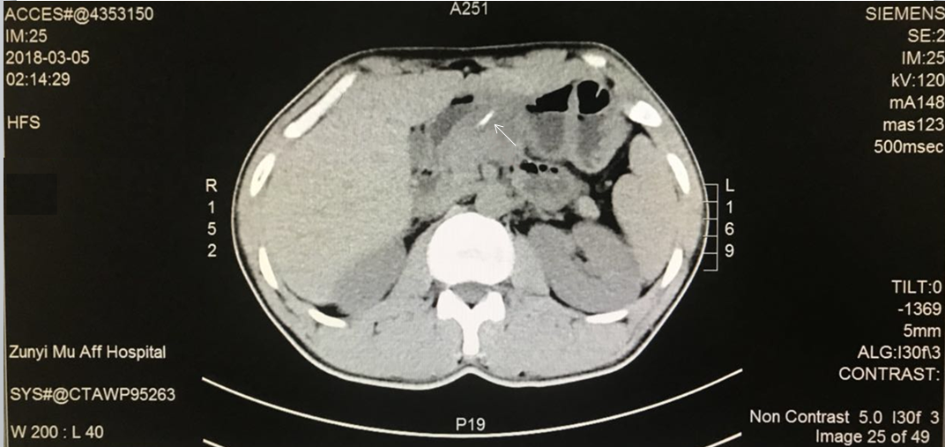
D
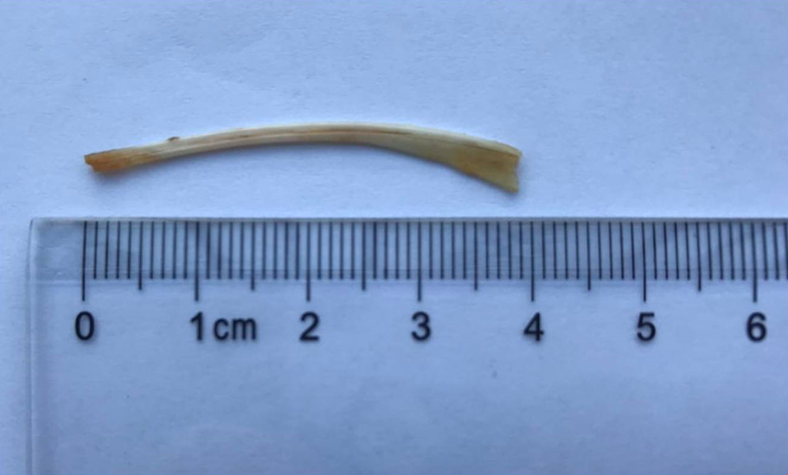
Figure 1 Images of the patient. A: Upper endoscopy revealed an irregular submucosal tumor on the front wall of the gastric antrum; B: Endoscopic ultrasonography showed abnormal and irregular thickening of the stomach wall and an approximately 3.5-cm linear and hyperechoic lesion protruding through the thickened stomach wall and the pancreatic body (arrow); C: Computed tomography image showing a thin, linear, hyperdense structure (arrow) along the stomach wall and pancreatic body; D: Photograph of the fish bone after removal.

