Name of Journal: World Journal of Clinical Cases
Manuscript NO: 85118
Manuscript Type: CASE REPORT

Posterior reversible encephalopathy syndrome following uneventful clipping of an unruptured intracranial aneurysm: A case report

Hwang J et al. PRES following aneurysm clipping

Joseph Hwang, Won-Ho Cho, Seung-Heon Cha, Jun-Kyueng Ko

Joseph Hwang, Won-Ho Cho, Seung-Heon Cha, Jun-Kyueng Ko, Department of Neurosurgery, Biomedical Research Institute, Pusan National University Hospital, School of Medicine, Pusan National University, Busan 49241, South Korea

Author contributions: Ko JK and Hwang J contributed to manuscript writing and editing, and data collection; Cho WH and Cha SH contributed to conceptualization and supervision; all authors have read and approved the final manuscript.

Supported by Clinical Research Grant from Pusan National University Hospital in 2022.

Corresponding author: Jun-Kyueng Ko, MD, PhD, Associate Professor, Department of Neurosurgery, Biomedical Research Institute, Pusan National University Hospital, School of Medicine, Pusan National University, 179 Gudeok-Ro, Seo-Gu, Busan 49241, South Korea. redcheek09@naver.com

Received: April 13, 2023
Revised: May 10, 2023
Accepted: June 6, 2023
Published online: July 6, 2023

Abstract
BACKGROUND
Posterior reversible encephalopathy syndrome (PRES) is characterized mainly by occipital and parietal lobe involvement, which can be reversible within a few days. Herein, we report a rare case of PRES that developed after craniotomy for an unruptured intracranial aneurysm (UIA).

CASE SUMMARY
A 59-year-old man underwent clipping surgery for the treatment of UIA arising from the left middle cerebral artery. Clipping surgery was performed uneventfully, and he regained consciousness quickly immediately after the surgery. At the 4th hour after surgery, he developed a disorder of consciousness and aphasia. Magnetic resonance imaging revealed cortical and subcortical T2/FLAIR hyperintensities in the parietal, occipital, and frontal lobes ipsilaterally, without restricted diffusion, consistent with unilateral PRES. With conservative treatment, his symptoms and radiological findings almost completely disappeared within weeks. In our case, the important causative factor of PRES was suspected to be a sudden increase in cerebral perfusion pressure associated with temporary M1 occlusion.

CONCLUSION
Our unique case highlights that, to our knowledge, this is the second report of PRES developing after craniotomy for the treatment of UIA. Surgeons must keep PRES in mind as one of the causes of perioperative neurological abnormality following clipping of an UIA.

Key Words: Clipping; Magnetic resonance imaging; Posterior reversible encephalopathy syndrome; Unruptured intracranial aneurysm; Case report

©The Author(s) 2023. Published by Baishideng Publishing Group Inc. All rights reserved.

Citation: Hwang J, Cho WH, Cha SH, Ko JK. Posterior reversible encephalopathy syndrome following uneventful clipping of an unruptured intracranial aneurysm: A case report. World J Clin Cases 2023; 11(19): 4723-4728
URL: https://www.wjgnet.com/2307-8960/full/v11/i19/4723.htm
DOI: https://dx.doi.org/10.12998/wjcc.v11.i19.4723

Core Tip: Posterior reversible encephalopathy syndrome (PRES) is a clinicoradiological syndrome characterized by predominant parietal and occipital involvement, which can be reversible within a few days. We report a rare case of PRES that developed after clipping surgery for an unruptured intracranial aneurysm (UIA). In our case, the important causative factor of PRES was suspected to be a sudden increase in cerebral perfusion pressure associated with temporary M1 occlusion. Our unique case highlights that, to our knowledge, this is the second report of PRES developing after craniotomy for the treatment of UIA. Surgeons must keep PRES in mind as one of the causes of perioperative neurological abnormality following clipping of an UIA.

INTRODUCTION
Posterior reversible encephalopathy syndrome (PRES) is a clinical and radiological entity in which reversible changes occur in the central nervous system (CNS), associated with typical features on magnetic resonance imaging (MRI)^{[1]}. The main symptoms of PRES include insidious onset of headache, altered mentality, seizures, and cortical blindness, with edematous changes primarily in the occipital cortex and/or white matter bilaterally on radiological imaging^{[1,2]}. The term ‘PRES’ was first introduced in 1996 by Hinchey and his colleagues^{[3]}. It has been mainly described in relation to the hypertensive crisis—particularly in the setting of renal failure, sepsis, eclampsia, and the use of immunosuppressant drugs, such as calcineurin inhibitors^{[4]}. Since then, many reports have focused on the imaging findings and pathophysiology of this condition. Although various underlying conditions of PRES have been reported, to the best of our knowledge, only one case of PRES that developed after clipping surgery for the treatment of an unruptured intracranial aneurysm (UIA) has been reported^{[5]}. Here, we would like to report the second case of PRES.

CASE PRESENTATION
Chief complaints
Sudden deterioration of consciousness developed at the 4th hour after surgical clipping of an UIA.

History of present illness
A 59-year-old man who had undergone uneventful coiling for a ruptured anterior communicating artery aneurysm one month ago was readmitted to our hospital for surgical clipping of the left middle cerebral artery (MCA) aneurysm unfavorable for coiling. He recovered uneventfully from the subarachnoid hemorrhage one month ago and had no neurological abnormalities. All other preoperative evaluations, including hematological tests, were unremarkable. Digital subtraction angiography revealed a 5.4 mm-sized aneurysm at the left MCA bifurcation without any other remarkable findings (Figure 1). Left frontotemporal craniotomy for clipping of the UIA was successfully performed under general anesthesia. General anesthesia and operating times were 4 h 25 min and 3 h 7 min, respectively. No intraoperative aneurysm rupture or venous injury occurred. In the course of three temporary M1 occlusions each lasting 8 min, 6 min, and 5 min, we applied various permanent clips to achieve complete obliteration of the UIA. Immediately after surgery, the patient’s condition and the computed tomography (CT) findings were stable. However, sudden deterioration in the level of consciousness and aphasia developed 4 h later.

History of past illness
He had no specific medical history other than high blood pressure, which was well controlled by amlodipine (5 mg/d).

Personal and family history
The patient admitted to smoking ten cigarettes daily for > 20 years. The remaining personal and family histories did not contribute.

Physical examination
The patient’s vital signs were: Blood pressure, 129/84 mmHg; heart rate, 67 beats per min; body temperature, 37.0°C; and respiratory rate, 21 breaths per min. Neurological examination demonstrated stuporous mentality (Glasgow Coma Scale score of 10) and profound global aphasia. The function of cranial nerves was intact. He had normal tone in all limbs and normal power in the left limbs, but slightly reduced power in (4/5) in the right limbs. Sensory examination was normal. The tendon reflexes of the extremities were normal.

Laboratory examinations
There were no abnormalities in routine blood tests, blood biochemistry, blood coagulation, and routine urine tests.

Imaging examinations
After confirming absence of an abnormal finding on non-contrast brain CT performed immediately, MRI was carried out in succession. It showed widespread high signal intensities especially in the cortex and subcortical region of the ipsilateral fronto-parieto-occipital lobes in fluid attenuation inversion recovery images (Figure 2A). The lesions were iso or high signal intensity in diffusion-weighted images (Figure 2B) and high signal intensity in apparent diffusion coefficient maps (Figure 2C) without any signs of diffusion restriction, consistent with vasogenic edema. In contrast-enhanced three-dimensional T1-weighted images, lesions showed patchy enhancement (Figure 2D). Susceptibility-weighted images did not demonstrate hemorrhage. Since major arteries were still clearly depicted on magnetic resonance angiography besides clip artifacts, vascular problems including reversible cerebral vasoconstriction syndrome could be excluded from the diagnosis. The CT perfusion study was negative.

FINAL DIAGNOSIS
The imaging findings were suggestive of PRES in the left hemisphere.

TREATMENT
The patient gradually recovered with dexamethasone injections and supportive care, without additional neurologic signs.

OUTCOME AND FOLLOW-UP
He was discharged with a modified Rankin scale score of 0 at 3 wk after surgery. On serial MRI scans, most of the lesions gradually disappeared within few weeks. However, several lesions in the subcortical white matter persisted even after 1 year, despite being reduced in size (Figure 3).

DISCUSSION
PRES is a clinicoradiological syndrome characterized mainly by occipital and parietal lobe involvement, which can be recovered within a few days or weeks^{[1]}. In our patient, PRES was diagnosed based on the typical clinical presentation and MRI finding after excluding CNS infections, air embolus, and sinus thrombosis. As clinical symptoms resolve after several weeks in most cases of PRES, neurological abnormalities gradually improved from the 4th day after surgery and our patient fully recovered without any deficit 3 wk after surgery. MRI typically shows symmetrical high signal intensity in both parieto-occipital cortical-subcortical white matter in fluid attenuation inversion recovery images^{[2]}. However, our case showed an atypical finding of unilateral involvement in PRES. The involvement in PRES could be asymmetrical or rarely unilateral. Reports of unilateral lesions include those related to subarachnoid hemorrhage-induced cerebral vasospasm and PRES associated with MCA occlusion^{[6]}. Since PRES was first described in 1996, various MRI findings have been reported. In addition to the typical site of PRES involvement, almost any region of the brain can also be involved^{[1,6]}. Involvement of the basal ganglia or brain stem while sparing the subcortical regions was named “central-variant” PRES accounting for about 4% of the cases, and it was distinctly reported that 10% of the patients were involved in the splenium of the corpus callosum^{[2,7]}. Restricted diffusion is sometimes observed in PRES, and resulted in irreversible cell death^{[8]}. It has been rarely reported that intracranial hemorrhage can also be accompanied by this condition in around 5%–17% of the cases, and it could present as minimal hemorrhages, intraparenchymal hematoma, and subarachnoid hemorrhage^{[1,9]}. However, an intracranial hemorrhage-related finding was not found in our case, even in susceptibility-weighted images.
The pathophysiology of PRES remains a mystery nearly 25 years after its initial description. The most well-known and accepted theory is an increase in arterial pressure above the upper limit for cerebral autoregulation, causing vasogenic edema^{[4]}. This theory is supported by hypertension, which is common in patients with PRES. However, this hypertension theory does not explain all situations. Although rare, PRES has been reported in patients with normal or slightly elevated blood pressure, and serious cerebral edema has been reported in PRES without severe hypertension^{[4,6]}. In the present case, the overall intraoperative mean blood pressure was maintained at around 60 mmHg and no blood pressure surge was reported immediately after surgery. Therefore, we hypothesized that a sudden increase in cerebral perfusion pressure associated with temporary M1 occlusion and intracranial hypotension secondary to the cerebrospinal fluid (CSF) leak caused a degree of hyperperfusion that precipitated PRES. These assumptions support the reason for PRES spreading within the brain hemisphere ipsilateral to the treated UIA, and not bilateral involvement. It was also inferred that diffuse subarachnoid hemorrhage, which occurred one month before surgery, partially contributed to increased susceptibility to autoregulation breakdown. Another mechanism to explain the development of PRES is the activation of immune system through cascade as a result of inducing endothelial dysfunction^{[10]}. Kur et al^{[11]} reported three cases of systemic lupus erythematosus (SLE) with PRES, assuming that PRES may be a feature of disease activity with nephritis and hypertension or a result of immunosuppressive therapy in patients with SLE. Patients with autoimmune diseases are more susceptible to endothelial dysfunction and consequently to the occurrence of PRES^{[12]}.
To the best of our knowledge, only one case of PRES that developed after clipping surgery for the treatment of UIA has been reported^{[5]}. The authors supposed that the cause of PRES in their case was rapid blood pressure fluctuations accompanying general anesthesia for clipping surgery, and PRES, which occurs after craniotomy, is unilateral and can become severe in the craniotomy area and leave sequelae. Recently, Fukushima et al^{[13]} reported a case of delayed leucoencephalopathy after coil embolization of the UIA, which was supposed to be caused by delayed hypersensitivity to the bioactive polyglycolic-polylactic acid coil. The diagnosis of PRES was excluded as an etiology for the white matter lesion because of unilateral involvement of the lesions. However, their imaging findings are consistent with the current unilateral PRES. Since the causes of PRES are very diverse and difficult to define accurately, it could be assumed that several case reports with different diagnoses for phenomena similar to actual PRES have been reported. According to a report studying cerebral hyperperfusion syndrome and related conditions, such as hypertensive encephalopathy, PRES, and reversible cerebral vasoconstriction syndrome, these syndromes can share similar pathophysiological mechanism such as cerebral vasoconstriction, endothelial damage, blood-brain barrier dysfunction, brain edema, and, sometimes intracerebral hemorrhage, with fatalities described in all reports^{[14]}. Despite knowledge of these syndromes, they still remain unknown. However, it is important to be aware of this condition as it can be cured through early diagnosis and treatment^{[12]}.

CONCLUSION
Our unique case highlights that, to our knowledge, this is the second report of PRES developing after craniotomy for the treatment of UIA. Although it may be very rare, prolonged temporary occlusion time and CSF leak may cause the development of PRES in the brain with impaired autoregulation. Surgeons must keep PRES in mind as one of the causes of neurological abnormality after clipping of an UIA.

REFERENCES
1 McKinney AM, Short J, Truwit CL, McKinney ZJ, Kozak OS, SantaCruz KS, Teksam M. Posterior reversible encephalopathy syndrome: incidence of atypical regions of involvement and imaging findings. AJR Am J Roentgenol 2007; 189: 904-912 [PMID: 17885064 DOI: 10.2214/AJR.07.2024]
2 Hugonnet E, Da Ines D, Boby H, Claise B, Petitcolin V, Lannareix V, Garcier JM. Posterior reversible encephalopathy syndrome (PRES): features on CT and MR imaging. Diagn Interv Imaging 2013; 94: 45-52 [PMID: 22835573 DOI: 10.1016/j.diii.2012.02.005]
3 Hinchey J, Chaves C, Appignani B, Breen J, Pao L, Wang A, Pessin MS, Lamy C, Mas JL, Caplan LR. A reversible posterior leukoencephalopathy syndrome. N Engl J Med 1996; 334: 494-500 [PMID: 8559202 DOI: 10.1056/NEJM199602223340803]
4 Bartynski WS. Posterior reversible encephalopathy syndrome, part 2: controversies surrounding pathophysiology of vasogenic edema. AJNR Am J Neuroradiol 2008; 29: 1043-1049 [PMID: 18403560 DOI: 10.3174/ajnr.A0929]
5 Chihara H, Hatano T, Ando M, Takita W, Tokunaga K, Hashikawa T, Funakoshi Y, Kamata T, Higashi E, Nagata I. A Case of Posterior Reversible Encephalopathy Syndrome After Surgical Clipping of Unruptured Cerebral Aneurysm. World Neurosurg 2019; 124: 323-327 [PMID: 30660882 DOI: 10.1016/j.wneu.2019.01.014]
6 Çamlıdağ İ, Cho YJ, Park M, Lee SK. Atypical Unilateral Posterior Reversible Encephalopathy Syndrome Mimicking a Middle Cerebral Artery Infarction. Korean J Radiol 2015; 16: 1104-1108 [PMID: 26356795 DOI: 10.3348/kjr.2015.16.5.1104]
7 McKinney AM, Jagadeesan BD, Truwit CL. Central-variant posterior reversible encephalopathy syndrome: brainstem or basal ganglia involvement lacking cortical or subcortical cerebral edema. AJR Am J Roentgenol 2013; 201: 631-638 [PMID: 23971457 DOI: 10.2214/AJR.12.9677]
8 Covarrubias DJ, Luetmer PH, Campeau NG. Posterior reversible encephalopathy syndrome: prognostic utility of quantitative diffusion-weighted MR images. AJNR Am J Neuroradiol 2002; 23: 1038-1048 [PMID: 12063238]
9 Hefzy HM, Bartynski WS, Boardman JF, Lacomis D. Hemorrhage in posterior reversible encephalopathy syndrome: imaging and clinical features. AJNR Am J Neuroradiol 2009; 30: 1371-1379 [PMID: 19386731 DOI: 10.3174/ajnr.A1588]
10 Bartynski WS. Posterior reversible encephalopathy syndrome, part 1: fundamental imaging and clinical features. AJNR Am J Neuroradiol 2008; 29: 1036-1042 [PMID: 18356474 DOI: 10.3174/ajnr.A0928]
11 Kur JK, Esdaile JM. Posterior reversible encephalopathy syndrome--an underrecognized manifestation of systemic lupus erythematosus. J Rheumatol 2006; 33: 2178-2183 [PMID: 16960925]
12 Ferreira TS, Reis F, Appenzeller S. Posterior reversible encephalopathy syndrome and association with systemic lupus erythematosus. Lupus 2016; 25: 1369-1376 [PMID: 27084028 DOI: 10.1177/0961203316643598]
13 Fukushima Y, Nakahara I. Delayed leucoencephalopathy after coil embolisation of unruptured cerebral aneurysm. BMJ Case Rep 2018; 2018 [PMID: 29936444 DOI: 10.1136/bcr-2018-224569]
14 Delgado MG, Bogousslavsky J. Cerebral Hyperperfusion Syndrome and Related Conditions. Eur Neurol 2020; 83: 453-457 [PMID: 33070131 DOI: 10.1159/000511307]

Footnotes
Informed consent statement: Written informed consent was obtained from the patient for publication of this report and any accompanying images. We guarantee patient anonymity.

Conflict-of-interest statement: The authors declare that they have no conflict of interest to disclose.

CARE Checklist (2016) statement: The authors have read the CARE Checklist (2016), and the manuscript was prepared and revised according to the CARE Checklist (2016).

Open-Access: This article is an open-access article that was selected by an in-house editor and fully peer-reviewed by external reviewers. It is distributed in accordance with the Creative Commons Attribution NonCommercial (CC BY-NC 4.0) license, which permits others to distribute, remix, adapt, build upon this work non-commercially, and license their derivative works on different terms, provided the original work is properly cited and the use is non-commercial. See: https://creativecommons.org/Licenses/by-nc/4.0/

Provenance and peer review: Unsolicited article; Externally peer reviewed.
Peer-review model: Single blind

Peer-review started: April 13, 2023
First decision: May 8, 2023
Article in press: June 6, 2023

Specialty type: Neuroimaging
Country/Territory of origin: South Korea
Peer-review report’s scientific quality classification
Grade A (Excellent): 0
Grade B (Very good): 0
Grade C (Good): C, C
Grade D (Fair): D
Grade E (Poor): 0

P-Reviewer: Reis F, Brazil; Shao A, China S-Editor: Liu JH L-Editor: A P-Editor: Liu JH
Figure Legends
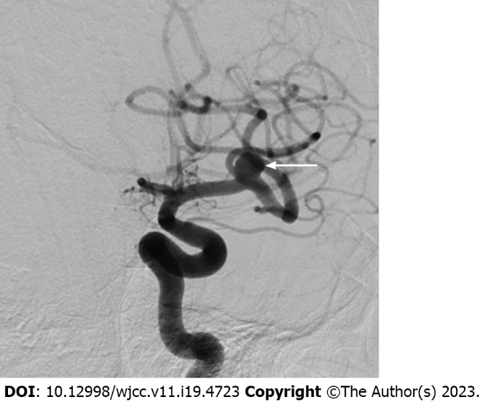
Figure 1 Left internal carotid artery angiography. Preoperative image shows a small aneurysm (arrow) at the left middle cerebral artery bifurcation with an unfavorable dome-to-neck ratio.
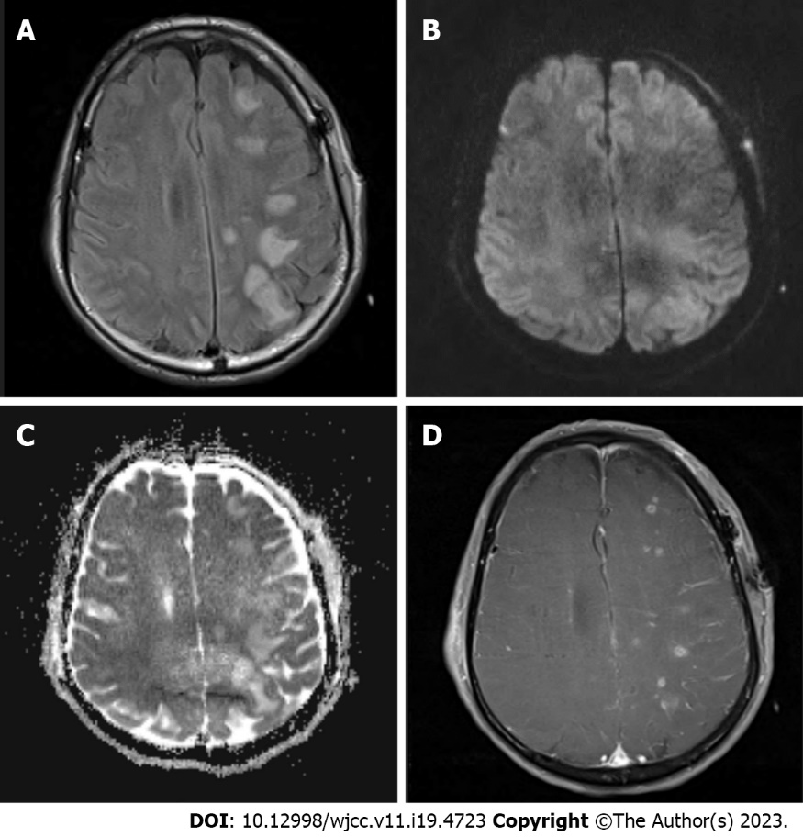

Figure 2 Magnetic resonance imaging obtained immediately following deterioration of consciousness A: Axial fluid attenuation inversion recovery image shows extensive hyperintense lesions predominantly in the cortex and subcortical white matter of the left frontoparietal lobe; B: Diffusion-weighted image shows that lesions are iso to hyperintense without any signs of restricted diffusion; C: Apparent diffusion coefficient maps show that lesions are hyperintense, indicating vasogenic edema; D: On the contrast-enhanced three-dimensional T1-weighted image, lesions show patchy enhancement.
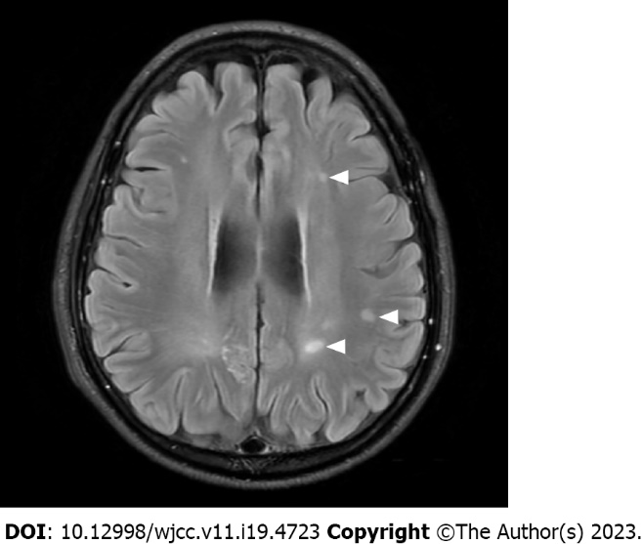
Figure 3 Follow-up magnetic resonance imaging. Fluid attenuation inversion recovery image performed at one year after clipping surgery shows that several lesions (arrow heads) in the subcortical white matter persisted, despite being reduced in size.

Published by Baishideng Publishing Group Inc
7041 Koll Center Parkway, Suite 160, Pleasanton, CA 94566, USA
Telephone: +1-925-3991568
E-mail: bpgoffice@wjgnet.com
Help Desk: https://www.f6publishing.com/helpdesk
https://www.wjgnet.com

© 2023 Baishideng Publishing Group Inc. All rights reserved.

