Name of Journal: World Journal of Clinical Cases
Manuscript NO: 52250
Manuscript Type: CASE REPORT

Must pilots permanently quit flying career after treatment for colorectal cancer? - Medical waiver for Air Force pilots with colorectal cancer: Three case reports

Gu GL et al. Medical waiver for Air Force pilots with CRC

Guo-Li Gu, Fu-Xiao Duan, Zhi Zhang, Xue-Ming Wei, Li Cui, Bo Zhang

Guo-Li Gu, Zhi Zhang, Xue-Ming Wei, Department of General Surgery, Air Force Medical Center, PLA, Beijing 100142, China

Fu-Xiao Duan, Department of General Surgery, the General Hospital of Northern Theater Command PLA, Shenyang 110016, Liaoning Province, China

Li Cui, Department of Aviation Diseases, Air Force Medical Center, PLA, Beijing 100142, China

Bo Zhang, Department of Medical Research, Air Force Medical Center, PLA, Beijing 100142, China

Author contributions: Gu GL and Duan FX contributed equally to this study; Gu GL, Cui L and Zhang B designed the research; Gu GL, Duan FX, Zhang Z and Wei XM collected and analyzed the clinical data; Gu GL and Duan FX wrote the manuscript; Zhang B and Cui L revised the manuscript.

Supported by Major Projects of the Chinese PLA ‘‘Thirteenth Five-Year Plan’’ Logistics Research Subject, No. AKJ15J003 and No. AKJ15J001; and Incubation Project of Military Medical Science and Technology Youth Cultivation Program, No. 17QNP023.

Corresponding author: Bo Zhang, MD, Chief Doctor, Professor, Department of Medical Research, Air Force Medical Center, PLA, No. 30, Fucheng Road, Haidian District, Beijing 100142, China. hero1822@163.com

Received: November 14, 2019
Revised: December 9, 2019
Accepted: December 14, 2019
Published online:
Abstract
BACKGROUND
Colorectal cancer (CRC) could seriously threaten the physical and mental health of pilots. Shall they end their flying after treatment of CRC? With this study, we investigated the possibility of a gradual medical waiver for such pilots to fly aircrafts again after treatment of CRC.

CASE SUMMARY
We analyzed the medical waiver and clinical data of 3 pilots with CRC, who had accepted the treatment at the Department of General Surgery, Air Force Medical Center (formerly, Air Force General Hospital) between 2013 and 2018. All 3 cases underwent a series of comprehensive treatment courses, including radical resection of CRC, sequential radiotherapy, and chemotherapy. The follow-up results were satisfactory. After passing through the high-risk period of recurrence and metastasis of CRC, they all were given a medical waiver for flying again. Medical observation showed that their flying operations were safe.

CONCLUSION
The CRC treatment shall follow the guidelines for diagnosis and treatment and should simultaneously protect the combating capabilities of pilots as much as possible. It is safe for pilots with CRC, who are continuously monitored under medical observation after passing through the high-risk period of recurrence and metastasis, to undertake military flight missions again.

Key words: Colorectal cancer; Pilot; Waiver; Treatment; Military medicine; Aeromedicine; Case report

Gu GL, Duan FX, Zhang Z, Wei XM, Cui L, Zhang B. Must pilots permanently quit flying career after treatment for colorectal cancer? - Medical waiver for Air Force pilots with colorectal cancer: Three case reports. World J Clin Cases 2019; In press

Core tip: Colorectal cancer could seriously threaten the physical and mental health of pilots. The question that presents then is, shall they end their flying career aftertreatment of colorectal cancer? In this study, we investigated the possibility of a gradual medical waiver for the pilots to fly aircrafts again after treatment of colorectal cancer.

INTRODUCTION
Colorectal cancer has become one of the most common malignant tumors in China^{[1]}. The onset age of patients with colorectal cancers in China is about 10 years earlier than that in the West^{[2]}. About 40% of the patients are under 40-years-old and most of them have been in the middle or late stage upon diagnosis.
In general, some pilots rely on alcohol and tobacco to relieve the huge mental and physical exhaustion during flight training^{[3]}. The combination of high sugar, high calorie and high protein foods as well as environment of high temperature, coldness, electromagnetic radiation, high acceleration, low pressure and hypoxia makes Air Force pilots a high-risk group for colorectal cancers, which could seriously threaten their physical and mental health or even their careers. In recent years, the General Surgery Department of the Air Force Characteristic Medical Center has treated 2 Air Force pilots with colorectal cancers, who had been allowed to fly aircrafts again after comprehensive treatment.

CASE PRESENTATION
Chief complaints
Case 1: A male training aircraft pilot at the age of 44 years, who had suffered from hematochezia for more than 1 mo.

Case 2: A male training aircraft pilot at the age of 52 years, who had suffered from dyschezia for about 2 mo.

Case 3: A male bomber pilot at the age of 48, who had suffered from intermittent lower abdominal pain for about 6 mo.

History of present illness
Case 1: In October 2013, the patient was hospitalized due to “blood in stool for more than 1 mo”. About 1 mo before the hospitalization, he found fresh blood in his stool, which was amorphous with increased frequency and tenesmus.

Case 2: In October 2015, the patient was a hospitalized due to “difficulty in defecation for 2 mo”. At 2 mo before that, he had difficulty in defecation for no clear reason.

Case 3: Due to “intermittent lower abdominal pain for more than 6 mo”, the patient was hospitalized. At 6 mo before that, the patient felt lower abdominal pain for no clear reason. The condition worsened right after eating but became relieved afterwards. The stool was occasionally amorphous with no mucus and blood. No obvious abnormalities were found upon clinical assessment in local hospitals. During the period, the abdominal pain and discomfort symptoms occasionally occurred, but the patient could still operate aircrafts. On March 31, 2016, moderately differentiated adenocarcinomas in his descending colon was diagnosed through enteroscopy.

History of past illness
No other abnormal health conditions were reported in any of the 3 cases.

Personal and family history
All 3 cases had no specific history of genetic diseases.

Physical examination upon admission
Case 1: Digital rectal examination found a hard discoid mass of about 3 cm × 2 cm at 12 o’clock position when the patient was in the knee-chest posture.

Case 2: The digital rectal examination found the lower margin of a nodular mass at the 7-12 o’clock position when the patient was in the knee-chest posture. It was found to be hard and fixed, and the finger sheath was stained with blood.

Case 3: No abnormalities were found in the physical examination and digital rectal examination.

Laboratory examinations
All routine laboratory findings were within normal limits in all 3 cases.

Imaging examinations
Case 1: The enteroscopy saw a cauliflower-like lump 5-8 cm away from the anus in the intestinal cavity, with hyperemia on the surface and unclear boundaries. The follow-up pathological report showed moderately differentiated tubular adenocarcinoma. The ultrasound colonoscopy determined a T3-4 phase. The positron emission tomography/computed tomography found that the local rectal intestinal wall was unevenly thickened with active metabolism. It was diagnosed as likely rectal cancer. There were numerous small lymph nodes with slightly increased metabolism around the rectum, as shown in (Figure 1A-C).

Case 2: The enteroscopy saw a circular cauliflower-like lump of about 4 cm long at 5 cm away from the anus, with ulcer on the surface. The intestinal cavity was so narrow that the scope could hardly pass through it. The tissue around was fragile and easy to bleed. The pelvic magnetic resonance imaging found that the rectal wall was irregularly thickened. Rectal cancer was considered likely, with a few small lymph nodes in the presacral region (Figure 1D-F).

Case 3: Reexamination by enteroscopy showed that the sigmoid colon (about 35 cm away from the anus) had a circumferential cauliflower-like lesion of 3 cm in length with uneven surface, ulceration, and clear boundaries. The surrounding tissue was fragile and easy to bleed. The intestinal cavity was narrow. The pathological report showed a moderately differentiated adenocarcinoma. The abdominal computed tomography found that the middle and lower segments of the descending colon (5-6 cm long) was irregular thickened on the intestinal wall and the intestinal cavity was narrow with unclear boundary. There were numerous lymph nodes around the intestine with diameter about 1.0 cm, as shown in Figure 2.

FINAL DIAGNOSIS
Case 1 and Case 2
Rectal cancer with local lymph nodes metastasis (cT₂N₁M₀).

Case 3
Descending colon cancer with local lymph nodes metastasis (cT₄N₁M₀).

TREATMENT
Case 1
On October to 31, 2013, the patient accepted the “transabdominal radical treatment for rectal cancer” under general anesthesia. The postoperative pathological report showed that protuberant moderately differentiated adenocarcinoma (about 0.5 cm × 3.5 cm × 1.5 cm) had invaded into the muscular layer. Intravascular cancer thrombus could be seen but without definite nerve invasion. Lymph node metastasis could be seen (3/23). The pathological stage was IIIa (pT₂N_{1b}M₀). The patient did well during the postoperative recovery process, which included eight rounds of XELOX chemotherapy combined with concurrent radiotherapies (50Gy/25f). The treatment was completed in August 2014.

Case 2
On November 25, 2015, the patient accepted the “transabdominal radical treatment for rectal cancer and prophylactic ileostomy” under general anesthesia. The postoperative pathological report showed that the rectal ulcerative moderately differentiated adenocarcinoma had invaded into the serosa layer. The intravascular tumor thrombus and nerve invasion could be seen. No lymph node metastasis was found (0/15). The pathological stage was IIb (pT_{4a}N₀M₀). After three rounds of XELOX chemotherapies, the patient accepted local radiotherapy (50Gy/25f) and took capecitabine orally, then accepted another four rounds of XELOX chemotherapies. Closure of the ileostomy was performed in July 2016.

Case 3
On April 19, 2016, the patient accepted “laparoscopic exploration and hand-assisted laparoscopic left hemicolectomy” under general anesthesia. Postoperative pathological report showed that the ulcerative moderately differentiated adenocarcinoma of colon (3 cm × 3 cm × 2 cm) had invaded into the serosa layer with no vascular thrombus or lymph node metastasis (0/14). The pathological stage was IIb (pT_{4a}N₀M₀). The patient took six rounds of XELOX chemotherapies.

OUTCOME AND FOLLOW-UP
Case 1
After the treatment process ended in August 2014, no recurrence or metastasis was observed in follow-up visits, which took place every 6 mo. In June 2016, the patient was allowed to fly aircrafts (only those with two seats) again. To date, it has been 38 mo since the medical waiver for flight was granted. His average flight time is about 250 h per year. No recurrence or metastasis has been observed in medical examination (Figures 3A, B, 4A).

Case 2
In the follow-up visits of every 6 mo, no recurrence or metastasis was found. In February 2018, the patient was qualified in flight test. It has been 18 mo since the medical waiver for flight was granted. His average flight time is about 220 h per year. No recurrence or metastasis has been observed in medical examination (Figures 3C, D, 4B).

Case 3
In the follow-up visits of every 6 mo, no recurrence or metastasis was found. In June 2018, the patient was qualified in flight test. It has been 14 mo since the medical waiver for flight was given. His average flight time is about 240 h per year. No recurrence or metastasis has been observed in medical examination (Figure 5).

DISCUSSION
The acute obstruction, bleeding and perforation induced by CRC may cause disability during flight. While the chronic bleeding caused by tumors is very hidden, the secondary anemia may cause flight accidents. Digital rectal examination, occult blood in stool, tumor markers and electronic colonoscopy are the most important means for early diagnosis of CRC. None of the 3 cases presented herein was diagnosed at the early stage, due to the following reasons: 1) Lack of characteristic symptoms in the early stage of colorectal cancer^{[4,5]}; 2) The pilots had good physical constitution and strong disease tolerance; 3) The troops are stationed far away from cities, where there are poor medical conditions. Therefore, Air Force physicians should be alert to early symptoms and pay attention to the digital rectal examination. It is also very important to carry out digestive endoscopy and tests of tumor markers, stool occult blood and other targeted laboratory parameters during annual physical examination for early detection of CRC for high-risk groups.
Military flight has stringent requirements for the health of pilots^{[6-8]}. The China Military regulations stipulate the following: (1) Those with obvious dysfunctions after treatment of abdominal organ diseases or injuries are unqualified; (2) Those with obvious dysfunctions after treatment of anal and rectal diseases are unqualified; (3) Those with malignant tumors or benign tumors that affect their normal functions are unqualified; (4) Those having good curative effects after the treatment for early malignant tumors shall be evaluated separately. The Air Force physicians shall try their best to protect the flight functions of pilots other than following the diagnosis and treatment criteria for common groups. Further evaluation shall be made on the choice of surgical methods (laparoscopy or laparotomy), the size of incision (whether abdominal wall muscle is damaged), the delineation of radiotherapy target area, the setting of radiation dose, and the choice of chemotherapeutic drugs, etc. Beside radical cancer treatment as the primary goal, it is important to prepare a comprehensive treatment plan for the pilots with CRC so that they can fly aircrafts again after surgeries.
At present, there is no military regulation on medical waiver for pilots with CRC to fly aircrafts again. The United States Military Forces also have different or even conflicting regulations on such medical waiver for the pilots of different aircrafts. For example^{[9,10]}: (1) The medical waiver can be granted to pilots who have undergone surgical removal of all gross tumors, or who have completed adjuvant treatment without any side effects of treatment, or who have no evidence of tumor after operations. However, those with lymph node metastasis shall be considered until 2 years after the completion of treatment^{[11,12]}. (2) In general, the medical waiver shall not be granted to the pilots with distant metastasis, residual tumors, and treatment-related side effects. There is also a rule stating that the pilots with CRC or histories of CRC are not eligible for flight.
All the 3 cases reported here had passed the high-risk period of recurrence and metastasis for 2 years after surgical operations^{[13-15]}. With reference to relevant foreign guidelines and the latest evidence-based guidelines at home and abroad, also considering the types of aircrafts, the flight posts, personal willingness, organizational opinions and psychosomatic tests, the individualized flight qualification assessment shall be conducted for these pilots and they will also undergo rigorous follow-up medical observation. It is the responsibility of military surgeons to maintain the health of the pilots and maintain their combat effectiveness. It is their duty to provide the sick pilots with the right treatment so they can have the largest chance to resume flying. However, whether the pilots who resumed flying can fit with the combat requirements is still an important issue to be resolved. The current case studies showed that pilots who resumed flight only satisfied the flight time requirement for training.

CONCLUSION
Based on the routine diagnosis and treatment criteria, the exploratory experience indicated that the flight function of pilots diagnosed with CRC shall be protected. It is safe for a pilot who was diagnosed with CRC but who has passed through the high-risk period of recurrence and metastasis to fly aircrafts again under strict medical observation.

REFERENCES
1 Zhang L, Cao F, Zhang G, Shi L, Chen S, Zhang Z, Zhi W, Ma T. Trends in and Predictions of Colorectal Cancer Incidence and Mortality in China From 1990 to 2025. Front Oncol 2019; 9: 98 [PMID: 30847304 DOI: 10.3389/fonc.2019.00098]
2 Cai SR, Huang YQ, Zhang SZ, Li QR, Ma XY, Zheng S. Effects of subitems in the colorectal cancer screening protocol on the Chinese colorectal cancer screening program: an analysis based on natural community screening results. BMC Cancer 2019; 19: 47 [PMID: 30630450 DOI: 10.1186/s12885-018-5191-y]
3 Kong AY, Golden SD, Myers AE, Little MA, Klesges R, Talcott W, Vandegrift SM, Cassidy DG, Ribisl KM. Availability, price and promotions for cigarettes and non-cigarette tobacco products: an observational comparison of US Air Force bases with nearby tobacco retailers, 2016. Tob Control 2019; 28: 189-194 [PMID: 29705745 DOI: 10.1136/tobaccocontrol-2018-054266]
4 Dillner J. Early detection and prevention. Mol Oncol 2019; 13: 591-598 [PMID: 30676688 DOI: 10.1002/1878-0261.12459]
5 Januszewicz W, Fitzgerald RC. Early detection and therapeutics. Mol Oncol 2019; 13: 599-613 [PMID: 30677217 DOI: 10.1002/1878-0261.12458]
6 Dhaliwal S, Carter RE. Aerospace, Assessment Of Fitness For Duty 2019 [PMID: 30860716]
7 Storms PR, Michaelson R, Brehm W. Medical waiver experience at U.S. Air Force Special Operations Command, 1992-2003. Aviat Space Environ Med 2004; 75: 1070-1074 [PMID: 15619862]
8 Gu GL, Wei XM, Xu XR, Li DC, Wang SL, Gu J. Synchronous rectal and gastric cancer in a fighter pilot: aeromedical concerns. Indian J Surg 2013; 75: 456-459 [PMID: 24426647 DOI: 10.1007/s12262-013-0837-0]
9 Murray K, Lam KBH, McLoughlin D, Sadhra SS. Factors in Removing Job Restrictions for Cancer Survivors in the United Kingdom Royal Air Force. J Occup Rehabil 2019; 29: 25-30 [PMID: 29460091 DOI: 10.1007/s10926-018-9758-x]
10 Syburra T, Nicol E, Mitchell S, Bron D, Rosendahl U, Pepper J. To fly as a pilot after cardiac surgery. Eur J Cardiothorac Surg 2018; 53: 505-511 [PMID: 29040454 DOI: 10.1093/ejcts/ezx346]
11 Clemente Fuentes RW, Chung C. Aerospace, Military, Civil and International Regulations To Decrease Human Factor Errors In Aviation 2019 [PMID: 31536244]
12 Curry IP, Kelley AM, Gaydos SJ. Clinical Diagnoses Leading to Suspension in Army Aircrew: An Epidemiological Study. Aerosp Med Hum Perform 2018; 89: 587-592 [PMID: 29921349 DOI: 10.3357/AMHP.5048.2018]
13 Kelley AM, Curry I, Powell-Dunford N. Medical Suspension in Female Army Rotary-Wing Aviators. Mil Med 2019; 184: e143-e147 [PMID: 31222264 DOI: 10.1093/milmed/usy154]
14 Xu XR, Wang BR, Zhang Y, Jin ZG. Radiotherapeutic treatment of a fighter pilot with nasopharyngeal carcinoma. Aviat Space Environ Med 2014; 85: 1056-1060 [PMID: 25245907 DOI: 10.3357/ASEM.3901.2014]
15 McCrary BF, Van Syoc DL. Permanent flying disqualifications of USAF pilots and navigators (1995-1999). Aviat Space Environ Med 2002; 73: 1117-1121 [PMID: 12433238]
Footnotes
Informed consent statement: We obtained consent from the patients or their relatives for publication of this report.

Conflict-of-interest statement: The authors declare that they have no conflicts of interest.

CARE Checklist (2016) statement: The authors have read the CARE Checklist (2016), and the manuscript was prepared and revised according to the CARE Checklist (2016).

Open-Access: This article is an open-access article that was selected by an in-house editor and fully peer-reviewed by external reviewers. It is distributed in accordance with the Creative Commons Attribution Non Commercial (CC BY-NC 4.0) license, which permits others to distribute, remix, adapt, build upon this work non-commercially, and license their derivative works on different terms, provided the original work is properly cited and the use is non-commercial. See: http://creativecommons.org/licenses/by-nc/4.0/

Manuscript source: Unsolicited manuscript

Peer-review started: November 14, 2019
First decision: November 21, 2019
Article in press:

Specialty type: Medicine, research and experimental
Country of origin: China
Peer-review report classification
Grade A (Excellent): 0
Grade B (Very good): B, B
Grade C (Good): 0
Grade D (Fair): 0
Grade E (Poor): 0

P-Reviewer: Nguyen TLM, Okada S S-Editor: Dou Y L-Editor: Filipodia E-Editor:

Figure Legends
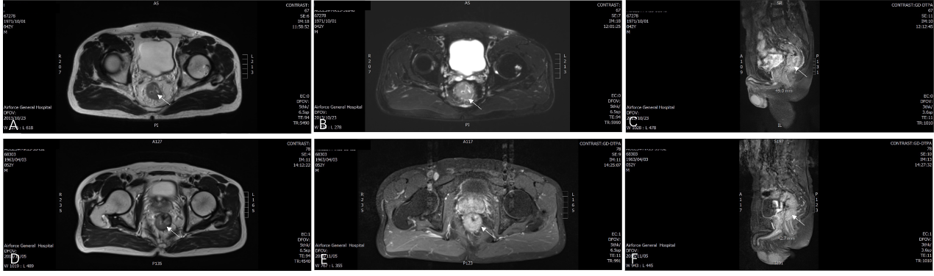
Figure 1 Preoperative pelvic magnetic resonance imaging. A-C: Preoperative pelvic magnetic resonance imaging (MRI) of Case 1 (white arrow shows the rectal cancer, 2013/10/23); D-F: Preoperative pelvic MRI of Case 2 (white arrow shows the rectal cancer, 2015/11/05).

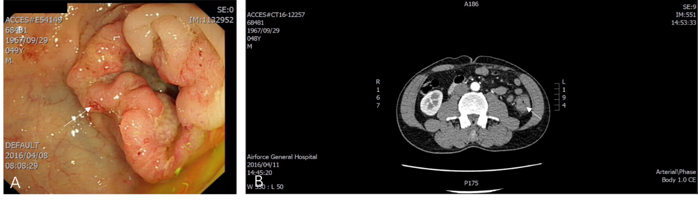
Figure 2 Preoperative performance of Case 3. A: Preoperative colonoscopy of Case 3 (white arrow shows the colon cancer, 2016/04/08); B: Preoperative abdominal computed tomography of Case 3 (white arrow shows the colon cancer, 2016/04/11).

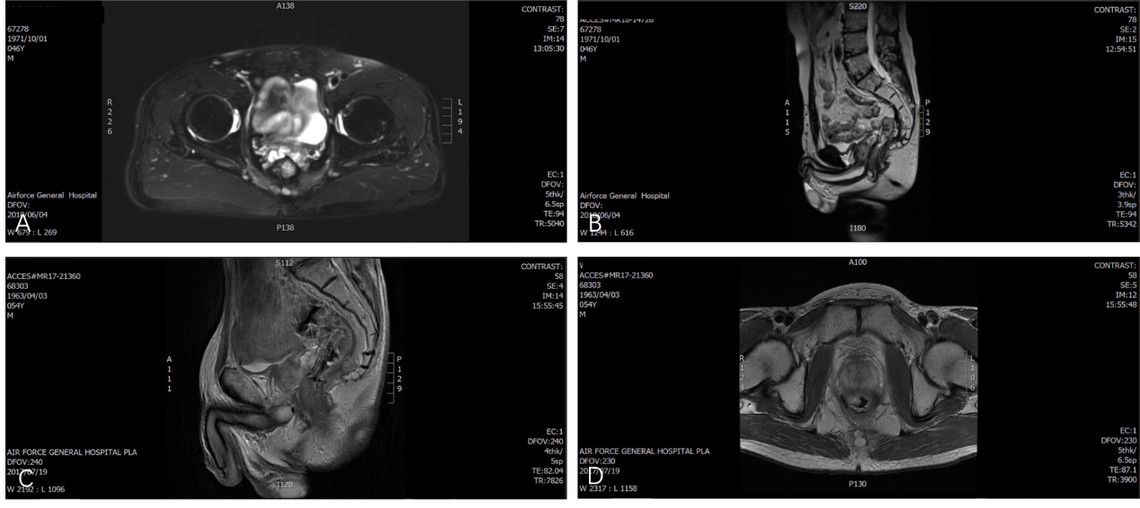
Figure 3 Recent magnetic resonance imaging reexamination. A, B: Recent magnetic resonance imaging (MRI) reexamination of Case 1 (2018/06/04); C, D: Recent MRI reexamination of Case 2 (2017/07/19).

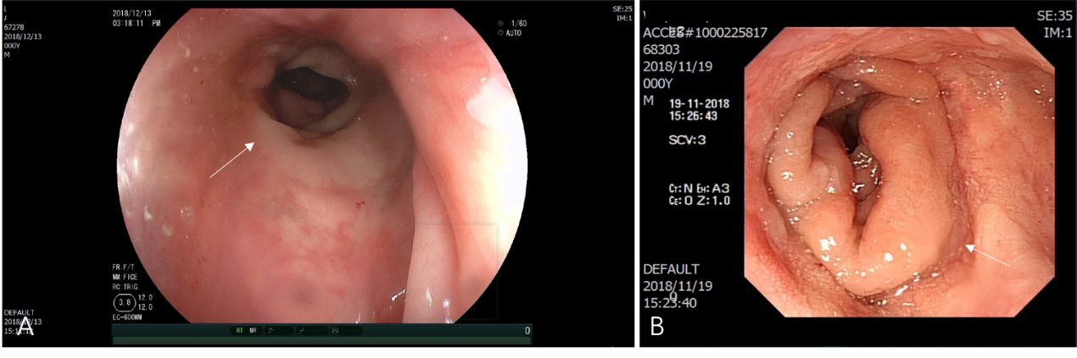
Figure 4 Recent reexamination colonoscopy. A: Recent reexamination colonoscopy of Case 1 (white arrow shows the anastomotic stoma, 2018/12/13); B: Recent reexamination colonoscopy of Case 2 (white arrow shows the anastomotic stoma, 2018/11/19).

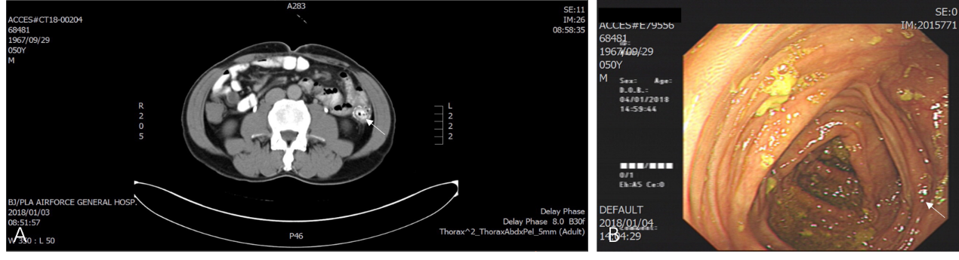
Figure 5 Recent reexamination of Case 3. A: Recent abdominal computed tomography reexamination of Case 3 (white arrow shows the anastomotic stoma, 2018/01/03); B: Recent reexamination colonoscopy of Case 3 (white arrow shows the anastomotic stoma, 2018/01/04).

