Name of Journal: World Journal of Clinical Cases
Manuscript NO: 50398
Manuscript Type: CASE REPORT

Re-revision surgery for re-recurrent valgus deformity after revision total knee arthroplasty in a patient with severe valgus deformity: A case report

Du YQ et al. Re-recurrent valgus deformity after THA

Yin-Qiao Du, Jing-Yang Sun, Ming Ni, Yong-Gang Zhou

Yin-Qiao Du, Jing-Yang Sun, Ming Ni, Yong-Gang Zhou, Department of Orthopedics, General Hospital of Chinese People’s Liberation Army, Beijing 100853, China

ORCID number: Yin-Qiao Du (0000-0002-7460-4101); Jing-Yang Sun (0000-0002-9370-8213); Ming Ni (0000-0002-3910-0127); Yong-Gang Zhou (0000-0002-7304-4691).

Author contributions: Du YQ wrote this paper; Sun JY was responsible for sorting the data; Ni M and Zhou YG designed this case report; Zhou YG performed the operation.

Supported by National Key Research and Development Program of China, No. 2017YFB1104104.

Informed consent statement: Informed consent was obtained from the patient included in this case report.

Conflict-of-interest statement: The authors declare that there is no conflict of interest involved.

CARE Checklist (2016) statement: The authors have read the CARE Checklist (2016), and the manuscripts was prepared and revised according to the CARE Checklist (2016).

Open-Access: This article is an open-access article which was selected by an in-house editor and fully peer-reviewed by external reviewers. It is distributed in accordance with the Creative Commons Attribution Non Commercial (CC BY-NC 4.0) license, which permits others to distribute, remix, adapt, build upon this work non-commercially, and license their derivative works on different terms, provided the original work is properly cited and the use is non-commercial. See: http://creativecommons.org/licenses/by-nc/4.0/

Manuscript source: Unsolicited manuscript

Corresponding author: Yong-Gang Zhou, MD, PhD, Doctor, Department of Orthopedics, General Hospital of Chinese People’s Liberation Army, 28 Fuxing Road, Haidian District, Beijing, 100853, China. ygzhou301@163.com
Telephone: +86-10-66938404
Fax: +86-10-66938404

Received: July 17, 2019
Peer-review started: July 21, 2019
First decision: September 9, 2019
Revised: September 17, 2019
Accepted: September 25, 2019
Article in press:
Published online:

Abstract

BACKGROUND
Recurrent valgus deformity is a common complication after total knee arthroplasty (TKA) in patients with valgus deformity. However, re-revision surgery for re-recurrent valgus deformity after revision TKA in patients with valgus deformity before primary TKA is uncommon.

CASE SUMMARY
We report a 72-year-old woman with two recurrent valgus deformities after TKA for a valgus knee deformity who underwent two revision surgeries to rectify the deformity. In the re-revision surgery, bone defects were successfully reconstructed by using the augments, cement in combination with screws, and a sleeve. An appropriate neutral alignment of the lower limb was restored by using the perfect femoral entry point and the long diaphyseal cementless stem. Adequate fixation of the metaphysis and diaphysis of the femur was obtained with the sleeve and long diaphyseal cementless stem. The patient was pain-free and deformity-free for 2.5 years.

CONCLUSION
The management of bone defects, the choice of the stem, and the femoral entry point are of vital importance in the revision or re-revision TKA for recurrent valgus deformity.

Key words: Revision total knee arthroplasty; Valgus deformity; Bone defects; Recurrent; Case report

© The Author(s) 2019. Published by Baishideng Publishing Group Inc. All rights reserved.

Core tip: Recurrent valgus deformity is a complication of total knee arthroplasty (TKA) in patients with severe valgus deformity. It is very difficult to perform the revision TKA. The management of bone defects, the choice of the stem, and the femoral entry point are of vital importance in the revision TKA.

Du YQ, Sun JY, Ni M, Zhou YG. Re-revision surgery for re-recurrent valgus deformity after revision total knee arthroplasty in a patient with severe valgus deformity: A case report. World J Clin Cases 2019; In press

INTRODUCTION
For more than a decade, the number of total knee arthroplasties (TKAs) had been steadily increasing with the increased demand for rectifying deformities and alleviating pain^{[1,2]}. However, TKA with valgus deformity was considered a surgical challenge, and the incidence of recurrent valgus deformities was very high^{[3]}. The revision surgery for failed TKAs becomes unusually complex because of the presence of tremendous bone defects of the lateral femoral condyle. While the development of highly porous cones and sleeves has enabled the reconstruction of areas with massive metaphyseal bone defects and the improvement of solid fixations^{[4-6]}, the fixation of the diaphyseal stem was also crucial for revision TKA success. The extension of the stem is important in transferring the bending and torsional stresses generated by articulation of the joint away from the joint surface toward the strong diaphyseal bone^{[7]}. The length of the diaphyseal stem and the entry point of the femoral intramedullary (IM) rod are the cornerstones of achieving perfect lower limb alignment. Therefore, the management of bone defects, the choice of the stem, and the femoral entry point are of vital importance in revision TKA for recurrent valgus deformity. Here, we report a patient with a rare, severe valgus deformity who underwent two revision surgeries for recurrent valgus deformity after TKA.

CASE PRESENTATION
Chief complaints
A 72-year-old woman visited our hospital 6 years after revision surgery for left TKA with a chief complaint of pain which worsened for 1 month.

History of present illness
The patient underwent left primary TKA (NexGen LPS-FLEX, Zimmer, Warsaw, Indiana, United States) and sliding osteotomy of the lateral femur condyle in 2008 for a severe valgus deformity at another institution. Six months later, she again presented with valgus deformity and pain in the left knee. In-house X-rays revealed notable femoral component loosening and recurrent valgus deformity (Figure 1).
Then, the revision of the knee components was performed in 2010 at another institution. The system that the surgeon used was the press fit condylar Sigma total condylar III (TC3) system (DePuy, Warsaw, Indiana, United States). All the stems on the femoral and tibial sides were cementless, and the cement that was reinforced with screws was used to reconstruct the defects of the lateral femoral condyle (Figure 2). The patient did not report any serious symptoms for six years. In 2016, she started complaining of knee pain again, and she showed limited movement and valgus deformity.

History of past illness
She suffered from hypertension for 2 years. Her blood pressure was controlled by using antihypertensive drugs.

Personal and family history
The patient did not have any specific personal or family history of disease.

Physical examination upon admission
We evaluated her before re-revision TKA. In the clinical examination, the knee was equally painful with weight-bearing and passive motions. The range of motion was from 5° to 80° of flexion. There was anterior-posterior laxity of 5-10 mm. With valgus stress, there was a marked medial instability of more than 15°.

Laboratory examinations
The patient was evaluated to rule out infection. The knee was aspirated preoperatively. The synovial red blood cell count was 13-18/high power field, and the synovial white blood cell count, polymorphonuclear cells (%), and leukocyte esterase were normal. There was no bacterial growth in the aspirate. Likewise, the serum C-reactive protein, erythrocyte sedimentation rate, and interleukin-6 were normal. An emission computed tomography scan of the bone in the whole body was also found to be negative for infection.

Imaging examinations
In 2016, X-rays showed loosening of the femoral component and the stem (Figure 3).

FINAL DIAGNOSIS
The final diagnosis included loosening of the components and stem of the femoral side and recurrent valgus deformity in the left knee.

TREATMENT
During surgery, the medial joint space was opened widely with valgus stress during flexion and extension. The quadriceps snip technique was used to assist in the surgical exposure of the knee. The components and stem of the femoral side were loosened, and those of the tibial side were well stabilized. After removal of the loose femoral component and stem, we evaluated the intraoperative bone defects (type FIIB) according to the Anderson Orthopaedic Research Institute (AORI) classification (AORI classification of bone defects in revision TKA)^{[8]}. The cement reinforced with screws was used to reconstruct the defects of the lateral femoral condyle. A lateral distal femoral block augment (4 mm thick) and posterior femoral augments (the medial and lateral sides were 4 mm and 8 mm thick, respectively) were used to restore the defects of the joint surface and epiphysis. A porous titanium metaphyseal sleeve (size: 40 mm) was used in the treatment of metaphyseal bone defects. A TC3 femoral component (size: 4) in combination with a cementless stem (size: 16 mm × 115 mm), which was engaged in the cortical bone of diaphysis, was implanted with a hybrid fixation. Then, a new constrained polyethylene liner (17.5 mm) was placed in the tibial component plate (Figure 4).

OUTCOME AND FOLLOW-UP
Postoperative X-rays confirmed excellent placement of the components after left TKA (Figure 5). Continuous passive motions and partial weight-bearing actions with a walking aid were initiated on the second postoperative day, and the range of motion was gradually increased to 0°-90° of flexion. The patient had no postoperative complications and was discharged from the hospital on postoperative day 4. Physical therapy stressed a gentle range of motion and strengthening exercise with no forced flexion. Four weeks after surgery, she gradually resumed full weight-bearing activities.
Following this surgery, the patient made an eventful recovery, and 2.5 years have now passed after the re-revision TKA. She was satisfied with her knee, with a hospital for special surgery score of 84 (preoperative score: 31), was pain-free, and had a range of motion of 0°-100° of flexion. The X-rays showed that the left knee arthroplasty was in the expected position with no radiographic signs of loosening (Figure 6).

DISCUSSION
We present an experience with a 72-year-old woman with two recurrent valgus deformities after TKA for a valgus knee deformity. The patient underwent two revision surgeries because of the recurrent valgus deformity.
Primary TKA for a valgus knee deformity represents a challenge for orthopaedic surgeons, especially beginners^{[9,10]}. Nikolopoulos et al^{[9]} presented in his review article several complications that have been reported more frequently in patients with a valgus knee deformity who underwent TKA, and the incidence of recurrent valgus deformity ranged from 4% to 38%. A recurrent valgus deformity could result in massive bone defects of the lateral femoral condyle. For large or uncontained defects, including AORI type II, treatment alternatives include modular augments, the cement reinforced with screws, and porous titanium metaphyseal sleeve. Distal and posterior femoral defects managed with modular augments allow for the placement of well-positioned and correctly sized femoral components in contact with host bone^{[11]}, and posterior femoral augments are particularly useful in restoring the proper anteroposterior dimension of the component, achieving the correct rotation of the femoral component and addressing the extension-flexion mismatch by altering the flexion gap^{[12]}. Porous titanium metaphyseal sleeves with a stepped shape and titanium bead coating are easy to use for fixation by bone ingrowth and are available to fill the metaphyseal defects. The femoral component is attached to the sleeve through the Morse junction on the instrument^{[13]}. Although many authors recommended the use of cement in combination with screws in cases of contained or uncontained defects between 5 mm and 10 mm, we still used the cement to reconstruct the massive defects of the lateral femoral condyle. According to zonal fixation concepts, solid fixation should be achieved in at least two of three zones^{[14]}. The cementless stem and metaphyseal sleeve at least helped in promoting an additional fixation in the metaphysis (zone 2) and diaphysis (zone 3) of the femur, so the cement in combination with screws is safe to use to reconstruct the lateral femoral condyle.
We analysed the causes of failure of the revision TKA and considered the invalid entry point of the femoral IM rod and the short cementless stem as the main causes.
According to the postoperative X-rays after revision TKA, the entry point of the femoral IM rod was located at the centre of the coronal plane and posterior to the centre of the femoral marrow cavity in the sagittal plane, which resulted in residual valgus deformity, gross flexion-extension mismatch, and loading stresses on the lateral femoral condyle and ultimately led to the failure of the reconstruction of the lateral femoral condyle. Tan et al^{[15]} suggested that the femoral entry point should be located medial to the centre of the knee joint in the coronal plane for a valgus knee arthroplasty. In the re-revision surgery, we adjusted the entry point of the femoral IM rod to be medial of the centre of the joint in the coronal plane (the intersection of the anatomical axis and the distal femoral joint line) and in the centre of the femoral marrow cavity in the sagittal plane, restoring the neutral alignment of the lower limb.
While augments and sleeves have greatly enhanced the modern surgeon’s ability to gain solid fixation in metaphyseal bone, stems continue to be useful in revision TKA to bypass defects and enhance the structural stability of revision components^{[16]}. In revision surgery, the surgeon chose a cementless stem to bypass the metaphyseal defect. However, the stem was too short and thin to achieve solid fixation in the diaphysis (zone 3) of the femur. In the re-revision surgery, we used a long diaphyseal cementless stem, which engaged in the cortical bone of diaphysis, to transfer loads to the diaphysis and reduce micromotions. The long diaphyseal cementless stem not only assisted in offloading interface stresses but also guided the IM rod to prevent malalignment^{[17,18]}.
When the joint surface and epiphysis (zone 1) are inadequate, fixation of the metaphysis (zone 2) and diaphysis (zone 3) of the femur becomes particularly important. In this case, the insufficient fixation of the metaphysis and diaphysis were reasons the revision TKA failed. The invalid entry point of the femoral IM rod and the short cementless stem, which led to lower limb malalignment, were major causes of failure and re-revision surgery.

CONCLUSION
Recurrent valgus deformity is the most commonly reported complication after TKA for a valgus knee deformity, leading to massive bone defects of the lateral femoral condyle. The restoration of bone defects, component stability, and perfect lower limb alignment are the main challenges in the revision or re-revision TKA. In this case, bone defects were successfully reconstructed by using the augments, the cement in combination with screws, and a sleeve. An appropriate neutral alignment of the lower limb was restored by using the perfect entry point of the femoral IM rod and the long diaphyseal cementless stem. Adequate fixation of the metaphysis and diaphysis of the femur was obtained with the sleeve and the long diaphyseal cementless stem. All these factors were the cornerstones of the success of this case.

REFERENCES
1 Kurtz S, Ong K, Lau E, Mowat F, Halpern M. Projections of primary and revision hip and knee arthroplasty in the United States from 2005 to 2030. J Bone Joint Surg Am 2007; 89: 780-785 [PMID: 17403800 DOI: 10.2106/jbjs.f.00222]
2 Patel A, Pavlou G, Mújica-Mota RE, Toms AD. The epidemiology of revision total knee and hip arthroplasty in England and Wales: a comparative analysis with projections for the United States. A study using the National Joint Registry dataset. Bone Joint J 2015; 97-B: 1076-1081 [PMID: 26224824 DOI: 10.1302/0301-620X.97B8.35170]
3 Rossi R, Rosso F, Cottino U, Dettoni F, Bonasia DE, Bruzzone M. Total knee arthroplasty in the valgus knee. Int Orthop 2014; 38: 273-283 [PMID: 24366186 DOI: 10.1007/s00264-013-2227-4]
4 Thorsell M, Hedström M, Wick MC, Weiss RJ. Good clinical and radiographic outcome of cementless metal metaphyseal sleeves in total knee arthroplasty. Acta Orthop 2018; 89: 84-88 [PMID: 29105554 DOI: 10.1080/17453674.2017.1398013]
5 Sandiford NA, Misur P, Garbuz DS, Greidanus NV, Masri BA. No Difference Between Trabecular Metal Cones and Femoral Head Allografts in Revision TKA: Minimum 5-year Followup. Clin Orthop Relat Res 2017; 475: 118-124 [PMID: 27287857 DOI: 10.1007/s11999-016-4898-9]
6 Sheth NP, Bonadio MB, Demange MK. Bone Loss in Revision Total Knee Arthroplasty: Evaluation and Management. J Am Acad Orthop Surg 2017; 25: 348-357 [PMID: 28406878 DOI: 10.5435/JAAOS-D-15-00660]
7 Completo A, Simões JA, Fonseca F. Revision total knee arthroplasty: the influence of femoral stems in load sharing and stability. Knee 2009; 16: 275-279 [PMID: 19299144 DOI: 10.1016/j.knee.2008.12.008]
8 Engh GA, Ammeen DJ. Classification and preoperative radiographic evaluation: knee. Orthop Clin North Am 1998; 29: 205-217 [PMID: 9553566 DOI: 10.1016/S0030-5898(05)70319-9]
9 Nikolopoulos D, Michos I, Safos G, Safos P. Current surgical strategies for total arthroplasty in valgus knee. World J Orthop 2015; 6: 469-482 [PMID: 26191494 DOI: 10.5312/wjo.v6.i6.469]
10 Favorito PJ, Mihalko WM, Krackow KA. Total knee arthroplasty in the valgus knee. J Am Acad Orthop Surg 2002; 10: 16-24 [PMID: 11809047 DOI: 10.1016/j.otsr.2010.03.009]
11 Sculco PK, Abdel MP, Hanssen AD, Lewallen DG. The management of bone loss in revision total knee arthroplasty: rebuild, reinforce, and augment. Bone Joint J 2016; 98-B: 120-124 [PMID: 26733657 DOI: 10.1302/0301-620X.98B1.36345]
12 Vasso M, Beaufils P, Cerciello S, Schiavone Panni A. Bone loss following knee arthroplasty: potential treatment options. Arch Orthop Trauma Surg 2014; 134: 543-553 [PMID: 24519708 DOI: 10.1007/s00402-014-1941-8]
13 Agarwal S, Neogi DS, Morgan-Jones R. Metaphyseal sleeves in revision total knee arthroplasty: Minimum seven-year follow-up study. Knee 2018; 25: 1299-1307 [PMID: 30297257 DOI: 10.1016/j.knee.2018.09.010]
14 Morgan-Jones R, Oussedik SI, Graichen H, Haddad FS. Zonal fixation in revision total knee arthroplasty. Bone Joint J 2015; 97-B: 147-149 [PMID: 25628273 DOI: 10.1302/0301-620X.97B2.34144]
15 Tan H, Wang Y, Long T, Nie B, Mao Z, Yue B. How to accurately determine the distal femoral valgus cut angle in the valgus knee arthroplasty. Int Orthop 2018; 42: 537-542 [PMID: 29356933 DOI: 10.1007/s00264-018-3778-1]
16 Driesman AS, Macaulay W, Schwarzkopf R. Cemented versus Cementless Stems in Revision Total Knee Arthroplasty. J Knee Surg 2019; 32: 704-709 [PMID: 30736057 DOI: 10.1055/s-0039-1678686]
17 Mancuso F, Beltrame A, Colombo E, Miani E, Bassini F. Management of metaphyseal bone loss in revision knee arthroplasty. Acta Biomed 2017; 88: 98-111 [PMID: 28657571]
18 Huten D. Femorotibial bone loss during revision total knee arthroplasty. Orthop Traumatol Surg Res 2013; 99: S22-S33 [PMID: 23333128 DOI: 10.1016/j.otsr.2012.11.009]
P-Reviewer: Ünver B S-Editor: Dou Y L-Editor: Wang TQ E-Editor:

Specialty type: Medicine, Research and Experimental
Country of origin: China
Peer-review report classification
Grade A (Excellent): 0
Grade B (Very good): B
Grade C (Good): C, C
Grade D (Fair): D
Grade E (Poor): 0

A B
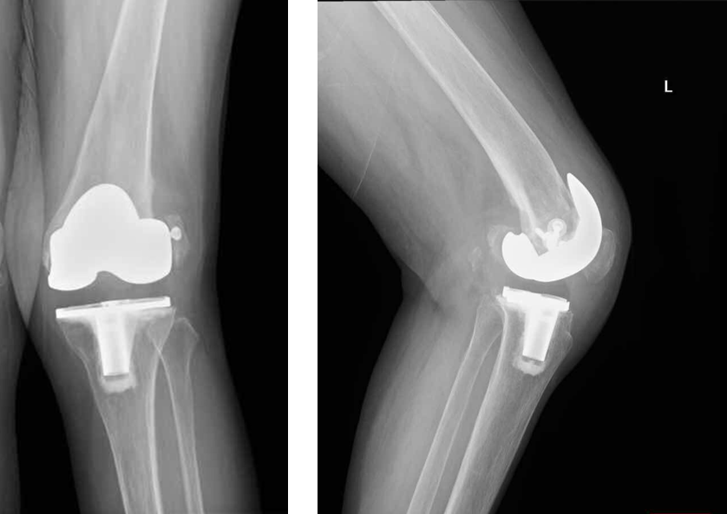
Figure 1 Radiographs of the left knee at 6 months after primary total knee arthroplasty showing the signs of femoral component loosening and recurrent valgus deformity. A: Anteroposterior radiograph; B: Lateral radiograph.

A B C
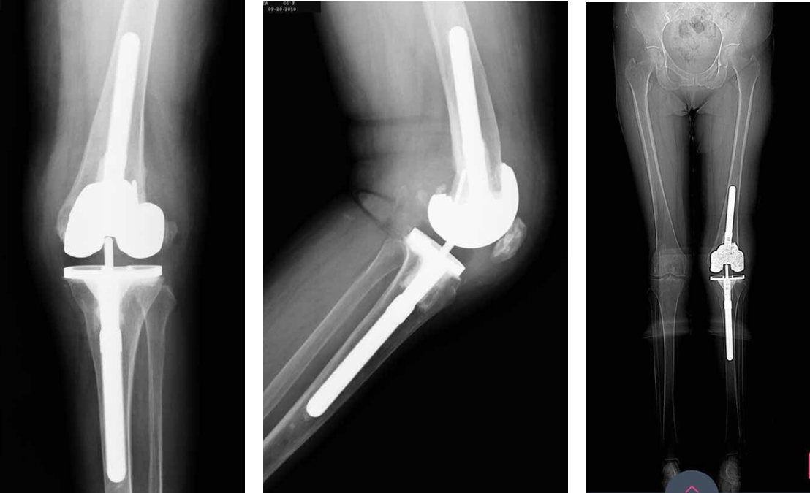
Figure 2 Radiographs after revision total knee arthroplasty showing residual valgus deformity. A: Anteroposterior radiograph; B: Lateral radiograph; C: Standing hip-to-ankle anteroposterior radiograph.

A B C
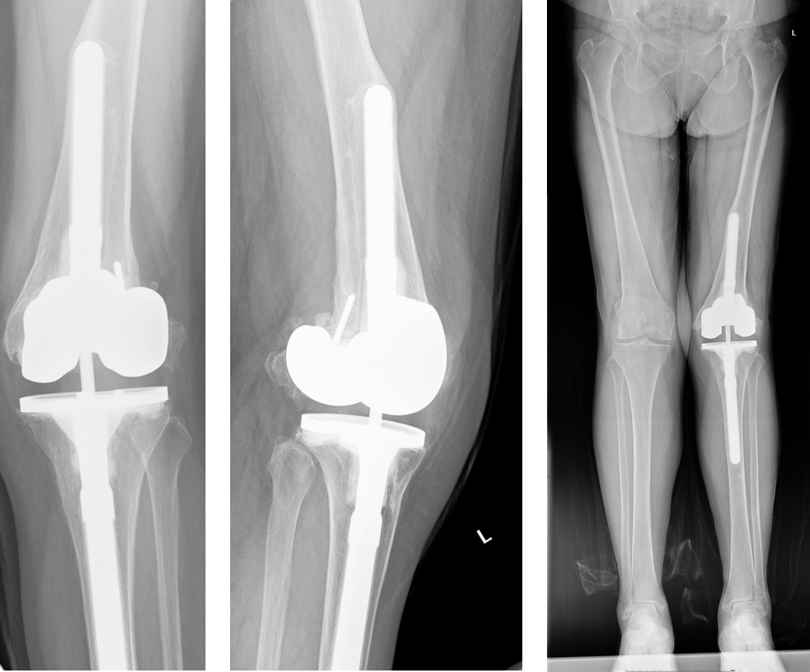
Figure 3 Radiographs at 6 years after revision total knee arthroplasty showing signs of the loosening of femoral components and recurrent valgus deformity, and the femoral cementless stem breaking through the cortical bone of the femur. A: Anteroposterior radiograph; B: Lateral radiograph; C: Standing hip-to-ankle anteroposterior radiograph.

A B C D
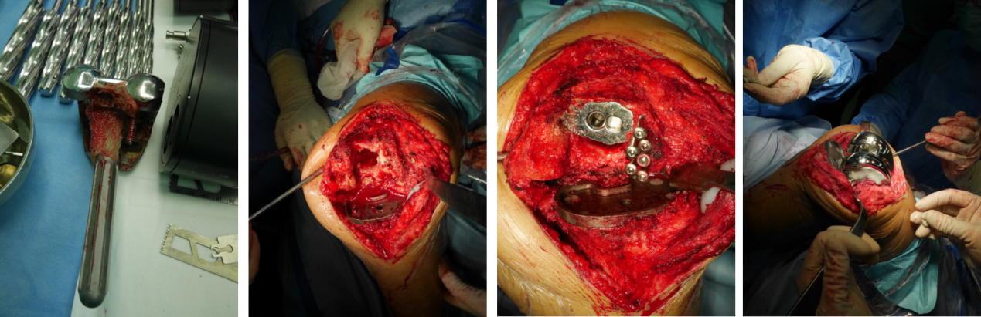
Figure 4 Intraoperative images. A: Removal of femoral components from the previous revision and the cementless stem; B: Tremendous bone defects (type FIIB) in the lateral femoral condyle; C: The screws were used to reconstruct the defects of the lateral femoral condyle; D: A total condylar III femoral component with a sleeve that was implanted with a hybrid fixation and the cement reinforced with screws were used to reconstruct the defects of the lateral femoral condyle.

A B C
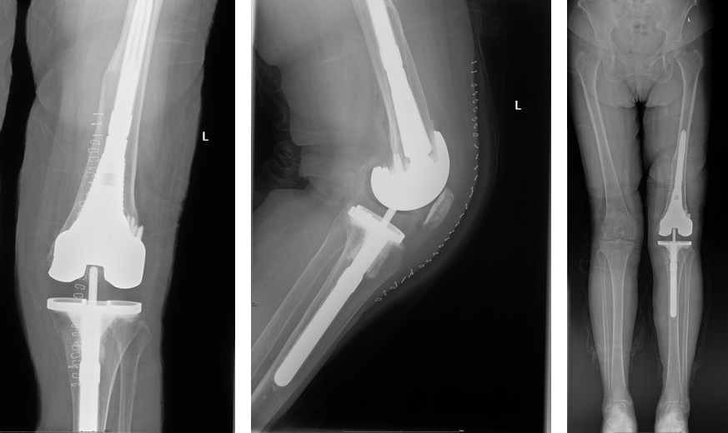
Figure 5 Radiographs after re-revision total knee arthroplasty. The positions of the components were satisfactory based on the radiographs, and an appropriate neutral alignment of the lower limb was restored. A: Anteroposterior radiograph; B: Lateral radiograph; C: Standing hip-to-ankle anteroposterior radiograph.

A B C
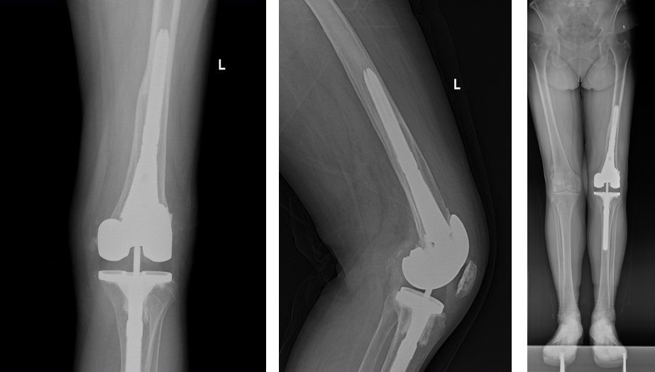
Figure 6 Radiographs at 2.5 years after re-revision total knee arthroplasty. The left knee arthroplasty was in the expected position with no radiographic signs of loosening. A: Anteroposterior radiograph; B: Lateral radiograph; C: Standing hip-to-ankle anteroposterior radiograph.

