Name of journal: World Journal of Gastroenterology
ESPS Manuscript NO: 2818
Columns: META-ANALYSIS

Prediction of the severity of acute pancreatitis on admission by urinary trypsinogen activation peptide: A meta-analysisa

Huang W et al. Trypsinogen activation peptide and acute pancreatitis

Wei Huang, Kiran Altaf, Tao Jin, Jun-Jie Xiong, Li Wen, Muhammad A Javed, Marianne Johnstone, Ping Xue, Christopher M Halloran, Qing Xia

Wei Huang, Tao Jin, Ping Xue, Qing Xia, Sichuan Provincial Pancreatitis Center, Department of Integrated Traditional and Western Medicine, West China Hospital, Sichuan University, Chengdu 610041, Sichuan Province, China

Kiran Altaf, Muhammad A Javed, Marianne Johnstone, Christopher M Halloran, NIHR Liverpool Pancreas Biomedical Research Unit, Royal Liverpool University Hospital, University of Liverpool, Liverpool, L69 3GA, United Kingdom

Jun-Jie Xiong, Li Wen, Department of Hepato-Biliary-Pancreatic Surgery, West China Hospital, Sichuan University, Chengdu 610041, Sichuan Province, China

Author contributions: Huang W and Altaf K contributed equally to this work; Xue P, Halloran CM and Xia Q designed the research, corrected and approved the manuscript; Huang W and Altaf K developed the literature search and carried out statistical analysis of the studies; Jin T, Xiong JJ, Wen L, Javed MA and Johnstone M performed data extraction; Huang W and Altaf K wrote the manuscript; and all authors read and approved the final manuscript.

Supported by Technology Supported Program of Sichuan Province, No. 2011SZ0291; the National Natural Science Foundation of China, No. 81072910 and National Institute for Health Research, United Kingdom

Correspondence to: Ping Xue, MD, PhD, Sichuan Provincial Pancreatitis Center, Department of Integrated Traditional and Western Medicine, West China Hospital, Sichuan University, Guo Xue Rd 37, Chengdu 610041, Sichuan Province, China. sppc.wch.scu@gmail.com

Telephone: +86-28-85423373 Fax: +86-28-85423373

Received: March 16, 2013 Revised: May 20, 2013
Accepted: June 19, 2013

Published online:

Abstract
AIM: To undertake a meta-analysis on the value of urinary trypsinogen activation peptide (uTAP) in predicting severity of acute pancreatitis on admission.

METHODS: Major databases including Medline, Embase, Science Citation Index Expanded and the Cochrane Central Register of Controlled Trials in the Cochrane Library were searched to identify all relevant studies from January 1990 to January 2013. Pooled sensitivity, specificity and the diagnostic odds ratios (DORs) with 95% confidence interval (CI) were calculated for each study and were compared to other systems/biomarkers if mentioned within the same study. Summary receiver-operating curves were conducted and the area under the curve (AUC) was evaluated.

RESULTS: In total, six studies of uTAP with a cut-off value of 35 nmol/L were included in this meta-analysis. Overall, the pooled sensitivity and specificity of uTAP for predicting severity of acute pancreatitis, at time of admission, was 71% and 75%, respectively (AUC = 0.83, DOR = 8.67, 95%CI: 3.7-20.33). When uTAP was compared with plasma C-reactive protein, the pooled sensitivity, specificity, AUC and DOR were 0.64 vs 0.67, 0.77 vs 0.75, 0.82 vs 0.79 and 6.27 vs 6.32. Similarly, the pooled sensitivity, specificity, AUC and DOR of uTAP vs Acute Physiology and Chronic Health Evaluation II II; within the first 48 h of admission were found to be 0.64 vs 0.69, 0.77 vs 0.61, 0.82 vs 0.73 and 6.27 vs 4.61.

CONCLUSION: uTAP has the potential to act as a stratification marker on admission in differentiating disease severity of acute pancreatitis.

© 2013 Baishideng. All rights reserved.

Key words: Acute pancreatitis; Urinary trypsinogen activation peptide; C-reactive protein; Acute Physiology and Chronic Health Evaluation II score; Meta-analysis

Core tip: Currently, the assessment of the severity of acute pancreatitis on admission remains a challenge to clinicians. Single, rapid biochemical marker is a preferred choice than clinical and CT scoring systems. In this study, the value of on admission urinary trypsinogen activation peptide (uTAP) in predicting severity of acute pancreatitis was assessed. It was found that the ability of on admission uTAP to predict severity of acute pancreatitis was comparable to C-reactive protein (at 48 h) and was potentially better than Acute Physiology and Chronic Health Evaluation II score (at 48 h), the most frequently used biochemical marker and clinical scoring system in acute pancreatitis, respectively.

Huang W, Altaf K, Jin T, Xiong JJ, Wen L, Javed MA, Johnstone M, Xue P, Halloran CM, Xia Q. Prediction of the severity of acute pancreatitis on admission by urinary trypsinogen activation peptide: A meta-analysis.

Available from:
DOI:

INTRODUCTION
Acute pancreatitis causes up to 210000 admissions in the United States annually and remains a diagnostic, prognostic and therapeutic dilemma for surgeons and physicians^{[1]}. Although mild acute pancreatitis is associated with virtually no mortality, severe acute pancreatitis continues to be at the other end of the spectrum with mortality reaching up to 30%, mainly due to pancreatic necrosis and organ failure^{[2]}.
As severe acute pancreatitis may progress very fast and is normally associated with a complicated clinical course and higher mortality, it is vital to capture these patients as early as possible to initiate appropriate supportive management, especially within the first 24 h after symptoms onset^{[3]}. Therefore, in the last few decades many biomarkers^{[4]}, radiological^{[5]} and clinical scoring systems^{[6,7]} have been developed and validated to fulfil this role. These, however, have not been entirely successful. Glasgow^{[8]}, Acute Physiology and Chronic Health Evaluation II (APACHE II)^{[9]}, Ranson^{[10]} scoring systems and plasma C-reactive protein (CRP)^{[11]} are still the most widely used parameters and form part of many guidelines, but their use does come with its own limitations.
There is enough evidence to establish trypsinogen activation as one of the earliest steps in the pathophysiology of the disease^{[12, 13]}, and consequently, trypsinogen activation peptide (TAP) has been shown to be an excellent marker for severity stratification in different experimental acute pancreatitis models^{[14]}. In human acute pancreatitis, TAP is rapidly excreted in urine and the urinary^{[15]} and peritoneal fluid^{[16]} TAP concentrations correlate well with disease severity. Therefore, it is reasonable to hypothesize that pancreas-specific activation peptides would be elevated (in the urine) from the onset of the disease and could potentially serve as early biomarkers. Urinary TAP (uTAP) is the most studied peptide for predicting severity of acute pancreatitis^{[17]}, but its diagnostic values to severe acute pancreatitis have not been systematically assessed. In this study, a meta-analysis was carried out to evaluate existing evidence of uTAP in predicting the severity of acute pancreatitis.

MATERIALS AND METHODS
Study selection
A comprehensive literature search of Medline, Embase, Science Citation Index Expanded and the Cochrane Central Register of Controlled Trials in The Cochrane Library was carried out for studies evaluating prognostic efficacy of uTAP from January 1990 (the first human study)^{[15]} to February 2013. Medical subject headings (MeSH) and keywords were used: “trypsinogen activation peptide” or “activation peptide” and “acute pancreatitis” or “severe acute pancreatitis” or “post endoscopic retrograde cholangiopancreatography (ERCP) pancreatitis”. Equivalent free-text search terms were used in the search strategy. All abstract supplements from published literature or from relevant international meetings were searched manually. Relevant papers were also identified from the reference lists of previous papers. Only studies which were published in English as full-text articles were included. Final inclusion of articles was determined by consensus; when this failed, a third author adjudicated. Severe acute pancreatitis was defined as development of organ failure and/or local complications^{[15,18]}.

Inclusion and exclusion criteria
Two authors independently identiﬁed and screened the search ﬁndings for potentially eligible studies.

Inclusion criteria: (1) English language studies published as full text articles in peer-reviewed journals; (2) Human studies; (3) Studies with available data; and (4) When similar studies were reported by the same institution, the study in better quality was included.

Exclusion criteria: (1) Abstracts, letters, editorials, expert opinions, reviews and case reports; (2) where only concentration or P value was reported; (3) Studies assessing efficacy of serum/plasma TAP in predicting the severity of acute pancreatitis; and (4) Studies assessing efficacy of uTAP in diagnosing acute pancreatitis.

Data extraction and quality assessment
Data were extracted by two independent observers using standardized forms. The recorded data included study design, demographics (age, gender, etiology and country of origin), severity of disease, duration from symptoms onset to admission, time point for the collection of samples and cut-off values. Diagnostic parameters including true positivity (TP), false positivity (FP), false negativity (FN) and true negativity (TN) were extracted directly or by calculating the sensitivity and specificity of uTAP for predicting the severity of acute pancreatitis. TP, FP, FN and TN were also extracted for serum CRP and APACHE II score at the highest diagnostic values during the first 2 d after admission if these were reported in the included studies. The quality of the included studies was assessed independently by two reviewers using the Standards for Reporting of Diagnostic Accuracy (STARD) initiative guidelines^{[19]}. Studies with a STARD score of ≥ 16 were considered as high quality studies.

Statistical analysis
Meta-analysis was made with Meta-DiSc 1.4 software (Hospital Ramóny Cajal, Madrid, Spain). Pooled sensitivity, specificity, and diagnostic odds ratio (DOR) with diagnostic value Q were calculated. The mentioned parameters were pooled respectively with a corresponding 95% confidence interval (95%CI). Receiver operating characteristics were also generated and expressed by area under curve (AUC). The AUC represents the accuracy of diagnosis and DOR indicates its diagnostic capability for differentiating disease groups from negative groups^{[20]}. Heterogeneity was evaluated using Cochran’s Q test and a P value of 0.1 was considered significantly different. I² statistics were used to measure the percentage of total variation across the studies because of heterogeneity (I² of 50% or more indicating the presence of heterogeneity)^{[21]}. The publication bias of included studies was assessed using funnel plot of effect effective sample size weighted regression tests of asymmetry^{[22]}. Meta-analysis was performed using a fixed-effect model if there was no heterogeneity among the studies, otherwise the random effects model was used^{[23]}. The sensitivity analyses were undertaken by excluding each study from the analysis to ascertain its effect on the overall results. Subgroup analyses were dependent on the following items: high quality studies, sample size ≥ 50 in each study, single center studies and severity defined by 1992 Atlanta Classification^{[18]}.

RESULTS
Description of included trials in the meta-analysis
Details of literature research are shown in Figure 1 and 16 clinical studies were identified. Excluded were seven studies: one for the lack of data for analysis^{[24]}, one studied peritoneal fluid TAP^{[25]}, two studied serum/plasma TAP^{[26,27]}, three for diagnosing acute pancreatitis but not for assessing the severity^{[28]} or post-ERCP pancreatitis^{[29,30]}. Of the 9 studies ^{[15,31-38]} that were potentially useful for analysis; only six had the cut-off of 35 nmol/L; it being variable in the remaining three and therefore, these six studies were included in the final analysis.

Study and patient characteristics
Table 1 describes the included studies and patient characteristics. All of the six included studies were prospectively designed and were of high quality (STARD score ≥ 16). There were 2 multicenter^{[32,37]} and 4 single center^{[33-35,38]} trials. Five studies^{[32-35,38]} defined the severity of acute pancreatitis by the 1992 Atlanta Classification in which severe cases include the moderate and the severe groups according to the revised Atlanta Classification^{[39]}. One study defined severe acute pancreatitis as presence of local complication or presence of persistent organ failure that is more than 48 h^{[37]}. The predominant etiology in recruited patients was biliary in origin followed by alcoholic, ERCP and idiopathic.

Meta-analysis results
Results of the data extraction are shown in Table 2 and results of meta-analysis are shown in Figures 2 and 3, and summarized in Table 3.

On admission uTAP for predicting the severity of acute pancreatitis: Data from the six included studies (775 patients with 726 analyzed) revealed the pooled sensitivity, specificity, AUC and DOR to be 71% (95%CI: 63%-78%), 75% (95%CI: 72%-79%), 0.83 and 8.67 (95%CI: 3.7-20.33), respectively. Data are shown in Figure 2 and Table 3. These data suggest that uTAP has the potential to predict severity of acute pancreatitis.

uTAP vs plasma CRP for severity stratification: There were 3 studies^{[32,35,37]} that compared the prognostic value of on admission uTAP (440 patients analyzed) with plasma CRP (458 patients analyzed) within the first 48 h after admission in the severity stratification for acute pancreatitis. The pooled sensitivity, specificity, AUC value and DOR were 0.64 vs 0.67, 0.77 vs 0.75, 0.82 vs 0.79 and 6.27 vs 6.32, respectively (Figure 3A and B) for uTAP and CRP (best diagnostic values at 48 h). As is suggested by the data, prognostic efficacy of the two markers was found to be similar.

uTAP vs APACHE-II score for severity stratification: There were 4 studies ^{[32,34,35, 37]} that compared the prognostic value of on admission uTAP with APACHE II score within first 48 h after admission. Of these, 3 studies ^{[32,35,37]} used an APACHE II score ≥ 8 (422 patients analyzed) for defining severity and compared with uTAP (440 patients analyzed). The pooled sensitivity, specificity, AUC value and DOR were 0.64 vs 0.69, 0.77 vs 0.61, 0.82 vs 0.73 and 6.27 vs 4.61 for uTAP (values on admission) and APACHE II score (best diagnostic values at 48 h), respectively (Figure 3A and C). These data suggest that uTAP may have better prognostic values than APACHE II score in predicting the severity of acute pancreatitis.

Sensitivity and subgroup analysis: Outcomes for sensitivity and subgroup analysis are shown in Table 3. All six studies included were in high quality and sensitivity analysis demonstrated significant heterogeneity still existed in high quality studies (Q = 15.88, P = 0.0072, I² = 68.5%). Subgroup analysis showed significant heterogeneity also existed in studies with sample size ≥ 50 (Q = 10.28, P = 0.0360, I² = 61.1%), single center (Q = 12.92, P = 0.0048, I² = 76.8%), and severity defined by 1992 Atlanta Classification (Q = 13.65, P = 0.0085, I² = 70.7%)

Publication bias: A funnel plot was created to demonstrate bias of studies. The shape of the funnel plot showed asymmetry and this was confirmed with P = 0.001, showing more significant results present in smaller studies (P = 0.001; Figure 4).

DISCUSSION
Upon admission, severity prediction of acute pancreatitis is crucial. This is still controversial, not universal and is mired with institutional differences. The current commonly used severity prediction systems include clinical assessment, biochemical markers, clinical and radiological scoring systems^{[40,41]}. Clinical assessment provides a relatively high specificity (83%-98%) for ruling out mild acute pancreatitis, but suffers with poor sensitivity (34%-64%) for the same^{[40]}. When compared with clinical scoring systems, contrast-enhanced computerized tomography (CECT) has not been found to be superior in predicting outcomes of acute pancreatitis on admission^{[5]}.
Ideally, an ideal biomarker for prediction of disease severity should be accurate, rapid, inexpensive and non-invasive. The pancreas-specific biomarkers are generally thought to be related to disease severity^{[14]}. In 1988, a TAP assay with a detection limit of 10 picomolar concentration was developed by Hurley et al^{[42]}, enabling the detection of TAP in the body fluid to become more feasible. In a multicenter study conducted by Neoptolemos et al^{[32]} that recruited 172 acute pancreatitis patients, uTAP concentration was found to be significantly different between mild and severe acute pancreatitis from 0-96 h after symptoms onset. Most importantly, uTAP values at both 24 and 48 h after admission provided the highest prognostic values for severe acute pancreatitis when compared to plasma CRP and clinical scoring systems (APACHE-II, Glasgow and Ranson).
For the six studies included in this meta-analysis, the pooled results indicated that uTAP has potential of predicting the severity of acute pancreatitis upon hospital admission (AUC = 0.83, DOR = 8.67, 95%CI: 3.7-20.33). This is at least comparable with the current in-use biomarkers^{[6]}. While most of the currently used biomarkers are non-specific in nature (specific to inflammation and other aspects), TAP is specific to the pancreas and is liberated within the first few hours after the onset of symptoms^{[15,32]}. The prognostic value of uTAP (on admission) was similar to APACHE-II score obtained 24 h after admission in this meta-analysis. It is noteworthy that despite APACHE-II score being one of the most frequently used clinical scores to assess the severity of acute pancreatitis, it is cumbersome to use and has dubious use in certain settings; i.e., in critical care environments where physiology has been corrected. Therefore, there is a need for simple and quick severity prediction techniques.
The prognostic values of an on-admission uTAP were also compared with plasma CRP (obtained 0-48 h after admission), currently the most widely used severity biomarker in acute pancreatitis and other acute inflammatory disease^{[43]}. uTAP showed relatively higher diagnostic values than the plasma CRP and suggested that uTAP might be a highly valuable biomarker for the quick assessment of acute pancreatitis severity on admission. It is unsurprising, therefore, that the revised Atlanta Classification^{[39]} introduces the potential use of uTAP for severity stratification although it has not been widely adopted as of yet in the clinical arena.
To investigate presence of heterogeneity, sensitivity and subgroup analyses were performed, based on sample size, study center and definition of severity. There was significant heterogeneity among studies with sample size ≥ 50, single center and severity defined by 1992 Atlanta Classification. This has been shown in many studies before that multicenter studies tend to have better and more reliable results than single centre studies. Same is the case with increasing the sample size. Most of our studies used Atlanta criteria for severity stratification albeit one which represented a small proportion of the same cohort. From a clinical perspective, heterogeneity may also be caused by the definition of the severity. All the severe acute pancreatitis included in this meta-analysis had two distinct entities: the moderate and the severe categories according to the revised Atlanta Classification. The proportion of moderate and severe may have had a significant impact on the results of uTAP. On the other hand, the proportion of patients who had pancreatic necrosis may also have an impact on the uTAP levels. Moreover, whether etiology plays a role in this regard remains unknown. Unsurprisingly, there is a publication bias towards more significant effects reported in smaller sample sizes. This may have implications on the interpretation of the pooled sensitivity and sensitivity. These problems can only be overcome in the future by more large studies being performed.
The 1992 Atlanta Classification defines severe acute pancreatitis if organ failure/or local complications such as pancreatic necrosis, abscess, or pseudocyst are present ^{[17]}. Pancreatic necrosis, however, is only characterized as more than 30% necrosis area non-enhancement on CECT, this might lead to false negative results of uTAP when the pancreatic necrosis is less than 30%. The revised Atlanta Classification categorizes severity of acute pancreatitis into mild, moderate and severe classes^{[[39]}; the determinant-based classification stratifies severity of acute pancreatitis into mild, moderate, severe and critical categories^{[44]}. These classifications consider pancreatic necrosis and persistent organ failure as the key detriments of outcomes of acute pancreatitis. Compared to 1992 Atlanta Classification the new definition of pancreatic necrosis is described as the detection of any area of non-enhancement or every heterogeneous peri-pancreatic collection on CECT. These updated definitions and classifications might prove to be very useful in re-assessing importance of an on-admission uTAP for the quick assessment of severity in acute pancreatitis. One might postulate that uTAP may have high prognostic accuracy in identifying patients with a disease course that is at least moderate to severe or for ruling out mild patients.
This review suffers from relatively small sample size, publication bias of smaller studies and heterogeneity in some of the inclusion criteria. To the best of our knowledge, this is the most comprehensive meta-analysis on the subject to date. We have tried to summarize the existing data, identify problems in undertaking that, point out potential areas of improvement and suggest guidelines for future studies.
In summary, uTAP is a rapid assay for assessment severity of acute pancreatitis on admission and provides good prognostic accuracy for severe acute pancreatitis based on 1992 Atlanta Classification. New studies should evaluate its value in a bigger patient cohort with uniform inclusion criteria and in line with the newly proposed classification systems.

COMMENTS
Background
The assessment of severity of acute pancreatitis is crucial upon admission. Currently, clinical assessment, biochemical markers, clinical and CT scoring systems are used individually or in combination to fulfil the need. However, single, cheap and rapid biochemical marker is preferred due to practical and economical reasons. In this regard, urinary trypsinogen activation peptide (uTAP) has been developed and validated in many clinical studies, showing good diagnostic values in predicting severe acute pancreatitis. However, these results have not been systematically assessed.

Research frontiers
To conduct a meta-analysis on the value of uTAP in predicting severity of acute pancreatitis on admission.

Innovations and breakthroughs
The Revised Atlanta Classification has introduced the potential use of uTAP in prediction of severity stratification. However, currently clinical studies regarding this topic have not been systemically analyzed to provide evidence for uTAP to be widely adopted in the clinical arena. This is the first meta-analysis summarizing data obtained from six studies in which the uTAP cut-off concentration (35 nmol/L) was the same for severity stratification. The meta-analysis showed that the diagnostic values of uTAP (on admission) for severity acute pancreatitis were comparable to CRP (at 48 h after admission) and were potentially better than APACHE-II score (at 48 h after admission), the most frequently used biochemical marker and clinical scoring system in acute pancreatitis, respectively.

Applications
The results of the meta-analysis encourage the use of uTAP in routine clinical practice, although this needs to be established in further well designed studies with possible comparisons to the new severity classification systems.

Peer review
This is a well written study that provides useful data on the usefulness of uTAP in the diagnostic/staging algorythm for acute pancreatitis. It is a powerful study that essentially means that uTAP is unlikely to find a widespread place in acute pancreatitis prognostic scoring as there are other more widely used tests available that are equivalent.

REFERENCES
1 Swaroop VS, Chari ST, Clain JE. Severe acute pancreatitis. JAMA 2004; 291: 2865-2868 [PMID: 15199038 DOI: 10.1001/jama.291.23.2865]
2 Gurusamy KS, Farouk M, Tweedie JH. UK guidelines for management of acute pancreatitis: is it time to change? Gut 2005; 54: 1344-1345 [PMID: 16099804 DOI: 10.1136/gut.2005.071076]
3 Fisher JM, Gardner TB. The "golden hours" of management in acute pancreatitis. Am J Gastroenterol 2012; 107: 1146-1150 [PMID: 22858994 DOI: 10.1038/ajg.2012.91]
4 Al-Bahrani AZ, Ammori BJ. Clinical laboratory assessment of acute pancreatitis. Clin Chim Acta 2005; 362: 26-48 [PMID: 16024009 DOI: 10.1016/j.cccn.2005.06.008]
5 Bollen TL, Singh VK, Maurer R, Repas K, van Es HW, Banks PA, Mortele KJ. A comparative evaluation of radiologic and clinical scoring systems in the early prediction of severity in acute pancreatitis. Am J Gastroenterol 2012; 107: 612-619 [PMID: 22186977 DOI: 10.1038/ajg.2011.438]
6 Dambrauskas Z, Gulbinas A, Pundzius J, Barauskas G. Value of the different prognostic systems and biological markers for predicting severity and progression of acute pancreatitis. Scand J Gastroenterol 2010; 45: 959-970 [PMID: 20367283 DOI: 10.3109/00365521003770244]
7 Mounzer R, Langmead CJ, Wu BU, Evans AC, Bishehsari F, Muddana V, Singh VK, Slivka A, Whitcomb DC, Yadav D, Banks PA, Papachristou GI. Comparison of existing clinical scoring systems to predict persistent organ failure in patients with acute pancreatitis. Gastroenterology 2012; 142: 1476-182; quiz 1476-182; [PMID: 22425589 DOI: 10.1053/j.gastro.2012.03.005]
8 Imrie CW, Benjamin IS, Ferguson JC, McKay AJ, Mackenzie I, O'Neill J, Blumgart LH. A single-centre double-blind trial of Trasylol therapy in primary acute pancreatitis. Br J Surg 1978; 65: 337-341 [PMID: 348250]
9 Larvin M, McMahon MJ. APACHE-II score for assessment and monitoring of acute pancreatitis. Lancet 1989; 2: 201-205 [PMID: 2568529]
10 Ranson JH, Rifkind KM, Roses DF, Fink SD, Eng K, Localio SA. Objective early identification of severe acute pancreatitis. Am J Gastroenterol 1974; 61: 443-451 [PMID: 4835417]
11 Pezzilli R, Zerbi A, Di Carlo V, Bassi C, Delle Fave GF. Practical guidelines for acute pancreatitis. Pancreatology 2010; 10: 523-535 [PMID: 20975316 DOI: 10.1159/000314602]
12 Gaiser S, Daniluk J, Liu Y, Tsou L, Chu J, Lee W, Longnecker DS, Logsdon CD, Ji B. Intracellular activation of trypsinogen in transgenic mice induces acute but not chronic pancreatitis. Gut 2011; 60: 1379-1388 [PMID: 21471572 DOI: 10.1136/gut.2010.226175]
13 Dawra R, Sah RP, Dudeja V, Rishi L, Talukdar R, Garg P, Saluja AK. Intra-acinar trypsinogen activation mediates early stages of pancreatic injury but not inflammation in mice with acute pancreatitis. Gastroenterology 2011; 141: 2210-2217.e2 [PMID: 21875495 DOI: 10.1053/j.gastro.2011.08.033]
14 Borgström A, Appelros S, Müller CA, Uhl W, Büchler MW. Role of activation peptides from pancreatic proenzymes in the diagnosis and prognosis of acute pancreatitis. Surgery 2002; 131: 125-128 [PMID: 11854688]
15 Gudgeon AM, Heath DI, Hurley P, Jehanli A, Patel G, Wilson C, Shenkin A, Austen BM, Imrie CW, Hermon-Taylor J. Trypsinogen activation peptides assay in the early prediction of severity of acute pancreatitis. Lancet 1990; 335: 4-8 [PMID: 1967341]
16 Heath DI, Wilson C, Gudgeon AM, Jehanli A, Shenkin A, Imrie CW. Trypsinogen activation peptides (TAP) concentrations in the peritoneal fluid of patients with acute pancreatitis and their relation to the presence of histologically confirmed pancreatic necrosis. Gut 1994; 35: 1311-1315 [PMID: 7525422]
17 Frossard JL. Trypsin activation peptide (TAP) in acute pancreatitis: from pathophysiology to clinical usefulness. JOP 2001; 2: 69-77 [PMID: 11867866]
18 Bradley EL. A clinically based classification system for acute pancreatitis. Summary of the International Symposium on Acute Pancreatitis, Atlanta, Ga, September 11 through 13, 1992. Arch Surg 1993; 128: 586-590 [PMID: 8489394]
19 Bossuyt PM, Reitsma JB, Bruns DE, Gatsonis CA, Glasziou PP, Irwig LM, Lijmer JG, Moher D, Rennie D, de Vet HC. Towards complete and accurate reporting of studies of diagnostic accuracy: the STARD initiative. BMJ 2003; 326: 41-44 [PMID: 12511463]
20 Glas AS, Lijmer JG, Prins MH, Bonsel GJ, Bossuyt PM. The diagnostic odds ratio: a single indicator of test performance. J Clin Epidemiol 2003; 56: 1129-1135 [PMID: 14615004]
21 Higgins JP, Thompson SG, Deeks JJ, Altman DG. Measuring inconsistency in meta-analyses. BMJ 2003; 327: 557-560 [PMID: 12958120 DOI: 10.1136/bmj.327.7414.557]
22 Deeks JJ, Macaskill P, Irwig L. The performance of tests of publication bias and other sample size effects in systematic reviews of diagnostic test accuracy was assessed. J Clin Epidemiol 2005; 58: 882-893 [PMID: 16085191 DOI: 10.1016/j.jclinepi.2005.01.016]
23 DerSimonian R, Laird N. Meta-analysis in clinical trials. Control Clin Trials 1986; 7: 177-188 [PMID: 3802833]
24 Lempinen M, Stenman UH, Puolakkainen P, Hietaranta A, Haapiainen R, Kemppainen E. Sequential changes in pancreatic markers in acute pancreatitis. Scand J Gastroenterol 2003; 38: 666-675 [PMID: 12825877]
25 Heath DI, Cruickshank A, Gudgeon AM, Jehanli A, Shenkin A, Imrie CW. The relationship between pancreatic enzyme release and activation and the acute-phase protein response in patients with acute pancreatitis. Pancreas 1995; 10: 347-353 [PMID: 7540760]
26 Pezzilli R, Venturi M, Morselli-Labate AM, Ceciliato R, Lamparelli MG, Rossi A, Moneta D, Piscitelli L, Corinaldesi R. Serum trypsinogen activation peptide in the assessment of the diagnosis and severity of acute pancreatic damage: a pilot study using a new determination technique. Pancreas 2004; 29: 298-305 [PMID: 15502646]
27 Kemppainen E, Mayer J, Puolakkainen P, Raraty M, Slavin J, Neoptolemos JP. Plasma trypsinogen activation peptide in patients with acute pancreatitis. Br J Surg 2001; 88: 679-680 [PMID: 11350439 DOI: 10.1046/j.1365-2168.2001.01747.x]
28 Sáez J, Martínez J, Trigo C, Sánchez-Payá J, Compañy L, Laveda R, Griñó P, García C, Pérez-Mateo M. Clinical value of rapid urine trypsinogen-2 test strip, urinary trypsinogen activation peptide, and serum and urinary activation peptide of carboxypeptidase B in acute pancreatitis. World J Gastroenterol 2005; 11: 7261-7265 [PMID: 16437625]
29 Banks PA, Carr-Locke DL, Slivka A, Van Dam J, Lichtenstein DR, Hughes M. Urinary trypsinogen activation peptides (TAP) are not increased in mild ERCP-induced pancreatitis. Pancreas 1996; 12: 294-297 [PMID: 8830337]
30 Pezzilli R, Mariani A, Gabbrielli A, Morselli-Labate AM, Barassi A. Serum and urine trypsinogen activation peptide in assessing post-endoscopic retrograde cholangiopancreatography pancreatitis. Pancreas 2010; 39: 108-110 [PMID: 20019567 DOI: 10.1097/MPA.0b013e3181bab5fb]
31 Tenner S, Fernandez-del Castillo C, Warshaw A, Steinberg W, Hermon-Taylor J, Valenzuela JE, Hariri M, Hughes M, Banks PA. Urinary trypsinogen activation peptide (TAP) predicts severity in patients with acute pancreatitis. Int J Pancreatol 1997; 21: 105-110 [PMID: 9209951]
32 Neoptolemos JP, Kemppainen EA, Mayer JM, Fitzpatrick JM, Raraty MG, Slavin J, Beger HG, Hietaranta AJ, Puolakkainen PA. Early prediction of severity in acute pancreatitis by urinary trypsinogen activation peptide: a multicentre study. Lancet 2000; 355: 1955-1960 [PMID: 10859041]
33 Khan Z, Vlodov J, Horovitz J, Jose RM, Iswara K, Smotkin J, Brown A, Tenner S. Urinary trypsinogen activation peptide is more accurate than hematocrit in determining severity in patients with acute pancreatitis: a prospective study. Am J Gastroenterol 2002; 97: 1973-1977 [PMID: 12190163 DOI: 10.1111/j.1572-0241.2002.05953.x]
34 Liu ZS, Jiang CQ, Qian Q, Sun Q, Fan LF, Ai ZL. Early prediction of severe acute pancreatitis by urinary trypsinogen activation peptide. Hepatobiliary Pancreat Dis Int 2002; 1: 285-289 [PMID: 14612286]
35 Lempinen M, Stenman UH, Finne P, Puolakkainen P, Haapiainen R, Kemppainen E. Trypsinogen-2 and trypsinogen activation peptide (TAP) in urine of patients with acute pancreatitis. J Surg Res 2003; 111: 267-273 [PMID: 12850473]
36 Sáez J, Martínez J, Trigo C, Sánchez-Payá J, Griñó P, Compañy L, Laveda R, Penalva JC, García C, Pérez-Mateo M. A comparative study of the activation peptide of carboxypeptidase B and trypsinogen as early predictors of the severity of acute pancreatitis. Pancreas 2004; 29: e9-14 [PMID: 15211118]
37 Johnson CD, Lempinen M, Imrie CW, Puolakkainen P, Kemppainen E, Carter R, McKay C. Urinary trypsinogen activation peptide as a marker of severe acute pancreatitis. Br J Surg 2004; 91: 1027-1033 [PMID: 15286966 DOI: 10.1002/bjs.4612]
38 Huang QL, Qian ZX, Li H. A comparative study of the urinary trypsinogen-2, trypsinogen activation peptide, and the computed tomography severity index as early predictors of the severity of acute pancreatitis. Hepatogastroenterology 2010; 57: 1295-1299 [PMID: 21410075]
39 Banks PA, Bollen TL, Dervenis C, Gooszen HG, Johnson CD, Sarr MG, Tsiotos GG, Vege SS. Classification of acute pancreatitis--2012: revision of the Atlanta classification and definitions by international consensus. Gut 2013; 62: 102-111 [PMID: 23100216 DOI: 10.1136/gutjnl-2012-302779]
40 Papachristou GI, Clermont G, Sharma A, Yadav D, Whitcomb DC. Risk and markers of severe acute pancreatitis. Gastroenterol Clin North Am 2007; 36: 277-96, viii [PMID: 17533079 DOI: 10.1016/j.gtc.2007.03.003]
41 Lippi G, Valentino M, Cervellin G. Laboratory diagnosis of acute pancreatitis: in search of the Holy Grail. Crit Rev Clin Lab Sci 2012; 49: 18-31 [PMID: 22339380 DOI: 10.3109/10408363.2012.658354]
42 Hurley PR, Cook A, Jehanli A, Austen BM, Hermon-Taylor J. Development of radioimmunoassays for free tetra-L-aspartyl-L-lysine trypsinogen activation peptides (TAP). J Immunol Methods 1988; 111: 195-203 [PMID: 3397545]
43 Ansar W, Ghosh S. C-reactive protein and the biology of disease. Immunol Res 2013; 56: 131-142 [PMID: 23371836 DOI: 10.1007/s12026-013-8384-0]
44 Dellinger EP, Forsmark CE, Layer P, Lévy P, Maraví-Poma E, Petrov MS, Shimosegawa T, Siriwardena AK, Uomo G, Whitcomb DC, Windsor JA. Determinant-based classification of acute pancreatitis severity: an international multidisciplinary consultation. Ann Surg 2012; 256: 875-880 [PMID: 22735715 DOI: 10.1097/SLA.0b013e318256f778]
P-Reviewers Bramhall SR, Du YQ
S-Editor Zhai HH L-Editor E-Editor

Selected publications found in Medline, Embase, Science Citation Index Expanded and the Cochrane Central Register of Controlled Trials in The Cochrane Library (n = 158)

Studies were excluded (n = 142):
75 duplicated articles;
23 case reports;
17 review articles;
12 letters;
15 editorials
Original articles (n = 16)
4 reports were excluded:
1 lack of individual data;
3 for diagnosing acute pancreatitis
Studies with full-text for detailed assessment (n = 12)
3 reports were excluded:
1 for peritoneal fluid;
2 for serum/plasma
Studies satisfied the aim of the meta-analysis (n = 9)
Studies with cut-off of 35 nmol/L(n = 6)
Figure 1 Flow diagram illustrating the process of identification of relevant studies.

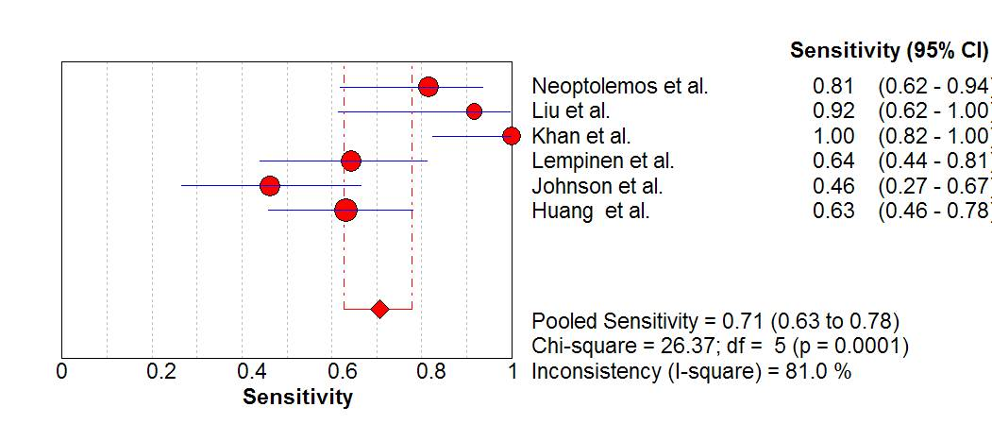
A

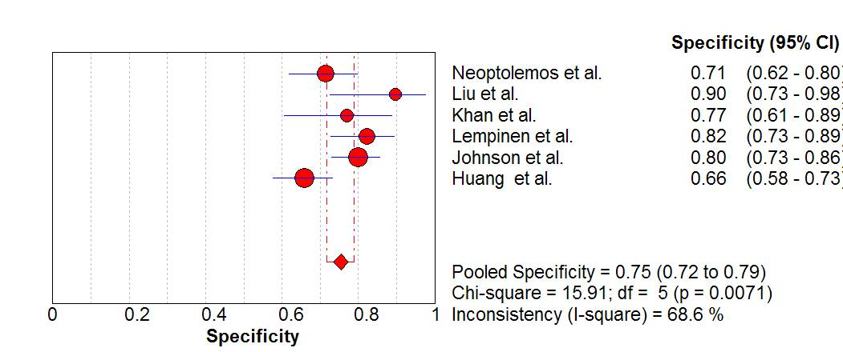
B

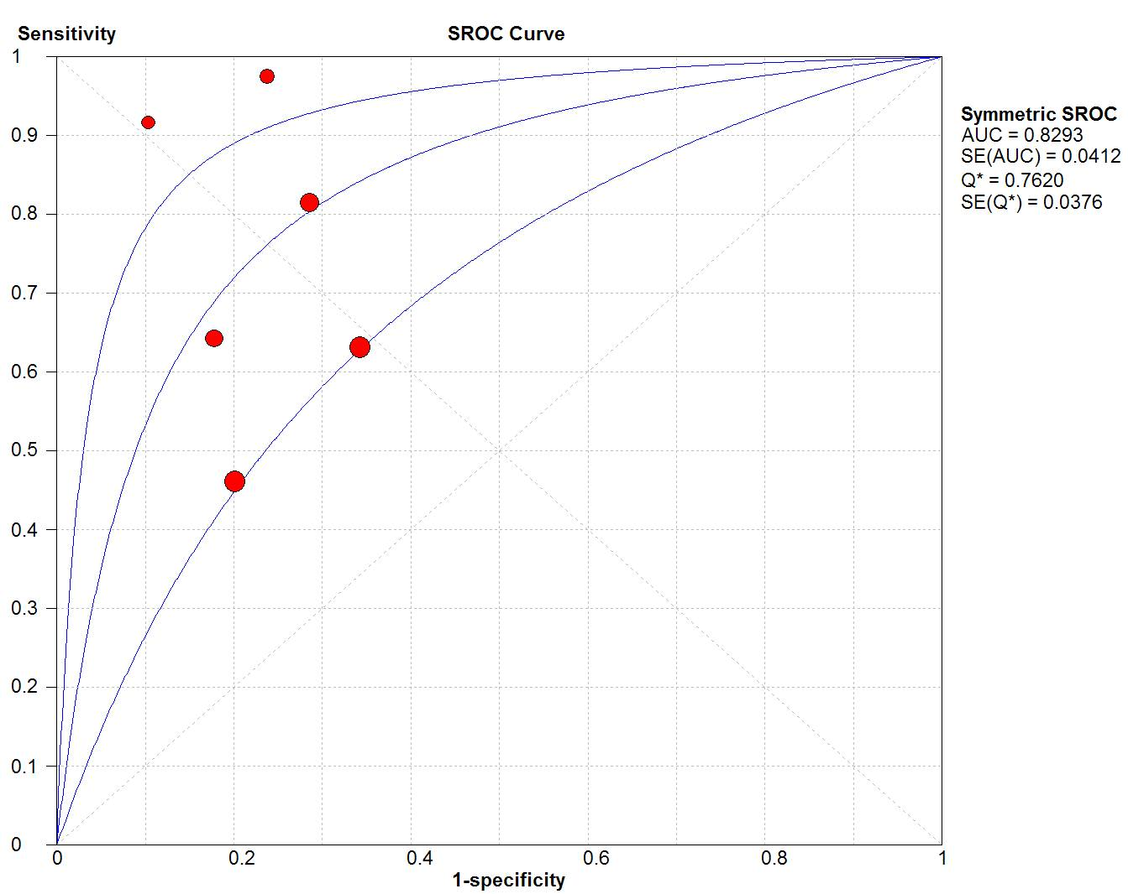
C

Figure 2 Forest plots of (A) sensitivity, (B) specificity, and (C) summary receiver operating characteristic curve for on admission urinary trypsinogen activation peptide in predicting severe acute pancreatitis.

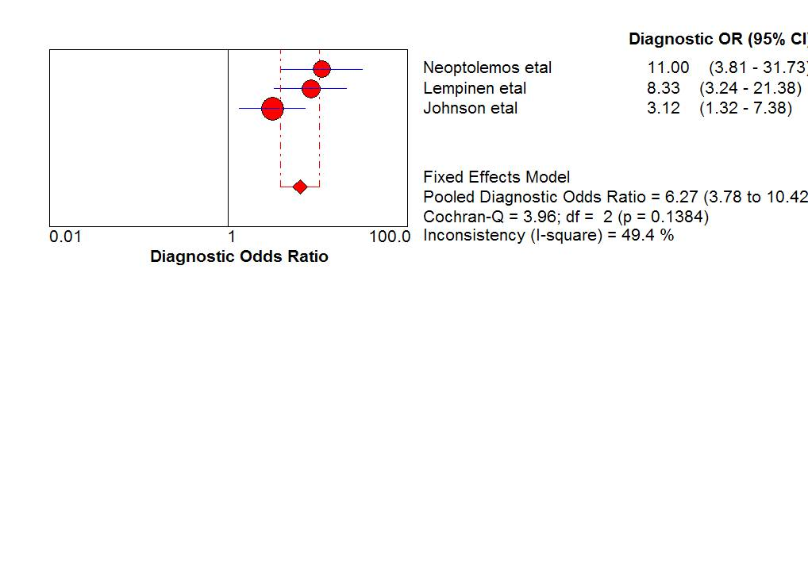
A

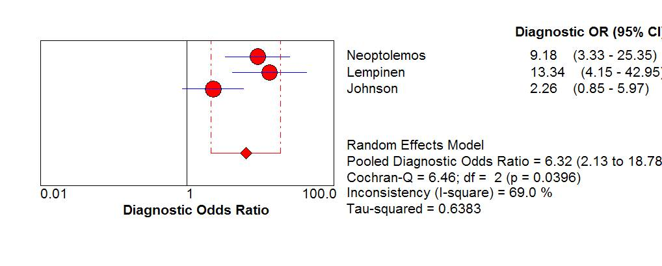
B

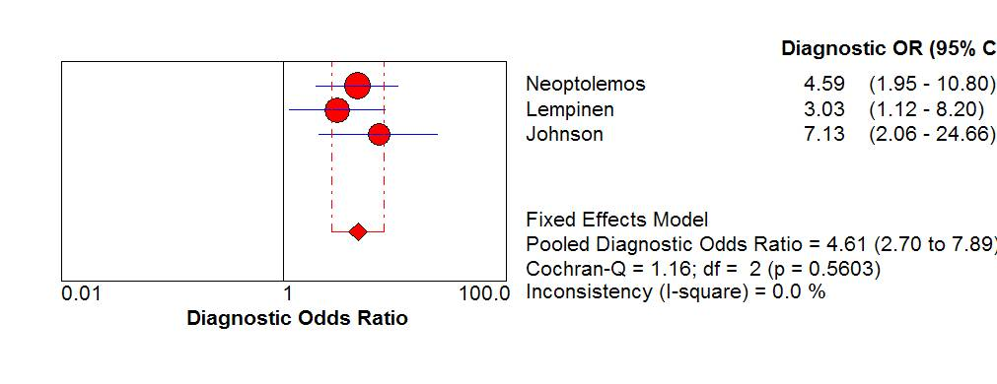
C
Figure 3 Forest plots of diagnostic odds ratios for urinary trypsinogen activation peptide vs serum C-reactive protein and urinary trypsinogen activation peptide vs Acute Physiology and Chronic Health Evaluation II score in predicting severe acute pancreatitis. The pooled diagnostic odds ratiosof on-admissioin urinary trypsinogen activation peptide (A), plasma C-reactive protein at 48 h (B) and Acute Physiology and Chronic Health Evaluation II score score at 48 h (C).

Figure 4 Funnel plot of effect effective sample size weighted regression tests of asymmetry for included studies. ESS: Effective sample size.
Table 1 Characteristics of included prospective studies for urinary trypsinogen activation peptide as a predictor of severity of acute pancreatitis
Trials | Year | Country | Sampling time  after admission | Cut-off  value (nmol/L) |  | Total  (n) | Male/  female (n) | Mild/  severe (n) | Mean age: male/female (yr) | Etiology
Neoptolemos et al^{[32]} | 2000 | Multicenter | On admission |  | 35 | 172 | 87/85 | 137/35 | 52 (29-84) | Biliary 74, alcoholic 62, other 36
Liu et al^{[34]} | 2002 | China | On admission |  | 35 | 41 | NA | 29/12 | NA | NA
Khan et al^{[33]} | 2002 | USA | On admission |  | 35 | 58 | 33/25 | 39/19 | 69 ± 19 | Biliary 26, alcoholic 18, HTC 3, postoperative (including ERCP) 9, idiopathic 2
Lempinen et al^{[35]} | 2003 | Finland | On admission |  | 35 | 127 | NA | 98/29 | NA | Biliary 24, alcoholic 74, other 29
Johnson et al^{[37]} | 2004 | Multicenter | On admission |  | 35 | 190 | 104/86 | 164/26 | 54 (42-70) | Biliary 70, alcohol 65, other 55
Huang et al^{[38]} | 2010 | China | On admission |  | 35 | 187 | 112/75 | 149/38 | 60.4 ± 6.7;  59.5 ± 8.1 | Biliary 139, alcoholic 19, other 29
ERCP: Endoscopic retrograde cholangiopancreatography; HTC: Hyperlipidemia, NA: Not available.
Table 2 Diagnostic parameters of included studies
Trials | Patients (n) | Patients analyzed (mild/severe) | TP | FP | FN | TN
Neoptolemos et al^{[32]} | 172 | 132 (105/27) | 22 | 30 | 5 | 75
Liu et al^{[34]} | 41 | 41 (29/12) | 11 | 3 | 1 | 26
Khan et al^{[33]} | 58 | 58 (39/19) | 19 | 9 | 0 | 30
Lempinen et al^{[35]} | 127 | 118 (90/28) | 18 | 16 | 10 | 74
Johnson et al^{[37]} | 190 | 190 (164/26) | 12 | 33 | 14 | 131
Huang et al^{[38]} | 187 | 187 (149/38) | 24 | 51 | 14 | 98
TP: True positive; FP: False positive; FN: False negative; TN: True negative.

Table 3 Meta-analysis outcomes of included studies

 | Trials (n) | Patients (n) | AUC | DOR (95%CI) | Q | P value | I²
All studies | 6 | 726 | 0.83 | 8.67 (3.70-20.33) | 15.88 | 0.0072 | 68.5%
Study subgroups
Sample size ≥ 50 | 5 | 685 | 0.80 | 6.48 (3.05-13.74) | 10.28 | 0.0360 | 61.1%
Single center | 4 | 413 | 0.86 | 14.25 (3.39-59.80) | 12.92 | 0.0048 | 76.8%
1992 Atlanta Classification | 5 | 536 | 0.84 | 11.97 (4.17-34.36) | 13.65 | 0.0085 | 70.7%
AUC: Area under the curve; DOR: Diagnostic odds ratios.

