Name of Journal: World Journal of Clinical Cases
Manuscript NO: 74185
Manuscript Type: CASE REPORT

Catheter-related infections caused by Mycobacterium abscessus in a patient with motor neurone disease: A case report

Pan SF et al. Catheter-related infections caused by M. abscessus

Su-Fei Pan, Yuan-Yuan Zhang, Xiao-Zhen Wang, Jing-Jing Sun, Shao-Ling Song, Yu-Rong Tang, Ji-Liang Wang

Su-Fei Pan, Yuan-Yuan Zhang, Xiao-Zhen Wang, Jing-Jing Sun, Shao-Ling Song, Yu-Rong Tang, Ji-Liang Wang, Department of Laboratory Medicine, Shengli Oilfield Central Hospital, Dongying 257034, Shandong Province, China

Author contributions: Pan SF, Zhang YY, and Wang JL designed the research and wrote the paper; Pan SF, Zhang YY, Wang XZ, Sun JJ, Song SL, and Tang YR collected all the data related to the case report; Wang JL supervised the report; all authors have read and approved the final manuscript.

Corresponding author: Ji-Liang Wang, MS, Chief Doctor, Department of Laboratory Medicine, Shengli Oilfield Central Hospital, No. 31 Jinan Road, Dongying District, Dongying 257034, Shandong Province, China. zxyywjl@163.com

Received: December 16, 2021
Revised: February 23, 2022
Accepted: March 26, 2022
Published online:

Abstract
BACKGROUND
Mycobacterium abscessus (M. abscessus) is a rapidly growing mycobacterium and ubiquitous in the environment, which infrequently causes disease in humans. However, it can cause cutaneous or respiratory infections among immunocompromised hosts. Due to the resistance to most antibiotics, the pathogen is formidable and difficult-to-treat.

CASE SUMMARY
Here, we present a case of catheter-related M. abscessus infections in a patient with motor neurone disease. Catheter and peripheral blood cultures of the patient showed positive results during Gram staining and acid-fast staining. The alarm time of catheter blood culture was 10.6 h earlier than that of peripheral blood. After removal of the peripherally inserted central catheter, secretion and catheter blood culture were positive. M. abscessus was identified by matrix-assisted laser desorption ionization-time of flight mass spectrometry and 16S rDNA sequencing.

CONCLUSION
For catheter-related M. abscessus infection, rapid diagnosis and timely and adequate antimicrobial therapy are crucial.

Key Words: Catheter-related infections; Diagnosis; Motor neurone disease; Mycobacterium abscessus; Case report

Pan SF, Zhang YY, Wang XZ, Sun JJ, Song SL, Tang YR, Wang JL. Catheter-related infections caused by Mycobacterium abscessus in a patient with motor neurone disease: A case report. World J Clin Cases 2022; In press

Core Tip: Mycobacterium abscessus (M. abscessus) is a rapidly growing mycobacterium and ubiquitous in the environment, which infrequently causes disease in humans. However, it can cause cutaneous or respiratory infections among immunocompromised hosts. Due to the resistance to most antibiotics, the pathogen is formidable and difficult-to-treat. Here, we present a case of catheter-related M. abscessus infections in a patient with motor neurone disease. M. abscessus was identified by matrix-assisted laser desorption ionization-time of flight mass spectrometry and 16S rDNA sequencing. For catheter-related M. abscessus infection, rapid diagnosis and timely and adequate antimicrobial therapy are crucial.

INTRODUCTION
Mycobacterium abscessus (M. abscessus) is a rapidly growing non-tuberculous mycobacterium and is ubiquitous in the environment^{[1]}. Recent gene sequence analysis has shown that M. abscessus can be divided into three different subspecies (M. abscessus subsp. bolletii, M. abscessus subsp. abscessus, and M. abscessus subsp. massiliense)^{[2]}. M. abscessus can cause a variety of clinical manifestations including cutaneous infections, catheter-related infections, post-surgical soft tissue infections, and respiratory diseases^{[3]}. Besides, the incidence of pulmonary non-tuberculous mycobacteria infection has been increasing^{[4]}. Of all the rapidly growing mycobacteria, M. abscessus is the most common cause of pulmonary infections. M. abscessus is also one of the mycobacteria that are most often isolated from patients with cystic fibrosis^{[5]}. However, M. abscessus is resistant to most antibiotics in vitro, and thus is a formidable and difficult-to-treat pathogen^{[6]}. At present, little is known regarding the diagnosis and management of catheter-related M. abscessus infections due to only a limited number of cases that have been reported^{[7,8]}. Here, we present a case of catheter-related M. abscessus infections in a patient with motor neurone disease.

CASE PRESENTATION
Chief complaints
On February 6, 2019, a 62-year-old Chinese man presented with mild skin edema at the site of the peripherally inserted central venous catheter (PICC, median cubital vein) which had been inserted for 30 d, without skin redness and inflammatory exudation.

History of present illness
He presented with a two-day history of dyspnea and was admitted to our emergency intensive care unit with a diagnosis of motor neurone disease on January 7, 2019. The patient received comprehensive symptomatic treatment including invasive ventilator-assisted ventilation, pulse oxygen saturation measurement, expectorant, and nutritional supplement.

History of past illness
There was no history of past illness.

Personal and family history
There was no personal and family history.

Physical examination
Physical examination revealed that he was stuporous with a Glasgow coma scale of E1VTM1. His body temperature was 35.0 °C, heart rate 66 beats per minute, blood pressure 90/54 mmHg, and respiratory rate 23 breaths per minute.

Laboratory examinations
Routine blood tests revealed 3.7 × 10⁹ cells/L white blood cells (reference range, 4.0-10.0 × 10⁹ cells/L) and 67.2% neutrophils (reference range, 40%-75%). Catheter and peripheral blood cultures were performed on February 10, 2019. On February 11, 2019, he presented with elevated body temperature (37.1 °C), white blood cells (10.2 × 10⁹ cells/L), and neutrophils (86.7%). The serum procalcitonin and C-reactive protein levels was 0.99 ng/mL (reference range, 0-0.05 ng/mL) and 184.9 mg/L (reference range, 0-5 mg/L), respectively. The patient began to receive anti-infective treatment with vancomycin. On February 19, 2019, the blood culture showed positive results during Gram staining (Figure 1A) and acid-fast staining (Figure 1B). The alarm time of catheter blood culture was 10.6 h earlier than that of peripheral blood culture. The treatment regimen of the patient was changed to combination therapy with vancomycin and amikacin.
On February 23, 2019, repeat blood cultures showed positive acid-fast bacilli, and the treatment regimen was adjusted to amikacin plus clarithromycin. On the second day, his body temperature was 35.3 °C, his heart rate was 74 beats per minute, white blood cells 7.4 × 10⁹ cells/L, and neutrophils 77.6%. After removal of the PICC on March 11, 2019, secretion culture and catheter blood culture were all positive. The blood culture isolate was identified as M. abscessus by matrix-assisted laser desorption ionization-time of flight mass spectrometry (MALDI-TOF MS) (Figure 2A) and 16S rDNA sequencing (Figure 2B).

FINAL DIAGNOSIS
The patient was finally diagnosed with catheter-related infections caused by M. abscessus.

TREATMENT
He continued to receive anti-infective treatment with amikacin plus clarithromycin.

OUTCOME AND FOLLOW-UP
His body temperature was maintained at a basic level (35-36.3 °C). Unfortunately, the patient gave up treatment due to an unsatisfactory response to respiratory failure and shock and was discharged on April 13, 2019.

DISCUSSION
M. abscessus was a terrible and difficult-to-treat mycobacterial pathogen, which is resistant to most antibiotics in vitro^{[9]}. It was ubiquitous in the environment including soil, water, and dust, and survived extreme temperatures and nutritional deprivation^{[10]}. It can cause soft tissue and skin infections after surgical procedures or trauma, pulmonary infections, and disseminated diseases among immunocompromised hosts^{[11]}. Infections in immunocompetent patients tend to be more localized, and usually due to contamination of wounds or abrasions with soil, water, dust, or other materials^{[12]}. While, infections in immunosuppressed patients are often deeper and more diffuse, involving subcutaneous tissue, and leading to the formation of an abscess. Catheter-related infections often occurred in the setting of central venous access devices^{[13]}. In the present study, we present a case of catheter-related M. abscessus infections in a patient with motor neurone disease.
Catheter-related bloodstream infection (CRBSI) is the most common complication associated with the use of intravascular catheters^{[14]}. Our patient was a 62-year-old man with motor neurone disease. He had been treated in our hospital many times due to respiratory failure, shock, and electrolyte disorder. During the hospitalization, the patient used PICC for blood controls, which was high-risk factor for CRBSI. No other obvious source of bloodstream infection was found, except for PICC. He presented with fever and mild skin edema at the site of PICC. Routine blood tests revealed elevated white blood cells and neutrophils, procalcitonin, and C-reactive protein. Catheter and peripheral blood cultures of the patient showed positive results during Gram staining and acid-fast staining. The alarm time of catheter blood culture was 10.6 h earlier than that of peripheral blood. He was diagnosed with catheter-related infections. Gram positive cocci (such as staphylococcus epidermidis, staphylococcus aureus, and enterococcus) have been historically the leading cause of CRBSI^{[15]}. Catheter-related M. abscessus infection is relatively rare, with limited literature reports^{[7,8]}. In the present study, M. abscessus was identified by matrix-assisted laser desorption ionization-time of flight mass spectrometry and 16S rDNA sequencing. The patient was finally diagnosed with catheter-related infections caused by M. abscessus.
The main threat of M. abscessus is its antibiotic resistance. M. abscessus may be the most resistant species among pathogenic rapidly growing mycobacteria, and its antimicrobial therapy is still a challenge^{[8]}. A previous study showed that the treatment strategy of M. abscessus infections was the combination of multiple antibiotics, including amikacin, ofloxacin, ciprofloxacin, clarithromycin, and doxycycline^{[16]}. In vitro studies showed that clarithromycin was the most effective of these antibiotics^{[17]}. In the present study, the patient received anti-infective treatment with amikacin plus clarithromycin. In addition, in the case of catheter-related M. abscessus infections, removal of the catheter is necessary due to the high incidence of relapsing or uncontrolled bacteremia^{[8]}. After the removal of the PICC of our patient, he continued to receive anti-infective treatment with amikacin plus clarithromycin, and his body temperature was maintained at a basic level (35-36.3 °C). Unfortunately, the patient gave up treatment due to an unsatisfactory response to respiratory failure and shock, so the long-term treatment results were not obtained.

CONCLUSION
In conclusion, we reported a case of catheter-related M. abscessus infections in a patient with motor neurone disease. For catheter-related M. abscessus infection, rapid diagnosis, and timely and adequate antimicrobial therapy are crucial.

REFERENCES
1 Rodríguez-García R, Espina Angulo MJ, Escudero Augusto D. Cutaneous infection with Mycobacterium abscessus. Intensive Care Med 2018; 44: 2292-2293 [PMID: 29974168 DOI: 10.1007/s00134-018-5284-8]
2 Aziz DB, Low JL, Wu ML, Gengenbacher M, Teo JWP, Dartois V, Dick T. Rifabutin Is Active against Mycobacterium abscessus Complex. Antimicrob Agents Chemother 2017; 61 [PMID: 28396540 DOI: 10.1128/AAC.00155-17]
3 Gutiérrez AV, Viljoen A, Ghigo E, Herrmann JL, Kremer L. Glycopeptidolipids, a Double-Edged Sword of the Mycobacterium abscessus Complex. Front Microbiol 2018; 9: 1145 [PMID: 29922253 DOI: 10.3389/fmicb.2018.01145]
4 Benwill JL, Wallace RJ Jr. Mycobacterium abscessus: challenges in diagnosis and treatment. Curr Opin Infect Dis 2014; 27: 506-510 [PMID: 25268925 DOI: 10.1097/QCO.0000000000000104]
5 Petrini B. Mycobacterium abscessus: an emerging rapid-growing potential pathogen. APMIS 2006; 114: 319-328 [PMID: 16725007 DOI: 10.1111/j.1600-0463.2006.apm_390.x]
6 Koh WJ, Jeon K, Lee NY, Kim BJ, Kook YH, Lee SH, Park YK, Kim CK, Shin SJ, Huitt GA, Daley CL, Kwon OJ. Clinical significance of differentiation of Mycobacterium massiliense from Mycobacterium abscessus. Am J Respir Crit Care Med 2011; 183: 405-410 [PMID: 20833823 DOI: 10.1164/rccm.201003-0395OC]
7 Lee SA, Raad II, Adachi JA, Han XY. Catheter-related bloodstream infection caused by Mycobacterium brumae. J Clin Microbiol 2004; 42: 5429-5431 [PMID: 15528764 DOI: 10.1128/JCM.42.11.5429-5431.2004]
8 Laurens C, Héry-Arnaud G, Chiron R, Oziol E, Jean-Pierre H, Bouzinbi N, Vande Perre P, Bañuls AL, Godreuil S. Sacroiliitis secondary to catheter-related bacteremia due to Mycobacterium abscessus (sensu stricto). Ann Clin Microbiol Antimicrob 2014; 13: 9 [PMID: 24479655 DOI: 10.1186/1476-0711-13-9]
9 Griffith DE, Brown-Elliott BA, Benwill JL, Wallace RJ Jr. Mycobacterium abscessus. "Pleased to meet you, hope you guess my name...". Ann Am Thorac Soc 2015; 12: 436-439 [PMID: 25643064 DOI: 10.1513/AnnalsATS.201501-015OI]
10 Mooren VHJF, Bleeker MWP, van Ingen J, Hermans MHA, Wever PC. Disseminated Mycobacterium abscessus infection in a peritoneal dialysis patient. IDCases 2017; 9: 6-7 [PMID: 28529886 DOI: 10.1016/j.idcr.2017.05.001]
11 Bechara C, Macheras E, Heym B, Pages A, Auffret N. Mycobacterium abscessus skin infection after tattooing: first case report and review of the literature. Dermatology 2010; 221: 1-4 [PMID: 20558973 DOI: 10.1159/000313974]
12 Drage LA, Ecker PM, Orenstein R, Phillips PK, Edson RS. An outbreak of Mycobacterium chelonae infections in tattoos. J Am Acad Dermatol 2010; 62: 501-506 [PMID: 19733936 DOI: 10.1016/j.jaad.2009.03.034]
13 Xie O, Khan S, Globan M, Lea K, Bajel A, Slavin M. Mycobacterium abscessus bloodstream infection: Unexpected catheter tunnel infection localized by PET/CT. Transpl Infect Dis 2019; 21: e13147 [PMID: 31306546 DOI: 10.1111/tid.13147]
14 Ruiz-Ruigómez M, Fernández-Ruiz M, San-Juan R, López-Medrano F, Orellana MÁ, Corbella L, Rodríguez-Goncer I, Hernández Jiménez P, Aguado JM. Impact of duration of antibiotic therapy in central venous catheter-related bloodstream infection due to Gram-negative bacilli. J Antimicrob Chemother 2020; 75: 3049-3055 [PMID: 32591804 DOI: 10.1093/jac/dkaa244]
15 Tarpatzi A, Avlamis A, Papaparaskevas J, Daikos GL, Stefanou I, Katsandri A, Vasilakopoulou A, Chatzigeorgiou KS, Petrikkos GL. Incidence and risk factors for central vascular catheter-related bloodstream infections in a tertiary care hospital. New Microbiol 2012; 35: 429-437 [PMID: 23109010]
16 Kameyama H, Mori Y, Kimura T, Sugishita C, Adachi T, Sonomura K, Kusaba T, Tanda S, Kishimoto N, Okigaki M, Hatta T, Matsubara H. A case report of Mycobacterium abscessus peritonitis in a peritoneal dialysis patient. Ther Apher Dial 2007; 11: 449-451 [PMID: 18028172 DOI: 10.1111/j.1744-9987.2007.00526.x]
17 Ellis EN, Schutze GE, Wheeler JG. Nontuberculous mycobacterial exit-site infection and abscess in a peritoneal dialysis patient. A case report and review of the literature. Pediatr Nephrol 2005; 20: 1016-1018 [PMID: 15880270 DOI: 10.1007/s00467-005-1870-4]

Footnotes
Informed consent statement: Written informed consent was obtained from the patient.

Conflict-of-interest statement: The authors declare that they have no conflict of interest.

CARE Checklist (2016) statement: The authors have read the CARE Checklist (2016), and the manuscript was prepared and revised according to the CARE Checklist (2016).

Open-Access: This article is an open-access article that was selected by an in-house editor and fully peer-reviewed by external reviewers. It is distributed in accordance with the Creative Commons Attribution NonCommercial (CC BY-NC 4.0) license, which permits others to distribute, remix, adapt, build upon this work non-commercially, and license their derivative works on different terms, provided the original work is properly cited and the use is non-commercial. See: https://creativecommons.org/Licenses/by-nc/4.0/

Provenance and peer review: Unsolicited article; Externally peer reviewed.

Peer-review model: Single blind

Peer-review started: December 16, 2021
First decision: February 14, 2022
Article in press:

Specialty type: Medicine, research and experimental
Country/Territory of origin: China
Peer-review report’s scientific quality classification
Grade A (Excellent): 0
Grade B (Very good): 0
Grade C (Good): C, C
Grade D (Fair): 0
Grade E (Poor): 0

P-Reviewer: Karavaş E, Turkey; Vagholkar K, India S-Editor: Fan JR L-Editor: A P-Editor: Fan JR

Figure Legends
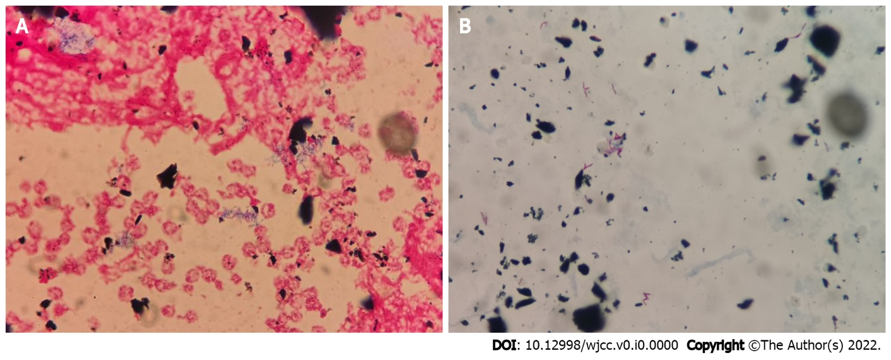
Figure 1 Blood culture findings of the patient. A: Gram staining of the strain isolated from catheter blood culture; B: Acid-fast staining of the strain isolated from catheter blood culture.
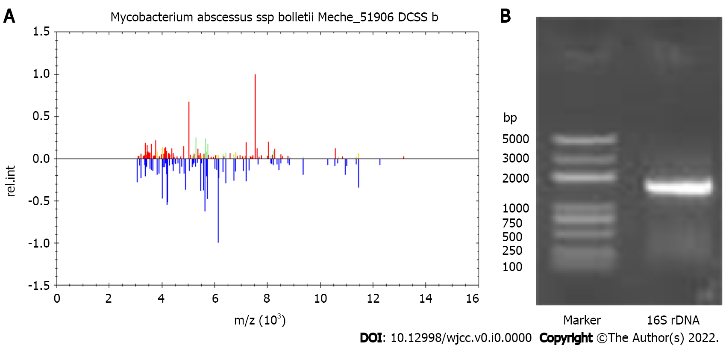
Figure 2 Identification of Mycobacterium abscessus. A: Mass spectrometry identification results of Mycobacterium abscessus (M. abscessus); B: Gel electrophoresis of the 16S rDNA. The nucleotide sequences were analyzed with the National Center for Biotechnology Information BLAST. The almost full-length 16S rDNA gene sequence of the blood culture isolate shared 100% identity with that of M. abscessus subsp. massiliense.

