Name of Journal: World Journal of Clinical Cases
Manuscript NO: 78268
Manuscript Type: CASE REPORT

Idiopathic tenosynovitis of the wrist with multiple rice bodies: A case report and review of literature

Tian Y et al. Idiopathic rice bodies tenosynovitis of wrist

Yong Tian, Hong-Bin Zhou, Kai Yi, Kai-Jian Wang

Yong Tian, Hong-Bin Zhou, Kai Yi, Kai-Jian Wang, Department of Orthopedics, Yichang Yiling Hospital, Yichang 443100, Hubei Province, China

Author contributions: Tian Y drafted the manuscript; Tian Y, Yi K and Wang KJ managed the case; Zhou HB revised the manuscript critically and the literature; all read and approved the final manuscript; all authors have read and approved the final manuscript.

Corresponding author: Yong Tian, MD, Occupational Physician, Department of Orthopedics, Yichang Yiling Hospital, No. 32 Donghu Road, Yiling District, Yichang 443100, Hubei Province, China. tyong0911@sina.com

Received: July 26, 2022
Revised: September 19, 2022
Accepted: October 19, 2022
Published online: November 16, 2022

Abstract
BACKGROUND
Multiple rice bodies in the wrist is a rare disorder that requires surgery, and there are still many uncertainties regarding its diagnosis and treatment.

CASE SUMMARY
We described a rare case of chronic idiopathic tenosynovitis with rice bodies of the wrist in a 71-year-old man and reviewed similar topics in the literature. A total of 43 articles and 61 cases were included in the literature review. Our case had a usual presentation: it was similar to those in the literature. The affected population was mainly older adults, with an average age of 59.43 (range, 3 to 90) years. The male-to-female ratio was 1.54:1 (37/24).Most of them showed limited swelling and pain, only 23.0% had carpal tunnel symptoms, and the average disease duration was 18.03 (0.5-60) mo. Wrist flexor tendon sheath involvement was the most common (95.1%, 58/61), and only 3 cases had extensor tendon sheath involvement.The main causes were tuberculosis (34.4%, 21/61), non-tuberculous mycobacteria (24.6%, 15/61), idiopathic tenosynovitis (31.1%, 19/61), and others (9.84%, 6/61). There were 10 patients with recurrences; in 6 of them, were due to non-tuberculous mycobacterial infections.

CONCLUSION
We reported a case of wrist idiopathic tenosynovitis with rice body formation, and established a clinical management algorithm for wrist tenosynovitis with rice bodies, which can provide some reference for our clinical diagnosis and treatment. The symptoms of rice-body bursitis of the wrist are insidious, nonspecific, and difficult to identify. The aetiology is mainly idiopathic tenosynovitis and mycobacterial (tuberculosis or non-tuberculous) infections; the latter are difficult to treat and require long-duration systemic combination antibiotic therapies. Therefore, before a diagnosis of idiopathic tenosynovitis is made, we must exclude other causes, especially mycobacterial infections.

Key Words: Idiopathic tenosynovitis; Rice bodies; Wrist; Mycobacterial infection; Case report

©The Author(s) 2022. Published by Baishideng Publishing Group Inc. All rights reserved.

Citation: Tian Y, Zhou HB, Yi K, Wang KJ. Idiopathic tenosynovitis of the wrist with multiple rice bodies: A case report and review of literature. World J Clin Cases 2022; 10(32): 11908-11920
URL: https://www.wjgnet.com/2307-8960/full/v10/i32/11908.htm
DOI: https://dx.doi.org/10.12998/wjcc.v10.i32.11908

Core Tip: We report a rare case of wrist idiopathic tenosynovitis with rice bodies formation. The rice body formation in the wrist is a sporadic disease that requires surgical treatment. Its symptoms are insidious, nonspecific and difficult to identify. And we did the literature review, which can provide a reference for the diagnosis and treatment of the wrist rice-body bursitis.
INTRODUCTION
Riese^{[1]} first described rice bodies in tuberculous arthritis in 1895 and named the condition so because it resembled polished white rice. Microscopically, the rice bodies are composed of eosinophilic nuclei and fibrin due to a non-specific reaction to chronic joint inflammation^{[2]}. Rice body formation has no significant correlation with disease progression, severity, or prognosis^{[3]}. It is commonly seen in tuberculous arthritis, rheumatoid arthritis, and seronegative rheumatoid arthritis, and has also been reported in hip replacement surgery^{[4]}, fungal infections^{[5]}, and systemic lupus erythematosus^{[6]}. It mainly occurs in the joint capsule or the surrounding synovial sac of the shoulder and knee, but rarely in the wrist. Herein, we present a case of wrist tenosynovitis with rice body formation; the patient underwent surgery and had no recurrence during the twelve-month follow-up. In addition, we review the relevant literature to further appreciate the condition’s epidemiological characteristics.

CASE PRESENTATION
Chief complaints
A 71-year-old man complained of increased swelling of his left wrist and exercise restriction.

History of present illness
The patient was admitted to our orthopaedic outpatient department because of increased swelling and restricted movements of his left wrist for half a month.

History of past illness
The patient had no recent history of trauma, except for an injury to the back of the left hand more than ten years earlier that resulted in the flexion of the left hand's fingers in a semi-clenched fist shape. He had had a history of eczema for three years, had been treated with traditional Chinese medicine, and denied a history of tuberculosis.

Personal and family history
The patient had no special personal and family history.

Physical examination
Physical examination revealed a cystic mass on the palmar side of the left wrist with unclear borders and mild tenderness. The left hand's fingers were not weak or numb, and Tinel’s sign was negative. The range of motion of left wrist flexion was 0°-45°.

Laboratory examinations
Laboratory tests were normal. The erythrocyte sedimentation rate was 18 mm/L, and the C-reactive protein was 0 mg/L.

Imaging examinations
Ultrasound examination in other hospitals showed a cystic hypoechoic mass on the palmar side of the left wrist, with clear borders, an uneven internal echo, noticeable enhancement of the posterior sound, and spot-like blood flow signals around it (Figure 1). We then performed a magnetic resonance imaging (MRI) examination and found a large cystic mass in the volar flexor tendon and carpal tunnel of the left wrist. The mass was filled with rice-sized particles that showed low signals both on the T1 and T2 weighted images (Figure 2). The left carpal tunnel volume had increased, the median nerve structure was unclear, and the left transverse carpal ligament showed an arcuate bulge. Soft tissue swelling of the distal left forearm, around the wrist and the left palm, was observed, with a patch-like long T1 and high T2 weighted-signal shadow.

Histopathological examination
On histopathological examination of the resected cyst wall, chronic, nonspecific inflammation was observed. The postoperative rheumatoid factor test was normal, at 1.40 IU/mL. The final diagnosis was idiopathic tenosynovitis with multiple rice bodies. Two weeks after the operation, the wound healed, and the stitches were removed. During the twelve-month follow-up period, the symptoms resolved without recurrence.

FINAL DIAGNOSIS
Idiopathic tenosynovitis.

TREATMENT
An excision biopsy was performed, with an "N" incision along the left wrist. Intraoperative incision of the carpal tunnel revealed a cystic mass originating from the tendon sheath of the flexor carpal tendon throughout the palm, carpal tunnel, and distal end of the forearm. After the cyst wall was cut open, many white rice-sized loose bodies were observed (Figure 3). All the rice bodies and the whole bursa were removed. The acid-fast bacilli smear test of the cyst fluid was negative, and the mycobacterial culture was negative too.

OUTCOME AND FOLLOW-UP
Two weeks after the operation, the wound healed, and the stitches were removed. During the twelve-month follow-up period, the symptoms resolved without recurrence.

DISCUSSION
Rice bodies are loose fibrous particles of various sizes and shapes in the synovial bursa around a joint. They can float freely in joint fluid or attach to the synovium and are considered non-specific reactions and final products of chronic inflammation, hyperplasia, and secondary degeneration^{[2]}. Most rice bodies are mainly composed of fibrin and a small amount of collagen; only a tiny part is wholly composed of fibrin. Some also contain neuraminidase and lipids on the surface^{[2,7]}. The mechanism of rice body formation is still controversial. Cheung et al^{[8]} found that rice bodies and the synovium contained equal proportions of types I and III collagen and type AB collagen and speculated that the formation of rice grains is related to synovial microinfarction. Berg et al^{[7]} also observed that some rice bodies contain vascular tissue, indicating that they were previously connected to the synovium. Non-vascular-type rice bodies are likely to be further degraded from vascular-type ones. However, a study on rice bodies from a patient with JIA (Juvenile rheumatoid arthritis) showed that they contain a large number of synovial B-type cells, which are located in a matrix composed of collagen fibres, fibrin, and amorphous substances, and may be responsible for the secretion of collagen and fibrin^{[9]}. Popert et al^{[3]} subsequently proposed that rice bodies are formed independently of the synovium, and synovial B cells may play an essential role in this process. In summary, we consider that synovial microinfarction and synovial B cells work together to lead to the formation of rice bodies. After synovial microinfarction, sloughing of the infarcted tissue into the synovial fluid forms the initial rice bodies — synovial fragments that contain inflammatory cells, synovial B cells, and vascular tissue. The final rice bodies are gradually formed by the secretion of fibrin from synovial B cells and the deposition of fibrin in the synovial fluid.
In diagnostic imageology, the principal differential diagnoses of rice bodies are synovial chondromatosis and pigmented villonodular synovitis. Ultrasonography and MRI are the most effective diagnostic imaging modalities. On ultrasonography, rice granules appear as low-to-anechoic spherical intracapsular nodules but are almost indistinguishable from synovial chondromatosis^{[10]}. On MRI, rice bodies show low signal T1 and T2 weighted sequences. In contrast, the nodules of synovial chondromatosis show a high signal on the T2-weighted sequence because of the presence of cartilage components. Meanwhile, the signal cavity of pigmented villous nodular synovitis reflects hemosiderin deposition and the lack of sensitivity artefacts of the gradient echo sequence, which can be distinguished from rice bodies^{[10]}.
However, the biggest challenge of wrist rice-body bursitis is to find the relevant cause — rheumatoid, tuberculosis, idiopathic tenosynovitis, or other diseases — which is important for postoperative drug treatment and patient prognostication. To solve this problem, we conducted a literature search in the PubMed, MEDLINE and CNKI (China National Knowledge Infrastructure) databases and used "rice body," "rice bodies," "rice body formation," and "wrist" as search terms. A total of 43 articles and 61 cases were included; their characteristics are summarized in Tables 1 and 2. Our case was similar to those in the literature, with a usual presentation. The affected population was mainly older adults, with an average age of 59.43 (range, 3 to 90) years. The male-to-female ratio was 1.54:1 (37/24). The presentation was insidious, most of them showed limited swelling and pain, only 23.0% had carpal tunnel symptoms, and the average duration was 18.03 (0.5-60) mo. The wrist flexor tendon sheath was mainly involved (95.1%, 58/61), and only three cases had extensor tendon sheath involvement. Our patient mainly showed gradual swelling and limited mobility of the left wrist. Physical examination revealed a cystic mass with unclear borders and slight tenderness. Of the 61 cases reviewed, 60 were managed surgically, and aspiration alone was only done for 1 case^{[11]}. Although its clinical significance is not clear, the inflammatory stimulating effect of rice bodies has been proven. Moreover, the removal of rice bodies was accompanied by clinical improvement and reduction of synovitis^{[12,13]}. Our patient's symptoms also significantly improved after the operation. In addition, these patients need to receive corresponding chemotherapy postoperatively, including anti-tubercular and anti-rheumatoid treatment. Among these cases, the causes included tuberculosis (34.4%, 21/61), non-tuberculous mycobacteria (24.6%, 15/61), idiopathic tenosynovitis (31.1%, 19/61), and others (9.84%, 6/61). Mycobacteria, including tuberculous and non-tuberculous ones, were the main cause. Currently, it is recommended that isoniazid, pyrazinamide, ethambutol, and rifampicin be used for 2 mo followed by a bitherapy for 3-10 mo^{[14]}. There were ten recurrences during the average follow-up period of 22.6 mo (3-78 mo), six of which were patients with non-tuberculous mycobacterial infections. Non-tuberculous mycobacteria are also called atypical mycobacteria; they are usually spread through direct contact with the environment (such as water and soil)^{[15]}. The current anti-mycobacterial drugs mainly include the first-line drugs (clarithromycin, rifampicin, and levofloxacin) and the second-line drugs (streptomycin and ofloxacin). Atypical mycobacterial infections of the hand and wrist require antibiotic therapy for 6–12 mo^{[15-17]}. Even so, their prognosis is not optimistic: there were 40.0% (6/15) cases of relapse in our review. Idiopathic tenosynovitis with rice bodies is non-association with rheumatic diseases, tuberculosis infection, or trauma; removing the rice granules can achieve symptom relief and a good prognosis. Our patient recovered well after the operation with no signs of recurrence. In addition, rice body formation is frequently seen in rheumatoid arthritis, which is more likely to involve the knee joint, not the wrist joint. Likewise, in our review, only one case was of rheumatoid arthritis.
Finally, we summarized a clinical management algorithm for wrist tenosynovitis with rice bodies (Figure 4). Carpal tunnel release and tenosynovectomy with the extraction of rice bodies were recommended. Before surgery, ultrasonography and MRI examination are necessary; they are the most important standard for diagnosis. In addition, we need to take note of the laboratory tests, especially erythrocyte sedimentation rate, C-reactive protein, and the biomarkers of rheumatoid arthritis — antinuclear antibody, anti-cyclic citrullinated peptide, and rheumatoid factor. Purified protein derivative and T-SPOT tests are important for screening for tuberculosis. If necessary, we also need to perform chest X-ray or lung computed tomography imaging examinations. We should perform further pathological examination of the synovium and the rice bodies, bacterial culture, polymerase chain reaction, and acid-fast staining postoperatively. Patients with mycobacterial infections must strictly be on standardized, long-term, combined drug treatment to avoid recurrence. Because there are few such cases and related studies, this management algorithm can only provide a certain reference and needs to be further improved.

CONCLUSION
We reported a case of wrist idiopathic tenosynovitis with rice body formation and established a clinical management algorithm for wrist tenosynovitis with rice bodies, which provides a reference for clinical diagnosis and treatment. Rice body formation in the wrist is a sporadic disease that requires surgical management. Its symptoms are insidious, nonspecific, and difficult to identify. Idiopathic tenosynovitis and mycobacterial (tuberculosis or non-tuberculous) infections are the main causes, so, before a diagnosis of idiopathic tenosynovitis is made, we must exclude other causes, especially mycobacterial infections. We should especially take notice of non-tuberculous mycobacterial infections because they are difficult to treat and have poor prognoses and high recurrence rates. Therefore, anti-nontuberculous mycobacterial drug treatment is also a key issue that needs to be resolved.

REFERENCES
1 Riese H. Die Reiskorperchen in tuberculkoserkrankten Synovalsacken. Deut Zeit Chir 1895; 42: 1-99
2 Albrecht M, Marinetti GV, Jacox RF, Vaughan JH. A biochemical and electron microscopy study of rice bodies from rheumatoid patients. Arthritis Rheum 1965; 8: 1053-1063 [PMID: 5884816 DOI: 10.1002/art.1780080605]
3 Popert AJ, Scott DL, Wainwright AC, Walton KW, Williamson N, Chapman JH. Frequency of occurrence, mode of development, and significance or rice bodies in rheumatoid joints. Ann Rheum Dis 1982; 41: 109-117 [PMID: 6176192 DOI: 10.1136/ard.41.2.109]
4 Issack PS. Formation of a large rice body-containing cyst following total hip arthroplasty. BMC Res Notes 2012; 5: 294 [PMID: 22698085 DOI: 10.1186/1756-0500-5-294]
5 Jeong YM, Cho HY, Lee SW, Hwang YM, Kim YK. Candida septic arthritis with rice body formation: a case report and review of literature. Korean J Radiol 2013; 14: 465-469 [PMID: 23690715 DOI: 10.3348/kjr.2013.14.3.465]
6 Ohtani K, Fukuda K, Hamanishi C. A case of systemic lupus erythematosus associated with trigger wrist. Mod Rheumatol 2002; 12: 69-71 [PMID: 24383835 DOI: 10.3109/s101650200011]
7 Berg E, Wainwright R, Barton B, Puchtler H, McDonald T. On the nature of rheumatoid rice bodies: an immunologic, histochemical, and electron microscope study. Arthritis Rheum 1977; 20: 1343-1349 [PMID: 334184 DOI: 10.1002/art.1780200707]
8 Cheung HS, Ryan LM, Kozin F, McCarty DJ. Synovial origins of Rice bodies in joint fluid. Arthritis Rheum 1980; 23: 72-76 [PMID: 7352946 DOI: 10.1002/art.1780230112]
9 Wynne-Roberts CR, Cassidy JT. Juvenile rheumatoid arthritis with rice bodies: light and electron microscopic studies. Ann Rheum Dis 1979; 38: 8-13 [PMID: 434952 DOI: 10.1136/ard.38.1.8]
10 Joshi PS. Severe Sub-Acromial Bursitis with Rice Bodies in a Patient with Rheumatoid Arthritis: A Case Report and Review of Literature. Malays Orthop J 2018; 12: 52-55 [PMID: 30112130 DOI: 10.5704/MOJ.1807.010]
11 Gupta L, Gupta V, Kumar T. Rice Bodies in Tuberculous Tenosynovitis of Wrist. Reumatol Clin (Engl Ed) 2018; 14: 314-316 [PMID: 29102590 DOI: 10.1016/j.reuma.2017.08.003]
12 McCarthy DJ, Cheung HS. Origin and significance of rice bodies in synovial fluid. Lancet 1982; 2: 715-716 [PMID: 6126648 DOI: 10.1016/s0140-6736(82)90735-8]
13 Popert J. Rice-bodies, synovial debris, and joint lavage. Br J Rheumatol 1985; 24: 1-2 [PMID: 3978359 DOI: 10.1093/rheumatology/24.1.1]
14 World Health Organization. WHO Guidelines Approved by the Guidelines Review Committee, Treatment of Tuberculosis: Guidelines. Geneva: World Health Organization Copyright, 2010
15 Bachoura A, Zelouf DS. Mycobacterial Infections in the Hand and Wrist. Hand Clin 2020; 36: 387-396 [PMID: 32586466 DOI: 10.1016/j.hcl.2020.03.013]
16 Cheung JP, Fung BK, Ip WY. Mycobacterium marinum infection of the deep structures of the hand and wrist: 25 years of experience. Hand Surg 2010; 15: 211-216 [PMID: 21089196 DOI: 10.1142/S0218810410004874]
17 Balagué N, Uçkay I, Vostrel P, Hinrikson H, Van Aaken I, Beaulieu JY. Non-tuberculous mycobacterial infections of the hand. Chir Main 2015; 34: 18-23 [PMID: 25579828 DOI: 10.1016/j.main.2014.12.004]
18 Suso S, Peidro L, Ramon R. Tuberculous synovitis with "rice bodies" presenting as carpal tunnel syndrome. J Hand Surg Am 1988; 13: 574-576 [PMID: 3418063 DOI: 10.1016/s0363-5023(88)80099-6]
19 Sugano I, Nagao T, Tajima Y, Ishida Y, Nagao K, Ohno T, Ooishi S. Variation among giant rice bodies: report of four cases and their clinicopathological features. Skeletal Radiol 2000; 29: 525-529 [PMID: 11000298 DOI: 10.1007/s002560000258]
20 Chau CL, Griffith JF, Chan PT, Lui TH, Yu KS, Ngai WK. Rice-body formation in atypical mycobacterial tenosynovitis and bursitis: findings on sonography and MR imaging. AJR Am J Roentgenol 2003; 180: 1455-1459 [PMID: 12704068 DOI: 10.2214/ajr.180.5.1801455]
21 Lee EY, Rubin DA, Brown DM. Recurrent Mycobacterium marinum tenosynovitis of the wrist mimicking extraarticular synovial chondromatosis on MR images. Skeletal Radiol 2004; 33: 405-408 [PMID: 15127246 DOI: 10.1007/s00256-004-0786-6]
22 Huang GS, Lee CH, Chen CY. Clinical images: Tuberculous rice bodies of the wrist. Arthritis Rheum 2005; 52: 1950 [PMID: 15934133 DOI: 10.1002/art.21057]
23 Tyllianakis M, Kasimatis G, Athanaselis S, Melachrinou M. Rice-body formation and tenosynovitis of the wrist: a case report. J Orthop Surg (Hong Kong) 2006; 14: 208-211 [PMID: 16914791 DOI: 10.1177/230949900601400221]
24 Ergun T, Lakadamyali H, Aydin O. Multiple rice body formation accompanying the chronic nonspecific tenosynovitis of flexor tendons of the wrist. Radiat Med 2008; 26: 545-548 [PMID: 19030963 DOI: 10.1007/s11604-008-0270-7]
25 Teo SC, George J, Kamarul T. Tubercular synovitis mimicking rheumatoid nodules. Med J Malaysia 2008; 63: 159-161 [PMID: 18942309]
26 Nagasawa H, Okada K, Senma S, Chida S, Shimada Y. Tenosynovitis with rice body formation in a non-tuberculosis patient: a case report. Ups J Med Sci 2009; 114: 184-188 [PMID: 19736610 DOI: 10.1080/03009730902931408]
27 Sanal HT, Zor F, Kocaoğlu M, Bulakbaşi N. Atypical mycobacterial tenosynovitis and bursitis of the wrist. Diagn Interv Radiol 2009; 15: 266-268 [PMID: 19862676 DOI: 10.4261/1305-3825.DIR.1506-07.1]
28 Hung MH, Ho KC, Huang KF. Tuberculous tenosynovitis with rice body formation. ANZ J Surg 2011; 81: 572 [PMID: 22295405 DOI: 10.1111/j.1445-2197.2011.05811.x]
29 Iyengar K, Manickavasagar T, Nadkarni J, Mansour P, Loh W. Bilateral recurrent wrist flexor tenosynovitis and rice body formation in a patient with sero-negative rheumatoid arthritis: A case report and review of literature. Int J Surg Case Rep 2011; 2: 208-211 [PMID: 22096729 DOI: 10.1016/j.ijscr.2011.07.001]
30 Woon CY, Phoon ES, Lee JY, Puhaindran ME, Peng YP, Teoh LC. Rice bodies, millet seeds, and melon seeds in tuberculous tenosynovitis of the hand and wrist. Ann Plast Surg 2011; 66: 610-617 [PMID: 20948407 DOI: 10.1097/SAP.0b013e3181e35ca5]
31 Chavan S, Sable SS, Tekade S, Punia P. Tuberculous tenosynovitis presenting as ganglion of wrist. Case Rep Surg 2012; 2012: 143921 [PMID: 23320240 DOI: 10.1155/2012/143921]
32 Forse CL, Mucha BL, Santos ML, Ongcapin EH. Rice body formation without rheumatic disease or tuberculosis infection: a case report and literature review. Clin Rheumatol 2012; 31: 1753-1756 [PMID: 22941257 DOI: 10.1007/s10067-012-2063-8]
33 Chan HT, Tseng CC, Chen PY, Chao CM, Lai CC. Rice body--Mycobacterium intracellulare tenosynovitis. QJM 2014; 107: 395 [PMID: 23970187 DOI: 10.1093/qjmed/hct175]
34 De Groote J, Ovreeide P, Mermuys K, Casselman J. Flexor tendon tenosynovitis with rice body formation in rheumatoid arthritis. JBR-BTR 2014; 97: 123 [PMID: 25073250 DOI: 10.5334/jbr-btr.45]
35 Hong SE, Pak JH, Suh HS, Kang SR, Park BY. Rice Body Tenosynovitis without Tuberculosis Infection after Multiple Acupuncture Procedures in a Hand. Arch Plast Surg 2015; 42: 502-505 [PMID: 26217578 DOI: 10.5999/aps.2015.42.4.502]
36 Weber E, Gagneux-Brunon A, Jacomo V, Rousselon T, Lucht F, Botelho-Nevers E. Tenosynovitis: a rare presentation of tuberculosis better known by hand surgeons than infectious diseases specialists. Infection 2015; 43: 261-266 [PMID: 25690847 DOI: 10.1007/s15010-015-0741-6]
37 Bayram S, Erşen A, Altan M, Durmaz H. Tuberculosis tenosynovitis with multiple rice bodies of the flexor tendons in the wrist: A case report. Int J Surg Case Rep 2016; 27: 129-132 [PMID: 27611797 DOI: 10.1016/j.ijscr.2016.08.021]
38 Sbai MA, Benzarti S, Msek H, Boussen M, Khorbi A. Pseudotumoral form of soft-tissue tuberculosis of the wrist. Int J Mycobacteriol 2016; 5: 99-101 [PMID: 26927998 DOI: 10.1016/j.ijmyco.2015.08.001]
39 Sulaiman H, Atiya N, Loi KW, Ng KP. Rice bodies in the wrist joint. Eur J Intern Med 2016; 35: e7-e8 [PMID: 27498273 DOI: 10.1016/j.ejim.2016.07.014]
40 Namkoong H, Fukumoto K, Hongo I, Hasegawa N. Refractory tenosynovitis with 'rice bodies' in the hand due to Mycobacterium intracellulare. Infection 2016; 44: 393-394 [PMID: 26410296 DOI: 10.1007/s15010-015-0844-0]
41 Nabet A, Faruqui S, Hogan CJ. Rice Bodies and a Partial Flexor Tendon Rupture in a Patient with Juvenile Idiopathic Arthritis: A Case Report and Review of the Literature. JBJS Case Connect 2017; 7: e41 [PMID: 29244679 DOI: 10.2106/JBJS.CC.16.00114]
42 Yamamoto D, Tada K, Suganuma S, Ikeda K, Tsuchiya H. Non-tuberculous Mycobacterium or Fungus Induced Chronic Tenosynovitis with Rice Body of the Hand. J Hand Surg Asian Pac Vol 2017; 22: 337-342 [PMID: 28774249 DOI: 10.1142/S0218810417500393]
43 Baidoo PK, Baddoo D, Ocloo A, Agbley D, Lartey S, Baddoo NA. Tuberculous tenosynovitis of the flexor tendons of the wrist: a case report. BMC Res Notes 2018; 11: 238 [PMID: 29636100 DOI: 10.1186/s13104-018-3343-4]
44 Celikyay F, Yuksekkaya RZ, Bostan B. Flexor tenosynovitis of the wrist including rice bodies. Joint Bone Spine 2018; 85: 373 [PMID: 28757343 DOI: 10.1016/j.jbspin.2017.07.005]
45 Hashimoto K, Nishimura S, Oka N, Kakinoki R, Akagi M. Tuberculoma with phlegmon-like symptoms mimicking soft tissue sarcoma in the wrist: A case report. Mol Clin Oncol 2018; 9: 207-210 [PMID: 30101023 DOI: 10.3892/mco.2018.1652]
46 Mohammed Reda F, Talal G, Moncef B, Reda-Allah B, Moulay Omar L, Mohammed Saleh B. Mass of the thenar eminence hiding idiopathic massive rice bodies formation with a compression of the median nerve: Case report and review of the literature. Int J Surg Case Rep 2018; 50: 28-31 [PMID: 30071378 DOI: 10.1016/j.ijscr.2018.07.025]
47 Saraya T, Fukuoka K, Maruno H, Komagata Y, Fujiwara M, Kaname S, Arimura Y, Yamada A, Takizawa H. Tenosynovitis with Rice Body Formation Due to Mycobacterium Intracellulare Infection After Initiation of Infliximab Therapy. Am J Case Rep 2018; 19: 656-662 [PMID: 29875354 DOI: 10.12659/AJCR.908785]
48 Kurra C, Caldwell M, Taylor K, Nwachukwu C, Salar M, Kaye MB, Gopinath A, Altunkaynak C, Wasserman P. Candida Parapsilosis associated rice bodies in the extensor compartment of the wrist--an emerging finding. Radiol Case Rep 2019; 14: 1539-1544 [PMID: 31709023 DOI: 10.1016/j.radcr.2019.09.032]
49 Matcuk GR Jr, Patel DB, Lefebvre RE. Horseshoe abscess of the hand with rice bodies secondary to mycobacterium avium intracellulare infection. Clin Imaging 2020; 63: 24-29 [PMID: 32120309 DOI: 10.1016/j.clinimag.2020.02.015]
50 Perţea M, Veliceasa B, Velenciuc N, Terinte C, Mitrea M, Ciobanu P, Alexa O, Luncă S. Idiopathic tenosynovitis with rice bodies. Rom J Morphol Embryol 2020; 61: 457-463 [PMID: 33544797 DOI: 10.47162/RJME.61.2.15]
51 Daoussis D, Kraniotis P, Diamantakis G, Panos G, Panagiotopoulos E. Rice bodies in MRI. Joint Bone Spine 2021; 88: 105079 [PMID: 32987156 DOI: 10.1016/j.jbspin.2020.09.011]
52 Tomala L, Wintzer HO, Elsner J. [Rice bodies : Case report of a rare finding in chronic tenosynovitis]. Unfallchirurg 2021; 124: 853-855 [PMID: 34213574 DOI: 10.1007/s00113-021-01008-4]
53 Zeng DJ, Chi WD, Weidong, Zheng CX. A rare case of myochondrial bursitis in the left wrist. Guangdong Yixue 2018; 39: 345 [DOI: 10.13820/j.cnki.gdyx.2018.s1.122]
54 Li LJ, Zhang LM. Surgical treatment of rice body synovitis of wrist joints in one case. Linchuang Guke Zazhi 2019; 22: 250
55 Cheng XG, Li DX, Cao Y, Zeng XC. Bursitis with rice bodies formation in wrist joint: Case report. Zhongguo Jieru Yingxiang Yu Zhiliao Xue 2020; 17: 512 [DOI: 10.13929/j.issn.1672-8475.2020.08.016]
56 Liang XS, Li JH, Wu B. A case report of chronic tenosynovitis of the wrist with rice body formation. Zhongguo Jiaoxing Waike Zazhi 2020; 28: 959-960
57 Liu J, Cheng X, Wang R, Zeng X. Rice Bodies in Cinematic Rendering. Arthritis Rheumatol 2021; 73: 2077 [PMID: 34731535 DOI: 10.1002/art.41890]
58 Korkmaz MÇ, Tolu S, Şimşek S. A Rare Case of Flexor Tenosynovitis Due to Tuberculosis in Hand and Wrist: a Case Report. Acta Chir Orthop Traumatol Cech 2021; 88: 237-239 [PMID: 34228622]

Footnotes
Informed consent statement: All study participants, or their legal guardian, provided informed written consent prior to study enrollment.

Conflict-of-interest statement: All the authors report no relevant conflicts of interest for this article.

CARE Checklist (2016) statement: The authors have read the CARE Checklist (2016), and the manuscript was prepared and revised according to the CARE Checklist (2016).

Open-Access: This article is an open-access article that was selected by an in-house editor and fully peer-reviewed by external reviewers. It is distributed in accordance with the Creative Commons Attribution NonCommercial (CC BY-NC 4.0) license, which permits others to distribute, remix, adapt, build upon this work non-commercially, and license their derivative works on different terms, provided the original work is properly cited and the use is non-commercial. See: https://creativecommons.org/Licenses/by-nc/4.0/

Provenance and peer review: Unsolicited article; Externally peer reviewed.
Peer-review model: Single blind

Peer-review started: July 26, 2022
First decision: September 5, 2022
Article in press: October 19, 2022

Specialty type: Medicine, research and experimental
Country/Territory of origin: China
Peer-review report’s scientific quality classification
Grade A (Excellent): 0
Grade B (Very good): B
Grade C (Good): 0
Grade D (Fair): D
Grade E (Poor): 0

P-Reviewer: Jeevannavar SS, India; Pace V, Italy S-Editor: Gao CC L-Editor: P-Editor: Gao CC

Figure Legends
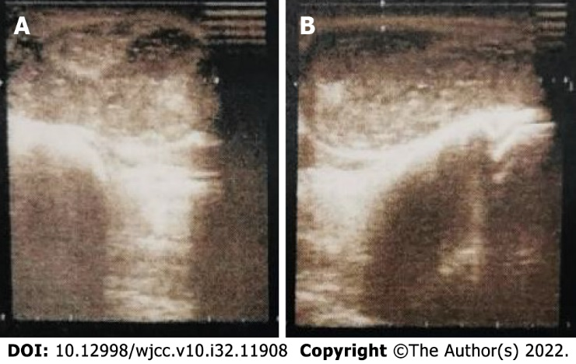
Figure 1 Ultrasound-guided shows a cystic mass across palm and wrist, filled with scattered hypoechoic nodules. A: Palm; B: Wrist.

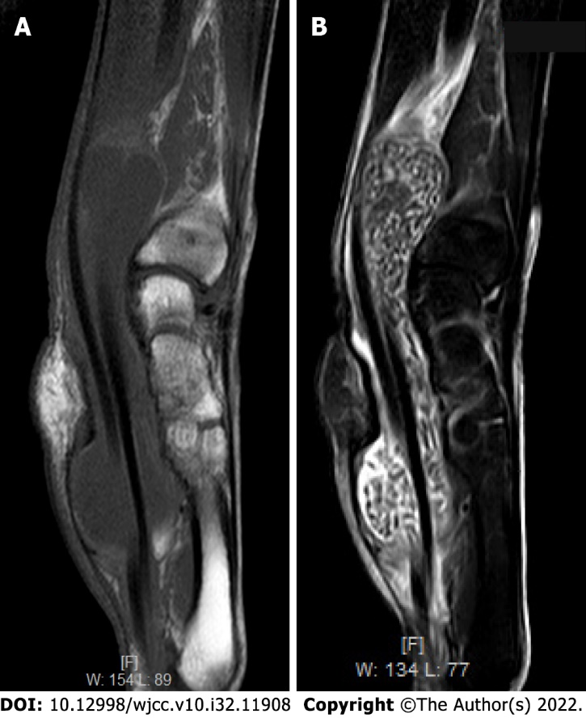
Figure 2 The mass was filled with rice-sized particles. A and B: T1 (A) weighted and other signal, T2 (B) weighted low signal, scattered in nodules.

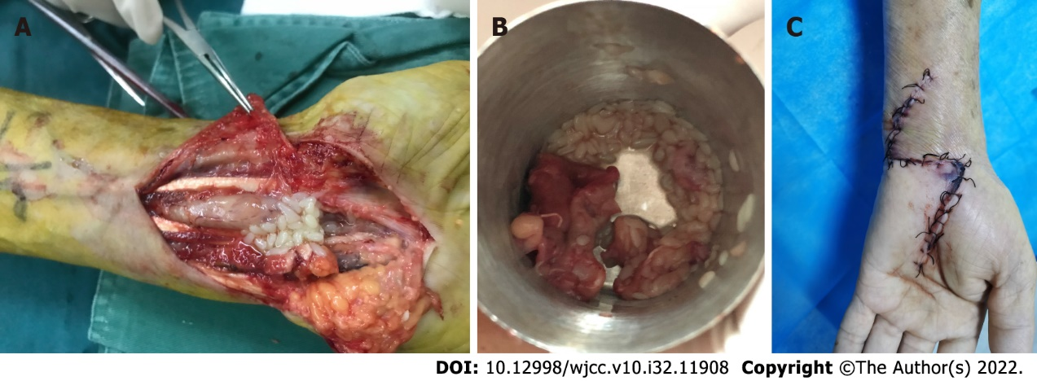
Figure 3 The loose body of rice grain size (rice body) is seen during the operation. A: Rice bodies in the flexor tendon sheath; B: Bursa and rice body of the resected lesion; C: Wound recovery one week after surgery.
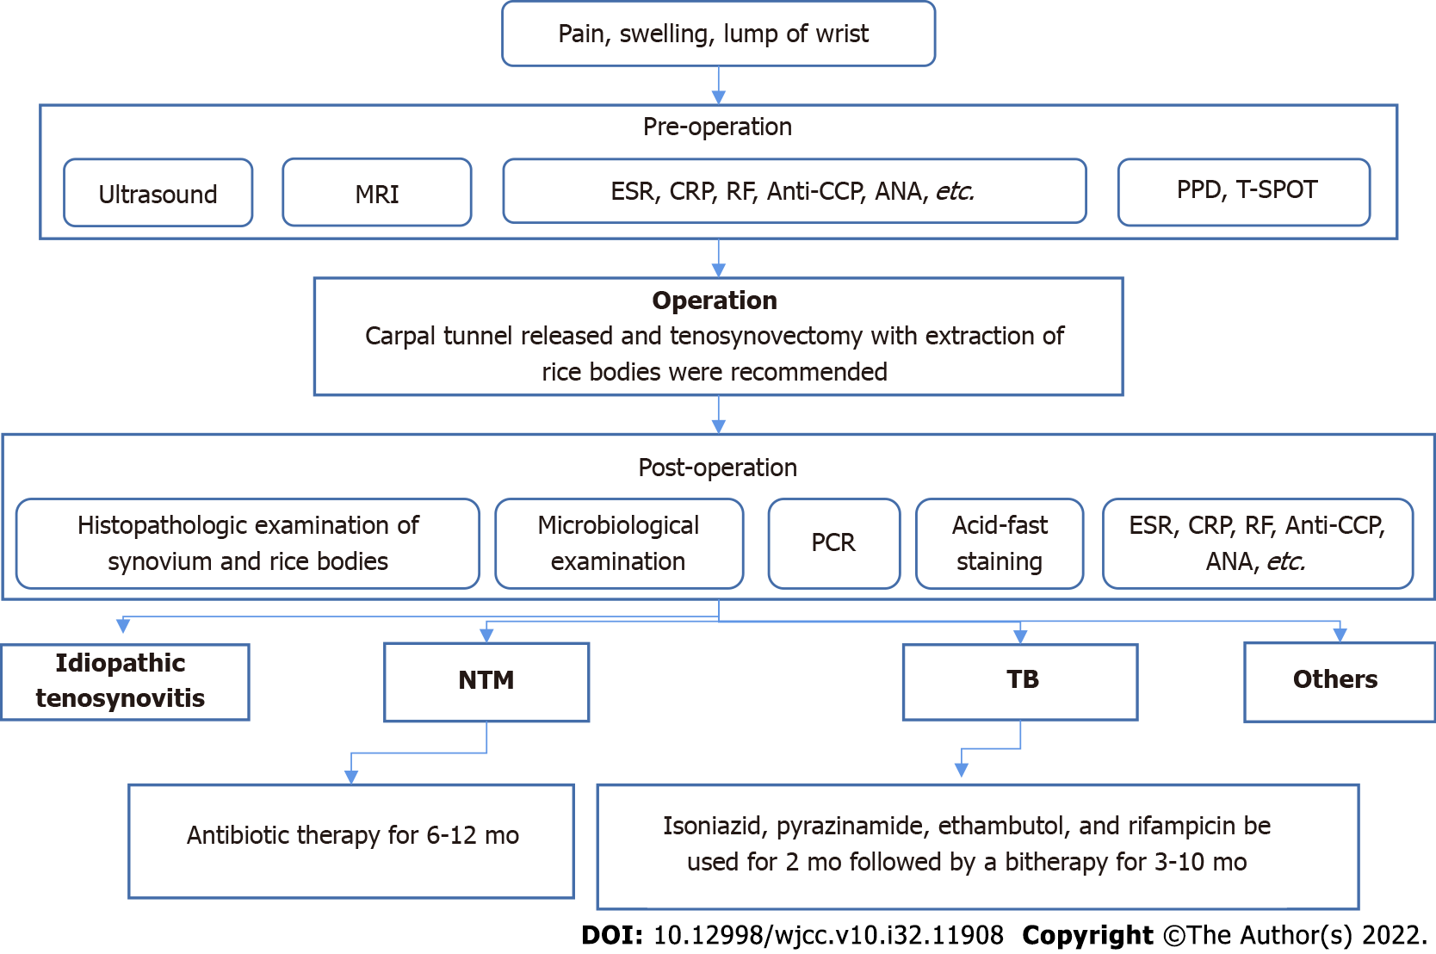
Figure 4 Management algorithm of synovitis with rice bodies in the wrist. MRI: Magnetic resonance imaging; ESR: Erythrocyte sedimentation rate; CRP: C-reactive protein; RF: Rheumatoid factors; Anti-CCP: Anti-cyclic citrullinated peptide; ANA: Antinuclear antibody; PPD: Purified protein derivative; T-spot: T cell spot test; PCR: Polymerase chain reaction; NTM: Non-tuberculous mycobacteria; TB: Tuberculous.
Table 1 Selected literature review of rice bodies for comparison of outcomes reported
 | Numbers | Percent
Gender
Male | 37 | 60.7
Female | 24 | 39.3
Involved site
Flexor tendon sheath | 58 | 95.1
Extensor tendon sheath | 3 | 4.90
Pathogenesis
TB | 21 | 34.4
NTM | 15 | 24.6
Idiopathic tenosynovitis | 19 | 31.1
Other reasons | 6 | 9.8
ESR
Normal | 13 | 21.3
High | 14 | 23.0
ND | 34 | 55.7
CRP
Normal | 21 | 34.4
High | 4 | 6.60
ND | 36 | 59.0
CTS
Negative | 14 | 23.0
Positive | 15 | 24.5
ND | 32 | 52.5
Surgical treatment
Yes | 60 | 98.4
No | 1 | 1.6
Recurrence
Yes | 10 | 16.4
No | 35 | 57.4
ND | 16 | 26.2
ND: Not described; CTS: Carpal tunnel syndrome; TB: Tuberculosis; NTM: Non-tuberculous mycobacteria; ESR: Erythrocyte sedimentation rate; CRP: C-reaction protein.

Table 2 Description of 57 rice bodies published cases
Ref. | Gender/age (yr) |  | Location | Symptoms/duration | Laboratory testing | Histological findings | Pathogenesis | Surgical treatment | Duration-antibiotics | Outcome
Suso et al^{[18]}, 1988 | M/41 | Flexor tendon sheath |  | Pain, swelling, restricted ROM, CTS | Elevated ESR of 51 mm/h | Tuberculous granuloma, langerhan’s cells | TB | Yes | I + R-9 mo | No recurrence during 3 yr follow-up
Sugano et al^{[19]}, 2000 | M/81 | Flexor tendon sheath |  | Swelling/24 mo | Normal | giant cell, granuloma | IT | Yes | No | ND
Ohtani et al^{[6]}, 2002 | F/54 | Flexor tendon sheath |  | Pain, swelling, restricted ROM/12 mo | ND | Chronic nonspecific inflammation | SLE | Yes | No | No recurrence during 1 yr follow-up
Chau et al^{[20]}, 2003 | M/50 | Flexor tendon sheath |  | Swelling/13 mo | ND | Granuloma, giant cell | NTM | Yes | Anti-tuberculous chemotherapy | Recurrence 5 mo later and re-operation
 | M/69 | Flexor tendon sheath |  | Swelling/13 mo | ND | Granuloma, giant cell | NTM | Yes | Anti-tuberculous chemotherapy | No recurrence
 | F/71 | Flexor tendon sheath |  | Pain, swelling, CTS/13 mo | ND | Granuloma, giant cell | NTM | Yes | Anti-tuberculous chemotherapy | No recurrence
Lee et al^{[21]}, 2004 | M/62 | Flexor tendon sheath |  | Swelling, restricted ROM/30 mo | ND | Granuloma | NTM | Yes | Biaxin | Recurrence 2 yr later and re-operation
Huang et al^{[22]}, 2005 | M/21 | Flexor tendon sheath |  | Swelling/24 mo | ND | Granuloma, langerhan’s cells | TB | Yes | I + R + E-9 mo | No recurrence during 9 mo follow-up
Tyllianakis et al^{[23]}, 2006 | F/61 | Flexor tendon sheath |  | Pain, swelling, restricted ROM/6 mo | Elevated ESR of 40 mm/h | Chronic nonspecific inflammation | IT | Yes | No | No recurrence during 1 yr follow-up
Ergun et al^{[24]}, 2008 | M/32 | Flexor tendon sheath |  | Swelling/4 mo | Elevated ESR of 37 mm/h | Chronic nonspecific inflammation | IT | Yes | No | No recurrence during 2 yr follow-up
Teo et al^{[25]}, 2008 | F/49 | Flexor tendon sheath |  | Pain, swelling, restricted ROM/7 mo | Elevated ESR of 36 mm/h | Caseous necrosis | TB | Yes | No | ND
Nagasawa et al^{[26]}, 2009 | M/68 | Flexor tendon sheath |  | Pain, swelling, restricted ROM/1 mo | Normal | Chronic nonspecific inflammation | IT | Yes | No | No recurrence during 5 yr follow-up
Sanal et al^{[27]}, 2009 | M/22 | Flexor tendon sheath |  | Pain, swelling/30 mo | ND | ND | NTM | Yes | Tetracycline | ND
Hung et al^{[28]}, 2011 | F/56 | Flexor tendon sheath |  | Pain, swelling/60 mo | Normal | granuloma | TB | Yes | Anti-tuberculous chemotherapy for 3 mo | No recurrence during 1 yr follow-up
Iyengar et al^{[29]}, 2011 | F/72 | Flexor tendon sheath |  | Pain, swelling, restricted ROM, CTS/6 mo | Elevated ESR of 50 mm/h | Fibrinoid necrosis | Serum-negative RA | Yes | No | Recurrence 5 mo later and re-operation
Woon et al^{[30]}, 2011 | M/87 | Flexor tendon sheath |  | Swelling/14 mo | ND | Granuloma | TB | Yes | Anti-tuberculous chemotherapy | No recurrence during 4 yr follow-up
 | M/70 | Flexor tendon sheath |  | Swelling/14 months | ND | Granuloma | TB | Yes | Anti-tuberculous chemotherapy | No recurrence during 4 yr follow-up
 | F/30 | Flexor tendon sheath |  | Pain, swelling, restricted ROM, CTS/14 mo | ND | Tuberculous granuloma, multinucleate giant cell | TB | Yes | Anti-tuberculous chemotherapy | No recurrence during 4 yr follow-up
 | M/44 | Flexor tendon sheath |  | Swelling/14 mo | ND | Epithelioid granuloma, multinucleate giant cell | TB | Yes | Anti-tuberculous chemotherapy | No recurrence during 4 yr follow-up
 | F/24 | Flexor tendon sheath |  | Swelling/14 mo | ND | Epithelioid granuloma, multinucleate giant cell, central caseation | TB | Yes | Anti-tuberculous chemotherapy | No recurrence during 4 yr follow-up
 | F/70 | Flexor tendon sheath |  | Pain, swelling, restricted ROM, CTS/14 mo | ND | Granuloma, central caseation | TB | Yes | Anti-tuberculous chemotherapy | No recurrence during 4 yr follow-up
Chavan et al^{[31]}, 2012 | M/57 | Flexor tendon sheath |  | Pain, swelling/36 mo | Elevated ESR of 45 mm/h | Granuloma, caseous necrosis | TB | Yes | Anti-tuberculous chemotherapy | ND
Catherine et al^{[32]}, 2012 | M/51 | Flexor tendon sheath |  | Pain, swelling, restricted ROM, CTS/24 mo | Normal | Granuloma | IT | Yes | No | No recurrence during 1 yr follow-up
Chan et al^{[33]}, 2014 | M/76 | Flexor tendon sheath |  | Pain, swelling, restricted ROM/12 mo | Elevated ESR of 48 mm/h and CRP of 22.5 mg/L | Chronic nonspecific inflammation | NTM | Yes | CAM + R + E-2 mo | No recurrence during 1.5 yr follow-up
De Groote et al^{[34]}, 2014 | M/69 | Flexor tendon sheath |  | Pain, swelling, restricted ROM | ND | ND | RA | Yes | No | ND
Hong et al^{[35]}, 2015 | M/80 | Flexor tendon sheath |  | Swelling/36 mo | Normal | Chronic nonspecific inflammation | IT | Yes | No | No recurrence during 1 yr follow-up
Weber et al^{[36]}, 2015 | M/66 | Flexor tendon sheath |  | Pain, swelling, restricted ROM/6 mo | Elevated CRP of 16 mg/L | Granuloma, giant cell | TB | Yes | I + R-7 mo, P + E-1 mo | No recurrence during 7 mo follow-up
Bayram et al^{[37]}, 2016 | M/50 | Flexor tendon sheath |  | pain, swelling, restricted ROM/24 mo | Elevated ESR of 24 mm/h and CRP of 18 mg/L | Granuloma | TB | Yes | Anti-tuberculous chemotherapy for 12 mo | Recurrence 6 mo later and re-operation
Sbai et al^{[38]}, 2016 | M/45 | Extensor tendon sheath |  | Pain, swelling/6 mo | Elevated ESR of 50 mm/h | Giant cell, granuloma, caseous necrosis | TB | Yes | E + P-2 mo, I + R-8 mo | No recurrence during 2 yr follow-up
Sulaiman et al^{[39]}, 2016 | F/71 | Extensor tendon sheath |  | Swelling, restricted ROM/36 mo | ND | ND | NTM | Yes | Anti-tuberculous chemotherapy and azithromycin for 9 mo | No recurrence during 9 mo follow-up
Namkoong et al^{[40]}, 2016 | M/76 | Flexor tendon sheath |  | Tendernerss, swelling/2 mo | ND | Granuloma | NTM | Yes | Anti-tuberculous chemotherapy | Recurrence 12 mo later and re-operation
Nabet et al^{[41]}, 2017 | M/3 | Flexor tendon sheath |  | pain, swelling, restricted ROM/2 mo | Normal | Chronic nonspecific inflammation | JIA | Yes | NSAID-14 mo | No recurrence during 2.5 yr follow-up
Yamamoto et al^{[42]}, 2017 | M/70 | Flexor tendon sheath |  | ND | ND | ND | IT | Yes | No | ND
 | M/70 | Flexor tendon sheath |  | ND | ND | Granuloma | NTM | Yes | Anti-tuberculous chemotherapy | Recurrence and re-operation of 2 times during 37 mo follow-up
 | M/53 | Flexor tendon sheath |  | ND | ND | Granuloma | TB | Yes | Anti-tuberculous chemotherapy | Recurrence 14 mo later and re-operation
 | M/63 | Flexor tendon sheath |  | ND | ND | Granuloma | TB | Yes | Anti-tuberculous chemotherapy for 12 mo | ND during 1 yr follow-up
 | F/83 | Flexor tendon sheath |  | ND | ND | Fibrin deposition | Candida | Yes | Anti-tuberculous chemotherapy and CAM | Recurrence 4 mo later and re-operation
 | F/73 | Flexor tendon sheath |  | ND | ND | Granuloma | NTM | Yes | F-8 mo | No recurrence during 8 mo follow-up
 | M/90 | Flexor tendon sheath |  | ND | ND | Granuloma | NTM | Yes | F + CAM + E | No recurrence during 6 mo follow-up
 | F/77 | Flexor tendon sheath |  | ND | ND | Granuloma | NTM | Yes | F + CAM + E | No recurrence during 1 yr follow-up
 | F/80 | Flexor tendon sheath |  | ND | ND | Granuloma | IT | Yes | F + CAM + E | No recurrence during 6 mo follow-up
Baidoo et al^{[43]}, 2018 | F/65 | Flexor tendon sheath |  | pain, swelling, restricted ROM, CTS/24 mo | Elevated ESR of 94 mm/h | Granuloma, langerhan’s cells | TB | Yes | E + P-3 mo, I + R-9 mo | No recurrence during 1 yr follow-up
Celikyay et al^{[44]}, 2018 | M/34 | Flexor tendon sheath |  | ND | ND | Granuloma, caseous necrosis | TB | Yes | No | ND
Gupta et al^{[11]}, 2018 | F/50 | Flexor tendon sheath |  | Pain, swelling, restricted ROM/9 mo | Elevated ESR of 50 mm/h | ND | TB | No | Anti-tuberculous chemotherapy for 6 mo | No recurrence during 6 mo follow-up
Hashimoto et al^{[45]}, 2018 | M/79 | Flexor tendon sheath |  | Swelling/3 mo | ND | Caseous necrosis, langerhan’s cells | TB | Yes | Anti-tuberculous chemotherapy for 2 mo | No recurrence during 1 yr follow-up
Mohammed Reda et al^{[46]}, 2018 | M/69 | Flexor tendon sheath |  | Pain, swelling, CTS/24 mo | Normal | Chronic nonspecific inflammation | IT | Yes | No | No recurrence during 1 yr follow-up
Saraya et al^{[47]}, 2018 | F/74 | Flexor tendon sheath |  | Swelling, restricted ROM/48 mo | Elevated ESR of 35 mm/h | Granuloma | NTM | Yes | R + E + CAM-6 mo | Recurrence 5 yr later and Remedication for 1.5 yr
Kurra et al^{[48]}, 2019 | F/44 | Extensor tendon sheath |  | Pain, swelling/12 mo | ND | Chronic nonspecific inflammation | Candida | Yes | No | ND
Matcuk et al^{[49]}, 2020 | F/80 | Flexor tendon sheath |  | Pain, swelling, restricted ROM/6 mo | Elevated ESR of 65 mm/h | Chronic nonspecific inflammation | NTM | Yes | Azithromycin+ E + moxifloxacin + linezolid | Recurrence 3 mo later and re-operation
Perţea et al^{[50]}, 2020 | F/65 | Flexor tendon sheath |  | Pain, swelling, restricted ROM, CTS/2 mo | Normal | Epithelioid granuloma, langerhan’s cells | IT | Yes | No | No recurrence during 30.4 mo follow-up
 | F/70 | Flexor tendon sheath |  | Pain, swelling, restricted ROM, CTS/4 mo | Normal | Epithelioid granuloma, langerhan’s cells | IT | Yes | No | No recurrence during 30.4 mo follow-up
 | M/56 | Flexor tendon sheath |  | Swelling/24 mo | Normal | Epithelioid granuloma, langerhan’s cells | IT | Yes | No | No recurrence during 30.4 mo follow-up
 | M/47 | Flexor tendon sheath |  | Swelling/48 mo | Normal | Epithelioid granuloma, langerhan’s cells | IT | Yes | No | No recurrence during 30.4 mo follow-up
Daoussis et al^{[51]}, 2021 | F/63 | Flexor tendon sheath |  | ND | ND | ND | NTM | Yes | Anti-tuberculous chemotherapy | ND
Tomala et al^{[52]}, 2021 | F/86 | Flexor tendon sheath |  | Pain, swelling, restricted ROM, CTS/24 mo | ND | Chronic nonspecific inflammation | IT | Yes | No | ND
Zeng et al^{[53]}, 2018 | M/67 | Flexor tendon sheath |  | Pain, swelling, restricted ROM/24 mo | Elevated CRP of 32.8 mg/L | Chronic nonspecific inflammation | IT | Yes | No | No recurrence
Li and Zhang et al^{[54]}, 2019 | M/55 | Flexor tendon sheath |  | Pain, swelling, restricted ROM/36 mo | ND | Chronic nonspecific inflammation | IT | Yes | No | No recurrence during 3 mo follow-up
Cheng et al^{[55]}, 2020 | M/41 | Flexor tendon sheath |  | Pain, swelling, restricted ROM, CTS/0.5 mo | Elevated ESR of 17 mm/h | ND | IT | Yes | No | ND
Liang et al^{[56]}, 2020 | F/45 | Flexor tendon sheath |  | Pain, swelling, restricted ROM, CTS/24 mo | Normal | Chronic nonspecific inflammation | IT | Yes | No | No recurrence during 1 yr follow-up
Liu et al^{[57]}, 2021 | M/56 | Flexor tendon sheath |  | Pain, swelling, CTS/24 mo | ND | Prominent acidophilic, amorphous necrotic areas | IT | Yes | No | ND
Korkmaz et al^{[58]}, 2021 | M/42 | Flexor tendon sheath |  | Pain, swelling/24 mo | Normal | Granulomatous lesions with central necrosis | TB | Yes | Anti-tuberculous chemotherapy | No recurrence during 4 mo follow-up
M/F: Male/female; ND: Not described; ROM: Range of movement; CTS: Carpal tunnel syndrome; TB: Tuberculosis; NTM: Nontuberculous mycobacteria; IT: Idiopathic tenosynovitis; JIA: Juvenile idiopathic arthritis; RA: Rheumatoid arthritis; ESR: Erythrocyte sedimentation rate; CRP: C-reaction protein; I: Isoniazide; R: Rifampicin; E: Ethambutol; P: Pyrazinamide; NSAID: Nonsteroidal anti-inflammatory drug; CAM: Clarithromycin; F: Fluconazole.

Published by Baishideng Publishing Group Inc
7041 Koll Center Parkway, Suite 160, Pleasanton, CA 94566, USA
Telephone: +1-925-3991568
E-mail: bpgoffice@wjgnet.com
Help Desk: https://www.f6publishing.com/helpdesk
https://www.wjgnet.com

© 2022 Baishideng Publishing Group Inc. All rights reserved.

