Name of Journal: World Journal of Clinical Cases
Manuscript NO: 82147
Manuscript Type: MINIREVIEWS

Laparoscopic common bile duct exploration to treat choledocholithiasis in situs inversus patients: A technical review

Chiu BY et al. LCBDE for SI patients with choledocholithiasis

Bo-Ya Chiu, Shu-Hung Chuang, Shih-Chang Chuang, Kung-Kai Kuo

Bo-Ya Chiu, School of Post-baccalaureate Medicine, College of Medicine, Kaohsiung Medical University, Kaohsiung 80708, Taiwan

Shu-Hung Chuang, Shih-Chang Chuang, Kung-Kai Kuo, Division of General and Digestive Surgery, Department of Surgery, Kaohsiung Medical University Hospital, Kaohsiung Medical University, Kaohsiung 80708, Taiwan

Shu-Hung Chuang, Shih-Chang Chuang, Kung-Kai Kuo, School of Medicine, College of Medicine, Kaohsiung Medical University, Kaohsiung 80708, Taiwan

Author contributions: Chiu BY and Chuang SH drafted the manuscript; Chuang SH, Chuang SC, and Kuo KK revised the manuscript; All authors have read and approved the final manuscript.

Corresponding author: Shu-Hung Chuang, MD, PhD, Assistant Professor, Doctor, Surgeon, Surgical Oncologist, Division of General and Digestive Surgery, Department of Surgery, Kaohsiung Medical University Hospital, Kaohsiung Medical University, No. 100 Shih-Chuan 1st Road, Sanmin District, Kaohsiung 80708, Taiwan. atreecsw@hotmail.com

Received: December 6, 2022
Revised: January 18, 2023
Accepted: February 27, 2023
Published online:

Abstract
Situs inversus (SI) is a rare congenital condition characterized by a mirror-image transposition of the major visceral organs. Since the 1990s, more than one hundred SI patients have been reported to have successfully undergone laparoscopic cholecystectomy. In these cases, the major problem is to overcome is the left-right condition for right-handed surgeons. Laparoscopic common bile duct exploration (LCBDE), an alternative to treat patients with bile duct stones, has shown equivalent efficacy and is less likely to cause pancreatitis than endoscopic retrograde cholangiopancreatography. Recent updated meta-analyses revealed that a shorter postoperative hospital stay, fewer procedural interventions, cost-effectiveness, a higher stone clearance rate, and fewer perioperative complications are additional advantages of LCBDE. However, the technique is technically demanding, even for skilled laparoscopic surgeons. Conducting LCBDE in patients with difficult situations, such as SI, is more complex than usual. We herein review published SI patients with choledocholithiasis treated by LCBDE, including our own experience, and this paper focuses on the technical aspects.

Key Words: Choledocholithiasis; Choledochotomy; Laparoscopic common bile duct exploration; Single incision; Situs inversus; Transcystic

Chiu BY, Chuang SH, Chuang SC, Kuo KK. Laparoscopic common bile duct exploration to treat choledocholithiasis in situs inversus patients: A technical review. World J Clin Cases 2023; In press

Core Tip: Laparoscopic common bile duct exploration (LCBDE) is an alternative option to treat choledocholithiasis. Compared to endoscopic retrograde cholangiopancreatography, it has been demonstrated that LCBDE has resulted in shorter hospital stays, fewer procedures, and greater cost-effectiveness in recent studies. Nevertheless, LCBDE is a technically demanding procedure. It is even more challenging in difficult circumstances such as situs inversus (SI). Herein, we present an analysis of published SI patients with choledocholithiasis treated by LCBDE and our own case, and this paper focuses on the technical aspects.

INTRODUCTION
For more than two decades, laparoscopic common bile duct exploration (LCBDE) and endoscopic retrograde cholangiopancreatography (ERCP) with stone removal have been widely accepted techniques for managing common bile duct (CBD) stones^{[1-3]}. As LCBDE is a technically demanding procedure, ERCP has gradually become mainstream in clinical practice. In 2018, an updated network meta-analysis including 13 trials and 1757 patients revealed that laparoscopic cholecystectomy (LC) plus LCBDE had better outcomes than LC plus ERCP in terms of not only length of hospital stay but also stone clearance rate and perioperative complications^{[4]}. Other studies exhibited inconsistent results^{[3,5,6]}. The trend in favor of ERCP resulted in decreased familiarity with LCBDE by surgeons. The complex steps and delicate tools used in LCBDE also make it challenging to perform.
Situs inversus (SI) is a rare condition causing left-right positioning of thoracic and abdominal organs^{[7]}. Clinically, SI by itself is asymptomatic; however, when it is associated with CBD stones, the diagnosis can be challenging due to the reversed anatomical location^{[8]}. This is also true for LC and LCBDE. As LC in SI has been studied in two meta-analyses^{[9,10]}, LCBDE in SI is limited to a small number of case reports. This review is aimed at assessing published SI patients treated by LCBDE and shares our own experience in the technical aspects.

LITERATURE REVIEW AND OUR OWN EXPERIENCE
Data collection
A search for all articles regarding CBD exploration in patients with SI was conducted in The Cochrane Library, PubMed, Embase, and Web of Science without language restriction until October 5, 2022. The keywords used were “Situs inversus” plus “laparoscopic bile duct exploration”, “choledocholithotripsy”, “choledocholithotomy”, “choledocholithiasis”, and “bile duct stone”. All relevant studies reporting one or more cases of CBD stone exploration in SI that were found as full texts, structured abstracts or conference reports were included. Studies that described procedures conducted in open surgery or other than CBD exploration were excluded. Duplications of the same patient reported in different studies were also excluded. A total of 12 records were identified by the literature search. In accordance with the study exclusion criteria, two articles were excluded for reporting the same patient^{[11,12]}, and the other two articles were excluded for open surgery^{[13,14]}. Finally, eight case reports were included in this review^{[8,15-21]}. The detailed information is presented in Tables 1-3.

Our own experience
A 79-year-old female with SI had underlying hypertension, type II diabetes mellitus, dyslipidemia, and an operation history of ectopic pregnancy 50 years prior. This time, she suffered from postprandial epigastric pain accompanied by a jaundice episode 5 d before her medical seeking. At the emergency room, physical examination was unremarkable. Laboratory values showed white blood cell 7,200/mm (normal range: 4000–10000), C-reactive protein 33.31 mg/dL (0–8), total bilirubin 1.17 mg/dL (1.0–2.0), direct bilirubin 0.5 mg/dL (0.2–1), alanine transaminase 39 IU/L (10–40), aspartate aminotransferase 89 IU/L (10–42), and alkaline phosphatase 147 IU/L (28–94). Abdominal computed tomography (CT) showed cholelithiasis and choledocholithiasis in the distal CBD (Figure 1A and B). Other anomalies included distal CBD draining into the duodenal 3rd portion, duplication of the right ureter, and right hydroureteronephrosis (Figure 1A and C). Under the impression of acute calculous cholecystitis and choledocholithiasis with obstructive jaundice and liver function impairment, she was admitted for single-incision LC and LCBDE. The detailed surgical procedure is discussed below, and the patient’s postoperative recovery was uneventful. She was discharged on the 3rd postoperative day. No complications occurred after a 24.5-mo follow-up.
The single-incision LCBDE (SILCBDE) technique has been described in detail previously^{[22,23]}. The patient was given general anesthesia and placed in the reverse Trendelenburg position. The surgeon and the assistant stood on the right side of the patient owing to the mirror positioning of the intraabdominal organs. The surgery began with the insertion of a commercial multichannel port through a 2 cm left paraumbilical incision. A 5-mm atraumatic grasper was inserted through the left 5-mm port to retract the gallbladder to the 2 o’clock direction. A 5-mm 50-cm-long 30-degree laparoscope was passed through the lower 12-mm port to provide visualization. The working ports were served by the upper 12-mm and right 5-mm ports. After dissecting Calot’s triangle (Figure 2A) and securing the proximal cystic duct, a small incision was made into the cystic duct, and a 5 French feeding tube was passed into the nondilated cystic duct (Figure 2B and C). We conducted a diagnostic intraoperative cholangiogram (IOC), and distal CBD stones were confirmed (Figure 3A). Then, we used a modified technique named "basket-in-catheter"(BIC)^{[24]}: The Dormia basket was inserted into a six French feeding tube and then went forward to the predestined distance. After entering the distal CBD, the basket was opened to trap the stone (Figures 2B and 3B). After stone clearance, completion IOC was performed to confirm that there were no retained stones (Figure 3C). Finally, the cystic duct was closed, and the gallbladder was detached from the liver bed (Figure 2D) with a closed suction drain left in the subhepatic space. The surgery took 152 min with an estimated blood loss of 5 ml. The details of the operation are shown in the Video.

ACUTE BILIARY TRACT DISEASE IN SITUS INVERSUS PATIENTS
Overview of Situs inversus
SI is a rare defect of situs orientation. As SI fails to generate normal left-right asymmetry, it results in a spectrum of laterality disturbances^{[25]}. The most common of these is immotile cilia syndrome, known as Kartagener syndrome^{[26-28]}. Ivemark’s syndrome, cardiac malformation and biliary atresia are also found in patients with SI^{[29-31]}. In our case, duplication of the right ureter and abnormal insertion of the distal CBD into the 3rd portion of the duodenum were found on CT (Figures 1 and 3C). Although their association with SI remains unclear^{[32,33]}, we should always pay attention to SI patients to identify possible anomalies in preoperative surveys.

Diagnosis
A total of 9 case reports including our case, was comprised of eight women and one man with ages ranging from 50 to 79 years of age, as detailed in Table 1. Systemic disease was reported in four patients^{[18,20,21]}, and one of them was equipped with a pacemaker^{[20]}. One patient had an ectopic pregnancy history. Also, one patient had undergone LC before, but residual gallbladder and CBD stones were found six months later^{[17]}. The presentation in four of these patients was jaundice^{[15,19,21]}, while four patients developed cholecystitis^{[8,15,19]}. Additional high-resolution imaging was used to assess the abdominal anatomy in six patients: Two patients underwent abdominal CT only^{[16]}, magnetic resonance cholangiopancreatography (MRCP) was used in two cases^{[18,19]}, and two patients underwent both CT and MRCP^{[8,21]}.
Due to the left-right presentation of SI, a timely diagnosis of acute abdominal diseases in SI patients is difﬁcult for emergency physicians^{[34,35]}. Liu et al^{[8]} reported a 15-d delay diagnosis of acute cholangitis^{[8]}. For patients with postprandial left upper abdominal pain, physical examination is needed to reveal a heartbeat in the right hemithorax and hepatic dullness in the left upper abdomen so that cholelithiasis associated with SI can be considered in addition to acute myocardial infarction or a peptic ulcer. In patients with uncertain features, a careful physical examination with radiological investigations plays a signiﬁcant role in SI diagnosis^{[36,37]}. Here, we propose a practical algorithm for the diagnosis and management of cholelithiasis and choledocholithiasis in SI patients (Figure 4).

Endoscopic retrograde cholangiopancreatography vs laparoscopic common bile duct exploration
Patients with SI also pose significant challenges to endoscopists and surgeons^{[38-42]}. ERCP is one of the most challenging procedures in SI patients. Given the reversed anatomy, a 180-degree clockwise rotation in the duodenum is often required^{[43-47]}. Furthermore, cannulation to the bile duct is difficult because of the lack of visualization and the ectopic location of the ampulla of Vater in SI patients^{[7]}. In 2022, Ding et al^{[48]} published a case series containing 14 patients with SI undergoing ERCP. The rate of successful cannulation was 85.7% (12/14), while difficult cannulation occurred in 71.4% (10/14) of those patients^{[48]}. Although the literature review until 2021 revealed a 100% cannulation success of 41 patients^{[48]}, one of five cases reported in 2022 failed^{[49-52]}. Plus there were 5 failed cases in our literature review, and the overall success rate was 87.7%. Compared to ERCP, LCBDE provides full intraperitoneal visualization. In the five case reports of our literature review, all the patients had successful LCBDE after failed ERCP, and the former might be a better option to treat choledocholithiasis in SI patients.

LAPAROSCOPIC COMMON BILE DUCT EXPLORATION IN SITUS INVERSUS PATIENTS
Outcome
In addition to our case, the operative time was only shown in two more patients: 240 min^{[21]} and 129 min^{[16]}. Postoperative hospital stay was also recorded in two other patients as five days^{[8]} and seven days^{[17]}. While we spent 152 min to complete the SILCBDE, the postoperative hospital stay was only three days. Of these patients, no conversion, complication, or mortality was recorded. The detailed operative results are presented in Table 3.

Trocar positioning
Conducting laparoscopic surgery in SI patients is also difficult owing to the transposed organs^{[53-55]}. The first consideration is trocar positioning. There are essentially two types of laparoscopic port placements in SI patients: The “American mirror technique” and the “French mirror technique”^{[9,10]}. Surgeons can choose either of them depending on their discretion. In most of the case reports in our review, the “American mirror technique” was used, while some authors ambiguously described it as a “conventional technique” that could be the “American mirror technique” or “French mirror technique”. The handedness of the surgeons is the second problem^{[56,57]}. Surgeons use their left hand for dissection via the epigastric port and use the right hand for the midclavicular port. As most surgeons are right-handed, using the left hand will not be precise and may pose danger. In using the right hand, however, the surgeon will have to cross the patient’s body to perform the dissection^{[10]}. To address this dilemma, a systemic review showed that left-handed surgeons yielded shorter intervention times than right-handed surgeons during LC of SI patients^{[9]}. However, there were only seven left-handed surgeons in 121 cases in this study. While most surgical procedures are designed for right-handed surgeons, it is not uncommon for left-handed surgeons to use their right hand as the working hand in daily practice^{[58,59]}. Using a nondominant hand might not have much impact on the surgical outcome.
In our literature review of LCBDE in SI patients (Table 2), although some of the patients ambiguously described their operative technique as "conventional"^{[8,15,20]}, most of them reported a four-port technique with the American mirror style^{[18,19,21]}. Our patient is the only case treated by SILCBDE.

Single-incision laparoscopic common bile duct exploration
Compared with the difficulty in LCBDE for SI patients, SILCBDE seems to have some advantages. We developed this novel technique in July 2012, and it soon became our standard of care for choledocholithiasis, including difficult situations such as Mirizzi syndrome Csendes type II-IV^{[22,23,60]}. In addition to a 5-mm 50-cm-long 30-degree laparoscope and a 5-mm flexible fiber choledochosope set, only conventional straight laparoscopic instruments were needed. Either the single-incision multiple-port longitudinal-array technique^{[61]} or a commercial multichannel port could be used at the surgeon’s discretion (Figure 5). This procedure is indicated for every patient with choledocholithiasis who can tolerate regular laparoscopic surgery. While SILCBDE is selected for SI patients, the mirror position of trocars is unnecessary because only one single port was used. The handedness problem is invalid, as dissection can be performed by the right hand, and the left hand can be used for gallbladder traction^{[62-65]}. It has little adverse effect in our technique as well, while gallbladder traction is usually carried out by the assistant^{[22,23,66]}. Additionally, SILCBDE decreases incisional trauma and postoperative pain, speeds recovery and provides favorable cosmesis. The only modification needed is the positions of operators and assistants, which should be moved from the patient’s left side to the right side. Since our surgeon is an experienced surgeon who has performed more than 100 SILCBDEs^{[22]}, the risk of major complications is minimal. Our patient also attained the shortest postoperative stay in this review.

Choledochotomy and transcystic approach
Another issue in SI undergoing LCBDE is the approach route. The laparoscopic approach for CBD stones can be categorized into transcystic exploration and choledochotomy^{[67]}. The location, number, and size of the CBD stones along with the anatomy of the cystic duct and the CBD influence the choice between these two techniques^{[68]}. For example, small distal stones (≤ 6 mm diameter) are more suitable for the transcystic approach; choledochotomy can be considered if the CBD is larger than 7 mm or intrahepatic duct stones exist^{[67]}. In our literature review, choledochoscopy was used in three patients to conduct bile duct exploration^{[16,18,21]}. Five patients underwent choledochotomy that closed by one T-tube drainage^{[21]}, one patient had primary closure^{[18]}, two patients had choledochoduodenostomies^{[17,19]}, and the remaining one patient had an unmentioned repair^{[16]}. The only transcystic approach was applied in our case. Balloon and saline sweeping was used in one case^{[17]}, and we used a basket in a catheter to remove the bile duct stone (Table 2).
Although many studies have reported that transcystic approaches have shorter postoperative hospital stays and fewer bile leaks than choledochotomies^{[69-72]}, in most of the cases in our review, the latter was used. Senthilnathan et al^{[17]} mentioned that a residual gallbladder containing small calculi was found six months after LC in an SI patient^{[17]}. CBD stones were also exhibited at the same time, which might have migrated from the cystic duct. In this situation, a transcystic approach might be a better option to detect and remove retained cystic duct stones that could be missed by choledochotomy. Our patient is the only case in which a transcystic approach was applied in this review. We showed that SILCBDE with a transcytic approach can be performed successfully in an SI patient. In addition, we used a modified technique named BIC^{[24]}. As choledochoscopy is a delicate device and could be under repair at times, BIC can be performed easily by using a small feeding tube and a stone basket. In our experience, it could achieve stone clearance in nearly half of simple CBD stone cases (data unpublished). With these novel techniques, an SI patient with choledocholithiasis can experience the least invasive LCBDE approach. In our case, SILCBDE via a transcystic approach using a modified BIC technique took 152 min to complete, similar to other cases in this review. After a 24.5-mo follow-up, no late complications or stone recurrence were identified.

Limitation
There are several limitations to our study that must be acknowledged. First, due to the rarity of such cases, the number of included cases is very limited. The conclusion might be considered expert opinions, relatively low-quality evidence. Second, cases included in our review were published between 2004 and 2022. Bias could occur because of the advances in techniques and instruments used, which results in consistent cohort heterogeneity. Finally, missing data were encountered in most of the patients, and therefore, some important issues were difficult to address. For example, information on the postoperative length of hospital stay and complications was only available for three (33.3%) and five (55.6%) patients, respectively.

CONCLUSION
Both ERCP and LCBDE are valid options to treat choledocholithiasis by experienced endoscopists and surgeons. Although there are no related comparative studies, LCBDE seems to be superior to ERCP for SI patients in terms of better intraperitoneal visualization and a lower failure rate. In SI patients, some difficulties of conventional multiport laparoscopic surgical techniques could be overcome by SILCBDE. The transcystic approach and a modified BIC technique are also feasible and safe with many benefits, as we described in our report.

REFERENCES
1 European Association for the Study of the Liver (EASL). Electronic address: easloffice@easloffice.eu. EASL Clinical Practice Guidelines on the prevention, diagnosis and treatment of gallstones. J Hepatol 2016; 65: 146-181 [PMID: 27085810 DOI: 10.1016/j.jhep.2016.03.005]
2 Park CH. [The Management of Common Bile Duct Stones]. Korean J Gastroenterol 2018; 71: 260-263 [PMID: 29791984 DOI: 10.4166/kjg.2018.71.5.260]
3 Zhang J, Ling X. Risk factors and management of primary choledocholithiasis: a systematic review. ANZ J Surg 2021; 91: 530-536 [PMID: 32815266 DOI: 10.1111/ans.16211]
4 Pan L, Chen M, Ji L, Zheng L, Yan P, Fang J, Zhang B, Cai X. The Safety and Efficacy of Laparoscopic Common Bile Duct Exploration Combined with Cholecystectomy for the Management of Cholecysto-choledocholithiasis: An Up-to-date Meta-analysis. Ann Surg 2018; 268: 247-253 [PMID: 29533266 DOI: 10.1097/SLA.0000000000002731]
5 Parra-Membrives P, Martínez-Baena D, Lorente-Herce J, Jiménez-Riera G. Comparative Study of Three Bile Duct Closure Methods Following Laparoscopic Common Bile Duct Exploration for Choledocholithiasis. J Laparoendosc Adv Surg Tech A 2018; 28: 145-151 [PMID: 28976804 DOI: 10.1089/lap.2017.0433]
6 Morton A, Cralley A, Brooke-Sanchez M, Pieracci FM. Laparoscopic common bile duct exploration by acute care surgeons saves time and money compared to ERCP. Am J Surg 2022; 224: 116-119 [PMID: 35351289 DOI: 10.1016/j.amjsurg.2022.03.026]
7 Eitler K, Bibok A, Telkes G. Situs Inversus Totalis: A Clinical Review. Int J Gen Med 2022; 15: 2437-2449 [PMID: 35264880 DOI: 10.2147/IJGM.S295444]
8 Liu Y, Wu L, Chen Y, Li D, Jiang J, Zhong W, Cao Y. Delayed diagnosis of abdominal pain in patient with situs inversus totalis in emergency department: A case report. Medicine (Baltimore) 2017; 96: e9028 [PMID: 29245291 DOI: 10.1097/MD.0000000000009028]
9 Enciu O, Toma EA, Tulin A, Georgescu DE, Miron A. Look beyond the Mirror: Laparoscopic Cholecystectomy in Situs Inversus Totalis-A Systematic Review and Meta-Analysis (and Report of New Technique). Diagnostics (Basel) 2022; 12 [PMID: 35626419 DOI: 10.3390/diagnostics12051265]
10 Chaouch MA, Jerraya H, Dougaz MW, Nouira R, Dziri C. A Systematic Review of Laparoscopic Cholecystectomy in Situs Inversus. J Invest Surg 2021; 34: 324-333 [PMID: 31164015 DOI: 10.1080/08941939.2019.1622822]
11 Wong J, Tang CN, Chau CH, Luk YW, Li MK. Laparoscopic cholecystectomy and exploration of common bile duct in a patient with situs inversus. Surg Endosc 2001; 15: 218 [PMID: 12200663 DOI: 10.1007/s004640040037]
12 Tang CN, Tsui KK, Ha JP, Siu WT, Li MK. Laparoscopic exploration of the common bile duct: 10-year experience of 174 patients from a single centre. Hong Kong Med J 2006; 12: 191-196 [PMID: 16760546]
13 Emmanuel J, Sriram N, Muthukaruppan R. Endoscopic retrograde cholangiopancreatography in a patient with complete situs inversus viscerum: A case report and literature review. DEN Open 2022; 2: e17 [PMID: 35310748 DOI: 10.1002/deo2.17]
14 Alzahrani HA, Yamani NM. Gallbladder agenesis with a primary choledochal stone in a patient with situs inversus totalis. Am J Case Rep 2014; 15: 185-188 [PMID: 24803979 DOI: 10.12659/AJCR.890523]
15 Weber-Sánchez A, Bravo-Torreblanca C, Garteiz-Martínez D, Carbó-Romano R, Vega-Rivera F, Hernández R. [Case report: laparoscopic cholecystectomy and common bile duct exploration in a 60 year-old patient with situs inversus]. Rev Gastroenterol Mex 2011; 76: 255-259 [PMID: 22041317]
16 Han SJ, Chun KS, Song IS. Laparoscopic cbd exploration in patient with situs inversus totalis. HPB 2012; 14: 328 [DOI: 10.1111/j.1477-2574.2012.00512.x]
17 Senthilnathan P, Parthasarathi R, Rajapandian S, Praveen Raj P, Vijai A, Nalankilli VP, Srivatsan G, Sabnis S, Palanivelu C. Laparoscopic CBD exploration with choledochoduodenostomy for bileduct stones in a patient with situs inversus totalis. Surgical Endoscopy and Other Interventional Techniques 2017; 31: S95 [DOI: 10.1007/s00464-017-5448-6]
18 Simkhada S, Malla B, Shrestha R. Laparoscopic Cholecystectomy and Common Bile Duct Exploration in Situs Inversus Patients. Kathmandu Univ Med J (KUMJ) 2021; 19: 271-274 [PMID: 34819450]
19 Takalkar YP, Koranne MS, Vashist KS, Khedekar PG, Garale MN, Rege SA, Dalvi AN. Laparoscopic cholecystectomy with choledochoduodenostomy in a patient with situs inversus totalis. J Minim Access Surg 2018; 14: 241-243 [PMID: 29882522 DOI: 10.4103/jmas.JMAS_122_17]
20 Tai CK, Tang CN, Ha JP, Chau CH, Siu WT, Li MK. Laparoscopic exploration of common bile duct in difficult choledocholithiasis. Surg Endosc 2004; 18: 910-914 [PMID: 15095079 DOI: 10.1007/s00464-003-8216-8]
21 Kang SB, Han HS. Laparoscopic exploration of the common bile duct in a patient with situs inversus totalis. J Laparoendosc Adv Surg Tech A 2004; 14: 103-106 [PMID: 15107220 DOI: 10.1089/109264204322973880]
22 Chuang SH, Hung MC, Huang SW, Chou DA, Wu HS. Single-incision laparoscopic common bile duct exploration in 101 consecutive patients: choledochotomy, transcystic, and transfistulous approaches. Surg Endosc 2018; 32: 485-497 [PMID: 28643057 DOI: 10.1007/s00464-017-5658-y]
23 Chuang SH, Chen PH, Chang CM, Tsai YF, Lin CS. Single-incision laparoscopic common bile duct exploration with conventional instruments: an innovative technique and a comparative study. J Gastrointest Surg 2014; 18: 737-743 [PMID: 24347312 DOI: 10.1007/s11605-013-2420-1]
24 Qandeel H, Zino S, Hanif Z, Nassar MK, Nassar AH. Basket-in-catheter access for transcystic laparoscopic bile duct exploration: technique and results. Surg Endosc 2016; 30: 1958-1964 [PMID: 26198157 DOI: 10.1007/s00464-015-4421-5]
25 Soofi M, Alpert MA, Barbadora J, Mukerji B, Mukerji V. Human Laterality Disorders: Pathogenesis, Clinical Manifestations, Diagnosis, and Management. Am J Med Sci 2021; 362: 233-242 [PMID: 34052215 DOI: 10.1016/j.amjms.2021.05.020]
26 Zurcher K, Kawashima A. Kartagener's Syndrome. N Engl J Med 2021; 384: e45 [PMID: 33764707 DOI: 10.1056/NEJMicm2028152]
27 Wallmeier J, Nielsen KG, Kuehni CE, Lucas JS, Leigh MW, Zariwala MA, Omran H. Motile ciliopathies. Nat Rev Dis Primers 2020; 6: 77 [PMID: 32943623 DOI: 10.1038/s41572-020-0209-6]
28 Lucas JS, Davis SD, Omran H, Shoemark A. Primary ciliary dyskinesia in the genomics age. Lancet Respir Med 2020; 8: 202-216 [PMID: 31624012 DOI: 10.1016/S2213-2600(19)30374-1]
29 Chen W, Guo Z, Qian L, Wang L. Comorbidities in situs inversus totalis: A hospital-based study. Birth Defects Res 2020; 112: 418-426 [PMID: 31994846 DOI: 10.1002/bdr2.1652]
30 Masiwal P, Chenthil KS, Priyadarsini B, Gnanaprakasam J, Srihari I. Ivemark Syndrome. J Assoc Physicians India 2016; 64: 73-75 [PMID: 27735157]
31 Nair R, Muthukuru SR. Dextrocardia. 2022 Sep 19. In: StatPearls [Internet]. Treasure Island (FL): StatPearls Publishing; 2022 Jan- [PMID: 32310534]
32 Munshi FI, Polotti CF, Elsamra SE. Robot-Assisted Radical Cystectomy with Intracorporeal Ileal Conduit in a Patient with Situs Inversus Totalis. J Endourol Case Rep 2020; 6: 135-138 [PMID: 33102709 DOI: 10.1089/cren.2019.0137]
33 Miheţiu AF, Bratu DG, Popescu OM, Juravle C, Dumitrean IE, Chicea R. A rare case of situs inversus totalis associated with sigmoid diverticulitis and appendicular agenesis. Embryological, clinical considerations and literature review. Rom J Morphol Embryol 2021; 62: 861-867 [PMID: 35263418 DOI: 10.47162/RJME.62.3.27]
34 Di Buono G, Maienza E, Buscemi S, Randisi B, Romano G, Agrusa A. Acute appendicitis in a patient with situs viscerum inversus totalis: Role of laparoscopic approach. A case report and brief literature review. Int J Surg Case Rep 2020; 77S: S29-S33 [PMID: 33208280 DOI: 10.1016/j.ijscr.2020.10.047]
35 Herrera Ortiz AF, Lacouture JC, Sandoval Medina D, Gómez Meléndez LJ, Uscategui R. Acute Cholecystitis in a Patient With Situs Inversus Totalis: An Unexpected Finding. Cureus 2021; 13: e15799 [PMID: 34306867 DOI: 10.7759/cureus.15799]
36 Evola G, Ferrara F, Di Fede GF, Patanè M, Sarvà S, Piazza L. Left-sided acute appendicitis in a patient with situs viscerum inversus totalis: A case report. Int J Surg Case Rep 2022; 90: 106658 [PMID: 34915437 DOI: 10.1016/j.ijscr.2021.106658]
37 Umar UA, Alremeithi AN, Qayyum H. Incidental diagnosis of situs inversus totalis: a perspective from an emergency department attendance. BMJ Case Rep 2021; 14 [PMID: 33837038 DOI: 10.1136/bcr-2021-242337]
38 Abbey E, Yang F, Qi L, Wu JJ, Tong L, Zhen Z. Situs inversus totalis patients with gastric cancer: Robotic surgery the standard of treatment?-A case report. Int J Surg Case Rep 2021; 81: 105818 [PMID: 33887833 DOI: 10.1016/j.ijscr.2021.105818]
39 Kasai S, Hino H, Shiomi A, Kagawa H, Manabe S, Yamaoka Y, Kato S, Hanaoka M, Kinugasa Y. Robotic-assisted surgery for rectal cancer with situs inversus totalis: A case report. Asian J Endosc Surg 2021; 14: 803-806 [PMID: 33797194 DOI: 10.1111/ases.12937]
40 Li X, Liu Z, Kong R, Zhang C, Ge S. Robot-assisted beating-heart surgery for atrial septal defect repair in a case of situs inversus totalis with dextrocardia. Int J Med Robot 2021; 17: e2304 [PMID: 34197045 DOI: 10.1002/rcs.2304]
41 Yeom SS, Kim KH, Lee SY, Kim CH, Kim HR, Kim YJ. Reduced-Port Laparoscopic Surgery for Patients With Proximal Transverse Colon Cancer With Situs Inversus Totalis: A Case Report. Ann Coloproctol 2018; 34: 322-325 [PMID: 30630305 DOI: 10.3393/ac.2018.05.29.1]
42 Jomaa S, Deeb H, Alshaar D, Alahmar FO. Surgical challenges during open pancreaticoduodenectomy in a patient with situs inversus totalis: A rare case report and literature review. Ann Med Surg (Lond) 2022; 82: 104610 [PMID: 36268427 DOI: 10.1016/j.amsu.2022.104610]
43 Hu L, Chai Y, Yang X, Wu Z, Sun H, Wang Z. Duodenoscope combined with laparoscopy in treatment of biliary stones for a patient with situs inversus totalis: A case report. Medicine (Baltimore) 2019; 98: e14272 [PMID: 30762727 DOI: 10.1097/MD.0000000000014272]
44 de la Serna-Higuera C, Perez-Miranda M, Flores-Cruz G, Gil-Simón P, Caro-Patón A. Endoscopic retrograde cholangiopancreatography in situs inversus partialis. Endoscopy 2010; 42 Suppl 2: E98 [PMID: 20306407 DOI: 10.1055/s-0029-1214968]
45 Yoshida A, Minaga K, Takeda O, Hanno H, Takayanagi S, Dozaiku T, Kudo M. Successful biliary cannulation using a novel rotatable sphincterotome in a patient with situs inversus totalis. Endoscopy 2020; 52: E333-E334 [PMID: 32131093 DOI: 10.1055/a-1122-8416]
46 Tanisaka Y, Ryozawa S, Sudo K, Fujita A, Mizuide M, Nonaka K, Tashima T. Successful endoscopic retrograde cholangiopancreatography using pancreatic guidewire placement for biliary cannulation in a patient with situs inversus and Billroth-I gastrectomy (with video). JGH Open 2019; 3: 540-541 [PMID: 31832558 DOI: 10.1002/jgh3.12163]
47 Shimoda F, Satoh A, Asonuma S, Umemura K, Shimosegawa T. Successful removal of multiple bile duct stones using a papillary large balloon dilation in a very elderly woman with situs inversus totalis. Clin J Gastroenterol 2021; 14: 309-313 [PMID: 32772241 DOI: 10.1007/s12328-020-01198-1]
48 Ding B, Wang J, Wei X, Du Y, Xia L, Sun C, Han K, Yang X, Guo X, Pan Y, Wang X. Efficacy and safety of ERCP in patients with situs inversus totalis: multicenter case series and literature review. BMC Gastroenterol 2022; 22: 497 [PMID: 36451092 DOI: 10.1186/s12876-022-02593-3]
49 Gao YK, Liu SH, Xie SA, Wen HP, Cao LQ. Successful endoscopic drainage of malignant obstructive jaundice in patients with situs inversus totalis: Two cases report. Int J Surg Case Rep 2022; 93: 106873 [PMID: 35290847 DOI: 10.1016/j.ijscr.2022.106873]
50 Naser J, Sarmini MT, Vozzo C, Saleh MA, Chahal P. ERCP and EUS technique in situs inversus totalis: preparing for a left-sided plot twist. VideoGIE 2022; 7: 367-370 [PMID: 36238805 DOI: 10.1016/j.vgie.2022.05.008]
51 Oh CH. Successful endoscopic retrograde cholangiopancreatography and bilateral stenting in a patient with situs inversus totalis. Dig Liver Dis 2022; 54: 136-137 [PMID: 33067158 DOI: 10.1016/j.dld.2020.09.019]
52 Valdivielso Cortázar E, Porto Fuentes Ó, González Peñas L, Couto Wörner I, Souto Ruzo J, González Conde B, Estévez Prieto E, Alonso Aguirre P. ERCP and situs inversus. Rev Esp Enferm Dig 2022; 114: 176-177 [PMID: 34696595 DOI: 10.17235/reed.2021.8374/2021]
53 Atwez A, Keilani Z. Laparoscopic Roux-en-Y gastric bypass in a patient with situs inversus totalis: Case report, technical tips and review of the literature. Int J Surg Case Rep 2018; 45: 56-62 [PMID: 29573597 DOI: 10.1016/j.ijscr.2018.03.004]
54 Sagawa H, Ito S, Hayakawa S, Ueno S, Okubo T, Tanaka T, Ogawa R, Takahashi H, Matsuo Y, Mitsui A, Kimura M, Takiguchi S. Robotic distal gastrectomy for gastric cancer in a patient with situs inversus totalis and a vascular anomaly. Int Cancer Conf J 2022; 11: 253-260 [PMID: 36186219 DOI: 10.1007/s13691-022-00554-x]
55 Zavalza JF, Molina GA, Paipilla OA, Gil M, Rosales K. Situs inversus and bariatric surgery: A challenge for the surgical team. Ann Med Surg (Lond) 2021; 72: 102972 [PMID: 34840772 DOI: 10.1016/j.amsu.2021.102972]
56 Patle NM, Tantia O, Sasmal PK, Khanna S, Sen B. Laparoscopic cholecystectomy in situs inversus-our experience of 6 cases. Indian J Surg 2010; 72: 391-394 [PMID: 21966139 DOI: 10.1007/s12262-010-0159-4]
57 García-Núñez LM, Soto-Ortega LE, Payró-Hernández LE, Cabello-Pasini R. [Laparoscopic cholecystectomy in situs inversus: the disadvantage of being right-handed.]. Rev Gastroenterol Mex 2008; 73: 149-152 [PMID: 19671501]
58 Tchantchaleishvili V, Myers PO. Left-handedness--a handicap for training in surgery? J Surg Educ 2010; 67: 233-236 [PMID: 20816359 DOI: 10.1016/j.jsurg.2010.06.001]
59 Prasad NK, Kvasnovsky C, Wise ES, Kavic SM. The Right Way to Teach Left-Handed Residents: Strategies for Training by Right Handers. J Surg Educ 2018; 75: 271-277 [PMID: 28756969 DOI: 10.1016/j.jsurg.2017.07.004]
60 Chuang SH, Kuo KK, Chuang SC, Wang SN, Chang WT, Su WL, Huang JW, Wu PH, Chan HM, Kuok CH. Single-incision versus four-incision laparoscopic transfistulous bile duct exploration for Mirizzi syndrome type II. Surg Endosc 2022; 36: 8672-8683 [PMID: 35697855 DOI: 10.1007/s00464-022-09369-6]
61 Chuang SH, Yang WJ, Chang CM, Lin CS, Yeh MC. Is routine single-incision laparoscopic cholecystectomy feasible? A retrospective observational study. Am J Surg 2015; 210: 315-321 [PMID: 25916613 DOI: 10.1016/j.amjsurg.2014.12.032]
62 Khiangte E, Newme I, Patowary K, Phukan P. Single-port laparoscopic cholecystectomy in situs inversus totalis using the E.K. glove port. J Minim Access Surg 2013; 9: 180-182 [PMID: 24250066 DOI: 10.4103/0972-9941.118838]
63 Deguchi Y, Mitamura K, Omotaka S, Eguchi J, Sakuma D, Sato M, Nomura N, Ito T, Grimes KL, Inoue H. Single-incision cholecystectomy in a patient with situs inversus totalis presenting with cholelithiasis: A case report. Asian J Endosc Surg 2015; 8: 347-349 [PMID: 26303735 DOI: 10.1111/ases.12180]
64 Jhobta RS, Gupta A, Negi B, Negi K. Single-incision laparoscopic cholecystectomy using conventional instruments in situs inversus totalis. BMJ Case Rep 2018; 11 [PMID: 30567103 DOI: 10.1136/bcr-2018-226404]
65 Jang EJ, Roh YH. Single Port Laparoscopic Cholecystectomy in a Patient with Situs Inversus Totalis: A Case Report. J Minim Invasive Surg 2019; 22: 81-84 [PMID: 35602771 DOI: 10.7602/jmis.2019.22.2.81]
66 Chuang SH, Lin CS. Single-incision laparoscopic surgery for biliary tract disease. World J Gastroenterol 2016; 22: 736-747 [PMID: 26811621 DOI: 10.3748/wjg.v22.i2.736]
67 Gupta N. Role of laparoscopic common bile duct exploration in the management of choledocholithiasis. World J Gastrointest Surg 2016; 8: 376-381 [PMID: 27231516 DOI: 10.4240/wjgs.v8.i5.376]
68 Zerey M, Haggerty S, Richardson W, Santos B, Fanelli R, Brunt LM, Stefanidis D. Laparoscopic common bile duct exploration. Surg Endosc 2018; 32: 2603-2612 [PMID: 29273878 DOI: 10.1007/s00464-017-5991-1]
69 Navaratne L, Martinez Isla A. Transductal versus transcystic laparoscopic common bile duct exploration: an institutional review of over four hundred cases. Surg Endosc 2021; 35: 437-448 [PMID: 32246237 DOI: 10.1007/s00464-020-07522-7]
70 Bekheit M, Smith R, Ramsay G, Soggiu F, Ghazanfar M, Ahmed I. Meta-analysis of laparoscopic transcystic versus transcholedochal common bile duct exploration for choledocholithiasis. BJS Open 2019; 3: 242-251 [PMID: 31183439 DOI: 10.1002/bjs5.50132]
71 Feng Q, Huang Y, Wang K, Yuan R, Xiong X, Wu L. Laparoscopic Transcystic Common Bile Duct Exploration: Advantages over Laparoscopic Choledochotomy. PLoS One 2016; 11: e0162885 [PMID: 27668730 DOI: 10.1371/journal.pone.0162885]
72 Guan H, Jiang G, Mao X. Primary duct closure combined with transcystic drainage versus T-tube drainage after laparoscopic choledochotomy. ANZ J Surg 2019; 89: 885-888 [PMID: 31067598 DOI: 10.1111/ans.15163]

Footnotes
Conflict-of-interest statement: All the authors report no relevant conflicts of interest for this article.

Open-Access: This article is an open-access article that was selected by an in-house editor and fully peer-reviewed by external reviewers. It is distributed in accordance with the Creative Commons Attribution NonCommercial (CC BY-NC 4.0) license, which permits others to distribute, remix, adapt, build upon this work non-commercially, and license their derivative works on different terms, provided the original work is properly cited and the use is non-commercial. See: https://creativecommons.org/Licenses/by-nc/4.0/

Provenance and peer review: Invited article; Externally peer reviewed.
Peer-review model: Single blind

Peer-review started: December 6, 2022
First decision: December 26, 2022
Article in press:

Specialty type: Medicine, research and experimental
Country/Territory of origin: Taiwan
Peer-review report’s scientific quality classification
Grade A (Excellent): 0
Grade B (Very good): B
Grade C (Good): 0
Grade D (Fair): D
Grade E (Poor): 0

P-Reviewer: Atqiaee K, Iran; Miao G, China S-Editor: Li L L-Editor: A P-Editor: Li L

Figure Legends
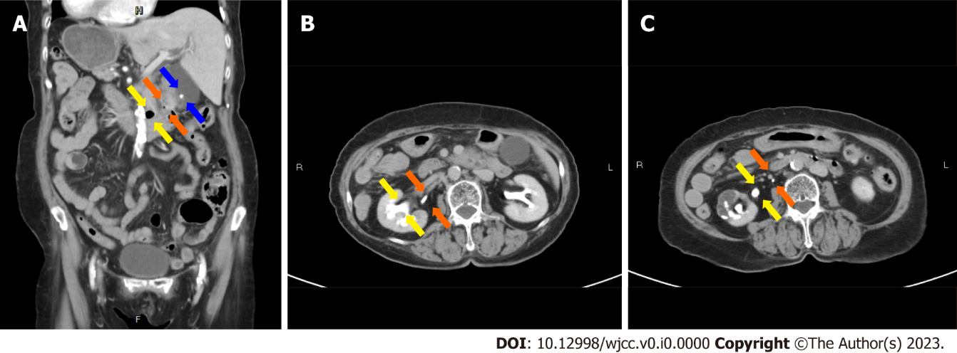
Figure 1 Preoperative computed tomography showed situs inversus, stones in the gallbladder and the common bile duct, and associated anomalies. A: A gallbladder stone (blue arrows), a common bile duct stone (orange arrows) and a diverticulum at the 3rd portion of the duodenum (yellow arrows); B: Right upper ureter of the duplication (orange arrows) and lower pelvis of the duplication (yellow arrows); C: Right upper ureter (orange arrows) and right lower ureter (yellow arrows).
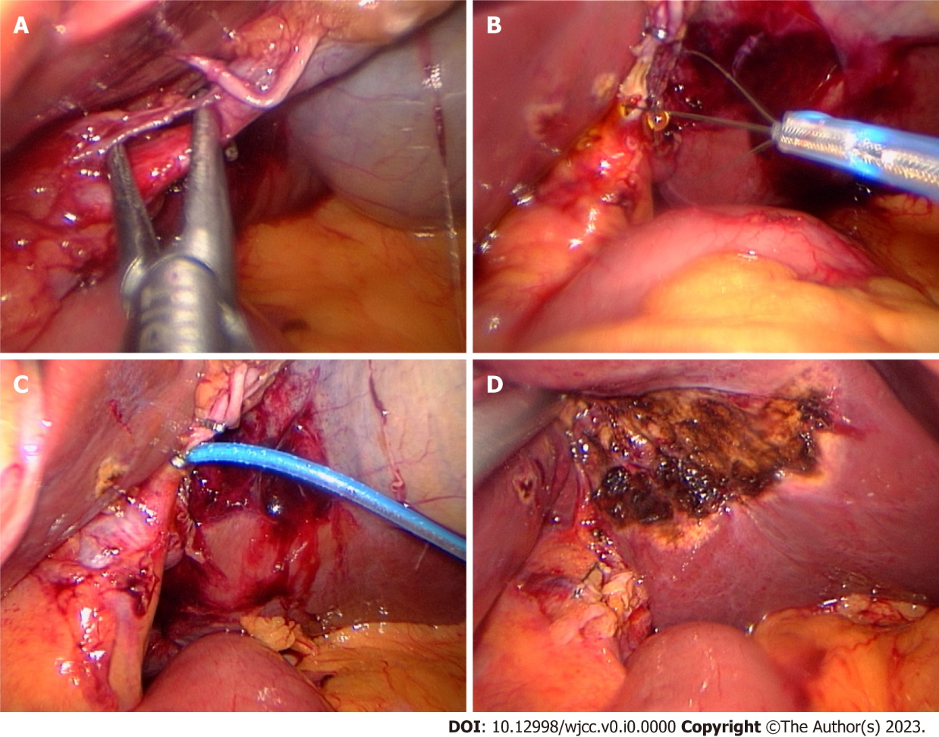
Figure 2 Intraoperative photos during single-incision laparoscopic transcystic common bile duct exploration in a patient with situs inversus. A: Dissection of the hepatocystic triangle; B: An opened retrieval basket in a 6 French feeding tube; C: Cystic duct cannulation for intraoperative cholangiography; D: Completion of choledocholithotripsy and cholecystectomy.

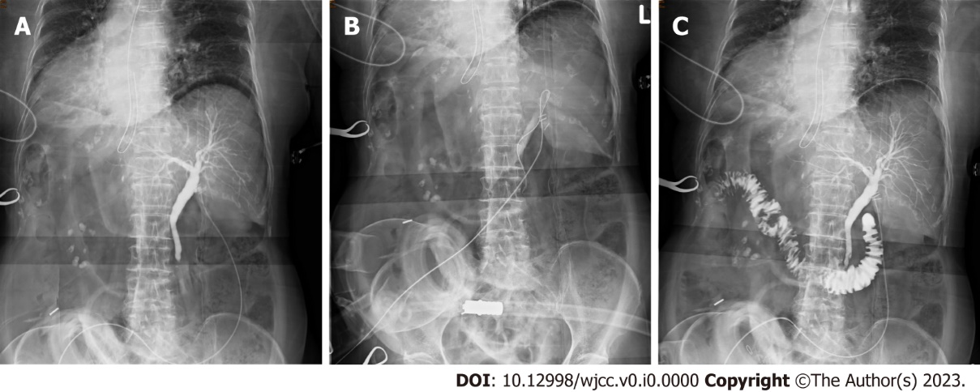
Figure 3 Intraoperative cholangiograms during transcystic choledocholithotripsy using a modified “basket in catheter” technique. A: The diagnostic cholangiogram showed an obstructive biliary tree; B: Transcystic basket trawling; C: The completion cholangiogram revealed stone clearance and a patent distal common bile duct.
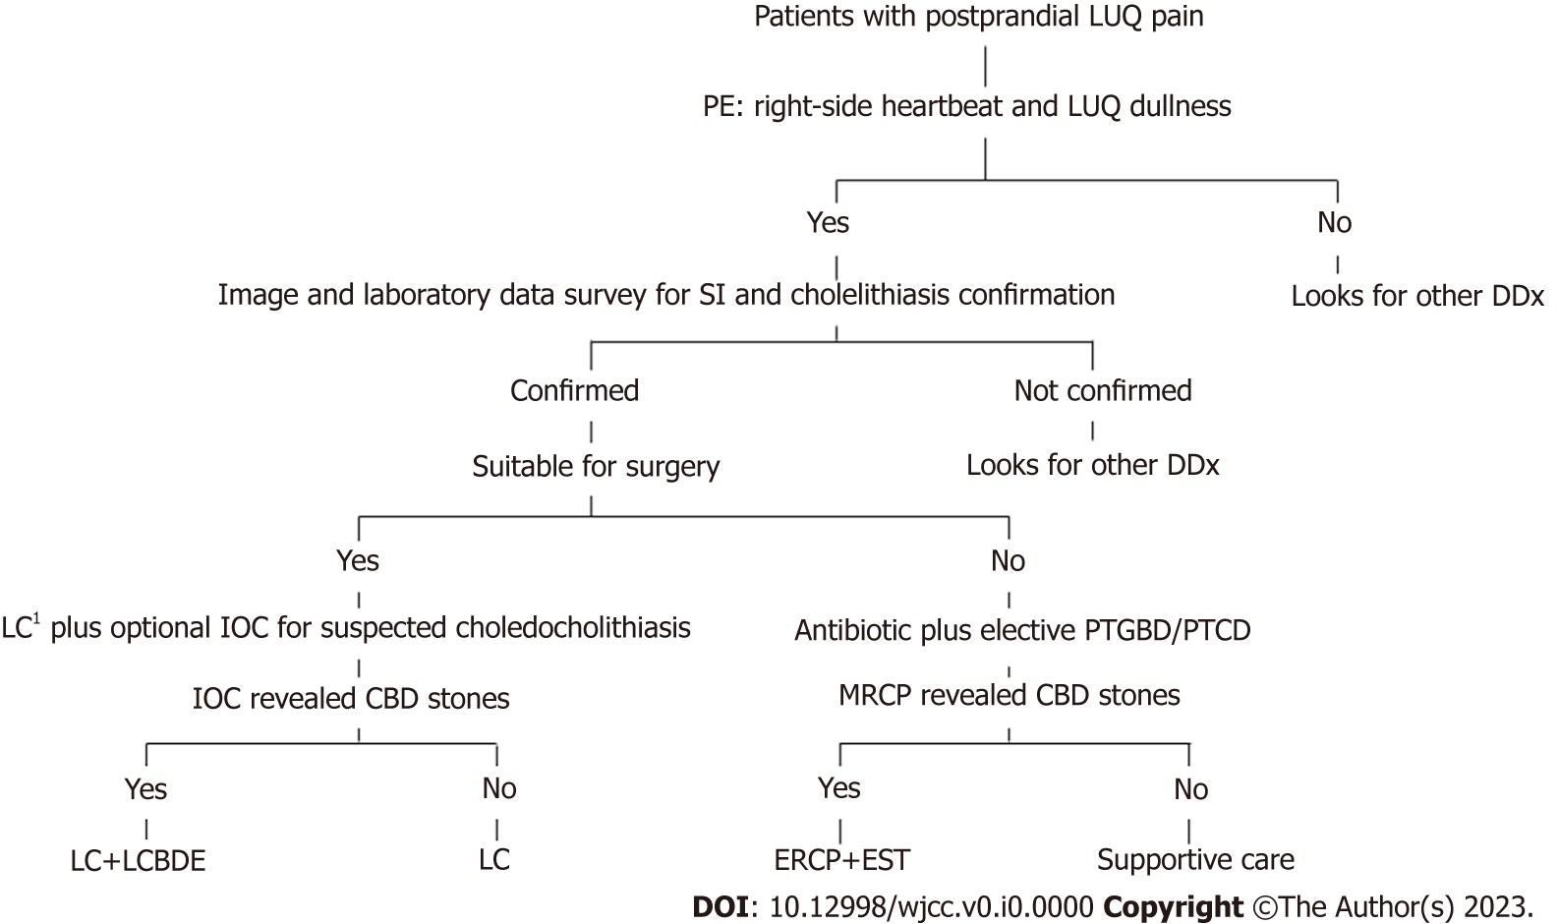
Figure 4 A practical algorithm for diagnosis and management to treat cholelithiasis and choledocholithiasis in situs inversus patients. ¹Laparoscopic cholecystectomy can be performed with four ports or a single port based on the surgeon’s discretion. LUQ: Left upper quadrant; PE: Physical examination; SI: Situs inversus; DDx: Differential diagnosis; LC: Laparoscopic cholecystectomy; IOC: Intraoperative cholangiography; MRCP: Magnetic resonance cholangiopancreatography; PTGBD: Percutaneous transhepatic gallbladder drainage; PTCD: Percutaneous transhepatic cholangiography and drainage; CBD: Common bile duct; LCBDE: Laparoscopic common bile duct exploration; ERCP: Endoscopic retrograde cholangiopancreatography; EST: Endoscopic sphincterotomy.

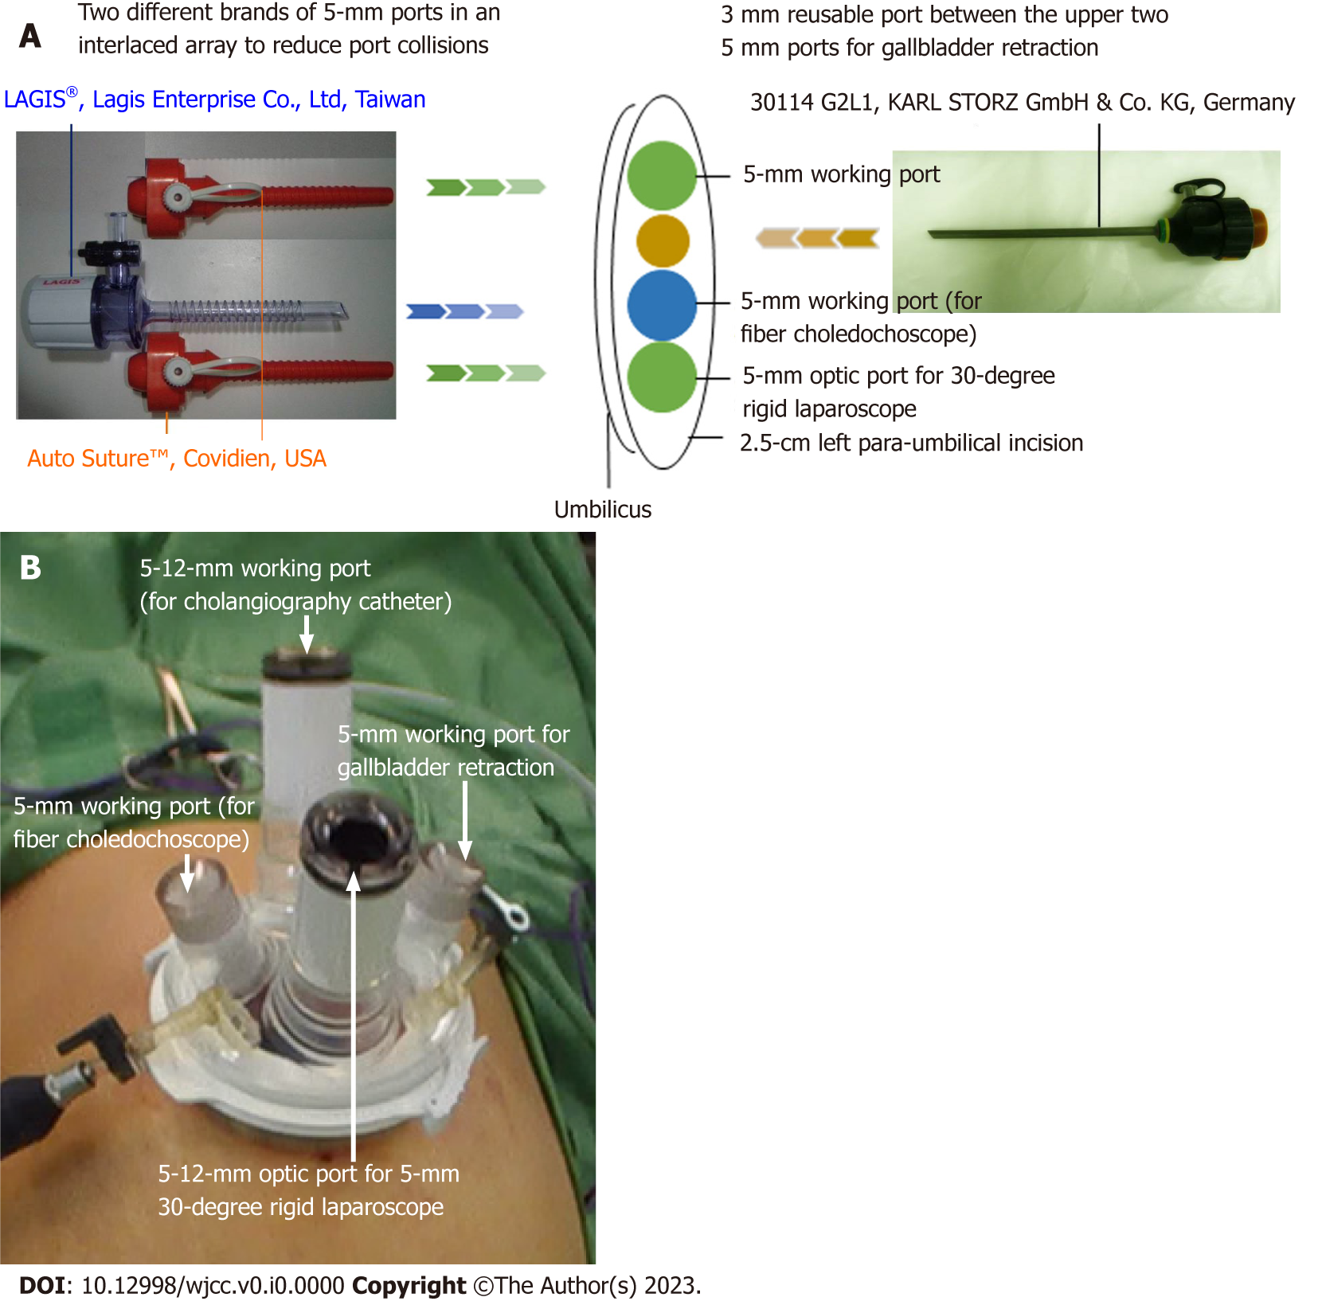
Figure 5 Port design in single-incision laparoscopic common bile duct exploration. A: The single-incision multiple-port longitudinal-array technique; B: A commercial multichannel port.

Table 1 Preoperative characteristics of situs inversus patients treated by laparoscopic bile duct exploration in the literature review
Authors | Year | Age | Sex | Medical history | Presentation | Diagnostic tools for CBD stone | Preoperative intervention
Kang et al^{[21]} | 2004 | 64 | F | Atrial fibrillation | Jaundice, abnormal liver function | Echo, CT, MRCP | Nil
Tai et al^{[20]} | 2004 | NA | F | Arrhythmia with pacemaker implantation | NA | NA | ERCP
Weber-Sánchez et al^{[15]} | 2011 | 60 | M | NA | Jaundice, cholecystitis | NA | NA
Han et al^{[16]} | 2012 | 71 | F | NA | NA | CT | ERCP
Liu et al^{[8]} | 2017 | 51 | F | Nil | Cholecystitis, abnormal liver function | CT, MRCP | Nil
Senthilnathan et al^{[17]} | 2017 | 76 | F | Gallbladder stone s/p open cholecystectomy | NA | NA | ERCP
Takalkar et al^{[19]} | 2018 | 50 | F | NA | Jaundice, abnormal liver function, cholecystitis | Echo, MRCP | ERCP + ERBD
Simkhada et al^{[18]} | 2021 | 63 | F | HTN, hypothyroidism ,CKD | NA | MRCP | ERCP
Our case | 2022 | 79 | F | HTN, hyperlipidemia, DM, CKD, ectopic pregnancy | Jaundice, abnormal liver function, cholecystitis | CT | Nil
F: Female; M: Male; s/p: Status post; HTN: Hypertension; DM: Diabetes mellitus; CKD: Chronic kidney disease; CT: Computed tomography; MRCP: Magnetic resonance cholangiopancreatography; ERCP: Endoscopic retrograde cholangiopancreatography; ERBD: Endoscopic retrograde biliary drainage; NA: Not available; CBD: Common bile duct.

Table 2 Intraoperative characteristics of situs inversus patients treated by laparoscopic bile duct exploration in the literature review
Author | Year | IOC | Incision number | Style | Position | Surgeon site | Working hand | Choledochoscopy | CBDE route | Approach technique
Kang et al^{[21]} | 2004 | N | 4 | MirA | NA | Right side | Left | Yes | Choledochotomy with T-tube closure | Choledochoscopy
Tai et al^{[20]} | 2004 | N | 4ª | NA | NA | NA | NA | NA | NA | NA
Weber-Sánchez et al^{[15]} | 2011 | N | 4ª | NA | NA | NA | NA | NA | NA | NA
Han et al^{[16]} | 2012 | N | 4 | MirCon | NA | NA | NA | Yes | Choledochotomy | Choledochoscopy
Liu et al^{[8]} | 2017 | N | 4ª | NA | NA | NA | NA | NA | NA | NA
Senthilnathan et al^{[17]} | 2017 | Y | 4 | MirCon | Supine, split legs | Between legs | NA | No | Choledochotomy with CDD^{b} | Balloon and saline sweep
Takalkar et al^{[19]} | 2018 | N | 4 | MirA | NA | NA | NA | No | Choledochotomy with CDD^{c} | NA
Simkhada et al^{[18]} | 2021 | N | 4 | MirA | Lithotomy | Right side | Left | Yes | Choledochotomy with primary closure | Endo-forceps
Our case | 2022 | Y | 1 | SP | Reverse Trendelenburg | Right side | Right | No | Transcystic approach | Basket in catheter
ªDefined as conventional in study.
^{b}Underwent laparoscopic cholecystectomy six months prior. Found common bile duct stone and small residual gallbladder containing stone this time.
^{c}Due to signiﬁcant dilation of the common bile duct (> 2 cm).
IOC: Intraoperative cholangiogram; MirA: Mirrored American; MirCon: Mirrored conventional; SP: Single-port. CDD: Choledochoduodenostomy; CBDE: Common bile duct exploration; NA: Not available; N: No; Y: Yes.

Table 3 Operative results of situs inversus patients treated by laparoscopic bile duct exploration in the literature review
Author | Year | OP time (min) | Conversion | PLOS (d) | Complication | Mortality | Follow-up (mo)
Kang et al^{[21]} | 2004 | 240 | No | NA | NA | Nil | Nil
Tai et al^{[20]} | 2004 | NA | No | NA | Nil | Nil | Nil
Weber-Sánchez et al^{[15]} | 2011 | NA | No | NA | NA | Nil | Nil
Han et al^{[16]} | 2012 | 129 | No | NA | Nil | Nil | Nil
Liu et al^{[8]} | 2017 | NA | No | 5 | Nil | Nil | Nil
Senthilnathan et al^{[17]} | 2017 | NA | No | 7 | Nil | Nil | Nil
Takalkar et al^{[19]} | 2018 | NA | No | NA | NA | Nil | Nil
Simkhada et al^{[18]} | 2021 | NA | No | NA | NA | Nil | Nil
Our case | 2022 | 152 | No | 3 | Nil | Nil | 24.5
OP: Operative; PLOS: Postoperative length of hospital stay; NA: Not available.

