Name of Journal: World Journal of Clinical Cases
Manuscript NO: 76022
Manuscript Type: CASE REPORT

Femoral neck stress fracture and medial tibial stress syndrome following high intensity interval training: A case report and review of literature

Tan DS et al. Stress injury after HIIT

Dawn Suwanie Tan, Fiona Millicent Cheung, Dekai Ng, Tin Lung Alan Cheung

Dawn Suwanie Tan, Fiona Millicent Cheung, Dekai Ng, Tin Lung Alan Cheung, Department of Orthopaedic Surgery, International Orthopaedic Clinic, Singapore, 329563, Singapore

Author contributions: Cheung FM and Cheung TLA designed the research; Tan DS and Ng D performed the research; Ng D and Cheung FM analysed the data; Tan DS and Cheung FM wrote the paper; Cheung TLA contributed to the revision process and wrote the revised manuscript.

Corresponding author: Tin Lung Alan Cheung, MBBS, Director, Department of Orthopaedic Surgery, International Orthopaedic Clinic, 38 Irrawaddy Road, 05-24 Mount Elizabeth Novena Specialist Centre, Singapore 329563, Singapore. drcheung@ioc-ortho.com

Received: February 27, 2022
Revised: May 25, 2022
Accepted: July 11, 2022
Published online: August 16, 2022

Abstract
BACKGROUND
Femoral and tibial stress injuries are commonly found in long distance running athletes. Stress fractures have rarely been reported in athletes performing high intensity interval training (HIIT) exercise. The objective of this study was to report a case of a patient who presented with medial tibial stress syndrome and femoral neck stress fracture after performing HIIT exercises.

CASE SUMMARY
A 26 year old female presented with bilateral medial tibial pain. She had been performing HIIT exercise for 45 min, five times weekly, for a seven month period. Her tibial pain was gradual in onset, and was now severe and worse on exercise, despite six weeks of rest. Magnetic resonance imaging (MRI) revealed bilateral medial tibial stress syndrome. As she was taking norethisterone for birth control, a dual energy X-ray absorbitometry scan was performed which demonstrated normal bone mineral density of her lumbar spine and femoral neck. She was managed conservatively with analgesia and physiotherapy, but continued to exercise against medical advice. She presented again six months later with severe right hip pain. MRI of her right hip demonstrated an incomplete stress fracture of her subtrochanteric region. Her symptoms resolved with strict rest and physiotherapy.

CONCLUSION
HIIT may cause stress injury of the tibia and femur in young individuals.

Key Words: High intensity interval training; Medial tibial stress syndrome; Femoral neck stress fracture; Exercise; Fracture; Case report

©The Author(s) 2022. Published by Baishideng Publishing Group Inc. All rights reserved.

Citation: Tan DS, Cheung FM, Ng D, Cheung TLA. Femoral neck stress fracture and medial tibial stress syndrome following high intensity interval training: A case report and review of literature. World J Clin Cases 2022; 10(23): 8323-8329
URL: https://www.wjgnet.com/2307-8960/full/v10/i23/8323.htm
DOI: https://dx.doi.org/10.12998/wjcc.v10.i23.8323

Core Tip: Stress injuries of the femur and tibia commonly occur in long distance runners, but have rarely been reported in individuals performing high intensity interval training (HIIT). An index of suspicion for stress injury, and proper investigation is required for patients presenting with hip or tibial pain following HIIT.

INTRODUCTION
High Intensity Interval Training (HIIT) has become increasingly popular as a method of exercise. HIIT involves alternating periods of relatively intense work and recovery. HIIT exercises may be subdivided into aerobic exercises e.g., running and cycling, and body weight/resistance exercises. HIIT programs can vary greatly and combine both types of exercise^{[1]}. The incidence and type adverse events related to HIIT exercise are not well known, with isolated case reports described in the literature. However, injury rates may be under-reported and higher than previously realised^{[2]}.
Medial tibial stress syndrome (MTSS), also known to the layman as ‘shin-splints’, is exercise-induced pain over the anterior tibia which may lead to stress fracture. MTSS is common in long distance runners and military personnel^{[3]}. Femoral neck stress fractures (FNSF) are an uncommon but potentially disabling cause of athletes presenting with exercise-related hip and groin pain. The commonest causative sports are marathon and long-distance running. Outcomes are considerably worse for fractures with a delay in diagnosis, and displacement^{[4]}.
This study reports a case of bilateral medial tibial stress syndrome, and subsequent femoral neck stress fracture, following prolonged high intensity interval training in a young female adult. Such a case has not previously been reported.

CASE PRESENTATION
Chief complaints
A 26 year old female presented in the outpatient clinic with bilateral tibial pain following HIIT. Continuation of exercise resulted in severe right groin pain six months later.

History of present illness
A 26 year old female presented with bilateral medial tibial pain. She had been performing HIIT exercise for 45 min, five times weekly, for a seven month period. Her tibial pain was gradual in onset, and was now severe and worse on exercise, despite six weeks of rest. The patient was unwilling to cease HIIT and continued to exercise against medical advice. She presented with severe right groin pain six months later.

History of past illness
There was no specific underlying disease.

Personal and family history
The patient was taking norethisterone for birth control. She had previously had an open reduction and internal fixation of a right ankle fracture seven years previously and had made a full recovery.

Physical examination
On initial presentation the patient complained of pain in the anteromedial aspect of the middle third of both tibiae. There was tenderness bilaterally in these regions. Gait was normal and the patient was able to squat and tiptoe easily. Spine and bilateral hip, knee and ankle examination was within normal limits. There were no clinical features of rhabodomyolysis such as myalgia, muscle weakness or dark urine. She presented six months later with right groin pain. Range of motion in both hips was 135/135, adduction 35/35, abduction 45/45, internal rotation 10/15 (painful and reduced motion on the right).

Laboratory examinations
Blood tests did not show any abnormality. Vitamin D level was within normal limits.

Imaging examinations
Radiographs did not show any tibial fracture. An old healed right ankle fracture fixation was seen (Figure 1). MRI scans of both tibiae demonstrated periosteal oedema and fluid overlying the antero-medial cortices of the tibial diaphyses, but no fracture, consistent with bilateral medial tibial stress syndrome (Figure 2).
MRI scan of the right hip demonstrated an incomplete, undisplaced stress fracture at the medial subtrochanteric level of the right femur (Figure 3). A dual energy X-ray absorbitometry scan demonstrated a normal BMD of the lumbar (L1-L4) vertebrae with a T-score of +0.6 and normal BMD of the left femoral neck, T-score +1.8.

MULTIDISCIPLINARY EXPERT CONSULTATION
Dr. Mishra N, Chief of Endocrinology, Singapore Medical Group.

FINAL DIAGNOSIS
Bilateral medial tibial stress syndrome; femoral neck stress fracture.

TREATMENT
The patient was managed conservatively with analgesia and physiotherapy, but continued to exercise against medical advice. She presented again six months later with severe right hip pain.

OUTCOME AND FOLLOW-UP
The patient was warned of the risk of hip fracture requiring surgery. Her symptoms resolved with strict rest and physiotherapy.

DISCUSSION
The main objective of this study was to highlight the risk of stress injury to the tibia and femur in a young population performing HIIT. A sequential combination of these injuries is unusual and has not been reported before following HIIT.
HIIT has become increasingly popular as a method of exercise. HIIT involves alternating periods of relatively intense work and recovery. HIIT exercises may be subdivided into aerobic exercises e.g., running and cycling, and body weight/resistance exercises^{[1]}. Disciplines such as Crossfit, Tabata training, F45, and ‘Bootcamps’ are examples of HIIT^{[5-8]}. HIIT programs can vary greatly, and may combine aerobic and weight/resistance exercises.
The principle of HIIT is that a greater volume of higher intensity exercise is accumulated during a single HIIT exercise session, compared to traditional moderate-intensity continuous exercise (MICE) training^{[9,10]}. It has been postulated that HIIT improves cardiovascular health, metabolic capacity, and aerobic performance, at a similar or superior rate to MICE^{[11]}. HIIT may be beneficial in individuals with chronic disease^{[12-18]}, and in adolescents and the elderly^{[19-22]}. The incidence and type adverse events related to HIIT exercise are not well known, with isolated case reports described in the literature^{[23-25]}. However, injury rates may be under-reported and higher than previously realised^{[2,26]}.
MTSS, known to the layperson as ‘shin-splints’, is exercise-induced pain over the anterior tibia, and may lead to tibial stress fractures^{[1]}. MTSS has an incidence of approximately 13 to 20% in runners, and up to 35% in military recruits^{[27]}. Predisposing factors include increasing load and volume of high impact exercise, female gender, previous history of MTSS, high BMI^{[28-32]}, as well as Vitamin D deficiency^{[33,34]}.
MTSS results from accumulated cortical microdamage which exceeds the ability of the bone to repair itself^{[35]}. Periostitis usually occurs at the site of bony injury, which is at the site of attachment of the tendinous attachments of the soleus, flexor digitorum longus, and posterior tibialis muscles.
MTSS is primarily a clinical diagnosis^{[36]}. Imaging may be performed to exclude a more significant tibial injury such as a stress fracture. Whereas radiographs alone may detect a stress fracture, MRI is the gold standard investigation for identifying MTSS and stress fractures. MRI findings include periosteal oedema and bone marrow oedema. Isotope bone scans are less specific and sensitive than MRI. High-resolution computed tomography is an option but has lower sensitivity than MRI or isotope bone scan. Excluding Vitamin D deficiency is also helpful^{[30,37]}.
MTSS is typically managed conservatively, with rest and lifestyle/activity modification to reduce load and stress. An ideal duration of rest and activity has not been defined. There is low-quality evidence to suggest that adjunct therapies such as ice massage, ultrasound therapy, and extracorporeal shockwave therapy, and orthotics may be of benefit. Not every patient that experiences MTSS develops a tibial stress fracture. Severe tibial stress fractures may require surgical intervention^{[38-40]}.
FNSF are an uncommon but potentially disabling cause of athletes presenting with exercise-related hip and groin pain. FNSFs account for 5% of all stress fractures and 3% of all sports-related stress fractures. The commonest causative sports are marathon and long-distance running. Outcomes are considerably worse for fractures with a delay in diagnosis and displacement. Risk factors for FNSFs include female gender, poor baseline physical fitness, eating disorders, amenorrhea, and decreased bone mineral density. A combination of repetitive mechanical load to the femoral neck, and bone absorption exceeding metabolic repair during remodelling, may result in FNSF. Radiographs are initially used for diagnosis but have low sensitivity. MRI scan has 100% sensitivity and is the gold standard investigation to detect FNSF. An early diagnosis is important to prevent fracture displacement and reduce risk of avascular necrosis. Management consists of surgical and non-surgical treatments, depending upon symptoms, and fracture characteristics such as location and displacement^{[4,41-45]}.
In this case report, the patient was a female who had subjected herself to a large volume of high intensity training. MRI scanning, which is the gold standard to detect bony stress injury, was utilised to confirm the diagnosis^{[46,47]}. Vitamin D deficiency and osteoporosis were excluded. Stress injury was detected, and treated with rest and physical therapy. Surgery was not required. A sequential combination of tibial and femoral stress injury following HIIT exercise has not been reported before. More research needs to be performed to determine a safe duration, type and intensity of exercise performed during HIIT to reduce risk of stress injury.

CONCLUSION
HIIT can lead to stress injury of the tibia and femur in a young population.

REFERENCES
1 Billat LV. Interval training for performance: a scientific and empirical practice. Special recommendations for middle- and long-distance running. Part I: aerobic interval training. Sports Med 2001; 31: 13-31 [PMID: 11219499 DOI: 10.2165/00007256-200131010-00002]
2 Rynecki ND, Siracuse BL, Ippolito JA, Beebe KS. Injuries sustained during high intensity interval training: are modern fitness trends contributing to increased injury rates? J Sports Med Phys Fitness 2019; 59: 1206-1212 [PMID: 30758171 DOI: 10.23736/S0022-4707.19.09407-6]
3 Kiel J, Kaiser K. Stress Reaction and Fractures. 2021 Aug 4. In: StatPearls [Internet]. Treasure Island (FL): StatPearls Publishing, 2022 [PMID: 29939612]
4 Robertson GA, Wood AM. Femoral Neck Stress Fractures in Sport: A Current Concepts Review. Sports Med Int Open 2017; 1: E58-E68 [PMID: 30539087 DOI: 10.1055/s-0043-103946]
5 Claudino JG, Gabbett TJ, Bourgeois F, Souza HS, Miranda RC, Mezêncio B, Soncin R, Cardoso Filho CA, Bottaro M, Hernandez AJ, Amadio AC, Serrão JC. CrossFit Overview: Systematic Review and Meta-analysis. Sports Med Open 2018; 4: 11 [PMID: 29484512 DOI: 10.1186/s40798-018-0124-5]
6 Tabata I. Tabata training: one of the most energetically effective high-intensity intermittent training methods. J Physiol Sci 2019; 69: 559-572 [PMID: 31004287 DOI: 10.1007/s12576-019-00676-7]
7 Smith AAH, Wananu M, Carlson MD. Spontaneous Coronary Artery Dissection in a Healthy Woman after Initiating a High-Intensity Interval Training Workout Program. Am J Cardiol 2018; 122: 1588-1589 [PMID: 30180959 DOI: 10.1016/j.amjcard.2018.07.013]
8 Hoffman JR, Kahana A, Chapnik L, Shamiss A, Davidson B. The relationship of physical fitness on pilot candidate selection in the Israel Air Force. Aviat Space Environ Med 1999; 70: 131-134 [PMID: 10206931]
9 Gibala MJ, Little JP, Macdonald MJ, Hawley JA. Physiological adaptations to low-volume, high-intensity interval training in health and disease. J Physiol 2012; 590: 1077-1084 [PMID: 22289907 DOI: 10.1113/jphysiol.2011.224725]
10 CHRISTENSEN EH, HEDMAN R, SALTIN B. Intermittent and continuous running. (A further contribution to the physiology of intermittent work.). Acta Physiol Scand 1960; 50: 269-286 [PMID: 14448704 DOI: 10.1111/j.1748-1716.1960.tb00181.x]
11 Helgerud J, Høydal K, Wang E, Karlsen T, Berg P, Bjerkaas M, Simonsen T, Helgesen C, Hjorth N, Bach R, Hoff J. Aerobic high-intensity intervals improve VO2max more than moderate training. Med Sci Sports Exerc 2007; 39: 665-671 [PMID: 17414804 DOI: 10.1249/mss.0b013e3180304570]
12 Beauchamp MK, Nonoyama M, Goldstein RS, Hill K, Dolmage TE, Mathur S, Brooks D. Interval vs continuous training in individuals with chronic obstructive pulmonary disease--a systematic review. Thorax 2010; 65: 157-164 [PMID: 19996334 DOI: 10.1136/thx.2009.123000]
13 Guiraud T, Nigam A, Gremeaux V, Meyer P, Juneau M, Bosquet L. High-intensity interval training in cardiac rehabilitation. Sports Med 2012; 42: 587-605 [PMID: 22694349 DOI: 10.2165/11631910-000000000-00000]
14 Kessler HS, Sisson SB, Short KR. The potential for high-intensity interval training to reduce cardiometabolic disease risk. Sports Med 2012; 42: 489-509 [PMID: 22587821 DOI: 10.2165/11630910-000000000-00000]
15 Ross LM, Porter RR, Durstine JL. High-intensity interval training (HIIT) for patients with chronic diseases. J Sport Health Sci 2016; 5: 139-144 [PMID: 30356536 DOI: 10.1016/j.jshs.2016.04.005]
16 Rognmo Ø, Hetland E, Helgerud J, Hoff J, Slørdahl SA. High intensity aerobic interval exercise is superior to moderate intensity exercise for increasing aerobic capacity in patients with coronary artery disease. Eur J Cardiovasc Prev Rehabil 2004; 11: 216-222 [PMID: 15179103 DOI: 10.1097/01.hjr.0000131677.96762.0c]
17 Freyssin C, Verkindt C, Prieur F, Benaich P, Maunier S, Blanc P. Cardiac rehabilitation in chronic heart failure: effect of an 8-week, high-intensity interval training vs continuous training. Arch Phys Med Rehabil 2012; 93: 1359-1364 [PMID: 22446291 DOI: 10.1016/j.apmr.2012.03.007]
18 Karstoft K, Winding K, Knudsen SH, Nielsen JS, Thomsen C, Pedersen BK, Solomon TP. The effects of free-living interval-walking training on glycemic control, body composition, and physical fitness in type 2 diabetic patients: a randomized, controlled trial. Diabetes Care 2013; 36: 228-236 [PMID: 23002086 DOI: 10.2337/dc12-0658]
9 Terada T, Wilson BJ, Myette-Côté E, Kuzik N, Bell GJ, McCargar LJ, Boulé NG. Targeting specific interstitial glycemic parameters with high-intensity interval exercise and fasted-state exercise in type 2 diabetes. Metabolism 2016; 65: 599-608 [PMID: 27085769 DOI: 10.1016/j.metabol.2016.01.003]
20 Cao M, Quan M, Zhuang J. Effect of High-Intensity Interval Training vs Moderate-Intensity Continuous Training on Cardiorespiratory Fitness in Children and Adolescents: A Meta-Analysis. Int J Environ Res Public Health 2019; 16 [PMID: 31052205 DOI: 10.3390/ijerph16091533]
21 Martin-Smith R, Cox A, Buchan DS, Baker JS, Grace F, Sculthorpe N. High Intensity Interval Training (HIIT) Improves Cardiorespiratory Fitness (CRF) in Healthy, Overweight and Obese Adolescents: A Systematic Review and Meta-Analysis of Controlled Studies. Int J Environ Res Public Health 2020; 17 [PMID: 32344773 DOI: 10.3390/ijerph17082955]
22 Marriott CFS, Petrella AFM, Marriott ECS, Boa Sorte Silva NC, Petrella RJ. High-Intensity Interval Training in Older Adults: a Scoping Review. Sports Med Open 2021; 7: 49 [PMID: 34279765 DOI: 10.1186/s40798-021-00344-4]
23 Jiménez-García JD, Martínez-Amat A, De la Torre-Cruz MJ, Fábrega-Cuadros R, Cruz-Díaz D, Aibar-Almazán A, Achalandabaso-Ochoa A, Hita-Contreras F. Suspension Training HIIT Improves Gait Speed, Strength and Quality of Life in Older Adults. Int J Sports Med 2019; 40: 116-124 [PMID: 30605922 DOI: 10.1055/a-0787-1548]
24 Vukanic D, Murphy D, Juhdi A, Leonard M. A Big HIIT: A Fracture Dislocation of the Hip in a Young Man Participating in Extreme Conditioning Exercise: A Case Report. JBJS Case Connect 2020; 10: e1900516 [PMID: 32910585 DOI: 10.2106/JBJS.CC.19.00516]
25 Sephien A, Orr J, Remaley DT. Pectoralis major tear in a 23-year-old woman while performing high-intensity interval training: a rare presentation. BMJ Case Rep 2020; 13 [PMID: 32193177 DOI: 10.1136/bcr-2019-232649]
26 Jackson, J, Hart S, Fries CA, Robinson J, Murray J, Wood AM. CrossFitter’s knee: patellofemoral chondral injury following high-intensity functional training. J R Nav Med Serv Spring; 103: 35-38 [PMID: 30088738]
27 Minghelli B, Vicente P. Musculoskeletal injuries in Portuguese CrossFit practitioners. J Sports Med Phys Fitness 2019; 59: 1213-1220 [PMID: 30722656 DOI: 10.23736/S0022-4707.19.09367-8]
28 Yates B, White S. The incidence and risk factors in the development of medial tibial stress syndrome among naval recruits. Am J Sports Med 2004; 32: 772-780 [PMID: 15090396 DOI: 10.1177/0095399703258776]
29 Reinking MF, Austin TM, Richter RR, Krieger MM. Medial Tibial Stress Syndrome in Active Individuals: A Systematic Review and Meta-analysis of Risk Factors. Sports Health 2017; 9: 252-261 [PMID: 27729482 DOI: 10.1177/1941738116673299]
30 Franklyn M, Oakes B. Aetiology and mechanisms of injury in medial tibial stress syndrome: Current and future developments. World J Orthop 2015; 6: 577-589 [PMID: 26396934 DOI: 10.5312/wjo.v6.i8.577]
31 Moen MH, Tol JL, Weir A, Steunebrink M, De Winter TC. Medial tibial stress syndrome: a critical review. Sports Med 2009; 39: 523-546 [PMID: 19530750 DOI: 10.2165/00007256-200939070-00002]
32 Hamstra-Wright KL, Bliven KC, Bay C. Risk factors for medial tibial stress syndrome in physically active individuals such as runners and military personnel: a systematic review and meta-analysis. Br J Sports Med 2015; 49: 362-369 [PMID: 25185588 DOI: 10.1136/bjsports-2014-093462]
33 Barton CJ, Bonanno DR, Carr J, Neal BS, Malliaras P, Franklyn-Miller A, Menz HB. Running retraining to treat lower limb injuries: a mixed-methods study of current evidence synthesised with expert opinion. Br J Sports Med 2016; 50: 513-526 [PMID: 26884223 DOI: 10.1136/bjsports-2015-095278]
34 Tenforde AS, Sayres LC, Sainani KL, Fredericson M. Evaluating the relationship of calcium and vitamin D in the prevention of stress fracture injuries in the young athlete: a review of the literature. PM R 2010; 2: 945-949 [PMID: 20970764 DOI: 10.1016/j.pmrj.2010.05.006]
35 Ruohola JP, Laaksi I, Ylikomi T, Haataja R, Mattila VM, Sahi T, Tuohimaa P, Pihlajamäki H. Association between serum 25(OH)D concentrations and bone stress fractures in Finnish young men. J Bone Miner Res 2006; 21: 1483-1488 [PMID: 16939407 DOI: 10.1359/jbmr.060607]
36 Winters M, Burr DB, van der Hoeven H, Condon KW, Bellemans J, Moen MH. Microcrack-associated bone remodeling is rarely observed in biopsies from athletes with medial tibial stress syndrome. J Bone Miner Metab 2019; 37: 496-502 [PMID: 30066165 DOI: 10.1007/s00774-018-0945-9]
37 Winters M, Bakker EWP, Moen MH, Barten CC, Teeuwen R, Weir A. Medial tibial stress syndrome can be diagnosed reliably using history and physical examination. Br J Sports Med 2018; 52: 1267-1272 [PMID: 28179260 DOI: 10.1136/bjsports-2016-097037]
38 Moen MH, Schmikli SL, Weir A, Steeneken V, Stapper G, de Slegte R, Tol JL, Backx FJ. A prospective study on MRI findings and prognostic factors in athletes with MTSS. Scand J Med Sci Sports 2014; 24: 204-210 [PMID: 22515327 DOI: 10.1111/j.1600-0838.2012.01467.x]
39 Winters M, Eskes M, Weir A, Moen MH, Backx FJ, Bakker EW. Treatment of medial tibial stress syndrome: a systematic review. Sports Med 2013; 43: 1315-1333 [PMID: 23979968 DOI: 10.1007/s40279-013-0087-0]
40 Lohrer H, Malliaropoulos N, Korakakis V, Padhiar N. Exercise-induced leg pain in athletes: diagnostic, assessment, and management strategies. Phys Sportsmed 2019; 47: 47-59 [PMID: 30345867 DOI: 10.1080/00913847.2018.1537861]
41 Bonanno DR, Murley GS, Munteanu SE, Landorf KB, Menz HB. Effectiveness of foot orthoses for the prevention of lower limb overuse injuries in naval recruits: a randomised controlled trial. Br J Sports Med 2018; 52: 298-302 [PMID: 29056595 DOI: 10.1136/bjsports-2017-098273]
42 Matcuk GR Jr, Mahanty SR, Skalski MR, Patel DB, White EA, Gottsegen CJ. Stress fractures: pathophysiology, clinical presentation, imaging features, and treatment options. Emerg Radiol 2016; 23: 365-375 [PMID: 27002328 DOI: 10.1007/s10140-016-1390-5]
43 Voss L, DaSilva M, Trafton PG. Bilateral femoral neck stress fractures in an amenorrheic athlete. Am J Orthop (Belle Mead NJ) 1997; 26: 789-792 [PMID: 9402215]
44 Bennell K, Matheson G, Meeuwisse W, Brukner P. Risk factors for stress fractures. Sports Med 1999; 28: 91-122 [PMID: 10492029 DOI: 10.2165/00007256-199928020-00004]
45 Maffulli, N., Longo, U. and Denaro, V., 2009. Femoral Neck Stress Fractures. Operative Techniques in Sports Medicine 2009; 17: 90-93 [DOI: 10.1053/j.otsm.2009.06.001]
46 Sofka CM. Imaging of stress fractures. Clin Sports Med 2006; 25: 53-62, viii [PMID: 16324973 DOI: 10.1016/j.csm.2005.08.009]
47 Biz C, Berizzi A, Crimì A, Marcato C, Trovarelli G, Ruggieri P. Management and treatment of femoral neck stress fractures in recreational runners: a report of four cases and review of the literature. Acta Biomed 2017; 88: 96-106 [PMID: 29083360 DOI: 10.23750/abm.v88i4-S.6800]

Footnotes
Informed consent statement: The patient provided informed written consent prior to study enrolment.

Conflict-of-interest statement: All authors declare that there are no conflicts of interest involved.

CARE Checklist (2016) statement: The authors have read the CARE Checklist (2016), and the manuscript was prepared and revised according to the CARE Checklist (2016).

Open-Access: This article is an open-access article that was selected by an in-house editor and fully peer-reviewed by external reviewers. It is distributed in accordance with the Creative Commons Attribution NonCommercial (CC BY-NC 4.0) license, which permits others to distribute, remix, adapt, build upon this work non-commercially, and license their derivative works on different terms, provided the original work is properly cited and the use is non-commercial. See: https://creativecommons.org/Licenses/by-nc/4.0/

Provenance and peer review: Unsolicited article; Externally peer reviewed.
Peer-review model: Single blind

Peer-review started: February 27, 2022
First decision: April 8, 2022
Article in press: July 11, 2022

Specialty type: Medicine, research and experimental
Country/Territory of origin: Singapore
Peer-review report’s scientific quality classification
Grade A (Excellent): 0
Grade B (Very good): B
Grade C (Good): C
Grade D (Fair): 0
Grade E (Poor): 0

P-Reviewer: Vyshka G, Albania; Xu G, China S-Editor: Wang LL L-Editor: A P-Editor: Wang LL

Figure Legends
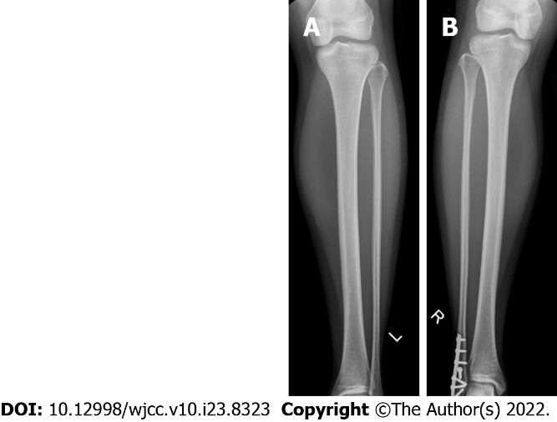
Figure 1 Radiograph. A: Radiograph of left tibia; B: Radiograph of right tibia (previous healed fibula fracture fixation).

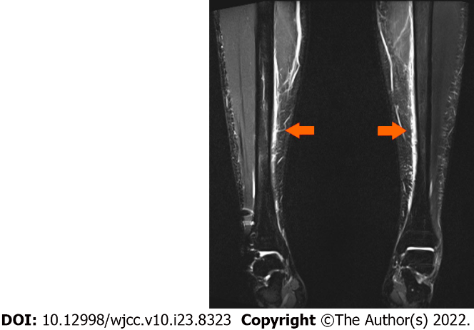
Figure 2 Magnetic resonance imaging bilateral tibiae. Arrows denote regions of periosteal oedema.

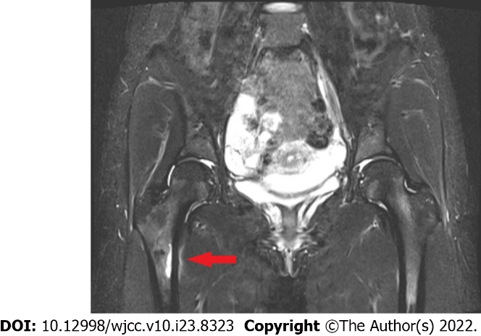
Figure 3 Magnetic resonance imaging pelvis. Arrow demonstrates stress fracture right medial subtrochanteric region.

Published by Baishideng Publishing Group Inc
7041 Koll Center Parkway, Suite 160, Pleasanton, CA 94566, USA
Telephone: +1-925-3991568
E-mail: bpgoffice@wjgnet.com
Help Desk: https://www.f6publishing.com/helpdesk
https://www.wjgnet.com

© 2022 Baishideng Publishing Group Inc. All rights reserved.

