Name of Journal: World Journal of Hepatology
Manuscript No: 41492
Manuscript Type: CASE REPORT

Caval replacement with parietal peritoneum tube graft for septic thrombophlebitis after hepatectomy: A case report

Charlotte M et al. Management of septic thrombophlebitis after hepatectomy

Charlotte Maulat, Léopoldine Lapierre, Isabelle Migueres, Xavier Chaufour, Guillaume Martin-Blondel, Fabrice Muscari

Charlotte Maulat, Isabelle Migueres, Fabrice Muscari, Digestive Surgery, Toulouse University Hospital, Toulouse 31400, France

Léopoldine Lapierre, Guillaume Martin-Blondel, Department of Infectious and Tropical Diseases, Toulouse-Purpan University Hospital, Toulouse 31300, France

Xavier Chaufour, Vascular Surgery Department, Toulouse-Rangueil University Hospital, Toulouse 31059, France

ORCID number: Charlotte Maulat (0000-0002-0384-6592); Léopoldine Lapierre (0000-0001-9940-1725); Isabelle Migueres (0000-0002-5792-4090); Xavier Chaufour (0000-0001-9212-9589); Guillaume Martin-Blondel (0000-0002-8363-7028); Fabrice Muscari (000-0001-6754-1686).

Author contributions: Maulat C, Lapierre L, Martin-Blondel G and Muscari F performed research and wrote the paper; Migueres I and Chaufour X provided critical revision of the manuscript for important intellectual content.

Informed consent statement: The patient gave its informed consent for this publication.

Conflict-of-interest statement: There are no conflicts of interest to report.

CARE Checklist (2016) statement: The CARE Checklist (2016) have been adopted for this manuscript.

Open-Access: This article is an open-access article which was selected by an in-house editor and fully peer-reviewed by external reviewers. It is distributed in accordance with the Creative Commons Attribution Non Commercial (CC BY-NC 4.0) license, which permits others to distribute, remix, adapt, build upon this work non-commercially, and license their derivative works on different terms, provided the original work is properly cited and the use is non-commercial. See: http://creativecommons.org/licenses/by-nc/4.0/

Manuscript source: Unsolicited manuscript

Corresponding author to: Charlotte Maulat, Academic Fellow, Digestive surgery, Toulouse University Hospital, 1 Avenue Jean Poulhès, Toulouse 31400, France. charlotte.maulat@gmail.com

Telephone: +33-56-1322741
Fax: +33-56-1322936

Received: September 18, 2018
Peer-review started: September 18, 2018
First decision: October 18, 2018
Revised: November 4, 2018
Accepted: December 6, 2018
Article in press: December 7, 2018
Published online: January 27, 2019
Abstract
BACKGROUND
Caval vein thrombosis after hepatectomy is rare, although it increases mortality and morbidity. The evolution of this thrombosis into a septic thrombophlebitis responsible for persistent septicaemia after a hepatectomy has not been reported to date in the literature. We here report the management of a 54-year-old woman operated for a peripheral cholangiocarcinoma who developed a suppurated thrombophlebitis of the vena cava following a hepatectomy.

CASE SUMMARY
This patient was operated by left lobectomy extended to segment V with bile duct resection and Roux-en-Y hepaticojejunostomy. After the surgery, she developed Streptococcus anginosus, Escherichia coli, and Enterococcus faecium bacteraemias, as well as Candida albicans fungemia. A computed tomography scan revealed a bilioma which was percutaneously drained. Despite adequate antibiotic therapy, the patient’s condition remained septic. A diagnosis of septic thrombophlebitis of the vena cava was made on post-operative day 25. The patient was then operated again for a surgical thrombectomy and complete caval reconstruction with a parietal peritoneum tube graft. Use of the peritoneum as a vascular graft is an inexpensive technique, it is readily and rapidly available, and it allows caval replacement in a septic area. Septic thrombophlebitis of the vena cava after hepatectomy has not been described previously and it warrants being added to the spectrum of potential complications of this procedure.

CONCLUSION
Septic thrombophlebitis of the vena cava was successfully treated with antibiotic and anticoagulation treatments, prompt surgical thrombectomy and caval reconstruction.

Key words: Bilioma; Septic thrombophlebitis; Septicaemia; Parietal peritoneum tube graft; Complete caval reconstruction; Case report

© The Author(s) 2019. Published by Baishideng Publishing Group Inc. All rights reserved.

Core tip: Caval vein thrombosis after hepatectomy is rare, although it increases mortality and morbidity. Its evolution into a septic thrombophlebitis responsible for persistent septicaemia after a hepatectomy has not been reported to date in the literature. This study reports the management of a 54-year-old woman with peripheral cholangiocarcinoma who developed a suppurated thrombophlebitis of the vena cava following a hepatectomy. A combination of antibiotic and anticoagulation treatments, prompt surgical thrombectomy and complete caval reconstruction was associated with a favorable outcome. Use of the peritoneum as a vascular graft is an inexpensive technique, and it allows caval replacement in a septic area.

Citation: Maulat C, Lapierre L, Migueres I, Chaufour X, Martin-Blondel G, Muscari F. Caval replacement with parietal peritoneum tube graft for septic thrombophlebitis after hepatectomy: A case report. World J Hepatol 2019; 11(1): 133-137
URL: https://www.wjgnet.com/1948-5182/full/v11/i1/133.htm
DOI: https://dx.doi.org/10.4254/wjh.v11.i1.133
INTRODUCTION
Caval vein thrombosis after hepatectomy is rare, although it increases mortality and morbidity^{[1]}. The evolution of this thrombosis into a septic thrombophlebitis has not been reported to date in the literature. We here report the management of a 54-year-old woman operated for a peripheral cholangiocarcinoma who developed a suppurated thrombophlebitis of the vena cava following a hepatectomy.

CASE PRESENTATION
This patient was operated by left lobectomy extended to segment V with bile duct resection and Roux-en-Y hepaticojejunostomy. Besides its cancer, the patient had no medical history, including thromboembolic or cardiovascular diseases. On post-operative day 3 (POD3), she developed Streptococcus anginosus, Escherichia coli, and Enterococcus faecium (E. faecium) bacteraemias, as well as Candida albicans (C. albicans) fungemia. A computed tomography (CT) scan revealed a 5 cm bilioma. Antibiotic treatment based on ceftriaxon, teicoplanin, and caspofungin was started while the bilioma was percutaneously drained on POD10, and cultures were positive for C. albicans. However, both the E. faecium bacteraemia and the C. albicans fungemia persisted, with sepsis (high-grade fever, hyperleukocytosis and tachycardia). The choice and the administration of these antibiotics were deemed to be appropriate, as were the teicoplanin serum levels.
The clinical condition of the patient continued to deteriorate, despite appropriate antibiotic treatment. Another CT scan on POD25 revealed thrombophlebitis of the inferior vena cava closed to the bilioma (Figure 1), and new subpleural nodular lesions suggestive of an embolic mechanism.

FINAL DIAGNOSIS
A diagnosis of septic thrombophlebitis of the inferior vena cava was made.

TREATMENT
The patient was operated again on POD27 for a thrombectomy and replacement of the inferior vena cava. First, the vena cava was controlled above and below the hepatic vein and the upper the renal veins after performing the Kocher manoeuvre. The bilioma was found along with an infectious necrosis with suppuration and thrombosis of the front side of the vena cava at the rear of the hepatic pedicle (Figure 2). A vascular resection was performed with vena cava clamping without exclusion of the liver. A reconstruction of the vena cava with a parietal peritoneum patch harvested from the posterior aponeurosis of the left rectus abdominal muscle was carried out. The segment of peritoneum was sutured into a 20 mm tubular shape with a longitudinal Prolene 5-0 running suture. The segment of peritoneal tube was sutured to the vena cava with a longitudinal Prolene 5-0 running suture (Figure 3). The thrombus was positive for both E. faecium and C. albicans.

OUTCOME AND FOLLOW-UP
In the days that followed, the fever abated progressively, while the sepsis disappeared and all of the repeated blood cultures remained negative. The patient was discharged on POD67 with anticoagulation treatment. She remained afebrile, and the antibiotic treatment has been terminated.

DISCUSSION
Septic thrombophlebitis related to vascular invasion from adjacent non-vascular infections is best illustrated by thrombophlebitis of the internal jugular vein^{[2]}. This complication has also been reported for limb veins, portal (pylephlebitis) and mesenteric veins after abdominal infections, pelvic veins following postpartum infections, and dural sinuses^{[3]}.
Isolated septic thrombophlebitis of the vena cava has been reported in a small number of cases, mainly caused by prolonged central venous catheterization, but never after hepatectomy^{[4-6]}. Septic thrombophlebitis of the vena cava is a rare disease that induce the increase of the morbidity and the mortality, as a result of sepsis and septic emboli that can cause septic pulmonary emboli and infective endocarditis^{[7]}. The rarity of these complication results in diagnostic delay and a higher level of severity.

Optimal management of septic thrombophlebitis remains unclear due to the limited data available from comparative trials^{[8]}. Key components comprise appropriate antibiotic treatment along with surgical or radiological drainage of the primary or secondary embolic infectious foci. Anticoagulation is an option, although it should be considered early in the management of septic thrombophlebitis in the absence of non-acceptable haemorrhagic risk^{[9]}. Finally, endovascular or surgical thrombectomy can be an option in cases of deep vein septic thrombophlebitis that are refractory to conservative treatment^{[3,9,10]}. In this unstable septic patient, management relied on removal of the foci of infection by surgical thrombectomy of the inferior vena cava, thereby allowing prompt and definitive control of the sepsis. In this septic environment, autologous parietal peritoneum for complete caval replacement was used to avoid reconstruction of the vena cava with synthetic materials. The parietal peritoneum was harvested from the posterior aponeurosis of the rectus abdominal muscle, thereby allowing a particularly stiff graft for support of the vena cava flow to be obtained^{[11]}. Use of the peritoneum as a vascular graft has been reported in animal models^{[12]} and has been described as a safe and good option for circumferential replacement of the vena cava^{[11,13-16]}. This technique is inexpensive, it is readily and rapidly available, it uses the same surgical incision, and it allows caval replacement in a septic area.
Septic thrombophlebitis of the vena cava after hepatectomy has not been described previously, and it warrants being added to the spectrum of potential complications of this procedure. A combination of antibiotic and anticoagulation treatments, prompt surgical thrombectomy, and complete caval reconstruction with a parietal peritoneum tube graft was associated with a favorable outcome in this severe case.

EXPERIENCES AND LESSONS
Septic thrombophlebitis of the vena cava after hepatectomy is a rare complication of this procedure. Septic thrombophlebitis of the vena cava was successfully treated with antibiotic and anticoagulation treatments, prompt surgical thrombectomy and caval reconstruction. Use of the peritoneum as a vascular graft is an inexpensive technique, it is readily and rapidly available, and it allows caval replacement in a septic area.
REFERENCES
1 McAree BJ, O'Donnell ME, Fitzmaurice GJ, Reid JA, Spence RA, Lee B. Inferior vena cava thrombosis: a review of current practice. Vasc Med 2013; 18: 32-43 [PMID: 23439778 DOI: 10.1177/1358863X12471967]
2 Lemierre A. On certain septicaemias due to anaerobic organisms. Lancet 1936; 227: 701-703 [DOI: 10.1016/S0140-6736(00)57035-4]
3 Kniemeyer HW, Grabitz K, Buhl R, Wüst HJ, Sandmann W. Surgical treatment of septic deep venous thrombosis. Surgery 1995; 118: 49-53 [PMID: 7604379 DOI: 10.1016/S0039-6060(05)80009-1]
4 Bank ER, Glazer GM. Ultrasonographic detection of infected thrombus in the inferior vena cava. J Ultrasound Med 1984; 3: 567-568 [PMID: 6392590 DOI: 10.7863/jum.1984.3.12.567]
5 Koh YX, Chng JK, Tan SG. A rare case of septic deep vein thrombosis in the inferior vena cava and the left iliac vein in an intravenous drug abuser. Ann Vasc Dis 2012; 5: 389-392 [PMID: 23555542 DOI: 10.3400/avd.cr.12.00036]
6 Benoit D, Decruyenaere J, Vandewoude K, Roosens C, Hoste E, Poelaert J, Vermassen F, Colardyn F. Management of candidal thrombophlebitis of the central veins: case report and review. Clin Infect Dis 1998; 26: 393-397 [PMID: 9502461 DOI: 10.1086/516319]
7 Talaie T, Drucker C, Aicher B, Khalifeh A, Lal B, Sarkar R, Toursavadkohi S. Endovascular Thrombectomy of Septic Thrombophlebitis of the Inferior Vena Cava: Case Report and Review of the Literature. Vasc Endovascular Surg 2018; 52: 641-647 [PMID: 29898647 DOI: 10.1177/1538574418779475]
8 Osowicki J, Kapur S, Phuong LK, Dobson S. The long shadow of lemierre's syndrome. J Infect 2017; 74 Suppl 1: S47-S53 [PMID: 28646962 DOI: 10.1016/S0163-4453(17)30191-3]
9 Falagas ME, Vardakas KZ, Athanasiou S. Intravenous heparin in combination with antibiotics for the treatment of deep vein septic thrombophlebitis: a systematic review. Eur J Pharmacol 2007; 557: 93-98 [PMID: 17222406 DOI: 10.1016/j.ejphar.2006.11.068]
10 Sulaiman L, Hunter J, Farquharson F, Reddy H. Mechanical thrombectomy of an infected deep venous thrombosis: a novel technique of source control in sepsis. Br J Anaesth 2011; 106: 65-68 [PMID: 20952425 DOI: 10.1093/bja/aeq276]
11 Dokmak S, Aussilhou B, Sauvanet A, Nagarajan G, Farges O, Belghiti J. Parietal Peritoneum as an Autologous Substitute for Venous Reconstruction in Hepatopancreatobiliary Surgery. Ann Surg 2015; 262: 366-371 [PMID: 25243564 DOI: 10.1097/SLA.0000000000000959]
12 Salimi F, Hodjati H, Monabbati A, Keshavarzian A. Inferior vena cava reconstruction with a flap of parietal peritoneum: an animal study. Arch Iran Med 2009; 12: 448-453 [PMID: 19722765 DOI: 10.7326/0003-4819-151-5-200909010-00139]
13 Coubeau L, Rico Juri JM, Ciccarelli O, Jabbour N, Lerut J. The Use of Autologous Peritoneum for Complete Caval Replacement Following Resection of Major Intra-abdominal Malignancies. World J Surg 2017; 41: 1005-1011 [PMID: 27826769 DOI: 10.1007/s00268-016-3804-7]
14 Pulitano C, Crawford M, Ho P, Gallagher J, Joseph D, Stephen M, Sandroussi C. Autogenous peritoneo-fascial graft: a versatile and inexpensive technique for repair of inferior vena cava. J Surg Oncol 2013; 107: 871-872 [PMID: 23661422 DOI: 10.1002/jso.23334]
15 Chin PT, Gallagher PJ, Stephen MS. Inferior vena caval resection with autogenous peritoneo-fascial patch graft caval repair: a new technique. Aust N Z J Surg 1999; 69: 391-392 [PMID: 10353558 DOI: 10.1046/j.1440-1622.1999.01579.x]
16 Pulitanó C, Crawford M, Ho P, Gallagher J, Joseph D, Stephen M, Sandroussi C. The use of biological grafts for reconstruction of the inferior vena cava is a safe and valid alternative: results in 32 patients in a single institution. HPB (Oxford) 2013; 15: 628-632 [PMID: 23458108 DOI: 10.1111/hpb.12029]

P-Reviewer: Ahmed M, El-Bendary M, Garbuzenko DV, Hann HW, Luo GH, Qi XS
S-Editor: Ji FF
L-Editor: A E-Editor: Tan WW

Specialty type: Gastroenterology and hepatology
Country of origin: France
Peer-review report classification
Grade A (Excellent): A, A
Grade B (Very good): B, B
Grade C (Good): C
Grade D (Fair): 0
Grade E (Poor): E

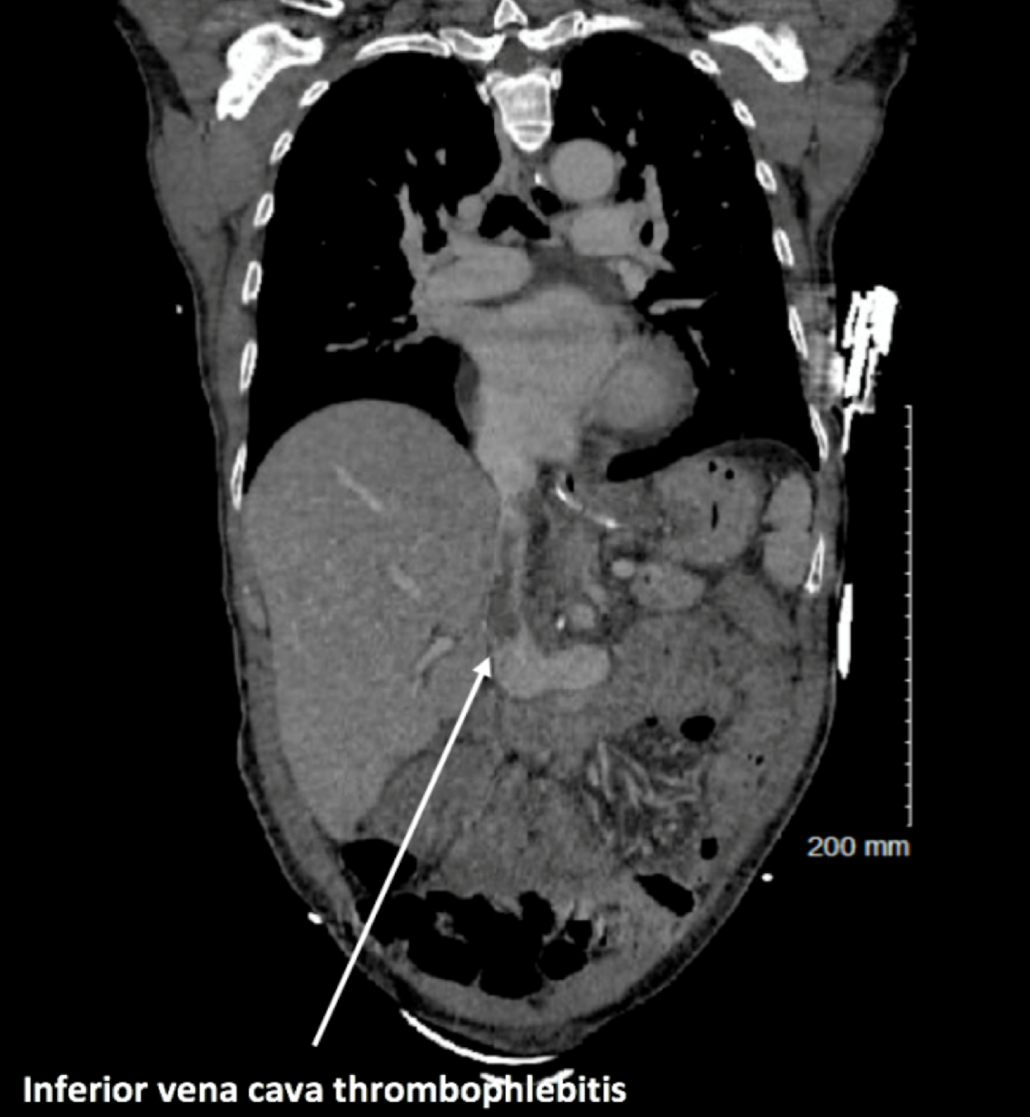
Figure 1 Coronal computed tomography scan of thrombophlebitis of the vena cava after hepatectomy.
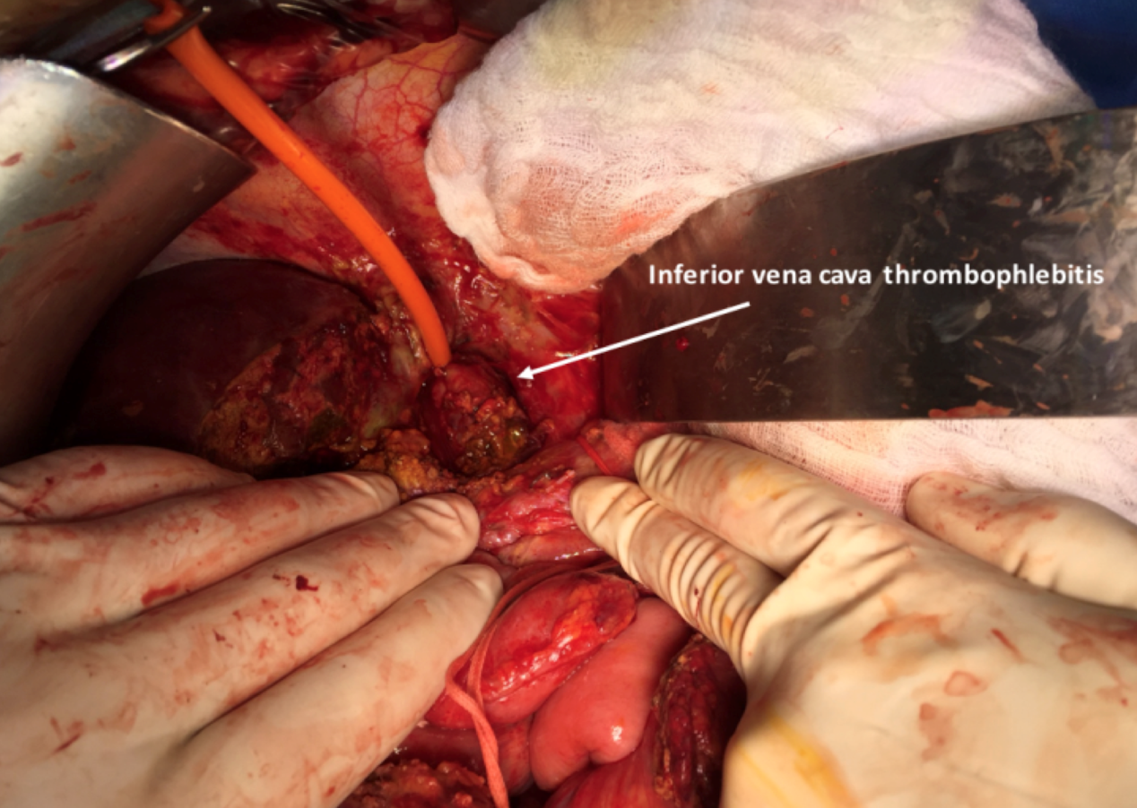
Figure 2 Image of the thrombus during the second surgery.
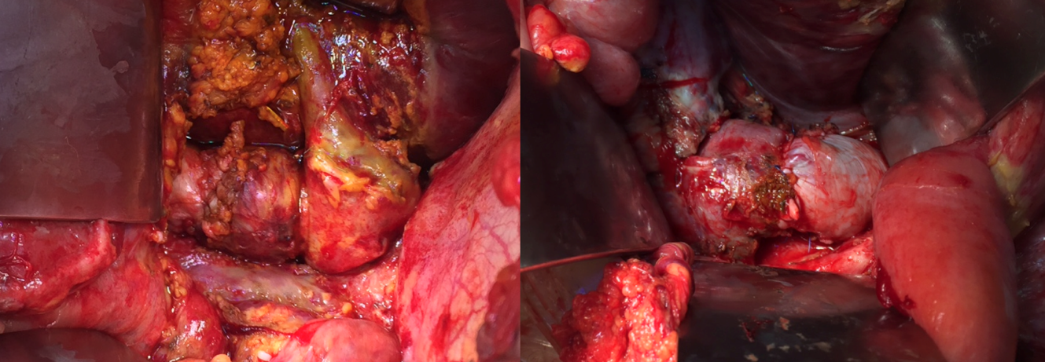
Figure 3 Vena cava reconstruction with a parietal peritoneum tube graft.

