Name of Journal: World Journal of Orthopedics
ESPS Manuscript NO: 30115
Manuscript Type: Minireviews

Evaluation and treatment of internal impingement of the shoulder in overhead athletes

Corpus KT et al. Internal impingement of the shoulder

Keith T Corpus, Christopher L Camp, David M Dines, David W Altchek, Joshua S Dines

Keith T Corpus, Christopher L Camp, David M Dines, David W Altchek, Joshua S Dines, Shoulder and Sports Medicine Service, Hospital for Special Surgery, New York, NY 10021, United States

Author contributions: All authors equally contributed to this paper with conception and design of the study, literature review and analysis, drafting and critical revision and editing, and final approval of the final version.

Conflict-of-interest statement: No potential conflicts of interest. No financial support.

Open-Access: This article is an open-access article which was selected by an in-house editor and fully peer-reviewed by external reviewers. It is distributed in accordance with the Creative Commons Attribution Non Commercial (CC BY-NC 4.0) license, which permits others to distribute, remix, adapt, build upon this work non-commercially, and license their derivative works on different terms, provided the original work is properly cited and the use is non-commercial. See: http://creativecommons.org/licenses/by-nc/4.0/

Manuscript source: Invited manuscript

Correspondence to: Keith T Corpus, MD, Academic Training Department, Shoulder and Sports Medicine Service, Hospital for Special Surgery, 535 E 70th Street, New York, NY 10021, United States. corpuske@hss.edu
Telephone: +1-312-6187775

Received: April 28, 2016
Peer-review started: April 28, 2016
First decision: May 17, 2016
Revised: September 14, 2016
Accepted: October 5, 2016
Article in press:
Published online:

Abstract
One of the most common pathologic processes seen in overhead throwing athletes is posterior shoulder pain resulting from internal impingement. “Internal impingement” is a term used to describe a constellation of symptoms which result from the greater tuberosity of the humerus and the articular surface of the rotator cuff abutting the posterosuperior glenoid when the shoulder is in an abducted and externally rotated position. The pathophysiology in symptomatic internal impingement is multifactorial, involving physiologic shoulder remodeling, posterior capsular contracture, and scapular dyskinesis. Throwers with internal impingement may complain of shoulder stiffness or the need for a prolonged warm-up, decline in performance, or posterior shoulder pain. On physical examination, patients will demonstrate limited internal rotation and posterior shoulder pain with a posterior impingement test. Common imaging findings include the classic “Bennett lesion” on radiographs, as well as articular-sided partial rotator cuff tears and concomitant SLAP lesions. Mainstays of treatment include intense non-operative management focusing on rest and stretching protocols focusing on the posterior capsule. Operative management is variable depending on the exact pathology, but largely consists of rotator cuff debridement. Outcomes of operative treatment have been mixed, therefore intense non-operative treatment should remain the focus of treatment.

Key words: Internal impingement; Overhead athlete; Partial rotator cuff tear; Scapular dyskinesis; Posterior capsular contracture; SLAP tear

© The Author(s) 2016. Published by Baishideng Publishing Group Inc. All rights reserved.

Core tip: “Internal impingement” is a term used to describe a constellation of symptoms which result from the greater tuberosity of the humerus and the articular surface of the rotator cuff abutting the posterosuperior glenoid when the shoulder is in an abducted and externally rotated position. The pathophysiology in symptomatic internal impingement is multifactorial, involving physiologic shoulder remodeling, posterior capsular contracture, and scapular dyskinesis. Mainstays of treatment include intense non-operative management focusing on rest and stretching protocols focusing on the posterior capsule.

Corpus KT, Camp CL, Dines DM, Altchek DW, Dines JS. Evaluation and treatment of internal impingement of the shoulder in overhead athletes. World J Orthop 2016; In press

INTRODUCTION
Overhead throwing athletes, in particular baseball players, often place unique and significant repetitive stresses across the shoulder at the extremes of the functional arc of motion^{[1]}. Over the course of a career, repeated loading can lead to osseous and soft-tissue changes and ultimately pathology of the shoulder girdle^{[2–6]}. The complex biomechanics of the elite thrower predispose them to multiple types of shoulder dysfunction, and these patients often serve as a clinical challenge for the sports medicine physician.
One of the most common pathologic processes seen in this patient population is shoulder pain resulting from internal impingement. “Internal impingement” is a term used to describe a constellation of symptoms which result from the greater tuberosity of the humerus and the articular surface of the rotator cuff abutting the posterosuperior glenoid when the shoulder is in an abducted and externally rotated position^{[7]}.
The purpose of this article is to review the pathoanatomic features of symptomatic internal impingement, as well as review the current concepts involved with diagnosis and treatment of this condition.

HISTORICAL PERSPECTIVE
Posterior shoulder pain has been a debated topic dating back to the 1950s, as described by Bennett^{[8]}. At that time, he proposed that pain in the posterior shoulder was secondary to inflammation in the posterior capsule and inferior glenohumeral ligament due to triceps traction. This traction injury resulted in exostosis of the posteroinferior glenoid rim, which became known as the “Bennett lesion”^{[8]}. Bennett also described the presence of articular-sided posterosuperior rotator cuff tears in these same athletes^{[9]}. In 1977, Lombardo et al^{[10]} further described ossification of the posterior glenoid rim in their description of an open approach for treatment of posterior shoulder pain in overhead throwing athletes.
In 1985, Andrews et al^{[11]} described a series of overhead athletes with posterior shoulder pain that developed articular-sided posterosuperior cuff tears with concomitant SLAP lesions. Later, Jobe et al^{[12]} reported on a series of overhead athletes with posterosuperior impingement associated with anterior instability. They found that these patients did not respond well to standard subacromial decompression, but rather had success with anterior capsulolabral reconstruction. In addition, these patients often presented with a number of associated injuries including superior or inferior labral tears, rotator cuff tears, injury to the greater tuberosity or glenoid, or inferior glenohumeral ligament injury.
In 1992, Walch et al^{[7]} reported a series of patients with impingement between the articular side of the supraspinatus tendon and the posterosuperior edge of the glenoid cavity, typically noted during maximal abduction and external rotation. At arthroscopy, these patients classically demonstrated a partial articular-sided rotator cuff tear. As a result, they described the “internal impingement” mechanism in which the undersurface of the posterior rotator cuff becomes entrapped between the labrum and the greater tuberosity in the abduction-external rotation position^{[7,13]}.

PATHOPHYSIOLOGY AND BIOMECHANICS
The biomechanical pathogenesis of internal impingement has been widely debated since its description. Some had posited that acquired anterior instability is the causative factor, while others have refuted this notion citing evidence suggesting no correlation between symptomatic internal impingement and anterior glenohumeral translation^{[12,14–20]}. More current thinking suggests that symptomatic internal impingement is multifactorial, involving physiologic shoulder remodeling, posterior capsular contracture, and scapular dyskinesis^{[21,22]}.

Kinetic chain
The kinetic chain concept describes the coordinated motion that transmits energy in a synchronized fashion from the lower extremity, through the trunk, to the shoulder, and finally to the ball as it is released^{[23–25]}. Key elements of the kinetic chain are leg strength, body rotation, core strength, scapular position and motion, and shoulder rotation. Inflexibility, weakness, and imbalance of any point in the kinetic chain can create a situation where the arm lags behind the legs and trunk, placing the throwing shoulder in a vulnerable position, increasing stresses about the shoulder and leading to injury.
This concept is vital to the throwing motion and has been broken down in to six distinct phases which comprise the throwing cycle. The first three phases consist of the wind-up, early cocking, and late cocking phases. These phases account for the bulk of the total time spent in the throwing motion (approximately 1.5 s), and they allow proper positioning of the lower extremities, core, and arms in preparation for release of the ball^{[15,26,27]}. In the late cocking phase, the shoulder is placed in abduction (90-100 degrees) and maximal external rotation (170-180 degrees), the position commonly associated with internal impingement^{[7]}. The fourth phase, the acceleration phase, is the phase in which the greatest angular velocity change is seen across the shoulder joint as the ball is propelled forward. This motion occurs at a rotational velocity of over 7250 degrees per second and is the fastest human motion to ever be recorded^{[24,28–30]}. It follows that this phase results in the most injuries, despite being the shortest phase (0.05 s). As the ball is released, the deceleration phase and follow through phase are completed which result in a distraction force across the joint as the arm is slowed (0.35 s).

Thrower’s paradox
The “thrower’s paradox” refers to the delicate balance between mobility and stability which allows pitchers to achieve a high level of function^{[24,31]}. To generate rational velocities upwards of 7000°/s, the arc of motion must be expanded to allow maximal external rotation of the shoulder. The normal arc of rotation of a healthy shoulder from maximal internal rotation to maximal external rotation is 180°^{[31]}. The arc of motion in a high-level throwing athlete is shifted posteriorly to allow for increased external rotation at the cost of decreased internal rotation by allowing increased clearance of the greater tuberosity over the glenoid during rotation^{[2–4,21,23,25]}. Increased external rotation is achieved by a number of shoulder adaptations that develop over time including increased retroversion of the humeral head and glenoid, and increased anterior capsular laxity^{[1,2,4,5,17,32]}.
Andrews et al^{[33]} and Bigliani et al^{[34]} have suggested that glenohumeral joint laxity is a common finding among throwing athletes. Jobe et al^{[12,32,35]} originally described “subtle instability”, or microinstability, to define the acquired laxity and anterior translation of the humeral head that occurs with the arm in a maximally abducted and externally rotated position. At what point this laxity becomes pathologic is another matter of debate. Subtle instability is postulated to result from repetitive shear stresses during the cocking and acceleration phases and contributes to the development of labral tears and articular-sided rotator cuff tears. Paley et al^{[17]} stated anterior instability is actually the most significant factor in the development of internal impingement.
Alternatively, some authors have posited that microinstability of the shoulder actually protects against internal impingement^{[3,7,21]}. Cadaveric, magnetic resonance imaging (MRI), and arthroscopic studies have consistently shown that contact of the rotator cuff on the posterosuperior labrum is a normal, physiologic occurrence^{[3,21,23,28]}. This theory postulates that the abnormal laxity of the humerus relative to the glenoid actually prevents impingement between the greater tuberosity and superior glenoid.
The anatomic changes allowing for increased external rotation can also result in remodeling of the posterior soft tissues, leading to contracture of the posterior capsule and posterior band of the inferior glenohumeral ligament^{[21]}. This increased external rotation creates increased torsional and shear stress upon the biceps anchor and undersurface of the rotator cuff^{[1,7,28,32,35,36]}.
Despite the need for increased laxity, adequate stability must be maintained to prevent symptomatic humeral head subluxation, often achieved through further posterior capsular contracture. When present, these alterations can contribute to internal impingement and lead to rotator cuff tears, labral tears, capsular injuries, chondral injuries, and biceps tendon pathology. These findings were confirmed in a cadaveric model by Grossman et al^{[26]}, who reported on a simulated posterior capsular contraction model which led to GIRD and posterosuperior translation of the humeral head during the late cocking, ultimately resulting in SLAP injuries. Each of these processes can lead to pain, decreased velocity, loss of control, and diminished endurance in the throwing athlete.
Clinically, loss of 15 degrees or more of internal rotation in the throwing shoulder compared to the non-dominant arm is commonly seen. The potential for injury increases once this threshold has been reached. Burkhart et al^{[21,37]}, have reported that shoulders with an internal rotation deficit > 25 degrees are at increased risk for development of SLAP lesions as a result of increased posterosuperior peel back on the labrum. In addition, Dines et al^{[38]} have shown that throwers with ulnar collateral ligament insufficiency at the elbow demonstrated a significant amount of GIRD as compared to players without a history of elbow injury.

Scapular dyskinesis
Kibler^{[39]} has defined scapular dyskinesis as an alteration in the normal resting position of the scapula or an alteration in the normal dynamic scapular motion. The scapula serves as an important link in the kinetic chain. When the scapula is unable to effectively transmit energy from the trunk to the pitching arm or stabilize the shoulder properly, pitching mechanics become inefficient and pitching velocity can suffer. Pitchers will then compensate by recruiting other surrounding musculature and increasing stress across the shoulder joint^{[39]}.
Scapular motion has been found to be more intricate than once thought. Instead of the proposed 2:1 ratio of humeral to scapular motion during forward elevation, recent studies have shown the scapula to have a more complex role in shoulder motion. Scapular motion is now defined in three planes: Internal/external rotation around a vertical axis, upward/downward rotation around a horizontal axis, and anterior/posterior tilt around a horizontal axis^{[39]}. The intricate scapular positioning is controlled dynamically by force couples generated by the trapezius, serratus anterior, latissimus dorsi, and rhomboid musculature. These muscular couples contract before rotator cuff activation, allowing the cuff to contract against a stable scapular base^{[40]}.
Myers et al^{[41]} have previously reported that throwers normally develop upward rotation, internal rotation, and retraction of the scapula during forward elevation of the humerus. Scapular dyskinesis may result from inflexibility or imbalances in periscapular muscles secondary to fatigue, direct trauma, or nerve injury^{[25]}. In pitchers with poor scapulothoracic rhythm, there is a trend toward scapular internal rotation and protraction around the rib cage resulting from inflexibility or imbalances in the periscapular musculature^{[41]}. When the scapula is ineffective in stabilizing the shoulder, the rotator cuff is forced to over-compensate to stabilize the glenohumeral joint. These loads are then transmitted to the superior glenoid and the articular surface of the rotator cuff tendons and can lead to injury. This alteration in function is thought to be an independent factor in the development of internal impingement. It follows that scapular dyskinesis has been reported in up to 100% of patients with internal impingement^{[40,42]}.

HISTORY AND PHYSICAL EXAMINATION
A thorough history is the first step in appropriately diagnosing internal impingement (Table 1). Throwers with internal impingement may complain of shoulder stiffness or the need for a prolonged warm-up. They may also note a decline in performance, including loss of control or decreases in pitch velocity. They may also describe posterior shoulder pain, especially in the late cocking phase. These complaints were outlined by Jobe^{[35]}, who defined three stages in the clinical presentation of internal impingement. Stage I consists of stiffness and difficulty in warming up, but no complaints of pain. Stage II is hallmarked by the complaint of pain during the late cocking phase of the throwing cycle. Those patients that have recurrent pain after a period of adequate rest and rehabilitation are classified as Stage III (Table 2).
The classic presentation and physical exam findings in the throwing shoulder with internal impingement commonly consists of posterior glenohumeral joint line tenderness, increased external rotation, and decreased internal rotation. Despite this common pattern, a complete and thorough physical exam is important to identify any other associated shoulder pathology. The exam should start with visual inspection. Inspection may demonstrate greater muscular development in the dominant extremity, but assessment for any muscular atrophy must be performed. The scapulae are evaluated for positioning, dyskinesis, and winging. The scapula may have a prominent inferior medial border, and the throwing shoulder may appear to sag inferiorly compared to the non-throwing shoulder. Next, the coracoid process, anterior and posterior joint lines, greater tuberosity, long head of biceps tendon, AC joint, and deltoid should be palpated for tenderness.
Rotational glenohumeral motion should be assessed with the arm at the side and at 90 degrees of abduction. Internal impingement typically leads to posterior shoulder tightness in the throwing shoulder, leading to a loss of internal rotation^{[4,43]}. This finding has been confirmed in a population of college baseball players with shoulder pain, who demonstrated a 10 degree loss of internal rotation in their throwing shoulder as compared to both their non-dominant shoulder and pain-free controls^{[44]}. Forward elevation and horizontal abduction should also be evaluated.
Strength examination focusing the rotator cuff should be completed in all patients with suspected internal impingement. Rotator cuff involvement can range from undersurface fraying, to partial articular-sided tears, to full-thickness tears. The most common tendon involved is usually the infraspinatus; therefore special attention should be paid to external rotation strength.
Special testing may include the relocation test, described by Jobe, in which the shoulder is placed in 90 degrees of abduction and maximal external rotation. While in this position, the humerus is loaded in both an anterior and posterior direction. While posterior directed force will provoke pain and impingement, anterior loads will relieve pain (opposite from the traditional findings in patients with anterior shoulder instability)^{[35]}. A second test, the posterior impingement sign, was described by Meister^{[45]} and involves placing the shoulder into 90 to 110 degrees of abduction, slight extension, and maximum external rotation. The provocation of deep posterior pain indicates a positive test and is highly correlated with undersurface tearing of the rotator cuff and/or posterior labrum.
In addition to the relocation test described above, a global stability exam is also important in the evaluation of internal impingement. The difficulty with stability examination in this patient population harkens back to the “thrower’s paradox” previously described. Many of these patients have adaptive laxity, which must be distinguished from pathologic laxity. Most often, the most important finding is the patient’s subjective sensation of shoulder subluxation during examination, which may occur while placing the patient in the position of apprehension. Additionally, a good examination under anesthesia at arthroscopy is vital for stability testing.
Lastly, examination of the posterosuperior labrum is an important component of the internal impingement exam, as labral tears in this location are common. Multiple physical exam maneuvers have been described for evaluation of the superior labrum and have shown high sensitivity for detection of tears, but none have shown high specificity for identification of superior labral tears^{[46–48]}.

RADIOGRAPHIC EVALUATION
Radiographic evaluation should begin with standard shoulder radiographs, including internal and external rotation anteroposterior, scapular Y, axillary, and West Point views^{[1]}. Radiographs may be normal in the setting of internal impingement, but patients may display several radiographic findings in association with this pathologic process. Common radiographic findings include the “Bennett lesion” (exostosis of the posteroinferior glenoid rim), sclerosis of the greater tuberosity, posterior humeral head osteochondral cysts, and rounding of the posterior glenoid rim^{[8,9]}.
The mainstay of radiographic evaluation is MRI, which has a high sensitivity for capsular, labral, and rotator cuff pathology in the throwing shoulder. At our institution, we routinely perform noncontrast MRI, as it has been shown to have equivalent or superior sensitivity and specificity rates to MR arthrogram, when appropriate pulse sequences are utilized^{[49]}. Common MRI findings in patients with internal impingement include posterosuperior labral tears, partial-thickness articular-sided rotator cuff tears most notably at the junction between the supraspinatus and infraspinatus as they insert on to the humeral head, and cystic changes in the posterior aspect of the humeral head^{[50,51]}. Additionally, patients can display calcification at the scapular attachment of the posterior capsule (Bennett lesion), posterior capsular contracture and thickening at the level of the posterior band of the inferior glenohumeral ligament, and subchondral fracture and remodeling of the posterosuperior glenoid^{[1]} (Figures 1-3).

TREATMENT
Nonoperative management
Once a diagnosis of internal impingement is made, non-operative management should be recommended as the first line treatment. The proper non-operative treatment can be tailored based on stages set forth by Jobe discussed earlier^{[35]}. Patients in Stage I (those with complaints of stiffness and difficulty warming up but without localized posterior shoulder pain) should be prescribed a course of nonsteroidal anti-inflammatories and rest. Patients in Stage II (those with isolated posterior shoulder pain) usually require four to six weeks of rest and can also benefit from physical therapy^{[1]}. Physical therapy has been shown to be both therapeutic and protective against further injury in several studies^{[21,22,31]}.
Given the pathophysiologic mechanism of internal impingement, therapy is focused on correction of aberrant shoulder range of motion and scapular dyskinesis. To that end, special attention should be paid to correction of GIRD through the “sleeper stretch” which allows posterior capsular stretching. In a study of high-level tennis players performing daily “sleeper stretch” exercises, patients were found to have significant increases in both internal rotation and total rotation, as well as a 38% decrease in the prevalence of shoulder problems^{[21]} (Figure 4). In addition, scapular stabilization exercises should be recommended. As the throwing motion involves the entire body through the kinetic chain, core strengthening and lower body strengthening must also be stressed simultaneously. Lastly, proper throwing mechanics should be enforced, especially for younger athletes.
Corticosteroid injections directed at the posteroinferior glenoid rim have been described^{[52]}. These injections have mostly been used for diagnostic, rather than therapeutic, purposes. To this point, no compelling data has been published to support injections for internal impingement and should be used judiciously due to the potential risk of permanent tendon damage.

Operative treatment
Due to the spectrum of pathology seen in internal impingement, multiple operative treatment options exist. Paley et al^{[17]}, published a series demonstrating > 80% incidence of concomitant articular-sided rotator cuff tear in professional overhead athletes with internal impingement. Often, this tear will be associated with an adjacent “kissing lesion” seen as a labral tear. Historically, treatment of these lesions has included debridement or repair and possible acromioplasty, with mixed results. Andrews et al^{[11]} published a series of thirty-six overhead athletes with articular-sided partial tears of the supraspinatus that underwent arthroscopic debridement. They found 85% were able to return to their premorbid level of function, which they attributed to stimulation of tendon healing via debridement. Similarly, Sonnery-Cottet et al^{[20]} performed arthroscopic debridement on twenty-eight tennis players with articular-sided partial tears and glenoid lesions. 79% were able to return to play, but 91% still had some persistent pain.
Historically, most surgeons have felt that lesions involving more than half of the thickness of a rotator cuff tendon should be repaired. Some authors support completion of these partial tears to aid in soft-tissue mobilization, followed by standard double-row repair^{[53–55]}. More recent data suggests that partial tears up to 75% in high-level throwing athletes should be debrided unless they involve the anterior cable of the rotator cuff. The high forces that throwing athletes generate subject the cuff to intense stress and threaten the repair integrity^{[56]}. In cases involving injury to the anterior cable, the anterior cable can be repaired and the partial thickness posterior cuff injury can be debrided. If partial tear completion and repair is indicated, a lateralized double-row repair as described by Dines et al^{[57]}, should be considered as it has shown favorable outcomes in professional overhead throwing athletes, allowing restoration of a more anatomic footprint.
Additional pathology seen in internal impingement includes SLAP tears, biceps tenosynovitis, and degenerative changes in the humeral articular surface^{[7,58]}. Meister et al^{[45]} reported their results of twenty-two overhead athletes with internal impingement who underwent debridement of the rotator cuff, biceps, and labrum. A subset of patients also underwent arthroscopic removal of a Bennett lesion. Only 55% of the cohort had returned to their premorbid level at 6 years post-op. Neri et al^{[59]} also evaluated a cohort of high-level overhead athletes who underwent Type II SLAP repairs at a mean of three years follow up and found that only 57% were able to return to their pre-injury level of competition, while an additional 25% returned to sport but were limited by pain. These marginal results may be due to the higher demand elite overhead athletes place on their shoulders and higher expectations amongst the study group. In addition, Neri et al^{[59]} showed that a statistically significant correlation did exist between the presence of partial-thickness rotator cuff tears and the inability to return to pre-injury level of play (Figure 5).
Andrews et al^{[60]} have suggested that the poor results of debridement alone could be attributed to unaddressed subtle anterior laxity. As a result, they advocated for concomitant open anterior stabilization. They reported a 92% success rate at an average of close to three years postoperatively in a cohort of twenty-five athletes. Other studies have had less-optimistic results^{[35]}.
Lastly, some authors have proposed osseous procedures to address the osseous changes which heavily contribute process of internal impingement. Riand et al^{[61]} reported on humeral osteotomies to increase humeral retroversion in twenty patients who had continued pain after arthroscopic debridement. Eleven of the twenty patients were able to resume sports activities at the same level, and five were able to resume sports at a lower level.

CONCLUSION
Internal impingement is a complex pathologic process secondary to repetitive use in overhead athletes resulting in articular-sided partial-thickness rotator cuff tears and SLAP lesions. The pathogenesis of internal impingement is multi-factorial. Understanding the etiology and pathogenesis will allow proper diagnosis and treatment.

REFERENCES
1 Drakos MC, Rudzki JR, Allen AA, Potter HG, Altchek DW. Internal impingement of the shoulder in the overhead athlete. J Bone Joint Surg Am 2009; 91: 2719-2728 [PMID: 19884449 DOI: 10.2106/JBJS.I.00409]
2 Crockett HC, Gross LB, Wilk KE, Schwartz ML, Reed J, O'Mara J, Reilly MT, Dugas JR, Meister K, Lyman S, Andrews JR. Osseous adaptation and range of motion at the glenohumeral joint in professional baseball pitchers. Am J Sports Med 2002; 30: 20-26 [PMID: 11798991]
3 Halbrecht JL, Tirman P, Atkin D. Internal impingement of the shoulder: comparison of findings between the throwing and nonthrowing shoulders of college baseball players. Arthroscopy 1999; 15: 253-258 [PMID: 10231101 DOI: 10.1016/S0749-8063(99)70030-7]
4 Myers JB, Laudner KG, Pasquale MR, Bradley JP, Lephart SM. Glenohumeral range of motion deficits and posterior shoulder tightness in throwers with pathologic internal impingement. Am J Sports Med 2006; 34: 385-391 [PMID: 16303877 DOI: 10.1177/0363546505281804]
5 Osbahr DC, Cannon DL, Speer KP. Retroversion of the humerus in the throwing shoulder of college baseball pitchers. Am J Sports Med 2002; 30: 347-353 [PMID: 12016074]
6 Wright RW, Paletta GA. Prevalence of the Bennett lesion of the shoulder in major league pitchers. Am J Sports Med 2004; 32: 121-124 [PMID: 14754734 DOI: 10.1177/0363546503260712]
7 Walch G, Boileau P, Noel E, Donell ST. Impingement of the deep surface of the supraspinatus tendon on the posterosuperior glenoid rim: An arthroscopic study. J Shoulder Elbow Surg 1992; 1: 238-245 [PMID: 22959196 DOI: 10.1016/S1058-2746(09)80065-7]
8 Bennett GE. Shoulder and elbow lesions distinctive of baseball players. 1947. Clin Orthop Relat Res 2012; 470: 1531-1533 [PMID: 22476897 DOI: 10.1007/s11999-012-2335-2]
9 Bennett GE. Elbow and shoulder lesions of baseball players: George E. Bennett MD (1885-1962). The 8th president of the AAOS 1939. Clin Orthop Relat Res 2008; 466: 62-73 [PMID: 18196375 DOI: 10.1007/s11999-007-0028-z]
10 Lombardo SJ, Jobe FW, Kerlan RK, Carter VS, Shields CL. Posterior shoulder lesions in throwing athletes. Am J Sports Med 1977; 5: 106-110 [PMID: 860772 DOI: 10.1177/036354657700500302]
11 Andrews JR, Broussard TS, Carson WG. Arthroscopy of the shoulder in the management of partial tears of the rotator cuff: a preliminary report. Arthroscopy 1985; 1: 117-122 [PMID: 4091915 DOI: 10.1016/S0749-8063(85)80041-4]
12 Jobe FW, Kvitne RS, Giangarra CE. Shoulder pain in the overhand or throwing athlete. The relationship of anterior instability and rotator cuff impingement. Orthop Rev 1989; 18: 963-975 [PMID: 2797861]
13 Walch G, Liotard JP, Boileau P, Noël E. [Postero-superior glenoid impingement. Another impingement of the shoulder]. J Radiol 1993; 74: 47-50 [PMID: 8483151]
14 Conway JE. Arthroscopic repair of partial-thickness rotator cuff tears and SLAP lesions in professional baseball players. Orthop Clin North Am 2001; 32: 443-456 [PMID: 11888139]
15 Jobe FW, Moynes DR, Tibone JE, Perry J. An EMG analysis of the shoulder in pitching. A second report. Am J Sports Med 1984; 12: 218-220 [PMID: 6742305]
16 Kvitne RS, Jobe FW. The diagnosis and treatment of anterior instability in the throwing athlete. Clin Orthop Relat Res 1993: 107-123 [PMID: 8504590]
17 Paley KJ, Jobe FW, Pink MM, Kvitne RS, ElAttrache NS. Arthroscopic findings in the overhand throwing athlete: evidence for posterior internal impingement of the rotator cuff. Arthroscopy 2000; 16: 35-40 [PMID: 10627343 DOI: 10.1016/S0749-8063(00)90125-7]
18 Borsa PA, Wilk KE, Jacobson JA, Scibek JS, Dover GC, Reinold MM, Andrews JR. Correlation of range of motion and glenohumeral translation in professional baseball pitchers. Am J Sports Med 2005; 33: 1392-1399 [PMID: 16002489 DOI: 10.1177/0363546504273490]
19 Ellenbecker TS, Mattalino AJ, Elam E, Caplinger R. Quantification of anterior translation of the humeral head in the throwing shoulder. Manual assessment versus stress radiography. Am J Sports Med 2000; 28: 161-167 [PMID: 10750991]
20 Sonnery-Cottet B, Edwards TB, Noel E, Walch G. Results of arthroscopic treatment of posterosuperior glenoid impingement in tennis players. Am J Sports Med 2002; 30: 227-232 [PMID: 11912093]
21 Burkhart SS, Morgan CD, Kibler WB. The disabled throwing shoulder: spectrum of pathology Part I: pathoanatomy and biomechanics. Arthroscopy 2003; 19: 404-420 [PMID: 12671624 DOI: 10.1053/jars.2003.50128]
22 Burkhart SS, Morgan CD, Kibler WB. The disabled throwing shoulder: spectrum of pathology Part III: The SICK scapula, scapular dyskinesis, the kinetic chain, and rehabilitation. Arthroscopy 2003; 19: 641-661 [PMID: 12861203 DOI: 10.1016/S0749-8063(03)00389-X]
23 Edelson G, Teitz C. Internal impingement in the shoulder. J Shoulder Elbow Surg 2000; 9: 308-315 [PMID: 10979527 DOI: 10.1067/mse.2000.105449]
24 Fleisig GS, Andrews JR, Dillman CJ, Escamilla RF. Kinetics of baseball pitching with implications about injury mechanisms. Am J Sports Med 1995; 23: 233-239 [PMID: 7778711 DOI: 10.1177/036354659502300218]
25 Braun BS, Kokmeyer D, Millett PJ. Shoulder Injuries in the Throwing Athlete Shoulder Injuries in the Throwing Athlete. Bone 2011: 966-978 [DOI: 10.2106/JBJS.H.01341]
26 Grossman MG, Tibone JE, McGarry MH, Schneider DJ, Veneziani S, Lee TQ. A cadaveric model of the throwing shoulder: a possible etiology of superior labrum anterior-to-posterior lesions. J Bone Joint Surg Am 2005; 87: 824-831 [PMID: 15805213 DOI: 10.2106/JBJS.D.01972]
27 Kelly BT, Backus SI, Warren RF, Williams RJ. Electromyographic analysis and phase definition of the overhead football throw. Am J Sports Med 2002; 30: 837-844 [PMID: 12435650 DOI: 10.1177/03635465020300061401]
28 Burkhart SS. Internal impingement of the shoulder. Instr Course Lect 2006; 55: 29-34 [PMID: 16958436]
29 Kuhn JE, Lindholm SR, Huston LJ, Soslowsky LJ, Blasier RB. Failure of the biceps superior labral complex: a cadaveric biomechanical investigation comparing the late cocking and early deceleration positions of throwing. Arthroscopy 2003; 19: 373-379 [PMID: 12671620 DOI: 10.1053/jars.2003.50044]
30 Levitz CL, Dugas J, Andrews JR. The use of arthroscopic thermal capsulorrhaphy to treat internal impingement in baseball players. Arthroscopy 2001; 17: 573-577 [PMID: 11447542 DOI: 10.1053/jars.2001.24853]
31 Wilk KE, Meister K, Andrews JR. Current concepts in the rehabilitation of the overhead throwing athlete. Am J Sports Med 2002; 30: 136-151 [PMID: 11799012 DOI: 10.1177/0363546506290403]
32 Jobe CM. Posterior superior glenoid impingement: expanded spectrum. Arthroscopy 1995; 11: 530-536 [PMID: 8534293 DOI: 10.1016/0749-8063(95)90128-0]
33 Andrews JR, Carson WG, McLeod WD. Glenoid labrum tears related to the long head of the biceps. Am J Sports Med 1985; 13: 337-341 [PMID: 4051091 DOI: 10.1177/036354658501300508]
34 Bigliani LU, Codd TP, Connor PM, Levine WN, Littlefield MA, Hershon SJ. Shoulder motion and laxity in the professional baseball player. Am J Sports Med 1997; 25: 609-613 [PMID: 9302464 DOI: 10.1177/036354659702500504]
35 Jobe CM. Superior glenoid impingement. Orthop Clin North Am 1997; 28: 137-143 [PMID: 9113710]
36 Heyworth BE, Williams RJ. Internal impingement of the shoulder. Am J Sports Med 2009; 37: 1024-1037 [PMID: 19059895 DOI: 10.1177/0363546508324966]
37 Burkhart SS, Morgan CD. The peel-back mechanism: its role in producing and extending posterior type II SLAP lesions and its effect on SLAP repair rehabilitation. Arthroscopy 1998; 14: 637-640 [PMID: 9754487 DOI: 10.1016/S0749-8063(98)70065-9]
38 Dines JS, Frank JB, Akerman M, Yocum LA. Glenohumeral internal rotation deficits in baseball players with ulnar collateral ligament insufficiency. Am J Sports Med 2009; 37: 566-570 [PMID: 19059890 DOI: 10.1177/0363546508326712]
39 Kibler WB. Scapular involvement in impingement: signs and symptoms. Instr Course Lect 2006; 55: 35-43 [PMID: 16958437]
40 Kibler WB. The role of the scapula in athletic shoulder function. Am J Sports Med 1998; 26: 325-337 [PMID: 9548131 DOI: 10.1177/03635465980260022801]
41 Myers JB, Laudner KG, Pasquale MR, Bradley JP, Lephart SM. Scapular position and orientation in throwing athletes. Am J Sports Med 2005; 33: 263-271 [PMID: 15701613 DOI: 10.1177/0363546504268138]
42 Warner JJ, Micheli LJ, Arslanian LE, Kennedy J, Kennedy R. Scapulothoracic motion in normal shoulders and shoulders with glenohumeral instability and impingement syndrome. A study using Moiré topographic analysis. Clin Orthop Relat Res 1992: 191-199 [PMID: 1446436]
43 Lintner D, Mayol M, Uzodinma O, Jones R, Labossiere D. Glenohumeral internal rotation deficits in professional pitchers enrolled in an internal rotation stretching program. Am J Sports Med 2007; 35: 617-621 [PMID: 17293473 DOI: 10.1177/0363546506296736]
44 Ruotolo C, Price E, Panchal A. Loss of total arc of motion in collegiate baseball players. J Shoulder Elbow Surg 2006; 15: 67-71 [PMID: 16414471 DOI: 10.1016/j.jse.2005.05.006]
45 Meister K, Buckley B, Batts J. The posterior impingement sign: diagnosis of rotator cuff and posterior labral tears secondary to internal impingement in overhand athletes. Am J Orthop (Belle Mead NJ) 2004; 33: 412-415 [PMID: 15379239]
46 Meserve BB, Cleland JA, Boucher TR. A meta-analysis examining clinical test utility for assessing superior labral anterior posterior lesions. Am J Sports Med 2009; 37: 2252-2258 [PMID: 19095895 DOI: 10.1177/0363546508325153]
47 O'Brien SJ, Pagnani MJ, Fealy S, McGlynn SR, Wilson JB. The active compression test: a new and effective test for diagnosing labral tears and acromioclavicular joint abnormality. Am J Sports Med 1998; 26: 610-613 [PMID: 9784804 DOI: 10.1177/03635465980260050201]
48 Parentis MA, Glousman RE, Mohr KS, Yocum LA. An evaluation of the provocative tests for superior labral anterior posterior lesions. Am J Sports Med 2006; 34: 265-268 [PMID: 16219944 DOI: 10.1177/0363546505279911]
49 Connell DA, Potter HG, Wickiewicz TL, Altchek DW, Warren RF. Noncontrast magnetic resonance imaging of superior labral lesions. 102 cases confirmed at arthroscopic surgery. Am J Sports Med 1999; 27: 208-213 [PMID: 10102103]
50 Kaplan LD, McMahon PJ, Towers J, Irrgang JJ, Rodosky MW. Internal impingement: findings on magnetic resonance imaging and arthroscopic evaluation. Arthroscopy 2004; 20: 701-704 [PMID: 15346111 DOI: 10.1016/j.arthro.2004.06.006]
51 Giaroli EL, Major NM, Higgins LD. MRI of internal impingement of the shoulder. AJR Am J Roentgenol 2005; 185: 925-929 [PMID: 16177410 DOI: 10.2214/AJR.04.0971]
52 Yoneda M, Nakagawa S, Hayashida K, Fukushima S, Wakitani S. Arthroscopic removal of symptomatic Bennett lesions in the shoulders of baseball players: arthroscopic Bennett-plasty. Am J Sports Med 2002; 30: 728-736 [PMID: 12239010]
53 Mithofer K, Fealy S, Altchek DW. Arthroscopic treatment of internal impingement of the shoulder. Tech Shoulder Elb Surg 2004; 5: 66-75
54 Lo IK, Burkhart SS. Double-row arthroscopic rotator cuff repair: re-establishing the footprint of the rotator cuff. Arthroscopy 2003; 19: 1035-1042 [PMID: 14608329]
55 Meier SW, Meier JD. Rotator cuff repair: the effect of double-row fixation on three-dimensional repair site. J Shoulder Elbow Surg 2006; 15: 691-696 [PMID: 17126241 DOI: 10.1016/j.jse.2006.03.004
56 Rudzki JR, Shaffer B. New approaches to diagnosis and arthroscopic management of partial-thickness cuff tears. Clin Sports Med 2008; 27: 691-717 [PMID: 19064151 DOI: 10.1016/j.csm.2008.06.004]
57 Dines JS, Jones K, Maher P, Altchek D. Arthroscopic Management of Full-Thickness Rotator Cuff Tears in Major League Baseball Pitchers: The Lateralized Footprint Repair Technique. Am J Orthop (Belle Mead NJ) 2016; 45: 128-133 [PMID: 26991564]
58 Payne LZ, Altchek DW, Craig EV, Warren RF. Arthroscopic treatment of partial rotator cuff tears in young athletes. A preliminary report. Am J Sports Med 1997; 25: 299-305 [PMID: 9167807 DOI: 10.1177/036354659702500305]
59 Neri BR, ElAttrache NS, Owsley KC, Mohr K, Yocum LA. Outcome of type II superior labral anterior posterior repairs in elite overhead athletes: Effect of concomitant partial-thickness rotator cuff tears. Am J Sports Med 2011; 39: 114-120 [PMID: 20940452 DOI: 10.1177/0363546510379971]
60 Andrews JR, Dugas JR. Diagnosis and treatment of shoulder injuries in the throwing athlete: the role of thermal-assisted capsular shrinkage. Instr Course Lect 2001; 50: 17-21 [PMID: 11372312]
61 Riand N, Levigne C, Renaud E, Walch G. Results of derotational humeral osteotomy in posterosuperior glenoid impingement. Am J Sports Med 1998; 26: 453-459 [PMID: 9617413]

P-Reviewer: Carbone S, Ertem K, Ko SH, Vulcano E S-Editor: Ji FF L-Editor: E-Editor:

Table 1 Keys to diagnosing internal impingement
History  Physical Exam  Imaging | Shoulder stiffness  Need for prolonged warm-up  Decline in performance (loss of velocity of control)  Posterior shoulder pain in late cocking phase  Posterior glenohumeral joint line tenderness  Increased external rotation, decreased internal rotation  Scapular dyskinesis  Positive anterior relocation test  Positive posterior impingement sign  Bennett lesion (exostosis of posteroinferior glenoid rim)  Sclerosis of greater tuberosity, posterior humeral head cysts, rounding of posterior glenoid rim  Posterosuperior labral tears  Partial-thickness articular-sided rotator cuff tears (supraspinatus, infraspinatus)

Table 2 Jobe’s clinical classification of internal impingement^{[35]}
Stage | Presentation/symptoms
I: Early  II: Intermediate  III: Advanced | Shoulder stiffness and need for prolonged warm–up, no pain with ADLs  Pain localized to the posterior shoulder in the late cocking phase, no pain with ADLs  Similar symptoms to Stage II, but refractory to a period of adequate rest and rehabilitation

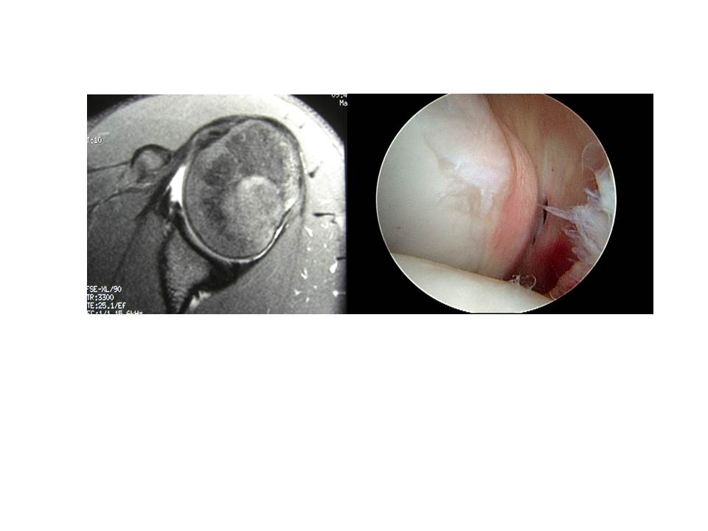
Figure 1 Magnetic resonance image of Bennett lesion and corresponding arthroscopic picture viewing posteriorly from anterosuperior portal.

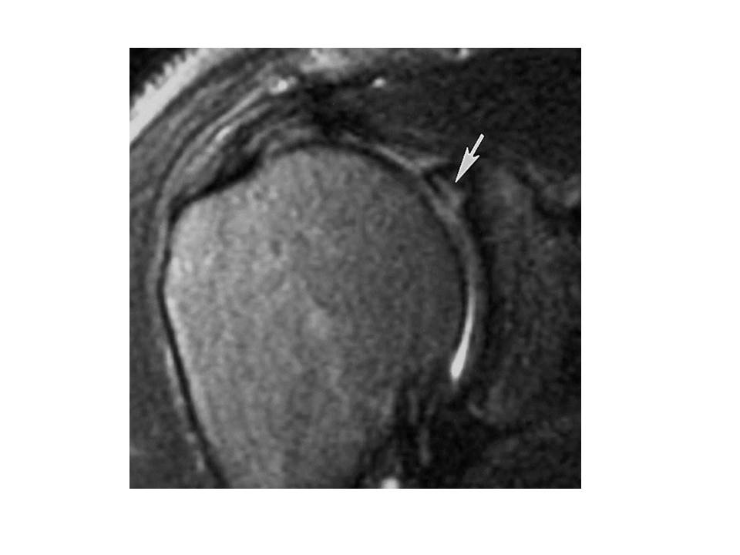
Figure 2 Magnetic resonance image of a Type 2 SLAP tear with concomitant partial thickness rotator cuff tear.

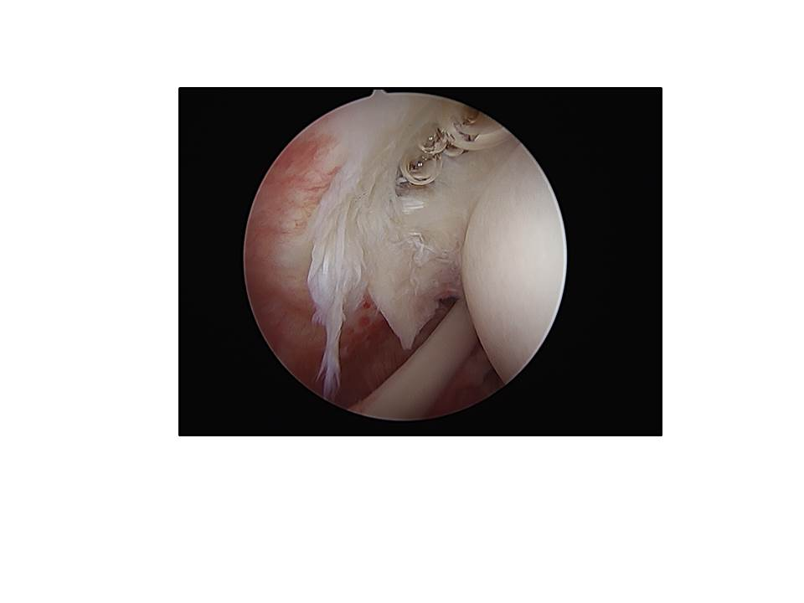
Figure 3 Partial thickness articular-sided tear of infraspinatus as viewed from posterior portal.

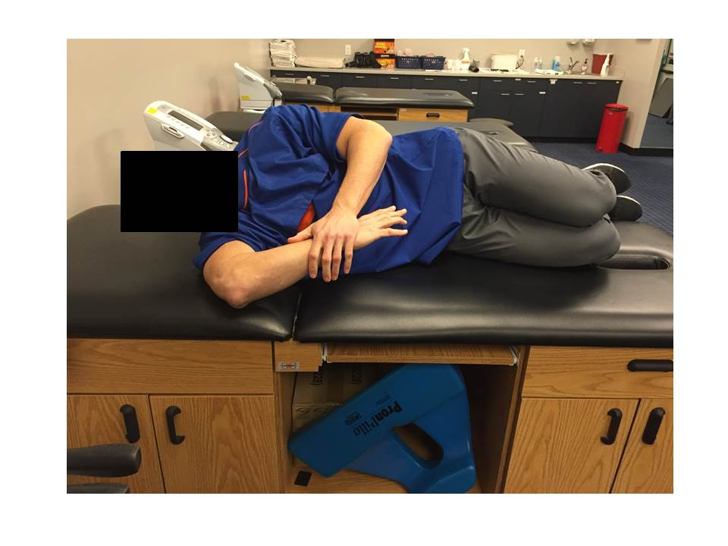
Figure 4 Demonstration of the “sleeper stretch”.

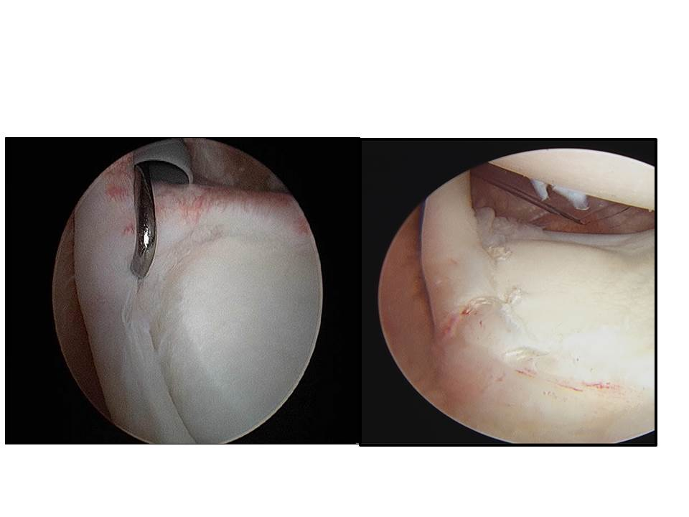
Figure 5 Type 2B SLAP tear s/p repair.

