Name of Journal: World Journal of Clinical Cases
Manuscript NO: 64569
Manuscript Type: CASE REPORT

Successful response to camrelizumab in metastatic bladder cancer: A case report

Xie C et al. Successful response to camrelizumab in mBC

Chen Xie, Xia Yuan, Shu-Hui Chen, Zhi-Yong Liu, Di-La Lu, Feng Xu, Zhi-Qiu Chen, Xiao-Ming Zhong

Chen Xie, Xia Yuan, Shu-Hui Chen, Zhi-Yong Liu, Di-La Lu, Xiao-Ming Zhong, Department of Radiology, Jiangxi Provincial Tumour Hospital, Nanchang 330029, Jiangxi Province, China

Chen Xie, Xia Yuan, Shu-Hui Chen, Zhi-Yong Liu, Di-La Lu, Xiao-Ming Zhong, Department of Radiology, The Affiliated Cancer Hospital of Nanchang University, Nanchang 330029, Jiangxi Province, China

Feng Xu, Zhi-Qiu Chen, Faculty of Medicine, Burning Rock Biotech, Guangzhou 510300, Guangdong Province, China

Author contributions: Zhong XM and Xie C conceived and designed the case report; Yuan X collected the data; Liu ZY, Chen SH, Xie C, and Chen ZQ performed the analysis; Lu DL performed the follow-up and recorded treatment-related side effects; Xu F and Zhong XM wrote the paper.

Corresponding author: Xiao-Ming Zhong, PhD, Chief Doctor, Department of Radiology, Jiangxi Provincial Tumour Hospital, No. 519 Beijing East Road, Nanchang 330029, Jiangxi Province, China. jddxf2012@126.com

Received: March 11, 2021
Revised: May 20, 2021
Accepted: July 12, 2021
Published online:

Abstract
BACKGROUND
There has been no report to use camrelizumab with chemotherapy for advanced bladder cancer patients with positive programmed death-ligand 1 (PD-L1) expression and high tumor mutational burden (TMB). More effective predictors of bladder cancer immunotherapy have yet to be explored, and the combination of multiple factors may be more predictive than a single factor.

CASE SUMMARY
We report the case of a 74-year-old male patient with recurrent metastatic bladder cancer, which demonstrated positive PD-L1 expression and high TMB. The immune checkpoint inhibitor camrelizumab was administered to the patient in combination with gemcitabine and cisplatin. The patient achieved a partial response with a progression-free survival of 11 mo.

CONCLUSION
This is the first report to use camrelizumab with chemotherapy for advanced bladder cancer patients with positive PD-L1 expression and high TMB.

Key Words: Programmed death-ligand 1; Tumor mutational burden; Bladder cancer; Camrelizumab; Next-generation sequencing; Case report

Xie C, Yuan X, Chen SH, Liu ZY, Lu DL, Xu F, Chen ZQ, Zhong XM. Successful response to camrelizumab in metastatic bladder cancer: A case report. World J Clin Cases 2021; In press

Core Tip: Eighty percent of patients with positive programmed death-ligand 1 (PD-L1) expression are unable to benefit from immunotherapy. Herein, we report the case of a 74-year-old male patient with recurrent metastatic bladder cancer, which demonstrated positive PD-L1 expression and high tumor mutational burden. The immune checkpoint inhibitor camrelizumab was administered to the patient in combination with gemcitabine and cisplatin. The patient achieved a partial response with a progression-free survival of 11 mo. More effective predictors of bladder cancer immunotherapy have yet to be explored, and the combination of multiple factors may be more predictive than a single factor.
INTRODUCTION
Multiple studies have demonstrated that blocking of programmed death 1 (PD-1) or its ligand programmed death-ligand 1 (PD-L1) improved anti-tumor activity in metastatic urothelial cancer patients with disease progression after standard chemotherapy^{[1-3]}. However, only a subset of patients is sensitive to immunotherapy. In addition to microsatellite instability (MSI) status and PD-L1 expression, tumor mutational burden (TMB), the third approved biomarker for immunosuppressant, could be used to predict the efficacy of immunosuppressive agents. Recently, increasing studies have indicated that there were no overlapping effects of PD-L1 expression and TMB on the response rate to PD-1/PD-L1 inhibitors across distinct tumor types, therefore they can be broadly used to categorize the immunologic subtypes of cancer^{[4]}.
Camrelizumab, as an anti-PD-1 inhibitor, provided an improved objective response rate (ORR) and disease control rate (DCR) in pre-treated patients with dMMR/MSI-high (MSI-H) and advanced or metastatic solid tumor. Several clinical trials of camrelizumab for advanced urinary system tumors such as NCT03827837 have been launched. It brings more treatment options to patients with an advanced or metastatic solid tumor, including bladder cancer. Herein, we report the case of a recurrent bladder cancer patient with positive PD-L1 expression and high TMB. The patient received camrelizumab in combination with chemotherapy and achieved a partial response (PR).

CASE PRESENTATION
Chief complaints
A patient presented with recurrent metastatic bladder cancer (metastatic urothelial carcinoma, mUC), which demonstrated positive PD-L1 expression and high TMB.

History of present illness
A 74-year-old male patient, with a history of high-grade urothelial carcinoma of the bladder, was initially presented to our hospital in August 2017 due to gross hematuria and dysuria. Recurrence of bladder cancer was declared by computed tomography (CT) imaging. The patient was subjected to radical cystectomy and lysis of pelvic adhesions. The pathological evaluation of the tumor sample indicated infiltrating high-grade urothelial carcinoma of the bladder which invaded the entire layer and surrounding adipose tissue (Figure 1). Two months after surgery, the patient had pain in the right pubic bone while magnetic resonance imaging (MRI) revealed recurrence of stage IV bladder cancer with bone metastases.

History of past illness
The patient had a free previous medical history.

Physical examination
Vital signs and general inspection included the head, neck, anterior torso, posterior torso, anterior chest, abdomen, male genitalia, gait, station, coordination. Our clinical consideration was the recurrence of bladder cancer.

Laboratory examinations
Routine blood tests, routine urine tests and urinary sediment examination, routine fecal tests and occult blood tests, blood biochemistry, immune indexes, infection indexes immunohistochemistry (IHC) test, routine blood test genetic mutation profiling, and TMB evaluation were performed.
The plasma sample of the patient was subjected to genetic mutation profiling and TMB evaluation through next-generation sequencing (NGS) with a panel consisting of 520 cancer-related genes (Burning Rock Biotech, Guangzhou, China). The sequencing identified a total of 19 somatic mutations, including PIK3CA (p.Glu545Lys) andARID1A (p.Ser1948fs) mutations, and RAF1 amplification (CN = 3.6). The TMB level was 19.8 mutations per Mb. Furthermore, IHC on tissue samples indicated positive PD-L1 protein expression with a tumor proportion score (TPS) of 20%.

Imaging examinations
CT imaging and MRI were performed. In September 2019, the reexamination of abdominal CT identified multiple newly appeared swollen retroperitoneal lymph nodes in which the largest node had a diameter of about 1.7 cm (Figure 2A). After three treatment cycles, the patient achieved a PR as the repeated CT scan on December 20, 2019 showed a 53% decrease in the target lesion (Figure 2B). Then, the patient continued camrelizumab (200 mg, D0, q3w) and gemcitabine (1 g, D1, D8, q3w) and maintained the PR (Figure 2C and D).

FINAL DIAGNOSIS
Recurrence of high-grade urothelial carcinoma of the bladder with bone metastases and multiple newly appearing swollen retroperitoneal lymph nodes.

TREATMENT
Palliative radiotherapy in the metastatic site was given to the patient. In May 2018, the patient had pain of the right ilium and the symphysis pubis and received palliative radiotherapy followed by four cycles of chemotherapy with paclitaxel liposome (210 mg Q3W) from July 10, 2018 to September 12, 2018. Based on the high TMB level and positive PD-L1 expression, the patient was administered with immunotherapy of camrelizumab (200 mg, D0, q3w) in combination with chemotherapy including gemcitabine (1 g, D1 and D8, q3w) and cisplatin (40 mg, D1-D3, q3w) since October 2019.

OUTCOME AND FOLLOW-UP
Since the patient had pain in the right pubic bone with bone metastases, palliative radiotherapy in the metastatic site was given to the patient, followed by four cycles of chemotherapy with paclitaxel liposome (210 mg Q3W). Mild gastrointestinal reactions developed during paclitaxel liposome and immunotherapy of camrelizumab (200 mg, D0, q3w) in combination with chemotherapy with gemcitabine (1 g, D1, D8, q3w) and cisplatin (40 mg, D1-D3, q3w). Oppression in the chest, grade 1 myeloid suppression, and abnormal liver and kidney function occurred during the first gemcitabine and cisplatin chemotherapy, and gemcitabine dose was therefore reduced. In addition, abnormal liver function, moderate anemia, and mild gastrointestinal reactions occurred during the immunotherapy with camrelizumab and chemotherapy with gemcitabine and cisplatin. The patient maintained PR. The latest follow-up in October 2020 showed the progression of the tumor. The total progression-free survival (PFS) of the patient since camrelizumab therapy was 11 mo.

DISCUSSION
The application of immunotherapy has thoroughly promoted the progress of cancer treatment in recent years. However, 80% of patients with positive PD-L1 are unable to benefit from immunotherapy. Hitherto FDA has approved five drugs as immunotherapies for bladder cancer, but the ORRs of these drugs in bladder cancer are 13.4%-21.1%^{[5]}. In clinical trials of camrelizumab in advanced solid tumors, some bladder carcinoma patients got a complete response^{[6]}. Camrelizumab provided improved ORR and DCR in pre-treated patients with dMMR/MSI-H and advanced or metastatic solid tumor^{[7,8]}. With the increase of approved immune checkpoint inhibitors, it is urgent to define patient subgroups that are more likely to have treatment benefits. PD-L1, as the only effective biomarker for prediction, is far from being enough.
High tumor mutation may lead to high neoantigen load and increased immunogenicity, which could promote recognition and killing abilities of the immune system. Multiple studies have shown that TMB is associated with the efficacy of mUC immunotherapy. A study indicated that tumor mutational load predicts survival after immunotherapy in mUC by the TMB cutoff of 17.6% or the cutoff of 25% by quartering^{[9]}. The updated result of the PURE-01 study revealed that TMB may predict the pathological response to pembrolizumab in patients with muscle-invasive bladder cancer while a pretreatment TMB of 15 mutations/Mb was predictive of pathological complete response^{[10]}. Another study showed that higher TMB levels revealed improved overall survival (OS) and lowered tumor recurrence^{[11]}. Based on many relevant clinical studies, On June 16, 2020, the Food and Drug Administration approved pembrolizumab for the treatment of adult and pediatric patients with unresectable or metastatic TMB-high [≥ 10 mutations/megabase (mut/Mb)] solid tumors.
In addition, the NGS results of the patient revealed an inactivated nonsense mutation in ARID1A (p.Ser1948fs) which results in the loss of ARID1A protein expression and indicates potential treatment response to immunotherapy. ARID1A mutation has a high incidence in tumors, and it can increase the efficacy of tumor immunotherapy through multiple mechanisms of action, including MSI-H phenotype, high TMB, upregulation of PD-L1 expression, and immune activated tumor microenvironment. The largest study of 17486 patients with gastrointestinal tumors has demonstrated selective DNA damage repair (DDR) defects and ARID1A defects were associated with high TMB. In general, ARID1A was inactivated with increased TMB and low gene copy number, suggesting that it may be an indicator of immunotherapy^{[12]}. Studies of immunotherapy for advanced urothelial carcinoma have shown that mutations in the DDR gene are associated with improved PFS and OS^{[13]}. The DDR gene is an independent factor associated with the efficacy of immunosuppressive therapy in mUC. In addition to high TMB (19.8 mutations per Mb) and positive PD-L1 expression (TPS 20%), the treatment benefit of camrelizumab observed in our case may also be explained by the change of the DDR gene. Hence, the patient received immunotherapy in combination with chemotherapy and achieved a PR with a PFS of 11 mo.
More effective predictors of bladder cancer immunotherapy have yet to be explored, and the combination of multiple factors may be more predictive than a single factor.

CONCLUSION
Here, we report a Chinese patient with advanced bladder cancer showing effective treatment response to camrelizumab in combination with chemotherapy. This is the first case report on the treatment effect of camrelizumab for advanced bladder cancer with positive PD-L1 expression and high TMB. Our study suggested that TMB, PD-L1 expression, and DDR gene mutation can be used in combination to predict treatment effects of immunotherapy. More studies are needed to develop effective biomarkers and identify appropriate patient subgroups that are more likely to benefit from cancer immunotherapies.

REFERENCES
1 Grayson M. Bladder cancer. Nature 2017; 551: S33 [PMID: 29117156 DOI: 10.1038/551S33a]
2 Berdik C. Unlocking bladder cancer. Nature 2017; 551: S34-S35 [PMID: 29117159 DOI: 10.1038/551S34a]
3 Crispen PL, Kusmartsev S. Mechanisms of immune evasion in bladder cancer. Cancer Immunol Immunother 2020; 69: 3-14 [PMID: 31811337 DOI: 10.1007/s00262-019-02443-4]
4 Yarchoan M, Albacker LA, Hopkins AC, Montesion M, Murugesan K, Vithayathil TT, Zaidi N, Azad NS, Laheru DA, Frampton GM, Jaffee EM. PD-L1 expression and tumor mutational burden are independent biomarkers in most cancers. JCI Insight 2019; 4 [PMID: 30895946 DOI: 10.1172/jci.insight.126908]
5 Yoon HS, Kwak C, Kim HH, Kim HS, Ku JH. Second-Line Systemic Treatment for Metastatic Urothelial Carcinoma: A Network Meta-Analysis of Randomized Phase III Clinical Trials. Front Oncol 2019; 9: 679 [PMID: 31403033 DOI: 10.3389/fonc.2019.00679]
6 Mo H, Huang J, Xu J, Chen X, Wu D, Qu D, Wang X, Lan B, Wang X, Xu J, Zhang H, Chi Y, Yang Q, Xu B. Safety, anti-tumour activity, and pharmacokinetics of fixed-dose SHR-1210, an anti-PD-1 antibody in advanced solid tumours: a dose-escalation, phase 1 study. Br J Cancer 2018; 119: 538-545 [PMID: 29755117 DOI: 10.1038/s41416-018-0100-3]
7 Chen J, Quan M, Chen Z, Zeng T, Li Y, Zhou Y, Hai Y, Gao Y. Camrelizumab in advanced or metastatic solid tumour patients with DNA mismatch repair deficient or microsatellite instability high: an open-label prospective pivotal trial. J Cancer Res Clin Oncol 2020; 146: 2651-2657 [PMID: 32623573 DOI: 10.1007/s00432-020-03251-5]
8 Seront E, Rottey S, Sautois B, Kerger J, D'Hondt LA, Verschaeve V, Canon JL, Dopchie C, Vandenbulcke JM, Whenham N, Goeminne JC, Clausse M, Verhoeven D, Glorieux P, Branders S, Dupont P, Schoonjans J, Feron O, Machiels JP. Phase II study of everolimus in patients with locally advanced or metastatic transitional cell carcinoma of the urothelial tract: clinical activity, molecular response, and biomarkers. Ann Oncol 2012; 23: 2663-2670 [PMID: 22473592 DOI: 10.1093/annonc/mds057]
9 Samstein RM, Lee CH, Shoushtari AN, Hellmann MD, Shen R, Janjigian YY, Barron DA, Zehir A, Jordan EJ, Omuro A, Kaley TJ, Kendall SM, Motzer RJ, Hakimi AA, Voss MH, Russo P, Rosenberg J, Iyer G, Bochner BH, Bajorin DF, Al-Ahmadie HA, Chaft JE, Rudin CM, Riely GJ, Baxi S, Ho AL, Wong RJ, Pfister DG, Wolchok JD, Barker CA, Gutin PH, Brennan CW, Tabar V, Mellinghoff IK, DeAngelis LM, Ariyan CE, Lee N, Tap WD, Gounder MM, D'Angelo SP, Saltz L, Stadler ZK, Scher HI, Baselga J, Razavi P, Klebanoff CA, Yaeger R, Segal NH, Ku GY, DeMatteo RP, Ladanyi M, Rizvi NA, Berger MF, Riaz N, Solit DB, Chan TA, Morris LGT. Tumor mutational load predicts survival after immunotherapy across multiple cancer types. Nat Genet 2019; 51: 202-206 [PMID: 30643254 DOI: 10.1038/s41588-018-0312-8]
10 Necchi A, Raggi D, Gallina A, Madison R, Colecchia M, Lucianò R, Montironi R, Giannatempo P, Farè E, Pederzoli F, Bandini M, Bianchi M, Colombo R, Gandaglia G, Fossati N, Marandino L, Capitanio U, Dehò F, Ali SM, Chung JH, Ross JS, Salonia A, Briganti A, Montorsi F. Updated Results of PURE-01 with Preliminary Activity of Neoadjuvant Pembrolizumab in Patients with Muscle-invasive Bladder Carcinoma with Variant Histologies. Eur Urol 2020; 77: 439-446 [PMID: 31708296 DOI: 10.1016/j.eururo.2019.10.026]
11 Zhang C, Shen L, Qi F, Wang J, Luo J. Multi-omics analysis of tumor mutation burden combined with immune infiltrates in bladder urothelial carcinoma. J Cell Physiol 2020; 235: 3849-3863 [PMID: 31596511 DOI: 10.1002/jcp.29279]
12 Hu G, Tu W, Yang L, Peng G, Yang L. ARID1A deficiency and immune checkpoint blockade therapy: From mechanisms to clinical application. Cancer Lett 2020; 473: 148-155 [PMID: 31911080 DOI: 10.1016/j.canlet.2020.01.001]
13 Teo MY, Seier K, Ostrovnaya I, Regazzi AM, Kania BE, Moran MM, Cipolla CK, Bluth MJ, Chaim J, Al-Ahmadie H, Snyder A, Carlo MI, Solit DB, Berger MF, Funt S, Wolchok JD, Iyer G, Bajorin DF, Callahan MK, Rosenberg JE. Alterations in DNA Damage Response and Repair Genes as Potential Marker of Clinical Benefit From PD-1/PD-L1 Blockade in Advanced Urothelial Cancers. J Clin Oncol 2018; 36: 1685-1694 [PMID: 29489427 DOI: 10.1200/JCO.2017.75.7740]

Footnotes
Informed consent statement: Informed written consent was obtained from the patient for the publication of this case report and any accompanying images.

Conflict-of-interest statement: The authors declare that they have no known competing financial interests or personal relationships that could have appeared to influence the work reported in this paper.

CARE Checklist (2016) statement: The authors have read the CARE Checklist (2016), and the manuscript was prepared and revised according to the CARE Checklist (2016).

Open-Access: This article is an open-access article that was selected by an in-house editor and fully peer-reviewed by external reviewers. It is distributed in accordance with the Creative Commons Attribution NonCommercial (CC BY-NC 4.0) license, which permits others to distribute, remix, adapt, build upon this work non-commercially, and license their derivative works on different terms, provided the original work is properly cited and the use is non-commercial. See: http://creativecommons.org/Licenses/by-nc/4.0/

Manuscript source: Unsolicited manuscript

Peer-review started: March 11, 2021
First decision: May 11, 2021
Article in press:

Specialty type: Medicine, research and experimental
Country/Territory of origin: China
Peer-review report’s scientific quality classification
Grade A (Excellent): 0
Grade B (Very good): B
Grade C (Good): C, C
Grade D (Fair): 0
Grade E (Poor): 0

P-Reviewer: Bellini MI, Desai DJ, Sachdeva S S-Editor: Gao CC L-Editor: Wang TQ P-Editor:
Figure Legends
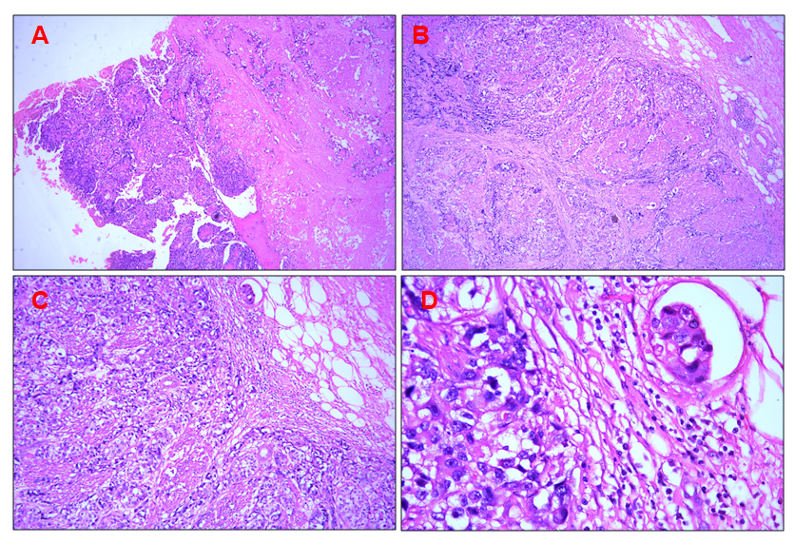
Figure 1 Pathological evaluation. A: High-grade urothelial carcinoma of the bladder (magnification, 40 ×); B-D: Invasion of the entire layer and surrounding adipose tissue by the high-grade urothelial carcinoma of the bladder [magnification, 40 × (B), 100 × (C), and 400 × (D)].

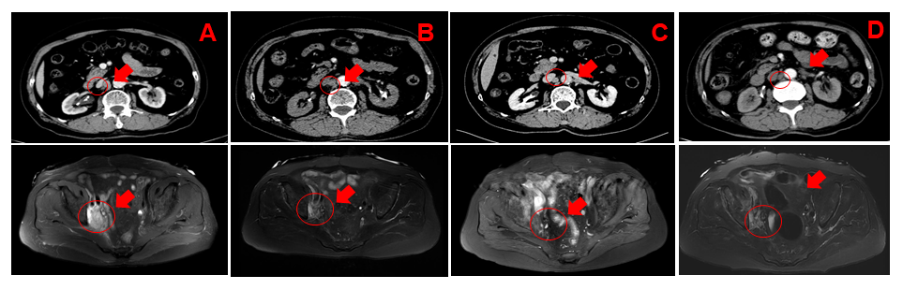
Figure 2 Computed tomography images. Computed tomography scans showed continuous shrinkage of lymph nodes in the retroperitoneum and right pelvic wall from September 2019 (A, 1.7 cm) to December 2019 (B, 0.8 cm), April 2020 (C, 0.8 cm), and July 2020 (D, 0.8 cm). Red arrows and circles indicate target lesions.

