Name of Journal: World Journal of Clinical Cases
Manuscript NO: 63780
Manuscript Type: MINIREVIEWS

Novel mechanism of hepatobiliary system damage and immunoglobulin G4 elevation caused by Clonorchis sinensis infection

Zhang XH et al. IgG4 elevation caused by Clonorchis sinensis infection

Xin-He Zhang, Die Huang, Yi-Ling Li, Bing Chang

Xin-He Zhang, Die Huang, Yi-Ling Li, Bing Chang, Department of Gastroenterology, The First Affiliated Hospital of China Medical University, Shenyang 110001, Liaoning Province, China

Author contributions: Chang B designed the study; Zhang XH and Huang D wrote the first draft; Zhang XH, Li YL, and Chang B reviewed and edited the manuscript; all authors read, revised, and approved the final manuscript.

Corresponding author: Bing Chang, PhD, Assistant Professor, Department of Gastroenterology, The First Affiliated Hospital of China Medical University, No. 155 North Nanjing Street, Heping District, Shenyang 110001, Liaoning Province, China. cb000216@163.com

Received: February 2, 2021
Revised: April 17, 2021
Accepted: July 2, 2021
Published online:

Abstract
Clonorchis sinensis infection is still a major public health problem. It is estimated that more than 15 million people worldwide are infected, especially in Northeast China, Taiwan, South Korea, and North Vietnam. The detection of Clonorchis sinensis eggs in feces and bile is still the only gold standard for the diagnosis of Clonorchis sinensis infection, and new detection methods are needed to improve the detection rate. After Clonorchis sinensis invades the human body, it mainly parasitizes the hepatobiliary tract. Therefore, it is closely related to hepatobiliary diseases such as cholangitis, bile duct stones, liver fibrosis, and cholangiocarcinoma. The increase in immunoglobulin G4 (IgG4) caused by Clonorchis sinensis infection is rare and there are few reports about the relevant mechanism. It may be related to the inflammatory factors interleukin (IL)-4, IL-10, and IL-13 produced by human phagocytes, T cells, B cells, and other immune cells in the process of resisting the invasion of Clonorchis sinensis. However, this finding still needs further clarification and confirmation. This article reviews the epidemiology, clinical manifestations, serology, imaging, pathogenic mechanism, and control measures of Clonorchis sinensis infection to help establish the diagnostic process for Clonorchis sinensis. We report novel mechanisms of IgG4 elevation due to Clonorchis sinensis infection to provide more experience and a theoretical basis for clinical diagnosis and treatment of this infection.

Key Words: Liver damage; Bile duct damage; Hepatobiliary system destruction; Clonorchis sinensis infection; Immunoglobulin G4; Clinical manifestations

Zhang XH, Huang D, Li YL, Chang B. Novel mechanism of hepatobiliary system damage and immunoglobulin G 4 elevation caused by Clonorchis sinensis infection. World J Clin Cases 2021; In press

Core Tip: The increase in immunoglobulin G4 (IgG4) caused by Clonorchis sinensis infection is rare and there are few reports about the relevant mechanism. We report several novel mechanisms of IgG4 elevation due to Clonorchis sinensis infection to provide more experience and a theoretical basis for clinical diagnosis and treatment of this infection.

INTRODUCTION
Clonorchis sinensis is an important food-borne parasite and one of the common zoonotic parasites. It was first discovered in the bile duct of a Chinese craftsman in Kolkata, India in 1875^{[1]}. At present, Clonorchis sinensis infection is still a major public health problem. It is estimated that more than 15 million people worldwide are infected, especially in Asian countries and regions, including China, Japan, South Korea, Taiwan, and Vietnam^{[2]}. Because adult Clonorchis sinensis often parasitizes the host's hepatobiliary ducts, it often damages the liver and bile ducts through mechanical destruction and excretion and secretion of antigens^{[3]}, which can easily cause abnormal liver function, bile duct dilatation, cholecystitis, obstructive jaundice, and a series of hepatobiliary injury diseases^{[4]}. Thus, Clonorchis sinensis is also called the liver fluke. If Clonorchis sinensis is not cleared in time, its long-term obstruction and inflammatory stimulation will induce gene changes^{[5]}, which will eventually lead to the occurrence of cholangiocarcinoma. The World Health Organization (WHO) International Agency for Research on Cancer has classified Clonorchis sinensis as a Class I carcinogen^{[6,7]}. This article reports several novel mechanisms of immunoglobulin (Ig) G4 elevation due to Clonorchis sinensis infection and reviews the epidemiology and clinical manifestations of Clonorchis sinensis infection published in the past to provide more experience and a theoretical basis for clinical diagnosis and treatment of this infection.

Life history
Clonorchis sinensis is a typical hermaphrodite that is 10-25 mm long and 3-5 mm wide. The front part of its body is sharp, while the back part is obtuse, and its shape is similar to a sunflower seed^{[8]}. Through the first intermediate host (freshwater snails) and the second intermediate host (freshwater fish or shrimp), it invades the ultimate host (humans and carnivorous mammals) after the stages of adult worm, egg, miracidium, sporocyst, rediae, cercaria, cysticercus, and metacercaria (Figure 1). The eggs produced by adults are excreted through feces and enter the water. They are swallowed by freshwater snails. In the digestive tract of the snails, the eggs hatch into miracidia. The miracidia pass through the intestinal wall and develop into sporocysts in the snails. Through asexual reproduction, sporocysts produce rediae. In the same way, the rediae produce cercaria, and the mature cercaria eventually escape from the snail body into the water, invade the muscles and other tissues of freshwater fish or shrimp in the water, and develop into mature cysticercus. After people eat freshwater fish or shrimp, under the action of gastric acid and pepsin, the larvae in the sac are activated. The larvae break through the sac in the duodenum and flow up through the bile to reach the intrahepatic bile duct. There have also been experiments indicating that the larvae can reach the intrahepatic bile duct through blood vessels or through the intestinal wall and finally inhabit in the bile duct of the host^{[9]}. The survival of adults after positioning can rely on their secretion of immune regulatory products^{[10]}, such as the upregulated expression of the secreted protein Clonorchis sinensis acetoacetyl-CoA thiolase located in the vitellarium and subtegumental muscle layer of adult worms^{[11]}, thereby helping the worms sense the cholesterol environment and better survive in the bile duct. After a large number of Clonorchis sinensis individuals colonize and survive, they cause bile duct obstruction and bile stasis, inducing inflammation, secondary liver function abnormalities, and cholecystitis. If Clonorchis sinensis survives longer, it may even cause liver fibrosis or cholangiocarcinoma. This is due to the excretions, secretions, and other metabolites produced during the parasitic process of the parasite^{[12]}, which can promote the proliferation of bile duct epithelial cells and inhibit cell apoptosis. It stimulates the expression of profibrotic genes in hepatic stellate cells^{[13,14]}, upregulates proto-oncogenes, inhibits the expression of tumor suppressor genes, induces the production of free radicals, changes the state of the extracellular matrix, and promotes tumor cell metastasis^{[15]}. A meta-analysis showed that the relative risk of liver fluke infection was 4.8, which is the strongest risk factor for cholangiocarcinoma^{[16]}.

Epidemiology
Types of endemic areas
Clonorchiasis infection is mainly prevalent in northeastern China, Taiwan of the China, southern South Korea, northern Vietnam, and eastern Russia^{[17,18]}. There are occasional reports of related infections in other parts of the world, but due to the rarity of such infections, there are no systematic epidemiological reports. China is the main country affected by Clonorchis sinensis. In 2016, the third survey report on the status of important human parasitic diseases in China showed that Clonorchis sinensis was detected in 6226 out of 305081 people, and the infection rate was 2.04%. A total of 89.37% of infected people are distributed in the northeast and in Guangdong and Guangxi provinces^{[19]}. Compared with other places in China, the prevalence rate is as much as 5-10 times higher. This is because there are many rivers in these areas, which are rich in freshwater fish such as river fish, and it is more common to eat freshwater fish. The infection rate in Taiwan is between 0.4% and 1.0%^{[1]}, with infections mainly occurring in Miaoli in northern Miaoli, Sun Moon Lake in the middle area, and Menong in the south^{[20]}. The seventh national survey on the infection rate of intestinal parasites in South Korea in 2004 showed that the infection rate of Clonorchis sinensis was 2.4%, and there were approximately 1.17 million infected people^{[21]}. The epidemic area was mainly the southern river basin, especially the Nakdong and Yeongsan watersheds, and the average infection rate of Clonorchis sinensis among residents was 8.4%^{[22]}. Since 2005, the Korean Centers for Disease Control have been treating infected people nationwide, especially in endemic areas. As a result, the national infection rate was reduced to 1.9% in the eighth survey of Korea in 2012^{[23]}. The WHO estimated in 2004 that approximately 1 million people in Vietnam were infected with Clonorchis sinensis. The disease is mainly prevalent in northern Vietnam, with a prevalence ranging from 0.2% to 40.1%^{[24,25]}, but a national sample survey has not been conducted, and most surveys are small and unsampled^{[25]}.

Source of infection and route of transmission
Freshwater fish are the main transmission route of Clonorchis sinensis infection. Most human clonorchiasis infections occur due to eating fish parasitized by Clonorchis sinensis. The intensity of the infection is proportional to the cumulative number of freshwater fish consumed in a lifetime. The habit of eating raw fish increases the risk of infection with Clonorchis sinensis by 53 times^{[24]}. A meta-analysis^{[26]} showed that the comprehensive prevalence of Clonorchis sinensis in Southeast Asian fishes was 30.5%, of which China constituted 35.1%, Korea constituted 29.7%, and Vietnam constituted 8.4%. A meta-analysis in China^{[27]} showed that 15 species of freshwater fishes have an average infection rate of 16.97%, with carp having the highest infection rate (40.74%). Among the 3221 freshwater fish examined in Northeast China, the overall prevalence of Clonorchis sinensis infection is 19.96%^{[28]}. Clonorchis sinensis cercariae are common in river fishes in South Korea^{[29-31]}, and the average infection rate of Clonorchis sinensis is 8.4%^{[22]}, with the highest infection rate in the Nakdong River Basin of 11.7%. In 2016, a small survey in northern Vietnam found that 69.7% of fish were infected with Clonorchis sinensis, and the prevalence and intensity were significantly higher than those in 2010^{[32,33]}.

Susceptible population
Investigations conducted in various places found that the infection rate with Clonorchis sinensis was higher in males than in females. In some areas, male infections were 2-3.6 times higher than female infections, which may be related to the different eating habits of men and women. In some areas, it was found that the number of men who have the habit of eating raw fish is three times that of women, and compared with women, men prefer to eat fish and have more social activities and eating opportunities^{[34-36]}. With increasing age, the infection rates in both men and women increase, and infection exists in all age groups, with the highest infection rate in the age group of 50 to 59. In addition, the infection rate in rural areas is significantly higher than that in urban areas. These characteristics can be reflected in the currently reported 11 cases of Clonorchis sinensis-infected patients (Table 1)^{[37-46]}. The average age of the infected patients was 47.27 years old, of which 72.73% were over 40 years old, with men accounting for 4/5 of the total number, and the medical history shows that most patients had the habit of eating freshwater fish raw.

Clinical manifestations and diagnosis
The incubation period of clonorchiasis is 1-2 mo, and patients may have different clinical manifestations. People with mild infections are often asymptomatic, and only eggs are found in the feces. Those with severe infections often start slowly, with dull pain and fullness in the upper right abdomen, nausea and vomiting, anorexia, fever, mild diarrhea, liver pain, liver swelling, major manifestations, and symptoms such as dizziness, insomnia, fatigue, lack of energy, palpitations, memory loss, and other neurasthenia. Pain in the right upper abdomen is the most common manifestation. Among the 11 cases reported, seven showed pain in the upper abdomen, accounting for 63.64%. The reason was that the parasites parasitized the bile ducts, causing the obstruction of the excretion of bile and other digestive substances, and the gallbladder strengthened and contracted, causing a series of symptoms of the digestive tract. When too many eggs accumulate, the bile duct will be blocked, leading to cholestasis and jaundice. In one-time consumption of food containing a large amount of Clonorchis sinensis metacercariae causing acute onset, the first symptoms consist of upper abdominal pain, a fever of up to 39 °C, and yellow urine, which are often accompanied by diarrhea, followed by hepatomegaly. Left hepatomegaly was predominant, and shock occurred.
Clonorchis sinensis infection most commonly presents an increased eosinophil count or proportion in laboratory examinations. Long-term parasitism may cause liver damage, especially the increase in alkaline phosphatase and gamma-glutamyl transferase, which are indicators of cholestasis. Computed tomography (CT) is a commonly used imaging examination method for clonorchiasis infection. It is characterized by diffuse dilation of intrahepatic bile ducts, and the small, dilated bile ducts under the capsule have similar diameters and are mainly distributed in the periphery of the liver^{[47]}. The size of the adult worm is similar to the diameter of the secondary bile duct of the liver, meaning that it can directly block the terminal bile duct and cause its distal expansion, and secondary inflammation will also cause secondary bile duct dilation. Magnetic resonance cholangiopancreatography (MRCP) is more advantageous in displaying biliary diseases and has the highest diagnostic accuracy for complications caused by Clonorchis sinensis infection. Whether through laboratory or imaging tests, the diagnosis is not specific. The gold standard for the diagnosis of Clonorchis sinensis infection is to find Clonorchis sinensis eggs in feces or bile by the smear method. However, the eggs are small and similar in shape and size to some other trematode eggs^{[48]}, so it is easy to miss diagnoses and infer misdiagnoses. Immunological testing can also be used to detect patients infected with Clonorchis sinensis, but the sensitivity and specificity are affected by the selected antigen and the degree of infection and it cannot be used as a basis for diagnosis^{[49]}. In addition, PCR molecular detection method development and serological explorations of Clonorchis sinensis infection-specific proteins are also ongoing. Recombinant Cs1 is located in a granular structure around the abdominal sucker, with a high sensitivity (94.3%) and specificity (94.4%)^{[50,51]}.

Clonorchis sinensis and IgG4
Immunoglobulins refer to animal proteins with antibody activity, including five major classes: IgG, IgA, IgM, IgD, and IgE^{[52]}. Among them, IgG is the main component of human serum immunoglobulins, accounting for approximately 70%-75% of the total immunoglobulins^{[53]}. IgG4 is one of the four subclasses of IgG. It is produced by plasma cells and has the lowest content in serum, accounting for approximately 5% of the total IgG^{[54]}. Unlike other IgG subclasses, the binding of IgG4 to the C1q protein complex is negligible and cannot activate the classical complement pathway. In addition, the unique half-antibody exchange reaction of IgG4, which is also known as Fab arm exchange, separates the heavy chains and recombines them randomly, resulting in a mixed population of IgG4 molecules with random pairs of heavy and light chains^{[55]}. This process causes the majority of IgG4 molecules in circulation to be composed of two different Fab arms, making them "bispecific" for a given antigen^{[56]}. IgG4 is mainly induced by interleukin (IL)-4 and IL-13 secreted by subtype 2 follicular helper T (Tfh) cells and IL-10 produced by CD4+CD25+Foxp3+ regulatory T cells.
T cells and their cytokines play an important role in the increase of IgG4 and the conversion of IgG4 classes^{[57]}. Type 1 helper cells (Th1) produce IL-2 and tumor necrosis factor-α to induce the inflammatory response, and type 2 helper cells (Th2) produce IL-4, IL-5, and IL-13 to counteract the microbicidal effect mediated by Th1. In terms of IgG4-related disease (IgG4-RD), the major disease with elevated IgG4, many studies have found the shift from Th1/Th2 balance to Th2 contributes to the pathogenesis of IgG4-RD. This is closely related to the cytokines produced by Th2. IL-4 and IL-10 are considered to be the main inducers of IgG4-type switching in naive B lymphocytes^{[58]}. It has been proved that the class switch to IgG4 is caused by co-stimulation with IL-4 and IL-10. In addition to T helper lymphocytes, IL-4 is also derived from eosinophils, basophils, and mast cells. In eosinophils and mast cells, IL-4 exists in the form of particle-related peptides, which can be released quickly in allergic inflammatory reactions. IL-4 stimulates major histocompatibility complex (MHC) class II molecules, B7, CD40, surface IgM, and low-affinity IgE receptor expressed by B cells, thus promoting the antigen presentation ability of B cells. IL-4 induces the isotype conversion of immunoglobulin from IgM to IgE. Through cell experiments, it was found that IL-4 can significantly increase the contents of IgG and IgG4 in IgG4-RD. The level of IL-4 was directly proportional to the value of IgG4^{[59]}. IL-10 is an important regulator of immune response, which directly affects antigen-presenting cells by down-regulating the expression of MHC class II and costimulatory molecules on the surface of macrophages and monocytes. IL-10 reduces the conversion to IgE induced by IL-4, and increases the conversion to IgG4^{[60]}. IL-13 is also responsible for the production of IgG4 and IgE by B cells, which drive the deposition of the extracellular matrix through activated fibroblasts. At present, the specific mechanism of the relationship between cytokines and IgG4-RD is not clear, probably because the inflammatory environment constructed by cytokines is a key step in the pathogenesis of IgG4-RD.
The elevation of IgG4 can be seen in a variety of diseases. The most common is IgG4-RD. IgG4-RD is a chronic, systemic, and autoinflammatory disease. The main clinical features of the disease are swelling, fibrosis, and sclerosis of the affected organs. The patient's serum IgG4 level is significantly increased, and a large number of lymphocytes in the affected tissues and organs form germinal centers, with especially prominent IgG4-positive plasma cell infiltration^{[61]}. Elevated IgG4 can also occur in a variety of malignant tumors^{[62]} and hepatitis, even closely related to severity^{[63]}.
However, elevated IgG4 is seen not only in the abovementioned diseases; allergic diseases, parasitic infections, bacterial infections, etc. can also cause IgG4 elevations. However, these diseases are often overlooked, especially parasitic infections, because parasitic infections that cause elevated IgG4 cases are not common and are often misdiagnosed as IgG4-RD. Saeki et al^{[64]} reported two cases of paragonimiasis infection. The serum IgG4 level of the patients was elevated, and the IgG4-positive plasma cells in the lung lesions were densely infiltrated. Baird et al^{[65]} also reported the case of a male patient with pulmonary schistosomiasis infection that caused a significant increase in serum IgG4 levels, which was considered to be related to IgG4-related lung diseases. However, lung biopsy revealed pulmonary schistosomiasis. Therefore, for patients with elevated IgG4, attention should be given to parasitic infections. However, there is currently little exploration about the increase in IgG4 caused by Clonorchis sinensis infection. Hong et al^{[66]} found that Clonorchis sinensis infection mainly induces the production of IgG and IgE through SDS-PAGE and immunoblotting, but IgM and IgA were less affected. They further explored the serum IgG subclasses induced by Clonorchis sinensis infection. The study found that among the subclasses of antibodies, IgG3 antibodies are the least common, IgG1 and IgG2 antibodies are not specific, IgG4 antibodies are prominent and specific, and the positive rates of IgG and IgG4 antibodies are directly related to the intensity of infection. Our unpublished cases of two patients with elevated IgG4 due to infection with Clonorchis sinensis lived in Shenyang, Northeast China. Liver function enzyme indexes of a 41-year-old woman and another 68-year-old man were all increased. IgG4 was significantly increased to 14.5 g/L and 7.69 g/L (normal value: 0.03-2.01 g/L). Abdominal CT and MRCP showed diffuse dilation of the bile duct and a full pancreas (Figure 2). The pathological results of the woman’s liver biopsy revealed a large amount of eosinophil infiltration and IgG4 infiltration (Figure 3). We performed a parasite examination of the patient's feces and detected eggs of Clonorchis sinensis under a microscope (Figure 4). The flow diagram of diagnosis is shown in Figure 5. Although the molecular mechanism of Clonorchis sinensis in causing the increase in IgG4 has not been elucidated in detail, it may be related to the inflammatory factors produced in the process of the human immune system resisting the invasion of the parasite (Figure 6).
First, Clonorchis sinensis infection induces an innate immune response. Multiple pattern recognition receptors on the surface of dendritic cells and macrophages can recognize the pathogen-related molecular patterns of the parasite and directly swallow and kill Clonorchis sinensis. For example, Clonorchis sinensis crude antigen can stimulate macrophages to produce the anti-inflammatory cytokine IL-10 through the ERK pathway^{[67]}. The types of pattern recognition receptors include Toll-like receptors (TLRs), scavenger receptors, and complement receptors. TLRs play an indispensable role in the immune response to parasite infections^{[68]}. A study found that^{[69]} the expression of the TLR2 gene and protein increased after Clonorchis sinensis infection of the liver in mice, and blocking the TLR2 signaling pathway induced a downregulation of the proportion of Th2 in CD4+ T cells in mice infected with Clonorchis sinensis. Since the production of IgG4 is mainly controlled by Th2, the TLRs signaling pathway may have certain significance in the formation of IgG4.
Second, after some parasites break through innate immunity, the adaptive immune system takes effect. The activation of T helper cells play an important role in the occurrence of the host immune response after Clonorchis sinensis infection. T helper cells are activated after binding to Clonorchis sinensis antigens and secrete IL-2 to promote T cell proliferation, mainly including Th1 and Th2. Th1 mainly secrete IL-2, IL-12, interferon (IFN), etc., activating phagocytes, NK cells, and others to directly kill Clonorchis sinensis. Chung et al^{[70]} confirmed that the Clonorchis sinensis coat protein rCsTegu21.6 stimulated T cell-specific antibody production and cytokine production of IL-2, IL-4, and IFN-γ in murine dendritic cells and T cell secretion. Th2 mainly produce IL-4, IL-5, IL-6, IL-10, IL-13, and other cytokines to promote the maturation of B cells, produce antibodies, and regulate humoral immunity. IL-4, IL-10, and IL-13 can all promote the expression of IgG4. Studies have shown that with the prolonged time of Clonorchis sinensis infection in BALB/c mice, spleen cells were cultured in vitro after infection for 2-4 wk. The secretion of the Th2 cytokines IL-10 and IL-5 increased, while the secretion of the Th1 cytokines IFN-γ and IL-2 decreased^{[71]}. Therefore, IgG4 may increase during the immune response caused by Clonorchis sinensis infection. B cells mainly secrete IgE antibodies. B cells and eosinophils play an extremely important role in the immune response to Clonorchis sinensis infection^{[72]}. After Clonorchis sinensis infection, Th2 cytokines can promote the production of IgE antibodies and subgroup conversion, and IL-5 can promote the development and activation of eosinophils. After the IgE antibodies bind to Clonorchis sinensis, they bind to the IgE receptor on the surface of eosinophils to promote cell activation, induce the production of bactericidal proteins and cytokines (IL-4, IL-5, and IL-13), and kill the parasites^{[73]}. IgE antibodies can also bind to Clonorchis sinensis antigens to promote the release of histamine and other biologically active substances from mast cells, promote intestinal peristalsis, and facilitate the elimination of parasites. Therefore, Clonorchis sinensis infection can cause IgE antibodies and eosinophils to increase. The inflammatory factors released by eosinophils are also beneficial to the production of IgG4.
Finally, in addition to the above possible mechanisms, the excretion and secretion products of Clonorchis sinensis may play an important role. CsRNASET2 is a glycosylated T2 ribonuclease that exists in the excretion and secretion products of Clonorchis sinensis. Xu et al^{[74]} immunized BALB/c mice with CsRNASET2 and found that the level of IL-4 expressed by the spleen cells of mice immunized with CsRNASET2 was elevated and that CsRNASET2 immunity triggered a Th2 immune response by promoting the synthesis of IL-4^{[74]}. In addition, the excretion and secretion products of Clonorchis sinensis can highly express nitric oxide by activating the nuclear factor kappa B signaling pathway, which promotes Th1 to Th2 immune transformation^{[75]}.

TREATMENT
The most effective treatment for clonorchiasis is praziquantel. According to the WHO recommendation, the dose is 25 mg/kg orally three times a day for 2 consecutive days^{[76]}. This program has cured approximately 99% of infected patients. If the first treatment cannot completely cure the infection, nearly 100% of patients can undergo a second treatment^{[77]}. Praziquantel also causes some adverse reactions, such as dizziness, headache, gastrointestinal pain, and nausea^{[2]}. These side effects are mild and tolerable, but severe hypersensitivity reactions can also occur, including skin rash or hives, difficulty breathing, and hypotensive shock^{[78]}. Compared with praziquantel, albendazole has fewer side effects and is well tolerated and lower in price, along with being safe, convenient, and economical. It can be used as the first choice for general treatment of clonorchiasis in Guangdong and is applicable to all age groups^{[79]}. Recently, it was discovered that tribendimidine has the same efficacy as praziquantel in the treatment of Clonorchis sinensis infections. Compared with praziquantel, it has fewer adverse effects and is being studied as a promising chemotherapy method^{[80-82]}. However, Xiao et al^{[83]} found that broad-spectrum anthelmintic mebendazole has potential for use against larvae (14 days old) and adults, according to oral administration at a single dose of 150 mg/kg in rats infected with Clonorchis sinensis. The single effective dose ranges of mebendazole and tribendimidine for clonorchiasis in rats are similar, but the window is wider, and the range of praziquantel is narrower. In addition, studies have found that Clonorchis sinensis does not easily survive under high concentrations of bile, so dopamine receptor antagonists that promote bile secretion and antipsychotics with dopaminergic antagonism (such as chlorpromazine, haloperidol, and clozapine) can also be considered as new anthelmintics. For complications such as upper cholangitis, which may require biliary drainage or surgery, cholecystitis may require cholecystectomy.

PREVENTION
Among strategies to prevent infectious diseases, vaccination is the most effective. However, there is still no effective vaccine to prevent the disease examined in this paper. Bai et al^{[84]} found that vaccination with the CsAg17 protein and cDNA can reduce the pathological changes of the bile duct and liver and reduce the burden of worms through cellular and humoral immune responses. Therefore, the CsAg17 gene and its products can be used as an effective candidate vaccine against Clonorchis sinensis, which furthers our understanding of the prevention and control of liver flukes, and more studies are needed to confirm this hypothesis in the future. Therefore, the current prevention strategy is mainly a comprehensive strategy of health education and health promotion, environmental reconstruction, and chemotherapy^{[81]}. Health education should be carried out in endemic areas, people should consciously refrain from eating raw and undercooked shrimp, and dogs and cats should not be fed raw fish or raw fish offal. More attention should be paid to the safety of freshwater fish, the infection rate and distribution of freshwater fish should be investigated in endemic areas, and infected ponds should be monitored. In addition, sanitary toilets should be built with harmless treatments, manure management should be strengthened, and untreated feces should not be emptied into fishponds or water sources^{[18]}.

CONCLUSION
Due to the widespread distribution of intermediate hosts and human eating habits, Clonorchis sinensis infection is still common. The detection of Clonorchis sinensis eggs in feces and bile is still the only gold standard for the diagnosis of Clonorchis sinensis infection, and new detection methods are needed to improve the detection rate. There is an urgent need for effective and systematic prevention strategies to increase human awareness and prevent Clonorchis sinensis infection. In addition, the increase in IgG4 caused by Clonorchis sinensis infection is rare, which may be related to the inflammatory factors IL-4, IL-10, and IL-13 produced by human phagocytes, T cells, B cells, and other immune cells in the process of resisting the invasion of Clonorchis sinensis. However, this finding still needs further clarification and confirmation.

REFERENCES
1 Lun ZR, Gasser RB, Lai DH, Li AX, Zhu XQ, Yu XB, Fang YY. Clonorchiasis: a key foodborne zoonosis in China. Lancet Infect Dis 2005; 5: 31-41 [PMID: 15620559 DOI: 10.1016/S1473-3099(04)01252-6]
2 Na BK, Pak JH, Hong SJ. Clonorchis sinensis and clonorchiasis. Acta Trop 2020; 203: 105309 [PMID: 31862466 DOI: 10.1016/j.actatropica.2019.105309]
3 Saijuntha W, Sithithaworn P, Kiatsopit N, Andrews RH, Petney TN. Liver Flukes: Clonorchis and Opisthorchis. Adv Exp Med Biol 2019; 1154: 139-180 [PMID: 31297762 DOI: 10.1007/978-3-030-18616-6_6]
4 Qian MB, Li HM, Jiang ZH, Yang YC, Lu MF, Wei K, Wei SL, Chen Y, Zhou CH, Chen YD, Zhou XN. Severe hepatobiliary morbidity is associated with Clonorchis sinensis infection: The evidence from a cross-sectional community study. PLoS Negl Trop Dis 2021; 15: e0009116 [PMID: 33507969 DOI: 10.1371/journal.pntd.0009116]
5 Wang C, Lei H, Tian Y, Shang M, Wu Y, Li Y, Zhao L, Shi M, Tang X, Chen T, Lv Z, Huang Y, Tang X, Yu X, Li X. Clonorchis sinensis granulin: identification, immunolocalization, and function in promoting the metastasis of cholangiocarcinoma and hepatocellular carcinoma. Parasit Vectors 2017; 10: 262 [PMID: 28545547 DOI: 10.1186/s13071-017-2179-4]
6 Bouvard V, Baan R, Straif K, Grosse Y, Secretan B, El Ghissassi F, Benbrahim-Tallaa L, Guha N, Freeman C, Galichet L, Cogliano V; WHO International Agency for Research on Cancer Monograph Working Group. A review of human carcinogens--Part B: biological agents. Lancet Oncol 2009; 10: 321-322 [PMID: 19350698 DOI: 10.1016/s1470-2045(09)70096-8]
7 Wang KX, Zhang RB, Cui YB, Tian Y, Cai R, Li CP. Clinical and epidemiological features of patients with clonorchiasis. World J Gastroenterol 2004; 10: 446-448 [PMID: 14760777 DOI: 10.3748/wjg.v10.i3.446]
8 Kim TS, Pak JH, Kim JB, Bahk YY. Clonorchis sinensis, an oriental liver fluke, as a human biological agent of cholangiocarcinoma: a brief review. BMB Rep 2016; 49: 590-597 [PMID: 27418285 DOI: 10.5483/bmbrep.2016.49.11.109]
9 Kim TI, Yoo WG, Kwak BK, Seok JW, Hong SJ. Tracing of the Bile-chemotactic migration of juvenile Clonorchis sinensis in rabbits by PET-CT. PLoS Negl Trop Dis 2011; 5: e1414 [PMID: 22180795 DOI: 10.1371/journal.pntd.0001414]
10 Maizels RM. Regulation of immunity and allergy by helminth parasites. Allergy 2020; 75: 524-534 [PMID: 31187881 DOI: 10.1111/all.13944]
11 Lin J, Qu H, Chen G, He L, Xu Y, Xie Z, Ren M, Sun J, Li S, Chen W, Chen X, Wang X, Li X, Liang C, Huang Y, Yu X. Clonorchis sinensis acetoacetyl-CoA thiolase: identification and characterization of its potential role in surviving in the bile duct. Parasit Vectors 2015; 8: 125 [PMID: 25880842 DOI: 10.1186/s13071-015-0728-2]
12 Shi Y, Yu K, Liang A, Huang Y, Ou F, Wei H, Wan X, Yang Y, Zhang W, Jiang Z. Identification and Analysis of the Tegument Protein and Excretory-Secretory Products of the Carcinogenic Liver Fluke Clonorchis sinensis. Front Microbiol 2020; 11: 555730 [PMID: 33072014 DOI: 10.3389/fmicb.2020.555730]
13 Zhang F, Liang P, Chen W, Wang X, Hu Y, Liang C, Sun J, Huang Y, Li R, Li X, Xu J, Yu X. Stage-specific expression, immunolocalization of Clonorchis sinensis lysophospholipase and its potential role in hepatic fibrosis. Parasitol Res 2013; 112: 737-749 [PMID: 23183703 DOI: 10.1007/s00436-012-3194-1]
14 Zhou L, Shi M, Zhao L, Lin Z, Tang Z, Sun H, Chen T, Lv Z, Xu J, Huang Y, Yu X. Clonorchis sinensis lysophospholipase A upregulates IL-25 expression in macrophages as a potential pathway to liver fibrosis. Parasit Vectors 2017; 10: 295 [PMID: 28623940 DOI: 10.1186/s13071-017-2228-z]
15 Kim EM, Kim JS, Choi MH, Hong ST, Bae YM. Effects of excretory/secretory products from Clonorchis sinensis and the carcinogen dimethylnitrosamine on the proliferation and cell cycle modulation of human epithelial HEK293T cells. Korean J Parasitol 2008; 46: 127-132 [PMID: 18830050 DOI: 10.3347/kjp.2008.46.3.127]
16 Shin HR, Oh JK, Masuyer E, Curado MP, Bouvard V, Fang YY, Wiangnon S, Sripa B, Hong ST. Epidemiology of cholangiocarcinoma: an update focusing on risk factors. Cancer Sci 2010; 101: 579-585 [PMID: 20085587 DOI: 10.1111/j.1349-7006.2009.01458.x]
17 Tang ZL, Huang Y, Yu XB. Current status and perspectives of Clonorchis sinensis and clonorchiasis: epidemiology, pathogenesis, omics, prevention and control. Infect Dis Poverty 2016; 5: 71 [PMID: 27384714 DOI: 10.1186/s40249-016-0166-1]
18 Sun J, Xin H, Jiang Z, Qian M, Duan K, Chen Y, Li S, Li W, Huang S, Gan X, Yang Y, Li Z. High endemicity of Clonorchis sinensis infection in Binyang County, southern China. PLoS Negl Trop Dis 2020; 14: e0008540 [PMID: 32776933 DOI: 10.1371/journal.pntd.0008540]
19 Zhu TJ, Chen YD, Qian MB, Zhu HH, Huang JL, Zhou CH, Zhou XN. Surveillance of clonorchiasis in China in 2016. Acta Trop 2020; 203: 105320 [PMID: 31877282 DOI: 10.1016/j.actatropica.2019.105320]
20 Chen ER. Clonorchiasis in Taiwan. Southeast Asian J Trop Med Public Health 1991; 22 Suppl: 184-185 [PMID: 1822883]
21 Kim TS, Cho SH, Huh S, Kong Y, Sohn WM, Hwang SS, Chai JY, Lee SH, Park YK, Oh DK, Lee JK; Working Groups in National Institute of Health; Korea Association of Health Promotion. A nationwide survey on the prevalence of intestinal parasitic infections in the Republic of Korea, 2004. Korean J Parasitol 2009; 47: 37-47 [PMID: 19290090 DOI: 10.3347/kjp.2009.47.1.37]
22 Jeong YI, Shin HE, Lee SE, Cheun HI, Ju JW, Kim JY, Park MY, Cho SH. Prevalence of Clonorchis sinensis Infection among Residents along 5 Major Rivers in the Republic of Korea. Korean J Parasitol 2016; 54: 215-219 [PMID: 27180582 DOI: 10.3347/kjp.2016.54.2.215]
23 Hong ST, Yong TS. Review of Successful Control of Parasitic Infections in Korea. Infect Chemother 2020; 52: 427-440 [PMID: 32869557 DOI: 10.3947/ic.2020.52.3.427]
24 Dang TC, Yajima A, Nguyen VK, Montresor A. Prevalence, intensity and risk factors for clonorchiasis and possible use of questionnaires to detect individuals at risk in northern Vietnam. Trans R Soc Trop Med Hyg 2008; 102: 1263-1268 [PMID: 18632126 DOI: 10.1016/j.trstmh.2008.06.002]
25 Qian MB, Chen YD, Liang S, Yang GJ, Zhou XN. The global epidemiology of clonorchiasis and its relation with cholangiocarcinoma. Infect Dis Poverty 2012; 1: 4 [PMID: 23849183 DOI: 10.1186/2049-9957-1-4]
26 Zhang Y, Gong QL, Lv QB, Qiu YY, Wang YC, Qiu HY, Guo XR, Gao JF, Chang QC, Wang CR. Prevalence of Clonorchis sinensis infection in fish in South-East Asia: A systematic review and meta-analysis. J Fish Dis 2020; 43: 1409-1418 [PMID: 32880984 DOI: 10.1111/jfd.13245]
27 Zhang R, Gao S, Geng Y, Huang D, Yu L, Zhang S, Cheng J, Fu Y. Epidemiological study on Clonorchis sinensis infection in Shenzhen area of Zhujiang delta in China. Parasitol Res 2007; 101: 179-183 [PMID: 17216484 DOI: 10.1007/s00436-006-0441-3]
28 Zhang Y, Chang QC, Zhang Y, Na L, Wang WT, Xu WW, Gao DZ, Liu ZX, Wang CR, Zhu XQ. Prevalence of Clonorchis sinensis infection in freshwater fishes in northeastern China. Vet Parasitol 2014; 204: 209-213 [PMID: 24880648 DOI: 10.1016/j.vetpar.2014.05.007]
29 Sohn WM, Na BK, Cho SH, Ju JW, Son DC. Prevalence and Intensity of Clonorchis sinensis Metacercariae in Freshwater Fish from Wicheon Stream in Gunwi-gun, Gyeongsangbuk-do, Korea. Korean J Parasitol 2018; 56: 41-48 [PMID: 29529849 DOI: 10.3347/kjp.2018.56.1.41]
30 Sohn WM, Na BK, Cho SH, Ju JW. Infection Status with Clonorchis sinensis Metacercariae in Fish from Yangcheon (Stream) in Sancheong-gun, Gyeongsangnam-do, Korea. Korean J Parasitol 2019; 57: 145-152 [PMID: 31104406 DOI: 10.3347/kjp.2019.57.2.145]
31 Yoon KB, Lim HC, Jeon DY, Park S, Cho SH, Ju JW, Shin SS, Na BK, Sohn WM. Infection Status with Clonorchis sinensis Metacercariae in Fish from Tamjin-gang (River) in Jeollanam-do, Republic of Korea. Korean J Parasitol 2018; 56: 183-188 [PMID: 29742873 DOI: 10.3347/kjp.2018.56.2.183]
32 Dai F, Hong SJ, Pak JH, Le TH, Choi SH, Na BK, Sohn WM. High Prevalence of Clonorchis sinensis and Other Zoonotic Trematode Metacercariae in Fish from a Local Market in Yen Bai Province, Northern Vietnam. Korean J Parasitol 2020; 58: 333-338 [PMID: 32615748 DOI: 10.3347/kjp.2020.58.3.333]
33 Phan VT, Ersbøll AK, Nguyen KV, Madsen H, Dalsgaard A. Farm-level risk factors for fish-borne zoonotic trematode infection in integrated small-scale fish farms in northern Vietnam. PLoS Negl Trop Dis 2010; 4: e742 [PMID: 20644617 DOI: 10.1371/journal.pntd.0000742]
34 Lee SE, Shin HE, Lee MR, Kim YH, Cho SH, Ju JW. Risk Factors of Clonorchis sinensis Human Infections in Endemic Areas, Haman-Gun, Republic of Korea: A Case-Control Study. Korean J Parasitol 2020; 58: 647-652 [PMID: 33412768 DOI: 10.3347/kjp.2020.58.6.647]
35 Nontasut P, Thong TV, Waikagul J, Anantaphruti MT, Fungladda W, Imamee N, De NV. Social and behavioral factors associated with Clonorchis infection in one commune located in the Red River Delta of Vietnam. Southeast Asian J Trop Med Public Health 2003; 34: 269-273 [PMID: 12971548]
36 Han S, Zhang X, Chen R, Wen J, Li Y, Shu J, Ling H, Zhang F. Trends in prevalence of clonorchiasis among patients in Heilongjiang province, Northeast China (2009-2012): implications for monitoring and control. PLoS One 2013; 8: e80173 [PMID: 24260354 DOI: 10.1371/journal.pone.0080173]
37 Wang N, Tang B, Hao Y, Bai X, Wang X, Li Y, Yang Y, Li S, Hao S, Wang X, Liu M, Liu X. Acute shock caused by Clonorchis sinensis infection: a case report. BMC Infect Dis 2019; 19: 1014 [PMID: 31783809 DOI: 10.1186/s12879-019-4644-5]
38 Hao Y, Bao W, Jin M, Li Y, Wang F. Painless Jaundice Caused by Clonorchis sinensis Infection: A Case Report. Korean J Parasitol 2016; 54: 323-327 [PMID: 27417088 DOI: 10.3347/kjp.2016.54.3.323]
39 Liu X, Zhu G, Cai C, Lv Z, Li J. Clonorchiasis sinensis detected by laparoscopic exploration of biliary tracts in two patients with obstructive jaundice. BMC Infect Dis 2019; 19: 33 [PMID: 30621611 DOI: 10.1186/s12879-019-3679-y]
40 Oh JT, Kang DB, Jo HJ. Acute cholecystitis associated with Clonorchis sinensis infection. Ann Surg Treat Res 2014; 87: 104-107 [PMID: 25114891 DOI: 10.4174/astr.2014.87.2.104]
41 Choi JH, Kim JH, Kim CH, Jung YK, Yeon JE, Byun KS, Kim I. Pancreatic mucinous cystadenoma of borderline malignancy associated with Clonorchis sinensis. Korean J Intern Med 2015; 30: 398-401 [PMID: 25995671 DOI: 10.3904/kjim.2015.30.3.398]
42 Lee HK, Jin SL, Lee HP, Choi SJ, Yum HK. Loffler's syndrome associated with Clonorchis sinensis infestation. Korean J Intern Med 2003; 18: 255-259 [PMID: 14717238 DOI: 10.3904/kjim.2003.18.4.255]
43 Lim JU, Joo KR, Shin HP, Cha JM, Lee JI, Lim SJ. Obstructive jaundice caused by Clonorchiasis-associated duodenal papillitis: a case report. J Korean Med Sci 2011; 26: 135-137 [PMID: 21218042 DOI: 10.3346/jkms.2011.26.1.135]
44 Fujiya K, Ganno H, Ando M, Chong JM. Clonorchis sinensis ova in bile juice cytology from a patient with severe hyperbilirubinemia and portal vein thrombosis. Diagn Cytopathol 2016; 44: 223-225 [PMID: 26663478 DOI: 10.1002/dc.23400]
45 Papachristou GI, Schoedel KE, Ramanathan R, Rabinovitz M. Clonorchis sinensis-associated cholangiocarcinoma: a case report and review of the literature. Dig Dis Sci 2005; 50: 2159-2162 [PMID: 16240232 DOI: 10.1007/s10620-005-3024-8]
46 Bian HF, Zhang LY, Xiang J. [A case of Clonorchis sinensis infection complicated with gallstone]. Zhongguo Ji Sheng Chong Xue Yu Ji Sheng Chong Bing Za Zhi 2001; 19: 353 [PMID: 12572069]
47 Choi D, Hong ST. Imaging diagnosis of clonorchiasis. Korean J Parasitol 2007; 45: 77-85 [PMID: 17570969 DOI: 10.3347/kjp.2007.45.2.77]
48 Sato M, Thaenkham U, Dekumyoy P, Waikagul J. Discrimination of O. viverrini, C. sinensis, H. pumilio and H. taichui using nuclear DNA-based PCR targeting ribosomal DNA ITS regions. Acta Trop 2009; 109: 81-83 [PMID: 18952037 DOI: 10.1016/j.actatropica.2008.09.015]
49 Nie G, Wang T, Lu S, Liu W, Li Y, Lei J. Detection of Clonorchis sinensis circulating antigen in sera from Chinese patients by immunomagnetic bead ELISA based on IgY. PLoS One 2014; 9: e113208 [PMID: 25474577 DOI: 10.1371/journal.pone.0113208]
50 Cheng N, Xu XN, Zhou Y, Dong YT, Bao YF, Xu B, Hu W, Feng Z. Cs1, a Clonorchis sinensis-derived serodiagnostic antigen containing tandem repeats and a signal peptide. PLoS Negl Trop Dis 2018; 12: e0006683 [PMID: 30070987 DOI: 10.1371/journal.pntd.0006683]
51 Cho PY, Na BK, Choi KM, Kim JS, Cho SH, Lee WJ, Lim SB, Cha SH, Park YK, Pak JH, Lee HW, Hong SJ, Kim TS. Development of a polymerase chain reaction applicable to rapid and sensitive detection of Clonorchis sinensis eggs in human stool samples. Pathog Glob Health 2013; 107: 253-259 [PMID: 23916334 DOI: 10.1179/2047773213Y.0000000099]
52 Nezlin R. Dynamic Aspects of the Immunoglobulin Structure. Immunol Invest 2019; 48: 771-780 [PMID: 31044633 DOI: 10.1080/08820139.2019.1597110]
53 Maibom-Thomsen SL, Trier NH, Holm BE, Hansen KB, Rasmussen MI, Chailyan A, Marcatili P, Højrup P, Houen G. Immunoglobulin G structure and rheumatoid factor epitopes. PLoS One 2019; 14: e0217624 [PMID: 31199818 DOI: 10.1371/journal.pone.0217624]
54 Aalberse RC, Stapel SO, Schuurman J, Rispens T. Immunoglobulin G4: an odd antibody. Clin Exp Allergy 2009; 39: 469-477 [PMID: 19222496 DOI: 10.1111/j.1365-2222.2009.03207.x]
55 Davies AM, Sutton BJ. Human IgG4: a structural perspective. Immunol Rev 2015; 268: 139-159 [PMID: 26497518 DOI: 10.1111/imr.12349]
56 Nirula A, Glaser SM, Kalled SL, Taylor FR. What is IgG4? A review of the biology of a unique immunoglobulin subtype. Curr Opin Rheumatol 2011; 23: 119-124 [PMID: 21124094 DOI: 10.1097/BOR.0b013e3283412fd4]
57 Kubo S, Nakayamada S, Tanaka Y. Immunophenotype involved in IgG4-related disease. Mod Rheumatol 2019; 29: 226-230 [PMID: 30334637 DOI: 10.1080/14397595.2018.1537962]
58 Della-Torre E, Lanzillotta M, Doglioni C. Immunology of IgG4-related disease. Clin Exp Immunol 2015; 181: 191-206 [PMID: 25865251 DOI: 10.1111/cei.12641]
59 Akiyama M, Yasuoka H, Yoshimoto K, Takeuchi T. Interleukin-4 contributes to the shift of balance of IgG subclasses toward IgG4 in IgG4-related disease. Cytokine 2018; 110: 416-419 [PMID: 29861381 DOI: 10.1016/j.cyto.2018.05.009]
60 Moriyama M, Nakamura S. Th1/Th2 Immune Balance and Other T Helper Subsets in IgG4-Related Disease. Curr Top Microbiol Immunol 2017; 401: 75-83 [PMID: 27744510 DOI: 10.1007/82_2016_40]
61 Umehara H, Okazaki K, Masaki Y, Kawano M, Yamamoto M, Saeki T, Matsui S, Yoshino T, Nakamura S, Kawa S, Hamano H, Kamisawa T, Shimosegawa T, Shimatsu A, Nakamura S, Ito T, Notohara K, Sumida T, Tanaka Y, Mimori T, Chiba T, Mishima M, Hibi T, Tsubouchi H, Inui K, Ohara H. Comprehensive diagnostic criteria for IgG4-related disease (IgG4-RD), 2011. Mod Rheumatol 2012; 22: 21-30 [PMID: 22218969 DOI: 10.1007/s10165-011-0571-z]
62 Crescioli S, Correa I, Karagiannis P, Davies AM, Sutton BJ, Nestle FO, Karagiannis SN. IgG4 Characteristics and Functions in Cancer Immunity. Curr Allergy Asthma Rep 2016; 16: 7 [PMID: 26742760 DOI: 10.1007/s11882-015-0580-7]
63 Santos VCD, Schinoni MI, Oliveira IS, Atta MLS, Atta AM. IgG1 and IgG4 antibodies against Core and NS3 antigens of hepatitis C virus. Rev Soc Bras Med Trop 2019; 52: e20180491 [PMID: 30843970 DOI: 10.1590/0037-8682-0491-2018]
64 Saeki S, Horio Y, Hirosako S, Ichiyasu H, Fujii K, Kohrogi H. Elevated serum IgG4 levels in two cases of paragonimiasis. Respirol Case Rep 2015; 3: 92-94 [PMID: 26392854 DOI: 10.1002/rcr2.110]
65 Baird T, Cooper CL, Wong R, Runnegar N, Keir G. Pulmonary schistosomiasis mimicking IgG4-related lung disease. Respirol Case Rep 2018; 6: e00276 [PMID: 29046807 DOI: 10.1002/rcr2.276]
66 Hong ST, Kho WG, Lee M, Lee JS, Lee SH. Immunoblot patterns of clonorchiasis. Korean J Parasitol 1997; 35: 87-93 [PMID: 9241982 DOI: 10.3347/kjp.1997.35.2.87]
67 Jin Y, Wi HJ, Choi MH, Hong ST, Bae YM. Regulation of anti-inflammatory cytokines IL-10 and TGF-β in mouse dendritic cells through treatment with Clonorchis sinensis crude antigen. Exp Mol Med 2014; 46: e74 [PMID: 24480801 DOI: 10.1038/emm.2013.144]
68 Yan C, Li XY, Li B, Zhang BB, Xu JT, Hua H, Yu Q, Liu ZZ, Fu LL, Tang RX, Zheng KY. Expression of Toll-like receptor (TLR) 2 and TLR4 in the livers of mice infected by Clonorchis sinensis. J Infect Dev Ctries 2015; 9: 1147-1155 [PMID: 26517491 DOI: 10.3855/jidc.6698]
69 Zhang BB, Yan C, Fang F, Du Y, Ma R, Li XY, Yu Q, Meng D, Tang RX, Zheng KY. Increased hepatic Th2 and Treg subsets are associated with biliary fibrosis in different strains of mice caused by Clonorchis sinensis. PLoS One 2017; 12: e0171005 [PMID: 28151995 DOI: 10.1371/journal.pone.0171005]
70 Chung E, Kim YJ, Lee MR, Cho SH, Ju JW. A 21.6 kDa tegumental protein of Clonorchis sinensis induces a Th1/Th2 mixed immune response in mice. Immun Inflamm Dis 2018; 6: 435-447 [PMID: 30298703 DOI: 10.1002/iid3.235]
71 Choi YK, Yoon BI, Won YS, Lee CH, Hyun BH, Kim HC, Oh GT, Kim DY. Cytokine responses in mice infected with Clonorchis sinensis. Parasitol Res 2003; 91: 87-93 [PMID: 12898229 DOI: 10.1007/s00436-003-0934-2]
72 Yu Q, Zhang Y, Zhang YZ, Yan C, Wang XT, Li XC, Tang RX, Zheng KY. Membrane-bound IgE on B cells is increased during Clonorchis sinensis infection. Immunobiology 2019; 224: 347-352 [PMID: 30987761 DOI: 10.1016/j.imbio.2019.03.004]
73 Kim EM, Yu HS, Jin Y, Choi MH, Bae YM, Hong ST. Local immune response to primary infection and re-infection by Clonorchis sinensis in FVB mice. Parasitol Int 2017; 66: 436-442 [PMID: 27856336 DOI: 10.1016/j.parint.2016.11.006]
74 Xu Y, Lin J, Bian M, Chen W, Liang P, Wang X, Shang M, Qu H, Wu Z, Huang Y, Yu X. CsRNASET2 is an important component of Clonorchis sinensis responsible for eliciting Th2 immune response. Parasitol Res 2015; 114: 2371-2379 [PMID: 25828812 DOI: 10.1007/s00436-015-4435-x]
75 Nam JH, Moon JH, Kim IK, Lee MR, Hong SJ, Ahn JH, Chung JW, Pak JH. Free radicals enzymatically triggered by Clonorchis sinensis excretory-secretory products cause NF-κB-mediated inflammation in human cholangiocarcinoma cells. Int J Parasitol 2012; 42: 103-113 [PMID: 22138019 DOI: 10.1016/j.ijpara.2011.11.001]
76 Control of foodborne trematode infections. Report of a WHO Study Group. World Health Organ Tech Rep Ser 1995; 849: 1-157 [PMID: 7740791]
77 Locke V, Richardson MS. Clonorchis Sinensis. 2021 Mar 30. In: StatPearls [Internet]. Treasure Island (FL): StatPearls Publishing; 2021 Jan– [PMID: 30422487]
78 Lee JM, Lim HS, Hong ST. Hypersensitive reaction to praziquantel in a clonorchiasis patient. Korean J Parasitol 2011; 49: 273-275 [PMID: 22072827 DOI: 10.3347/kjp.2011.49.3.273]
79 Ying-Yan Z, Ting-Jun X, Man W, Yue-Yi F, Le L. [Prevalence of Clonorchis sinensis infection and effect of albendazole treatment among residents in two communities of Zhongshan City]. Zhongguo Xue Xi Chong Bing Fang Zhi Za Zhi 2018; 30: 219-221 [PMID: 29770671 DOI: 10.16250/j.32.1374.2017131]
80 Hong ST, Fang Y. Clonorchis sinensis and clonorchiasis, an update. Parasitol Int 2012; 61: 17-24 [PMID: 21741496 DOI: 10.1016/j.parint.2011.06.007]
81 Qian MB, Yap P, Yang YC, Liang H, Jiang ZH, Li W, Tan YG, Zhou H, Utzinger J, Zhou XN, Keiser J. Efficacy and safety of tribendimidine against Clonorchis sinensis. Clin Infect Dis 2013; 56: e76-e82 [PMID: 23223597 DOI: 10.1093/cid/cis1011]
82 Xu LL, Jiang B, Duan JH, Zhuang SF, Liu YC, Zhu SQ, Zhang LP, Zhang HB, Xiao SH, Zhou XN. Efficacy and safety of praziquantel, tribendimidine and mebendazole in patients with co-infection of Clonorchis sinensis and other helminths. PLoS Negl Trop Dis 2014; 8: e3046 [PMID: 25122121 DOI: 10.1371/journal.pntd.0003046]
83 Xiao SH, Xue J, Xu LL, Zhang YN, Qiang HQ. Comparative effect of mebendazole, albendazole, tribendimidine, and praziquantel in treatment of rats infected with Clonorchis sinensis. Parasitol Res 2011; 108: 723-730 [PMID: 21136080 DOI: 10.1007/s00436-010-2187-1]
84 Bai X, Song JH, Dai F, Lee JY, Hong SJ. Clonorchis sinensis secretory protein CsAg17 vaccine induces immune protection. Parasit Vectors 2020; 13: 215 [PMID: 32334611 DOI: 10.1186/s13071-020-04083-5]

Footnotes
Conflict-of-interest statement: The authors declare that they have no conflict of interest to disclose.

Open-Access: This article is an open-access article that was selected by an in-house editor and fully peer-reviewed by external reviewers. It is distributed in accordance with the Creative Commons Attribution NonCommercial (CC BY-NC 4.0) license, which permits others to distribute, remix, adapt, build upon this work non-commercially, and license their derivative works on different terms, provided the original work is properly cited and the use is non-commercial. See: http://creativecommons.org/Licenses/by-nc/4.0/

Manuscript source: Unsolicited manuscript

Peer-review started: February 2, 2021
First decision: April 5, 2021
Article in press:

Specialty type: Medicine, research and experimental
Country/Territory of origin: China
Peer-review report’s scientific quality classification
Grade A (Excellent): 0
Grade B (Very good): 0
Grade C (Good): C, C
Grade D (Fair): 0
Grade E (Poor): 0

P-Reviewer: Feng J S-Editor: Fan JR L-Editor: Wang TQ P-Editor:

Figure Legends
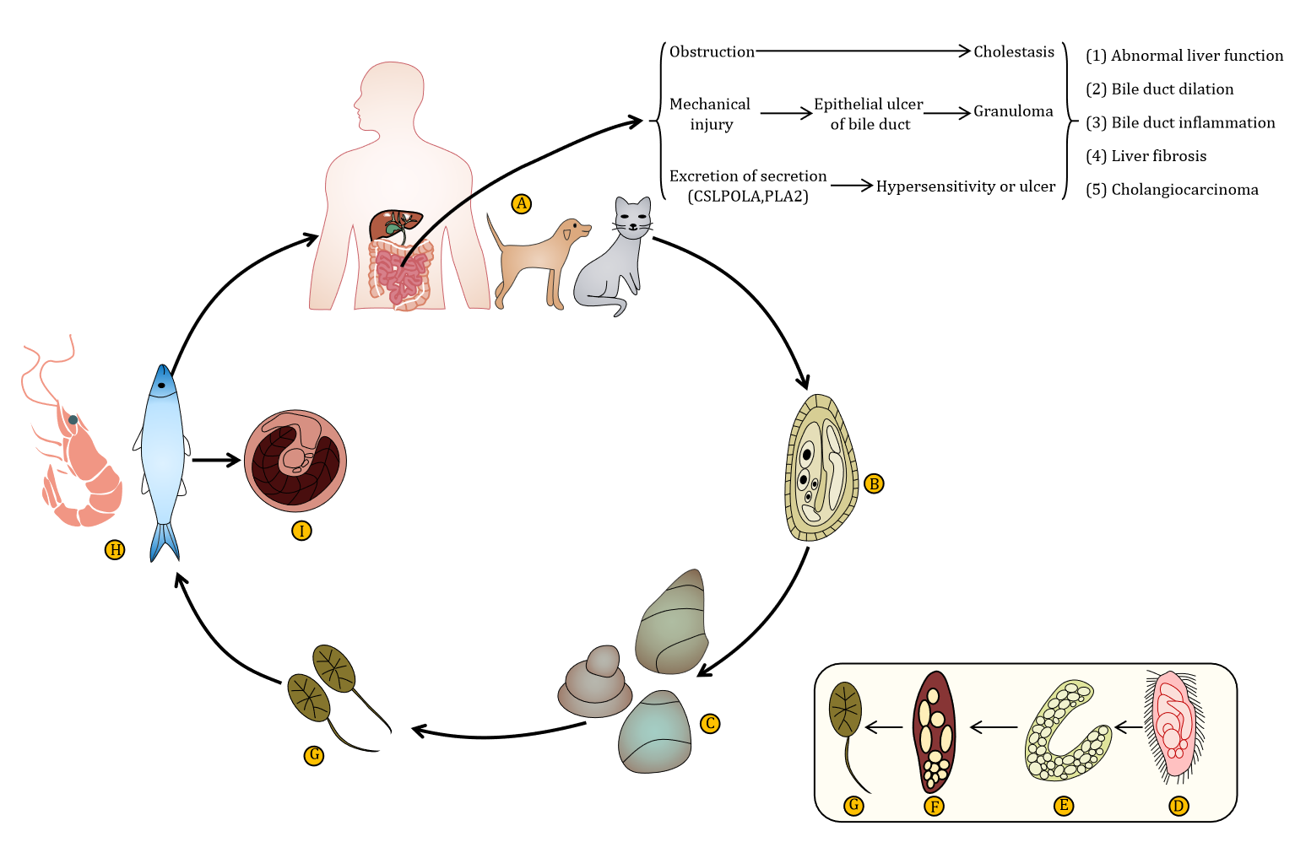
Figure 1 The life history of Clonorchis sinensis. A: Ultimate host; B: Egg; C: The first intermediate host; D: Miracidium; E: Sporocyst; F: Rediae; G: Cercaria; H: The second intermediate host; I: Cysticercus.

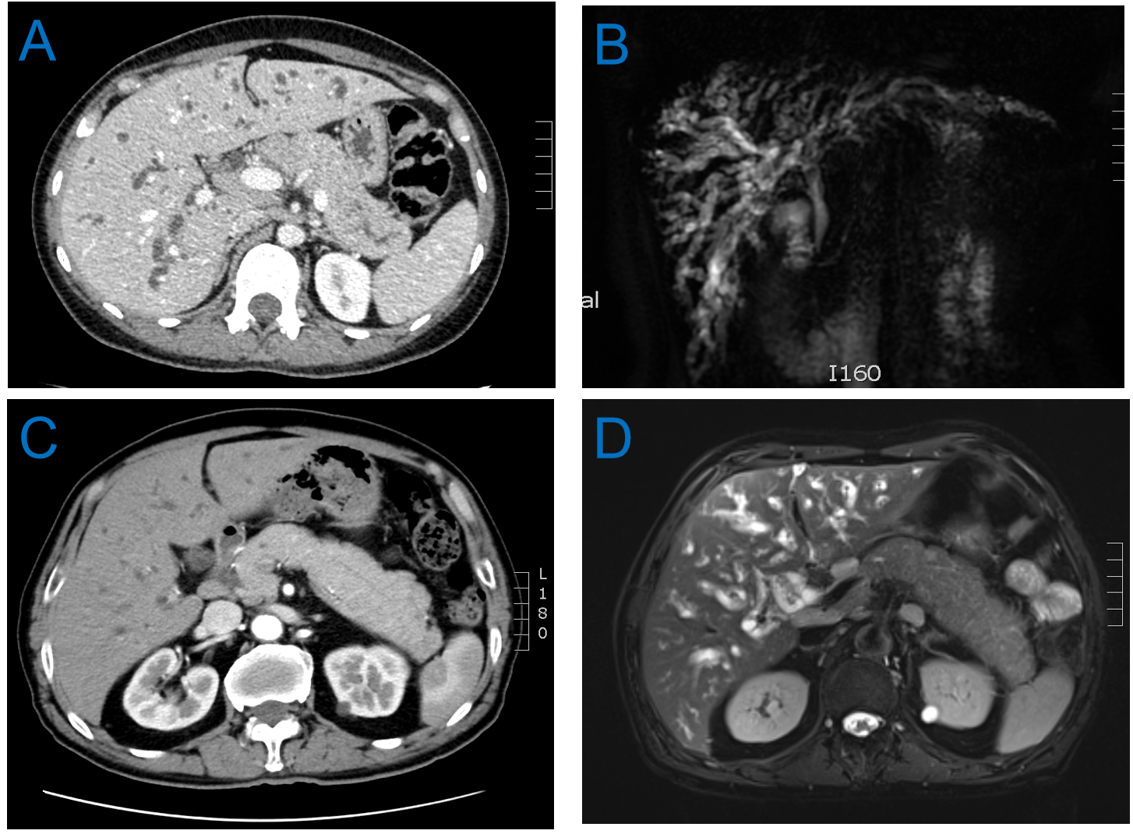
Figure 2 Images. A: Computed tomography (CT) image of a woman. The intrahepatic bile duct was diffusely dilated, the pancreas was full, the pancreatic duct in the tail of the body was slightly dilated, and multiple enlarged lymph nodes in the hilar and retroperitoneum were visible; B: Magnetic resonance cholangiopancreatography (MRCP) image of the woman. Intrahepatic bile ducts were dilated and had an uneven thickness, and the pancreas was full; C: CT image of a man. The intrahepatic bile duct was diffusely dilated, and the pancreas was full; D: MRCP image of the man. The intrahepatic and extrahepatic bile ducts and common bile ducts were dilated, and enlarged peripancreatic lymph nodes were visible.

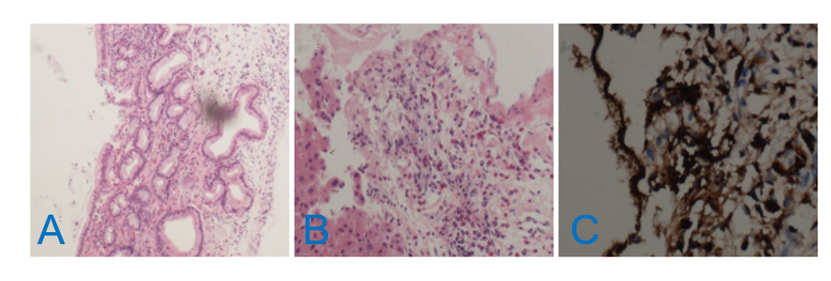
Figure 3 Pathological pictures. A: Massive bile duct hyperplasia; B: Eosinophils and plasma cells; C: Immunoglobulin G 4.

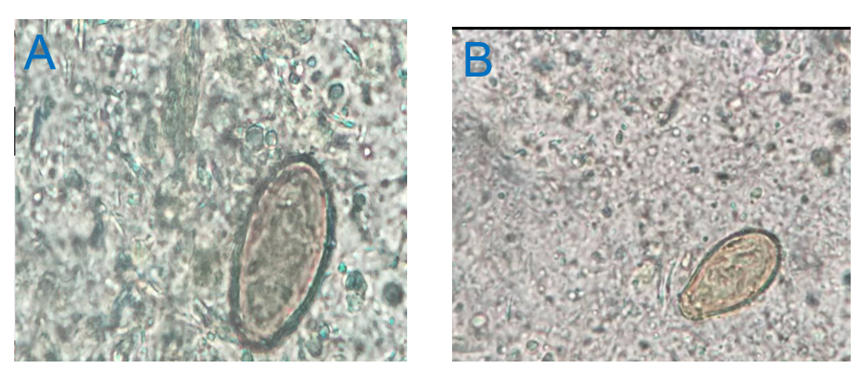
Figure 4 Clonorchis sinensis eggs in stool. A: Woman; B: Man.

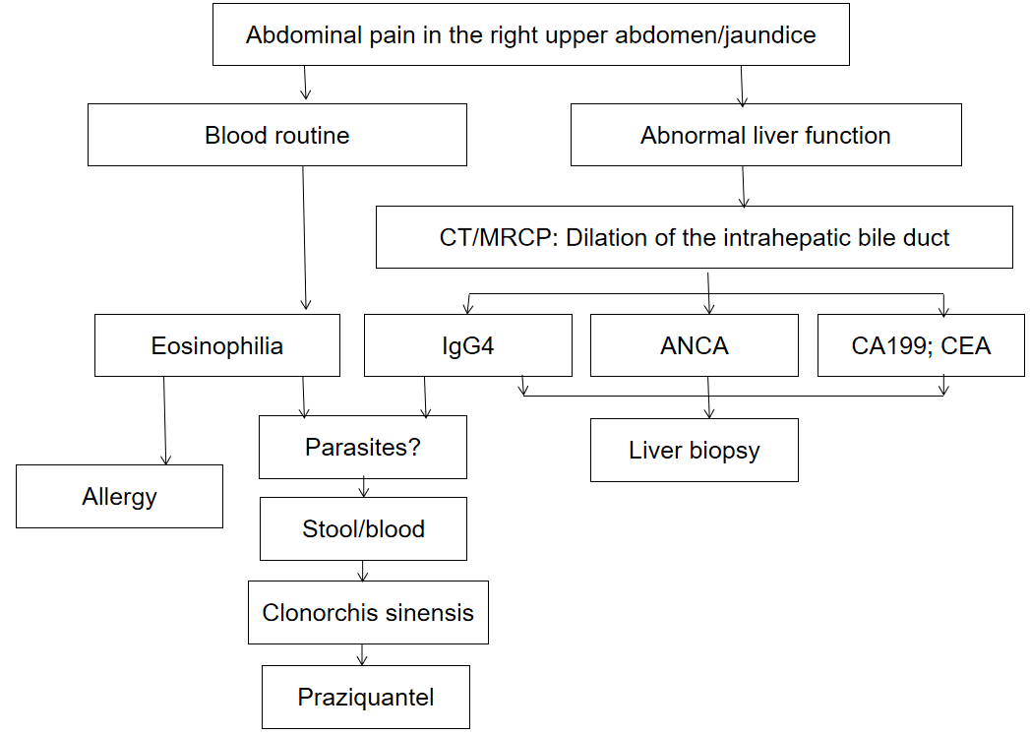
Figure 5 Flow diagram of diagnosis. IgG4: Immunoglobulin G 4; ANCA: Anti-neutrophil cytoplasmic antibody; CEA: Carcinoembryonic antigen; CT: Computed tomography; MRCP: Magnetic resonance cholangiopancreatography.

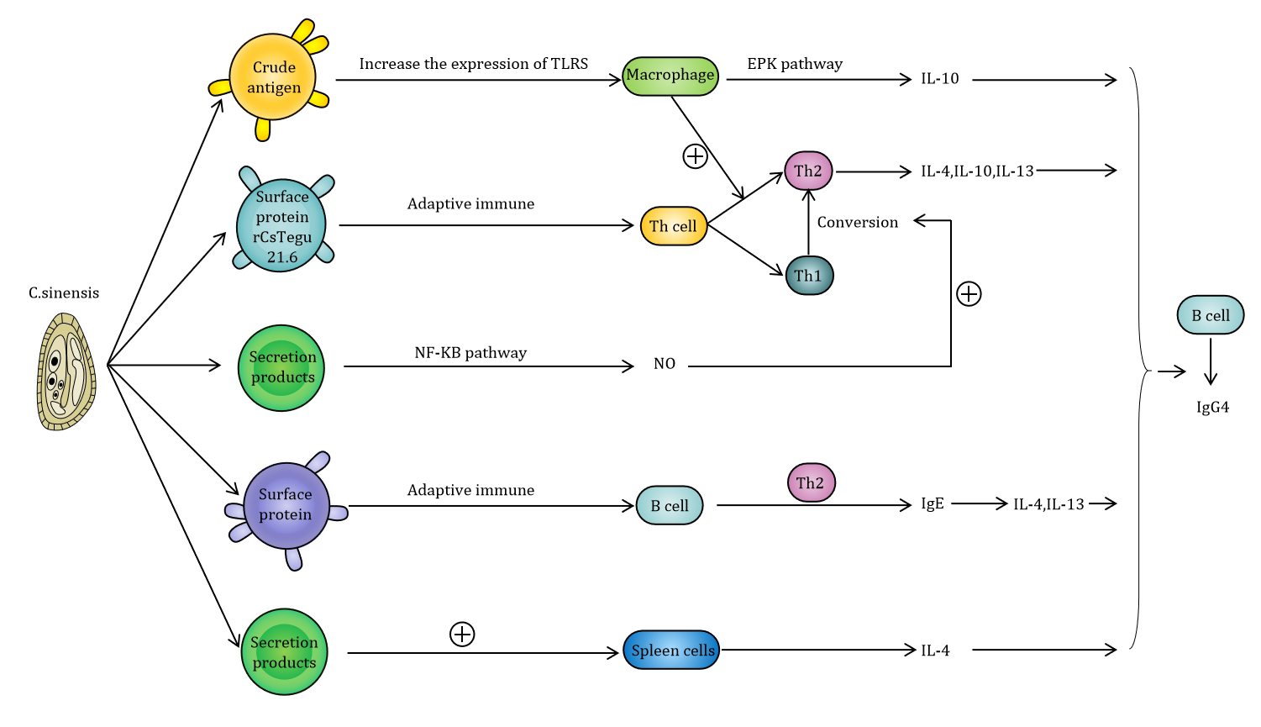
Figure 6 The related mechanisms between Clonorchis sinensis and immunoglobulin G4. TLRS: Toll-like receptors; EPK: Eukaryotic protein kinase; IL: Interleukin; IgE: Immunoglobulins E; NF-kB: Nuclear factor kappa B.

Table 1 Review of case reports of Clonorchis sinensis
Country | Ref. | Age | Sex | Food | History
China | Wang et al^{[37]}, 2019 | 52 | Male | Freshwater fish | None
China | Hao et al^{[38]}, 2016 | 48 | Male | None | None
China | Liu et al^{[39]}, 2019 | 49 | Male | Freshwater fish | -
China | Liu et al^{[39]}, 2019 | 40 | Female | Freshwater fish | -
South Korea | Oh et al^{[40]}, 2014 | 68 | Male | Freshwater fish | Gastric cancer and inguinal hernia
South Korea | Choi et al^{[41]}, 2015 | 53 | Male | Freshwater fish | Chronic hepatitis B
South Korea | Lee et al^{[42]}, 2003 | 54 | Male | Freshwater fish | None
South Korea | Lim et al^{[43]}, 2011 | 26 | Male | Freshwater fish | -
Japan | Fujiya et al^{[44]}, 2016 | 60 | Male | None | -
United States | Papachristou et al^{[45]}, 2005 | 35 | Male | None | -
China | Bian et al^{[46]}, 2001 | 35 | Female | None | -
Symptom(s) | Ultrasound | CT | MRCP | ERCP | Pathology
Severe abdominal pain in the right upper abdomen, acute shock | - | Cholecystitis, stone-like material in the gallbladder | Cholecystitis, stone-like material in the gallbladder | - | -
Jaundice | - | Cholecystitis, mild dilation of the intrahepatic duct | Cholecystitis, mild dilation of the intrahepatic duct | - | Liver biopsy: Eosinophil infiltration, obvious bile duct hyperplasia, liver cell degeneration, bile duct capillary blockage, chronic G3S1 hepatitis
Severe abdominal pain in the right upper abdomen | - | - | Bile duct stones, obvious spread of intrahepatic ducts | - | -
Jaundice, Severe abdominal pain | - | Bile duct obstruction, dilatation of the intrahepatic bile duct, bile duct stones, gallbladder stones | - | - | -
Fever, Severe abdominal pain in the right upper abdomen | - | Gallbladder dilation, thickening of the wall, fluid around the gallbladder, mild dilation of the extrahepatic bile duct | Gallbladder dilation, fluid around the gallbladder, mild dilation of the extrahepatic bile duct | - | Pathological examination of the gallbladder: Severe inflammatory mucosa and parasite eggs
Blood in stool, abdominal pain | - | A 4.3 cm heterogeneous solid and cystic mass in the distal pancreas | Multiple cystic tumors in the tail of the pancreas | - | -
Erythema rash | Mild splenomegaly | - | - | - | Lung biopsy: Microscopic examination of lung tissue shows infiltration of eosinophils
Anorexia, fatigue and weight loss | - | Mild dilation of intrahepatic bile duct | Slight dilation of bile ducts with irregular wall and depression | Edema and bulging of the duodenal papilla | Pathological examination of the duodenal papilla: Chronic active inflammation with many eosinophils in the mucosal layer
Jaundice, abdominal pain | - | Gallstone in the common bile duct, gallbladder stone, thrombus in the main hilar branch of the hilum, completely occluded in the left hilar branch | - | - | -
Darkened urine, fatigue, weight loss | - | Soft tissue masses in the hilum, dilation of intrahepatic and extrahepatic ducts, ascites | - | Irregular dilation of intrahepatic and extrahepatic ducts | -
Upper abdominal discomfort, nausea, anorexia | Cholecystitis, common bile duct obstruction | - | - | - | -
EO | IgE | ALT (U/L) | TBIL | Diagnosis | Treatment
15.1% | - | - | 230.3 μmol/ L | Laparotomy, bile | Praziquantel
50% | - | 211.9 | 229.7 μmol/ L | Stool | Praziquantel
6.50% | - | 236 | 128.8 μmol/ L | Common bile duct exploration by laparoscopy | Albendazole
15.40% | - | 399 | 129.2 μmol/ L | Common bile duct exploration by laparoscopy | Albendazole
- | - | 94 | 2.8 mg/dL | Laparotomy, gallbladder | Praziquantel
- | - | 27 |  | Laparotomy, pancreas
35% | 1020 IL/ML | - |  | Stool | Praziquantel
18.30% | - | 248 | 11.3 mg/dL | Bile | Praziquantel
154/μL | - | 171 |  | Bile | Praziquantel
4% | - | 135 | 4.0 mg/dL | Biliary biopsy | Praziquantel
- | - | - | - | Biliary biopsy | Praziquantel
CT: Computed tomography; MRCP: Magnetic resonance cholangiopancreatography; ERCP: Endoscopic retrograde cholangiopancreatography; IgE: Immunoglobulin E; ALT: Alanine aminotransferase; TBIL: Total bilirubin.

