Name of Journal: World Journal of Clinical Cases
Manuscript NO: 66324
Manuscript Type: CASE REPORT

Oral cyclophosphamide-induced posterior reversible encephalopathy syndrome in a patient with ANCA-associated vasculitis: A case report

Kim Y et al. Cyclophosphamide-induced PRES

Yire Kim, Jihye Kwak, Sehyun Jung, Seunghye Lee, Ha Nee Jang, Hyun Seop Cho, Se-Ho Chang, Hyun-Jung Kim

Yire Kim, Jihye Kwak, Sehyun Jung, Seunghye Lee, Ha Nee Jang, Hyun Seop Cho, Se-Ho Chang, Hyun-Jung Kim, Internal Medicine, Gyeongsang National University Hospital, Jinju 52727, South Korea

Ha Nee Jang, Hyun Seop Cho, Se-Ho Chang, Hyun-Jung Kim, Institute of Health Sciences, Gyeongsang National University, Jinju 52727, South Korea

Se-Ho Chang, Hyun-Jung Kim, Internal Medicine, College of Medicine, Gyeongsang National University, Jinju 52727, South Korea

Author contributions: Kim Y, Kwak J, Cho HS and Kim HJ collected data, reviewed the literature and contributed to manuscript drafting; Jung S, Lee S, Jang HN and Chang SH reviewed the literature and contributed to manuscript drafting; Kim Y analyzed and interpreted the imaging findings; Kim Y and Kim HJ were responsible for the revision of the manuscript for important intellectual content; All authors have read and approve the final manuscript.

Corresponding author: Hyun-Jung Kim, MD, PhD, Professor, Internal Medicine, Gyeongsang National University Hospital, 79 Gangnam-ro, Jinju 52727, South Korea. kimhjyh@gnu.ac.kr

Received: March 29, 2021
Revised: April 30, 2021
Accepted: May 20, 2021
Published online: July 26, 2021

Abstract
BACKGROUND
Posterior reversible encephalopathy syndrome (PRES) manifests many neurological symptoms with typical features on neuroimaging studies and has various risk factors. Cyclophosphamide is one of the therapeutic agents for anti-neutrophil cytoplasmic antibody (ANCA)-associated vasculitis. Cyclophosphamide as the sole cause of PRES has been reported in only a few cases. Herein, we report a unique case of early-onset oral cyclophosphamide-induced PRES in a patient with ANCA-associated vasculitis.

CASE SUMMARY
A 73-year-old man was transferred to our hospital for sepsis due to acute cholangitis. He had already received hemodialysis for two weeks due to septic acute kidney injury. His azotemia was not improved after sepsis resolved and perinuclear-ANCA was positive. Kidney biopsy showed crescentic glomerulonephritis. Alveolar hemorrhage was observed on bronchoscopy. He was initially treated with intravenous methylprednisolone and plasma exchange for one week. And then, two days after adding oral cyclophosphamide, the patient developed generalized tonic-clonic seizures. We diagnosed PRES by Brain magnetic resonance imaging (MRI) and electroencephalography. Seizures were controlled with fosphenytoin 750 mg. Cyclophosphamide was suspected to be the cause of PRES and withdrawal. His mentality was recovered after seven days and brain MRI showed normal state after two weeks.

CONCLUSION
The present case shows the possibility of PRES induction due to short-term use of oral cyclophosphamide therapy. Physicians should carefully monitor neurologic symptoms after oral cyclophosphamide administration in elderly patients with underlying diseases like sepsis, renal failure and ANCA-associated vasculitis.

Key Words: Cyclophosphamide; Posterior reversible encephalopathy syndrome; Anti-neutrophil cytoplasmic antibody-associated vasculitis; Renal failure; Case report

©The Author(s) 2021. Published by Baishideng Publishing Group Inc. All rights reserved.

Citation: Kim Y, Kwak J, Jung S, Lee S, Jang HN, Cho HS, Chang SH, Kim HJ. Oral cyclophosphamide-induced posterior reversible encephalopathy syndrome in a patient with ANCA-associated vasculitis: A case report. World J Clin Cases 2021; 9(21): 6130-6137
URL: https://www.wjgnet.com/2307-8960/full/v9/i21/6130.htm
DOI: https://dx.doi.org/10.12998/wjcc.v9.i21.6130

Core Tip: Posterior reversible encephalopathy syndrome (PRES) is a neurological disease that can occur suddenly during the clinical course of various disorders. Since the clinical course of PRES is reversible, it is important to diagnose it quickly and correct the cause. Cyclophosphamide has recently been reported as one of the causes of PRES. This is the first report that PRES occurred at the early onset of oral cyclophosphamide therapy. Physicians should carefully monitor neurologic symptoms after oral cyclophosphamide administration in elderly patients with underlying diseases like sepsis, renal failure, and anti-neutrophil cytoplasmic antibody-associated vasculitis.

INTRODUCTION
The symptoms of posterior reversible encephalopathy syndrome (PRES) include headache, seizure, visual disturbance, and loss of consciousness with varying severity. PRES shows typical features in the posterior parietal-temporal-occipital areas on brain imaging^{[1]}. Risk factors for PRES include immunosuppressive agents, cytotoxic drugs, renal disease, autoimmune disease, hypertensive encephalopathy, organ transplantation and eclampsia^{[1,2]}
Cyclophosphamide is an alkylating agent widely used in the treatment of certain malignancies and autoimmune diseases^{[3,4]}. Intravenous (IV) cyclophosphamide-induced PRES has been reported in several cases where cyclophosphamide was used to treat rapidly progressive glomerulonephritis (RPGN) including anti-neutrophil cytoplasmic antibody (ANCA)-associated vasculitis^{[3,5,6]}. However, all these cases occurred at least 3 wk after administration of oral cyclophosphamide^{[7,8]}. Herein, we present a case of PRES appearing after short-term administration of oral cyclophosphamide in a patient with RPGN caused by ANCA-associated vasculitis.

CASE PRESENTATION
Chief complaints
A 73-year-old man was consulted to nephrology for persistent oliguric azotemia during admission to hepatology of our hospital.

History of present illness
He already started hemodialysis via right internal jugular vein long-term dialysis catheter at one month ago due to septic acute kidney injury with uremic symptoms and oliguria. His azotemia and oliguria were not improved after sepsis resolving and he was still receiving hemodialysis for one month.

History of past illness
He had received intravenous antibiotic therapy and endoscopic retrograde biliary drainage state for sepsis due to acute cholangitis and common biliary duct cancer for one month.

Personal and family history
He denied taking any medications and past medical history except antibiotic therapy.

Physical examination
His blood pressure was 148/80 mmHg and he had both sides of pretibial pitting edema.

Laboratory examinations
His initial blood urea nitrogen and serum creatinine (sCr) were 46.8 mg/dL and 5.33 mg/dL. But his sCr was 0.8 mg/dL at one month ago. His total protein, serum albumin and total cholesterol were 5.6 g/dL, 2.2 g/dL and 136 mg/dL, respectively. Urinalysis revealed proteinuria (+1) with a protein/creatinine ratio of 3.6 mg/mg and microscopic hematuria. Serologic tests for viral hepatitis were all negative, and serum immunologic tests were within normal range for C3 and C4 and negative for anti-nuclear antibody (Ab), anti-ds DNA Ab, immunoglobulin G, A, and M levels, cryoglobulin and anti-phospholipid Ab. However, the patient was positive for perinuclear-ANCA.

further diagnostic work-up and treatment
Kidney needle biopsy and bronchoscopy were performed due to clinically suspected RPGN.
Renal pathologic findings were compatible with crescentic glomerulonephritis. Bronchoscopic finding showed diffuse alveolar hemorrhage. The patient’s final diagnosis was ANCA-associated vasculitis with pulmonary-renal syndrome.
We chose plasma exchange with oral cyclophosphamide and glucocorticoids therapy for newly diagnosed ANCA-associated vasculitis with severe renal failure^{[9]}. But we delayed cyclophosphamide after plasma exchange finished because he was still receiving antibiotic therapy for acute cholangitis. He was initially treated with intravenous methylprednisolone 30 mg/d and therapeutic plasma exchanges at the same time. After three times of plasma exchange for one week was done, oral cyclophosphamide 100 mg/d was started. The third day after the second dose of oral cyclophosphamide therapy, the patient suddenly developed generalized tonic-clonic seizures with deviation of both eyeballs for 30 s, five times consecutively, and when the seizure attack occurred, blood pressure was 175/76 mmHg. After the seizure, the patient exhibited stuporous mental status.

Imaging examinations
Brain magnetic resonance imaging (MRI) was immediately performed and revealed multifocal high signal intensity in both frontoparietal lobes, temporal lobes, occipital lobes, cerebellum and pons on T2 fluid attenuated inversion recovery (FLAIR) but no abnormal change on diffusion-weighted imaging (DWI) and apparent diffusion coefficient (ADC) (Figure 1). Electroencephalography showed frequent short bursts of bilateral polymorphic delta to theta slow waves of medium to high amplitude, mixed with short-attenuated periods.

FINAL DIAGNOSIS
The final diagnosis of the presented case was cyclophosphamide-induced PRES.

TREATMENT
We discussed the seizure management of this patient with the neurologist of our hospital. Seizure was controlled by administration of IV fosphenytoin 750 mg. IV methylprednisolone (30 mg/d) was continued but cyclophosphamide was discontinued due to the cause of PRES suspected.

OUTCOME AND FOLLOW-UP
Mental status fully recovered approximately seven days after the seizure attack. Follow-up brain MRI was performed two weeks after PRES onset and the images indicated that the disseminated enhancing lesions on T2 FLAIR had resolved (Figure 2) and the patient had no neurologic symptoms at this time.
After 10 d of seizure, oliguria was resolved and sCr recovered to 3.98 mg/dL. Hemodialysis was discontinued and the patient was discharged from the hospital with oral prednisolone. His clinical course was shown in Figure 3.
After follow-up for 4 mo at an outpatient clinic, he was treated with a maintenance dose of oral methylprednisolone (10 mg/day) with gradual tapering. His renal function was maintained at stable chronic kidney disease stage G4A2 (sCr, 2.41 mg/dL; eGFR by CKD-EPI, 25 mL/min per 1.73 m²; urine protein/creatinine ratio, 0.3 mg/mg). He has not relapsed any other neurologic symptoms.

DISCUSSION
PRES is a clinico-radiographic syndrome of varying etiology that was first described in a 1996 case series. The pathophysiology of PRES is a breakdown of cerebral autoregulation due to hypertensive encephalopathy, leading to disruption of the blood-brain barrier with fluid transudation and hemorrhage. Origins of PRES are diverse and often include hypertensive encephalopathy, renal failure, sepsis, vasculitis, autoimmune diseases, immunosuppressive agents and cytotoxic drugs^{[1,2]}.
Cyclophosphamide is an immunosuppressive drug widely used for the treatment of malignancy and autoimmune diseases like glomerulonephritis and ANCA-associated vasculitis. It is well described side effects of cyclophosphamide like leukopenia, severe infection, amenorrhea and malignancy^{[10]}. But it has recently been reported that cyclophosphamide is one of the causes of PRES. Especially, cyclophosphamide-induced PRES was reported in eight patients with RPGN (Table 1). Their PRES were more frequently developed in IV infusion than in oral prescription. It took longer to develop PRES with oral cyclophosphamide compared to IV drugs. Furthermore, two patients with ANCA-associated vasculitis and one with lupus nephritis who used IV injection developed PRES in 3 d^{[5,6,11]}. Among two cases of oral cyclophosphamide-induced PRES, Cha et al^{[7]} reported a 36-year-old woman with anti-GBM Ab glomerulonephritis treated with oral methylprednisolone, plasmapheresis and oral cyclophosphamide who suddenly developed PRES after 3 mo of treatment. Ganesh et al^{[8]} reported a 25-year-old female with Henoch-Schönlein purpura nephritis with crescents. She was treated with IV methylprednisolone and oral cyclophosphamide who developed PRES 26 days after starting cyclophosphamide. But our patient developed PRES 3 days after starting cyclophosphamide. Therefore, this is the first case of early onset of oral cyclophosphamide-induced PRES.
Several mechanisms are suggested as the cause of PRES in these patients. First is sudden hypertension because high blood pressure was reported in seven of nine PRES cases (Table 1). Hypertensive episodes or blood pressure fluctuations above the upper limit of autoregulation lead to cerebral hyperperfusion and cause vascular leakage and vasogenic edema. The posterior cerebrum areas appear particularly susceptible to blood circulation changes. Second is endothelial dysfunction caused by endogenous or exogenous toxins from cytotoxic substances, eclampsia, sepsis or autoimmune disorders. Immunologic reactions may trigger endothelial activation due to excessive cytokine release followed by vascular leakage of proteins and fluid into the interstitium^{[1,2]}. PRES associated ANCA-associated vasculitis itself has been reported, too and PRES was resolved after steroid pulse therapy^{[12]}. Third is renal failure that all RPGN patients have. Renal dysfunction has been reported in half of all patients with PRES^{[13]}. In patients with renal failure, administration of cyclophosphamide and decreased plasma clearance apparently result in increased systemic drug exposure and enhanced toxicity^{[14]}. However, cyclophosphamide metabolite pharmacokinetics does not explain the occurrence of PRES because the metabolites cannot easily cross the blood-brain barrier, although they do have cytotoxic properties^{[15]}. Therefore, whether accompanying renal dysfunction is the primary cause of PRES remains unclear.
When this patient was diagnosed with PRES, he had some risk factors such as immunosuppressive therapy, abrupt hypertension at the onset of seizure, azotemia, sepsis, ANCA-associated vasculitis as autoimmune disease and renal failure. However, seizures might not be the result but the cause of high blood pressure in this patient because his blood pressure was well controlled before seizure. His uremic symptoms and azotemia were also stable by regular hemodialysis for one month even though it was not normal. Both sepsis and vasculitis may cause damage to vascular endothelial cells to varying degrees. But his cholangitis was nearly improving state after antibiotic medication for six weeks at the time of seizure attack. And the activity of vasculitis was controlled by steroid pulse therapy and plasma exchange for one week. So, we could rule out the sepsis and vasculitis as the cause of PRES. We suspected the cyclophosphamide as the cause of PRES in this patient even though short-term use of oral cyclophosphamide. Seizure with loss of consciousness spontaneously resolved after cyclophosphamide withdrawal. We suggest that the contributing factors of early onset of oral cyclophosphamide-induced PRES is his severe azotemia, old age and underlying disease of sepsis and ANCA-associated vasculitis.

CONCLUSION
Our case report indicates that even short-term treatment with oral cyclophosphamide can cause PRES as a side effect of cyclophosphamide. Physicians should carefully monitor neurologic symptoms after oral cyclophosphamide administration in elderly patients with underlying diseases like sepsis, renal failure, and ANCA-associated vasculitis.

ACKNOWLEDGEMENTS
The authors thank the patient for his support.

REFERENCES
1 Hinchey J, Chaves C, Appignani B, Breen J, Pao L, Wang A, Pessin MS, Lamy C, Mas JL, Caplan LR. A reversible posterior leukoencephalopathy syndrome. N Engl J Med 1996; 334: 494-500 [PMID: 8559202 DOI: 10.1056/NEJM199602223340803]
2 Fischer M, Schmutzhard E. Posterior reversible encephalopathy syndrome. J Neurol 2017; 264: 1608-1616 [PMID: 28054130 DOI: 10.1007/s00415-016-8377-8]
3 Abenza-Abildua MJ, Fuentes B, Diaz D, Royo A, Olea T, Aguilar-Amat MJ, Diez-Tejedor E. Cyclophosphamide-induced reversible posterior leukoencephalopathy syndrome. BMJ Case Rep 2009; 2009 [PMID: 21686794 DOI: 10.1136/bcr.07.2008.0467]
4 Lee CH, Lee YM, Ahn SH, Ryu DW, Song JH, Lee MS. Cyclophosphamide-induced Posterior Reversible Encephalopathy Syndrome in a Patient with Lupus Nephritis. J Rheum Dis 2013: 103 [DOI: 10.4078/jrd.2013.20.2.103]
5 Scailteux LM, Hudier L, Renaudineau E, Jego P, Drouet T. Posterior Reversible Encephalopathy Syndrome after a First Injection of Cyclophosphamide: A Case Report. J Pharm 2015: 163 [DOI: 10.4172/2329-6887.1000163]
6 Pan D, Sabharwal B, Vallejo F. Posterior Reversible Encephalopathy Syndrome Secondary to Cyclophosphamide in the Treatment of Pulmonary Renal Syndrome. Chest 2017: A367 [DOI: 10.1016/j.chest.2017.08.393]
7 Cha B, Kim DY, Jang H, Hwang SD, Choi HJ, Kim MJ. Unusual Case of Posterior Reversible Encephalopathy Syndrome in a Patient with Anti-glomerular Basement Membrane Antibody Glomerulonephritis: A Case Report and Review of the Literature. Electrolyte Blood Press 2017; 15: 12-16 [PMID: 29042902 DOI: 10.5049/EBP.2017.15.1.12]
8 Ganesh K, Nair RR, Kurian G, Mathew A, Sreedharan S, Paul Z. Posterior Reversible Encephalopathy Syndrome in Kidney Disease. Kidney Int Rep 2018; 3: 502-507 [PMID: 29725657 DOI: 10.1016/j.ekir.2017.10.017]
9 Geetha D, Jefferson JA. ANCA-Associated Vasculitis: Core Curriculum 2020. Am J Kidney Dis 2020; 75: 124-137 [PMID: 31358311 DOI: 10.1053/j.ajkd.2019.04.031]
10 Dan D, Fischer R, Adler S, Förger F, Villiger PM. Cyclophosphamide: As bad as its reputation? Long-term single centre experience of cyclophosphamide side effects in the treatment of systemic autoimmune diseases. Swiss Med Wkly 2014; 144: w14030 [PMID: 25341028 DOI: 10.4414/smw.2014.14030]
11 Jabrane M, Ait Lahcen Z, Fadili W, Laouad I. A case of PRES in an active lupus nephritis patient after treatment of corticosteroid and cyclophosphamide. Rheumatol Int 2015; 35: 935-938 [PMID: 25387825 DOI: 10.1007/s00296-014-3173-1]
12 Marra AM, Barilaro G, Villella V, Granata M. Eosinophilic granulomatosis with polyangiitis (EGPA) and PRES: a case-based review of literature in ANCA-associated vasculitides. Rheumatol Int 2015; 35: 1591-1595 [PMID: 25836767 DOI: 10.1007/s00296-015-3261-x]
13 Fugate JE, Rabinstein AA. Posterior reversible encephalopathy syndrome: clinical and radiological manifestations, pathophysiology, and outstanding questions. Lancet Neurol 2015; 14: 914-925 [PMID: 26184985 DOI: 10.1016/S1474-4422(15)00111-8]
14 Jayaweera JL, Withana MR, Dalpatadu CK, Beligaswatta CD, Rajapakse T, Jayasinghe S, Chang T. Cyclophosphamide-induced posterior reversible encephalopathy syndrome (PRES): a case report. J Med Case Rep 2014; 8: 442 [PMID: 25519913 DOI: 10.1186/1752-1947-8-442]
15 Grochow LB, Colvin M. Clinical pharmacokinetics of cyclophosphamide. Clin Pharmacokinet 1979; 4: 380-394 [PMID: 389529 DOI: 10.2165/00003088-197904050-00004]
16 Zekić T, Benić MS, Antulov R, Antončić I, Novak S. The multifactorial origin of posterior reversible encephalopathy syndrome in cyclophosphamide-treated lupus patients. Rheumatol Int 2017; 37: 2105-2114 [PMID: 29043491 DOI: 10.1007/s00296-017-3843-x]

Footnotes
Informed consent statement: Informed written consent was obtained from the patient for publication of this report and any accompanying images.

Conflict-of-interest statement: The authors declare that they have no conflict of interest.

CARE Checklist (2016) statement: The authors have read the CARE Checklist (2016), and the manuscript was prepared and revised according to the CARE Checklist (2016).

Open-Access: This article is an open-access article that was selected by an in-house editor and fully peer-reviewed by external reviewers. It is distributed in accordance with the Creative Commons Attribution NonCommercial (CC BY-NC 4.0) license, which permits others to distribute, remix, adapt, build upon this work non-commercially, and license their derivative works on different terms, provided the original work is properly cited and the use is non-commercial. See: http://creativecommons.org/Licenses/by-nc/4.0/

Manuscript source: Unsolicited Manuscript
Corresponding Author's Membership in Professional Societies: International Society of Nephrology, No. 52629; American Society of Nephrology, No. 136426.

Peer-review started: March 29, 2021
First decision: April 28, 2021
Article in press: May 20, 2021

Specialty type: Urology and Nephrology
Country/Territory of origin: South Korea
Peer-review report’s scientific quality classification
Grade A (Excellent): 0
Grade B (Very good): 0
Grade C (Good): C
Grade D (Fair): 0
Grade E (Poor): 0

P-Reviewer: Zhang L S-Editor: Ma YJ L-Editor: A P-Editor: Yuan YY

Figure Legends
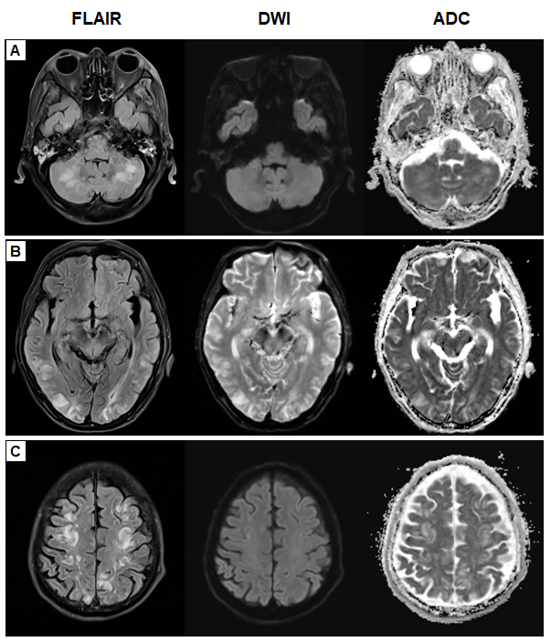
Figure 1 Initial axial brain magnetic resonance imaging findings (T2 fluid attenuated inversion recovery, diffusion-weighted imaging and apparent diffusion coefficient sequences). T2 fluid attenuated inversion recovery images showed multifocal high signal intensities in bilateral cerebellum (A) bilateral parieto-occipital lobes (B) and fronto-parietal lobes (C). T2 FLAIR: T2 fluid attenuated inversion recovery; DWI: diffusion-weighted imaging; ADC: apparent diffusion coefficient.
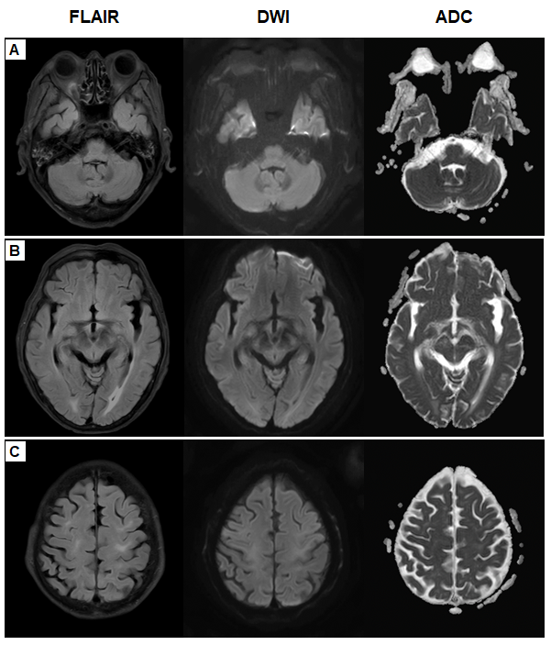
Figure 2 Follow-up axial brain magnetic resonance imaging findings (T2 fluid attenuated inversion recovery, diffusion-weighted imaging and apparent diffusion coefficient sequences). T2 fluid attenuated inversion recovery showed near complete resolution of multifocal lesions of bilateral cerebellum (A), bilateral parieto-occipital lobes (B) and fronto-parietal lobes (C). T2 FLAIR: T2 fluid attenuated inversion recovery; DWI: diffusion-weighted imaging; ADC: apparent diffusion coefficient.
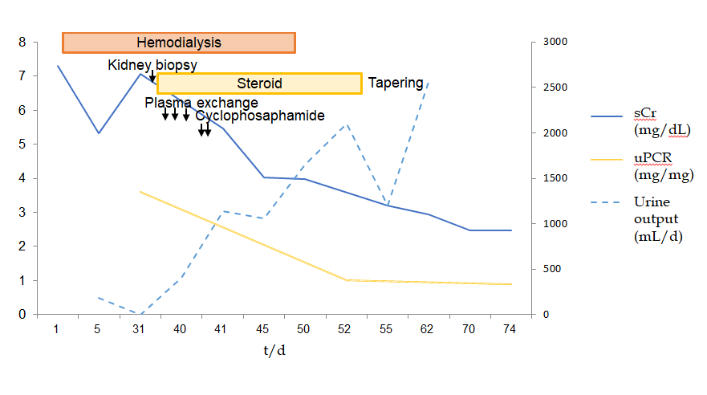
Figure 3 Clinical course.
Table 1 Reported cases of cyclophosphamideinduced posterior reversible encephalopathy syndrome in patients with rapidly progressive glomerulonephritis
Ref. | Age (yr) | Sex | Country | Renal diagnosis | Immunosuppressant | BP (mmHg) | SCr (mg/dL) | Onset of PRES after CP (d) | Recovery time (d)
Abenza-Abildua et al^{[3]} | 27 | F | Spain | Anti-GBM disease | pulse Pd, IV CP | 185/105 | 8.5 | 30 | 2
Lee et al^{[4]} | 45 | F | South Korea | Lupus nephritis | pulse Pd, IV CP | 190/100 | 2.68 | 16 | 20
Scailteux et al^{[5]} | 75 | M | France | ANCA vasculitis | pulse Pd, IV CP | 164/91 | 2.40 | 3 | 18
Jabrane et al^{[11]} | 16 | F | Morocco | Lupus nephritis | pulse Pd, IV CP | 120/70 | 5.8 | 3 | 1
Pan et al^{[6]} | 22 | F | United States | ANCA vasculitis | pulse Pd, IV CP | 170/110 | 1.47 | 3 | NR
Cha et al^{[7]} | 36 | F | South Korea | Anti-GBM disease | pulse Pd, oral CP | 200/120 | 4.7 | 90 | 28
Zekić et al^{[16]} | 18 | F | Croatia | Lupus nephritis | pulse Pd, IV CP | 160/100 | normal | 14 | 45
Ganesh et al^{[8]} | 25 | F | India | H-S purpura | pulse Pd, oral CP | normal | moderate RF | 26 | NR
present | 73 | M | South Korea | ANCA vasculitis | pulse Pd, oral CP | 175/76 | 5.47 | 3 | 7
ANCA: Anti-neutrophil cytoplasmic antibody; BP: Blood pressure; CP: Cyclophosphamide; H-S: Henoch-Schönlein; IV: Intravenous; GBM: Glomerular basement membrane; GN: Glomerulonephritis; NR: Not reported; Pd: Prednisolone; PRES: Posterior reversible encephalopathy syndrome; RF: Renal failure, RPGN: Rapidly progressive GN.

Published by Baishideng Publishing Group Inc
7041 Koll Center Parkway, Suite 160, Pleasanton, CA 94566, USA
Telephone: +1-925-3991568
E-mail: bpgoffice@wjgnet.com
Help Desk: https://www.f6publishing.com/helpdesk
https://www.wjgnet.com

© 2021 Baishideng Publishing Group Inc. All rights reserved.

