Name of journal: World Journal of Clinical Cases
ESPS Manuscript NO: 1642
Columns: CASE REPORT

Oral rehabilitation of Parkinsonism patient: A case report

Singh Y et al. Managing Parkinsonism patient.

Yashpal Singh, Monika Saini, Neha Garg

YashpalSingh, Monika Saini, Neha Garg, Department of Prosthodontics, Subharti Dental College, Meerut, UP 250005, India

Author contributions: Singh Y fabricated the complete denture for the patient; Saini Massisted in the procedure and helped in writing the paper; Garg N helped in photography and other micellanous work regarding the case report; all the authors contributed to the manuscript in writing and revision.

Correspondence to: Yashpal Singh, MD, Department of Prosthodontics, Subharti dental College, Delhi-Haridwar Bypass Road, Meerut, UP 250005, India. dryashpal.singh@gmail.com

Telephone: +91-987-396612 Fax: +91-987-3296612

Received: December 25, 2012 Revised: February 14, 2013
Accepted: March 21, 2013

Published online:

Abstract
Parkinson’s disease is an idiopathic disorder of the central nervous system characterized by resting tremors, muscular rigidity, slow and decreased movements. Oral rehabilitation of these patients requires special care especially in those cases where patient socioeconomic status is not good and patient cannot come several times for fabrication of complete denture.This clinical report presents a case of parkinsonism patient who is completely rehabilitated in 3 appointments using special techniques. Border moulding, final impression and jaw relation procedures were done in one appointment by using a custom tray with detachable handles and occlusal rims.

© 2013Baishideng. All rights reserved.

Key words: Parkinson’s disease; Tich buttons; Detachable handles and occlusal rims; Monoplane teeth

Core tip: Parkinsonism is a debilitating disease. Patient can not visit the dentist frequently for the procedures like complete denture especially when disease is in advanced stage.The matter becomes worse when patient is poor and unable to bear the cost. This case report presents solution to above mentioned problem in a simple and lucid manner where patient has to visit the dentist only thrice and bear no extra cost.

Singh Y, Saini M, Garg N. Oral rehabilitation of Parkinsonism patient: A case report

Available from:
DOI:

INTRODUCTION
Parkinson’s disease is a chronic, progressive, neurodegenerative, disorder characterised by resting tremor (in hands, arms, legs, jaw, and face); rigidity and stiffness (limbs and trunk), and postural instability or impaired balance and coordination^{[1-3]}.
It is the fourth most common neurodegenerative disorder^{[2]}. Itis characterized by resting tremors, muscular rigidity, slow and decreased movement and postural instability. It is a major cause of disability, social isolation, loss of self- esteem and depression. Oral rehabilitation of these patients requires multidisciplinary approach^{[3]} and special care because due to increased tremors, increased saliva, diminished adaptive skills, and poor muscle control by the patient prosthodontic procedures becomes difficult to perform as well as retention of dentures is compromised^{[4]}. Also patient finds difficulty in care and maintenance of the denture. Therefore, prosthodonticprocedures becomes difficult to perform and requires special care and attention.Moreover patient could not visit the dentist several times due to his medical condition^{[5]}.
Previous studies^{[6-10]} have been done on fabrication of complete denture for patients suffering from Parkinson’s disease. The main drawback was its cost. Parkinsonism patient who belonged to poor socio-economic status could not afford such therapy. Here tich buttons were used instead of metal styli that solved this problem. Tich buttons are cheap and easily available than metal styli.
This clinical report describes fabrication of complete denture for patient suffering from Parkinson’s disease by using certain modification like combining border moulding, final impression and jaw relation procedures in one appointment^{[11]} by using a custom tray with detachable handles and occlusal rims with the help of tich buttons, use of non-anatomic or monoplane teeth, that helped in delivery of the denture in three appointments.

CASE REPORT
A 55 year old male patient reported to the Dental OPD, Subharti Dental College, meerut for the fabrication of complete denture. The patient had medical history of Parkinsonism since 5 years and was on drug therapy. His physical and financial condition instilled to plan a denture with certain modifications.

Procedure
On the first day primary impressions were made with impression compound in the conventional manner and the primary cast was obtained now, the acrylic resinwas mixed and adapted on the primary cast to make custom tray in the conventional manner. Before acrylic resin set, sleeve of one tich button was inserted in anterior region and two in posterior region (Figure 1A). Surveyor was used for this so as to make the long axis of all vertical and parallel to each other. Now the other part of tich button is placed on the anterior and handles were made (Figure 1B). After setting handles were separated from the tray and all tich buttons locked with its other part and occlusalrims were fabricated on it. Now maxillary and mandibular custom trays were ready for making impressions with the detachable handles and occlusal rims depending on the procedure. On the second appointment with the handles attached, border moulding was completed. Now the handles were removed and occlusal rims were attached, vertical and centric jaw relation records were established in conventional manner (Figure 1C). Final impression was made with Zinc oxide Eugenolwith handles reattached. After final impression both occlusal rims were reattached and sealed at established vertical and centric relation (Figure 1D). Custom tray and final impressions from occlusal rims were separated and handles reattached, impressions were poured after beading and boxing. Occlusal rims were reattached and measurements of the proper position of buttons and height of the rims noted to avoid any error in placing buttons on denture bases. Finally mounting was done. Denture bases are fabricated in the conventional manner but at the same time placing sleeves of buttons on it before setting (Figure 1E). Position of the buttons can be verified by rims as well as measurements taken before. Now the rims reattached on the new sleeves and teeth arrangement was done using monoplane teeth (Figure 1F). On the third appointment trial dentures were checked in the patient’s mouth for esthetics, phonetics, border extensions, midline and vertical dimension (Figure 1G). To avoid fourth visit of patient wax up and carving were done at the time of teeth arrangement. Dentures cured and polished and delivered to the patient (Figure 1H).

DISCUSSION
Parkinson’s disease is a chronic, progressive, neurodegenerative, disorder characterized by resting tremor (in hands, arms, legs, jaw, and face); rigidity and stiffness (limbs and trunk), and postural instability or impaired balance and coordination. There are peculiar clinical features of this disease,like resting tremors, muscular rigidity and hypokinesia, facial impassiveness and Cog-wheel type of rigidity^{[12]}.
Dentists face many problems^{[13,14]} in fabrication of complete denture in such patient because increased tremors, increased saliva, diminished adaptive skills, and poor muscle control make impression making, jaw relation recording difficult causing compromised retention. When the center of gravity is displaced there may be tendency to fall forward/ backward. Tongue may dislodge the mandibular denture, facial muscles that are rigid or uncontrollable may prevent a maxillary denture from maintaining a retentive seal. Also patient finds difficulty in care and maintenance of the denture.
The patient was not able to come visit several times for the procedure therefore border moulding, final impression and jaw relation procedures were combined in one appointment by using a custom tray with detachable handles and occlusal rims with the help of tich buttons. In such cases facebow transfer and gothic arch tracings cannot be recorded due to medical contion of the patient. This eliminated the use of semi or fully adjustable articulator. Monoplane teeth were used to compensate variable centric relation.
The technique described here is a relatively simple and with drastic departure from the conventional procedure. With this technique, complete denture was delivered in three visits and was also very economical to the patient. Though this technique increases laboratory time but reduces the clinical visits to a greater extent without compromising the basic principles of complete denture fabrication.

REFERENCES
1 Walker B R, Boon N A, Colledge N R. Davidson’s principles & practice of Medicine. 20th ed. Edinburgh: Churchill Livingstone pub, 2006: 1218
2 Dirks SJ, Paunovich ED, Terezhalmy GT, Chiodo LK. The patient with Parkinson's disease. Quintessence Int 2003; 34: 379-393 [PMID: 12795358]
3 Fiske J, Hyland K. Parkinson's disease and oral care. Dent Update 2000; 27: 58-65 [PMID: 11218273]
4 Rahn AO, Heartwell CM. Textbook of complete dentures. 5th ed. London: Philadelphia, 1993: 134
5 Persson M, Osterberg T, Granérus AK, Karlsson S. Influence of Parkinson's disease on oral health. Acta Odontol Scand 1992; 50: 37-42 [PMID: 1348899]
6 Heckmann SM, Heckmann JG, Weber HP. Clinical outcomes of three Parkinson's disease patients treated with mandibular implant overdentures. Clin Oral Implants Res 2000; 11: 566-571 [PMID: 11168250]
7 Omprakash YV, Hallikerimath RB, Gangadhar SA. Prosthodontic management of a case of Parkinson’s disease- A case report. JIPS 2004; 4: 21-24
8 Chu FC, Deng FL, Siu AS, Chow TW. Implant-tissue supported, magnet-retained mandibular overdenture for an edentulous patient with Parkinson's disease: a clinical report. J Prosthet Dent 2004; 91: 219-222 [PMID: 15060489]
9 Packer M, Nikitin V, Coward T, Davis DM, Fiske J. The potential benefits of dental implants on the oral health quality of life of people with Parkinson's disease. Gerodontology 2009; 26: 11-18 [PMID: 19278520 DOI: 10.1111/j.1741-2358.2008.00233.x]
10 Rajeswari CL. Prosthodontic considerations in Parkinson’s disease. People’s Journal of Scientific Research 2010; 3: 45-47
11 Ansari IH. A one-appointment impression and centric relation record technique for compromised complete denture patients. J Prosthet Dent 1997; 78: 320-323 [PMID: 9297651 DOI: 10.1016/S0022-3913(97)70033-7]
12 Friedlander AH, Mahler M, Norman KM, Ettinger RL. Parkinson disease: systemic and orofacial manifestations, medical and dental management. J Am Dent Assoc 2009; 140: 658-669 [PMID: 19491161]
13 Langer A. Prosthodontic failures in patients with systemic disorders. J Oral Rehabil 1979; 6: 13-19 [PMID: 282412 DOI: 10.1111/j.1365-2842.1979.tb00399.x]
14 Kieser J, Jones G, Borlase G, MacFadyen E. Dental treatment of patients with neurodegenerative disease. N Z Dent J 1999; 95: 130-134 [PMID: 10687380]
P-Reviewers Panciani PP, Teive HAG
S-Editor Zhai HH L-Editor E-Editor

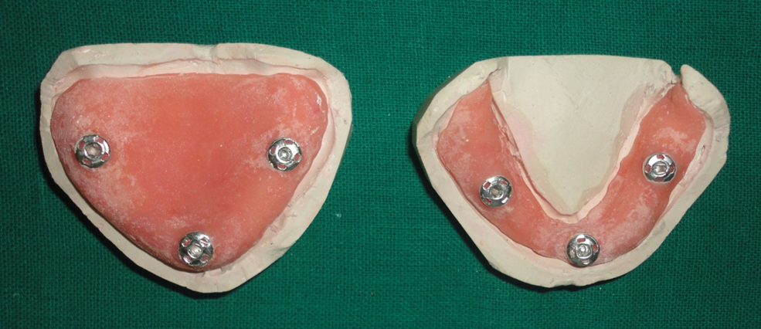
A
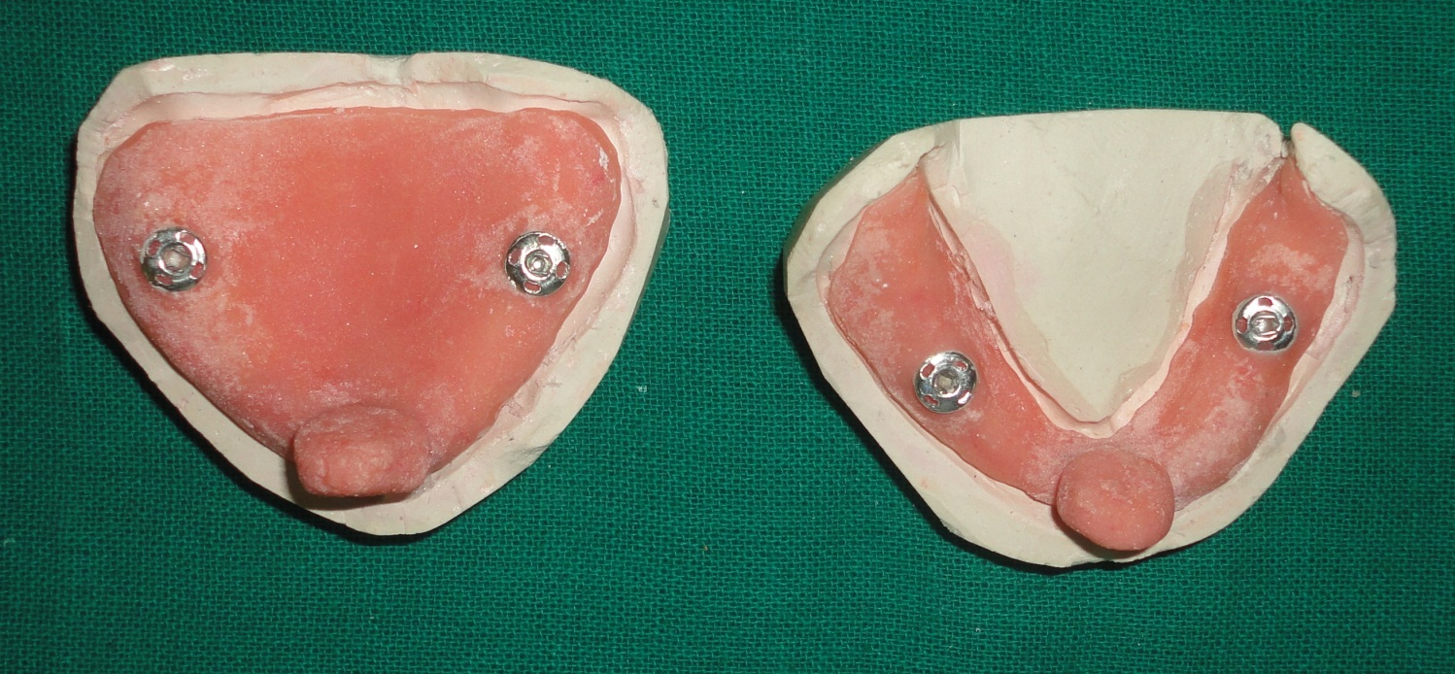
B
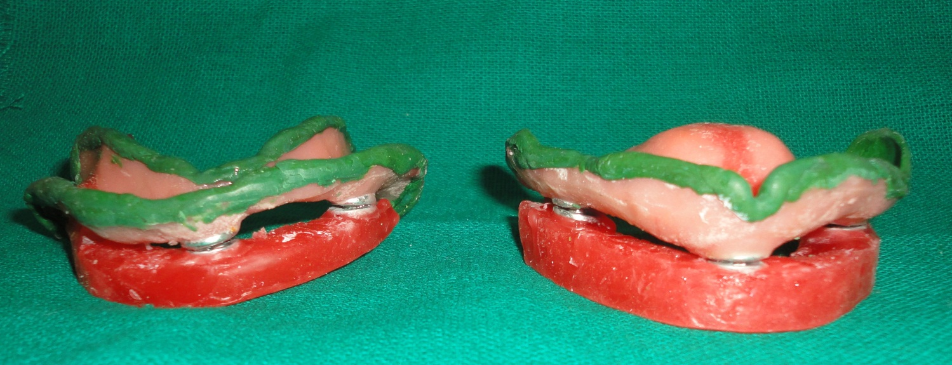
C
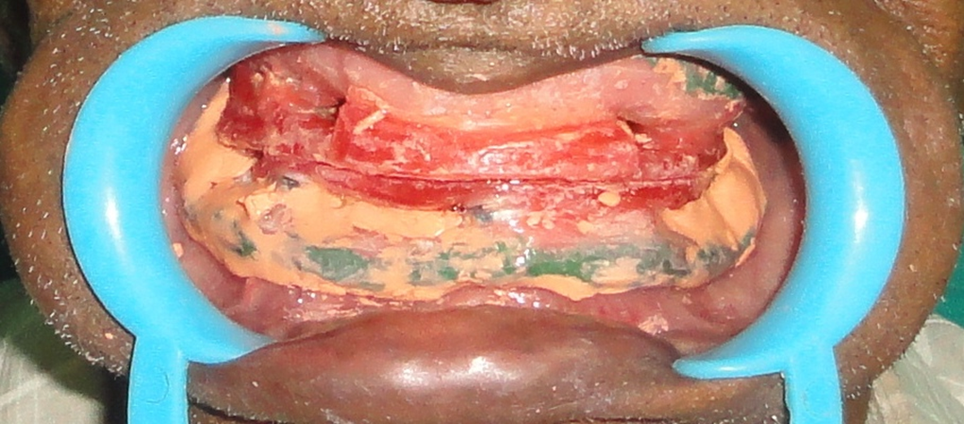
D
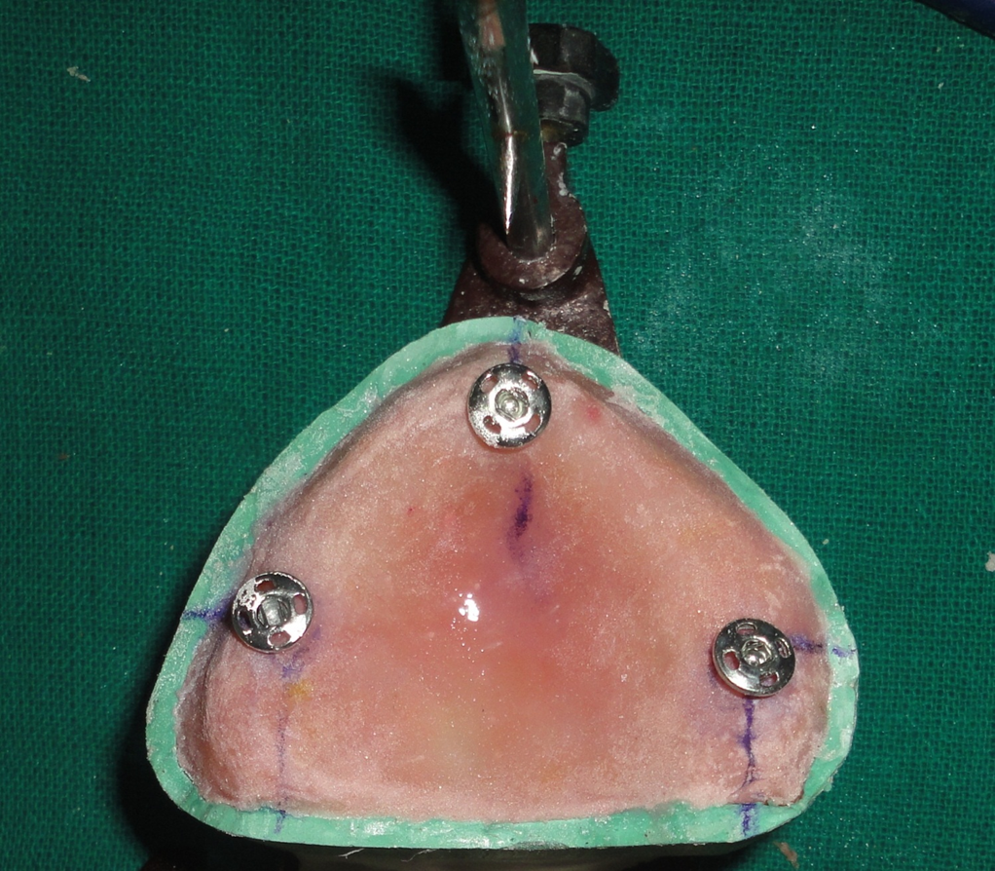
E
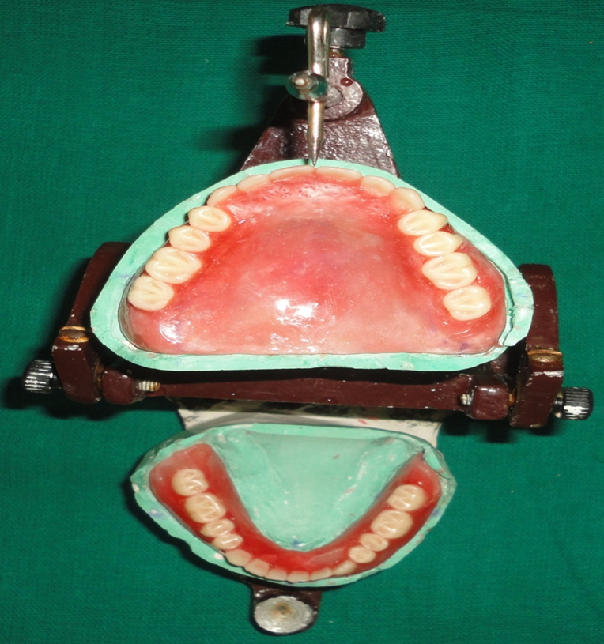
F
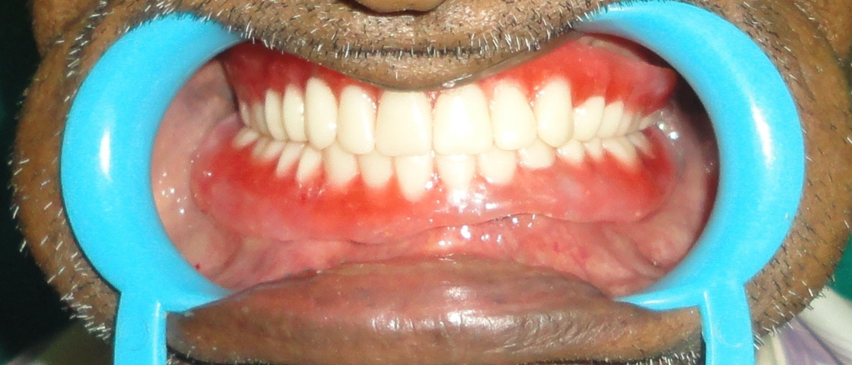
G
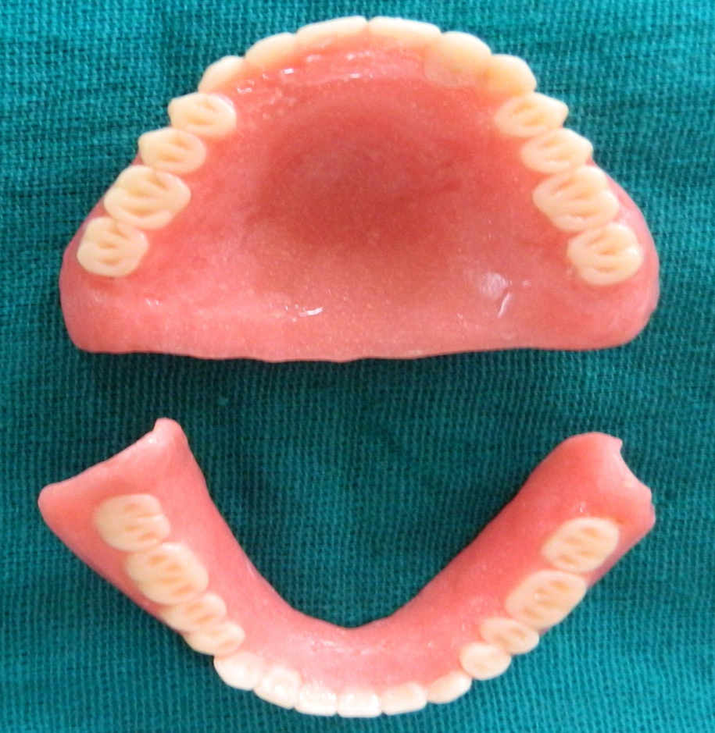
H
Figure 1 Denture procedure.
A-C: Maxillary and mandibular special trays. A: Before acrylic resin set, sleeve of one tich button was inserted in anterior region and two in posterior region; B: After setting handles were separated from the tray and all tich buttons locked with its other part and occlusal rims were fabricated on it; C: Now the handles were removed and occlusal rims were attached, ready to record vertical and centric jaw relation in conventional manner; D: Recording of jaw relation. Final impression was made with zinc oxide eugenol with handles reattached. After final impression both occlusal rims were reattached and sealed at established vertical and centric relation; E: Articulation and mounting of casts on mean value articulator. Articulation and mounting of casts on mean value articulator; F: The rims reattached on the new sleeves and teeth arrangement was done using monoplane teeth; G: Trial dentures were checked in the patient’s mouth for esthetics, phonetics, border extensions, midline and vertical dimension; H: Dentures cured and polished and delivered to the patient.

