Name of journal: World Journal of Gastroenterology
ESPS Manuscript NO: 18422
Columns: ORIGINAL ARTICLE

Retrospective study
Three-dimensional vs two-dimensional video assisted thoracoscopic esophagectomy for patients with esophageal cancer

Li Z et al. 3D VATE for esophageal cancer

Zhao Li, Jing-Pei Li, Xiong Qin, Bin-Bin Xu, Yu-Dong Han, Si-Da Liu, Wen-Zhuo Zhu, Ming-Zheng Peng, Qiang Lin

Zhao Li, Xiong Qin, Bin-Bin Xu, Yu-Dong Han, Si-Da Liu, Wen-Zhuo Zhu, Ming-Zheng Peng, Qiang Lin, Department of Thoracic Surgery, Shanghai General Hospital, Shanghai Jiaotong University school of medicine, Shanghai 200080, China

Jing-Pei Li, Department of Thoracic Surgery, Guangzhou Medical University First Affiliated Hospital, Guangzhou 510120, Guangdong Province, China

Author contributions: Li Z and Li JP contributed equally to this work; Li Z, Li JP and Xu BB collocted and analyzed the data; Li Z and Qin X drafted the manuscript; Han YD and Liu SD provided analytical oversight; Peng MZ offered technical and material support; Li Z and Lin Q supervised the study and provided administrative support; all authors have read and approved the final version to be published.

Institutional review board statement: This study is approved by the Clinical Ethics Committee of Shanghai General Hospital, School of Medicine, Shanghai Jiaotong University.

Informed consent statement: All study participants provided informed written consent prior to study enrollment.

Conflict-of-interest statement: No conflict of interest is declared.

Data sharing statement: No additional data are available.

Open-Access: This article is an open-access article which was selected by an in-house editor and fully peer-reviewed by external reviewers. It is distributed in accordance with the Creative Commons Attribution Non Commercial (CC BY-NC 4.0) license, which permits others to distribute, remix, adapt, build upon this work non-commercially, and license their derivative works on different terms, provided the original work is properly cited and the use is non-commercial. See: http://creativecommons.org/licenses/by-nc/4.0/

Correspondence to: Qiang Lin, MD, Department of Thoracic Surgery, Shanghai General Hospital, Shanghai Jiaotong University school of medicine, No. 1630 Dongfang Road, Shanghai 200080, China. xklinqiang@hotmail.com
Telephone: +86-21-36123602

Received: April 20, 2015
Peer-review started: April 21, 2015
First decision: June 19, 2015
Revised: July 8, 2015
Accepted: August 30, 2015

Article in press:
Published online:

Abstract
AIM: To define the benefits of three-dimensional video-assisted thoracoscopic esophagectomy (3D-VATE) over 2D-VATE for esophageal cancer.

METHODS: A total of 93 patients with esophageal cancer including 45 patients receiving 3D-VATE and 48 receiving 2D-VATE were evaluated. Data related to patient and cancer characteristics, Operating time, Intra-operative bleeding, morbidity and mortality, post-operative inflammatory markers, Numerical Rating Scale (NRS) for post-operative pain, Constant-Murley rating system (CMS) for shoulder recovery and oxygenation index (OI) were collected. All medical records were retrieved from a prospectively maintained oncological database at our institution. A retrospective study was performed to compare the short-term surgical outcomes between the two groups.

RESULTS: No significant differences were found between the two groups in both morbidity and mortality (P = 0.328). An enhanced surgical recovery was noted in the 3D group as indicated by shortened thoracoscopic operation time (3D vs 2D: 68 ± 13.79 min vs 83 ± 13 min, P < 0.01), minor intra-operative blood loss (3D vs 2D: 68.2 ± 10.7 ml vs 89.8 ± 10.4 ml, P < 0.01), earlier chest tube removal (3D vs 2D: 2.67 ± 1.01 vs 3.75 ± 1.15 d, P < 0.01), shorter length of hospital stay (3D vs 2D: 9.07 ± 2.00 vs 10.85 ± 3.40 d, P < 0.01), lower in-hospital expenses (3D vs 2D: 74968.4 ± 9637.8 vs 86211.1 ± 8519.7 RMB, P < 0.01), lower pain intensity (P < 0.01) and faster recovery of the left shoulder function (P < 0.01). Better preservation of the pulmonary function was also found in the 3D group as the decline of the oxgenation index (OI) post operation was significantly lower than that of the 2D group (P < 0.01). Changes of post-operative inflammatory markers, including procalcitonin (PCT) (POD 4 and POD 7: P < 0.01), peripheral granulocytes (POD 1, POD 4 and POD 7: P < 0.01) and hypersensitive C-reactive protein (hsCRP) (POD 4: P < 0.01) in 3D-VATE patients were less than those in the 2D group. Moreover, utilization of the 3D technique extended the dissection of the thoracic lymph nodes (P < 0.01), with better exposure of nodes in the left laryngeal recurrent nerve (P = 0.031).

CONCLUSION: 3D-VATE could be a more viable technique over 2D-VATE in terms of short-term outcomes for patients with esophageal cancer.

Key words: Three-dimensional video-assisted thoracoscopic esophagectomy; Two-dimensional video-assisted thoracoscopic esophagectomy; Esophageal cancer; surgical outcomes

© The Author(s) 2015. Published by Baishideng Publishing Group Inc. All rights reserved.

Core tip: Minimally invasive esophagectomy (MIE) has been the predominant option for esophageal cancers. However, conventional two-dimensional video-assisted thoracoscopic esophagectomy (2D-VATE) is limited in its operating fields and disturbed eye-hand coordination, which may hamper necessary lymph nodes dissection and increase chances of surgical-related trauma. The introduction of 3D-VATE with 24-fold magnified view is designed to overcome such disadvantages. However, the benefits of 3D-VATE over 2D-VATE have not been fully studied in terms of surgical outcomes. This work, to our knowledge, is for the first time to report the definitive advantages of 3D-VATE in short-term outcomes.

Li Z, Li JP, Qin X, Xu BB, Han YD, Liu SD, Zhu WZ, Peng MZ, Lin Q. Three-dimensional vs two-dimensional video assisted thoracoscopic esophagectomy for patients with esophageal cancer. World J Gastroenterol 2015; In press

INTRODUCTION
Surgery remains the treatment of choice for esophageal cancer^{[1,2]}. However, conventional open esophagectomy has been associated with high rates of morbidity and mortality^{[3-5]}. Since the first report by Cuschieri et al in 1992, minimally invasive esophagectomy (MIE) has become a viable alternative. Accumulating evidence has shown that the application of MIE is associated with a substantial decrease in blood loss, fewer complication rates and short hospital stays^{[6,7]}. However, MIE with two-dimensional (2D) visualization is known for its limitations, such as a restricted operating field and disturbed eye-hand coordination. These limitations may hamper necessary lymph nodes dissection and increase the chances of surgically related trauma^{[8]}. The Da Vinci robotic system was developed with a three-dimensional camera, which offers a tenfold magnified view of the operating field. This could be of great value in lymph nodes dissection and mediastinal dissection of the esophagus as it gives the actual depth perception to the surgeons^{[9]}. However, the robotic system requires specific instruments that took a much longer time to prepare and a prolonged learning curve for surgeons to adopt the technique^{[10]}. Above all, the costs and technical challenges substantially limited its application, especially in developing countries^{[11]}.
The introduction of the three-dimensional video-assisted thoracoscopic esophgagectomy (3D-VATE) was designed to overcome some of the disadvantages of 2D-VATE. It offers 24-fold three-dimensional imaging, which is comparable to that of the robotic system in restoring the actual depth perception to surgeons. The learning curve of 3D-VATE is potentially shorter than 2D-VATE/robotic-assisted esophagectomy^{[12-14]}. Moreover, the expenses of 3D-VATE is much lower compared to robotic-assissted esophagectomy. The cost-efficiency of 3D-VATE allows wide use in esophagectomies, especially in developing countries such as China. Because the majority of esophageal cancer patients come from rural areas with relatively low social-economic conditions, the use of 3D-VATE could be a more viable alternative for these individuals.
However, the belief that 3D-VATE outweighs 2D-VATE has not been fully explored in scope and magnitude. In this study, we included a total of 93 patients from the Eastern parts of China to compare the postoperative outcomes in patients undergoing 3D- and 2D-VATE for esophageal cancers.

MATERIALS AND METHODS
Patients
Prior written informed consent was obtained from all participants and the study was approved by the Clinical Ethics Committee of the First People's Hospital, Shanghai Jiaotong University. From April 2013 to October 2014, a total of 93 patients undergoing minimally invasive esophagectomy were selected out of the database including 45 patients for 3D-VATE and 48 for 2D-VATE. Eight patients from the 3D group were excluded, i.e., four patients with benign esophageal diseases and two with esophageal cancer who received minimally invasive Ivor Lewis esophagectomy.
The overall operating time was the time from skin-to-skin. The thoracoscopic operating time refers to the resection time. Intraoperative bleeding was collected by anesthetists. Pulmonary complications included pneumonia, respiratory failure and adult respiratory distress syndrome (ARDS). A pneumonia diagnosis was based on radiographic evidence with a body temperature > 38.1 ℃. Diagnosis of ARDS was made according to the American-European consensus conference on ARDS^{[15]}. Systemic acute-phase responses to surgical stress was indicated by inflammatory markers on postoperative days (PODs) 1, 4 and 7, including serum hypersensitive C-reactive protein (hsCRP), white blood cells (WBCs), granulocytes (GRs) and procalcitonin (PCT).
The post-operative pain intensity was reported using numerical rating scale for pain (NRS; 0 = no pain, 10 = maximal imaginable pain)^{[16]}. Post-operative shoulder recovery was described using the Constant-Murley rating system^{[17]}. Changes in the oxygenation index (OI) on PODs 1, 2, 3, 5 and 7 compared to pre-operative baselines were used as the indicator for pulmonary function recovery. Detailed operative procedures of 3D-VATE and 2D-VATE are described below. Tumors were staged according to the classification system of the American Joint Committee on Cancer and Union for International Cancer Control.

Surgical procedures
All patients received a combination of epidural and general anesthesia before operation. The patients were turned to the left lateral decubitus position and four trocars were placed. Operative procedure of thoracoscopic part was in a manner similar to minimally invasive esophagectomy (MIE)^{[18-20]}. The thoracic duct, mediastinal pleura, and lymph nodes at para-esophageal, subcarinal, and peribronchial stations were dissected to remain en bloc with the esophagus. After completion of the total mediastinal lymph node dissection, a 28-Fr chest tube was placed, and the collapsed right lung was inflated. The patient then was turned to the supine position.
Gastric mobilization and upper abdominal lymph node dissection were performed using laparoscopy as previously reported^{[21]}. At the end of the abdominal phase, left cervicotomy was performed, and the cervical esophagus was mobilized. The esophagogastric specimen was pulled out through the neck incision under laparoscopic observation. Esophagogastric anastomosis was performed with a side-to-side stapled anastomosis.
For 3D group, the monitor shows two separate images, one for the left eye and one for the right eye, which are presented to the corresponding eye by special filter glasses. Both images are composed of partial spectra of the three primary colors, i.e., red, green and blue. These partial spectra used for the left image are different from those of the right image and are generated with the aid of interference filters. By these means the images are coded and can be assigned to the corresponding eye via the mentioned glasses^{[22]}. For 2D group, the monitor presents identical images in 2D mode apart from the stereoscopic effect. We both used a 30° degree camera in 2D and 3D group.

Perioperative management
All patients were transferred to the intensive care units (ICU) with extubation after surgery. Oxygen administration was discontinued when the O₂ saturation level was > 95% of room air. Patient-controlled epidural analgesia was continued up to POD 5 in both groups. Enteral nutrition was started on POD 4. Oral intake was started after the removal of the nasogastric tube on POD 6. Blood cell counts and laboratory data were taken on PODs 1, 4 and 7.Patients were discharged when chest tube was removed.

Statistical analysis
Data are presented as mean ± SD. Comparisons were made between the two groups using Student t-test for continuous measures and a chi-squared test for categorical variables. Significance was set as a P value < 0.05. All analyses were performed using the SPSS vesion 19.0 (SPSS Inc., IL, United States).

RESULTS
Patient demographics
A total of 93 patients underwent minimally invasive esophagectomy at our institution with 45 3D-VATE cases and 48 2D-VATE cases. The average age was 63.8 years and 65.1 years for 3D and 2D groups, respectively. Comorbidities such as cardiac, renal and pulmonary functions were comparable between the 3D and 2D groups (Table 1). In the 3D group, 8 patients received preoperative chemotherapy and 12 patients received radiotherapy. However, this was significantly different from the 2D group.

Morbidity and mortality
Postoperative morbidity was similar between the groups as shown in Table 2. The morbidity of pulmonary, cardiac and renal systems showed no statistical differences. No significant differences were found between the two groups in terms of anastomotic leakage, wound infections or unplanned returns to the operating room.

Surgical recovery indications
The overall surgical time (138 ± 14 min vs 167 ± 20 min; P < 0.001) and the thoracoscopic surgical time (68 ± 13.79 min vs 83 ± 13min; P < 0.001) was both remarkably shortened in the 3D group compared to the 2D group. Intraoperative bleeding in the 3D group was minor (68 ± 13.79 ml vs 83 ± 13 ml, P < 0.01) with earlier chest tube removal after surgery (2.67 ± 1.01 d vs 3.75 ± 1.15 d, P < 0.01), reduced length of the hospital stay (9.07 ± 2.00 d vs 10.85 ± 3.40 d, P = 0.003) and lower in-hospital expenses (RMB 74968 ± 9637 yuan vs 86211 ± 8519 yuan, P < 0.01; Table 3). Figure 1 showed the pain intensity of the patients undergoing the 3D-VATE and 2D-VATE via the numerical pain rating scale. The pain degree of the patients on PODs 3，5 and postoperative months (POMs) 1, 2 and 3 indicates a statistically significant difference between the 3D group and the 2D group (P < 0.05). (3D vs 2D, POD 3: 3.93 ± 0.84 vs 5.48 ± 1.15, P = 0.002; POD 5: 3.96 ± 0.82 vs 5.40 ± 1.01, P = 0.01; POM 1: 4.69 ±1.15 vs 5.63 ± 1.44, P = 0.048; POM 2: 3.87 ± 0.94 vs 4.75 ± 1.2, P = 0.029; POM 3: 2.07 ± 0.863 vs 3.38 ± 1.20, P = 0.007). Figure 2 summarizes the patients recovery condition of the shoulder function in the two groups. The shouler recovery condition made a statistically significant difference between the two groups on POM 1 (3D vs 2D, POM 1:87.40 ± 3.14 vs 83.50 ± 4.05, P = 0.03).

Pulmonary function recovery
Decline of the OI on PODs 1, 2, 3, 5 and 7 was significantly smaller in the 3D group compared to those in the 2D group (Table 4, Figure 3), indicating a better preservation of the pulmonary function in the 3D group (POD 1: 71.01 ± 17.92 mmHg vs 86.25 ± 15.91 mmHg; POD 2: 66.71 ± 17.58 mmHg vs 132.22 ± 25.04 mmHg; POD 3: 113.69 ± 20.25 mmHg vs 126.14 ± 22.96 mmHg; POD 5: 76.79 ± 23.52 mmHg vs 117.25 ± 34.88 mmHg; POD 7: 87.26 ± 19.88 mmHg vs 107.83 ± 27.11 mmHg, P < 0.01).

Inflammatory markers
Systemic responses to surgical stress were studied to evaluate the surgical invasiveness. Increases in inflammatory markers, including hsCRP, WBCs, granulocytes and PCT, were significantly lower on POD 4 in the 3D group (3D vs 2D, hsCRP: 0.32 ± 0.14 μg/L vs 0.71 ± 0.14 μg/L; P < 0.01). In addition, the rise of GR on PODs 1 and 4 were significantly lower in the 3D group (POD 1: 4.88 ± 1.18 ug/L vs 6.13 ± 1.42 ug/L; POD 4; 3.59 ± 0.85 ug/L vs 6.25 ± 1.21 ug/L, P < 0.01). The rates for other inflammatory factors were equivalent between the two groups (Table 5).

Lymph nodes dissection and exposure
Total lymph node dissection, including nodes from the abdomen, thorax and neck, was not significantly different between the two groups. However, the 3D technique greatly extended dissection of the thoracic lymph nodes (P = 0.008) with better exposure of nodes in the regions of the left laryngeal recurrent nerve (P < 0.01) and the aortic arch (P = 0.005; Table 6).

DICUSSION
Shortened length of hospital stay, reduced impairment of pulmonary function, minor invasiveness and more extensive lymphadenectomy were found among patients undergoing 3D-VATE compared to 2D-VATE in our study.
The shorter hospital stay may indicate an accelerated recovery from surgery in the 3D group. Contributive factors included reduced intraoperitive time, blood loss and post-operative pain when compared to the 2D group. Daniel et al^{[10]} reviewed 43 cases undergoing robotic-assisted thoracoscopic surgery in pulmonary lobectomy and found that 3D visualization could facilitate a faster resection compared to open cases. Boone et al^{[9]} reported that 47 patients with resectable esophageal cancer undergoing robot-assisted thoracoscopic esophagectomy achieved a significant decrease in resection time due to the magnified view of the 3D-HD camera. The 3D camera has to be moved more frequently during the operation, as small amounts of bleeding can interfere significantly with visualization, which may prolong overall procedure duration. However, decreased total blood loss allows the surgeons to have more freedom and greater efficiency in difficult tasks^{[9,10,13]}. In our study, the resection time continued to improve in the 3D group as experience accumulated despite these complexities. Furthermore, post-operative pain intensity is another important indicator for post-operative recovery. The present study found a significantly lower pain score and an earlier recovery of shoulder function in 3D group compared to the 2D group. With a more proper mediastinal dissection in the aid of 3D imaging, surgical injuries were reduced such as repeated compression and stretching of nerves and muscles.
In the present study, we found that the decline of the OI over pre-operative baselines were much lower in the 3D group compared to the 2D group, suggesting reduced surgical-related pulmonary impairment. Because anesthesia management was no different between the two groups, decreased post-op pain could be an important contributor to better preservation of post-operative pulmonary function in the 3D group. This finding is consistent with previous studies as post-operative pain intensity has been identified as an independent predictive factor for pulmonary function recovery^{[23]}. Moreover, reduced duration of lung deflation due to shortened resection time in the 3D group is another factor accounting for fewer changes in the OI for the 3D-VATE.
Systemic responses to post-operative stress are another indicator for surgical invasiveness^{[23]}. Inflammatory factors, including C-reactive protein (CRP), peripheral leukocytes, granulocytes counts and PCT, are commonly used for acute phase responses to tissue injury[^{24,25]}. In this study, we compared the changes in these variables before and after surgery in the two groups. Both groups showed significant increases in these inflammatory markers compared to pre-op baselines, with the 3D group to a lesser extent.These findings suggested minor post-operative stress in the 3D group. With a 24-fold magnified view of the operation fileds, the 3D high-definition VATE offers a more meticulous and precise dissection in a confined surgical field. This results in minor surgical invasiveness and consequent post-operative stress responses as indicated in our findings.
The lymph node status is a major prognostic factor for esophageal carcinomas^{[26,27]}. A more extensive lymphadenectomy is positively correlated to better survival in patients with esophageal cancer. Even in patients who initially presented with a locally curable disease, 20% were found to eventually have node-positive disease that required esophagectomy^{[28]}. However, studies showed that lymph node dissection was inadequate for patients undergoing MIE and open esophagectomy^{[28-30]}. In our study, we found that utilization of a three-dimesional high-definition camera allows better exposure of thoracic lymph nodes and thus more extensive resection. Dissection of lymph nodes in regions of the left laryngeal recurrent nerve and aotic arch is not practical for open and 2D esophagectomy due to limited information on spatial depth, which can be derived only from secondary spatial depth cues and experience. The 3D technique is designed to overcome this defect. It returns the actual depth perception to the surgeons, which facilitates the improvement of surgical performance^{[13,30,31]}.
All data of the present study were retrieved from a prospectively maintained oncological database at our institution with standadized systematic collection of medical records. This database helped to reduce observation bias to a great extent as analysis of patients profiles showed no significant difference between the two groups. However, there are several limitations to our study. First, both surgeon-specific and team-related factors could lead to information bias. It was not until January 2013 that we introduced 3D-VATE to the treatment of esophageal cancer. To ensure sufficient training in 3D-VATE esophagectomy, we slowly accumulated nearly 30 patients with clinical Stage I esophageal cancer before surgeons of our thoracic department gradually passed their learning curve by April, 2013. Second, selection of patients undergoing 3D-VATE was mainly on a first-come and first-served basis in our study. However, confounding factors such as patient willingness, educational backgrounds and economic conditions contributed to selection biases, which were unfortunately not available for further analysis in the retrospective study. Indications of MIE for esophageal cancers remains controversial. In this study, the inclusion criterion for MIE was non-discriminative of early or advanced disease stages^{[31]}. Further randomized controlled studies are needed to determine the benefits of 3D-VATE in long-term outcomes
In conclusion, compared with 2D-VATE successful utilization of 3D-VATE for esophageal carcinomas was associated with an accelerated recovery, the preservation of pulmonary function, reduced surgical stress and more extensive lymphadenectomy. In conclusion, 3D-VATE could be a more advantageous technique over 2D-VATE. Further investigations are needed to confirm this conclusion.

COMMENTS
Background
The optimal surgical approach for esophageal cancer remains controversial. Three-dimensional video-assisted thoracoscopic esophagectomy (3D-VATE) are believed to offer unique advantages when compared to conventional 2D thoracoscopic techniques. However, the benefits of 3D-VATE over 2D-VATE have not been fully studied.

Research frontiers
The 3D-VATE is a minimally invasive technique with less surgical stress and faster recovery compared to open approach. It offers a 24-fold three dimensional imaging, which facilitates the restoring the actual depth perception to surgeons and improvement of surgical performance.

Innovations and breakthroughs
The use of 3D-VATE for esophageal carcinomas was associated with an accelerated recovery, the preservation of pulmonary function, reduced surgical stress and more extensive lymphadenectomy. In conclusion, 3D-VATE could be a more advantageous technique over 2D-VATE.

Applications
The cost-efficiency of 3D-VATE allows the wide use in esophagectomies, especially in developing countries such as China. Since the majority of esophageal cancer patients come from rural areas with relatively low social-economic conditions, the 3D-VATE could be a more viable alternative for these individuals.

Terminology
The 3D-VATE is a minimally invasive technique that uses three-dimensional video, which offers a 24-fold three dimensional imaging that helps to restore the actual depth perception to surgeons.

Peer-review
The paper is well written, well designed. It is a novel idea. The manuscript is excellent and shows the great improve in the surgical treatment of esophagus cancer.

REFERNCES
1 Barreto JC, Posner MC. Transhiatal versus transthoracic esophagectomy for esophageal cancer. World J Gastroenterol 2010; 16: 3804-3810 [PMID: 20698043]
2 Bjelović M, Stojakov D, Spica B, Velicković D, Gunjić D, Skrobić O, Djurasić L, Grujić D, Pesko P. Minimally invasive esophagectomy in the treatment of esophageal cancer. Acta Chir Iugosl 2011; 58: 27-30 [PMID: 22519187]
3 Nagpal K, Ahmed K, Vats A, Yakoub D, James D, Ashrafian H, Darzi A, Moorthy K, Athanasiou T. Is minimally invasive surgery beneficial in the management of esophageal cancer? A meta-analysis. Surg Endosc 2010; 24: 1621-1629 [PMID: 20108155 DOI: 10.1007/s00464-009-0822-7]
4 Thrift AP, Whiteman DC. The incidence of esophageal adenocarcinoma continues to rise: analysis of period and birth cohort effects on recent trends. Ann Oncol 2012; 23: 3155-3162 [PMID: 22847812 DOI: 10.1093/annonc/mds181]
5 Siegel R, Naishadham D, Jemal A. Cancer statistics, 2013. CA Cancer J Clin 2013; 63: 11-30 [PMID: 23335087 DOI: 10.3322/caac.21166]
6 Wright CD, Kucharczuk JC, O'Brien SM, Grab JD, Allen MS. Predictors of major morbidity and mortality after esophagectomy for esophageal cancer: a Society of Thoracic Surgeons General Thoracic Surgery Database risk adjustment model. J Thorac Cardiovasc Surg 2009; 137: 587-95; discussion 596 [PMID: 19258071 DOI: 10.1016/j.jtcvs]
7 Wei B, D'Amico TA. Thoracoscopic versus robotic approaches: advantages and disadvantages. Thorac Surg Clin 2014; 24: 177-88, vi [PMID: 24780422 DOI: 10.1016/j.thorsurg.2014.02.001]
8 Camarillo DB, Krummel TM, Salisbury JK. Robotic technology in surgery: past, present, and future. Am J Surg 2004; 188: 2S-15S [PMID: 15476646]
9 Boone J, Borel Rinkes IH, van Hillegersberg R. Robot-assisted thoracolaparoscopic esophagolymphadenectomy for esophageal cancer. Surg Endosc 2007; 21: 2342-2343 [PMID: 17926098]
10 Oh DS, Cho I, Karamian B, DeMeester SR, Hagen JA. Early adoption of robotic pulmonary lobectomy: feasibility and initial outcomes. Am Surg 2013; 79: 1075-1080 [PMID: 24160802]
11 Ding R, Tong X, Xu S, Zhang D, Gao X, Teng H, Qu J, Wang S. [A comparative study of Da Vinci robot system with video-assisted thoracoscopy in the surgical treatment of mediastinal lesions]. Zhongguo Fei Ai Za Zhi 2014; 17: 557-562 [PMID: 25034587 DOI: 10.3779/j.issn.1009-3419]
12 Park A, Lee G, Seagull FJ, Meenaghan N, Dexter D. Patients benefit while surgeons suffer: an impending epidemic. J Am Coll Surg 2010; 210: 306-313 [PMID: 20193893 DOI: 10.1016/j.jamcollsurg]
13 Storz P, Buess GF, Kunert W, Kirschniak A. 3D HD versus 2D HD: surgical task efficiency in standardised phantom tasks. Surg Endosc 2012; 26: 1454-1460 [PMID: 22179446 DOI: 10.1007/s00464-011-2055-9]
14 Veronesi G. Robotic thoracic surgery: technical considerations and learning curve for pulmonary resection. Thorac Surg Clin 2014; 24: 135-41, v [PMID: 24780416 DOI: 10.1016/j.thorsurg]
15 van der Sluis PC, Verhage RJ, van der Horst S, van der Wal WM, Ruurda JP, van Hillegersberg R. A new clinical scoring system to define pneumonia following esophagectomy for cancer. Dig Surg 2014; 31: 108-116 [PMID: 24903566 DOI: 10.1159/000357350]
16 McCaffrey M, Beebe A. Giving narcotics for pain. Nursing 1989; 19: 161-165 [PMID: 2573871]
17 Romeo AA, Mazzocca A, Hang DW, Shott S, Bach BR. Shoulder scoring scales for the evaluation of rotator cuff repair. Clin Orthop Relat Res 2004; : 107-114 [PMID: 15552145]
18 Jamieson GG, Lamb PJ, Thompson SK. The role of lymphadenectomy in esophageal cancer. Ann Surg 2009; 250: 206-209 [PMID: 19638911 DOI: 10.1097/SLA.0b013e3181b16cd1]
19 Chen BF, Zhu CC, Wang CG, Ma DH, Lin J, Zhang B, Kong M. [Clinical comparative study of minimally invasive esophagectomy versus open esophagectomy for esophageal carcinoma]. Zhonghua Wai Ke Za Zhi 2010; 48: 1206-1209 [PMID: 21055206]
20 Pennathur A, Awais O, Luketich JD. Technique of minimally invasive Ivor Lewis esophagectomy. Ann Thorac Surg 2010; 89: S2159-S2162 [PMID: 20494002 DOI: 10.1016/j.athoracsur]
21 Kim DJ, Hyung WJ, Lee CY, Lee JG, Haam SJ, Park IK, Chung KY. Thoracoscopic esophagectomy for esophageal cancer: feasibility and safety of robotic assistance in the prone position. J Thorac Cardiovasc Surg 2010; 139: 53-59.e1 [PMID: 19660280 DOI: 10.1016/j.jtcvs.2009.05.030]
22 Kunert W, Storz P, Kirschniak A. For 3D laparoscopy: a step toward advanced surgical navigation: how to get maximum benefit from 3D vision. Surg Endosc 2013; 27: 696-699 [PMID: 22806526 DOI: 10.1007/s00464-012-2468-0]
23 Nagahiro I, Andou A, Aoe M, Sano Y, Date H, Shimizu N. Pulmonary function, postoperative pain, and serum cytokine level after lobectomy: a comparison of VATS and conventional procedure. Ann Thorac Surg 2001; 72: 362-365 [PMID: 11515867]
24 Grande M, Tucci GF, Adorisio O, Barini A, Rulli F, Neri A, Franchi F, Farinon AM. Systemic acute-phase response after laparoscopic and open cholecystectomy. Surg Endosc 2002; 16: 313-316 [PMID: 11967686]
25 Hildebrandt U, Kessler K, Plusczyk T, Pistorius G, Vollmar B, Menger MD. Comparison of surgical stress between laparoscopic and open colonic resections. Surg Endosc 2003; 17: 242-246 [PMID: 12399854]
26 Veeramachaneni NK, Zoole JB, Decker PA, Putnam JB, Meyers BF. Lymph node analysis in esophageal resection: American College of Surgeons Oncology Group Z0060 trial. Ann Thorac Surg 2008; 86: 418-21; discussion 421 [PMID: 18640307 DOI: 10.1016/j.athoracsur.2008.04.043]
27 Alline M, Bertrand MM, Colombo PE, Mourregot A, Rouanet P. [Lymph node dissection: what for? From esophagus to rectum: surgical and lymph node related prognostic factors]. Bull Cancer 2014; 101: 368-372 [PMID: 24793629 DOI: 10.1684/bdc.2014.1929]
28 Rizk NP, Ishwaran H, Rice TW, Chen LQ, Schipper PH, Kesler KA, Law S, Lerut TE, Reed CE, Salo JA, Scott WJ, Hofstetter WL, Watson TJ, Allen MS, Rusch VW, Blackstone EH. Optimum lymphadenectomy for esophageal cancer. Ann Surg 2010; 251: 46-50 [PMID: 20032718 DOI: 10.1097/SLA.0b013e3181b2f6ee]
29 Barnett SA, Rizk NP. Randomized clinical trials in esophageal carcinoma. Surg Oncol Clin N Am 2010; 19: 59-80 [PMID: 19914560 DOI: 10.1016/j.soc.2009.09.007]
30 Lin J, Kang M, Chen C, Lin R, Zheng W, Zhug Y, Deng F, Chen S. Thoracolaparoscopy oesophagectomy and extensive two-field lymphadenectomy for oesophageal cancer: introduction and teaching of a new technique in a high-volume centre. Eur J Cardiothorac Surg 2013; 43: 115-121 [PMID: 22518035 DOI: 10.1093/ejcts/ezs151]
31 Dhamija A, Rosen JE, Dhamija A, Gould Rothberg BE, Kim AW, Detterbeck FC, Boffa DJ. Learning curve to lymph node resection in minimally invasive esophagectomy for cancer. Innovations (Phila) 2014; 9: 286-291 [PMID: 25084251 DOI: 10.1097/IMI.0000000000000082]

P-Reviewer: Caboclo JLF, Dobrucali AM, Ghanaat M S-Editor: Ma YJ L-Editor: E-Editor:

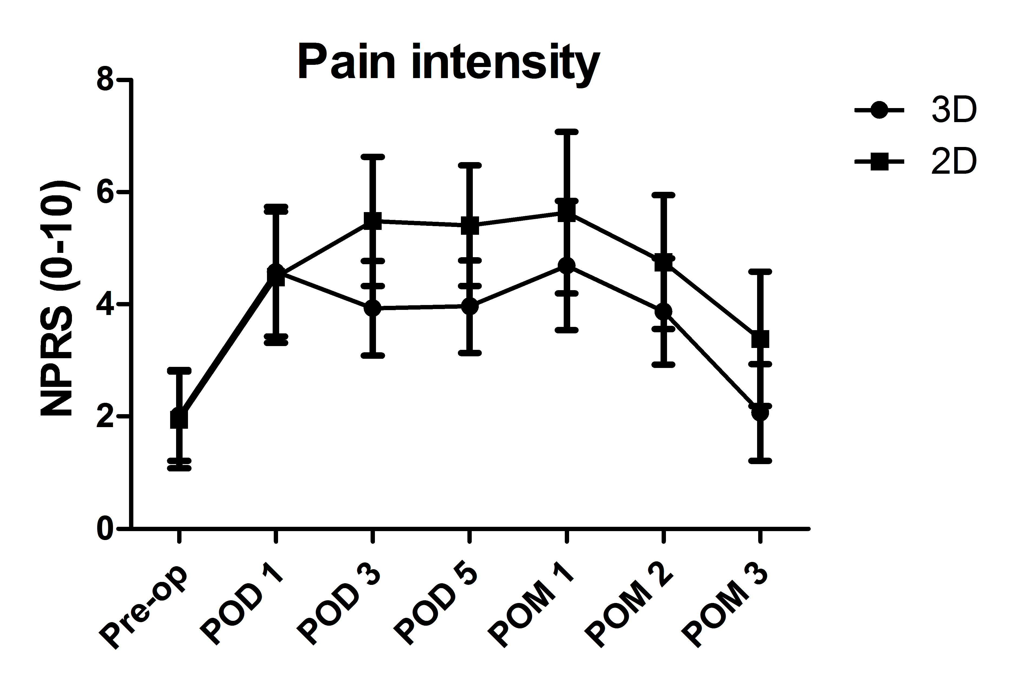

Figure 1 Pain intensity. The pain intensity of the patients undergoing the 3D-VATE and 2D-VATE was showed via the numerical pain rating scale (NPRS). The pain degree of the patients on PODs 3, 5 and POMs 1, 2 and 3 indicates a statistically significant difference between the 3D group and the 2D group (P < 0.05). (3D vs 2D, POD 3: 3.93 ± 0.84 vs 5.48 ± 1.15, P = 0.002; POD 5: 3.96 ± 0.82 vs 5.40 ± 1.01, P = 0.01; POM 1: 4.69 ± 1.15 vs 5.63 ± 1.44, P = 0.048; POM 2: 3.87 ± 0.94 vs 4.75 ± 1.2, P = 0.029; POM 3: 2.07 ± 0.863 vs 3.38 ± 1.20, P = 0.007). NPRS: Aumerical pain rating scale; pre-op: preoperation; POD: post-operative day.

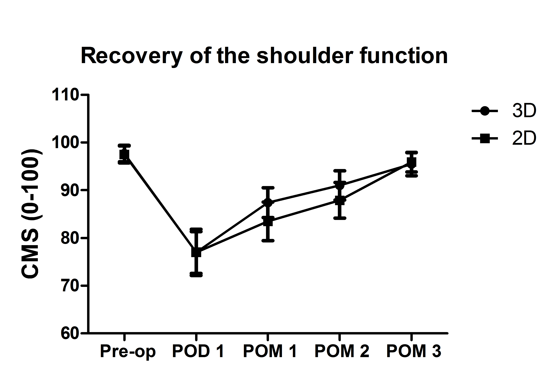
Figure 2 Recovery of the shoulder function. The shouler recovery condition made a statistically significant difference between the two groups on POM 1 (3D vs 2D, POM 1:87.40 ± 3.14 vs 83.50 ± 4.05, P = 0.03). CMS: Constant-Murley scale; pre-op: pre-operation; POD: post-operative day; POM: post-operative month.

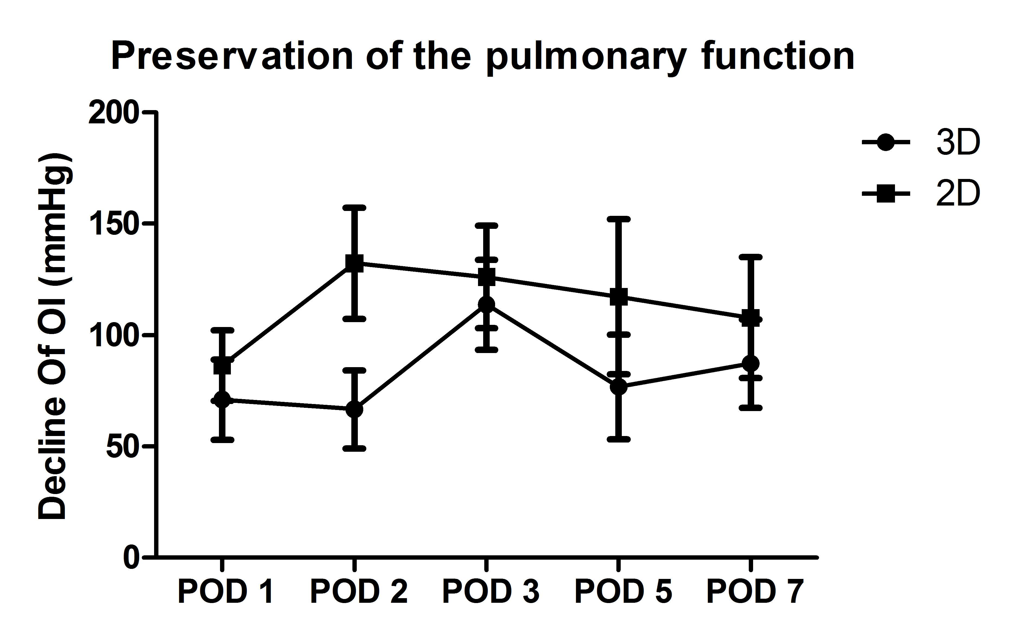
Figure 3 Preservation of the pulmonary function. Decline of the OI on PODs 1, 2, 3, 5 and 7 was significantly smaller in the 3D group compared to those in the 2D group. (POD 1: 71.01 ± 17.92 mmHg vs 86.25 ± 15.91 mmHg; POD 2: 66.71 ± 17.58 mmHg vs 132.22±25.04 mmHg; POD 3: 113.69 ± 20.25 mmHg vs 126.14 ± 22.96 mmHg; POD 5: 76.79 ± 23.52 mmHg vs 117.25 ± 34.88 mmHg; POD 7: 87.26 ± 19.88 mmHg vs 107.83 ± 27.11 mmHg, P < 0.01). OI: oxygenation index; POD: post-operative day.

Table 1 Patient demographics n (%)
 | 3D-VATE  n = 45 | 2D-VATE  n = 48 | P-value
Age (yr) | 63.8 ± 10.2 | 65.1 ± 9.8 | 0.55
Gender |  |  | 0.66
Male | 29 (64.4) | 34 (70.8)
Female | 16 (35.6) | 14 (29.2)
Functional status |  |  | 0.25
Independence | 44 (97.8) | 47 (97.9)
Partial dependence | 1 (2.2) | 0 (0)
Complete dependence | 0 (0) | 1 (2.1)
Weight loss¹ | 13 (28.9) | 11 (22.9) | 0.64
Smoking² | 7 (15.6) | 9 (18.8) | 0.91
Use of AAS | 0 (0) | 1 (2.1) | 1
LEVF％ | 68.7 ± 1.5 | 68.6 ± 1.5 | 0.73
FS％ | 39.3 ± 2.3 | 39.5 ± 2.0 | 0.7
Hypertension | 10 (22.2) | 19 (39.6) | 0.078
Renal failure | 0 (0) | 2 (4.2) | 0.5
Dialysis | 0 (0) | 1 (2.1) | 1
Ascites | 1 (2.2) | 1 (2.1) | 0.96
Esophageal varices | 0 (0) | 1 (2.1) | 1
Preoperative chemotherapy | 8 (17.8) | 9 (18.8) | 1
Preoperative radiation | 12 (26.7) | 13 (27.1) | 1
Prior operation | 0 (0) | 1 (2.1) | 1

¹Weight loss > 10% over 6 mo; ²Smoking over the past year. Prior operation within 30 d. AAS: Anabolic-androgenic steroids; LEVF: Left ventricular ejection fraction; FS: Fraction shortening; VATE: video-assisted thoracoscopic esophagectomy.

Table 2 Postoperative morbidity and mortality n (%)
 | 3D-VATE  (n = 45) | 3D-VATE  (n = 48) | P-value
Morbidity | 13 (28.9) | 8 (16.7) | 0.328
Mortality | 1 (2.2) | 1 (2.1) | NS
Pulmonary complications |  |  | NS
Pneumonia | 5 (11.1) | 7 (14.6) | 0.76
Re-intubation | 4 (8.9) | 5 (10.4)
Pulmonary embolism | 1 (2.2) | 1 (2.1)
Ventilation > 48 h | 4 (8.9) | 4 (8.3)
Wound infections |  |  | NS
Neck | 0 (0) | 0 (0)
Thorax | 0 (0) | 1 (2.1)
Abdomen | 0 (0) | 0 (0)
Renal complications |  |  | NS
Progressive renal insufficiency | 0 (0) | 0 (0)
Acute renal failure | 0 (0) | 0 (0)
Urinary tract infections | 1 (2.2) | 1 (2.1)
Cardiac complications |  |  | NS
Cardiac arrest | 0 (0) | 0 (0)
Myocardial infarction | 0 (0) | 0 (0)
Trachycadia/Arrhythmias | 1 (2.2) | 4 (8.3) | 0.363
Deep venous thrombosis | 0 (0) | 0 (0) | NS
Anastomotic leakage | 1 (2.2) | 1 (2.1) | NS
Unplanned return to OR | 2 (4.4) | 4 (8.3) | 0.678

NS: not significant; OR: operating room; VATE: video-assisted thoracoscopic esophagectomy.

Table 3 Surgical recovery indicators
 | 3D-VATE (%)  n = 45 | 2D-VATE (%)  n = 48 | P-value
Thoracoscopic operating time¹ (min) | 68 ± 13.79 | 83 ± 13 | < 0.01
Operating time² (min) | 138 ± 14 | 167 ± 20 | < 0.01
Bleeding (ml) | 68.2 ± 10.7 | 89.8 ± 10.4 | < 0.01
Chest drains (ml) | 306.6 ± 56.2 | 366.4 ± 62.6 | < 0.01
Chest tube duration (d) | 2.67 ± 1.01 | 3.75 ± 1.15 | < 0.01
Length of stay (d) | 9.07 ± 2.00 | 10.85 ± 3.40 | 0.003
Expenses (RMB) | 74968.4 ± 9637.8 | 86211.1 ± 8519.7 | < 0.01

¹Thoracoscopic operating time refers to the resection time; ²Operating time is the time from skin to skin. VATE: video-assisted thoracoscopic esophagectomy.

Table 4 Pre-operative baselines of pulmonary function
 | 3D-VATE (%)  (n = 45) | 2D-VATE (%)  (n = 48) | P-value
Smoking¹ | 7 (15.6) | 9 (18.8) | 0.91
FEV₁ (L) | 2.73 ± 0.36 | 2.77 ± 0.36 | 0.65
FEV₁ % | 85.1 ± 5.8 | 86.6 ± 6.5 | 0.26
Dlco％ | 91.9 ± 3.88 | 92.8 ± 3.78 | 0.23
PaO₂ (mmHg) | 407.8 ± 19.7 | 402.1 ± 18.7 | 0.16
BMIe | 22.5 ± 2.0 | 22.2 ± 2.0 | 0.44
ASA class^{f} | 2.58 ± 0.54 | 2.58 ± 0.53 | 0.96

¹Smoking (in the past year). FEV₁: Forced expiratory volume in one second; Dlco: Diffusing capacity of the lung for carbon monoxide; PaO₂: Oxygen tension; BMI: Body mass index; ASA class: American Society of Anesthesiologists physical status classification system.

Table 5 Inflammatory markers
 | 3D-VATE  n = 45 | 2D-VATE  n = 48 | P-value

Preoperative baselines
WBC (10⁹/L) | 5.54 ± 0.88 | 5.39 ± 0.89 | 0.45
GR (10⁹/L) | 3.88 ± 0.55 | 3.77 ± 0.52 | 0.28
hsCRP (mg/L) | 1.76 ± 0.43 | 1.82 ± 0.43 | 0.51
PCT (μg/L) | 0.03 ± 0.01 | 0.03 ± 0.01 | 0.97

Postoperative outcomes

Δ^{e}WBC
POD1 (10⁹/L) | 5.64 ± 1.60 | 6.75 ± 1.37 | 0.001
POD4 (10⁹/L) | 3.87 ± 1.05 | 6.65 ± 1.01 | < 0.01
POD7 (10⁹/L) | 2.48 ± 0.50 | 2.54 ± 0.66 | 0.667

ΔGR
POD1 (10⁹/L) | 4.88 ± 1.18 | 6.13 ± 1.42 | < 0.01
POD4 (10⁹/L) | 3.59 ± 0.85 | 6.25 ± 1.21 | < 0.01
POD7 (10⁹/L) | 2.24 ± 0.63 | 2.68 ± 0.67 | 0.001

ΔCRP
POD1 (mg/L) | 42.5 ± 15.3 | 40.1 ± 16.9 | 0.544
POD4 (mg/L) | 102.5 ± 61.3 | 137.9 ± 64.1 | < 0.01
POD7 (mg/L) | 88.4 ± 47.1 | 91.5 ± 41.3 | 0.225

ΔPCT
POD1 (μg/L) | 0.71 ± 0.17 | 0.68 ± 0.20 | 0.414
POD4 (μg/L) | 0.32 ± 0.14 | 0.71 ± 0.14 | < 0.01
POD7 (μg/L) | 0.46 ± 0.23 | 1.01 ± 0.26 | < 0.01

WBCs: White blood cells; GR: Granulocytes; hsCRP: Hypersensitive C-reactive protein; PCT: Procalcitonin; Δ: Data compared to baselines; VATE: video-assisted thoracoscopic esophagectomy.

Table 6 Histopathological results and lymph node dissection/exposure n (%)
 | 3D-VATE  n = 45 | 2D-VATE  n = 48 | P-value
Tumor location |  |  | NS
Upper third of the esophagus | 8 (17.8) | 9 (18.8)
Middle third of the esophagus | 29 (64.4) | 30 (62.5)
Lower third of the esophagus | 8 (17.8) | 9 (18.8)
Histological type |  |  | NS
Adenocarcinoma | 0 (0) | 1 (2.1)
Squamous cell carcinoma | 45 (100) | 47 (97.9)
TNM stage |  |  | NS
I | 12 (26.7) | 9 (18.8)
II | 16 (35.5) | 13 (27.1)
III | 17 (37.8) | 26 (54.2)

Lymph nodes dissection
Total¹ LNN | 24.8 ± 5.2 | 21.4 ± 6.3 | NS
Thoracic LNN | 13.13 ± 3.43 | 8.96 ± 4.05 | < 0.01
Thoracic LN group | 2.56 ± 1.12 | 2.00 ± 0.85 | 0.008
Laryngeal recurrent nerve LNN (L) | 2.67 ± 1.15 | 1.17 ± 0.83 | < 0.01
Laryngeal recurrent nerve LNN (R) | 2.27 ± 1.74 | 2.33 ± 1.39 | NS
Esophageal LNN | 3.64 ± 2.05 | 3.58 ± 1.16 | NS
Subcarinal LNN | 3.89 ± 2.59 | 2.73 ± 1.08 | 0.005

Lymph nodes exposure
Laryngeal recurrent nerve (L) (Y) | 41 (91.1) | 35 (72.9) | 0.031
Laryngeal recurrent nerve (R) (Y) | 43 (95.6) | 43 (89.6) | 0.44

¹Inclusive for lymph nodes harvested from abdomen, chest and neck. TNM: Tumor node metastasis; LNN: Lymph node number; L: Left; R: Right; NS: not significant; VATE: video-assisted thoracoscopic esophagectomy.

