Name of Journal: World Journal of Clinical Cases
Manuscript NO: 83087
Manuscript Type: CASE REPORT

Application of apical negative pressure irrigation in the nonsurgical treatment of radicular cysts: A case report

Chen GP et al. Nonsurgical treatment of radicular cysts

Gong-Pei Chen, Yan-Zhen Zhang, Dan-Hua Ling

Gong-Pei Chen, Yan-Zhen Zhang, Dan-Hua Ling, Department of General Dentistry, The Second Affiliated Hospital, Zhejiang University School of Medicine, Hangzhou 310052, Zhejiang Province, China

Author contributions: Chen GP and Ling DH performed the dental treatment; Chen GP, Zhang YZ and Ling DH reviewed the literature, and contributed to the drafting of the manuscript; Zhang YZ and Ling DH contributed to the design of the treatment plan; Chen GP and Ling DH were responsible for the revision of the manuscript for important intellectual content; and All authors issued final approval for the version to be submitted.

Supported by the Medical Health Science and Technology Project of Zhejiang Provincial Health Commission, No. 2022RC158.

Corresponding author: Dan-Hua Ling, MM, Doctor, Department of General Dentistry, The Second Affiliated Hospital of Zhejiang University School of Medicine, No. 1511 Jianghong Road, Binjiang District, 310052 Hangzhou, Zhejiang Province, China. lingdanhua@zju.edu.cn

Received: February 7, 2023
Revised: March 27, 2023
Accepted: April 13, 2023
Published online: May 26, 2023
Abstract
BACKGROUND
Radicular cysts are one of the most common odontogenic cystic lesions found in the jaw. Nonsurgical treatment of large radicular cysts is a topic of ongoing debate, and there is still no clear consensus on the most effective therapies. The apical negative pressure irrigation system aspirates the cystic fluid and releases the static pressure in the radicular cyst, representing a minimally invasive approach for decompression. In this case, the radicular cyst was in close proximity to the mandibular nerve canal. We used nonsurgical endodontic treatment with a homemade apical negative pressure irrigation system and the prognosis was good.

CASE SUMMARY
A 27-year-old male presented to our Department of General Dentistry with complaints of pain in the mandibular right molar when chewing. The patient had no history of drug allergies or systemic disease. A multidisciplinary management approach was designed and included root canal retreatment with a homemade apical negative pressure irrigation system, deep margin elevation and prosthodontic treatment. According to a 1-year follow-up period, the patient showed a favorable outcome.

CONCLUSION
This report reveals that nonsurgical treatment with an apical negative pressure irrigation system may provide new insights into the treatment of radicular cysts.

Key Words: Apical negative pressure irrigation; Radicular cyst; Nonsurgical root canal treatment; Case report

©The Author(s) 2023. Published by Baishideng Publishing Group Inc. All rights reserved.

Citation: Chen GP, Zhang YZ, Ling DH. Application of apical negative pressure irrigation in the nonsurgical treatment of radicular cysts: A case report. World J Clin Cases 2023; 11(15): 3612-3618
URL: https://www.wjgnet.com/2307-8960/full/v11/i15/3612.htm
DOI: https://dx.doi.org/10.12998/wjcc.v11.i15.3612

Core Tip: We present a case of a radicular cyst treated through root canal retreatment with a homemade apical negative pressure irrigation system, which had excellent therapeutic effects. This is a minimally invasive technique because it is carried out through root canal access without impinging on anatomic structures, bone, or soft tissues. This case report offers new insight into the treatment of patients with radicular cysts.
INTRODUCTION
Radicular cysts are one of the most common odontogenic cystic lesions found in the jaw^{[1]}. These cysts develop as a result of inflammation in the pulp and periodontium, originating from Malassez's epithelial remnants. They can grow to significant sizes and lead to extensive bone damage^{[2]}.
These cysts usually go unnoticed because of their painless nature and small size. Radicular cysts might expand significantly, leading to extensive damage to the surrounding bone and compromising the integrity of the relevant vital teeth. The surgical treatments for radicular cysts include total enucleation, marsupialization or decompression, or a combination of these techniques^{[3]}. In recent years, an increasing number of publications have reported that radicular cysts can be healed by nonsurgical endodontic treatment^{[4,5]}. However, it is controversial whether large radicular cystic lesions can be cured by nonsurgical endodontic treatment^{[6,7]}.
In this case report, the radicular cyst was in close proximity to the mandibular nerve canal, and there would be a high risk of damage to the mandibular nerve if surgical treatment was performed. Thus, we performed nonsurgical endodontic treatment with a homemade apical negative pressure irrigation system and achieved a good outcome. The cyst was reconstructed in three dimensions by 3D Slicer 5.0.3 software, and prognosis was evaluated by comparing changes in cyst volume. Nonsurgical treatment of large radicular cysts is a topic of ongoing debate, and there is still no clear consensus on the most effective therapies. This study provides new insight into the treatment and prognostic evaluation of radicular cysts.

CASE PRESENTATION
Chief complaints
A 27-year-old man visited the Department of General Dentistry, the Second Affiliated Hospital of Zhejiang University School of Medicine, and reported that his right mandibular molar was painful when chewing, which had been lasting for two weeks.

History of present illness
The patient experienced pain in the mandibular right molar when chewing for about two weeks.

History of past illness
The patient had undergone root canal treatment and inlay restoration in another hospital 5 years prior. He did not report any systemic illnesses or history of drug allergies, nor did he show any obvious contraindications to dental treatment.

Personal and family history
There was no personal or family history reported by the patient.

Physical examination
In the clinical examination, tooth 47 had an inlay restoration and showed a sensitive response to percussion. No mobility or swelling was evident. The periodontal probing depth of tooth 47 was < 3.0 mm (Figure 1).

Laboratory examinations
This case did not involve any laboratory examinations.

Imaging examinations
Cone-beam CT scan (Planmeca Romexis Viewer 4.5.0R, Planmeca Oy, Helsinki, Finland) showed a high-density shadow in the root canal of tooth 47 and a 13 mm × 9 mm × 10 mm low-density shadow in the apical region, with clear borders and bone white lines. The filling overhang was visible in the distal cervical region of the tooth (Figure 2).

FINAL DIAGNOSIS
The tooth was diagnosed with a radicular cyst based on the patient's history, as well as clinical and radiographic examination findings.

TREATMENT
A multidisciplinary management plan was designed, which comprised root canal retreatment with a homemade apical negative pressure irrigation system (Figure 3), deep margin elevation and prosthodontic treatment. The patients were informed about the treatment plan and possible longer-term outcome for tooth 47 and signed an informed consent form.
The first step was root canal retreatment. A rubber dam was properly positioned, the access cavity was opened directly on the inlay, and the original filling was removed under a microscope (Figure 4A). A G drill, a K file and Ni-Ti rotary instruments (Dentsply Sirona, Switzerland) were used to remove the root canal fillings. Using electronic apex locator and #8 file to determine the working length, and the canal was then prepareed until a #15 size was achieved. During this step, each K file size went beyond the apical foramen by 2 mm, and a homemade apical negative pressure irrigation system was used to drain the cystic fluid (Figure 4B). The Ni-Ti rotary instruments were selected for root canal preparation with the crown-down preparation method. During the preparation, 1% sodium hypochlorite and 0.9% normal saline were used together with the homemade apical negative pressure irrigation system for irrigation (Figure 4C). The canals were dehydrated using paper points, followed by the application of a paste made of calcium hydroxide [Ca(OH)2]. Finally, the access cavity was sealed with Cavit™.
At 2 wk postoperation, the patient experienced no pain upon percussion. The single cone technique was used to fill the canal with gutta-percha (Gapadent, Tianjin, China) and iRoot SP (Innovative BioCeramix, Vancouver, BC, Canada) (Figure 4D). The access cavity was then sealed by glass ionomer (GC- Fuji IX Japan) (Figure 4E). A final digital PAX was taken at this time, in which we could see that the canals were well obturated (Figure 4F).

OUTCOME AND FOLLOW-UP
During the 3-mo, 6-mo, and 12-mo follow-up periods, the patient did not report any symptoms. A cone-beam CT scan (Planmeca Romexis Viewer 4.5.0R, Planmeca Oy, Helsinki, Finland) was performed again after 6 months. After exporting the 3D CBCT data, 3D Slicer 5.0.3 software was applied to reconstruct a 3D model of the radicular cyst, which showed that the volume was reduced by approximately 80% (Figure 5). Then, the inlay and filling overhang in the distal cervical region of tooth 47 were removed. Deep margin elevation was performed with Smart Dentin Replacement (Dentsply Sirona, Switzerland) and repaired with lava ultimate high toughness porcelain inlay (3M Dental Products, MN, United States) (Figure 6).

DISCUSSION
Radicular cysts, as chronic apical periodontitis, are mostly caused by untreated pulpitis and apical periodontitis, incomplete root canal treatment or posttraumatic pulp necrosis without spontaneous symptoms that do not receive timely treatment^{[8,9]}. Radicular cysts have a slow course, with no obvious clinical symptoms other than pain and swelling in some patients, and are closely associated with chronic periradicular granulomas and periradicular abscesses, which can transform into each other. The management of large periapical cyst-like lesions has been the subject of much debate. Treatment options may vary from nonsurgical root canal treatment, endodontic microsurgery, or tooth extraction^{[10]}. The different treatment approaches mainly aimed at eliminating the cystic epithelium while minimizing the potential harm to vital structures. Surgical therapy often causes complications such as destruction of the adjacent teeth and important adjacent anatomical structures.
When managing inflammatory lesions associated with an intracanal infection, it is recommended to adopt a conservative approach. It has been suggested that the main reasons for the failure of root canal therapy to treat some of the larger diameter apical cysts are improper endodontic flushing methods during root preparation, failure to use pharmaceutical solvents, improper selection of endodontic sealants, or unclean root canals^{[11]}. Currently, the most commonly used clinical method for root canal irrigation is syringe irrigation. However, syringe irrigation alone does not provide effective cleaning of the three-dimensional root canal system. From the perspective of hydrodynamics, the syringe can only effectively flush the area 1-2 mm beyond the tip of the needle, so it is not effective in cleaning anatomically restricted areas, especially the lateral root canals, accessory root canal, isthmus, and apical areas affected by the air-blocking phenomena^{[12]}. Since Schoeffel^{[13]} first proposed apical negative pressure irrigation in 2007, increasing attention has been given to the application of apical negative pressure irrigation in root canal therapy. Studies have shown that negative pressure irrigation can reduce the amount of irrigation liquid that spills over the root tip during irrigation, eliminate the apical airlock effect, improve the cleaning efficiency in the area of root canal stenosis and reduce the incidence of postoperative pain^{[13-15]}. In addition, negative pressure in the root canal relieves the static pressure in the radicular cyst, allowing for adequate drainage of the cystic fluid and promoting healing of the cyst^{[15]}.
In this case, the radicular cyst was in close proximity to the mandibular nerve canal, and there was a greater risk of damage to the mandibular nerve if surgical treatment was performed. Therefore, this patient was treated with nonsurgical root canal retreatment in combination with a homemade apical negative pressure irrigation system. This conservative method has several advantages, such as less discomfort because no surgical flaps are necessary; In contrast to marsupialization or surgical decompression, it is a minimally invasive technique. The procedure is performed through the root canal access means that patient cooperation is not required, and there is no damage to surrounding anatomic structures, bone, or soft tissues.In addition, this technique also generates proper healing^{[16]}.
3D Slicer, a multiplatform software that runs on personal computers, can be extended to enable new algorithms and applications and permits multiple configuring, which range from simple 3D visibility of medical images to different reconstructed and generated images^{[17]}. The patient’s 3D CBCT data were exported before treatment and at the postoperative follow-up, and 3D Slicer software was applied to reconstruct the 3D appearance of the cyst. The prognosis of the radicular cysts after nonsurgical treatment was observed by calculating the volume at different time periods.

CONCLUSION
We report a case of a radicular cyst that achieved a good prognosis through nonsurgical treatment with an apical negative pressure irrigation system. We utilized CBCT data to generate a 3D model of the radicular cyst with 3D Slicer, and this model enabled us to better evaluate prognosis. This case report offers new insight into the treatment of patients with radicular cysts. Future studies with large samples are needed to evaluate the efficacy of nonsurgical endodontic treatment with apical negative pressure irrigation in patient with radicular cysts.

REFERENCES
1 Ramachandran Nair PN, Pajarola G, Schroeder HE. Types and incidence of human periapical lesions obtained with extracted teeth. Oral Surg Oral Med Oral Pathol Oral Radiol Endod 1996; 81: 93-102 [PMID: 8850492 DOI: 10.1016/s1079-2104(96)80156-9]
2 Lin LM, Huang GT, Rosenberg PA. Proliferation of epithelial cell rests, formation of apical cysts, and regression of apical cysts after periapical wound healing. J Endod 2007; 33: 908-916 [PMID: 17878074 DOI: 10.1016/j.joen.2007.02.006]
3 Gonzalez SM, Spalding PM, Payne JB, Giannini PJ. A dentigerous cyst associated with bilaterally impacted mandibular canines in a girl: a case report. J Med Case Rep 2011; 5: 230 [PMID: 21699678 DOI: 10.1186/1752-1947-5-230]
4 Ghorbanzadeh S, Ashraf H, Hosseinpour S, Ghorbanzadeh F. Nonsurgical Management of a Large Periapical Lesion: A Case Report. Iran Endod J 2017; 12: 253-256 [PMID: 28512496 DOI: 10.22037/iej.2017.49]
5 Fernandes M, de Ataide I. Nonsurgical management of periapical lesions. J Conserv Dent 2010; 13: 240-245 [PMID: 21217952 DOI: 10.4103/0972-0707.73384]
6 Lin LM, Ricucci D, Lin J, Rosenberg PA. Nonsurgical root canal therapy of large cyst-like inflammatory periapical lesions and inflammatory apical cysts. J Endod 2009; 35: 607-615 [PMID: 19410070 DOI: 10.1016/j.joen.2009.02.012]
7 Talpos-Niculescu RM, Popa M, Rusu LC, Pricop MO, Nica LM, Talpos-Niculescu S. Conservative Approach in the Management of Large Periapical Cyst-Like Lesions. A Report of Two Cases. Medicina (Kaunas) 2021; 57 [PMID: 34068934 DOI: 10.3390/medicina57050497]
8 Martins JN, Freitas F, Andre S, Moreira A, Carames J. Very Large Inflammatory Odontogenic Cyst with Origin on a Single Long Time Traumatized Lower Incisor. J Clin Diagn Res 2015; 9: ZD07-ZD10 [PMID: 26393219 DOI: 10.7860/JCDR/2015/14571.6173]
9 Karamifar K, Tondari A, Saghiri MA. Endodontic Periapical Lesion: An Overview on the Etiology, Diagnosis and Current Treatment Modalities. Eur Endod J 2020; 5: 54-67 [PMID: 32766513 DOI: 10.14744/eej.2020.42714]
10 Oztan MD. Endodontic treatment of teeth associated with a large periapical lesion. Int Endod J 2002; 35: 73-78 [PMID: 11853242 DOI: 10.1046/j.1365-2591.2002.00455.x]
11 Ahmed HM, Al Rayes MH, Saini D. Management and prognosis of teeth with trauma induced crown fractures and large periapical cyst like lesions following apical surgery with and without retrograde filling. J Conserv Dent 2012; 15: 77-79 [PMID: 22368341 DOI: 10.4103/0972-0707.92612]
12 Tay FR, Gu LS, Schoeffel GJ, Wimmer C, Susin L, Zhang K, Arun SN, Kim J, Looney SW, Pashley DH. Effect of vapor lock on root canal debridement by using a side-vented needle for positive-pressure irrigant delivery. J Endod 2010; 36: 745-750 [PMID: 20307757 DOI: 10.1016/j.joen.2009.11.022]
13 Miller TA, Baumgartner JC. Comparison of the antimicrobial efficacy of irrigation using the EndoVac to endodontic needle delivery. J Endod 2010; 36: 509-511 [PMID: 20171372 DOI: 10.1016/j.joen.2009.10.008]
14 Chow TW. Mechanical effectiveness of root canal irrigation. J Endod 1983; 9: 475-479 [PMID: 6586975 DOI: 10.1016/s0099-2399(83)80162-9]
15 Nielsen BA, Craig Baumgartner J. Comparison of the EndoVac system to needle irrigation of root canals. J Endod 2007; 33: 611-615 [PMID: 17437884 DOI: 10.1016/j.joen.2007.01.020]
16 Mejia JL, Donado JE, Basrani B. Active nonsurgical decompression of large periapical lesions--3 case reports. J Can Dent Assoc 2004; 70: 691-694 [PMID: 15530268]
17 Gonzalo Domínguez M, Hernández C, Ruisoto P, Juanes JA, Prats A, Hernández T. Morphological and Volumetric Assessment of Cerebral Ventricular System with 3D Slicer Software. J Med Syst 2016; 40: 154 [PMID: 27147517 DOI: 10.1007/s10916-016-0510-9]

Footnotes
Informed consent statement: The patient provided informed written consent prior to study enrollment.

Conflict-of-interest statement: All the authors declare that there are no conflicts of interest regarding the publication of this paper.

CARE Checklist (2016) statement: The authors have read the CARE Checklist (2016), and the manuscript was prepared and revised according to the CARE Checklist (2016).

Open-Access: This article is an open-access article that was selected by an in-house editor and fully peer-reviewed by external reviewers. It is distributed in accordance with the Creative Commons Attribution NonCommercial (CC BY-NC 4.0) license, which permits others to distribute, remix, adapt, build upon this work non-commercially, and license their derivative works on different terms, provided the original work is properly cited and the use is non-commercial. See: https://creativecommons.org/Licenses/by-nc/4.0/

Provenance and peer review: Unsolicited article; Externally peer reviewed.
Peer-review model: Single blind

Peer-review started: February 7, 2023
First decision: March 14, 2023
Article in press: April 13, 2023

Specialty type: Dentistry, oral surgery and medicine
Country/Territory of origin: China
Peer-review report’s scientific quality classification
Grade A (Excellent): 0
Grade B (Very good): B
Grade C (Good): 0
Grade D (Fair): D
Grade E (Poor): 0

P-Reviewer: Grawish ME, Egypt; Rakhshan V, Iran S-Editor: Liu JH L-Editor: A P-Editor: Yuan YY
Figure Legends
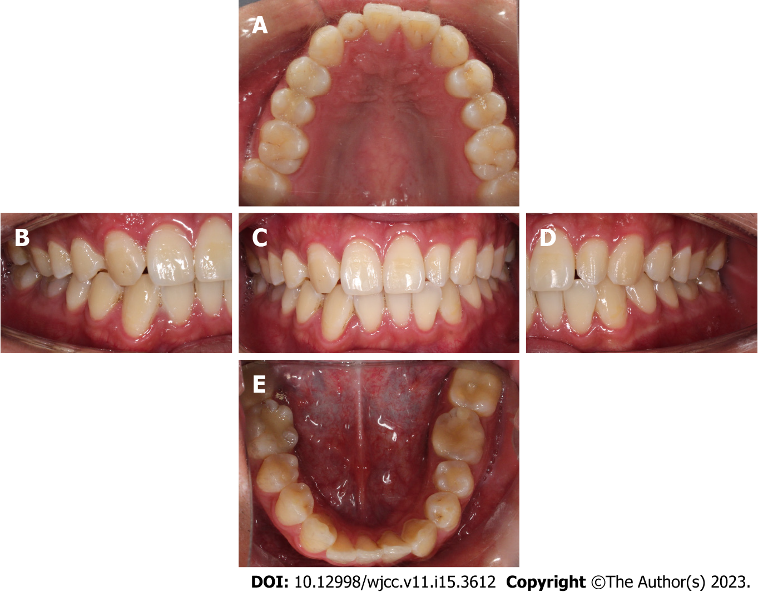
Figure 1 Intraoral photographs before treatment. A: Maxillary occlusal view; B: Right buccal view; C: Frontal view; D: Left buccal view; E: Mandibular occlusal view.
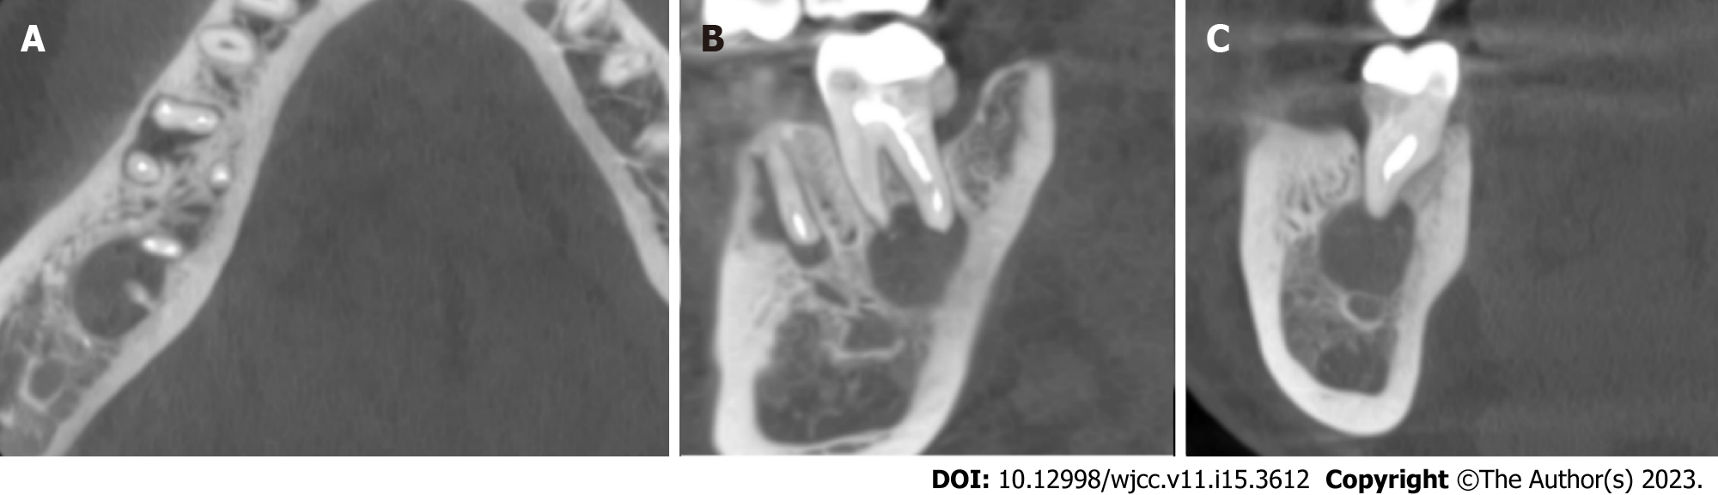
Figure 2 Cone-beam computed tomography of the mandibular second molar with a radicular cyst. A: Axial sections of the mandibular second molar with a radicular cyst; B: Sagittal sections of the mandibular second molar with a radicular cyst; C: Coronal sections of the mandibular second molar with a radicular cyst.
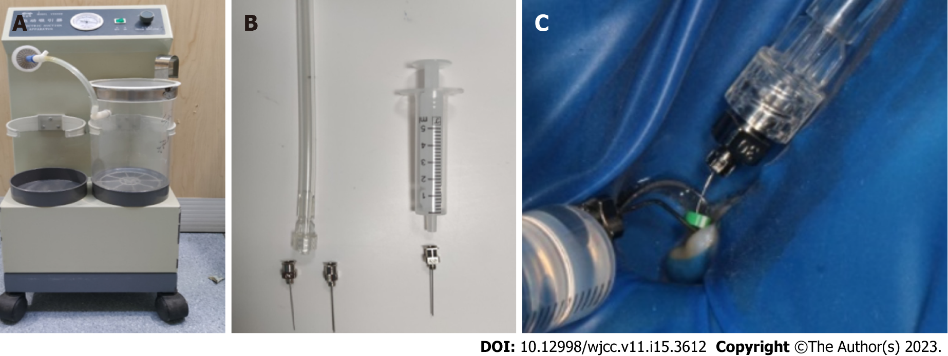
Figure 3 Construction of apical negative pressure irrigation system with commonly used clinical instruments. A: Electric aspirator (Smanfeng, Shanghai); B: Flat bottom metal needle and 10 mL disposable syringe; C: The negative pressure irrigation system is used clinically with a 30 G metal needle as a microtube for aspirating the irrigation fluid in the apical segment and a 27 G metal needle as a large cannula for aspirating the irrigation fluid in the middle and upper segments of the root canal. 25 G needle is used as a delivery needle for delivering a constant flow rate of irrigation fluid to the root canal orifice.
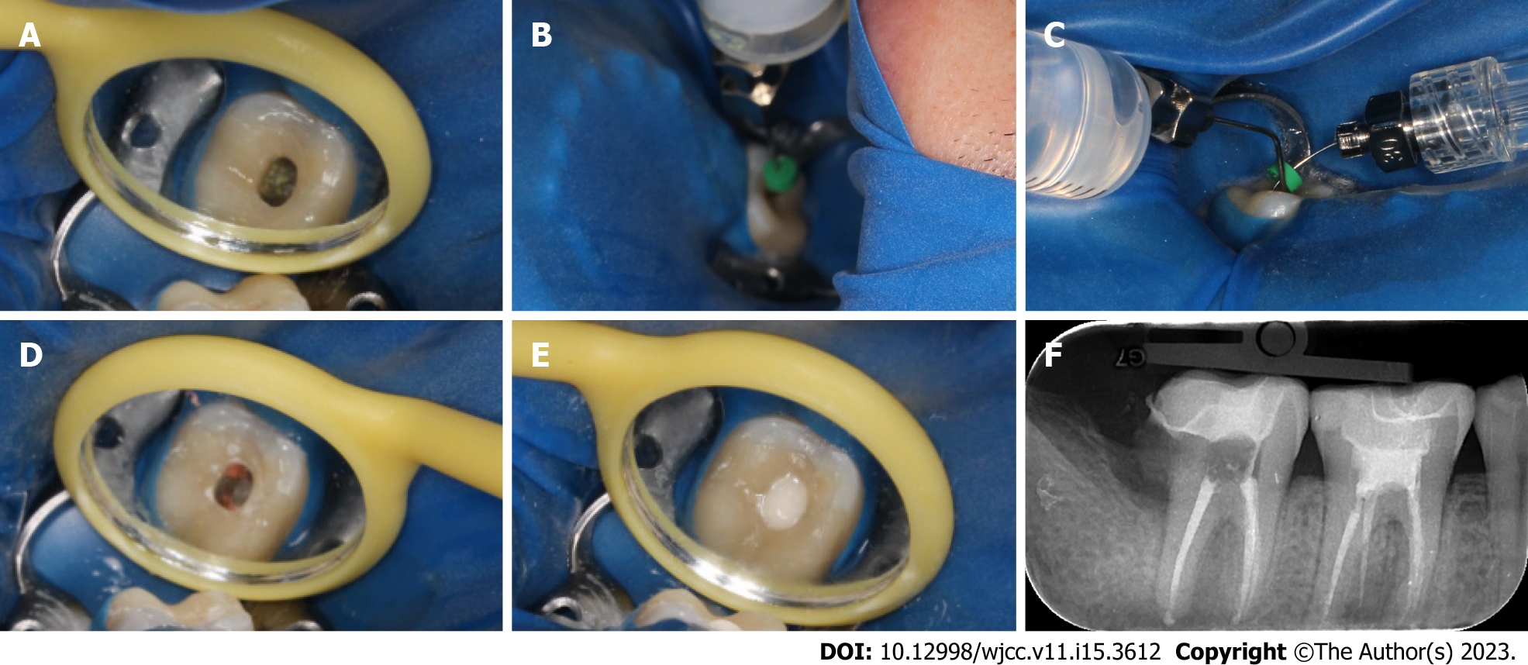
Figure 4 Root canal retreatment of tooth 47. A: The access cavity was opened directly on the inlay and the original filling were removed under a microscope; B: A self-made apical negative pressure irrigation system was used to drain the cystic fluid; C: During the preparation, 1% sodium hypochlorite and 0.9% normal saline were used together with the self-made apical negative pressure irrigation system for irrigation; D: Complete canal obturation was achieved via single cone technique; E: Image of the access cavity sealed glass ionomer; F: A final digital PAX revealed that the canals were well-obturated.
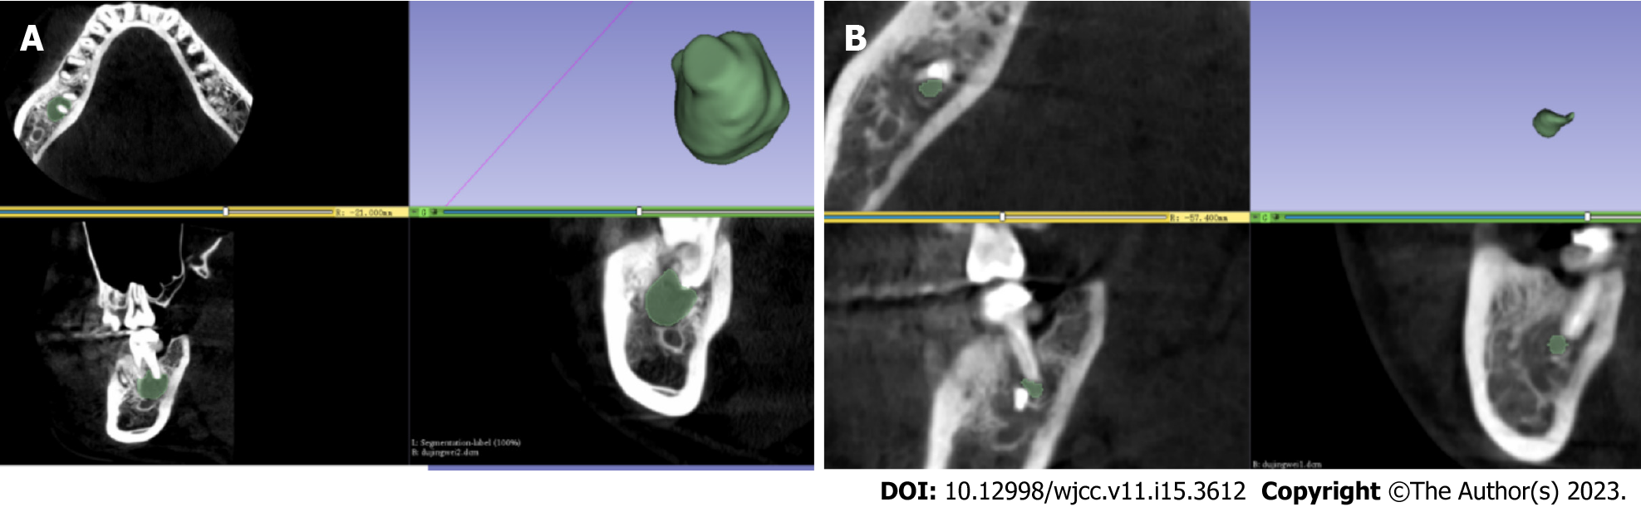
Figure 5 3D model of the radicular cyst reconstructed by 3Dslicer 5.0.3 software. A: 3D model of the radicular cyst reconstructed by 3Dslicer 5.0.3 software before treatment; B: 3D model of the radicular cyst reconstructed by 3Dslicer 5.0.3 software after 6 mo.
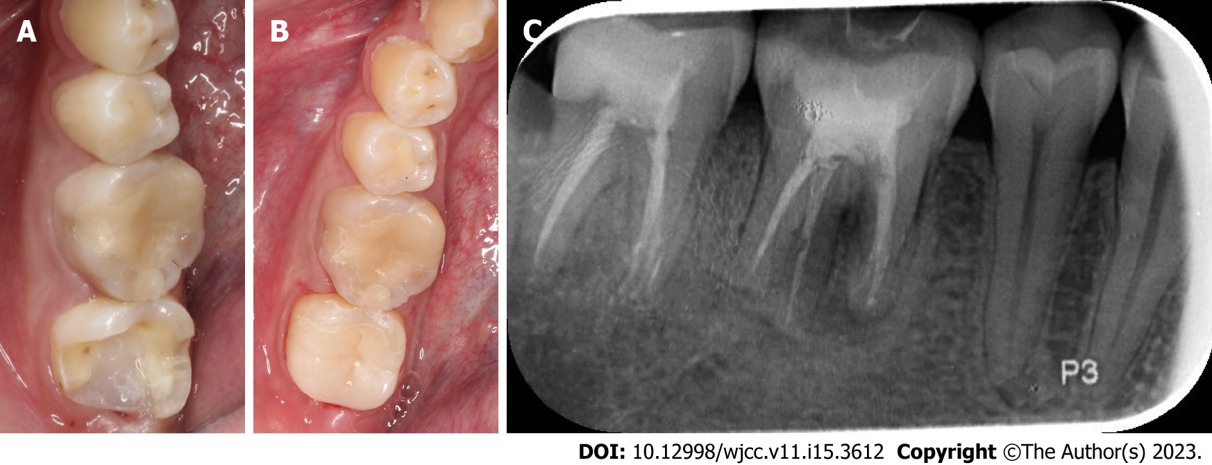
Figure 6 Deep margin elevation and lava ultimate high toughness porcelain inlay. A: Image of the tooth after deep margin elevation; B: Intraoral photographs of lava ultimate high toughness porcelain inlay; C: A digital PAX at 1-year recall.

Published by Baishideng Publishing Group Inc
7041 Koll Center Parkway, Suite 160, Pleasanton, CA 94566, USA
Telephone: +1-925-3991568
E-mail: bpgoffice@wjgnet.com
Help Desk: https://www.f6publishing.com/helpdesk
https://www.wjgnet.com

© 2023 Baishideng Publishing Group Inc. All rights reserved.

