Name of Journal: World Journal of Gastroenterology
Manuscript NO: 59280
Manuscript Type: ORIGINAL ARTICLE

Observational Study
Estimation of visceral fat is useful for the diagnosis of significant fibrosis in patients with non-alcoholic fatty liver disease

Hernández-Conde M et al. Visceral fat for diagnosis of significant fibrosis

Marta Hernández-Conde, Elba Llop, Carlos Fernández Carrillo, Beatriz Tormo, Javier Abad, Luis Rodriguez, Christie Perelló, Marta López Gomez, José Luis Martínez-Porras, Natalia Fernández Puga, Maria Trapero-Marugan, Enrique Fraga, Carlos Ferre Aracil, José Luis Calleja Panero

Marta Hernández-Conde, Elba Llop, Carlos Fernández Carrillo, Beatriz Tormo, Javier Abad, Luis Rodriguez, Christie Perelló, Marta López Gomez, José Luis Martínez-Porras, Natalia Fernández Puga, Maria Trapero-Marugan, Enrique Fraga, Carlos Ferre Aracil, José Luis Calleja Panero, Gastroenterology and Hepatology Department, IDIPHISA, Hospital Universitario Puerta de Hierro-Majadahonda, Madrid 28222, Spain

Elba Llop, Carlos Fernández Carrillo, Maria Trapero-Marugan, Enrique Fraga, José Luis Calleja Panero, Centro de Investigación Biomédica en Red en el Área temática de Enfermedades Hepáticas, Instituto de Salud Carlos III, Madrid 28029, Spain

Author contributions: Hernández-Conde M contributed to study concept and design, acquisition of data, statistical analysis and interpretation of data; manuscript preparation; Llop E contributed to study concept and design, statistical analysis and interpretation of data; critical discussion and support; Fernández Carrillo C contributed to critical discussion and support; Tormo B, Abad J, Rodríguez L, Perelló C, López-Gómez M, Martínez-Porras JL, Fernández-Puga N, Trapero M, Fraga E and Ferre C contributed to acquisition of data; Calleja Panero JL contributed to concept and design, analysis and interpretation of data, manuscript preparation, final drafting of the manuscript and study supervision.

Corresponding author: José Luis Calleja Panero, PhD, Chairman, Chief Doctor, Senior Researcher, Gastroenterology and Hepatology Department, IDIPHISA, Hospital Universitario Puerta de Hierro-Majadahonda, C/Joaquín Rodrigo, 2, Madrid 28222, Spain. joseluis.calleja@uam.es

Received: September 5, 2020
Revised: October 9, 2020
Accepted: October 26, 2020
Published online:

Abstract
BACKGROUND
Obesity is a risk factor for non-alcoholic fatty liver disease (NAFLD), although obese patients with NAFLD do not always develop significant fibrosis. The distribution of body fat could predict the risk of NAFLD progression.

AIM
To investigate the role of bioelectrical impedance-estimated visceral fat (VF) in assessing NAFLD severity.

METHODS
In this cross-sectional study, patients with biopsy-proven NAFLD were prospectively included. All patients underwent anthropometric evaluation, blood tests and bioelectrical impedance analysis.

RESULTS
Between 2017 and 2020, 119 patients were included [66.4% male, 56 years (SD 10.7), 62.2% obese, 61.3% with metabolic syndrome]. Sixty of them (50.4%) showed significant fibrosis (≥ F2) in liver biopsy. Age, VF and metabolic syndrome were associated with significant fibrosis (61 years vs 52 years, 16.4 vs 13.1, 73.3% vs 49.2%, respectively; P < 0.001 for all). In the multivariate analysis, VF and age were independently associated with significant fibrosis (VF, OR: 1.11, 95%CI: 1.02-1.22, P = 0.02; age, OR: 1.08, 95%CI: 1.03-1.12, P < 0.01). A model including these variables showed and area under the receiver operating characteristic curve (AUROC) of 0.75, which was not inferior to transient elastography or NAFLD fibrosis score AUROCs. We developed a nomogram including age and VF for assessing significant fibrosis in routine practice.

CONCLUSION
VF is a surrogate marker of liver fibrosis in patients with NAFLD. Bioelectrical impedance analysis is an inexpensive and simple method that can be combined with age to guide patient referral when other resources may be unavailable.

Key Words: Non-alcoholic fatty liver disease; Visceral fat; Liver fibrosis; Bioimpedanciometry; Metabolic syndrome; Obesity

Hernández-Conde M, Llop E, Fernández Carrillo C, Tormo B, Abad J, Rodriguez L, Perelló C, López Gomez M, Martínez-Porras JL, Fernández Puga N, Trapero-Marugan M, Fraga E, Ferre Aracil C, Calleja Panero JL. Estimation of visceral fat is useful for the diagnosis of significant fibrosis in patients with non-alcoholic fatty liver disease. World J Gastroenterol 2020; In press

Core Tip: Obesity is a risk factor for non-alcoholic fatty liver disease (NAFLD), although obese patients with NAFLD do not always develop significant fibrosis. The distribution of body fat could predict the risk of NAFLD progression. Our study demonstrates that bioimpedanciometry-estimated visceral fat is useful for detecting advanced NAFLD. Our proposed simple method would allow referral to specialized care in a wide variety of resource-limited settings. Future studies will aim at validating this tool in larger prospective cohorts.

INTRODUCTION
Non-alcoholic fatty liver disease (NAFLD) is a major cause of chronic liver disease in the world, ranging from simple steatosis to non-alcoholic steatohepatitis (NASH), which can lead to significant fibrosis, liver cirrhosis and hepatocellular carcinoma^{[1,2]}. As the hepatic manifestation of metabolic syndrome (MetS), NAFLD is more prevalent within patients with obesity, type 2 diabetes mellitus, dyslipidemia and/or hypertension^{[3-5]}. Particularly, metabolic unhealthy status may have a greater impact on NASH and significant fibrosis than obesity itself^{[6]}. Obese subjects do not always develop NAFLD and NAFLD can occur in non-obese subjects^{[7]}. In this regard, abdominal fat deposition is closely related with MetS^{[8]}. Waist circumference (WC), waist-to-height ratio and waist-to-hip ratio are surrogate markers of abdominal fat, which can rule in MetS^{[9]}. However, the visceral component of abdominal fat is most intimately associated with MetS and adverse outcomes, probably through pro-inflammatory adipokines^{[8,10,11]}. Visceral fat (VF) is a key element in the pathogenesis of NAFLD, independently of insulin resistance and liver steatosis^{[12-17]}. However, VF cannot be captured by the aforementioned indices. Several works have proposed measuring VF as an indirect marker of NAFLD by using different techniques and thresholds^{[13,15,16,18-23]}. None of these studies assessed a possible correlation of VF with liver fibrosis while the prognosis of NAFLD patients is strongly conditioned by fibrosis^{[24]}.
Methods for assessing VF and liver fibrosis in NAFLD patients include computed tomography (CT) scan, magnetic resonance imaging and histological analysis, which are impractical in real clinics. Even though transient elastography is simple, non-invasive and reliable for estimating fibrosis in NAFLD, it is not always available^{[25]}. On the contrary, bioelectrical impedance analysis (BIA) is innocuous and easy to use. In addition, it is operator-independent and less expensive than CT scan and magnetic resonance imaging^{[3]}.
Currently, it is unknown if VF may be a reliable measure of NAFLD severity. On the other hand, BIA may have all the features to become a preferred method for VF estimation. Therefore, we aimed at assessing the role of BIA as a non-invasive tool for assessing NAFLD severity. To this end, we compared BIA with liver biopsy, transient elastography and other indirect methods.

MATERIALS AND METHODS
Study design
This is a cross-sectional study prospectively including consecutive biopsy-proven NAFLD adult outpatients in a third-level hospital. Exclusion criteria encompassed any other liver comorbidity, history of bariatric or ileal surgery, liver or kidney transplantation, malignancy or treatment with any drug known to induce liver steatosis or insulin sensitization, such as estrogens, amiodarone, methotrexate and tamoxifen. The protocol was approved by the Ethics Committee of the Hospital Universitario Puerta de Hierro-Majadahonda (PI 05-18, 12/03/2018) and it was conducted according to the 1975 Declaration of Helsinki and the Good Clinical Practice guidelines. Written informed consent was obtained from all patients prior to inclusion.

Data collection
Prior to liver biopsy, all the patients underwent abdominal ultrasound, liver transient elastography (FibroScan® 502 Touch, Echosens, Paris, France) and controlled attenuation parameter (CAP, Echosens, Paris, France), as clinically indicated. M or XL probes were used as needed^{[26]}. CAP (dB/m) was considered only when the associated elastography measurement was valid [median measurement/interquartile range ≥ 0.3 (kPa)]. Liver biopsy was performed as part of the clinical work-up for NAFLD diagnosis. For our study, all the slides were reviewed by an experienced liver pathologist (C.S.) using the NAFLD activity score (NAS)^{[27]}. Significant fibrosis was defined as fibrosis stage ≥ 2.
All the patients underwent a complete anthropometric evaluation, blood tests and BIA after overnight fasting by the same investigator, mostly the same day of the liver biopsy. Height, weight and WC were measured with patients in light clothing, after removing their shoes and emptying their bladders. Total and visceral adipose tissue were measured by BIA (DC430PMA, Tanita, Amsterdam, The Netherlands). A rating between 1 and 12 indicates a healthy level of VF and a rating between 13 and 59 indicates an excessive accumulation of VF. Obesity was defined as a body mass index (BMI) (weight/height²) of ≥ 30 kg/m² and overweight as 25-30 kg/m². An increased WC was defined as ≥ 102 cm for men and ≥ 88 cm for women^{[28]}. Insulin resistance was calculated by the homeostatic model assessment^{[29]}. MetS was defined according to the National Cholesterol Education Program Adult Treatment Panel III definitions when three or more criteria were met^{[30]}.

Statistical analysis
Quantitative variables were described as mean ± SD or median and range where appropriate. Categorical variables were described in percentages. For bivariate analysis, quantitative variables were compared using Student´s t-test. When normality or equality of variances was not observed, non-parametric tests were used. Categorical variables were compared using Chi-squared and Chi-squared for trend tests, or Fisher’s exact test. Correlations between quantitative variables were assessed using Pearson or Spearman rank correlations, as appropriate. To compare variables in more than two groups, Kruskal-Wallis test was used. Multivariable logistic-regression standardized models were constructed by introducing explanatory variables other than transient elastography measurements, with a P < 0.2, using a backward elimination method. Diagnostic accuracy was determined by the area under the receiver operating characteristic curve (AUROC) and 95%CI. Sensitivity, specificity, positive predictive value and negative predictive value were calculated for the models. Youden index was used to determine the optimal cut-off value for these. Statistical analyses were performed with STATA software 14 (Stata Corporation, College Station, TX, United States) and P < 0.05 was considered statistically significant.

RESULTS
Between September 2017 and February 2020, 390 NAFLD patients were screened for the study, 119 of who were included (Supplementary Figure 1). Patient characteristics are shown in Table 1. The mean age was 56 ± 10.7 years, 66.4% of the patients were male and 95% were overweight or obese. Type 2 diabetes mellitus and MetS were predominant (55.5% and 61.3%, respectively). Accordingly, mean WC and VF were elevated (109.3 ± 14 cm, 14.8 ± 5.3, respectively). Significant fibrosis was present in 60 patients (50.4%) and cirrhosis was found in 18 patients (15.1%).
VF measurements positively correlated with WC, BMI and liver fat measurement by CAP (r = 0.67; r = 0.64 and r = 0.32, respectively; p < 0.001) (Table 2). We assessed possible associations for all these parameters with the several components of NAS in liver histology. None of these parameters was associated with the presence of NASH, excepting CAP (343 dB/m vs 319 dB/m; P = 0.018), which positively correlated with the degree of steatosis and overall activity score (Supplementary Table 1). However, VF was the only parameter associated with histological fibrosis stage (r² = 0.112; P < 0.01). VF measurements were lowest for those patients with F0-1 in liver biopsy and highest for those patients showing F4, with intermediate levels for those with F2-3 (P < 0.01) (Figure 1A), therefore displaying a linear increase (r² = 0.11, P < 0.01). Even though WC and BMI correlated with transient elastography measurements (r = 0.23 and r = 0.25, respectively; P < 0.05), they did not correlate with the gold standard. When focusing on patients with significant fibrosis, VF was the only parameter that was statistically significantly associated (16.4 vs 13.1, P < 0.001) (Table 3 and Figure 1B). In addition, these patients were older and showed a higher frequency of MetS than those without significant fibrosis (61 years vs 52 years, 73.3% vs 49.2%; P < 0.01 for both). In multivariable regression analysis excluding transient elastography, age and VF were the only variables independently associated with histological significant fibrosis (VF, OR: 1.11, 95%CI: 1.02-1.22, P = 0.021; age, OR: 1.08, 95%CI: 1.03-1.12, P = 0.001). A model including these variables showed an AUROC of 0.75 (95%CI: 0.66-0.84), with a sensitivity of 70%, a specificity of 67.8%, as well as positive and negative predictive values of 68.9% and 69%, respectively (Figure 2A). When comparing our model AUROC with the AUROCs for transient elastography and NAFLD fibrosis score, we found no significant differences among them (0.82 and 0.78 vs 0.75, P = 0.099 and 0.345, respectively, Figure 2B). Based on our results, we built a simple nomogram including age and VF for the prediction of significant fibrosis in routine practice (Figure 3). A nomogram probability of 50% was the cut-off that best identified patients with significant fibrosis, showing an AUROC of 0.7 (sensitivity, 67%; specificity, 73%).

DISCUSSION
NAFLD is one of the most prevalent chronic liver diseases worldwide, which can progress to steatohepatitis, fibrosis, cirrhosis and rarely hepatocellular carcinoma without cirrhosis^{[1,2]}. NAFLD is associated with diet, MetS, obesity and adverse cardiovascular events^{[3,31-33]}. Even though fat deposition is a key pathophysiologic element, the distribution of fat deposits must be underscored. Large population studies have shown markers of increased VF to be independent predictors of cardiovascular and overall mortality^{[10,34]}. In addition, central body fat distribution has been associated with the development of NAFLD^{[22]}. CT scan is the most effective method to differentiate subcutaneous from visceral obesity. However, it has many limitations such as price, radiation and availability^{[35]}. Therefore, identifying simple anthropometric markers of VF in clinical practice may be extremely useful to assess metabolic status. In our study including 119 patients with biopsy-proven NAFLD, we investigate the value of VF estimated by BIA as a non-invasive marker of NAFLD severity
A number of studies show that simple anthropometric indices related with abdominal obesity, such as BMI and WC, are able to predict the presence of NAFLD. ^{[19,36,37]}. In our study including patients already diagnosed with NAFLD, all WC, BMI and CAP showed increased values, and VF measurements positively correlated with them. Yet, when assessing liver histology, which is the gold standard, associations with NAS features were overall poor. Here, VF was the only parameter associated with fibrosis stage, even though VF was not associated with the degree of steatosis. Liver fibrosis is the strongest histological feature influencing outcomes in the long term and late stages of NAFLD may have waning degrees of steatosis^{[24]}. All these findings concur with previous studies suggesting that body composition is capital to assess NAFLD and metabolic risk factors as a whole. Although BMI is a robust marker for obesity, it does not provide any information about the anatomic distribution of fat^{[21,23,38]}. Similarly, WC is a well-known and simple parameter included in the definition of MetS, but it may fail to distinguish visceral from subcutaneous fat and is influenced by patient height^{[19,39]}. In addition to depending on weight gain, visceral adipose tissue also accumulates more rapidly with increasing age, which allows time for disease progression as well^{[40]}. Thus, an increased prevalence and severity of NAFLD is expected for older ages^{[41]}. In our study, those patients with significant fibrosis were older than F0-1 patients.
Our hypothesis was supported by the multivariable model, which confirmed VF and age as the only independent risk factors for significant liver fibrosis measured by liver biopsy. The fact that MetS and its components lost their significance in the multivariable analysis, points again to VF as an active mediator, rather than just a marker of MetS. Although obesity is a risk factor for NAFLD, insulin resistance and cardiovascular diseases, not every obese patient is insulin resistant or at high risk for liver and cardiovascular diseases. In fact, VF seems to influence NAFLD genesis independently of insulin resistance^{[12,42,43]}. The precise mechanisms by which VF exerts its damaging consequences remain controversial, but it has been suggested that visceral adipose tissue may be infiltrated with inflammatory cells and release inflammatory cytokines which travel through the portal vein to the liver, in addition to free fatty acids^{[10,31,37,43-46]}. Visceral obesity is probably the most important target for future interventions in MetS and NAFLD.
Because NAFLD has become a major Public Health concern, it is essential to find screening tools to identify patients at risk of NASH or significant fibrosis for specialist referral, before they present with important complications^{[47]}. Accurate assessment of liver fibrosis in primary care and other settings is limited by a reliance on blood tests, which correlate poorly with liver fibrosis, as well as a restricted access to more discriminatory tests such as transient elastography^{[48]}. Our model was built excluding transient elastography and is able to identify advanced liver fibrosis with an AUROC of 0.75 by using BIA measurement and age. Of note, this AUROC was not significantly different from that of transient elastography or NAFLD fibrosis score. To simplify the model and enhance its utility, we built a nomogram, which provides visual means of calculating the probability for a given patient to have significant fibrosis. Potentially, this would allow initial assessment in a wide variety of clinical and resource-availability settings, since no blood draw would be needed and bioimpedanciometry devices are less costly than other equipment, with no or minimal training.
Certainly, our study has a number of limitations. The cross-sectional design does not allow for causation and prognosis assessment. On the other hand, sample size is relatively limited, although biopsies were available. The population studied was Caucasian while other populations may be more or less prone to abdominal obesity and VF accumulation, thus needing specific calibration. The absence of a control group may be controversial as a limitation since liver biopsy is indicated only for those NAFLD patients with suspicion of significant fibrosis. Finally, VF was not evaluated by CT scan but BIA has been shown to have a high correlation with CT scan^{[49]}. Additionally, BIA is easy to operate, inexpensive, highly reproducible, and radiation free.

CONCLUSION
In conclusion, our study demonstrates that BIA-estimated visceral adipose tissue is useful for detecting advanced NAFLD, independently of MetS. Our proposed simple method would allow referral to specialized care in a wide variety of resource-limited settings. Future studies will aim at validating this tool in larger prospective cohorts.

ARTICLE HIGHLIGHTS
Research background
Obesity is a risk factor for non-alcoholic fatty liver disease (NAFLD), although obese patients with NAFLD do not always develop significant fibrosis.

Research motivation
The distribution of body fat could predict the risk of NAFLD progression.

Research objectives
Our aim was to investigate the role of bioelectrical impedance-estimated visceral fat (VF) in assessing NAFLD severity.

Research methods
It is a cross-sectional study. In which patients with biopsy-proven NAFLD were prospectively included.

Research results
In the multivariate analysis, VF and age were independently associated with significant fibrosis (VF, OR: 1.11, 95%CI: 1.02-1.22, P = 0.02; age, OR: 1.08, 95%CI: 1.03-1.12, P < 0.01). A model including these variables showed and area under the receiver operating characteristic curve (AUROC) of 0.75, which was not inferior to transient elastography or NAFLD fibrosis score AUROCs. We developed a nomogram including age and VF for assessing significant fibrosis in routine practice.

Research conclusions
Bioelectrical impedance analysis is an inexpensive and simple method that can be combined with age to guide patient referral when other resources may be unavailable.

Research perspectives
Future studies will aim at validating this tool in larger prospective cohorts.

REFERENCES
1 Vernon G, Baranova A, Younossi ZM. Systematic review: the epidemiology and natural history of non-alcoholic fatty liver disease and non-alcoholic steatohepatitis in adults. Aliment Pharmacol Ther 2011; 34: 274-285 [PMID: 21623852 DOI: 10.1111/j.1365-2036.2011.04724.x]
2 Lavine JE, Schwimmer JB. Nonalcoholic fatty liver disease in the pediatric population. Clin Liver Dis 2004; 8: 549-558, viii-viix [PMID: 15331063 DOI: 10.1016/j.cld.2004.04.010]
3 Kwon YM, Oh SW, Hwang SS, Lee C, Kwon H, Chung GE. Association of nonalcoholic fatty liver disease with components of metabolic syndrome according to body mass index in Korean adults. Am J Gastroenterol 2012; 107: 1852-1858 [PMID: 23032980 DOI: 10.1038/ajg.2012.314]
4 Hamaguchi M, Kojima T, Takeda N, Nakagawa T, Taniguchi H, Fujii K, Omatsu T, Nakajima T, Sarui H, Shimazaki M, Kato T, Okuda J, Ida K. The metabolic syndrome as a predictor of nonalcoholic fatty liver disease. Ann Intern Med 2005; 143: 722-728 [PMID: 16287793 DOI: 10.7326/0003-4819-143-10-200511150-00009]
5 Abenavoli L, Milic N, Di Renzo L, Preveden T, Medić-Stojanoska M, De Lorenzo A. Metabolic aspects of adult patients with nonalcoholic fatty liver disease. World J Gastroenterol 2016; 22: 7006-7016 [PMID: 27610012 DOI: 10.3748/wjg.v22.i31.7006]
6 Ampuero J, Aller R, Gallego-Durán R, Banales JM, Crespo J, García-Monzón C, Pareja MJ, Vilar-Gómez E, Caballería J, Escudero-García D, Gomez-Camarero J, Calleja JL, Latorre M, Albillos A, Salmeron J, Aspichueta P, Lo Iacono O, Francés R, Benlloch S, Fernández-Rodríguez C, García-Samaniego J, Estévez P, Andrade RJ, Turnes J, Romero-Gómez M; HEPAmet Registry. The effects of metabolic status on non-alcoholic fatty liver disease-related outcomes, beyond the presence of obesity. Aliment Pharmacol Ther 2018; 48: 1260-1270 [PMID: 30353552 DOI: 10.1111/apt.15015]
7 Kim D, Kim WR. Nonobese Fatty Liver Disease. Clin Gastroenterol Hepatol 2017; 15: 474-485 [PMID: 27581063 DOI: 10.1016/j.cgh.2016.08.028]
8 Fox CS, Massaro JM, Hoffmann U, Pou KM, Maurovich-Horvat P, Liu CY, Vasan RS, Murabito JM, Meigs JB, Cupples LA, D'Agostino RB Sr, O'Donnell CJ. Abdominal visceral and subcutaneous adipose tissue compartments: association with metabolic risk factors in the Framingham Heart Study. Circulation 2007; 116: 39-48 [PMID: 17576866 DOI: 10.1161/CIRCULATIONAHA.106.675355]
9 Alberti KG, Zimmet P, Shaw J; IDF Epidemiology Task Force Consensus Group. The metabolic syndrome--a new worldwide definition. Lancet 2005; 366: 1059-1062 [PMID: 16182882 DOI: 10.1016/S0140-6736(05)67402-8]
10 Kuk JL, Katzmarzyk PT, Nichaman MZ, Church TS, Blair SN, Ross R. Visceral fat is an independent predictor of all-cause mortality in men. Obesity (Silver Spring) 2006; 14: 336-341 [PMID: 16571861 DOI: 10.1038/oby.2006.43]
11 Piya MK, McTernan PG, Kumar S. Adipokine inflammation and insulin resistance: the role of glucose, lipids and endotoxin. J Endocrinol 2013; 216: T1-T15 [PMID: 23160966 DOI: 10.1530/JOE-12-0498]
12 van der Poorten D, Milner KL, Hui J, Hodge A, Trenell MI, Kench JG, London R, Peduto T, Chisholm DJ, George J. Visceral fat: a key mediator of steatohepatitis in metabolic liver disease. Hepatology 2008; 48: 449-457 [PMID: 18627003 DOI: 10.1002/hep.22350]
13 Park BJ, Kim YJ, Kim DH, Kim W, Jung YJ, Yoon JH, Kim CY, Cho YM, Kim SH, Lee KB, Jang JJ, Lee HS. Visceral adipose tissue area is an independent risk factor for hepatic steatosis. J Gastroenterol Hepatol 2008; 23: 900-907 [PMID: 17995942 DOI: 10.1111/j.1440-1746.2007.05212.x]
14 Sobhonslidsuk A, Jongjirasiri S, Thakkinstian A, Wisedopas N, Bunnag P, Puavilai G. Visceral fat and insulin resistance as predictors of non-alcoholic steatohepatitis. World J Gastroenterol 2007; 13: 3614-3618 [PMID: 17659713 DOI: 10.3748/wjg.v13.i26.3614]
15 Eguchi Y, Eguchi T, Mizuta T, Ide Y, Yasutake T, Iwakiri R, Hisatomi A, Ozaki I, Yamamoto K, Kitajima Y, Kawaguchi Y, Kuroki S, Ono N. Visceral fat accumulation and insulin resistance are important factors in nonalcoholic fatty liver disease. J Gastroenterol 2006; 41: 462-469 [PMID: 16799888 DOI: 10.1007/s00535-006-1790-5]
16 Koda M, Kawakami M, Murawaki Y, Senda M. The impact of visceral fat in nonalcoholic fatty liver disease: cross-sectional and longitudinal studies. J Gastroenterol 2007; 42: 897-903 [PMID: 18008034 DOI: 10.1007/s00535-007-2107-z]
17 Abenavoli L, Luigiano C, Guzzi PH, Milic N, Morace C, Stelitano L, Consolo P, Miraglia S, Fagoonee S, Virgilio C, Luzza F, De Lorenzo A, Pellicano R. Serum adipokine levels in overweight patients and their relationship with non-alcoholic fatty liver disease. Panminerva Med 2014; 56: 189-193 [PMID: 24994581]
18 Hamaguchi M, Kojima T, Itoh Y, Harano Y, Fujii K, Nakajima T, Kato T, Takeda N, Okuda J, Ida K, Kawahito Y, Yoshikawa T, Okanoue T. The severity of ultrasonographic findings in nonalcoholic fatty liver disease reflects the metabolic syndrome and visceral fat accumulation. Am J Gastroenterol 2007; 102: 2708-2715 [PMID: 17894848 DOI: 10.1111/j.1572-0241.2007.01526.x]
19 Lee HW, Kim KJ, Jung KS, Chon YE, Huh JH, Park KH, Chung JB, Kim CO, Han KH, Park JY. The relationship between visceral obesity and hepatic steatosis measured by controlled attenuation parameter. PLoS One 2017; 12: e0187066 [PMID: 29077769 DOI: 10.1371/journal.pone.0187066]
20 Ko YH, Wong TC, Hsu YY, Kuo KL, Yang SH. The Correlation Between Body Fat, Visceral Fat, and Nonalcoholic Fatty Liver Disease. Metab Syndr Relat Disord 2017; 15: 304-311 [PMID: 28481662 DOI: 10.1089/met.2017.0001]
21 Radmard AR, Rahmanian MS, Abrishami A, Yoonessi A, Kooraki S, Dadgostar M, Hashemi Taheri AP, Gerami Seresht M, Poustchi H, Jafari E, Malekzadeh R, Merat S. Assessment of Abdominal Fat Distribution in Non-Alcoholic Fatty Liver Disease by Magnetic Resonance Imaging: a Population-based Study. Arch Iran Med 2016; 19: 693-699 [PMID: 27743433]
22 Yu AH, Duan-Mu YY, Zhang Y, Wang L, Guo Z, Yu YQ, Wang YS, Cheng XG. Correlation between Non-Alcoholic Fatty Liver Disease and Visceral Adipose Tissue in Non-Obese Chinese Adults: A CT Evaluation. Korean J Radiol 2018; 19: 923-929 [PMID: 30174482 DOI: 10.3348/kjr.2018.19.5.923]
23 Ha Y, Seo N, Shim JH, Kim SY, Park JA, Han S, Kim KW, Yu E, Kim KM, Lim YS, Lee HC, Chung YH, Lee YS. Intimate association of visceral obesity with non-alcoholic fatty liver disease in healthy Asians: A case-control study. J Gastroenterol Hepatol 2015; 30: 1666-1672 [PMID: 25974139 DOI: 10.1111/jgh.12996]
24 Ekstedt M, Hagström H, Nasr P, Fredrikson M, Stål P, Kechagias S, Hultcrantz R. Fibrosis stage is the strongest predictor for disease-specific mortality in NAFLD after up to 33 years of follow-up. Hepatology 2015; 61: 1547-1554 [PMID: 25125077 DOI: 10.1002/hep.27368]
25 Vuppalanchi R, Siddiqui MS, Van Natta ML, Hallinan E, Brandman D, Kowdley K, Neuschwander-Tetri BA, Loomba R, Dasarathy S, Abdelmalek M, Doo E, Tonascia JA, Kleiner DE, Sanyal AJ, Chalasani N; NASH Clinical Research Network. Performance characteristics of vibration-controlled transient elastography for evaluation of nonalcoholic fatty liver disease. Hepatology 2018; 67: 134-144 [PMID: 28859228 DOI: 10.1002/hep.29489]
26 Abenavoli L, Beaugrand M. Transient elastography in non-alcoholic fatty liver disease. Ann Hepatol 2012; 11: 172-178 [PMID: 22345333]
27 Kleiner DE, Brunt EM, Van Natta M, Behling C, Contos MJ, Cummings OW, Ferrell LD, Liu YC, Torbenson MS, Unalp-Arida A, Yeh M, McCullough AJ, Sanyal AJ; Nonalcoholic Steatohepatitis Clinical Research Network. Design and validation of a histological scoring system for nonalcoholic fatty liver disease. Hepatology 2005; 41: 1313-1321 [PMID: 15915461 DOI: 10.1002/hep.20701]
28 Lean ME, Han TS, Morrison CE. Waist circumference as a measure for indicating need for weight management. BMJ 1995; 311: 158-161 [PMID: 7613427 DOI: 10.1136/bmj.311.6998.158]
29 Matthews DR, Hosker JP, Rudenski AS, Naylor BA, Treacher DF, Turner RC. Homeostasis model assessment: insulin resistance and beta-cell function from fasting plasma glucose and insulin concentrations in man. Diabetologia 1985; 28: 412-419 [PMID: 3899825 DOI: 10.1007/BF00280883]
30 Expert Panel on Detection, Evaluation, and Treatment of High Blood Cholesterol in Adults. Executive Summary of The Third Report of The National Cholesterol Education Program (NCEP) Expert Panel on Detection, Evaluation, And Treatment of High Blood Cholesterol In Adults (Adult Treatment Panel III). JAMA 2001; 285: 2486-2497 [PMID: 11368702 DOI: 10.1001/jama.285.19.2486]
31 Targher G, Arcaro G. Non-alcoholic fatty liver disease and increased risk of cardiovascular disease. Atherosclerosis 2007; 191: 235-240 [PMID: 16970951 DOI: 10.1016/j.atherosclerosis.2006.08.021]
32 Targher G, Byrne CD, Lonardo A, Zoppini G, Barbui C. Non-alcoholic fatty liver disease and risk of incident cardiovascular disease: A meta-analysis. J Hepatol 2016; 65: 589-600 [PMID: 27212244 DOI: 10.1016/j.jhep.2016.05.013]
33 Abenavoli L, Boccuto L, Federico A, Dallio M, Loguercio C, Di Renzo L, De Lorenzo A. Diet and Non-Alcoholic Fatty Liver Disease: The Mediterranean Way. Int J Environ Res Public Health 2019; 16: [PMID: 31438482 DOI: 10.3390/ijerph16173011]
34 Empana JP, Ducimetiere P, Charles MA, Jouven X. Sagittal abdominal diameter and risk of sudden death in asymptomatic middle-aged men: the Paris Prospective Study I. Circulation 2004; 110: 2781-2785 [PMID: 15492315 DOI: 10.1161/01.CIR.0000146395.64065.BA]
35 Baumgartner RN, Heymsfield SB, Roche AF, Bernardino M. Abdominal composition quantified by computed tomography. Am J Clin Nutr 1988; 48: 936-945 [PMID: 3421203 DOI: 10.1093/ajcn/48.4.936]
36 Singh A, Parida S, Narayan J, Nath P, Padhi PK, Pati GK, Parida PK, Meher C, Agrawal O, Singh SP. Simple Anthropometric Indices are Useful for Predicting Non-alcoholic Fatty Liver Disease [NAFLD] in Asian Indians. J Clin Exp Hepatol 2017; 7: 310-315 [PMID: 29234195 DOI: 10.1016/j.jceh.2017.05.005]
37 Yoo HJ, Park MS, Lee CH, Yang SJ, Kim TN, Lim KI, Kang HJ, Song W, Yeon JE, Baik SH, Choi DS, Choi KM. Cutoff points of abdominal obesity indices in screening for non-alcoholic fatty liver disease in Asians. Liver Int 2010; 30: 1189-1196 [PMID: 20602679 DOI: 10.1111/j.1478-3231.2010.02300.x]
38 Lee JY, Kim KM, Lee SG, Yu E, Lim YS, Lee HC, Chung YH, Lee YS, Suh DJ. Prevalence and risk factors of non-alcoholic fatty liver disease in potential living liver donors in Korea: a review of 589 consecutive liver biopsies in a single center. J Hepatol 2007; 47: 239-244 [PMID: 17400323 DOI: 10.1016/j.jhep.2007.02.007]
39 Schneider HJ, Friedrich N, Klotsche J, Pieper L, Nauck M, John U, Dörr M, Felix S, Lehnert H, Pittrow D, Silber S, Völzke H, Stalla GK, Wallaschofski H, Wittchen HU. The predictive value of different measures of obesity for incident cardiovascular events and mortality. J Clin Endocrinol Metab 2010; 95: 1777-1785 [PMID: 20130075 DOI: 10.1210/jc.2009-1584]
40 Shen W, Punyanitya M, Silva AM, Chen J, Gallagher D, Sardinha LB, Allison DB, Heymsfield SB. Sexual dimorphism of adipose tissue distribution across the lifespan: a cross-sectional whole-body magnetic resonance imaging study. Nutr Metab (Lond) 2009; 6: 17 [PMID: 19371437 DOI: 10.1186/1743-7075-6-17]
41 Suzuki A, Abdelmalek MF, Unalp-Arida A, Yates K, Sanyal A, Guy C, Diehl AM. Regional anthropometric measures and hepatic fibrosis in patients with nonalcoholic Fatty liver disease. Clin Gastroenterol Hepatol 2010; 8: 1062-1069 [PMID: 20728571 DOI: 10.1016/j.cgh.2010.08.005]
42 Després JP, Lemieux I. Abdominal obesity and metabolic syndrome. Nature 2006; 444: 881-887 [PMID: 17167477 DOI: 10.1038/nature05488]
43 Wajchenberg BL. Subcutaneous and visceral adipose tissue: their relation to the metabolic syndrome. Endocr Rev 2000; 21: 697-738 [PMID: 11133069 DOI: 10.1210/edrv.21.6.0415]
44 Freedland ES. Role of a critical visceral adipose tissue threshold (CVATT) in metabolic syndrome: implications for controlling dietary carbohydrates: a review. Nutr Metab (Lond) 2004; 1: 12 [PMID: 15530168 DOI: 10.1186/1743-7075-1-12]
45 Ibrahim MM. Subcutaneous and visceral adipose tissue: structural and functional differences. Obes Rev 2010; 11: 11-18 [PMID: 19656312 DOI: 10.1111/j.1467-789X.2009.00623.x]
46 Dâmaso AR, de Piano A, Campos RM, Corgosinho FC, Siegfried W, Caranti DA, Masquio DC, Carnier J, Sanches Pde L, Leão da Silva P, Nascimento CM, Oyama LM, Dantas AD, de Mello MT, Tufik S, Tock L. Multidisciplinary approach to the treatment of obese adolescents: effects on cardiovascular risk factors, inflammatory profile, and neuroendocrine regulation of energy balance. Int J Endocrinol 2013; 2013: 541032 [PMID: 24285955 DOI: 10.1155/2013/541032]
47 Srivastava A, Gailer R, Tanwar S, Trembling P, Parkes J, Rodger A, Suri D, Thorburn D, Sennett K, Morgan S, Tsochatzis EA, Rosenberg W. Prospective evaluation of a primary care referral pathway for patients with non-alcoholic fatty liver disease. J Hepatol 2019; 71: 371-378 [PMID: 30965069 DOI: 10.1016/j.jhep.2019.03.033]
48 Verma S, Jensen D, Hart J, Mohanty SR. Predictive value of ALT levels for non-alcoholic steatohepatitis (NASH) and advanced fibrosis in non-alcoholic fatty liver disease (NAFLD). Liver Int 2013; 33: 1398-1405 [PMID: 23763360 DOI: 10.1111/liv.12226]
49 Ogawa H, Fujitani K, Tsujinaka T, Imanishi K, Shirakata H, Kantani A, Hirao M, Kurokawa Y, Utsumi S. InBody 720 as a new method of evaluating visceral obesity. Hepatogastroenterology 2011; 58: 42-44 [PMID: 21510284]

Footnotes
Institutional review board statement: The protocol was approved by the Ethics Committee of the Hospital Universitario Puerta de Hierro-Majadahonda (PI 05-18, 12/03/2018) and it was conducted according to the 1975 Declaration of Helsinki and the Good Clinical Practice guidelines.

Informed consent statement: Written informed consent was obtained from all patients prior to inclusion.

Conflict-of-interest statement: The authors have no conflicts of interest relevant to this article.

Data sharing statement: No additional data are available.

STROBE statement: The authors have read the STROBE Statement-checklist of items, and the manuscript was prepared and revised according to the STROBE Statement-checklist of items.

Open-Access: This article is an open-access article that was selected by an in-house editor and fully peer-reviewed by external reviewers. It is distributed in accordance with the Creative Commons Attribution NonCommercial (CC BY-NC 4.0) license, which permits others to distribute, remix, adapt, build upon this work non-commercially, and license their derivative works on different terms, provided the original work is properly cited and the use is non-commercial. See: http://creativecommons.org/Licenses/by-nc/4.0/

Manuscript source: Unsolicited manuscript

Corresponding Author's Membership in Professional Societies: Asociación Española de Gastroenterología; and United European Gastroenterology.

Peer-review started: September 5, 2020
First decision: September 30, 2020
Article in press:

Specialty type: Gastroenterology and hepatology
Country/Territory of origin: Spain
Peer-review report’s scientific quality classification
Grade A (Excellent): A
Grade B (Very good): 0
Grade C (Good): 0
Grade D (Fair): 0
Grade E (Poor): 0

P-Reviewer: Abenavoli L S-Editor: Zhang H L-Editor: P-Editor:
Figure Legends
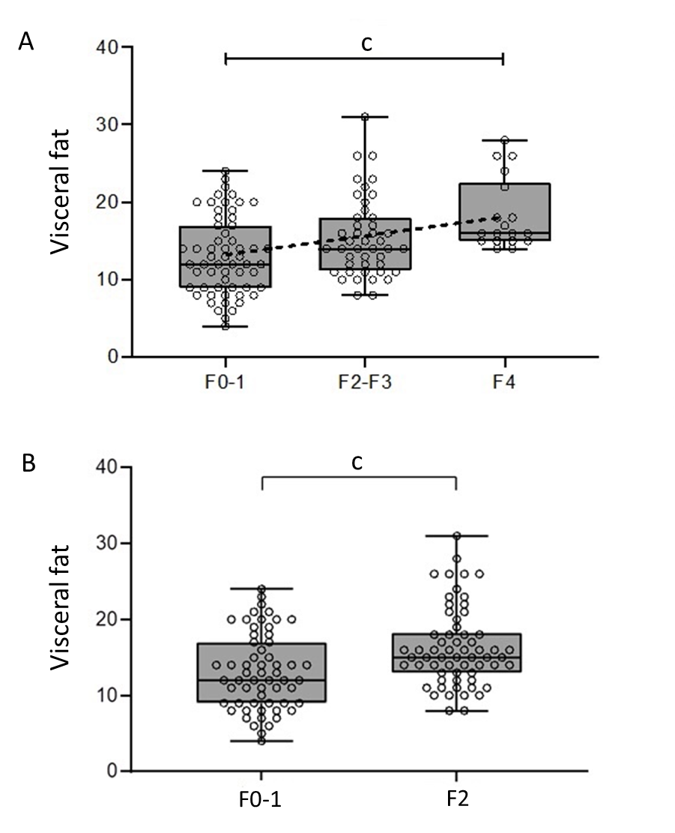
Figure 1 Visceral fat measurement by bioimpedanciometry, according to histological fibrosis stage. A: Visceral fat measurements increased along with fibrosis stage assessed by histological analysis (F0-1, 12; F2-3, 14; F4, 16; Kruskal-Wallis ^{c}P < 0.001). A line can be fit by linear regression, showing linear association (r² = 0.11, ^{c}P < 0.001); B: Visceral fat measurements were greater for those patients with significant fibrosis (16.3 vs 13.1, ^{c}P < 0.001).
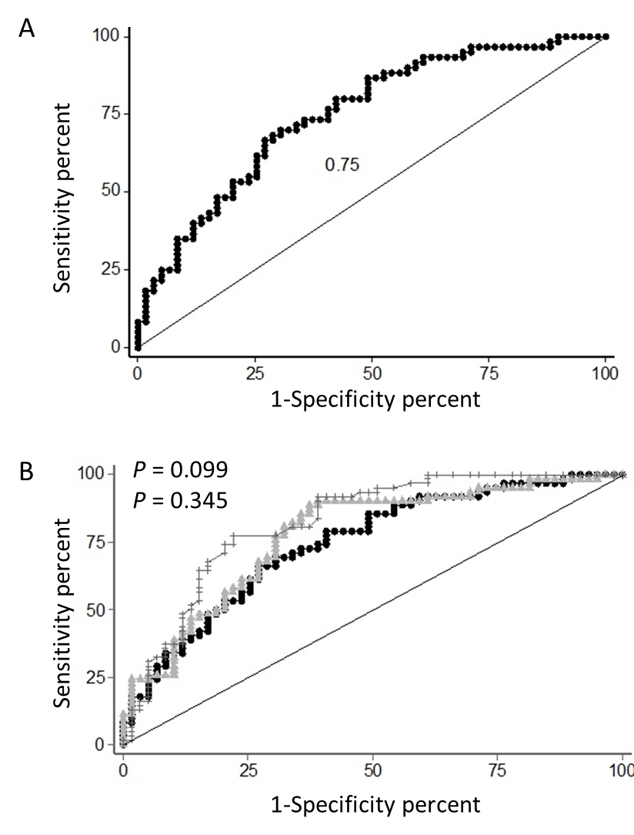
Figure 2 Area under the receiver operating characteristic curve. A: Receiver operating characteristic (ROC) curve for non-invasive diagnosis of significant liver fibrosis by a model including age and visceral fat; B: Comparison of the areas under ROC curves for a model using age and visceral fat versus liver elastography measurement, to predict significant liver fibrosis. Circles denote our model, triangles indicate non-alcoholic fatty liver disease fibrosis score and crosses denote liver elastography.
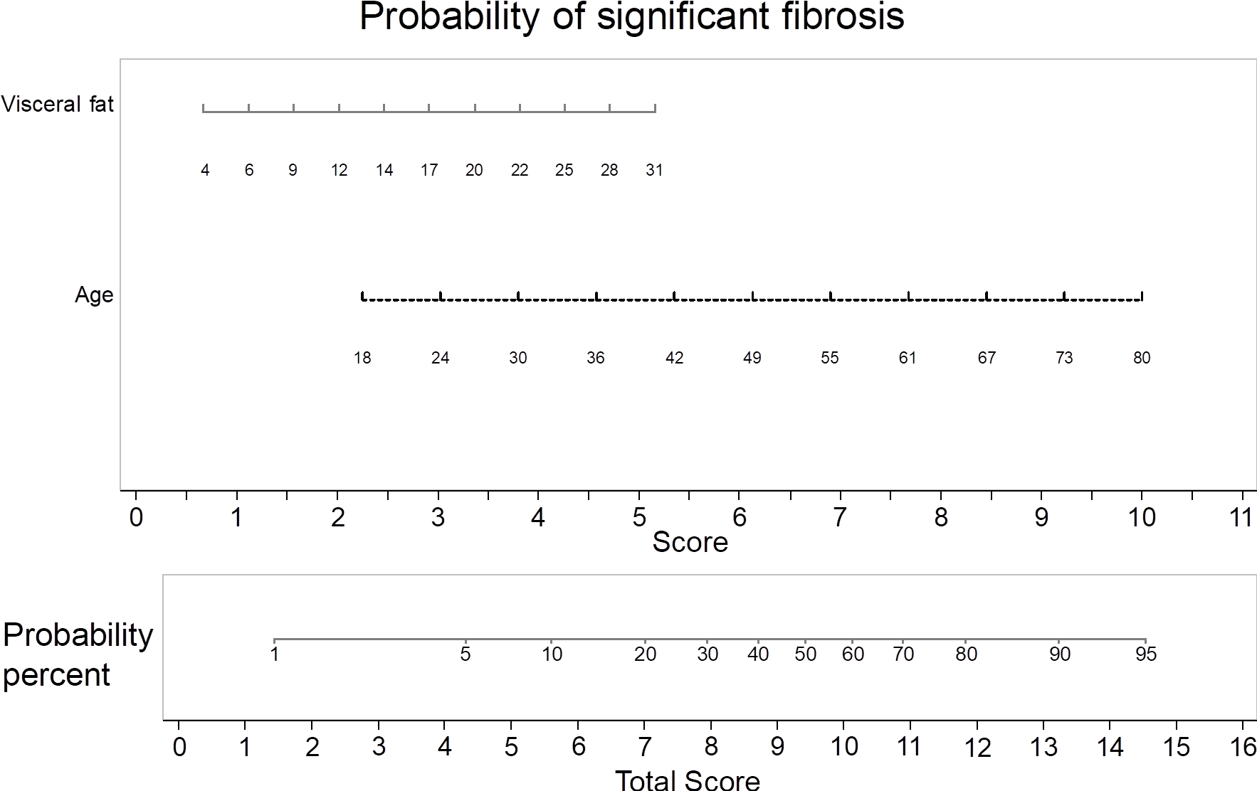
Figure 3 Nomogram for assessing the probability of significant liver fibrosis in a clinically useful manner. With the variables resulting from the multivariate regression model, we built an easy-to-use visual tool. In an individual patient, visceral fat levels and age correspond to a score. Combining these scores gives a total score that can be converted to a probability of that patient having significant fibrosis in liver biopsy. For example, a patient with a visceral fat level of 12 (score 2) and with 55 years old (score 7) would have a total score of 9 and a corresponding probability of histological significant fibrosis of 43%.
Table 1 Patient characteristics
 | n = 119
Age (yr), mean ± SD | 56 ± 10.7
18-30, n (%) | 2 (1.7)
31-50, n (%) | 30 (25.2)
51-70, n (%) | 79 (66.4)
> 70, n (%) | 8 (6.7)
Sex (male), n (%) | 79 (66.4)
Metabolic syndrome, n (%) | 73 (61.3)
Increased waist circumference, n (%) | 91 (76.5)
Hypertension, n (%) | 63 (52.9)
Type 2 diabetes mellitus, n (%) | 66 (55.5)
Increased Triglyceride levels, n (%) | 61 (51.3)
Low HDL-cholesterol levels, n (%) | 53 (44.5)
HOMA-IR, mean ± SD | 7.5 ± 13.1
BMI (kg/m²), mean ± SD | 32.5 ± 5.2
Obese, n (%) | 74 (62.2)
Normal BMI, n (%) | 6 (5)
Waist circumference (cm), mean ± SD | 109.3 ± 14
Visceral fat, mean ± SD¹ | 14.8 ± 5.3
Visceral fat ≥ 13, n (%)² | 77 (63.6)
CAP (dB/m), mean ± SD | 330.9 ± 50.4
Liver elastography (Kpa), mean ± SD | 11.7 ± 8
Histological fibrosis stage, n (%)
F0-1 | 59 (49.6)
F2 | 18 (15.1)
F3 | 24 (20.2)
F4 | 18 (15.1)
¹Measured by bioimpendanciometry analysis; ²Upper threshold of normality provided by the manufacturer. HOMA-IR: Homeostasis Model Assessment of Insulin Resistance; HDL-cholesterol: High-density lipoprotein cholesterol; CAP: Controlled attenuation parameter.
Table 2 Correlations of visceral fat with anthropometric parameters, liver fat and liver fibrosis
 | HOMA-IR | BMI (kg/m²) | WC (cm) | Hepatic fat (CAP) (dB/m) | Liver elastography (kPa) | Histological fibrosis stage
Visceral fat | 0.16 | 0.64^{b} | 0.67^{b} | 0.32^{b} | 0.33^{b} | 0.112^{b}
Hepatic fat (CAP) (dB/m) | 0.001 | 0.45^{b} | 0.38^{b} |  | 0.20 | 0.002
WC (cm) | 0.24ª | 0.81^{b} |  | 0.38^{b} | 0.23ª | 0.009
BMI (kg/m²) | 0.21ª |  | 0.81^{b} | 0.45^{b} | 0.25^{b} | 0.003
The values correspond with r correlation coefficient or r² coefficient for histological fibrosis stage. ªP < 0.05; ^{b}P < 0.01; HOMA-IR: Homeostasis Model Assessment of Insulin Resistance; CAP: Controlled attenuation parameter; WC: Waist circumference; BMI: Body mass index.
Table 3 Patient characteristics according to significant liver fibrosis (F ≥ 2)
 | F0-1 (n = 59) | F ≥ 2 (n = 60) | P
Age (yr), mean ± SD | 52 ± 10.5 | 61 ± 9.4 | < 0.001
Sex (male), n (%) | 34 (57.6) | 45 (75) | 0.054
Metabolic syndrome, n (%) | 29 (49.2) | 44 (73.3) | 0.007
Number metabolic risk factors, n (%) |  |  | 0.002¹
0 | 4 (6.8) | 2 (3.3)
1 | 11 (18.6) | 5 (8.3)
2 | 15 (25.4) | 9 (15)
3 | 17 (28.8) | 17 (28.3)
4 | 9 (15.3) | 18 (30)
5 | 3 (5.1) | 9 (15)
Type 2 diabetes mellitus, n (%) | 24 (40.7) | 42 (67.7) | 0.003
BMI (kg/m²), mean ± SD | 32.5 ± 5.6 | 32.6 ± 4.8 | 0.966
Obese, n (%) | 36 (61) | 38 (63.3) | 0.794
Normal BMI, n (%) | 5 (8.5) | 1 (1.7) | 0.090
Waist circumference (cm), mean ± SD | 108.6 ± 14.9 | 109.8 ± 13.3 | 0.663
Visceral fat, mean ± SD | 13.1 ± 5 | 16.4 ± 5.1 | < 0.001
Visceral fat ≥ 13, n (%) | 29 (49.2) | 48 (77.4) | 0.001
CAP (dB/m), mean ± SD | 330.5 ± 58 | 331.2 ± 44 | 0.946
Liver elastography (kPa), mean ± SD | 8.8 ± 5.6 | 14.5 ± 8.8 | < 0.001
Significant P values are shown in bold font. ¹Chi-squared for trend test. CAP: Controlled attenuation parameter; BMI: Body mass index.

