Name of Journal: World Journal of Clinical Cases
Manuscript NO: 58822
Manuscript Type: CASE REPORT

Treatment of pediatric intracranial dissecting aneurysm with clipping and angioplasty, and next-generation sequencing analysis: A case report and literature review

Sun N et al. Pediatric intracranial dissecting aneurysm

Ning Sun, Xin-Yu Yang, Yan Zhao, Qing-Jiang Zhang, Xiao Ma, Zhong-Nan Wei, Meng-Qi Li

Ning Sun, Qing-Jiang Zhang, Xiao Ma, Zhong-Nan Wei, Department of Neurosurgery, Tianjin Children’s Hospital, Tianjin 300134, China

Xin-Yu Yang, Yan Zhao, Meng-Qi Li, Department of Neurosurgery, Tianjin Medical University General Hospital, Tianjin 300052, China

Author contributions: Sun N, Yang XY, and Zhao Y drafted the manuscript; Zhang QJ and Ma X prepared the figures; Wei ZN and Li MQ prepared the clinical and imaging data; Sun N finalized the manuscript; Yang XY checked and reviewed the article; All authors read and approved the final draft.

Supported by National Natural Science Foundation of China, No. 81571144

Corresponding author: Ning Sun, MD, Surgeon, Department of Neurosurgery, Tianjin Children’s Hospital, No. 238 Longyan Road, Beichen District, Tianjin 300134, China. sunning64tj@yahoo.com

Received: August 12, 2020
Revised: December 11, 2020
Accepted: December 23, 2020
Published online:

Abstract
BACKGROUND
Large intracranial dissecting aneurysm (IDA) in the anterior cerebral circulation is rare in children. There has been no consensus on the diagnosis and treatment for IDA in children.

CASE SUMMARY
We report a 3-year-old boy with a large ruptured IDA in the right middle cerebral artery (16 mm × 14 mm). The IDA was successfully managed with clipping and angioplasty. Next-generation sequencing of the blood sample followed by bioinformatics analysis suggested that the rs78977446 variant of the ADAMTS13 gene is a risk for pediatric IDA. Three years after surgery, the boy was developmentally normal.

CONCLUSION
Clipping and angioplasty are effective treatments for ruptured IDA in the anterior cerebral circulation. ADAMTS13 rs78977446 is a risk factor for pediatric IDA.

Key Words: Intracranial dissecting aneurysm; Clipping; Pathogenic variants; ADAMTS13; Case report

Sun N, Yang XY, Zhao Y, Zhang QJ, Ma X, Wei ZN, Li MQ. Treatment of pediatric intracranial dissecting aneurysm with clipping and angioplasty, and next-generation sequencing analysis: A case report and literature review. World J Clin Cases 2020; In press

Core Tip: The index case was a 3-year-old boy with a large ruptured intracranial dissecting aneurysm in the right middle cerebral artery (16 mm × 14 mm). He was successfully treated by clipping and angioplasty. Whole-genome high-throughput sequencing identified the rs78977446 variant of the ADAMTS13 gene. Bioinformatics analysis using the American College of Medical Genetics guidelines and literature search suggested that this variant is a risk factor for pediatric intracranial dissecting aneurysm.
INTRODUCTION
Rupture of intracranial dissecting aneurysms (IDA) is a cause of subarachnoid hemorrhage (SAH) in children^{[1]}. The incidence of IDA is estimated to be no more than that for cervical dissecting artery (2.6–3.0 per 100000 people per year)^{[2,3]}. Both genetic and environmental factors contribute to the development of pediatric IDA^{[4]}. At the level of pathology, ultimate formation of intramural hematoma between the intima and media consists of tear of artery and rupture of vasa vasorum^{[5]}. IDA is associated with syphilis^{[6]}, connective tissue diseases^{[7]}, atherosclerosis^{[8]}, infection^{[9]}, migraine^{[10]}, hyperhomocysteinemia^{[10]}, and alpha-1 antitrypsin deficiency^{[11]}. A key event in dissecting aneurysms is the sudden widespread disruption of the internal elastic lamina and media^{[12,13]}.
IDA in children, and particularly in the anterior cerebral circulation, has rarely been reported and represents a formidable challenge in both the diagnosis and treatment^{[14]}.
We report a case of SAH caused by ruptured IDA in the anterior cerebral circulation. The patient was successfully treated with clipping and angioplasty. We also performed whole-genome sequencing to identify potential pathogenic gene polymorphisms.

CASE PRESENTATION
Chief complaints
A 3-year-old boy presented with intermittent non-projectile vomiting after a brief episode of syncope.

History of present illness
There was no clear triggering events for the emergence of symptoms. There was no blood in the gastric contents. Upon admission, the boy was lethargic but able to respond to command.

History of past illness
He had no history of trauma or surgery and no family history of cardiovascular diseases.

Physical examination
The Glasgow Coma Scale score was 14. Hunt-Hess grade was III. Pupil reflex was normal. The muscle strength was grade III in the left leg.

Laboratory examinations
With the exception of increased white blood cell count (8.58 × 10⁹/L), the laboratory test results were normal.

Imaging examinations
Computed tomography (CT) scan showed subarachnoid hemorrhage in the lateral fissure cistern and a small amount of blood in the right lateral ventricle (Figure 1A). CT angiography showed ruptured aneurysm in the right middle cerebral artery (Figure 1B-D). The intracranial aneurysm (IA) was 16 mm × 14 mm, with a wide neck. The pearl-and-string sign (proximal stenosis and distal stenosis in the intracranial aneurysm) was consistent with dissecting aneurysm (Figure 1C and D), as previously reported^{[15]}.

FINAL DIAGNOSIS
Based on these features, a diagnosis of IDA was established.

TREATMENT
Surgery was conducted using a pterional approach under general anesthesia. After adequate exposure of the parent artery, an IA was apparent at the junction between M1 and M2. There was severe stenosis in the proximal part of the aneurysm. The aneurysm wall was extremely thin. The normal anatomical structure of the parent artery has been apparently destroyed. The aneurysm was opened, and the blood clot within the aneurysm and the patent artery was removed. Then the IA was clipped (Figure 2A and B). The normal anatomical structure of the parent artery was restored and the parent vessel remained patent. IDA lesion was resected and tissue specimen was sent to pathologic examination (Figure 2B and C).

OUTCOME AND FOLLOW-UP
CT angiography was conducted 2 wk later, and showed no aneurysm; the parent artery was patent (Figure 3A-C). Neurologic symptoms and signs gradually improved. At the 1 mo follow-up visit, the boy was healthy, with the exception of slight muscle weakness in the left leg (grade IV). At 3 years later, the patient had completely recovered. CT angiography revealed normal blood supply to the brain (Figure 3D).

Pathogenic variants
Whole-genome sequencing (Novogene, Beijing, China) of the blood sample followed by bioinformatics analysis according to the American College of Medical Genetics guidelines^{[16]} revealed 13 candidate genes (Table 1). Next, we searched the PubMed database using the keyword “intracranial aneurysm” or “dissecting,” and “genes including pathogenic variation.” The literature review suggested an association between the rs78977446 variant of the ADAMTS13 gene and pediatric IDA. Briefly, ADAMTS13 participates in the inflammatory processes and vascular remodeling in IA^{[17,18]}. Genetic variants, transcription abnormality, and methylation changes in the ADAMTS genes may be an important factor for IA^{[19]}. In addition to IA, an autopsy study of 31 cases of aortic dissections revealed much higher frequency (0.1613) of the rs11575933 variant of the ADAMTS13 gene in aortic dissections^{[20]} vs healthy control subjects (https://www.ncbi.nlm.nih.gov/snp/?term=rs11575933).

DISCUSSION
Treatment of ruptured IDA
IDA can be classified into two types. In type 1 IDA, the dissection is located between the elastic layer and media layer, and causes ischemic stroke. In type 2 IDA, the dissection occurs between the media and adventitia, and causes SAH^{[21]}.
Treatment options for type 2 IDA include microsurgical clipping, coiling embolization, triple stent, trapping^{[22]}, bypass^{[23]}, wrapping, and complete exclusion^{[24]}. The choice of these treatment modalities remains controversial^{[25]}.
As an endovascular interventional therapy, clipping has been frequently used in pediatric IDA of the posterior circulation^{[26-28]}. It does not require craniotomy and thus is associated with minimal surgical trauma. The IDA in the index case was relatively large, and was ruptured. Thus, controlling bleeding and preventing rebleeding were the primary aims of the treatment^{[29]}. For this rare ruptured large dissecting aneurysm, microsurgery clipping and patent vessel remodeling may have a lower probability of long-term recurrence. More importantly, the lesions can be visualized during the microsurgery. Blood clot in the parent artery was cleared to establish the normal anatomy of the parent artery. IDA, which is similar to the saccular aneurysm in the same location, has the risk of rebleeding during the acute stage^{[30]}. Also, recurrence after several years has been reported^{[31]}. As a result, long-term monitoring is required.

Genetic indications and precision medication
Sequencing analysis followed by bioinformatics analysis and literature review suggested that the rs78977446 variant of the ADAMTS13 gene is a risk for pediatric IDA. IDA is more common in children than in adults, indicating a genetic contribution, but genetic studies for pediatric IDA are rare. In a previous study, the mutational rate was significantly higher in intracranial vertebral–basilar artery dissection cases than in controls^{[32]}. RNF213 rs112735431 (c.14576G>A) frequency is significantly lower in patients with intracranial vertebral artery dissection. The genetic predisposition to IDA in the index case may form the basis of future recurrence, and physicians should be aware of the unique circumstance of each patient^{[33]}.

CONCLUSION
In summary, clipping and angioplasty are appropriate treatments for ruptured IDA in the anterior cerebral circulation. The rs78977446 variant of the ADAMTS13 gene is a risk factor for pediatric IDA.

REFERENCES
1 Friedman AH, Drake CG. Subarachnoid hemorrhage from intracranial dissecting aneurysm. J Neurosurg 1984; 60: 325-334 [PMID: 6693960 DOI: 10.3171/jns.1984.60.2.0325]
2 Béjot Y, Daubail B, Debette S, Durier J, Giroud M. Incidence and outcome of cerebrovascular events related to cervical artery dissection: the Dijon Stroke Registry. Int J Stroke 2014; 9: 879-882 [PMID: 24148660 DOI: 10.1111/ijs.12154]
3 Lee VH, Brown RD Jr, Mandrekar JN, Mokri B. Incidence and outcome of cervical artery dissection: a population-based study. Neurology 2006; 67: 1809-1812 [PMID: 17130413 DOI: 10.1212/01.wnl.0000244486.30455.71]
4 Rabinov JD, Hellinger FR, Morris PP, Ogilvy CS, Putman CM. Endovascular management of vertebrobasilar dissecting aneurysms. AJNR Am J Neuroradiol 2003; 24: 1421-1428 [PMID: 12917140 DOI: 10.1016/s1076-6332(03)00018-7d]
5 Kim YK, Schulman S. Cervical artery dissection: pathology, epidemiology and management. Thromb Res 2009; 123: 810-821 [PMID: 19269682 DOI: 10.1016/j.thromres.2009.01.013]
6 Kellett MW, Young GR, Fletcher NA. Paraparesis due to syphilitic aortic dissection. Neurology 1997; 48: 221-223 [PMID: 9008521 DOI: 10.1212/WNL.48.1.221]
7 Brandt T, Orberk E, Weber R, Werner I, Busse O, Müller BT, Wigger F, Grau A, Grond-Ginsbach C, Hausser I. Pathogenesis of cervical artery dissections: association with connective tissue abnormalities. Neurology 2001; 57: 24-30 [PMID: 11445623 DOI: 10.1212/wnl.57.1.24]
8 Larson EW, Edwards WD. Risk factors for aortic dissection: a necropsy study of 161 cases. Am J Cardiol 1984; 53: 849-855 [PMID: 6702637 DOI: 10.1016/0002-9149(84)90418-1]
9 Guillon B, Bousser MG. [Epidemiology and pathophysiology of spontaneous cervical artery dissection]. J Neuroradiol 2002; 29: 241-249 [PMID: 12538941 DOI: 10.1002/hbm.10067]
10 Rubinstein SM, Peerdeman SM, van Tulder MW, Riphagen I, Haldeman S. A systematic review of the risk factors for cervical artery dissection. Stroke 2005; 36: 1575-1580 [PMID: 15933263 DOI: 10.1161/01.STR.0000169919.73219.30]
11 Schievink WI, Prakash UB, Piepgras DG, Mokri B. Alpha 1-antitrypsin deficiency in intracranial aneurysms and cervical artery dissection. Lancet 1994; 343: 452-453 [PMID: 7905956 DOI: 10.1016/s0140-6736(94)92693-x]
12 Mizutani T, Kojima H, Asamoto S. Healing process for cerebral dissecting aneurysms presenting with subarachnoid hemorrhage. Neurosurgery 2004; 54: 342-7; discussion 347-8 [PMID: 14744280 DOI: 10.1227/01.NEU.0000103449.80484.7E]
13 Mizutani T, Kojima H, Asamoto S, Miki Y. Pathological mechanism and three-dimensional structure of cerebral dissecting aneurysms. J Neurosurg 2001; 94: 712-717 [PMID: 11354401 DOI: 10.3171/jns.2001.94.5.0712]
14 Debette S, Compter A, Labeyrie MA, Uyttenboogaart M, Metso TM, Majersik JJ, Goeggel-Simonetti B, Engelter ST, Pezzini A, Bijlenga P, Southerland AM, Naggara O, Béjot Y, Cole JW, Ducros A, Giacalone G, Schilling S, Reiner P, Sarikaya H, Welleweerd JC, Kappelle LJ, de Borst GJ, Bonati LH, Jung S, Thijs V, Martin JJ, Brandt T, Grond-Ginsbach C, Kloss M, Mizutani T, Minematsu K, Meschia JF, Pereira VM, Bersano A, Touzé E, Lyrer PA, Leys D, Chabriat H, Markus HS, Worrall BB, Chabrier S, Baumgartner R, Stapf C, Tatlisumak T, Arnold M, Bousser MG. Epidemiology, pathophysiology, diagnosis, and management of intracranial artery dissection. Lancet Neurol 2015; 14: 640-654 [PMID: 25987283 DOI: 10.1016/S1474-4422(15)00009-5]
15 Hermes J, Lakshmanan R, Watkins L, Davagnanam I. Teaching NeuroImages: Intracranial arterial dissection. Neurology 2017; 88: e111-e112 [PMID: 28320929 DOI: 10.1212/WNL.0000000000003733]
16 Richards S, Aziz N, Bale S, Bick D, Das S, Gastier-Foster J, Grody WW, Hegde M, Lyon E, Spector E, Voelkerding K, Rehm HL; ACMG Laboratory Quality Assurance Committee. Standards and guidelines for the interpretation of sequence variants: a joint consensus recommendation of the American College of Medical Genetics and Genomics and the Association for Molecular Pathology. Genet Med 2015; 17: 405-424 [PMID: 25741868 DOI: 10.1038/gim.2015.30]
17 Arning A, Jeibmann A, Köhnemann S, Brokinkel B, Ewelt C, Berger K, Wellmann J, Nowak-Göttl U, Stummer W, Stoll M, Holling M. ADAMTS genes and the risk of cerebral aneurysm. J Neurosurg 2016; 125: 269-274 [PMID: 26745484 DOI: 10.3171/2015.7.JNS154]
18 Hanson E, Jood K, Nilsson S, Blomstrand C, Jern C. Association between genetic variation at the ADAMTS13 locus and ischemic stroke. J Thromb Haemost 2009; 7: 2147-2148 [PMID: 19765208 DOI: 10.1111/j.1538-7836.2009.03617.x]
19 Chen S, Li M, Xin W, Liu S, Zheng L, Li Y, Li M, Zhan M, Yang X. Intracranial aneurysm's association with genetic variants, transcription abnormality, and methylation changes in ADAMTS genes. PeerJ 2020; 8: e8596 [PMID: 32095376 DOI: 10.7717/peerj.8596]
20 Nakagawa M, Matsusue A, Umetsu K, Iino M, Ishikawa T, Yuasa I. Genotyping of the c.1423C>T (p.P475S) polymorphism in the ADAMTS13 gene by APLP and HRM assays: Northeastern Asian origin of the mutant. Leg Med (Tokyo) 2016; 21: 1-4 [PMID: 27497325 DOI: 10.1016/j.legalmed.2016.04.010]
21 Sasaki O, Koike T, Tanaka R, Ogawa H. Subarachnoid hemorrhage from a dissecting aneurysm of the middle cerebral artery. Case report. J Neurosurg 1991; 74: 504-507 [PMID: 1993917 DOI: 10.3171/jns.1991.74.3.0504]
22 Araki S, Oda K, Fujita T, Kawakami M. Internal trapping of a ruptured vertebral artery dissecting aneurysm followed by recanalization of the trapped vertebral artery without aneurysm recurrence: case report. Neurol Med Chir (Tokyo) 2010; 50: 914-917 [PMID: 21030804 DOI: 10.2176/nmc.50.914]
23 Starke RM, Ding D, Durst CR, Crowley RW, Liu KC. Combined microsurgical PICA-PICA bypass and endovascular parent artery occlusion for a ruptured dissecting vertebral artery aneurysm. Neurosurg Focus 2015; 38: Video3 [PMID: 25554844 DOI: 10.3171/2015.V1.FOCUS14526]
24 Narata AP, Yilmaz H, Schaller K, Lovblad KO, Pereira VM. Flow-diverting stent for ruptured intracranial dissecting aneurysm of vertebral artery. Neurosurgery 2012; 70: 982-988; discussion 988-989 [PMID: 21937937 DOI: 10.1227/NEU.0b013e318236715e]
25 de Divitiis O, Di Somma A, Somma T, Cavallo LM, Marseglia M, Briganti F, Cappabianca P. Surgical clipping of a dissecting aneurysm of the precommunicating segment of the anterior cerebral artery: a case report and review of the literature. J Med Case Rep 2015; 9: 117 [PMID: 26001929 DOI: 10.1186/s13256-015-0604-x]
26 Shin YS, Kim BM, Kim SH, Suh SH, Ryu CW, Koh JS, Kim DI, Kim DJ. Endovascular treatment of bilateral intracranial vertebral artery dissecting aneurysms presenting with subarachnoid hemorrhage. Neurosurgery 2012; 70: 75-81; discussion 81 [PMID: 21796008 DOI: 10.1227/NEU.0b013e31822ed1f0]
27 Briganti F, Cicala D, Tortora F, Leone G, Napoli M, Maiuri F. Endovascular treatment of a giant dissecting aneurysm of the posterior cerebral artery. A case report and literature review. Neuroradiol J 2012; 25: 695-701 [PMID: 24029183 DOI: 10.1177/197140091202500609]
28 Li H, Zhang X, Li XF, He XY, Zhu GH, Fang QR, Wang ZQ, Duan CZ. Predictors of Favorable Outcome of Intracranial Basilar Dissecting Aneurysm. J Stroke Cerebrovasc Dis 2015; 24: 1951-1956 [PMID: 26082343 DOI: 10.1016/j.jstrokecerebrovasdis.2015.05.013]
29 Massimi L, Moret J, Tamburrini G, Di Rocco C. Dissecting giant vertebro-basilar aneurysms. Childs Nerv Syst 2003; 19: 204-210 [PMID: 12715187 DOI: 10.1007/s00381-003-0726-0]
30 Aoki N, Sakai T. Rebleeding from intracranial dissecting aneurysm in the vertebral artery. Stroke 1990; 21: 1628-1631 [PMID: 2237959 DOI: 10.1161/01.STR.21.11.1628]
31 Ikeda T, Kurita H, Konishi Y, Fujitsuka M, Hino K, Shiokawa Y, Saito I. De novo dissecting aneurysm in a patient with a ruptured saccular lesion. Case report. J Neurosurg 2002; 97: 701-704 [PMID: 12296658 DOI: 10.3171/jns.2002.97.3.0701]
32 Wang K, Zhao S, Zhang Q, Yuan J, Liu J, Ding X, Song X, Lin J, Du R, Zhou Y, Sugimoto M, Chen W, Yuan B, Liu J, Yan Z, Liu B, Zhang Y, Li X, Niu Y, Long B, Shen Y, Zhang S, Abe K, Su J, Wu Z, Wu N, Liu P, Yang X; Deciphering Disorders Involving Scoliosis & Comorbidities (DISCO) study. Whole-exome sequencing reveals known and novel variants in a cohort of intracranial vertebral-basilar artery dissection (IVAD). J Hum Genet 2018; 63: 1119-1128 [PMID: 30115950 DOI: 10.1038/s10038-018-0496-x]
33 Schork NJ. Personalized medicine: Time for one-person trials. Nature 2015; 520: 609-611 [PMID: 25925459 DOI: 10.1038/520609a]

Footnotes
Informed consent statement: Informed written consent was obtained from the parents of the patient for publication of this report and accompanying images.

Conflict-of-interest statement: The authors declare that they have no conflict of interest.

CARE Checklist (2016) statement: The authors have read the CARE Checklist (2016), and the manuscript was prepared and revised according to the CARE Checklist (2016)

Open-Access: This article is an open-access article that was selected by an in-house editor and fully peer-reviewed by external reviewers. It is distributed in accordance with the Creative Commons Attribution NonCommercial (CC BY-NC 4.0) license, which permits others to distribute, remix, adapt, build upon this work non-commercially, and license their derivative works on different terms, provided the original work is properly cited and the use is non-commercial. See: http://creativecommons.org/Licenses/by-nc/4.0/

Manuscript source: Unsolicited manuscript

Peer-review started: August 12, 2020
First decision: December 3, 2020
Article in press:

Specialty type: Medicine, research and experimental
Country/Territory of origin: China
Peer-review report’s scientific quality classification
Grade A (Excellent): 0
Grade B (Very good): B
Grade C (Good): 0
Grade D (Fair): 0
Grade E (Poor): 0

P-Reviewer: Kheiralla OAM S-Editor: Fan JR L-Editor: Filipodia P-Editor:

Figure Legends
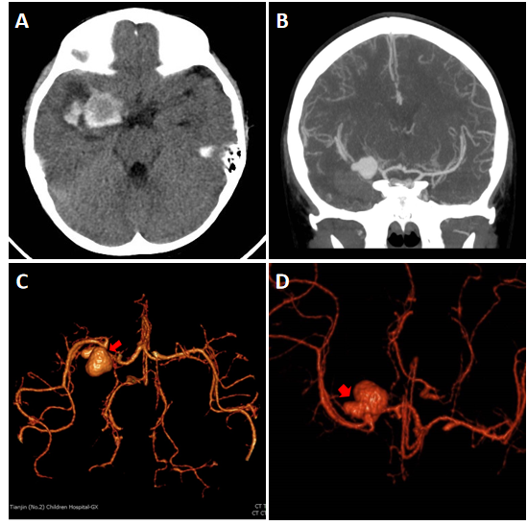
Figure 1 Preoperative imaging examination. A: Subarachnoid hemorrhage caused by ruptured intracranial dissecting aneurysm (IDA); B: Computed tomography angiography shows intracranial aneurysm in the right medical council on alcohol; C and D: Pearl-and-string sign of IDAs (focal stenoses proximally and distally, which are noted by red arrows.
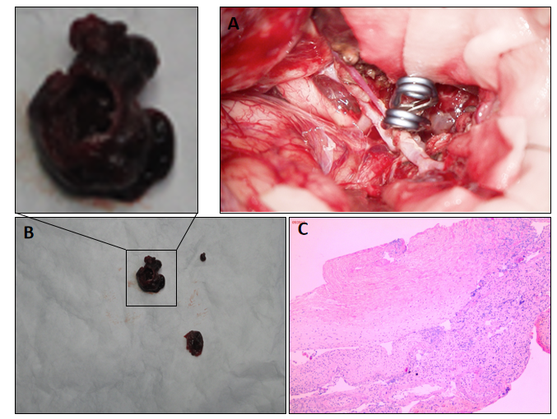
Figure 2 Clipping and angioplasty for intracranial dissecting aneurysms, and pathological examination. A: The aneurysm was clipped; B: The wall of the intracranial dissecting aneurysm was very thin, and a thrombus was adhered to the wall; C: The intracranial dissecting aneurysm was resected and sent for pathological examination. Pathological examination indicated irregular and malformed vascular wall structure with inflammatory infiltration.
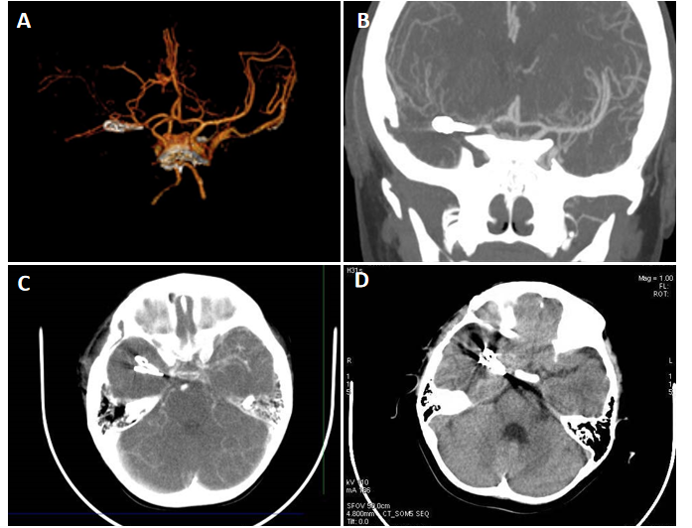
Figure 3 Postoperative computed tomography angiography examination and follow-up. A-C: Postoperative computed tomography angiography examination indicated that the aneurysm had been resected, and the blood flow of the constructed medical council on alcohol was unobstructed; D: The 3-year follow-up showed no recurrence.
Table 1 Pathogenic variants found by American College of Medical Genetics guidelines
Chromosome | Position | Variation | REF | ALT | Function | Gene | SIFT | Mutation taster | CADD
1 | 47610522 | rs570554271 | C | T | Stopgain | CYP4A22 | - | 1, A | 10.070978, 36
2 | 234637905 | rs45625338 | C | T | Missense | UGT1A3 | 0.0, D | 1, D | 2.458692, 19.20
8 | 145699712 | - | G | A | Missense | FOXH1 | 0.0, D | 1, D | 6.334943, 29.3
9 | 136310917 | rs78977446 | C | T | Missense | ADAMTS13 | 0.081, T | 1, N | 0.962795, 10.45
11 | 17482222 | rs185040406 | C | T | Missense | ABCC8 | 0.07, T | 0.777604, N | 3.415216, 23.0
12 | 85266484 | rs12424429 | G | A | Missense | SLC6A15 | 0.295, T | 0.975276, N | -
13 | 100518634 | rs41281112 | C | T | Stopgain | CLYBL | - | 1, A | 8.514350, 35
14 | 75514138 | rs28756990 | C | A | Missense | MLH3 | 0.034, D | 1, N | 2.798595, 21.4
16 | 3705465 | rs77254040 | C | G | Missense | DNASE1 | 0.007, D | 1, D | 3.289682, 22.8
18 | 29867688 | rs3744921 | T | C | Missense | GAREM1 | 0.22, T | 0.999954, D | 1.071666, 11.06
19 | 4157148 | rs77002741 | G | A | Missense | CREB3L3 | 0.169, T | 1, N | 1.858481, 15.34
19 | 39898667 | rs3746083 | C | T | Synonymous | ZFP36 | - | - | -
22 | 50523267 | rs184241759 | C | T | Missense | MLC1 | 0.007, D | 1, N | 3.434483, 23.0
CADD score > 15 means that the variation affects protein function. ALT: Mutation-type; REF: Reference. A SIFT score indicates whether the variation is likely to cause changes in protein structure or function: D: Deleterious (sift ≤ 0.05); T: Tolerated (sift > 0.05). MutationTaster represents the effect of the mutation on the protein sequence: A: Disease_causing_automatic; D: Disease_causing; N: Polymorphism; P: Polymorphism_automatic.

