Name of journal: World Journal of Gastroenterology
ESPS Manuscript NO: 31877
Manuscript Type: ORIGINAL ARTICLE

Basic Study
Effect of a poloxamer 407-based thermosensitive gel on minimization of thermal injury to diaphragm during microwave ablation of the liver

Zhang LL et al. A poloxamer 407 gel minimizes thermal injury

Li-Li Zhang, Gui-Min Xia, Yu-Jiang Liu, Rui Dou, John Eisenbrey, Ji-Bin Liu, Xiao-Wei Wang, Lin-Xue Qian

Li-Li Zhang, Yu-Jiang Liu, Rui Dou, Lin-XueQian, Department of Ultrasound, Beijing Friendship Hospital, Capital Medical University, Beijing 100054, China

Gui-Min Xia, Pharmaceutics Department, Institute of Medicinal Biotechnology, Chinese Academy of Medical Science and Peking Union Medical College, Beijing100054, China

John Eisenbrey, Ji-Bin Liu, Department of Radiology, Thomas Jefferson University, Philadelphia, PA 19107, United States

Author contributions: Zhang LL, Xia GM, Liu YJ, Dou R, Eisenbrey J, Liu JB, Wang XW and Qian LX contributed to the study design, acquisition and analysis, writing and revisions of the paper, and approval of the final draft for submission.

Supported by the National Key Research and Development Program No. 2016YFA0201504 and the Clinical-Basic Cooperation Program from Capital Medical University No. 15JL10.

Institutional animal care and use committee statement: All procedures involving animals were reviewed and approved by the Institutional Animal Care and Use Committee of the Department of Ultrasound, Beijing Friendship Hospital, Capital Medical University (IACUC Number: 15-4003).

Conflict-of-interest statement: The authors alone are responsible for the paper. The authors declare no conflicts of interest.

Data sharing statement: Technical appendix, statistical code, and dataset available from the corresponding author at qianlinxue2002@163.com.

Open-Access: This article is an open-access article which was selected by an in-house editor and fully peer-reviewed by external reviewers. It is distributed in accordance with the Creative Commons Attribution Non Commercial (CC BY-NC 4.0) license, which permits others to distribute, remix, adapt, build upon this work non-commercially, and license their derivative works on different terms, provided the original work is properly cited and the use is non-commercial. See: http://creativecommons.org/licenses/by-nc/4.0/

Manuscript source: Unsolicited manuscript

Correspondence to: Dr. Lin-Xue Qian, Department of Ultrasound, Beijing Friendship Hospital, Capital Medical University, You’anmenwai Xitoutiao 10, Beijing 100054, China. qianlinxue2002@163.com
Telephone: +86-10-63138576
Fax: +86-10-83165944

Received: December 12, 2016
Peer-review started: December 13, 2016
First decision: January 10, 2017
Revised: January 21, 2017
Accepted: February 16, 2017
Article in press:
Published online:
Abstract
AIM
To assess the insulating effect of a poloxamer 407-based gel during microwave ablation of the liver adjacent to the diaphragm.

METHODS
We prepared serial dilutions of poloxamer 407 (P407), and 25% (w/w) concentration was identified as suitable for ablation procedures. Subsequently, microwave ablations were performed on the livers of 24 rabbits (gel, saline, control group, n = 8 in each). The P407 solution and 0.9% normal saline were injected into the potential space between the diaphragm and liver in experimental groups. No barriers were applied to the controls. After microwave ablations, the frequency, size, and degree of thermal injury were compared histologically among the three groups. Subsequently, other eight rabbits were injected with the P407 solution and microwave ablation was performed. The levels of ALT, AST, BUN and Cr in serum were tested at 1 d before microwave ablation and 3 and 7 d after operation.

RESULTS
In vivo ablation, thermal injury to the adjacent diaphragm was in turn in the control, saline, 25 % P407 gel group (P = 0.001 – 0.040). However, there was no significant difference in the volume of ablation zone among the three groups (P > 0.05). Moreover, there were no statistical differences among the preoperative and postoperative gel groups in indicators level in serum (all P > 0.05).

CONCLUSION
Twenty-five percent P407 gel could be a more effective choice during microwave ablation of hepatic tumors adjacent to the diaphragm. Further studies for clinical translation are warranted.

Key words: Microwave ablation; Hepatocellular carcinoma; Injury; Poloxamer; Hydrodissection

©The Author(s) 2017. Published by Baishideng Publishing Group Inc. All rights reserved.

Core tip: Collateral thermal damage is the most common complication of microwave ablation. Conventional liquids can move away and be absorbed quickly, then difficult to get a good separation effect. This study aimed to assess the insulating effect of a poloxamer 407-based thermosensitive gel during microwave ablation of the liver adjacent to the diaphragm. We prepared serial dilutions of poloxamer 407 (P407), and 25% (w/w) concentration was identified as suitable for ablation procedures. 25% P407 effectively protect the diaphragm during microwave ablation of the liver, which is superior to 5% dextrose in water and 0.9% saline.

Zhang LL, Xia GM, Liu YJ, Dou R, Eisenbrey J, Liu JB, Wang XW, Qian LX. Effect of a poloxamer 407-based thermosensitive gel on minimization of thermal injury to diaphragm during microwave ablation of the liver. World J Gastroenterol 2017; In press
INTRODUCTION
Percutaneous thermal ablation as a minimally invasive procedure has been widely used for treating liver tumors in the past 20 years especially hepatocellular carcinoma (HCC)^{[1]}. Over the years, different types of ablation applicators have been widely accepted, such as microwave (MW), radiofrequency (RF)electrical current, laser and cryoablation^{[2,3]}. Percutaneous thermal ablation has been credited with almost equivalent survival rates and a rapid return to normal status compared to surgical resection^{[4,5]}. Several studies have noted that MW ablation could create larger ablation zones compared to RF ablation^{[6,7]}. A MW ablation at 60 °C has been found to immediately induce coagulative necrosis of the tumors^{[8]}.
In the treatment of HCC, a low energy can result in incomplete ablation and local progression. However, high-power microwave ablations often result in thermal injury to non-target organs, including the gallbladder, diaphragm and so on^{[9]}. This poses a challenge to the interventional doctors. As previous studies reported, about 15% of liver tumors deemed as high risk are not suitable for thermal ablation^{[10,11]}.
To reduce such harmful effects, several methods have been suggested during the ablation of subcapsular hepatic lesions. Hydrodissection is the most commonly applied technique to insulate adjacent structures such as 5% dextrose in water (D5W) and 0.9% NS^{[12,13]}. That has been found to be effective at decreasing unintended thermal injury, however D5W and NS tend to move away quickly from target sites thereby reduce the insulating effect.
P407 is a nonionic surfactant composed of polyethylene oxide–polypropylene oxide–polyethylene oxide triblock copolymers^{[14]}. It is currently used in clinical therapy as a drug carrier^{[15, 16]}. P407 has an attractive property that it can, from being in liquid state at low temperatures transform into a semisolid gel state at elevated temperatures (gelation temperature), which depends on heat conduction of the surroundings^{[15,17]}. This indicated that P407 gel may be useful in microwave ablation of the liver. The aim of our study was to evaluate in vivo the insulating properties of a poloxamer 407-based thermosensitive gel during microwave ablation of the liver adjacent to the diaphragm.

MATERIALS AND METHODS
Study subjects
The subjects included in this study were thirty-two male and female healthy New Zealand white rabbits (weight = 1.5 - 2.5 kg). The study protocol was approved by the research Animal Care and Use Committee of our institution. The treatment of animals was according to the National Institutes of Health Guide for the Care and Use of Laboratory Animals.

Concentration optimization
The sol-gel transformation of the injectable thermosensitive solution is expected to occur at slightly below room temperature. A series of dilutions ranging from 15% - 30 % (w/w) P407 (BASF, Germany, Batch No. WPWJ554C) in deionized water were prepared and their gelation temperatures were determined using a rotor equipped with a controlled heating system^{[18]} (magnetic rotor size 1.5 cm × 0.6 cm, stirring rate 300 rotations/min). The samples were slowly heated at a rate of 0.5 °C/min from the initial temperature of 15 °C. The gelation temperatures were defined as when the magnetic rotor completely stopped rotating. Each concentration was tested in triplicate simultaneously. Eventually, an optimal concentration of the P407 solution was obtained. Then the viscosity of 25% P407 gel was tested with a Brookfield R/S⁺ rheometer (Stoughton, MA, United States) with a circulating water bath. The sample was heated from 15 °C to 30 °C at a constant shear rate of 5/s. The rheological behavior of 25% P407 was investigated.

Microwave ablation instrument
A water-cooled MW ablation system was used in this study (KY-2000; Kangyou Medical Instruments, Nanjing, China). The generator can produce 1-100 W of power at 2450 MHz. We used a Model T₁₁ (an outer diameter of 15 G) microwave ablation needle, with distance 11mm from the front end of the gap to the tip. An output setting of 60 W for 300 s was usually used for ablation sessions. However, since rabbit liver is small and fragile, such high microwave power could easily penetrate the liver. Therefore, ablation was performed for 180 s at 40 W in this study.
An iron- constantan thermocouple was used to monitoring temperature in real time. The system has 21-gauge thermocouple needles, which were percutaneously placed at a designated location. For data acquisition, HP 34970A (Hewlett Packard, CA, United States) with a 16-bit analog output function was used.

Ex vivo temperature measurement
Insulation effectiveness during MW ablation was evaluated ex vivo as described in Figure 1. Two swine liver pieces were placed in a six-well plate (diameter 2 cm and depth 2 cm) which was positioned in a water bath at 37 °C. To obtain a 5 mm or 10 mm barrier between the liver pieces, 25% P407 gel was used as a hydrodissection. The ablation needles were placed vertically into the livers at a depth of 1.5 cm, 5 mm away from the barrier. The ablation needle and temperature probes were positioned in parallel, maintaining a distance of 5 mm between the ablation needle and the primary needle (R1). We compared the insulation effects of a 5-mm-thick barrier against a 10-mm-thick barrier. Microwaves were applied three times at 40 W for 3 min. The temperature differences between probes R1 and R2 were recorded every 30 s and mapped. Moreover, whenever R1 reached 60 °C, the temperature at R2 was measured.

Preparation of experimental animals
Thirty-two male and female healthy New Zealand white rabbits were used for this study (weight = 1.5 - 2.5 kg). Eight rabbits were employed to study the safety of the P407 gel, as described later. The other 24rabbits were randomly assigned to three experimental groups. Two experimental groups were injected with 5 mL P407 and 5 mL 0.9% NS, respectively, between the diaphragm and the liver. Such volume enabled the presence of a 5 mm barrier by ultrasonic examination. For control animals, no protective technique was used. Before each ablation procedure, the rabbits were anesthetized with 30 mg/kg intravenous pentobarbital sodium (Sigma, Germany). The abdomen was shaved, disinfected routinely, and the animals were placed in a supine position for MW ablation.

MW ablation
All of the procedures described in this study were performed by two interventional clinicians. The animals were ultrasonically scanned to choose the best puncture sites (avoiding important blood vessels and ribs). A 2 mm scar was incised at the edge of the skin with a sharp knife. The MW antennas were placed 5 mm away from the liver surface. The ablation applicator was used for 3 min at an output power of 40 W. During MW ablations, the thickness of hydrodissection barrier was observed for each experimental group. All interventional procedures were monitored and guided by ultrasound examination.

Animal sacrifice and data analysis
The 24 rabbits were sacrificed and dissected immediately after MW ablation. The liver ablation zones and adjacent diaphragms were photographed and the ablation effects compared. Subsequently, the diaphragm and liver samples were fixed in 10% formalin, embedded in paraffin, and stained with hematoxylin and eosin. An experienced pathologist evaluated thermal injury to the diaphragm histologically. The volumes of ablation zones were calculated and compared using the following formula.
Volume (V) = π/6×a b c
where a is dimension 1, b is dimension 2, and c is dimension 3.(a is the largest diameter, and b and c are the other mutually perpendicular diameters).
Thermal injury to the diaphragm was expressed as a diameter of injured lesions. In addition, we graded the degree of thermal injury to the diaphragm according to a four-point scoring system (none, 0; mild, 1; moderate, 2; severe, 3) based on a consensus of two of the contributing authors. If a diaphragm was seen discolored and having a thickened pale area that extended toward the pleural margin, it was considered seriously injured. The suspected injured diaphragms were sectioned and graded on a scale of 0–3: 0, no injury; 1, mild injury up to one-third thickness; 2, moderate injury to two-thirds thickness; and 3, severe injury^{[19]}.

In vivo safety experiment
Eight rabbits were injected with the P407 solution at a dose of 5 mL into the potential space between the diaphragm and liver under ultrasonic guidance and MW ablation was performed at 40 W for 3 min. Using 2 mL of ear vein blood, the levels of ALT, AST, BUN, and Cr in serum were tested 1 d before and 3 and 7 d after the procedures so as to check liver and renal functions.

Statistical analysis
The experimental data were analyzed using SPSS software, version 16.0. Quantitative data were described as mean ± SD and were evaluated using one-way analysis of variance. The levels of thermal injury were compared using the Mann–Whitney test (Kruskal–Wallis test). P < 0.05 was considered statistically significant.

RESULTS
Optimal formulation
The sol-gel transformation temperature decreased as P407 concentration increased (Figure 2A). Finally, gelation temperature of 25% P407 (BASF) solution was 22 °C. For clinical purposes, the thermosensitive gel should have a relatively lower gelation temperature in order to gelate rapidly in target site and facilitate our operation smoothly. Our results show that 25% P407 solution gelled at about 1.5 min in a water bath at 37 °C but 16 min at room temperature. Such short interval is beneficial to operate the surgery rapidly and smoothly. So we propose that 25% P407 gel could be an ideal choice for ablation procedures.
The rheological behavior of P407 is also presented as a flow curve (Figure 2B). The sample exhibited low viscosity and characterized fluidic behavior below 18 °C. It is feasible to be injected. When the gelation temperature was reached, the viscosity sharply increased. By this time, the sample had transformed into a semisolid state.

Ex vivo MW ablation and temperature testing
After MW ablation for 3 min, the maximum temperature difference of 26.4 ± 0.5 °C was observed between R1 and R2 with a P407 gel thickness of 5 mm (Figure 3A). When the mean temperature of R1 reached 60 °C at 180 s, the temperature of R2 was 41.9 ± 1.1 °C (Figure 3B) and the temperature difference was 18.1 ± 1.5 °C (Figure 3A). However, the maximum temperature difference of 30.9 ± 2.2 °C (Figure 3A) was observed after MW ablation for 3 min with a P407 gel thickness of 10 mm, the mean temperature of R1 was 60 °C and that of R2 was 29.1 ± 2.4 °C (Figure 3B). Our results demonstrate that a 5-mm P407 gel is adequate to insulate the surrounding tissue from thermal damage.

Gross pathology
When monitored ultrasonically, no changes in gel thickness were observed during MW ablation (Figures 4A and B). After MW ablation, laparotomy was performed on the experimental animals immediately and the in situ gel and liver ablation zones were observed (Figure 5). Similarly, for the saline group, the initial barrier thickness was also 5 mm (Figure 4C). The distance between ablation needle tip and the edge of the liver was approximately 5 mm. However, the thickness reduced to 1.3 mm at the end of the ablation procedure (Figure 4D). After several hours, 25 % P407 gel was not detected by ultrasound.
The effects of ablations extended into the surrounding diaphragm in all of the control animals (eight), five of the saline-protected animals and none of the gel-protected animals. Table 1 shows that thermal damage to the diaphragm differed significantly in size and severity among the three groups (P < 0.05). However, no difference in the volume of ablation zone was detected among the three experimental groups (P = 0.353; Table 2). Representative photographs of gross specimens of ablated liver and injured diaphragm are shown in Figure 6.

Safety assessment
The levels of ALT, AST, BUN, and Cr in serum were assayed before and after MW ablation (Table 3) as indicators of liver and renal functions. Our statistical analysis showed that there was no significant difference among the groups pre- and postoperatively (P > 0.05; Table 3).

DISCUSSION
MW ablation is considered an effective treatment for small hepatocellular carcinomas^{[20,21]}. However, several complications may occur, including hemorrhage, pleural effusion and thermal injury^{[1]}. Among these, thermal injury to non-target tissue is the most common side effect, in particular when the tumor is close to vital organs, thereby resulting in poor prognosis. Therefore ablation is not recommended for large tumors located close to the diaphragm or the gastrointestinal tract.
Many investigators have attempted to reduce collateral thermal damage by means of hydrodissection^{[13,22]}. Although several conventional thermoprotective fluids are known, low viscosities as a result of their high mobility pose a challenge. In some cases, a continuous infusion of the fluid need to be maintained during the whole ablation procedure, leading to fluid overload and patient discomfort^{[23,24]}. Thus, we optimized the fluids to replace conventional hydrodissection applied for microwave ablation of the liver.
In the present study, 25% P407solution exhibited potential as a thermoprotective barrier during MW ablations. It exhibited low viscosity at below 18 °C as D5Wand 0.9% NS, which allows for injectability without resistance through small needles. However, 25 % P407 transformed into a semi-solid state rapidly at 37 °C, providing a stable gel barrier at the injection site. It was not detected by ultrasound after several hours. Therefore more critical ablations, such as for high-risk liver cancers, are possible to be performed when using P407 as a thermoprotective agent, although MW ablation is generally not preferred method for treating such cases. It is well known that conventional hydrodissection fluids flow away from target sites due to heat convection, thereby dissipating heat from the ablation site. Nevertheless, this appears to play little role in the mechanism of P407 gel. Instead, it appears to work mainly through heat conduction. Further studies are needed to establish the mechanisms of thermoprotection by P407.
According to ex vivo temperature studies, 25% P407 gel of 5 mm thickness can result in a temperature difference of about 18 °C between both sides of the gel. During ablation, the temperature was 29.1 ± 2.4 °C on the other side of the gel corresponding to the one side of tissue necrosis temperature (60 °C). This insulation effect is enough to protect the surrounding tissues adjacent to the ablation zones as well as to reduce post-operative complications. Besides, the volume of the fluid required to be injected into the body is significant low, it would be much more easily accepted by patients in clinical setting.
Most important of all, none of the animals in the gel group experienced diaphragmatic injury, even when MW ablation was performed at the subcapsular region of the liver. It is partly due to the gel had been placed into a preset position and remained stable during MW ablation. In contrast, thermal damage in the saline group was serious, due in part to the tendency of saline to flow away from the injection site, thereby providing partial protection to the diaphragm during liver ablations. In many cases, continuous infusion is unavoidable in the case of saline, which is not suitable in clinical practice especially for patients susceptible to volume overload.
In addition, 25% P407 was found to be safe on our experimental animals through in vivo safety studies involving liver and renal function tests. Yet, 3 and 7days post-operatively are still in acute time, further studies for over a long period of time are necessary to establish the safety of P407 gel.
In spite of the accomplishments of the present study, there are a few limitations. Firstly, the sample size was relatively small (n = 24 ablations), yet the insulation effect showed statistical significance. Further comprehensive studies are required to prove the safety and effectiveness of 25% P407 gel during microwave ablation for small hepatocellular carcinoma. Secondly, healthy rabbits were included rather than tumor models. However, this may not affect our study findings, because the study aim was to assess thermoprotection properties rather than treatment effectiveness.
In conclusion, 25% P407 gel could be a more effective choice during microwave ablation of subcapsular hepatic tumors adjacent to the diaphragm. Further studies for clinical translation are warranted.

COMMENTS
Background
Percutaneous thermal ablation has been a widely used method for treating liver tumors. However, about 15% of liver tumors deemed as high risk are not suitable for thermal ablation due to collateral thermal damage. Several methods especially hydrodissection have been suggested during the ablation of subcapsular hepatic lesions.

Research frontiers
Hydrodissection such as 5% dextrose in water (D5W) and 0.9% NS that has been found to be effective at decreasing unintended thermal injury, however D5W and NS tend to move away quickly from target sites thereby reducing the insulating effect.

Innovations and breakthroughs
In the study, the authors utilized the thermosensitivity of poloxamer 407 as novel hydrodissection to protect the surrounding tissues during microwave ablations.

Applications
In medical practice, percutaneous microwave (MW) ablation has been credited with almost equivalent survival rates as surgical resection. As the results of this study suggest, critical ablations, such as for high-risk liver cancers, are possible to be performed when using P407 as a thermoprotective agent, although MW ablation is generally not recommended for treating such cases. In addition, since the volume of the fluid required to be injected into the body is significantly low, it would be more easily accepted by patients in clinical setting It should be noted that this material would be much-needed in most clinical situations such as high risk liver tumors.

Terminology
The study material is thermosensitive in nature. This means that it behaves like a liquid at low temperature and transforms into a get state at an increased temperature.

Peer-review
This is an interesting manuscript about the effect of a poloxamer 407-based thermosensitive gel on minimization of thermal injury to diaphragm during microwave ablation of the liver.

REFERENCES
1 Liang P, Wang Y, Yu X, Dong B. Malignant liver tumors: treatment with percutaneous microwave ablation--complications among cohort of 1136 patients. Radiology 2009; 251: 933-940 [PMID: 19304921 DOI: 10.1148/radiol.2513081740]
2 Mertyna P, Goldberg W, Yang W, Goldberg SN. Thermal ablation a comparison of thermal dose required for radiofrequency-, microwave-, and laser-induced coagulation in an ex vivo bovine liver model. Acad Radiol 2009; 16: 1539-1548 [PMID: 19836267 DOI: 10.1016/j.acra.2009.06.016]
3 Callstrom MR, Kurup AN. Percutaneous ablation for bone and soft tissue metastases--why cryoablation? Skeletal Radiol 2009; 38: 835-839 [PMID: 19590871 DOI: 10.1007/s00256-009-0736-4]
4 Lubner MG, Brace CL, Hinshaw JL, Lee FT. Microwave tumor ablation: mechanism of action, clinical results, and devices. J Vasc Interv Radiol 2010; 21: S192-S203 [PMID: 20656229 DOI: 10.1016/j.jvir.2010.04.007]
5 Livraghi T, Meloni F, Di Stasi M, Rolle E, Solbiati L, Tinelli C, Rossi S. Sustained complete response and complications rates after radiofrequency ablation of very early hepatocellular carcinoma in cirrhosis: Is resection still the treatment of choice? Hepatology 2008; 47: 82-89 [PMID: 18008357 DOI: 10.1002/hep.21933]
6 Laeseke PF, Lee FT, Sampson LA, van der Weide DW, Brace CL. Microwave ablation versus radiofrequency ablation in the kidney: high-power triaxial antennas create larger ablation zones than similarly sized internally cooled electrodes. J Vasc Interv Radiol 2009; 20: 1224-1229 [PMID: 19616970 DOI: 10.1016/j.jvir.2009.05.029]
7 Laeseke PF, Lee FT, van der Weide DW, Brace CL. Multiple-Antenna Microwave Ablation: Spatially Distributing Power Improves Thermal Profiles and Reduces Invasiveness. J Interv Oncol 2009; 2: 65-72 [PMID: 21857888]
8 Zhou P, Liang P, Yu X, Wang Y, Dong B. Percutaneous microwave ablation of liver cancer adjacent to the gastrointestinal tract. J Gastrointest Surg 2009; 13: 318-324 [PMID: 18825464 DOI: 10.1007/s11605-008-0710-9]
9 Rhim H, Yoon KH, Lee JM, Cho Y, Cho JS, Kim SH, Lee WJ, Lim HK, Nam GJ, Han SS, Kim YH, Park CM, Kim PN, Byun JY. Major complications after radio-frequency thermal ablation of hepatic tumors: spectrum of imaging findings. Radiographics 2003; 23: 123-34; discussion 134-6 [PMID: 12533647 DOI: 10.1148/rg.231025054]
10 Teratani T, Yoshida H, Shiina S, Obi S, Sato S, Tateishi R, Mine N, Kondo Y, Kawabe T, Omata M. Radiofrequency ablation for hepatocellular carcinoma in so-called high-risk locations. Hepatology 2006; 43: 1101-1108 [PMID: 16628706 DOI: 10.1002/hep.21164]
11 Wong SN, Lin CJ, Lin CC, Chen WT, Cua IH, Lin SM. Combined percutaneous radiofrequency ablation and ethanol injection for hepatocellular carcinoma in high-risk locations. AJR Am J Roentgenol 2008; 190: W187-W195 [PMID: 18287411 DOI: 10.2214/AJR.07.2537]
12 Hinshaw JL, Laeseke PF, Winter TC, Kliewer MA, Fine JP, Lee FT. Radiofrequency ablation of peripheral liver tumors: intraperitoneal 5% dextrose in water decreases postprocedural pain. AJR Am J Roentgenol 2006; 186: S306-S310 [PMID: 16632692 DOI: 10.2214/AJR.05.0140]
13 Zhang M, Liang P, Cheng ZG, Yu XL, Han ZY, Yu J. Efficacy and safety of artificial ascites in assisting percutaneous microwave ablation of hepatic tumours adjacent to the gastrointestinal tract. Int J Hyperthermia 2014; 30: 134-141 [PMID: 24571176 DOI: 10.3109/02656736.2014.891765]
14 Dumortier G, Grossiord JL, Agnely F, Chaumeil JC. A review of poloxamer 407 pharmaceutical and pharmacological characteristics. Pharm Res 2006; 23: 2709-2728 [PMID: 17096184 DOI: 10.1007/s11095-006-9104-4]
15 Miyazaki S, Takeuchi S, Yokouchi C, Takada M. Pluronic F-127 gels as a vehicle for topical administration of anticancer agents. Chem Pharm Bull (Tokyo) 1984; 32: 4205-4208 [PMID: 6529816]
16 Ricci EJ, Lunardi LO, Nanclares DM, Marchetti JM. Sustained release of lidocaine from Poloxamer 407 gels. Int J Pharm 2005; 288: 235-244 [PMID: 15620863 DOI: 10.1016/j.ijpharm.2004.09.028]
17 Johnson A, Sprangers A, Cassidy P, Heyrman S, Hinshaw JL, Lubner M, Puccinelli J, Brace C. Design and validation of a thermoreversible material for percutaneous tissue hydrodissection. J Biomed Mater Res B Appl Biomater 2013; 101: 1400-1409 [PMID: 24591222 DOI: 10.1002/jbm.b.32959]
18 Yong CS, Choi JS, Quan QZ, Rhee JD, Kim CK, Lim SJ, Kim KM, Oh PS, Choi HG. Effect of sodium chloride on the gelation temperature, gel strength and bioadhesive force of poloxamer gels containing diclofenac sodium. Int J Pharm 2001; 226: 195-205 [PMID: 11532582]
19 Kim YS, Rhim H, Paik SS. Radiofrequency ablation of the liver in a rabbit model: creation of artificial ascites to minimize collateral thermal injury to the diaphragm and stomach. J Vasc Interv Radiol 2006; 17: 541-547 [PMID: 16567679 DOI: 10.1097/01.rvi.0000208305.65202.84]
20 Martin RC, Scoggins CR, McMasters KM. Microwave hepatic ablation: initial experience of safety and efficacy. J Surg Oncol 2007; 96: 481-486 [PMID: 17654527 DOI: 10.1002/jso.20750]
21 Thandassery RB, Goenka U, Goenka MK. Role of local ablative therapy for hepatocellular carcinoma. J Clin Exp Hepatol 2014; 4: S104-S111 [PMID: 25755601 DOI: 10.1016/j.jceh.2014.03.046]
22 Chen EA, Neeman Z, Lee FT, Kam A, Wood B. Thermal protection with 5% dextrose solution blanket during radiofrequency ablation. Cardiovasc Intervent Radiol 2006; 29: 1093-1096 [PMID: 16802079 DOI: 10.1007/s00270-004-6216-2]
23 Raman SS, Lu DS, Vodopich DJ, Sayre J, Lassman C. Minimizing diaphragmatic injury during radio-frequency ablation: efficacy of subphrenic peritoneal saline injection in a porcine model. Radiology 2002; 222: 819-823 [PMID: 11867807 DOI: 10.1148/radiol.2223001805]
24 Bodily KD, Atwell TD, Mandrekar JN, Farrell MA, Callstrom MR, Schmit GD, Charboneau JW. Hydrodisplacement in the percutaneous cryoablation of 50 renal tumors. AJR Am J Roentgenol 2010; 194: 779-783 [PMID: 20173159 DOI: 10.2214/AJR.08.1570]

P-Reviewer: Gilbert MR, Mayer RJ S-Editor: Qi Y L-Editor: E-Editor:

Specialty type: Gastroenterology and hepatology
Country of origin: China
Peer-review report classification
Grade A (Excellent): 0
Grade B (Very good): B, B
Grade C (Good): 0
Grade D (Fair): 0
Grade E (Poor): 0

Figure 1 Schematic of the experimental set-up used for ex vivo microwave ablations in a six-well plate. Two swine liver pieces were held at a specific distance, d, which were set to 5 mm or 10 mm. This separation provides a hydrodissection barrier. The ablation needle and temperature probes were positioned in parallel. The distance was always 5 mm between the ablation needle and the primary needle (R1).

Figure 2 Optimal formulation. A: Several concentrations of P407 were prepared. A stirring magnetic bar was used to determine the gelation temperature. When the magnetic bar stopped moving, the solution was considered gelled. The reliable data were defined three times in parallel (mean ± SD, n = 3). A negative correlation was observed between gelation temperatures and concentrations of P407. A 25% (w/w) P407 solution was found to gel at 22.3 °C. B: A Brookfield R/S⁺rheometer (Stoughton, MA, United States) with a spindle attached was used to study the viscosity of 25 % (w/w) P407 solution. It was programmed to increase the temperature from 15 °C to 30 °C at a shear rate of 5/s. The viscosity was relatively low at temperatures below 18 °C and characterized a fluidic state. Then a sharp increase in viscosity was observed as an inflexion point was reached at sol-gel transition temperature (22.3 °C). By this time, it turned into a semisolid.
Figure 3 Ex vivo microwave ablation and temperature testing. A: Temperature differences between R1 and R2 when 5-mm-thick and 10-mm-thick gels were maintained. B: Temperatures of R2 when the temperature at R1 was 60 °C. The mean temperature at R2 was 41.9 ± 1.1 °C with a 5-mm-thick gel. When the gel was prepared for 10-mm-thick separation, the mean temperature at R2 was 29.1 ± 2.4 °C.
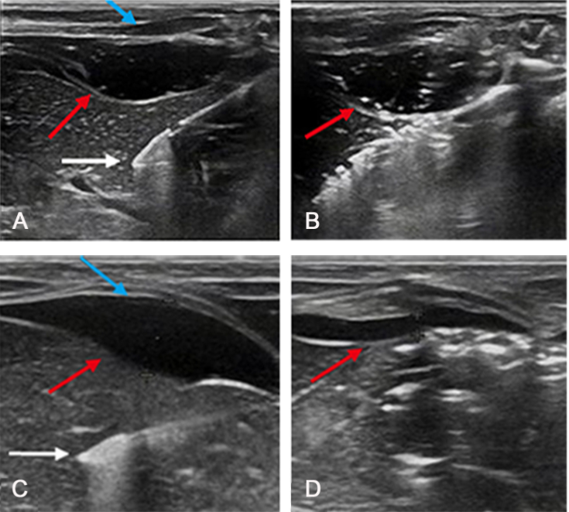
Figure 4 Ultrasonographic view. A: Ultrasonographic view of the placement of the ablation needle (white arrow) with the P407 gel (red arrow) positioned between the diaphragm (blue arrow) and liver; B: Image captured to assess the change in the size of P407 barrier at 3 min during MW ablation. No apparent thinning was observed (red arrow); C: Ultrasound image showing a saline barrier (red arrow) of 5 mm thickness between the diaphragm (blue arrow) and liver and the placement of ablation needle (white arrow); D: Ultrasound image showing a hydrodissection barrier of about 1.3 mm thickness (red arrow) at the end of the ablation procedure.
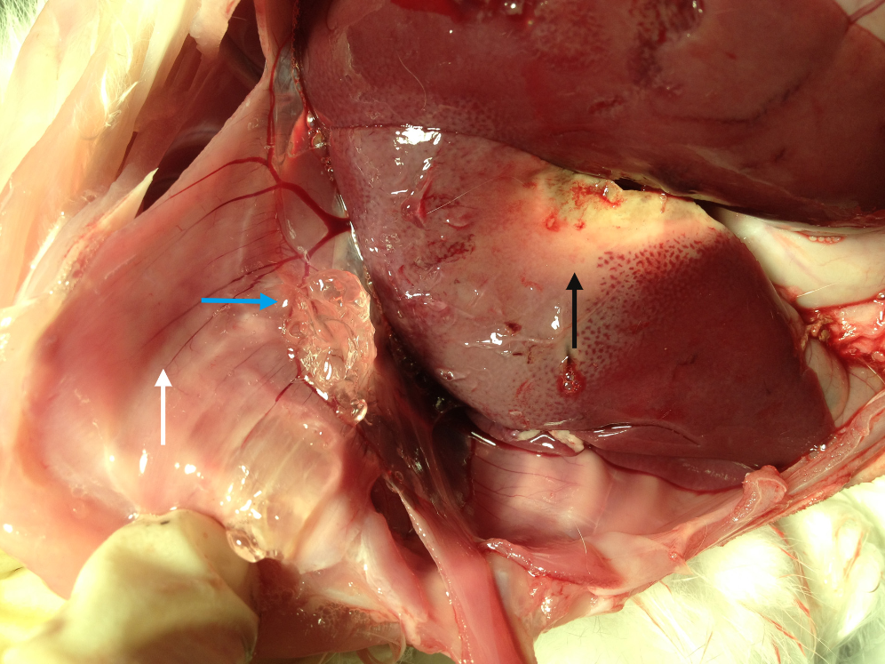
Figure 5 Upon performing a laparotomy, the gel (blue arrow) is seen between the diaphragm (white arrow) and liver lobe (black arrow). Photograph showing a MW ablation zone at the liver lobe (black arrow), yet no thermal injury to the diaphragm can be observed.
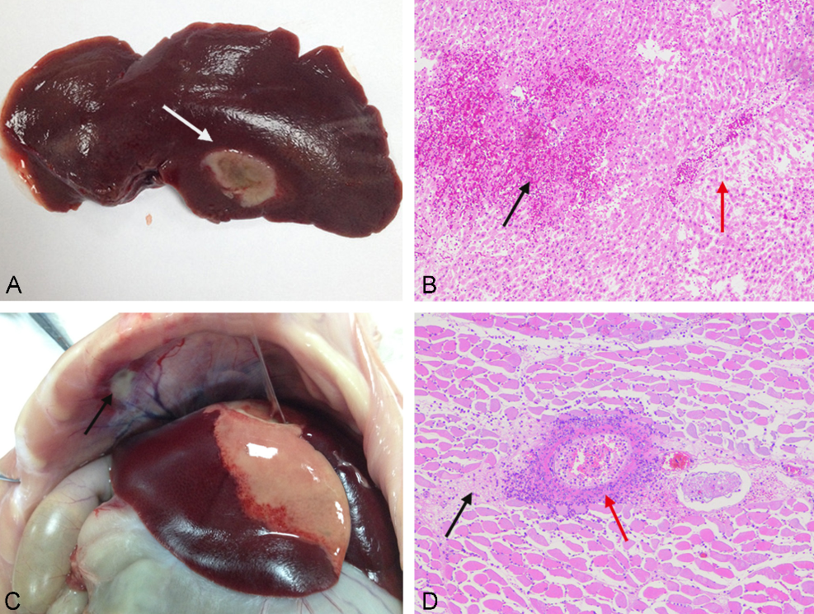
Figure 6 Histopathologic images of thermal lesions of the liver and diaphragm. A: Photograph showing a gray microwave (MW) ablation lesion (white arrow) in the liver lobe; B: Image depicting liver tissue congestion (black arrow), local hepatic sinus expansion, and hepatic cord disappearance due to atrophy and necrosis (red arrow); C: Photograph highlighting a gray-white lesion in the diaphragm (black arrow); D: Image showing a large number of inflammatory cells (red arrow) around the diaphragm and local necrocytosis of the muscular tissue (black arrow).

Table 1 Comparison of thermal injury to the diaphragm among the three groups (n = 8)

Diaphragmatic injury | Gel group  (n = 8) | Saline group  (n = 8) | Control group  (n = 8) | P value
Injury rate | 0 | 5% | 8%
Size (cm) | 0 | 0.9 ± 0.7ª | 1.7 ± 0.3^{b,c} | 0.001¹
Grade (score) | 0 | 0.6 ± 1.1^{d} | 1.8 ± 0.7^{e,f} | 0.001¹
The maximum diameter of thermal injury to the diaphragmatic surface is reported. ¹Statistically significant difference, Mann–Whitney test. ªP = 0.011 vs gel group; ^{b}P = 0.001 vs gel group; ^{c}P = 0.005 vs saline group; ^{d}P = 0.010 vs gel group; ^{e}P = 0.001 vs gel group; ^{f}P = 0.040 vs saline group.

Table 2 Comparison of the Size of microwave Ablation Zones among the three groups (n = 8)

 | Gel group | Saline group | Control group | P value
Dimension 1 (cm) | 2.06 ± 0.38 | 2.14 ± 0.15 | 2.19 ± 0.14
Dimension 2 (cm) | 1.28 ± 0.18 | 1.26 ± 0.22 | 1.38 ± 0.14
Dimension 3 (cm)  Volume (cm³) | 1.24 ± 0.18  1.76 ± 0.66 | 1.23 ± 0.22  1.75 ± 0.54 | 1.34 ± 0.16  2.11 ± 0.43 | 0.353

Table 3 Comparison of hepatic and renal functions before and after microwave ablation (n = 8)

Indicator | Baseline | Postablation |  | P value
 |  | Day 3 | Day 7
ALT (U/L) | 45.38 ± 5.24 | 41.57 ± 3.96 | 41.50 ± 4.14 | 0.166
AST (U/L) | 50.79 ± 3.95 | 47.25 ± 3.28 | 45.63 ± 5.10 | 0.062
BUN (mmol/L) | 7.50 ± 0.90 | 7.14 ± 1.10 | 7.12 ± 1.05 | 0.708
Cr (µmol/L) | 66.24 ± 4.14 | 62.77 ± 7.16 | 62.04 ± 3.39 | 0.244

