Name of Journal: World Journal of Gastroenterology
Manuscript NO: 86090
Manuscript Type: LETTER TO THE EDITOR

Pitfalls and promises of bile duct alternatives: There is plenty of room in the regenerative surgery

Klabukov ID et al. Plenty of room in regenerative surgery

Ilya D Klabukov, Denis S Baranovskii, Peter V Shegay, Andrey D Kaprin

Ilya D Klabukov, Denis S Baranovskii, Department of Regenerative Medicine, National Medical Research Radiological Center of the Ministry of Health of the Russian Federation, Obninsk 249036, Russia

Peter V Shegay, Andrey D Kaprin, Center for Innovative Radiological and Regenerative Technologies, National Medical Research Radiological Center of the Ministry of Health of the Russian Federation, Obninsk 249036, Russia

Author contributions: Klabukov ID designed and performed research, and wrote the letter; Baranovskii DS analyzed data; Baranovskii DS, Shegay PV, and Kaprin AD revised the letter.

Corresponding author: Ilya D Klabukov, MSc, PhD, Director, Department of Regenerative Medicine, National Medical Research Radiological Center, 4 Koroleva Street, Obninsk 249036, Russia. ilya.klabukov@gmail.com

Received: May 31, 2023
Revised: July 11, 2023
Accepted: July 25, 2023
Published online:

Abstract
Current abdominal surgery has several approaches for biliary reconstruction. However, the creation of functional and clinically applicable bile duct substitutes still represents an unmet need. In the paper by Miyazawa and colleagues, approaches to the creation of bile duct alternatives were summarized, and the reasons for the lack of development in this area were explained. The history of bile duct surgery since the nineteenth century was also traced, leading to the conclusion that the use of bioabsorbable materials holds promise for the creation of bile duct substitutes in the future. We suggest three ideas that may stimulate progress in the field of bile duct substitute creation. First, a systematic analysis of the causative factors leading to failure or success in the creation of bile duct substitutes may help to develop more effective approaches. Second, the regeneration of a bile duct is delicately balanced between epithelialization and subsequent submucosal maturation within limited time frames, which may be more apparent when using quantitative models to estimate outcomes. Third, the utilization of the organism’s endogenous regeneration abilities may enhance the creation of bile duct substitutes. We are convinced that an interdisciplinary approach, including quantitative methods, machine learning, and deep retrospective analysis of the causes that led to success and failure in studies on the creation of bile duct substitutes, holds great value. Additionally, more attention should be directed towards the balance of epithelialization and submucosal maturation rates, as well as induced angiogenesis. These ideas deserve further investigation to pave the way for bile duct restoration with physiologically relevant outcomes.

Key Words: Bile duct alternative; Bile duct substitute; Regenerative medicine; Regenerative surgery; Theoretical surgery; Quantitative human physiology

Klabukov ID, Baranovskii DS, Shegay P, Kaprin A. Pitfalls and promises of bile duct alternatives: There is plenty of room in the regenerative surgery. World J Gastroenterol 2023; In press

Core Tip: Progress towards the development of clinically applicable bile duct substitutes can be achieved by applying an interdisciplinary approach. This approach should include the utilization of quantitative mathematical methods, principles of cross-tissue interactions for epithelial and submucosal tissues, as well as deep retrospective data analysis of the causes of success and failure in studies on the creation of bile duct substitutes.

TO THE EDITOR
We read with great interest the paper by Miyazawa et al^{[1]}, who analyzed the drawbacks and advantages of various alternatives for bile ducts. The authors described the current approaches for substituting the bile duct and acknowledged that a suitable graft has not yet been developed due to limited understanding of the mechanisms involved in the healing and regeneration of bile duct tissue. They are convinced that the use of bioabsorbable materials may facilitate the creation of bile duct substitutes in the future.
The authors have fairly mentioned that there is a 100-year history of attempts to create satisfactory bile duct substitutes^{[2]}. However, despite significant advancements in material and life sciences, the development of engineered bile ducts has not been successful. None of the grafts currently available are reliable enough for use in clinical practice. Additionally, due to the variant anatomy of bile ducts (Figure 1A)^{[3,4]}, it is nearly impossible to completely prevent iatrogenic injuries.
One of the most valuable features of the paper by Miyazawa et al^{[1]} is the systematization and analysis of the early attempts to create bile duct alternatives, as application of a systematic approach. The authors traced the history of reconstructive hepatobiliary surgery since the 1880s and discussed many intriguing studies. However, we noticed that the causes of negative or positive results are not usually analyzed or systematized in these studies. For example, in the study by Doillon et al, it was shown that pre-exposure of a venous graft in glycerol improves surgical outcomes^{[5]}, but the fundamental reasons for such improvement were not investigated in this study, as well as in many other papers.
First, we want to emphasize that the analysis of the causes of negative and positive results is just as important as the results themselves. Additionally, studies that describe the unsuccessful use of rubber tubes^{[6]}, polyvinyl chloride^{[7]}, silastic^{[8]}, lyophilized and siliconized dura mater^{[9]} in both humans and animals are valuable as they shed light on the various causes of postoperative surprises. We believe that a systematic analysis of the factors that contribute to failure or success in creating bile duct substitutes could help develop more effective approaches. It is important to note that such a systematic review has never been conducted before.
Secondly, quantitative methods of analysis can also highlight interesting patterns. Specifically, the studies reviewed by the authors revealed the limitations of bile duct epithelialization, which was found to be approximately 3 cm long and not more than 1-2 mm per week^{[10-12]}. Additionally, the required time for submucosal maturation was estimated to be around 6-12 mo^{[10,13]}. These findings provide support for the hypothesis that there are several deterministic mechanisms of bile duct regeneration that have yet to be discovered and completely understood. Furthermore, this suggests that the regeneration of the bile duct is delicately balanced between epithelialization and subsequent submucosal maturation within limited time frames (Figure 1B).
Thirdly, the utilization of the organism’s endogenous regeneration abilities may enhance the effectiveness of bile duct substitutes. Cross-tissue interactions play a crucial role in the process of regeneration, as they determine the normal and pathological proliferation and maturation of tissues^{[14]}. Moreover, in interconnected tissues, not only interactions but also division of labor and competition between different tissues become relevant^{[15]}. This phenomenon has gained significant importance, particularly in relation to the biliary microbiota’s role in inflammatory diseases of the biliary tract^{[16]}. Therefore, the correct surgical approach with incompatible tissues, or the reconstruction of biliary tissues with incompatible materials, may lead to the development of chronic disorders and require additional supplementation. For example, some methods that have been underestimated include the stimulation of not only blood vessel growth but also lymphatic vessel growth in the interstitium, as well as the specific chemotaxis of mesenchymal stromal cells to the site of injury (Figure 1C).
Miyazawa et al^{[1]} have demonstrated a connection between vascularization/angiogenesis and the maturation of biliary glands, as well as the stabilization of inflammation^{[17]}. Considering the recently discovered crucial role played by vascular endothelial growth factor in biliary tree development and cell cycle regulation^{[18]}, inducing angiogenesis could be a promising avenue for future research. It is worth noting that the use of grafts may yield varying outcomes, mainly due to differences in their structure, immunogenicity, and vascular density, regardless of whether they are autologous or allogeneic. Therefore, the mechanical (rheological) and cyto compatible properties of the substitute material are important (Figure 1D).
The functional and biomimetic properties of the bile duct substitute are expected to promote the growth of resident cells and facilitate tissue regeneration^{[19]}. However, significant advancements in regenerative medicine necessitate innovative ideas from interdisciplinary fields. The application of mathematical logic to human physiology has the potential to accelerate progress in tissue engineering^{[20]}. For example, the phase space method, well known in physics, can provide new insights into physiological relevance in bioengineering^{[21]}. This promising and novel concept relies on the application of mathematical logic and machine learning to forecast surgical outcomes, commonly referred to as theoretical surgery^{[22]}.
We assume that the views of the surgeon and the biophysicist on the same facts and problems differ, particularly in terms of abstract concepts. This highlights the necessity for collaborative work among specialists from various fields (Table 1). We firmly believe that the integration of quantitative methods and retrospective analysis in bioengineering will open up new avenues for developing models of inter-tissue interaction, ultimately yielding groundbreaking outcomes in bile duct engineering.

REFERENCES
1 Miyazawa M, Aikawa M, Takashima J, Kobayashi H, Ohnishi S, Ikada Y. Pitfalls and promises of bile duct alternatives: A narrative review. World J Gastroenterol 2022; 28: 5707-5722 [PMID: 36338889 DOI: 10.3748/wjg.v28.i39.5707]
2 Ahrendt SA, Pitt HA. A history of the bilioenteric anastomosis. Arch Surg 1990; 125: 1493-1500 [PMID: 2241564 DOI: 10.1001/archsurg.1990.01410230087016]
3 Kowalczyk KA, Majewski A. Analysis of surgical errors associated with anatomical variations clinically relevant in general surgery. Review of the literature. Transl Res Anat 2021; 23: 100107 [DOI: 10.1016/j.tria.2020.100107]
4 Żytkowski A, Tubbs RS, Iwanaga J, Clarke E, Polguj M, Wysiadecki G. Anatomical normality and variability: historical perspective and methodological considerations. Transl Res Anat 2021; 23: 100105 [DOI: 10.1016/j.tria.2020.100105]
5 Doillon C, Dureau G, Clendinnen G, Eloy R. Effects of glycerol pretreatment upon biliary or venous grafts in bile duct replacement. Surg Gynecol Obstet 1981; 152: 613-620 [PMID: 7221844]
6 Sullivan AG. Reconstruction of the Bile Ducts. JAMA 1909; 53: 774-777 [DOI: 10.1001/jama.1909.92550100001001f]
7 Apalakis A. An experimental evaluation of the types of material used for bile duct drainage tubes. Br J Surg 1976; 63: 440-445 [PMID: 1276671 DOI: 10.1002/bjs.1800630608]
8 Cantor MO. Silicone rubber t tubes for common duct drainage. Am J Surg 1964; 107: 666-668 [PMID: 14136357 DOI: 10.1016/0002-9610(64)90341-1]
9 Gagni G, Favaretto P, Luzzani A, Ferrini S, Marchi F, Ciprian V, Gadioli P, Mastropasqua D, Dal Cortivo G, Sovran C. [Choledochal prostheses with lyophilized and siliconed dura mater. Experimental research; preliminary results]. Minerva Chir 1979; 34: 1209-1216 [PMID: 548824]
10 Montalvo-Javé EE, Mendoza Barrera GE, Valderrama Treviño AI, Piña Barba MC, Montalvo-Arenas C, Rojas Mendoza F, León Mancilla B, García Pineda MA, Jaime Limón Á, Albores Saavedra J, Tapia-Jurado J. Absorbable bioprosthesis for the treatment of bile duct injury in an experimental model. Int J Surg 2015; 20: 163-169 [PMID: 26166740 DOI: 10.1016/j.ijsu.2015.06.074]
11 Heistermann HP, Palmes D, Stratmann U, Hohlbach G, Hierlemann H, Langer M, Spiegel HU. A new technique for reconstruction of the common bile duct by an autologous vein graft and a biodegradable endoluminal stent. J Invest Surg 2006; 19: 57-60 [PMID: 16546930 DOI: 10.1080/08941930500444560]
12 Palmes D, Wolters H, Spiegel HU, M Ller E, Minin E, Heistermann HP. Morphological changes during creation of a neo-bile duct using a vein and a biodegradable endoluminal stent. J Invest Surg 2009; 22: 435-444 [PMID: 20001814 DOI: 10.3109/08941930903410791]
13 Lahey FH, Pyrtek LJ. Experience with the operative management of 280 strictures of the bile ducts, with a description of a new method and a complete follow-up study of the end results in 229 of the cases. Surg Gynecol Obstet 1950; 91: 25-56 [PMID: 15442823]
14 Cote LE, Feldman JL. Won't You be My Neighbor: How Epithelial Cells Connect Together to Build Global Tissue Polarity. Front Cell Dev Biol 2022; 10: 887107 [PMID: 35800889 DOI: 10.3389/fcell.2022.887107]
15 Adler M, Moriel N, Goeva A, Avraham-Davidi I, Mages S, Adams TS, Kaminski N, Macosko EZ, Regev A, Medzhitov R, Nitzan M. Emergence of division of labor in tissues through cell interactions and spatial cues. Cell Rep 2023; 42: 112412 [PMID: 37086403 DOI: 10.1016/j.celrep.2023.112412]
16 Liu Y, Sun LY, Zhu ZJ, Wei L, Qu W, Zeng ZG. Bile microbiota: new insights into biliary complications in liver transplant recipients. Ann Transl Med 2020; 8: 354 [PMID: 32355798 DOI: 10.21037/atm.2020.02.60]
17 Shang H, Zeng JP, Wang SY, Xiao Y, Yang JH, Yu SQ, Liu XC, Jiang N, Shi XL, Jin S. Extrahepatic bile duct reconstruction in pigs with heterogenous animal-derived artificial bile ducts: A preliminary experience. World J Gastroenterol 2020; 26: 7312-7324 [PMID: 33362386 DOI: 10.3748/wjg.v26.i46.7312]
18 Mariotti V, Fiorotto R, Cadamuro M, Fabris L, Strazzabosco M. New insights on the role of vascular endothelial growth factor in biliary pathophysiology. JHEP Rep 2021; 3: 100251 [PMID: 34151244 DOI: 10.1016/j.jhepr.2021.100251]
19 Sun Q, Shen Z, Liang X, He Y, Kong D, Midgley AC, Wang K. Progress and Current Limitations of Materials for Artificial Bile Duct Engineering. Materials (Basel) 2021; 14 [PMID: 34885623 DOI: 10.3390/ma14237468]
20 Klabukov ID, Krasilnikova OA, Baranovskii DS. Quantitative human physiology: An introduction guide for advanced tissue engineering. Biotechnol J 2021: e2100481 [PMID: 34605205 DOI: 10.1002/biot.202100481]
21 Klabukov I, Tenchurin T, Shepelev A, Baranovskii D, Mamagulashvili V, Dyuzheva T, Krasilnikova O, Balyasin M, Lyundup A, Krasheninnikov M, Sulina Y, Gomzyak V, Krasheninnikov S, Buzin A, Zayratyants G, Yakimova A, Demchenko A, Ivanov S, Shegay P, Kaprin A, Chvalun S. Biomechanical Behaviors and Degradation Properties of Multilayered Polymer Scaffolds: The Phase Space Method for Bile Duct Design and Bioengineering. Biomedicines 2023; 11 [PMID: 36979723 DOI: 10.3390/biomedicines11030745]
22 Lorenz W, Rothmund M. Theoretical surgery: a new specialty in operative medicine. World J Surg 1989; 13: 292-299 [PMID: 2662629 DOI: 10.1007/BF01659037]

Footnotes
Conflict-of-interest statement: All the authors report no relevant conflicts of interest for this article.

Open-Access: This article is an open-access article that was selected by an in-house editor and fully peer-reviewed by external reviewers. It is distributed in accordance with the Creative Commons Attribution NonCommercial (CC BY-NC 4.0) license, which permits others to distribute, remix, adapt, build upon this work non-commercially, and license their derivative works on different terms, provided the original work is properly cited and the use is non-commercial. See: https://creativecommons.org/Licenses/by-nc/4.0/

Provenance and peer review: Unsolicited article; Externally peer reviewed.
Peer-review model: Single blind
Corresponding Author’s Membership in Professional Societies: Tissue Engineering and Regenerative Medicine International Society, 6416.

Peer-review started: May 31, 2023
First decision: July 8, 2023
Article in press:

Specialty type: Gastroenterology and hepatology
Country/Territory of origin: Russia
Peer-review report’s scientific quality classification
Grade A (Excellent): 0
Grade B (Very good): B
Grade C (Good): C
Grade D (Fair): 0
Grade E (Poor): 0

P-Reviewer: Midgley AC, China; Wang G, China S-Editor: Wang JJ L-Editor: A P-Editor: Wang JJ

Figure Legends
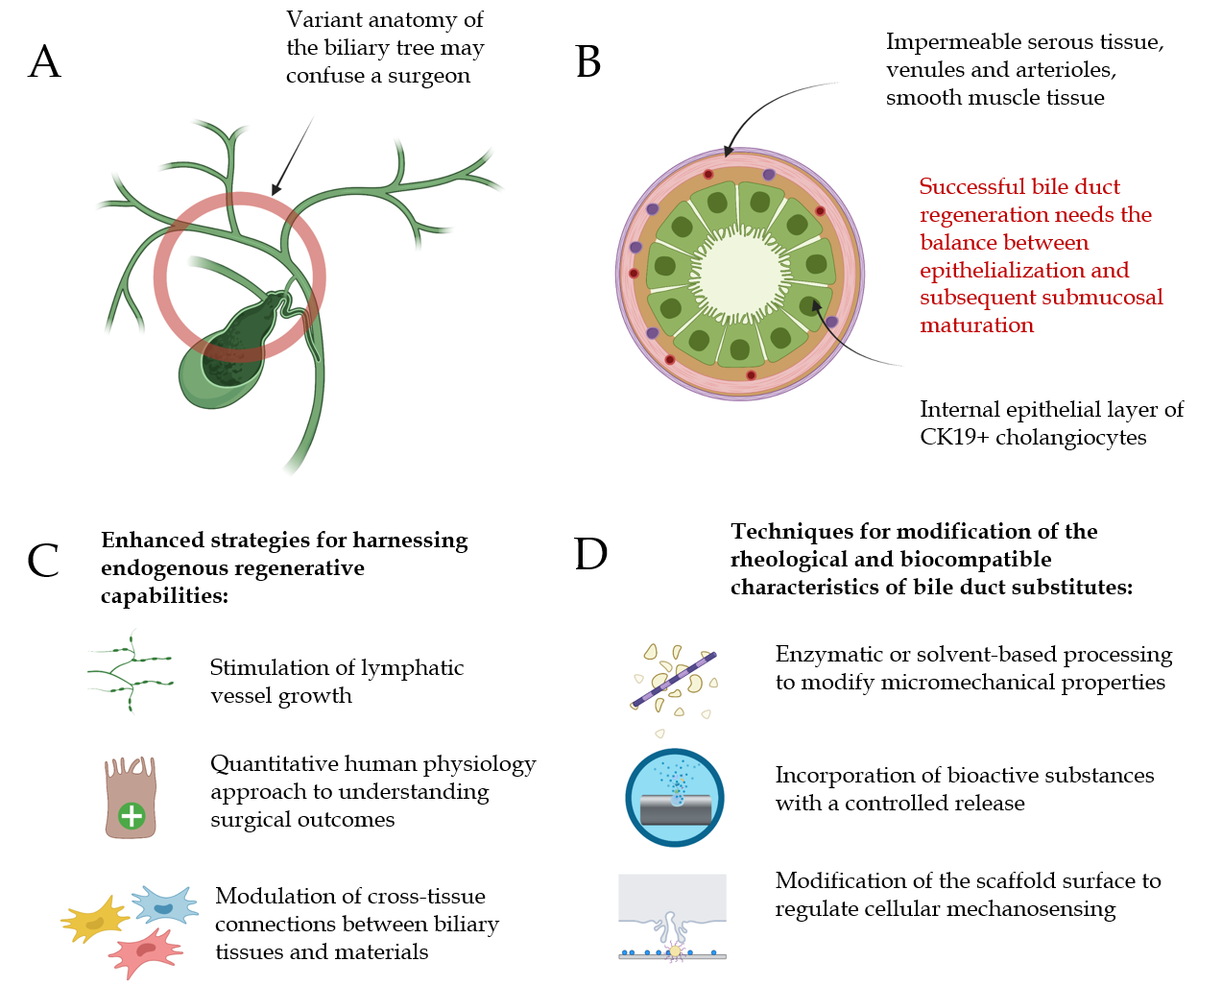
Figure 1 Bioengineer’s Bile duct wallet cards. A: Variant anatomy of the biliary tree may confuse the surgeon; B: Successful bile duct regeneration needs the balance between epithelialization and subsequent submucosal maturation; C: Advanced techniques for the use of endogenous regeneration abilities; D: Techniques for modification of the rheological and biocompatible characteristics of bile duct substitutes. Created with BioRender.com.

Table 1 Differences in understanding of the clinical evidences between a surgeon and a physiologist
Clinical evidences | Understanding of a surgeon | Understanding of a physiologist
There are many negative results of the use of materials for bile duct repair | Materials associated with complications are not suitable for clinical practice | The causes of failure are what we need to determine. Can we cluster these causes to understand the underlying mechanisms? If we only consider successful cases, we will commit survival bias and be unable to determine the reasons for successful outcomes
Bile duct epithelialization never exceed the following limits: About 3 cm long and growth not more than 1-2 mm per week | We must avoid implanting grafts (autografts) longer than 3 cm. This is an interesting fact. My experience supports these values, so I am aware of the potential outcomes that may be achieved after a surgical procedure | The presence of stable values indicates the conservatism of the underlying regenerative mechanisms, which are not dependent on the surgeon’s skills or the quality of the materials
The normal human bile is not sterile and contains both living cholangiocytes and normal biliary microbiota | These are interesting facts, but we still lack the necessary tools to support endogenous regeneration in routine clinical practice. The application of cells remains unproven | The presence of living cells in bile may support the existence of unknown ways for the migration of bile duct cells. These methods need to be discovered and applied for bile duct regeneration

