Name of Journal: World Journal of Cardiology
ESPS Manuscript NO: 21778
Manuscript Type: Clinical Trials Study

Clinical outcomes of combined flow-pressure drop measurements using newly developed diagnostic endpoint: Pressure drop coefficient in patients with coronary artery dysfunction

Effat M et al. Improved interventional outcomes using pressure drop coefficient

Mohamed Effat, Srikara Viswanath Peelukhana, Rupak K Banerjee

Mohamed Effat, Division of Cardiovascular Diseases, University of Cincinnati Medical Center, Veteran Affairs Medical Center, Cincinnati, OH 45221, United States

Srikara Viswanath Peelukhana, Department of Mechanical and Materials Engineering, University of Cincinnati, Veteran Affairs Medical Center, Cincinnati, OH 45221, United States

Rupak K Banerjee, Department of Mechanical and Materials Engineering, Veteran Affairs Medical Center, Cincinnati, OH 45221, United States

Author contributions: Effat M, Peelukhana SV, Banerjee RK, designed the research; Effat M performed the interventions; Banerjee RK assimilated the data; Peelukhana SV performed the data analysis; Effat M, Banerjee RK and Peelukhana SV wrote the paper.

Supported by VA Merit Review Grant (I01CX000342-01), Department of Veteran Affairs.

Institutional review board statement: The study protocol was approved by the institutional review board at University of Cincinnati (UC) and the research and development committee at the Cincinnati Veteran Affairs Medical Center (CVAMC).

Clinical trial registration statement: The study was registered with Clinicaltrials.gov. The registration identification number is NCT01719016.

Informed consent statement: All study participants, provided informed written consent prior to the study enrolment.

Conflict-of-interest statement: The authors report no financial relationships or conflicts of interest regarding the content herein.

Data sharing statement: Technical details and statistical methods are available with the corresponding author at rupak.banerjee@uc.edu.

Open-Access: This article is an open-access article which selected by an in-house editor and fully peer-reviewed by external reviewers. It distributed in accordance with the Creative Commons Attribution Non Commercial (CC BY-NC 4.0) license, which permits others to distribute, remix, adapt, build upon this work non-commercially, and license their derivative works on different terms, provided the original work is properly cited and the use is non-commercial. See: http://creativecommons.org/licenses/by-nc/4.0/

Correspondence to: Rupak K Banerjee, PhD, PE, Department of Mechanical and Materials Engineering, Veteran Affairs Medical Center, 598 Rhodes Hall, PO Box 0072, Cincinnati, OH 45221, United States. rupak.banerjee@uc.edu
Telephone: +1-513-5562124
Fax: +1-513-5563390

Received: July 31, 2015
Peer-review started: August 1, 2015
First decision: September 29, 2015
Revised: November 2, 2015
Accepted: December 29, 2015
Article in press:
Published online:

Abstract
AIM: To combine pressure and flow parameter, pressure drop coefficient (CDP) will results in better clinical outcomes in comparison to the fractional flow reserve (FFR) group.

METHODS: To test this hypothesis, a comparison was made between the FFR < 0.75 and CDP > 27.9 groups in this study, for the major adverse cardiac events [major adverse cardiac events (MACE): Primary outcome] and patients’ quality of life (secondary outcome). Further, a comparison was also made between the survival curves for the FFR < 0.75 and CDP > 27.9 groups. Two-tailed χ² test proportions were performed for the comparison of primary and secondary outcomes. Kaplan-Meier survival analysis was performed to compare the survival curves of FFR < 0.75 and CDP > 27.9 groups (MedcalcV10.2, Mariakerke, Belgium). Results were considered statistically significant for P < 0.05.

RESULTS: The primary outcomes (%MACE) in the FFR < 0.75 group (20%, 4 out of 20) was not statistically different (P = 0.24) from the %MACE occurring in CDP > 27.9 group (8.57%, 2 out of 35). Noteworthy is the reduction in the %MACE in the CDP >27.9 group, in comparison to the FFR < 0.75 group. Further, the secondary outcomes were statistically insignificant between the FFR < 0.75 and CDP > 27.9 groups. Survival analysis results suggest that the survival time for the CDP > 27.9 group (n = 35) is significantly higher (P = 0.048) in comparison to the survival time for the FFR < 0.75 group (n = 20). The results remained similar for a FFR = 0.80 cut-off.

CONCLUSION: Based on the above, CDP could prove to be a better diagnostic end-point for clinical revascularization decision-making in the cardiac catheterization laboratories.

Key words: Pressure drop coefficient; Interventional cardiology; Intermediate coronary stenosis

© The Author(s) 2016. Published by Baishideng Publishing Group Inc. All rights reserved.

Core tip: In the case of intermediate coronary stenosis, fractional flow reserve (FFR) is traditionally used as a functional end-point for interventional decision making in a cardiac catheterization laboratory. In this outcomes study, it was purported that critical decision point could prove to be a better clinical end-point for decision-making in comparison to the FFR.

Effat M, Peelukhana SV, Banerjee RK. Clinical outcomes of combined flow-pressure drop measurements using newly developed diagnostic endpoint: Pressure drop coefficient in patients with coronary artery dysfunction. World J Cardiol 2016; In press

INTRODUCTION
Accurate assessment of the severity of intermediate coronary stenosis is a clinical challenge to the interventional cardiologists. Quantitative anatomic tools have been proposed to address the issue but their relevance is still a matter of debate. Recently, the assessment of functional coronary lesion severity using sensor-equipped guidewires has emerged as a standard diagnostic modality to provide objective evidence of myocardial ischemia during cardiac catheterization^{[1,2]}. Coronary diagnostic indices, fractional flow reserve (FFR; pressure derived), and coronary flow reserve (CFR; flow derived) showed a high agreement with non-invasive stress testing^{[3-5]}.
FFR (ratio of pressure distal to the stenosis to the pressure proximal to the stenosis) is the current gold standard for evaluating the functional significance of an epicardial stenosis^{[6-8]}. FFR has a lower bound of “0”, representing complete vessel obstruction and an upper bound of “1“ represented no obstruction and normal flow. Based on extensive clinical outcomes trials, a cut-off value of 0.75^{[7]} for FFR was shown to indicate hemodynamic significance of coronary stenosis in the presence of single vessel disease, and 0.80 for multi-vessel disease^{[9-13]}. The limitations of FFR include the assumption of zero central venous pressure, and its dependence on achieving maximal hyperemia. Failure to achieve peak hyperemia may result in not achieving minimal constant microvascular resistance, leading to under estimation of pressure drop and over estimation of FFR across a stenosis^{[14]}.
The flow derived parameter CFR (ratio of flow at hyperemia to flow at rest) was found to have excellent agreement with noninvasive stress testing at a cut-off value of 2.0^{[3]}. An abnormal CFR (< 2.0) corresponded to reversible myocardial perfusion defects with high sensitivity and specificity^{[3]}. It should be noted that CFR provides the combined effect of epicardial stenosis and microvascular dysfunction, but cannot differentiate between the two. Hence, evaluation of epicardial coronary stenosis may not be accurate in the setting of microvascular dysfunction.
FFR and CFR are based on either intra coronary pressure or flow. Therefore, they can both be confounded by the presence of microvascular disease and cannot differentiate between hemodynamic status of the epicardial stenosis and microvasculature^{[15,16]}. To overcome these limitations of FFR and CFR, combined pressure and velocity parameters were proposed. However, these parameters were defined for detection of either epicardial stenosis, namely, hyperemic stenosis resistance index (HSR; ratio of pressure drop across the stenosis to the distal velocity during hyperemia)^{[4]}; or for the detection of microvascular dysfunction, namely, hyperemic microvascular resistance index (HMR; ratio of mean distal pressure and velocity during hyperemia)^{[17]}.
For simultaneous detection of epicardial stenosis and microvascular dysfunction using a single diagnostic parameter, we recently introduced the functional index, the pressure drop coefficient CDP, the ratio of trans-stenotic pressure drop, Δp, to distal dynamic pressure, (½ × blood density × APV²), where APV (average peak flow velocity) is measured under maximal hyperemia^{[18]}. The pressure drop coefficient (CDP) was validated in in vitro^{[18,19]}, and in vivo animal studies^{[18-24]} to differentiate between epicardial stenosis and microvascular dysfunction. Further, in a recent pilot clinical study^{[25]} CDP has been shown in a patient population to distinguish between degrees of stenosis severity. Further, for making interventional decisions, CDP > 27.9^{[26,27]} was proposed as an indicator of significant epicardial stenosis, corresponding to a FFR < 0.75 cut-off in a single vessel.
However, for the CDP to be included into regular clinical practice, the cut-off value CDP > 27.9 need to be associated with positive clinical outcomes. Hence, the objective of this pilot study is to compare the outcomes between the CDP > 27.9 and the clinical gold standard, FFR < 0.75. The hypothesis is that the combined pressure and flow parameter, CDP will results in better clinical outcomes in comparison to the FFR group. To test this hypothesis, a comparison was made between the FFR < 0.75 and CDP > 27.9 groups in this study, for the major adverse cardiac events [major adverse cardiac events (MACE): Primary outcome] and patients’ condition (secondary outcome). Further, a comparison was also made between the survival curves for the FFR < 0.75 and CDP > 27.9 groups.

MATERIALs AND METHODS
Study patients
The protocol^{[25]} was approved by the institutional review board at University of Cincinnati (UC) and Cincinnati Veteran Affairs Medical Center (CVAMC), and informed consent was obtained from all the participants. Patients who underwent exercise testing and myocardial perfusion scans were consented based on the inclusion and exclusion criteria, as explained below. The study was registered with Clinicaltrials.gov, with the identifier NCT01719016.
The study population consisted of 86 patients enrolled at the UC and CVAMC. Table 1 summarizes the clinical characteristics of the enrolled patients. The inclusion criteria for the study were: (1) chest pain; (2) abnormal stress test; (3) an angiographically detectable stenosis of moderate severity (defined as approximately 50% by visual examination) in a major coronary artery; and (4) left ventricular ejection fraction > 25%. Patients were excluded if they had: (1) left ventricular ejection fraction < 25%; (2) non-dialysis dependent chronic kidney disease with baseline serum creatinine greater than 2.5 gm/dL; (3) history of type-II heparin induced thrombocytopenia; (4) ostial lesions, serial stenoses, significant left main stenosis; e) significant co-morbid conditions that would make coronary angiography prohibitive and contraindicated; and (5) pregnant women.

Cardiac catheterization and hemodynamic measurement
Using standard-of-care catheterization techniques, vascular access was through the femoral approach; a 5-to-6-French catheter was introduced into the femoral sheath and advanced into the ostium of the coronary artery. Unfractionated heparin was administered using a weight-based protocol. Aortic pressure was measured through the guiding catheter. Intra coronary pressure and flow measurements were obtained across the lesions either by using a 0.014-inch-diameter guidewire (Combowire, Volcano Corporation, California, United States) that combines a standard Doppler sensor at the tip and a standard pressure sensor 1.5 cm proximal to the tip or by 0.014-inch-diameter pressure and Doppler guide wires separately. The Combowire (or pressure wire) was set at zero, calibrated, advanced through the guiding catheter and normalized to aortic pressure before insertion into the target vessel. The wire was positioned distal to the stenosis in the target vessel, with the pressure transducer at least 30 mm distal to lesion. The position of the Doppler sensor was manipulated until an optimal and stable blood velocity signal was obtained. Adenosine was then infused intravenously (140 µg/kg per min)^{[25]} or via intracoronary (20 µg for the right coronary artery and 40 µg for the left coronary artery)^{[28]} to induce maximal coronary blood flow. Aortic pressure (P_{a}), coronary pressure (P_{d}) and average peak velocity (APV) distal to the stenosis were recorded. All signals were continuously recorded at rest and throughout induction and decline of maximum hyperemia.

CDP calculation
Percent diameter stenosis, reference diameter, and minimal lumen diameter were obtained by quantitative analysis of coronary angiograms, with the use of a validated automated contour detection algorithm (Centricity Cardiology, GE Healthcare). CDP^{[18,20-22,24,27]} is defined as the ratio of trans-stenotic pressure drop () to distal dynamic pressure. The product of blood density (ρ), the square of average peak flow velocity (APV) and a constant value of 0.5, i.e., 0.5 × ρ × APV², is calculated to obtain distal dynamic pressure, measured at hyperemia. Blood density, ρ does not change significantly at hyperemia, and thus can be assumed to have a constant value (1.05 gm/cm³)^{[20, 29]}.
(a dimensionless parameter; where ), p_{a} and p_{d} are mean pressures measured proximal and distal to the stenosis at hyperemia, respectively.

Patient follow-up and study endpoints
All the patients were followed up through either chart review, a phone call, and/or a questionnaire. The period of follow-up was a minimum of 1 year. Through the follow-up, the primary outcomes, consisting of MACE, were determined. MACE was defined as the composite of all-cause mortality, myocardial infarction (MI), and repeat revascularization (Table 2).
The secondary outcomes consisting of patients’ condition were determined through follow-up questionnaire based on 5 questions (Table 2). Q1: How has your health condition been after procedure? Q2: Have you been diagnosed of heart attack after procedure? Q3: Have you been experiencing chest pain requiring you to take nitroglycerin, since you had the procedure? Q4: Did you have any interventional procedure done after cardiac catheterization? Q5: Have you been re-hospitalized for cardiac-condition after this cardiac procedure? The answers to these questions consisted of the secondary outcomes.

Statistical analysis
The authors had prior biostatistics background, as apparent from previous publications^{[13,14,17-19]}. Any patient lost to follow-up was counted as censored data. The data was segregated based on the cut-off value of FFR < 0.75 and FFR < 0.80 for significant epicardial stenosis. Similarly, for corresponding significant epicardial stenosis, CDP > 27.9 and CDP > 25.4^{[26,27]} were used as the cut-off value. For the primary outcome analysis, the %MACE in the FFR < 0.75 (n = 20) group were quantified and compared against the %MACE in corresponding CDP > 27.9 (n = 39) group. Similar comparisons were also performed between the %MACE in the FFR > 0.75 (n = 66) and CD P < 27.9 (n = 47) groups. The same analysis were also performed for FFR = 0.80 and CD P = 25.4 groups.
For the secondary outcome analysis, the responses to the five questions (please see above) were quantified as percentages and compared between the FFR and CDP groups. For Q1, the number of patients answering “not feeling well” was counted. For Q3, Q4, and Q5, any patient answering “Yes” was counted. Q2 was excluded from presentation since there were no patients diagnosed with heart attack. All the comparisons were performed using a two-tailed χ² test with Yates correction. As a double check, comparisons were also performed using Fisher’s exact test.
Further, survival analysis was also performed to assess the performance of CDP against FFR. The time between the index procedure and the time when the patient was last contacted (last follow-up) was recorded. Any patient who reached the primary outcome (%MACE) was counted as positive. Any patient lost to follow-up or who didn’t reach the outcome was entered as censored data. Based on this, Kaplan-Meier survival analysis was performed. A comparison between the survival curves for the two groups was also performed using log-rank test. All the analyses were performed using MedCalc (V10.2, Mariakerke, Belgium). Results were considered statistically significant for P < 0.05.

RESULTS
In order to test the effectiveness of CDP cut-off (CDP > 27.9 and CDP > 25.4) as a guide for intervention decisions, the primary and secondary outcomes in patients were quantified and compared against the FFR cut-off (FFR < 0.75 and FFR < 0.80). In addition, survival curves were also generated and compared between the groups. These results are summarized below.

Primary outcome comparison between CDP and FFR
A comparison of the %MACE between the FFR < 0.75 and CDP > 27.9 groups, and FFR > 0.75 and CD P < 27.9 groups is summarized in Figure 1A. The %MACE in the FFR < 0.75 group (20%, 4 out of 20) was not statistically different (P = 0.24) from the %MACE occurring in CDP > 27.9 group (8.57%, 2 out of 35). Noteworthy is the reduction in the %MACE in the CDP > 27.9 group, in comparison to the FFR < 0.75 group. If a CDP-based strategy were to be implemented, the %MACE in this group would be lower (8.57%) in comparison to the FFR-guided strategy group (%MACE = 20%).
Similarly, the %MACE in FFR > 0.75 group was 6.06% (4 out of 66). This value was statistically insignificant (P = 0.45) in comparison to a %MACE in the CD P < 27.9 group (11.76%, 6 out of 51).
Similar comparisons for FFR = 0.80 and CD P = 25.4 groups are presented in Figure 1B. The %MACE in the FFR < 0.80 group (20%, 7 out of 35) was not statistically different (P = 0.23) from the %MACE occurring in CDP > 25.4 group (7.69%, 3 out of 39).
Similarly, the %MACE in FFR > 0.80 group was 1.96% (1 out of 51). This value was statistically insignificant (P = 0.16) in comparison to a %MACE in the CD P < 25.4 group (10.64%, 5 out of 47).

Secondary outcome comparison between CDP and FFR
The secondary outcomes, quantified through responses of the patients through follow-up questionnaire were also compared between the FFR < 0.75 and CDP > 27.9 groups, and also between the FFR > 0.75 and CD P < 27.9 groups. These results are summarized in Figures 2A and 2B, respectively.
Figure 2A summarizes the comparison between the FFR < 0.75 and CDP > 27.9 groups. In the FFR < 0.75 group patients not feeling well (Q1: 35%, 7/20) was statistically insignificant (P = 0.36) in comparison to the slightly lower % of patients not feeling well in the CDP > 27.9 group (20%, 7/35). Similarly, the % of patients answering “Yes” to Q3, Q4, Q5 in the FFR < 0.75 group (Q3: 30%, 6/20; Q4: 25%, 5/20; Q5: 10%, 2/20) was not statistically different (Figure 2A) in comparison to the CDP > 27.9 group (Q3: 20%, 7/35; Q4: 11.43%, 4/35; Q5: 11.43%, 4/35).
In the FFR > 0.75 group (Figure 2B) patients not feeling well (Q1: 1.51%, 1/66) was statistically insignificant (P = 0.59) in comparison to the % of patients not feeling well in the CD P < 27.9 group (1.96%, 1/51). Similarly, the % of patients answering “Yes” to Q3, Q4, Q5 in the FFR < 0.75 group (Q3: 9.09%, 6/66; Q4: 4.54%, 3/66; Q5: 7.58%, 5/66) was not statistically different (Figure 2B) in comparison to the CD P < 27.9 group (Q3: 9.8%, 5/51; Q4: 7.84%, 4/51; Q5: 5.88%, 3/51).
Figure 2C summarizes the comparison between the FFR < 0.80 and CDP > 25.4 groups. In the FFR < 0.80 group patients not feeling well (Q1: 20%, 7/35) was statistically insignificant (P = 0.94) in comparison to the CDP > 25.4 group (17.95%, 7/39). Similarly, the % of patients answering “Yes” to Q3, Q4, Q5 in the FFR < 0.75 group (Q3: 17.14%, 6/35; Q4: 14.29%, 5/35; Q5: 5.71%, 2/35) was not statistically different (Figure 2A) in comparison to the CDP > 27.9 group (Q3: 17.95%, 7/39; Q4: 10.26%, 4/39; Q5: 10.26%, 4/39).
In the FFR > 0.80 group (Figure 2D) patients not feeling well (Q1: 1.96%, 1/51) was statistically insignificant (P = 0.47) in comparison to the % of patients not feeling well in the CD P < 25.4 group (2.13%, 1/47). Similarly, the % of patients answering “Yes” to Q3, Q4, Q5 in the FFR < 0.80 group (Q3: 11.76%, 6/51; Q4: 5.88%, 3/51; Q5: 9.80%, 5/51) was not statistically different (Figure 2D) in comparison to the CD P < 25.4 group (Q3: 10.64%, 5/47; Q4: 8.51%, 4/47; Q5: 6.38%, 3/47).

Survival analysis
The Kaplan-Meier survival curves for the FFR < 0.75 and CDP > 27.9 groups were presented in Figure 3A. The results suggest that the survival time for the CDP > 27.9 group (n = 35) is significant (P = 0.048) in comparison to the survival time for the FFR < 0.75 group (n = 20). Further, the hazard ratio between the two groups is 0.22 (95% CI: 0.06 to 1.24). This means that the survival expectancy in the FFR < 0.75 group is 0.22 times the survival probability in the CDP > 27.9 group. Similar results for FFR < 0.80 and CDP > 25.4 groups are presented in Figure 3B. The survival time for the CDP > 25.4 group (n = 39) is moderately significant (P = 0.066) in comparison to the survival time for the FFR < 0.80 group (n = 35).
The Kaplan-Meier survival curves for the FFR > 0.75 and CD P < 27.9 groups were presented in Figure 4A. The results suggest that the survival time for the CD P < 27.9 group (n = 51) is not significantly (P = 0.29) in comparison to the survival time for the FFR > 0.75 group (n = 66). Further, the hazard ratio between the two groups is 1.95 (95%CI: 0.56 to 6.82). Similar results for FFR > 0.80 and CD P < 25.4 groups are presented in Figure 4B. The survival time for the CD P < 25.4 group (n = 47) is not significant (P = 0.094) in comparison to the survival time for the FFR > 0.80 group (n = 51).

DISCUSSION
The conceptual advantages of using a single physiological parameter that incorporates both pressure and flow measurements is well supported by ample evidence. However, the question remains whether this consideration is relevant in a clinical setting. The results of this study suggest that if a clinical decision making strategy is based on CDP instead of FFR, there would be a significant increase in event free survival. Additionally, comparing patients who had CDP > 27.9 to FFR < 0.75 and CDP > 25.4 with FFR < 0.80 resulted in a trend towards reduced MACE and improved quality of life. Similar results were observed for FFR = 0.80 cut-off, with a corresponding CDP cut-off of 25.4. It can be purported that the difference in clinical outcomes seen in this study reflects an enhanced accuracy in predicting ischemia.
CDP, defined as coronary trans-lesional pressure drop (∆p) to distal dynamic pressure (0.5 × ρ × APV²) uses both pressure and flow measurements to assess stenosis severity. Additionally, it has the advantage of being a non-dimensional parameter based on fundamental fluid dynamics principles. It has been shown that coronary pressure drop (∆p) – flow relationship in a stenosed vessel is non-linear and can be described by ∆ P = aV + BV², where a and b are stenosis specific constants and V is the velocity. The ∆p includes (a) viscous loss, a linear relationship of ∆p and flow (or velocity), resulting from the friction between the blood flow and the lumen of the stenosis wall; and (b) loss due to the momentum change, a quadratic relationship of ∆p and velocity, caused by the area change due to the stenosis.
FFR and CFR are affected in opposite directions by microvascular resistance, and assessment of ischemia by measuring FFR and CFR in the same coronary vasculature may yield discordant results in up to 40% of the cases^{[30]}. This can be explained by the presence of diffuse epicardial disease which would lower CFR without significant impact on FFR. Conversely, a well preserved microvascular auto regulatory function may maintain CFR above the ischemic threshold while FFR is abnormal. In the presence of such conditions as diffuse lesion or concomitant microvascular disease, the complex interaction between pressure and flow might not be sufficiently explained by FFR or CFR alone, as FFR is a pressure-derived parameter and CFR is a flow-derived parameter. On the other hand, CDP combines both the pressure and flow in a single parameter and thus can distinguish between both epicardial and microvascular dysfunction^{[22,26]}.
As previously mentioned, both FFR and CFR depend critically on the achievement of maximal hyperemia. Failure to achieve peak hyperemia may result in not achieving minimal constant microvascular resistance leading to under estimation of pressure drop and over estimation of FFR across a stenosis^{[11]}. It should be noted that in the presence of microvascular dysfunction and submaximal hyperemia, pressure drop, and blood flow are affected in the same direction. Physiologically, the extent of reduction in maximal hyperemic flow due to microvascular dysfunction is higher than that due to epicardial stenosis^{[20]}. In such circumstances, the square of maximal hyperemic flow in the denominator of CDP significantly accounts for this reduction, thus providing an increased resolving power for CDP for accurate evaluation of the status of epicardial stenosis.
Given these advantages of CDP, we believe that it can potentially have a significant role in clinical practice. Further, it should also be noted that the utilization of dual sensor wires for diagnostic purposes also hasn’t gained sufficient traction in cardiac catheterization laboratories partly because of the added complexity in acquiring functional data. Nevertheless, as the evidence from clinical outcome studies evolves and the technology advances further in making the dual sensor wires more steerable, less expensive and easier to use, the employment of these sophisticated concepts will be more tenable for use and applicability in the cardiac catheterization laboratory.
Several studies have confirmed the clinical utility of FFR in applying a “functional” PCI approach for the treatment of coronary stenosis, i.e., to only revascularize the angiographic lesions that show significant FFR while deferring others. The DEFER study^{[11]} comprised of 181 patients with stable ischemic heart disease and intermediate coronary stenosis. FFR > 0.75 was used to defer PCI and follow medical therapy in the deferred arm. At 5 years follow up, the rate of MI or death was significantly lower in the deferred group in comparison to the PCI group. The FAME trial^{[13]} randomized 1005 patients to either FFR guided PCI or angiography guided PCI. The primary endpoint of MACE (MI, death, or repeat revascularization) at one year was significantly lower in the FFR guided strategy (13.2% vs 18.3%, p = 0.02).
To compare the outcomes between FFR guided PCI and optimal medical therapy alone, FAME 2^{[31]}, randomized 888 patients. The study was terminated early due to a significant difference in the primary endpoint of MACE in favor of the FFR guided strategy.
The results of these studies validate the role of FFR in guiding clinical decision for management of coronary artery disease. Further, our study is purporting an improved accuracy for CDP over FFR in predicting major ischemic events as well as angina free survival. The reported outcomes from our analysis support the value of using CDP to make decisions regarding deference of revascularization in clinical practice. Although statistical significance was not reached on most endpoints, the trends were robustly consistent throughout the spectrum of outcome follow ups. Further validation in a larger cohort and a longer follow up period may yield a stronger difference in support of CDP.

Limitations
In this study, all the clinical decisions were made on the basis of FFR only. Thus, using a larger sample size, a prospective randomized clinical trial of FFR vs CDP is needed to further investigate the clinical performance of CDP relative to FFR and validate the outcomes from this exploratory study.

DISCUSSION
In this pilot study, the primary (%MACE) and secondary (improved quality of life) outcomes between the FFR < 0.75 and CDP >27.9 groups were compared. The %MACE in the CD P < 27.9 groups were slightly lower in comparison to the FFR < 0.75 group. However, this comparison was statistically insignificant. Similarly, the secondary outcomes were not different between the FFR < 0.75 and CDP > 27.9 groups.
The event free survival in the CD P < 27.9 group was significantly (P = 0.048) higher in comparison the survival time in FFR < 0.75 group. Based on these, CDP could prove to be a good clinical endpoint for revascularization decision-making in a catheterization laboratory.

ACKNOWLEDGEMENTS
This research was funded by the VA Merit Review Grant (I01CX000342-01), Department of Veteran Affairs. The authors would like to thank Dr. Kranthi Kolli for his initial data assimilation, and Dr. Jason Meunier, Rachel Mardis, and Ginger Conway for their help with the data assimilation.
Further, the authors would like to acknowledge Drs. Leesar, Helmy, and Arif for the catheterization procedures and data acquisition, which has been reported in previous publications^{[26,27,32]}.

COMMENTS
Background
Accurate assessment of the severity of intermediate coronary stenosis is a clinical challenge to the interventional cardiologists. Quantitative anatomic tools have been proposed to address the issue but their relevance is still a matter of debate. Hence, functional assessment of coronary lesion severity using sensor-equipped guidewires has emerged as a standard diagnostic modality to provide objective evidence of myocardial ischemia during cardiac catheterization.

Research frontiers
Pressure based parameter, fractional flow reserve (FFR) is currently being used as a clinical diagnostic marker for coronary interventions. A value of FFR < 0.80 is indicative of functionally significant coronary blockage, while a FFR > 0.80 indicates deferral of intervention to a later time. The applicability of FFR for intermediate stenosis intervention decision-making, in the presence of concomitant microvascular disease is an active research area.

Innovations and breakthroughs
This study proposes the newly developed diagnostic parameters, pressure drop coefficient (CDP), defined based on fundamental fluid dynamics. CDP combines both pressure and flow readings for interventional decision-making. Hence, it might prove to be a better parameter resulting in improved patient outcomes, as shown in this exploratory study.

Applications
The parameter CDP could be used for interventional decision-making in a cardiac catheterization laboratory, particularly in the presence of an intermediate coronary stenosis.

Terminology
There is no additional terminology that needs to be defined.

Peer-review
This is a nicely written article focusing on the clinical significance of different and combined flow-pressure drop measurements in CAD patients. The study is well planned and documented

REFERENCES
1 Smith SC, Feldman TE, Hirshfeld JW, Jacobs AK, Kern MJ, King SB, Morrison DA, O'Neill WW, Schaff HV, Whitlow PL, Williams DO, Antman EM, Adams CD, Anderson JL, Faxon DP, Fuster V, Halperin JL, Hiratzka LF, Hunt SA, Nishimura R, Ornato JP, Page RL, Riegel B. ACC/AHA/SCAI 2005 Guideline Update for Percutaneous Coronary Intervention--summary article: a report of the American College of Cardiology/American Heart Association Task Force on Practice Guidelines (ACC/AHA/SCAI Writing Committee to Update the 2001 Guidelines for Percutaneous Coronary Intervention). Circulation 2006; 113: 156-175 [PMID: 16391169 DOI: 10.1161/CIRCULATIONAHA.105.170815]
2 Wijns W, Kolh PH. Experience with revascularization procedures does matter: low volume means worse outcome. Eur Heart J 2010; 31: 1954-1957 [PMID: 20525981 DOI: 10.1093/eurheartj/ehq172]
3 Kern MJ, Lerman A, Bech JW, De Bruyne B, Eeckhout E, Fearon WF, Higano ST, Lim MJ, Meuwissen M, Piek JJ, Pijls NH, Siebes M, Spaan JA. Physiological assessment of coronary artery disease in the cardiac catheterization laboratory: a scientific statement from the American Heart Association Committee on Diagnostic and Interventional Cardiac Catheterization, Council on Clinical Cardiology. Circulation 2006; 114: 1321-1341 [PMID: 16940193 DOI: 10.1161/CIRCULATIONAHA.106.177276]
4 Meuwissen M, Siebes M, Chamuleau SA, van Eck-Smit BL, Koch KT, de Winter RJ, Tijssen JG, Spaan JA, Piek JJ. Hyperemic stenosis resistance index for evaluation of functional coronary lesion severity. Circulation 2002; 106: 441-446 [PMID: 12135943 DOI: 10.1161/01.CIR.0000023041.26199.29]
5 Kern MJ. Coronary physiology revisited: practical insights from the cardiac catheterization laboratory. Circulation 2000; 101: 1344-1351 [PMID: 10725297 DOI: 10.1161/01.CIR.101.11.1344]
6 Pijls NH, Fearon WF, Tonino PA, Siebert U, Ikeno F, Bornschein B, van't Veer M, Klauss V, Manoharan G, Engstrøm T, Oldroyd KG, Ver Lee PN, MacCarthy PA, De Bruyne B. Fractional flow reserve versus angiography for guiding percutaneous coronary intervention in patients with multivessel coronary artery disease: 2-year follow-up of the FAME (Fractional Flow Reserve Versus Angiography for Multivessel Evaluation) study. J Am Coll Cardiol 2010; 56: 177-184 [PMID: 20537493 DOI: 10.1016/j.jacc.2010.04.012]
7 Pijls NH, van Son JA, Kirkeeide RL, De Bruyne B, Gould KL. Experimental basis of determining maximum coronary, myocardial, and collateral blood flow by pressure measurements for assessing functional stenosis severity before and after percutaneous transluminal coronary angioplasty. Circulation 1993; 87: 1354-1367 [PMID: 8462157 DOI: 10.1161/01.CIR.87.4.1354]
8 Tonino PA, Fearon WF, De Bruyne B, Oldroyd KG, Leesar MA, Ver Lee PN, Maccarthy PA, Van't Veer M, Pijls NH. Angiographic versus functional severity of coronary artery stenoses in the FAME study fractional flow reserve versus angiography in multivessel evaluation. J Am Coll Cardiol 2010; 55: 2816-2821 [PMID: 20579537 DOI: 10.1016/j.jacc.2009.11.096]
9 Pijls NH, Van Gelder B, Van der Voort P, Peels K, Bracke FA, Bonnier HJ, el Gamal MI. Fractional flow reserve. A useful index to evaluate the influence of an epicardial coronary stenosis on myocardial blood flow. Circulation 1995; 92: 3183-3193 [PMID: 7586302 DOI: 10.1161/01.CIR.92.11.3183]
10 Silber S, Albertsson P, Aviles FF, Camici PG, Colombo A, Hamm C, Jorgensen E, Marco J, Nordrehaug JE, Ruzyllo W, Urban P, Stone GWWijns W. Guidelines for Percutaneous Coronary Interventions. The Task Force for Percutaneous Coronary Interventions of the European Society of Cardiology. Eur Heart J 2005; 26; 8: 804-47 [PMID: 15769784 DOI: 10.1093/eurheartj/ehi138]
11 Pijls NH, van Schaardenburgh P, Manoharan G, Boersma E, Bech JW, van't Veer M, Bär F, Hoorntje J, Koolen J, Wijns W, de Bruyne B. Percutaneous coronary intervention of functionally nonsignificant stenosis: 5-year follow-up of the DEFER Study. J Am Coll Cardiol 2007; 49: 2105-2111 [PMID: 17531660 DOI: 10.1016/j.jacc.2007.01.087]
12 De Bruyne B, Fearon WF, Pijls NH, Barbato E, Tonino P, Piroth Z, Jagic N, Mobius-Winckler S, Rioufol G, Witt N, Kala P, MacCarthy P, Engström T, Oldroyd K, Mavromatis K, Manoharan G, Verlee P, Frobert O, Curzen N, Johnson JB, Limacher A, Nüesch E, Jüni P. Fractional flow reserve-guided PCI for stable coronary artery disease. N Engl J Med 2014; 371: 1208-1217 [PMID: 25176289 DOI: 10.1056/NEJMoa1408758]
13 Tonino PA, De Bruyne B, Pijls NH, Siebert U, Ikeno F, van' t Veer M, Klauss V, Manoharan G, Engstrøm T, Oldroyd KG, Ver Lee PN, MacCarthy PA, Fearon WF. Fractional flow reserve versus angiography for guiding percutaneous coronary intervention. N Engl J Med 2009; 360: 213-224 [PMID: 19144937 DOI: 10.1056/NEJMoa0807611]
14 Pijls NH, Kern MJ, Yock PG, De Bruyne B. Practice and potential pitfalls of coronary pressure measurement. Catheter Cardiovasc Interv 2000; 49: 1-16 [PMID: 10627357 DOI: 10.1002/(SICI)1522-726X(200001)49:1<1::AID-CCD1>3.0.CO;2-5]
15 Hoffman JI. Problems of coronary flow reserve. Ann Biomed Eng 2000; 28: 884-896 [PMID: 11144672 DOI: 10.1114/1.1308503]
16 van de Hoef TP, Nolte F, Rolandi MC, Piek JJ, van den Wijngaard JP, Spaan JA, Siebes M. Coronary pressure-flow relations as basis for the understanding of coronary physiology. J Mol Cell Cardiol 2012; 52: 786-793 [PMID: 21840314 DOI: 10.1016/j.yjmcc.2011.07.025]
17 Siebes M, Verhoeff BJ, Meuwissen M, de Winter RJ, Spaan JA, Piek JJ. Single-wire pressure and flow velocity measurement to quantify coronary stenosis hemodynamics and effects of percutaneous interventions. Circulation 2004; 109: 756-762 [PMID: 14970112 DOI: 10.1161/01.CIR.0000112571.06979.B2]
18 Sinha Roy A, Back MR, Khoury SF, Schneeberger EW, Back LH, Velury VV, Millard RW, Banerjee RK. Functional and anatomical diagnosis of coronary artery stenoses. J Surg Res 2008; 150: 24-33 [PMID: 18262546 DOI: 10.1016/j.jss.2007.10.018]
19 Peelukhana SV, Back LH, Banerjee RK. Influence of coronary collateral flow on coronary diagnostic parameters: an in vitro study. J Biomech 2009; 42: 2753-2759 [PMID: 19775695 DOI: 10.1016/j.jbiomech.2009.08.013]
20 Banerjee RK, Ashtekar KD, Effat MA, Helmy TA, Kim E, Schneeberger EW, Sinha RA, Gottliebson WM, Back LH. Concurrent assessment of epicardial coronary artery stenosis and microvascular dysfunction using diagnostic endpoints derived from fundamental fluid dynamics principles. J Invasive Cardiol 2009; 21: 511-517 [PMID: 19805837]
21 Kolli KK, Banerjee RK, Peelukhana SV, Helmy TA, Leesar MA, Arif I, Schneeberger EW, Hand D, Succop P, Gottliebson WM, Effat MA. Influence of heart rate on fractional flow reserve, pressure drop coefficient, and lesion flow coefficient for epicardial coronary stenosis in a porcine model. Am J Physiol Heart Circ Physiol 2011; 300: H382-H387 [PMID: 20935151 DOI: 10.1152/ajpheart.00412.2010]
22 Kolli KK, Banerjee RK, Peelukhana SV, Effat MA, Leesar MA, Arif I, Schneeberger EW, Succop P, Gottliebson WM, Helmy TA. Effect of changes in contractility on pressure drop coefficient and fractional flow reserve in a porcine model. J Invasive Cardiol 2012; 24: 6-12 [PMID: 22210582]
23 Peelukhana SV, Banerjee RK, Kolli KK, Effat MA, Helmy TA, Leesar MA, Schneeberger EW, Succop P, Gottliebson W, Irif A. Effect of heart rate on hemodynamic endpoints under concomitant microvascular disease in a porcine model. Am J Physiol Heart Circ Physiol 2012; 302: H1563-H1573 [PMID: 22287585 DOI: 10.1152/ajpheart.01042.2011]
24 Peelukhana SV, Kolli KK, Leesar MA, Effat MA, Helmy TA, Arif I, Schneeberger EW, Succop P, Banerjee RK. Effect of myocardial contractility on hemodynamic end points under concomitant microvascular disease in a porcine model. Heart Vessels 2014; 29: 97-109 [PMID: 23624760 DOI: 10.1007/s00380-013-0355-9]
25 Kolli KK, Helmy TA, Peelukhana SV, Arif I, Leesar MA, Back LH, Banerjee RK, Effat MA. Functional diagnosis of coronary stenoses using pressure drop coefficient: a pilot study in humans. Catheter Cardiovasc Interv 2014; 83: 377-385 [PMID: 23785016 DOI: 10.1002/ccd.25085]
26 Kolli KK, Arif I, Peelukhana SV, Succop P, Back LH, Helmy TA, Leesar MA, Effat MA, Banerjee RK. Diagnostic performance of pressure drop coefficient in relation to fractional flow reserve and coronary flow reserve. J Invasive Cardiol 2014; 26: 188-195 [PMID: 24791716]
27 Kolli KK, van de Hoef TP, Effat MA, Banerjee RK, Peelukhana SV, Succop P, Leesar MA, Imran A, Piek JJ, Helmy TA. Diagnostic cutoff for pressure drop coefficient in relation to fractional flow reserve and coronary flow reserve: A Patient-Level Analysis. Catheter Cardiovasc Interv 2015; Epub ahead of print [PMID: 26424295 DOI: 10.1002/ccd.26063]
28 van de Hoef TP, Nolte F, Damman P, Delewi R, Bax M, Chamuleau SA, Voskuil M, Siebes M, Tijssen JG, Spaan JA, Piek JJ, Meuwissen M. Diagnostic accuracy of combined intracoronary pressure and flow velocity information during baseline conditions: adenosine-free assessment of functional coronary lesion severity. Circ Cardiovasc Interv 2012; 5: 508-514 [PMID: 22787017 DOI: 10.1161/CIRCINTERVENTIONS.111.965707]
29 Banerjee RK, Sinha Roy A, Back LH, Back MR, Khoury SF, Millard RW. Characterizing momentum change and viscous loss of a hemodynamic endpoint in assessment of coronary lesions. J Biomech 2007; 40: 652-662 [PMID: 16530204 DOI: 10.1016/j.jbiomech.2006.01.014]
30 Johnson NP, Kirkeeide RL, Gould KL. Is discordance of coronary flow reserve and fractional flow reserve due to methodology or clinically relevant coronary pathophysiology? JACC Cardiovasc Imaging 2012; 5: 193-202 [PMID: 22340827 DOI: 10.1016/j.jcmg.2011.09.020]
31 De Bruyne B, Pijls NH, Kalesan B, Barbato E, Tonino PA, Piroth Z, Jagic N, Möbius-Winkler S, Rioufol G, Witt N, Kala P, MacCarthy P, Engström T, Oldroyd KG, Mavromatis K, Manoharan G, Verlee P, Frobert O, Curzen N, Johnson JB, Jüni P, Fearon WF. Fractional flow reserve-guided PCI versus medical therapy in stable coronary disease. N Engl J Med 2012; 367: 991-1001 [PMID: 22924638 DOI: 10.1056/NEJMoa1205361]
32 Peelukhana SV, Effat M, Kolli KK, Arif I, Helmy T, Leesar M, Kerr H, Back LH, Banerjee R. Lesion flow coefficient: a combined anatomical and functional parameter for detection of coronary artery disease--a clinical study. J Invasive Cardiol 2015; 27: 54-64 [PMID: 25589702]

P-Reviewer: Feher G, Ng TMH, Petix NR, Vermeersch P S-Editor: Qiu S L-Editor: E-Editor:

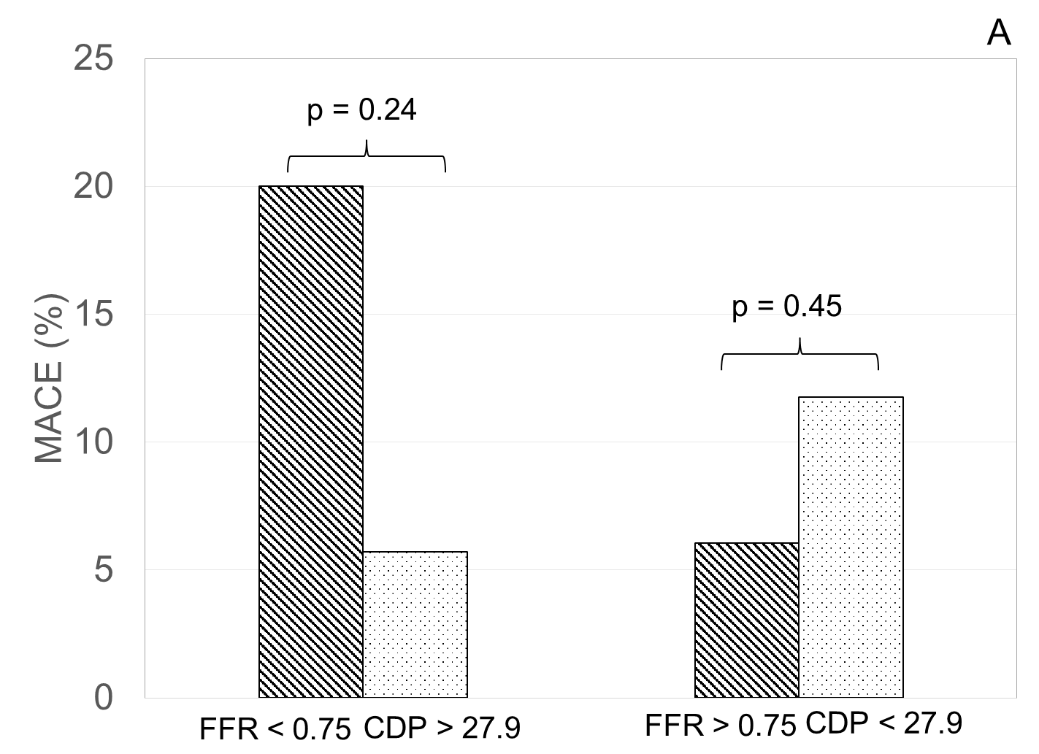
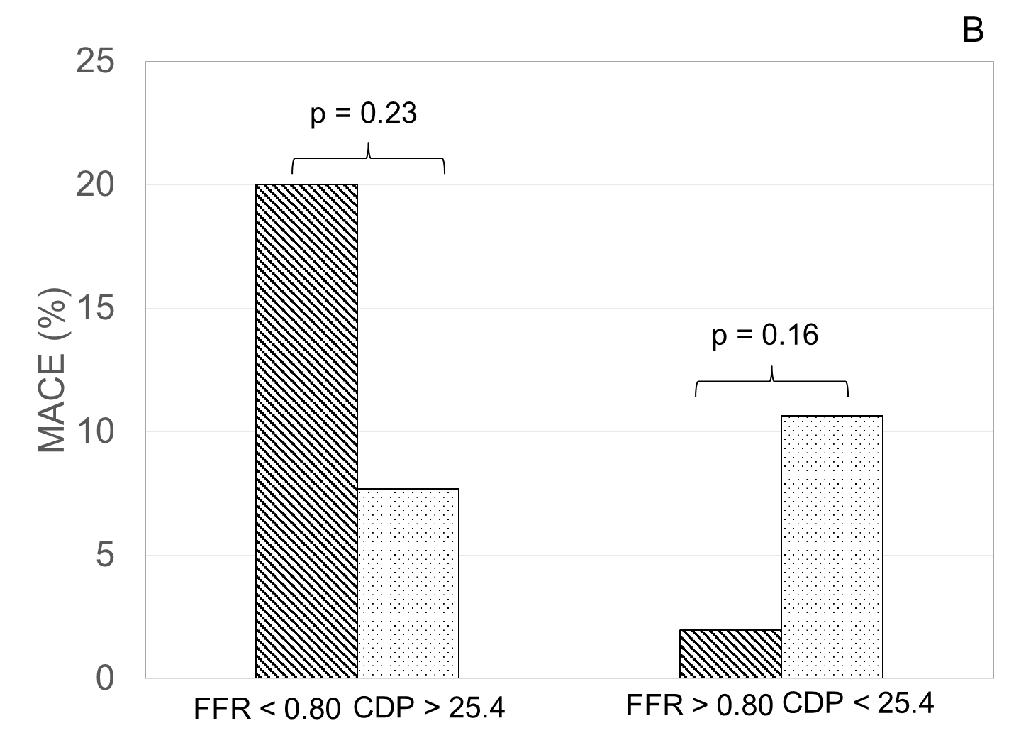
Figure 1 Comparison of % major adverse cardiac events in fractional flow reserve and pressure drop coefficient groups. MACE: Major adverse cardiac events; FFR: Fractional flow reserve; CDP: Pressure drop coefficient.

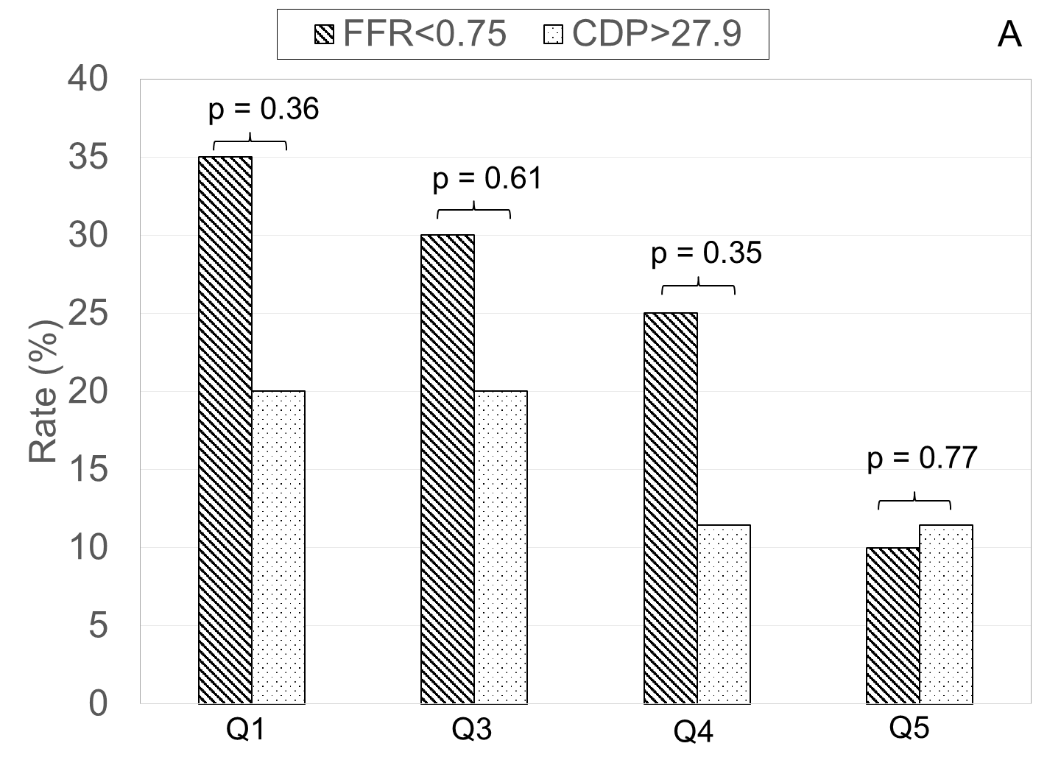
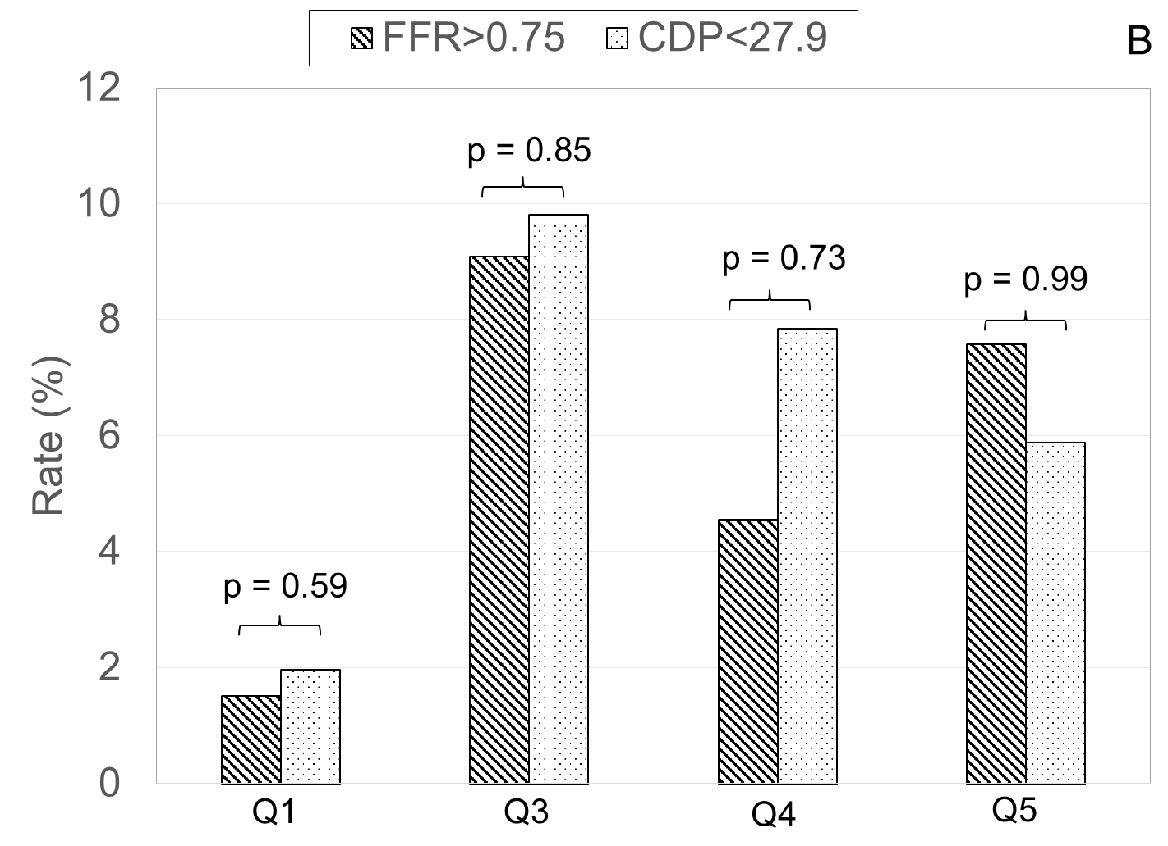
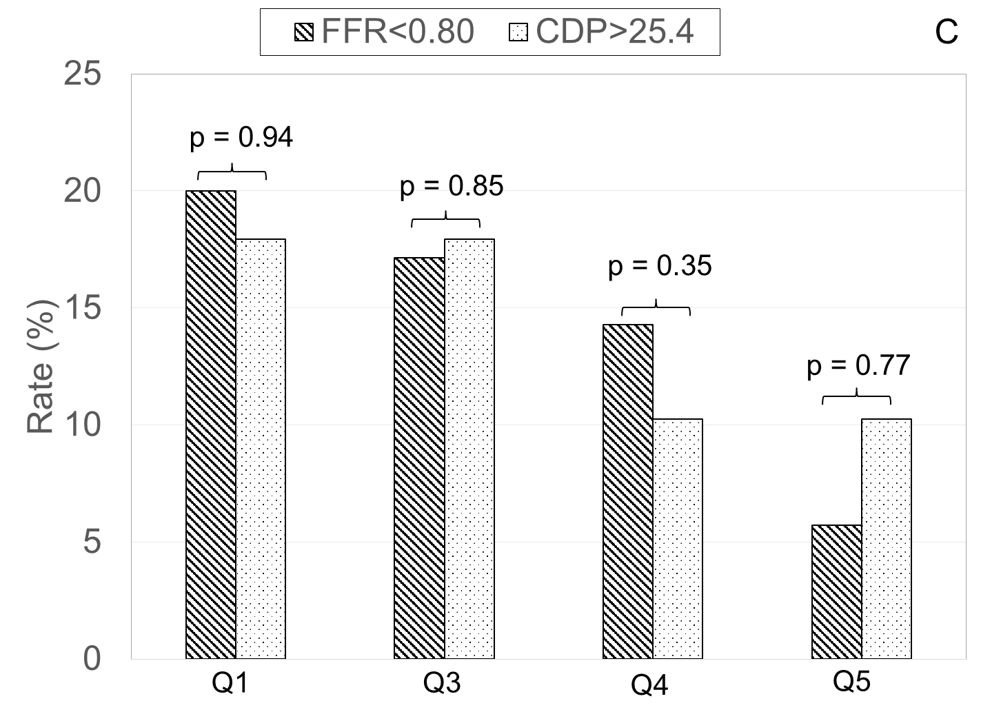
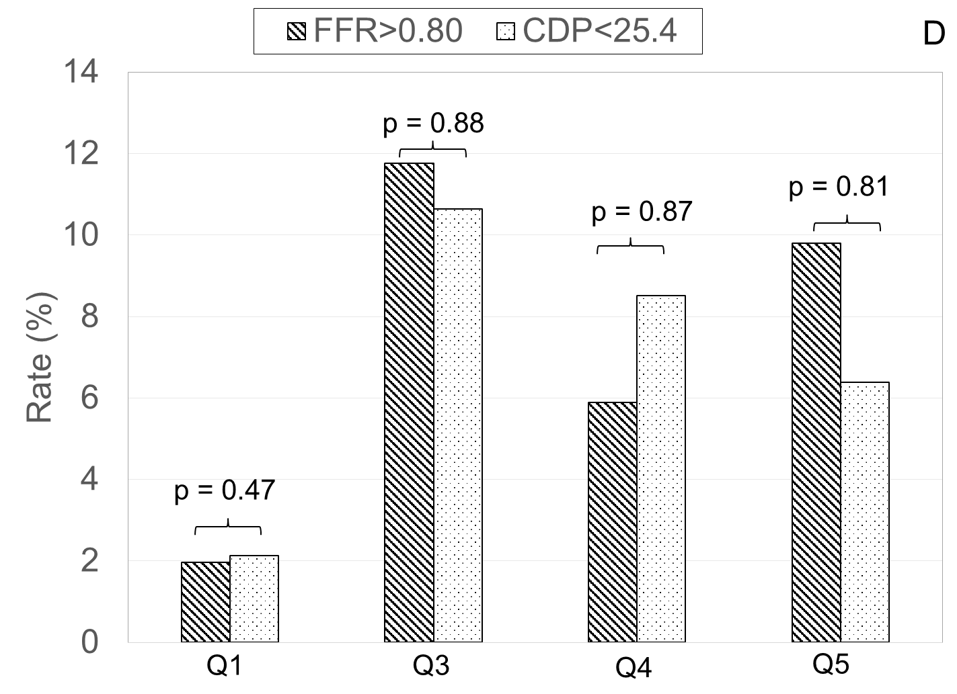

Figure 2 Comparison of patient conditions between fractional flow reserve and pressure drop coefficient groups at follow-up. (A) FFR < 0.75 and CDP > 27.9; (B) FFR > 0.75 and CD P < 27.9; (C) FFR < 0.80 and CDP > 25.4; (D) FFR > 0.80 and CD P < 25.4. MACE: Major adverse cardiac events; FFR: Fractional flow reserve; CDP: Pressure drop coefficient.

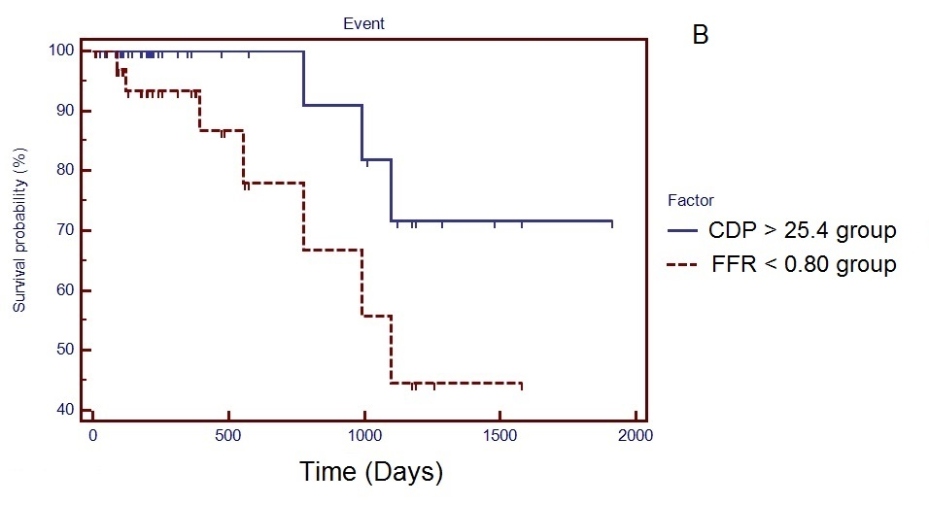
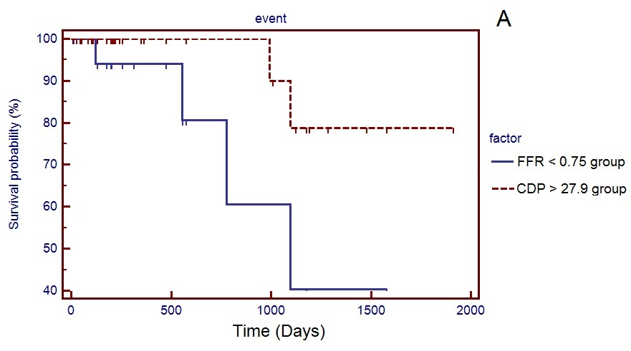
Figure 3 Survival curves. (A) FFR < 0.75 and CDP > 27.9 groups (P = 0.048); (B) FFR < 0.80 and CDP > 25.4 (P = 0.066). FFR: Fractional flow reserve; CDP: Pressure drop coefficient.

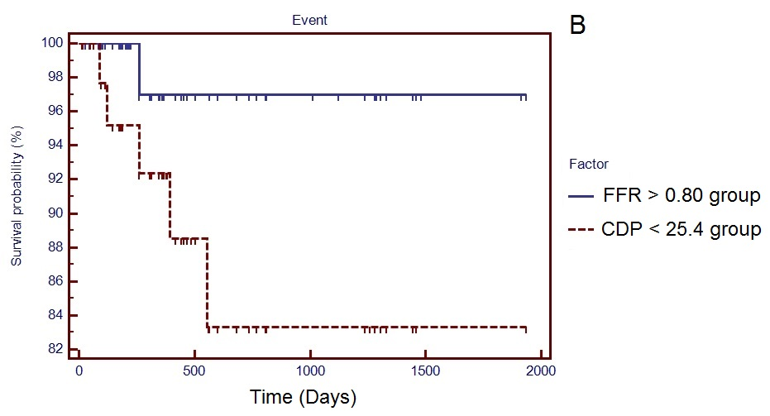
Figure 4 Survival curves. (A) FFR > 0.75 and CD P < 27.9 group, P = 0.29; (B) FFR > 0.80 and CD P < 25.4 (P = 0.09). FFR: Fractional flow reserve; CDP: Pressure drop coefficient.

Table 1 Summary of the characteristics of the 86 recruited patients
Variable |  | Study/group
Sex (M/F) |  | 77/9
Age (years) |  | 61 ± 9
Ejection Fraction (%) |  | 58 ± 10
Clinical history
 | Diabetes | 42/86
 | Hypertension | 70/86
 | Dyslipidemia | 60/86
 | Previous myocardial infarction | 21/86
 | Smoking history | 52/86
 | Family History of CAD | 23/86
 | LV Hypertrophy | 4/86
Affected artery
 | LAD | 43
 | LCX | 17
 | RCA | 26

Table 2 Summary of the primary and secondary outcomes at a minimum of 1-year follow-up period
Variable |  | FFR < 0.75 | FFR > 0.75 | CDP > 27.9 | CD P < 27.9 | FFR < 0.80 | FFR > 0.80 | CD P < 25.4 | CDP > 25.4
Primary outcome | Composite of MACE
 | All-cause mortality | 3/20 | 2/66 | 2/35 | 3/51 | 4/35 | 1/51 | 3/47 | 2/39
 | Myocardial infarction | 1/20 | 1/66 | 0/35 | 2/51 | 2/35 | 0/51 | 1/47 | 1/39
 | Revascularization | 0/20 | 1/66 | 0/35 | 1/52 | 1/35 | 0/51 | 1/47 | 0/39
Secondary outcome: All questions related to patients’ condition after the procedure | Q1: Health condition | 7/20 | 1/66 | 7/35 | 1/51 | 7/35 | 1/51 | 7/47 | 1/39
 | Q2: Heart attack | 0/20 | 0/66 | 0/35 | 0/51 | 0/35 | 0/51 | 0/47 | 0/39
 | Q3: Chest pain requiring medication | 6/20 | 6/66 | 7/35 | 5/51 | 6/35 | 6/51 | 7/47 | 5/39
 | Q4: Interventional procedure | 5/20 | 3/66 | 4/35 | 4/51 | 5/35 | 3/51 | 4/47 | 4/39
 | Q5: Re-hospitalization due to cardiac condition | 2/20 | 5/66 | 4/35 | 3/51 | 2/35 | 5/51 | 4/47 | 3/39
MACE: Major adverse cardiac events; FFR: Fractional flow reserve; CDP: Pressure drop coefficient.

