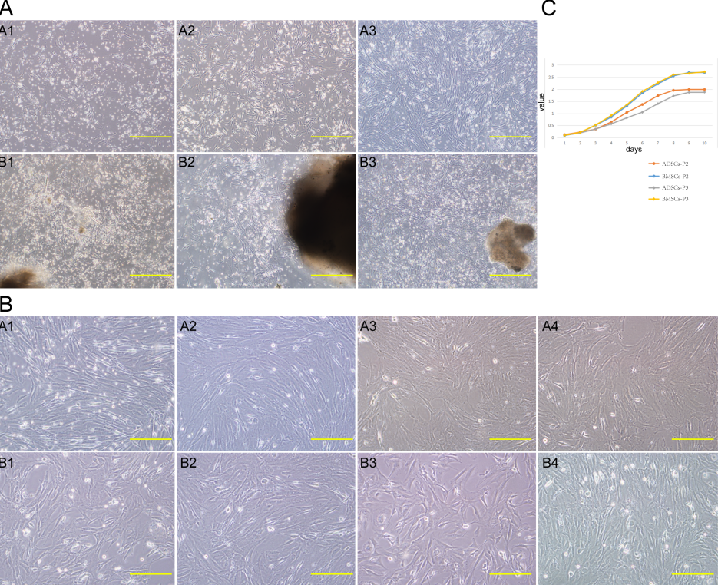
Supplement Figure 1 Primary culture, morphology, and growth kinetics of adipose-derived stromal cells and bone marrow stromal cells. A: A1–A3, ADSCs are fibroblast-like cells; the number of cells increased gradually; on day 4, cells exhibited an obvious spiral structure. B1–B3, Fibroblast-like BMSCs ‘climbed out’ from the bone fragments; the number of cells increased gradually; on day 4, cells exhibited a spiral structure. B: A1–A4 shows passages 1–4 of ADSCs. B1–B4 shows passages 1–4 of BMSCs; all are long, spindle-shaped cells and showed no obvious difference in morphology. C: The two cell types had an S-shaped growth curve. During the first 3 d, the cells grew slowly. From day 4, the two cell types began to grow rapidly and entered a logarithmic growth period. From day 8, the cells stopped growing and entered a growth plateau phase. ADSCs: Adipose-derived stromal cells; BMSCs: Bone marrow stromal cells.

Table 1 Primers
Gene | Sequence (5’-3’) | Product size (bp)
ALB | F: ACCTCCTTTAAGGAAAACCC  R: GACGGACAGATGAGACCAAT | 214
CK-18 | F: GTGGAAGTGGATGCCCC  R: TCAGCTCCGTGAGTGTGG | 196
CK-19 | F: GAGCGTGATCAGCGGTTT  R: TCGAGGGAGGGGTTAGAG | 258
AFP | F: AGAAAAACTCTGGCGATGGG  R: GGAAACTGGAAGGGTGGGAC | 190
G-6-P | F: CAATCTCCTCTGGGTGGC  R: TTGCTGTAGTAGTCGGTGTCC | 111
Actin | F: TACGAGGGCTATGCTCTCC  R: TTGATGTCACGCACGATTT | 143
ALB: Albumin; CK-18: Cytokeratin 18; AFP: Alpha fetoprotein; G-6-P: Glucose-6-phosphate.

Supplement Table 1 Statistical results of cell proliferation of the two kind of cells
Groups | P values
ADSCs-P2-BMSCs-P2 | 0.3974, > 0.05
ADSCs-P3-BMSCs-P3 | 0.1965, > 0.05
ADSCs-P2-ADSCs-P3 | 0.6600, > 0.05
BMSCs-P2-BMSCs-P3 | 0.9483, > 0.05
ADSCs: Adipose-derived stromal cells; BMSCs: Bone marrow stromal cells.

Supplement Table 2 Expression of surface antigens of adipose-derived stromal cells and bone marrow stromal cells (%)
 | ADSCs-P2 | ADSCs-P3 | BMSCs-P2 | BMSCs-P3
CD29 | 99.87 | 99.90 | 98.82 | 99.94
CD90 | 95.68 | 98.55 | 96.20 | 98.23
CD11b | 5.60 | 3.73 | 3.73 | 0.32
CD45 | 0.32 | 2.30 | 1.74 | 1.01
ADSCs: Adipose-derived stromal cells; BMSCs: Bone marrow stromal cells.

