Name of journal: World Journal of Virology
ESPS Manuscript NO: 14890
Manuscript Type: MINIREVIEWS

Purinergic signaling and human immunodeficiency virus/acquired immune deficiency syndrome: From viral entry to therapy

Passos DF et al. Purinergic signaling and HIV/AIDS: From viral entry to therapy

Daniela F Passos, Maria Rosa C Schetinger, Daniela BR Leal

Daniela F Passos, Daniela BR Leal, Departamento de Microbiologia e Parasitologia, Centro de Ciências da Saúde, Universidade Federal de Santa Maria, Santa Maria, RS 97105-900, Brazil

Maria Rosa C Schetinger, Departamento de Bioquímica e Biologia Molecular, Centro de Ciências Naturais e Exatas, Universidade Federal de Santa Maria, Santa Maria, RS 97105-900, Brazil

Author contributions: Passos DF, Schetinger MRC and Leal DBR solely contributed to this paper.

Conflict-of-interest statement: We declare that we have no conflict of interest.

Open-Access: This article is an open-access article which selected by an in-house editor and fully peer-reviewed by external reviewers. It distributed in accordance with the Creative Commons Attribution Non Commercial (CC BY-NC 4.0) license, which permits others to distribute, remix, adapt, build upon this work non-commercially, and license their derivative works on different terms, provided the original work is properly cited and the use is non-commercial. See: http://creativecommons.org/licenses/by-nc/4.0/

Correspondence to: Daniela BR Leal, PhD, Departamento de Microbiologia e Parasitologia, Centro de Ciências da Saúde, Universidade Federal de Santa Maria, Av. Roraima, Santa Maria, RS 97105-900, Brazil. daniela.leal@ufsm.br
Telephone: + 55-55-32209581
Fax: + 55-55-32208242

Received: October 29, 2014
Peer-review started: October 29, 2014
First decision: December 12, 2014
Revised: July 21, 2015
Accepted: August 4, 2015
Article in press:
Published online:
Abstract
Human immunodeficiency virus (HIV) infection is a serious condition associated to severe immune dysfunction and immunodeficiency. Mechanisms involved in HIV-associated immune activation, inflammation and loss of CD4+ T cells have been extensively studied, including those concerning purinergic signaling pathways. Purinergic signaling components are involved in viral entry and replication and disease progression. Research involving the participation of purinergic signaling in HIV infection has been not only important to elucidate disease mechanisms but also to introduce new approaches to therapy. The involvement of purinergic signaling in the pathogenesis of HIV infection and its implications in the control of the HIV infection are reviewed in this paper.

Key words: Human immunodeficiency virus; Purinergic signaling; Immune activation; Inflammation

© The Author(s) 2015. Published by Baishideng Publishing Group Inc. All rights reserved.

Core tip: This paper reviews the latest findings regarding the involvement of the purinergic signaling system and human immunodeficiency virus (HIV) infection. On the last 10 years, several studies have been published on the participation of purinergic signaling in HIV infection. The findings helped to elucidate disease mechanisms and proposed new targets and approaches to therapy. We have found that basic and clinical research on this field are very promising and must be further pursued.

Passos DF, Schetinger MRC, Leal DBR. Purinergic signaling and human immunodeficiency virus/acquired immune deficiency syndrome: From viral entry to therapy. World J Virol 2015; In press

Introduction
Acquired immune deficiency syndrome (AIDS) is a pandemic disorder caused by the human immunodeficiency virus (HIV). HIV infection is characterized by persistent immune activation, inflammation and loss of CD4+ T cells, which altogether lead to immunodeficiency^{[1-3]}. The pathological mechanisms involving these dysfunctions along with disease progression markers and prospective ways of halting disease progression are targets of extensive research. Although a great number of pathological mechanisms have been proposed, a lot remain unclear.
The connection between purinergic signaling and HIV infection is not consistently in favour of the host or the pathogen. Purinergic receptors may favour viral entry^{[4,5]} whilst its enzymes may help to halt disease progression^{[6]} and boost immune response against the virus^{[7]}. However, the increasing knowledge of purinergic signaling components and their connection to HIV infection has been remarkably valuable in the understanding of the disease mechanisms. Furthermore, this knowledge raises the possibility of using purinergic receptors antagonists, purinergic signaling mediators and their analogs in HIV therapy^{[8-10]}.
The aim of this paper is to review purinergic signaling and its involvement, through its components (enzymes, receptors) and mediators (ATP and adenosine), in HIV virus entry and replication, disease progression, and potential therapeutic strategies.

Background on Purinergic signaling
Following the identification of ATP, along with purinergic co-transmission and the P1 and P2 receptors in the 70’s, the purinergic signaling system has been intensely studied^{[11,12]}. The receptors were characterized and the ATP mechanisms of release and breakdown have been described. Consequently, the involvement of the purinergic system in the pathophysiology of several human disorders has been uncovered and the possibility of using these pathways as targets for therapy has been raised^{[12]}.
ATP (Adenosine triphosphate), ADP (Adenosine diphosphate), AMP (Adenosine monophosphate) and adenosine are extracellular purines that mediate a series of physiological and pathological processes^{[12]}. Receptors to purines are specific cell surface molecules called purinergic receptors. Two distinct purinergic receptor families have been indentified: P1 and P2 receptors. P1 are specific to adenosine and comprise 4 subfamilies, while P2 receptors are selective to ATP and AMP and contain two subfamilies, P2X and P2Y, based on their chemical properties. Additionally, P2X is subdivided into 7 subtypes and P2Y into 8^{[13,14]}. Purinergic receptors families, subfamilies and subtypes are shown on Table 1.
Extracellular nucleotide concentrations are regulated by ectoenzymes that hydrolyse these nucleotides; the NTPDase1 (CD39) cleaves ATP to AMP, NTPDase2 (CD39L1) cleaves ATP to ADP, 5′-ectonucleotidase (CD73) produces adenosine from AMP, ectonucleotide pyrophosphatase/phosphodiesterase (E-NPP) breaks down ATP into AMP, and alkaline phosphatases (AP) which dephosphorylates nucleotides^{[15]}. Adenosine, which has its physiological effects mediated by P1 receptors, can be either transported into the cell or inactivated by adenosine deaminase (ADA) and purine nucleoside phosphorylase (PNP)^{[15]}. Figure 1 shows a schematic representation of the purinergic pathway. Although each purinergic signalling component has its own function they do not operate independently. In physiological conditions they act in cooperation interfering with the function of other elements. When considering pathogenic conditions these cross-talks and networks must be taken into consideration^{[16]}.
In viral infection, purinergic extracellular nucleotides and receptors not only participate in the innate and adaptive responses but also modulate the immune responses^{[17]}. The release of ATP by damaged cells generates a danger signal acting as a DAMP, it also stimulates the NOD-like receptor mediated inflammasome and the activation of the capase-1 pathway^{[18]}. Extracellular ATP also acts as a costimulatory signal to T cells and drives the differentiation of gut T helper 17 (Th17) cells^{[19]}.
The purinergic signaling system is involved in a series of processes including, neurotransmission, neuro and immune modulation, secretion, cell proliferation, differentiation, apoptosis, cell death, phagocytosis, chemotaxis and embryonic development^{[11,17,20,21]}. Purinergic signaling has been linked to a series of acute and chronic inflammatory diseases^{[22]} including inflammatory bowel disease^{[23]}, cancer^{[13]}, ischemia^{[24]} and acute lung injury^{[25]}. Therapeutic approaches using the components of the purinergic system are being developed for a number of diseases^{[12]} such as cancer^{[20,26,27]}, diabetes^{[28]}, osteoporosis^{[29]}, and neurodegenerative diseases^{[30]} as well as HIV^{[8-10]}. Consequently, the involvement of the purinergic system in the pathophysiology of several human disorders has been uncovered and the possibility of using these pathways as targets for therapy has been raised^{[12]}.
The first study linking the purinergic signaling system and HIV infection was published in 2005, Leal et al^{[6]} identified an increased NTPDase activity in CD39-positive lymphocytes of HIV-infected patients. Further studies associating CD39 and HIV disease progression were published in 2011 and 2013^{[31-33]}. In 2007, a study highlighted the protective effect of adenosine receptors against neuronal damage in primary murine cultured brain cells^{[34]}, followed by later studies correlating dementia and other HIV-associated neurocognitive disorders to ATP release and P2X in primary neuron-glia co-cultures from mouse striatum^{[35]} and adenosine receptors in HIV-infected macrophages^{[36]}. Studies on pannexin hemichannels and purinergic receptors and HIV infection have been published in the last few years^{[4,5]}. ADA also has been the subject of study in the context of HIV infection, proving to be a immune response booster^{[7]} and a biomarker for disease progression^{[37]} and accelerated aging associated with HIV infection^{[38]}.

HIV Infection and the Immune system
Host defence against HIV depends on a combination of adaptive and innate responses^{[39]}. Despite the ability of these responses to briefly control disease progression, they are not capable of eliminating the virus. The complex interaction between the host response and HIV virus has been extensively studied and the HIV has been shown to take advantage of host metabolic pathways and proteins, known as host permissive factors, allowing the virus to thrive and persist in the host organism^{[40-42]}.
As with other viruses, the first line of defence against HIV is the innate response. Germ line-encoded Pattern-Recognition Receptors (PRRs) are essential players in the innate response. PRRs include toll-like receptors (TLRs), membrane-bound C-type lectin receptors (CLRs), NOD-like receptors (NLRs) and RIG-I-like receptors (RLRs), and unidentified proteins capable of recognizing DNA or RNA^{[43]}. These PPRS recognize pathogen-associated molecular patterns (PAMPs) and danger-associated molecular patterns (DAMPs). Although the knowledge of HIV-specific PPRs and PAMPs remains scarce, RIG-I was recently described as being involved in recognizing cytosolic HIV genomic RNA^{[44]}. The recognition of PAMPS and DAMPS by the PRRs triggers a cascade of signaling pathways on the surface of antigen-presenting cells (APCs) and dendritic cells (DCs), which initiate host inflammatory and immune responses. When the APCs and the DCs are stimulated, the CD4+ T cells and the natural killer (NK) cells are activated in the lymph nodes and the adaptive response is initiated^{[45,46]}.
DCs are not only important APCs along with macrophages and monocytes in both innate and adaptive responses^{[3]}, but they also modulate the adaptive response together with NK cells^{[46]}. Once the DCs are activated, they produce cytokines and induce T helper 1 (Th 1) responses and consequently cytotoxic T lymphocyte (CTL) responses^{[46]}. However, HIV specifically targets CD4+ T cells along with macrophages and DCs which are essential for the antiviral response^{[2]}.

Purinergic signaling and the immune system
In physiological conditions, the cells are able to maintain a balance in the levels of ATP^{[47]}. In pathological conditions, on the other hand, injured, necrotic and activated cells release ATP into the extracellular environment, where it interacts with P2 receptors or is degraded by ectoenzymes. Purinergic signaling seems to be an important regulator of the activation of NOD-like receptor family, pyrin domain containing 3 (NLRP3) inflammasome. P2 receptors control the potassium efflux contributing to the activation of the inflamassomes^{[48,49]}. The release of ATP from necrotic cells activates the NLRP3 inflammasome via the P2X7 receptor^{[18,50]}. HIV-1 acts as primary signal to activate the NLRP3 inflammasome^{[51]}, since local release of ATP is stimulated by the binding of HIV gp120 to its receptor which results in activation of purinergic receptors^{[5,52]}. The activation of the inflammasome is important in the antiviral response since it may lead to the elimination of the infected cells by pyroptosis^{[53-55]}. Figure 2 illustrates the activation of NLRP3 inflamassome in a HIV infected CD4 T cell. In the specific case of HIV infection pyroptosis might not be a protective method since it does not eliminate the infection, instead it creates a pathogenic cycle in which the death of CD4+ T cells results in the release of inflammatory signals that attract more CD4+ T cells which subsequently die creating a state of chronic inflammation^{[54]}.
Recruitment of inflammatory cells to the sites of infection as part of an antiviral response involves the release of nucleotides and an autocrine purinergic signaling pathway^{[42,56]}. The release of nucleotides triggers the polarization of purinergic proteins and receptors contributing to migration of phagocytes to the sites of inflammation and infection^{[42]}. P2 purinergic receptors are also involved in chemotaxis^{[42]}. Purinergic receptors are not only involved in chemotaxis but also in the modulation of immune responses^{[56]}.
The multiple and complex processes leading to inflammation and immune activation are not fully understood. Appay and Sauce^{[2]} (2008) proposed a simplified model for immune activation and inflammation in HIV infection in which three well-known major events, depletion of CD4+ T cells, immune activation and exhaustion of regenerative capacity, all contribute to inefficient immune response and loss of T cell homeostatic regulation^{[2]}. During acute infection, the depletion of gut mucosal CD4+ T cells triggers the loss of protective mechanisms such as the epithelial barrier and immune cells that otherwise would block translocation of microbial products from the gut into the circulation^{[57-59]}. These microbial products such as bacterial DNA and lipopolysaccharides activate the innate response receptors and a signaling cascade, consequently boosting the production of inflammatory cytokines^{[60]}. These events prompt a systemic immune activation that characterizes the chronic phase of HIV infection and consequent loss of peripheral CD4+ T cells^{[60]}. Chronic immune activation and inflammation increases cell turnover and causes the accelerated aging of the immune system driving HIV-specific CD8+ T cells to exhaustion^{[2]}.
DCs represent an important link between the innate and adaptive responses. ATP enhances the antiviral response by activating DCs which then migrate to the lymph nodes. Extracellular ATP was found to interfere with the transfer of HIV-1 from immature DCs to CD4+ T cells thereby controlling the spread of the virus by halting viral replication^{[61]}.

ATP release and purinergic receptors in HIV-associated neurocognitive disorders
ATP release and purinergic receptors are involved in pathologies of the central nervous system (CNS) in neurodegenerative, neuropsychiatric and neurocognitive diseases^{[62]}. Regarding the toxic effects of extracellular purines in HIV infection, a connection between HIV-associated neurocognitive disorders (HAND) and the pathological release of purines by HIV-infected macrophages was found. High concentrations of ATP, ADP, AMP and small amounts of adenosine were found in HIV-infected macrophages along with glutamate, suggesting that ATP release from these cells might be involved in neuronal damage in HIV-infected patients^{[53]}. These purinergic molecules are thought to mediate calcium influxes through activation of calcium receptors, causing damage or death of neurons^{[35]}.
Several mechanisms are involved in the neurocognitive impairment that affects HIV infected patients. The HIV transactivator of transcription Tat induces the release of cytokines and chemokines from microglia, microglia, macrophages, neurons, and astrocytes in the CNS and causes disruption of the blood-brain barrier with resulting neurotoxicity^{[63]}. Recently it was suggested the P2X receptors are involved in HIV and opioid neuropathogenesis^{[36]}. The use of TNP-ATP, a non-selective P2X antagonist, prevented the neurotoxic damage caused by exposure to morphine and/or HIV Tat or ATP in striatal neurons^{[36]}. P2X4 receptors are expressed by subpopulations of striatal neurons and glia and are activated by excess levels of extracellular ATP caused by morphine and/or HIV-1 Tat^{[36]}. The involvement of P2X4 in HIV and opioid neuropathogenesis was confirmed by the fact that selective blockade of P2X1, P2X3, or P2X7 receptors, not P2X4, were not able to prevent Tat or morphine induced neurotoxicity, suggesting this particular receptor might be a potential new target for prevention of HAND^{[36]}.
HIV-associated dementia is linked to inflammation and consequent production of proinflammatory cytokines. The adenosine receptor A1AR was shown to inhibit Tat-mediated proapoptosis by attenuating intracellular Ca²⁺ and production of nitric oxide^{[34]}. More recently, it was demonstrated that the activation of the A2A adenosine receptor inhibits Tat-induced TNF-α production in monocytes thereby suggesting that adenosine is an important regulator of cytokine production and its pathway a possible therapeutic target for CNS inflammatory disorders^{[64]}.

Pannexin hemichannels and purinergic receptors are involved in the process of HIV viral entry and immune activation
ATP is transported mainly through a combination of vesicular release, connexin and pannexin hemichannels^{[12]}, but also includes P2X7 receptors and maxi-ion channels^{[65]}. The role of pannexin hemichannels have been studied in a number of pathophysiological events including calcium signaling, cellular differentiation, cellular migration, inflammation, cell death, innate and adaptive immune responses and HIV viral entry^{[66,67]}. To ensure an efficient entry into the cell, the HIV-1 gp120 protein binds to CD4⁺ T cell receptor and chemokine coreceptors CXCR4 or CCR5. It has been demonstrated that this binding increases the intracellular free calcium, induces the opening of Panx-1 hemichannels in response to ATP release and activation of purinergic receptors^{[68]}. Once opened, Panx-1 hemichannels facilitate virus entry by changing ionic gradients with further release of further signals such as ATP that activate extracellular purines and receptors^{[68]}. Orellana et al^{[68]} (2013) suggested that Panx-1 hemichannels are part of the apparatus of host proteins of which the virus takes advantage to enter the cells and replicate, and that the opening of these hemichannels might be involved in other events such as viral fusion.
In addition to Panx-1 hemichannels, other purinergic signaling pathways components may favor virus entry and subsequent events in viral infection. Purinergic receptors are also implicated in virus entry. A recent study demonstrated that the HIV-encoded Env complex triggers the release of ATP and subsequently activates the purinergic receptors initiating a cascade of events^{[4]}. The extracellular ATP released through the Panx-1 hemichannels act on purinergic receptors, including P2Y2 which along with pannexin-1, ATP and Pyk2 were shown to be essential for HIV-1 replication^{[4]}, since purinergic receptor inhibitors and antagonists blocked HIV-1 replication^{[4]}. P2Y2 activates the proline-rich tyrosine kinase, an important step in the cascade, which is also a critical effector of HIV-1 infection^{[4]}. Overexpression of P2Y2 in peripheral blood mononuclear cells (PBMCs) increased the depolarization of the plasma membrane, an event required for Env-dependent HIV-1 fusion^{[4]}.
P2X1 is also involved in viral entry, while P2X7 and P2Y1 might be involved in later events of viral infection; antagonists for all these receptors blocked viral replication but only antagonists for P2X1 blocked viral entry^{[5]}. The binding of gp120 to host CD4 and co-receptors induces ATP release and subsequent activation of P2X1 receptors required for viral entry. P2X7 and P2Y1 may require greater amounts of accumulated ATP to be activated for involvement in later steps of the viral cycle^{[5]}. Hazleton et al^{[5]} (2012) also suggests that other products of ATP are also involved in the process of entry and replication of HIV. Further studies are necessary to elucidate the mechanisms and explore the therapeutic potential of purinergic receptors antagonists.
As mentioned previously, P2X7 is involved in HIV-1 replication and much higher concentrations of ATP are needed to activate this receptor. ATP release though Panx-1 hemichannels are thought to achieve a sufficiently high local concentration of ATP to induce P2X7 activation, which in turn activates the opening of Panx-1 hemichannels, creating a cycle that leads to persistent immune activation^{[69]}. This positive feedback loop might be one of the multiple mechanisms involved in persistent activation during HIV infection^{[52]}. The role of purinergic receptors in HIV entry, fusion and replication is summarized in Figure 3.

Ectoenzymes and HIV disease progression
Whilst ATP may promote inflammation, adenosine is considered a mostly anti-inflammatory molecule and a crucial regulator in innate and adaptive immune responses^{[70]}. Ectoenzymes CD39 (NTPDase-1) and CD73 (ecto-5’-nucleotidase) are known to dephosphorylate extracellular ATP to adenosine, playing an important role in immune modulation^{[33,71,72]}. The role of the ectoenzymes in physiological processes and diseases has been extensively studied, specially the NTPDase and 5’-ecto-nucleotidase activities^{[73]}. Co-expression of CD39 and CD73 plays an important part in keeping the balance between activation and regulation of the immune response against HIV and, subsequently, in the halting of disease progression^{[51,74]}.
CD39 cleaves ATP into AMP while CD73 converts AMP into adenosine, increasing the expression of A2AR agonist and cyclic AMP (cAMP). CD39 is a marker of lymphoid activation which requires ATP as an energy source. This enzyme hydrolyses ATP into AMP to maintain the ATP levels, preserve cellular integrity and modulate the immune response^{[6]}. Our group has found that the NTPDase-1 activity is increased in lymphocytes of HIV-positive patients suggesting that it might be due to apoptosis and the need to reduce the toxic effects of ATP release^{[6]}. In the last few years a series of studies have investigated the role of T regulatory (Treg) cells expressing CD39 in HIV infection^{[31-33]}. Nikolova et al^{[33]} (2011) have established that the expansion of Treg CD39+ cells in HIV-infected individuals might contribute to disease progression, since they inhibit T cell proliferation. Another study also describes the increased expression of CD39 in Treg cells and its association with disease progression and immune activation^{[32]}. In addition, CD39 was found to be involved in the inefficiency of the CD8⁺ T cell response during chronic HIV infection by inhibition of important cytokine production^{[33]}. In support of this finding, Jenabian et al^{[31]} (2013) show that the expansion of Treg CD39+ cells inhibits IL-2 production thereby suppressing the function of CD4+ T cells; this occurs through demethylation of an essential CpG site in the IL-2 gene promoter. CD39+ Treg cells were shown to inhibit HIV replication mediated by cAMP in conventional T cells, suggesting they have a protective effect against HIV infection^{[75]}.
Unlike CD39, that is overexpressed in HIV-infected individuals, CD73 has shown to be depleted, which leads to decreased adenosine suppression and failure to control persistent cell activation contributing to disease progression^{[76,77]}. Another interesting finding is that once the pool of CD4+CD73+ cells is depleted they can no longer be expanded, even if the CD4+ cell levels are recovered^{[76]}.
ADA is a purinergic signaling enzyme responsible for catalyzing the deamination of adenosine and also involved in modulating the T cell response against HIV^{[7,78-80]}. ADA boosts both the CD4+ and CD8+ memory cell response to HIV and also reduces the suppression mediated by Treg cells^{[7,78-80]}. In DCs, ADA has been shown to be capable of boosting immunogenicity and increasing the secretion of pro-inflammatory cytokines^{[7,78,80]}. All this data taken together suggests that ADA would be a strong candidate target for therapeutic and vaccine approaches^{[7,78,79]}.

ADA as disease progression and senescence biomarker
HIV infected individuals are subject to accelerated aging, this might be due not only to the chronic inflammation and immune activation inherent of HIV infection^{[81]}, but also as a consequence of highly active antiretroviral therapy (HAART)^{[82]}. In fact, immune activation has been a major cause of morbidity and mortality from AIDS-defining and non-AIDS defining diseases in patients undergoing antiretroviral treatment^{[83]}. The increased production of inflammatory cytokines arising from the chronic inflammatory status enhances a process called “inflammaging”^{[84]}. The term “inflammaids” was employed to define the extensive activation of innate and adaptive immunity during HIV infection, which resembles the process of inflammaging^{[85,86]}. The HIV infection per se predisposes infected patients to premature aging, however the interplay between these pathological changes and HAART makes the situation even more complex^{[82]}. The age-associated disorders that affect HIV infected patients include neurological and metabolic diseases and immunosenescence; the premature aging also has an impact on disease progression markers such as CD4+ and CD8+ T cell counts^{[87]}. Since immune activation is a strong predictor of disease progression and consequent immunosenescence and premature aging, several biomarkers have been identified^{[37,38,88]}. ADA has been shown to be not only a suitable marker of immune activation and disease progression^{[37]} but also a suitable biomarker of senescent human CD8 +T cells^{[38]}.

Purinergic receptors, ATP/Adenosine and ATP analogs as potential therapeutic approaches
The study of the implications of ATP and purinergic signaling in HIV infection has highlighted its potential use in therapeutic approaches^{[4,8,9,89]}.
As discussed earlier in this paper, studies have shown that purinergic receptors are essential for viral entry and replication^{[4,5]}. A recent study has demonstrated that the inhibition of purinergic signaling blocks HIV-1 membrane fusion^{[10]}. This study reveals that PPADS, a nonselective purinergic antagonist, is capable of inhibiting cell-to-cell and cell-free HIV-1 infection in both X4- and R5-tropic virus infections^{[10]}. This finding highlights the potential use of P2X-selective purinergic antagonists to inhibit HIV-1 fusion.
Wagner^{[8]} (2011) proposes the use of ATP combined with HAART to eliminate infected cells, exploiting the ability of ATP to modulate the immune response^{[17]}. Recently, the use of ATP analogs was proposed to inhibit HIV-1 transcription by preventing cyclin-dependent kinases (Cdks) binding to Tat thus inhibiting Tat-dependent transcription^{[9]}.

conclusion
HIV infection is a serious condition with a huge impact on global health. Despite all efforts to contain the spread of the virus, prolonging the life span and quality of life of infected individuals, prevalence^{[90]}, morbidity and mortality^{[91]} rates are still high. Much is known about HIV infection but there are still areas in critical need of both basic and clinical research^{[92,93]}.
The understanding of pathogenic mechanisms involved in HIV infection and progression to AIDS, in which metabolic pathways such as purinergic signaling are involved, is crucial to achieve important objectives in controlling this condition.
Metabolic pathways have been the subject of investigation in the search for new therapies^{[52]} and even a cure for HIV^{[94]}. Even though the involvement of the purinergic signaling pathway in viral infections, including HIV, are multiple and ambiguous, it deserves further attention^{[22]}. Studies on the subject have helped to elucidate disease mechanisms and propose new targets and approaches to therapy.The identification of prognostic biomarkers and the recognition of candidate target genes or pathways to improve therapy are high priority areas where HIV infection is concerned. Purinergic signaling system components are relevant topics of study both for development of biomarkers as well as potential therapeutic targets.
The data reviewed in this paper reveals that this research field must be encouraged. We believe further studies targeting purinergic signaling enzymes and receptors must be particularly pursued due to its relevance in the process of understanding of the pathogenic mechanisms and the promise of new therapies in the future.

REFERENCES
1 Mogensen TH, Melchjorsen J, Larsen CS, Paludan SR. Innate immune recognition and activation during HIV infection. Retrovirology 2010; 7: 54 [PMID: 20569472 DOI: 10.1186/1742-4690-7-54]
2 Appay V, Sauce D. Immune activation and inflammation in HIV-1 infection: causes and consequences. J Pathol 2008; 214: 231-241 [PMID: 18161758 DOI: 10.1002/path.2276]
3 Perera SS, Saksena NK. Innate, Adaptive ans Intrinsic immunity in Human Immunodeficiency virus infection. Am J Infect Dis 2012; 8: 132 [DOI: 10.3844/ajidsp.2012.132.148]
4 Séror C, Melki MT, Subra F, Raza SQ, Bras M, Saïdi H, Nardacci R, Voisin L, Paoletti A, Law F, Martins I, Amendola A, Abdul-Sater AA, Ciccosanti F, Delelis O, Niedergang F, Thierry S, Said-Sadier N, Lamaze C, Métivier D, Estaquier J, Fimia GM, Falasca L, Casetti R, Modjtahedi N, Kanellopoulos J, Mouscadet JF, Ojcius DM, Piacentini M, Gougeon ML, Kroemer G, Perfettini JL. Extracellular ATP acts on P2Y2 purinergic receptors to facilitate HIV-1 infection. J Exp Med 2011; 208: 1823-1834 [PMID: 21859844 DOI: 10.1084/jem.20101805]
5 Hazleton JE, Berman JW, Eugenin EA. Purinergic receptors are required for HIV-1 infection of primary human macrophages. J Immunol 2012; 188: 4488-4495 [PMID: 22450808 DOI: 10.4049/jimmunol.1102482]
6 Leal DB, Streher CA, Bertoncheli Cde M, Carli LF, Leal CA, da Silva JE, Morsch VM, Schetinger MR. HIV infection is associated with increased NTPDase activity that correlates with CD39-positive lymphocytes. Biochim Biophys Acta 2005; 1746: 129-134 [PMID: 16344116]
7 Naval-Macabuhay I, Casanova V, Garcia F, Leon A, Gil C, Rovira C, Miralles L, Lluís C, Canela EI, Mallol J, Gatell JM, Gallart T, McCormick PJ, Climent N. ADA Reduces the HIV-1-Specific Tregs and Enhances HIV-1-Specific CD4 and CD8 Effector and Memory T-Cell Responses in AIDS Research And Human Retroviruses. New Rochelle, NY: Mary Ann Liebert, 2013. Available from: URL: http://mccormicklab.com/content/ada-reduces
8 Wagner MC. The therapeutic potential of adenosine triphosphate as an immune modulator in the treatment of HIV/AIDS: a combination approach with HAART. Curr HIV Res 2011; 9: 209-222 [PMID: 21675943 DOI: 10.2174/157016211796320289]
9 Narayanan A, Sampey G, Van Duyne R, Guendel I, Kehn-Hall K, Roman J, Currer R, Galons H, Oumata N, Joseph B, Meijer L, Caputi M, Nekhai S, Kashanchi F. Use of ATP analogs to inhibit HIV-1 transcription. Virology 2012; 432: 219-231 [PMID: 22771113 DOI: 10.1016/j.virol.2012.06.007]
10 Swartz TH, Esposito AM, Durham ND, Hartmann BM, Chen BK. P2X-selective purinergic antagonists are strong inhibitors of HIV-1 fusion during both cell-to-cell and cell-free infection. J Virol 2014; 88: 11504-11515 [PMID: 25031337]
11 Burnstock G. Purinergic signalling: Its unpopular beginning, its acceptance and its exciting future. Bioessays 2012; 34: 218-225 [PMID: 22237698 DOI: 10.1002/bies.201100130]
12 Burnstock G. Purinergic signalling: pathophysiology and therapeutic potential. Keio J Med 2013; 62: 63-73 [PMID: 24067872]
13 Di Virgilio F. Purines, purinergic receptors, and cancer. Cancer Res 2012; 72: 5441-5447 [PMID: 23090120 DOI: 10.1158/0008-5472.CAN-12-1600]
14 Burnstock G. Purinergic signalling: past, present and future. Braz J Med Biol Res 2009; 42: 3-8 [PMID: 18853040]
15 Yegutkin GG. Nucleotide- and nucleoside-converting ectoenzymes: Important modulators of purinergic signalling cascade. Biochim Biophys Acta 2008; 1783: 673-694 [PMID: 18302942 DOI: 10.1016/j.bbamcr.2008.01.024]
16 Volonté C, D'Ambrosi N. Membrane compartments and purinergic signalling: the purinome, a complex interplay among ligands, degrading enzymes, receptors and transporters. FEBS J 2009; 276: 318-329 [PMID: 19076212 DOI: 10.1111/j.1742-4658.2008.06793.x]
17 Di Virgilio F. Purinergic signalling in the immune system. A brief update. Purinergic Signal 2007; 3: 1-3 [PMID: 18404413]
18 Riteau N, Baron L, Villeret B, Guillou N, Savigny F, Ryffel B, Rassendren F, Le Bert M, Gombault A, Couillin I. ATP release and purinergic signaling: a common pathway for particle-mediated inflammasome activation. Cell Death Dis 2012; 3: e403 [PMID: 23059822]
19 Trautmann A. Extracellular ATP in the immune system: more than just a "danger signal". Sci Signal 2009; 2: pe6 [PMID: 19193605 DOI: 10.1126/scisignal.256pe6]
20 Burnstock G. Pathophysiology and therapeutic potential of purinergic signaling. Pharmacol Rev 2006; 58: 58-86 [PMID: 16507883]
21 Murgia M, Pizzo P, Steinberg TH, Di Virgilio F. Characterization of the cytotoxic effect of extracellular ATP in J774 mouse macrophages. Biochem J 1992; 288 (Pt 3): 897-901 [PMID: 1472003]
22 Eltzschig HK, Sitkovsky MV, Robson SC. Purinergic signaling during inflammation. N Engl J Med 2012; 367: 2322-2333 [PMID: 23234515 DOI: 10.1056/NEJMra1205750]
23 Colgan SP, Eltzschig HK. Adenosine and hypoxia-inducible factor signaling in intestinal injury and recovery. Annu Rev Physiol 2012; 74: 153-175 [PMID: 21942704]
24 Grenz A, Homann D, Eltzschig HK. Extracellular adenosine: a safety signal that dampens hypoxia-induced inflammation during ischemia. Antioxid Redox Signal 2011; 15: 2221-2234 [PMID: 21126189]
25 Eckle T, Koeppen M, Eltzschig HK. Role of extracellular adenosine in acute lung injury. Physiology (Bethesda) 2009; 24: 298-306 [PMID: 19815856 DOI: 10.1152/physiol.00022.2009]
26 Rapaport E. Treatment of human tumor cells with ADP or ATP yields arrest of growth in the S phase of the cell cycle. J Cell Physiol 1983; 114: 279-283 [PMID: 6833403]
27 White N, Burnstock G. P2 receptors and cancer. Trends Pharmacol Sci 2006; 27: 211-217 [PMID: 16530853]
28 Taylor SR, Turner CM, Elliott JI, McDaid J, Hewitt R, Smith J, Pickering MC, Whitehouse DL, Cook HT, Burnstock G, Pusey CD, Unwin RJ, Tam FW. P2X7 deficiency attenuates renal injury in experimental glomerulonephritis. J Am Soc Nephrol 2009; 20: 1275-1281 [PMID: 19389853]
29 Agrawal A, Buckley KA, Bowers K, Furber M, Gallagher JA, Gartland A. The effects of P2X7 receptor antagonists on the formation and function of human osteoclasts in vitro. Purinergic Signal 2010; 6: 307-315 [PMID: 21103214]
30 Burnstock G. Physiology and pathophysiology of purinergic neurotransmission. Physiol Rev 2007; 87: 659-797 [PMID: 17429044]
31 Jenabian MA, Seddiki N, Yatim A, Carriere M, Hulin A, Younas M, Ghadimi E, Kök A, Routy JP, Tremblay A, Sévigny J, Lelievre JD, Levy Y. Regulatory T cells negatively affect IL-2 production of effector T cells through CD39/adenosine pathway in HIV infection. PLoS Pathog 2013; 9: e1003319 [PMID: 23658513]
32 Schulze Zur Wiesch J, Thomssen A, Hartjen P, Tóth I, Lehmann C, Meyer-Olson D, Colberg K, Frerk S, Babikir D, Schmiedel S, Degen O, Mauss S, Rockstroh J, Staszewski S, Khaykin P, Strasak A, Lohse AW, Fätkenheuer G, Hauber J, van Lunzen J. Comprehensive analysis of frequency and phenotype of T regulatory cells in HIV infection: CD39 expression of FoxP3+ T regulatory cells correlates with progressive disease. J Virol 2011; 85: 1287-1297 [PMID: 21047964]
33 Nikolova M, Carriere M, Jenabian MA, Limou S, Younas M, Kök A, Huë S, Seddiki N, Hulin A, Delaneau O, Schuitemaker H, Herbeck JT, Mullins JI, Muhtarova M, Bensussan A, Zagury JF, Lelievre JD, Lévy Y. CD39/adenosine pathway is involved in AIDS progression. PLoS Pathog 2011; 7: e1002110 [PMID: 21750674]
34 Pingle SC, Jajoo S, Mukherjea D, Sniderhan LF, Jhaveri KA, Marcuzzi A, Rybak LP, Maggirwar SB, Ramkumar V. Activation of the adenosine A1 receptor inhibits HIV-1 tat-induced apoptosis by reducing nuclear factor-kappaB activation and inducible nitric-oxide synthase. Mol Pharmacol 2007; 72: 856-867 [PMID: 17609415]
35 Tovar-Y-Romo LB, Kolson DL, Bandaru VV, Drewes JL, Graham DR, Haughey NJ. Adenosine triphosphate released from HIV-infected macrophages regulates glutamatergic tone and dendritic spine density on neurons. J Neuroimmune Pharmacol 2013; 8: 998-1009 [PMID: 23686368]
36 Sorrell ME, Hauser KF. Ligand-gated purinergic receptors regulate HIV-1 Tat and morphine related neurotoxicity in primary mouse striatal neuron-glia co-cultures. J Neuroimmune Pharmacol 2014; 9: 233-244 [PMID: 24158495]
37 Ipp H, Zemlin AE, Glashoff RH, van Wyk J, Vanker N, Reid T, Bekker LG. Serum adenosine deaminase and total immunoglobulin G correlate with markers of immune activation and inversely with CD4 counts in asymptomatic, treatment-naive HIV infection. J Clin Immunol 2013; 33: 605-612 [PMID: 23160984]
38 Chou JP, Ramirez CM, Wu JE, Effros RB. Accelerated aging in HIV/AIDS: novel biomarkers of senescent human CD8+ T cells. PLoS One 2013; 8: e64702 [PMID: 23717651]
39 Mohan T, Bhatnagar S, Gupta DL, Rao DN. Current understanding of HIV-1 and T-cell adaptive immunity: progress to date. Microb Pathog 2014; 73: 60-69 [PMID: 24930593]
40 Swanstrom R, Coffin J. HIV-1 pathogenesis: the virus. Cold Spring Harb Perspect Med 2012; 2: a007443 [PMID: 23143844]
41 Lackner AA, Lederman MM, Rodriguez B. HIV pathogenesis: the host. Cold Spring Harb Perspect Med 2012; 2: a007005 [PMID: 22951442]
42 Paoletti A, Raza SQ, Voisin L, Law F, Pipoli da Fonseca J, Caillet M, Kroemer G, Perfettini JL. Multifaceted roles of purinergic receptors in viral infection. Microbes Infect 2012; 14: 1278-1283 [PMID: 22683717]
43 Kawai T, Akira S. Toll-like receptors and their crosstalk with other innate receptors in infection and immunity. Immunity 2011; 34: 637-650 [PMID: 21616434]
44 Berg RK, Melchjorsen J, Rintahaka J, Diget E, Søby S, Horan KA, Gorelick RJ, Matikainen S, Larsen CS, Ostergaard L, Paludan SR, Mogensen TH. Genomic HIV RNA induces innate immune responses through RIG-I-dependent sensing of secondary-structured RNA. PLoS One 2012; 7: e29291 [PMID: 22235281]
45 Suresh R, Mosser DM. Pattern recognition receptors in innate immunity, host defense, and immunopathology. Adv Physiol Educ 2013; 37: 284-291 [PMID: 24292903]
46 Altfeld M, Fadda L, Frleta D, Bhardwaj N. DCs and NK cells: critical effectors in the immune response to HIV-1. Nat Rev Immunol 2011; 11: 176-186 [PMID: 21350578]
47 Corriden R, Insel PA. Basal release of ATP: an autocrine-paracrine mechanism for cell regulation. Sci Signal 2010; 3: re1 [PMID: 20068232]
48 Ralevic V, Burnstock G. Receptors for purines and pyrimidines. Pharmacol Rev 1998; 50: 413-492 [PMID: 9755289]
49 Lamkanfi M, Kanneganti TD, Franchi L, Núñez G. Caspase-1 inflammasomes in infection and inflammation. J Leukoc Biol 2007; 82: 220-225 [PMID: 17442855]
50 Gombault A, Baron L, Couillin I. ATP release and purinergic signaling in NLRP3 inflammasome activation. Front Immunol 2012; 3: 414 [PMID: 23316199]
51 Hernandez JC, Latz E, Urcuqui-Inchima S. HIV-1 induces the first signal to activate the NLRP3 inflammasome in monocyte-derived macrophages. Intervirology 2014; 57: 36-42 [PMID: 24008203]
52 Craveiro M, Clerc I, Sitbon M, Taylor N. Metabolic pathways as regulators of HIV infection. Curr Opin HIV AIDS 2013; 8: 182-189 [PMID: 23564003]
53 Bergsbaken T, Fink SL, Cookson BT. Pyroptosis: host cell death and inflammation. Nat Rev Microbiol 2009; 7: 99-109 [PMID: 19148178]
54 Doitsh G, Galloway NL, Geng X, Yang Z, Monroe KM, Zepeda O, Hunt PW, Hatano H, Sowinski S, Muñoz-Arias I, Greene WC. Cell death by pyroptosis drives CD4 T-cell depletion in HIV-1 infection. Nature 2014; 505: 509-514 [PMID: 24356306]
55 Miao EA, Rajan JV, Aderem A. Caspase-1-induced pyroptotic cell death. Immunol Rev 2011; 243: 206-214 [PMID: 21884178]
56 Junger WG. Immune cell regulation by autocrine purinergic signalling. Nat Rev Immunol 2011; 11: 201-212 [PMID: 21331080]
57 Marchetti G, Tincati C, Silvestri G. Microbial translocation in the pathogenesis of HIV infection and AIDS. Clin Microbiol Rev 2013; 26: 2-18 [PMID: 23297256]
58 Sandler NG, Douek DC. Microbial translocation in HIV infection: causes, consequences and treatment opportunities. Nat Rev Microbiol 2012; 10: 655-666 [PMID: 22886237]
59 Klatt NR, Funderburg NT, Brenchley JM. Microbial translocation, immune activation, and HIV disease. Trends Microbiol 2013; 21: 6-13 [PMID: 23062765]
60 Nasi M, Pinti M, Mussini C, Cossarizza A. Persistent inflammation in HIV infection: established concepts, new perspectives. Immunol Lett 2014; 161: 184-188 [PMID: 24487059]
61 Barat C, Gilbert C, Imbeault M, Tremblay MJ. Extracellular ATP reduces HIV-1 transfer from immature dendritic cells to CD4+ T lymphocytes. Retrovirology 2008; 5: 30 [PMID: 18373845]
62 Burnstock G, Krügel U, Abbracchio MP, Illes P. Purinergic signalling: from normal behaviour to pathological brain function. Prog Neurobiol 2011; 95: 229-274 [PMID: 21907261]
63 Hazleton JE, Berman JW, Eugenin EA. Novel mechanisms of central nervous system damage in HIV infection. HIV AIDS (Auckl) 2010; 2: 39-49 [PMID: 22096383]
64 Fotheringham J, Mayne M, Holden C, Nath A, Geiger JD. Adenosine receptors control HIV-1 Tat-induced inflammatory responses through protein phosphatase. Virology 2004; 327: 186-195 [PMID: 15351206]
65 Burnstock G. Purine and pyrimidine receptors. Cell Mol Life Sci 2007; 64: 1471-1483 [PMID: 17375261]
66 Paoletti A, Raza SQ, Voisin L, Law F, Caillet M, Martins I, Deutsch E, Perfettini JL. Editorial: Pannexin-1--the hidden gatekeeper for HIV-1. J Leukoc Biol 2013; 94: 390-392 [PMID: 23990659]
67 Velasquez S, Eugenin EA. Role of Pannexin-1 hemichannels and purinergic receptors in the pathogenesis of human diseases. Front Physiol 2014; 5: 96 [PMID: 24672487]
68 Orellana JA, Velasquez S, Williams DW, Sáez JC, Berman JW, Eugenin EA. Pannexin1 hemichannels are critical for HIV infection of human primary CD4+ T lymphocytes. J Leukoc Biol 2013; 94: 399-407 [PMID: 23456773]
69 Schenk U, Westendorf AM, Radaelli E, Casati A, Ferro M, Fumagalli M, Verderio C, Buer J, Scanziani E, Grassi F. Purinergic control of T cell activation by ATP released through pannexin-1 hemichannels. Sci Signal 2008; 1: ra6 [PMID: 18827222]
70 Ernst PB, Garrison JC, Thompson LF. Much ado about adenosine: adenosine synthesis and function in regulatory T cell biology. J Immunol 2010; 185: 1993-1998 [PMID: 20686167]
71 Regateiro FS, Cobbold SP, Waldmann H. CD73 and adenosine generation in the creation of regulatory microenvironments. Clin Exp Immunol 2013; 171: 1-7 [PMID: 23199317]
72 Leal DB, Streher CA, Neu TN, Bittencourt FP, Leal CA, da Silva JE, Morsch VM, Schetinger MR. Characterization of NTPDase (NTPDase1; ecto-apyrase; ecto-diphosphohydrolase; CD39; EC 3.6.1.5) activity in human lymphocytes. Biochim Biophys Acta 2005; 1721: 9-15 [PMID: 15652174]
73 Schetinger MR, Morsch VM, Bonan CD, Wyse AT. NTPDase and 5'-nucleotidase activities in physiological and disease conditions: new perspectives for human health. Biofactors 2007; 31: 77-98 [PMID: 18806312]
74 Chevalier MF, Weiss L. The split personality of regulatory T cells in HIV infection. Blood 2013; 121: 29-37 [PMID: 23043072]
75 Moreno-Fernandez ME, Rueda CM, Rusie LK, Chougnet CA. Regulatory T cells control HIV replication in activated T cells through a cAMP-dependent mechanism. Blood 2011; 117: 5372-5380 [PMID: 21436067]
76 Schuler PJ, Macatangay BJ, Saze Z, Jackson EK, Riddler SA, Buchanan WG, Hilldorfer BB, Mellors JW, Whiteside TL, Rinaldo CR. CD4⁺CD73⁺ T cells are associated with lower T-cell activation and C reactive protein levels and are depleted in HIV-1 infection regardless of viral suppression. AIDS 2013; 27: 1545-1555 [PMID: 24005375]
77 Toth I, Hauber J, Hartjen P, van Lunzen J, Schulze zur Wiesch J. Downregulation of the 5’-ectonucleotidase CD73 of CD8 CTL of HIV infected patients correlates with immune activation and diminished IL-2 production. Retrovirology 2012; 9 (Suppl 2): 261 [DOI: 10.1186/1742-4690-9-S2-P261]
78 Casanova V, Naval-Macabuhay I, Massanella M, Rodríguez-García M, Blanco J, Gatell JM, García F, Gallart T, Lluis C, Mallol J, Franco R, Climent N, McCormick PJ. Adenosine deaminase enhances the immunogenicity of human dendritic cells from healthy and HIV-infected individuals. PLoS One 2012; 7: e51287 [PMID: 23240012]
79 Climent N, Martinez-Navio JM, Gil C, Garcia F, Rovira C, Hurtado C, Miralles L, Gatell JM, Gallart T, Mallol J, Lluis C, Franco R. Adenosine deaminase enhances T-cell response elicited by dendritic cells loaded with inactivated HIV. Immunol Cell Biol 2009; 87: 634-639 [PMID: 19668260]
80 Martinez-Navio JM, Casanova V, Pacheco R, Naval-Macabuhay I, Climent N, Garcia F, Gatell JM, Mallol J, Gallart T, Lluis C, Franco R. Adenosine deaminase potentiates the generation of effector, memory, and regulatory CD4+ T cells. J Leukoc Biol 2011; 89: 127-136 [PMID: 20959412]
81 Deeks SG. HIV infection, inflammation, immunosenescence, and aging. Annu Rev Med 2011; 62: 141-155 [PMID: 21090961]
82 Torres RA, Lewis W. Aging and HIV/AIDS: pathogenetic role of therapeutic side effects. Lab Invest 2014; 94: 120-128 [PMID: 24336070]
83 Rajasuriar R, Khoury G, Kamarulzaman A, French MA, Cameron PU, Lewin SR. Persistent immune activation in chronic HIV infection: do any interventions work? AIDS 2013; 27: 1199-1208 [PMID: 23324661]
84 Franceschi C, Capri M, Monti D, Giunta S, Olivieri F, Sevini F, Panourgia MP, Invidia L, Celani L, Scurti M, Cevenini E, Castellani GC, Salvioli S. Inflammaging and anti-inflammaging: a systemic perspective on aging and longevity emerged from studies in humans. Mech Ageing Dev 2007; 128: 92-105 [PMID: 17116321]
85 De Biasi S, Pinti M, Nasi M, Gibellini L, Bertoncelli L, Manzini S, Mussini C, Cossarizza A. HIV-1 infection and the aging of the immune system: facts, similarities and perspectives. JECM 2011: 3: 143-150 [DOI: 10.1016/j.jecm.2011.06.001]
86 Nasi M, Pinti M, De Biasi S, Gibellini L, Ferraro D, Mussini C, Cossarizza A. Aging with HIV infection: a journey to the center of inflammAIDS, immunosenescence and neuroHIV. Immunol Lett 2014; 162: 329-333 [PMID: 24996041]
87 Pirrone V, Libon DJ, Sell C, Lerner CA, Nonnemacher MR, Wigdahl B. Impact of age on markers of HIV-1 disease. Future Virol 2013; 8: 81-101 [PMID: 23596462]
88 Sainz T, Serrano-Villar S, Díaz L, González Tomé MI, Gurbindo MD, de José MI, Mellado MJ, Ramos JT, Zamora J, Moreno S, Muñoz-Fernández MA. The CD4/CD8 ratio as a marker T-cell activation, senescence and activation/exhaustion in treated HIV-infected children and young adults. AIDS 2013; 27: 1513-1516 [PMID: 23435292]
89 Lou KJ. New targets for HIV. SciBX: Science-Business eXchange 2011; 4(36) [DOI: 10.1038/scibx.2011.1005]
90 WHO. Number of people (all ages) living with HIV. [accessed 2014 Oct 12]. Available from: URL: http://www.who.int/gho/hiv/epidemic_status/cases_all/en/.
91 WHO. Number of deaths due to HIV/AIDS. [accessed 2014 Oct 12]. Available from: URL: http://www.who.int/gho/hiv/epidemic_status/deaths/en/.
92 Maartens G, Celum C, Lewin SR. HIV infection: epidemiology, pathogenesis, treatment, and prevention. Lancet 2014; 384: 258-271 [PMID: 24907868]
93 High KP, Brennan-Ing M, Clifford DB, Cohen MH, Currier J, Deeks SG, Deren S, Effros RB, Gebo K, Goronzy JJ, Justice AC, Landay A, Levin J, Miotti PG, Munk RJ, Nass H, Rinaldo CR, Shlipak MG, Tracy R, Valcour V, Vance DE, Walston JD, Volberding P. HIV and aging: state of knowledge and areas of critical need for research. A report to the NIH Office of AIDS Research by the HIV and Aging Working Group. J Acquir Immune Defic Syndr 2012; 60 Suppl 1: S1-18 [PMID: 22688010]
94 Badley AD, Sainski A, Wightman F, Lewin SR. Altering cell death pathways as an approach to cure HIV infection. Cell Death Dis 2013; 4: e718 [PMID: 23846220]

P-Reviewer: Davis DA, Diefenbach R, Shih WL S-Editor: Ji FF L-Editor: E-Editor:

Table 1 Purinergic receptors families, subfamilies and subtypes.subdivisions
Family | Subfamily | Subtype | Ligand | Cell type expression
P1 | A1 | NA | Adenosine | Neutrophils, monocytes, macrophages, and DCs
 | A2A | NA | Adenosine | Neutrophils, monocytes, macrophages, DCs, T, B and NK cells
 | A2B | NA | Adenosine | Neutrophils, monocytes, macrophages, DCs, T and NK cells
 | A3 | NA | Adenosine | Neutrophils, monocytes, macrophages, DCs, T and NK cells
P2 | P2Y | P2Y1 | ADP | Neutrophils, monocytes, macrophages, DCs, T, B and NK cells
 |  | P2Y2 | ATP, UTP | Neutrophils, monocytes, macrophages, DCs, T, B and NK cells
 |  | P2Y4 | UTP (ATP, UDP) | Monocytes, macrophages, DCs, T and B cells
 |  | P2Y6 | UDP, UTP | Neutrophils, monocytes, macrophages, DCs, T and B cells
 |  | P2Y11P2Y8 | ATP | Monocytes, macrophages, DCs, T and B cells
 |  | P2Y12 | ADP | Neutrophils, monocytes, macrophages, T and B cells
 |  | P2Y13 | ADP, ATP | Neutrophils, monocytes, DCs, T and B cells
 |  | P2Y14 | UDP, glucose | Neutrophils, DCs, T, B and NK cells
 | P2X | P2X1 | ATP | Neutrophils, monocytes, macrophages, DCs, T, B and NK cells
 |  | P2X2 | ATP | B cells
 |  | P2X3 | ATP | B and NK cells
 |  | P2X4 | ATP | Neutrophils, monocytes, macrophages, DCs, T, B and NK cells
 |  | P2X5 | ATP | Neutrophils, monocytes, macrophages, DCs, T and B cells
 |  | P2X6 | ATP | B and NK cells
 |  | P2X7 | ATP | Neutrophils, monocytes, macrophages, DCs, T, B and NK cells
NA: Not applicable; DC: Dendritic cells; NK: Natural killer cells. Adapted from Junger WC, 2011^{[56]}.

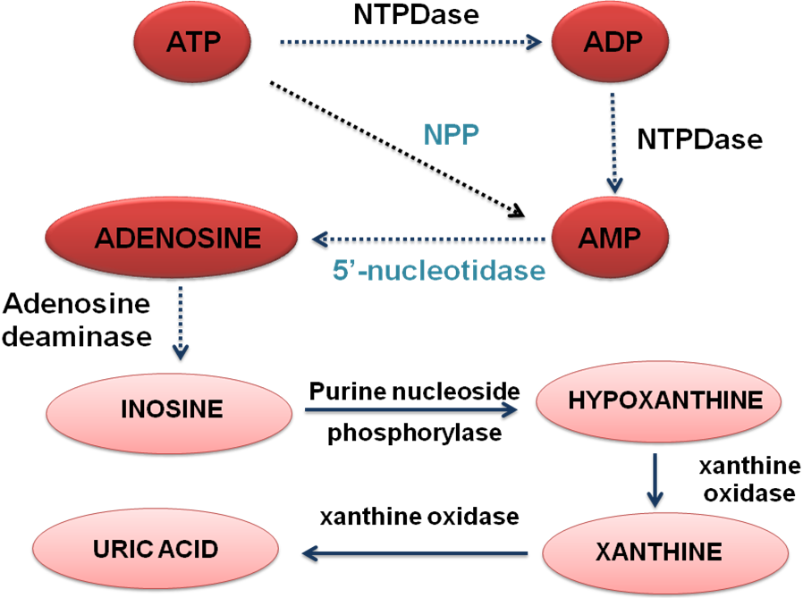
Figure 1 Schematic representation of the purinergic pathway. ATP is broken down to ADP and AMP by NTPDase or directly to AMP by pyrophosphatase/phosphodiesterase (NPP). AMP is converted to adenosine by 5′-ectonucleotidase (CD73). Adenosine deaminase (ADA) transforms adenosine into inosine which is converted in hypoxanthine by purine nucleoside phosphorylase (PNP). Xantine oxidase catalyzes the oxidation of hypoxanthine to xanthine and xanthine to uric acid.
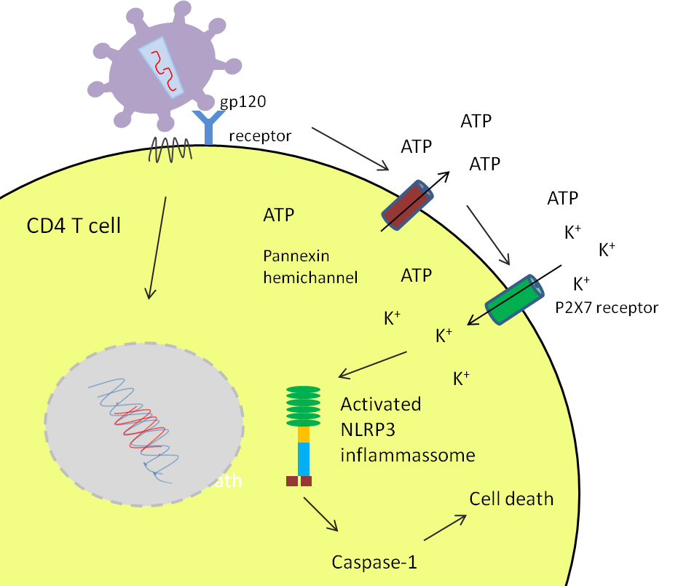Figure 2 Schematic illustration of ATP release and activation of NOD-like receptor family, pyrin domain containing 3 inflamassome in a human immunodeficiency virus infected CD4 T cell. Once human immunodeficiency virus gp120 binds to its receptor ATP release is stimulated through pannexin hemichannels with consequent activation of P2X7 receptor. The influx of potassium causes the activation of NOD-like receptor family, pyrin domain containing 3 (NLRP3) inflammassome leading to cell death via Caspase-1.

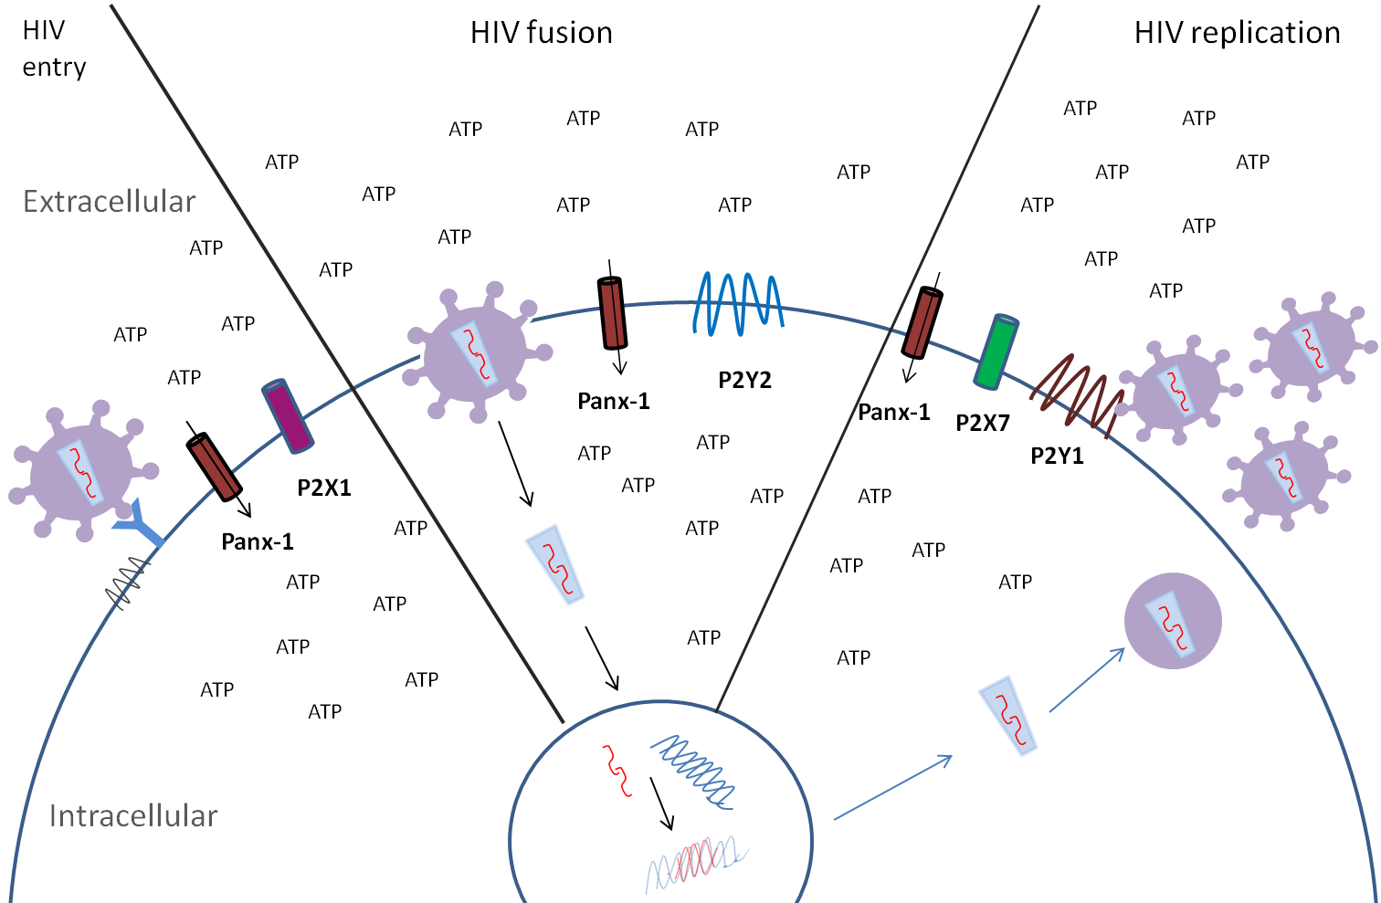
Figure 3 Schematic representation of purinergic receptors involvement in human immunodeficiency virus infection. Pannexin hemichannels (Panx-1) are open in response to ATP release and activation of purinergic receptors, facilitating viral entry, fusion and replication. The blockage of viral entry by P2X1 antagonists suggests it is involved in this stage of infection. P2Y2 increases cell membrane depolarization facilitating fusion. P2X7 and P2Y1 are involved in later steps of viral cycle.

