Name of Journal: World Journal of Gastroenterology
Manuscript NO: 66329
Manuscript Type: FRONTIER

Imaging of the chemotherapy-induced hepatic damage: Yellow liver, blue liver, and pseudocirrhosis

Calistri L et al. Imaging of chemotherapy-induced hepatic damage

Linda Calistri, Vieri Rastrelli, Cosimo Nardi, Davide Maraghelli, Sofia Vidali, Michele Pietragalla, Stefano Colagrande

Linda Calistri, Vieri Rastrelli, Cosimo Nardi, Davide Maraghelli, Sofia Vidali, Michele Pietragalla, Stefano Colagrande, Department of Experimental and Clinical Biomedical Sciences Mario Serio, University of Florence, Azienda Ospedaliera Universitaria Careggi, Florence 50134, Italy

Author contributions: Calistri L, Rastrelli V and Colagrande S contributed equally to this work, in terms of conceptualization, writing the original draft, reviewing and editing; Maraghelli D, Vidali S, Pietragalla M contributed in figures and references research; and all the authors have read and approved the final manuscript.

Corresponding author: Stefano Colagrande, MD, Full Professor, Department of Experimental and Clinical Biomedical Sciences Mario Serio, University of Florence, Azienda Ospedaliera Universitaria Careggi, Largo Brambilla 3, Florence 50134, Italy. stefano.colagrande@unifi.it

Received: April 19, 2021
Revised: June 15, 2021
Accepted: November 29, 2021
Published online:

Abstract
The liver is the major drug-metabolizing and drug-detoxifying organ. Many drugs can cause liver damage through various mechanisms; however, the liver response to injury includes a relatively narrow spectrum of alterations that, regardless of the cause, are represented by phlogosis, oxidative stress and necrosis. The combination of these alterations mainly results in three radiological findings: vascular alterations, structural changes and metabolic function reduction. Chemotherapy has changed in recent decades in terms of the drugs, protocols and duration, allowing patients a longer life expectancy. As a consequence, we are currently observing an increase in chemotherapy-associated liver injury patterns once considered unusual. Recognizing this form of damage in an early stage is crucial for reconsidering the therapy regimen and thus avoiding severe complications. In this frontier article, we analyze the role of imaging in detecting some of these pathological patterns, such as pseudocirrhosis, “yellow liver” due to chemotherapy-associated steatosis-steatohepatitis, and “blue liver”, including sinusoidal obstruction syndrome, veno-occlusive disease and peliosis.

Key Words: Hepatic damage; Yellow liver; Chemotherapy-associated steatohepatitis; Blue liver; Sinusoidal obstruction syndrome; Veno-occlusive disease; Peliosis; Pseudocirrhosis

Calistri L, Rastrelli V, Nardi C, Maraghelli D, Vidali S, Pietragalla M, Colagrande S. Imaging of the chemotherapy-induced hepatic damage: Yellow liver, blue liver, and pseudocirrhosis. World J Gastroenterol 2021; In press

Core Tip: Chemotherapy-induced hepatic damage represents an increasingly frequent condition observed in oncology patients: recent pharmacological innovations and specific and longer therapies have led to longer life expectancy and, inevitably, to an increase in systemic side effects and organ damage, primarily in the liver because of its detoxifying function. Even for experienced radiologists, the assessment of radiological patterns associated with liver injury derived from chemotherapy can sometimes be challenging. Our aim is to summarize useful ways to recognize, understand and monitor the evolution of these forms of hepatic damage to support clinicians in decision making.

INTRODUCTION
The liver plays key roles in the metabolism and detoxification of many commonly used drugs, predisposing hepatocytes to xenobiotic- and toxin-induced injury^{[1]}. Chemotherapy has recently evolved, from the use of cytotoxic drugs to new biological drugs acting on specific molecules critical for cell growth, differentiation, and nutrient supply. The advent of these new treatments, as well as the frequent use of multidrug regimens and the longer duration of systemic therapies due to longer survival, have increased the potential for liver parenchymal damage, collectively referred to as chemotherapy-associated liver injury (CALI)^{[2]}.
The first case of CALI was reported in the early 1950s in reference to clinical and laboratory signs of hepatic fibrosis presented by 5 children with acute leukemia during folic acid antagonist treatment^{[3]}. Recently, efforts to identify imaging features and standardize the management of CALI have been made^{[4,5]}. However, with the advent of newer molecular targeted oncological therapies and, more recently, immune checkpoint inhibitors, the evaluation and treatment of liver toxicity associated with these drugs are still evolving^{[6-9]}.
Regardless of the cause of injury, CALI can manifest as nonspecific symptoms and signs of abdominal discomfort, evidence of hepatomegaly, and/or elevated liver function tests, often representing a diagnostic dilemma for the oncologist, as the same symptoms and signs of liver injury may also be unrelated to chemotherapy^{[4,10]}.
Moreover, many chemotherapy-induced hepatic parenchymal effects can impair the detection of liver metastases. As patients with metastatic cancer increasingly undergo chemotherapy with curative intent, it is mandatory that radiologists understand the pathophysiology of these therapy-induced liver changes and become familiar with their imaging features^{[11]}. Finally, the early recognition of certain adverse reactions is essential for cancer patients to prevent dangerous complications such as acute hepatitis, liver cirrhosis, and even liver failure. Often, patients can be managed with supportive therapies, and the liver toxicity may resolve after discontinuation of chemotherapy.
After a summary of the main forms of liver damage, including drug-induced liver injury (DILI), we analyze the role of imaging in detecting certain pathological patterns of CALI that may appear during oncologic follow-up, such as so-called “yellow liver”, “blue liver” and “pseudocirrhosis”.

Hepatic Damage
Various forms of hepatocyte injury are known: infectious (viral hepatitis), autoimmune hepatitis, toxicity/drug-induced injury, metabolic injury (nonalcoholic fatty liver disease), and intracellular depositions (hemochromatosis, alpha-1-antitrypsin, Wilson disease, and metabolic diseases such as glycogen storage disorders)^{[12]}. Other types of damage involve biliary stasis-induced injury (“long standing obstruction of the bile duct”), injury to the hepatic artery that affects circulation, and damage from physical/chemical agents^{[13-16]}. Vascular alterations, inflammation and oxidative stress represent the pathogenesis of various forms of liver damage: in liver ischemia–reperfusion injury (during the liver transplantation process), the damage involves all parenchymal cells (hepatocytes, endothelial cells and cholangiocytes)^{[17]}. The lack of substrates and oxygen during the ischemic phase of injury results in the mitochondrial production of reactive oxygen species (ROS); in the reperfusion phase, the availability of oxygen further accentuates the oxidative stress, increasing damage to the donor liver; moreover, there is a concomitant release of inflammatory cytokines and an influx of inflammatory cells that amplify tissue injury^{[18]}. Considering a more general definition of damage as a reversible or irreversible modification of cellular and/or tissue function in response to a stressful stimulus, the liver response to injury includes a relatively narrow spectrum of morphologic changes, and accordingly, there are only a few pathologic patterns that can be recognized microscopically^{[19]}.
Therefore, dividing liver injury patterns by the cell type being destroyed, regardless of the cause, we can categorize injuries into cell-indiscriminate (most frequently in response to mechanical injury, ischemia, and liver resection), cholestatic (typically in response to mechanical and presumed autoimmune biliary injury), and hepatocyte-associated injuries^{[20]}. Hepatocyte-related injury includes cell death (apoptosis, necrosis, necroptosis, and autophagy) and degenerative and/or intracellular accumulation (i.e., ballooning degeneration, steatosis and iron or copper accumulation)^{[20,21]}.
Clinical data and animal models suggest that hepatocyte death is the key trigger of liver disease progression, manifested by the subsequent development of inflammation due to an influx of acute or chronic inflammatory cells involving the lobular parenchyma (diffuse inflammation), foci inside lobules or limited to the portal tracts (focal inflammation). If the damage is severe enough, and if the blood flow is adequate, then hepatic regeneration can restore a functional liver mass. If the damage is chronic, liver fibrosis/cirrhosis may develop^{[19,22]}.

Liver blood flow
Knowing the peculiarities of hepatic vascularity helps with understanding the imaging features of liver damage. Hepatic feeding is guaranteed for a 70%-75% by portal flow, with a low oxygen content and high metabolite content, and for a 20%-25% by arterial flow with a high oxygen content and a low metabolite content. The two systems are interconnected through transvasal, transsinusoidal and peribiliary communications that allow the arterial supply to compensate for any small reduction in portal inflow, according to a mechanism regulated by humoral mediators (adenosine, histamine, vasopressin, and prostacyclin) and by the autonomic nervous system, activated by hepatocyte demand for oxygen and metabolites^{[13,23]}. This condition appears on computed tomography (CT)/magnetic resonance (MR) images as hyperdensity/hyperintensity of the involved parenchyma during the arterial phase, also called transient hepatic parenchymal enhancement (THPE)^{[24]}. Depending on the level of the obstacle and the predominance of the shunt involved, different THPE, either localized or diffuse, can be seen on images. There are three diffuse types: (1) If the obstacle diffusely compromises the intralobular vein or the structures downstream (e.g., in Budd-Chiari or right-sided heart failure), the prevailing plexus is the trans-sinusoidal plexus, and the resulting THPE is of the “mosaic” type (Figure 1A); (2) If the obstacle is at the level of the portal axis or upstream from the intralobular vein (as happens in portal thrombosis or cirrhosis, respectively), the prevailing shunt is peribiliary, and the resulting THPE is of the “central-peripheral” type (Figure 1B); and (3) In contrast, if the peribiliary plexus is blocked, as occurs in bile duct dilatation or sometimes in cholangitis, arterialization is “peribiliary”^{[24]} (Figure 1C).
In addition to the major vascular systems, a third type of vasculature contributes no more than 2%–3% of hepatic blood flow, establishing communication between the systemic venous system and the portal system, and it includes capsular veins, Sappey’s paraumbilical veins, epiploic and hilar veins, suspensory ligament and diaphragmatic veins, and accessory cystic veins^{[24]}. These components may act according to the pressure gradient through an anomalous blood supply or drainage from vessels to certain areas of the parenchyma, mainly located in segments I–IV. Normally, the third inflow is “afferent” to the liver, but its flow direction can be reversed. Therefore, during portal hypertension or under other stress conditions, the intraportal pressure becomes higher than that of the systemic veins, and the “third” hepatic system becomes efferent, allowing a preferential outflow that can cause a localized reduction in portal inflow, sometimes resulting in a compensatory “arterial buffer response” and correlated sequelae^{[24]}. The same diversion of the third inflow explains both the development of shunting systems in cirrhotic liver and the appearance of pseudonodular lesions in noncirrhotic liver, especially after chemotherapy, which can damage minor portal vessels and facilitate blood inflow through the third inflow system^{[24]}.
In general, if the cause of arterial rebound persists, hepatocyte can be injured as in normal conditions they need low oxygen tension and high nutrient levels typical of those supplied by portal inflow. Therefore, persistent hemodynamic changes can determine focal metabolic alterations that result in focal sparing in fatty liver or nodular fat accumulation in normal liver, which are typically found in the subdiaphragmatic aspect of the right lobe, the posterior aspect of the left lobe, the periportal aspect of segment IV, around the falciform ligament and around the gallbladder bed^{[25,26]} (Figure 2). Finally, if the obstacle remains, then the insufficient blood supply to much of the liver leads to metabolic infarction, fibrosis and atrophy of the liver (especially in segments V, VI and VII, where the third inflow is lacking or poorly represented) (Figure 3), along with compensatory nodular regenerative hyperplasia (NRH) and large regenerative nodules in areas of hepatic parenchyma that maintain an adequate portal and arterial blood supply (especially the left lobe and segment VIII, with higher third inflow)^{[24,27-29]}.

DILI
DILI is a current hot topic, as seen by the increasing number of publications in recent years^{[30-32]}. It is a challenging clinical problem with respect to both diagnosis and management, with an estimated incidence of 14 to 19 cases per 100000 persons^{[30]}. Iproniazid, cinchophen, and sulfonamides were the first prototypical hepatotoxins to be identified^{[31,33]}. By the mid-1980s, close to 1000 drugs were linked to hepatic injury^{[34]}. Clinically, DILI ranges from asymptomatic hypertrasaminasemia and hepatitis to acute or fulminant hepatic failure^{[35]}. Although severe DILI is rare, drugs have become the overall leading cause of acute liver failure in the United States and other Western countries^{[31]}: acetaminophen (paracetamol) is the responsible drug in 40%-50% of these cases, with another 11%-12% of cases caused by herbal compounds and dietary supplements, equaling the frequency of cases due to acute viral hepatitis^{[36,37]}.
On the basis of liver function tests, DILI may be defined as predominantly hepatic, distinguished by disproportionate elevations in serum aminotransferases compared with the level of alkaline phosphatase, or cholestasis, distinguished by inverted, disproportionate and mixed patterns^{[36]}.
Considering the histopathology, DILI is particularly complex. The United States DILI Network recognizes 18 distinct categories of DILI: acute and chronic hepatitis, acute and chronic cholestasis, cholestasis-hepatitis, granulomatous, macro- and microvesicular steatosis, steatohepatitis, zonal and nonzonal necrosis, vascular injury, hepatocellular alterations, nodular regenerative hyperplasia, mixed or unclassified injury, minimal nonspecific changes, absolutely normal, and massive necrosis^{[38]}.
Currently, DILI is classified as either idiosyncratic (injury unpredictable, not dose-dependent, and caused by agents that have little or no intrinsic liver toxicity) or direct (injury predictable, dose-dependent, and caused by agents that are intrinsically toxic to the liver), but indirect injury is now accepted as a third type (caused by the action of the drug not by its toxic or idiosyncratic properties, such as the induction of immune-mediated hepatitis or the worsening of pre-existing hepatitis or fatty liver disease)^{[30]}.
The most common forms of DILI involve idiosyncratic hepatotoxicity, including acute and chronic hepatitis (most often associated with isoniazid, nitrofurantoin, and diclofenac and with methyldopa, minocycline, and statins, respectively), acute and chronic cholestasis (correlated with estrogens, androgenic steroids and flurixidine), and mixed hepatitis-cholestasis (due to amoxicillin-clavulanate and fluoroquinolones) patterns^{[30,32,39]}.
Many antineoplastic agents can cause acute hepatic necrosis due to direct hepatoxicity, as well as sinusoidal obstructive syndrome (SOS) (myeloablative agents, alkylating agents and monoclonal antibody-cytotoxic conjugates such as gemtuzumab and ozogamicin) or NRH (azathioprine, mercaptopurine and thioguanine)^{[30,32,39]}.
Finally, an increasing form of indirect injury is immune-mediated liver injury due to various immunomodulatory agents, tumor necrosis factor antagonists, and, most important, antineoplastic checkpoint inhibitors^{[40-42]}. There are several reports of the reactivation of both hepatitis B and hepatitis C in patients treated with agents such as rituximab, cyclophosphamide, doxorubicin, vincristine, or prednisolone for lymphoma^{[2,43]}.

CALI
Among the various forms of DILI, CALI is often reported in the literature, mainly in association with patients with colorectal liver metastases^{[44-46]}. CALI appears to be regimen-specific, generally including two main types of liver injury, vascular changes and fatty changes, which are primarily associated with the development of ROS that lead to cellular damage and activate apoptosis pathways^{[5]}. The prevalence of CALI increases with the duration of chemotherapy, and currently, no convincing data on the reversibility of CALI are available^{[46]}.
Various studies support the important clinical impact of CALI. Karoui et al^{[47]} demonstrated that CALIs increased the risk of postoperative liver failure by 11%, with others such as Vauthey et al^{[48]} demonstrating increased 90-d postoperative mortality in patients with steatohepatitis (14.7% vs 1.6%). Nevertheless, it remains unclear whether CALI influences survival. Although Tamandl et al^{[49]} reported lower survival in patients with SOS, other studies demonstrated that SOS is associated with a lesser degree of regression of liver metastases, and this regression, not SOS, impacts prognosis^{[50,51]}. Controversial data have also been reported for steatosis^{[50,52]}. Moreover, postoperative morbidity and mortality due to liver failure are often related to inadequate function of the residual liver^{[53]}. Therefore, the improved detection of CALI during the preoperative assessment of the future liver remnant is an important clinical issue.
More frequently, oxaliplatin treatment is associated with SOS, which occurs in 19%–52% of patients and is linked to an increased occurrence of NRH^{[54]}. Irinotecan-based treatments are related to the appearance of steatohepatitis, with a rate of 20.2%, and its effects are exacerbated by baseline obesity and/or metabolic syndrome^{[51,55]}. Furthermore, the development of steatosis was observed in 30 to 47% of patients who received 5-fluorouracil therapy, which remains a cornerstone of modern chemotherapy^{[10,56]}.
More unusual forms of CALI include pseudocirrhosis, which is mostly observed in patients undergoing chemotherapy for breast cancer, and chemotherapy-induced sclerosing cholangitis (CISC)^{[57]}. CISC is a form of secondary sclerosing cholangitis, occasionally resulting from ischemic injury to the bile ducts associated with hepatic artery infusion with fluoropyrimidines (incidence of 8%-55%). Since biliary endothelial cells, in contrast to hepatocytes, derive their vascular supply almost exclusively from the branches of hepatic arteries^{[58]}, arterial occlusion may cause bile duct ischemia and fibrosis without parenchymal infarction. The main finding was segmental or diffuse narrowing of the cystic, biliary-shared, left and right hepatic ducts, with sparing of the common intrapancreatic bile duct, which is usually supplied by branches of the gastroduodenal artery^{[58]}. Reports of CISC triggered by systemic chemotherapy (taxanes, bevacizumab, paclitaxel, or cisplatin) are even more rare^{[59,60]}. Although CISC should be considered rare, it is clinically important, requiring frequent endoscopic intervention to maintain biliary drainage^{[58]}.
Finally, over the past two decades, molecular targeted agents, including small-molecule protein kinase inhibitors, monoclonal antibodies, and immune checkpoint inhibitors, have become promising for use in the treatment of various malignant neoplasms (especially malignant melanoma, non-small cell lung cancer and renal cell carcinoma)^{[61]}. Protein kinase inhibitors are reported to induce a low-grade elevation in serum transaminases in approximately 30% of patients and high-grade elevation in 2% of patients^{[62]}. Liver injury due to immune checkpoint inhibitors most often presents with a hepatocellular biochemical pattern, occurring in 2%-30% of patients, with increasing risk when multiple immune checkpoint inhibitors are administered and in patients who develop other immune-related adverse events, although severe cases remain very rare^{[63]}.
Overall, radiologists should know that chemotherapy frequently modifies not only the radiological appearances of liver tumors but also the imaging features of the non-tumor-bearing liver. Excluding CISC, due to its rarity, and acute hepatitis, due to its nonspecific imaging features (hepatosplenomegaly, collapsed gallbladder with wall thickening, decreased liver enhancement, ascites and widening of the periportal space due to edema)^{[2]}, we analyze the role of imaging in the identification of more typical features of CALI, namely, yellow liver, blue liver and pseudocirrhosis.

YELLOW LIVER
The term “yellow liver” refers to a macroscopic feature of the liver that can be observed upon histopathologic examination and is determined by a general increase in the parenchymal lipidic content, compared to physiological normal texture^{[5]}. Different pathological conditions fall under the generic definition of yellow liver. Hepatic steatosis is identified by pathological deposition of lipid vesicles in hepatocytes, usually associated with metabolic syndrome, obesity, diabetes, insulin resistance or alcohol^{[64]}. Hepatic steatosis must be differentiated by steatohepatitis, a more serious histologic complication where fat deposition is associated with an inflammatory response, consisting of ballooning of hepatocytes, lobular inflammation, hepatocyte degeneration and thus fibrosis of different grades, including liver cirrhosis^{[48]}. CASH is a form of steatohepatitis that can sometimes develop as a consequence of therapies with chemotherapeutic agents (CTAs) that produce side effects critical for hepatocyte^{[65,66]}.
Among the forms of CALI, other than the aforementioned association with 5-fluorouracil-based treatment^{[57]}, steatosis is seen in 14.6% and 41.1% of patients with estrogen-receptor-positive breast cancer treated with tamoxifen and anastrozole, respectively^{[10,67]}. Additionally, cases of steatosis in patients receiving pazopanib and bevacizumab, alone and in combination with paclitaxel, have been reported^{[6]}. Similarly, an increased incidence of CASH in recent decades has been reported^{[56,68,69]}. Although the true frequency of these pathologies is not easily determined^{[65,70]}, as mentioned above, the prevalence of CASH is increasing in patients undergoing treatment with 5-fluorouracil and irinotecan^{[71]}, especially when the drugs are coadministered^{[48]}. Additionally, platinum derivatives (oxaliplatin), taxanes and methotrexate have been linked to this condition, and with a lower frequency, L-asparaginase, dactinomycin, mitomycin C and bleomycin sulfate^{[72,73]}.
Interestingly, steatosis and CASH occur not only during treatment for liver metastases but also in the course of systemic chemotherapy for nonmetastatic cancer^{[71]}. Considering the pathogenesis of steatosis, as discussed above (see “Liver blood flow”), persistent hemodynamic changes determining focal metabolic alterations and the third hepatic inflow system are involved. The pathogenesis of CASH remains under discussion, and different mechanisms have been proposed. First, CTAs can be responsible for decreasing fatty acid oxidation, thus generating oxidative stress with hepatocyte dysfunction^{[74]}. According to You et al^{[11]}, CTAs have been reported to produce abundant ROS, damaging not only cancer cells but also normal cells. This damage promotes both the deposition of lipid vesicles into hepatocytes and inflammation^{[65,75]}. Robinson et al^{[57]} described a “two hits” model, in which patients with underlying hepatic steatosis, undergo a “second hit” to the parenchyma, represented by chemotherapy-induced oxidative stress or mitochondrial dysfunction, creating the conditions of inflammation and giving rise to CASH. Finally, minor portal vessels can be increasingly susceptible to the direct damage caused by CTAs, facilitating the reversion of the “third inflow” system and triggering consequent arterial compensation. Therefore, the resultant inadequate perfusion, together with direct damage to hepatocytes, can contribute to the metabolic dysfunction critical for CASH development^{[24]}.
Fatty infiltration leading to yellow liver requires a relatively short development time (generally only a few weeks after the beginning of chemotherapy)^{[57]}. Hepatic steatosis and steatohepatitis are typically asymptomatic even when liver function tests are abnormal, making an early diagnosis a difficult goal^{[4]}. When chemotherapy is withdrawn, there is often a regression of steatosis, suggesting that most of the changes caused by chemotherapy are at least partially reversible^{[6,57]}. In other cases, especially when the diagnosis is delayed or under-evaluated, the parenchymal inflammatory response can lead to more serious and irreversible changes, including fibrosis and atrophy. Finally, the regenerative phenomenon of liver parenchyma, such as in NRH, is a possible compensatory response to injury, as long as adequate perfusion is maintained^{[28,56,76]}. As expected, when steatosis is present prior to the therapy, liver is thought to be more susceptible to CALI due to its impaired regenerative capability and abnormal innate immunity^{[10]}. Diffuse forms of hepatic steatosis and steatohepatitis can be obstacles to surgical planning, e.g., not allowing large liver resection due to presence of metastases^{[69]}. Patients with steatosis who undergo major hepatectomy have increased blood loss, more postoperative complications, and a longer stay in the intensive care unit than patients with healthy livers^{[19]}. Finally, patients’ postoperative morbidity and mortality can be increased since both steatosis and steatohepatitis impair liver function^{[48]}.

Imaging
Clinicians increasingly demand the quantification of liver fat to grade the level of hepatic damage, not only in living donors for liver transplantation and for patients who must undergo liver resections or bariatric surgery but also in patients receiving potentially hepatotoxic therapies. The ability of MR-based methods to detect and quantify steatosis has been investigated in the past 30 years, and substantial correlations between pathologically and radiologically determined fat fractions have been demonstrated^{[77-79]}.
However, most often, in daily practice, steatosis and steatohepatitis are evaluated qualitatively. From a radiological point of view, it is impossible to differentiate between these two forms of liver disease, as they can be distinguished only by histologic alterations^{[71]}. The distribution of CASH, as well as hepatic steatosis, can vary from diffuse to focal infiltration. Ultrasound allows a subjective estimation of the degree of diffuse fatty infiltration using some features that include liver brightness and contrast between the liver and the kidney^{[80]}. On an unenhanced CT scan, diffuse steatosis can be diagnosed when attenuation of the liver is at least 10 Hounsfield units less than that of the spleen, the hepatic-to-splenic attenuation ratio is less than 1, or the liver attenuation is less than 40 Hounsfield units (Figure 4A). In more severe cases, intrahepatic vessels may appear hyperdense relative to fat-containing liver tissue^{[81]}. With MRI, chemical shift gradient-echo imaging with in-phase and out-of-phase acquisitions is the most widely used technique for the assessment of fatty liver (Figure 4E and F). These scans show signal intensity loss on out-of-phase images in comparison with in-phase images, whereas the application of chemical fat saturation sequences is less sensitive^{[82,83]}.
While diffuse forms of steatosis are not difficult to recognize, focal fat deposition or fatty sparing can sometimes mimic a hepatic mass or single and multimetastatic disease^{[84]}. However, MRI often serves as a problem-solving tool because signal loss on out-of-phase T1-weighted images cannot be seen in metastasis^{[85]}. Additionally, focal fatty deposition or sparing can be recognized by the characteristic location (in the anatomic sites of the third inflow system), geographic pattern rather than round or oval shapes, absence of a mass effect on the vasculature, poorly delineated margins, and contrast enhancement that is similar to or less than that of the normal liver parenchyma^{[9,86]} (Figure 5). These features usually allow for the differentiation of focal or multifocal fat accumulations from hepatocellular carcinoma, hepatic adenoma, focal nodular hyperplasia (FNH), FNH-like nodules and hypervascular metastases that show mass effects, marked or heterogeneous enhancement, and sometimes necrotic and hemorrhagic areas; however, hepatocellular carcinomas, hepatic adenomas and, more rarely, FNH, may involve microscopic fat content^{[87]}. Clinical manifestations and diffusion-weighted images can help in the more complex differentiation of ischemic or mucinous metastases, abscesses, lymphoma and hypovascular metastases^{[87-89]} (Figure 4K). The differential diagnosis between large areas of focal steatosis with infiltrative hepatocellular carcinoma may be more difficult; irregular liver contours, mild mosaic pattern enhancement and the presence of portal vein thrombosis are suggestive of the latter^{[87]}. Shape, location and MR chemical shift imaging allow us to distinguish periportal fat deposition from other periportal abnormalities (edema, inflammation, hemorrhage, and lymphatic dilatation) and focal sparing in the liver with diffuse steatosis mimicking hypervascular lesions (such as hemangiomas or arterioportal shunts)^{[87]}. Interestingly, when steatosis develops during chemotherapy, in the presence of hepatic metastases, the parenchyma surrounding the lesion can be spared from steatosis^{[90]}. Once again, this outcome may be attributed to a modification of parenchymal perfusion, and in particular, a reduction of portal inflow in the peritumoral area caused by direct compression of the adjacent parenchyma, the presence of tumor emboli in the portal vein branches^{[90]} and/or the neoangiogenesis that accompanies tumoral growth, increasing arterial perfusion^{[91,92]}.
Morphological changes such as increased craniocaudal liver diameter and an increased caudate-to-right lobe ratio are more characteristic of steatohepatitis^{[93]}. Finally, when CASH is diagnosed in advanced stages and, in particular, when it progresses toward cirrhosis, typical morphological changes of the latter can be observed^{[94]}.

BLUE LIVER
Blue liver refers to parenchymal venous congestion resulting from blockage of blood outflow, macroscopically characterized by an intraoperative subcapsular livid appearance and a similar “marble” bluish-red discoloration on the cut surface^{[95]}. Budd-Chiari syndrome is a typical postsinusoidal form of blue liver. In this case, the physical obstacle to hepatic outflow, represented by stenosis or a thrombus, is located in the hepatic veins or in the inferior vena cava, and therefore, considering the blood flow, after the hepatic sinusoids^{[24]}. However, different causes of blue liver are possible. Other postsinusoidal forms include increased blood pressure in the right atrium (e.g., congestive heart failure, constrictive pericarditis, and mitral stenosis)^{[96]}. Moreover, injuries to the sinusoidal endothelium itself can cause a sinusoidal form of blue liver that is mainly known as SOS, but that includes a full spectrum of histologic features involving restrictive (nonthrombotic sinusoidal obstruction and perisinusoidal fibrosis), dilating (hepatic sinusoid dilation and peliosis) and regenerative (NRH) aspects of the disease^{[97]}.
Considering CALI, sinusoidal endothelial injury can be defined as nontumor-bearing hepatic parenchymal damage resulting from chemotherapy itself, not associated with the presence or infiltration of hepatic metastasis^{[11,98]}. Therefore, the injury primarily originates at the level of the sinusoidal endothelium, eventually extending distally to the centrilobular veins or proximally to the portal branches. Its pathogenesis remains under discussion, but some consistent data have been reported. Namely, oxaliplatin induces depolymerization of F-actin in sinusoidal endothelial cells and activates matrix metallopeptidase (MMP-9 and MMP-2)^{[57,99,100]}. This activation results in cytokine production, which induces sinusoidal endothelial damage and swelling^{[101]}. Depletion of antioxidants such as glutathione and nitric oxide from endothelial cells can increase the damage^{[102]}. Therefore, floating red blood cells enter the space of Disse through the gaps formed in the sinusoidal endothelium (the basis of peliosis), and collagen fibers are deposited in the extravascular space (perisinusoidal fibrosis). A combination of these factors, in addition to clogging of necrotic sinusoidal endothelial cells in sinusoids, results in sinusoidal narrowing, thus causing obstruction and increased pressure in the sinusoids. When sinusoidal outflow blockage is sustained, sinusoids upstream of the obstruction undergo dilation and disruption, resulting in pseudocystic blood-filled lacunae typical of peliosis. Concurrently, the damage from altered hepatic blood flow induces the regeneration of residual hepatocytes to replace the parenchymal damaged cells, giving rise to NRH^{[103]}.
As a consequence, the histology of sinusoidal injury involved in blue liver is heterogeneous. In the early phase, vascular alterations are predominant, including sinusoidal dilatation and congestion, perisinusoidal hemorrhage and peliosis. With the progression of the damage, fibrosis of different grades (which can be localized in the perisinusoidal space around the centrilobular vein or portal vein) is dominant, and hepatocyte disruption and NRH are evident. Although primarily originating from impaired hepatic perfusion, blue liver is characterized by parenchymal nodularity without fibrous septa, with a benign aspect similar to that of FNH, resulting from the regeneration of hepatocytes replacing the parenchymal damaged cells^{[57]}. Oxaliplatin is a well-known drug implicated in the development of NRH, vascular injury, such as sinusoidal ballooning, microvascular injury, and long-term fibrosis. Furthermore, paclitaxel, capecitabine, doxorubicin, and trastuzumab are also known to be causative CTAs^{[104]}.
In cases of severe progression, the chronic presentation of blue liver can be similar to that observed in cirrhosis^{[105]}. However, in the advanced stage of chemotherapy-induced sinusoidal injury, fibrosis develops primarily between the centrilobular veins; in contrast, in primary liver disease, such as cirrhosis, bridging fibrosis, promoted by inflammation, usually develops between portal spaces. Therefore, the histologic pattern that occurs in certain forms of blue liver has been variably defined as “cardiac cirrhosis”, “reversed lobulation” or “centrilobular cirrhosis”^{[96]}.

Veno-occlusive disease and SOS
Veno-occlusive disease (VOD) is a well-established condition historically associated with myelosuppressive therapy in hematologic malignancies, and it is characterized by the obliteration of small hepatic venules and centrilobular fibrosis without macroscopic signs of obstruction^{[97]}. This pathologic alteration was first reported in 1920 by Willmot et al^{[106]} and was caused by lethal intoxication by pyrrolizidine alkaloids, which are present in certain herbal remedies. The association between chemotherapy and VOD became clear in the 1950s^{[107]}. Finally, in 1999, when DeLeve et al^{[98]} recognized that the disease originated primarily in the hepatic sinusoid and did not necessarily involve the centrilobular vein, the disease was renamed SOS. These two forms therefore indicate a non-thrombotic obstruction of hepatic sinusoids with (VOD) or without (SOS) involvement of the centrilobular veins, whereas large hepatic veins remain patent^{[98]}.
More often, these pathological conditions diffusely involve the nontumor-bearing hepatic parenchyma. However, rare cases of focal SOS have been reported. The true incidence of sinusoidal focal injury remains unknown, but radiologists should be aware of it since, similar to focal steatosis, it can mimic hepatic metastasis^{[11,108]}.
Several CTAs are critical for the sinusoidal type of CALI. In particular, cyclophosphamide has been associated with the development of a rapidly progressive form of VOD^{[109]}. Even 5-fluorouracil, mercaptopurine, dacarbazine, and vincristine have been associated with it^{[110]}, with an onset of damage ranging from 1 to 3 wk after initiation of therapy^{[4]}.
However, oxaliplatin, more than other CTAs, seems to be particularly involved in the development of SOS. According to Rubbia-Brandt et al^{[103]}, 51%–79% of patients who underwent oxaliplatin-based therapy developed SOS, compared with only 21%–30% of the patients who received different regimens^{[75,111]}. Nonetheless, the incidence of sinusoidal injury is significantly higher in patients who receive more than 6 cycles of chemotherapy, while adding the anti-vascular endothelial growth factor antibody bevacizumab seems to have a protective effect^{[112]}.
Most patients with diffuse SOS are asymptomatic, in contrast to patients with VOD^{[97]}. Clinical presentation in the acute phase may include abdominal pain and ascites. In the subacute setting, patients present with recurrent ascites and hepatosplenomegaly resulting from portal hypertension, which can be confirmed with a transjugular biopsy (pressure gradient > 10 mmHg), while the chronic presentation is similar to that of cirrhosis. Hematic tests may show nonspecifically increased bilirubin and hepatic enzyme levels^{[105]}.
Concerning prognosis, diffuse forms of SOS are associated with poor outcomes and a higher complication rate after major hepatectomy. Especially since the liver parenchyma tends to become soft and brittle, patients who undergo hepatectomy show an increased risk of perioperative morbidity (approximately 30%)^{[97,99]} and postoperative complications^{[113]}. Indeed, the presence of SOS is associated with a reduced liver functional reserve^{[108]}.

Imaging
Since the disease was renamed, imaging findings of VOD have been limited to case reports^{[114]}, whereas data regarding SOS are more consistent.
Concerning oxaliplatin-based chemotherapy, the radiological features reach a maximal severity approximately 4 mo after the beginning of therapy, and they show radiologic remission approximately 3 mo after discontinuation^{[115]}. The cessation of chemotherapy is often followed by a reduction in these abnormalities, suggesting that SOS, at least for mild-to-moderate forms, both diffuse and focal, is potentially reversible^{[108]}.
Morphological alterations such as hepatosplenomegaly, periportal edema, edematous wall thickening of the gallbladder and ascites can be seen^{[116]}. With the detection of ascites, it is important to confirm the diagnosis of SOS and distinguish it from the malignant ascites associated with peritoneal spread or metastasis^{[117]}. US may show a decrease or reversal of blood flow in the portal veins, but its usefulness is debated^{[105,108]}. Contrast-enhanced CT imaging features include arterial-portal heterogeneous parenchymal enhancement, characterized by a “mosaic pattern” or diffuse linear hypoattenuation lesions resulting from hepatic congestion, which tend to be homogenous in the late phase. These alterations are predominantly located in the peripheral area (67.1%) and right hepatic lobe (62.4%), with an irregular distribution of abnormal areas intermingled with intact lobules^{[11,118]}. A reduced caliber of suprahepatic veins has also been reported^{[4]}. Eventually, complications of portal hypertension, such as the presence of periesophageal varices, form^{[116]}.
Similarly, MR images show a heterogeneous reticular or linear pattern in the nontumor-bearing parenchyma characterized by hypointensity on T1-weighted images and hyperintensity on T2-weighted images. Using liver-specific contrast agent (CA), reticular hypointensity of background liver tissue on hepatobiliary phase images with a high prevalence in peripheral areas of the liver is highly specific for SOS, occurring in 69% of cases^{[11,119]}. This radiological finding is probably due to reduced uptake of liver-specific CA resulting from dysfunctional damaged hepatocytes and reduced portal flow^{[119]} (Figure 6I, J, and K). In focal SOS, the presence of ill-defined margins, especially on hepatobiliary phase images, and the absence of restricted diffusion on diffusion-weighted images, can help differentiate focal hepatic toxicity from metastasis^{[118]}.
Severe forms of SOS can also progress after discontinuation of therapy, leading to the appearance of regenerative phenomena including cirrhotic alterations^{[10]}. In addition, in oxaliplatin-treated patients, portal hypertension and histological changes in NRH can arise during long-term therapy with 6-thioguanine for acute lymphatic leukemia^{[120]}. The nodularity of NRH is usually microscopic and thus is not detectable on images. Larger nodules can show hyper/hypointensity on T1/T2-weighted images and increased vascularity (hyperintensity in the arterial phase, followed by iso- or slight hyperintensity in the portal and equilibrium phases), but their benign nature can be confirmed by their normal uptake of liver-specific MR CAs^{[57]}.
Finally, FNH-like lesions have been described to occur in these patients many years after the discontinuation of chemotherapy^{[108]} (Figure 7).

Hepatic sinusoid dilatation and peliosis hepatis
Hepatic sinusoid dilatation (HSD) is a rare hepatic vascular lesion characterized by diffuse dilatation of hepatic capillaries with or without venous outflow obstruction. Causes of HSD with hepatic outflow obstruction include Budd Chiari syndrome, pericardial disease or right heart failure, and sinusoidal occlusion secondary to endothelial sinusoidal damage itself, as in SOS. It can be classified according to the affected zone of the hepatic lobule as centrilobular, periportal, or irregular^{[108]}. On the other hand, forms of HSD without venous outflow obstruction are caused by extrahepatic acute inflammatory conditions (pyelonephritis, cholecystitis, pneumonia, pancreatitis, and inflammatory bowel diseases), use of oral contraceptives (still debated as a possible cause) and chronic conditions, such as congenital or idiopathic vascular diseases, neoplasms with or without secondary liver involvement, inflammatory or infectious diseases, the use of hormones and drugs.
HSD can be distinguished from peliosis, since the latter shows evidence of rupture of the reticulin fibers that support hepatocytes and sinusoids^{[121]}. More precisely, peliosis hepatis is characterized by multiple blood-filled cystic lesions at the level of the sinusoids, with dimensions ranging from 1 mm to several centimeters, randomly distributed throughout the lobule, with loss of the endothelium^{[120]}. Peliosis hepatitis was first described in 1861 on the basis of the Greek word “pelios”, meaning “reddish” or “bluish”, referring to the parenchymal color^{[122,123]}. It is often a primary idiopathic condition (Figure 8). However, different etiologies have been proposed for secondary forms, including toxins (arsenic and polyvinyl chloride) and certain drugs, such as steroids, oral contraceptives, tamoxifen, 6-thioguanine, 6-mercaptopurine and methotrexate. Chronic wasting diseases have been proposed as another possible causes (diabetes mellitus, malignancy, acquired immunodeficiency syndrome, pregnancy, and infectious diseases, such as tuberculosis, leprosy, Bartonella and adenovirus)^{[105,120,124]}.
Its pathogenesis is not completely clear, except for SOS-dependent peliosis, and regardless of the cause, sinusoidal damage has been generally proposed as being critical to outflow blockage and dilation of the sinusoids/central vein of the hepatic lobule^{[120,125]}. Moreover, hepatocellular necrosis may represent another possible mechanism with the subsequent formation of blood-filled lacunae^{[126,127]}. Two different histological forms of peliosis can be identified: the parenchymal type, usually associated with hemorrhagic parenchymal necrosis and characterized by a lack of endothelial lining within the blood-filled lacunae, and the phlebectatic type, with a dilated central vein, showing an endothelial lining within the cystic spaces^{[128]}. However, these seem to represent different temporal phases of the same condition, with the endothelial lining in the blood-filled lacunae continuously being disrupted and rapidly reconstituted^{[129]}.
The distribution of the lesions can vary considerably, from focal areas of peliosis within the liver parenchyma to widespread forms occupying most of the liver parenchyma^{[130,131]}. Peliosis hepatis is usually an asymptomatic condition and therefore is often incidentally diagnosed. However, patients can present with hepatomegaly, portal hypertension, hepatic failure and ascites. Severe abdominal pain is a possible complication associated with minor trauma, resulting in hepatic rupture and hemoperitoneum^{[132]}. The evolution of peliosis is variable and unpredictable. Peliosis sometimes worsens in terms of extension, thus remaining asymptomatic^{[133,134]}. In the presence of underlying conditions such as HCV-related cirrhosis, it can promote the risk of liver failure^{[130,134]}. In some cases, especially in young patients, this alteration can cause compression and stenosis of the vena cava^{[135]}. However, regression is also possible once the etiologic agent causing secondary peliosis is identified and treated^{[130,134]}, and idiopathic forms can undergo spontaneous regression^{[136]}.

Imaging
On contrast-enhanced CT and MR images, HSD is associated with the typical features described for SOS, with mosaic pattern enhancement in the arterial-portal phase and reticular hypointense appearance in the MR hepatobiliary phase. On T2-weighted images, the affected areas may show slightly increased and heterogeneous signal intensity^{[137]} (Figure 9).
The imaging features of peliosis depend on its extension, pathologic type and stage of blood components. In a few cases, the number or size of the peliotic lesions can increase in a short period and disseminate throughout the liver, resembling the progression of liver carcinoma or metastases^{[138]}.
On US, peliotic lesions appear homogeneous and hyperechoic, associated with pseudocyst formation, which may correspond to venous lacunae in the parenchyma^{[124]}, whereas in fatty liver, they will appear as hypoechoic lesions. In addition, when hemorrhage is present, US shows heterogeneously hypoechoic lesions. Unenhanced CT generally shows hypodense lesions, eventually associated with hyperdense foci, secondary to hemorrhage or calcifications (Figure 10). In dynamic phases, the pattern is variable; usually, in the arterial phase, the lesions show vessel-like enhancement at the center (target sign), with centrifugal enhancement during the venous phase; however, a centripetal enhancement pattern is also possible, which may be confused with that of a hemangioma^{[139]}. Lesions tend to acquire diffuse homogeneous enhancement in the delayed phase^{[120,128]}. In the presence of thrombosed cavities, these latter may show no enhancement.
MR examination is the gold standard for radiologic diagnosis, presenting high specificity and sensitivity in the detection of the features of peliosis^{[134,136]}. In MRI, on T2-weighted sequences, peliotic lesions are usually hyperintense compared to liver parenchyma with foci with a higher signal, which is likely attributable to hemorrhagic necrosis. On T1-weighted sequences, the lesions are hypointense, although isointense and hyperintense foci have also been described, depending on the age and the status of the blood components^{[120,140]}. Exophytic extension of the peliotic nodules and fluid-fluid level, probably due to old and new blood products in the lesions, are rarely reported^{[140]}. The dynamic behavior after CA administration is similar to that seen on CT scan, typically centrifugal, and more rarely centripetal^{[120]}. In the hepatobiliary phase, a “branching” appearance caused by the direct demonstration of the vascular component within the lesion has been reported^{[134]}. Although peliosis hepatis is a benign condition, the apparent diffusion coefficient values are lower than those of a normal-appearing liver, probably due to its content, including thrombi and hemorrhaged areas^{[140]} (Figure 6). If the clinical and radiological findings are suggestive of peliosis, percutaneous liver biopsy should be avoided because of the significant risk of severe bleeding^{[141]}.
A summary of the liver mosaic appearance enhancement in blue liver and a classification of hepatic peliosis types are shown in Figure 11 and Figure 12, respectively.

PSEUDOCIRRHOSIS
Pseudocirrhosis is a pathological condition characterized by morphological changes of the liver mimicking macronodular cirrhosis without histopathological confirmation^{[104,142]}. The ‘‘pseudo’’ prefix can also lead to confusion, indicating a more benign condition than cirrhosis; indeed, even for patients who are asymptomatic and pseudocirrhosisis identified only incidentally during oncological follow-up, most patients can develop serious systemic complications, sometimes life-threatening, including portal hypertension, ascites and splenomegaly^{[143]}. Abdominal distension, ascites and splenomegaly are the most common initial presentations in patients. Therefore, early recognition is important.
Breast cancer liver metastasis treated with chemotherapy is the most commonly reported cause of pseudocirrhosis^{[143,144]}. However, it has also been linked to other metastatic diseases, including gastroenteric (pancreatic, esophageal, and colon), small-cell lung and thyroid cancers^{[144,145]}. Vuppalanchi et al^{[146]} estimated a prevalence of up to 50% in patients with metastatic breast cancer. Qayyum et al^{[142]} said that approximately 75% of patients with liver metastatic breast cancer receiving chemotherapy demonstrated various degrees of hepatic contour abnormalities, from limited retraction to diffuse nodularity, and that approximately 9% of these patients developed portal hypertension. Morphological changes were seen after a median follow-up interval of 15 mo^{[142]}. Indeed, the real prevalence of pseudocirrhosis has not yet been defined^{[147]}. Interestingly, it is often observed in patients with a major morphologic response to chemotherapy^{[145]}. Among the various CTAs, most cases of pseudocirrhotic changes are described after patients receive regimens including gemcitabine, 5-flurouracil, oxaliplatin^{[2]} and trastuzumab^{[4,104]}. More recently, Vuppalanchi et al^{[146]} described two cases of pseudocirrhosis in patients after they had received the latest target therapy.
The pathophysiology of postchemotherapy pseudocirrhosis is still unknown, but it is proposed to be multifactorial and represent a mechanism of both cancer regression as a response of hepatic metastasis to CTAs and a consequence of the hepatotoxic effect of the treatment itself and cancer progression, with fibrosis surrounding the infiltrating hepatic tumor^{[147,148]}. Tumor shrinkage in response to chemotherapy causes hepatic capsular retraction and scar formation around metastatic lesions, thus resulting in macronodular cirrhosis^{[149,150]}. The regenerative response of hepatocytes to ischemia following chemotherapy-induced injury has been proposed as another mechanism; in this case, the development of NRH is thought to be critical to compression of the surrounding parenchyma, resulting in atrophy^{[151]}. Finally, sinusoidal obstruction may contribute to pseudocirrhosis^{[146,149]}. This effect may be secondary to both chemotherapy-induced sinusoidal damage and mechanical compression resulting from metastases, leading to rebound arterialization and portal flow reduction, which helps to explain the atrophy of the parenchyma and the cirrhotic appearance of the liver^{[152]}. Interestingly, the mechanism is quite similar to that proposed by Breen for hepatic changes during cirrhotic progression^{[153]}. A general rule of progression is proposed as follows: less portal inflow, an arterial phenomenon, metabolic infarction and fatty changes, fibrosis and atrophy^{[24,154]}. Importantly, in this setting, in contrast to liver cirrhosis, histologic examination is consistent with NRH without bridging fibrosis^{[151]}. In chemotherapy-naïve patients, however, pseudocirrhosis seems to occur only rarely^{[155]} (Figure 13). This second type of pseudocirrhosis is linked to cancer progression and may be related to tumor size, with extensive ﬁbrosis corresponding to a desmoplastic reaction surrounding the infiltrating tumors^{[155,156]}. The pressure generated by fibrosis determines parenchymal portal flow lessening, with a consequent arterial reaction^{[24]}. Therefore, in chemotherapy-naïve patients, the pathogenesis may also be similar to that after chemotherapy. Histologic examination of this second setting of pseudocirrhosis shows extensive fibrosis resulting from a desmoplastic reaction determined by the infiltrating lesion^{[149]}.

Imaging
The diagnosis of pseudocirrhosis is radiological and is defined by features typical of cirrhosis^{[104,142]}. Because it progresses rapidly compared with ‘true’ liver cirrhosis, it can be easy to detect serial changes in liver morphology on imaging studies.
On CT or MR, hepatomegaly and diffuse fatty changes of the liver parenchyma were initially seen, with smooth hepatic surfaces and metastases that focally bulge out. These are followed by a reduction in the hepatic volume along with capsular retraction^{[104]} (Figure 14). With time, fibrosis becomes prominent, confluent low-attenuation nodularity with irregular enhancement can be seen, and parenchymal atrophy of the right lobe associated with relative hypertrophy of the caudate and left lobe becomes more evident^{[104]}. Moreover, other findings complicating cirrhotic changes include signs of portal hypertension such as splenomegaly, ascites and portosystemic varices^{[143]}. Liver-specific gadolinium-enhanced MR can confirm the same morphological alterations, allowing for more accuracy in the characterization of any metastases. These lesions may appear as several focal lesions with high signal intensity on T2-weighted images and low signal intensity on T1-weighted images, with rim enhancement after CA administration^{[157]} (Figure 15). Tumor markers do not increase during the period of pseudocirrhosis, indicating that progression of metastasis is unlikely^{[104]}. Furthermore, nonspecific radiological findings may lead to a misinterpretation of the cancer response^{[147,158]}. In addition, noncirrhotic causes of diffuse liver surface nodularity vary, and the clinical presentations are quite similar. In some of these causes, such as chronic Budd-Chiari syndrome, chronic portal vein thrombosis and pseudomyxoma peritonei, hepatic contour changes are easily distinguishable from cirrhosis because of their characteristic features. The latter shows coarse and lobulated contours, while nodularity associated with cirrhosis is typically relatively fine and diffuse. However, noncirrhotic causes of fine, diffuse nodularity are occasionally shown not only in pseudocirrhosis but also in hepatic failure and sarcoidosis^{[143]}. Fulminant hepatic failure can present with diffuse surface nodularity due to a combination of alternating foci of confluent regenerative nodules and necrosis^{[159]}. Sarcoidosis of the liver is rarely observable on imaging because noncaseating granulomas are usually microscopic. However, it can sometimes be visible as diffuse granular heterogeneity with or without fine nodularity of the hepatic surface^{[160,161]}.
Moreover, once pseudocirrhosis has been properly assessed, careful monitoring and appropriate management of complications are necessary to avoid progression toward life-threatening complications, such as hepatic failure, encephalopathy, and esophageal/gastric variceal bleeding, similar to those seen in classic severe cirrhosis^{[144,147]}. Therapy should be modified and sometimes interrupted^{[154]} because imaging features of pseudocirrhosis have been shown to completely resolve in some patients^{[154,158]}.

CONCLUSION
In conclusion, many drugs can cause liver damage through various mechanisms in oncologic patients. As a consequence of the longer life expectancy of these patients, chemotherapy-associated liver injury is becoming increasingly frequent. Radiologists need to be aware of and know the imaging patterns of chemotherapy injury, supporting clinicians in therapeutic decisions and thus preventing severe complications for patients.

REFERENCES
1 Field KM, Dow C, Michael M. Part I: Liver function in oncology: biochemistry and beyond. Lancet Oncol 2008; 9: 1092-1101 [PMID: 19012858 DOI: 10.1016/S1470-2045(08)70279-1]
2 Sharma A, Houshyar R, Bhosale P, Choi JI, Gulati R, Lall C. Chemotherapy induced liver abnormalities: an imaging perspective. Clin Mol Hepatol 2014; 20: 317-326 [PMID: 25320738 DOI: 10.3350/cmh.2014.20.3.317]
3 Colsky J, Greenspan EM, Warren TN. Hepatic fibrosis in children with acute leukemia after therapy with folic acid antagonists. AMA Arch Pathol 1955; 59: 198-206 [PMID: 13227717]
4 Ngo D, Jia JB, Green CS, Gulati AT, Lall C. Cancer therapy related complications in the liver, pancreas, and biliary system: an imaging perspective. Insights Imaging 2015; 6: 665-677 [PMID: 26443452 DOI: 10.1007/s13244-015-0436-7]
5 White MA, Fong Y, Singh G. Chemotherapy-Associated Hepatotoxicities. Surg Clin North Am 2016; 96: 207-217 [PMID: 27017860 DOI: 10.1016/j.suc.2015.11.005]
6 Howard SA, Krajewski KM, Thornton E, Jagannathan JP, O'Regan K, Cleary J, Ramaiya N. Decade of molecular targeted therapy: abdominal manifestations of drug toxicities--what radiologists should know. AJR Am J Roentgenol 2012; 199: 58-64 [PMID: 22733894 DOI: 10.2214/AJR.11.7432]
7 Lee KW, Chan SL. Hepatotoxicity of targeted therapy for cancer. Expert Opin Drug Metab Toxicol 2016; 12: 789-802 [PMID: 27187715 DOI: 10.1080/17425255.2016.1190831]
8 Michot JM, Bigenwald C, Champiat S, Collins M, Carbonnel F, Postel-Vinay S, Berdelou A, Varga A, Bahleda R, Hollebecque A, Massard C, Fuerea A, Ribrag V, Gazzah A, Armand JP, Amellal N, Angevin E, Noel N, Boutros C, Mateus C, Robert C, Soria JC, Marabelle A, Lambotte O. Immune-related adverse events with immune checkpoint blockade: a comprehensive review. Eur J Cancer 2016; 54: 139-148 [PMID: 26765102 DOI: 10.1016/j.ejca.2015.11.016]
9 Alessandrino F, Tirumani SH, Krajewski KM, Shinagare AB, Jagannathan JP, Ramaiya NH, Di Salvo DN. Imaging of hepatic toxicity of systemic therapy in a tertiary cancer centre: chemotherapy, haematopoietic stem cell transplantation, molecular targeted therapies, and immune checkpoint inhibitors. Clin Radiol 2017; 72: 521-533 [PMID: 28476244 DOI: 10.1016/j.crad.2017.04.003]
10 Maor Y, Malnick S. Liver injury induced by anticancer chemotherapy and radiation therapy. Int J Hepatol 2013; 2013: 815105 [PMID: 23970972 DOI: 10.1155/2013/815105]
11 You SH, Park BJ, Kim YH. Hepatic Lesions that Mimic Metastasis on Radiological Imaging during Chemotherapy for Gastrointestinal Malignancy: Recent Updates. Korean J Radiol 2017; 18: 413-426 [PMID: 28458594 DOI: 10.3348/kjr.2017.18.3.413]
12 Kouroumalis E, Voumvouraki A, Augoustaki A, Samonakis DN. Autophagy in liver diseases. World J Hepatol 2021; 13: 6-65 [PMID: 33584986 DOI: 10.4254/wjh.v13.i1.6]
13 Itai Y, Matsui O. Blood flow and liver imaging. Radiology 1997; 202: 306-314 [PMID: 9015047 DOI: 10.1148/radiology.202.2.9015047]
14 Strasberg SM, Helton WS. An analytical review of vasculobiliary injury in laparoscopic and open cholecystectomy. HPB (Oxford) 2011; 13: 1-14 [PMID: 21159098 DOI: 10.1111/j.1477-2574.2010]
15 Gu X, Manautou JE. Molecular mechanisms underlying chemical liver injury. Expert Rev Mol Med 2012; 14: e4 [PMID: 22306029 DOI: 10.1017/S1462399411002110]
16 Kim J, Jung Y. Radiation-induced liver disease: current understanding and future perspectives. Exp Mol Med 2017; 49: e359 [PMID: 28729640 DOI: 10.1038/emm.2017.85]
17 Bhogal RH, Mirza DF, Afford SC, Mergental H. Biomarkers of Liver Injury during Transplantation in an Era of Machine Perfusion. Int J Mol Sci 2020; 21 [PMID: 32106626 DOI: 10.3390/ijms21051578]
18 Konishi T, Lentsch AB. Hepatic Ischemia/Reperfusion: Mechanisms of Tissue Injury, Repair, and Regeneration. Gene Expr 2017; 17: 277-287 [PMID: 28893351 DOI: 10.3727/105221617X15042750874156]
19 O'Neil M, Damjanov I, Taylor RM. Pattern of Liver Injury. In: Liver Pathology for Clinicians. 1st ed. Switzerland: Springer, 2015: 45-89
20 Tu T, Calabro SR, Lee A, Maczurek AE, Budzinska MA, Warner FJ, McLennan SV, Shackel NA. Hepatocytes in liver injury: Victim, bystander, or accomplice in progressive fibrosis? J Gastroenterol Hepatol 2015; 30: 1696-1704 [PMID: 26239824 DOI: 10.1111/jgh.13065]
21 Malhi H, Guicciardi ME, Gores GJ. Hepatocyte death: a clear and present danger. Physiol Rev 2010; 90: 1165-1194 [PMID: 20664081 DOI: 10.1152/physrev.00061.2009]
22 Luedde T, Kaplowitz N, Schwabe RF. Cell death and cell death responses in liver disease: mechanisms and clinical relevance. Gastroenterology 2014; 147: 765-783.e4 [PMID: 25046161 DOI: 10.1053/j.gastro.2014.07.018]
23 Colagrande S, Centi N, Carmignani L, Salvatore Politi L, Villari N. [Meaning and etiopathogenesis of sectorial transient hepatic attenuation differences (THAD)]. Radiol Med 2003; 105: 180-187 [PMID: 12835641]
24 Colagrande S, Pradella S, Lucarini S, Marra F. Transient Hepatic Parenchymal Enhancement detected at dynamic imaging: a short instruction manual for the clinician. Dig Liver Dis 2012; 44: 363-368 [PMID: 22153702 DOI: 10.1016/j.dld.2011.10.026]
25 Colagrande S, Centi N, Galdiero R, Ragozzino A. Transient hepatic intensity differences: part 2, Those not associated with focal lesions. AJR Am J Roentgenol 2007; 188: 160-166 [PMID: 17179359 DOI: 10.2214/AJR.05.1367]
26 Yoshimitsu K, Honda H, Kuroiwa T, Irie H, Aibe H, Shinozaki K, Masuda K. Unusual hemodynamics and pseudolesions of the noncirrhotic liver at CT. Radiographics 2001; 21 Spec No: S81-S96 [PMID: 11598250 DOI: 10.1148/radiographics.21.suppl_1.g01oc06s81]
27 Hann LE, Getrajdman GI, Brown KT, Bach AM, Teitcher JB, Fong Y, Blumgart LH. Hepatic lobar atrophy: association with ipsilateral portal vein obstruction. AJR Am J Roentgenol 1996; 167: 1017-1021 [PMID: 8819404 DOI: 10.2214/ajr.167.4.8819404]
28 Brancatelli G, Federle MP, Grazioli L, Golfieri R, Lencioni R. Benign regenerative nodules in Budd-Chiari syndrome and other vascular disorders of the liver: radiologic-pathologic and clinical correlation. Radiographics 2002; 22: 847-862 [PMID: 12110714 DOI: 10.1148/radiographics.22.4.g02jl17847]
29 Pinzani M, Rombouts K, Colagrande S. Fibrosis in chronic liver diseases: diagnosis and management. J Hepatol 2005; 42 Suppl: S22-S36 [PMID: 15777570 DOI: 10.1016/j.jhep.2004.12.008]
30 Hoofnagle JH, Björnsson ES. Drug-Induced Liver Injury - Types and Phenotypes. N Engl J Med 2019; 381: 264-273 [PMID: 31314970 DOI: 10.1056/NEJMra1816149]
31 Lewis JH. The Art and Science of Diagnosing and Managing Drug-induced Liver Injury in 2015 and Beyond. Clin Gastroenterol Hepatol 2015; 13: 2173-89.e8 [PMID: 26116527 DOI: 10.1016/j.cgh.2015.06.017]
32 Fisher K, Vuppalanchi R, Saxena R. Drug-Induced Liver Injury. Arch Pathol Lab Med 2015; 139: 876-887 [PMID: 26125428 DOI: 10.5858/arpa.2014-0214-RA]
33 Zimmerman HJ. Classification of Hepatotoxins and Mechanism of Toxicity. In: Hepatotoxicity: the adverse effects of drugs and other chemicals on the liver. 2nd ed. Philadelphia: Lippincott, William & Wilkins, 1999: 111-146
34 Sarges P, Steinberg JM, Lewis JH. Drug-Induced Liver Injury: Highlights from a Review of the 2015 Literature. Drug Saf 2016; 39: 801-821 [PMID: 27142208 DOI: 10.1007/s40264-016-0427-8]
35 Alempijevic T, Zec S, Milosavljevic T. Drug-induced liver injury: Do we know everything? World J Hepatol 2017; 9: 491-502 [PMID: 28443154 DOI: 10.4254/wjh.v9.i10.491]
36 Björnsson E. Drug-induced liver injury: Hy's rule revisited. Clin Pharmacol Ther 2006; 79: 521-528 [PMID: 16765139 DOI: 10.1016/j.clpt.2006.02.012]
37 Reuben A, Koch DG, Lee WM; Acute Liver Failure Study Group. Drug-induced acute liver failure: results of a U.S. multicenter, prospective study. Hepatology 2010; 52: 2065-2076 [PMID: 20949552 DOI: 10.1002/hep.23937]
38 Kleiner DE, Chalasani NP, Lee WM, Fontana RJ, Bonkovsky HL, Watkins PB, Hayashi PH, Davern TJ, Navarro V, Reddy R, Talwalkar JA, Stolz A, Gu J, Barnhart H, Hoofnagle JH; Drug-Induced Liver Injury Network (DILIN). Hepatic histological findings in suspected drug-induced liver injury: systematic evaluation and clinical associations. Hepatology 2014; 59: 661-670 [PMID: 24037963 DOI: 10.1002/hep.26709]
39 Kleiner DE. Drug-induced Liver Injury: The Hepatic Pathologist's Approach. Gastroenterol Clin North Am 2017; 46: 273-296 [PMID: 28506365 DOI: 10.1016/j.gtc.2017.01.004]
40 Aliberti S, Grignani G, Allione P, Fizzotti M, Galatola G, Pisacane A, Aglietta M. An acute hepatitis resembling autoimmune hepatitis occurring during imatinib therapy in a gastrointestinal stromal tumor patient. Am J Clin Oncol 2009; 32: 640-641 [PMID: 19955903 DOI: 10.1097/COC.0b013e31802b4ef7]
41 Ghabril M, Bonkovsky HL, Kum C, Davern T, Hayashi PH, Kleiner DE, Serrano J, Rochon J, Fontana RJ, Bonacini M; US Drug-Induced Liver Injury Network. Liver injury from tumor necrosis factor-α antagonists: analysis of thirty-four cases. Clin Gastroenterol Hepatol 2013; 11: 558-564.e3 [PMID: 23333219 DOI: 10.1016/j.cgh.2012.12.025]
42 Kleiner DE, Berman D. Pathologic changes in ipilimumab-related hepatitis in patients with metastatic melanoma. Dig Dis Sci 2012; 57: 2233-2240 [PMID: 22434096 DOI: 10.1007/s10620-012-2140-5]
43 Faggioli P, De Paschale M, Tocci A, Luoni M, Fava S, De Paoli A, Tosi A, Cassi E. Acute hepatic toxicity during cyclic chemotherapy in non Hodgkin's lymphoma. Haematologica 1997; 82: 38-42 [PMID: 9107080]
44 Parmar KL, O'Reilly D, Valle JW, Braun M, Naish JH, Williams SR, Lloyd WK, Malcomson L, Cresswell K, Bamford C, Renehan AG. Prospective study of change in liver function and fat in patients with colorectal liver metastases undergoing preoperative chemotherapy: protocol for the CLiFF Study. BMJ Open 2020; 10: e027630 [PMID: 32967864 DOI: 10.1136/bmjopen-2018-027630]
45 Reginelli A, Vacca G, Zanaletti N, Troiani T, Natella R, Maggialetti N, Palumbo P, Giovagnoni A, Ciardiello F, Cappabianca S. Diagnostic value/performance of radiological liver imaging during chemoterapy for gastrointestinal malignancy: a critical review. Acta Biomed 2019; 90: 51-61 [PMID: 31085973 DOI: 10.23750/abm.v90i5-S.8346]
46 Vigano L, De Rosa G, Toso C, Andres A, Ferrero A, Roth A, Sperti E, Majno P, Rubbia-Brandt L. Reversibility of chemotherapy-related liver injury. J Hepatol 2017; 67: 84-91 [PMID: 28284915 DOI: 10.1016/j.jhep.2017.02.031]
47 Karoui M, Penna C, Amin-Hashem M, Mitry E, Benoist S, Franc B, Rougier P, Nordlinger B. Influence of preoperative chemotherapy on the risk of major hepatectomy for colorectal liver metastases. Ann Surg 2006; 243: 1-7 [PMID: 16371728 DOI: 10.1097/01.sla.0000193603.26265.c3]
48 Vauthey JN, Pawlik TM, Ribero D, Wu TT, Zorzi D, Hoff PM, Xiong HQ, Eng C, Lauwers GY, Mino-Kenudson M, Risio M, Muratore A, Capussotti L, Curley SA, Abdalla EK. Chemotherapy regimen predicts steatohepatitis and an increase in 90-day mortality after surgery for hepatic colorectal metastases. J Clin Oncol 2006; 24: 2065-2072 [PMID: 16648507 DOI: 10.1200/JCO.2005.05.3074]
49 Tamandl D, Klinger M, Eipeldauer S, Herberger B, Kaczirek K, Gruenberger B, Gruenberger T. Sinusoidal obstruction syndrome impairs long-term outcome of colorectal liver metastases treated with resection after neoadjuvant chemotherapy. Ann Surg Oncol 2011; 18: 421-430 [PMID: 20844968 DOI: 10.1245/s10434-010-1317-4]
50 Viganò L, Capussotti L, De Rosa G, De Saussure WO, Mentha G, Rubbia-Brandt L. Liver resection for colorectal metastases after chemotherapy: impact of chemotherapy-related liver injuries, pathological tumor response, and micrometastases on long-term survival. Ann Surg 2013; 258: 731-40; discussion 741-2 [PMID: 24045448 DOI: 10.1097/SLA.0b013e3182a6183e]
51 Zhao J, Sawo P, Rensen SS, Rouflart MMJ, Winstanley A, Vreuls CPH, Verheij J, van Mierlo KMC, Lodewick TM, van Woerden V, van Tiel FH, van Dam RM, Dejong CHC, Olde Damink SWM. Impact of chemotherapy-associated liver injury on tumour regression grade and survival in patients with colorectal liver metastases. HPB (Oxford) 2018; 20: 147-154 [PMID: 28969959 DOI: 10.1016/j.hpb.2017.08.030]
52 Parkin E, O'Reilly DA, Adam R, Kaiser GM, Laurent C, Elias D, Capussotti L, Renehan AG; LiverMetSurvey Centres. Equivalent survival in patients with and without steatosis undergoing resection for colorectal liver metastases following pre-operative chemotherapy. Eur J Surg Oncol 2014; 40: 1436-1444 [PMID: 25189474 DOI: 10.1016/j.ejso.2014.07.040]
53 Poon RT, Fan ST, Lo CM, Liu CL, Lam CM, Yuen WK, Yeung C, Wong J. Extended hepatic resection for hepatocellular carcinoma in patients with cirrhosis: is it justified? Ann Surg 2002; 236: 602-611 [PMID: 12409666 DOI: 10.1097/00000658-200211000-00010]
54 Cayet S, Pasco J, Dujardin F, Besson M, Orain I, De Muret A, Miquelestorena-Standley E, Thiery J, Genet T, Le Bayon AG. Diagnostic performance of contrast-enhanced CT-scan in sinusoidal obstruction syndrome induced by chemotherapy of colorectal liver metastases: Radio-pathological correlation. Eur J Radiol 2017; 94: 180-190 [PMID: 28712693 DOI: 10.1016/j.ejrad.2017.06.025]
55 Gentilucci UV, Santini D, Vincenzi B, Fiori E, Picardi A, Tonini G. Chemotherapy-induced steatohepatitis in colorectal cancer patients. J Clin Oncol 2006; 24: 5467; author reply 5467-5467; author reply 5468 [PMID: 17135651 DOI: 10.1200/JCO.2006.08.1828]
56 Peppercorn PD, Reznek RH, Wilson P, Slevin ML, Gupta RK. Demonstration of hepatic steatosis by computerized tomography in patients receiving 5-fluorouracil-based therapy for advanced colorectal cancer. Br J Cancer 1998; 77: 2008-2011 [PMID: 9667683 DOI: 10.1038/bjc.1998.333]
57 Robinson PJ. The effects of cancer chemotherapy on liver imaging. Eur Radiol 2009; 19: 1752-1762 [PMID: 19238392 DOI: 10.1007/s00330-009-1333-6]
58 Sandrasegaran K, Alazmi WM, Tann M, Fogel EL, McHenry L, Lehman GA. Chemotherapy-induced sclerosing cholangitis. Clin Radiol 2006; 61: 670-678 [PMID: 16843750 DOI: 10.1016/j.crad.2006.02.013]
59 Delis S, Triantopoulou C, Bakoyiannis A, Tassopoulos N, Athanasiou K, Dervenis C. Sclerosing cholangitis in the era of target chemotherapy: a possible anti-VEGF effect. Dig Liver Dis 2009; 41: 72-77 [PMID: 18294938 DOI: 10.1016/j.dld.2007.11.016]
60 Kusakabe A, Ohkawa K, Fukutake N, Sakakibara M, Imai T, Abe Y, Takada R, Ikezawa K, Nawa T, Ashida R, Kimura T, Nagata S, Katayama K. Chemotherapy-Induced Sclerosing Cholangitis Caused by Systemic Chemotherapy. ACG Case Rep J 2019; 6: e00136 [PMID: 31620533 DOI: 10.14309/crj.0000000000000136]
61 Zen Y, Yeh MM. Hepatotoxicity of immune checkpoint inhibitors: a histology study of seven cases in comparison with autoimmune hepatitis and idiosyncratic drug-induced liver injury. Mod Pathol 2018; 31: 965-973 [PMID: 29403081 DOI: 10.1038/s41379-018-0013-y]
62 Shah RR, Morganroth J, Shah DR. Hepatotoxicity of tyrosine kinase inhibitors: clinical and regulatory perspectives. Drug Saf 2013; 36: 491-503 [PMID: 23620168 DOI: 10.1007/s40264-013-0048-4]
63 Jennings JJ, Mandaliya R, Nakshabandi A, Lewis JH. Hepatotoxicity induced by immune checkpoint inhibitors: a comprehensive review including current and alternative management strategies. Expert Opin Drug Metab Toxicol 2019; 15: 231-244 [PMID: 30677306 DOI: 10.1080/17425255.2019.1574744]
64 Aguilera-Méndez A. Nonalcoholic hepatic steatosis: a silent disease Rev Med Inst Mex Seguro Soc 2019; 56: 544-549 [PMID: 30889343]
65 Khan AZ, Morris-Stiff G, Makuuchi M. Patterns of chemotherapy-induced hepatic injury and their implications for patients undergoing liver resection for colorectal liver metastases. J Hepatobiliary Pancreat Surg 2009; 16: 137-144 [PMID: 19093069 DOI: 10.1007/s00534-008-0016-z]
66 Viswanathan C, Truong MT, Sagebiel TL, Bronstein Y, Vikram R, Patnana M, Silverman PM, Bhosale PR. Abdominal and pelvic complications of nonoperative oncologic therapy. Radiographics 2014; 34: 941-961 [PMID: 25019433 DOI: 10.1148/rg.344140082]
67 Ushijima K, Yahata H, Yoshikawa H, Konishi I, Yasugi T, Saito T, Nakanishi T, Sasaki H, Saji F, Iwasaka T, Hatae M, Kodama S, Saito T, Terakawa N, Yaegashi N, Hiura M, Sakamoto A, Tsuda H, Fukunaga M, Kamura T. Multicenter phase II study of fertility-sparing treatment with medroxyprogesterone acetate for endometrial carcinoma and atypical hyperplasia in young women. J Clin Oncol 2007; 25: 2798-2803 [PMID: 17602085 DOI: 10.1200/JCO.2006.08.8344]
68 Kooby DA, Fong Y, Suriawinata A, Gonen M, Allen PJ, Klimstra DS, DeMatteo RP, D'Angelica M, Blumgart LH, Jarnagin WR. Impact of steatosis on perioperative outcome following hepatic resection. J Gastrointest Surg 2003; 7: 1034-1044 [PMID: 14675713 DOI: 10.1016/j.gassur.2003.09.012]
69 Fernandez FG, Ritter J, Goodwin JW, Linehan DC, Hawkins WG, Strasberg SM. Effect of steatohepatitis associated with irinotecan or oxaliplatin pretreatment on resectability of hepatic colorectal metastases. J Am Coll Surg 2005; 200: 845-853 [PMID: 15922194 DOI: 10.1016/j.jamcollsurg.2005.01.024]
70 Zorzi D, Laurent A, Pawlik TM, Lauwers GY, Vauthey JN, Abdalla EK. Chemotherapy-associated hepatotoxicity and surgery for colorectal liver metastases. Br J Surg 2007; 94: 274-286 [PMID: 17315288 DOI: 10.1002/bjs.5719]
71 Birch JC, Khatri G, Watumull LM, Arriaga YE, Leyendecker JR. Unintended Consequences of Systemic and Ablative Oncologic Therapy in the Abdomen and Pelvis. Radiographics 2018; 38: 1158-1179 [PMID: 29995613 DOI: 10.1148/rg.2018170137]
72 McDonald GB, Tirumali N. Intestinal and liver toxicity of antineoplastic drugs. West J Med 1984; 140: 250-259 [PMID: 6375139]
73 Bethke A, Kühne K, Platzek I, Stroszczynski C. Neoadjuvant treatment of colorectal liver metastases is associated with altered contrast enhancement on computed tomography. Cancer Imaging 2011; 11: 91-99 [PMID: 21771709 DOI: 10.1102/1470-7330.2011.0015]
74 Meunier L, Larrey D. Chemotherapy-associated steatohepatitis. Ann Hepatol 2020; 19: 597-601 [PMID: 32061473 DOI: 10.1016/j.aohep.2019.11.012]
75 Mehta NN, Ravikumar R, Coldham CA, Buckels JA, Hubscher SG, Bramhall SR, Wigmore SJ, Mayer AD, Mirza DF. Effect of preoperative chemotherapy on liver resection for colorectal liver metastases. Eur J Surg Oncol 2008; 34: 782-786 [PMID: 18160247 DOI: 10.1016/j.ejso.2007.09.007]
76 Morris-Stiff G, White AD, Gomez D, Cameron IC, Farid S, Toogood GJ, Lodge JP, Prasad KR. Nodular regenerative hyperplasia (NRH) complicating oxaliplatin chemotherapy in patients undergoing resection of colorectal liver metastases. Eur J Surg Oncol 2014; 40: 1016-1020 [PMID: 24370284 DOI: 10.1016/j.ejso.2013.09.015]
77 Qayyum A, Nystrom M, Noworolski SM, Chu P, Mohanty A, Merriman R. MRI steatosis grading: development and initial validation of a color mapping system. AJR Am J Roentgenol 2012; 198: 582-588 [PMID: 22357996 DOI: 10.2214/AJR.11.6729]
78 Wu CH, Ho MC, Jeng YM, Hsu CY, Liang PC, Hu RH, Lai HS, Shih TT. Quantification of hepatic steatosis: a comparison of the accuracy among multiple magnetic resonance techniques. J Gastroenterol Hepatol 2014; 29: 807-813 [PMID: 24224538 DOI: 10.1111/jgh.12451]
79 Corrias G, Krebs S, Eskreis-Winkler S, Ryan D, Zheng J, Capanu M, Saba L, Monti S, Fung M, Reeder S, Mannelli L. MRI liver fat quantification in an oncologic population: the added value of complex chemical shift-encoded MRI. Clin Imaging 2018; 52: 193-199 [PMID: 30103108 DOI: 10.1016/j.clinimag.2018.08.002]
80 Ferraioli G, Soares Monteiro LB. Ultrasound-based techniques for the diagnosis of liver steatosis. World J Gastroenterol 2019; 25: 6053-6062 [PMID: 31686762 DOI: 10.3748/wjg.v25.i40.6053]
81 Ricci C, Longo R, Gioulis E, Bosco M, Pollesello P, Masutti F, Crocè LS, Paoletti S, de Bernard B, Tiribelli C, Dalla Palma L. Noninvasive in vivo quantitative assessment of fat content in human liver. J Hepatol 1997; 27: 108-113 [PMID: 9252082 DOI: 10.1016/s0168-8278(97)80288-7]
82 Venkataraman S, Braga L, Semelka RC. Imaging the fatty liver. Magn Reson Imaging Clin N Am 2002; 10: 93-103 [PMID: 11998577 DOI: 10.1016/s1064-9689(03)00051-5]
83 Rinella ME, McCarthy R, Thakrar K, Finn JP, Rao SM, Koffron AJ, Abecassis M, Blei AT. Dual-echo, chemical shift gradient-echo magnetic resonance imaging to quantify hepatic steatosis: Implications for living liver donation. Liver Transpl 2003; 9: 851-856 [PMID: 12884199 DOI: 10.1053/jlts.2003.50153]
84 Choi JS, Kim MJ. Education and imaging: hepatobiliary and pancreatic: focal steatohepatitis mimicking a metastasis. J Gastroenterol Hepatol 2011; 26: 415 [PMID: 21261737 DOI: 10.1111/j.1440-1746.2010.06614.x]
85 Boll DT, Merkle EM. Diffuse liver disease: strategies for hepatic CT and MR imaging. Radiographics 2009; 29: 1591-1614 [PMID: 19959510 DOI: 10.1148/rg.296095513]
86 Itai Y, Matsui O. 'Nonportal' splanchnic venous supply to the liver: abnormal findings on CT, US and MRI. Eur Radiol 1999; 9: 237-243 [PMID: 10101644 DOI: 10.1007/s003300050661]
87 Hamer OW, Aguirre DA, Casola G, Lavine JE, Woenckhaus M, Sirlin CB. Fatty liver: imaging patterns and pitfalls. Radiographics 2006; 26: 1637-1653 [PMID: 17102041 DOI: 10.1148/rg.266065004]
88 Colagrande S, Castellani A, Nardi C, Lorini C, Calistri L, Filippone A. The role of diffusion-weighted imaging in the detection of hepatic metastases from colorectal cancer: A comparison with unenhanced and Gd-EOB-DTPA enhanced MRI. Eur J Radiol 2016; 85: 1027-1034 [PMID: 27130067 DOI: 10.1016/j.ejrad.2016.02.011]
89 Colagrande S, Calistri L, Grazzini G, Nardi C, Busoni S, Morana G, Grazioli L. MRI features of primary hepatic lymphoma. Abdom Radiol (NY) 2018; 43: 2277-2287 [PMID: 29460044 DOI: 10.1007/s00261-018-1476-5]
90 Itai Y. Peritumoral sparing of fatty liver: another important instance of focal sparing caused by a hepatic tumor. AJR Am J Roentgenol 2000; 174: 868-870 [PMID: 10701644 DOI: 10.2214/ajr.174.3.1740868b]
91 Haugeberg G, Strohmeyer T, Lierse W, Böcker W. The vascularization of liver metastases. Histological investigation of gelatine-injected liver specimens with special regard to the vascularization of micrometastases. J Cancer Res Clin Oncol 1988; 114: 415-419 [PMID: 2457592 DOI: 10.1007/BF02128188]
92 Miles KA. Tumour angiogenesis and its relation to contrast enhancement on computed tomography: a review. Eur J Radiol 1999; 30: 198-205 [PMID: 10452718 DOI: 10.1016/s0720-048x(99)00012-1]
93 Oliva MR, Mortele KJ, Segatto E, Glickman JN, Erturk SM, Ros PR, Silverman SG. Computed tomography features of nonalcoholic steatohepatitis with histopathologic correlation. J Comput Assist Tomogr 2006; 30: 37-43 [PMID: 16365570 DOI: 10.1097/01.rct.0000193818.31749.84]
94 Kudo M, Zheng RQ, Kim SR, Okabe Y, Osaki Y, Iijima H, Itani T, Kasugai H, Kanematsu M, Ito K, Usuki N, Shimamatsu K, Kage M, Kojiro M. Diagnostic accuracy of imaging for liver cirrhosis compared to histologically proven liver cirrhosis. A multicenter collaborative study. Intervirology 2008; 51 Suppl 1: 17-26 [PMID: 18544944 DOI: 10.1159/000122595]
95 Al-Qudah G, Ghanem M, Blebea J, Shaheen S. Blue Liver: Case Report of Blue Liver. Am J Case Rep 2020; 21: e923553 [PMID: 32738134 DOI: 10.12659/AJCR.923553]
96 Fortea JI, Puente Á, Cuadrado A, Huelin P, Pellón R, González Sánchez FJ, Mayorga M, Cagigal ML, García Carrera I, Cobreros M, Crespo J, Fábrega E. Congestive Hepatopathy. Int J Mol Sci 2020; 21 [PMID: 33321947 DOI: 10.3390/ijms21249420]
97 Ward J, Guthrie JA, Sheridan MB, Boyes S, Smith JT, Wilson D, Wyatt JI, Treanor D, Robinson PJ. Sinusoidal obstructive syndrome diagnosed with superparamagnetic iron oxide-enhanced magnetic resonance imaging in patients with chemotherapy-treated colorectal liver metastases. J Clin Oncol 2008; 26: 4304-4310 [PMID: 18779617 DOI: 10.1200/JCO.2008.16.1893]
98 DeLeve LD, McCuskey RS, Wang X, Hu L, McCuskey MK, Epstein RB, Kanel GC. Characterization of a reproducible rat model of hepatic veno-occlusive disease. Hepatology 1999; 29: 1779-1791 [PMID: 10347121 DOI: 10.1002/hep.510290615]
99 Aloia T, Sebagh M, Plasse M, Karam V, Lévi F, Giacchetti S, Azoulay D, Bismuth H, Castaing D, Adam R. Liver histology and surgical outcomes after preoperative chemotherapy with fluorouracil plus oxaliplatin in colorectal cancer liver metastases. J Clin Oncol 2006; 24: 4983-4990 [PMID: 17075116 DOI: 10.1200/JCO.2006.05.8156]
100 Arakawa Y, Shimada M, Utsunomya T, Imura S, Morine Y, Ikemoto T, Hanaoka J, Sugimoto K, Bando Y. Oxaliplatin-related sinusoidal obstruction syndrome mimicking metastatic liver tumors. Hepatol Res 2013; 43: 685-689 [PMID: 23730707 DOI: 10.1111/j.1872-034X.2012.01114.x]
101 Sakumura M, Tajiri K, Miwa S, Nagata K, Kawai K, Miyazono T, Arita K, Wada A, Murakami J, Sugiyama T. Hepatic Sinusoidal Obstruction Syndrome Induced by Non-transplant Chemotherapy for Non-Hodgkin Lymphoma. Intern Med 2017; 56: 395-400 [PMID: 28202860 DOI: 10.2169/internalmedicine.56.7669]
102 King PD, Perry MC. Hepatotoxicity of chemotherapy. Oncologist 2001; 6: 162-176 [PMID: 11306728 DOI: 10.1634/theoncologist.6-2-162]
103 Rubbia-Brandt L, Lauwers GY, Wang H, Majno PE, Tanabe K, Zhu AX, Brezault C, Soubrane O, Abdalla EK, Vauthey JN, Mentha G, Terris B. Sinusoidal obstruction syndrome and nodular regenerative hyperplasia are frequent oxaliplatin-associated liver lesions and partially prevented by bevacizumab in patients with hepatic colorectal metastasis. Histopathology 2010; 56: 430-439 [PMID: 20459550 DOI: 10.1111/j.1365-2559.2010.03511.x]
104 Jeong WK, Choi SY, Kim J. Pseudocirrhosis as a complication after chemotherapy for hepatic metastasis from breast cancer. Clin Mol Hepatol 2013; 19: 190-194 [PMID: 23837145 DOI: 10.3350/cmh.2013.19.2.190]
105 Elsayes KM, Shaaban AM, Rothan SM, Javadi S, Madrazo BL, Castillo RP, Casillas VJ, Menias CO. A Comprehensive Approach to Hepatic Vascular Disease. Radiographics 2017; 37: 813-836 [PMID: 28430541 DOI: 10.1148/rg.2017160161]
106 Willmot FC, Robertson GW. Senecio disease, or cirrhosis of the liver due to senecio poisoning. Lancet 1920; 196: 848-849 [DOI: 10.1016/s0140-6736(01)00020-4]
107 Selzer G, Parker RG. Senecio poisoning exhibiting as Chiari's syndrome; a report on twelve cases. Am J Pathol 1951; 27: 885-907 [PMID: 14868767]
108 Brancatelli G, Furlan A, Calandra A, Dioguardi Burgio M. Hepatic sinusoidal dilatation. Abdom Radiol (NY) 2018; 43: 2011-2022 [PMID: 29392360 DOI: 10.1007/s00261-018-1465-8]
109 Lee WM. Drug-induced hepatotoxicity. N Engl J Med 1995; 333: 1118-1127 [PMID: 7565951 DOI: 10.1056/NEJM199510263331706]
110 Stoneham S, Lennard L, Coen P, Lilleyman J, Saha V. Veno-occlusive disease in patients receiving thiopurines during maintenance therapy for childhood acute lymphoblastic leukaemia. Br J Haematol 2003; 123: 100-102 [PMID: 14510948 DOI: 10.1046/j.1365-2141.2003.04578.x]
111 Nakano H, Oussoultzoglou E, Rosso E, Casnedi S, Chenard-Neu MP, Dufour P, Bachellier P, Jaeck D. Sinusoidal injury increases morbidity after major hepatectomy in patients with colorectal liver metastases receiving preoperative chemotherapy. Ann Surg 2008; 247: 118-124 [PMID: 18156931 DOI: 10.1097/SLA.0b013e31815774de]
112 Ribero D, Wang H, Donadon M, Zorzi D, Thomas MB, Eng C, Chang DZ, Curley SA, Abdalla EK, Ellis LM, Vauthey JN. Bevacizumab improves pathologic response and protects against hepatic injury in patients treated with oxaliplatin-based chemotherapy for colorectal liver metastases. Cancer 2007; 110: 2761-2767 [PMID: 17960603 DOI: 10.1002/cncr.23099]
113 Fan CQ, Crawford JM. Sinusoidal obstruction syndrome (hepatic veno-occlusive disease). J Clin Exp Hepatol 2014; 4: 332-346 [PMID: 25755580 DOI: 10.1016/j.jceh.2014.10.002]
114 van den Bosch MA, van Hoe L. MR imaging findings in two patients with hepatic veno-occlusive disease following bone marrow transplantation. Eur Radiol 2000; 10: 1290-1293 [PMID: 10939493 DOI: 10.1007/s003300000330]
115 Han NY, Park BJ, Kim MJ, Sung DJ, Cho SB. Hepatic Parenchymal Heterogeneity on Contrast-enhanced CT Scans Following Oxaliplatin-based Chemotherapy: Natural History and Association with Clinical Evidence of Sinusoidal Obstruction Syndrome. Radiology 2015; 276: 766-774 [PMID: 25822471 DOI: 10.1148/radiol.2015141749]
116 Erturk SM, Mortelé KJ, Binkert CA, Glickman JN, Oliva MR, Ros PR, Silverman SG. CT features of hepatic venoocclusive disease and hepatic graft-versus-host disease in patients after hematopoietic stem cell transplantation. AJR Am J Roentgenol 2006; 186: 1497-1501 [PMID: 16714636 DOI: 10.2214/AJR.05.0539]
117 Sangisetty SL, Miner TJ. Malignant ascites: A review of prognostic factors, pathophysiology and therapeutic measures. World J Gastrointest Surg 2012; 4: 87-95 [PMID: 22590662 DOI: 10.4240/wjgs.v4.i4.87]
118 Han NY, Park BJ, Sung DJ, Kim MJ, Cho SB, Lee CH, Jang YJ, Kim SY, Kim DS, Um SH, Won NH, Yang KS. Chemotherapy-induced focal hepatopathy in patients with gastrointestinal malignancy: gadoxetic acid--enhanced and diffusion-weighted MR imaging with clinical-pathologic correlation. Radiology 2014; 271: 416-425 [PMID: 24475862 DOI: 10.1148/radiol.13131810]
119 Shin NY, Kim MJ, Lim JS, Park MS, Chung YE, Choi JY, Kim KW, Park YN. Accuracy of gadoxetic acid-enhanced magnetic resonance imaging for the diagnosis of sinusoidal obstruction syndrome in patients with chemotherapy-treated colorectal liver metastases. Eur Radiol 2012; 22: 864-871 [PMID: 22108766 DOI: 10.1007/s00330-011-2333-x]
120 Iannaccone R, Federle MP, Brancatelli G, Matsui O, Fishman EK, Narra VR, Grazioli L, McCarthy SM, Piacentini F, Maruzzelli L, Passariello R, Vilgrain V. Peliosis hepatis: spectrum of imaging findings. AJR Am J Roentgenol 2006; 187: W43-W52 [PMID: 16794138 DOI: 10.2214/AJR.05.0167]
121 Wanless IR, Huang WY. Vascular disorders. In: Burt A, Portmann B, Ferrell L, editors. MacSween’s pathology of the liver. 6th ed. New York: Elsevier, 2012: 618-619.
122 Xiong WJ, Hu LJ, Jian YC, He Y, Zhou W, Guo XL, Zheng YX. Focal peliosis hepatis in a colon cancer patient resembling metastatic liver tumor. World J Gastroenterol 2012; 18: 5999-6002 [PMID: 23139621 DOI: 10.3748/wjg.v18.i41.5999]
123 Yu CY, Chang LC, Chen LW, Lee TS, Chien RN, Hsieh MF, Chiang KC. Peliosis hepatis complicated by portal hypertension following renal transplantation. World J Gastroenterol 2014; 20: 2420-2425 [PMID: 24605041 DOI: 10.3748/wjg.v20.i9.2420]
124 Crocetti D, Palmieri A, Pedullà G, Pasta V, D'Orazi V, Grazi GL. Peliosis hepatis: Personal experience and literature review. World J Gastroenterol 2015; 21: 13188-13194 [PMID: 26675327 DOI: 10.3748/wjg.v21.i46.13188]
125 Colagrande S, Tonarelli A, Leone F. [Peliosis hepatis: semiology with ultrasonography, computerized tomography, and magnetic resonance. Report of 2 cases]. Radiol Med 1995; 89: 897-900 [PMID: 7644754]
126 Brancatelli G, Vilgrain V, Federle MP, Hakime A, Lagalla R, Iannaccone R, Valla D. Budd-Chiari syndrome: spectrum of imaging findings. AJR Am J Roentgenol 2007; 188: W168-W176 [PMID: 17242224 DOI: 10.2214/AJR.05.0168]
127 Mungan Z, Pinarbasi B, Bakir B, Gulluoglu M, Baran B, Akyuz F, Demir K, Kaymakoglu S. Congenital portal vein aneurysm associated with peliosis hepatis and intestinal lymphangiectasia. Gastroenterol Res Pract 2009; 2009: 479264 [PMID: 20368998 DOI: 10.1155/2009/479264]
128 Gouya H, Vignaux O, Legmann P, de Pigneux G, Bonnin A. Peliosis hepatis: triphasic helical CT and dynamic MRI findings. Abdom Imaging 2001; 26: 507-509 [PMID: 11503089 DOI: 10.1007/s00261-001-0023-x]
129 Buelow B, Otjen J, Sabath AP, Harruff RC. Peliosis hepatis presenting as liver rupture in a vulnerable adult: a case report. Am J Forensic Med Pathol 2012; 33: 307-310 [PMID: 22104329 DOI: 10.1097/PAF.0b013e31823a8b38]
130 Samyn M, Hadzic N, Davenport M, Verma A, Karani J, Portmann B, Mieli-Vergani G. Peliosis hepatis in childhood: case report and review of the literature. J Pediatr Gastroenterol Nutr 2004; 39: 431-434 [PMID: 15448437 DOI: 10.1097/00005176-200410000-00024]
131 Ben Hassen W, Wagner M, Lucidarme O. Unusual hepatic lesion in a patient with a lung tumor. Gastroenterology 2014; 147: e7-e8 [PMID: 24880008 DOI: 10.1053/j.gastro.2014.02.050]
132 Cimbanassi S, Aseni P, Mariani A, Sammartano F, Bonacina E, Chiara O. Spontaneous hepatic rupture during pregnancy in a patient with peliosis hepatis. Ann Hepatol 2015; 14: 553-558 [PMID: 26019044]
133 Choi SK, Jin JS, Cho SG, Choi SJ, Kim CS, Choe YM, Lee KY. Spontaneous liver rupture in a patient with peliosis hepatis: a case report. World J Gastroenterol 2009; 15: 5493-5497 [PMID: 19916182 DOI: 10.3748/wjg.15.5493]
134 Ferrozzi F, Tognini G, Zuccoli G, Cademartiri F, Pavone P. Peliosis hepatis with pseudotumoral and hemorrhagic evolution: CT and MR findings. Abdom Imaging 2001; 26: 197-199 [PMID: 11178700 DOI: 10.1007/s002610000131]
135 Hiorns MP, Rossi UG, Roebuck DJ. Peliosis hepatis causing inferior vena cava compression in a 3-year-old child. Pediatr Radiol 2005; 35: 209-211 [PMID: 15448948 DOI: 10.1007/s00247-004-1311-8]
136 Savastano S, San Bortolo O, Velo E, Rettore C, Altavilla G. Pseudotumoral appearance of peliosis hepatis. AJR Am J Roentgenol 2005; 185: 558-559 [PMID: 16037541 DOI: 10.2214/ajr.185.2.01850558]
137 Furlan A, Minervini MI, Borhani AA, Dioguardi Burgio M, Tublin ME, Brancatelli G. Hepatic Sinusoidal Dilatation: A Review of Causes With Imaging-Pathologic Correlation. Semin Ultrasound CT MR 2016; 37: 525-532 [PMID: 27986171 DOI: 10.1053/j.sult.2016.08.007]
138 Terlizzi JP, Azizi R, Chow MD, Underberg-Davis S, Nosher JL, Stafford PW, Pierre J. Peliosis hepatis in a child with myotubular myopathy: successful treatment using hepatic artery embolization. J Pediatr Surg 2013; 48: e9-e12 [PMID: 23932635 DOI: 10.1016/j.jpedsurg.2013.06.014]
139 Steinke K, Terraciano L, Wiesner W. Unusual cross-sectional imaging findings in hepatic peliosis. Eur Radiol 2003; 13: 1916-1919 [PMID: 12942295 DOI: 10.1007/s00330-002-1675-9]
140 Battal B, Kocaoglu M, Atay AA, Bulakbasi N. Multifocal peliosis hepatis: MR and diffusion-weighted MR-imaging findings of an atypical case. Ups J Med Sci 2010; 115: 153-156 [PMID: 20095924 DOI: 10.1080/03009730903262118]
141 Vignaux O, Legmann P, de Pinieux G, Chaussade S, Spaulding C, Couturier D, Bonnin A. Hemorrhagic necrosis due to peliosis hepatis: imaging findings and pathological correlation. Eur Radiol 1999; 9: 454-456 [PMID: 10087115 DOI: 10.1007/s003300050691]
142 Qayyum A, Lee GK, Yeh BM, Allen JN, Venook AP, Coakley FV. Frequency of hepatic contour abnormalities and signs of portal hypertension at CT in patients receiving chemotherapy for breast cancer metastatic to the liver. Clin Imaging 2007; 31: 6-10 [PMID: 17189839 DOI: 10.1016/j.clinimag.2006.09.028]
143 Jha P, Poder L, Wang ZJ, Westphalen AC, Yeh BM, Coakley FV. Radiologic mimics of cirrhosis. AJR Am J Roentgenol 2010; 194: 993-999 [PMID: 20308502 DOI: 10.2214/AJR.09.3409]
144 Adike A, Karlin N, Menias C, Carey EJ. Pseudocirrhosis: A Case Series and Literature Review. Case Rep Gastroenterol 2016; 10: 381-391 [PMID: 27721722 DOI: 10.1159/000448066]
145 Battisti S, Guida FM, Pagliara E, Tonini G, Zobel BB, Santini D. Pseudocirrhosis after anti-EGFR-based neoadjuvant therapy for hepatic metastasis from colon cancer: a different point of view. Clin Colorectal Cancer 2014; 13: e13-e15 [PMID: 25085312 DOI: 10.1016/j.clcc.2014.06.003]
146 Vuppalanchi R, Saxena R, Storniolo AMV, Chalasani N. Pseudocirrhosis and liver failure in patients with metastatic breast cancer after treatment with palbociclib. Hepatology 2017; 65: 1762-1764 [PMID: 27397671 DOI: 10.1002/hep.28720]
147 Lee SL, Chang ED, Na SJ, Kim JS, An HJ, Ko YH, Won HS. Pseudocirrhosis of breast cancer metastases to the liver treated by chemotherapy. Cancer Res Treat 2014; 46: 98-103 [PMID: 24520229 DOI: 10.4143/crt.2014.46.1.98]
148 Fennessy FM, Mortele KJ, Kluckert T, Gogate A, Ondategui-Parra S, Ros P, Silverman SG. Hepatic capsular retraction in metastatic carcinoma of the breast occurring with increase or decrease in size of subjacent metastasis. AJR Am J Roentgenol 2004; 182: 651-655 [PMID: 14975965 DOI: 10.2214/ajr.182.3.1820651]
149 Sass DA, Clark K, Grzybicki D, Rabinovitz M, Shaw-Stiffel TA. Diffuse desmoplastic metastatic breast cancer simulating cirrhosis with severe portal hypertension: a case of "pseudocirrhosis". Dig Dis Sci 2007; 52: 749-752 [PMID: 17265127 DOI: 10.1007/s10620-006-9332-9]
150 Kang SP, Taddei T, McLennan B, Lacy J. Pseudocirrhosis in a pancreatic cancer patient with liver metastases: a case report of complete resolution of pseudocirrhosis with an early recognition and management. World J Gastroenterol 2008; 14: 1622-1624 [PMID: 18330959 DOI: 10.3748/wjg.14.1622]
151 Young ST, Paulson EK, Washington K, Gulliver DJ, Vredenburgh JJ, Baker ME. CT of the liver in patients with metastatic breast carcinoma treated by chemotherapy: findings simulating cirrhosis. AJR Am J Roentgenol 1994; 163: 1385-1388 [PMID: 7992734 DOI: 10.2214/ajr.163.6.7992734]
152 Gülberg V, Haag K, Rössle M, Gerbes AL. Hepatic arterial buffer response in patients with advanced cirrhosis. Hepatology 2002; 35: 630-634 [PMID: 11870377 DOI: 10.1053/jhep.2002.31722]
153 Breen DJ, Rutherford EE, Stedman B, Lee-Elliott C, Hacking CN. Intrahepatic arterioportal shunting and anomalous venous drainage: understanding the CT features in the liver. Eur Radiol 2004; 14: 2249-2260 [PMID: 15197479 DOI: 10.1007/s00330-004-2334-0]
154 Golfieri R, Gavelli G. [Liver hemodynamic changes, pseudolesions and benign nodular flow-dependent lesions. Their pathogenesis and spiral computed tomographic radiological aspects]. Radiol Med 2000; 99: 233-249 [PMID: 10884824]
155 Nascimento AB, Mitchell DG, Rubin R, Weaver E. Diffuse desmoplastic breast carcinoma metastases to the liver simulating cirrhosis at MR imaging: report of two cases. Radiology 2001; 221: 117-121 [PMID: 11568328 DOI: 10.1148/radiol.2211001754]
156 Sonnenblick A, Appelbaum L, Peretz T. Liver failure on the background of pseudocirrhosis in patients with liver metastasis from breast cancer, who responded to treatment. Onkologie 2011; 34: 199-201 [PMID: 21447980 DOI: 10.1159/000327010]
157 Burkill GJ, King LJ, Scurr E, Healy JC. Breast carcinoma metastases to the liver simulating cirrhosis. Radiology 2002; 225: 917; author reply 917-917; author reply 918 [PMID: 12461279 DOI: 10.1148/radiol.2253020336]
158 Vilgrain V, Lagadec M, Ronot M. Pitfalls in Liver Imaging. Radiology 2016; 278: 34-51 [PMID: 26690991 DOI: 10.1148/radiol.2015142576]
159 Romero M, Palmer SL, Kahn JA, Ihde L, Lin LM, Kosco A, Shinar R, Ghandforoush A, Chan LS, Petrovic LM, Sher LS, Fong TL. Imaging appearance in acute liver failure: correlation with clinical and pathology findings. Dig Dis Sci 2014; 59: 1987-1995 [PMID: 24691628 DOI: 10.1007/s10620-014-3106-6]
160 Gezer NS, Başara I, Altay C, Harman M, Rocher L, Karabulut N, Seçil M. Abdominal sarcoidosis: cross-sectional imaging findings. Diagn Interv Radiol 2015; 21: 111-117 [PMID: 25512071 DOI: 10.5152/dir.2014.14210]
161 Masuda K, Takenaga S, Morikawa K, Kano A, Ojiri H. Hepatic sarcoidosis with atypical radiological manifestations: A case report. Radiol Case Rep 2018; 13: 936-939 [PMID: 30105085 DOI: 10.1016/j.radcr.2018.06.013]

Footnotes
Conflict-of-interest statement: There are no known conflicts of interest associated with this publication and there has been no financial support for this work that could have influenced its outcome.

Open-Access: This article is an open-access article that was selected by an in-house editor and fully peer-reviewed by external reviewers. It is distributed in accordance with the Creative Commons Attribution NonCommercial (CC BY-NC 4.0) license, which permits others to distribute, remix, adapt, build upon this work non-commercially, and license their derivative works on different terms, provided the original work is properly cited and the use is non-commercial. See: https://creativecommons.org/Licenses/by-nc/4.0/

Provenance and peer review: Invited article; Externally peer reviewed.
Peer-review model: Single blind

Peer-review started: April 19, 2021
First decision: June 3, 2021
Article in press:

Specialty type: Radiology, Nuclear Medicine and Medical Imaging
Country/Territory of origin: Italy
Peer-review report’s scientific quality classification
Grade A (Excellent): A
Grade B (Very good): B
Grade C (Good): 0
Grade D (Fair): 0
Grade E (Poor): 0

P-Reviewer: Chen LW, Pan W S-Editor: Wang JL L-Editor: P-Editor:

Figure Legends
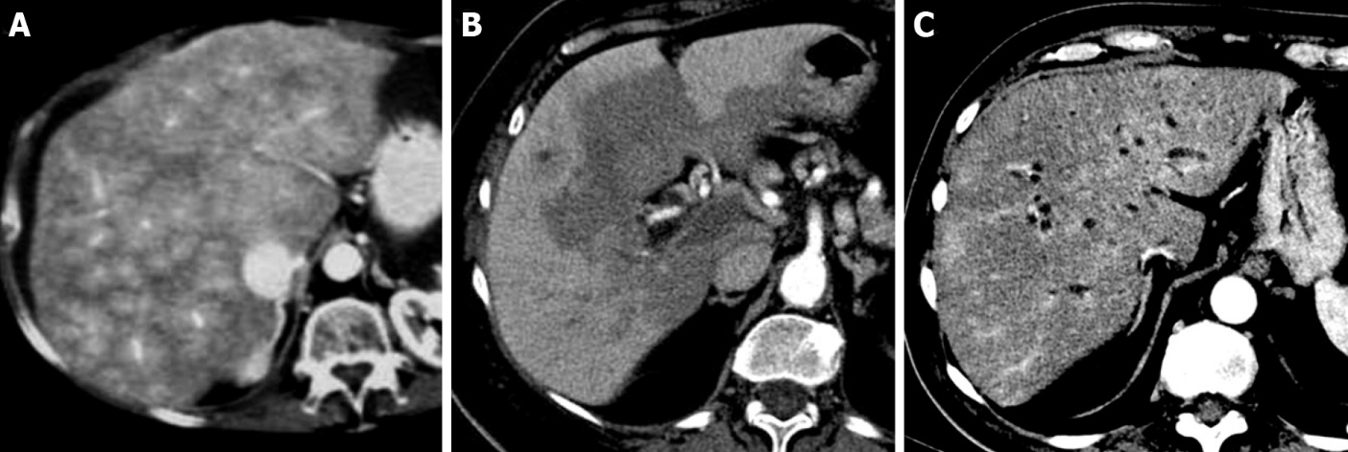
Figure 1 Transient hepatic parenchymal enhancement. A: Contrast-enhanced computed tomography axial scan in the arterial phase shows a “mosaic” pattern of enhancement in patients with Budd-Chiari syndrome; B: “Central-peripheral” pattern in patients with portal thrombosis; C: “Peribiliary” pattern in patients with cholangitis.

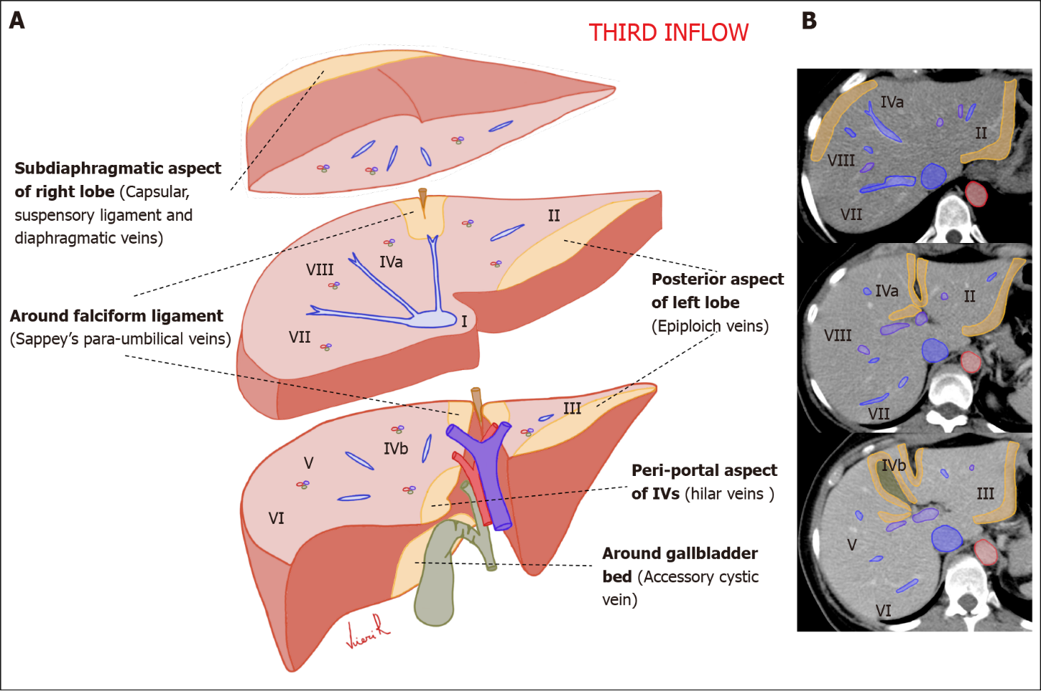
Figure 2 Schematic representation of the anatomical sites of the liver “Third inflow” in hepatic sections. Yellow areas show the typical sites of focal sparing in fatty liver or nodular fat accumulation in the normal liver. A: Volumetric representation; B: Computed tomography axial scan.

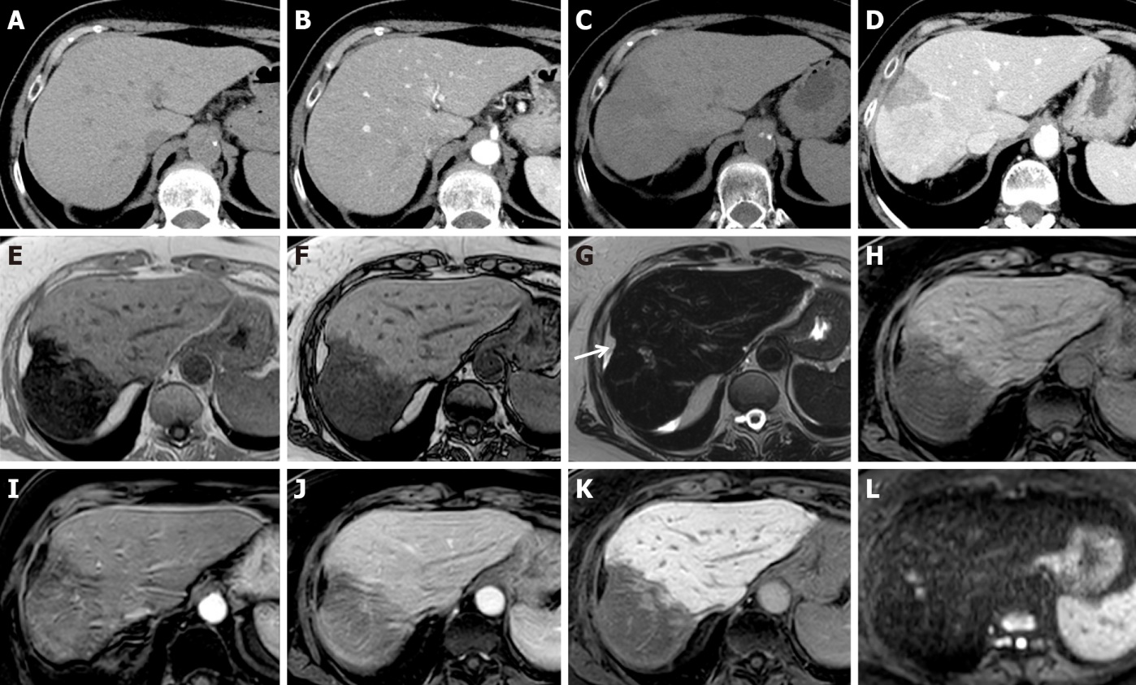
Figure 3 Liver metabolic infarction areas in patients with breast cancer. A, B: Unenhanced (A) and arterial phase (B) computed tomography (CT) axial scan before therapy show normal liver; C, D: Unenhanced (C) and late arterial phase (D) CT axial scans after 3 mo of therapy show early steatotic changes of the parenchyma and inhomogeneous enhancement in segments VII-VIII; E-L: Magnetic resonance after 6 mo of therapy shows progression of parenchymal involution and atrophy in gradient echo (GE) T1w in-phase (E), GE T1w out-of-phase (F), fat sat GE 3D T1w unenhanced (H), arterial (I), portal (J) and hepatobiliary phase (K). Capsular retraction is seen (white arrow). On T2w (G), and high b-value diffusion-weighted (L) images, no signal alteration was detectable.

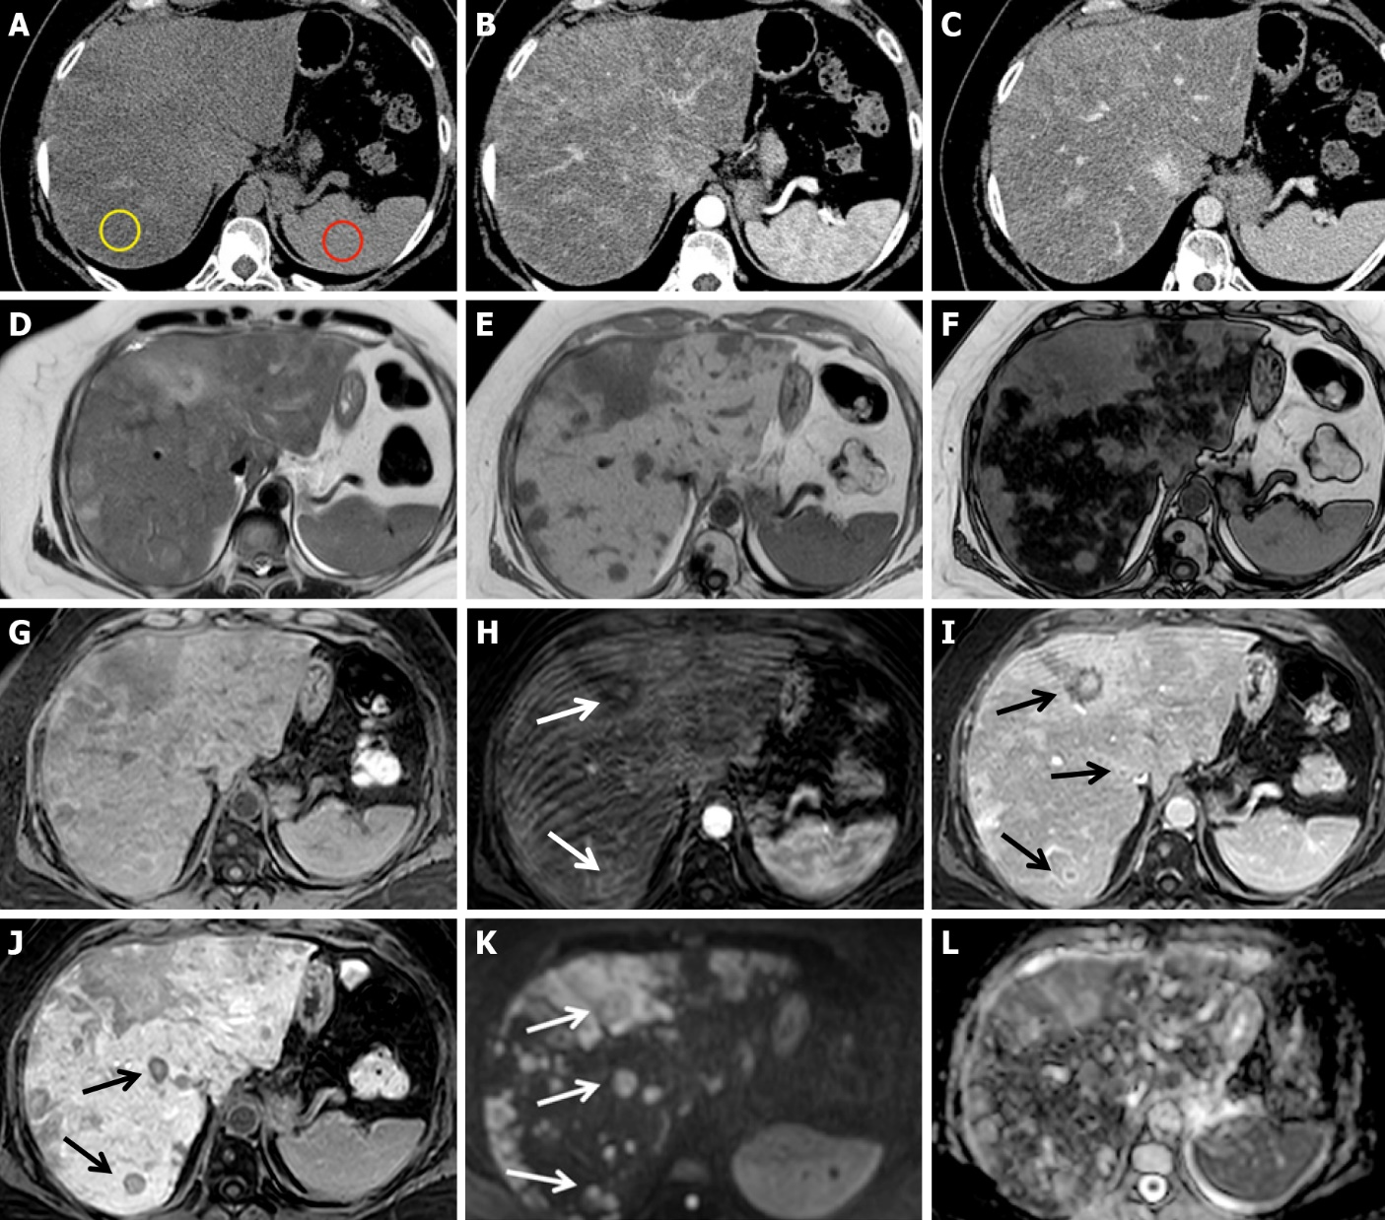
Figure 4 Chemotherapy-associated diffuse steatosis in patients with liver metastatic colorectal cancer 6 mo after the beginning of chemotherapy with 5-fluorouracil + folinic acid + irinotecan. A-C: Unenhanced computed tomography axial scan (A), arterial (B) and portal phase (C) show severe inhomogeneous hepatic steatosis. Liver attenuation in steatotic areas is 8 HU (yellow ROI), less than that of the spleen (43 HU, red ROI), and the hepatic/splenic attenuation ratio is << 1. No nodules are visible; D-L: On magnetic resonance performed during the following week, gradient echo (GE) T1w in-phase (E) and out-of-phase (F) images confirm severe hepatic steatosis. On unenhanced fat sat GE 3D T1w images (G), arterial (H), portal (I), hepatobiliary (J) phases and high b-value diffusion-weighted images (K), multiple metastases are evident, some of which are characterized by rim enhancement (arrows). The T2-weighted image (D) and apparent diffusion coefficient map (L) are also shown.

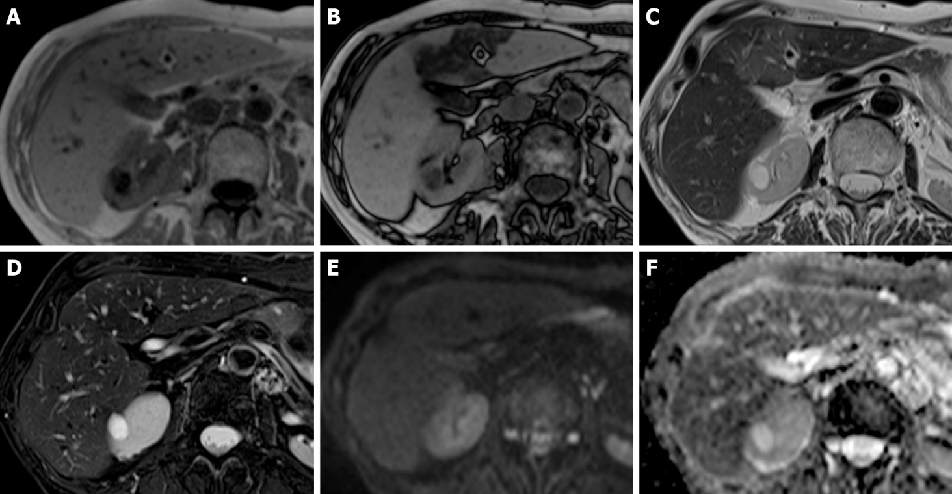
Figure 5 Chemotherapy-associated focal steatosis in patients with lung cancer 3 mo after the beginning of immunotherapy. A-F: On magnetic resonance, focal geographic fatty deposition, poorly delineated, is seen as signal hypointensity on gradient echo (GE) T1w out-of-phase (B) in the periportal aspect of segment IV and around the falciform ligament. On T2w images (C) it is weakly hyperintense. No signal alterations are seen on the GE T1w in-phase images (A), T2w fat saturation (D), diffusion-weighted (E) images, or apparent diffusion coefficient map (F).

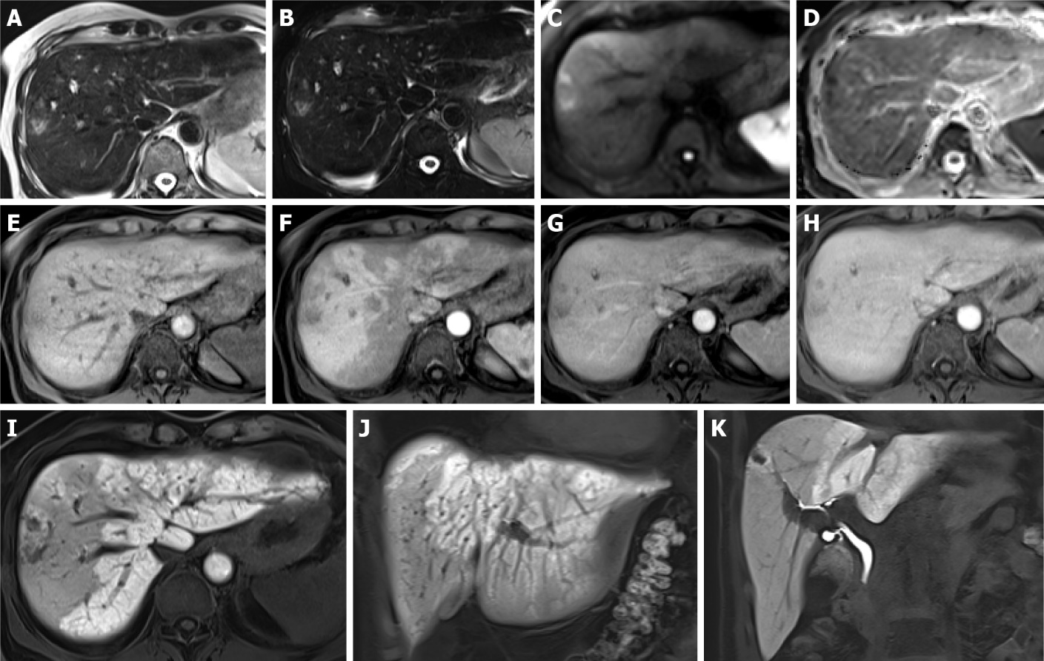
Figure 6 Association between sinusoidal obstructive syndrome and peliosis in patients without a history of hepatopathy, with lung cancer treated with 3 cycles of cisplatin and etoposide and 12 subsequent cycles of immunotherapy. A-K: After 1 year of therapy, magnetic resonance was performed for abdominal pain and an increase in liver enzymes. Hyperintense nodules on T2w (A), T2w fat sat (B) and high b-value diffusion-weighted images (C) are seen. On the apparent diffusion coefficient map (D), they are hypointense. On dynamic imaging, weak enhancement is seen (E: Unenhanced image; F, G, H: Arterial, portal and equilibrium phases, respectively). In the hepatobiliary phase, they appear predominantly hypointense (I-K). A transcutaneous biopsy was performed, resulting in peliosis nodules. Mosaic pattern enhancement of the liver parenchyma in the arterial phase (F) and reticular aspects in the hepatobiliary phase (I-J) were consistent with sinusoidal obstructive syndrome.

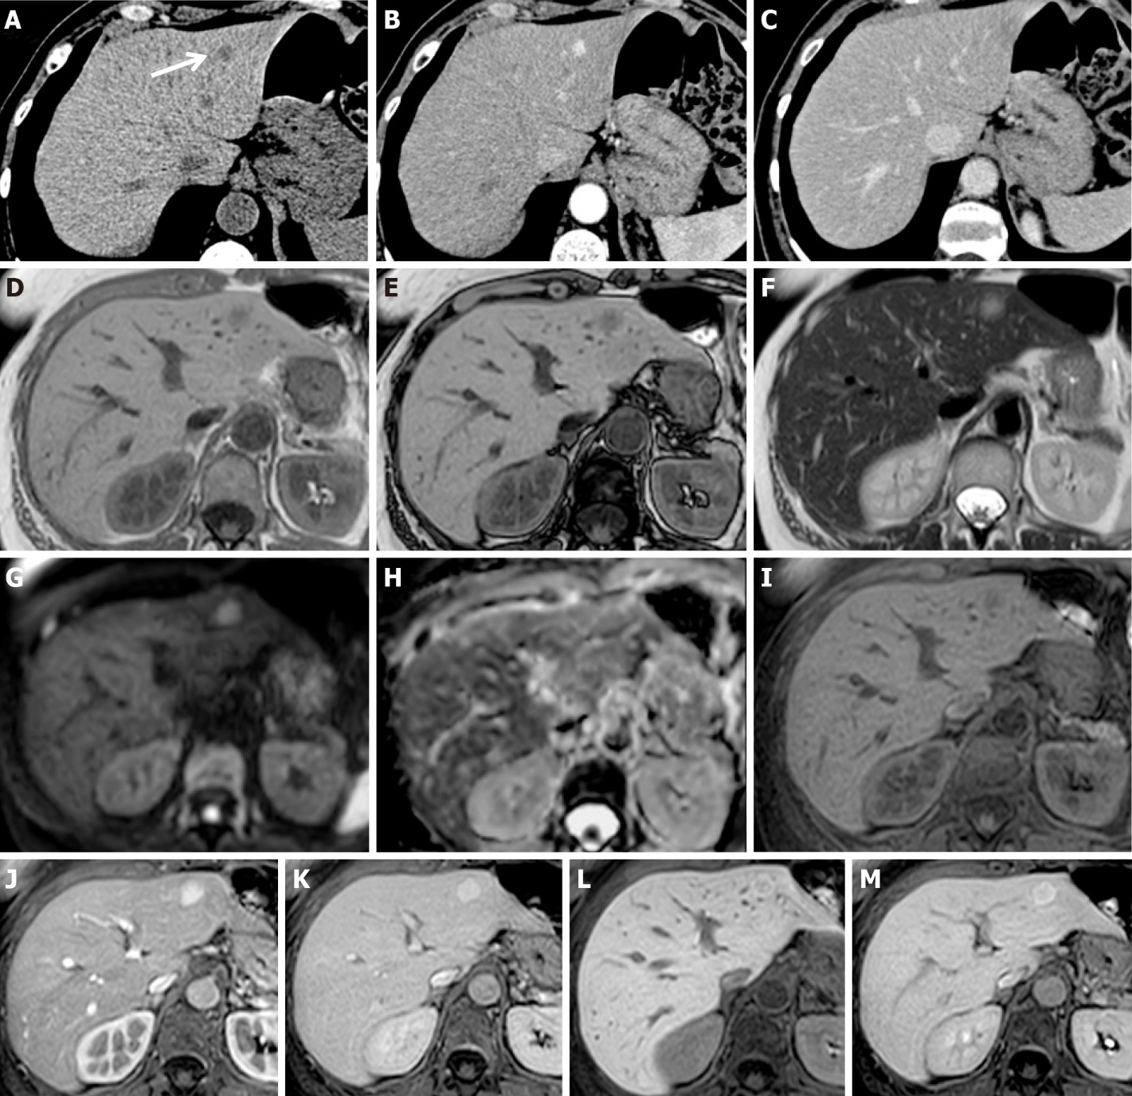
Figure 7 Focal nodular hyperplasia-like nodules in patients with colorectal cancer treated with surgery and adjuvant chemotherapy. A-C: Six months after adjuvant chemotherapy discontinuation, contrast-enhanced computed tomography (CT) showed a newly appeared nodule in segment II (white arrow), hypodense on unenhanced scan (A), with contrast enhancement on arterial phase (B) without washout in portal phase (C); D-M: Magnetic resonance performed 3 mo after CT showed a volumetric increase in the nodule, characterized by signal hypointensity in gradient echo T1w in-phase (D) and out-of-phase (E) and weak hyperintensity in T2w images (F), without diffusivity restriction on diffusion-weighted imaging (G-H). After liver-specific contrast agent administration, it presented homogeneous wash-in on the arterial phase (J) compared to the unenhanced image (I), no wash-out (K), and weak central signal hypointensity on equilibrium (L) and hepatobiliary (M) phases. A transcutaneous biopsy was performed, resulting in focal nodular hyperplasia-like nodules.

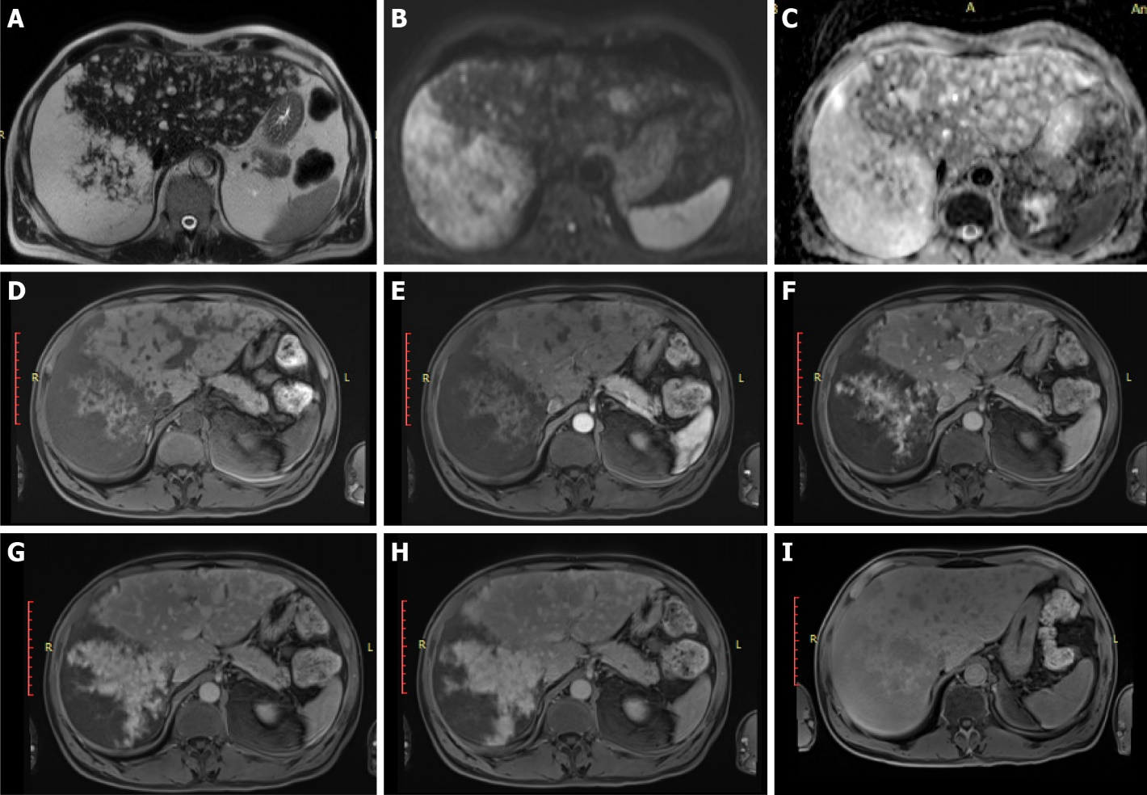
Figure 8 Primary idiopathic diffuse peliosis in patients without a cancer history. A-C: On magnetic resonance T2w images (A) and on diffusion-weighted imaging (B: High b value; C: Apparent diffusion coefficient map), numerous hemangioma-like lesions are visible, the largest in segments VII-VIII; D-I: After interstitial contrast agent administration, progressive centrifugal enhancement of the lesions was observed (D: Fat sat gradient echo 3D T1w unenhanced image; E, F, G: Arterial, portal and equilibrium phases; H-I: 5 and 30 min after contrast agent administration).

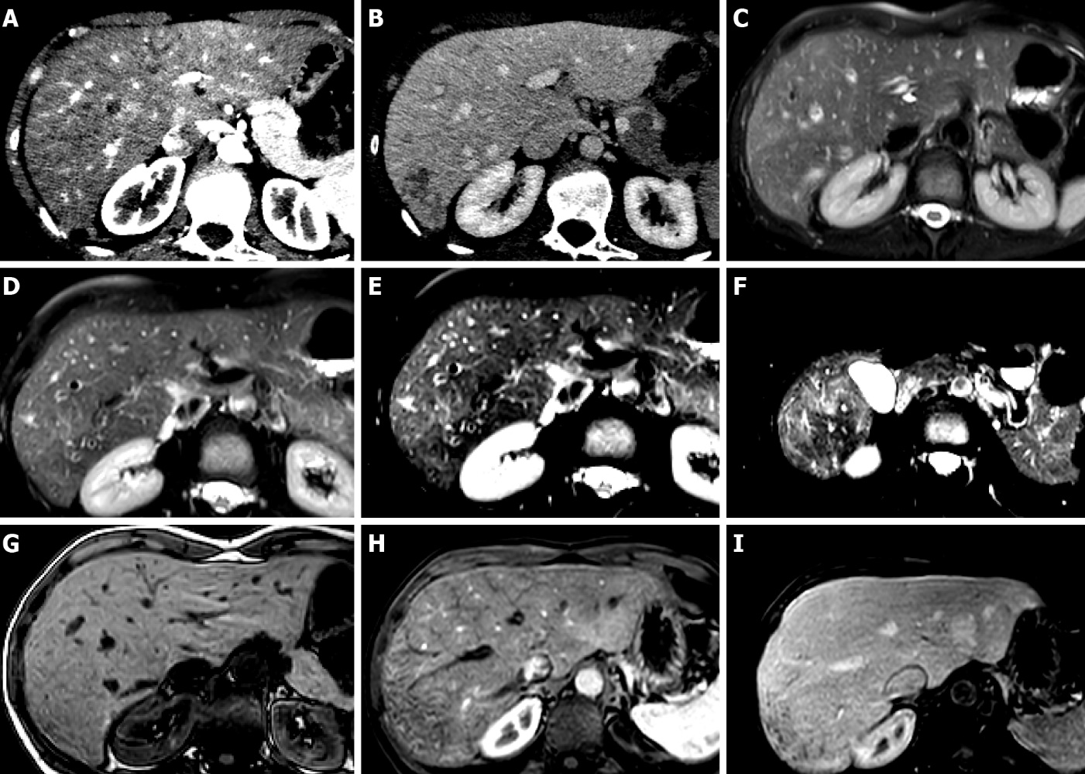
Figure 9 Hepatic sinusoid dilatation in patients with breast cancer during hormone therapy. A, B: Arterial (A) and portal (B) computed tomography axial scans show a liver mosaic pattern of arterial enhancement, with reticular aspects on the subcapsular parenchyma of segment VII in the portal phase; C-F: Magnetic resonance (MR) T2w images show mild signal hyperintensity on different liver sections and different echo times; G-I: MR unenhanced (G), arterial (H) and portal phases (I) confirm the mosaic pattern mostly subcapsular of the liver parenchyma.

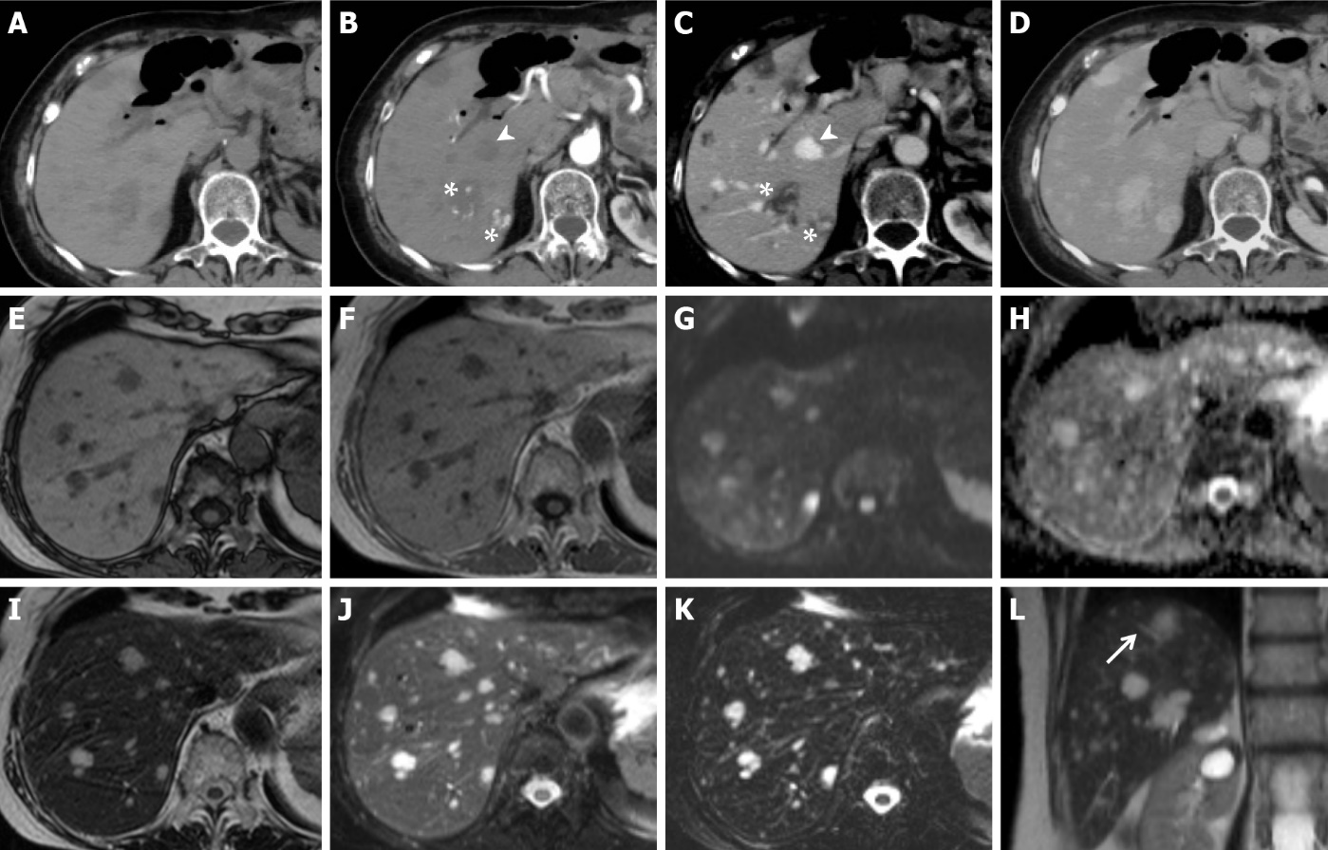
Figure 10 Secondary idiopathic multiple peliotic lesions in patients with a history of 6-mercaptopurine treatment for leukemia. A-D: Contrast-enhanced computed tomography shows multiple lesions, hypodense on unenhanced scan (A) with dystrophic calcifications and hyperdense foci, probably secondary to hemorrhage. On dynamic imaging (B, axial arterial phase; C, axial portal phase), the lesions present centripetal (arrowhead) or centrifugal (asterisk) globular contrast enhancement without signs of washout. In the delayed phase (D), they appear isodense compared with the hepatic parenchyma; E-L: Magnetic resonance confirming the presence of hypointense lesions on T1w images (E-F) and hyperintense lesions on T2w images (I, J and L, arrow), which maintain high signal in long echoes echo time 320 ms (K). No signs of altered diffusion (G-H) or mass effects are shown. These characteristics were consistent with multiple peliotic lesions.

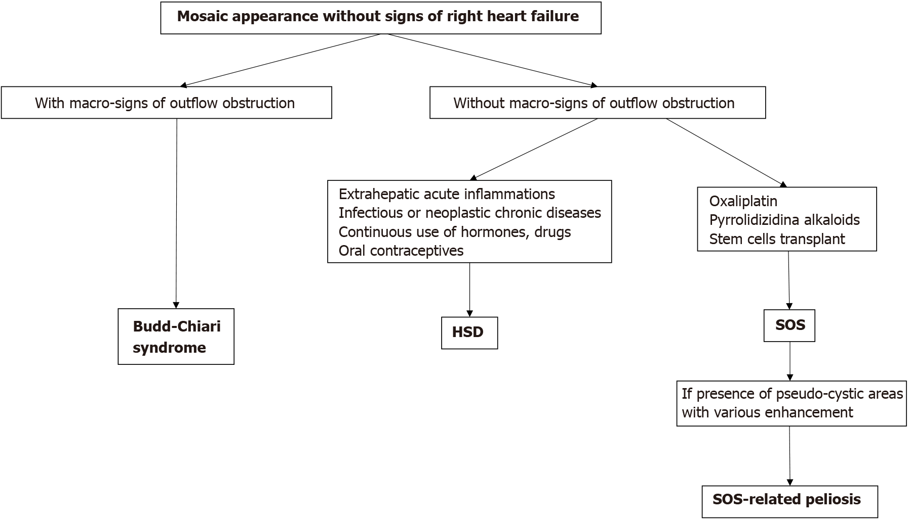
Figure 11 Diagram of different forms of mosaic pattern enhancement in blue liver syndrome. HSD: Hepatic sinusoid dilatation; SOS: Sinusoidal obstruction syndrome.

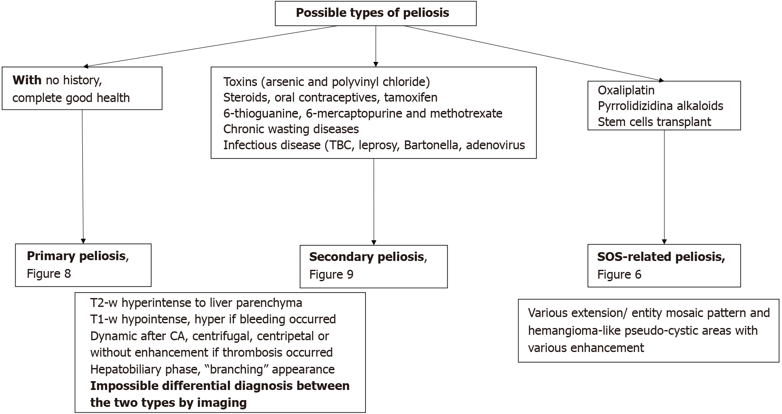
Figure 12 Diagram showing the classification of hepatic peliosis. SOS: Sinusoidal obstruction syndrome; CA: contrast agent.

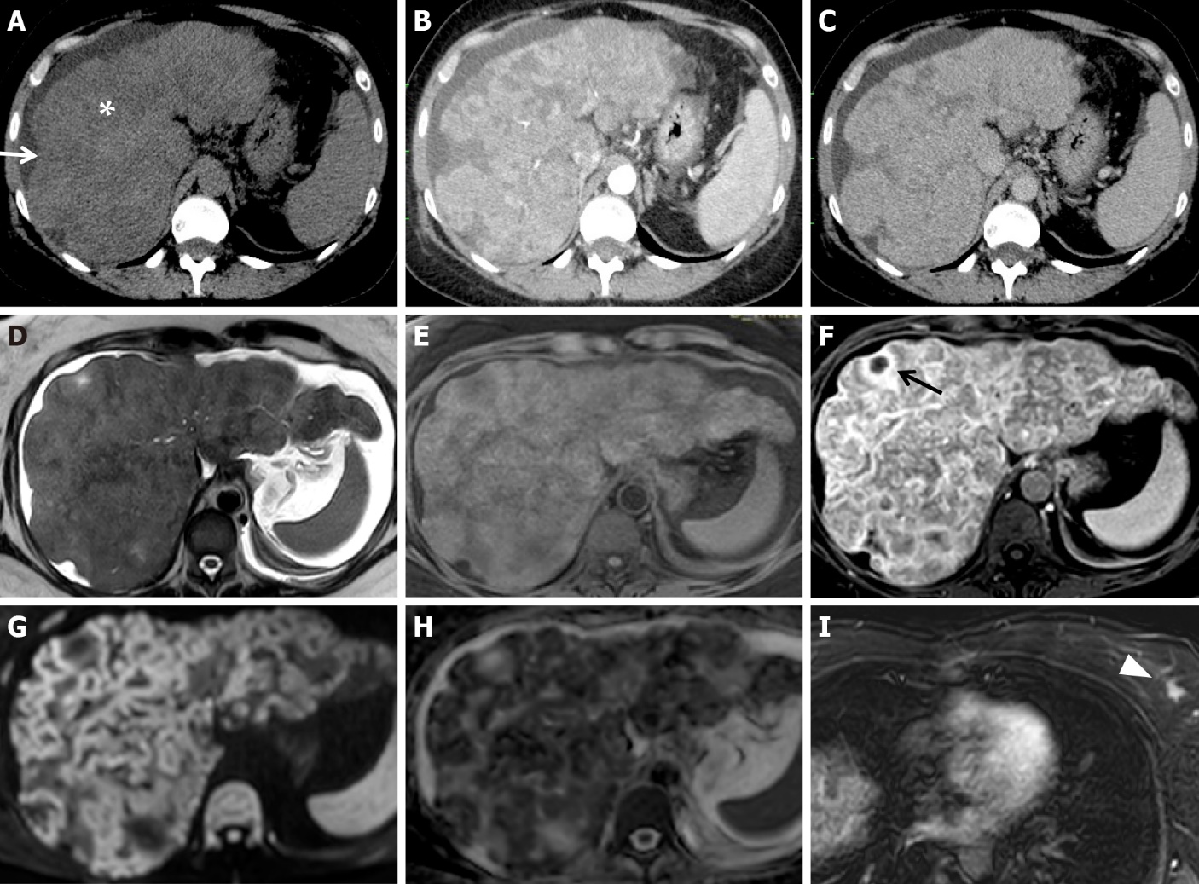
Figure 13 Pathologically proven pseudocirrhosis due to a small breast cancer in a chemotherapy “naïve patient”, having received no chemotherapy. A-C: On unenhanced (A) computed tomography (CT) axial scans, a lobulated liver contour with retraction of the capsular surface (white arrow), low-attenuation parenchymal areas, and ascites (white asterisk) are seen. On arterial (B) and portal (C) CT axial scans, architectural disorder and heterogeneous contrast enhancement are detectable; D-I: On magnetic resonance, the presence of ascites is confirmed on T2w images (D). Profound structural and architectural changes due to the presence of coarse nodules separated by areas of fibrosis in an unenhanced fat sat gradient echo 3D T1w image (E) and a contrast-enhanced phase T1w image at equilibrium (F) are visible; various confluent nodules with irregular hyperintense rims on high b-value diffusion-weighted images (G) and low signal intensity in apparent diffusion coefficient map value (H) were observed. A small necrotic area inside a nodule is indicated in F (black arrow). One small left breast cancer nodule (white arrowhead) on a contrast-enhanced T1w image is visible in the arterial phase (I).

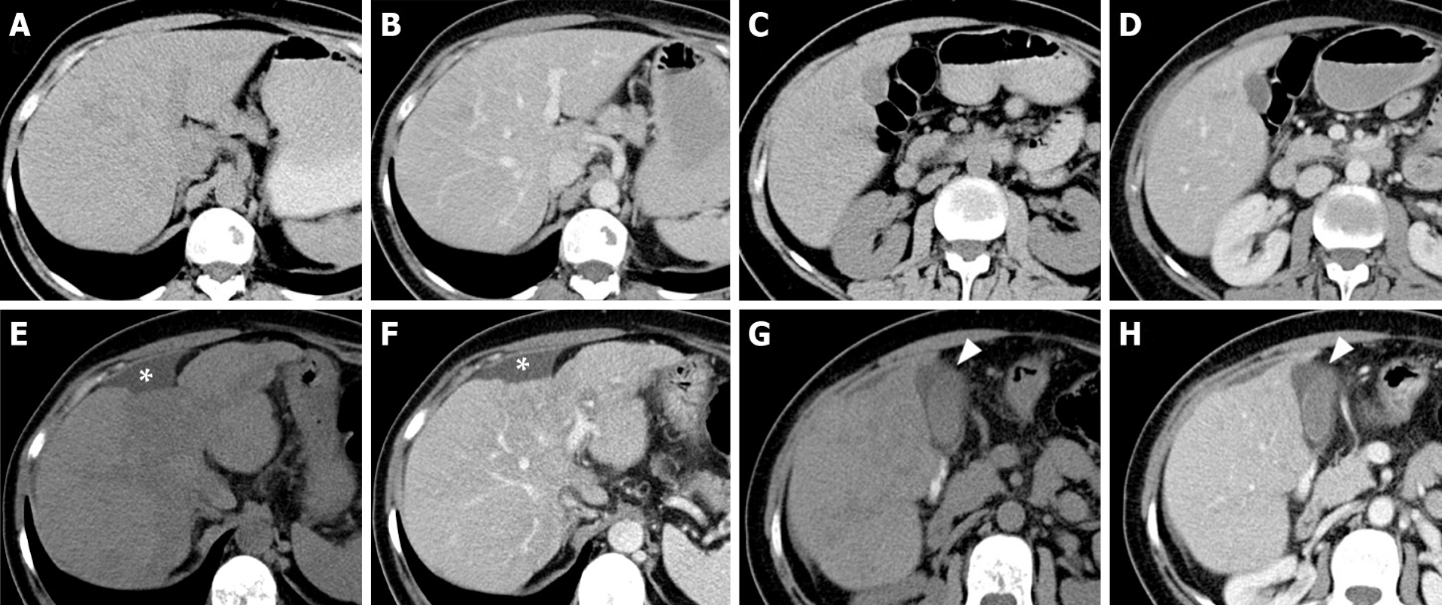
Figure 14 Early features of pseudocirrhosis in patients with metastatic breast cancer treated with gemcitabine for 12 mo. A-D: On axial unenhanced (A, C) and contrast-enhanced portal (B, D) computed tomography (CT) scan images, executed prior chemotherapy, the liver presents a regular volume, morphology and a smooth surface. No signs of ascites are present; E-H: On CT exam after chemotherapy (12 mo) at the same levels, in the same phases, fatty changes of the liver parenchyma, reduction of the hepatic volume with relative hypertrophy of the left lobe, irregular margins and capsular retraction corresponding to the IV segment (asterisk) were detectable. Peri-hepatic and pericholecystic effusion occurred (arrowhead).

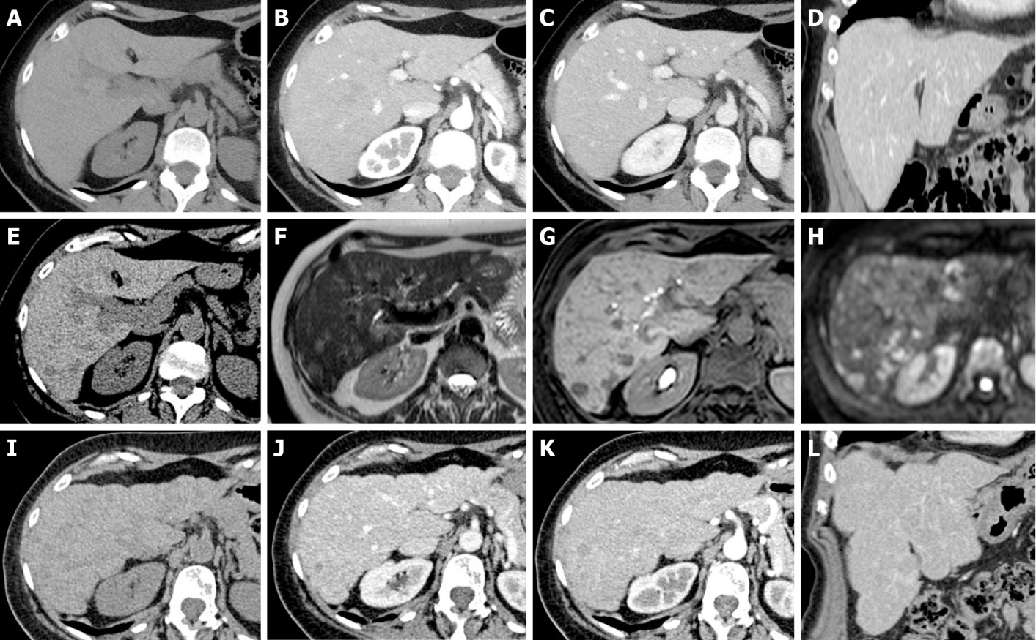
Figure 15 Pseudocirrhosis in patients with breast cancer treated with surgery and 6 mo of chemotherapy (capecitabine and monoclonal antibodies). A-D: Unenhanced (A: Axial) and contrast-enhanced computed tomography (CT) (B: Axial arterial phase; C: Axial portal phase; D: Coronal portal phase) was performed at staging. The liver shows regular volume, morphology and a smooth surface. No focal lesions were found; thus, no chemotherapy was undertaken; E: At the 1-year follow-up, unenhanced CT demonstrated the appearance of a hypodense focal lesion (arrowhead); F-H: A complete magnetic resonance study with liver-specific contrast agent confirmed the presence of new focal lesions consistent with metastases. Mild hyperintensity in the T2w sequence (F), clear hypointensity in the fat sat gradient echo 3D T1w hepatobiliary phase (G) and high signal in diffusion-weighted images (H) are shown. Chemotherapy was started. I-L: A 6-mo follow-up unenhanced (I: Axial) and contrast-enhanced CT (J: Axial arterial phase; K: Axial portal phase; L: Coronal portal phase) shows typical signs of liver pseudocirrhotic changes: parenchymal volume reduction, irregular macrocyclic margins, right lobe atrophy and caudate lobe hypertrophy.

