Name of journal: World Journal of Gastroenterology
ESPS Manuscript NO: 1391
Columns: CASE REPORT

Coexistence of gastrointestinal stromal tumor, esophageal and gastric cardia carcinomas: Case report

Zhou Y et al. Coexistence of esophageal and gastric carcinomas

Yong Zhou, Xu-Dong Wu, Quan Shi, Jing Jia

Yong Zhou, Department of General surgery, Yancheng City No.1 People’s Hospital, Yancheng 224005, Jiangsu Province, China

Xu-Dong Wu, Department of Gastroenterology, Yancheng City No.1 People’s Hospital, Yancheng 224005, Jiangsu Province, China

Quan Shi, Department of Radiology, Yancheng City No.1 People’s Hospital, Yancheng 224005, Jiangsu Province, China

Jing Jia, Department of Nephrology, Yancheng City No.1 People’s Hospital, Yancheng 224005, Jiangsu Province, China

Author contributions: Zhou Y, Wu XD, Shi Q, Jia J contributed to the manuscript writing and revision.

Correspondence to: Xu-Dong Wu, PhD, Department of Gastroenterology, Yancheng City No.1 People’s Hospital, 16 Yuehe Road, Yancheng 224005, Jiangsu Province, China. hnjsycwxd@163.com

Telephone: + 86-510-88508910 Fax: +86-510-88508910

Received: December 6, 2012 Revised: December 27, 2012
Accepted: January 11, 2013
Published online:

Abstract
Gastric gastrointestinal stromal tumor (GIST), esophageal squamous cell carcinoma and gastric cardia adenocarcinoma are distinct neoplasms originating from different cell layers; therefore, simultaneous development of such carcinomas is relatively rare. Auxiliary examinations revealed coexistence of esophageal, gastric cardia carcinoma with lymph node metastasis in a 77 year old male. Intraoperatively, an extra-luminal tumor (about 6.0 cm × 5.0 cm × 6.0 cm) at the posterior wall of the gastric body, a tumor (about 2.5 cm × 2.0 cm) at the lower esophagus and an infiltrative and stenosing tumor (about 1.0 cm × 2.0 cm) at the gastric cardia had been detected. Wedge resection for extra-luminal gastric tumor, radical esophagectomy for lower esophageal tumor and cardia resection with gastroesophageal (supra-aortic arch anastomoses) were performed. Postoper- ative histological examination showed synchronous occurrence of gastric GIST, esophageal squamous cell carcinoma and gastric cardia adenocarcinoma. Further, immunohistochemistry indicated strong staining for c-Kit/CD117, Dog-1, Ki-67 and smooth muscle, while expression of S-100 and CD34 was negative.

© 2013 Baishideng. All rights reserved.

Key words: Gastrointestinal stromal tumor; Esophageal squamous cell carcinoma; Gastric cardia adenocarcinoma

Zhou Y, Wu XD, Shi Q, Jia J. Coexistence of gastrointestinal stromal tumor, esophageal and gastric cardia carcinomas: Case report.
World J Gastroenterol 2013;
Available from: URL: http://www.wjgnet.com/esps/
DOI: http://dx.doi.org/10.3748/wjg.v19.i0.0000

INTRODUCTION
Recent years, cases of synchronous development of a gastrointestinal stromal tumor (GIST) and another neoplasm with different incidence, etiology, evolution and prognostic have been reported more frequently ^{[1-3]}. Although squamous cell carcinoma and adenocarcinoma constitute the most common type of esophageal and gastric cardia tumor correspondingly, simultaneous development of a GIST is relatively rare. Here, we report a case of synchronous occurrence of gastric GIST, esophageal squamous cell carcinoma and gastric cardia adenocarcinoma.

CASE REPORT
A 77 year old male presented with dysphagia for 2 mo. Then, he went to a local hospital. And upper gastrointestinal (GI) endoscopy was performed there, which showed a tumor arising from the lower esophagus and extending into the lumen; an ulcerated tumor located in the cardia, just below the gastroesophageal junction.
He had no relevant past history and family history. Clinical examination did not find any palpable abdominal mass. Laboratory exam was normal.
Esophagography showed a filling defect on the anterior wall of the lower esophagus (Figure 1). Computed tomography (CT) scan showed circumfere- ntial thickening of the lower esophageal wall with loss of lumen. Scan obtained at a lower level displayed focal thickening of the gastric cardia wall with marked enhancement. Furthermore, scans obtained at lower levels displayed a large, heterogeneous, round-like mass close to the greater curvature of the stomach. The patient was diagnosed presumptively with synchronous esophageal and gastric cardia carcinoma with lymph node metastasis (Figure 2).
We performed a surgical operation. Intraoperatively, an extra-luminal tumor (about 6.0 cm × 5.0 cm × 6.0 cm) at the posterior wall of the gastric body, a tumor (about 2.5 cm × 2.0 cm) at the lower esophagus and an infiltrative and stenosing tumor (about 1.0 cm × 2.0 cm) at the gastric cardia had been detected. Wedge resection for extra-luminal gastric tumor, radical esophagectomy for lower esophageal tumor and cardia resection with gastroesophageal (supra- aortic arch anastomoses) were performed.
On histopathological examination, the gastric cardia tumor was a mid differentiated gastric adenocarcinoma (pT_{1b}N₀M₀); the lower esophageal tumor was a low-mid differentiated squamous cell carcinoma (pT₃N₀M₀) (Figure 3). There was no vascular invasion and no lymph node metastasis.
Further histopathological examination of the extra-luminal gastric tumor revealed GIST of the high-risk category, which showed a high mitotic index (> 10 mitoses/50 high-power fields). Immunohistochemistry indicated strong staining for c-Kit/CD117, Dog-1, Ki-67 and smooth muscle, while expression of S-100 and CD34 was negative (Figure 3). He was diagnosed as high grade gastric GIST due to large tumor size (> 5 cm) and unfavorable histopathological features (high mitotic index and strong positivity for ki-67).

DISCUSSION
GISTs are rare, accounting for only 0.1%–3% of all gastrointestinal malignancies. Primary GISTs arise most commonly in the stomach (50%–70%), followed by the small intestine (25%–35%), colon and rectum (5%–10%) and esophagus (< 5%)^{[4]}. These tumors are considered to originate from interstitial cells of Cajal or their precursors, because both strongly express the c-KIT protein (CD117; a type III tyrosine kinase receptor encoded by the c-kit proto-ongogene) ^{[5]}.
Radical surgery is the main treatment in primary resectable GISTs. Recurrence, metastatic disease or unresectable tumors could be treated with Imatinib (a small-molecule tyrosine-kinase inhibitor) ^{[6]}.
Adenocarcinoma of the stomach ranks as the second most common cancer worldwide, which comprises 80% of all stomach cancers. Squamous cell carcinoma mainly occurs in the mid to lower esophagus, which is not common to have other accompanying cancerous lesions. Suzuki et al^{[7]} reported that the most common lesion is the stomach (59.6%), followed by the colon and rectum (12.3%). Although, various hypotheses, such as gene mutations, expression of metallothioneins and influenced neighboring tissues by the same carcinogen have been proposed regarding the simultaneous development of GIST and other cancers^{[8,9]}. However, at present, no data are available to support such hypotheses. Furthermore, simultaneous occurrence of gastric GIST, esophageal squamous cell carcinoma and gastric adenocarcinoma is uncommon in the literature. Simple coincidence could be the most reasonable explanation.
For patients with primary GIST, surgical resection is the only chance for cure. Resection can usually be accomplished with only a wedge resection of the stomach or a segmental resection of the small bowel for small GISTS, whereas extensive surgery is occasionally required for larger or poorly positioned GISTs ^{[6]}.
The only curative treatment of esophageal cancer or gastric cardia cancer is surgical resection. After esophagectomy, digestive tract reconstruction can be accomplished using the remaining stomach, depending on the location of the gastric tumor. The colon or jejunum is frequently choice for esophageal substitution. In our opinion, digestive tract reconstruction with the remaining stomach should be a reasonable choice for old people (age > 75 years old). Although the GIST is big in size, only wedge resection of the stomach was performed to keep enough stomach for digestive tract reconstruction.
In our case, we considered gastric adenocarcinomas to be an early stage gastric cancer and esophageal squamous cell carcinoma to be a middle stage esophageal cancer. Meantime, the patient was diagnosed as high grade gastric GIST due to large tumor size (> 5 cm) and unfavorable histopathological features (high mitotic index and strong positivity for ki-67). Therefore, we suggested the patient to accept chemoradiation therapy and adjuvant imatinib treatment. But the patient refused. A postoperative CT scan performed 3 mo later showed no evidence of tumor recurrence. The patient needs a long follow-up period.

REFERENCES
1 Theodosopoulos T, Dellaportas D, Psychogiou V, Gennatas K, Kondi-Pafiti A, Gkiokas G, Papaconstantinou I, Polymeneas G. Synchronous gastric adenocarcinoma and gastrointestinal stromal tumor (GIST) of the stomach: a case report. World J Surg Oncol 2011; 9: 60 [PMID: 21615935 DOI: 10.1186/1477-7819-9-60].]
2 Yamamoto D, Hamada Y, Tsubota Y, Kawakami K, Yamamoto C, Yamamoto M. Simultaneous development of adenocarcinoma and gastrointestinal stromal tumor (GIST) in the stomach: case report. World J Surg Oncol 2012; 10: 6 [PMID: 22230934 DOI: 10.1186/1477-7819-10-6].]
3 Firat Ö, Çalişkan C, Karaca C, Sezak M, Özütemız Ö, Ersın S, Güler A. Coexistence of gastric cancer and gastrointestinal stromal tumor: report of two cases. Turk J Gastroenterol 2010; 21: 302-304 [PMID: 20931437]
4 Miettinen M, Lasota J. Gastrointestinal stromal tumors--definition, clinical, histological, immunohistochemical, and molecular genetic features and differential diagnosis. Virchows Arch 2001; 438: 1-12 [PMID: 11213830 DOI: 10.1007/s004280000338]
5 Feng F, Liu XH, Xie Q, Liu WQ, Bai CG, Ma DL. Expression and mutation of c-kit gene in gastrointestinal stromal tumors. World J Gastroenterol 2003; 9: 2548-2551 [PMID: 14606094]
6 Chaudhry UI, DeMatteo RP. Advances in the surgical management of gastrointestinal stromal tumor. Adv Surg 2011; 45: 197-209 [PMID: 21954688]
7 Suzuki S, Nishimaki T, Suzuki T, Kanda T, Nakagawa S, Hatakeyama K. Outcomes of simultaneous resection of synchronous esophageal and extraesophageal carcinomas. J Am Coll Surg 2002; 195: 23-29 [PMID: 12113541]
8 Rauf F, Ahmad Z, Muzzafar S, Hussaini AS. Synchronous occurrence of gastrointestinal stromal tumor and gastric adenocarcinoma: a case report. J Pak Med Assoc 2006; 56: 184-186 [PMID: 16711342]
9 Nemes C, Rogojan L, Surdea-Blaga T, Seicean A, Dumitrascu DL, Ciuce C. Gastrointestinal stromal tumor (GIST) associated with synchronous colon adenocarcinoma - a case report. J Gastrointestin Liver Dis 2012; 21: 101-103 [PMID: 22457867]
P-Reviewer Peparini N S-Editor Gou SX L-Editor E-Editor

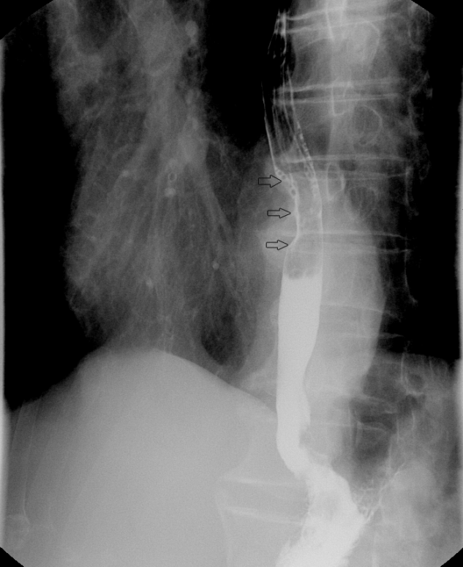
Figure 1 Esophagography showed a filling defect on the anterior wall of the lower esophagus.

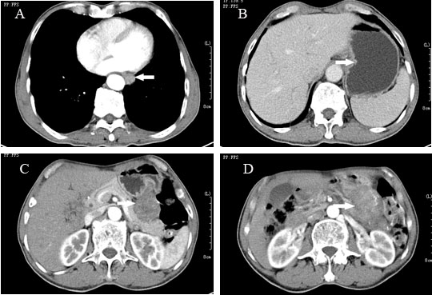
Figure 2 Computed tomography scan. A: Computed tomography (CT) scan showed circumferential thickening (arrow) of the lower esophageal wall with loss of lumen; B: Scan obtained at a lower level displayed focal thickening (arrow) of the gastric wall with marked enhancement; C, D: Scan obtained at lower levels displayed a large, heterogeneous, round-like mass close to the greater curvature of the stomach.
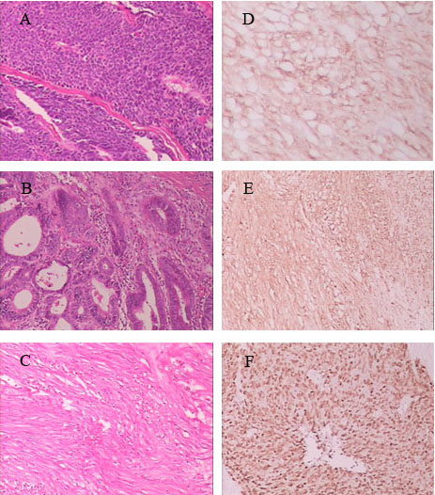
Figure 3 Microscopic image. A: Microscopic image of esophageal squamous cell carcinomas (× 10 magnification); B: Microscopic image of gastric cardia adenocarcinoma (× 10 magnification); C: Microscopic image of gastrointestinal stromal tumor (×10 magnification); D-F: The immunohistochemistry indicated strong staining for Dog-1 (D, ×40 magnification), c-Kit/CD117 (E, ×10 magnification), Ki-67 (F, ×10 magnification).

