Name of Journal: World Journal of Clinical Cases
Manuscript NO: 87208
Manuscript Type: LETTER TO THE EDITOR

Artificial intelligence and machine learning in motor recovery: A rehabilitation medicine perspective

Swarnakar R et al. AI in motor recovery: Rehabilitation perspective

Raktim Swarnakar, Shiv Lal Yadav

Raktim Swarnakar, Shiv Lal Yadav, Department of Physical Medicine and Rehabilitation, All India Institute of Medical Sciences, New Delhi 110029, Delhi, India

Author contributions: Swarnakar R contributed to the conception and design; Swarnakar R and Yadav SL contributed to the literature search and writing.

Corresponding author: Raktim Swarnakar, MBBS, MD, Doctor, Department of Physical Medicine and Rehabilitation, All India Institute of Medical Sciences, Ansari Nagar, New Delhi 110029, Delhi, India. raktimswarnakar@hotmail.com

Received: July 29, 2023
Revised: September 1, 2023
Accepted: September 18, 2023
Published online: October 16, 2023

Abstract
Artificial intelligence (AI) and machine learning (ML) are powerful technologies with the potential to revolutionize motor recovery in rehabilitation medicine. This perspective explores how AI and ML are harnessed to assess, diagnose, and design personalized treatment plans for patients with motor impairments. The integration of wearable sensors, virtual reality, augmented reality, and robotic devices allows for precise movement analysis and adaptive neurorehabilitation approaches. Moreover, AI-driven telerehabilitation enables remote monitoring and consultation. Although these applications show promise, healthcare professionals must interpret AI-generated insights and ensure patient safety. While AI and ML are in their early stages, ongoing research will determine their effectiveness in rehabilitation medicine.

Key Words: Artificial intelligence; Motor learning; Rehabilitation; Motor recovery; Machine learning; Physical medicine and rehabilitation

©The Author(s) 2023. Published by Baishideng Publishing Group Inc. All rights reserved.

Citation: Swarnakar R, Yadav SL. Artificial intelligence and machine learning in motor recovery: A rehabilitation medicine perspective. World J Clin Cases 2023; 11(29): 7258-7260
URL: https://www.wjgnet.com/2307-8960/full/v11/i29/7258.htm
DOI: https://dx.doi.org/10.12998/wjcc.v11.i29.7258

Core Tip: Artificial intelligence (AI) and machine learning (ML) are promising to revolutionize motor recovery in rehabilitation medicine. These technologies enable precise movement analysis, personalized treatment plans, and adaptive neurorehabilitation approaches using wearable sensors, virtual reality, augmented reality, and robotic devices. AI-driven telerehabilitation also facilitates remote monitoring and consultation. However, healthcare professionals must interpret AI-generated insights and prioritize patient safety. Ongoing research will determine the true potential of AI and ML in shaping the future of rehabilitation medicine.

TO THE EDITOR
Artificial intelligence (AI) is the simulation of human intelligence by machines. Machine learning (ML) is the process by which a computer algorithm perceives data, identifies patterns, and finally predicts relationships within those patterns. Deep learning is a type of ML that uses an artificial neural network to process an input through multilayered, interconnected nodes ('deep')^{[1]}. We read an article by Salimi et al^{[2]} with interest and found that AI has many roles in trauma orthopedics. We would like to highlight the importance of AI in rehabilitation medicine especially for motor recovery. AI and ML have great potential for motor recovery within the field of rehabilitation medicine^{[3]}. These technologies can aid in assessing patients' conditions, designing personalized treatment plans, monitoring progress, and optimizing rehabilitation strategies. Here, we provide a perspective on how AI and ML are utilized in motor recovery in rehabilitation settings (Figure 1).
Assessment and diagnosis: AI and ML algorithms can analyze various data sources, such as medical records, imaging studies, and sensor data, to assess the severity of motor impairments, identify specific deficits, and diagnose underlying conditions. These algorithms can process large datasets quickly, enabling efficient and objective assessments. Using trained algorithms, AI can accurately identify and highlight specific areas of concern, like fractures, tissue damage, or joint misalignments. It can also compare the patient's images with a vast database of similar cases, aiding in pattern recognition and anomaly detection.
Predictive modeling: AI and ML can develop predictive models that estimate the expected motor recovery trajectory based on individual characteristics and treatment factors. By considering factors such as age, comorbidities, and treatment protocols, these models can help clinicians set realistic goals, predict potential outcomes, and tailor rehabilitation plans accordingly. For instance, if the model predicts a slower recovery compared to the expected timeline, doctor can adjust the treatment plan promptly. This proactive approach maximizes the chances of better outcomes by tailoring the rehabilitation program based on real-time predictive insights.
Personalized treatment planning: AI and ML can assist in developing personalized treatment plans by integrating patient-specific data and evidence-based guidelines. These algorithms can analyze a patient's clinical information, functional abilities, and treatment history to generate recommendations on the most appropriate interventions, exercise protocols, and assistive technologies.
Sensor-based movement analysis: AI and ML algorithms can process data from wearable sensors, such as accelerometers or inertial measurement units, to analyze movement patterns, kinematics, and muscle activity. As part of the rehabilitation process, the person wears a set of wearable sensors, such as accelerometers or inertial measurement units, on their body. These sensors can be attached to different parts of the body, such as the legs, arms, or torso, to capture precise movement data in real-time. This information provides insights into the quality of movement, identifies deviations from normal patterns, and guides the design of targeted rehabilitation exercises.
Virtual reality (VR) and augmented reality (AR): AI and ML can be employed in VR and AR applications for motor recovery. These technologies create immersive and interactive environments that simulate real-world activities and promote motor learning. AI algorithms can adapt the virtual environments based on the patient's progress, customize the difficulty level, and provide real-time feedback to facilitate motor relearning^{[4]}.
Robotic-assisted rehabilitation: AI and ML algorithms are utilized in robotic devices used for motor rehabilitation. These algorithms can analyze patient data, adapt the robotic assistance to the individual's needs, and modulate the intensity and complexity of exercises. The AI-driven robotic systems can provide real-time feedback, quantify performance metrics, and track progress over time^{[5]}.
Adaptive neurorehabilitation: AI and ML can support adaptive neurorehabilitation approaches, where rehabilitation interventions are continuously adjusted based on the patient's progress and physiological responses. By integrating real-time patient data, these algorithms can adapt the intensity, duration, and difficulty of exercises, maximizing engagement and promoting neural plasticity. Sensors continuously collect data on the patient's brain activity, muscle responses, and movement patterns. AI algorithms analyze this data in real-time, identifying patterns of progress and areas of challenge. For instance, if the AI detects that a specific cognitive exercise is becoming too easy for the patient, it can automatically adjust the difficulty level to provide a more stimulating challenge. Conversely, if a physical movement exercise is causing frustration, the AI can adapt the intensity to match the patient's comfort and capabilities.
Telerehabilitation: AI and ML enable remote monitoring and telerehabilitation programs. By collecting and analyzing data from wearable devices or video assessments, these technologies can remotely assess patient progress, provide personalized feedback, and facilitate remote consultations between patients and healthcare providers^{[6]}.
The integration of AI and ML in motor recovery has the potential to improve rehabilitation outcomes, enhance patient engagement, and optimize resource allocation. However, it is important to note that the involvement of healthcare professionals remains crucial in interpreting AI-generated insights, ensuring patient safety, and providing human expertise throughout the rehabilitation process. Furthermore, we would also like to propose the use of AI and ML in future in the assessment and diagnosis, predictive modeling, personalized treatment planning, sensor-based movement analysis and adaptive neurorehabilitation in the field of rehabilitation medicine.
In conclusion, it is important to note that AI and ML are both in their early infancy. Further research is needed to comment on the effectiveness of such applications in rehabilitation medicine.

REFERENCES
1 Aung YYM, Wong DCS, Ting DSW. The promise of artificial intelligence: a review of the opportunities and challenges of artificial intelligence in healthcare. Br Med Bull 2021; 139: 4-15 [PMID: 34405854 DOI: 10.1093/bmb/ldab016]
2 Salimi M, Parry JA, Shahrokhi R, Mosalamiaghili S. Application of artificial intelligence in trauma orthopedics: Limitation and prospects. World J Clin Cases 2023; 11: 4231-4240 [PMID: 37449222 DOI: 10.12998/wjcc.v11.i18.4231]
3 Anderson D. Artificial Intelligence and Applications in PM&R. Am J Phys Med Rehabil 2019; 98: e128-e129 [PMID: 30839314 DOI: 10.1097/PHM.0000000000001171]
4 Kefaliakos A, Pliakos I, Kiekkas P, Charalampidou M, Diomidous M. Virtual Reality in the Rehabilitation of Patients with Neurological Disorders. Stud Health Technol Inform 2016; 226: 45-47 [PMID: 27350462]
5 Laut J, Porfiri M, Raghavan P. The Present and Future of Robotic Technology in Rehabilitation. Curr Phys Med Rehabil Rep 2016; 4: 312-319 [PMID: 28603663 DOI: 10.1007/s40141-016-0139-0]
6 Kuziemsky C, Maeder AJ, John O, Gogia SB, Basu A, Meher S, Ito M. Role of Artificial Intelligence within the Telehealth Domain. Yearb Med Inform 2019; 28: 35-40 [PMID: 31022750 DOI: 10.1055/s-0039-1677897]

Footnotes
Conflict-of-interest statement: The authors have no conflicts of interest to declare.

Open-Access: This article is an open-access article that was selected by an in-house editor and fully peer-reviewed by external reviewers. It is distributed in accordance with the Creative Commons Attribution NonCommercial (CC BY-NC 4.0) license, which permits others to distribute, remix, adapt, build upon this work non-commercially, and license their derivative works on different terms, provided the original work is properly cited and the use is non-commercial. See: https://creativecommons.org/Licenses/by-nc/4.0/

Provenance and peer review: Unsolicited article; Externally peer reviewed.

Peer-review model: Single blind

Peer-review started: July 29, 2023
First decision: August 16, 2023
Article in press: September 18, 2023

Specialty type: Medicine, research and experimental
Country/Territory of origin: India
Peer-review report’s scientific quality classification
Grade A (Excellent): 0
Grade B (Very good): 0
Grade C (Good): 0
Grade D (Fair): D
Grade E (Poor): 0

P-Reviewer: Dye DC, United States S-Editor: Lin C L-Editor: Filipodia P-Editor: Yu HG
Figure Legends
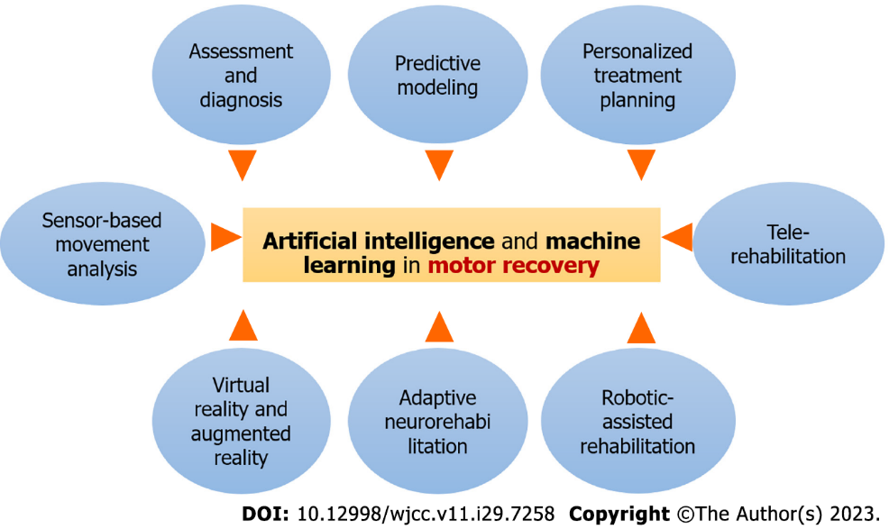
Figure 1 Artificial intelligence and machine learning in motor recovery.

Published by Baishideng Publishing Group Inc
7041 Koll Center Parkway, Suite 160, Pleasanton, CA 94566, USA
Telephone: +1-925-3991568
E-mail: bpgoffice@wjgnet.com
Help Desk: https://www.f6publishing.com/helpdesk
https://www.wjgnet.com

© 2023 Baishideng Publishing Group Inc. All rights reserved.

