Name of Journal: World Journal of Psychiatry
Manuscript NO: 82883
Manuscript Type: ORIGINAL ARTICLE

Case Control Study
Population-based affective-disorder-related biomedical/biophysical multi-hyper-morbidity across the lifespan: A 16-year population study

Cawthorpe DRL et al. Lifespan affective disorder-related hyper-morbidity

David RL Cawthorpe, Dan Cohen

David RL Cawthorpe, Community Health Sciences and Psychiatry, Cumming School of Medicine, Calgary T2N4N1, Alberta, Canada

Dan Cohen, Mental Health Organization North-Holland North, Utrecht University, Alkmaar 1811, North Holland, Netherlands

Author contributions: Cawthorpe DRL collected the data, designed the study, and conducted the analysis and paper draft; Cohen D provided constructive critique, expertise, edited the draft; all authors have reviewed and approved the final version.

Corresponding author: David RL Cawthorpe, PhD, Adjunct Professor, Community Health Sciences and Psychiatry, Cumming School of Medicine, 3330 Hospital Dr NW, Calgary T2N4N1, Alberta, Canada. cawthord@ucalgary.ca

Received: January 5, 2023
Revised: March 3, 2023
Accepted: May 31, 2023
Published online:

Abstract
BACKGROUND
There are few if any life-span population-based studies of psychiatric disorder-associated biomedical and biophysical disorders and diseases (morbidity).

AIM
To scope the present state of research regarding the biomedical and biophysical morbidity associated with affective and mental disorder in epidemiological samples, and to examine the life-span relationship between affective disorders and biomedical/biophysical disorders to illustrate a novel approach employing the odds ratio to represent the intensity of biomedical and biophysical morbidity associated in time in a population.

METHODS
A repeatable systematic literature search of PubMed was represented in summary. Additionally, a regional population-based dataset was constructed and analyzed to represent the age- and sex-specific diagnoses (International Classification of Diseases Version 9, ICD-9) for those with and without affective disorder. The analysis presents a novel index of the relative age-specific frequency of life-span biomedical and biophysical diagnoses associated with affective disorder.

RESULTS
The volume of biomedical and biophysical morbidity associated with mental disorder literature has increased, yet few studies measure comprehensive temporal hyper-morbidity (over-representation of diseases over time, either before or after the index diagnostic event) in populations. Further, there have been only a few population-based studies examining the morbidity associated with affective disorder and only one that examines the full diagnostic range of lifespan morbidity. Substantial differences arose between males and females with more females than males having greater frequencies of diagnoses. The age-specific distributions of the maximum proportional diagnosis frequency ratios for each sex illustrate the greatest diagnosis-specific differences when comparing the biomedical and biophysical diagnoses of those with and without affective disorder when the same diagnosis was represented in each grouping at the same age.

CONCLUSION
Clinical research needs to focus on more than one or two comorbid biomedical or biophysical disorders at a time. Comprehensive population-based examination of the lifespan biomedical and biophysical multi-morbidity associated with affective disorder has the potential to directly inform clinical practice. Representing the proportional ratios of age-specific frequency of diagnoses for the full range of ICD-9 diagnoses is a novel analytical model. Diagnostic frequency appears a viable representation of a given disease state, such as affective disorder. Fortunately, the WPA has developed a global education section to better understand the biomedical and biophysical morbidity associated with all psychiatric disorders. This has been identified by the WPA as the psychiatric practice challenge of the 21st century.

Key Words: Biomedical/biophysical morbidity; Temporal hyper-morbidity; Mental disorder; Population; Epidemiology

Cawthorpe DRL, Cohen D. Population-based affective-disorder-related biomedical/biophysical multi-hyper-morbidity across the lifespan: A 16-year population study. World J Psychiatry 2023; In press

Core Tip: The paper presents a scoping review of publications with focus on the biomedical and biophysical morbidities associated with psychiatric disorder and a novel example from a population of the relationship between affective disorder and the frequency of associated biomedical and biophysical morbidities across the lifespan.

INTRODUCTION
Numerous recent studies have examined the comorbidity of affective disorders and other mental processes^{[1-5]} and disorders^{[6-9]}. Less common is the study of biomedical or biophysical and affective disorder comorbidity. The studies that do address the comorbidity of affective disorders and biomedical diseases and disorders, predominantly focus on one singular biomedical diagnosis, such as diabetes^{[10-12]} and chronic pain^{[13,14]}. A few studies investigated a range of comorbid disorders, such as asthma, diabetes, epilepsy, food allergy, or juvenile arthritis arising within 6 mo of any mental problem^{[15]}. In one study, biomedical markers have been identified indicating links between mental disorder and chronic physical illness^{[16]}. Overall, the study of biomedical and biophysical morbidity in association with mental disorders has been constrained.
To date, while there have been some large sample studies of mental^{[17-20]} and physical disorders^{[21-24]}, there have been few large sample studies examining relationship specifically between psychoses, such as affective disorders and biomedical/biophysical disorders. One large sample World Health Organization survey study found the number of medical conditions to increase with the number of psychotic symptoms within a 12 pre-survey month period^{[25]}. In this study, a wide variety of medical conditions and health problems- such as angina, asthma, arthritis, tuberculosis, vision or hearing problems, mouth/teeth problems, alcohol consumption, smoking, and accidents - were reported to be more frequent in individuals with psychotic symptoms.
This altogether brief, focused, literature review outlines the constraints of studies focusing on psychiatric disorder-associated biomedical and biophysical morbidity. There is the need to introduce not only a broader perspective and definitions of morbidity, but also the need to find different approaches to its study.
The purpose of this study is twofold: First to present the current state of the art of biomedical and biophysical morbidity associated with mental disorder in large population-based samples in the published literature (PubMed). Secondly, both as an illustration and an example, we examined the lifespan association with affective psychoses of the full range of biomedical/biophysical diagnoses in a large 16-year regional population sample. We examined the full range of International Classification of Disease (ICD-9) biomedical and biophysical disorders and diseases in a population comparing those with affective disorder and those without any mental disorder. Further the paper presents a novel analysis and graphic representation of the frequency of biomedical and biophysical disorders and diseases of each specific ICD-9 disorder expressed as a ratio comparing the dependent groups.
The dataset in this study was originally compiled to investigate one a priori hypothesis in support of the original adverse childhood experience study^{[26-29]}. The hypothesis assumed early adversity to be one gateway to subsequent mental disorder. Based on this assumption the hypothesis was that given the presence of any ICD-9 mental disorder diagnosis, biomedical and biophysical disorders would be proportionally greater than among those without any mental disorder. This proved to be the case with substantial over-representation of biomedical and biophysical disorders in those with any mental disorder^{[18]}.
The analysis underpinning the original study of this regional 16-year dataset was a relatively simple representation of the data in terms of odds ratios. Subsequently of interest was the temporal order of biomedical and biophysical disorders in relation to mental disorder and vice versa^{[20,22]}, in addition to the order of diagnoses in prospective age-defined cohorts^{[21,23]}.

MATERIALS AND METHODS
Literature search
Several PubMed searches of mesh and title terms provided an overview of the number of the current population-based psychiatric morbidity research publications (represented in tables associated with each searches’ terms). Searching mesh and title terms provided an index of publication frequency with a focus on population, epidemiology, morbidity, and psychiatry. The details of each listed search result in PubMed recorded in Table 1 are repeatable. The results precisely list the total number of papers in each search. The position of the search (e.g., title) indicates the importance of the terms in the search. In the results quotients are expressed in the terms of the results (number of publications) for the numerator expressed as a fraction of the results in generic search (unspecified position) for the denominator (#publications).

Cohort-study
The data for the population-based component of this study were collected under ethics ID REB15-1057. The data represented the health seeking population from the Calgary Health Zone in Alberta, Canada between April 1993 and November 2010. To receive payment all Alberta physicians, even practitioners in private clinics, directly bill the provincial health plan for each patient visit. The data consisted for each patient visit of a record that included an anonymous, encrypted, unique patient identifier, an ICD-9 diagnosis code, age, and sex. The analyzed data was grouped (dependent variable) according to the presence or absence of the ICD-9 diagnosis code 296 representing the affective disorders. The group wherein affective disorders were absent consisted of those without any mental disorders. The independent variable represented all biomedical and biophysical disorders linked within each group (+/- affective disorders). Additionally, the results were stratified on the variable age. The sexes were analyzed separately.

Analysis
The frequency of publications resulting from the PubMed literature searches were tabulated.
From the population-based based, the dependent groups were described in terms of age, sex, total frequency of diagnoses, counts of unique individuals together with the standard deviations and ranges.
The algorithm underpinning the comparative analysis of the groups with and without affective disorders ordered all diagnoses in sequence for individuals stratified by age within groups. Within each group for each diagnosis and each age, the total count of each diagnosis (frequency) was denominated by each age-specific sample size and represented as the proportion of the age-specific sample having a specific diagnosis in each group. For example, if each patient in each age-specific sample received one given diagnosis, the proportional value for that diagnosis would be one. If fewer than the total number of patients in each age-specific sample received a given diagnosis the proportional value would be less than one. If the age-specific sample received the diagnosis more than once each, then the proportional value would be greater than one. Novel in this analysis is the proportional value representing the intensity of any diagnosis within each age-specific strata of each dependent group.
Where age-specific diagnoses occurred in both dependent groups, between groups comparisons of the proportional diagnosis frequency ratio of each age-specific diagnosis for those with and without affective disorders was possible. While similar in formula construction to the odds ratio, the numerator of each group proportion represented each diagnosis' frequency (intensity) within the unique individuals at each specified age.
Ratio of Frequency Proportions of biomedical and biophysical disorders = [With/Without] affective disorder
The ratio of diagnosis frequency between the two groups, when greater than the value one, identifies that the intensity (frequency) of the diagnosis under comparison is greater in the dependent variable group with affective disorder. When the ratio of diagnosis frequency between the two groups is less than one, the diagnosis under comparison is greater in the dependent variable group without affective disorder. Diagnosis frequency within individuals is a way of representing the intensity of the associated disorders in the ratios of the compared groups.
Age-specific diagnoses could also occur in one group but not the other. Diagnoses that occurred only in one or the other group were noteworthy based on the possibility of conferring risk in the affective disorder groups or protection in the group without affective disorders. These diagnoses become asymptotic with the limit of value zero. Where a real frequency was greater in the group without affective disorder the value was between zero and one.
All ICD diagnoses were coded according to the numeric values of their natural codes, with V codes assigned values in the 1200 range and procedures (laboratory, anesthesiology, etc.) in the 1500 range.
The representation of age-specific diagnoses provides an index of the frequency or intensity of occurrence over lifespan of the biomedical and biophysical diagnoses associated with affective disorder.

RESULTS
Literature Searches
Table 1 shows 17 searches. The last search represents all searchable fields of publications containing the wildcard psych@ and mental. The value of this search serves to denominate the largest value with the MeSH term search for the wildcard terms morbid*, epidemiolog*, and psych*. Of note the same search with mental replacing the wildcard term psych* produced zero results. The most generous quotient value indicates that 4.94% (165364/3347210) of the search research results had a precise focus on the MeSH terms. It may also be seen in Table 1 that when the MeSH terms are more precisely constrained (e.g., morbidity, epidemiology, or comorbidity) there are substantially fewer results and even fewer when these terms are searched for in titles alone. Note that the PubMed graphic associated with the search resulting in 165364 articles showed that the articles per year peaked in 2019 with a total of 10239 articles published.

Population sample description
Table 2 describes the distributions of the groups with and without affective disorder. Note that the group without affective disorder consists of individuals without any other mental disorders. As well, there are more females than males with affective disorder and females have in total and on average a higher frequency of biomedical and biophysical diagnoses (mean = 291) compared to males (mean = 239). The average age of females is older than males in the group with affective disorder and younger in the group without affective disorder.
Note in the following graphs when the frequency of diagnosis ratios for each dependent group is equal to the value one, it means that the ratio of each group is equal. When greater than the value one, the ratio is greater in the group with affective disorders. When less than the value one, the ratio is greater in the group without affective disorders. Figure 1 shows the proportional total diagnosis frequency ratios > 1 distribution of associated biomedical and biophysical diagnoses by age comparing males with and without affective disorder. Figure 2 shows the proportional frequency ratios > 1 distribution of maximum values comparing in males comparing those with and without affective disorder. Figure 3 shows the complete proportional ratios > 1 distribution comparing males with and without affective disorder. Figure 4 shows the proportional total diagnosis frequency ratios > 1 distribution of associated biomedical and biophysical diagnoses by age comparing females with and without affective disorder. Figure 5 shows the proportional frequency ratios > 1 distribution of maximum values comparing in females comparing those with and without affective disorder. Figure 6 shows the complete proportional ratios > 1 distribution comparing females with and without affective disorder.
Overall, the reader might take away the following main points of the graphic representations of comparative unique frequency ratios of diagnosis for all ICD-9 diagnoses by age are as follow: (1) Those with affective disorder have greater frequencies of unique ICD-9 diagnoses across age; and (2) Males are substantially different than females.
In Figures 1 and 4, the maximum proportional diagnosis frequency ratios' distributions for males and females across all ages most clearly illustrate the sex differences. For example, the age-specific maximum proportional diagnosis frequency ratios are greater for males earlier in life. The maximal values in Figures 1 and 4 are greater than Figures 2 and 5 and more so in Figures 3 and 6, as the values in the latter figures are distributed across the frequency of individual diagnoses for a given sample size, rather than quotients within the summed frequency across the range of all ICD disorders within in a given age-specific sample sizes comparing the groups with and without affective disorder.
Figures 2 and 5 illustrate the sex differences within the subset of age-specific proportional diagnosis frequency ratios distributions for males and females showing the maximum proportional diagnosis frequency ratio values for each age across the full range of ICD diagnoses. Note that the graphs truncate around the proportional diagnosis frequency ratio less than 800 for males and about 100 for females, indicating a much higher proportional frequency of age-specific diagnosis for males.
From the full distribution of age-specific proportional diagnosis frequency ratios distributions shown for males and females in Figures 3 and 6, it is apparent that females have more laboratory testing and procedures, while males have more V code diagnoses. Figures 3 and 6 both automatically truncate for visualization at the value 6.0 for both males and females when the full distributions are represented. The areas of the visible plateaus are relative to the height of each where the sequence of disorders by age reach their maximal peaks. Further, Figures 3 and 6 represent the ratios of the average frequency quotients for those with and without affective disorder, rather than the maximum values by age across all ICD disorders. Note the frequency of peaks closer at the value 1200 on the diagnosis axis comparing males and females, the frequency of V-Code peaks is greater for males across all ages. Similarly, note the frequency of peaks closer of the value 1500 on the diagnosis axis comparing males and females, the frequency of Laboratory Testing peaks is greater for females across all ages.

DISCUSSION
Our first purpose, examination of the volume of population-based morbidity literature, yields clear results. The PubMed search scope indicates that there has been a rapid increase in morbidity focused research after 1990 with a peak number of publications (n = 10238) in 2019. However, the specific publications cited in this paper indicate that only a minority (4.94%) specifically focus on mental disorder associated temporal biomedical and biophysical hyper-morbidity (Table 1). Even fewer account for the full range of morbidity in populations^{[18-24]}.
Our second purpose was the examination of affective disorder associated life-span multi-morbidity of biomedical and biophysical diagnoses in a 16-year population sample. Each age-specific grouping could enter or leave the dataset in any of the 16 years. Other studies of the same dataset focusing on prospective cohort samples (e.g., < 1 year of age before January 1, 1995) in comparison to the same age group across the 16-year sample provide evidence indicating that all ages across the whole 16-year grouping in the current analysis does not unduly bias the results^{[23]}. Thus, we are confident that the cumulative age specific results are similarly unbiased.
As expected, our results illustrate substantial differences between males and females: we found that more females than males were diagnosed with greater frequencies of diagnoses at different ages. This outcome is similar to epidemiological population based studies of affective disorder^{[30-33]}.
When comparing the same biomedical and biophysical diagnoses between the two groups at the same age, the age-specific distributions of the maximum proportional diagnosis frequency ratios for each sex showed the greatest diagnosis-specific differences between the two sexes.
Possibly of interest are the biomedical and biophysical diagnoses that do not overlap for males and females between the groups with and without affective disorder. The within group age-specific proportional distributions (not represented as between group ratios) of the non-overlapping diagnoses may in the affective disorder group represent diagnoses associated with increased etiological or sequelae risk over time. It may also be possible that non-overlapping diagnoses may in the group without affective disorder may represent protective diagnoses. These speculations, however, are well beyond the data limits of the present study, albeit such information as is presented may serve as a signpost for future research.

Strengths
Representing the full range of ICD-9 diagnoses as well as examining the proportional diagnosis frequency ratios of overlapping age-specific diagnoses is a novel data representation model. For example, the main difference in comparison to other formula, such as the odds ratio, is that the within-sample intensity of age-specific diagnoses may be represented and compared. The odds ratio generally counts unique individuals, and as such, features such as the frequency of given diagnoses are lost in the comparison. Diagnostic frequency may be an indicator of the severity or chronicity of a particular disease state.

Limitations
The PubMed searches were not thorough or reviewed in terms of content. The searches deviated from typical systematic reviews or meta-analyses. The searches employed a standardized approach only to illustrate the volume of morbidity-focused research.
While proportional diagnosis frequency ratios of overlapping age-specific diagnoses may be a novel form of life-span data representation, it is also important to consider the within group proportions of age-specific diagnoses. It was noted in the methods that when this value exceeded 1.0 the whole within sample had received the diagnosis. The proportional diagnosis frequency ratios of overlapping age-specific diagnoses reported in this study were not limited to only those disorders having within group proportions greater than the value one. The main reason for this omission was to represent the proportional diagnosis frequency ratios available within the full range of ICD-9 diagnoses. Future work will address this limitation.
Finally, the foregoing novel analyses are a pointer to the complexity of any understanding of the temporal hyper-morbidity of affective disorders, save any mental disorder. For example, a next level of complexity in analysis requires the calculation of the conditional order of diagnoses within individuals. Conditional order is not simply the frequency of diagnoses for the dependent groups of individuals in time, (total of diagnoses on date 1, 2, 3…n) independent of the diagnosis that each individual experiences before or after any given diagnosis. The conditional sequence of diagnoses within individuals may reveal more information that is relevant to the etiology and prognosis of disorders arising before and after an index diagnosis of affective disorder.

CONCLUSION
The study of complex morbidity is emerging as a primary field of research^{[34]} with multiple levels of definition^{[35]}. Despite a rapid increase in morbidity focused research after 1990, a small minority of 4.94% specifically focus on mental disorder associated temporal biomedical and biophysical hyper-morbidity. The publications cited in this paper indicate only a few are focused on lifespan, biomedical and biophysical, population-based, temporal, hyper-morbidity^{[18-24]}. The present study represents to the best of our knowledge the first comprehensive population-based examination of the lifespan biomedical and biophysical multi-morbidity that is associated with affective disorder. By employing a novel model of data representation, we were able to show the intensity of the affective disorder associated diagnoses. Based on the present results, a paradigm shift is required in terms of how in psychiatric and medical practice morbidity is conceptualized, defined, and studied^{[36,37]}. An important step in re-defining morbidity is illustrated in the recent establishment of the World Psychiatric Association Comorbidity Section, wherein the study of morbidity is identified as central 21st century challenge for psychiatry^{[38,39]}.

ARTICLE HIGHLIGHTS
Research background
The latest series of publications based on “big-data” leading to this one, have also, in part, contributed to the formation and development of the World psychiatric Association Comorbidity Section.

Research motivation
This overall study was inspired by the Adverse childhood experiences (ACE) study. ACE are associated with lifespan morbidity and many leading causes of death in adulthood. The ACE study is a landmark research effort that investigated the relationship between childhood abuse and household dysfunction, and the leading causes of death in adulthood. The study found that individuals who experienced adverse childhood experiences such as physical, emotional, or sexual abuse, neglect, household dysfunction (e.g., substance abuse, mental illness, incarceration, and divorce), are at higher risk for several chronic health conditions and premature death. The findings of the ACE study demonstrate the far-reaching impact that childhood experiences can have on adult health and well-being. The study's results highlight the importance of addressing childhood trauma and promoting healthy family environments to prevent chronic disease and improve overall health outcomes in adulthood.

Research objectives
To orient all divisions of medicine to the fact that big data has shown important lifespan links between mental disorder and biomedical and biophysical diseases, wherein mental disorder is fundamental linchpin in time, generally leading to hyper-morbidity and hyper-morbidity is a linchpin to mental disorder; and to develop algorithms identifying the precise (conditional) order for individuals and examining how these orders group may prove useful to both clinical practice and research into disease mechanism.

Research methods
We are now developing advanced algorithms for the reduction of data for representation. The example in this paper presents a novel approach to analysis based on the intensity or frequency of total and unique diagnoses by age for all individuals in a large population. In this paper, about 90 million diagnoses for about .75 million individuals are reduced to one graphic for each of males and females of age by frequency of diagnosis ratios for each of about 1000 ICD diagnoses.

Research results
It is apparent that there is greater temporal hyper-morbidity for those with affective disorder compared to those without any psychiatric diagnosis. When different publication results are compared, there are different disease vulnerabilities (e.g., cancer and ulcerative colitis) related to different classes of psychiatric disorders and vice versa.

Research conclusions
Understanding temporal hyper-morbidity (and perhaps hypo-morbidity) is dependent on large population-based datasets. The results are fascinating in the sense that analyzing whole stable populations over time is more like accounting than statistical analysis and the results from the first population health index paper were intra-ocular (e.g., over 50% of the population has a mental disorder over 16 years and over 3 times the biomedical and biophysical disorders.) This is in line with the World Psychiatry Association’s identification of the 21st century’s challenge is understanding and responding to mental disorder-related biomedical and biophysical morbidity.

Research perspectives
The conditional groupings are complex (as in the graphics of this paper), and like a classical 'road map' problem, and will likely depend on smart algorithms and artificial intelligence to unravel the clinical meaning for practice related to the next patient who walks through the door and mechanisms underlying groups such as autism, cancers, ulcerative colitis and viral pneumonia). The work to date is largely a signpost, pointing in a future direction. Even so, ChatGPT has already been directed to write several testable algorithms. As it stands, the population health index centered on mental disorder indeed represents an inflation-proof mechanism by which regions and nations may evaluate the cost/benefit impact of universal population-based prevention/promotion and early intervention investments and strategies.

ACKNOWLEDGEMENTS
Thanks to Prof. Norman Sartorius for his continuous inspiration and encouragement. Truly a living legend (https://pubmed.ncbi.nlm.nih.gov/31777346/).

REFERENCES
1 Parlikar R, Sreeraj VS, Chhabra H, Thimmashetty VH, Parameshwaran S, Selvaraj S, Shivakumar V, Narayanaswamy JC, Rao NP, Venkatasubramanian G. Add-on HD-tDCS for obsessive-compulsive disorder with comorbid bipolar affective disorder: A case series. Asian J Psychiatr 2019; 43: 87-90 [PMID: 31108398 DOI: 10.1016/j.ajp.2019.05.015]
2 Chandran N, Parmar A, Deb KS. A Rare Presentation of a Case of Obsessive-compulsive Disorder Comorbid with Bipolar Affective Disorder. Indian J Psychol Med 2017; 39: 794-796 [PMID: 29284814 DOI: 10.4103/0253-7176.219655]
3 Lee RS, Dore G, Juckes L, De Regt T, Naismith SL, Lagopoulos J, Tickell A, Hickie IB, Hermens DF. Cognitive dysfunction and functional disability in alcohol-dependent adults with or without a comorbid affective disorder. Cogn Neuropsychiatry 2015; 20: 222-231 [PMID: 25707710 DOI: 10.1080/13546805.2015.1014031]
4 Kučukalić A, Bravo-Mehmedbašić A, Kulenović AD. Frequency of bipolar affective disorder in patients with major depressive episode with or without psychiatric co-morbid disorders. Psychiatr Danub 2012; 24 Suppl 3: S321-S325 [PMID: 23114810]
5 Jana AK, Praharaj SK, Sinha VK. Comorbid bipolar affective disorder and obsessive compulsive disorder in childhood: a case study and brief review. Indian J Psychol Med 2012; 34: 279-282 [PMID: 23440037 DOI: 10.4103/0253-7176.106036]
6 Schneider U, Altmann A, Baumann M, Bernzen J, Bertz B, Bimber U, Broese T, Broocks A, Burtscheidt W, Cimander KF, Degkwitz P, Driessen M, Ehrenreich H, Fischbach E, Folkerts H, Frank H, Gurth D, Havemann-Reinecke U, Heber W, Heuer J, Hingsammer A, Jacobs S, Krampe H, Lange W, Lay T, Leimbach M, Lemke MR, Leweke M, Mangholz A, Massing W, Meyenberg R, Porzig J, Quattert T, Redner C, Ritzel G, Rollnik JD, Sauvageoll R, Schläfke D, Schmid G, Schröder H, Schwichtenberg U, Schwoon D, Seifert J, Sickelmann I, Sieveking CF, Spiess C, Stiegemann HH, Stracke R, Straetgen HD, Subkowski P, Thomasius R, Tretzel H, Verner LJ, Vitens J, Wagner T, Weirich S, Weiss I, Wendorff T, Wetterling T, Wiese B, Wittfoot J. Comorbid anxiety and affective disorder in alcohol-dependent patients seeking treatment: the first Multicentre Study in Germany. Alcohol Alcohol 2001; 36: 219-223 [PMID: 11373258 DOI: 10.1093/alcalc/36.3.219]
7 Lam RW, Lee SK, Tam EM, Grewal A, Yatham LN. An open trial of light therapy for women with seasonal affective disorder and comorbid bulimia nervosa. J Clin Psychiatry 2001; 62: 164-168 [PMID: 11305701 DOI: 10.4088/jcp.v62n0305]
8 Kessing LV. The effect of comorbid alcoholism on recurrence in affective disorder: a case register study. J Affect Disord 1999; 53: 49-55 [PMID: 10363666 DOI: 10.1016/s0165-0327(98)00095-0]
9 Shangguan F, Chen Z, Feng L, Lu J, Zhang XY. The prevalence and clinical correlates of suicide attempts in comorbid subclinical hypothyroidism in patients with never-treated major depressive disorder in China. J Affect Disord 2022; 312: 54-60 [PMID: 35728676 DOI: 10.1016/j.jad.2022.06.020]
10 Kane NS, Bloor LE, Michaels J. Enhancing Diabetes Self-Management Education and Psychological Services for Veterans With Comorbid Chronic Health and Mental Health Conditions. Fed Pract 2021; 38: e22-e28 [PMID: 34177225 DOI: 10.12788/fp.0106]
11 Wu LC, Lai CY, Huang CJ, Chou FH, Yu ET, Yu CY. Psychological distress and diabetes self-management in patients with type 2 diabetes and comorbid serious mental illness. Arch Psychiatr Nurs 2020; 34: 218-223 [PMID: 32828352 DOI: 10.1016/j.apnu.2020.04.013]
12 Aftab A, Bhat C, Gunzler D, Cassidy K, Thomas C, McCormick R, Dawson NV, Sajatovic M. Associations among comorbid anxiety, psychiatric symptomatology, and diabetic control in a population with serious mental illness and diabetes: Findings from an interventional randomized controlled trial. Int J Psychiatry Med 2018; 53: 126-140 [PMID: 29280685 DOI: 10.1177/0091217417749795]
13 Brooks JM, Umucu E, Storm M, Chiu C, Wu JR, Fortuna KL. Preliminary Outcomes of an Older Peer and Clinician co-Facilitated Pain Rehabilitation Intervention among Adults Aged 50 Years and Older with Comorbid Chronic Pain and Mental Health Conditions. Psychiatr Q 2021; 92: 561-571 [PMID: 32827098 DOI: 10.1007/s11126-020-09831-5]
14 Ohse L, Burian R, Hahn E, Burian H, Ta TMT, Diefenbacher A, Böge K. Process-Outcome Associations in an Interdisciplinary Treatment for Chronic Pain and Comorbid Mental Disorders Based on Acceptance and Commitment Therapy. Pain Med 2021; 22: 2615-2626 [PMID: 33755159 DOI: 10.1093/pm/pnab102.]
15 Butler A, Van Lieshout RJ, Lipman EL, MacMillan HL, Gonzalez A, Gorter JW, Georgiades K, Speechley KN, Boyle MH, Ferro MA. Mental disorder in children with physical conditions: a pilot study. BMJ Open 2018; 8: e019011 [PMID: 29301763 DOI: 10.1136/bmjopen-2017-019011]
16 Kornelsen E, Buchan MC, Gonzalez A, Ferro MA. Hair Cortisol Concentration and Mental Disorder in Children With Chronic Physical Illness. Chronic Stress (Thousand Oaks) 2019; 3: 2470547019875116 [PMID: 32440601 DOI: 10.1177/2470547019875116]
17 Rasul F, Stansfeld SA, Hart CL, Gillis C, Smith GD. Common mental disorder and physical illness in the Renfrew and Paisley (MIDSPAN) study. J Psychosom Res 2002; 53: 1163-1170 [PMID: 12480000 DOI: 10.1016/s0022-3999(02)00352-5]
18 Cawthorpe D. A novel population-based health index for mental disorder. Perm J 2013; 17: 50-54 [PMID: 23704844 DOI: 10.7812/TPP/12-081]
19 Wilkes TC, Guyn L, Li B, Lu M, Cawthorpe D. Association of child and adolescent psychiatric disorders with somatic or biomedical diagnoses: do population-based utilization study results support the adverse childhood experiences study? Perm J 2012; 16: 23-26 [PMID: 22745612 DOI: 10.7812/TPP/11-149]
20 Cawthorpe D, Davidson M. Temporal comorbidity of mental disorder and ulcerative colitis. Perm J 2015; 19: 52-57 [PMID: 25663206 DOI: 10.7812/TPP/14-120]
21 Cawthorpe D. A 16-Year Cohort Analysis of Autism Spectrum Disorder-Associated Morbidity in a Pediatric Population. Front Psychiatry 2018; 9: 635 [PMID: 30555361 DOI: 10.3389/fpsyt.2018.00635]
22 Cawthorpe D, Kerba M, Narendran A, Ghuttora H, Chartier G, Sartorius N. Temporal order of cancers and mental disorders in an adult population. BJPsych Open 2018; 4: 95-105 [PMID: 29971152 DOI: 10.1192/bjo.2018.5]
23 Chai PH, Chang S, Cawthorpe D. The Temporal Hyper-Morbidity of Asthma and Attention Deficit Disorder: Implications for Interpretation Based on Comparison of Prospective and Cross-Sectional Population Samples. Psychiatry Investig 2021; 18: 166-171 [PMID: 33601870 DOI: 10.30773/pi.2020.0349]
24 Chartier G, Cawthorpe D. From 'Big 4' to 'Big 5': a review and epidemiological study on the relationship between psychiatric disorders and World Health Organization preventable diseases. Curr Opin Psychiatry 2016; 29: 316-321 [PMID: 27427856 DOI: 10.1097/YCO.0000000000000270]
25 Moreno C, Nuevo R, Chatterji S, Verdes E, Arango C, Ayuso-Mateos JL. Psychotic symptoms are associated with physical health problems independently of a mental disorder diagnosis: results from the WHO World Health Survey. World Psychiatry 2013; 12: 251-257 [PMID: 24096791 DOI: 10.1002/wps.20070]
26 Felitti VJ. The Relation Between Adverse Childhood Experiences and Adult Health: Turning Gold into Lead. Perm J 2002; 6: 44-47 [PMID: 30313011 DOI: 10.7812/TPP/02.994]
27 Koball AM, Domoff SE, Klevan J, Olson-Dorff D, Borgert A, Rasmussen C. The impact of adverse childhood experiences on healthcare utilization in children. Child Abuse Negl 2021; 111: 104797 [PMID: 33223306 DOI: 10.1016/j.chiabu.2020.104797]
28 Hamby S, Elm JHL, Howell KH, Merrick MT. Recognizing the cumulative burden of childhood adversities transforms science and practice for trauma and resilience. Am Psychol 2021; 76: 230-242 [PMID: 33734791 DOI: 10.1037/amp0000763]
29 Portwood SG, Lawler MJ, Roberts MC. Science, practice, and policy related to adverse childhood experiences: Framing the conversation. Am Psychol 2021; 76: 181-187 [PMID: 33734787 DOI: 10.1037/amp0000809]
30 Clayton PJ. The epidemiology of bipolar affective disorder. Compr Psychiatry 1981; 22: 31-43 [PMID: 7460563 DOI: 10.1016/0010-440x(81)90051-1]
31 Myers JK, Weissman MM, Tischler GL, Holzer CE 3rd, Leaf PJ, Orvaschel H, Anthony JC, Boyd JH, Burke JD Jr, Kramer M. Six-month prevalence of psychiatric disorders in three communities 1980 to 1982. Arch Gen Psychiatry 1984; 41: 959-967 [PMID: 6332591 DOI: 10.1001/archpsyc.1984.01790210041006]
32 Bebbington P, Ramana R. The epidemiology of bipolar affective disorder. Soc Psychiatry Psychiatr Epidemiol 1995; 30: 279-292 [PMID: 8560330 DOI: 10.1007/BF00805795]
33 Lloyd T, Jones PB. The epidemiology of bipolar affective disorder; a review of the literature and introduction to work in progress. Acta Neuropsychiatr 2000; 12: 99-103 [PMID: 26975262 DOI: 10.1017/S092427080003550X]
34 Heinze G, Sartorius N, Guizar Sanchez DP, Bernard-Fuentes N, Cawthorpe D, Cimino L, Cohen D, Lecic-Tosevski D, Filipcic I, Lloyd C, Mohan I, Ndetei D, Poyurovsky M, Rabbani G, Starostina E, Yifeng W, EstefaníaLimon L. Integration of mental health comorbidity in medical specialty programs in 20 countries. Int J Psychiatry Med 2021; 56: 278-293 [PMID: 33827304 DOI: 10.1177/00912174211007675]
35 Jakovljević M, Ostojić L. Comorbidity and multimorbidity in medicine today: challenges and opportunities for bringing separated branches of medicine closer to each other. Psychiatr Danub 2013; 25 Suppl 1: 18-28 [PMID: 23806971 DOI: 10.1016/j.ejim.2012.11.003]
36 Ramasubbu R, Beaulieu S, Taylor VH, Schaffer A, McIntyre RS; Canadian Network for Mood and Anxiety Treatments (CANMAT) Task Force. The CANMAT task force recommendations for the management of patients with mood disorders and comorbid medical conditions: diagnostic, assessment, and treatment principles. Ann Clin Psychiatry 2012; 24: 82-90 [PMID: 22303524]
37 Kilbourne AM, Cornelius JR, Han X, Pincus HA, Shad M, Salloum I, Conigliaro J, Haas GL. Burden of general medical conditions among individuals with bipolar disorder. Bipolar Disord 2004; 6: 368-373 [PMID: 15383128 DOI: 10.1111/j.1399-5618.2004.00138.x]
38 Sartorius N. Comorbidity of mental and physical disorders: a key problem for medicine in the 21st century. Acta Psychiatr Scand 2018; 137: 369-370 [PMID: 29637546 DOI: 10.1111/acps.12888]
39 Fiorillo A, de Girolamo G, Simunovic IF, Gureje O, Isaac M, Lloyd C, Mari J, Patel V, Reif A, Starostina E, Summergrad P, Sartorius N. The relationship between physical and mental health: an update from the WPA Working Group on Managing Comorbidity of Mental and Physical Health. World Psychiatry 2023; 22: 169-170 [PMID: 36640405 DOI: 10.1002/wps.21055]

Footnotes
Institutional review board statement: The data for this study were collected under ethics ID REB15-1057.

Conflict-of-interest statement: The authors have no conflicts of interest to declare.

Data sharing statement: No additional data are available.

STROBE statement: The authors have read the STROBE Statement—checklist of items, and the manuscript was prepared and revised according to the STROBE Statement—checklist of items.

Open-Access: This article is an open-access article that was selected by an in-house editor and fully peer-reviewed by external reviewers. It is distributed in accordance with the Creative Commons Attribution NonCommercial (CC BY-NC 4.0) license, which permits others to distribute, remix, adapt, build upon this work non-commercially, and license their derivative works on different terms, provided the original work is properly cited and the use is non-commercial. See: https://creativecommons.org/Licenses/by-nc/4.0/

Provenance and peer review: Invited article; Externally peer reviewed.
Peer-review model: Single blind

Peer-review started: January 6, 2023
First decision: February 21, 2023
Article in press:

Specialty type: Psychiatry
Country/Territory of origin: Canada
Peer-review report’s scientific quality classification
Grade A (Excellent): A
Grade B (Very good): 0
Grade C (Good): C
Grade D (Fair): 0
Grade E (Poor): 0

P-Reviewer: Chakrabarti S, India; Liu XQ, China S-Editor: Chang Kl L-Editor: A P-Editor:

Figure Legends
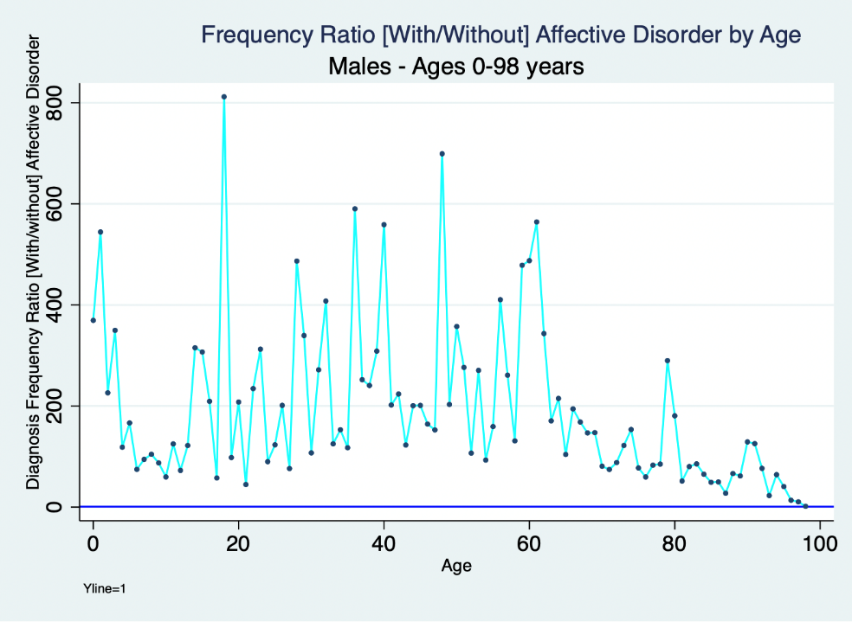
Figure 1 Proportional total diagnosis frequency ratios > 1 distribution of associated biomedical and biophysical diagnoses by age comparing males with and without affective disorder.

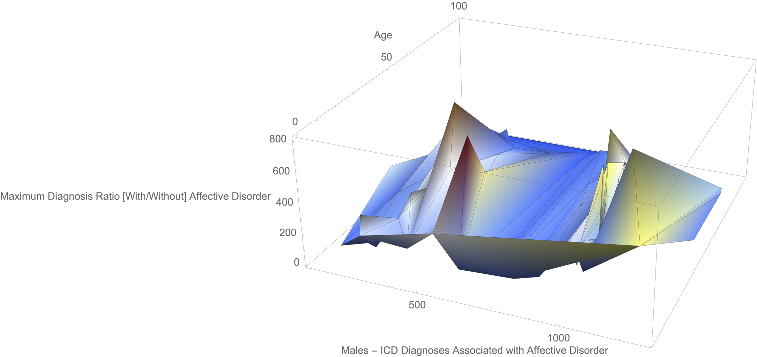
Figure 2 Proportional frequency ratios > 1 distribution of maximum values comparing in males comparing those with and without affective disorder.

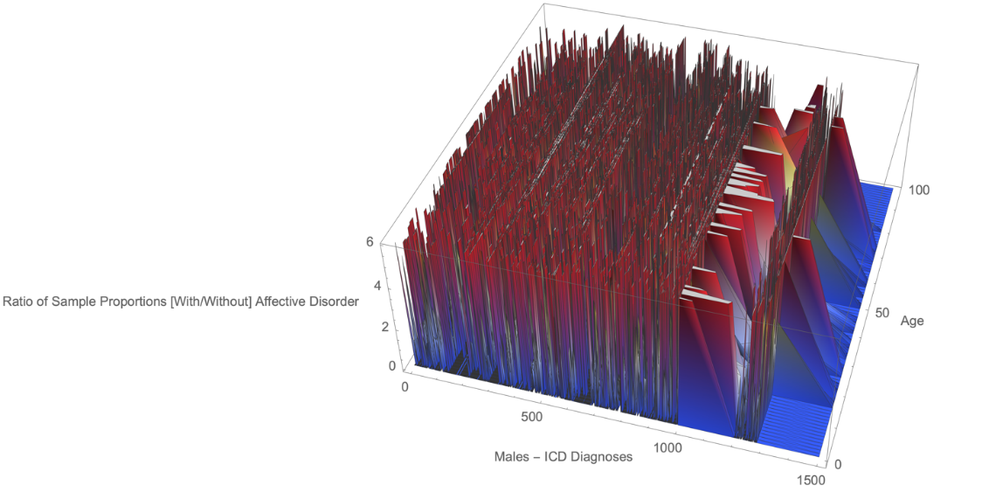
Figure 3 Complete proportional ratios > 1 distribution comparing males with and without affective disorder.

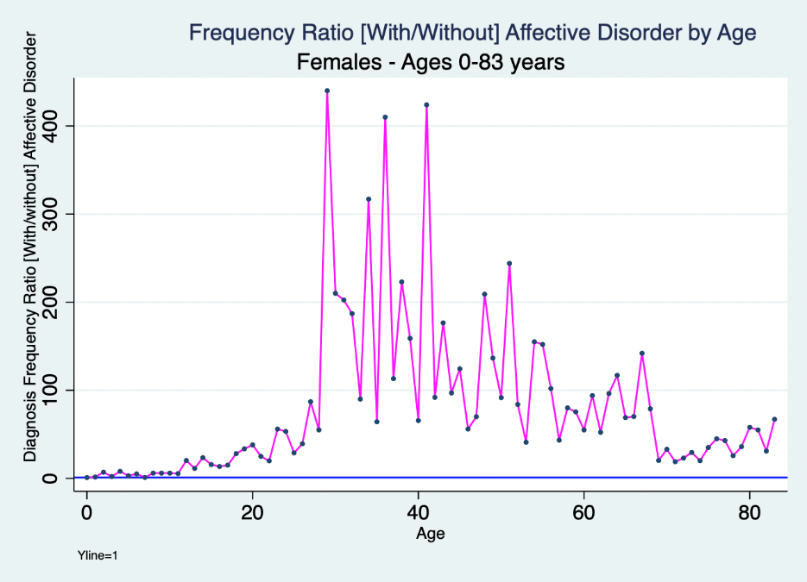
Figure 4 Proportional total diagnosis frequency ratios > 1 distribution of associated biomedical and biophysical diagnoses by age comparing females with and without affective disorder.

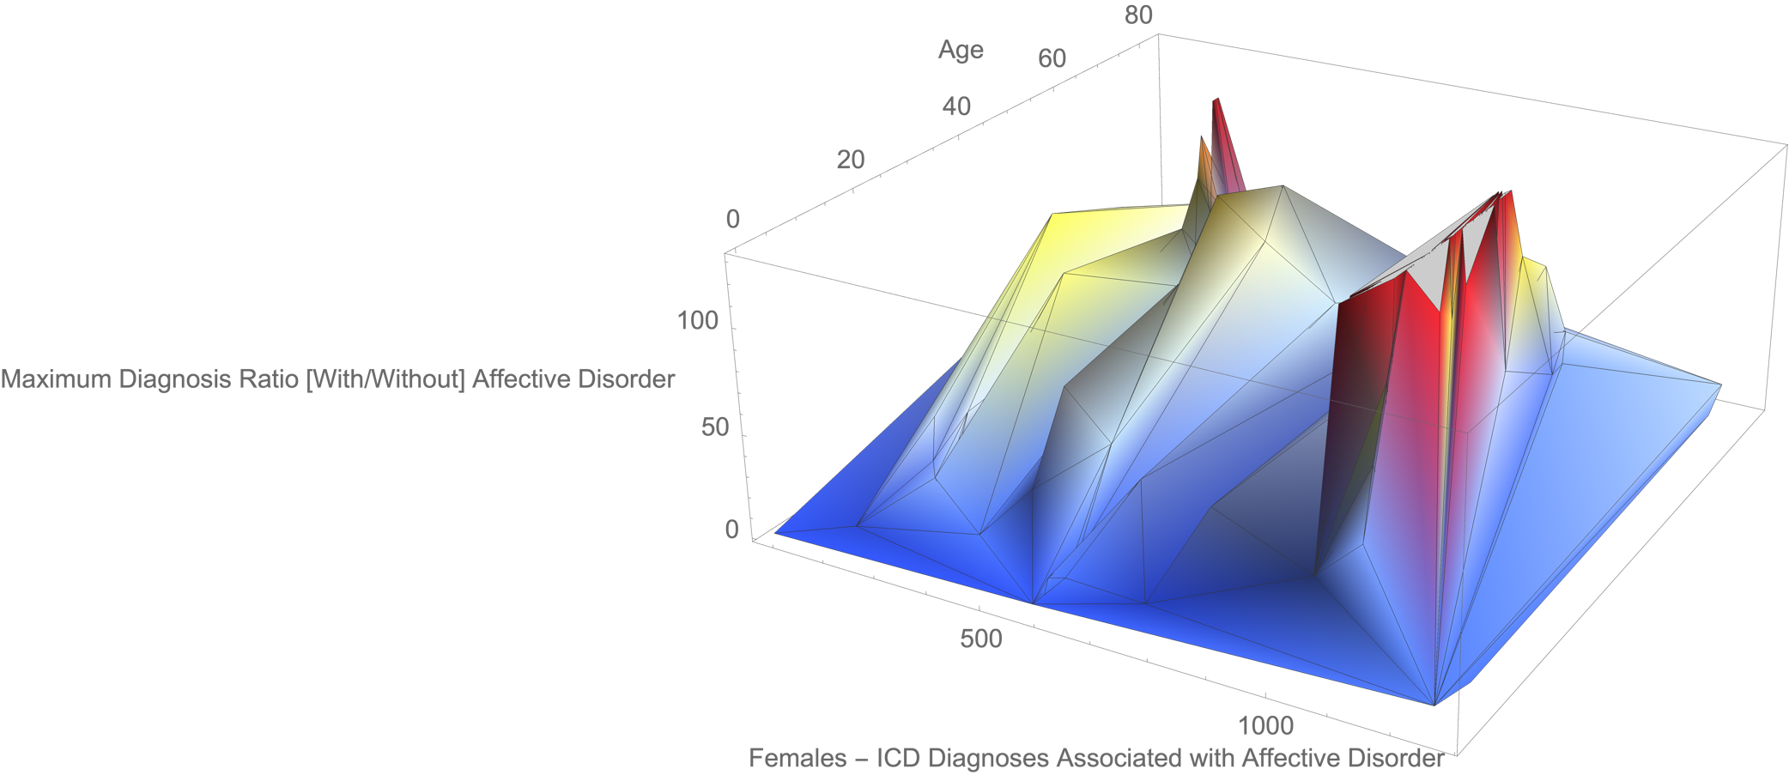
Figure 5 Proportional frequency ratios > 1 distribution of maximum values comparing in females comparing those with and without affective disorder.

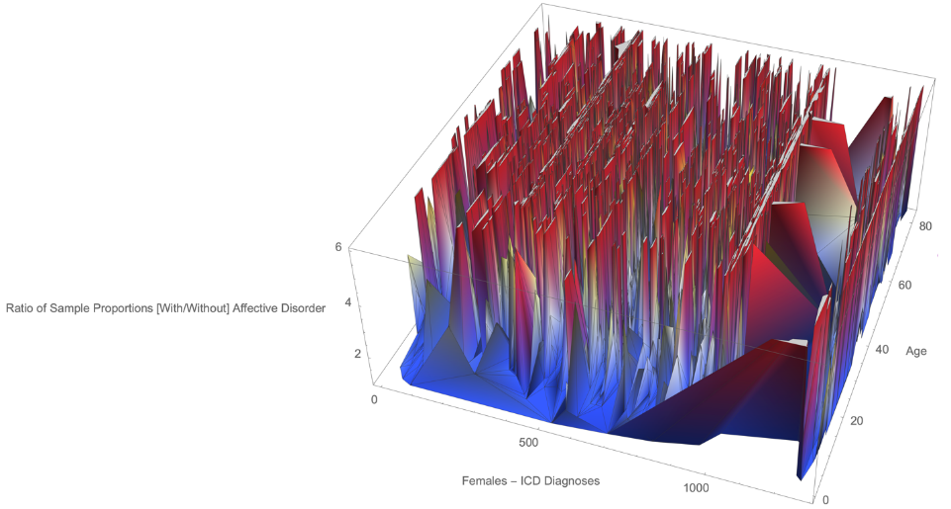
Figure 6 Complete proportional ratios > 1 distribution comparing females with and without affective disorder.

Table 1: Volume of research publications for repeatable PubMed literature searches
Search condition | Frequency of results
“Consortium in Psychiatric Epidemiology”[Title] | 0
“International Consortium in Psychiatric Epidemiology”[Title] | 0
“International Consortium in Psychiatric Epidemiology” | 6
“Psychiatric Epidemiology”[Title] | 245
“ICPE” AND “psych*” | 379
“ICPE” AND (psych*[Title]) | 60
morbid*[MeSH Terms] AND epidemiolog*[MeSH Terms] AND psych*[MeSH Terms] | 165364
morbid*[MeSH Terms] AND epidemiolog*[MeSH Terms] AND mental[MeSH Terms] | 0
((morbidity[MeSH Terms]) AND (epidemiology[MeSH Terms])) AND (psych*[MeSH Terms]) | 309
comorbidity[MeSH Terms] AND “epidemiology”[MeSH Terms] AND “psych*”[MeSH Terms] | 56
“comorbidity”[Title] AND “epidemiology”[Title] AND “psych*”[Title] | 18
((morbidity[Title]) AND (epidemiology[Title])) AND (population[Title]) | 12
((morbidity[Title]) AND (epidemiology[Title])) AND (psych*[Title]) | 10
((morbidity[Title]) AND (epidemiology[MeSH Terms])) AND (psych*[MeSH Terms]) | 8
“International Consortium in Psychiatric Epidemiology” - Articles found by citation matching | 6
“morbidity”[Title] AND “epidemiology”[MeSH Terms] AND “psych*”[Title] | 2
((morbidity[Title]) AND (epidemiology[Title])) AND (mental[Title]) | 1
(psych*) or (mental) | 3347210

Table 2 Demographics and diagnosis frequency of groups with and without affective disorder
Variables | Affective disorder
Females | With | Without
Unique individuals | 23637 | 141427
Mean age | 47 | 38
SD age | 20 | 24
Range age | (1-104) | (0-103)
Mean diagnoses | 291 | 56
SD diagnoses | 253 | 66
Range diagnoses | (1, 3164) | (1, 2424)
Total diagnoses | 6881012 | 7986931
Males | With | Without
Unique individuals | 16164 | 165527
Mean age | 35 | 46
SD | 23 | 19
Range age | (0, 103) | (0, 102)
Mean diagnoses | 239 | 44
SD diagnoses | 257 | 58
Range diagnoses | (1, 4316) | (1, 1864)
Total diagnoses | 3862550 | 7301122
SD: Standard deviations.

