Name of Journal: World Journal of Transplantation
Manuscript NO: 33493
Manuscript Type: Original Article
Observational Study

Lymphocyte recovery is an independent predictor of relapse in allogeneic hematopoietic cell transplantation recipients for acute leukemia

Damlaj M et al. Early lymphocyte recovery decreases relapse rate

Moussab Damlaj, Samer Ghazi, Walid Mashaqbeh, Gamal Gmati, Hend Salama, Khadega A Abuelgasim, Mushtaq Rather, Ali Hajeer, Mohsen Al-Zahrani, Abdul-Rahman Jazieh, Ayman Hejazi, Ahmad Al Askar

Moussab Damlaj, Samer Ghazi, Walid Mashaqbeh, Gamal Gmati, Hend Salama, Khadega A Abuelgasim, Mushtaq Rather Mohsen Al-Zahrani, Abdul-Rahman Jazieh, Ayman Hejazi, Ahmad Al Askar, Division of Hematology and HSCT, Department of Oncology, King Abdulaziz Medical City, P.O. Box 22490, Riyadh 11426, Saudi Arabia

Moussab Damlaj, Samer Ghazi, Walid Mashaqbeh, Gamal Gmati, Hend Salama, Khadega A Abuelgasim, Mushtaq Rather, Mohsen Al-Zahrani, Abdul-Rahman Jazieh, Ayman Hejazi, Ahmad Al Askar, King Abdullah International Medical Research Center, P.O. Box 22490, Riyadh 11426, Saudi Arabia

Ali Hajeer, King Saud bin Abdulaziz University for Health Sciences, P.O. Box 22490, Riyadh 11426, Saudi Arabia

Author contributions: Damlaj M designed the study; Damlaj M, Ghazi S and Mashaqbeh W collected data; all authors analysed the data, provided patients, wrote and reviewed the manuscript, and approved final version of the manuscript.

Institutional review board statement: This study was approved by the institutional review board at King Abdulaziz Medical City (KAMC) – King Abdallah International Medical Research Center (KAIMRC).

Informed consent statement: The institutional review board waived informed consent due to the retrospective study design without patient contact or intervention; thus representing minimal risk study.

Conflict of interest statement: There are no conflicts of interest relevant to the conduct of this study.

Data sharing statement: There are no additional data available.

Open-Access: This article is an open-access article which was selected by an in-house editor and fully peer-reviewed by external reviewers. It is distributed in accordance with the Creative Commons Attribution Non Commercial (CC BY-NC 4.0) license, which permits others to distribute, remix, adapt, build upon this work non-commercially, and license their derivative works on different terms, provided the original work is properly cited and the use is non-commercial. See: http://creativecommons.org/licenses/by-nc/4.0/

Manuscript source: Invited manuscript

Correspondence to: Moussab Damlaj, MD, FRCPC, FACP, Division of Hematology and HSCT, Department of Oncology, King Abdulaziz Medical City, P.O. Box 22490, Riyadh 11426, Saudi Arabia. damlajmo@ngha.med.sa

Received: February 11, 2017
Peer-review started: February 15, 2017
First decision: March 27, 2017
Revised: July 6, 2017
Accepted: July 21, 2017
Article in press:
Published online:

Abstract
AIM
To examine the optimal absolute lymphocyte count (ALC) cut-off utilizing receiver operator characteristics (ROC) in addition to graft characteristics associated with early ALC recovery.

METHODS
Patients who received T-cell replete peripheral hematopoietic cell transplantation (HCT) for acute leukemia were identified. ALC cut-off was established using ROC analysis and subsequently the cohort was stratified. Time to endpoint analysis and cox regression modelling was computed to analyze outcomes.

RESULTS
A total of 72 pts met the inclusion criteria and were analyzed. Optimal ALC cut-off was established to be on day 14 (D14) with ALC > 0.3 × 10⁹/L. At 2 years, cumulative incidence of relapse was 16.9% vs 46.9% (P = 0.025) for early and delayed lymphocyte recovery cohorts, respectively. Chronic graft vs host disease was more prevalent in the early lymphocyte recovery (ELR) group at 70% vs 27%, respectively (P = 0.0006). On multivariable analysis for relapse, ELR retained its prognostic significance with HR 0.27 (0.05-0.94, P = 0.038).

CONCLUSION
ELR is an independent predictor for relapse in patients receiving allogeneic HCT for acute leukemia. ELR was influenced by graft characteristics particularly CD34 count.

Key words: Acute leukemia; Allogeneic transplant; Absolute lymphocyte count

© The Author(s) 2017. Published by Baishideng Publishing Group Inc. All rights reserved.

Core tip: Disease relapse remains the most common cause of treatment failure after allogeneic hematopoietic stem cell transplantation for acute leukemia. Previous studies have identified that early lymphocyte recovery can be a surrogate of graft vs leukemia effect hence identifying high risk patients for relapse. However, published reports are heterogeneous with regards to timeline and magnitude of lymphocyte recovery. Using receiver operator characteristics with area under the curve, we identified that absolute lymphocyte count > 0.3 × 10⁹/L at day 14 is associated with half the relapse risk which was statistically significant at the multivariable analysis. There was a trend towards improved progression free survival and overall survival for patients with early lymphocyte recovery. In conclusion, we observed that lymphocyte recovery is an independent predictor of relapse in allogeneic transplant recipients for acute leukemia. This would help identify high risk patients who may benefit from maintenance strategies post-transplant.

Damlaj M, Ghazi S, Mashaqbeh W, Gmati G, Salama H, Abuelgasim KA, Rather M, Hajeer A, Al-Zahrani M, Jazieh A, Hejazi A, Al Askar A. Lymphocyte recovery is an independent predictor of relapse in allogeneic hematopoietic cell transplantation recipients for acute leukemia. World J Transplant 2017; In press

INTRODUCTION
Allogeneic hematopoietic stem cell transplantation (HCT) is widely used to cure a number of hematologic malignancies including acute myeloid leukemia (AML) and lymphoblastic leukemia / lymphoma (ALL)^{[1-4]}. Relapse of the primary disease remains the most frequent cause of treatment failure in contemporary HCT recipients^{[5]}. Several factors are associated with relapse such as status at HCT, associated cytogenetic abnormalities, conditioning regimen and occurrence of chronic graft vs host disease^{[6]}. Prognosis after overt relapse post-HCT is very poor and a minority of patients are able to achieve durable remissions^{[7]}. Hence, identification of patients at risk of relapse may permit preemptive interventions for relapse prevention^{[8]}.
Immune reconstitution post HCT, particularly lymphocyte recovery, can be a surrogate for graft vs leukemia (GVL) effect hence improved long term disease control. Several groups reported that early absolute lymphocyte count (ALC) recovery is associated with decreased relapse rates in hematologic malignancies. However, there is heterogeneity regarding the predictive optimal threshold and timing of lymphocyte recovery. For example Michelis et al^{[9]} reported that ALC ≥ 0.5 × 10⁹/L on day 28 in AML patients is associated with reduction of the relapse risk at multivariable analysis with HR 0.49 (0.26-0.92, P = 0.03) without a survival advantage. On the other hand, Kumar et al^{[10,11]} showed that ALC ≥ 0.15 × 10⁹/L on day +30 resulted in a 3 fold reduction in relapse risk in AML patients but an ALC of > 0.17 × 10⁹/L on day +21 was protective from relapse in ALL patients. Thoma et al. showed that ALC > 0.3 × 10⁹/L on day +100 is associated with improved overall survival (OS)^{[12]}.
In light of the above discrepancies, we examined the impact of ALC recovery on post HCT outcomes; where optimal ALC threshold and timeline was analyzed using receiver operator characteristics (ROC) and area under the curve (AUC). We also analyzed infused allograft cellular content for factors predicting early ALC recovery.

MATERIALS AND METHODS
Patient selection
After due institutional review board (IRB) approval, patients ≥ 14 years of age with AML or ALL who underwent HCT at our institution between 2010 – 2015 were identified.
The selection criteria included patients receiving myeloablative (MAC) or reduced intensity conditioning (RIC) from related or unrelated donors. Classification of the conditioning intensity was based on the criteria suggested by the Centre of International Blood and Marrow Transplant Research (CIBMTR)^{[13]}. Selection of regimen intensity was at the discretion of the treating physician and generally patients with a Hematopoeitic Stem Cell Co-morbidity index (HCT-CI) < 3 were considered for MAC regimen^{[14]}. Patients with ALL who were candidates for MAC, preferentially received a total body irradiation (TBI) based regimen. Exclusion criteria were for patients who received a bone marrow graft or cord blood stem cell source, second transplant and those who underwent in vivo or in vitro T-cell depletion. Data were collected retrospectively from the patient’s electronic medical records. Cytogenetic data at the time of diagnosis was collected and stratified as previously described for AML patients^{[15]}. ALL patients with hypodiploid karyotype, translocations at (4;11), (11q23), (9;22) and (1;19) were deemed high risk, and remaining patients were classified as standard risk^{[16-20]}.

Preparative regimens and GVHD prophylaxis
Patients candidates for MAC intensity received one of two regimens based on the underlying diagnosis; patients with ALL received cyclosphosphamide 60 mg/kg intravenously (IV) for two days followed by 1200 cGy of TBI fractioned twice daily for three days. Patients with AML received fludarabine 30 mg/m² daily for five days in addition to busulfan 3.2 mg/kg IV daily for four days in addition to cyclophosphamide 60 mg/kg IV daily for 2 d. Mesna was given for bladder protection. For RIC regimens, patients received either fludarabine 30 mg/m² IV daily for 5 days with busulfan 3.2 mg/kg IV daily for two days or fludarabine 30 mg/m² IV daily for 5 d with melphalan 70 mg/m² IV for two days. Phenytoin loading and maintenance was given for seizure prophylaxis if busulfan was used until 24 hours post last dose. Graft vs Host Disease (GVHD) prophylaxis consisted of methotrexate and cyclosporine. Methotrexate was given at 15 mg/m² on day +1 followed by 10 mg/m² on days +3, +6 and +11 with leucovorin rescue 24 hrs post each methotrexate dose. Day +11 was omitted if there is evidence of significant liver toxicity or grade ≥ 2 mucositis.

Definitions and transplant related outcomes
OS was calculated from the date of transplant until the date of death of any cause or last documented follow-up date. Progression Free Survival (PFS) was calculated from the time of transplant until death of any cause or relapse. Cumulative Incidence of Relapse (CIR) was calculated from the date of transplant until relapse or date of last follow up. Cumulative Incidence of Non Relapse Mortality (NRM) was calculated from the date of transplant until death of any cause without evidence of disease relapse. Acute and chronic GVHD was diagnosed according to standard criteria. Neutrophil engraftment was defined as an absolute neutrophil count (ANC) of 0.5 × 10⁹/L or higher for 3 consecutive days. Platelet engraftment was defined as platelet count higher than 20 × 10⁹/L for 7 consecutive days without transfusion support.

End points
The primary end point was to examine the impact of early ALC recovery (ELR) on CIR. Secondary endpoints were to examine effect of ELR on other post HCT outcomes (OS, PFS and NRM) and to examine infused allo-graft cellular content for factors predicting ELR. ALC was abstracted on days +7, +14, +21 and +28 from the Complete Blood Count (CBC) post HCT using either the automated or manual differential method^{[21]}.

Statistical analysis
Baseline patient, disease and treatment related variables were reported using descriptive statistics (counts, medians and percentages). Categorical and continuous variables were compared using Pearson's chi-squared and Wilcoxon / Kruskal-Wallis, respectively. Probability of OS was computed using the Kaplan-Meier method. Group comparisons were made using the log-rank test. Time to event was calculated from the date of transplant until the event of interest or point of last clinical encounter, in which case the event will be censored. Cumulative incidence was computed as competing events using Grey's model, considering death as a competing event for relapse and relapse as a competing event for NRM. Univariable and multivariable analyses were performed using Cox proportional hazard regression modelling and expressed as Hazard Ratio (HR) with 95% Confidence Interval (CI) and P value. Any variable with a P ≤ 0.1 was incorporated into the multivariable model in a stepwise selection process. Thresholds of ALC recovery post HCT as well as infused allograft characteristics, if present, were assessed using the receiver operating characteristics curve (ROC) and area under the curve (AUC) for the end point of relapse. Statistical analysis were performed using JMP Pro Version 11 (SAS Institute, Cary, NC, United States) software and EZR on R commander version 1.28^{[22]}.

RESULTS
Patient and transplant characteristics
A total of 72 patients met the inclusion criteria and their data were analysed. Baseline characteristics of the cohort are shown in Table 1. Majority of transplants were from related donors (88%), while the remaining minority (12%) were from unrelated donors. Transplants were from peripheral blood stem cells, while cord blood and bone marrow grafts were excluded due to different immune reconstitution kinetics. All patients were from the Middle East and North Africa Region (MENA). The median follow up was 17 months (range: 2-64.8) at which point the CIR was 35.2% and OS was 67.3%.

Optimal ALC threshold
ROC curves with AUC were used to determine the best cut-off value for ALC on days +7, +14, +21 and +28 based on their utility as a marker for the binary outcome of relapse vs no relapse. ALC on day +14 > 0.3 × 10⁹/L was identified as the optimal cut-off point. Patients were subsequently stratified as ELR if ALC on day +14 > 0.3 × 10⁹/L and delayed lymphocyte recovery (DLR) if day +14 ALC was ≤ 0.3 × 10⁹/L. Patient’s disease and HCT related variables are stratified per lymphocyte recovery as shown in Table 1. Cohorts were similar with regards to age, gender, diagnosis, performance status, cytogenetic risk, status at HCT, stem cell source, donor gender, ABO matching and conditioning intensity. Regimens containing TBI were more common in the DLR group at 63% vs 33% (P = 0.019).

Infused allo-graft characteristics influencing ELR
We examined infused allo-graft cellular contents for factors predicting ELR in our patients. Optimal thresholds were again determined by ROC with AUC analysis. We observed that infusing grafts with the following characteristics was associated with higher incidence of ELR; CD 34 of < 6 × 10⁶/kg (71% vs 42%, P = 0.018), CD3 > 24 × 10⁷/kg (19% vs 2%, P = 0.017), infused ALC > 1.3 × 10⁸/kg (96% vs 74%; P = 0.015), infused lymphocyte-monocyte ratio (LMR) > 4 (33% vs 11%, P = 0.022) and CD 34 < 6 × 10⁶/kg with ALC > 1.3 × 10⁸/kg (67% vs 27%, P = 0.0012). These results are show in Table 2.

Impact of ELR on post HCT outcomes
Stratified by lymphocyte recovery, after 2 years of follow up, the CIR was significantly higher for the DLR vs ELR groups at 46.9% vs 16.9%, respectively (P = 0.025). On the other hand, at 2 years, there was a non-significant difference of NRM between the two cohorts at 14.2% vs 23.3% for the DLR and ERL groups, respectively (P = 0.51). There was a trend towards improved 2 year PFS for the ELR at 61.9% vs 40.1% (P = 0.09), but no significant difference of OS was observed at 70.1% vs 53.9% for ELR vs DLR, respectively (P = 0.12) (Figure 1). Median time to ANC and platelet engraftment was similar for both groups at 17 (12-29) days and 24 (21-37) for ELR and 17 (12-25) and 24 (7-42), respectively (P = 0.76, 0.98). Incidence of aGVHD was similar but cGVHD was significantly higher in the ELR groups at 70% vs 27% (P = 0.0006). These results are shown in Table 3.
Six variables were found to influence relapse at univariable analysis; age at HCT HR 0.97 (0.94-1.01, P = 0.1), single marital status HR 2.59 (1.13-6.65, P = 0.023), female donor to male recipient HR 2.15 (0.91-4.7, P = 0.079), CR1 remission HR 0.52 (0.23-1.15; P = 0.1), cGVHD HR 0.24 (0.079-0.59, P = 0.0013) and ELR 0.31 (0.09-0.8, P = 0.014). We also examined the impact of TBI on relapse given the higher incidence of TBI based conditioning in the DLR group, but did not see an apparent impact with HR1.003 (0.46-2.2, P = 0.99). Three factors remained prognostic at the multivariable analysis which were ELR HR 0.27 (0.05-0.94, P = 0.038), CR1 remission HR 0.36 (0.15-0.87, P = 0.024) and cGVHD 0.33 (0.1-0.92, P = 0.035). These results are shown in Table 4.
Causes of mortality in the ELR and DLR cohorts were related to relapse of primary disease in 3/8 (38%) and 18/24 (75%), infection 1/8 (12%) vs 0/24, organ failure 0/8 vs 1/24 (4.2%), aGVHD 1/8 (12) vs 2/24 (8.3%) and cGVHD 3/8 (38%) vs 3/24 (12%). These results are shown in Table 5.

DISCUSSION
The present analysis highlights again the value of ELR as a protective factor from disease relapse in acute leukemia. In particular, we report that ALC > 0.3 × 10⁸/kg on day +14 post allogeneic HCT for acute leukemia is an independent factor predicting decreased CIR at multivariable analysis. We also observed a trend towards improved PFS and OS; however this did not meet statistical significance. NRM was not significant between both cohorts, however both the incidence of cGVHD and cGVHD related deaths were more frequent in the ELR group. Incidence of cGVHD related deaths was 37.5% (3/8) in the ELR group compared to 12.5% (3/24) in the DLR group. This perhaps explains the lack of statistical significance seen for PFS and OS.
Give that graft source and manipulation can affect cellular reconstitution post-transplant, we excluded patients who received bone marrow or cord blood grafts in addition to those receiving T-cell depleted manipulation of the graft^{[23,24]}. TBI was administered more frequently in the DLR group, but we did not observe an impact on relapse using TBI at the univariable analysis level with HR: 1 (0.46-2.2, P = 0.99).
At multivariable analysis, three factors had an impact on relapse: CR1, cGVHD and ELR. cGVHD is well described to decrease incidence of relapse due to a parallel GVL effect^{[25]}. The current analysis supports the hypothesis that ELR is a surrogate for GVL as cGVHD incidence was significantly higher in the ELR group. Incidence of cGVHD related deaths were also more frequent in the ELR group, which likely accounts for the observed NRM, PFS and OS rates.
Although lymphocyte subsets were not identified in this analysis, the most plausible subset implicated in our analysis would likely be the natural killer (NK) cells as they represent the bulk of recovered lymphocytes by two weeks post HCT^{[26]}. Previously, NK cells were found to be an independent factor predicting post HCT outcomes in T-cell depleted grafts^{[27]}. However, this finding was not reproduced when T-cell replete grafts were used^{[28]}. That said, this observed protective effect from ELR is likely a complex interplay between various lymphocyte subsets, such as NK cells, cytotoxic T-lymphocytes (CD8+) and regulatory T-cells (CD4+ and CD25+)^{[29,30]}.Furthermore, the infused graft cellular content likely impacts post HCT reconstitution, and this has been well demonstrated in the autologous HCT setting and to a lesser extent allogeneic HCT^{[12,31-33]}.
Infused allo-graft cellular content predicts post HCT reconstitution. We observed that higher T-cell and absolute lymphocyte content was significantly associated with ELR. Higher CD34 content is typically associated with faster engraftment and decreased rejection^{[34,35]}. The National Marrow Donor Program (NMDP) reported on a cohort of over 900 unrelated HCTs using peripheral blood stem cells indicating that higher CD34 doses resulted in rapid engraftment, decreased transplant related mortality (TRM) and improved OS using various conditioning regimens^{[36]}. However, the median stem cell dose administered was 6 × 10⁶/kg and 5 × 10⁶/kg in myeloablative (MAC) and reduced intensity RIC transplants, respectively. We found that infusing < 6 × 10⁶/kg stem cells was significantly associated with ELR. This is consistent with other reports indicating that administering higher doses of stem cells leads to detrimental outcomes both in MAC and RIC regimens^{[37-40]}. Collectively, it appears that the optimal stem cell dose is 6-8 × 10⁶/kg, thus striking a balance between (GVL) and GVHD^{[41]}.
This analysis has inherent limitations, primarily due to the retrospective nature and sample size. We excluded patients who had T-cell manipulation or grafts other than peripheral blood stem cells as these factors can impact immune reconstitution. However, a number of important observations were made. First, similar to prior reports, we observed that ELR is protective of relapse but the timing post HCT and lymphocyte thresholds were determined using ROC-AUC and not empirically. Second, a higher incidence of cGVHD and cGVHD related deaths was seen with ELR, which confirms the likely mechanism of lower CIR seen in this cohort. Interestingly, marital status was significantly associated with decreased CIR although it did not retain significance at the multivariable analysis. Lastly, we reported that infusing less stem cells correlates better with ELR thus challenging the notion of “more is better”.
In summary, the presented study demonstrates an independent protective effect of ALC at 14 d post allogeneic HCT. Given that patients with acute leukemia relapsing after allogeneic HCT have a dismal prognosis. Early identification of these cases may facilitate pre-emptive decisions such as early cessation of immune-suppression or use of lymphocyte infusion in order to better harness the GVL effect, or other maintenance strategies such as hypomethylating agents. These important observations warrant further study.

COMMENTS
Background
Disease relapse remains the most common cause of treatment failure after allogeneic hematopoietic stem cell transplantation for acute leukemia. Several factors are associated with relapse such as status at hematopoietic cell transplantation (HCT), associated cytogenetic abnormalities, conditioning regimen and occurrence of chronic graft vs host disease. Prognosis after overt relapse post-HCT is very poor and a minority of patients are able to achieve durable remissions. Hence, identification of patients at risk of relapse may permit preemptive interventions for relapse prevention. Immune reconstitution post HCT, particularly lymphocyte recovery, can be a surrogate for GVL effect hence improved long term disease control.

Research frontiers
Several groups reported that early absolute lymphocyte count (ALC) recovery is associated with decreased relapse rates in hematologic malignancies. However, there is heterogeneity regarding the predictive optimal threshold and timing of lymphocyte recovery.

Innovations and breakthroughs
We examined the impact of ALC recovery on post HCT outcomes. Using receiver operator characteristics with area under the curve, we identified that absolute lymphocyte count > 0.3 × 10⁹/L at day 14 is associated with half the relapse risk which was statistically significant at the multivariable analysis. We also observed that infused graft content influences ALC recovery.

Applications
Given that patients with acute leukemia relapsing after allogeneic HCT have a dismal prognosis. Early identification of these cases may facilitate pre-emptive decisions such as early cessation of immune-suppression or use of lymphocyte infusion in order to better harness the GVL effect, or other maintenance strategies such as hypomethylating agents.

Terminology
ALC recovery post allogeneic HCT is an easy to measure marker and can be used as a surrogate to identify high risk patients for relapse. Using receiver operator characteristics with area under the curve can help identify the optimal ALC threshold to exhibit this protective effect.

Peer-review
This is an interesting study, demonstrating lymphocyte recovery as independent predictor for relapse in allogenic hematopoietic stem cell transplantation for acute leukemia.

REFERENCES
- Farag SS, Ruppert AS, Mrózek K, Mayer RJ, Stone RM, Carroll AJ, Powell BL, Moore JO, Pettenati MJ, Koduru PR, Stamberg J, Baer MR, Block AW, Vardiman JW, Kolitz JE, Schiffer CA, Larson RA, Bloomfield CD. Outcome of induction and postremission therapy in younger adults with acute myeloid leukemia with normal karyotype: a cancer and leukemia group B study. J Clin Oncol 2005; 23: 482-493 [PMID: 15534356 DOI: 10.1200/JCO.2005.06.090]
- Yanada M, Matsuo K, Emi N, Naoe T. Efficacy of allogeneic hematopoietic stem cell transplantation depends on cytogenetic risk for acute myeloid leukemia in first disease remission: a metaanalysis. Cancer 2005; 103: 1652-1658 [PMID: 15742336 DOI: 10.1002/cncr.20945]
- Koreth J, Schlenk R, Kopecky KJ, Honda S, Sierra J, Djulbegovic BJ, Wadleigh M, DeAngelo DJ, Stone RM, Sakamaki H, Appelbaum FR, Döhner H, Antin JH, Soiffer RJ, Cutler C. Allogeneic stem cell transplantation for acute myeloid leukemia in first complete remission: systematic review and meta-analysis of prospective clinical trials. JAMA 2009; 301: 2349-2361 [PMID: 19509382 DOI: 10.1001/jama.2009.813]
- Majhail NS, Farnia SH, Carpenter PA, Champlin RE, Crawford S, Marks DI, Omel JL, Orchard PJ, Palmer J, Saber W, Savani BN, Veys PA, Bredeson CN, Giralt SA, LeMaistre CF; American Society for Blood and Marrow Transplantation. Indications for Autologous and Allogeneic Hematopoietic Cell Transplantation: Guidelines from the American Society for Blood and Marrow Transplantation. Biol Blood Marrow Transplant 2015; 21: 1863-1869 [PMID: 26256941 DOI: 10.1016/j.bbmt.2015.07.032]
- Barrett AJ, Battiwalla M. Relapse after allogeneic stem cell transplantation. Expert Rev Hematol 2010; 3: 429-441 [PMID: 21083034 DOI: 10.1586/ehm.10.32]
- Ossenkoppele GJ, Janssen JJ, van de Loosdrecht AA. Risk factors for relapse after allogeneic transplantation in acute myeloid leukemia. Haematologica 2016; 101: 20-25 [PMID: 26721801 DOI: 10.3324/haematol.2015.139105]
- Savani BN, Mielke S, Reddy N, Goodman S, Jagasia M, Rezvani K. Management of relapse after allo-SCT for AML and the role of second transplantation. Bone Marrow Transplant 2009; 44: 769-777 [PMID: 19855439 DOI: 10.1038/bmt.2009.300]
- de Lima M, Porter DL, Battiwalla M, Bishop MR, Giralt SA, Hardy NM, Kröger N, Wayne AS, Schmid C. Proceedings from the National Cancer Institute's Second International Workshop on the Biology, Prevention, and Treatment of Relapse After Hematopoietic Stem Cell Transplantation: part III. Prevention and treatment of relapse after allogeneic transplantation. Biol Blood Marrow Transplant 2014; 20: 4-13 [PMID: 24018392 DOI: 10.1016/j.bbmt.2013.08.012]
- Michelis FV, Messner HA, Loach D, Uhm J, Gupta V, Lipton JH, Seftel MD, Kuruvilla J, Kim DD. Early lymphocyte recovery at 28 d post-transplant is predictive of reduced risk of relapse in patients with acute myeloid leukemia transplanted with peripheral blood stem cell grafts. Eur J Haematol 2014; 93: 273-280 [PMID: 24725056 DOI: 10.1111/ejh.12338]
- Kumar S, Chen MG, Gastineau DA, Gertz MA, Inwards DJ, Lacy MQ, Tefferi A, Litzow MR. Effect of slow lymphocyte recovery and type of graft-versus-host disease prophylaxis on relapse after allogeneic bone marrow transplantation for acute myelogenous leukemia. Bone Marrow Transplant 2001; 28: 951-956 [PMID: 11753550 DOI: 10.1038/sj.bmt.1703262]
- Kumar S, Chen MG, Gastineau DA, Gertz MA, Inwards DJ, Lacy MQ, Tefferi A, Litzow MR. Lymphocyte recovery after allogeneic bone marrow transplantation predicts risk of relapse in acute lymphoblastic leukemia. Leukemia 2003; 17: 1865-1870 [PMID: 12970788 DOI: 10.1038/sj.leu.2403055]
- Thoma MD, Huneke TJ, DeCook LJ, Johnson ND, Wiegand RA, Litzow MR, Hogan WJ, Porrata LF, Holtan SG. Peripheral blood lymphocyte and monocyte recovery and survival in acute leukemia postmyeloablative allogeneic hematopoietic stem cell transplant. Biol Blood Marrow Transplant 2012; 18: 600-607 [PMID: 21843495 DOI: 10.1016/j.bbmt.2011.08.007]
- Bacigalupo A, Ballen K, Rizzo D, Giralt S, Lazarus H, Ho V, Apperley J, Slavin S, Pasquini M, Sandmaier BM, Barrett J, Blaise D, Lowski R, Horowitz M. Defining the intensity of conditioning regimens: working definitions. Biol Blood Marrow Transplant 2009; 15: 1628-1633 [PMID: 19896087 DOI: 10.1016/j.bbmt.2009.07.004]
- Sorror ML, Maris MB, Storb R, Baron F, Sandmaier BM, Maloney DG, Storer B. Hematopoietic cell transplantation (HCT)-specific comorbidity index: a new tool for risk assessment before allogeneic HCT. Blood 2005; 106: 2912-2919 [PMID: 15994282 DOI: 10.1182/blood-2005-05-2004]
- Grimwade D, Hills RK, Moorman AV, Walker H, Chatters S, Goldstone AH, Wheatley K, Harrison CJ, Burnett AK; National Cancer Research Institute Adult Leukaemia Working Group. Refinement of cytogenetic classification in acute myeloid leukemia: determination of prognostic significance of rare recurring chromosomal abnormalities among 5876 younger adult patients treated in the United Kingdom Medical Research Council trials. Blood 2010; 116: 354-365 [PMID: 20385793 DOI: 10.1182/blood-2009-11-254441]
- Moorman AV, Ensor HM, Richards SM, Chilton L, Schwab C, Kinsey SE, Vora A, Mitchell CD, Harrison CJ. Prognostic effect of chromosomal abnormalities in childhood B-cell precursor acute lymphoblastic leukaemia: results from the UK Medical Research Council ALL97/99 randomised trial. Lancet Oncol 2010; 11: 429-438 [PMID: 20409752 DOI: 10.1016/S1470-2045(10)70066-8]
- Thirman MJ, Gill HJ, Burnett RC, Mbangkollo D, McCabe NR, Kobayashi H, Ziemin-van der Poel S, Kaneko Y, Morgan R, Sandberg AA. Rearrangement of the MLL gene in acute lymphoblastic and acute myeloid leukemias with 11q23 chromosomal translocations. N Engl J Med 1993; 329: 909-914 [PMID: 8361504 DOI: 10.1056/NEJM199309233291302]
- Rambaldi A, Attuati V, Bassan R, Neonato MG, Viero P, Battista R, Di Bona E, Rossi G, Pogliani E, Ruggeri M, Amaru R, Rivolta A, Giudici G, Biondi A, Barbui T. Molecular diagnosis and clinical relevance of t(9;22), t(4;11) and t(1;19) chromosome abnormalities in a consecutive group of 141 adult patients with acute lymphoblastic leukemia. Leuk Lymphoma 1996; 21: 457-466 [PMID: 9172811 DOI: 10.3109/10428199609093444]
- Crist WM, Carroll AJ, Shuster JJ, Behm FG, Whitehead M, Vietti TJ, Look AT, Mahoney D, Ragab A, Pullen DJ. Poor prognosis of children with pre-B acute lymphoblastic leukemia is associated with the t(1;19)(q23;p13): a Pediatric Oncology Group study. Blood 1990; 76: 117-122 [PMID: 2364165]
- Harrison CJ, Moorman AV, Broadfield ZJ, Cheung KL, Harris RL, Reza Jalali G, Robinson HM, Barber KE, Richards SM, Mitchell CD, Eden TO, Hann IM, Hill FG, Kinsey SE, Gibson BE, Lilleyman J, Vora A, Goldstone AH, Franklin IM, Durrant J, Martineau M; Childhood and Adult Leukaemia Working Parties. Three distinct subgroups of hypodiploidy in acute lymphoblastic leukaemia. Br J Haematol 2004; 125: 552-559 [PMID: 15147369 DOI: 10.1111/j.1365-2141.2004.04948.x]
- Cox CJ, Habermann TM, Payne BA, Klee GG, Pierre RV. Evaluation of the Coulter Counter model S-Plus IV. Am J Clin Pathol 1985; 84: 297-306 [PMID: 4036859]
- Kanda Y. Investigation of the freely available easy-to-use software 'EZR' for medical statistics. Bone Marrow Transplant 2013; 48: 452-458 [PMID: 23208313 DOI: 10.1038/bmt.2012.244]
- Anasetti C, Logan BR, Lee SJ, Waller EK, Weisdorf DJ, Wingard JR, Cutler CS, Westervelt P, Woolfrey A, Couban S, Ehninger G, Johnston L, Maziarz RT, Pulsipher MA, Porter DL, Mineishi S, McCarty JM, Khan SP, Anderlini P, Bensinger WI, Leitman SF, Rowley SD, Bredeson C, Carter SL, Horowitz MM, Confer DL; Blood and Marrow Transplant Clinical Trials Network. Peripheral-blood stem cells versus bone marrow from unrelated donors. N Engl J Med 2012; 367: 1487-1496 [PMID: 23075175 DOI: 10.1056/NEJMoa1203517]
- Jacobson CA, Turki AT, McDonough SM, Stevenson KE, Kim HT, Kao G, Herrera MI, Reynolds CG, Alyea EP, Ho VT, Koreth J, Armand P, Chen YB, Ballen K, Soiffer RJ, Antin JH, Cutler CS, Ritz J. Immune reconstitution after double umbilical cord blood stem cell transplantation: comparison with unrelated peripheral blood stem cell transplantation. Biol Blood Marrow Transplant 2012; 18: 565-574 [PMID: 21875503 DOI: 10.1016/j.bbmt.2011.08.018]
- Signori A, Crocchiolo R, Oneto R, Sacchi N, Sormani MP, Fagioli F, Rambaldi A, Ciceri F, Bacigalupo A. Chronic GVHD is associated with lower relapse risk irrespective of stem cell source among patients receiving transplantation from unrelated donors. Bone Marrow Transplant 2012; 47: 1474-1478 [PMID: 22465976 DOI: 10.1038/bmt.2012.58]
- Storek J, Geddes M, Khan F, Huard B, Helg C, Chalandon Y, Passweg J, Roosnek E. Reconstitution of the immune system after hematopoietic stem cell transplantation in humans. Semin Immunopathol 2008; 30: 425-437 [PMID: 18949477 DOI: 10.1007/s00281-008-0132-5]
- Savani BN, Mielke S, Adams S, Uribe M, Rezvani K, Yong AS, Zeilah J, Kurlander R, Srinivasan R, Childs R, Hensel N, Barrett AJ. Rapid natural killer cell recovery determines outcome after T-cell-depleted HLA-identical stem cell transplantation in patients with myeloid leukemias but not with acute lymphoblastic leukemia. Leukemia 2007; 21: 2145-2152 [PMID: 17673900 DOI: 10.1038/sj.leu.2404892]
- Bühlmann L, Buser AS, Cantoni N, Gerull S, Tichelli A, Gratwohl A, Stern M. Lymphocyte subset recovery and outcome after T-cell replete allogeneic hematopoietic SCT. Bone Marrow Transplant 2011; 46: 1357-1362 [PMID: 21113185 DOI: 10.1038/bmt.2010.306]
- Edinger M, Hoffmann P, Ermann J, Drago K, Fathman CG, Strober S, Negrin RS. CD4+CD25+ regulatory T cells preserve graft-versus-tumor activity while inhibiting graft-versus-host disease after bone marrow transplantation. Nat Med 2003; 9: 1144-1150 [PMID: 12925844 DOI: 10.1038/nm915]
- Di Ianni M, Falzetti F, Carotti A, Terenzi A, Castellino F, Bonifacio E, Del Papa B, Zei T, Ostini RI, Cecchini D, Aloisi T, Perruccio K, Ruggeri L, Balucani C, Pierini A, Sportoletti P, Aristei C, Falini B, Reisner Y, Velardi A, Aversa F, Martelli MF. Tregs prevent GVHD and promote immune reconstitution in HLA-haploidentical transplantation. Blood 2011; 117: 3921-3928 [PMID: 21292771 DOI: 10.1182/blood-2010-10-311894]
- Porrata LF, Inwards DJ, Ansell SM, Micallef IN, Johnston PB, Hogan WJ, Markovic SN. Infused autograft lymphocyte-to-monocyte ratio and survival in T-cell lymphoma post-autologous peripheral blood hematopoietic stem cell transplantation. J Hematol Oncol 2015; 8: 80 [PMID: 26138828 DOI: 10.1186/s13045-015-0178-5]
- Porrata LF, Inwards DJ, Ansell SM, Micallef IN, Johnston PB, Hogan WJ, Markovic SN. Day 100 Peripheral Blood Absolute Lymphocyte/Monocyte Ratio and Survival in Classical Hodgkin's Lymphoma Postautologous Peripheral Blood Hematopoietic Stem Cell Transplantation. Bone Marrow Res 2013; 2013: 658371 [PMID: 23710362 DOI: 10.1155/2013/658371]
- DeCook LJ, Thoma M, Huneke T, Johnson ND, Wiegand RA, Patnaik MM, Litzow MR, Hogan WJ, Porrata LF, Holtan SG. Impact of lymphocyte and monocyte recovery on the outcomes of allogeneic hematopoietic SCT with fludarabine and melphalan conditioning. Bone Marrow Transplant 2013; 48: 708-714 [PMID: 23103674 DOI: 10.1038/bmt.2012.211]
- Storb R, Prentice RL, Thomas ED. Marrow transplantation for treatment of aplastic anemia. An analysis of factors associated with graft rejection. N Engl J Med 1977; 296: 61-66 [PMID: 136605 DOI: 10.1056/NEJM197701132960201]
- Bittencourt H, Rocha V, Chevret S, Socié G, Espérou H, Devergie A, Dal Cortivo L, Marolleau JP, Garnier F, Ribaud P, Gluckman E. Association of CD34 cell dose with hematopoietic recovery, infections, and other outcomes after HLA-identical sibling bone marrow transplantation. Blood 2002; 99: 2726-2733 [PMID: 11929759]
- Pulsipher MA, Chitphakdithai P, Logan BR, Leitman SF, Anderlini P, Klein JP, Horowitz MM, Miller JP, King RJ, Confer DL. Donor, recipient, and transplant characteristics as risk factors after unrelated donor PBSC transplantation: beneficial effects of higher CD34+ cell dose. Blood 2009; 114: 2606-2616 [PMID: 19608747 DOI: 10.1182/blood-2009-03-208355]
- Remberger M, Törlén J, Ringdén O, Engström M, Watz E, Uhlin M, Mattsson J. Effect of Total Nucleated and CD34(+) Cell Dose on Outcome after Allogeneic Hematopoietic Stem Cell Transplantation. Biol Blood Marrow Transplant 2015; 21: 889-893 [PMID: 25662230 DOI: 10.1016/j.bbmt.2015.01.025]
- Mehta J, Mehta J, Frankfurt O, Altman J, Evens A, Tallman M, Gordon L, Williams S, Winter J, Krishnamurthy J, Duffey S, Singh V, Meagher R, Grinblatt D, Kaminer L, Singhal S. Optimizing the CD34 + cell dose for reduced-intensity allogeneic hematopoietic stem cell transplantation. Leuk Lymphoma 2009; 50: 1434-1441 [PMID: 19603344 DOI: 10.1080/10428190903085944]
- Przepiorka D, Smith TL, Folloder J, Khouri I, Ueno NT, Mehra R, Körbling M, Huh YO, Giralt S, Gajewski J, Donato M, Cleary K, Claxton D, Braunschweig I, van Besien K, Andersson BS, Anderlini P, Champlin R. Risk factors for acute graft-versus-host disease after allogeneic blood stem cell transplantation. Blood 1999; 94: 1465-1470 [PMID: 10438735]
- Mohty M, Bilger K, Jourdan E, Kuentz M, Michallet M, Bourhis JH, Milpied N, Sutton L, Jouet JP, Attal M, Bordigoni P, Cahn JY, Sadoun A, Ifrah N, Guyotat D, Faucher C, Fegueux N, Reiffers J, Maraninchi D, Blaise D. Higher doses of CD34+ peripheral blood stem cells are associated with increased mortality from chronic graft-versus-host disease after allogeneic HLA-identical sibling transplantation. Leukemia 2003; 17: 869-875 [PMID: 12750699 DOI: 10.1038/sj.leu.2402909]
- Shimoni A, Nagler A. Stem-cell dose for allogeneic hematopoietic stem cell transplantation in hematological malignancies: is more better? Leuk Lymphoma 2009; 50: 1395-1396 [PMID: 19672777 DOI: 10.1080/10428190903174367]
P-Reviewer: Li Z, Ramírez M S-Editor: Kong JX L-Editor: E-Editor:

Specialty type: Transplantation
Country of origin: Saudi Arabia
Peer-review report classification
Grade A (Excellent): 0
Grade B (Very good): 0
Grade C (Good): C, C
Grade D (Fair): 0
Grade E (Poor): 0

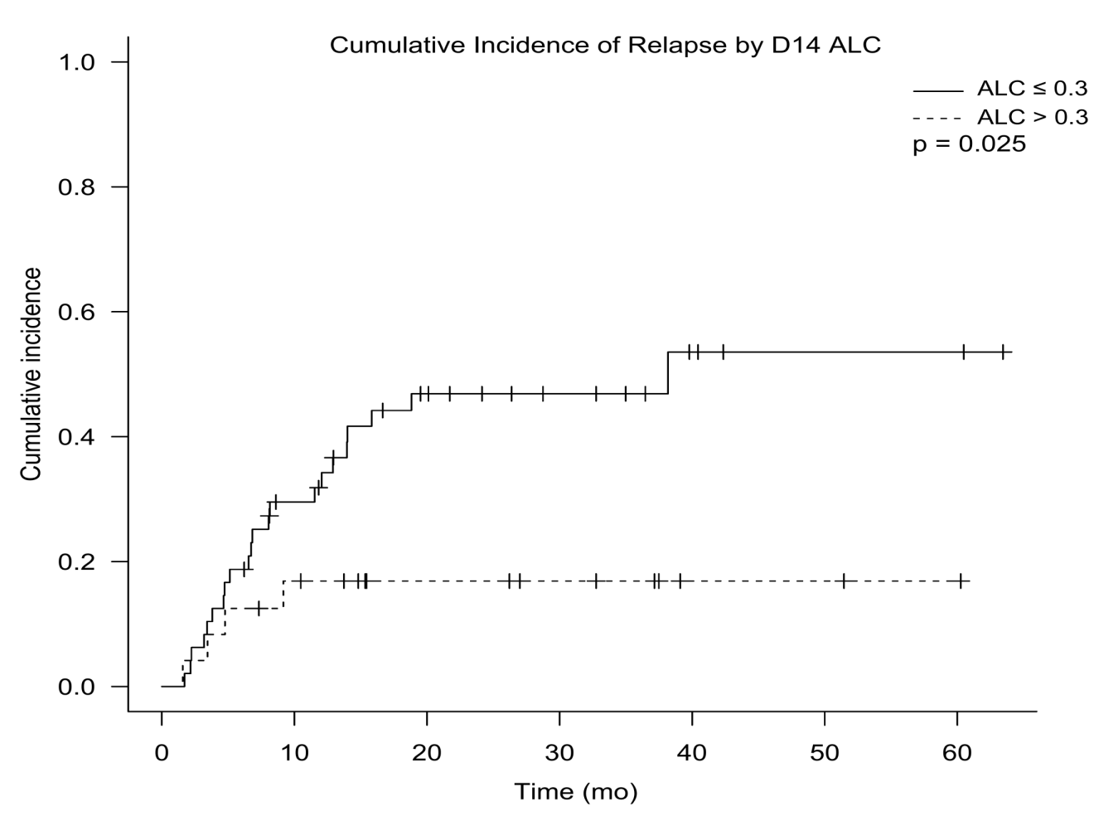
A
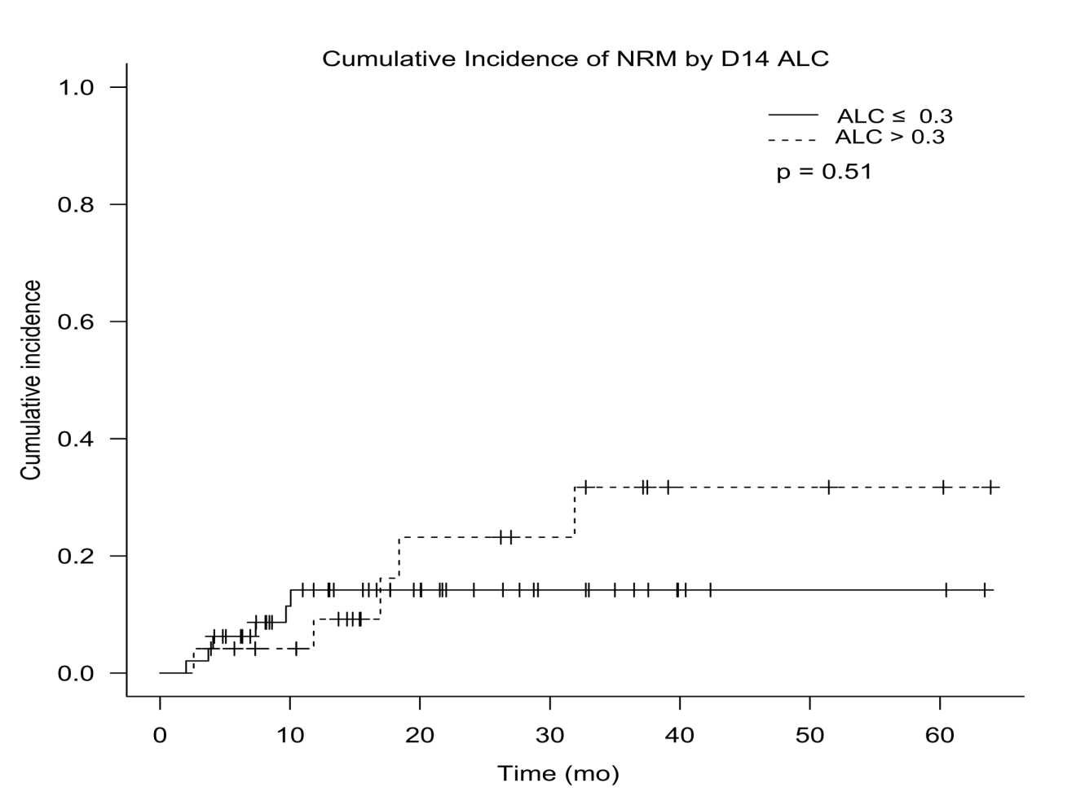
B

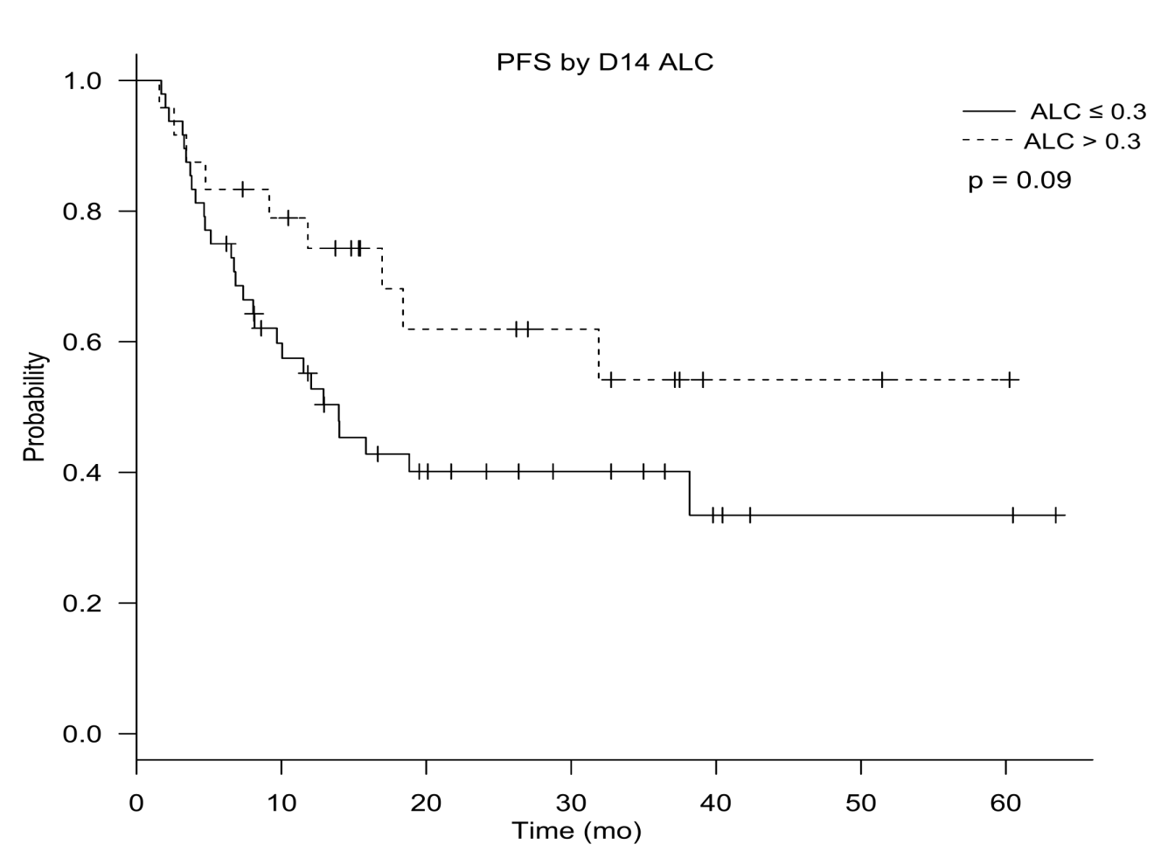
C

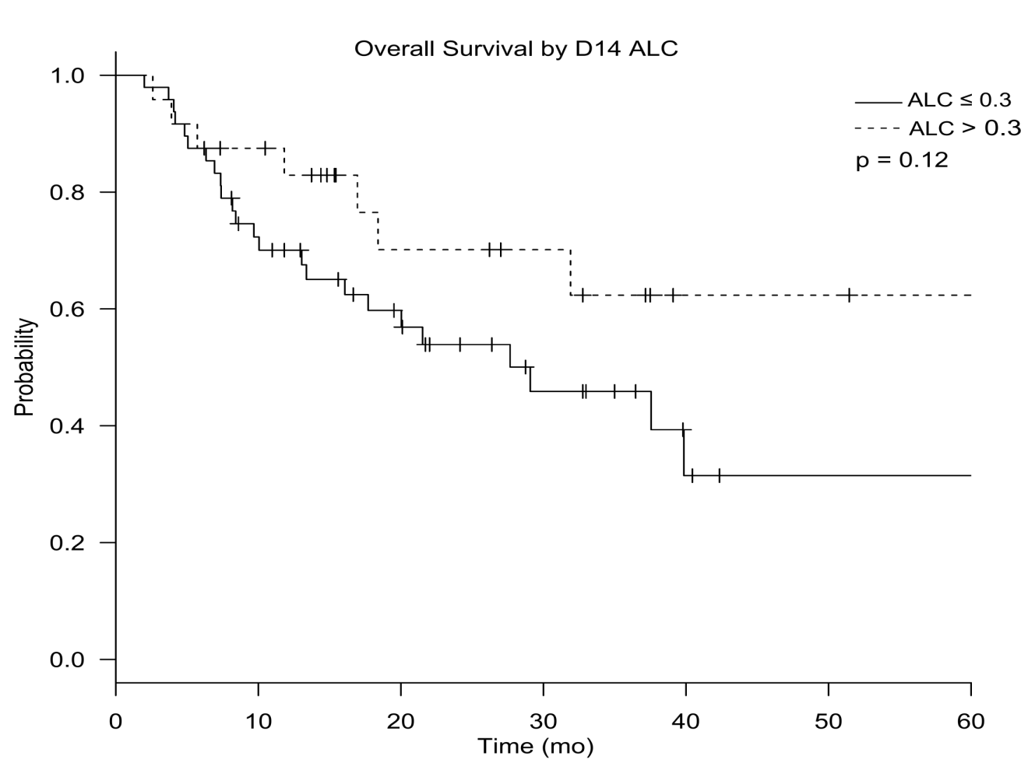
D
Figure 1 Post transplantation outcome of cumulative incidence of relapse (A), cumulative incidence of non-relapse mortality (B), progression free survival (C), and overall survival (D) stratified by lymphocyte recovery on day 14.

Table 1 Baseline characteristics of patients stratified by lymphocyte recovery n (%)
Variable | ALC > 0.3  (n = 24) | ALC ≤ 0.3  (n = 48) | P value
Patient age in years, median (range) | 28 (16-57) | 23 (14-63) | 0.57
Recipient gender, male | 13 (54) | 28 (58) | 0.74
Diagnosis  AML  ALL | 13 (54)  11 (46) | 22 (45)  26 (54) | 0.54
ECOG | 1 (0-2) | 0 (0-3) | 0.86
Cytogenetics (AML)  Favorable  Intermediate  High risk | 3 (25)  7 (58)  2(17) | 2 (10)  15 (71)  4 (67) | 0.5
Cytogenetics (ALL)  Standard  High risk | 5 (56)  4 (44) | 11 (50)  11(50) | 0.78
Female donor/male recipient | 4 (17) | 11 (23) | 0.53
Related donor | 21 (88) | 42 (88) | 1
Status at HCT  CR1  ≥ CR2 | 13 (54)  11 (46) | 31 (66)  16 (34) | 0.33
ABO Matching  Match  Major/bidirectional  Minor | 16 (67)  3 (12)  5 (21) | 31 (64)  8 (17)  9 (19) | 0.89
TBI containing regimen | 8 (33) | 30 (63) | 0.019
Conditioning intensity  MAC  RIC | 18 (75)  6 (25) | 42 (88)  6 (12) | 0.19
HCT: Hematopoietic stem cell transplant; AML: Acute myeloid leukemia; ALL: Acute lymphoblastic leukemia; ALC: Absolute lymphocyte count; ECOG: Eastern cooperative oncology group; TBI: Total body irradiation; CR: Complete remission; MAC: Myeloablative conditioning; RIC: Reduced intensity conditioning.

Table 2 Graft characteristics as predictors of lymphocyte recovery n (%)
Graft characteristic | ALC > 0.3  (n = 24) | ALC ≤ 0.3  (n = 48) | P value
CD 34 × 10⁶/ kg < 6, | 17 (71) | 20 (42) | 0.018
TNC > 7 × 10⁷/kg | 5 (21) | 10 (21) | 1
CD 3 > 24 × 10⁷/kg | 4 (19) | 1 (2) | 0.017
CD 34 <6 × 10⁶/kg, CD 3 > 24 × 10⁷/kg | 3 (100) | 0 (0) | 0.0088
MNC > 2.7 × 10⁸/kg | 20 (83) | 33 (69) | 0.17
ALC > 1.3 × 10⁸/kg | 23 (96) | 35 (74) | 0.015
AMC> 1.75 × 10⁸/kg | 3 (13) | 14 (30) | 0.093
ALC > 1.3 × 10⁸/kg, CD34 < 6 × 10⁸/kg | 16 (67) | 13 (27) | 0.0012
LMR > 4 | 8 (33) | 5 (11) | 0.022
ALC: Absolute lymphocyte count; TNC: Total nuclear count; MNC: Mono-nuclear count; AMC: Absolute monocyte count; LMR: Lymphocyte-monocyte ratio.

Table 3 Transplant related outcomes
Variables | ALC > 0.3  (n = 24) | ALC ≤ 0.3  (n = 48) | P value
CIR (2-yr) | 16.9% | 46.9% | 0.025
NRM (2-yr) | 23.2% | 14.2% | 0.51
PFS (2-yr) | 61.9% | 40.1% | 0.09
OS (2-yr) | 70.1% | 53.9% | 0.12
Plt engraftment (median, d) | 24 (21-37) | 24 (7-42) | 0.98
ANC engraftment (median, d) | 17 (12-29) | 17 (12-25) | 0.76
aGVHD | 5 (22) | 15 (31) | 0.4
cGVHD | 16 (70) | 13 (27) | 0.0006
ALC: Absolute lymphocyte count; CIR: Cumulative incidence of relapse; NRM: Non-relapse mortality; PFS: Progression free survival; OS: Overall survival; plt: Platelet; ANC: Absolute neutrophil count; aGVHD: Acute or chronic graft vs host disease; cGVHD: Chronic graft vs host disease.

Table 4 Univariable and multivariable risk factors influencing incidence of relapse
IR | Univariable HR  (95%CI; P value) | Multivariable HR  (95%CI; P value)
Age at HCT | 0.97 (0.94-1.01; P = 0.1) | 0.13 (0.0096-1.38; P = 0.093)
Single Marital status | 2.59 (1.13-6.65; P = 0.023) | 0.82 (0.21-3.27; P = 0.77)
AML vs ALL | 0.82 (0.36-1.8; P = 0.62)
Female D Male R | 2.15 (0.91-4.7; P = 0.079) | 2.24 (0.88-5.31; P = 0.086)
Match vs Mismatch | 1.9 (0.3-6.7; P = 0.42)
MRD vs Other | 1.6 (0.47-10; P = 0.49)
D14 ALC > 0.3 | 0.31 (0.09-0.8; P = 0.014) | 0.27 (0.05-0.94; P = 0.038)
MAC vs RIC | 1.38 (0.46-3.4; P = 0.53)
CR1 vs other | 0.52 (0.23-1.15; P = 0.1) | 0.36 (0.15-0.87; P = 0.024)
aGVHD | 0.54 (0.16-1.43; P = 0.23)
cGVHD | 0.24 (0.079-0.59; P = 0.0013) | 0.33 (0.1-0.92; P = 0.035)
ALC: Absolute lymphocyte count; HR: Hazard ratio; CR1: First complete remission; R: Recipient; D: Donor; AML: Acute myeloid leukemia; ALL: Acute lymphoblastic leukemia; cGVHD: Chronic graft vs host disease; MAC: Myeloablative conditioning; RIC: Reduced intensity conditioning; MRD: Matched related donor.

Table 5 Causes of mortality stratified by absolute lymphocyte count recovery
Variables | ALC > 0.3  (n = 8) | ALC ≤ 0.3  (n = 24)
Primary disease | 3 | 18
Infection | 1 | N/A
Organ failure | N/A | 1
aGVHD | 1 | 2
cGVHD | 3 | 3
ALC: Absolute lymphocyte count; aGVHD: Acute or chronic graft vs host disease; cGVHD: Chronic graft vs host disease; N/A: Not available.

