Name of journal: World Journal of Clinical Cases
ESPS Manuscript NO: 7466
Columns: CASE REPORT

Case of early right ventricular pacing lead perforation and review of the literature

Nash G et al. Early right ventricular pacing lead perforation

Gary Nash, John Mark Williams, Rajasekhar Nekkanti, Assad Movahed

Gary Nash, John Mark Williams, Rajasekhar Nekkanti, Assad Movahed, Department of Cardiovascular Sciences, East Carolina University, Brody School of Medicine, East Carolina Heart Institute, Greenville, NC 27858, United States.

Author contributions: Nash G, Williams J, Nekkanti R and Movahed A contributed to the manuscript writing and revision.

Supported by “East Carolina Heart Institute”

Correspondence to: Assad Movahed, MD, Department of Cardiovascular Sciences, East Carolina University, Brody School of Medicine, East Carolina Heart Institute, 115 Heart Drive, Mail Stop 651, Greenville, NC 27834, United States. movaheda@ecu.edu
Telephone: +1-252-7444400 Fax: +1-252-7447724

Received: November 19, 2013 Revised: March 6, 2014
Accepted: May 8, 2014

Published online:
Abstract
We report a case of a 77-year-old patient with complete atrioventricular block. She underwent permanent pacemaker implantation complicated by right ventricular lead perforation. This was suspected on transthoracic echocardiogram and confirmed by chest computed tomography. The lead was repositioned in the cardiac electrophysiology lab followed by an uneventful course thereafter.

© 2014 Baishideng Publishing Group Inc. All rights reserved.

Key words: Pacemaker Lead Perforation

Core tips: Cardiac perforation should be considered in cases of pacing lead malfunction. Chest computed tomography is helpful in diagnosing lead perforation and can be done without contrast and using a small field of view to diminish the effective radiation dose.

Nash G, Williams JM, Nekkanti R, Movahed A. Case of early right ventricular pacing lead perforation and review of the literature. World J Clin Cases 2014; In press
Available from:
DOI:

INTRODUCTION
Cardiac perforation is a known complication of lead implantation and should be considered in cases of post operative lead malfunction. We present a case of early lead perforation diagnosed by chest computed tomography (CT).

CASE REPORT
A 77-year-old Caucasian female with a past medical history of hypertension, hyperlipidemia and stage 3 chronic kidney disease was brought to the emergency department from home, after her family noticed her “passing out” while seated in a chair. She was noted to regain consciousness within a few seconds. On initial evaluation, her temperature was 36.6 degrees Celsius, blood pressure was 116/61 mmHg, pulse was 43 bpm and regular, respiratory rate was 12 breaths per minute, oxygen saturation on room air was 99%, physical exam was otherwise unremarkable. A sinus node rate of 88 bpm with 2:1 atrioventricular block (ventricular rate of 44 bpm), right bundle branch block and left anterior fasicular block was noted on a 12 lead electrocardiogram (ECG). Exercise myocardial scintigraphy performed one month prior to admission was normal. She was not taking any medications that could cause iatrogenic bradycardia. Ten seconds of ventricular asystole was noted on inpatient telemetry monitoring prompting insertion of a temporary transvenous pacemaker. Six hours later, a dual chamber permanent pacemaker was implanted in the cardiac electrophysiology lab with good post operative sensing and pacing thresholds in the atrium and ventricle. Twelve hours later she complained of left upper quadrant abdominal pain. Inpatient telemetry demonstrated 2:1 atrioventricular block with loss of ventricular capture at high pacing output (Figure 1). Chest X-ray did not show any shift in lead positions. A temporary transvenous pacemaker was reinserted. Ventricular lead perforation was suspected. A transthoracic echocardiogram demonstrated an echo bright structure protruding into the pericardial space. However, the images were suboptimal in quality and therefore technically limited to confirm lead perforation. A localized moderate sized pericardial effusion with right ventricular diastolic collapse best seen on M mode imaging (Figure 2) was also noted. She demonstrated no clinical signs of cardiac tamponade. Non contrast chest CT confirmed lead perforation (Figure 3) with the tip of the right ventricular lead in the pericardial space. The lead was repositioned in the cardiac electrophysiology lab under fluoroscopic and echocardiographic guidance (Figure 4). Follow up echocardiogram revealed no change in the size of the effusion. There was also resolution of right ventricular diastolic collapse. Device interrogation demonstrated stable pacing and sensing thresholds in the right ventricle. The leads remained in stable position on chest X-ray. On follow up 1 week later the patient was doing well with complete resolution of the pericardial effusion on echocardiogram.

DISCUSSION
Complications associated with permanent pacemaker implantation include pneumothorax, myocardial perforation, lead dislodgement or fracture, infection, hematoma, erosion and vein thrombosis^{[1]}. The rates of cardiac perforation range from 0.1% to 0.8% for pacemaker leads^{[2]}. One should be alerted to the possibility of cardiac perforation by a pacemaker lead if pacing or sensing malfunction is noted. Most cases of lead perforation happen during or shortly after implant, but cases of late perforation as long as 4.8 years after implant have been reported^{[3]}. Chest X-ray has traditionally been used to evaluate lead positioning in cases of suspected pacemaker lead perforation. Echocardiogram can be used to provide additional information such as extent of pericardial effusion. Another option is a non-contrast chest CT utilizing a small field of view to reduce the effective radiation dose. In a small case series Henrikson et al^{[4]} demonstrated that 64 slice Chest CT was able to make the diagnosis of cardiac perforation by a device lead in all suspected cases. Risk factors for lead perforation include patient characteristics such as female sex, age, small body habitus, thin heart walls; concomitant therapies such as steroids or anticoagulants; implant techniques; and the design characteristics of the lead^{[2]}. Cardiac perforation by a lead can be corrected by repositioning it under fluoroscopic guidance in the cardiac electrophysiology lab, however surgery may be necessary.

COMMENTS
Case characteristics
This is a 77-year-old Caucasian female with a past medical history of hypertension, hyperlipidemia and stage 3 chronic kidney disease who presented with an episode of syncope.

Clinical diagnosis
She had an episode of ventricular asystole while in the hospital and underwent permanent pacemaker implantation complicated by lead perforation.

Differential diagnosis
Ischemic, infectious, iatrogenic and endocrine causes of atrioventricular block were ruled out.

Laboratory diagnosis
The patient had normal electrolytes, TSH and was not on any AV nodal blocking agents.

Imaging diagnosis
A non-contrast chest computed tomography confirmed pacemaker lead perforation.

Pathological diagnosis
There were no relevant pathological findings in this case.

Treatment
The patient underwent permanent pacemaker implantation with subsequent lead revision after being diagnosed with cardiac perforation.

Related reports
There are other case reports using various imaging modalities to diagnose cardiac perforation by a pacemaker lead.

Experiences and lessons
Cardiac perforation by a pacemaker lead should be considered in cases of device malfunction regardless of the age of the device.

Peer review
A well done case report. I find no ancillary comments that would aid the readership, continued success with your excellent writing.
REFERENCES
1 Phibbs B, Marriott HJ. Complications of permanent transvenous pacing. N Engl J Med 1985; 312: 1428-1432 [PMID: 3887169 DOI: 10.1056/NEJM198505303122205]
2 Carlson MD, Freedman RA, Levine PA. Lead perforation: incidence in registries. Pacing Clin Electrophysiol 2008; 31: 13-15 [PMID: 18181903 DOI: 10.1111/j.1540-8159.2007.00943.x]
3 Alla VM, Reddy YM, Abide W, Hee T, Hunter C. Delayed lead perforation: can we ever let the guard down? Cardiol Res Pract 2010; 2010: [PMID: 20811487 DOI: 10.4061/2010/741751]
4 Henrikson CA, Leng CT, Yuh DD, Brinker JA. Computed tomography to assess possible cardiac lead perforation. Pacing Clin Electrophysiol 2006; 29: 509-511 [PMID: 16689847 DOI: 10.1111/j.1540-8159.2006.00385.x]

P-Reviewers: Marinkovic SP, Sijens PE S-Editor: Qi Y
L-Editor: E-Editor:

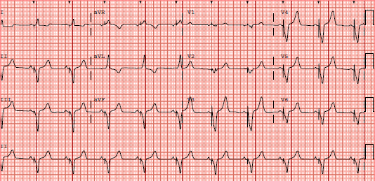

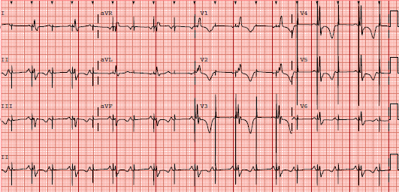

Figure 1 Electrocardiogram on the top panel taken immediately after permanent pacemaker implantation demonstrates atrial sensing with ventricular pacing. The electrocardiogram on the bottom panel demonstrates failure to capture in the right ventricle with underlying 2:1 atrioventricular Block. The pacing configuration was bipolar with high outputs. Notice the prominent pacing spikes.
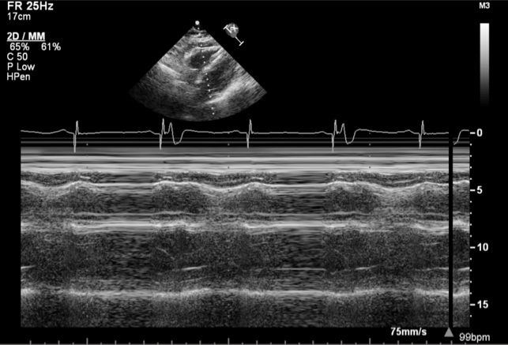

Figure 2 Top image is an apical 4 chamber view of a transthoracic echocardiogram showing a moderate sized localized pericardial effusion with an echo bright structure within the effusion suspicious for lead perforation. The bottom image is taken in m mode and demonstrates right ventricular diastolic collapse suggestive of increased pericardial pressures.

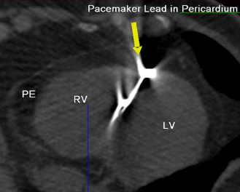

Figure 3 This is an axial view of a non contrast chest computed tomography confirming diagnosis of right ventricular lead perforation. The yellow arrow points to the perforated lead. There is a pericardial effusion (PE). The right ventricle (RV) and left ventricle (LV) are also demonstrated.

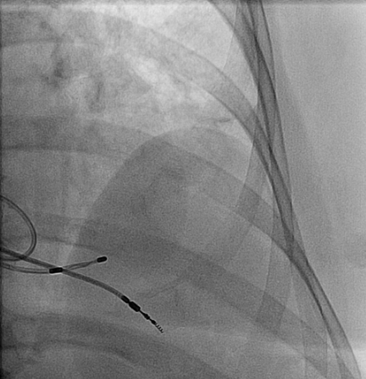
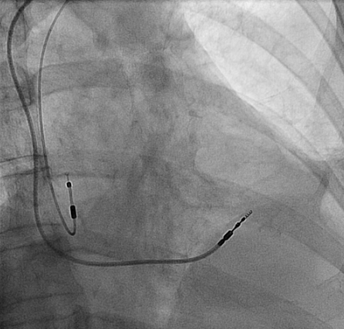

Figure 4 Top image shows the right ventricular permanent pacemaker lead protruding well past the heart border. A temporary transvenous pacemaker lead can also be seen within the right ventricle. The bottom image shows the repositioned right ventricular lead higher up on the interventricular septum and absence of the temporary transvenous pacemaker lead. The right atrial lead can also be seen in this image.

