Name of Journal: World Journal of Gastroenterology
Manuscript NO: 80338
Manuscript Type: ORIGINAL ARTICLE

Basic Study
Liver infiltration of multiple immune cells during the process of acute liver injury and repair

Xie Y et al. Immune cell infiltration in acute liver injury

Yuan Xie, Ke-Bo Zhong, Yang Hu, Yong-Lun Xi, Shi-Xing Guan, Meng Xu, Yuan Lin, Feng-Yong Liu, Wei-Jie Zhou, Yi Gao

Yuan Xie, Ke-Bo Zhong, Yi Gao, General Surgery Center, Department of Hepatobiliary Surgery II, Guangdong Provincial Research Center for Artificial Organ and Tissue Engineering, Guangzhou Clinical Research and Transformation Center for Artificial Liver, Institute of Regenerative Medicine, Zhujiang Hospital, Southern Medical University, Guangzhou 510280, Guangdong Province, China

Yang Hu, Yong-Lun Xi, Shi-Xing Guan, Wei-Jie Zhou, State Key Laboratory of Organ Failure Research, Department of Pathology, Cancer Research Institute, School of Basic Medical Sciences, Southern Medical University, Guangzhou 510515, Guangdong Province, China

Meng Xu, Yuan Lin, Wei-Jie Zhou, Department of General Surgery & Guangdong Provincial Key Laboratory of Precision Medicine for Gastrointestinal Tumor, Nanfang Hospital, First Clinical Medical School, Southern Medical University, Guangzhou 510515, Guangdong Province, China

Feng-Yong Liu, Department of Interventional Radiology, Senior Department of Oncology, Fifth Medical Center of PLA General Hospital, Beijing 100853, China

Yi Gao, State Key Laboratory of Organ Failure Research, Southern Medical University, Guangzhou 510280, Guangdong Province, China

Author contributions: Xie Y designed the experiments and wrote the manuscript; Zhong KB and Hu Y performed statistic and bioinformatic analyses; Xie Y, Zhong KB and Hu Y contributed equally to this work; Xi YL, Guan SX, Xu M, Lin Y helped to perform the experiments; Gao Y and Zhou WJ conceived the project; Liu FY supervised the schedule progress of the project; Gao Y, Zhou WJ and Liu FY were co-corresponding authors, and they contributed equally to this project; all authors have read and approved the final manuscript.

Supported by the National Key R&D Program of China, No. 2018YFA0108200, No. 2018YFC1106400; the National Natural Science Foundation of China, No. 31972926, 32000607, No. 82270645, No. 92068206; Guangdong Basic and Applied Basic Research Foundation, No. 2020A1515111111, No. 2019A1515110145; and China Postdoctoral Science Foundation, No. 2019M660205.

Corresponding author: Yi Gao, MD, Doctor, General Surgery Center, Department of Hepatobiliary Surgery II, Guangdong Provincial Research Center for Artificial Organ and Tissue Engineering, Guangzhou Clinical Research and Transformation Center for Artificial Liver, Institute of Regenerative Medicine, Zhujiang Hospital, Southern Medical University, No. 253 Gongye Middle Avenue, Haizhu District, Guangzhou 510280, Guangdong Province, China. gaoyi6146@163.com

Received: September 30, 2022
Revised: October 29, 2022
Accepted: November 18, 2022
Published online:

Abstract
BACKGROUND
Immune cells, including neutrophils, natural killer (NK) cells, T cells, NKT cells and macrophages, participate in the progression of acute liver injury and hepatic recovery. To date, there has been no systematic study on the quantitative changes in these different immune cells from initial injury to subsequent recovery.

AIM
To investigate the infiltration changes of various immune cells in acute liver injury models over time, and to study the relationship between the changes in leukocyte cell-derived chemotaxin 2 (LECT2) and the infiltration of several immune cells.

METHODS
Carbon tetrachloride- and concanavalin A-induced acute liver injury models were employed to mimic toxin-induced and autoimmune-mediated liver injury respectively. The quantitative changes in various immune cells were monitored at different time points. Serum samples were collected, and liver tissues were harvested. Ly6G, CD161, CD4, CD8 and F4/80 staining were used to indicate neutrophils, NK/NKT cells, CD4⁺ T cells, CD8⁺ T cells and macrophages, respectively. Lect2-KO mice were used to detect the function of LECT2.

RESULTS
During the injury and repair process, different types of immune cells began to increase, reached their peaks and fell into decline at different time points. Furthermore, when the serum alanine transaminase (ALT) and aspartate transaminase (AST) indices reverted to normal levels 7 d after the injury, the infiltration of immune cells still existed even 14 d after the injury, showing an obvious lag effect. We found that the expression of LECT2 was upregulated in acute liver injury mouse models, and the liver injuries of Lect2-KO mice were less severe than those of wild-type mice. Compared with wild-type mice, Lect2-KO mice had different immune cell infiltration.

CONCLUSION
The recovery time of immune cells was far behind that of serum ALT and AST during the process of liver repair. LECT2 could regulate monocyte/macrophage chemotaxis and might be used as a therapeutic target for acute liver injury.

Key Words: Immune cells; Liver injury; Liver repair; Leukocyte cell-derived chemotaxin 2

Xie Y, Zhong KB, Hu Y, Xi YL, Guan SX, Xu M, Lin Y, Liu FY, Zhou WJ, Gao Y. Liver infiltration of multiple immune cells during the process of acute liver injury and repair. World J Gastroenterol 2022; In press

Core Tip: In our study, we systematically described the infiltration changes of various immune cells during the process of acute liver injury and repair. We found that the recovery time of immune cells was far behind that of serum alanine transaminase and aspartate transaminase during the process of liver repair. Moreover, we found that leukocyte cell-derived chemotaxin 2 (LECT2) was upregulated in acute liver injury mouse models and the changes in LECT2 were related to the changes in several immune cells. LECT2 could regulate monocyte/macrophage chemotaxis and might be used as a therapeutic target for acute liver injury.

INTRODUCTION
Acute liver injury is induced by a variety of causes, including viral infection, autoimmune diseases, alcohol or drug abuse and toxin intake, which can lead to liver failure and even death^{[1,2]}. Various immune cells, including neutrophils, natural killer (NK) cells, T cells, NKT cells and macrophages, are directed and recruited to damaged sites and inflammatory lesions following acute injury^{[3]}. Accumulated studies have indicated that these immune cells may participate in the progression of liver injury^{[4-6]} and hepatic recovery^{[7-9]}. A complete description of the changes in the number of various immune cells during the process of liver injury and repair could indicate the potential roles of these immune cells and may also help to treat acute liver injury by regulating these different immune cells at different time points. To date, there has been no systematic study on the quantitative changes in these different immune cells from initial injury to subsequent recovery. Here, we employed carbon tetrachloride (CCl₄)- and concanavalin A (ConA)-induced acute liver injury mouse models to mimic toxin-induced and autoimmune-mediated liver injury, respectively, and monitored the dynamic changes in various immune cells over time.
Leukocyte cell-derived chemotaxin 2 (LECT2) is a 16-kDa protein mainly produced by hepatocytes, first isolated in PHA-activated human T-cell leukemia SKW-3 cells in 1996^{[10]}. Increasing evidence suggests that LECT2 is a pleiotropic protein, it not only functions as a cytokine to exhibit chemotactic properties but also plays multifunctional roles in some physiological conditions and pathological abnormalities^{[11]}, such as neuronal development^{[12]}, liver regeneration^{[13]}, homeostasis of hematopoietic stem cells^{[14]}, liver fibrosis^{[15,16]}, insulin resistance^{[17]} and renal amyloidosis^{[18]}. We found that, during the repair of acute liver injury, the changes in LECT2 were related to the changes in several immune cells. Acute liver injury might be treated by inhibiting LECT2.

MATERIALS AND METHODS
Mice
C57BL6/J (wild-type) mice were purchased from Guangzhou University of Chinese Medicine. Lect2-KO mice were provided by Professor Jiong Chen from Ningbo University. The genomic DNA from the Lect2-KO mice was extracted for PCR amplification with the forward and reverse primers (Forward: 5’-CATAGCCAGGGGACTATGTTTTA-3’; Reverse: 5’-ATATAGTCATAGCTGCACACAGCA-3’). The PCR products were further used to confirm genotyping by Sanger sequencing. Mice were kept in a standard 12 h light–dark cycle under specific-pathogen-free conditions, and were allowed free access to water and food. All mice used for the study were male, healthy and immune-normal, weighing 22-25 g. Animal-related research protocols were consistent with the US Public Health Service Policy on Use of Laboratory Animals, and were approved by the Ethics Committee on Use and Care of Animals of Southern Medical University.

Acute liver injury models
CCl₄ (Maclin, C805332) and ConA (Solarbio, C8110) were separately used for the induction of acute liver injury model. For the CCl₄-induced acute liver injury model, mice were injected intraperitoneally with a CCl₄ mixture at a dose of 10 mL/kg body weight once (CCl₄ dissolved in olive oil at a volume ratio of 1:4). For the ConA-induced acute liver injury model, mice were injected intravenously with ConA solution at a dose of 10 mg/kg body weight once (ConA dissolved in PBS at a concentration of 2 mg/mL). Serum samples and liver tissues were collected and stored at -80 ℃ refrigerator for subsequent analyses. There were five mice per group.

Immunohistochemical staining
Harvested liver tissues were fixed in 4% neutral buffered formalin, and then dehydrated and embedded in paraffin. Sections of 3.5-mm thickness were dewaxed, and incubated in antigen retrieval solution for 5 min at 120 ℃, and then endogenous peroxidases were blocked with 3% H₂O₂ for 15 min. The slides were incubated with goat serum for 40 min at 37 ℃ to block nonspecific binding sites, followed by incubation with the appropriate primary antibodies overnight at 4 ℃, and then with HRP (horseradish peroxidase) anti-rabbit IgG for 30 min at 37 ℃. Color was developed by incubation with a DAB substrate kit (Zsbio, ZLI-9017). After washing with PBS, sections were counterstained with hematoxylin. Major primary antibodies used in the study included anti-Ly6G antibody (1:100, CST, 87048), anti-CD161 antibody (1:200, CST, 39197), anti-CD4 antibody (1:500, Abcam, ab183685), anti-CD8 antibody (1:1000, Abcam, ab209775) and anti-F4/80 antibody (1:200, CST, 70076). Images from ten random fields were taken for each section, under a 200 × light microscope. Cells positive for Ly6G, CD161, CD4 and CD8 were counted manually. The percentages of F4/80 positive areas were calculated automatically by ImageJ software.

qRT-PCR
Total RNA from mouse livers was extracted using TRIzol reagent (AG, 21102), and reverse transcribed using Evo M-MLV RT Premix (AG, 11706). Quantitative qRT-PCR was performed on an ABI 7500 Fast real-time PCR system with SYBR Green Master PCR Mix (AG, 11701), Rox Reference Dye (AG, 11710) and primers. The primers applied in qRT-PCR were as follows: Lect2 forward (mouse), 5’-GGACGTGTGACAGCTATGGC-3’; Lect2 reverse (mouse), 5’-TCCCAGTGAATGGTGCATACA-3’; GAPDH forward (mouse), 5’-AGAAGGTGGTGAAGCAGGCATC-3’, GAPDH reverse (mouse), 5’-CGAAGGTGGAAGAGTGGGAGTTG-3’.

ELISA
The serum levels of ALT, AST and TBil were detected by an Automated Chemical Analyzer (Mindray, BS-240VET) with standard diagnostic kits. The serum levels of LECT2 were tested by an ELISA kit (Cloud-Clone, SEF541Mu).

RNA sequencing
The wild-type and Lect2-KO mice were injected with CCl₄ or ConA, and then livers from these mice were harvested after 2 d. Livers were also obtained from wild-type mice without CCl₄ and ConA treatment as standard controls. Total RNA was extracted from the tissue using TRIzol reagent according to the manufacturer’s instructions (Invitrogen) and genomic DNA was removed with DNaseI (TaKaRa). Then RNA quality was determined and only a high-quality RNA sample was used to construct a sequencing library. RNA-seq transcriptome libraries were prepared following the TruSeqTM RNA Sample Preparation Kit (Illumina, San Diego, CA, United States) using 1 μg of total RNA. Messenger RNA was isolated according to the poly (A) selection method by oligo (dT) beads and then fragmented by fragmentation buffer. Next, double-stranded cDNA was synthesized using a SuperScript double-stranded cDNA synthesis kit (Invitrogen, CA, United States) with random hexamer primers (Illumina). The synthesized cDNA was subjected to end-repair, phosphorylation and ‘A’ base addition according to Illumina’s library construction protocol. Libraries were size selected for cDNA target fragments of 300 bp, followed by PCR amplification with Phusion DNA polymerase (NEB) for 15 PCR cycles. After quantification by TBS380, the paired-end RNA-seq sequencing library was sequenced with an Illumina NovaSeq 6000 sequencer. All steps of RNA sequencing were performed by Majorbio BioPharm Technology Corporation, Shanghai.

Chemotaxis assay
Transwell inserts with 8-μm pores were used for the chemotaxis assay. THP-1 cells (2 × 10⁶/mL, 200 µL) were suspended in RPMI 1640 medium containing 10% FBS and 4000 nmol/L PMA (Bioss, D10289s), cells were seeded in each upper chamber. LECT2 (Abcam ab188467) and MCP-1 (Proteintech, Ag24085) were added to the lower chambers filled with 500 µl serum free medium containing 4000 nmol/L PMA. After incubation at 37 ℃ in 5% CO₂ for 2 h, the Transwell inserts were removed. Six consecutive pictures were taken with 200 × light microscope for the cells that migrated to the lower chambers. The number of cells was counted by ImageJ software for each picture.

Statistical analysis
The results of the experiments are presented as the mean ± SD. The experimental data were analyzed by Student's t test. Statistical analysis and graph production were performed by GraphPad Prism software. A P value < 0.05 was considered to be statistically significant.

RESULTS
Immune cell infiltration during the process of CCl₄-induced liver injury and repair
A single injection of CCl₄ at a dose of 10 mL/kg body weight was used to mimic toxin-induced acute liver injury in mice. The levels of serum alanine transaminase (ALT), aspartate transaminase (AST) and total bilirubin (TBil) were measured to evaluate the degree of liver injury from 0 h to 14 d after CCl₄ treatment. The levels of serum ALT, AST and TBil increased as early as 6 h, followed by a sharp rise and a peak on the 1st and 2nd days, respectively, and then decreased to normal on the 5th day (Figure 1A-C). Ly6G, CD161, CD4, CD8 and F4/80 staining were used to indicate neutrophils, NK/NKT cells, CD4⁺ T cells, CD8⁺ T cells and macrophages, respectively. Neutrophils increased as early as 6 h, followed by a sharp rise lasting for 2 d (Figure 1D and Supplementary Figure 1). NK/NKT cells increased as early as the 1st day, followed by a continuous rise with a peak on the 5th day (Figure 1E and Supplementary Figure 2). CD4⁺ T cells increased as early as the 2nd day, and peaked on the 5th day (Figure 1F and Supplementary Figure 3). CD8⁺ T cells increased as early as the 1st day, and peaked on the 5th day (Figure 1G and Supplementary Figure 4). Macrophages increased as early as the 1st day, followed by a peak lasting for approximately 4 d (Figure 1H and Supplementary Figure 5). It should be noted that the number of infiltrated neutrophils, NK/NKT cells, CD8⁺ T cells and macrophages on the 14th day after CCl₄ treatment was still higher than that of the control, compared with the fact that the levels of serum ALT, AST and TBil decreased to normal on the 5th day after CCl₄ treatment.

Immune cell infiltration during the process of ConA-induced liver injury and repair
A single injection of ConA at a dose of 10 mg/kg body weight was used to mimic autoimmune-mediated acute liver injury in mice. In contrast to CCl₄-treated mice, in ConA-treated mice, the levels of serum ALT, AST and TBil peaked as soon as 6 h, followed by a rapid decline on the 1st day, and then decreased to normal within 3 d (Figure 2A-C). In the ConA-induced acute injury model, neutrophils increased sharply and peaked as soon as 6 h (Figure 2D and Supplementary Figure 6). NK/NKT cells increased as early as the 1st day, and then peaked on the 2nd day (Figure 2E and Supplementary Figure 7). CD4⁺ T cells increased as early as the 1st day, followed by a peak on the 2nd day (Figure 2F and Supplementary Figure 8). CD8⁺ T cells increased gradually from 6 h to 2 d, and peaked on the 2nd day (Figure 2G and Supplementary Figure 9). Macrophages increased as early as 6 h, peaked on the 2nd day and lasted for approximately 4 d (Figure 2H and Supplementary Figure 10). Notably, the above immune cells could hardly revert to the normal count within 7 d.

The expression of LECT2 was increased in acute liver injury models
We detected the dynamic changes in LECT2 expression in liver tissues and serum from 0 h to 14 d after CCl₄ and ConA treatment. We found that the expression of Lect2 mRNA was significantly increased on the 2nd day after CCl₄ treatment (Figure 3A), while increased levels of serum LECT2 could be observed on the 1st day and lasted for 2 wk, with a peak on the 2nd day (Figure 3B). In the ConA-induced acute injury model, the expression of Lect2 mRNA was significantly increased on the 3rd, 5th and 7th days (Figure 3C), while increased levels of serum LECT2 could be observed at as early as 6 h and lasted for 1 wk, with a peak at 6 h (Figure 3D).

Lect2-KO mice showed less severe liver injuries
The levels of AST were significantly decreased in CCl₄-treated Lect2-KO mice on the 5th day compared with their WT (wild-type) counterparts (Figure 4A and B). The levels of ALT were significantly decreased in ConA-treated Lect2-KO mice at 6 h compared with their WT counterparts (Figure 4C and D).

The effect of LECT2 on immune cell infiltration in acute liver injury models
We selected the peak time for different types of immune cells in the CCl₄ or ConA-induced acute injury model to observe the effect of LECT2 on the liver infiltration of various immune cells. WT and Lect2-KO mice were treated with CCl₄ and ConA, respectively, and livers were harvested on the 2nd and 5th days after CCl₄ treatment. For the mice treated with ConA, livers were harvested at the 6th hour and 2nd day. First, we compared the number of immune cells between Lect2-KO mice and WT controls at 0 h without CCl₄ and ConA treatment. We found that more neutrophils, NK/NKT cells, CD4⁺ and CD8⁺ T cells emerged in Lect2-KO mice (Figure 5 and Figure 6). Next, we compared the number of immune cells between Lect2-KO mice and WT controls when treated with CCl₄ or ConA. In the CCl₄-induced acute injury model, we found that the livers of Lect2-KO mice had less infiltration of NK/NKT cells and macrophages than those of WT mice. There was no difference in the number of neutrophils, CD4⁺ T cells or CD8⁺ T cells (Figure 5A-F). In the ConA-induced acute injury model, the livers of Lect2-KO mice had more infiltrated neutrophils, CD4⁺ T cells and CD8⁺ T cells but fewer macrophages than those of WT mice. There was no difference in the number of NK/NKT cells (Figure 6A-F).

Chemokine-related genes changed in Lect2-KO mice
Chemokines are chemotactic cytokines that are capable of recruiting immune cells to sites of injury and inflammation. Next, we explored whether knockout of the Lect2 gene regulated the expression of chemokines in acute liver injury. RNA sequencing analysis was performed on injured liver samples derived from CCl₄ or ConA-treated Lect2-KO and WT mice. Differentially expressed genes were identified with a p-adjust value < 0.05 and fold change > 2. By Kyoto Encyclopedia of Genes and Genomes pathway enrichment analysis, we found that these changed genes could be partly categorized into chemokine signaling pathways (Figure 7A) and cytokine-cytokine receptor interactions (Figure 7B). Knockout of the Lect2 gene upregulated the expression of CXCL9, CXCL14, CCL6 and CCL22, and downregulated the expression of CCL19 in the CCl₄-treated mice (Figure 7C). In the ConA-treated mice, knockout of the Lect2 gene led to upregulated expression of CXCL2, CXCL3, CXCL5, CCL2 and CCL6 and downregulated expression of CCL21a, CCL21b and CCL27a (Figure 7D).

LECT2 promoted THP-1 monocyte chemotaxis
Since Lect2-KO mice displayed less macrophage infiltration than their WT counterparts in both CCl₄- and ConA-induced acute injury models, we explored whether LECT2 promoted monocytes/macrophage chemotaxis. The transwell assay showed that LECT2 could promote THP-1 monocytes chemotaxis (Figure 8A), but its chemotaxis was weaker than that of MCP-1, which is a well-recognized monocyte chemokine (Figure 8B).

DISCUSSION
The liver infiltration of various immune cell populations, including neutrophils, NK/NKT cells, T cells and monocytes/macrophages, is a critical pathological feature following acute liver injury and plays important roles in liver injury or repair^{[1-9]}. Although there are many studies on the function of immune cells during liver injury or repair, there is still no study on the quantitative changes in immune cell infiltration at different time points from the beginning of injury to the end of repair. For the first time, employing CCl₄- and ConA-induced acute liver injury models, we monitored the infiltration of immune cells over time and found that different types of immune cells began to increase, reached their peaks and fell into decline at different time points, indicating that they played different roles in different injuries or repair stages. Therefore, appropriate regulation of immune cells at different time points may be a better strategy for the treatment of acute liver injury.
We were surprised to find that during the repair process, when the serum ALT and AST indices had reverted to normal levels 7 d after the injury, the infiltration of immune cells still existed even 14 d after the injury, showing an obvious lag effect. This suggests that the liver does not completely recover to normal as quickly as we previously thought. The recovery of serum indicators (ALT, AST, etc.) does not mean that the liver has recovered to normal, and the corresponding treatment may need to be extended accordingly. Therefore, in addition to the serological indices, we suggest immunological indices to measure the repair of liver injury, which may have important value for the clinical treatment and prognosis of liver diseases. These remaining immune cells may continue to regulate liver repair and play a role in the response of the liver to rechallenges.
We previously reported that LECT2 regulated chronic liver fibrogenesis^{[15,16]}, while its role in acute liver injury is unclear. Here, we found that the expression of LECT2 was upregulated in acute liver injury models, and the liver injuries of Lect2-KO mice were less severe than those of wild-type mice. Compared with wild-type mice, Lect2-KO mice had different immune cell infiltration, suggesting that LECT2 may regulate acute liver injury and repair by regulating the infiltration of various immune cells. We demonstrated that LECT2 could indeed regulate monocyte/macrophage chemotaxis in vitro. Blocking LECT2 might be able to treat acute liver injury.
The limitation of this study is that we need further functional tests to verify the roles that different immune cells play in liver injury. In particular, when the liver is rechallenged, the roles of retained immune cells in the last injury need to be further studied. When the liver is rechallenged, these retained immune cells may cause greater damage to the liver, or may make the liver more tolerant to the same challenge.

CONCLUSION
In summary, we described the infiltration changes of various immune cells in acute liver injury models over time. We found that the recovery time of immune cells during the repair process was far behind that of serum ALT and AST. LECT2 could regulate monocyte/macrophage chemotaxis and might be used as a therapeutic target for acute liver injury.

ARTICLE HIGHLIGHTS
Research background
Immune cells, including neutrophils, natural killer (NK) cells, T cells, NKT cells and macrophages, participate in the progression of acute liver injury and hepatic recovery. leukocyte cell-derived chemotaxin 2 (LECT2) is a pleiotropic protein that not only functions as a cytokine to exhibit chemotactic properties but also plays multifunctional roles in some physiological conditions and pathological abnormalities.

Research motivation
To date, there has been no systematic study on the quantitative changes in these different immune cells from initial injury to subsequent recovery. LECT2 regulates chronic liver fibrogenesis, but its role in acute liver injury is unclear.

Research objectives
To investigate the infiltration changes of various immune cells in acute liver injury mouse models over time and to study the relationship between the changes in LECT2 and the infiltration of several immune cells.

Research methods
Carbon tetrachloride (CCl₄)- and concanavalin A (ConA)-induced acute liver injury mouse models were employed to mimic toxin-induced and autoimmune-mediated liver injury, respectively. Immunohistochemical staining was used to indicate immune cells, and the quantitative changes in various immune cells were monitored at different time points. The levels of serum alanine transaminase (ALT), aspartate transaminase (AST) and total bilirubin (TBil) were measured by an automated chemical analyzer. The expression of LECT2 in liver tissues was detected by quantitative real-time polymerase chain reaction and the levels of LECT2 in serum were tested by enzyme-linked immunosorbent assay. Transwell assays were used to assess the chemotactic effect of LECT2 on THP-1 monocytes.

Research results
During the injury and repair process, different types of immune cells began to increase, reached their peaks and fell into decline at different time points. Furthermore, when the serum ALT and AST indices reverted to normal levels 7 d after injury, the infiltration of immune cells still existed even 14 d after injury, showing an obvious lag effect. The expression of LECT2 was up-regulated in acute liver injury models, and the liver injuries of Lect2-KO mice were less severe than those of wild-type mice. Compared with wild-type mice, Lect2-KO mice had different immune cell infiltration.

Research conclusions
The recovery time of immune cells was far behind that of serum ALT and AST during the process of liver repair. LECT2 could regulate monocyte/macrophage chemotaxis and might be used as a therapeutic target for acute liver injury.

Research perspectives
Our study indicated the potential roles of these immune cells and proposed a therapeutic concept that acute liver injury might be treated by regulating different immune cells at different time points.

ACKNOWLEDGEMENTS
We thank Central Laboratory, Southern Medical University for providing facilities and technical support.

REFERENCES
1 Khoury T, Rmeileh AA, Yosha L, Benson AA, Daher S, Mizrahi M. Drug Induced Liver Injury: Review with a Focus on Genetic Factors, Tissue Diagnosis, and Treatment Options. J Clin Transl Hepatol 2015; 3: 99-108 [PMID: 26356634 DOI: 10.14218/JCTH.2015.00007]
2 Bernal W, Auzinger G, Dhawan A, Wendon J. Acute liver failure. Lancet 2010; 376: 190-201 [PMID: 20638564 DOI: 10.1016/S0140-6736(10)60274-7]
3 Karlmark KR, Wasmuth HE, Trautwein C, Tacke F. Chemokine-directed immune cell infiltration in acute and chronic liver disease. Expert Rev Gastroenterol Hepatol 2008; 2: 233-242 [PMID: 19072358 DOI: 10.1586/17474124.2.2.233]
4 Ayata CK, Ganal SC, Hockenjos B, Willim K, Vieira RP, Grimm M, Robaye B, Boeynaems JM, Di Virgilio F, Pellegatti P, Diefenbach A, Idzko M, Hasselblatt P. Purinergic P2Y₂ receptors promote neutrophil infiltration and hepatocyte death in mice with acute liver injury. Gastroenterology 2012; 143: 1620-1629.e4 [PMID: 22974709 DOI: 10.1053/j.gastro.2012.08.049]
5 Bi Y, Li J, Yang Y, Wang Q, Wang Q, Zhang X, Dong G, Wang Y, Duan Z, Shu Z, Liu T, Chen Y, Zhang K, Hong F. Human liver stem cells attenuate concanavalin A-induced acute liver injury by modulating myeloid-derived suppressor cells and CD4⁺ T cells in mice. Stem Cell Res Ther 2019; 10: 22 [PMID: 30635035 DOI: 10.1186/s13287-018-1128-2]
6 Geng J, Wang X, Wei H, Sun R, Tian Z. Efficient attenuation of NK cell-mediated liver injury through genetically manipulating multiple immunogenes by using a liver-directed vector. J Immunol 2013; 190: 4821-4829 [PMID: 23554312 DOI: 10.4049/jimmunol.1203129]
7 Yang W, Zhao X, Tao Y, Wu Y, He F, Tang L. Proteomic analysis reveals a protective role of specific macrophage subsets in liver repair. Sci Rep 2019; 9: 2953 [PMID: 30814596 DOI: 10.1038/s41598-019-39007-6]
8 Miura A, Hosono T, Seki T. Macrophage potentiates the recovery of liver zonation and metabolic function after acute liver injury. Sci Rep 2021; 11: 9730 [PMID: 33958644 DOI: 10.1038/s41598-021-88989-9]
9 Nguyen NT, Umbaugh DS, Sanchez-Guerrero G, Ramachandran A, Jaeschke H. Kupffer cells regulate liver recovery through induction of chemokine receptor CXCR2 on hepatocytes after acetaminophen overdose in mice. Arch Toxicol 2022; 96: 305-320 [PMID: 34724096 DOI: 10.1007/s00204-021-03183-0]
10 Yamagoe S, Yamakawa Y, Matsuo Y, Minowada J, Mizuno S, Suzuki K. Purification and primary amino acid sequence of a novel neutrophil chemotactic factor LECT2. Immunol Lett 1996; 52: 9-13 [PMID: 8877413 DOI: 10.1016/0165-2478(96)02572-2]
11 Xie Y, Fan KW, Guan SX, Hu Y, Gao Y, Zhou WJ. LECT2: A pleiotropic and promising hepatokine, from bench to bedside. J Cell Mol Med 2022; 26: 3598-3607 [PMID: 35656863 DOI: 10.1111/jcmm.17407]
12 Koshimizu Y, Ohtomi M. Regulation of neurite extension by expression of LECT2 and neurotrophins based on findings in LECT2-knockout mice. Brain Res 2010; 1311: 1-11 [PMID: 19917270 DOI: 10.1016/j.brainres.2009.11.010]
13 Ohtomi M, Nagai H, Ohtake H, Uchida T, Suzuki K. Dynamic change in expression of LECT2 during liver regeneration after partial hepatectomy in mice. Biomed Res 2007; 28: 247-253 [PMID: 18000337 DOI: 10.2220/biomedres.28.247]
14 Lu XJ, Chen Q, Rong YJ, Yang GJ, Li CH, Xu NY, Yu CH, Wang HY, Zhang S, Shi YH, Chen J. LECT2 drives haematopoietic stem cell expansion and mobilization via regulating the macrophages and osteolineage cells. Nat Commun 2016; 7: 12719 [PMID: 27596364 DOI: 10.1038/ncomms12719]
15 Xu M, Xu HH, Lin Y, Sun X, Wang LJ, Fang ZP, Su XH, Liang XJ, Hu Y, Liu ZM, Cheng Y, Wei Y, Li J, Li L, Liu HJ, Cheng Z, Tang N, Peng C, Li T, Liu T, Qiao L, Wu D, Ding YQ, Zhou WJ. LECT2, a Ligand for Tie1, Plays a Crucial Role in Liver Fibrogenesis. Cell 2019; 178: 1478-1492.e20 [PMID: 31474362 DOI: 10.1016/j.cell.2019.07.021]
16 Lin Y, Dong MQ, Liu ZM, Xu M, Huang ZH, Liu HJ, Gao Y, Zhou WJ. A strategy of vascular-targeted therapy for liver fibrosis. Hepatology 2022; 76: 660-675 [PMID: 34940991 DOI: 10.1002/hep.32299]
17 Lan F, Misu H, Chikamoto K, Takayama H, Kikuchi A, Mohri K, Takata N, Hayashi H, Matsuzawa-Nagata N, Takeshita Y, Noda H, Matsumoto Y, Ota T, Nagano T, Nakagen M, Miyamoto K, Takatsuki K, Seo T, Iwayama K, Tokuyama K, Matsugo S, Tang H, Saito Y, Yamagoe S, Kaneko S, Takamura T. LECT2 functions as a hepatokine that links obesity to skeletal muscle insulin resistance. Diabetes 2014; 63: 1649-1664 [PMID: 24478397 DOI: 10.2337/db13-0728]
18 Kowalski A, Cabrera J, Nasr S, Lerma E. Renal LECT2 amyloidosis: a newly described disorder gaining greater recognition. Clin Nephrol 2015; 84: 236-240 [PMID: 26308079 DOI: 10.5414/CN108549]

Footnotes
Institutional animal care and use committee statement: Animal-related research protocols were consistent with the US Public Health Service Policy on Use of Laboratory Animals, and were approved by the Ethics Committee on Use and Care of Animals of Southern Medical University.

Conflict-of-interest statement: All the authors report no relevant conflicts of interest for this article.

Data sharing statement: The data and materials of this study are available from Zhou WJ (weijiezhouum@163.com) upon reasonable request.

ARRIVE guidelines statement: The authors have read the ARRIVE guidelines, and the manuscript was prepared and revised according to the ARRIVE guidelines.

Open-Access: This article is an open-access article that was selected by an in-house editor and fully peer-reviewed by external reviewers. It is distributed in accordance with the Creative Commons Attribution NonCommercial (CC BY-NC 4.0) license, which permits others to distribute, remix, adapt, build upon this work non-commercially, and license their derivative works on different terms, provided the original work is properly cited and the use is non-commercial. See: https://creativecommons.org/Licenses/by-nc/4.0/

Provenance and peer review: Unsolicited article; Externally peer reviewed.
Peer-review model: Single blind

Peer-review started: September 30, 2022
First decision: October 21, 2022
Article in press:

Specialty type: Medicine, Research and Experimental
Country/Territory of origin: China
Peer-review report’s scientific quality classification
Grade A (Excellent): 0
Grade B (Very good): B
Grade C (Good): C
Grade D (Fair): 0
Grade E (Poor): 0

P-Reviewer: Chieppa M, Italy; Siristatidis C, Greece S-Editor: Gong ZM L-Editor: P-Editor:

Figure Legends
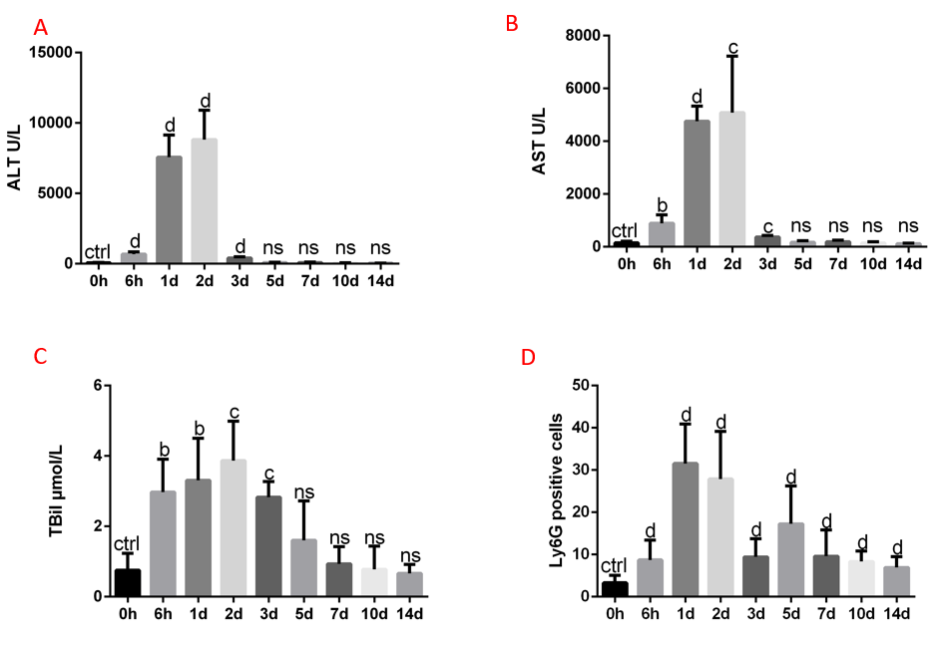
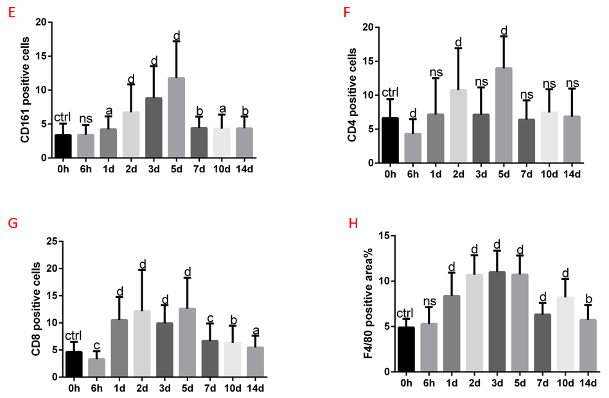
Figure 1 Immune cell infiltration during the process of carbon tetrachloride-induced liver injury and repair. A-C: The levels of alanine transaminase, aspartate transaminase and total bilirubin in carbon tetrachloride (CCl₄)-treated wild-type mice; D-H: Quantitative changes in the infiltration of various immune cells in the livers of CCl₄-treated wild-type mice. The data represent the mean ± SD. ªP < 0.05; ^{b}P < 0.01; ^{c}P < 0.001; ^{d}P < 0.0001. ctrl: Control; ns: Not significant; ALT: Alanine transaminase; AST: Aspartate transaminase; TBil: Total bilirubin.
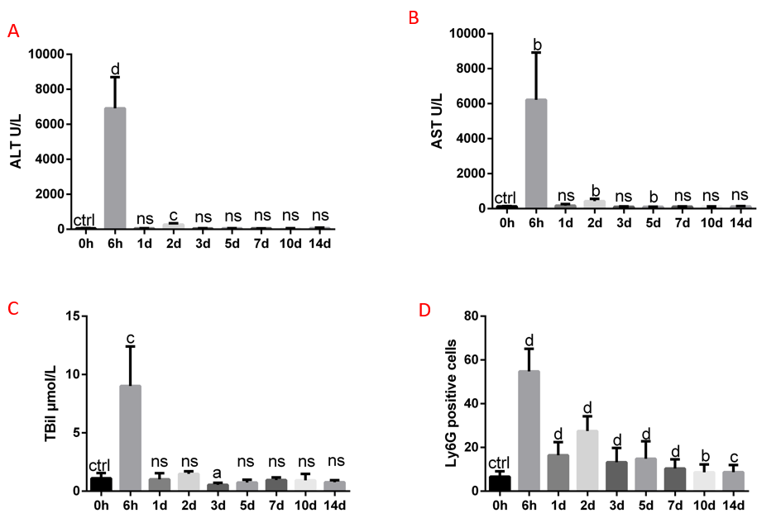
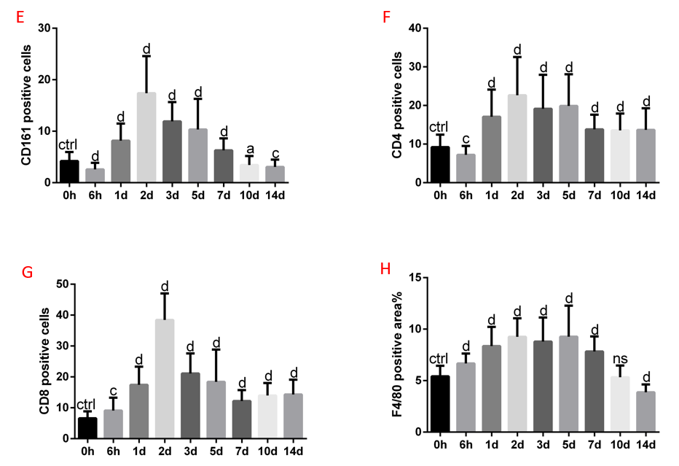
Figure 2 Immune cell infiltration during the process of concanavalin A-induced liver injury and repair. A-C: The levels of serum alanine transaminase, aspartate transaminase and total bilirubin in concanavalin A (ConA)-treated wild-type mice; D-H: Quantitative changes in the infiltration of various immune cells in the livers of ConA-treated wild-type mice. The data represent the mean ± SD. ªP < 0.05; ^{b}P < 0.01; ^{c}P < 0.001; ^{d}P < 0.0001. ctrl: Control; ns: Not significant; ALT: Alanine transaminase; AST: Aspartate transaminase; TBil: Total bilirubin.

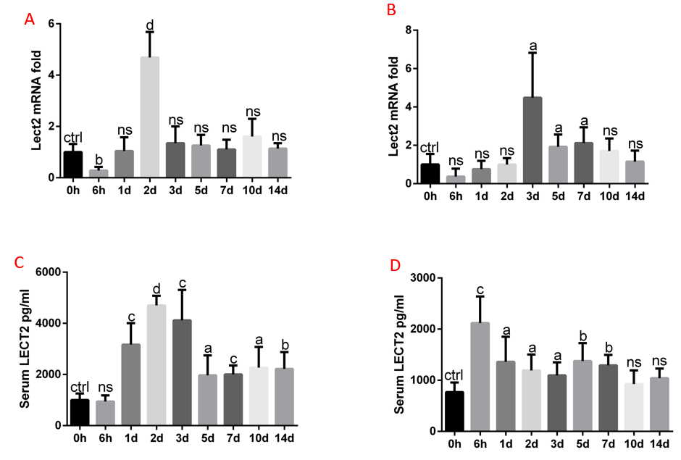
Figure 3 The expression of leukocyte cell-derived chemotaxin 2 was increased in acute liver injury models. A: The relative expression of Lect2 mRNA in the liver tissues of carbon tetrachloride (CCl₄)-treated wild-type mice; B The levels of serum leukocyte cell-derived chemotaxin 2 (LECT2) in CCl₄-treated wild-type mice; C: The relative expression of Lect2 mRNA in the liver tissues of concanavalin A (ConA)-treated wild-type mice; D: The levels of serum LECT2 in ConA-treated wild-type mice. The data represent the mean ± SD. ctrl: Control; ns: Not significant; ªP < 0.05; ^{b}P < 0.01; ^{c}P < 0.001; ^{d}P < 0.0001. ctrl: Control; ns: Not significant; LECT2: Leukocyte cell-derived chemotaxin 2.
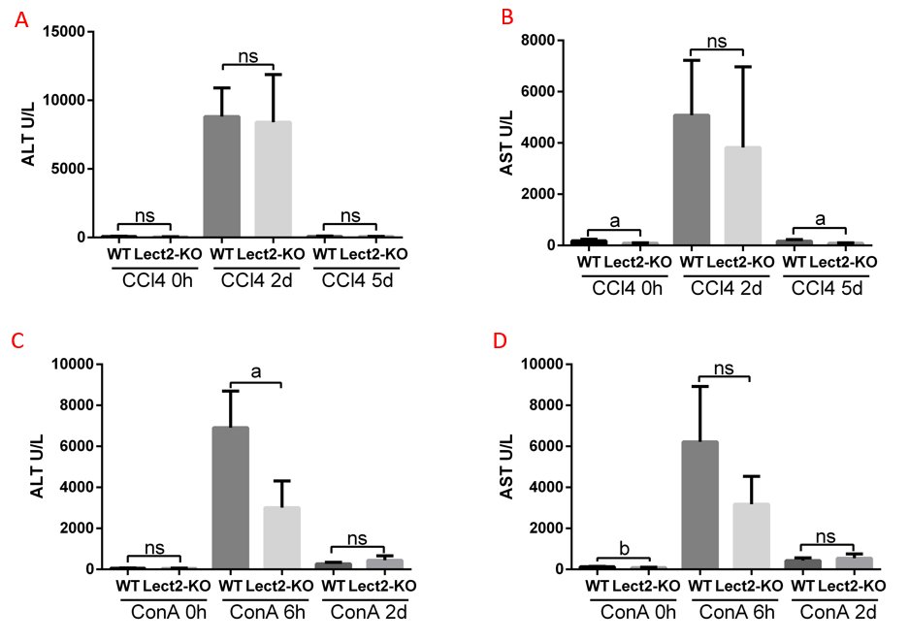
Figure 4 Lect2-KO mice showed less severe liver injuries. A and B: The levels of serum alanine transaminase (ALT) and aspartate transaminase (AST) in the wild-type and Lect2-KO mice, with or without carbon tetrachloride treatment; C and D: The levels of serum ALT and AST in the wild-type and Lect2-KO mice, with or without concanavalin A treatment. The data represent the mean ± SD. ªP < 0.05; ^{b}P < 0.01. ns: Not significant; ALT: Alanine transaminase; AST: Aspartate transaminase.

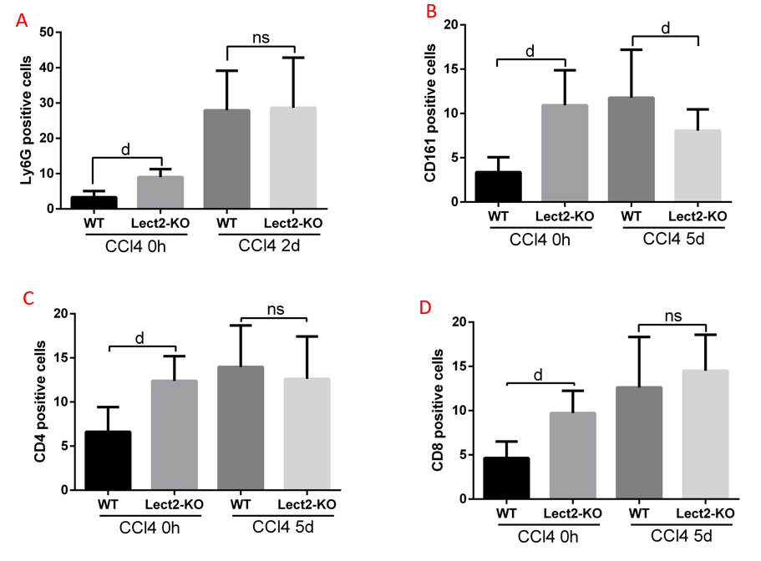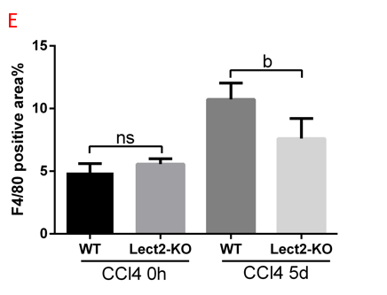
F
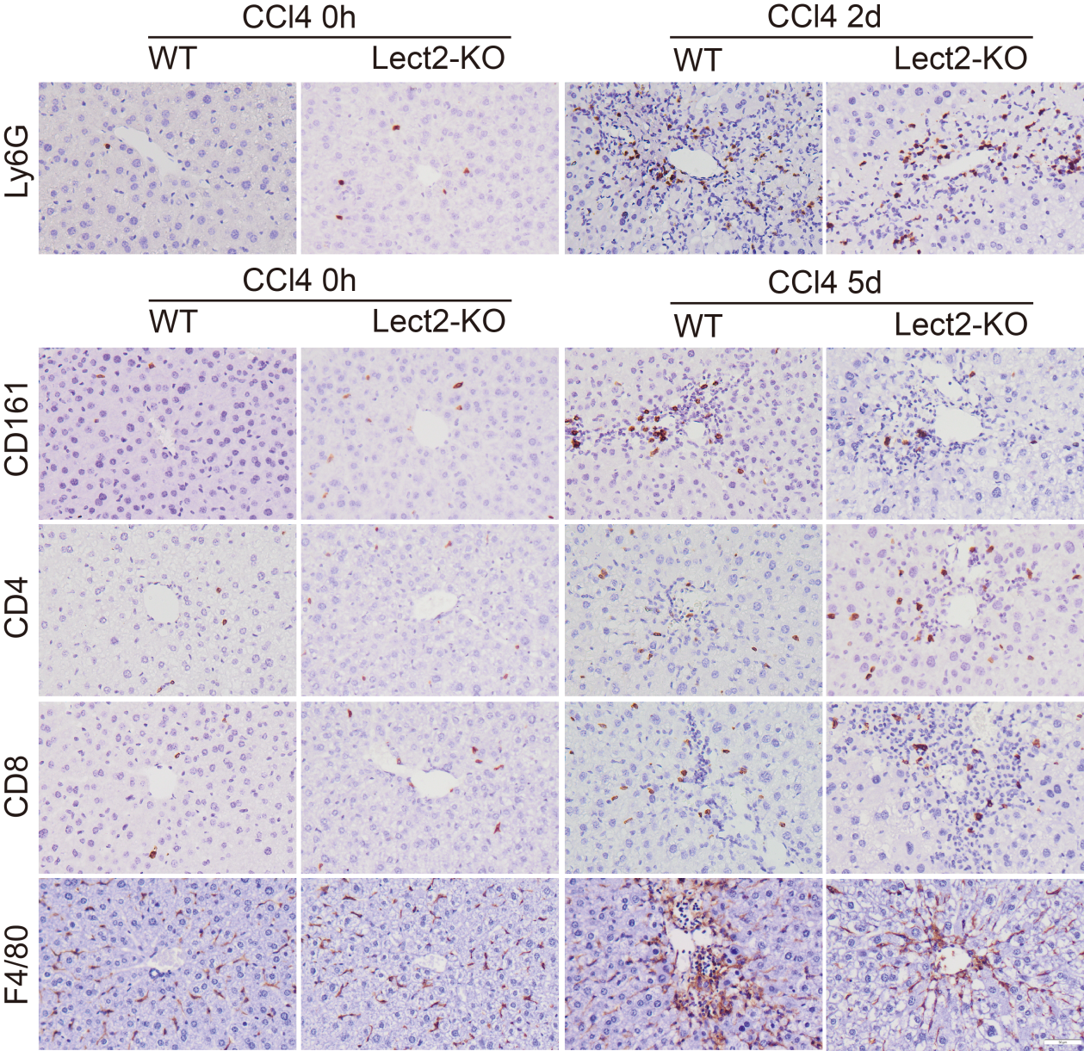
Figure 5 The effect of leukocyte cell-derived chemotaxin 2 on immune cell infiltration in the carbon tetrachloride-induced acute liver injury model. A-E: Quantitative changes in the infiltration of various immune cells in the livers of wild-type and Lect2-KO mice, with or without carbon tetrachloride (CCl₄) treatment; F: Representative images of infiltrated immune cells in CCl₄-treated wild-type and Lect2-KO mice, with or without CCl₄ treatment. The data represent the mean ± SD. ns: Not significant; ªP < 0.05; ^{b}P < 0.01; ^{c}P < 0.001; ^{d}P < 0.0001. Scale bar: 50 μm.
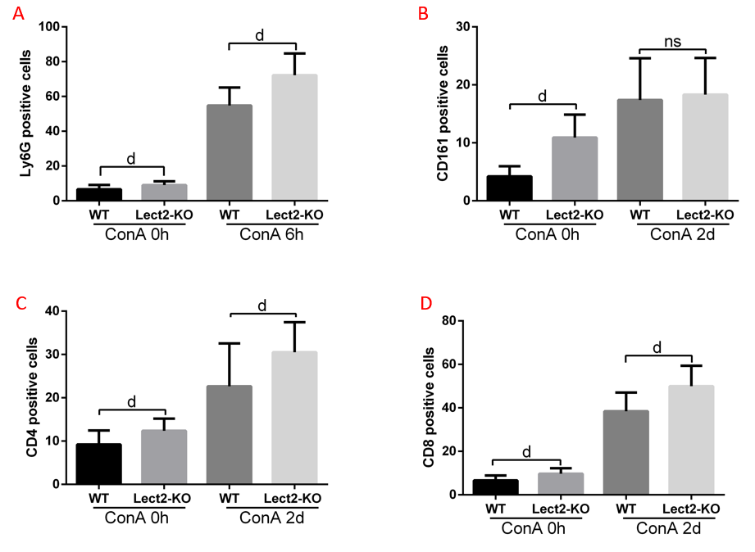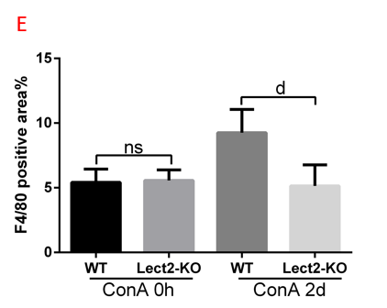
F
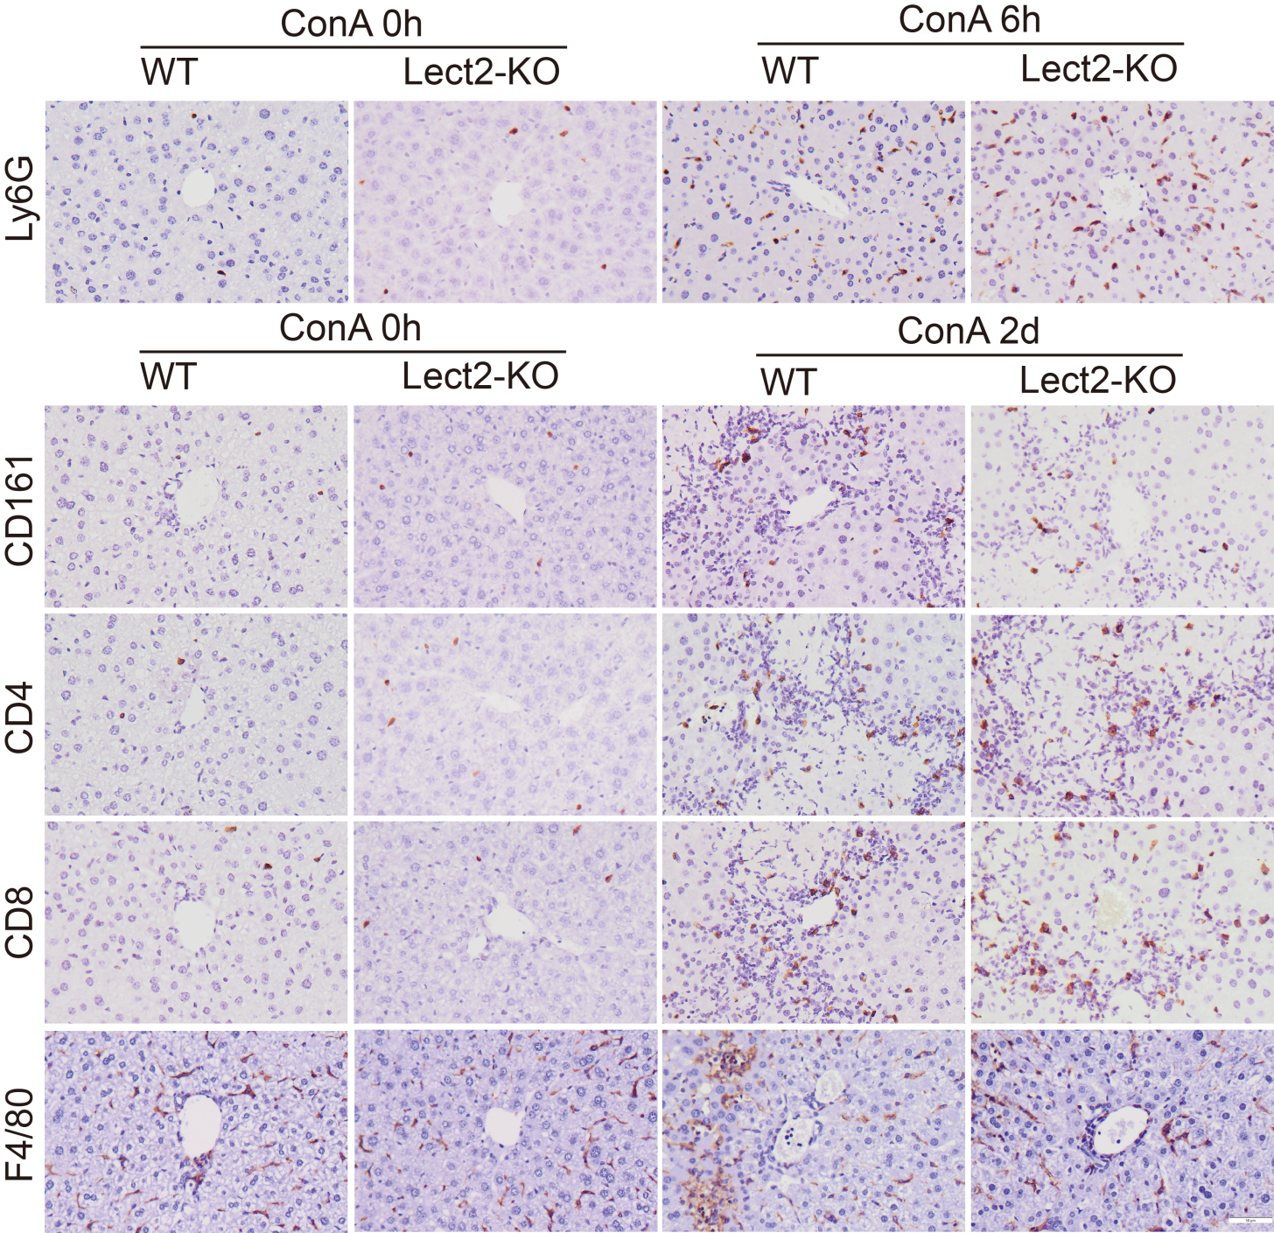
Figure 6 The effect of leukocyte cell-derived chemotaxin 2 on immune cell infiltration in the concanavalin A-induced acute liver injury model. A-E: Quantitative changes in the infiltration of various immune cells in the livers of wild-type and Lect2-KO mice, with or without concanavalin A (ConA) treatment; F: Representative images of infiltrated immune cells in ConA-treated wild-type and Lect2-KO mice, with or without ConA treatment. The data represent the mean ± SD. ªP < 0.05; ^{b}P < 0.01; ^{c}P < 0.001; ^{d}P < 0.0001. ns: Not significant; Scale bar: 50 μm.
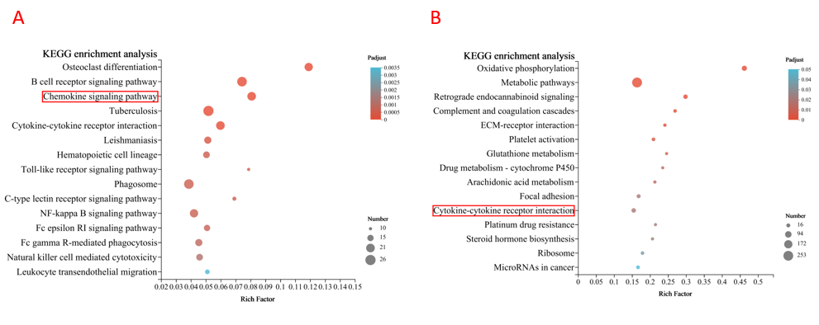
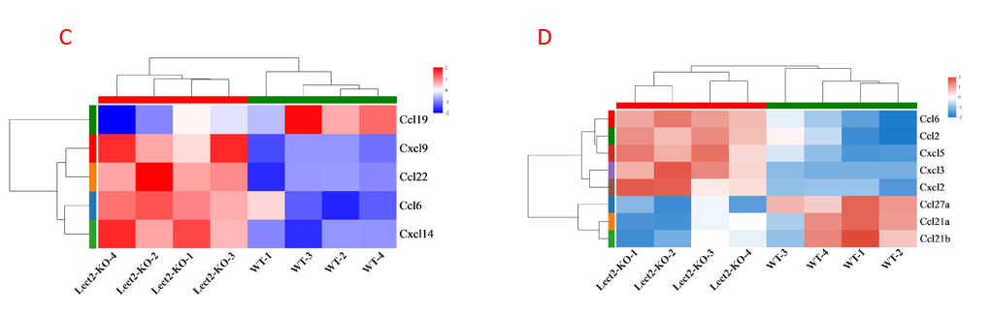
Figure 7 Chemokine-related genes changed in Lect2-KO mice. A: Kyoto Encyclopedia of Genes and Genomes (KEGG) analysis results for carbon tetrachloride (CCl₄)-treated Lect2-KO and wild-type mice; B: KEGG analysis results for concanavalin A (ConA)-treated Lect2-KO and wild-type mice; C: Heatmap of the differentially expressed chemokine-related genes between the Lect2-KO and wild-type mice after CCl₄ treatment; D: Heatmap of the differentially expressed chemokine-related genes between the Lect2-KO and wild-type mice after ConA treatment.
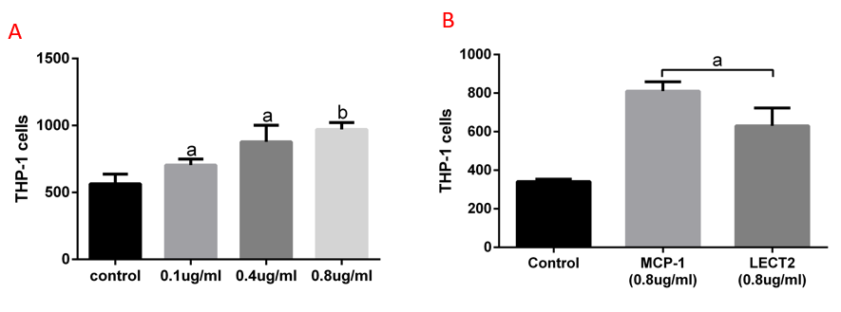
Figure 8 Leukocyte cell-derived chemotaxin 2 promoted THP-1 monocyte chemotaxis. A: Chemotactic effects of Lect2 on THP-1 cells when treated with different doses; B: Comparison of chemotactic effects between Lect2 and MCP-1. The data represent the mean ± SD. ªP < 0.05; ^{b}P < 0.01. ctrl: Control.

