Name of journal: World Journal of Gastroenterology
ESPS Manuscript NO: 32048
Manuscript Type: ORIGINAL ARTICLE

Basic Study
Notch signaling mediated by TGF-β/Smad pathway in concanavalin-A-induced liver fibrosis in rats

Wang Y et al. Notch in rat liver fibrosis

Yi Wang, Ruo-Wu Shen, Bing Han, Zhen Li, Le Xiong, Feng-Yu Zhang, Bei-Bei Cong, Bei Zhang

Yi Wang, Zhen Li, Le Xiong, Feng-Yu Zhang, Bei-Bei Cong, Bei Zhang, Department of Immunology, Medical College of Qingdao University, Qingdao 266071, Shandong Province, China

Ruo-Wu Shen, Department of Anatomy, Medical College of Qingdao University, Qingdao 266071, Shandong Province, China

Bing Han, Department of Hepatobiliary Surgery, Affiliated Hospital of Qingdao University, Qingdao 266071, Shandong Province, China

Author contributions: Zhang B supervised the entire study; Wang Y and Shen RW contributed equally to this research as co-first authors; Wang Y, Shen RW, Han B, Li Z, Xiong L, Zhang FY and Cong BB performed the research and analyzed the data; Wang Y wrote the paper; all authors have read and approved the final manuscript.

Supported by the Natural Science Foundation of Shandong Province, No. 2014ZRB01466.

Institutional review board statement: The study was reviewed and approved by the Qingdao University Medical College Institutional Review Board.

Institutional animal care and use committee statement: All procedures involving animals were reviewed and approved by the Institutional Animal Care and Use Committee of Qingdao University Medical College (No. SCXK20090007).

Conflict-of-interest statement: We declare that there are no conflicts of interest to disclose.

Data sharing statement: No additional data are available.

Open-Access: This article is an open-access article which was selected by an in-house editor and fully peer-reviewed by external reviewers. It is distributed in accordance with the Creative Commons Attribution Non Commercial (CC BY-NC 4.0) license, which permits others to distribute, remix, adapt, build upon this work non-commercially, and license their derivative works on different terms, provided the original work is properly cited and the use is non-commercial. See: http://creativecommons.org/licenses/by-nc/4.0/

Manuscript source: Unsolicited manuscript

Correspondence to: Dr. Bei Zhang, Department of Immunology, Medical College of Qingdao University, 308 Ningxia Road, Qingdao 266071, Shandong Province, China. zhangbei124@aliyun.com
Telephone: +86-186-61980199

Received: December 22, 2016
Peer-review started: December 23, 2016
First decision: January 10, 2016
Revised: January 26, 2016
Accepted: February 16, 2017
Article in press:
Published online:

Abstract
AIM
To explore the exact interaction between notch and transforming growth factor (TGF)-β signaling in liver fibrosis.

METHODS
We established a rat model of liver fibrosis induced by concanavalin A. Peripheral blood mononuclear cells (PBMCs) were isolated from model rats, and cultured with γ-secretase inhibitor DAPT and TGF-β inhibitor for 24 h. The mRNA levels of Notch and TGF-β signaling were detected by quantitative real-time polymerase chain reaction. Expression of Notch and TGF-β proteins was analyzed by Western blotting.

RESULTS
Compared to control rats, Notch and TGF-β signaling was activated in PBMCs of model rats. Administration of DAPT and TGF-β inhibitor suppressed Notch and TGF-β signal transducer in PBMCs of model rats. DAPT reduced mRNA and protein expression of TGF-β signaling, such as TGF-β1 and Smad3. TGF-β inhibitor also downregulated Notch1, Hes1 and Hes5, and mRNA and protein expression of the Notch signaling pathway.

CONCLUSION
Notch and TGF-β signaling play a role in liver fibrosis. TGF-β signaling upregulates Notch signaling, which promotes TGF-β signaling.

Key words: Notch; Transforming growth factor-β; Liver fibrosis; Peripheral blood mononuclear cells; Concanavalin A

© The Author(s) 2017. Published by Baishideng Publishing Group Inc. All rights reserved.

Core tip: Notch and transforming growth factor (TGF)-β activation plays an important role in liver fibrosis induced by concanavalin A. It has been shown that TGF-β facilitates liver fibrosis. However, the mechanism of action of Notch in liver fibrosis is not fully understood. In this study, we found that excessive activation of TGF-β regulated Notch in liver fibrosis in rats, and inhibition of TGF-β signaling blocked Notch signaling and vice versa. This may be a complementary mechanism of liver fibrosis, which provides a potential immunotherapeutic strategy.

Wang Y, Shen EW, Han B, Li Z, Xiong L, Zhang FY, Cong BB, Zhang B. Notch signaling mediated by TGF-β/Smad pathway in concanavalin-A-induced liver fibrosis in rats. World J Gastroenterol 2017; In press

INTRODUCTION
Liver fibrosis occurs as a result of chronic liver disease and is associated with severe morbidity and mortality. It is a reversible wound-healing response characterized by the accumulation of extracellular matrix (ECM) in liver injury^{[1]}. In the mechanisms of liver fibrosis, activation of resident hepatic stellate cells (HSCs) after liver injury remains a dominant theme^{[2]}. The quiescent HSCs can be induced by transforming growth factor (TGF)-β1 to transdifferentiate into myofibroblasts that secrete ECM^{[3]}. Accumulating evidence indicates that multiple signaling pathways, such as the Notch and TGF-β pathways, are involved in epithelial-to-mesenchymal transition and fibroblast activation, resulting in the development of renal fibrosis^{[4,5]}. Inhibition of Notch signaling can ameliorate renal fibrosis through inhibition of Notch-mediated TGF-β signaling activation^{[6]}. However, whether similar regulation occurs in liver fibrosis, and what happens between the two signaling pathways during the recovery stage of liver fibrosis, needs further clarification.
The Notch signaling is highly conserved existing in many animals. It is consisted of four Notch receptors (1–4) and five Notch ligands (delta-like 1, 3 and 4, and Jagged 1 and 2) in mammals^{[7]}. After the ligand binding, Notch receptors experience a series of cleavages catalyzed by the γ-secretase combination, leading to the release of the Notch intracellular domain (NICD), which can be blocked by the γ-secretase inhibitor^{[8]}. The NICD then enters into the nucleus where it induces directly transcription of its target genes, such as Hes1 and Hes5. Ligand-induced Notch signaling directs a key role in organ formation through effects on cellular differentiation, proliferation, survival and apoptosis^{[9]}. Recent studies have demonstrated that Notch signaling also involves in various tissue fibrosis, including idiopathic pulmonary fibrosis, kidney fibrosis, and cardiac fibrosis^{[5,10,11]}. However, the exact potential cellular mechanisms are not completely clear.
In this study, we researched the role of Notch signaling in liver fibrosis development and whether inhibition of Notch activation by γ-secretase inhibitor (DAPT) could suppress the TGF-β/Smad signaling pathway in a rat model of concanavalin (Con)A-induced liver fibrosis. We found that the Notch signaling is involved in liver fibrosis via activation of TGF-β/Smad pathway. Administration of DAPT markedly attenuated the TGF-β/Smad signaling pathway in ConA-induced liver fibrosis in rats.

MATERIALS AND METHODS
Animals
Male Wistar rats (weighing 210–230 g) were supplied by the Experimental Animal and Animal Experiment Center of Qingdao, Shandong, China. They were housed in the animal facility in a 12-h light–dark cycle, and the temperature was maintained at 22–23°C and relative humidity at 60%. The animals were randomly distributed into two groups: normal group (n = 12), which received a weekly intravenous injection of 300 μL phosphate-buffered saline (PBS) for 8 wk; and the model group (n = 36), which received a weekly intravenous injection of ConA (17.5 mg/kg, in 300 μL PBS) for 8 wk^{[12,13]}. During all experiments, rats were maintained in individually ventilated cages under specific pathogen-free conditions. Eight weeks later, we collected blood via cardiac puncture. Rats were handled and treated in accordance with the strict guiding principles of the National Institutes of Health for Experimental Care and Use of Animals and approved by the Institutional Animal Care and Use Committee of Qingdao University Medical College, Qingdao, China.

Cell culture and treatment
Peripheral blood mononuclear cells (PBMCs) were isolated from model rats by Ficoll–Hypaque density gradient centrifugation (TBD Science, Tianjin, China). The cells were washed three times with sterile PBS and suspended in a concentration of 2 × 10⁶ cells/mL in RPMI 1640 (HyClone, Logan, UT, United States) supplemented with 10% heat-inactivated fetal calf serum, and 1% penicillin–streptomycin (HyClone). The cells were cultured at 37 °C in a CO₂ incubator. These cells were treated with 0.25 μmol/L DAPT (HY-13027; MedChem Express, Monmouth Junction, NJ, United States) and 0.25 mmol/L TGF-β inhibitor (LY-364947; MedChem Express), with 0.1% dimethyl sulfoxide (DMSO) (Sigma, St. Louis, MO, United States) as a control. After treatment for 24 h, all cells were collected for total RNA and protein extraction.

Liver histopathological observation
After rats were killed, their blood vessels were perfused with PBS, followed by 4% paraformaldehyde. The livers were removed and fixed in 4% paraformaldehyde overnight and embedded in paraffin. Sections (4 μm) were cut and deparaffinized, stained with hematoxylin and eosin. Slides were evaluated using light microscopy by a pathologist on a blinded basis. Representative sections were presented.

Liver function
The serum levels of alanine aminotransferase (ALT), aspartate aminotransferase (AST) and albumin were measured with a biochemical autoanalyzer (P800; Roche, Basel, Switzerland).

Quantitative reverse transcription polymerase chain reaction
Total RNA was purified from cultured cells using TRIzol reagent (Takara, Otsu, Japan). Total RNA was reverse transcribed using PrimeScript RT Reagent Kit (Takara, Otsu, Japan). Quantitative everse transcription polymerase chain reaction (RT-PCR) was performed by mixing cDNA and gene-specific primers with iQ SYBR Green Supermix (Bio-Rad, Hercules, CA, United States), and reactions were carried out in an iCycler Thermal Cycler (Bio-Rad). Results were normalized to rat β-actin based on the threshold cycle (Ct) and relative fold change calculated by the 2^{−ΔΔCt} method. The primer sequences for mouse Notch 1–4, Jagged1, Hes1, Hes5, TGF-β1, Smad2 and Smad3 are described in Table 1.

Western blot analysis
Western blot analysis was performed using standard procedures with enhanced chemiluminescence using an ECL reagent and visualized by Imager (UVP Biospectrum 810, Upland, CA, United States). PBMCs were homogenized in RIPA lysis buffer (Thermo Scientific, Grand Island, NY, USA), and extracts were centrifuged for 10 min at 14000 × g at 4 °C. Total protein samples were analyzed by 10% SDS-PAGE and transferred to polyvinylidene difluoride membranes by a wet blotting procedure (100 V, 2 h, 4 °C). Blocking buffer (5%) incubation was followed by incubation with primary antibodies at 4°C overnight using the following concentrations: Notch1 (1: 1000, 4380; Cell Signaling Technology, Danvers, MA, United States); Hes1 (1: 1000, ab108937; Abcam, Cambridge, MA, United States); Hes5 (1: 1000, ab194111; Abcam); TGF-β (1: 1000, 3711; Cell Signaling Technology); Smad3 (1: 1000, ab40854; Abcam); and β-actin (1: 5000, TA-09; Zhongshan Jinqiao Biotechnology, Beijing, China), which acted as the internal control for normalization of protein expression. The quantification of densitometry calculated by a multimedia color image analysis system (Image-Pro Plus 6.0) was measured as a relative objective index.

Statistical analysis
Quantitative data are expressed as mean ± SD. Statistical comparisons among multiple groups were performed by Tukey’s post hoc test and one-way ANOVA. Student’s t test was used to compare the difference between two groups. P ≤ 0.05 was considered significant.

RESULTS
Notch signaling and TGF-β signaling are activated in liver fibrosis
To determine whether the Notch signaling and TGF-β signaling pathways were involved in liver fibrosis, we tested the expression of Notch- and TGF-β-related genes in liver fibrosis in rats. Eight weeks after intravenous injection of ConA, hematoxylin–eosin staining and liver function tests demonstrated modeling success compared with normal rats (Figure 1A, Table 1). RT-PCR analysis revealed that the mRNA levels of Notch1, Hes1, Hes5, TGF-β1 and Smad3 were significantly increased in PBMCs of model rats as compared with controls. Notch2, Notch3, Jagged1 and Smad2 were detectable, but in contrast to Notch1, their levels did not differ between models and controls. Notch4 and HeyL were not detectable (ªP < 0.05, ^{c}P < 0.001; Figure 1B). Through western blot analysis, we observed that the protein levels of Notch 1, Hes1, Hes5, TGF-β1 and Smad3 were increased after liver fibrosis (^{c}P < 0.001; Figure 1C and D). These results suggest that Notch and TGF-β signaling is activated in liver fibrosis in rats.

DAPT inhibits Notch and TGF-β signaling pathway in vitro
Because the TGF-β signaling was involved in the development of liver fibrosis^{[14]}, we tested whether DAPT affected this pathway in PBMCs of liver fibrosis rats. TGF-β1 and Smad3 expression was significantly downregulated in the PBMCs of liver fibrosis rats treated with DAPT compared with the DMSO groups (Figure 2). The levels of Notch1, Hes1 and Hes5 genes were significantly attenuated in the DAPT-treated group at the same time. Protein was extracted from the PBMCs of DAPT- or DMSO-treated rats for Western blotting. We observed a significant reducing in the expression of TGF-β1 and Smad3 protein, and a decrease in Notch1, Hes1, and Hes5 protein (Figure 2B, C). These changes indicated that inhibiting Notch signaling suppresses the activation of TGF-β signaling in PBMCs of liver fribosis model rats.

TGF-β inhibitor blocks the Notch and TGF-β signaling pathways in vitro
To further examine possible crosstalk between the Notch and TGF-β signaling pathways, the PBMCs from liver fibrosis rats were treated with TGF-β inhibitor. TGF-β inhibitor caused suppression of Notch1, Hes1, Hes5, TGF-β and Smad3 genes (Figure 3A), demonstrating that canonical TGF-β signaling pathway activity promotes the expression of Notch signaling pathway genes. Protein expression of Notch1, Hes1, Hes5, TGF-β and Smad3 in PBMCs cultured for 24 h with TGF-β inhibitor or DMSO was detected by Western blot analysis (Figure 3B, C). These results showed that treatment with TGF-β inhibitor effectively blocked the Notch signaling pathway in PBMCs from liver fibrosis rats.

DISCUSSION
We showed that there is an interaction between the Notch and TGF-β signaling pathways in ConA-induced liver fibrosis rats. We showed that Notch signaling and TGF-β signaling are activated in liver fibrosis rats, with prominent expression of the Notch1 receptor and TGF-β1 accumulation and increased transcription of target genes such as Hes1, Hes5 and Smad3 in PBMCs of model rats. Furthermore, we found that treatment with the γ-secretase inhibitor DAPT significantly inhibited Notch and TGF-β signaling in PBMCs of liver fibrosis rats, similar to the TGF-β inhibitor.
In the earliest stages, all forms of fibrosis are inflammatory–immunological reactions, and elements of both the innate and adaptive immune systems are involved in subsequent profibrotic processes^{[15]}. Growing evidence shows that Notch signaling plays a crucial role in the pathogenesis of multiple inflammatory diseases^{[16,17]}. Our findings of increased activation of Notch signaling are consistent with ConA-induced liver fibrosis. We have previously shown an imbalance between T helper 17 and T regulatory cells in liver fibrosis model rats. In addition, TGF-β plays an important part in both normal and diseased conditions in the liver and other organs ^{[14]}. The direct targets in the TGF-β1, Smads (Smad2, and especially Smad3), are critical mediators in fibrogenesis^{[18]}. In a recent study, TGF-β induced transport and Golgi organization 1 and unfolded protein response, which facilitated fibrogenesis in murine hepatic fibrosis^{[19]}. Furthermore, the Notch and TGF-β signaling pathways cooperatively regulate forkhead box p3 expression and regulatory T-cell maintenance in vitro and in vivo, and integration of the TGF-β and Notch1 pathways may be an important mechanism for the maintenance of immune homeostasis in the periphery ^{[20,21]}. Our study also showed that TGF-β signaling markedly increased in PBMCs of liver fibrosis rats. However, the cellular and molecular mechanism by Notch and TGF-β activation facilitates liver fibrosis have not been previously explored. Our study demonstrated that Notch signaling is mediated by the TGF-β/Smad signaling in liver fibrosis.
Evidence for the important role of Notch signaling is growing, such as the crosstalk between Notch and Hedgehog in liver injury, and the Notch inhibitor restriction of the TGF-β/Smad2/3 signaling pathway in kidney fibrosis^{[6,22]}, even TGF-b/Smad crosstalk with Notch in many diseases^{[23]}. However, the relation between Notch and TGF-β signaling pathway in liver fibrosis remains unclear. Previously, it has been shown that Notch3 and Hes1 are critically involved in CCL₄-induced liver fibrosis in rats^{[24]}. Hes1 and Hes5, as the targets of Notch affect chondrogenesis and chondrocyte hypertrophy in cartilage maintenance and osteoarthritis^{[25,26]}. In our study, we found that Notch1 was markedly increased in PBMCs during liver fibrogenesis. This may reveal the different fibrotic mechanism between liver and peripheral tissues. Studies analyzing the therapeutic potential of inhibitors of the γ-secretase complex that is required for release of the active NICD are currently the most common method for targeting Notch^{[27]}. It should be noted that our study examined only the interaction between the Notch and TGF-β signaling pathways in vitro, and we now need to explore the interaction in vivo in model rats and patients with liver fibrosis.
In summary, we have demonstrated that the Notch pathway is activated in liver fibrosis rats and that inhibition of Notch and TGF-β signaling reduces the mRNA and protein expression in immune-induced rat liver fibrosis. Thus, we conclude that Notch signaling exerts fibrogenesis mediated by the TGF-β/Smad signaling pathway, although additional research is needed to clarify the nuances of this process.

COMMENTS
Background
Liver fibrosis is distributed widely and a serious threat to human health. It is difficult to cure the disease because the pathogenesis is not completely understood. The current study suggests that liver damage is related to immune factors, and Notch and transforming growth factor (TGF)-β signaling play an important role in it. Blocking the two pathways may alleviate liver fibrosis.

Research frontiers
TGF-β is one of the key factors that activates quiescent hepatic stellate cells, which transform into myofibroblasts, and it also promotes collagen production. Notch crosstalk with TGF-β is involved in fibrosis of many organs including the liver, and overexpression of Notch intracellular domain and Smad3 activates their target gene transcription.

Innovations and breakthroughs
The present study showed that Notch signaling and TGF-β signaling regulate each other in liver fibrosis, which provide a new insight into the immune mechanism of liver fibrosis.

Applications
The results of this study may have a positive impact on patients with liver fibrosis and its outcome.

Terminology
Notch is a highly conserved signaling pathway among all animal species, and plays a key role in regulating cellular differentiation, proliferation, survival and apoptosis.

Peer-review
This article provides a particular answer only that is associated with the white blood cells being present in the circulation of the hepatic fibrosis-induced rats, presuming that the peripheral blood mononuclear cells (PBMCs) fraction is characteristic and indicative of the fibrotic state, and that the PBMC fraction may have a role in hepatic fibrogenesis.

REFERENCES
1 Hernandez-Gea V, Friedman SL. Pathogenesis of liver fibrosis. Annu Rev Pathol 2011; 6: 425-456 [PMID: 21073339 DOI: 10.1146/annurev-pathol-011110-130246]
2 Friedman SL. Mechanisms of hepatic fibrogenesis. Gastroenterology 2008; 134: 1655-1669 [PMID: 18471545 DOI: 10.1053/j.gastro.2008.03.003]
3 Lee UE, Friedman SL. Mechanisms of hepatic fibrogenesis. Best Pract Res Clin Gastroenterol 2011; 25: 195-206 [PMID: 21497738 DOI: 10.1016/j.bpg.2011.02.005]
4 Schnaper HW, Jandeska S, Runyan CE, Hubchak SC, Basu RK, Curley JF, Smith RD, Hayashida T. TGF-beta signal transduction in chronic kidney disease. Front Biosci (Landmark Ed) 2009; 14: 2448-2465 [PMID: 19273211]
5 Bielesz B, Sirin Y, Si H, Niranjan T, Gruenwald A, Ahn S, Kato H, Pullman J, Gessler M, Haase VH, Susztak K. Epithelial Notch signaling regulates interstitial fibrosis development in the kidneys of mice and humans. J Clin Invest 2010; 120: 4040-4054 [PMID: 20978353 DOI: 10.1172/JCI43025]
6 Xiao Z, Zhang J, Peng X, Dong Y, Jia L, Li H, Du J. The Notch γ-secretase inhibitor ameliorates kidney fibrosis via inhibition of TGF-β/Smad2/3 signaling pathway activation. Int J Biochem Cell Biol 2014; 55: 65-71 [PMID: 25150830 DOI: 10.1016/j.biocel.2014.08.009]
7 Maillard I, Adler SH, Pear WS. Notch and the immune system. Immunity 2003; 19: 781-791 [PMID: 14670296]
8 Milano J, McKay J, Dagenais C, Foster-Brown L, Pognan F, Gadient R, Jacobs RT, Zacco A, Greenberg B, Ciaccio PJ. Modulation of notch processing by gamma-secretase inhibitors causes intestinal goblet cell metaplasia and induction of genes known to specify gut secretory lineage differentiation. Toxicol Sci 2004; 82: 341-358 [PMID: 15319485 DOI: 10.1093/toxsci/kfh254]
9 Fiuza UM, Arias AM. Cell and molecular biology of Notch. J Endocrinol 2007; 194: 459-474 [PMID: 17761886 DOI: 10.1677/joe-07-0242]
10 Plantier L, Crestani B, Wert SE, Dehoux M, Zweytick B, Guenther A, Whitsett JA. Ectopic respiratory epithelial cell differentiation in bronchiolised distal airspaces in idiopathic pulmonary fibrosis. Thorax 2011; 66: 651-657 [DOI: 10.1136/thx.2010.151555]
11 Russell JL, Goetsch SC, Gaiano NR, Hill JA, Olson EN, Schneider JW. A dynamic notch injury response activates epicardium and contributes to fibrosis repair. Circ Res 2011; 108: 51-59 [PMID: 21106942 DOI: 10.1161/circresaha.110.233262]
12 Liang J, Zhang B, Shen RW, Liu JB, Gao MH, Li Y, Li YY, Zhang W. Preventive effect of halofuginone on concanavalin A-induced liver fibrosis. PLoS One 2013; 8: e82232 [PMID: 24358159 DOI: 10.1371/journal.pone.0082232]
13 Liang J, Zhang B, Shen RW, Liu JB, Gao MH, Geng X, Li Y, Li YY, Zhang W. The effect of antifibrotic drug halofugine on Th17 cells in concanavalin A-induced liver fibrosis. Scand J Immunol 2014; 79: 163-172 [PMID: 24383550 DOI: 10.1111/sji.12144]
14 Inagaki Y, Okazaki I. Emerging insights into Transforming growth factor beta Smad signal in hepatic fibrogenesis. Gut 2007; 56: 284-292 [PMID: 17303605 DOI: 10.1136/gut.2005.088690]
15 Wick G, Grundtman C, Mayerl C, Wimpissinger TF, Feichtinger J, Zelger B, Sgonc R, Wolfram D. The immunology of fibrosis. Annu Rev Immunol 2013; 31: 107-135 [PMID: 23516981 DOI: 10.1146/annurev-immunol-032712-095937]
16 Cheng YL, Choi Y, Sobey CG, Arumugam TV, Jo DG. Emerging roles of the γ-secretase-notch axis in inflammation. Pharmacol Ther 2015; 147: 80-90 [PMID: 25448038 DOI: 10.1016/j.pharmthera.2014.11.005]
17 Hans CP, Koenig SN, Huang N, Cheng J, Beceiro S, Guggilam A, Kuivaniemi H, Partida-Sánchez S, Garg V. Inhibition of Notch1 Signaling Reduces Abdominal Aortic Aneurysm in Mice by Attenuating Macrophage-Mediated Inflammation. Arterioscler Thromb Vasc Biol 2012; 32: 3012-3023 [PMID: 23087364 DOI: 10.1161/atvbaha.112.254219]
18 Wang C, Song X, Li Y, Han F, Gao S, Wang X, Xie S, Lv C. Low-dose paclitaxel ameliorates pulmonary fibrosis by suppressing TGF-β1/Smad3 pathway via miR-140 upregulation. PLoS One 2013; 8: e70725 [PMID: 23967091 DOI: 10.1371/journal.pone.0070725]
19 Maiers JL, Kostallari E, Mushref M, deAssuncao TM, Li H, Jalan-Sakrikar N, Huebert RC, Cao S, Malhi H, Shah VH. The unfolded protein response mediates fibrogenesis and collagen I secretion through regulating TANGO1 in mice. Hepatology 2016; Epub ahead of print [PMID: 28039913 DOI: 10.1002/hep.28921]
20 Samon JB, Champhekar A, Minter LM, Telfer JC, Miele L, Fauq A, Das P, Golde TE, Osborne BA. Notch1 and TGFbeta1 cooperatively regulate Foxp3 expression and the maintenance of peripheral regulatory T cells. Blood 2008; 112: 1813-1821 [PMID: 18550850 DOI: 10.1182/blood-2008-03-144980]
21 Ostroukhova M, Qi Z, Oriss TB, Dixon-McCarthy B, Ray P, Ray A. Treg-mediated immunosuppression involves activation of the Notch-HES1 axis by membrane-bound TGF-beta. J Clin Invest 2006; 116: 996-1004 [PMID: 16543950 DOI: 10.1172/JCI26490]
22 Xie G, Karaca G, Swiderska-Syn M, Michelotti GA, Krüger L, Chen Y, Premont RT, Choi SS, Diehl AM. Cross-talk between Notch and Hedgehog regulates hepatic stellate cell fate in mice. Hepatology 2013; 58: 1801-1813 [PMID: 23703657 DOI: 10.1002/hep.26511]
23 Luo K. Signaling Cross Talk between TGF-β/Smad and Other Signaling Pathways. Cold Spring Harb Perspect Biol 2017; 9: [PMID: 27836834 DOI: 10.1101/cshperspect]
24 Chen Y, Zheng S, Qi D, Zheng S, Guo J, Zhang S, Weng Z. Inhibition of Notch signaling by a γ-secretase inhibitor attenuates hepatic fibrosis in rats. PLoS One 2012; 7: e46512 [PMID: 23056328 DOI: 10.1371/journal.pone.0046512]
25 Rutkowski TP, Kohn A, Sharma D, Ren Y, Mirando AJ, Hilton MJ. HES factors regulate specific aspects of chondrogenesis and chondrocyte hypertrophy during cartilage development. J Cell Sci 2016; 129: 2145-2155 [PMID: 27160681 DOI: 10.1242/jcs.181271]
26 Liu Z, Chen J, Mirando AJ, Wang C, Zuscik MJ, O'Keefe RJ, Hilton MJ. A dual role for NOTCH signaling in joint cartilage maintenance and osteoarthritis. Sci Signal 2015; 8: ra71 [PMID: 26198357 DOI: 10.1126/scisignal.aaa3792]
27 Rizzo P, Osipo C, Foreman K, Golde T, Osborne B, Miele L. Rational targeting of Notch signaling in cancer. Oncogene 2008; 27: 5124-5131 [PMID: 18758481 DOI: 10.1038/onc.2008.226]

P-Reviewer: Abdelgawad IA, Ji G, Lendvai G S-Editor: Qi Y L-Editor: E-Editor:

Specialty type: Gastroenterology and hepatology
Country of origin: China
Peer-review report classification
Grade A (Excellent): 0
Grade B (Very good): B
Grade C (Good): C, C
Grade D (Fair): 0
Grade E (Poor): 0

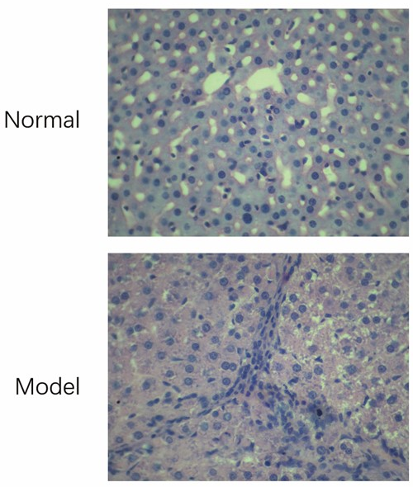
A
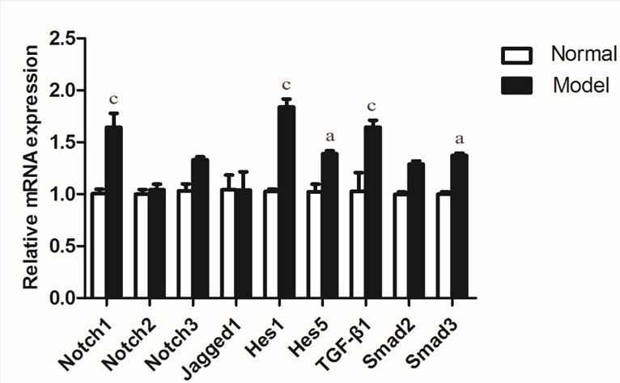
B
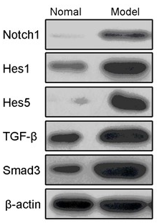
C
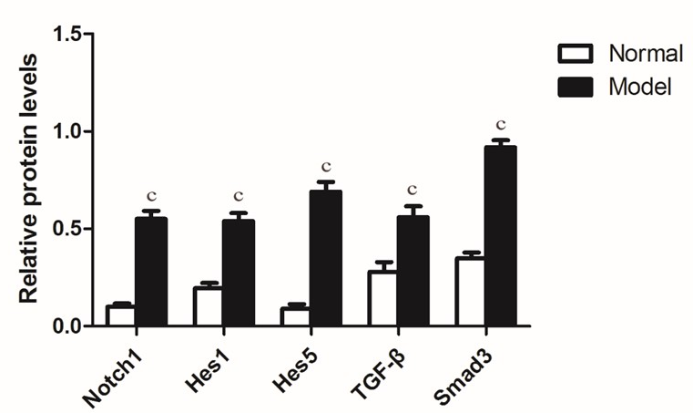
D

Figure 1 Notch signaling and transforming growth factor-β signaling pathways were activated in liver fibrosis rats. A: Representative hematoxylin–eosin staining in the livers from normal or model group rats (× 200); B: RT-PCR analyzed mRNA expression of Notch- and TGF-β-related genes in the PBMCs (2 × 10⁶) from model rats and control group; C, D: Protein expression and quantification of Notch1, Hes1, Hes5, TGF-β and Smad3 were measured by Western blotting in PBMCs (2 × 10⁶) from model rats and control group. ªP < 0.05, ^{c}P < 0.001 vs normal group, n = 12 per group.

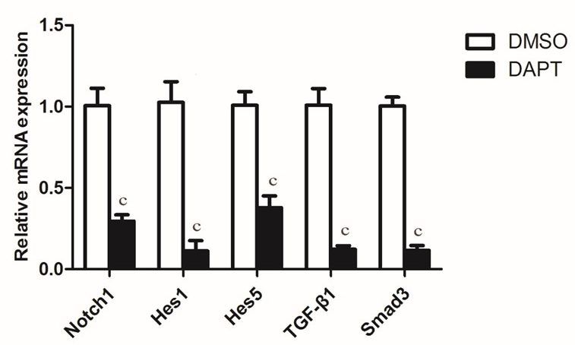
A
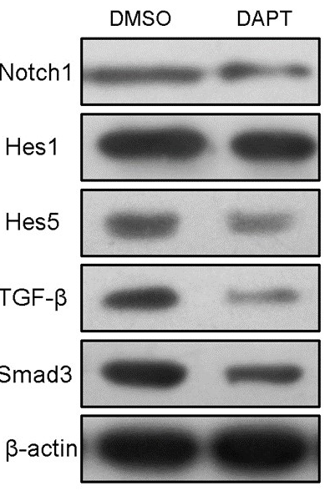
B
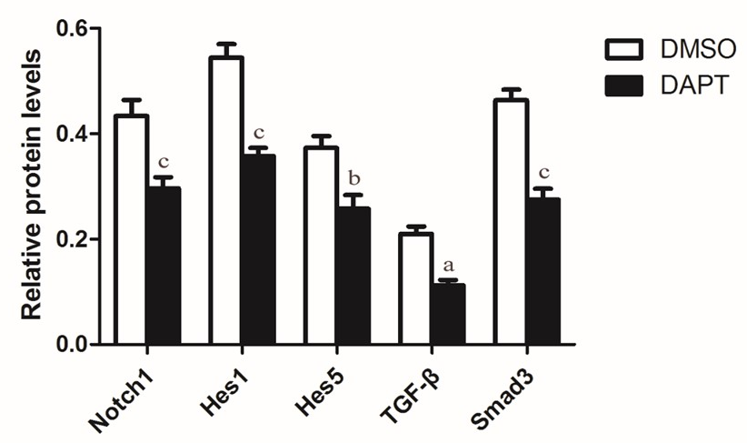
C

Figure 2 Notch γ-secretase inhibitor attenuates notch and transforming growth factor-β signaling pathways in peripheral blood mononuclear cells of liver fibrosis rats. A: mRNA expression for TGF-β1 Smad3 and Notch1, and Notch target genes Hes1 and Hes5 in PBMCs (2 × 10⁶) from rats treated with DAPT or DMSO for 24 h, as detected by RT-PCR. (B, C) Western blot analysis of protein expression of Notch1, Hes1, Hes5, TGF-β and Smad3 and quantification in PBMCs (2 × 10⁶) from rats treated with DAPT or DMSO for 24 h. ªP < 0.05, ^{b}P < 0.01, ^{c}P < 0.001 vs DMSO group, n = 12 per group.

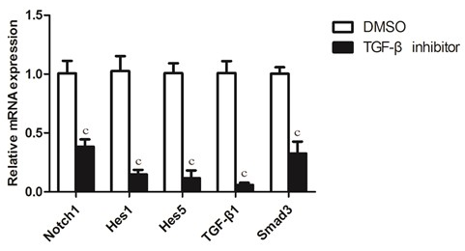
A
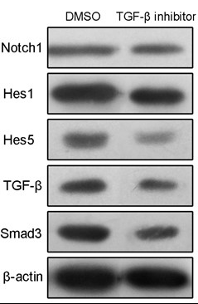
B
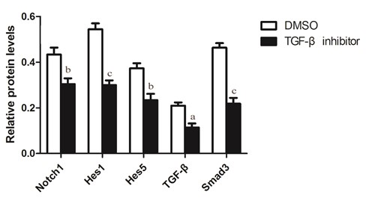
C

Figure 3 Transforming growth factor-β inhibitor blocks Notch and transforming growth factor-β signaling pathways in peripheral blood mononuclear cells of liver fibrosis rats. A: RT-PCR analyzed mRNA expression of TGF-β1 Smad3 and Notch1, and Notch target genes Hes1 and Hes5 in peripheral blood mononuclear cells (PBMCs) (2 × 10⁶) from rats treated with DAPT or DMSO for 24 h; B, C: Western blot analysis of Notch1, Hes1, Hes5, TGF-β and Smad3 and quantification in PBMCs (2 × 10⁶) from rats treated with DAPT or DMSO for 24 h. ªP < 0.05, ^{b}P < 0.01, ^{c}P < 0.001 vs DMSO group, n = 12 per group.

Table 1 Levels of serum biochemical markers in rats (mean ± SD)
Group | ALT(U/L) | AST(U/L) | Albumin (g/L)
Control | 47.32±5.21 | 167.68±14.31 | 34.23±2.62
Model | 75.13±9.68ª | 252.06±22.83ª | 25.60±1.90ª
ªP < 0.05 vs control, n = 12 per group. ALT: Alanine aminotransferase; AST: Aspartate aminotransferase.

Table 2 Sequences of primers for quantitative real-time reverse transcription polymerase chain reaction
Genes | Forward | Reverse
Notch1 | 5’-tcgtgctcctgttctttgtg-3’ | 5’-ttctctccgcttcttcttgc-3’
Notch2 | 5’-tgatgagcaggaacaggaga-3’ | 5’-atgagaagccaggagagcag-3’
Notch3 | 5’-atacccactacgggatgtgc-3’ | 5’-aggacgaagatgaccagcag-3’
Notch4 | 5’-ggatgaatgtcggagtgacc-3’ | 5’-ggctacacaagggaacctca-3’
Jagged1 | 5’-cagtggcttgggtctgttg-3’ | 5’-cattgttggtggtgttgtcc-3’
Hes1 | 5’-gtgggtcctaacgcagtgtc-3’ | 5’-gtcagaagagagaggtgggcta-3’
Hes5 | 5’-atgctcagtcccaaggagaa-3’ | 5’-ctccagcagcagtttcagc-3’
TGF-β1 | 5’-attcctggcgttaccttgg-3’ | 5’-agccctgtattccgttctct-3’
Smad2 | 5’-cggctgaactgtctcctacc-3’ | 5’-aggtctctccaaccctctgg-3’
Smad3 | 5’-ggtaaaggattgccaccaaa-3’ | 5’-gaacagccaggaaagggact-3’
β-actin | 5’-cacccgcgagtacaaccttc-3’ | 5’-cccatacccaccatcacacc-3’

