Name of Journal: World Journal of Hepatology
Manuscript NO: 39874
Manuscript Type: MINIREVIEWS

Decision modelling for economic evaluation of liver transplantation

Running title: Decision Analytical modelling for Liver Transplantation

Zhi Qu, Christian Krauth, Volker Eric Amelung, Alexander Kaltenborn, Jill Gwiasda, Lena Harries, Jan Beneke, Harald Schrem, Sebastian Liersch

Zhi Qu, Christian Krauth, Volker Eric Amelung, Alexander Kaltenborn, Jill Gwiasda, Lena Harries, Jan Beneke, Harald Schrem, Sebastian Liersch, Core Facility Quality Management and Health Technology Assessment in Transplantation, Integrated Research and Treatment Facility Transplantation (IFB-Tx), Hannover Medical School, Hannover 30625, Germany

Zhi Qu, Christian Krauth, Volker Eric Amelung, Lena Harries, Sebastian Liersch, Institute for Epidemiology, Social Medicine and Health Systems Research, Hannover Medical School, Hannover 30625, Germany

Harald Schrem, General, Visceral and Transplant Surgery, Hannover Medical School, Hannover 30625, Germany

ORCID number: Zhi Qu (0000-0003-0578-939X); Christian Krauth (0000-0003-0836-9737); Volker Eric Amelung (0000-0001-5721-2459); Alexander Kaltenborn (0000-0001-5885-0786); Jill Gwiasda (0000-0002-1749-5690); Lena Harries (0000-0003-3044-7906); Jan Beneke (0000-0003-2834-7164); Harald Schrem (0000-0002-5527-7555); Sebastian Liersch (0000-0002-0065-6101).

Authors’ contributions: Qu Z, Krauth C and Schrem H conceptualized the overview. Qu Z, Gwiasda J and Liersch S drafted the manuscript. Amelung VE, Kaltenborn A, Harries L, Beneke J and Schrem H critically reviewed the manuscript and contributed important intellectual contents.

Supported by a grant from the German Federal Ministry of Education and Research, No. 01EO1302.

Conflicts of interest: The authors of this manuscript declare no conflicts of interest.

Open-Access: This article is an open-access article which was selected by an in-house editor and fully peer-reviewed by external reviewers. It is distributed in accordance with the Creative Commons Attribution Non Commercial (CC BY-NC 4.0) license, which permits others to distribute, remix, adapt, build upon this work non-commercially, and license their derivative works on different terms, provided the original work is properly cited and the use is non-commercial. See: http://creativecommons.org/licenses/by-nc/4.0/

Manuscript source: Unsolicited manuscript

Correspondence to: Zhi Qu, PhD, Doctor, Core Facility Quality Management and Health Technology Assessment in Transplantation, Integrated Research and Treatment Facility Transplantation (IFB-Tx), Hannover Medical School, Carl-Neuberg-Str. 1, Hannover 30625, Germany. Qu.Zhi@mh-hannover.de
Telphone: +49-511-532- 4453
Fax: +49-511-532- 5347

Received: May 25, 2018
Peer-review started: May 25, 2018
First decision: June 13, 2018
Revised: July 2, 2018
Accepted:
Article in press:
Published online:

Abstract
As the gap between shortage of organs and the immense demand for liver grafts persists, every available donor liver needs to serve the optimum of utility, urgency and equity. To overcome this challenge, decision modelling might gather evidence from other studies and compare the costs and consequences of alternative options. For public health policy and clinical intervention assessment, it is a potentially powerful tool.
The most commonly used types of decision analytical models include decision trees, Markov model, microsimulation, discrete event simulation and system dynamic model. Analytic models could support decision makers in the field of liver transplantation when facing specific problems by synthesizing evidences, comprising all relevant options, generalizing results to other context, extending the time horizon and exploring the uncertainty. For modeling studies in economic evaluation for transplantation, understanding of current nature history of the disease is crucial, as well as the selection of appropriate modelling technique. The quality and availability of data is another key element for selection and development of decision analytical models. Besides, good practice guidelines should be complied, which is important for standardization and comparability between economic outputs.

Key words: Liver transplantation; Decision analysis; Decision support models; Resource allocation; Cost effectiveness; Cost benefit analysis; Decision tree

© The Author(s) 2018. Published by Baishideng Publishing Group Inc. All rights reserved.

Core tips: This overview focuses on providing an understanding of decision modelling approaches and their application in liver transplantation, demonstrates the major characteristics of decision analytic models as well as individual strengths and weaknesses of several main techniques for modelling. We believe, decision modelling might be able to provide the tools by bringing all the evidence from other studies together and comparing the costs and consequences of alternative options to come to a decision, it is a powerful tool for public health policy and clinical intervention assessment.

Abbreviations: ALF, acute liver failure. CTP, Child-Turcotte-Pugh. DES, discrete event simulation. DSA, deterministic sensitivity analysis. ELTR, European Liver Transplant Registry. ESLD, end stage liver disease. EVPI, expected value of perfect information. HCC, hepatocellular carcinoma. ICU, intensive care unit. ISPOR, International Society for Pharmaco-economics and Outcome Research. LDLT, living donor liver transplantation. MARS, molecular adsorbent recirculating system. MELD, Model for End-Stage Liver Disease. OPTN, Organ Procurement and Transplantation Network. PSA, probabilistic sensitivity analysis. QALYs, Quality Adjusted Life Years. QOL, quality of life. RCT, randomized controlled trial. SRTR, Scientific Registry of Transplant Recipients.

Title: Decision modelling for economic evaluation of liver transplantation

Authors: Qu Z, Krauth C, Amelung VE, Kaltenborn A, Gwiasda J, Harries L, Beneke J, Schrem H, Liersch S

INTRODUCTION
The improvement of immunosuppression, innovation of splitting technique and growing clinical experience in liver transplantation has increased the utilization of available donor organs and survival rates^{[1,2]}, however, the crisis of organ shortage is subsisting. In 2013, 5921 livers were donated for transplantation in the U.S., while 12407 patients were waiting for an appropriate donor^{[3]}. In 2016, 1567 patients received liver grafts while 1704 remained on the waiting list in 8 European countries ^{[4]}. Especially the situation in Germany has been under increasing pressure due to publicly discussed transplant scandals. Furthermore, the gap between donated organs and the necessity of transplants has been widening due to regulatory issues highlighting the relevance of public trust ^{[5]}. In 2011, 1191 liver transplantations were performed in Germany but 1792 patients were listed for liver transplantation ^{[6]}. Although living donation and split-liver transplantation have been established to relieve the shortage of organs, the immense demand for liver grafts increases constantly ^{[7–10]}. Managing this widening gap remains a major challenge ethically as well as economically. Decision modelling might provide the tools to overcome these challenges based on real clinical and economic data.
Due to the scarcity, every available donor liver should be allocated in a manner that maximizes the optimum of utility, urgency and equity. Required resources, funding and coverage by health care insurance for transplant systems need reliable information based on validated economic models to support political and practical decisions. The recent liver allocation system has been urgency confined in the past two decades and prioritized candidates by the Child-Turcotte-Pugh (CTP) score or Model for End-Stage Liver Disease (MELD) score and its adaptions ^{[11]}. However, MELD score or similar system lack predictive power for short and long term outcome of liver transplantation ^{[12]}, and also the consideration of utility and transplant benefit. In addition, care management interventions and extensive treatment of liver transplant recipients are commonly required and consume considerable financial resources in healthcare ^{[13]}. Therefore, selection and evaluation in this lifesaving procedure is an important topic in health economics ^{[14]}.
The economic evaluation involves different aspects of transplantation. Evaluations of donor organ quality, recipient characteristics as well as the strategies for organ allocation demand an economically-based decision evaluation. The considerations of alternative therapies other than transplantation as well as adequate immunosuppression therapy regimes after transplantation need intensive evaluation. In addition, comorbidities and complications play an important role in the estimation of cost-effectiveness of transplantation ^{[13]}.
Decision analytical models combine information from various sources to assess the implications of different decisions and could therefore generalize the evidence from other contexts when local data and studies are unavailable. This sets them apart from statistical models ^{[15]}. Furthermore, when the randomized clinical trial could not be performed due to practical or ethical issues, the power of decision analytical models still lies in their ability to generate results without primary data ^{[16]}. This review focuses on providing an understanding of decision modelling approaches and their application in liver transplantation.

WHAT IS DECISION MODELLING?
Decision analytic modelling uses mathematical relationships to define a series of consequences that derive from a set of options ^{[17]}. Although it shares a common theoretical foundation with statistic models and has a close association with Bayesian statistics ^{[18]}, the key feature of decision analytic modelling accounts for the variability and uncertainty in all possible decisions. Moreover, it combines evidence from other studies like clinical, cost and health related quality of life data as utility values and compares the cost and consequences of alternative options. This generates a framework to reflect on the key differences of possible end points from all the alternative options in terms of cost and effects. Thus it is a powerful tool for public health policy and clinical intervention assessment.
Even though the methods of decision analysis have been applied to medicine for over 40 years, their rather modest impact on real-world decision making ^{[19]} has only recently been on the rise. To illuminate decision analytic models, we introduce the most commonly used types of models: decision trees, Markov model, microsimulation, discrete event simulation and system dynamic model, illustrating how decision analytical models perform in the context of liver transplantation.

Decision Trees
A decision tree model is recognized as the simplest structural decision analytical model and represents both the clinical decision procedure as well as consequential results in aggregate level ^{[15, 20]}. All clinical outcomes of patient in a decision tree model are visualized as a series of decision nodes and follow pathways with probabilities for each respective branch.
An example is given by Kantola et al ^{[21]} in Figure 1. This study was designed to determine cost-utility of molecular adsorbent recirculating system (MARS) treatment in acute liver failure (ALF). The square node at the start of the tree represents the decision between alternative treatment strategies. The circular chance node shows the possible alternative events for a patient. Pathways (the “branches”) following each node represent a series of alternative events which are mutually exclusive. Probabilities show the likelihood of certain events, multiplying along the nodes and branches to estimate the overall probability of reaching the distinct outcome. Probabilities for all events assessed sum up to a total of one.
Following these branches and nodes, a total cost can be derived for the distinct combination of therapy options and be compared to the potential benefit such as Quality Adjusted Life Years (QALYs) in this case. Still, interpretation needs to account for clinical reason and include a careful discussion when assessing the most beneficial choice for the combination of therapies.

Simplicity and transparency of decision trees are their main advantages and may illustrate which possible set of options may be most promising. However, decision tree models can be very complex when used to model complicated long-term prognoses ^{[18]}. In other words, when they are used to model a chronic disease, decision trees can get complex with numerous lengthy pathways representing recurring events, which is very time consuming to analyses and communication.

Markov Models
Markov models are commonly used to provide a framework to represent sequences of events as a large number of complexity modelling options over time. Certain events lead to different health states, patients with different probabilities of transitioning from one state to another, given a defined period of time (cycle length). They commonly include large numbers of complexity modelling options. The number of states and the association among them are pre-defined in accordance with the decision problem, as well as the transition probabilities and cycle length ^{[17, 22]}.
Sarasin and his colleagues ^{[23]} showed an example of using Markov models to compare the gain of life expectancy and the cost-effectiveness of living and deceased donor liver transplantation in Figure 2. Each patient starts at the state of “cirrhosis, hepatocellular carcinoma (HCC), no contraindications to cadaveric liver transplantation”. With this initial state of health, they can then make a transition into several other states with different probabilities for each transition state for each defined, discrete time interval or cycle. They also might stay in their current state. The chances of transferring between different states are a set of defined transition probabilities derived from the appropriate transaction of longitudinal research data. Lengths of these cycles (one month in this example) depend on the disease or interventions of interest. To end the transition process in this Markov model, an absorbing state ‘death’ was set that the patients obviously cannot leave once reaching. Then the Markov process modeled an integrity profile of both donor and recipient life expectancy over a lifetime long horizon. The application of this Markov model handled the complexity of patients with early HCC and found that living donor liver transplantation (LDLT) is cost-effective compared to deceased donor LT under certain conditions ^{[23]}.

A major advantage of Markov models is that they account for time dependency and can model changing probabilities over time. Therefore, Markov models are eligible to analyze chronic and complex conditions and clinical matters ^{[24]} such as the transplant field relatively quickly and easily ^{[13]}. The important limitation of Markov models is the ‘Markov property’, also called ‘Markov assumption’, which assumes that the transition probabilities only depend on the current health status but not on the past history. Moreover, the Markov assumption might over-simplify the nature of disease as it handles patient cohorts homogenously ^{[18]}. For higher resolution in this regard, an alternative approach which known as patient leveled simulation can be applied.

Patient level simulation (Microsimulation)
The microsimulation model is featured by ‘individual sampling’ which means to simulate one individual at a time, rather than the whole cohort.
Perkins et al ^{[25]} developed a Markov based microsimulation model to compare results under the present liver allocation policy in the United States (Figure 3). This model simulates how each patient proceeds through the model with the chance of multiple parallel events. One individual case is randomly selected from all patients. The initial state is ’alive’. Patients can enter other states based on fixed transition probabilities which simulate events in one cycle (three months in this study), until reaching the state ‘death’. This study modeled the changes of the allocation policy which demonstrated the survival benefit for the patients who has a MELD score ≤14 from transplantation, among the highly diverse patient population in the waiting list. The results appear more reliable than models based on aggregated data and could also be validated.

The advantages of microsimulation models are flexibility in regard to different patterns of disease processes and intervention, because models keep track with each individual’s history ^{[19]}. Moreover, it can be useful when accumulating the history of each patient to determine the different transitions, costs and health benefit. However, there are also disadvantages in using microsimulation: First, outcome effective determinants in patients’ history demand more detailed data which challenge simply structured database research. Secondly, the simulation and computation of patient level simulation are time consuming. Consequentially, the uncertainty assessment is not flexible when compare with other types of decision analytic models.

Discrete event simulations
Discrete event simulations (DES) can represent the competition for resources and investigate the changes in stochastic systems ^{[26, 27]}, and are mainly used to evaluate health care systems. The capacity and utility of allocation systems have previously been assessed before and after policy changes ^{[28–31].} Another example reported by Shechter et al ^{[26]} is a biologically based discrete-event simulation model which represented the biological progression of end stage liver disease (ESLD) and examined the impact of changing allocation policies on this issue. The model was comprised of five modules: the patient generator, organ generator, pre-transplant natural history, matching algorithm, and post-transplant survival (Figure 4). DES allows different module run independently, as this study shows, pre-transplant history and allocation policy stand parallel and patients have individual attributes which may influence the pathway as well as the costs and outcome. Unlike patient level simulation models, DES is appropriate to model situations where constraints on resources could affect treatment options ^{[15, 32].}
DES have several methodological advantages compared to other commonly used models, because they simulate the time until the next event for a given patient which reduces the amount of time required for model construction and interim computations ^{[18]}. The output is not limited to survival only but also allows estimations for count of events and sub-group analyses ^{[33]}. Moreover, statistical processing tools for relevant input parameters can be deployed. In contrast, structural complexity is the most prominent disadvantage of DES which makes it difficult to apply to clinical research ^{[34]}. The complicated structure also makes it computations more extensive as regards time and resources compared to Markov models when dealing with the same decision problem ^{[35]}.

System dynamic models
System dynamic models allow modeling interactions within a population and with their environment over time, hence they are especially suited for studies related to infectious diseases. The theoretic background of a system dynamic model is that complex behaviors of systems are a result of ongoing accumulations of people, resources as well as biological and physiological states ^{[36]}. The probabilities of events can change through feedback of such accumulations. To the best of our knowledge, there is no application example of systematic dynamic models in the context of liver transplantation. However, examples of kidney ^{[37]} and corneal ^{[38]} transplantation showed the predicted number of transplantations are consistent with observed results, which indicates the potential usefulness of system dynamic models for this field.
The advantage of system dynamic models is the information of interactions between individuals, which may quantify the impact of intervention on outcomes more accurately. Disadvantages are similar to DES that information and interaction on individual level exponentially increase the complexity of model structure, computational burden, as well as less transparency than Markov models ^{[19]}.

HOW DECISION ANALYTIC MODELLING CAN BE USED IN THE FIELD OF LIVER TRANSPLANTATION
Decision analytic models, in contrast to statistical models, include decision making into analysis ^{[19]}. Established in economic evaluation within other fields, decision analytic models in liver transplantation aim to inform decision makers in two main areas: decision analysis and measurement ^{[18]}. There are several aspects in which decision analytical modelling could help decision makers in this field.

Combining different sources of evidence
In concordance with the principle of evidence based medicine, decision making on the basis of economic evaluation also requires the use of all accessible evidence related to the intervention effectiveness ^{[39]}. A decision analytical model offers a logic framework for the integration of data from very different sources, such as clinical trials, observational studies, insurance claim databases, case registries, public health statistics, and preference surveys ^{[40]}. In addition, more parameters related to resource utilization and utilities like unit cost, health-related quality of life (QOL) and preferences of patients are important evidence in economic evaluation ^{[18]}. This series of non-clinical indicators complement clinical data within the framework of decision analytics and support a much more complete picture of expectations from various parties involved. Especially the specific data for patients with ESLD should also be organized in informative resources. Cillo et al ^{[41]} recommend a prospective assessment which will substantially help decision analysis and the support of decision making process ^{[42]}.

Comprising relevant options
In most instances, a single study cannot compare all the relevant alternative options for treatment paths for diseases such as ESLD. Decision makers might therefore be challenged by a lacking comparison of all potentially effective interventions. New techniques like network meta-analysis extend the concept of indirect comparison by including multiple pairwise comparison information from clinical trials to constitute a network of evidence ^{[43, 44]}.

However, system dynamic models are more eligible to combine different types and sources of evidence, like clinical trials and patient questionnaires, and therefore adds fundamental information for the shared decision making process.

Applying results to other context/subgroups
The differences between patient subgroups can, for example, derive from either baseline characteristics like age, gender, comorbidity severity or variations of the healthcare context. Application of findings from one context can be difficult to transfer to other situations. Cucchetti et al ^{[45]} performed a study to measure the risk of age for salvage transplantation in patients resected for HCC. A Markov model was developed to quantify the effect of patient´s age above Milan criteria. Next, the risk of resection at an age 2 or 3 years below the age limit could be evaluated. The clinical evidence may not able to show the difference between subgroups in heterogeneity patients in long time horizon ^{[46]}, however, in this research the reduction of life expectancy of hepatic resection in different patient groups could be clearly shown with a decision model.

Extending the time horizon
Many of the interventions for liver transplant patients require long time periods and the weighing of the personal value added by these therapy options take a long time to assess for patients. Therefore, models that evaluate the benefit of interventions for patients should cover sufficient time horizons. Long-term consequences as well as costs of alternative options and interventions are substantially affected by time. Even lifetime horizons are often needed for many models and are almost always required for models in which options have different time varying survival rates ^{[40]}. Decision models offer the framework to include the effect and cost over time by adding respective results and can evaluate the effects of main intervention beyond primary data source and its continuous treatment effects ^{[40]}.

Exploring the uncertainty
A key interest in liver transplantation, is weighing probabilities of risk and success between different options, especially in organ resource allocation and decision on appropriate time point selection for certain interventions. Not only patients are affected, but also other potential organ recipients. Transplantation itself is not a definitely curing option but leads to a life-long immunosuppressive treatment. Population variation, parametric imprecision as well as modelling selections and other aspects challenge predictive modelling with uncertainty in different layers ^{[47]}. Clinical and economic data accessibility and validity also contribute to this uncertainty ^{[16]}.
In the face of those challenges, decision modelling methods are not only for reflecting this uncertainty but also to assess their influence so that the decision makers can make the choice with relevant possibility known. Analysis estimate the uncertainty due to parameters of interest is the most common approach to perform in modeling, which could be represented via deterministic sensitivity analysis (DSA) or probabilistic sensitivity analysis (PSA) ^{[48]}. In DSA, parameters in model are specified as multiple point estimates and varied manually to test the sensitivity of modeling results. In PSA, model inputs are specified as a distribution and varied to predefined probability distributions accordingly.
Along with the probabilistic analysis mentioned above, expected value of perfect information (EVPI) analysis is argued to be the most appropriate presentational technique for representing decision uncertainty. Jay and colleagues ^{[49]} showed cost-effectiveness of organ donation after cardiac death versus after brain death. This novel sensitivity analysis represents both, the probability of whether a decision is appropriate and its consequence, which is significance to compare the incremental net benefits under different accessibilities to the information of probabilities.

KEY POINT IN DECISION ANALYTICAL MODEL DEVELOPMENT
Understanding of disease nature history
Model construction should combine the efforts from multiple parties including clinical and economic experts and decision makers from the context of interest, and make best utilization of all available evidence. Neither the modeler nor the clinician alone could complete the task that conceptualizes an accuracy-simplicity balanced model. Accuracy of the model depends on whether the structure accounts for all important events or transitions and probabilities ^{[25]}. A thorough understanding of the disease is crucial for defining the possible health states in the model as well as capturing the occurrence of clinical events beyond follow-up ^{[50]}.

Model characteristic and techniques
The key consideration of decision analytical model selection is the acceptance of the modelling technique, model ‘error’, model appropriateness, dimensionality, and ease and speed of model development ^{[32]}. Decision trees are usually used when the process is not complicated, the recurrence of disease is not important and the time frame is short. Markov models are more feasible when simple chronic interventions are conducted. When the interaction is important, discrete event time and system dynamics could construct a more comprehensive and interactive system but the development time and cost may significantly increase ^{[51]}.
Figure 5 shows a flow chart for selecting the appropriate decision models based on the mentioned summaries and guidelines recommended by Barton et al ^{[15]} and Cooper et al ^{[32]}.

Data quality and availability
The quality and availability of data is another key element for selection and development of decision analytical models. Without sufficient and high quality data, development of models will be difficult and result in low validity. As discussed above, synthesizing evidence is one of the most important fields that decision analytical modelling could help with in economic evaluation. Generally, the information needed as input parameter for economic evaluation is derived from different kinds of data sources ^{[52]}, which include randomized clinical trial (RCT), observational studies, secondary data analysis (e.g., Meta-analysis) and expert opinions ^{[50]}. For the topics of interest in liver transplantation, ethical considerations may additionally constrain the option of performing RCT. Therefore, data from published literature needs to be aggregated and be approached in this context. Especially reviews and reports of European Liver Transplant Registry (ELTR), Organ Procurement and Transplantation Network (OPTN) and Scientific Registry of Transplant Recipients (SRTR) database are valuable sources.
However, the aggregated data may cause incorrect estimation of parameters within the models especially when multiple inputs are derived from single publications. In this situation, individual data from electronic medical data bases or re-analysis of available published individual level data will be more appropriate. When several studies provide results on same parameters of interest, researchers usually need to combine the different results by meta-analytical methods ^{[53]} or adopt the results reported in meta-analyses. When potential biases in the original research or meta-analyses are handled appropriately, inclusion of these results might increase uncertainty, which will be notable when constructing the model. Although the experts’ opinion is the least preferable data source because of the subjectivity, it may still play an important role when other source of evidence is absent, particularly to evaluate cost and resource use ^{[54]}.

Good practice guideline for modelling
The development of decision analytical models is a sophisticated task which requires the modelers to have sufficient experience, as well as the ability to evaluate, present and interpret the model output. The complexity of clinical pathway for complex interventions such as liver transplantation and the differences of health care environments between transplant centers and countries (e.g., organ availability, allocation strategy, financial assistance for transplantation, post-transplant management and consequential influence on QOL, challenge even the most experienced modeler to develop a model of economic outcome of interest ⁽⁵¹⁾. Therefore, the good practice guidelines have been significantly improving the process of model development, which is important for standardization and comparability between economic outputs.
The International Society for Pharmaco-economics and Outcomes Research (ISPOR) Task Force group published a series of guidelines on good practice standards for modeling research which set the standard for modeling practice ^{[48, 55–60].} However, these very detailed guidelines may not be well understood in practice when performing a modeling study for the first time. To bridge this gap, Rautenberg et al developed a beginner’s guide to support modelers alongside the development of decision analytical cost-effectiveness models ^{[61]}. This guide is especially helpful for researchers who are interested in utilization of this economic evaluation instrument, which is an easy-to-use practical guideline recommended for elementary modelers to initiate the studies in this field.

CONCLUSIONS
The current review demonstrates the major characteristic of decision analytic models (Table 1) as well as individual strengths and weaknesses of several main techniques for modelling. Decision trees are fit for interventions for disease without relapse or recurrence. Markov models are suitable for interventions for chronic conditions involving recurrent events over time. When individual level information is important, microsimulation models should be considered. If interactions between individuals are of importance, discrete event time models are suitable for simulation of the interaction of resource allocation. Dynamic models are fit to simulate the spread of infectious diseases.
Besides that, choosing of the best is dependent of advanced understanding for the disease and interventions. Inter-professional cooperation is very likely needed to combine methodological and clinical knowledge in a purposeful model. Furthermore data availability and quality must be taken into account, which is as important as the definition and measurement for critical model components. Availability, weighing and information on detail for interventions, alternatives, target populations, health outcome and time horizon have to be considered when conceptualizing the model in regards of the modelling technique, model appropriateness and ease and speed of model development.
This framework of methods guides the analyses and interpretation of various data sources to further conclusions and a more advanced understanding of various elements and aspects in the context of liver transplantation.

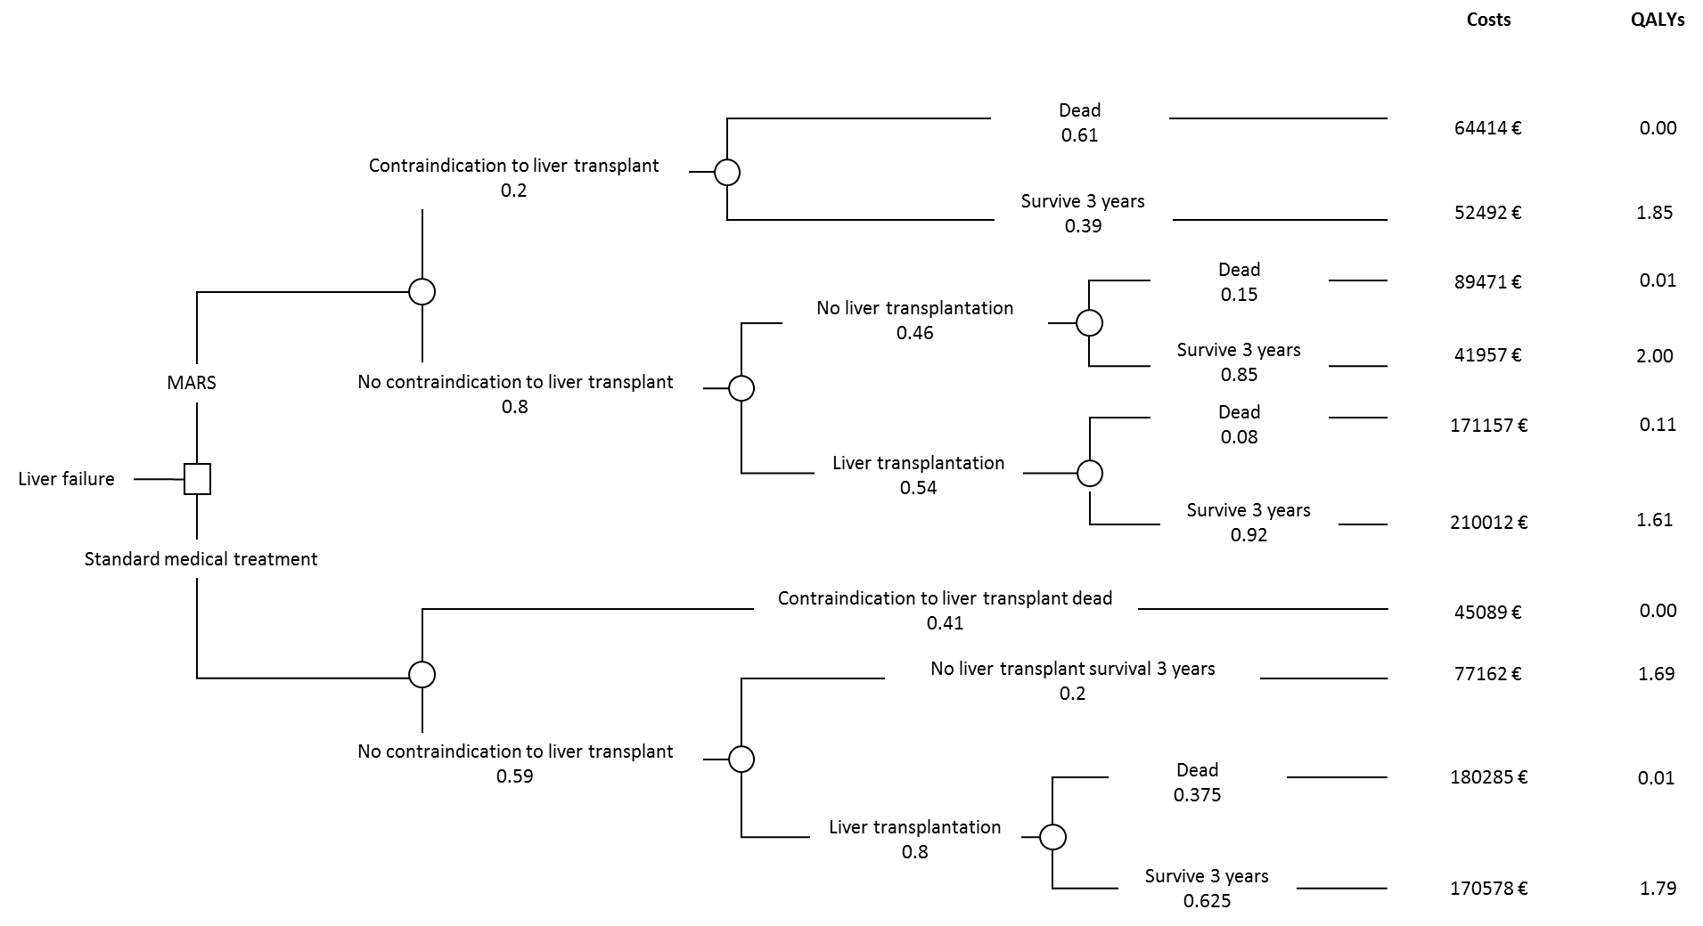

Figure 1.

Decision tree for determine the short-term cost-utility of treatment in acute liver failure. Choice between strategies (decision node), occurrence of chance events (chance node). Kantola et al. ^{[21]}
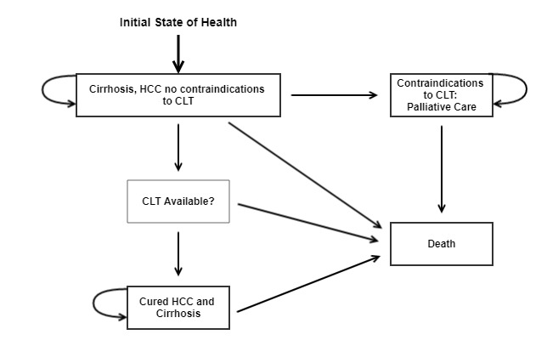
Figure 2. States of health in the decision model. Each square represents a state of health. Straight arrows represent the changes that may occur during each month. Curved arrows mean that the patient may remain in the same state of health. Sarasin et al. ^{[23]}
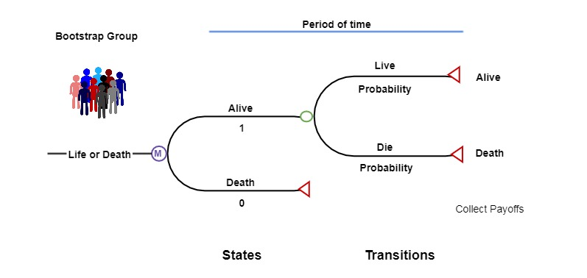
Figure 3. Simple example of a Markov microsimulation model. Perkins et al. ^{[25]}

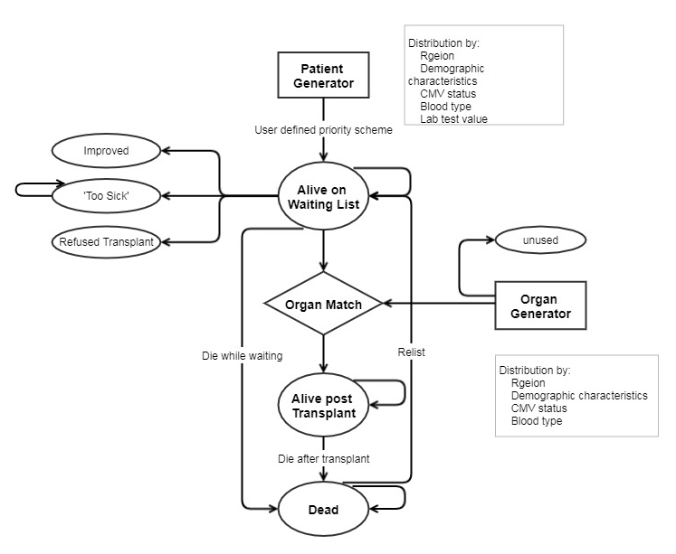
Figure 4. Model structure for patients entering the liver transplantation program. Shechter et al. ^{[26]}

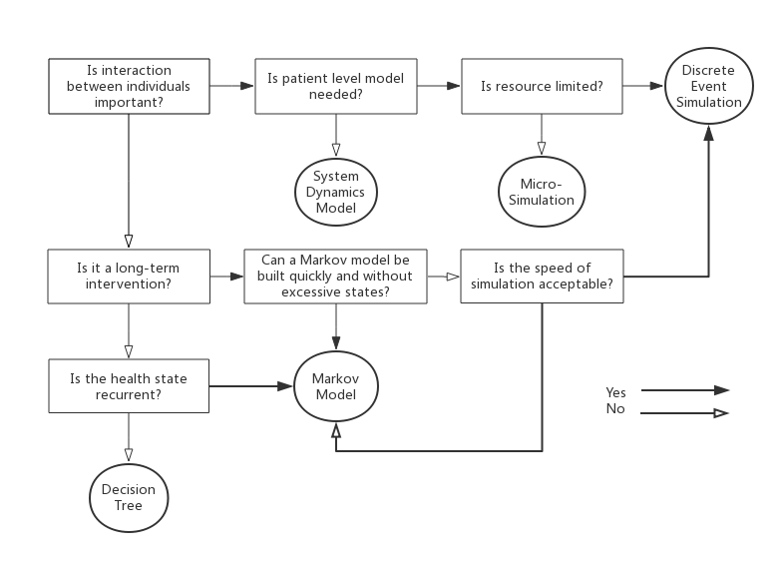
Figure 5. Scheme of selecting appropriate model type

Table 1. Summary of types of decision models in liver transplantation
Model type | Model description | Type of scenario most suited for
Decision tree | Clinical outcomes are modelled as a series of decision nodes and follow pathways with probabilities for each respective branch. | Disease without relapse or recurrence.
Markov model | Represents sequences of events which lead to different health states with different probabilities of transitioning from one state to another over defined period of time. | Chronic conditions involving recurrent events over time.
Microsimulation | Simulate one individual patient proceeds through the model with the chance of multiple parallel events. | Individual level information is important.
Discrete event simulation | Represents the competition for resources and investigate the changes in stochastic systems. | Interactions of resource allocation between individuals are of importance.
System dynamic model | Modeling interactions within a population and with their environment over time. | Spread of infectious diseases.

REFERENCES
1. Zarrinpar A, Busuttil RW. Liver transplantation: past, present and future. Nature Reviews Gastroenterology and Hepatology 2013; 10(7):434. [PMID: 23752825 DOI: 10.1038/nrgastro.2013.88]
2. Kim JS, Broering DC, Tustas RY, Fischer L, Ganschow R, Burdelski M, Rogiers X. Split liver transplantation: past, present and future. Pediatric transplantation 2004; 8(6):644–8. [PMID: 15598341 DOI: 10.1111/j.1399-3046.2004.00264.x]
3. Kim WR, Lake, JR, Smith JM, Skeans MA, Schladt DP, Edwards EB, Am Harper, Wainright JL, Snyder JJ, Israni AK. OPTN/SRTR 2013 annual data report: liver. American Journal of Transplantation 2015; 15(S2):1–28. [PMID: 25626341 DOI: 10.1111/ajt.13197]
4. Branger P, Samuel U. Annual Report 2016, Eurotransplant International Foundation. Annual report. Eurotransplant International Foundation 2017.
5. Schrem H, Kaltenborn A. Germany: Avoid more organ transplant scandals. Nature 2013; 498(7452):37. [PMID: 23739417 DOI: 10.1038/498037b]
6. Manns MP. Liver cirrhosis, transplantation and organ shortage. Deutsches Ärzteblatt International 2013; 110(6):83. [PMID: 23450999 DOI: 10.3238/arztebl.2013.0083]
7. Schrem H, Kleine M, Lankisch TO, Kaltenborn A, Kousoulas L, Zachau L, Lehner F, Klempnauer J. Long-term results after adult ex situ split liver transplantation since its introduction in 1987. World journal of surgery 2014; 38(7):1795–806. [PMID: 24414197 DOI: 10.1007/s00268-013-2444-4]
8. Chen C-L, Kabiling CS, Concejero AM. Why does living donor liver transplantation flourish in Asia? Nature Reviews Gastroenterology and Hepatology 2013; 10(12):746. [PMID: 24100300 DOI: 10.1038/nrgastro.2013.194]
9. Ng KK, Lo CM. Liver transplantation in Asia: past, present and future. Ann Acad Med Singapore 2009; 38(4):322–31. [PMID: 19434335]
10. Yersiz H, Renz JF, Busuttil RW. Split-liver transplantation: Past, present, and future. Transplantation reviews 2004; 18(4):164–70.[ PMID: 15598341 DOI: 10.1111/j.1399-3046.2004.00264.x]
11. Cholongitas E, Germani G, Burroughs AK. Prioritization for liver transplantation. Nature Reviews Gastroenterology and Hepatology 2010; 7(12):659. [PMID: 21045793 DOI: 10.1038/nrgastro.2010.169]
12. Kaltenborn A, Salinas R, Jaeger MD, Lehner F, Sakirow L, Klempnauer J, Schrem H. Model of End-Stage Liver Disease Score and Derived Variants Lack Prognostic Ability after Liver Transplantation. Annals of transplantation 2015; 20:441–8. [PMID: 26242315 DOI: 10.12659/AOT.893967]
13. Machnicki G, Seriai L, Schnitzler MA. Economics of transplantation: a review of the literature. Transplantation reviews 2006; 20(2):61–75. [ DOI: 10.1016/j.trre.2006.05.001]
14. Jarl J, Gerdtham U-G. Economic evaluations of organ transplantations-a systematic literature review. Nordic Journal of Health Economics 2011; 1(1). [DOI: 10.5617/njhe.168]
15. Barton P, Bryan S, Robinson S. Modelling in the economic evaluation of health care: selecting the appropriate approach. Journal of health services research & policy 2004; 9(2):110–8. [PMID: 15099459 DOI: 10.1258/135581904322987535]
16. Siebert U. When should decision-analytic modeling be used in the economic evaluation of health care?: Springer; 2003 DOI: 10.1007/s10198-003-0205-2.
17. Briggs A, Sculpher M, Claxton K. Decision modelling for health economic evaluation: OUP Oxford; 2006.
18. Drummond MF, Sculpher MJ, Claxton K, Stoddart GL, Torrance GW. Methods for the economic evaluation of health care programmes: Oxford university press; 2015.
19. Kuntz K, Sainfort F, Butler M, Taylor B, Kulasingam S, Gregory S, Mann E, Anderson JM, Kane RL. Decision and Simulation Modeling Alongside Systematic Reviews 2013. [PMID: 23534078]
20. Petrou S, Gray A. Economic evaluation using decision analytical modelling: design, conduct, analysis, and reporting. Bmj 2011; 342:d1766. [PMID: 21482590 DOI: 10.1136/bmj.d1766]
21. Kantola T, Mäklin S, Koivusalo A-M, Räsänen P, Rissanen A, Roine R, Sintonen H, Höckerstedt K, Isoniemi H. Cost-utility of molecular adsorbent recirculating system treatment in acute liver failure. World Journal of Gastroenterology: WJG 2010; 16(18):2227. [PMID: 20458759 DOI:10.3748/wjg.v16.i18.2227]
22. Sonnenberg FA, Beck JR. Markov models in medical decision making: a practical guide. Medical Decision Making 1993; 13(4):322–38. [PMID: 8246705 DOI: 10.1177/0272989X9301300409]
23. Sarasin FP, Majno PE, Llovet JM, Bruix J, Mentha G, Hadengue A. Living donor liver transplantation for early hepatocellular carcinoma: A life‐expectancy and cost‐effectiveness perspective. Hepatology 2001; 33(5):1073–9. [PMID: 11343234 DOI: 10.1053/jhep.2001.23311]
24. Briggs A, Sculpher M. An introduction to Markov modelling for economic evaluation. Pharmacoeconomics 1998; 13(4):397–409. [PMID: 10178664 DOI: 10.2165/00019053-199813040-00003]
25. Perkins JD, Halldorson JB, Bakthavatsalam R, Fix OK, Carithers RL, Reyes JD. Should liver transplantation in patients with model for end‐stage liver disease scores≤ 14 be avoided? A decision analysis approach. Liver transplantation 2009; 15(2):242–54. [PMID: 19177441 DOI: 10.1002/lt.21703]
26. Shechter SM, Bryce CL, Alagoz O, Kreke JE, Stahl JE, Schaefer AJ, Angus DC, Roberts MS. A clinically based discrete-event simulation of end-stage liver disease and the organ allocation process. Medical Decision Making 2005; 25(2):199–209. [PMID: 15800304 DOI: 10.1177/0272989X04268956]
27. Brennan A, Chick SE, Davies R. A taxonomy of model structures for economic evaluation of health technologies. Health economics 2006; 15(12):1295–310. [PMID: 16941543 DOI: 10.1002/hec.1148]
28. Koizumi N, Ganesan R, Gentili M, Chen C-H, Waters N, DasGupta D, Nicholas D, Patel A, Srinivasan D, Melancon K. Redesigning organ allocation boundaries for liver transplantation in the United States: Springer; 2014. [PMID: 26029745 DOI: 10.1007/978-3-319-01848-5_2]
29. Iyer AK, Schaefer AJ, Bryce CL, Zenarosa GL, Chang C-CH, Roberts MS, editors. A biologically based discrete-event simulation model of liver transplantation in the United States for pediatric and adult patients: Winter Simulation Conference; 2011. [DOI: 10.1109/wsc.2011.6147848]
30. Toro-Díaz H, Mayorga ME, Barritt AS, Orman ES, Wheeler SB. Predicting liver transplant capacity using discrete event simulation. Medical Decision Making 2015; 35(6):784–96. [PMID: 25391681 DOI: 10.1177/0272989X14559055]
31. Orman ES, Mayorga ME, Wheeler SB, Townsley RM, Toro‐Diaz HH, Hayashi PH, Sidney Barritt A. Declining liver graft quality threatens the future of liver transplantation in the United States. Liver transplantation 2015; 21(8):1040–50. [PMID: 25939487 DOI: 10.1002/lt.24160]
32. Cooper K, Brailsford SC, Davies R. Choice of modelling technique for evaluating health care interventions. Journal of the operational research society 2007; 58(2):168–76. [DOI: 10.1057/palgrave.jors.2602230]
33. Comas M, Castells X, Hoffmeister L, Román R, Cots F, Mar J, Gutiérrez‐Moreno S, Espallargues M. Discrete‐Event Simulation Applied to Analysis of Waiting Lists. Evaluation of a Prioritization System for Cataract Surgery. Value in Health 2008; 11(7):1203–13. [PMID: 18494754 DOI: 10.1111/j.1524-4733.2008.00322.x]
34. Caro JJ, Möller J. Advantages and disadvantages of discrete-event simulation for health economic analyses: Taylor & Francis; 2016. [PMID: 26967022 DOI: 10.1586/14737167.2016.1165608]
35. Karnon J. Alternative decision modelling techniques for the evaluation of health care technologies: Markov processes versus discrete event simulation. Health economics 2003; 12(10):837–48. [PMID: 14508868 DOI: 10.1002/hec.770]
36. Homer JB, Hirsch GB. System dynamics modeling for public health: background and opportunities. American journal of public health 2006; 96(3):452–8. [PMID: 16449591 DOI: 10.2105/AJPH.2005.062059]
37. Paricio I, Figal J. A System Dynamics Model of the Kidney Transplants in the U.S.; 2015.
38. Devi SP, Rao KS, Krishnaswamy S, Wang S. System dynamics model for simulation of the dynamics of corneal transplants. Opsearch 2010; 47(4):284–92. [DOI: 10.1007/s12597-010-0023-0]
39. Sackett DL, Rosenberg WMC, Gray JM, Haynes RB, Richardson WS. Evidence based medicine: what it is and what it isn't: British Medical Journal Publishing Group; 1996. [PMID: 8555924 DOI: 10.1136/bmj.312.7023.71]
40. Weinstein MC, O'brien B, Hornberger J, Jackson J, Johannesson M, McCabe C, Luce BR. Principles of good practice for decision analytic modeling in health‐care evaluation: report of the ISPOR Task Force on Good Research Practices—Modeling Studies. Value in Health 2003; 6(1):9–17. [PMID: 12535234 DOI: 10.1046/j.1524-4733.2003.00234.x]
41. Cillo U, Burra P, Mazzaferro V, Belli L, Pinna AD, Spada M, Nanni Costa A, Toniutto P, I‐BELT. A multistep, consensus‐based approach to organ allocation in liver transplantation: toward a “blended principle model”. American Journal of Transplantation 2015; 15(10):2552–61. [PMID: 26274338 DOI: 10.1111/ajt.13408]
42. Sapisochin G, Bruix J. Liver transplantation for hepatocellular carcinoma: outcomes and novel surgical approaches. Nature Reviews Gastroenterology and Hepatology 2017; 14(4):203. [PMID: 28053342 DOI: 10.1038/nrgastro.2016.193]
43. Jansen JP, Trikalinos T, Cappelleri JC, Daw J, Andes S, Eldessouki R, Salanti G. Indirect treatment comparison/network meta-analysis study questionnaire to assess relevance and credibility to inform health care decision making: an ISPOR-AMCP-NPC Good Practice Task Force report. Value in Health 2014; 17(2):157–73. [PMID: 24636374 DOI: 10.1016/j.jval.2014.01.004]
44. Greco T, Biondi-Zoccai G, Saleh O, Pasin L, Cabrini L, Zangrillo A, Landoni G. The attractiveness of network meta-analysis: a comprehensive systematic and narrative review. Heart, lung and vessels 2015; 7(2):133. [PMID: 26157739]
45. Cucchetti A, Cescon M, Trevisani F, Morelli MC, Ercolani G, Pellegrini S, Erroi V, Bigonzi E, Pinna AD. What is the probability of being too old for salvage transplantation after hepatocellular carcinoma resection? Digestive and Liver Disease 2012; 44(6):523–9. [PMID: 22387286 DOI: 10.1016/j.dld.2012.01.018]
46. Fuks D, Dokmak S, Paradis V, Diouf M, Durand F, Belghiti J. Benefit of initial resection of hepatocellular carcinoma followed by transplantation in case of recurrence: An intention‐to‐treat analysis. Hepatology 2012; 55(1):132–40. [PMID: 21932387 DOI: 10.1002/hep.24680]
47. Briggs AH. Handling uncertainty in cost-effectiveness models. Pharmacoeconomics 2000; 17(5):479–500. [PMID: 10977389 DOI: 10.2165/00019053-200017050-00006]
48. Briggs AH, Weinstein MC, Fenwick EAL, Karnon J, Sculpher MJ, Paltiel AD. Model parameter estimation and uncertainty: a report of the ISPOR-SMDM Modeling Good Research Practices Task Force-6. Value in Health 2012; 15(6):835–42. [PMID: 22999133 DOI: 10.1016/j.jval.2012.04.014]
49. Jay CL, Lyuksemburg V, Ladner D, Wang E, Holl JL, Hazen G, Abecassis MM, Skaro AI. The comparative effectiveness of donation after cardiac death versus donation after brain death liver transplantation: recognizing who can benefit. Hepatology 2011; 54(4):385A. [PMID: 22645057 DOI: 10.1002/lt.23418]
50. Saramago P, Manca A, Sutton AJ. Deriving input parameters for cost-effectiveness modeling: taxonomy of data types and approaches to their statistical synthesis. Value in Health 2012; 15(5):639–49. [PMID: 22867772 DOI: 10.1016/j.jval.2012.02.009]
51. Sun X, Faunce T. Decision-analytical modelling in health-care economic evaluations. The European Journal of Health Economics 2008; 9(4):313–23. [PMID: 17943332 DOI: 10.1007/s10198-007-0078-x]
52. Sculpher MJ, Claxton K, Drummond M, McCabe C. Whither trial‐based economic evaluation for health care decision making? Health economics 2006; 15(7):677–87. [PMID: 16491461 DOI: 10.1002/hec.1093]
53. Whitehead A. Meta-analysis of controlled clinical trials: John Wiley & Sons; 2002. (vol 7). [DOI:10.1002/0470854200]
54. Tanajewski L, Harris R, Harman DJ, Aithal GP, Card TR, Gkountouras G, Berdunov V, Guha IN, Elliott RA. Economic evaluation of a community-based diagnostic pathway to stratify adults for non-alcoholic fatty liver disease: a Markov model informed by a feasibility study. BMJ open 2017; 7(6):e015659. [PMID: 28679676 DOI: 10.1136/bmjopen-2016-015659]
55. Caro JJ, Briggs AH, Siebert U, Kuntz KM. Modeling good research practices—overview: a report of the ISPOR-SMDM Modeling Good Research Practices Task Force-1. Value in Health 2012; 15(6):796–803. [PMID: 22999128 DOI: 10.1016/j.jval.2012.06.012]
56. Roberts M, Russell LB, Paltiel AD, Chambers M, McEwan P, Krahn M. Conceptualizing a model: a report of the ISPOR-SMDM modeling good research practices task force-2. Value in Health 2012; 15(6):804–11. [PMID: 22990083 DOI: 10.1177/0272989X12454941]
57. Karnon J, Stahl J, Brennan A, Caro JJ, Mar J, Möller J. Modeling using discrete event simulation: a report of the ISPOR-SMDM Modeling Good Research Practices Task Force-4. Value in Health 2012; 15(6):821–7. [PMID: 22999131 DOI: 10.1016/j.jval.2012.04.013]
58. Siebert U, Alagoz O, Bayoumi AM, Jahn B, Owens DK, Cohen DJ, Kuntz KM. State-transition modeling: a report of the ISPOR-SMDM modeling good research practices task force-3. Value in Health 2012; 15(6):812–20. [PMID: 22999130 DOI: 10.1016/j.jval.2012.06.014]
59. Pitman R, Fisman D, Zaric GS, Postma M, Kretzschmar M, Edmunds J, Brisson M. Dynamic transmission modeling: a report of the ISPOR-SMDM modeling good research practices task force-5. Value in Health 2012; 15(6):828–34. [PMID: 22999132 DOI: 10.1016/j.jval.2012.06.011]
60. Eddy DM, Hollingworth W, Caro JJ, Tsevat J, McDonald KM, Wong JB. Model transparency and validation: a report of the ISPOR-SMDM Modeling Good Research Practices Task Force-7. Value in Health 2012; 15(6):843–50. [PMID: 22999134 DOI: 10.1016/j.jval.2012.04.012]
61. Rautenberg T, Hulme C, Edlin R. Methods to construct a step-by-step beginner’s guide to decision analytic cost-effectiveness modeling. ClinicoEconomics and outcomes research: CEOR 2016; 8:573. [PMID: 27785080 DOI: 10.2147/CEOR.S113569]

