Name of Journal: World Journal of Cardiology
Manuscript NO: 57393
Manuscript Type: CASE REPORT

Diffuse coronary artery vasospasm in a patient with subarachnoid hemorrhage: A case report

Grewal D et al. Diffuse CAV in a patient with SAH

Dennis Grewal, Adeba Mohammad, Pooja Swamy, Islam Abudayyeh, Mamas A Mamas, Purvi Parwani

Dennis Grewal, Adeba Mohammad, Pooja Swamy, Islam Abudayyeh, Purvi Parwani, Division of Cardiology, Department of Cardiology, Loma Linda University Medical Center, Loma Linda, CA 92354, United States

Mamas A Mamas, Keele Cardiovascular Research Group, Centre for Prognosis Research, Institutes of Applied Clinical Science and Primary Care and Health Sciences, Keele University, Stoke on Trent, Manchester M139PT, United Kingdom

Author contributions: Grewal D provided references for and wrote the majority of the introduction, discussion and conclusion sections and provided the figures; Mohammad A wrote the majority of the case presentation, acquired necessary documentation for submission and completed final formatting of submission documents; Swamy P performed the initial evaluation of the patient and assisted with the coronary catheterization; Abudayyeh I performed the coronary angiogram and provided the coronary catheterization films and still images; Swamy P, Abudayyeh I and Mamas MA contributed towards revising the manuscript critically for important intellectual content; Parwani P handled supervision, made substantial contribution to the conception of the paper, drafted the first manuscript, provided critical edits to the final manuscript in addition to providing the CMRI imaging, and is the senior and corresponding author of the manuscript.

Corresponding author: Purvi Parwani, FACC, MBBS, Assistant Professor, Division of Cardiology, Department of Cardiology, Loma Linda University Medical Center, 11234 Anderson St, Loma Linda, CA 92354, United States. pparwani@llu.edu

Received: June 6, 2020
Revised: July 3, 2020
Accepted: September 15, 2020
Published online:

Abstract
BACKGROUND
Coronary artery vasospasm (CAV) is a reversible, transient form of vasoconstriction with clinical manifestations ranging from stable angina to acute coronary syndromes (ACS). Vasospasm of epicardial coronary arteries or associated micro-vasculature can lead to total or subtotal occlusion and has been demonstrated in nearly 50% of patients undergoing angiography for suspected ACS. The mechanism for CAV has been described in literature, but in a subgroup of patients presenting with intracranial hemorrhage, it appears to be multifactorial. These patients tend to have electrocardiographic changes, elevation of cardiac biomarkers of injury and neurogenic stress cardiomyopathy.

CASE SUMMARY
A 44-year-old woman presented with severe headaches and tonic-clonic seizures. She was found to have diffuse subarachnoid hemorrhage (SAH) requiring ventricular drain placement, coil embolization and induced hypertension. She subsequently developed chest pain with ST elevations in anterior precordial leads, elevated cardiac enzymes and apical ballooning with left ventricular ejection fraction of 35% on transthoracic echocardiogram. Coronary angiogram revealed severe diffuse triple vessel stenoses secondary to CAV seen distally. Subsequent cardiac MRI notable for apical non-viability and scar formation.

CONCLUSION
This case highlights a unique etiology of acute myocardial infarction in a patient with SAH leading to ST elevations, diffuse triple vessel CAV and apical scar.

Key words: ST-elevation myocardial infarction; Acute coronary syndrome; Stress induced cardiomyopathy; Coronary artery vasospasm; Cerebral vasospasm; Subarachnoid hemorrhage; Case report

Grewal D, Mohammad A, Swamy P, Abudayyeh I, Mamas MA, Parwani P. Diffuse coronary artery vasospasm in a patient with subarachnoid hemorrhage: A case report. World J Cardiol 2020; In press

Core tip: Acute coronary syndromes often occur in patients with multiple co-morbidities and treatment plans need to be tailored to each unique presentation. We present a case of ST-elevation myocardial infarction in a patient with aneurysmal subarachnoid hemorrhage complicated by cerebral and coronary vasospasms, leading to apical infarct.

INTRODUCTION
Coronary artery vasospasm (CAV) is a reversible, transient form of vasoconstriction with clinical manifestations ranging from stable angina to acute coronary syndromes (ACS). Vasospasm of epicardial coronary arteries or associated micro-vasculature can lead to total or subtotal occlusion and has been demonstrated in nearly 50% of patients undergoing angiography for suspected ACS. The mechanism for CAV has been described in literature, but in a subgroup of patients presenting with intracranial hemorrhage, it appears to be multifactorial^{[1]}. These patients tend to have electrocardiographic changes, elevation of cardiac biomarkers of injury and neurogenic stress cardiomyopathy^{[2]}.
CAV was initially described by Prinzmetal et al^{[3]} in 1959 as a form of variant angina different from the heterogeneous group of classical anginal syndromes. A complex interplay of mechanisms including increased sympathetic drive to microvascular dysfunction have been described in the literature^{[4]}. Here, we present a case of a patient with an aneurysmal subarachnoid hemorrhage (SAH) complicated by cerebral vasospasm and concomitant severe CAV leading to an acute myocardial infarction presenting as ST-elevation myocardial infarction (STEMI) on electrocardiography (EKG). While severe CAV is the underlying pathophysiology for stress induced cardiomyopathy, acute myocardial infarction (AMI) and apical scarring are rare in those cases. There are only a few published case reports in the literature with such findings^{[5-7]}. Treatment options are challenging in such cases due to diffuse CAV and intracerebral hemorrhage.

CASE PRESENTATION
Chief complaints
Left sided chest pain.

History of present illness
A 44-year-old woman presented to the emergency department with thunderclap headache. She was found to have a ruptured cerebral aneurysm and SAH requiring neurosurgical intervention. This was followed by severe cerebral vasospasm and neurologic deficits treated with induced hypertension using high doses of vasopressors. Subsequently she was noted to develop chest pain associated with elevated cardiac biomarkers, ST elevation in precordial electrocardiogram (ECG) leads and new apical hypokinesis evident on echocardiogram. This was promptly evaluated with a coronary angiogram that demonstrated tapering distal small caliber coronary vessels supplying the territory noted to have wall motion abnormality.

History of past illness
Hypertension that is controlled on atenolol and hydrochlorothiazide outpatient.

Physical examination
The patient’s heart rate was 97 bpm, respiratory rate was 19 breaths per minute, blood pressure was 121/71 mmHg and oxygen saturation on room air was 100%. Cardiac examination revealed a regular rate and rhythm, and no jugular venous distention. Lung exam revealed clear breath sounds without crackles or wheezing.

Laboratory examinations
Cardiac enzymes with the onset of chest pain showed initial Troponin T at 0.60 ng/mL and peaked at 1.72 ng/mL with normal complete blood count and basic metabolic panel.
ECG during initial onset of chest pain showed sinus rhythm with ST elevations in V3-V5 (Figure 1A). Repeat ECG in the setting of ongoing symptoms showed normal sinus rhythm with ST elevations in V1-V3 with deep T-wave inversions in the anterior-septal leads (Figure 1B).

Imaging examinations
Initial echocardiogram during admission was unremarkable with LVEF 60% and normal wall motion. Repeat echocardiogram during STEMI showed a decrease in LVEF to 35%-40% with apical ballooning (Figure 2).
Coronary angiography showed patent left main artery, but 100% occlusion of the mid to distal left anterior descending artery and distal left circumflex (Figure 3A). There was 100% occlusion of the distal posterior descending artery and posterolateral artery (Figure 3B). We were unable to give nitrates during left heart catheterization to see if the vasospasm would improve as patient was hypotensive and we were instructed to keep permissive hypertension by our neurology colleagues. Three weeks after the initial angiogram, Cardiac MRI revealed intense delayed enhancement in subendocardial fashion involving the apical septum and apical segment suggestive of scarred myocardium due to myocardial infarction with LVEF of 58% (Figure 4). We believe this to have been an acute MI as baseline EKG did not show q-waves nor was there a personal history of MI or symptoms indicative of coronary artery disease (CAD) in the past.

Personal and family history
She has a past surgical history of cholecystectomy. She denies alcohol, tobacco, or recreational drug use. Family history is positive for hypertension in her parents.

FINAL DIAGNOSIS
ST elevation myocardial infarction secondary to severe coronary artery vasospasm causing reduced left ventricular function and apical ballooning.

TREATMENT
After the coronary angiogram, dual antiplatelet therapy and nitrates were added to her regimen to help reduce CAV. Her discharge medications included aspirin 81 mg daily, carvedilol 3.25 mg BID, atorvastatin 40 mg qhs, clopidogrel 75 mg daily, isosorbide mononitrate 30 mg daily and nitroglycerin sublingual as needed.

OUTCOME AND FOLLOW-UP
Patient follows up regularly with our cardiology clinic. She’s doing well with good exercise tolerance and remains angina free. Her systolic function remains persistently borderline with 50% EF and apical wall motion suggestive of apical infarct three months after her hospital discharge.

DISCUSSION
We present a rare case of severe CAV leading to apical infarct and low normal EF in setting of SAH and induced hypertension employed for its treatment. To our knowledge, this is the first case describing the coronary findings in a patient with SAH and apical infarct on CMR.
The typical pathogenesis for myocardial ischemia involves coronary artery atherosclerosis and/or plaque rupture^{[8]}; Our patient had minimal risk factors for CAD and suffered an acute myocardial infarction due to severe CAV which is known to be triggered by high sympathetic drive in patients with SAH. It is believed that excessive sympathetic drive in such cases lead to mismatch in myocardial oxygen demand and supply leading to neurogenic stunned myocardium (NSM)^{[9,10]}.
Neurogenic myocardial stunning has been described frequently in medical literature and is described as a state of reversible left ventricular dysfunction that occurs in up to 30% of patients with SAH. Echocardiographic manifestations of Takotsubo cardiomyopathy can be found in 1% to 6% of SAH patients with CAV being one of the underlying mechanisms^{[10,11]}. Overall involvement of myocardium and the incidence and description of SAH complicated by cerebral and coronary vasospasm is seldom described in literature^{[12]}. Animal studies have shown when blood is injected into the subarachnoid space, it is associated with increased amounts of coronary vasospasm in the subjects due to vagal pathway paralysis induced by sympathetic overactivity^{[13]}. This sympathetic overactivity can also occur as a result of rising intracranial pressures from SAH due to increased secretion of cerebrospinal fluid triggered by hemorrhage^{[14,15]}. Elevated catecholamine levels can be linked to cerebral vasospasms and have been associated with left ventricular dysfunction^{[11]}. Therapy for cerebral vasospasm includes hypervolemia and induced hypertension, which may further result in potential cardiopulmonary complications like myocardial ischemia and pulmonary edema^{[16]}. Proposed interventions like mechanical circulatory-assist devices with intra-aortic balloon pump have been shown to be successful for isolated patients with severe myocardial dysfunction complicated by cerebral vasospasms, but has not been studied thoroughly in this patient population^{[17]}.
Incidence of CAV in the setting of ACS has been studied with varying percentages of frequency based off populations studied. In a Taiwanese population, patients suspected to have coronary ischemia underwent coronary angiograms with findings of non-obstructive CAD, but ergonovine provocation testing was positive in 41% of patients^{[18]}. In a French study, Caucasian patients being worked up for acute MI showed CAV positive in only 15.5% of patients^{[19]}. Diagnosis and treatment of CAV has been well described in literature, but data in SAH remains scarce. Some research has been attempted in this area, in which prophylactic beta-blockers were hypothesized to reduce catecholaminergic surges in order to reduce the incidence and complications that arise from NSM, but a meta-analysis by Luo et al^{[20]} showed no statistical benefit to this therapy. Clinical evidence is widespread for CAV and treatment modalities using nitrates and calcium-channel blockers; however, in the subset of patients complicated by SAH, there is limited data regarding acute cardioprotective strategies^{[3]}.
Our patient was empirically treated with heparin infusion, aspirin therapy and calcium channel blocker (nimodipine) and was not taken to the catheterization lab immediately due to suspicion for coronary vasospasm due to SAH and high doses of vasopressor use. However, in order to attain a definitive cardiac diagnosis, the angiogram was done showing diffuse epicardial CAV resulting in her cardiomyopathy and evidence of myocardial infarction seen on CMR. Her delayed enhancement seen on CMR with wall motion abnormalities was intense and in subendocardial fashion which is indicative of an MI than stress induced cardiomyopathy like Takotsubo, which generally leads to little midmyocardial or patchy in distribution. Due to permissive hypertension requirement from neurology colleagues, her initial management of MI was tricky. Once her symptoms resolved, she was initiated on guidelines directed medical therapy of cardio selective beta-blocker and antiplatelets. Scarcity of medical literature relevant to this specific clinical scenario calls for individualized management approach. As we identify large percentage of patients with SAH and electrocardiographic abnormalities, elevated cardiac biomarkers and wall motion abnormalities, more data on how to carefully proceed with risk stratification, diagnosing and treating acute coronary syndromes in this population is needed^{[4]}.

CONCLUSION
Severe diffuse coronary artery vasospasm can lead to myocardial dysfunction and acute myocardial infarction in patients with SAH. Further research is needed to understand coronary vasospasm happening concomitant with cerebral vasospasm in order to attenuate consequences of severe CAV and develop cardioprotective strategies to minimize end-organ damage.

REFERENCES
1 Banki NM, Kopelnik A, Dae MW, Miss J, Tung P, Lawton MT, Drew BJ, Foster E, Smith W, Parmley WW, Zaroff JG. Acute neurocardiogenic injury after subarachnoid hemorrhage. Circulation 2005; 112: 3314-3319 [PMID: 16286583 DOI: 10.1161/CIRCULATIONAHA.105.558239]
2 Mayer SA, Lin J, Homma S, Solomon RA, Lennihan L, Sherman D, Fink ME, Beckford A, Klebanoff LM. Myocardial injury and left ventricular performance after subarachnoid hemorrhage. Stroke 1999; 30: 780-786 [PMID: 10187879 DOI: 10.1161/01.str.30.4.780]
3 Prinzmetal M, Kennamer R, Merliss R, Wada T, Bor N. Angina pectoris. I. A variant form of angina pectoris; preliminary report. Am J Med 1959; 27: 375-388 [PMID: 14434946 DOI: 10.1016/0002-9343(59)90003-8]
4 Lee VH, Oh JK, Mulvagh SL, Wijdicks EF. Mechanisms in neurogenic stress cardiomyopathy after aneurysmal subarachnoid hemorrhage. Neurocrit Care 2006; 5: 243-249 [PMID: 17290097 DOI: 10.1385/ncc:5:3:243]
5 Chen HY. Angiographic Coronary Spasm in a Case of Spontaneous Subarachnoid Hemorrhage Mimicking Acute Myocardial Infarction. Cardiol Res 2013; 4: 74-77 [PMID: 28352424 DOI: 10.4021/cr269w]
6 Yuki K, Kodama Y, Onda J, Emoto K, Morimoto T, Uozumi T. Coronary vasospasm following subarachnoid hemorrhage as a cause of stunned myocardium. Case report. J Neurosurg 1991; 75: 308-311 [PMID: 2072171 DOI: 10.3171/jns.1991.75.2.0308]
7 Toyama Y, Tanaka H, Nuruki K, Shirao T. Prinzmetal's variant angina associated with subarachnoid hemorrhage: A case report. Angiology 1979; 30: 211-218 [PMID: 434581 DOI: 10.1177/000331977903000311]
8 Shah PK. Pathophysiology of coronary thrombosis: role of plaque rupture and plaque erosion. Prog Cardiovasc Dis 2002; 44: 357-368 [PMID: 12024334 DOI: 10.1053/pcad.2002.123473]
9 Jain R, Deveikis J, Thompson BG. Management of patients with stunned myocardium associated with subarachnoid hemorrhage. AJNR Am J Neuroradiol 2004; 25: 126-129 [PMID: 14729541]
10 Talahma M, Alkhachroum AM, Alyahya M, Manjila S, Xiong W. Takotsubo cardiomyopathy in aneurysmal subarachnoid hemorrhage: Institutional experience and literature review. Clin Neurol Neurosurg 2016; 141: 65-70 [PMID: 26741878 DOI: 10.1016/j.clineuro.2015.12.005]
11 Kerro A, Woods T, Chang JJ. Neurogenic stunned myocardium in subarachnoid hemorrhage. J Crit Care 2017; 38: 27-34 [PMID: 27837689 DOI: 10.1016/j.jcrc.2016.10.010]
12 Nguyen H, Zaroff JG. Neurogenic stunned myocardium. Curr Neurol Neurosci Rep 2009; 9: 486-491 [PMID: 19818236 DOI: 10.1007/s11910-009-0071-0]
13 Yolas C, Kanat A, Aydin MD, Altas E, Kanat IF, Kazdal H, Duman A, Gundogdu B, Gursan N. Unraveling of the Effect of Nodose Ganglion Degeneration on the Coronary Artery Vasospasm After Subarachnoid Hemorrhage: An Experimental Study. World Neurosurg 2016; 86: 79-87 [PMID: 26365883 DOI: 10.1016/j.wneu.2015.09.004]
14 Kanat A, Turkmenoglu O, Aydin MD, Yolas C, Aydin N, Gursan N, Tumkaya L, Demir R. Toward changing of the pathophysiologic basis of acute hydrocephalus after subarachnoid hemorrhage: a preliminary experimental study. World Neurosurg 2013; 80: 390-395 [PMID: 23247027 DOI: 10.1016/j.wneu.2012.12.020]
15 Shivalkar B, Van Loon J, Wieland W, Tjandra-Maga TB, Borgers M, Plets C, Flameng W. Variable effects of explosive or gradual increase of intracranial pressure on myocardial structure and function. Circulation 1993; 87: 230-239 [PMID: 8419012 DOI: 10.1161/01.cir.87.1.230]
16 Temes RE, Tessitore E, Schmidt JM, Naidech AM, Fernandez A, Ostapkovich ND, Frontera JA, Wartenberg KE, Di Tullio MR, Badjatia N, Connolly ES, Mayer SA, Parra A. Left ventricular dysfunction and cerebral infarction from vasospasm after subarachnoid hemorrhage. Neurocrit Care 2010; 13: 359-365 [PMID: 20945116 DOI: 10.1007/s12028-010-9447-x]
17 Apostolides PJ, Greene KA, Zabramski JM, Fitzgerald JW, Spetzler RF. Intra-aortic balloon pump counterpulsation in the management of concomitant cerebral vasospasm and cardiac failure after subarachnoid hemorrhage: technical case report. Neurosurgery 1996; 38: 1056-9; discussion 1059-60 [PMID: 8727836 DOI: 10.1097/00006123-199605000-00042]
18 Wang CH, Kuo LT, Hung MJ, Cherng WJ. Coronary vasospasm as a possible cause of elevated cardiac troponin I in patients with acute coronary syndrome and insignificant coronary artery disease. Am Heart J 2002; 144: 275-281 [PMID: 12177645 DOI: 10.1067/mhj.2002.123843]
19 Da Costa A, Isaaz K, Faure E, Mourot S, Cerisier A, Lamaud M. Clinical characteristics, aetiological factors and long-term prognosis of myocardial infarction with an absolutely normal coronary angiogram; a 3-year follow-up study of 91 patients. Eur Heart J 2001; 22: 1459-1465 [PMID: 11482919 DOI: 10.1053/euhj.2000.2553]
20 Luo H, Song WX, Jiang JW, Zhao JL, Rong WL, Li MH. Effects of preadmission beta-blockers on neurogenic stunned myocardium after aneurysmal subarachnoid hemorrhage: A meta- analysis. Clin Neurol Neurosurg 2017; 158: 77-81 [PMID: 28499220 DOI: 10.1016/j.clineuro.2017.04.022]

Footnotes
Informed consent statement: Informed written consent was obtained from the patient for publication of this report and any accompanying images.

Conflict-of-interest statement: The authors have no conflict of interest to disclose.

CARE Checklist (2016) statement: The authors have read the CARE Checklist (2016), and the manuscript was prepared and revised accordingly.

Open-Access: This article is an open-access article that was selected by an in-house editor and fully peer-reviewed by external reviewers. It is distributed in accordance with the Creative Commons Attribution NonCommercial (CC BY-NC 4.0) license, which permits others to distribute, remix, adapt, build upon this work non-commercially, and license their derivative works on different terms, provided the original work is properly cited and the use is non-commercial. See: http://creativecommons.org/Licenses/by-nc/4.0/

Manuscript source: Invited manuscript

Peer-review started: June 6, 2020
First decision: June 20, 2020
Article in press:

Specialty type: Cardiac and cardiovascular systems
Country/Territory of origin: United States
Peer-review report’s scientific quality classification
Grade A (Excellent): 0
Grade B (Very good): B
Grade C (Good): 0
Grade D (Fair): D
Grade E (Poor): 0

P-Reviewer: Haaf P, Sato A S-Editor: Gong ZM L-Editor: P-Editor:

Figure Legends
A
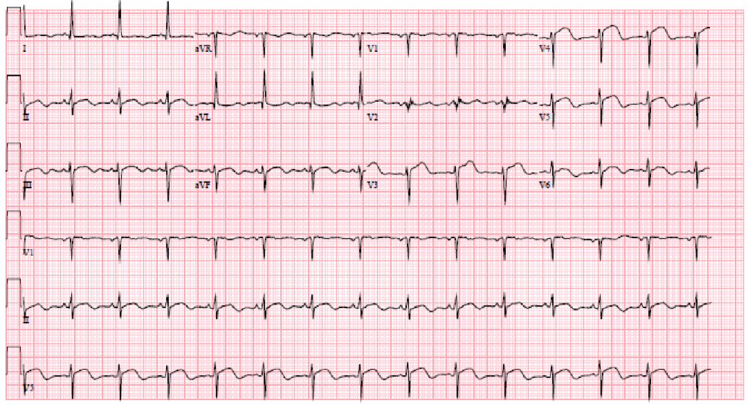
B
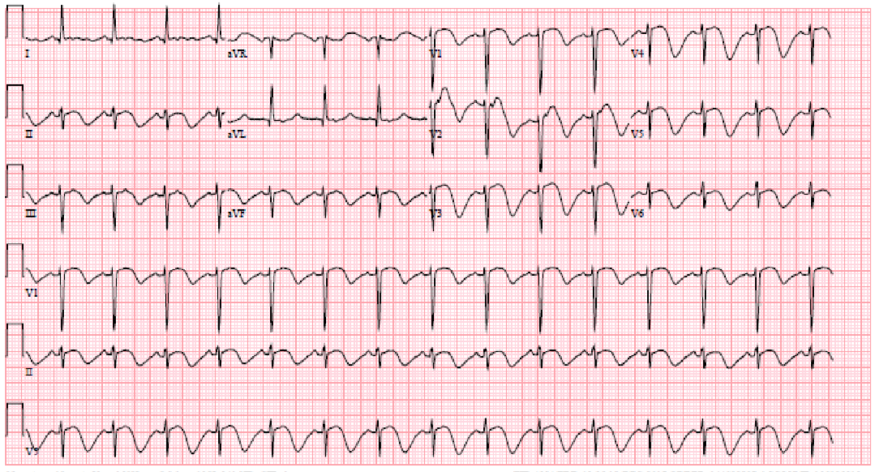
Figure 1 electrocardiogram. A: electrocardiogram (ECG) showing ST elevations in leads V3-V5, and evidence of left ventricular hypertrophy with repolarization abnormality and prolonged QTc. B: ECG showing normal sinus rhythm with ST elevations in V1-V3 with deep T-wave inversions in the anterior-septal leads.
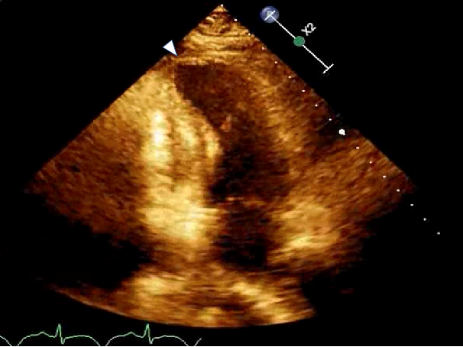
Figure 2 Echocardiogram on HD 16 showing apical ballooning.
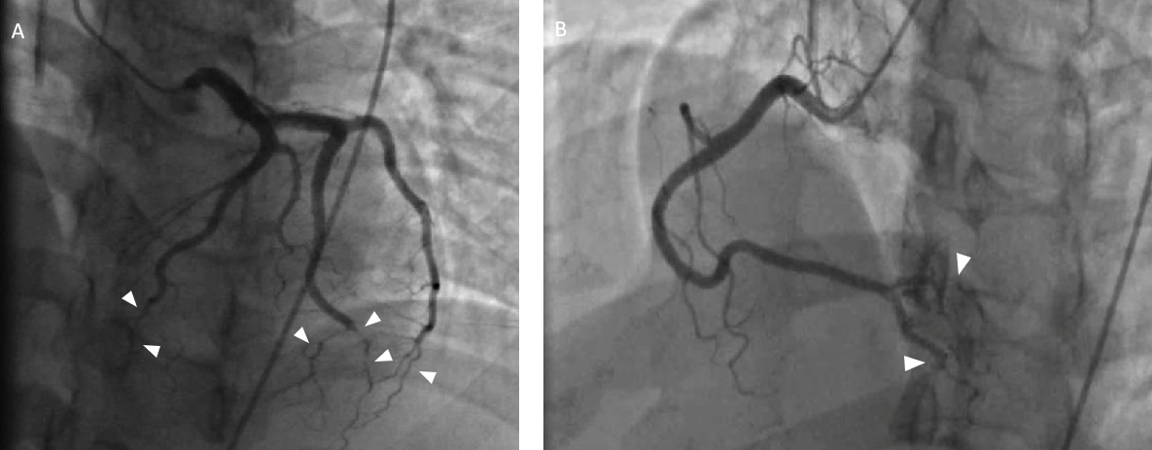
Figure 3 Coronary angiogram. A: Coronary angiogram shows severely atretic distal left anterior descending artery and obtuse marginal coronary arteries; B: The posterolateral and posterior descending artery branches of the right coronary artery are severely narrowed distally.
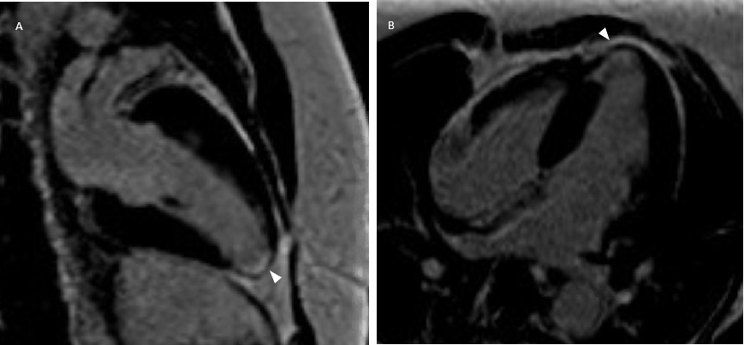
Figure 4 Cardiac magnetic resonance imaging shows delayed gadolinium enhancement suggestive of apical scarring and nonviability.

