Name of journal: World Journal of Ophthalmology
ESPS Manuscript NO: 9702
Columns: Original Article

Retrospective Study

Traumatic cataracts in children and its visual outcome

Shah MA et al. Traumatic cataracts in children and visual out come

Mehul A Shah, Shreya M Shah, Aarti H Chaudhry, Sandip Pannu

Mehul A Shah, Shreya M Shah, Aarti H Chaudhry, Sandip Pannu, Drashti Netralaya, Dahod 389151, Gujarat, India

Author contributions: All authors contributed to this work.

Ethics approval: Approval from ethical committee obtained.

Clinical trial registration: No.

Informed consent: Informed consent obtained from participants/guardians.

Conflict-of-interest: There is no conflict of interest.

Data sharing: No.

Open-Access: This article is an open-access article which was selected by an in-house editor and fully peer-reviewed by external reviewers. It is distributed in accordance with the Creative Commons Attribution Non Commercial (CC BY-NC 4.0) license, which permits others to distribute, remix, adapt, build upon this work non-commercially, and license their derivative works on different terms, provided the original work is properly cited and the use is non-commercial. See: http://creativecommons.org/licenses/by-nc/4.0/

Correspondence to: Drashti Netralaya, Medical Director, Drashti Netralaya, Chakalia Road, Dahod 389151, Gujarat, India. omtrust@rdiffmail.com

Telephone:+91-2673-645364
Fax:+91-2673-221232

Received: February 24, 2014
Peer-review started: March 2, 2014
First decision: April 4, 2014
Revised: February 15, 2015
Accepted: March 4, 2015
Article in press:
Published online:

Abstract
AIM: To review results of traumatic cataracts in children.

METHODS: Only those pediatric patients who fitted in the definite inclusion criteria were considered for study. They were further examined for any kind of co-morbidities because of trauma, operated upon for traumatic cataracts with intra ocular lens implantation. Amblyopia if present was treated. All were re-examined at the culmination of six week post operative period. According to Birmingham Eye Trauma Terminology System the traumatic cataract cases were divided into group 1(open globe) and group 2 (closed globe) and then determinants of visual acuity were compared.

RESULTS: There were 544 eyes (group 1) and 127 eyes (group 2) in our study of 671 eyes of pediatric traumatic cataracts. Visual acuity at the end of 6 wk after surgery, in the operated eye was > 6/60 in 450 (82.7%) and ≥ 6/12 215 (39.4%) eyes in open globe group and > 20/200 in 127 (81.8%) and ≥ 6/12 36 (28.4%) eyes in closed globe group (P = 0.143), and the difference between the groups was not significant in children. Overall, 402 (39.4%) eyes gained ≥ 6/60 and > 5/12 in 238 (35.4%) cases. Surgical treatment caused significant difference in visual outcome (P = 0.000). When we compared achieved visual outcome with ocular trauma score predicted vision.

CONCLUSION: Traumatic cataracts in children may have better outcome and ocular trauma score useful predictive method for the same.

Key words: Traumatic cataract; Betts; Ocular trauma score; Visual outcome

© The Author(s) 2015. Published by Baishideng Publishing Group Inc. All rights reserved.

Core tip: We have studied visual outcome in children in one of the largest published database in cases of traumatic cataracts in children. We have also studied validity of ocular trauma score in case of ocular injuries in pediatric age group.

Shah MA, Shah SM, Chaudhry AH, Pannu S. Traumatic cataracts in children and its visual outcome. World J Ophthalmol 2015; In press

INTRODUCTION
Very few studies have attended to the challenge of ocular injuries in rural regions, though trauma itself is one of the leading reasons behind monocular blindness in the developed countries^{[1,2]}. The probable causes of ocular injury vary in rural and urban regions and need to be looked into. Aiming available means in the right direction to strategize the prevention of such injuries requires knowledge regarding the etiology of injury^{[3,4]}. Pediatric ocular trauma essentially is prognostically bad and hence being a burden to the society. This can be taken care of to some extent with the help of aforementioned knowledge of etiology of injury.
Trauma to the eye is capable of giving rise to cataracts. There is no difference in the methods which are employed to assess the visual outcome.
The standardization of ocular injuries documentation was greatly facilitated following the introduction of Birmingham Eye Trauma Terminology System (BETTS)^{[5]} in regular practice. And hence the reviewing of visual outcomes will prove to be revealing. At our centre in this study visual outcomes in eyes operated for cataracts which suffered trauma were analyzed. Also post treatment predictors of visual outcomes were studied. Our hospital is situated in an area which is predominantly inhabited by tribal populace (around 4.2 million), where certified eye specialists cater to them a quality service at a very reasonable and low cost.

MATERIALS AND METHODS
We started this study following attaining authorization from hospital management and research board. Guardians’ (of the patients) written permission was also procured. In 2002 this research was proposed as a retrospective review. All children (≤ 18 years old) who developed Traumatic cataracts in any of the eyes detected and treated between 2003 and 2009 were registered in this research. Only those who were ready to join and those without any other severe physical collateral injury were taken in. All details related to their cases were obtained from our records and brought together employing a pre checked online form. A full history consisting of particulars of trauma, details of its management and type of surgery done to treat it was accumulated. Employing BETTS format (available online) first and subsequent visits reports were collected. In a similar way surgery details were gathered.
All patients of traumatic cataracts were split in two parts, namely, closed globe and open globe injuries. Open globe injuries were again sub grouped in to rupture and laceration injuries. This later type was again sub divided into trauma resulting in intraocular foreign body, perforating and penetrating traumas. Contusion and Lamellar laceration were the sub categories of closed ball injuries.
The usual demographic aspects were recorded, of course, but the main attention was given to the facts related to the time and type of injury, the objects responsible for injury and movement as well as activity at the time of trauma. Also verified were the treatment and details of earlier examinations.
By means of accepted protocol, thereafter, all the patients underwent examination, in which we tested visual acuity according to age as per guidelines laid down by American Academy of Ophthalmology (AAO). Slit lamp examination was carried out for anterior segment.
Depending on the extent of lenticular opacity, all the cataracts were categorized. as Viz. membranous cataract in those cases where organized lens matter and capsule formed a visually inseparable membrane, a rosette cataract where rosette pattern was noted and white soft cataract when anterior chamber displayed loose cortical matter along with ruptured capsule.
To assess posterior segment B-scan examination was carried out where media did not permit, otherwise indirect ophthalmoscopy with +20D lens was done^{[6]}.
The operative procedure was chosen depending on the state of lens and other ocular tissues. Cataracts with large, harder nuclei were necessarily dealt with by phacoemulsification technique. Softer ones were aspirated either co- axially or bimanually. Membranous cataracts were operated through pars-plana or anterior route with membranectomy and anterior vitrectomy.
Corneal injuries were prioritized and hence repaired first whereas cataract was managed later on. But recurrent inflammation was a rule rather than exception in patients who were operated upon previously for injury, which made the anterior Vitreous hazy and required anterior or pars plana vitrectomy and/or capsulectomy (in older patients).Where as in children under two years of age pars plana lensectomy along with anterior vitrectomy was a regulation procedure. Here primary intra ocular lens implantation was not considered.
As far as medical management is concerned, cycloplegics and steroids in topical form were given in all cases of which did not have infection. The severity of inflammation in anterior and posterior segments in the surgically treated eye decided the extent of medical treatment. All operated cases were reviewed on 1st, 3rd, 7th and 14th day. At the end of six weeks of surgery, refraction was ascertained. The routine follow up review was planned after 3 d, then every week for six weeks, every month for three months and quarterly for 1 year.
Visual acuity of all patients was checked according to AAO directives on all review visits. Slit lamp examination for anterior and indirect ophthalmoscopies for the posterior segment were essentially done on follow ups. VA more than 20/60 at the time of refraction examination was considered as having an acceptable grade of vision.
All through these follow up examinations data was fed online by means of a format developed by the International society of Ocular Trauma and sent to a Microsoft Excel Spreadsheet. Time and again thorough appraisal of the data was done on regular basis to make sure its completion. (SPSS 17) The statistical Package for The Social studies was utilized to evaluate the data. Bio statician certified data analyses report.

RESULTS
In this study we had 677 patients, all of whom had traumatic cataracts. 544 (81.07%) eyes had open globe type of injury where as 127 (18.9) were of closed globe injury type. 70.9% (496) were males, where as female were 29.2 %( 196). The average age was 10.53 ± 4.2 (0-17) (Table 1).
Analysis (by means of statistical tests and cross tabulation) of many factors related to demographic details vis. socio economic condition (79% belonged to lower stratum), locality (95% were from rural backdrop), patient entry (P = 0.000), etc., revealed that none of them had any significant bearing on VA after 6 wk (Tables 2-5).
Causative agent of injury and person’s physical movements as well as type of activity were also not noteworthy reasons as far as six weeks post operative visual acuity was concerned. Most frequent agent causing trauma was stick.
Evaluation of visual acuity before and after surgery revealed that management did essentially increase the visual acuity (Table 6).
Co axial or bi-manual aspiration of the ruptured cataract with cortical matter in anterior chamber (among open globe group in 48.6% cases) showed better visual acuity (Table 7).
In eyes which were greatly inflamed, we routinely did primary posterior capsulotomy with anterior vitrectomy. This also did not influence the six weeks post operative visual acuity to any extent.
The achieved visual acuity after six weeks of surgery was > 6/60 in 450 (82.7%) and ≥ 6/12 215 (39.4%) eyes in open globe group and > 20/200 in 127 (81.8%) and ≥ 6/1236 (28.4%) eyes in Closed globe group (P = 0.143), and the difference between the groups was not significant in children. Overall, 402 (39.4%) eyes gained ≥ 6/60 and > 5/12 in 238 (35.4%) cases. Surgical treatment caused significant difference in visual outcome (P = 0.000). When we compared achieved visual outcome compared with ocular trauma score predicted vision (Tables 8-10, Figure 1).

DISCUSSION
Our study compared patients with open- and closed-globe injuries who developed traumatic cataracts. Open globe injury cataracts had improved vision following surgical treatment (Tables 6 and 7).
Various authors have reported different results in children with traumatic cataracts: Shah et al^{[4]} reported 20/60 or better in 56% of their cases. Gradin Morgan^{[7,8]} 20/60 or better in 64.7%; Krishnamachary reported^{[9]} 6/24 or better in 74%; Kumar^{[10]} reported 6/18 or better in 50%; Staffieri 6/12 or better in 35%; Bekibele^{[12,13]}, 6/18 or better in 35.6%; Brar^{[14]} 0.2 or better in 62%; Cheema^{[15]} 6/18 in more than 68% of their cases; Karim^{[16]} 0.2 or better in 62%; Knight-Nanan^{[17]} 20/60 or better in 64%; Bienfait^{[18]} 0.7 in 27%; and Anwar^{[19]} reported 20/40 or better in 73% of their cases.
Using a polymethyl methacrylate (PMMA) lens, Verma^{[20]} reported a visual outcome similar to that found in our study. Eckstein^{[21]} and Zou^{[22]} reported that primary intraocular lens implantation is important for a better visual outcome, similar to our results. Also similar to our results, Vajpayee^{[23]} and Gupta^{[24]} reported primary insertion of an intraocular lens with posterior capsule rupture.
Shah^{[25]} reported that a better visual outcome was achieved when intervention was done between 5 and 30 d in adults with traumatic cataracts. As in our study, Rumelt^{[26]} found no significant difference between primary and secondary implantation. Staffieri^{[12]} performed primary implantation in 62% of cases vs 82% in our study. Kumar^{[11]} and Verma^{[20]} advocated primary posterior capsulotomy and vitrectomy for a better outcome; our results concurred.
We are not aware of any such study. Shah et al^{[26]} reported a comparison between open- and closed-globe injuries in general population. We are also not aware of another large series of successfully treated traumatic cataracts in children. In our study, final visual outcomes were achieved according to the OTS^{[27]} prediction in children with traumatic cataracts. Lesniakand Bauza^{[28]} reported no significant differences between the final visual acuities and the visual acuities predicted by OTS in children. Sharma^{[29]} proposed that the OTS calculated at the initial examination may be of prognostic value in children with penetrating eye injuries. However, Unver^{[30]} suggested that OTS calculations may have limited value as predictors of visual outcome in a pediatric population. Lima-Gomez Hans and Unver^{[31]} reported estimates for a 6-mo visual prognosis, but some of the variables required evaluation by an ophthalmologist. Using the OTS, 98.9% of the eyes in the general population could be graded in a trauma room. Knyazer^{[32]} reported the prognostic value of the OTS in zone-3 open globe injuries, and Man^{[33]} claimed equal prognostic effectiveness of both the OTS and CART in the general population. Although similar findings have been reported by other^{[32-34]}, our study presents one of the largest reported databases following cases of pediatric traumatic cataracts classified according to BETTS. Despite the long time delay between injury and treatment in many of the cases in our study, the OTS was still relevant.
In conclusions, satisfactory visual outcome can be achieved in children with traumatic cataracts, no significant difference found amongst open and closed globe injuries in pediatric age group.
This study shows the comparative evaluation of patients having closed globe injuries and open globe injuries in those cases who showed the development of traumatic cataract. Final visual result achieved in cases of traumatic cataracts in pediatric patients can fairly be foretold with the help of Ocular trauma score.

COMMENTS
Background
Ocular trauma in children in less explored area of visual outcome following cataract surgery in children was studied here.

Research frontiers
Surgical treatment has made significant difference in outcome. No significant difference found in open globe and closed globe groups. Ocular trauma score is a valid predictive model for visual outcome in children.

Innovations and breakthroughs
Study addresses probably largest published database for traumatic cataracts in children classified according to Birmingham Eye Trauma Terminology System, and compared visual outcome according to ocular trauma score.

Applications
Morphological consideration of traumatic cataracts and treatment guidelines according to the same may be useful.

Terminology
BETTS: Birmingham Eye Trauma Terminology System; OTS: Ocular trauma score.

Peer-review
This study has an important data that would be of interest.

REFERENCES
1 Khatry SK, Lewis AE, Schein OD, Thapa MD, Pradhan EK, Katz J. The epidemiology of ocular trauma in rural Nepal. Br J Ophthalmol 2004; 88: 456-460 [PMID: 15031153 DOI: 10.1136/bjo.2003.030700]
2 Abraham DI, Vitale SI, West SI, Isseme I. Epidemiology of eye injuries in rural Tanzania. Ophthalmic Epidemiol 1999; 6: 85-94 [PMID: 10420208 DOI: 10.1076/opep.6.2.85.1560]
3 Alfaro DV, Jablon EP, Rodriguez Fontal M, Villalba SJ, Morris RE, Grossman M, Roig-Melo E. Fishing-related ocular trauma. Am J Ophthalmol 2005; 139: 488-492 [PMID: 15767058 DOI: 10.1016/j.ajo.2004.10.011]
4 Shah M, Shah S, Khandekar R. Ocular injuries and visual status before and after their management in the tribal areas of Western India: a historical cohort study. Graefes Arch ClinExpOphthalmol 2008; 246: 191-197 [PMID: 18004587]
5 Kuhn F, Morris R, Witherspoon CD, Mester V. The Birmingham Eye Trauma Terminology system (BETT). J Fr Ophtalmol 2004; 27: 206-210 [PMID: 15029055]
6 Zhang Y, Zhang J, Shi S. [Determination of posterior lens capsule status in traumatic cataract with B-ultrasonography]. Zhonghua Yan KeZaZhi 1998; 34: 298-29, 22 [PMID: 11877213]
7 Gradin D, Yorston D. Intraocular lens implantation for traumatic cataract in children in East Africa. J Cataract Refract Surg 2001; 27: 2017-2025 [PMID: 11738920]
8 Morgan KS.Cataract surgery and intraocular lens implantation in children. CurrOpinOphthalmol 1993; 4: 54-60 [PMID: 10148292 DOI: 10.1097/00055735-199302000-00010]
9 Krishnamachary M, Rathi V, Gupta S. Management of traumatic cataract in children. J Cataract Refract Surg 1997; 23 Suppl 1: 681-687 [PMID: 9278825 DOI: 10.1016/S0886-3350(97)80054-5]
10 Kumar S, Panda A, Badhu BP, Das H. Safety of primary intraocular lens insertion in unilateral childhood traumatic cataract. JNMA J Nepal Med Assoc 2008; 47: 179-185 [PMID: 19079390]
11 Staffieri SE, Ruddle JB, Mackey DA. Rock, paper and scissors? Traumatic pediatric cataract in Victoria 1992-2006. Clin Experiment Ophthalmol 2010; 38: 237-241 [PMID: 20447118]
12 Bekibele CO, Fasina O. Visual outcome of traumatic cataract surgery in Ibadan, Nigeria. Niger J ClinPract 2008; 11: 372-375 [PMID: 19320414]
13 Brar GS, Ram J, Pandav SS, Reddy GS, Singh U, Gupta A. Postoperative complications and visual results in uniocular pediatric traumatic cataract. Ophthalmic Surg Lasers 2001; 32: 233-238 [PMID: 11371091]
14Cheema RA, LukarisAD. "Visual recovery in unilateral traumatic pediatric cataracts treated with posterior chamber intraocular lens and anterior vitrectomy in Pakistan." IntOphthalmol 1999; 23: 85-9
15 Karim A, Laghmari A, Benharbit M, Ibrahimy W, Essakali N, Daoudi R, Mohcine Z. [Therapeutic and prognostic problems of traumatic cataracts. Apropos of 45 cases]. J Fr Ophtalmol 1998; 21: 112-117 [PMID: 9759391]
16 Knight-Nanan D, O'Keefe M, Bowell R. Outcome and complications of intraocular lenses in children with cataract. J Cataract Refract Surg 1996; 22: 730-736 [PMID: 8844387]
17 Bienfait MF, Pameijer JH, Wildervanck de Blécourt-Devilee M. Intraocular lens implantation in children with unilateral traumatic cataract. IntOphthalmol 1990; 14: 271-276 [PMID: 2370129]
18 Anwar M, Bleik JH, von Noorden GK, el-Maghraby AA, Attia F. Posterior chamber lens implantation for primary repair of corneal lacerations and traumatic cataracts in children. J PediatrOphthalmol Strabismus 1994; 31: 157-161 [PMID: 7931949]
19 Verma N, Ram J, Sukhija J, Pandav SS, Gupta A. Outcome of in-the-bag implanted square-edge polymethyl methacrylate intraocular lenses with and without primary posterior capsulotomy in pediatric traumatic cataract. Indian J Ophthalmol 2011; 59: 347-351 [PMID: 21836338]
20 Eckstein M, Vijayalakshmi P, Killedar M, Gilbert C, Foster A. Aetiology of childhood cataract in south India. Br J Ophthalmol 1996; 80: 628-632 [PMID: 8795375]
21 Zou Y, Yang W, Li S, Yue L. Primary posterior chamber intraocular lens implantation in traumatic cataract with posterior capsule breaks. Yan KeXueBao 1995; 11: 140-142 [PMID: 8758841]
22 Vajpayee RB, Angra SK, Honavar SG, Titiyal JS, Sharma YR, Sakhuja N. Pre-existing posterior capsule breaks from perforating ocular injuries. J Cataract Refract Surg 1994; 20: 291-294 [PMID: 8064605]
23 Gupta AK, Grover AK, Gurha N. Traumatic cataract surgery with intraocular lens implantation in children. J PediatrOphthalmol Strabismus 1992; 29: 73-78 [PMID: 1588479]
24 Shah MA, Shah SM, Shah SB, Patel UA. Effect of interval between time of injury and timing of intervention on final visual outcome in cases of traumatic cataract. Eur J Ophthalmol 2011; 21: 760-765 [PMID: 21445838]
25 Rumelt S, Re2hany U. The influence of surgery and intraocular lens implantation timing on visual outcome in traumatic cataract. Graefes Arch ClinExpOphthalmol 2010; 248: 1293-1297 [PMID: 20585800 DOI: 10.1007/s00417-010-1378-x]
26 Shah MA, Shah SM, Shah SB, Patel CG, Patel UA, Appleware A, Gupta A. Comparative study of final visual outcome between open- and closed-globe injuries following surgical treatment of traumatic cataract. Graefes Arch ClinExpOphthalmol 2011; 249: 1775-1781 [PMID: 21735239]
27 Kuhn F, Maisiak R, Mann L, Mester V, Morris R, Witherspoon CD. The Ocular Trauma Score (OTS). OphthalmolClin North Am 2002; 15: 163-15, vi [PMID: 12229231 DOI: 10.1016/S0896-1549(02)00007-X]
28 Lesniak SP, Bauza A, Son JH, Zarbin MA, Langer P, Guo S, Wagner RS, Bhagat N. Twelve-year review of pediatric traumatic open globe injuries in an urban U.S. population. J PediatrOphthalmol Strabismus 2012; 49: 73-79 [PMID: 21766730 DOI: 10.3928/01913913-20110712-02]
29Sharma HE, Sharma N, Kipioti A. Comment on a new ocular trauma score in pediatric penetrating eye injuries. Eye (Lond) 2011; 25: 1240; author reply 1240-1241 [PMID: 21637302]
30 Unver YB, Acar N, Kapran Z, Altan T. Visual predictive value of the ocular trauma score in children. Br J Ophthalmol 2008; 92: 1122-1124 [PMID: 18653606]
31Lima-Gómez V, Blanco-Hernández DM, Rojas-Dosal JA. Ocular trauma score at the initial evaluation of ocular trauma. Cir Cir 2010; 78: 209-213 [PMID: 20642903]
32 Knyazer B, Levy J, Rosen S, Belfair N, Klemperer I, Lifshitz T. Prognostic factors in posterior open globe injuries (zone-III injuries). Clin Experiment Ophthalmol 2008; 36: 836-841 [PMID: 19278478 DOI: 10.1111/j.1442-9071.2009.0]
33 Yu Wai Man C, Steel D. Visual outcome after open globe injury: a comparison of two prognostic models--the Ocular Trauma Score and the Classification and Regression Tree. Eye (Lond) 2010; 24: 84-89 [PMID: 19229267]

P-Reviewer: BaykaraM, Nowak MSS-Editor: Song XXL-Editor: E-Editor:

Table 1 Age and sex distribution
 |  | Sex |  | Total
 |  | F | M
 | 0 to 2 | 6 | 7 | 13
 | 3 to 5 | 27 | 52 | 79
 | 6 to 10 | 74 | 179 | 253
 | 11 to 18 | 88 | 238 | 326
Total |  | 195 | 476 | 671
F: Female; M: Male.
Table 2 Patient entry and visual outcome at six weeks
Vision | Entry |  | Total
 | Self | ORD
< 1/60 | 19 | 0 | 19
1/60 to 3/60 | 68 | 30 | 98
6/60 to 6/36 | 74 | 53 | 127
6/24 to 6/18 | 125 | 55 | 180
> 6/12 to 6/9 | 178 | 53 | 231
Un cooperative | 11 | 5 | 16
Total | 475 | 196 | 671
P = 0.000. ORD: Outreach department.

Table 3 Object causing the injury
Object | Number  (n) | Percentage  (%)
Ball | 9 | 1.4
Cattle horn | 11 | 1.7
Cattle tail | 2 | 0.3
Finger | 5 | 0.8
Fire | 19 | 2.8
Glass | 7 | 1.1
Thorn | 23 | 3.4
Other | 59 | 8.8
Sharp object | 59 | 8.8
Stone | 72 | 10.7
Unknown | 60 | 8.8
Stick | 345 | 51.4
Total | 671 | 100.0

Table 4 Activity at the time of the injury
Object | Number  (n) | Percentage  (%)
Fall | 11 | 1.7
Making a fire | 19 | 2.8
Housework | 110 | 16.4
Employment | 38 | 5.6
Other | 85 | 12.7
Walking | 8 | 1.1
Playing | 370 | 55.1
Travelling | 22 | 3.4
Unknown | 8 | 1.1
Total | 671 | 100.0

Table 5 Age and visual outcome at six weeks
Post operative vision |  | Age categories |  |  |  | Total
 |  | 0 to 2 | 3 to 5 | 6 to 10 | 11 to 18
 | < 1/60 | 2 | 32 | 76 | 83 | 193
 | 1/60 TO 3/60 | 1 | 3 | 37 | 35 | 76
 | 6/60 TO 6/36 | 7 | 25 | 29 | 19 | 80
 | 6/24 TO 6/18 | 1 | 8 | 35 | 40 | 84
 | 6/12 TO 6/9 | 1 | 8 | 53 | 89 | 151
 | 6/6 TO 6/5 | 1 | 2 | 21 | 60 | 84
 | Un cooperative | 0 | 1 | 2 | 0 | 3
Total |  | 13 | 79 | 253 | 326 | 671
P = 0.000.

Table 6 Pre-treat and post-treatment vision comparison
Post operative vision |  | Pre operative vision |  |  |  |  |  | Total
 |  | < 1/60 | 1/60 TO 3/60 | 6/60 TO 6/36 | 6/24 TO 6/18 | 6/12 TO 6/9 | Uncooperative
 | < 1/60 | 182 | 4 | 6 | 0 | 1 | 0 | 193
 | 1/60 TO 3/60 | 70 | 5 | 1 | 0 | 0 | 0 | 76
 | 6/60 TO 6/36 | 55 | 8 | 15 | 1 | 0 | 1 | 80
 | 6/24 TO 6/18 | 71 | 10 | 2 | 1 | 0 | 0 | 84
 | 6/12 TO 6/9 | 125 | 17 | 7 | 1 | 1 | 0 | 151
 | 6/6 TO 6/5 | 64 | 10 | 6 | 4 | 0 | 0 | 84
 | Uncooperative | 2 | 0 | 0 | 0 | 0 | 1 | 3
Total |  | 569 | 54 | 37 | 7 | 2 | 2 | 671
P = 0.000.

Table 7 Comparative study of Morphology of cataract and visual outcome
Post operative vision |  | MORPHOLOGY |  |  |  |  | Total
 |  | Membranous | Rosette | SOFT Fluffy | Subluxated | Total
 | < 1/60 | 45 | 1 | 71 | 2 | 74 | 193
 | 1/60 TO 3/60 | 15 | 2 | 29 | 0 | 30 | 76
 | 6/60 TO 6/36 | 15 | 4 | 29 | 0 | 32 | 80
 | 6/24 TO 6/18 | 20 | 2 | 39 | 0 | 23 | 84
 | 6/12 TO 6/9 | 16 | 6 | 90 | 0 | 39 | 151
 | 6/6 TO 6/5 | 3 | 7 | 53 | 2 | 19 | 84
 | Uncooperative | 0 | 0 | 3 | 0 | 0 | 3
Total |  | 114 | 22 | 314 | 4 | 217 | 671
P = 0.000.

Table 8 Type of injury and visual outcome at six weeks
Vision | Category |  | Total
 | Closed | Open
1/60 | 6 | 12 | 18
1/60 to 3/60 | 19 | 80 | 99
6/60 to 6/36 | 29 | 97 | 126
6/24 to 6/18 | 39 | 138 | 177
> 6/12 | 30 | 206 | 236
UC | 6 | 9 | 15
Total | 127 | 544 | 671

P = 0.05. UC: Uncorrected vision.

Table 9 Comparison of ocular trauma score
Final visual outcome | Ocular Trauma Score |  |  |  |  | Total
 | 1 | 2 | 3 | 4 | 5
UC | 2 | 2 | 9 | 0 | 2 | 15
No PL | 6 | 13 | 0 | 0 | 0 | 19
HM, PL | 2 | 27 | 72 | 0 | 0 | 101
1/200 to 19/200 | 0 | 15 | 112 | 0 | 0 | 127
20/200 to 20/50 | 0 | 40 | 134 | 4 | 0 | 178
≥ 20/40 | 0 | 9 | 218 | 4 | 0 | 233
Total | 10 | 106 | 545 | 8 | 0 | 671
P = 0.000. OTS: Ocular trauma score; UC: Uncooperative; No PL: No light perception.

Table 10 Comparison of final visual outcome according to ocular trauma score
 | OTS-1 |  | OTS-2 |  | OTS-3 |  | OTS-4
Vision Category | Achieved  Final Visual Acuity | OTS Predicted Final Visual Acuity | Achieved  Final Visual Acuity | OTS Predicted Final Visual Acuity | Achieved  Final Visual Acuity | OTS Predicted Final Visual Acuity | Achieved  Final Visual Acuity | OTS Predicted Final Visual Acuity
No PL | 75 | 73 | 12 | 16 | 0 | 2 | 0 | 1
PL HM | 25 | 17 | 25 | 26 | 13.5 | 11 | 0 | 2
1/200 to19/200 | 0 | 7 | 14 | 14 | 21.3 | 15 | 0 | 2
20/200 to 20/50 | 0 | 2 | 38 | 38 | 24.5 | 28 | 50 | 21
≥ 20/40 | 0 | 1 | 00 | 4 | 40.5 | 44 | 50 | 74
P value | P = 0.265 |  | P = 0.220 |  | P = 0.220 |  | P = 0.172
Values are percentage of cases. No PL: No light perception.

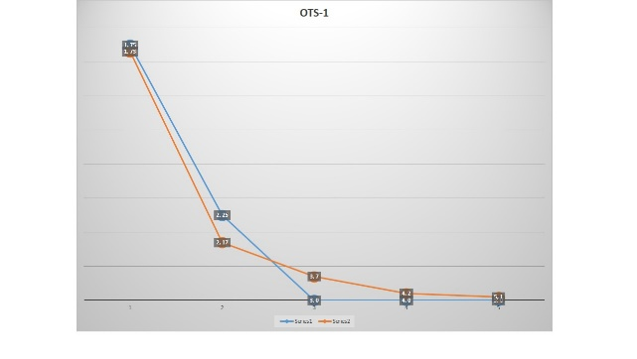
A

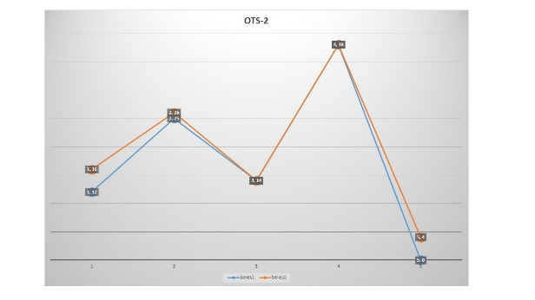
B

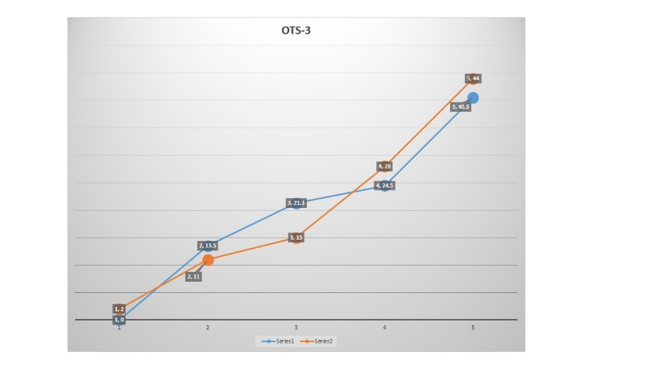
C

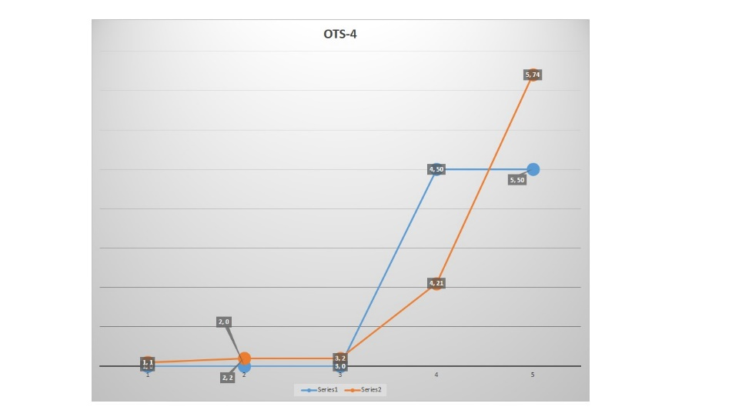
D
Figure 1 Comparison between ocular trauma score and achieved results. A: Comparison between OTS and achieved results in OTS-1 score category; B: Comparison between OTS and achieved results in OTS-2 score category; C: Comparison between OTS and achieved results in OTS-3 score category; D: Comparison between OTS and achieved results in OTS-4 score category. OTS: Ocular trauma score.

