Name of Journal: World Journal of Gastroenterology
ESPS Manuscript NO: 31321
Manuscript Type: ORIGINAL ARTICLE

Observational study
B2 adrenergic receptors and morphological changes of the enteric nervous system in colorectal adenocarcinoma

Ciurea RN et al. B2A receptors-ENS in colorectal cancer

Raluca Niculina Ciurea, Ion Rogoveanu, Daniel Pirici, Georgică-Costinel Târtea, Costin Teodor Streba, Cristina Florescu, Bogdan Cătălin, Ileana Puiu, Elena-Anca Târtea, Cristin Constantin Vere

Raluca Niculina Ciurea, Department of Pathology, University of Medicine and Pharmacy of Craiova, 200349 Craiova, Romania

Ion Rogoveanu, Costin Teodor Streba, Cristin Constantin Vere, Department of Gastroenterology, University of Medicine and Pharmacy of Craiova, 200349 Craiova, Romania

Daniel Pirici, Department of Research Methodology, University of Medicine and Pharmacy of Craiova, 200349 Craiova, Romania

Georgică-Costinel Târtea, Department of Internal Medicine, University of Medicine and Pharmacy of Craiova, 200349 Craiova, Romania

Cristina Florescu, Department of Cardiology, University of Medicine and Pharmacy of Craiova, 200349 Craiova, Romania

Bogdan Cătălin, Department of Physiology, University of Medicine and Pharmacy of Craiova, 200349 Craiova, Romania

Ileana Puiu, Department of Pediatrics, University of Medicine and Pharmacy of Craiova, 200349 Craiova, Romania

Elena-Anca Târtea, Department of Physiology, University of Medicine and Pharmacy of Craiova, 200349 Craiova, Romania

Author contributions: Ciurea RN, Rogoveanu I and Pirici D contributed equally to this work; Ciurea RN , Rogoveanu I and Pirici D designed, drafted and performed the research; Streba CT, Florescu C, Cătălin B, Puiu I and Târtea EA participated in writing, editing and reviewing of this manuscript; Târtea GC and Vere CC revised the paper and approved the final version.

Supported by the Romanian National Authority for Scientific Research and Innovation, CNCS – UEFISCDI, project No. PN-II-RU-TE-2014-4-0582, contract No. 160/01.10.2015.

Institutional review board statement: The study was reviewed and approved by the Institutional Review Board of the University of Medicine and Pharmacy of Craiova, Petru Rareș Street 2, 200349 Craiova, Romania (registration no. 53/19.05.2016).

Informed consent statement: All biological samples from the patients were taken after informed consent.

Conflict-of-interest statement: All the authors declare no conflict of interest.

Data sharing statement: No additional data are available.

Open-Access: This article is an open-access article which was selected by an in-house editor and fully peer-reviewed by external reviewers. It is distributed in accordance with the Creative Commons Attribution Non Commercial (CC BY-NC 4.0) license, which permits others to distribute, remix, adapt, build upon this work non-commercially, and license their derivative works on different terms, provided the original work is properly cited and the use is non-commercial. See: http://creativecommons.org/licenses/by-nc/4.0/

Manuscript source: Unsolicited manuscript

Correspondence to: Georgică-Costinel Târtea, MD, PhD, Department of Internal Medicine, University of Medicine and Pharmacy of Craiova, Petru Rareș Street 2, 200349 Craiova, Romania. georgetartea@gmail.com
Telephone: +40-740-303735

Received: November 10, 2016
Peer-review started: November 11, 2016
First decision: December 19, 2016
Revised: December 26, 2016
Accepted: January 11, 2017
Article in press:
Published online:

Abstract
AIM
To study the morphology of the enteric nervous system and the expression of beta-2 adrenergic (B2A) receptors in primary colorectal cancer.

METHODS

In this study we included forty-eight patients with primary colorectal cancer and nine patients for control tissue, who needed the excision of a colonic segment for benign conditions. We determined the clinicopathological features and evaluated the immunohistochemical expression pattern of B2A receptors as well as the morphological changes of the enteric nervous system (ENS). In order to assess statistical differences we used student t-test for comparing the means of two groups and one-way analysis of variance with Bonferroni’s post hoc analysis for comparing the means of more than two groups. Correlations were assessed using the Person’s correlation coefficient.

RESULTS

B2A receptors were significantly associated with tumor grading, tumor size, tumor invasion, lymph node metastasis (P < 0.05), while there were no statistically significant connections with gender, CRC location and gross appearance(P > 0.05) . We observed, on one hand, a decrease of the relative area, both for Auerbach and Meissner plexuses, with the increase of the tumor grading, and, on the other hand, an increase of the relative area of other nervous elements, which could neither be included in the Meissner plexus, nor in the Auerbach plexus, with the tumor grading. For G1 tumors we found that epithelial B2A area showed an inverse correlation with the Auerbach plexus areas [r (14) = -0.531, P < 0.05], while for G2 tumors, epithelial B2A areas showed an indirect variation with both the Auerbach plexus areas [r (14) = -0.453, P < 0.05] and the Meissner areas [r (14) = -0.825, P < 0.01]. For G3 tumors, the inverse dependence increased for both Auerbach [r (14)=-0.587, P < 0.05] and Meissner [r (14) = -0.934, P < 0.05] plexuses.

CONCLUSION

B2A receptors play an important role in the colorectal carcinogenesis and can be utilized as prognostic factors. Nevertheless, the ENS may lead to targeted molecular therapies.

Key words: Beta-2 adrenergic receptors; Enteric nervous system; Colorectal adenocarcinoma; Spectral unmixing immunohistochemistry; Tumor grading

© The Author(s) 2017. Published by Baishideng Publishing Group Inc. All rights reserved.

Core tip: In the present study we made the first description of beta-2 adrenergic (B2A) receptors found on the nuclear membrane of the colon adenocarcinoma cells. B2A receptors have a high level of expression in the neoplastic cells from colorectal adenocarcinoma, and a significant association was found between the expression of B2A receptors and tumor grading. In what enteric nervous system is concerned in colorectal cancer we observed a decrease of the relative area, both for Auerbach and Meissner plexuses, with the increase of the tumor grading, and an increase of the relative area of other nervous elements with the tumor grading.

Ciurea RN, Rogoveanu I, Pirici D, Târtea GC, Streba CT, Florescu C, Cătălin B, Puiu I, Târtea EA, Vere CC. B2A receptors and morphological changes of the enteric nervous system in colorectal adenocarcinoma. World J Gastroenterol 2017; In press

INTRODUCTION

Despite the progresses of the last years in the field of antineoplastic therapy, colorectal cancer still remains one of the major public health problems. In the United States, at January 1st 2016, from 15.5 millions of patients suffering from cancer, 724690 men had cancer of the colon and rectum, this cancer being the third most prevalent in women after the breast and uterine corpus cancer^{[1]}. Regarding the mortality, colon and rectum cancer rank as the fourth cause of mortality in the world with 694000 deaths, representing about 8.5% from the total deaths caused by cancer in 2012^{[2]}. Translational studies that identify new cancer prognostic markers, molecular changes that appear at the initiation of carcinogenesis and during the progression phase, as well as treatment targets, such as elements of the nervous system, are thus needed^{[3]}.
The idea of establishing connections between cancer and psychological influences belongs to the Greek doctor Galen, who, in the second century before Christ, showed that women with melancholic temperament develop breast cancer more frequently than other temperamental types^{[4]}.
The enteric nervous system (ENS) is the most complex part of the autonomic nervous system^{[5]}. It consists of three major ganglionic plexuses (mucous plexus, submucosal plexus also called Meissner, and myenteric plexus also called Auerbach), together with many aganglionare plexuses^{[6]}. Auerbach plexus is found starting at the esophagus to the terminal part of the digestive tract, between circular and longitudinal muscular layers^{[7]}. The ENS consists of approximately 500 million neurons, more than in the peripheral autonomic nervous system^{[8]}. The ENS is developed from the neural crest, from the sacral and vague segments of the neural tube^{[9]}.
The ENS is connected with the central nervous system via sympathetic and parasympathetic pathways, a connection known as the cerebroenteral axis^{[10]}. The background of the connections between the two divisions of the autonomic nervous system is represented by neurotransmitters such as acetylcholine for the parasympathetic nervous system and norepinephrine for the sympathetic nervous system^{[5]}. Although norepinephrine is not found in the enteric neurons, but only in the sympathetic afferent fibers that they receive; Li et al^{[11]} showed that norepinephrine transporter, which plays an important role in mediating the effects of norepinephrine, is expressed by enteric neurons. Some of these neurotransmitters act on receptors which are also expressed by colorectal carcinoma cells^{[4,11]}. B2A receptors are part of the family of cathecolamines receptors, and their activation can initiate multiple signalizing pathways in colorectal tumorigenesis^{[12]}. Moreover, blocking them may slow down or even stop the progression of the neoplastic process, but, in this case, the studies are contradictory^{[12]}.
Our aim was to compare the morphological changes of the ENS and to evaluate the expression changes of the B2A receptors in primary colorectal cancer versus normal colic mucosa, and also to find significant associations between these parameters and the clinicopathological features.

MATERIALS AND METHODS

Patients and specimens
In this study we analyzed specimens from forty-eight consecutive patients who underwent surgery with potentially curative resection for primary colorectal cancer, performed in the 1st Surgery Clinic of the Emergency County Hospital, Craiova, Romania. Patients were diagnosed with colorectal cancer in the 1st Medical Clinic, Gastroenterology Department of the Emergency County Hospital of Craiova between 2015 and 2016. As control, we used normal colorectal tissue taken from nine patients who were diagnosed with intestinal obstruction or other pathologies which needed surgery in order to perform the excision of a colonic segment. The study was approved by the Ethics Committee of the University of Medicine and Pharmacy of Craiova (registration no. 53/19.05.2016), according to the Declaration of Helsinki. All patients included in the study provided written acceptance and informed consent. In order to obtain clinical information from the patients, we reviewed their medical records, for gender, age, tumor size, sites of the primary tumor (right, transverse, left and sigmoid colon and rectum), T and N stages accordingly to American Joint Committee on Cancer, histological grading accordingly to World Health Organization criteria including well, moderate, or poor differentiated colorectal adenocarcinoma^{[13]}.

Tissue processing and immunohistochemistry
After we revisited the slides and confirmed the pathologies and tumor gradings, three µm-thick seriate sections were cut from each block, deparaffinized in xylene, rehydrated in graded alcohol series, and subjected to enzymatic immunohistochemistry utilizing a rabbit-anti-human anti-beta-2 adrenergic receptor (NBP2-15564, diluted as 1:200, Novus Biologicals, United Kingdom) and a rabbit anti-human anti-S100 (Z0311, diluted as 1:100, Dako, Glostrup, Denmark) primary antibodies. Briefly, the sections were first processed for antigen retrieval by microwaving in citrate buffer pH 6 for 20 min, incubated in 1% hydrogen peroxide in distilled water for 30 min to block the endogenous peroxidase activity, kept for another 30 min in 3% skimmed milk in PBS, then incubated with the primary antibodies at 4 °C for 18 h. Next day, the signal was amplified for 30 minutes utilizing a species specific peroxidase polymer-based system adsorbed for human immunoglobulins (Nikirei-Bioscience, Tokyo, Japan). The signal was finally detected with 3,3’-diaminobenzidine (DAB) (Dako) and the slides were coverslipped in DPX (Sigma-Aldrich, St. Louis, MO, United States) after a hematoxylin and eosin staining. All slides stained for each of the primary antibodies have been processed in the same time for protocol consistency together with control slides stained either with DAB or with hematoxylin and eosin in order to obtain pure spectral signatures of the respective stains (see further below). Negative controls were obtained by omitting the primary antibodies.

Image processing and statistics
In order to evaluate and quantify the immunohistochemical expression of the targets, light microscopy images were acquired on a Nikon Eclipse 90i motorized microscope (Elta90, Bucharest, Romania) equipped with a Nuance FX multispectral camera and the Nuance analysis software (Perkin Elmer, Hopkinton, MA, United States). After building a spectral library from individual slides stained with either hematoxylin or DAB (as described above), we were able to efficiently unmix and characterize the immunohistochemical expression patterns of interest (Figure 1). Furthermore, unmixed DAB signal was quantified as area and integrated optical density (average intensity/density of each area of interest) on 10 random images captured with a 20 × objective, using the Image-Pro Plus AMS 7 image analysis software (Media Cybernetics, Bethesda, MD, United States), the resulting data were averaged for each patient, and finally averaged and compared for each histopathological grade. Stroma was also considered separate in this analysis, be manually defining regions of interest in the captured images, prior to their analysis.
The total identifiable submucosal (Meissner's), myenteric (Auerbach's), and intratumoral nervous plexuses, as well as the multiaxonal bundles of nerves (> 20 µm) were imaged on the slides stained for S100 protein, and areas measured by manually defining the respective regions of interest. For referring densitometry data to total histological areas, whole hematoxylin-eosin slides were scanned on a desktop Benq 5560 scanner together with a microscopic stage micrometer, at 4.800 dpi against a white background. Image files were loaded in Image Pro Plus, and after pixel-size calibration for 1 mm against the microscopic stage micrometer, images were segmented and areas measured based on the same RGB profile created to automatically select the tissue on all the slides.
Data obtained after using the Image ProPlus AMS software were exported and plotted in Microsoft Office Excel 2010 (Microsoft Corporation, Redmond, Washington, United States) and were analyzed by using SPSS software (IBM SPSS Statistics, Version 20.0). In order to assess statistical differences we used student t-test for comparing the means of two groups and one-way ANOVA (ANOVA - analysis of variance) with Bonferroni’s post hoc analysis in order to compare the means of more than two groups. Correlations were assessed using the Person’s correlation coefficient. Data were reported as mean ± SD or the standard error of the means (SE). In all cases, p < 0.05 was used to indicate statistical significance.

RESULTS
Histopathological characterization
We have first sought to characterize the morphological expression of B2A receptor, taking advantage of the multispectral unmixing microscopy (Figure 2). Besides a faint diffuse cytoplasmic reaction, on normal colon mucosae, B2A exhibited a granular-like pattern in the cytoplasm of the enterocytes, above the nuclei, towards the luminal side of the covering epithelium. In the goblet cells, the signal was localized most frequently below the nucleus. Stromal cells also showed granular staining in their cytoplasmic compartment.
In well differentiated adenocarcinomas, most of the signal was still located towards the luminal side of the tumor cells, although on occasion granules could be clearly identified in the basal pole of the cells.
In moderately differentiated adenocarcinomas, the signal seemed to lose its granular appearance, becoming more diffuse and more intense in the epithelial cells.
In poorly differentiated adenocarcinomas, the intensity of the signal increased in the cytoplasm of the tumor cells, where on a general intense background, one could also identify very intense hotspots surrounding the nuclei with a random-like disposition against them. This time, clear-cut granular signal could now be observed on occasions in the nuclei or the folds of the nuclear membrane of the tumor cells. A direct counting of the of epithelial tumor cells exhibiting this intranuclear/close perinuclear expression pattern of B2A revealed a heterogenous distribution with an average of 12.84% positive- cells [ ± 12.10% (SD), min = 3%, max = 49%].
On the average there was no signal difference between different tumor stages for the staining of the stromal elements.
B2A receptors were also present in both stromal cells as well as nerves and nervous ganglia. In both submucosal and myenteric plexuses from the normal colon, the marker exhibited a dense-diffuse pattern in the cytoplasm of the ganglion cells, as well as in the satellite cells (Figure 3). Its expression was much fainter in the Schwann cells’ cytoplasm within the nerve bundles associated with non-tumor tissue. In the tumor tissue there was a somehow denser appearance in the cytoplasms of ganglion cells, and, interestingly, larger nerve bundles showed a clear-cut increase in signal density compared to non-tumor tissue. Smaller nerve bundles (deemed thinner than 20 µm for data stratification) were stained very faint, as in the control tissue.

B2A expression pattern in normal colonic mucosa and in different gradings of colorectal adenocarcinoma
In this study nine patients for control and sixteen for each tumor grading were included. The expression of B2A receptors was analyzed by determining both the area and the integrated optical density (IOD) of the signal, both in the total tissue and in the epithelial and stromal tissue for all the cases included in the study, as described in the chapter material and methods; and it was expressed as the mean ± SD. Regarding the expression of B2A receptors in the total tissue belonging to each patient included in the study, we observed that there was a gradual increase of both the area and IOD (Figure 4A and D) from the normal tissue to G1, G2 and G3 differentiated adenocarcinoma (from 5598.4 ± 3393.9 µm² for area and 862176.0 ± 469798.7 for IOD in normal tissue to 11583.3 ± 5521.3 µm² for area and 1717361.9 ± 886266.2 for IOD in G1, 27891.1 ± 12118.5 µm2 for area and 4240529.2 ± 1795221.7 for IOD in G2 and 37218.5 ± 9738.5 µm² for area and 5560460.5 ± 1720879.6 for IOD in G3). In this instance we observed a statistical significance on one-way analysis of variance with post hoc comparisons using the Bonferoni’s test between normal tissue and G2, G 3 (p = 0.000) and also between G1 and G2, G3 (p = 0.000) both for the area B2A and for the IOD.
The expression of B2A receptors only in the epithelium areas, this had a similar growth with its expression in the total tissue (Figure 4B and E), from normal tissue to G1, G2 and G3 differentiated adenocarcinoma (from 3076.5 ± 1895.5 µm² for area and 485440.8 ± 299641.9 for IOD in normal tissue to 7997.6 ± 5344.5 µm² for area and 1255032.6 ± 834235.5 for IOD in G1, 25423.0 ± 11100.6511 µm² for area and 3914461.91 ± 1673240.4 for IOD in G2 and 34670.1 ± 9146.9 µm² for area and 5184455.0 ± 1670704.2 for IOD in G3). Moreover, in this situation, we also observed a statistical significant difference between the normal tissue and G2, G3, similar with the expression of B2A receptors in the total tissue (p = 0.000) and G1, G2 and G3 (p = 0.000), but, in addition, we also noticed a statistical significant difference between G2 and G3 (p = 0.047) only for the area, while for IOD there was no significant difference (p = 0.141).
No significant differences between the means of B2A are receptors and IOD in the stroma of the normal colonic mucosa and different gradings of the colorectal adenocarcinoma could be observed (Figure 4C and F). These data show an increase of the expression of B2A receptors with the tumor grading on account of the epithelium and not of the stroma.

Morphological changes of the ENS in the colorectal adenocarcinoma
We analyzed the submucosal (Meissner’s), myenteric (Auerbach’s) and intratumoral nervous plexuses, as well as those of multiaxonal bundles of nerves (larger than 20 µm), which could not be included neither in the Auerbach nor in the Meissner plexus, by calculating the percentage average of the area of total nervous tissue, separately for both the normal colonic tissue and in different tumor gradings.
The density of the total nervous tissue expressed by percentage area recorded the smallest values in G1 graded tumors (0.129% ± 0.052%), followed by normal colonic tissue (0.184% ± 0.041%), G2 graded tumors (0.355% ± 0.131%) and G3 graded tumors (0.264% ± 0.172%) (Figure 5A). Here statistical differences between the percentage area from the normal colonic tissue and percentage area from G2 tumors (p = 0.013) were observed.
The density of the Auerbach plexuses relative areas revealed a net decrease from the normal tissue (0.136% ± 0.039%) to G1 (0.067% ± 0.043%), G2 (0.094% ± 0.078%) with a minimum for G3 gradings (0.023% ± 0.040%) (Figure 5B). In what this plexus’ density was concerned, significant differences were recorded between the percentage area from the normal colonic tissue and the percentage area from G3 (p = 0.013) tumors.
On the other hand, larger nervous bundles showed about the same pattern for the total analyzed areas (Figure 5C), but with a growth of the percentage nervous area in the normal colonic mucosa (0.013% ± 0.006%), in G1 (0.052% ± 0.033%), G2 (0.248% ± 0.087%) and in G3 (0.241% ± 0.146%) tumors. In this case, significant differences between the percentage nervous area in the normal colonic tissue and the area in G2 (p = 0.001) respectively G3 tumors (p = 0.002), and also between the percentage nervous area in G1 and the percentage nervous area in G2 (p = 0.004) and respectively G3 tumors (p = 0.008), were recorded.
Nevertheless, differences between the relative area of Meissner plexuses revealed the same pattern as for the Auerbach plexuses (Figure 5D), with a maximum in the normal colonic tissue (0.034% ± 0.017%), followed by G1 (0.009% ± 0.005%), G2 (0.012% ± 0.013%) and with a minimum in G3 tumors (0.002% ± 0.003%).
These data suggest, on one hand, a decrease of the relative area, of both Auerbach and Meissner plexuses, with the increasing tumor grading, and, on the other hand, an increase of the relative area of other nervous elements, which could not be included neither in the Meissner plexus, nor in the Auerbach plexus, again with the tumor grading.

Relationship between B2A receptors’ area-IOD and clinicopathological features
Both B2A receptors’ area and IOD were significantly linked with tumor size, tumor invasion, lymph node metastasis, while there were no statistically significant connections with gender, CRC location and gross appearance. In what it regards the involvement of age, there was no significant difference between B2A area in patients under 60 years old and patients over this age, while between B2A IOD and patients included in these age groups we found a significant difference (p = 0.018). These data are summarized in Table 1.
Moreover, for G1 tumors we found that epithelial B2A area showed an inverse correlation with the Auerbach plexus areas [r(14) = -0.531, p < 0.05], while for G2 tumors, epithelial B2A areas showed an indirect variation with both the Auerbach plexus areas [r(14) = -0.453, p < 0.05] and the Meissner areas [r(14) = -0.825, p < 0.01]. For G3 tumors, the inverse dependence increased for both Auerbach [r(14) = -0.587, p < 0.05] and Meissner [r(14) = -0.934, p < 0.05] plexuses. On control tissue we also found a strong indirect correlation between the B2A signal area and the Auerbach relative areas [r(7) = -0.897, p < 0.01], but not with the Meissner plexuses.

DISCUSSION
Both tumor microenvironment and its constituents have an extremely important role in carcinogenesis and in tumor progression. The interaction of the neoplastic and of the endothelial cells with the extracellular matrix, with the cells of the immune system and also with other elements, were carefully analyzed for their contribution as putative molecular targeted (antiangiogenic) therapies^{[14]}. However, the mechanisms that drive the pathogenesis and evolution of neoplasms are far from being understood. In colorectal neoplasm, nervous elements from the tumor microenvironment seem to play an important role. Regarding for example perineural invasion, Liebl et al^{[15]}, in a study that included 673 patients that were diagnosed with colorectal cancer, concluded that nerve invasion influences in a negative way the survival of the patients with colorectal cancer. However, it is not known if the nervous elements intervene first in the neuro-neoplastic chain, or if this role belongs to neoplastic cells both at the colorectal level and in other localizations of the neoplastic process.
In our study, we approached the neuro-neoplastic interrelationships in the colorectal adenocarcinoma, both as a structural characterization (by showing the changes of the ENS) and as an indirect functional characterization (by analyzing the expression of B2A receptors).
Regarding the morphology of the ENS, we found a decrease of the relative area, both for Auerbach and Meissner plexuses with the increase of the tumor grading, and, on the other hand, an increase of the relative area of other nervous elements, which could not be stratified neither in the Meissner plexus, nor in the Auerbach plexus, with the tumor grading. A study from 2004 showed that degenerative changes of the intrinsic neurons of the digestive tube cause either direct proportional variation between the size of nervous ganglions and tumor invasion and, also, an inverse proportional variation with the expression of synaptophysin in the enteric neurons of the colon^{[16]}. However, Godlewski J. showed that enteric nervous elements were not found in solid colorectal tumors, a finding which in fact supports some symptoms of patients with colorectal carcinoma^{[17]}. Kozlowska et al^{[18]} recently discovered that the atrophy of the myenteric plexus takes place in the immediate vicinity of the colorectal neoplasm, leading to a decrease both in the size of the nervous ganglia and also in the number of neurons per plexus, in comparison with the nervous plexuses located at a distance from the tumor advancing edge, but not of the submucosal plexus. The atrophy of the myenteric plexus is most probably caused by apoptosis, as both the extrinsic pathway of apoptosis activation via caspase 8 (CASP8) and the intrinsic pathway via activation of the caspase 3 (CASP3) are not different between the myenteric plexuses situated in the immediate vicinity of the colorectal neoplasm and those which are located at distance from this process^{[18]}. Many of the symptoms specific to colorectal cancer, such as change in bowel habit, flatulence, bloating and mucus discharge, constipation due to the alteration of the peristalsis, abdominal pain and others^{[19]} can be explained by the structural alterations of the ENS, highlighted both in our study and as well as in the studies mentioned above.
Regarding the neuro-neoplastic interrelationships at the colorectal level, we chose to study the expression of B2A receptors, because many intracellular signalizing pathways were discovered via this type of receptors until now, which are involved in the initiation, progression and cancer metastasis. In a previous study on a group of three patients, we have recently reported that the expression of B2A receptors increases with the tumor grading, but a large cohort is still necessary in order to confirm this observation^{[20]}. Neurotransmitters which act on this type of receptors are, mainly, adrenaline and noradrenaline. The role of noradrenaline in colorectal cancer development was highlighted by increasing the locomotor activity of SW 480 colon carcinoma cells and by blocking its effects on this type of cells after using the beta1/2 blocker propranolol^{[21]}. Moreover, the norepinephrine transporter, which plays an important role in mediating the effects of norepinephrine, is expressed by the enteric neurons^{[11]}. Also, adrenaline acts on this type of receptors, being the most important agonist of B2A receptors^{[22]}. Several studies showed the effects of adrenaline in colorectal adenocarcinoma^{[23-26]}. It is well known that B2A receptors for these neurotransmitters are G protein coupled receptors^{[27]}, and their activation may trigger complex intracellular signalizing involved in the carcinogenesis process, such as the activation of the arachidonic acid cascade, and, also, other pathways via the second messenger cyclic adenosine monophosphate (cAMP)^{[14,28]}. Other intracellular signalizing pathways are: proto-oncogene tyrosine-protein kinase Src (c-Src), involved in cancer progression and also in promoting other signals; mitogen-activated protein kinase (MAPK); protein kinase B(Akt); extracellular signal-regulated kinases (ERK1/2); cAMP response elements (CREB), which are linked to certain DNA sequences that decrease or increase the transcription of variate genes downstream^{[12,29,30]}. This type of receptor was also studied in other types of cancer including for example pancreas cancer^{[28]}, lung cancer^{[31]}, breast cancer^{[32]}and prostate cancer^{[33]}. Moreover, our analysis revealed a possible intranuclear/tight perinuclear localization of B2A receptors in poor differentiated adenocarcinoma, suggesting a connection between its arresting on the downstream of the signaling pathways, and more drastic cellular dedifferentiation and loss of function/gain of function signaling misbalances. Although more data are not yet available to clearly show the connection between B2A receptor levels and tumor recurrence, respectively the clinical outcomes of these patients, we are following up these patients for future references. To date, functional B2A receptors have been reportedly found on the nuclear membranes of ventricular miocardocytes^{[34]}, but to our knowledge this is the first description for colon adenocarcinoma cells. Further functional and electron microscopy studies will still be needed to clarify the implications of this observation.
In our study it was not possible to know for sure if the nervous structures which were deemed as other nerves were actually modified ganglia from the two plexuses or they represent sympathetic or parasympathetic afferents or efferents. They could not be cataloged neither as ganglia belonging to the Meissner plexus, nor as ganglia belonging to the Auerbach plexus, due to the structural changes caused by the neoplastic process. Neuro-neoplastic functional studies are required in order to find out if these nervous elements found in advanced gradings of colorectal adenocarcinoma secrete adrenaline and noradrenaline, and in this case, the regulation of B2A receptors examined in our study would be paracrine; or if the source of catecholamines would only be represented by the medulla, which seems to be least plausible if we take into account the short half-life of the catecholamines that activate B2A receptors^{[22]}.
We showed here that B2A area of expression in the tumor epithelium shows a moderate to strong inverse correlation with the areas of the Auerbach and Meissner plexuses. Although these are components of the stroma, there was no significant correlation between stromal or total B2A area and the number of nervous plexuses. There are too little elements to judge a functional association between these factors, but this is to our knowledge the first report of such a correlation for colon cancer. However, there are studies on breast tumors showing that stress-induced neuroendocrine activation leads to a massive increase of metastasis, and the treatment of stressed animals with the β-antagonist propranolol reversed the stress-induced inflammatory infiltrate and inhibited tumor metastasis^{[32]}, all these suggesting that the sympathetic nervous system might act as a regulator for tumor spreading and metastasis.
In conclusion, B2A receptors have a high expression level in the neoplastic cells from colorectal adenocarcinoma, and we found a significant association between the expression of B2A receptors and tumor grading. This shows that B2A receptors may play an important role in the antineoplastic therapy or they can be utilized as a prognostic factor. On the other hand, besides the functional changes caused by B2A receptors, structural changes of the ENS caused by the neoplastic process and the upward trend of the relative area of the nerves in colorectal adenocarcinoma might suggest that studies about targeted molecular therapies aiming not only at angiogenesis, but also at neurogenesis in colorectal cancer might represent an important treatment pathway.

comments
Background
Colorectal cancer still remains one of the major health problems worldwide. In this article, we want to compare the morphological changes of the enteric nervous system (ENS) and to evaluate the expression changes of the beta-2 adrenergic (B2A) receptors in primary colorectal cancer with normal colic mucosa, and also to find significant associations between these parameters and clinicopathological features.

Research frontiers
The mechanisms that drive the pathogenesis and the evolution of neoplasms are far from being understood. Translational studies that identify new colorectal cancer prognostic markers, molecular changes that appear at the initiation of carcinogenesis and during cancer’s progression, as well as treatment targets, such as nervous elements, are thus needed.

Innovations and breakthroughs
The authors made the first description of B2A receptors found in/on the nuclear membrane of the colon adenocarcinoma cells. B2A receptors have a high level of expression in the neoplastic cells from colorectal adenocarcinoma, and a significant association was found between the expression of B2A receptors and tumor grading. Until now, many intracellular signalizing pathways were discovered via this type of receptors, which are involved in the initiation, progression and cancer metastasis. On the other hand, in colorectal neoplasm, nervous elements from the tumor microenvironment seem to play an important role.

Applications
The present study looks into B2A receptors and morphological changes of the ENS in primary colorectal cancer. B2A receptors may play an important role in the antineoplastic therapy and they can be utilized as a critical prognostic factor. On the other hand, the structural changes of the ENS in colorectal adenocarcinoma may lead to targeted molecular therapies not only regarding angiogenesis, but also concerning neurogenesis in colorectal cancer.

Terminology
B2A receptors are G proteins coupled receptors and their activation may trigger complex intracellular signalizing involved in the carcinogenesis process. Neurotransmitters which act on this type of receptors are, mainly, adrenaline and noradrenaline.

Peer-review
The authors investigated the neuro-neoplastic interrelationship in colon cancer. Authors assessed the expression pattern of B2A receptors and morphological changes of the enteric nervous system in 48 primary colorectal cancers and 9 control non-colon cancer specimens. They concluded that B2A receptors could serve as a prognostic factor in colorectal cancer.

References1 Miller KD, Siegel RL, Lin CC, Mariotto AB, Kramer JL, Rowland JH, Stein KD, Alteri R, Jemal A. Cancer treatment and survivorship statistics, 2016. CA Cancer J Clin 2016; 66: 271-289 [PMID: 27253694 DOI: 10.3322/caac.21349]
2 Ferlay J, Soerjomataram I, Dikshit R, Eser S, Mathers C, Rebelo M, Parkin DM, Forman D, Bray F. Cancer incidence and mortality worldwide: sources, methods and major patterns in GLOBOCAN 2012. Int J Cancer 2015; 136: E359-E386 [PMID: 25220842 DOI: 10.1002/ijc.29210]
3 Janakiram NB, Rao CV. Molecular markers and targets for colorectal cancer prevention. Acta Pharmacol Sin 2008; 29: 1-20 [PMID: 18158862 DOI: 10.1111/j.1745-7254.2008.00742.x]
4 Fife A, Beasley PJ, Fertig DL. Psychoneuroimmunology and cancer: historical perspectives and current research. Adv Neuroimmunol 1996; 6: 179-190 [PMID: 8876773 DOI: 10.1016/0960-5428(96)00016-2]
5 Sayegh AI, Washington MC. Back to Basics: Regulation of the Gastrointestinal Functions. J Gastroint Dig Syst 2012; 2: 118 [doi: 10.4172/2161-069X.1000118]
6 Furness JB. The enteric nervous system and neurogastroenterology. Nat Rev Gastroenterol Hepatol 2012; 9: 286-294 [PMID: 22392290 DOI: 10.1038/nrgastro.2012.32]
7 Hansen MB. The enteric nervous system I: organisation and classification. Pharmacol Toxicol 2003; 92: 105-113 [PMID: 12753424 DOI: 10.1034/j.1600-0773.2003.t01-1-920301.x]
8 Furness JB. Integrated Neural and Endocrine Control of Gastrointestinal Function. Adv Exp Med Biol 2016; 891: 159-173 [PMID: 27379644 DOI: 10.1007/978-3-319-27592-5_16]
9 Lake JI, Heuckeroth RO. Enteric nervous system development: migration, differentiation, and disease. Am J Physiol Gastrointest Liver Physiol 2013; 305: G1-24 [PMID: 23639815 DOI: 10.1152/ajpgi.00452.2012]
10 Mayer EA, Tillisch K. The brain-gut axis in abdominal pain syndromes. Annu Rev Med 2011; 62: 381-396 [PMID: 21090962 DOI: 10.1146/annurev-med-012309-103958]
11 Li Z, Caron MG, Blakely RD, Margolis KG, Gershon MD. Dependence of serotonergic and other nonadrenergic enteric neurons on norepinephrine transporter expression. J Neurosci 2010; 30: 16730-16740 [PMID: 21148012 DOI: 10.1523/JNEUROSCI.2276-10.2010]
12 Chin CC, Li JM, Lee KF, Huang YC, Wang KC, Lai HC, Cheng CC, Kuo YH, Shi CS. Selective β2-AR Blockage Suppresses Colorectal Cancer Growth Through Regulation of EGFR-Akt/ERK1/2 Signaling, G1-Phase Arrest, and Apoptosis. J Cell Physiol 2016; 231: 459-472 [PMID: 26189563 DOI: 10.1002/jcp.25092]
13 Hamilton SR, Bosman FT, Boffetta P. Carcinoma of the colon and rectum. In: Bosman FT, Carneiro F, Hruban RH, Theise ND. WHO Classification of Tumours of the Digestive System. Lyon: IARC Press, 2010, 8: 134-46.
14 Jobling P, Pundavela J, Oliveira SM, Roselli S, Walker MM, Hondermarck H. Nerve-Cancer Cell Cross-talk: A Novel Promoter of Tumor Progression. Cancer Res 2015; 75: 1777-1781 [PMID: 25795709 DOI: 10.1158/0008-5472.CAN-14-3180]
15 Liebl F, Demir IE, Rosenberg R, Boldis A, Yildiz E, Kujundzic K, Kehl T, Dischl D, Schuster T, Maak M, Becker K, Langer R, Laschinger M, Friess H, Ceyhan GO. The severity of neural invasion is associated with shortened survival in colon cancer. Clin Cancer Res 2013; 19: 50-61 [PMID: 23147996 DOI: 10.1158/1078-0432.CCR-12-2392]
16 Sobaniec-Lotowska ME, Ciołkiewicz M, Pogumirski J, Sulkowski S, Sobczak A. Morphometry of synaptophysin immunoreactive ganglion cells in Auerbach plexus in patients with colorectal cancer. Is this a new prognostic factor? Folia Neuropathol 2004; 42: 167-170 [PMID: 15535035]
17 Godlewski J. Morphological changes in the enteric nervous system caused by carcinoma of the human large intestine. Folia Histochem Cytobiol 2010; 48: 157-162 [PMID: 20529833 DOI: 10.2478/v10042-010-0029-8]
18 Kozlowska A, Kwiatkowski P, Oponowicz A, Majewski M, Kmiec Z, Godlewski J. Myenteric plexuses atrophy in the vicinity of colorectal cancer tissue is not caused by apoptosis or necrosis. Folia Histochem Cytobiol 2016; 54: 99-107 [PMID: 27439439 DOI: 10.5603/FHC.a2016.0012]
19 Walter FM, Emery JD, Mendonca S, Hall N, Morris HC, Mills K, Dobson C, Bankhead C, Johnson M, Abel GA, Rutter MD, Hamilton W, Rubin GP. Symptoms and patient factors associated with longer time to diagnosis for colorectal cancer: results from a prospective cohort study. Br J Cancer 2016; 115: 533-541 [PMID: 27490803 DOI: 10.1038/bjc.2016.221]
20 Florescu C, Istrătoaie O, Târtea GC, Pirici D, Streba CT, Cătălin B, Puiu I, Târtea EA, Caragea DC, Ghiluşi MC, Comănescu MV, Rogoveanu I, Vere CC. Neuro-neoplastic interrelationships in colorectal level - immunohistochemical aspect in three cases and review of the literature. Rom J Morphol Embryol 2016; 57: 639-650 [PMID: 27833955]
21 Masur K, Niggemann B, Zanker KS, Entschladen F. Norepinephrine-induced migration of SW 480 colon carcinoma cells is inhibited by beta-blockers. Cancer Res 2001; 61: 2866-2869 [PMID: 11306460]
22 Westfall TC, Westfall DP. Adrenergic agonists and antagonists. In: Brunton LL, Chabner BA, Knollmann BC . Goodman & Gilman’s the pharmacological basis of therapeutics. 12th edition, McGraw–Hill, New York, 2011, 277–334.
23 Yao H, Duan Z, Wang M, Awonuga AO, Rappolee D, Xie Y. Adrenaline induces chemoresistance in HT-29 colon adenocarcinoma cells. Cancer Genet Cytogenet 2009; 190: 81-87 [PMID: 19380024 DOI: 10.1016/j.cancergencyto.2008.12.009]
24 Wong HP, Ho JW, Koo MW, Yu L, Wu WK, Lam EK, Tai EK, Ko JK, Shin VY, Chu KM, Cho CH. Effects of adrenaline in human colon adenocarcinoma HT-29 cells. Life Sci 2011; 88: 1108-1112 [PMID: 21565206 DOI: 10.1016/j.lfs.2011.04.007]
25 Pu J, Bai D, Yang X, Lu X, Xu L, Lu J. Adrenaline promotes cell proliferation and increases chemoresistance in colon cancer HT29 cells through induction of miR-155. Biochem Biophys Res Commun 2012; 428: 210-215 [PMID: 23036199 DOI: 10.1016/j.bbrc.2012.09.126]
26 Coelho M, Moz M, Correia G, Teixeira A, Medeiros R, Ribeiro L. Antiproliferative effects of β-blockers on human colorectal cancer cells. Oncol Rep 2015; 33: 2513-2520 [PMID: 25812650 DOI: 10.3892/or.2015.3874]
27 Irina G, Katrin A, Terence EH. Organizational Complexity of b-adrenergic Receptor Signaling Systems. In: Wang Q, Benos DJ, Balaban R, Simon SA. Advances in Adrenergic Receptor Biology, Elsevier, 2011, 2: 19-49.
28 Zhang D, Ma QY, Hu HT, Zhang M. β2-adrenergic antagonists suppress pancreatic cancer cell invasion by inhibiting CREB, NFκB and AP-1. Cancer Biol Ther 2010; 10: 19-29 [PMID: 20424515]
29 Tang J, Li Z, Lu L, Cho CH. β-Adrenergic system, a backstage manipulator regulating tumour progression and drug target in cancer therapy. Semin Cancer Biol 2013; 23: 533-542 [PMID: 24012659 DOI: 10.1016/j.semcancer.2013.08.009]
30 Armaiz-Pena GN, Allen JK, Cruz A, Stone RL, Nick AM, Lin YG, Han LY, Mangala LS, Villares GJ, Vivas-Mejia P, Rodriguez-Aguayo C, Nagaraja AS, Gharpure KM, Wu Z, English RD, Soman KV, Shahzad MM, Zigler M, Deavers MT, Zien A, Soldatos TG, Jackson DB, Wiktorowicz JE, Torres-Lugo M, Young T, De Geest K, Gallick GE, Bar-Eli M, Lopez-Berestein G, Cole SW, Lopez GE, Lutgendorf SK, Sood AK. Src activation by β-adrenoreceptors is a key switch for tumour metastasis. Nat Commun 2013; 4: 1403 [PMID: 23360994 DOI: 10.1038/ncomms2413]
31 Al-Wadei HA, Plummer HK, Ullah MF, Unger B, Brody JR, Schuller HM. Social stress promotes and γ-aminobutyric acid inhibits tumor growth in mouse models of non-small cell lung cancer. Cancer Prev Res (Phila) 2012; 5: 189-196 [PMID: 21955519 DOI: 10.1158/1940-6207.CAPR-11-0177]
32 Sloan EK, Priceman SJ, Cox BF, Yu S, Pimentel MA, Tangkanangnukul V, Arevalo JM, Morizono K, Karanikolas BD, Wu L, Sood AK, Cole SW. The sympathetic nervous system induces a metastatic switch in primary breast cancer. Cancer Res 2010; 70: 7042-7052 [PMID: 20823155 DOI: 10.1158/0008-5472.CAN-10-0522]
33 Ventura S, Evans BA. Does the autonomic nervous system contribute to the initiation and progression of prostate cancer? Asian J Androl 2013; 15: 715-716 [PMID: 24141535 DOI: 10.1038/aja.2013.114]
34 Boivin B, Lavoie C, Vaniotis G, Baragli A, Villeneuve LR, Ethier N, Trieu P, Allen BG, Hébert TE. Functional beta-adrenergic receptor signalling on nuclear membranes in adult rat and mouse ventricular cardiomyocytes. Cardiovasc Res 2006; 71: 69-78 [PMID: 16631628]

P-Reviewer: Steel JC, Lakatos PL S-Editor: Ma YJ L-Editor: E-Editor:

Specialty type: Gastroenterology and hepatology
Country of origin: Romania
Peer-review report classification
Grade A (Excellent): 0
Grade B (Very good): B
Grade C (Good): C
Grade D (Fair): 0
Grade E (Poor): 0

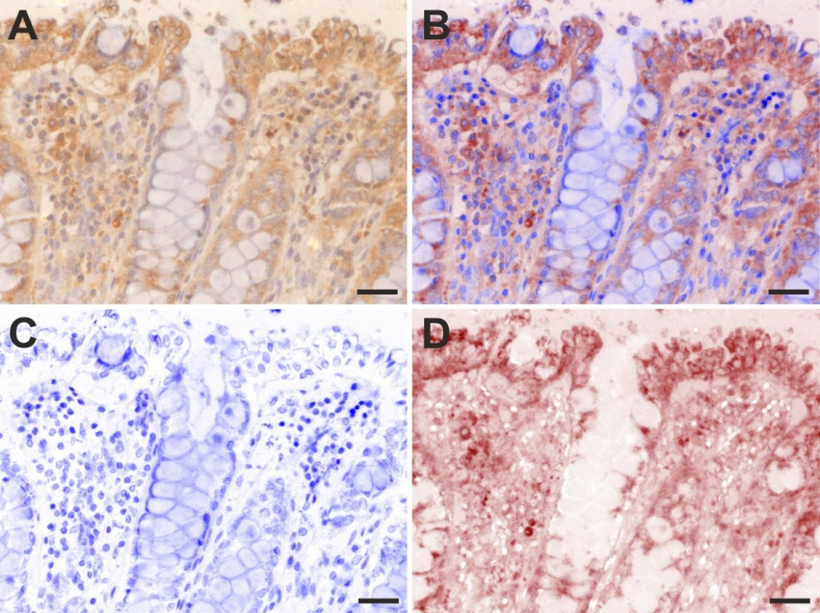
Figure 1 Example of spectral unmixing for the series of slides. A: immunostained for B2A receptors with DAB and counterstained with hematoxylin; B: pure DAB and hematoxylin signals are showed either overlapping or (C-D), individually. Scale bars represent 20 µm.

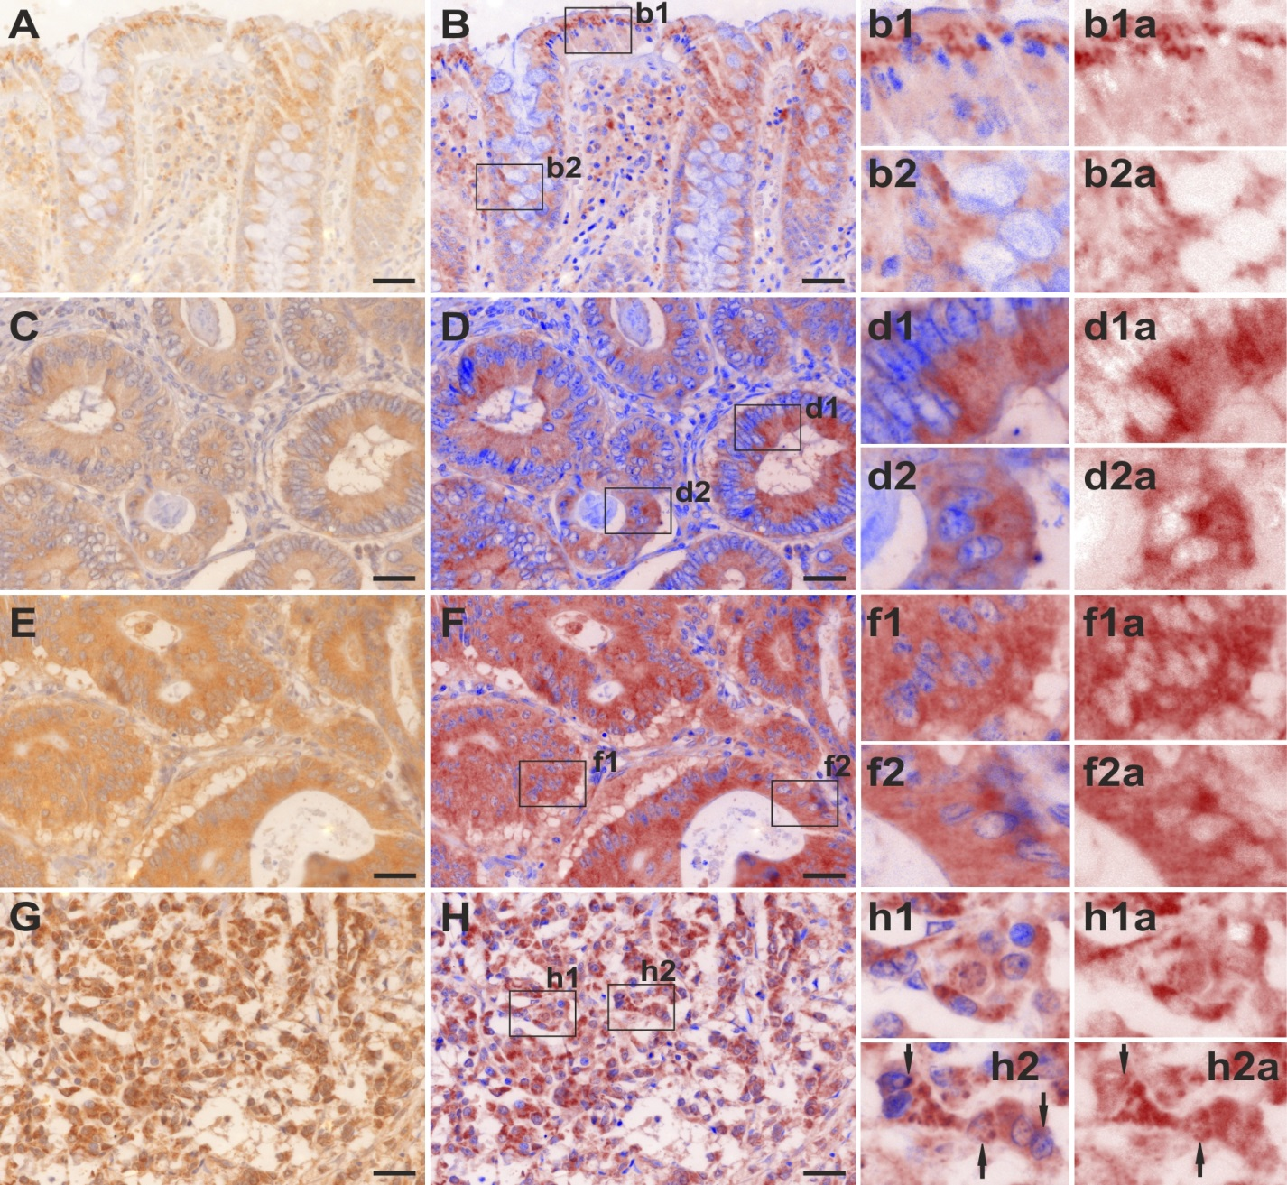
Figure 2 Analysis of the expression of B2A receptors in the normal and tumor colon tissue. RGB (A) and unmixed (B; b1, b1a; b2, b2a) images showing its presence mostly as dense granules in the supranuclear sector of the superficial layer of enterocytes (b1; b1a), as well as in the sub-nuclear region of the glandular cells of the cripts (b2; b2a). In well differentiated adenocarcinoma, RGB (C) and unmixed images (D; d1, d1a; d2, d2a) revealed a more dense-diffuse like pattern of expression mostly in the apical sector of the cells (d, d1a), but also in the basal pole of the cells (d2, d2a). In moderately differentiated adenocarcinoma, RGB (E) and unmixed images (F; f1, f1a; f2, f2a) revealed an ever denser and more uniform expression pattern in all the cytoplasm of the tumor cells. In poorly differentiated adenocarcinomas, RGB (G) and unmixed images (H; h1, h1a; h2, h2a) reveal an even denser granular expression pattern, with occasional intra(peri) nuclear localization (arrows in h2 and h2a). Small letters represent enlarged insets from the capital lettered images. Scale bars represent 20 µm.

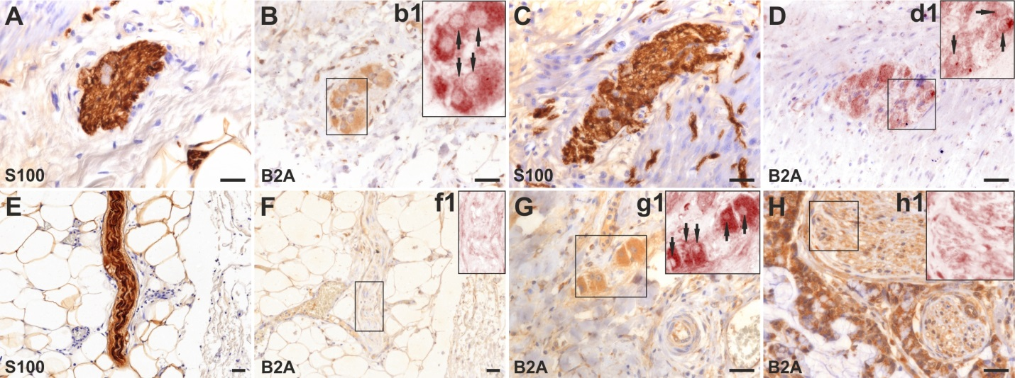
Figure 3 Expression of B2A receptors in the normal and tumor peripheral nervous tissue on serial sections immunostained for S100 protein (A, C, E, G) and B2A (B, b1; D; d1; F, f1; H, h1). Spectral unmixing showed that in the normal submucosal (b1) and myenteric (d1) plexuses, B2A was mostly expressed in the cytoplasm of the ganglion cells, being absent in small nerves dissecting the muscularis proper layer (C-D). Even in larger non-invaded nerves B2A showed a faint expression (E-F, f1 spectral unmixing). However, in invaded ganglia (G, g1) and nerves (H, h1) its expression seems to be expressed in both the cytoplasm of the ganglion cells (arrows in g1 – unmixed), as well as in the larger nerve bundles (h1 – unmixed). Small letters represent enlarged insets from the capital lettered images. Scale bars represent 20 µm.

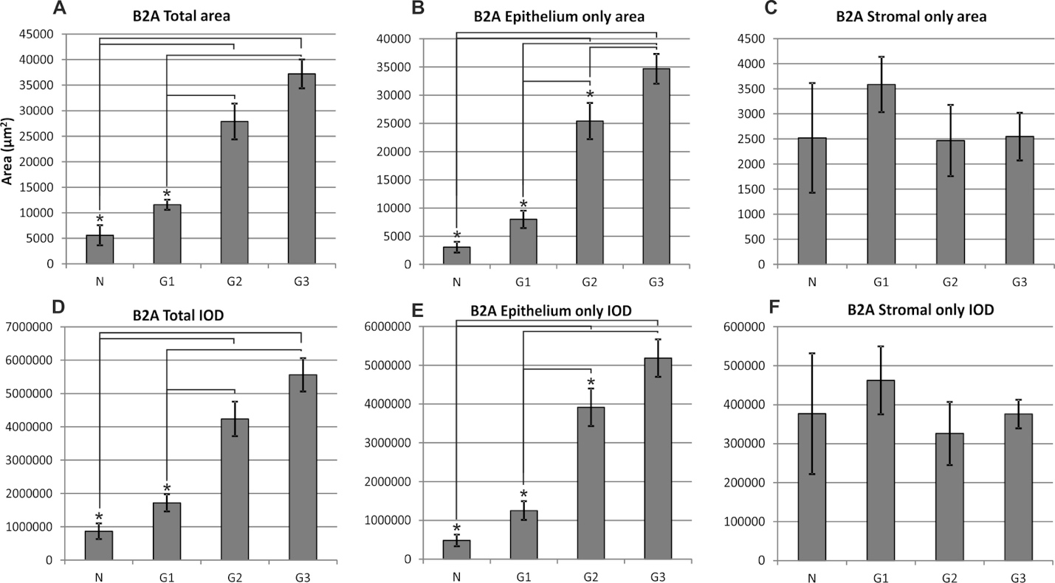
Figure 4 Analysis of the expression of B2A receptors. Total expression area increases gradually from normal tissue to G1, G2 and G3 differentiated adenocarcinoma (A), and this differentiation is driven by the expression in the epithelial areas (B), where assessing stromal signal revealed no differences (C). The same scenario is obtained when evaluating the integrated optical density (IOD) of the signal (D-F). The asterisk represents statistical significance on one-way analysis of variance with post hoc comparisons using the Bonferoni’s test. Error bars represent standard errors of the mean.

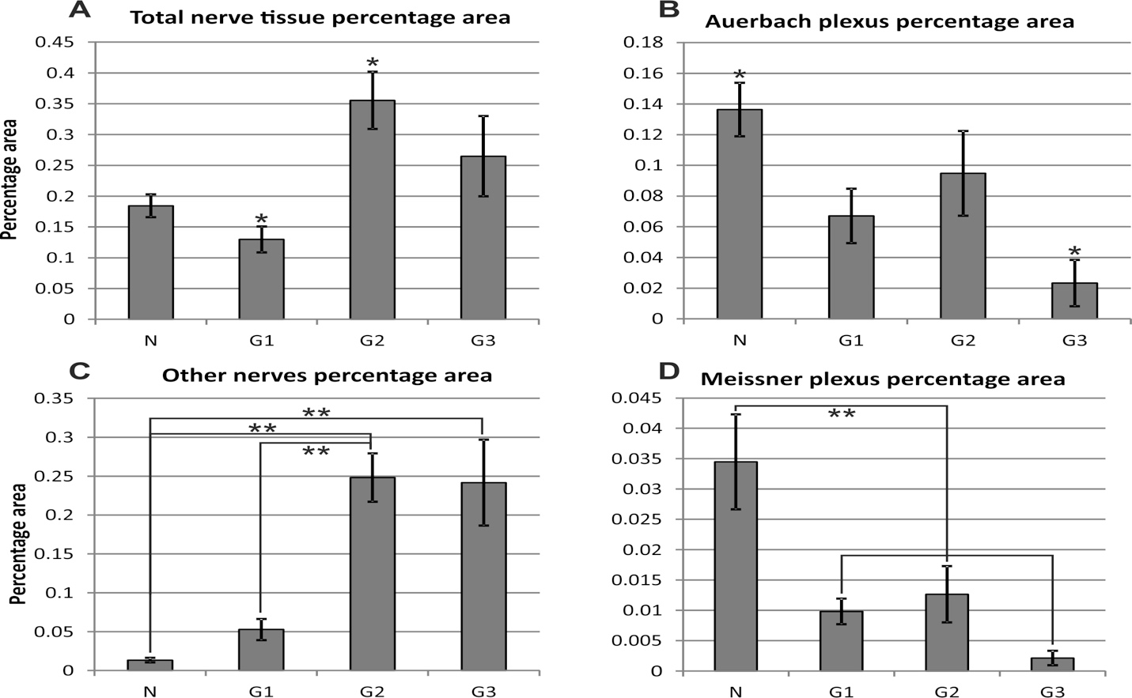
b
b
b
b
a
a
a
a
Figure 5 Comparison of the percentage areas of the total analyzed tissue fragments for the submucosal, myenteric plexuses, as well as for the multi-axonal fiber bundles. For the above peripheral total nerve elements, G1 graded tumors had the smallest percentage areas, followed by normal colon tissue and G2-G3 differentiated tumors (A). Density of the Auerbach plexuses relative areas revealed a clearcut decrease from normal tissue to G1-G2-G3 gradings, with a minimum for G3 grading (B). Larger nervous bundles showed the same pattern as for the total analyzed areas (C), while differences between the relative areas of Meissner plexuses revealed the same pattern as for the Auerbach plexuses (D), revealing that the total and plexus areas variate in opposite directions when considering increasing gradings. ªp < 0.05 and ^{b}p < 0.01 represent statistical significance on one-way analysis of variance with post hoc comparisons using the Bonferoni’s test. Error bars represent standard errors of the mean.

Table 1 Relationship between B2A receptors’ expression and clinicopathological features
Clinicopathological features |  | n | B2A only area (µm²)  mean ± SD | P-value¹ | B2A only IOD  mean ± SD | P-value¹
Gender | Male | 38 | 25332.4 ± 15753.5 | 0.126 | 2861294.1$±$1735364.6 | 0.109
 | Female | 19 | 19450.2 ± 11703.5 |  | 3833335.5$±$2431953.4
Age group | < 60 | 15 | 28796.9$±$13781.3 | 0.085 | 4742202.6$±$2372372.902 | 0.018ª
 | ≥ 60 | 42 | 21584.2$±$14860.9 |  | 3086368.8$±$2092543.9
Tumor size | < 5 cm | 23 | 15778.7$±$13661.5 | 0.003ª | 2463149.731$±$2229187.1 | 0.008ª
 | ≥ 5 cm | 25 | 28241.1$±$13584.4 |  | 4188867.1$±$2074271.4
CRC location | Right and transvers colon | 9 | 24817.5$±$19874.7 | 0.412 | 3818617.6$±$3131069.5 | 0.375
 | Left colon, sigmoid and rectum | 39 | 23347.2$±$14047.3 |  | 3492859.3$±$2140467.2
Gross  appearance | Exophytic | 20 | 23166.8$±$14796.3 | 0.429 | 3260358.1$±$2057001.7 | 0.208
 | Infiltrative, ulcero-infiltrative | 28 | 24010.8$±$15114.6 |  | 3852705.4$±$2501409.4
Tumor invasion | T₁₋₂ | 17 | 11110.3$±$6784.4 | 0.000ª | 1650300.5$±$1004078.8 | 0.000ª
 | T₃₋₄ | 31 | 36025.2$±$8632.1 |  | 5433145.7$±$1423440.9
Lymph node  metastasis | N₀₋₁ | 21 | 19264.3$±$12628.1 | 0.010ª | 2904065.0$±$1922977.6 | 0.013ª
 | N_{≥2} | 27 | 30022.8$±$15745.7 |  | 4498210.2$±$2467186.4
¹Student t-test. ªP < 0.05 vs control group. IOD: integrated optical density.

