Name of Journal: World Journal of Gastrointestinal Oncology
Manuscript NO: 76863
Manuscript Type: LETTER TO THE EDITOR

Acute or chronic inflammation role in gastrointestinal oncology

Chen HJ et al. Inflammation and gastrointestinal cancers

Hong-Jin Chen, Gui-You Liang, Xiong Chen, Zhou Du

Hong-Jin Chen, Gui-You Liang, Translational Medicine Research Center, Guizhou Medical University, Guiyang 550025, Guizhou Province, China

Hong-Jin Chen, Guizhou Institute of Precision Medicine, Affiliated Hospital of Guizhou Medical University, Guiyang 550009, Guizhou Province, China

Xiong Chen, Department of Endocrinology, The First Affiliated Hospital of Wenzhou Medical University, Wenzhou 325000, Zhejiang Province, China

Zhou Du, Department of Hernia and Abdominal Wall Surgery, The First Affiliated Hospital of Wenzhou Medical University, Wenzhou 325000, Zhejiang Province, China

Author contributions: Chen HJ and Chen X designed the research; Chen HJ wrote this comment; Liang GY and Du Z reviewed and supervised this manuscript; All authors approved the final version of the article.

Supported by the Start-up Fund of Guizhou Medical University, No. J2021032; the Postdoctoral Research Fund of Affiliated Hospital of Guizhou Medical University, No. BSH-Q-2021-10; and the Guizhou Provincial Health Commission, No. gzwkj2022-082.

Corresponding author: Zhou Du, MD, Chief Doctor, Department of Hernia and Abdominal Wall Surgery, The First Affiliated Hospital of Wenzhou Medical University, Shangcai Village, Nanbaixiang, Wenzhou 325000, Zhejiang Province, China. duzhou2190@126.com

Received: April 4, 2022
Revised: June 2, 2022
Accepted: July 16, 2022
Published online: August 15, 2022

Abstract
The following letter to the editor highlights the review titled “Inflammatory bowel disease-related colorectal cancer: Past, present and future perspectives” in World J Gastrointest Oncol 2022 March 15; 14(3): 547-567. It is necessary to explore the role of inflammation in promoting tumorigenesis and development of gastrointestinal cancers.

Key Words: Inflammatory; Gastrointestinal cancers; Development; Letter to the Editor; Colorectal cancer

©The Author(s) 2022. Published by Baishideng Publishing Group Inc. All rights reserved.

Citation: Chen HJ, Liang GY, Chen X, Du Z. Acute or chronic inflammation role in gastrointestinal oncology. World J Gastrointest Oncol 2022; 14(8): 1600-1603
URL: https://www.wjgnet.com/1948-5204/full/v14/i8/1600.htm
DOI: https://dx.doi.org/10.4251/wjgo.v14.i8.1600

Core Tip: Gastrointestinal cancers are systematic tumors with the largest number of patients in the world. Most patients are prone to migration, invasion or other malignant phenotypes. The treatment strategies mainly include surgical resection, radiotherapy and chemotherapy in clinic. However, the survival rate of cases still cannot be significantly improved. Recently, the relationship between inflammation and gastrointestinal tumors has been gradually clarified, and chronic inflammation plays an important role in the occurrence and deterioration of tumors. The main purpose of this letter is to illustrate the key role of inflammation in tumor progression and potential therapeutic directions.

TO THE EDITOR
We read with interest the review by Majumder et al^{[1]}, which is titled “Inflammatory bowel disease-related colorectal cancer: Past, present and future perspectives.” The tumor pathogenesis is complex and not yet clear. Recently, inflammation induced and promoted tumor occurrence and deterioration, and the presence of high levels of inflammatory factors in many tumor patients has gradually become clear. The gastrointestinal system is one of the most prone to inflammation. Patients with chronic inflammation are more likely to develop liver cancer, pancreatic cancer, stomach cancer and colon cancer than those without inflammation,. Studies have demonstrated that hepatitis B virus patients were more likely to get cancer of the liver, and prognosis and survival time is far less than the patients without hepatitis B virus^{[2]}. Patients with pancreatitis had a 4.8-times significantly higher risk of developing cancer than those without pancreatitis^{[3]}. Helicobacter pylori is one of the important risk factors for gastric cancer patients, and Helicobacter pylori will induce the occurrence of chronic gastritis^{[4]}. In addition, patients with colitis have an increased mortality of colon cancer by 15%^{[1]}. Therefore, if the potential biomarkers can be identified by early intervention of the synthesis, secretion and release of inflammatory factors, it may have great clinical significance for gastrointestinal tumors and improve the overall understanding of gastrointestinal tumors.
The interleukin (IL) family is the most common biomarker of inflammation. IL-1β, IL-6 and IL-10 are involved in the development and progression of gastrointestinal tumors. On the other hand, external stimuli, such as excessive oxidative stress, promote the secretion and release of the IL family, while the IL family itself has a certain feedback activation effect, thus exacerbating the inflammatory response^{[5]}. In colitis-cancer, IL-6 and other factors promote epidermal cell damage, and prolonged inflammatory damage will lead to abnormal proliferation of epidermal cells, which if not controlled will eventually lead to gene epigenetic modification mutation and ultimately induce tumorigenesis^{[6,7]}.
Tumor necrosis factor (TNF), another classic inflammatory factor, can promote the activation of neutrophils or macrophages to aggravate tissue damage by regulating monocyte chemotactic protein-1 and other mRNAs^{[8]}. Moreover, TNF accelerates the inflammatory process and thus leads to the occurrence of tumors^{[9]}. In addition, the role of a c-x-c motif chemokine ligand (CCL) family in gastrointestinal tumors is gradually becoming clear. CCLs infiltrated tissues by recruiting macrophages and releasing IL family members or TNF, further leading to local inflammatory infiltration of tissues, gene mutation and ultimately tumorigenesis^{[10]}.
Interestingly, some papers showed that chronic inflammatory responses promoted tumorigenesis and development, while acute inflammation is currently considered to inhibit tumor progression (Figure 1)^{[11]}. The new clinical research paper indicated that colon cancer patients with higher IL-6 and TNF (chronic inflammatory factors) developed a cancer recurrence. However, acute inflammatory factors, IL-10 and interferon γ, were lower in expression compared with those who did not recur^{[7]}. IL-12 is an acute inflammatory factor that could inhibit tumor progression in gastrointestinal tumors, and its high expression leads to a longer survival time^{[12]}. Additionally, the interferon family is a potential therapeutic biomarker, which could inhibit the occurrence and progression of gastrointestinal tumors by regulating cellular immunity, controlling cell cycle or promoting cell apoptosis^{[13,14]}. Moreover, the interferon family has been approved by the Food and Drug Administration for the treatment of tumors^{[15]}.
In conclusion, inflammation is involved in the entire gastrointestinal tumor process. The worse inflammation is mainly chronic inflammation, which can be induced by many reasons, such as unhealthy high-fat diet, excessive use of antibiotics, imbalance of intestinal flora and so on^{[16]}. Majumder et al^{[1]} systematically summarized the role of inflammatory factors in colon cancer. However, they failed to study and consider the role of acute inflammation in colon cancer. Therefore, inflammatory factors should be considered as important triggers to optimize current diagnosis and treatment strategies for early tumor diagnosis.

REFERENCES
1 Majumder S, Shivaji UN, Kasturi R, Sigamani A, Ghosh S, Iacucci M. Inflammatory bowel disease-related colorectal cancer: Past, present and future perspectives. World J Gastrointest Oncol 2022; 14: 547-567 [PMID: 35321275 DOI: 10.4251/wjgo.v14.i3.547]
2 Zhou Q, Zhang Q, Wang K, Huang T, Deng S, Wang Y, Cheng C. Anti-rheumatic drug-induced hepatitis B virus reactivation and preventive strategies for hepatocellular carcinoma. Pharmacol Res 2022; 178: 106181 [PMID: 35301112 DOI: 10.1016/j.phrs.2022.106181]
3 Petrov MS. Post-pancreatitis diabetes mellitus and excess intra-pancreatic fat deposition as harbingers of pancreatic cancer. World J Gastroenterol 2021; 27: 1936-1942 [PMID: 34007131 DOI: 10.3748/wjg.v27.i17.1936]
4 El Hafa F, Wang T, Ndifor VM, Jin G. Association between Helicobacter pylori antibodies determined by multiplex serology and gastric cancer risk: A meta-analysis. Helicobacter 2022: e12881 [DOI: 10.1111/hel.12881]
5 Zhou CB, Fang JY. The role of pyroptosis in gastrointestinal cancer and immune responses to intestinal microbial infection. Biochim Biophys Acta Rev Cancer 2019; 1872: 1-10 [PMID: 31059737 DOI: 10.1016/j.bbcan.2019.05.001]
6 Deng J, Zhao L, Yuan X, Li Y, Shi J, Zhang H, Zhao Y, Han L, Wang H, Yan Y, Zhao H, Wang H, Zou F. Pre-Administration of Berberine Exerts Chemopreventive Effects in AOM/DSS-Induced Colitis-Associated Carcinogenesis Mice via Modulating Inflammation and Intestinal Microbiota. Nutrients 2022; 14 [PMID: 35215376 DOI: 10.3390/nu14040726]
7 Fleming CA, O'Connell EP, Kavanagh RG, O'Leary DP, Twomey M, Corrigan MA, Wang JH, Maher MM, O'Connor OJ, Redmond HP. Body Composition, Inflammation, and 5-Year Outcomes in Colon Cancer. JAMA Netw Open 2021; 4: e2115274 [PMID: 34459908 DOI: 10.1001/jamanetworkopen.2021.15274]
8 Chen H, Zhang Y, Zhang W, Liu H, Sun C, Zhang B, Bai B, Wu D, Xiao Z, Lum H, Zhou J, Chen R, Liang G. Inhibition of myeloid differentiation factor 2 by baicalein protects against acute lung injury. Phytomedicine 2019; 63: 152997 [PMID: 31254764 DOI: 10.1016/j.phymed.2019.152997]
9 Tu M, Klein L, Espinet E, Georgomanolis T, Wegwitz F, Li X, Urbach L, Danieli-Mackay A, Küffer S, Bojarczuk K, Mizi A, Günesdogan U, Chapuy B, Gu Z, Neesse A, Kishore U, Ströbel P, Hessmann E, Hahn SA, Trumpp A, Papantonis A, Ellenrieder V, Singh SK. TNF-α-producing macrophages determine subtype identity and prognosis via AP1 enhancer reprogramming in pancreatic cancer. Nat Cancer 2021; 2: 1185-1203 [PMID: 35122059 DOI: 10.1038/s43018-021-00258-w]
10 Fogelman DR, Morris J, Xiao L, Hassan M, Vadhan S, Overman M, Javle S, Shroff R, Varadhachary G, Wolff R, Vence L, Maitra A, Cleeland C, Wang XS. A predictive model of inflammatory markers and patient-reported symptoms for cachexia in newly diagnosed pancreatic cancer patients. Support Care Cancer 2017; 25: 1809-1817 [PMID: 28111717 DOI: 10.1007/s00520-016-3553-z]
11 Zhao H, Wu L, Yan G, Chen Y, Zhou M, Wu Y, Li Y. Inflammation and tumor progression: signaling pathways and targeted intervention. Signal Transduct Target Ther 2021; 6: 263 [PMID: 34248142 DOI: 10.1038/s41392-021-00658-5]
12 Hu J, Yang Q, Zhang W, Du H, Chen Y, Zhao Q, Dao L, Xia X, Natalie Wall F, Zhang Z, Mahadeo K, Gorlick R, Kopetz S, Dotti G, Li S. Cell membrane-anchored and tumor-targeted IL-12 (attIL12)-T cell therapy for eliminating large and heterogeneous solid tumors. J Immunother Cancer 2022; 10 [PMID: 35027427 DOI: 10.1136/jitc-2021-003633]
13 Shi XY, Zhang XL, Shi QY, Qiu X, Wu XB, Zheng BL, Jiang HX, Qin SY. IFN-γ affects pancreatic cancer properties by MACC1-AS1/MACC1 axis via AKT/mTOR signaling pathway. Clin Transl Oncol 2022; 24: 1073-1085 [PMID: 35037236 DOI: 10.1007/s12094-021-02748-w]
14 Peng Y, Hu Y, Qiu L. Vesicular IFN-γ as a cooperative attacker to enhance anti-cancer effect of 5-fluorouracil via thymidine phosphorylase upregulation and tumor microenvironment normalization. Nanomedicine 2022; 40: 102501 [PMID: 34843983 DOI: 10.1016/j.nano.2021.102501]
15 Miller CH, Maher SG, Young HA. Clinical Use of Interferon-gamma. Ann N Y Acad Sci 2009; 1182: 69-79 [PMID: 20074276 DOI: 10.1111/j.1749-6632.2009.05069.x]
16 Alhobayb T, Peravali R, Ashkar M. The Relationship between Acute and Chronic Pancreatitis with Pancreatic Adenocarcinoma: Review. Diseases 2021; 9 [PMID: 34940031 DOI: 10.3390/diseases9040093]

Footnotes
Conflict-of-interest statement: All authors have nothing to disclose.

Open-Access: This article is an open-access article that was selected by an in-house editor and fully peer-reviewed by external reviewers. It is distributed in accordance with the Creative Commons Attribution NonCommercial (CC BY-NC 4.0) license, which permits others to distribute, remix, adapt, build upon this work non-commercially, and license their derivative works on different terms, provided the original work is properly cited and the use is non-commercial. See: https://creativecommons.org/Licenses/by-nc/4.0/

Provenance and peer review: Invited article; Externally peer reviewed.
Peer-review model: Single blind

Peer-review started: April 4, 2022
First decision: May 11, 2022
Article in press: July 16, 2022

Specialty type: Oncology
Country/Territory of origin: China
Peer-review report’s scientific quality classification
Grade A (Excellent): 0
Grade B (Very good): 0
Grade C (Good): C, C, C
Grade D (Fair): 0
Grade E (Poor): 0

P-Reviewer: Apiratwarakul K, Thailand; Kotlyarov S, Russia; Zhao Y, China S-Editor: Wang LL L-Editor: Filipodia P-Editor: Wang LL
Figure Legends
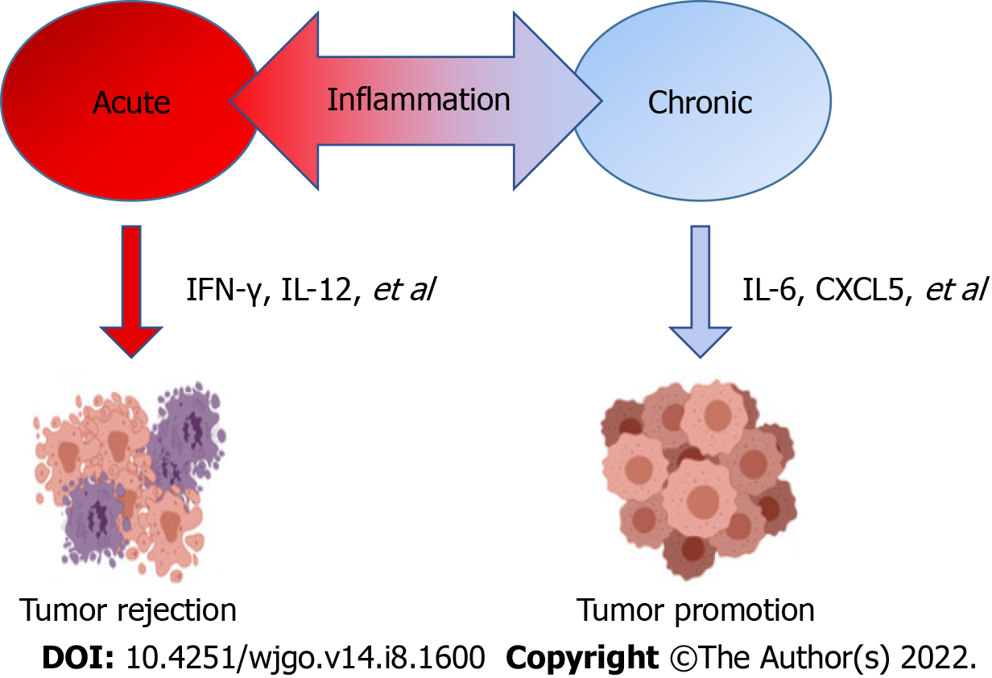
Figure 1 Relationship of inflammation and cancer.

Published by Baishideng Publishing Group Inc
7041 Koll Center Parkway, Suite 160, Pleasanton, CA 94566, USA
Telephone: +1-925-3991568
E-mail: bpgoffice@wjgnet.com
Help Desk: https://www.f6publishing.com/helpdesk
https://www.wjgnet.com

© 2022 Baishideng Publishing Group Inc. All rights reserved.

