Name of Journal: World Journal of Gastrointestinal Surgery
Manuscript NO: 82777
Manuscript Type: MINIREVIEWS

Median arcuate ligament syndrome often poses a diagnostic challenge: A literature review with a scope of our own experience

Giakoustids A et al. Median arcuate ligament syndrome

Alexandros Giakoustidis, Stavros Moschonas, Gregory Christodoulidis, Danae Chourmouzi, Anna Diamantidou, Sophia Masoura, Eleni Louri, Vasileios N Papadopoulos, Dimitrios Giakoustidis

Alexandros Giakoustidis, Stavros Moschonas, Vasileios N Papadopoulos, Dimitrios Giakoustidis, Department of Surgery, General Hospital Papageorgiou, Aristotle University of Thessaloniki, Thessaloniki 56429, Greece

Alexandros Giakoustidis, Danae Chourmouzi, Anna Diamantidou, Sophia Masoura, Eleni Louri, Dimitrios Giakoustidis, Fifth Department of Surgery, Interbalkan European Medical Centre, Thessaloniki 55535, Greece

Gregory Christodoulidis, Department of General Surgery, University Hospital of Larissa, Larissa 41110, Greece

Author contributions: Giakoustidis A designed the study, wrote most of the manuscript, and performed manuscript revisions; Moschonas S designed the study and wrote most of the manuscript; Christodoulidis G offered guidance and assisted as a corresponding author; Chourmouzi D, Diamantidou A, Masoura S, and Louri E assisted in writing part of the introduction and performed manuscript revisions; Papadopoulos VN and Giakoustidis D performed manuscript revisions.

Corresponding author: Gregory Christodoulidis, MD, PhD, Consultant Physician-Scientist, Department of General Surgery, University Hospital of Larissa, Mezourlo, Larissa 41110, Greece. gregsurg@yahoo.gr

Received: December 27, 2022
Revised: February 5, 2023
Accepted: April 18, 2023
Published online:

Abstract
The median arcuate ligament syndrome (MALS) is recognized as a rare clinical entity, characterized by chronic post-prandial abdominal pain, nausea, vomiting, and unintentional weight loss. Due to its vague symptomatology, it is mainly regarded as a diagnosis of exclusion. Patients can often be misdiagnosed for several years before a correct diagnosis is established, also due to a medical team’s clinical suspicion. We present a case series of two patients who suffered from MALS and were treated successfully. The first patient is a 32-year-old woman, presenting with post-prandial abdominal pain and weight loss that have lasted for the past ten years. The second patient, a 50-year-old woman, presented with similar symptomatology, with the symptoms lasting for the last five years. Both cases were treated by laparoscopic division of the median arcuate ligament fibers, which alleviated extrinsic pressure from the celiac artery. Previous cases of MALS were retrieved from PubMed, to assemble a better diagnostic algorithm and propose a treatment method of choice. The literature review suggests an angiography with a respiratory variation protocol as the diagnostic modality of choice, along with the laparoscopic division of the median arcuate ligament fibers as the proposed treatment of choice.

Key Words: Median arcuate ligament syndrome; Dunbar syndrome; Celiac trunk compression syndrome; Celiac artery compression syndrome; Case series; Review

Giakoustidis A, Moschonas S, Christodoulidis G, Chourmouzi D, Diamantidou A, Masoura S, Louri E, Papadopoulos VN, Giakoustidis D. Median arcuate ligament syndrome often poses a diagnostic challenge: A literature review with a scope of our own experience. World J Gastrointest Surg 2023; In press

Core Tip: Due to its rarity, reviews, meta-analyses, and guidelines regarding median arcuate ligament syndrome (MALS) are rare. Most data can be extracted by individual case reports and case series. Even though MALS has a low frequency among the general population, more and more studies continue to support the claim that an increasing percentage of people may be prone to present characteristics of the syndrome. Thus, using this case series of patients as an example, we explore the literature with an aim to propose an improved diagnostic algorithm and treatment of choice.

INTRODUCTION
The median arcuate ligament syndrome (MALS) does not represent a common clinical entity; however, its prevalence might be higher than previously considered^{[1]}. The European Society for Vascular Surgery guidelines regarding diseases of the mesenteric arteries and veins, state that MALS is the most common cause of single vessel abdominal arterial stenosis^{[2]}. It is characterized by recurrent episodes of post-prandial abdominal pain, nausea, vomiting, weight loss, and other more uncommon, but certainly potentially dangerous complications^{[3]}. Due to the confusing overlapping symptomatology between MALS and other chronic mesenteric ischemic clinical entities, many researchers believe that the syndrome may be under-diagnosed, as is the case in many patients with chronic mesenteric ischemia due to diagnostic delay^{[4]}. These factors have contributed to the lack of clinical studies and consensus guidelines for the diagnosis and treatment of this syndrome. Most clinical guidelines come from the systematic review and meta-analyses based on individual case reports and case series^{[5,6]}. In this paper, we present two patients who were laparoscopically treated for MALS. In addition, we attempt to add a narrative review of the literature regarding diagnostic workup and treatment options for this syndrome.

LITERATURE REVIEW
We conducted a review of the literature of the past 3 years throughout the PubMed database, using the terms “median arcuate ligament syndrome”, “MALS”, “median arcuate ligament syndrome case report”, “median arcuate ligament syndrome diagnosis”, and “median arcuate ligament syndrome treatment”.

PRESENTATION of Case 1
A 32-year-old woman presented to the outpatient clinic, complaining of abdominal pain, nausea, vomiting, and diarrhea. She had a ten-year history of recurrent post-prandial abdominal pain and weight loss. The symptoms have caused her to reduce her food intake and sometimes skip meals entirely. Her past medical history was unremarkable. She was not taking any prescribed medication and reported no allergies. The patient had never smoked and reported no significant alcohol consumption. Physical examination findings were unremarkable, other than the patient’s weight at 38 kg and her height at 160 cm [body mass index (BMI) = 14.8 kg/m²]. An abdominal X-ray showed gastric distension and no other remarkable findings. The magnetic resonance imaging (MRI) study performed with a respiratory variation protocol showed post-stenotic dilation of the celiac artery during expiration, along with a “J-shaped” or “hook-shaped” celiac artery (Figure 1).
After careful investigation of the patient’s history and examination of the physical and radiologic findings, a diagnosis of MALS was established. The patient was scheduled for a laparoscopic median arcuate ligament release.
For the laparoscopic surgery, the patient is placed in a reverse Trendelenburg position with the legs being apart. The surgeon is standing between the patient’s legs, a camera port is placed through the umbilicus, and four more ports are also inserted into the upper abdomen. The main goal of the procedure is to sustain a good view of the operative anatomy. The left and right diaphragmatic crura are exposed to achieve good view of the surgical field prior to the division of the median arcuate ligament fibers. The dissection of the diaphragmatic crura is continued cranially with the intention of identifying the branches of the celiac artery (common hepatic artery, left gastric artery and splenic artery). The left gastric artery is controlled with the use of a vessel loop and with significant traction, to prevent injuries upon the left gastric artery and maintain adequate view of the surgical field. The dissection continues until the plane of the abdominal aorta. At this point, it is easier to identify the connective tissue comprising the median arcuate ligament, along with fibers from the celiac plexus. Using hook diathermy and a laparoscopic dissector with diathermy, the median arcuate ligament fibers are excised. Inadvertently, some fibers from the celiac plexus are also cauterized, further adding to the main goal, which is reduction of the pressure upon the celiac artery, as well as dissecting the sympathetic pain fibers of the celiac plexus. During the procedure for case 1 specifically, an aberrant blood vessel heading towards the liver was recognized and carefully preserved. This further supports the theory of development of collateral blood vessels to compensate for the reduced flow through the celiac artery (Figure 2).

PRESENTATION of case 2
A 50-year-old woman presented to the outpatient clinic complaining of abdominal pain, nausea, and vomiting, with a 5-year history of post-prandial abdominal pain. She added that she had been losing weight over the referred time period. She also stated that she had undergone an extensive diagnostic workup in the past, for the same symptoms, but no diagnosis could be reached. Her past medical history was unremarkable. She was not taking any prescribed medication and reported no allergies. The patient had never smoked and reported no significant alcohol consumption. Physical examination findings were unremarkable and her BMI was in normal range (21 kg/m²). An abdominal X-ray showed gastric distension and no other remarkable findings. After reviewing her past diagnostic workups, an MRI with a respiratory variation protocol was performed. Similar to the first case, the patient’s celiac artery showed post-stenotic dilation during expiration, with a characteristic “J-shape”. A diagnosis of MALS was established and the patient underwent laparoscopic division of the median arcuate ligament fibers, thus relieving the pressure from the celiac artery. The surgical technique for case 2 was similar to that described earlier.
During subsequent follow-up checks, the most recent being a year after the procedures, both patients presented well. Physical examination and history did not reveal any findings or referred symptoms. The patients have gained weight and do not present any postoperative complications or symptoms.

DISCUSSION
The MALS, or otherwise called Dunbar syndrome, remains a rare clinical entity. Diagnosing the syndrome is a difficult task, due to the overlapping symptomatology among many other clinical entities^{[1]}. Even though the syndrome presents a low prevalence in the population, the anatomical variations responsible for the syndrome are present at a rather large portion of the population. Normally, the branches of the celiac artery arise from the abdominal aorta at the level of the T11-L1 vertebrae, while the diaphragmatic crura arise from the level of L1-L4^{[7]}. At that same level is where the median arcuate ligament connects the two parts of the diaphragmatic crura. In many people, a variation of the celiac artery arising at a higher level, or the diaphragmatic crura originating at a lower level, sets the circumstances for celiac artery compression. These anatomical prerequisites are found in 10%-24% of the population^{[1]}. Based on this percentage, MALS could be responsible for more cases of chronic mesenteric ischemia than previously thought. This vascular compression theory is accompanied by some other researchers who support that extrinsic pressure upon the celiac plexus from the median arcuate ligament may also play a role in the pathophysiology of the syndrome^{[4]}. The patients from the cases presented fit the characteristics of MALS, but the syndrome remains mostly a diagnosis of exclusion. The patient typically presents with postprandial abdominal pain, weight loss, nausea, vomiting, and diarrhea, among other complaints^{[8]}. From the physical examination, it is reported that in up to 35% of patients, an epigastric bruit can be heard on auscultation, but it certainly is not pathognomonic^{[6]}. These symptoms characterize a vast variety of diseases and syndromes throughout medicine, and certainly MALS is not the most common cause behind them^{[5]}. Due to its rarity and relatively low prevalence, a radiologist may not always have this specific diagnosis in mind and thus miss the characteristic findings in routine computed tomography (CT)^{[9]}. A study by Skeik et al^{[10]} stated that the prevalence for MALS among other non-atherosclerotic abdominal arterial vasculopathies was found to be around 15.3%. Mainly, the diagnosis of MALS requires careful examination of the physical, clinical, and imaging findings by a team of experienced physicians and radiologists. The diagnostic modalities that are more commonly used include CT of the abdomen with IV contrast, magnetic resonance angiography (MRA), or Doppler ultrasound with a respiratory variation protocol^{[4]}. However, the diagnosis may not be so simple in some cases, especially when the clinical presentation is not typical. One common complication of MALS due to the increased flow speed through the celiac trunk is the subsequent development of collateral blood vessels. This process causes damage to the endothelium of the arteries comprising the celiac trunk. One manifestation of this complication can be a spectrum of coagulopathies or vasculopathies, mainly affecting the organs supplied by the celiac trunk. For instance, a patient with symptomatology consistent with chronic mesenteric ischemia, along with splenic infarcts or pancreaticoduodenal aneurysms, superior mesenteric artery (SMA) thrombus, and retroperitoneal hemorrhage, should raise a question about examining the vasculature of the area for other abnormalities, to reach a definite diagnosis, which could include MALS, and also, treat the accompanying disease either via surgery or via interventional radiologic methods^{[11-15]}. All these complications and clinical presentations from MALS are reported in the literature, and as the cases of MALS increase, more complications could be associated with it. Another reason why the diagnosis of MALS may not be as easy as perhaps expected, is because it may even coincide with other vascular anomalies, such as a common origin of the SMA with the celiac trunk, or the co-incidence of syndromes such as the SMA syndrome or the nutcracker syndrome^{[16,17]}. A radiologist or a physician interpreting diagnostic imaging must always have in mind the case of aberrant anatomy when trying to reach a diagnosis.
In many cases, MALS may not be identified prior to other medical or surgical interventions, which could be the cause of many complex and threatening complications. During our search in the literature, in many cases the missed diagnosis caused a halt to the operative actions to re-evaluate pre-operative diagnostic imaging, thus prolonging operative time^{[18]}. In these cases, the decreased flow through the celiac trunk branches may cause postoperative complications, either medical or surgical, some of them even endangering the viability of other abdominal organs, as is the case in the reversal of flow in the hepatic artery causing liver ischemia^{[18]}.
Another important consideration about MALS occurs in the case of orthotopic liver transplantation. In these patients, MALS is considered a predisposing factor for hepatic artery thrombosis, due to the hemodynamic compromises in the hepatic artery^{[19]}. Specifically, the compression from the median arcuate ligament is responsible for a reduction of blood velocities in the hepatic artery. This vascular compromise may contribute to reduced blood supply to the liver graft, biliary complications, and hepatic artery thrombosis^{[20]}. In a recent retrospective study regarding patients receiving orthotopic liver transplantation, the presence of MALS dictated different management for the graft to be preserved and the procedure to be a success^{[19]}. According to Li et al^{[19]}, if flow from the hepatic artery is found to be reduced, the gastroduodenal arteries and the collateral branches should be preserved. Still, there is much debate regarding the surgical technique used in patients receiving orthotopic liver transplantation while suffering from MALS.
To prevent the mentioned complications and operative risks, a definitive diagnosis should be established in patients presenting with chronic mesenteric ischemic symptoms. Because these symptoms are non-specific, an extensive workup must be ordered, including right upper quadrant ultrasonography, abdominal CT, and upper endoscopy. Due to the prevalence of the disease, consensus guidelines for the diagnosis of MALS specifically are not reported. There have been some attempts to study a cohort of patients who have adhered to a strict plan for potential diagnosis and treatment of MALS, such as a recent study by Gerull et al^{[21]}. Mostly, patients undergo an extensive workup to exclude other diseases which are easier to definitively diagnose. A diagnostic modality that has been shown to have good efficiency and sensitivity is abdominal Doppler ultrasound, but it remains an operator dependent examination. A cut-off point that has been shown to have better efficiency is at 350 cm/s during the expiratory phase. Except for this cut-off, it has been reported that the difference in speed between the expiratory and inspiratory phase more than 50% has contributed towards the diagnosis of the syndrome^{[21]}. Even without the use of MRI or CT angiography, the characteristic “J-shape” of the celiac artery can be evident with the use of Doppler ultrasound^{[22]}. However, given the fact that Doppler ultrasound is operator dependent, it may not ultimately be the most accurate way of setting the diagnosis of MALS. So, keeping in mind that most patients have undergone an extensive diagnostic workup in the past, as was the case in our patients presented earlier, from our experience, our suggestion is to perform tests and diagnostic imaging that provide clear results. Thus, we consider MRA with a respiratory variation protocol to be the diagnostic modality of choice in patients undergoing a workup for MALS.
As far as the treatment options are concerned, procedures have varied throughout the years. Even when endovascular or other angioplasty techniques are considered as possible choices, it is possible that a surgical operation, preferably a laparoscopic procedure, is still superior to other approaches. This conclusion is evident from the cases where a surgical operation was required to treat the patients who initially underwent angioplasty procedures but were actually not relieved or did not show any sign of improvement. The main cause for the deficiencies of angioplasties to provide symptom relief is the inability to pass the guide wire through the stenosis formed from the median arcuate ligament and the diaphragmatic crura^{[23]}. Other than laparoscopic surgery, robotically assisted surgery is being considered as an alternative. However, data is scarce mainly due to the rarity of the syndrome and the limited experience with robotically assisted surgery in many hospitals. From studies regarding the postoperative outcomes, robotically assisted surgery is an acceptable option, providing treatment and good quality of life, as is evident from the good scores in questionnaires based on the patient’s experience^{[24,25]}.
A study by the American College of Surgeons National Surgical Quality Improvement Program which spanned for 10 years depicted that the patients in the laparoscopic group had lower length of stay, lower major complication rates, and lower reoperation rates^{[26]}. Even though the studies comparing robotically assisted surgery with laparoscopic surgery for MALS are rare, it has been stated that the abdominal pain associated with MALS was relieved more often in the group receiving the robotically assisted operation^{[27]}.
A very recent report from an expert panel on interventional radiology, regarding the topic of mesenteric ischemia, included MALS in their attempt to provide concise and evidence-based instructions for the diagnosis and treatment of mesenteric ischemia^{[28]}. From their recommendations, the selection of mesenteric angiography in lateral projection with a respiratory variation protocol (during both inspiration and expiration) is critical to the diagnosis of MALS and the depiction of the abdominal vascular anatomy. The development of collateral vessels, which is a complication from the celiac artery stenosis, has been found to be a poor prognostic factor in patients with MALS^{[28,29]}. The expert panel has also provided advice regarding the angioplasty vs surgical treatment options. According to their recommendations, transluminal angioplasty with the use of a stent should be reserved for patients whose symptoms and clinical presentation have not been resolved after a surgical division of the median arcuate ligament^{[28,30]}.
We acknowledge limitations in our mini-case series presentation and literature review. Our perspective originates from the diagnostic workup and treatment of two cases, which is still a relatively small number. Even though the diagnostic pathway and treatment used were successful, the collective study of more MALS cases can yield more definite results. Our review is based on recent studies and cases, and as the reported instances of the syndrome rise, more findings and guidelines can be published in the future.

CONCLUSION
Even though MALS is considered a diagnosis of exclusion, it should be considered in patients who seem to suffer from chronic mesenteric ischemic symptoms, but without a definite diagnosis. These patients have often already undergone an extensive workup, so it is important to choose the correct diagnostic approach, to provide definitive results. In our experience, the best options remain abdominal Doppler ultrasound and MRA with a respiratory variation protocol, with an extra advantage of the MRA as being non-operator dependent. Treatment should primarily focus on surgical release of the celiac artery, either laparoscopically or robotically assisted. Endovascular techniques should be reserved for patients who have already undergone a surgical procedure with no postoperative alleviation of symptoms.

REFERENCES
1 Kim EN, Lamb K, Relles D, Moudgill N, DiMuzio PJ, Eisenberg JA. Median Arcuate Ligament Syndrome-Review of This Rare Disease. JAMA Surg 2016; 151: 471-477 [PMID: 26934394 DOI: 10.1001/jamasurg.2016.0002]
2 Björck M, Koelemay M, Acosta S, Bastos Goncalves F, Kölbel T, Kolkman JJ, Lees T, Lefevre JH, Menyhei G, Oderich G, Esvs Guidelines Committee, Kolh P, de Borst GJ, Chakfe N, Debus S, Hinchliffe R, Kakkos S, Koncar I, Sanddal Lindholt J, Vega de Ceniga M, Vermassen F, Verzini F, Document Reviewers, Geelkerken B, Gloviczki P, Huber T, Naylor R. Editor's Choice - Management of the Diseases of Mesenteric Arteries and Veins: Clinical Practice Guidelines of the European Society of Vascular Surgery (ESVS). Eur J Vasc Endovasc Surg 2017; 53: 460-510 [PMID: 28359440 DOI: 10.1016/j.ejvs.2017.01.010]
3 Chaum M, Shouhed D, Kim S, Walts AE, Marchevsky AM. Clinico-pathologic findings in patients with median arcuate ligament syndrome (celiac artery compression syndrome). Ann Diagn Pathol 2021; 52: 151732 [PMID: 33798927 DOI: 10.1016/j.anndiagpath.2021.151732]
4 Goodall R, Langridge B, Onida S, Ellis M, Lane T, Davies AH. Median arcuate ligament syndrome. J Vasc Surg 2020; 71: 2170-2176 [PMID: 31882314 DOI: 10.1016/j.jvs.2019.11.012]
5 Metz FM, Blauw JTM, Brusse-Keizer M, Kolkman JJ, Bruno MJ, Geelkerken RH; Dutch Mesenteric Ischaemia Study Group. Systematic Review of the Efficacy of Treatment for Median Arcuate Ligament Syndrome. Eur J Vasc Endovasc Surg 2022; 64: 720-732 [PMID: 36075541 DOI: 10.1016/j.ejvs.2022.08.033]
6 Jimenez JC, Harlander-Locke M, Dutson EP. Open and laparoscopic treatment of median arcuate ligament syndrome. J Vasc Surg 2012; 56: 869-873 [PMID: 22743019 DOI: 10.1016/j.jvs.2012.04.057]
7 Loukas M, Pinyard J, Vaid S, Kinsella C, Tariq A, Tubbs RS. Clinical anatomy of celiac artery compression syndrome: a review. Clin Anat 2007; 20: 612-617 [PMID: 17309066 DOI: 10.1002/ca.20473]
8 DeCarlo C, Woo K, van Petersen AS, Geelkerken RH, Chen AJ, Yeh SL, Kim GY, Henke PK, Tracci MC, Schneck MB, Grotemeyer D, Meyer B, DeMartino RR, Wilkins PB, Iranmanesh S, Rastogi V, Aulivola B, Korepta LM, Shutze WP, Jett KG, Sorber R, Abularrage CJ, Long GW, Bove PG, Davies MG, Miserlis D, Shih M, Yi J, Gupta R, Loa J, Robinson DA, Gombert A, Doukas P, de Caridi G, Benedetto F, Wittgen CM, Smeds MR, Sumpio BE, Harris S, Szeberin Z, Pomozi E, Stilo F, Montelione N, Mouawad NJ, Lawrence P, Dua A. Factors associated with successful median arcuate ligament release in an international, multi-institutional cohort. J Vasc Surg 2023; 77: 567-577.e2 [PMID: 36306935 DOI: 10.1016/j.jvs.2022.10.022]
9 Narwani P, Khanna N, Rajendran I, Kaawan H, Al-Sam R. Median arcuate ligament syndrome diagnosis on Computed Tomography: what a radiologist needs to know. Radiol Case Rep 2021; 16: 3614-3617 [PMID: 34646405 DOI: 10.1016/j.radcr.2021.06.093]
10 Skeik N, Hyde JR, Olson SL, Thaler CM, Abuatiyeh W, Ahmed AK, Lyon DR, Witt DR, Garberich R, Sullivan T. Nonatherosclerotic Abdominal Vasculopathies. Ann Vasc Surg 2019; 60: 128-146 [PMID: 31200053 DOI: 10.1016/j.avsg.2019.04.004]
11 Chalh O, Billah NM, Nassar I. Median Arcuate Ligament Syndrome Revealed by Splenic Infarcts. J Belg Soc Radiol 2022; 106: 32 [PMID: 35581983 DOI: 10.5334/jbsr.2781]
12 Lu XC, Pei JG, Xie GH, Li YY, Han HM. Median arcuate ligament syndrome with retroperitoneal haemorrhage: A case report. World J Clin Cases 2022; 10: 7509-7516 [PMID: 36158028 DOI: 10.12998/wjcc.v10.i21.7509]
13 Akasaki Y, Takaki M, Konagaya K, Watanabe K, Shimizu T. Posterior inferior pancreaticduodenal artery aneurysm rupture due to median arcuate ligament syndrome. Am J Med Sci 2022; 364: e89-e90 [PMID: 35907570 DOI: 10.1016/j.amjms.2022.07.012]
14 Endo Y, Sekino H, Ishii S, Okada R, Kofunato Y, Nakano H, Watanabe Y, Marubashi S, Kono K, Ito H. Two cases of pancreaticoduodenal aneurysm with median arcuate ligament syndrome treated with coil embolization and median arcuate ligament incision. Radiol Case Rep 2022; 17: 3663-3668 [PMID: 35936877 DOI: 10.1016/j.radcr.2022.07.048]
15 Matsumoto K, Shinozaki H, Shinozaki S, Terauchi T, Lefor AK, Sata N. Normalization of Flow in the Common Hepatic Artery after Decompression of Median Arcuate Ligament Syndrome with Diminution of a Pancreatoduodenal Arcade Aneurysm. Case Rep Gastroenterol 2022; 16: 284-289 [PMID: 35702328 DOI: 10.1159/000524428]
16 Akkus AT, Atalay SA, Bayraktutan U. Median arcuate ligament syndrome in association with celiomesenteric trunk. Diagn Interv Imaging 2022; 103: 381-382 [PMID: 35643925 DOI: 10.1016/j.diii.2022.05.002]
17 Farina R, Gozzo C, Foti PV, Conti A, Vasile T, Pennisi I, Venturini M, Basile A. A man with the rare simultaneous combination of three abdominal vascular compression syndromes: median arcuate ligament syndrome, superior mesenteric artery syndrome, and nutcracker syndrome. Radiol Case Rep 2021; 16: 1264-1270 [PMID: 33854661 DOI: 10.1016/j.radcr.2021.02.065]
18 Usta S, Karabulut K, Artaş H. Median arcuate ligament syndrome noticed during pancreaticoduodenectomy. Turk J Surg 2022; 38: 95-97 [PMID: 35873742 DOI: 10.47717/turkjsurg.2022.3989]
19 Li SX, Fan YH, Tian GY, Lv GY. Feasible management of median arcuate ligament syndrome in orthotopic liver transplantation recipients. World J Gastrointest Surg 2022; 14: 976-985 [PMID: 36185558 DOI: 10.4240/wjgs.v14.i9.976]
20 Sun X, Fan Z, Qiu W, Chen Y, Jiang C, Lv G. Median arcuate ligament syndrome and arterial anastomotic bleeding inducing hepatic artery thrombosis after liver transplantation: A case report. Medicine (Baltimore) 2018; 97: e10947 [PMID: 29923979 DOI: 10.1097/MD.0000000000010947]
21 Gerull WD, Sherrill W, Awad MM. Robotic median arcuate ligament release: management algorithm and clinical outcomes from a large minimally invasive series. Surg Endosc 2022 [PMID: 35999316 DOI: 10.1007/s00464-022-09545-8]
22 Cernigliaro J, Chen F, Bhatt S. The "Hook" sign of median arcuate ligament syndrome on ultrasound. Abdom Radiol (NY) 2021; 46: 2251-2252 [PMID: 33141260 DOI: 10.1007/s00261-020-02842-7]
23 Yang K, Xu HW, Wei YG, Li B. Median arcuate ligament syndrome treated by laparoscopy after a failed balloon angioplasty: A case report. Asian J Surg 2023; 46: 1289-1290 [PMID: 36041892 DOI: 10.1016/j.asjsur.2022.08.070]
24 Magnus L, Chakfé N, Lejay A, Thaveau F. Robot Assisted Laparoscopy for Median Arcuate Ligament Syndrome Relief. EJVES Vasc Forum 2022; 56: 32-36 [PMID: 36035891 DOI: 10.1016/j.ejvsvf.2022.06.002]
25 Fernstrum C, Pryor M, Wright GP, Wolf AM. Robotic Surgery for Median Arcuate Ligament Syndrome. JSLS 2020; 24 [PMID: 32518479 DOI: 10.4293/JSLS.2020.00014]
26 Romero-Velez G, Barajas-Gamboa JS, Pantoja JP, Corcelles R, Rodriguez J, Navarrete S, Park WM, Kroh M. A nationwide analysis of median arcuate ligament release between 2010 and 2020: a NSQIP Study. Surg Endosc 2023; 37: 140-147 [PMID: 35854125 DOI: 10.1007/s00464-022-09431-3]
27 Shin TH, Rosinski B, Strong A, Fayazzadeh H, Fathalizadeh A, Rodriguez J, El-Hayek K. Robotic vs laparoscopic median arcuate ligament (MAL) release: a retrospective comparative study. Surg Endosc 2022; 36: 5416-5423 [PMID: 34811583 DOI: 10.1007/s00464-021-08877-1]
28 Expert Panel on Interventional Radiology, Lam A, Kim YJ, Fidelman N, Higgins M, Cash BD, Charalel RA, Guimaraes MS, Kwan SW, Patel PJ, Plett S, Scali ST, Stadtlander KS, Stoner M, Tong R, Kapoor BS. ACR Appropriateness Criteria® Radiologic Management of Mesenteric Ischemia: 2022 Update. J Am Coll Radiol 2022; 19: S433-S444 [PMID: 36436968 DOI: 10.1016/j.jacr.2022.09.006]
29 van Petersen AS, Kolkman JJ, Gerrits DG, van der Palen J, Zeebregts CJ, Geelkerken RH; Dutch Mesenteric Ischemia Study Group. Clinical significance of mesenteric arterial collateral circulation in patients with celiac artery compression syndrome. J Vasc Surg 2017; 65: 1366-1374 [PMID: 28259570 DOI: 10.1016/j.jvs.2016.11.052]
30 Tracci MC. Median arcuate ligament compression of the mesenteric vasculature. Tech Vasc Interv Radiol 2015; 18: 43-50 [PMID: 25814203 DOI: 10.1053/j.tvir.2014.12.007]

Footnotes
Conflict-of-interest statement: The authors declare no conflict of interests for this article.

Open-Access: This article is an open-access article that was selected by an in-house editor and fully peer-reviewed by external reviewers. It is distributed in accordance with the Creative Commons Attribution NonCommercial (CC BY-NC 4.0) license, which permits others to distribute, remix, adapt, build upon this work non-commercially, and license their derivative works on different terms, provided the original work is properly cited and the use is non-commercial. See: https://creativecommons.org/Licenses/by-nc/4.0/

Provenance and peer review: Unsolicited article; Externally peer reviewed.
Peer-review model: Single blind

Peer-review started: December 27, 2022
First decision: January 22, 2023
Article in press:

Specialty type: Surgery
Country/Territory of origin: Greece
Peer-review report’s scientific quality classification
Grade A (Excellent): 0
Grade B (Very good): B
Grade C (Good): C
Grade D (Fair): 0
Grade E (Poor): 0

P-Reviewer: Brigode WM, United States; Tuo BG, China S-Editor: Chen YL L-Editor: Wang TQ P-Editor:

Figure Legends
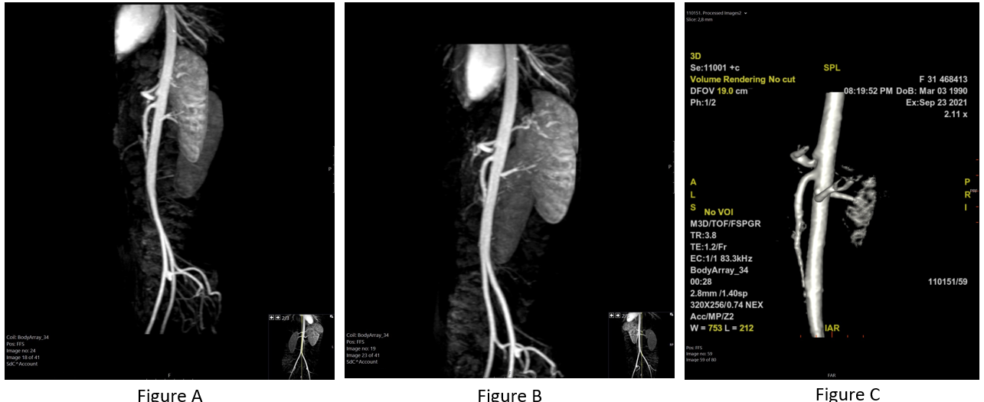
Figure 1 Magnetic resonance angiography with a respiratory variation protocol. A-C: Evident stenosis of the celiac artery and post-stenotic dilatation.

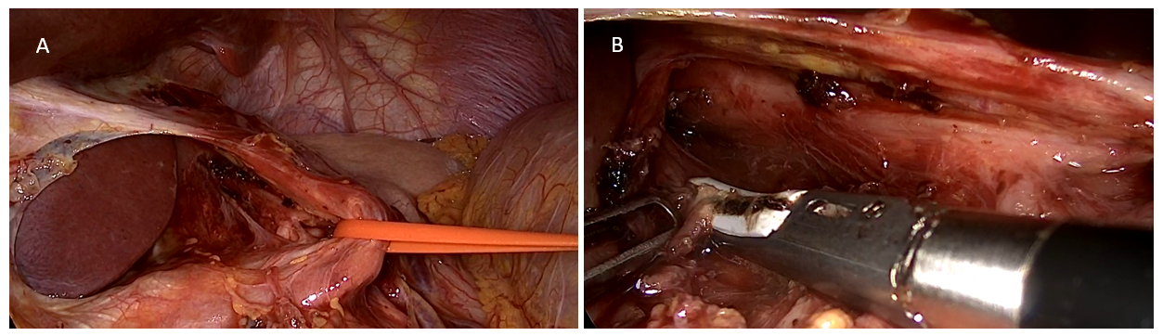
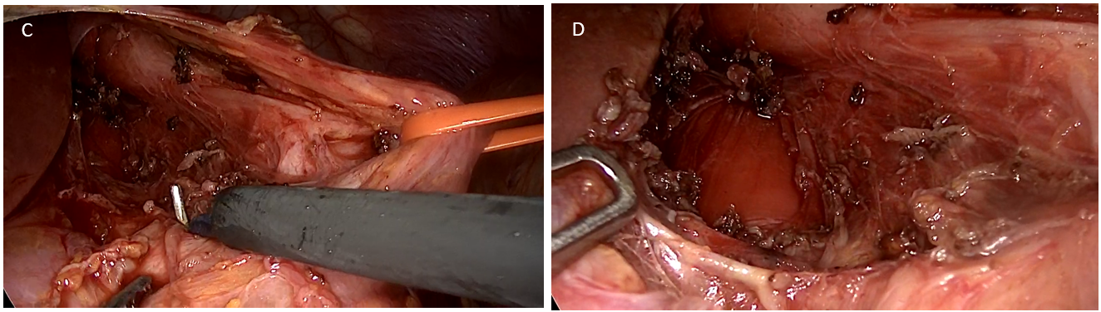
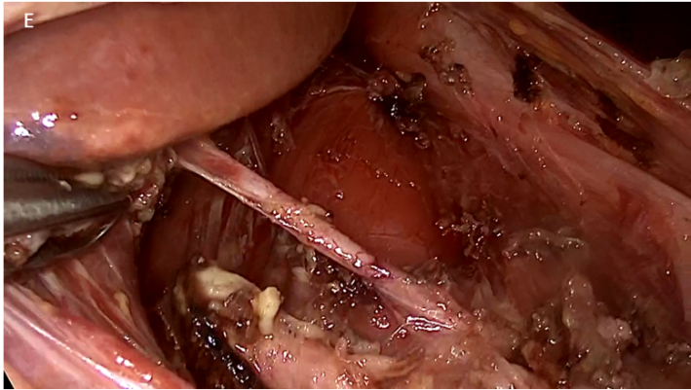
Figure 2 Intraoperative images. A: Vessel loop around the left gastric artery; B: Careful dissection along the diaphragmatic crura; C: Dissection continues as the aorta is starting to be exposed and relieved from the extrinsic pressure of the diaphragmatic crura and the median arcuate ligament; D: Exposure of the abdominal aorta after the dissection of the diaphragmatic crura, the median arcuate ligament, and the neural fibers of the celiac plexus; E: Final look of the abdominal aorta along with the recognition of an aberrant blood vessel towards the liver.

