Name of journal: World Journal of Gastroenterology
Manuscript NO: 50316
Manuscript type: ORIGINAL ARTICLE

Basic Study
Nucleus tractus solitarius mediates hyperalgesia induced by chronic pancreatitis in rats

Bai Y et al. Rat model of chronic pancreatitis

Yang Bai, Ying-Biao Chen, Xin-Tong Qiu, Yan-Bing Chen, Li-Tian Ma, Ying-Qi Li, Hong-Ke Sun, Ming-Ming Zhang, Ting Zhang, Tao Chen, Bo-Yuan Fan, Hui Li, Yun-Qing Li

Yang Bai, Xin-Tong Qiu, Yan-Bing Chen, Li-Tian Ma, Ming-Ming Zhang, Ting Zhang, Tao Chen, Hui Li, Yun-Qing Li, Department of Anatomy, Histology and Embryology & K. K. Leung Brain Research Centre, Fourth Military Medical University, Xi’an 710032, Shaanxi Province, China

Ying-Biao Chen, Department of Anatomy, Fujian Health College, Fuzhou 350101, Fujian Province, China

Ying-Qi Li, Hong-Ke Sun, Bo-Yuan Fan, Department of Cardiology, The Second Affiliated Hospital of Xian Jiaotong University, Xian Jiaotong University, Xi'an 710004, Shaanxi Province, China

Yun-Qing Li, Joint Laboratory of Neuroscience at Hainan Medical University and Fourth Military Medical University, Hainan Medical University, Haikou 571199, Hainan Province, China

ORCID number: Yang Bai (0000-0002-6618-8929); Ying-Biao Chen (0000-0001-7775-081X); Xin-Tong Qiu (0000-0001-5983-9474); Yan-Bing Chen (0000-0002-9399-8986); Li-Tian Ma (0000-0002-7177-4439); Ying-Qi Li (0000-0002-5239-4799); Hong-Ke Sun (0000-0003-3355-1127); Ming-Ming Zhang (0000-0002-1161-5313); Ting Zhang (0000-0002-6871-6238); Tao Chen (0000-0003-1956-0553); Bo-Yuan Fan (0000-0003-4559-962X); Hui Li (0000-0001-9083-7776); Yun-Qing Li (0000-0002-3707-3348).

Author contributions: Bai Y and Chen YB established the CP model, performed behavior tests and harvested tissue samples. Chen YB and Chen T performed electrophysiological tests. Ma LT, Li YQ and Sun HK carried out immunoblotting tests. Bai Y, Zhang T and Qiu XT performed immunostaining tests. Li YQ, Li H and Fan BY designed the study and edited the manuscript. Bai Y analyzed the data and wrote the manuscript. Bai Y and Chen YB contributed equally to this manuscript.

Supported by National Natural Science Foundations of China, No. 81620108008; Major Research and Development Project of Hainan Province, No. 2018153 to Yun-Qing Li; and Training Program for Scientific Research Scholars of Fujian Provincial Health and Family Planning Commission, No. 2018-ZQN-74 to Ying-Biao Chen.

Institutional animal care and use committee statement: All procedures involving animals were reviewed and approved by the Institutional Animal Care and Use Committee of the Fourth Military Medical University (IACUC protocol number: 20170702).

Conflict-of-interest statement: The authors declare there are no competing financial interests.

Data sharing statement: No additional data are available.

ARRIVE guidelines statement: The authors have read the ARRIVE guidelines, and the manuscript was prepared and revised according to the ARRIVE guidelines.

Open-Access: This is an open-access article that was selected by an in-house editor and fully peer-reviewed by external reviewers. It is distributed in accordance with the Creative Commons Attribution Non Commercial (CC BY-NC 4.0) license, which permits others to distribute, remix, adapt, build upon this work non-commercially, and license their derivative works on different terms, provided the original work is properly cited and the use is non-commercial. See: http://creativecommons.org/licenses/by-nc/4.0/

Manuscript source: Unsolicited manuscript

Corresponding author: Yun-Qing Li, PhD, Professor, Department of Anatomy, Histology and Embryology & K. K. Leung Brain Research Centre, Fourth Military Medical University, No. 169 West Chang-le Road, Xi'an 710032, Shaanxi Province, China. deptanat@fmmu.edu.cn
Telephone: +86-29-84772706
Fax: +86-29-83283229

Received: July 17, 2019
Peer-review started: July 19, 2019
First decision: August 18, 2019
Revised: September 6, 2019
Accepted: September 11, 2019
Article in press:
Published online:

Abstract
BACKGROUND
Central sensitization plays a pivotal role in the maintenance of chronic pain induced by chronic pancreatitis (CP). We hypothesized that the nucleus tractus solitarius (NTS), a primary central site that integrates pancreatic afferents apart from the thoracic spinal dorsal horn, plays a key role in the pathogenesis of visceral hypersensitivity in a rat model of CP.

AIM
To investigate the role of the NTS in the visceral hypersensitivity induced by chronic pancreatitis.

METHODS
CP was induced by the intraductal injection of trinitrobenzene sulfonic acid (TNBS) in rats. Pancreatic hyperalgesia was assessed by referred somatic pain via von Frey filaments. Neural activation of the NTS was indicated by FOS immunohistochemical staining. Basic synaptic transmission within the NTS was assessed by electrophysiological recordings. Expressions of vesicular glutamate transporters (VGluTs), N-methyl-D-aspartate receptor subtype 2B (NR2B) and α-Amino-3-hydroxy-5-methyl-4-isoxazolepropionic acid receptor subtype 1 (GluR1) were analyzed by immunoblotting. Membrane insertion of NR2B and GluR1 was evaluated by electron microscopy. The regulatory role of the NTS in visceral hypersensitivity was detected via pharmacological approach and chemogenetics in CP rats.

RESULTS
TNBS treatment significantly increased the number of FOS-expressing neurons within the caudal NTS. The excitatory synaptic transmission was substantially potentiated within the caudal NTS in CP rats (frequency: 5.87 ± 1.12 Hz in CP rats vs 2.55 ± 0.44 Hz in sham rats, P < 0.01; amplitude: 19.60 ± 1.39 pA in CP rats vs 14.71 ± 1.07 pA in sham rats; P < 0.01). CP rats showed upregulated expression of VGluT2, and increased phosphorylation and postsynaptic trafficking of NR2B and GluR1 within the caudal NTS. Blocking excitatory synaptic transmission via the AMPAR antagonist CNQX and the NMDAR antagonist AP-5 microinjection reversed visceral hypersensitivity in CP rats (abdominal withdraw threshold: 7.00 ± 1.02 g in CNQX group, 8.00 ± 0.81 g in AP-5 group and 1.10 ± 0.27 g in saline group, P < 0.01). Inhibiting the excitability of NTS neurons via chemogenetics also significantly attenuated pancreatic hyperalgesia (abdominal withdraw threshold: 13.67 ± 2.55 g in Gi group, 2.00 ± 1.37 g in Gq group and 2.36 ± 0.67 g in mCherry group, P < 0.01).

CONCLUSION
Our findings suggest that enhanced excitatory transmission within the caudal NTS contributes to pancreatic pain and emphasize the NTS as a pivotal hub for the processing of pancreatic afferents, which provide novel insights into the central sensitization of painful CP.

Key words: Rat; Chronic pancreatitis; Visceral hypersensitivity; The nucleus tractus solitarius; Excitatory synaptic transmission

© The Author(s) 2019. Published by Baishideng Publishing Group Inc. All rights reserved.

Core tip: This study investigates the role of the nucleus tractus solitarius (NTS) in the pathogenesis of visceral hypersensitivity in a rat model of chronic pancreatitis (CP). We demonstrated that CP rats exhibited potentiated excitatory synaptic transmission within the caudal NTS. This potentiation may be mediated by enhanced glutamate release and the recruitment of membrane glutamate receptors. Inhibiting both the excitatory synaptic transmission and neural activity of caudal NTS neurons alleviated visceral hypersensitivity in CP rats. Our results suggest the caudal NTS as a primary central site that processes pancreatic pain, as well as a potential therapeutic target for the treatment of chronic visceral pain in patients with CP.

Bai Y, Chen YB, Chen YB, Ma LT, Li YQ, Sun HK, Qiu XT, Zhang T, Chen T, Fan BY, Li H, Li YQ. Nucleus tractus solitarius mediates hyperalgesia induced by chronic pancreatitis in rats. World J Gastroenterol 2019; In press

INTRODUCTION
Persistent pain is the cardinal feature of chronic pancreatitis (CP) with a profound socioeconomic impact^{[1]}. The management of painful CP remains a major challenge because current therapeutic approaches fail to produce satisfactory results. More effective therapies require the discovery of novel targets based on new advances in our understanding of the neurobiology of painful CP^{[2,3]}. Anatomical knowledge indicates pancreatic sensory information enters the central nervous system via both sympathetic and vagus nerves. The former runs through the celiac plexus and reaches the lower thoracic spinal cord via the splanchnic nerve, while the latter runs through the nodose ganglion and connects with the nucleus tractus solitarius (NTS) via the abdominal vagus^{[4]}. Previous studies concerning the central processing of painful CP usually center on the thoracic spinal dorsal horn^{[5-7]}. In general, prolonged stimulation from peripheral sensitization facilitates aberrant excitation of dorsal horn neurons. This process is referred to as central sensitization and results in visceral hypersensitivity in chronic pancreatic pain^{[8-10]}. Unfortunately, much less focus has been directed on the role of the NTS in painful CP.
The NTS is a key relay station for primary visceral afferents located within the dorsomedial medulla oblongata. It is commonly recognized that the rostral third of the NTS is implicated in gustatory and oral somatosensory regulation^{[11]}, while the caudal two-thirds is a major hub for general visceral sensation^{[12]}. An increasing body of morphological evidence has demonstrated both mechanical^{[13,14]} and chemical^{[15-17]} gastrointestinal noxious stimuli induced overexpression of FOS within the NTS, suggesting the involvement of the NTS in the processing of visceral pain. However, the cellular and molecular mechanisms underlying the role of the NTS in visceral pain have not been reported.
Glutamate is the major excitatory neurotransmitter within the NTS. Excitatory synaptic transmission is generally mediated by the action of glutamate on two different ionotropic receptors, the N-methyl-D-aspartate receptor (NMDAR) and the α-Amino-3-hydroxy-5-methyl-4-isoxazolepropionic acid receptor (AMPAR), which plays a major role in the processing of visceral sensation within the NTS^{[18,19]}. Accumulating preclinical studies have provided evidence of plasticity changes in glutamatergic synaptic transmission within the NTS, including the upregulation, modification and membrane insertion of NMDAR and AMPAR, under pathological circumstances such as chronic hypertension and hypoxia^{[20-22]}. Our previous study also showed that excitatory synaptic transmission within the NTS was enhanced during chronic myocardial infarction (CMI) induced visceral pain^{[23]}. Both chemical lesion and pharmacological inhibition of the NTS exerted analgesic effects in cardiac visceral pain^{[23,24]}. Considering these, we hypothesized that excitatory synaptic transmission within the NTS is potentiated and contributes to visceral hypersensitivity in painful CP.
In the present study, we ﬁrst examined the expression of FOS within the NTS in rats with CP induced by intraductal trinitrobenzene sulfonic acid (TNBS) injection. Electrophysiological approach was subsequently performed to explore the changes in excitatory synaptic transmission within the NTS. Then, immunoblottings and electron microscopy were applied to unravel the potential molecular basis for these changes. Finally, we proved the pain-facilitating role of the NTS in the pathogenesis of painful CP via pharmacological method and chemogenetics.

MATERIALS AND METHODS
Animals and experimental design
Eighty-one male Sprague-Dawley rats (250-280 g) were provided by the Experimental Animal Center of the Fourth Military Medical University (Xi’an, China). All procedures were performed according to the guidelines of the International Association for the Study of Pain^{[25]} and approved by the Institutional Animal Care and Use Committee of the Fourth Military Medical University. Every measure was taken to minimize the discomfort of the animals. The animals were acclimatized to laboratory conditions (23 ℃, 12 h/12 h light/dark, 50% humidity) for two weeks prior to experimentation and were provided with water and food ad libitum 12 h before and after the induction of pancreatitis, during which food and water were withdrawn. Animals for tissue collection were euthanized by an overdose of 2% pentobarbital sodium (i.p., 100 mg/kg), while those for surgery were deeply anesthetized via 2% pentobarbital sodium (i.p., 40 mg/kg).
Experiment 1: Evidence of increased expression of FOS-immunoreactive (-ir) neurons within the NTS in CP rats. Eight rats were equally divided into 2 groups (sham and TNBS groups). Pancreatitis was induced by intraductal infusion of 0.4 mL 2% TNBS (Sigma, St. Louis, MO, USA) as previously reported^{[26]}. The sham rats received an equal volume of saline. On post-operation day (POD) 14, brain tissues were sampled for FOS immunostaining.
Experiment 2: Effect of painful CP on excitatory synaptic transmission within the NTS. Eighteen rats were equally divided into 2 groups (sham and TNBS groups). At POD 14, brainstem sections containing the NTS were obtained for electrophysiological recordings.
Experiment 3: Effect of painful CP on the expression of vesicular glutamate transporters (VGluTs), NMDAR subunit NR2B, and AMPAR subunit GluR1 within the NTS. Twelve rats were equally divided into 4 groups (sham, TNBS POD 7, POD 14 and POD 28 groups). All TNBS-treated rats were sacrificed according to aforementioned time points and processed for NTS sampling for VGluT1, VGluT2, NR2B and GluR1 immunoblotting.
Experiment 4: Evidence for painful CP induced membrane insertion of NR2B and GluR1 within the NTS. Six rats were equally divided into 2 groups (saline and TNBS groups). On POD 14, the brainstems were sampled for NR2B and GluR1 electron microscopy.
Experiment 5: Effects of CNQX (AMPAR antagonist) and AP-5 (NMDAR antagonist) microinjection into NTS on visceral hypersensitivity of CP rats. Nineteen rats were divided into 3 groups (6 rats in saline group, 6 rats in CNQX group and 7 rats in AP-5 group), and received cannula implantation upon the NTS 7 days before TNBS treatment. On POD 14, the AWT (abdominal withdraw threshold) was monitored before and after drug microinjection into the NTS.
Experiment 6: Effects of activation or inactivation of NTS excitatory neurons on visceral hypersensitivity of CP rats. Eighteen rats were equally divided into 3 groups (CaMKIIa-Gq, CaMKIIa-mCherry, and CaMKIIa-Gi groups), and received virus injection into the NTS 7 d before TNBS treatment. On POD 14, the AWT was monitored before and after clozapine-N-oxide (CNO) treatment.

von Frey test
As a measure of referred abdominal mechanical hypersensitivity in CP rats, AWT was monitored by von Frey filaments (VFF; Stoelting, Kiel, WI, United States) assay^{[26]}. For the VFF assay, the belly area designated for stimulation was shaved 3 d before testing. The animals were habituated in the testing apparatus until calming down. VFFs with increased forces from 0.16 g to 26 g were applied to the abdomen 5 times, each for 5-8 s with a 5 min interval. The minimal force that elicited at least 3 times withdrawn responses was considered as the AWT.

Immunohistochemical staining
On POD 14, the rats in Experiment 1 were deeply anesthetized and then perfused with 100 mL of 0.01 mol/L phosphate buffer saline (PBS, pH 7.4), followed by 500 mL 4% paraformaldehyde (PFA) fixative solution in 0.1 mol/L phosphate buffer (PB, pH 7.4). After perfusion, the brains were removed, placed in 30% sucrose solution for 24 h at 4 °C and then cut into coronal sections at 35 µm thickness into 6 dishes as 6 sets of every sixth serial sections. Next, the sections in the first set were incubated in 10% normal donkey serum for 40 min at room temperature (RT) to block nonspecific immunoreactivity, and then incubated overnight at 4 °C with the following antibodies in sequence: (1) mouse anti-FOS (1:500; Abcam, Cambridge, MA, United States) for 24 h at 4 °C; (2) biotinylated donkey anti-mouse (1:500; Millipore, Billerica, MA, United States) for 4 h at RT; and (3) avidin-biotin complex (1:200; ABC kit, Vector, Burlingame, CA, United States) for 2 h at RT. The sections were then reacted with 0.05 mol/L Tris-HCl buffer containing 0.02% DAB (Dojin, Kumamoto, Japan) and 0.003% H₂O₂ for visualizing FOS. Finally, the slices were mounted onto glass slides, and coverslipped for examination via light microscopy (AH-3, Olympus, Tokyo, Japan). The images were captured and analyzed using a Fluoview 1000 (Olympus). For FOS counting, at least 4 sections per brain region from each rat were counted for the average number of FOS-ir neurons in sham and TNBS groups (4 rats per group) by an investigator who was blind to the experiment. We limited our quantifications to medial prefrontal cortex (mPFC), anterior cingulate cortex (ACC), insular cortex (IC), paraventricular thalamic nucleus (PVT), central medial thalamic nucleus (CM), amygdala, periaqueductal gray (PAG), dorsal raphe nucleus (DR), parabrachial nuclei (PBN) and NTS, all of which were closely related to visceral pain^{[17,27]}.

Whole-cell patch-clamp recordings
On POD 14, the rats in Experiment 2 were anesthetized and coronal brainstem sections (300 μm) containing the NTS were cut at 4 °C with a vibratome in oxygenated ACSF (in mmol/L: 124 NaCl, 2.5 KCl, 2 MgSO₄, 2 CaCl₂, 25 NaHCO₃, 1 NaH₂PO₄, 37 glucose, pH 7.4). The sections were then transferred to a recovery chamber with oxygenated ACSF at RT for 1 h. For whole-cell patch-clamp recordings, the section was placed in a recording chamber maintained with oxygenated ACSF at 28 °C. The potassium-based intracellular solution within the micropipettes (8-10 MΩ) contained the following (in mmol/L): 120 K-gluconate, 5 NaCl, 0.2 EGTA, 10 HEPES, 2 MgATP, 0.1 Na₃GTP, 1 MgCl₂ and 10 phosphocreatine (adjusted to pH 7.2 with KOH, 290 mOsm). Neurons with small diameters (< 15 μm), which were assumed to receive excitatory afferents^{[28,29]}, were visually preselected in the commissure and medial part of caudal NTS neurons. Before recording, a concentric bipolar electrode was placed on the adjacent solitary tract and stimulus pulses were applied at a minimal voltage (1-15 V, 0.1 ms pulse width). Only neurons with a clear monosynaptic evoked excitatory postsynaptic currents (EPSC) peak were then processed for spontaneous EPSCs (sEPSCs) recording. sEPSCs were recorded for at least 10 min with the membrane clamped at -70 mV, and sEPSCs from 5 to 10 min were statistically analyzed. All recordings were conducted in the presence of picrotoxin (100 μM, Sigma) to block GABA_{A} receptor-mediated inhibitory synaptic currents. All recordings were performed with a MultiClamp 700B amplifier (Axon Instruments, Sunnyvale, CA, United States) and digitized at 5 kHz by DigiData 1550B (Axon Instruments). Data were discarded if the access resistance (10-30 MΩ) changed by 15% during the experiment.

Western blotting
Brainstem tissues from the rats in Experiment 3 were harvested in cold ACSF. Total protein was prepared for VGluT1, VGluT2, NR2B and GluR1 assays according to our previous study^{[30]}. Subsequently, 30 µg protein from each sample (quantitatively measured by bicinchoninic acid protein assay; Thermo Scientific; Rockford, IL, United States) was subjected to 10% sodium dodecyl sulfate-polyacrylamide gel (SDS-PAGE) electrophoresis and electrophoretically transferred to polyvinylidene difluoride (PVDF) membranes (Immobilon-P, Millipore, Billerica, MA, United States). After blocking in 5% Tris Buffered Saline Tween (TBST)-containing DifcoTM skim milk for 2 h, the membranes were incubated overnight at 4°C with the following primary antibodies: mouse anti-VGluT1 (1:500; Millipore); mouse anti-VGluT2 (1:500; Synaptic Systems, Goettingen, Niedersachsen, Germany); rabbit anti-pNR2B-Tyr¹⁴⁷² (1:500; Millipore); rabbit anti-NR2B (1:500; Abcam, Cambridge, United Kingdom); rabbit anti-GluR1 (1:500; Millipore); and rabbit anti-pGluR1-Ser⁸⁴⁵ (1:500; Millipore). The immunoblots were then incubated with horseradish peroxidase (HRP)-conjugated secondary antibodies (goat anti-rabbit/mouse, 1:5000; Amersham Pharmacia Biotech, Piscataway, NJ, United States). To verify equal loading, we also probed the membranes with rabbit anti-GAPDH (1:5000; Beijing TDY BIOTECH CO., Beijing, China). Bands were visualized via an enhanced chemiluminescence (ECL) detection method (Amersham Pharmacia Biotech) and exposed to film. The scanned images were quantified and analyzed with ImageJ software. Target protein levels were normalized against the GAPDH levels and expressed as fold changes relative to those of the sham group.

Electron microscopy
The rats in Experiment 4 were deeply anesthetized and perfused with 100 mL of 0.01 mol/L PBS followed by 500 mL of fixative containing 4% PFA and 0.05% glutaraldehyde in 0.1 mol/L PB. The brainstem was immediately removed and postfixed in the same fixative without glutaraldehyde at 4°C for 4 h and the lower medulla oblongata was then transversely cut on a vibratome (Microslicer DTM-1000; Dosaka EM, Kyoto, Japan) into 50 μm sections. The sections were further divided into four sets in four dishes. The sections in the first two dishes were subsequently processed for NR2B and GluR1 staining.
Sections were cryoprotected in 0.05 mol/L PB containing 30% sucrose and 10% glycerol for 30 min. The sections were freeze thawed with liquid nitrogen and then incubated in a blocking solution containing 20% normal goat serum in 0.05 mol/L Tris-buffered saline (TBS; pH 7.4) for 30 min, followed by incubation with rabbit anti-GluR1 (1:200; Millipore) or rabbit anti-NR2B (1:200; Abcam) at 4 °C for 12 h. After washing in TBS, the sections were incubated for 8 h in anti-rabbit antibody conjugated to 1.4 nm gold particles (1:100; Nanoprobes; Stony Brook, NY, United States). The sections were then processed as follows: (1) 1% post fixation with glutaraldehyde in 0.1 mol/L PB for 10 min; (2) silver enhancement with an HQ Silver Kit (Nanoprobes); (3) 1% OsO4 in 0.1 mol/L PB for 1 h; and (4) 1% uranyl acetate in 70% ethanol for 1 h. After dehydration, the sections were mounted on glass slides and embedded in epoxy resin (Durcupan; Fluka, Buchs, Switzerland). Under electron microscopy, the immunoreactivities were determined by the presence of the immunogold-silver particles distributed in the cytoplasm of the somata and dendrites. An asymmetric synaptic junction containing more than 2 immunogold-silver particles was considered as an immunoreactive postsynaptic structure. The average distance between individual gold particles and the closest edge of the postsynaptic active zone in each asymmetric synapse within the commissure and medial parts of the caudal NTS was counted.

Drug microinjection and behavioral tests
The rats were deeply anesthetized and secured on a stereotaxic apparatus (RWD life sciences, Shenzhen, Guangzhou, China). Guide cannulas (26 gauge; RWD life sciences) were implanted into the caudal NTS (14.00 mm caudal to the bregma)^{[31]}. Briefly, a partial occipital craniotomy was performed and the dura and arachnoid were incised to expose the dorsal surface of the brainstem at the level of the obex. The calamus scriptorius was identified and served as the anterior/posterior and lateral stereotaxic zero coordinate. The guide cannula was implanted in the NTS at coordinates that were 0.8 mm rostral and 0 mm lateral to the calamus scriptorius and 0.3 mm ventral to the dorsal surface of the medulla^{[24]}. On POD 14, intra-NTS injections were delivered through an injector cannula (30 gauge), which was located 0.2 mm lower than the guide. A microsyringe (10 μL, Hamilton, NV, United States) was connected to the injector by a thin polyethylene tube and was driven by a motorized pump (ALCBIO, Shanghai, China). AP-5 (50 mmol/L, 0.4 μL) or CNQX (20 mmol/L, 0.4 μL) was infused into the caudal NTS at a rate of 0.05 μL/min, with an equivalent volume of saline as the control. All injections were followed by an additional 5 min before removal of the injection cannula. The AWT was measured before TNBS treatment, and 30 min before and after drug microinjection at POD 14. Injection sites were verified post hoc, and the rats with inaccurate sites were excluded.

Chemogenetics and behavioral tests
To specifically modulate the activity of caudal NTS excitatory neurons, we injected Calmodulin-dependent Protein Kinase IIa (CaMKIIa) promoter-driven virus (rAAV2/9-CaMKIIa-hM4Di/hM3Dq-mCherry, 0.25 μL/30 min, BrainVTA, Wuhan, Hubei, China) into the caudal NTS 7 d before TNBS treatment, with an equivalent amount of rAAV2/9-CaMKIIa-mCherry injected as the sham group. The virus was injected into the NTS by pressure through a glass micropipette (tip diameter 15-25 μm) attached to a Hamilton microsyringe (1 μL) at coordinates that were 0.8 mm rostral and 0 mm lateral to the calamus scriptorius and 0.5 mm ventral to the dorsal surface of the medulla. AWT tests were performed before TNBS treatment, and 1 h before and after CNO administration (i.p., 3 mg/kg) at POD 14. Injection sites were verified post hoc, and the rats with inaccurate sites were excluded.

Data analysis
The results were expressed as the means ± SEM. Statistical analysis between two groups was tested by Student’s t-test (SPSS 17.0). Statistical comparison between multiple groups was performed using one-way ANOVA followed by the LSD post hoc test. Analyzed numbers for each experiment are indicated in the corresponding figures. P < 0.05 was considered statistically significant.

RESULTS
TNBS treatment increases FOS expression within caudal NTS
FOS is widely used as an indicator of neuronal activation under the condition of pain stimuli^{[32]}. In the present study, we selected POD 14 as the time point for FOS immunostaining, when rats exhibited robust visceral hypersensitivity^{[33]}. As the NTS is a long brain region along the rostro-caudal axis, we calculated the number of FOS-ir neurons from 5 different coronal sections that covered the whole NTS. As shown in Figure 1, no significant change in FOS expression was identified in the rostral NTS (Bregma -14.16: TNBS 142.25 ± 14.08 vs saline 143.25 ± 25.13; Bregma -14.88: TNBS 226 ± 21.41 vs saline 158.75 ± 23.56; P > 0.05; Figure 1A and B). However, more FOS-ir neurons were identified in the caudal NTS of the CP rats (Bregma -13.44: TNBS 238.5 ± 27.49 vs saline 155 ± 15.35; Bregma -14.16: TNBS 108 ± 6.99 vs saline 72.5 ± 6.34; Bregma -14.88: TNBS 76.75 ± 11.06 vs saline 41.75 ± 3.19; P < 0.05; n = 4 sections from 4 rats per group; Figure 1C-E). In the caudal NTS, more abundant FOS expression was observed in the medial (SolM) and commissural (SolC) regions of the NTS than in the lateral (SolL) region (Figure 1C-E) of the CP rats. These data provided morphological evidence for the activation of the caudal NTS under the condition of painful CP.
Apart from the NTS, many other pain-related areas exhibited higher levels of FOS expression in the CP rats (Supplementary Figure 1). In the cortical areas (Supplementary Figure 1A-C), TNBS treatment induced prominent FOS staining in the mPFC, ACC and IC. In the subcortical areas (Supplementary Figure 1D-E), FOS expression was mainly found in the PVT and CM as well as the amygdala. In the midbrain (Supplementary Figure 1F), TNBS treatment augmented FOS expression within the PAG and DR. In the brainstem (Supplementary Figure 1G), abundant FOS expression was also observed in the lateral part of the PBN. These observations suggest these classical brain regions associated with the sensory and emotional aspects of pain are activated during painful CP.

TNBS treatment enhances excitatory synaptic transmission within caudal NTS
We subsequently assessed whether there were electrophysiological changes in basal synaptic transmission within the caudal NTS in CP rats. The second order neurons within the SolM and SolC, which receive sensory inputs from the solitary tract^{[34]}, were recorded under voltage-clamp mode. Example recordings of sEPSCs from caudal NTS neurons in both groups are shown in Figure 2A. Comparing to the sham rats, the CP rats showed a rightward shift in the cumulative probability of the sEPSC amplitude (Figure 2B, left), with a leftward shift in the inter-event intervals (Figure 2B, right). The mean sEPSC amplitude (Figure 2C, left) was significantly higher (19.60 ± 1.39 pA vs 14.71 ± 1.07 pA; P < 0.01; n = 13 and 14 in the CP and sham rats, respectively) in the CP rats than that in the sham rats. The mean frequency (Figure 2C, right) was also significantly higher (5.87 ± 1.12 Hz vs 2.55 ± 0.44 Hz, P < 0.01) in the CP rats. These results suggest that increased presynaptic transmitter release probability and postsynaptic responsiveness both likely contribute to enhanced synaptic transmission in the caudal NTS of CP rats.

TNBS treatment increases the expression of VGluT2 within caudal NTS
VGluTs are essential for glutamatergic synaptic transmission through glutamate packaging and subsequent exocytotic release upon stimulation within the central nervous system. The variation in the level of VGLUTs could have a major impact on synaptic transmission^{[35,36]}. Both VGluT1 and VGluT2 terminals are present while VGluT2 terminals predominate within the NTS^{[37]}. To examine whether there are expressional changes of VGluTs within the caudal NTS in CP rats, biochemical studies were performed to measure the levels of VGluT1 and VGluT2 at different time points. Biochemical analysis showed the expression of VGluT2 was upregulated within the caudal NTS along the course of CP (Figure 3A and B), with no significant change in the VGluT1 level between the sham and CP rats (Figure 3A and C). These data suggest CP stimulates the secretion of glutamate, which may account for the increased presynaptic transmitter release within the caudal NTS.

TNBS treatment increases the expression of GluR1 and NR2B within caudal NTS
NMDAR is a tetra-heteromeric ligand-gated ion channel composed of an obligate NR1 subunit and NR2A-D subunits^{[38]}. Among these, NR2B participates in various synaptic signaling events and is implicated in a series of functions, including learning memory and chronic pain^{[39]}. AMPAR is also known to be a heteromeric tetramers containing GluR1-4. Although GluR2 is the most abundant subunit within the NTS^{[18]}, GluR1 exhibits expressional changes and may play a pivotal role in synaptic plasticity under pathological conditions, including chronic visceral pain^{[21,22]}. Considering these, we examined the expressional changes of these two representative glutamate receptor subunits within the caudal NTS. Biochemical analysis showed that CP triggered a long-term increase in the expressions of GluR1 (Figure 4A and B) and NR2B (Figure 4A and C) within the caudal NTS.
Phosphorylation is an important posttranslational modification for membrane targeting of glutamate receptors^{[40]}. The phosphorylation of cortical NMDAR, particularly its NR2B subunit, leads to enhanced synaptic NMPARs via inhibiting NMDAR endocytosis and mediates the chronification of pain^{[41]}. Likewise, cortical GluR1 phosphorylation also contributes to the localization and function of AMPAR during chronic pain^{[42-45]}. To confirm whether similar posttranslational modifications occurred during painful CP within the caudal NTS, we measured the phosphorylation status of NR2B and GluR1 using phosphorylation site-specific antibodies. Our data showed that both pNR2B (Figure 4D and E) and pGluR1 (Figure 4D and F) was robustly upregulated along the course of CP. These findings suggest TNBS treatment leads to the upregulation and modification of glutamate receptors, which may provide postsynaptic evidence for enhanced synaptic transmission within the caudal NTS.

Enhanced membrane insertion of NR2B and GluR1 within caudal NTS in CP rats
Both NMDAR and AMPAR are dynamically shifting in and out of the membrane according to synaptic activity, which, in turn, determines synaptic strength^{[46,47]}. Our biochemical data showed the upregulation of pNR2B and pGluR1 in CP rats, indicating the accumulation of postsynaptic NR2B and GluR1 within the caudal NTS. Under pre-embedding electron microscopy, we observed that more NR2B particles were closer to the synaptic active zone in the caudal NTS neurons from the CP rats (221.2 ± 14.33 nm, n = 152 synapses/3 rats) than those from the sham rats (332.3 ± 20.9 nm, n = 156 synapses/3 rats, P < 0.001) (Figure 5A-C). Similarly, more GluR1 particles were closer to the synaptic active zone in the CP rats (209.7 ± 12.87 nm, n = 150 synapses/3 rats) than the sham rats (266.1 ± 15.94 nm, n = 145 synapses/3 rats, P < 0.001) (Figure 5D-F). These results strongly suggest that CP induces postsynaptic accumulation of NR2B and GluR1 within caudal NTS neurons.

Inhibiting excitatory synaptic transmission within caudal NTS relieves CP-related visceral pain
We subsequently assessed whether inhibiting NTS glutamatergic transmission could alleviate the behavioral manifestations of pancreatic nociception in CP rats (Figure 6A and B). The behavioral results showed that microinjection of both CNQX and AP-5 into the caudal NTS increased the AWT in the CP rats on POD 14 (7.00 ± 1.02 g in CNQX group, 8.00 ± 0.81 g in AP-5 group and 1.10 ± 0.27 g n saline group; n = 6 for saline and CNQX groups and 7 for AP-5 group; P < 0.01; Figure 6C). These behavioral results indicated excitatory glutamatergic transmission within the caudal NTS contributes to the visceral hypersensitivity of CP rats.

Inhibiting excitatory caudal NTS neurons relieves CP-related visceral pain
Finally, we utilized chemogenetics to reversibly, bidirectionally modulate the activity of caudal NTS neurons in CP rats. We targeted both inhibitory and excitatory designer receptors exclusively activated by designer drugs (hM4Di and hM3Dq DREADD)^{[48]} to excitatory caudal NTS neurons by injecting rAAV2/9-CaMKIIa-hM3Dq/hM4Di-mCherry into the caudal NTS (Figure 7A and B). Behavioral results showed that inhibiting excitatory caudal NTS neurons alleviated pancreatic hyperalgesia while activating them exerted no significant effects on the AWT of CP rats on POD 14 (13.67 ± 2.55 g in Gi group, 2.00 ± 1.37 g in Gq group and 2.36 ± 0.67 g n mCherry group; n = 6 in each group; P < 0.01, Gi vs mCherry; Figure 7C). These indicated an important role of excitatory caudal NTS neurons in the production of CP-induced visceral pain.

DISCUSSION
NTS and visceral pain
NTS is a second-order subnuclear complex processing gustatory and general viscerosensory afferents in its rostral and caudal regions, respectively. Peripheral visceral afferents terminate in topographically distinct regions of the NTS^{[49-51]}. For gastrointestinal inputs, vagal afferents from the upper digestive tracts preferentially terminate in the central subnucleus of the intermediate NTS, while those from the subdiaphragmatic digestive tract target the SolM and SolC^{[50,52-54]}. A growing body of evidence using neural activation markers, such as FOS and phosphorylated extracellular signal-regulated kinases, suggest the NTS is activated during acute noxious gastrointestinal stimuli, as well as chronic ileitis pain^{[13-16,55,56]}. Our previous studies also showed the overexpression of FOS within the NTS, especially the SolM and SolC, in both irritable bowel syndrome (IBS) and CMI related visceral pain^{[17,23]}. In accordance with these findings, we observed an increased number of FOS-expressing neurons within the SolM and SolC in TNBS-treated rats, which provided morphological evidence for the involvement of the NTS in CP-related visceral pain^{[17,23]}.
Apart from the NTS, we observed that a series of brain areas exhibited elevated expression of FOS during painful CP. Among these regions, the mPFC, ACC, IC and amygdala are involved in the emotional dimension of pain^{[57]}; the PAG is the cardinal region for descending pain modulation^{[58]}; the PVT is a midline thalamic nucleus that encodes the affective and sensory components of pancreatic nociception^{[27]}; and the PBN is another crucial relay center for general visceral inputs^{[59]}. Previous morphological evidence demonstrated that the NTS sends direct projections toward the PBN, PVT and amygdala^{[60]}, which may then recruit a broad cortical and subcortical pain network, as well as the descending modulatory system for the processing or modulation of visceral pain. These potential pathways merit further investigations for understanding the neurocircuitry mechanisms of visceral pain.

Enhanced excitatory synaptic transmission within NTS during painful CP
The NTS is a major integrative center receiving peripheral cardiovascular, respiratory, and gastrointestinal inputs^{[61]}. Glutamatergic viscerosensory afferents enter via the solitary tract and connect with second-order NTS neurons^{[62,63]}. Our previous study showed that the excitatory synaptic transmission within the NTS was enhanced in chronic cardiac pain. In the present study, we also recorded second-order caudal NTS neurons and observed that both the frequency and amplitude of the sEPSCs were significantly increased in CP rats, suggesting both presynaptic and postsynaptic mechanisms may be involved.
VGLUTs are selectively located in glutamatergic terminals, the content of which changes in pathological states^{[18,64]}. VGluT2-containing terminals are found throughout the NTS, with VGluT1-positive terminals mainly distributed within the lateral NTS^{[37]}. For vagal afferent fibers, cardiac vagal fibers mainly express VGluT1 while other afferents predominantly express VGluT2 or both subtypes^{[65]}. Herein, our biochemical results showed the content of VGluT2 (expressed in pancreatic afferents), instead of VGluT1 (irrelevant to pancreatic afferents) significantly increased in CP rats, which may support our functional evidence showing the increased frequency of sEPSCs within the NTS. One limitation here is that the increased expression of VGluT2 may not only reflect the sensitization of vagal primary afferents because VGluT2-containing terminals within the NTS also originate from upper brain structures^{[18]}.
Among AMPAR subunits, GluR2-containing AMPARs are impermeable to Ca²⁺, while GluR2-lacking AMPARs possess high Ca²⁺ permeability^{[66]}. It is well-documented that both spinal and cortical GluR1 plays an important role in triggering synaptic plasticity induced by chronic pain^{[67,68]}, which also holds true in the case of the NTS. In accordance with our study^{[23]}, we also observed the upregulation and postsynaptic recruitment of NTS GluR1, which may contribute to the postsynaptic enhancement of the NTS during painful CP. In addition, emerging evidence has also indicated structural and functional changes of GluR1 within the NTS in chronic hypertension and hypoxia^{[21,22]}. This evidence implicates the role of NTS AMPA receptors in synaptic plasticity under pathological conditions.
The NMDAR is pivotal for triggering postsynaptic accumulation of GluR1 during the induction of long-term potentiation within the cerebral cortex. NR2B is a predominant subunit that determines the synaptic trafficking of the NMDAR and plays an important role in learning memory and chronic pain^{[67,69]}. Within the NTS, it is reported that NR2B maintains synaptic transmission during high frequency firing^{[70]}. Our data herein showed the upregulation and membrane recruitment of NR2B within the NTS in CP rats. Considering these findings, we speculated that excessive glutamate release from sensitized pancreatic afferents triggers overactivation of NR2B and subsequent membrane trafficking of Ca²⁺-permeable GluR1; the excessive calcium influx then initiates subsequent intracellular signaling pathways to phosphorylate GluR1 and NR2B, which promotes their membrane trafficking and long-term potentiation of NTS excitatory transmission. Another limitation of our study is that we did not examine whether there are expressional or postmodificational changes of other glutamate receptor subunits in painful CP. The detailed signaling mechanisms underlying the recruitment of NR2B and GluR1 also warrant further investigations.

NTS as a viable therapeutic target for painful CP
The role of the NTS in visceral pain has been demonstrated in several rodent models. For cardiac pain, both chemical lesion and pharmacological inhibition of NTS glutamate receptors ameliorated acute or chronic cardiac pain^{[23,24]}, while microinjection of glutamate into the NTS facilitated acute inflammatory cardiac pain^{[24]}. Moreover, chemical NTS lesion also relieved peritonitis-related visceral pain^{[71]}. Our data herein showed both blocking excitatory synaptic transmission within the NTS via CNQX and AP-5 and chemogenetic inactivation of excitatory NTS neurons ameliorated visceral hypersensitivity in CP rats. However, chemogenetic activation of NTS excitatory neurons did not aggravate visceral hypersensitivity in CP rats. This may be because NTS excitatory neurons have reached their peak activity under the condition of CP; thus, further enhancing their activity fails to elicit more pain sensation. One limitation in our pain-evaluating method is that withdrawal responses to pressure on abdominal wall are an indirect marker of visceral sensitization and do not necessarily implicate the pancreas itself^{[72]}. Thus, measuring defensive behaviors induced by pancreas stimulation may be a better way to evaluate the pain related to pancreatic neuropathy.
Current clinical treatment for painful CP relies on combination analgesic therapy, such as opioids and gabapentin, which achieves desirable analgesic efficacy yet inevitably severe adverse effects, such as drug addiction, emotional disorder and cognitive impairment^{[73,74]}. Therefore, there is an urgent need for the development of effective alternatives for painful CP. Our study supports the NTS as a major hub for processing pancreatic pain, which may pave the way for therapeutics aiming at modulating the activity of the NTS in the clinical remedy of refractory pancreatitis pain. To the best of our knowledge, acupuncture at orofacial acupoints has been applied in clinic to treat visceral pain for a long time^{[75]}, which is a result of acupuncture-induced inhibition of NTS hyperactivity^{[76,77]}. In addition, NTS activity can be therapeutically modulated electrically via noninvasive transcutaneous vagus nerve stimulation in the treatment of acute and chronic pain^{[78]}. We are optimistic that these neuromodulational approaches targeting at the NTS will tremendously benefit patients suffering from painful CP.
In conclusion, we provided morphological, biochemical, physiological and behavioral evidence showing that enhanced excitatory synaptic transmission within the caudal NTS contributes to hyperalgesia during painful CP. Both presynaptic and postsynaptic mechanisms are involved in this process. The data provided herein deepen our understanding of central sensitization in pancreatic pain and supports the NTS, apart from the thoracic spinal cord, as another important central site for the processing of pancreatic pain, which may provide new clues for gastroenterologists and pain physicians in the treatment of CP.

ARTICLE HIGHLIGHTS
Research background
Central sensitization plays a pivotal role in the maintenance of chronic pain induced by chronic pancreatitis (CP). Previous studies concerning the central processing of painful CP usually center on the spinal dorsal horn. However, much less focus has been directed on the nucleus tractus solitarius (NTS), another primary central site for pancreatic afferents, during painful CP.

Research motivation
We aimed to research the plastic changes of caudal NTS as well as its role in the development of painful CP in rats.

Research methods
Chronic pancreatitis was established by intraductal injection of trinitrobenzene sulfonic acid (TNBS) in rats. Abdomen mechanical hypersensitivity was assessed by von Frey filament test. Then, FOS immunohistochemical staining was performed to lay morphological evidence for NTS activation during painful CP, while patch-clamp recordings were performed to explore the changes of basic excitatory transmission of NTS in CP rats. Next, the expressions of VGluT1, NMDAR subunit NR2B and AMPAR subunit GluR1 were analyzed by immunoblottings. Membrane insertion of NR2B and GluR1 was evaluated by electron microscopy. Finally, AMPAR antagonist CNQX or NMDAR antagonist AP-5 was microinjected into the NTS to block the glutamatergic transmission on post-operation day (POD 14) and then abdominal withdraw threshold (AWT) was tested. Chemogenetic method was also utilized to activate or inhibit the activity of excitatory NTS neurons on POD 14 and then AWT was tested.

Research results
TNBS treatment increased the number of FOS-expressing neurons within caudal NTS. Both the frequency and the amplitude of sEPSC of second-order neurons within caudal NTS were substantially potentiated in CP rats. TNBS treatment upregulated the expression of VGluT2, and enhanced the phosphorylation and postsynaptic trafficking of NR2B and GluR1 within caudal NTS. Blocking excitatory synaptic transmission increased the AWT of CP rats. Chemogenetic inhibition of the excitability of excitatory NTS neurons also significantly attenuated pancreatic hyperalgesia.

Research conclusions
These data suggest that both presynaptic and postsynaptic mechanisms contribute to the enhanced excitatory transmission within caudal NTS, which mediates visceral hypersensitivity under the condition of painful CP.

Research perspectives
These results deepen our understanding of central sensitization in pancreatic pain and support the caudal NTS, apart from the thoracic spinal cord, as another important central site for the processing of pancreatic pain, which may provide new clues for gastroenterologists and pain physicians in the treatment of CP.

REFERENCES
1 Witt H, Apte MV, Keim V, Wilson JS. Chronic pancreatitis: challenges and advances in pathogenesis, genetics, diagnosis, and therapy. Gastroenterology 2007; 132: 1557-1573 [PMID: 17466744 DOI: 10.1053/j.gastro.2007.03.001]
2 Moran RA, James T, Pasricha PJ. Pancreatic pain. Curr Opin Gastroenterol 2015; 31: 407-415 [PMID: 26154428 DOI: 10.1097/MOG.0000000000000204]
3 Lieb JG 2nd, Forsmark CE. Review article: pain and chronic pancreatitis. Aliment Pharmacol Ther 2009; 29: 706-719 [PMID: 19284407 DOI: 10.1111/j.1365-2036.2009.03931.x]
4 Cervero F. Sensory innervation of the viscera: peripheral basis of visceral pain. Physiol Rev 1994; 74: 95-138 [PMID: 8295936 DOI: 10.1152/physrev.1994.74.1.95]
5 Liu PY, Lu CL, Wang CC, Lee IH, Hsieh JC, Chen CC, Lee HF, Lin HC, Chang FY, Lee SD. Spinal microglia initiate and maintain hyperalgesia in a rat model of chronic pancreatitis. Gastroenterology 2012; 142: 165-173.e2 [PMID: 21963786 DOI: 10.1053/j.gastro.2011.09.041]
6 Quan-Xin F, Fan F, Xiang-Ying F, Shu-Jun L, Shi-Qi W, Zhao-Xu L, Xu-Jie Z, Qing-Chuan Z, Wei W. Resolvin D1 reverses chronic pancreatitis-induced mechanical allodynia, phosphorylation of NMDA receptors, and cytokines expression in the thoracic spinal dorsal horn. BMC Gastroenterol 2012; 12: 148 [PMID: 23092159 DOI: 10.1186/1471-230X-12-148]
7 Feng QX, Wang W, Feng XY, Mei XP, Zhu C, Liu ZC, Li YQ, Dou KF, Zhao QC. Astrocytic activation in thoracic spinal cord contributes to persistent pain in rat model of chronic pancreatitis. Neuroscience 2010; 167: 501-509 [PMID: 20149842 DOI: 10.1016/j.neuroscience.2010.02.005]
8 Atsawarungruangkit A, Pongprasobchai S. Current understanding of the neuropathophysiology of pain in chronic pancreatitis. World J Gastrointest Pathophysiol 2015; 6: 193-202 [PMID: 26600977 DOI: 10.4291/wjgp.v6.i4.193]
9 Pasricha PJ. Unraveling the mystery of pain in chronic pancreatitis. Nat Rev Gastroenterol Hepatol 2012; 9: 140-151 [PMID: 22269952 DOI: 10.1038/nrgastro.2011.274]
10 Drewes AM, Krarup AL, Detlefsen S, Malmstrøm ML, Dimcevski G, Funch-Jensen P. Pain in chronic pancreatitis: the role of neuropathic pain mechanisms. Gut 2008; 57: 1616-1627 [PMID: 18566105 DOI: 10.1136/gut.2007.146621]
11 Travers JB, Travers SP, Norgren R. Gustatory neural processing in the hindbrain. Annu Rev Neurosci 1987; 10: 595-632 [PMID: 3551765 DOI: 10.1146/annurev.ne.10.030187.003115]
12 Loewy AD, Spyer KM. Central antonomic pathways. In: Central Regulation of Autonomic Functions. New York: Oxford University Press, 1990: 88-103
13 Sabbatini M, Molinari C, Grossini E, Mary DA, Vacca G, Cannas M. The pattern of c-Fos immunoreactivity in the hindbrain of the rat following stomach distension. Exp Brain Res 2004; 157: 315-323 [PMID: 15252702 DOI: 10.1007/s00221-004-1845-x]
14 Wang L, Martínez V, Larauche M, Taché Y. Proximal colon distension induces Fos expression in oxytocin-, vasopressin-, CRF- and catecholamines-containing neurons in rat brain. Brain Res 2009; 1247: 79-91 [PMID: 18955037 DOI: 10.1016/j.brainres.2008.09.094]
15 Hammond DL, Presley R, Gogas KR, Basbaum AI. Morphine or U-50,488 suppresses Fos protein-like immunoreactivity in the spinal cord and nucleus tractus solitarii evoked by a noxious visceral stimulus in the rat. J Comp Neurol 1992; 315: 244-253 [PMID: 1545011 DOI: 10.1002/cne.903150210]
16 Michl T, Jocic M, Heinemann A, Schuligoi R, Holzer P. Vagal afferent signaling of a gastric mucosal acid insult to medullary, pontine, thalamic, hypothalamic and limbic, but not cortical, nuclei of the rat brain. Pain 2001; 92: 19-27 [PMID: 11323123]
17 Zhang MM, Liu SB, Chen T, Koga K, Zhang T, Li YQ, Zhuo M. Effects of NB001 and gabapentin on irritable bowel syndrome-induced behavioral anxiety and spontaneous pain. Mol Brain 2014; 7: 47 [PMID: 24935250 DOI: 10.1186/1756-6606-7-47]
18 Baude A, Strube C, Tell F, Kessler JP. Glutamatergic neurotransmission in the nucleus tractus solitarii: structural and functional characteristics. J Chem Neuroanat 2009; 38: 145-153 [PMID: 19778680 DOI: 10.1016/j.jchemneu.2009.03.004]
19 Foley CM, Moffitt JA, Hay M, Hasser EM. Glutamate in the nucleus of the solitary tract activates both ionotropic and metabotropic glutamate receptors. Am J Physiol 1998; 275: R1858-R1866 [PMID: 9843874 DOI: 10.1152/ajpregu.1998.275.6.R1858]
20 Glass MJ, Kruzich PJ, Kreek MJ, Pickel VM. Decreased plasma membrane targeting of NMDA-NR1 receptor subunit in dendrites of medial nucleus tractus solitarius neurons in rats self-administering morphine. Synapse 2004; 53: 191-201 [PMID: 15266550 DOI: 10.1002/syn.20049]
21 Pamenter ME, Carr JA, Go A, Fu Z, Reid SG, Powell FL. Glutamate receptors in the nucleus tractus solitarius contribute to ventilatory acclimatization to hypoxia in rat. J Physiol 2014; 592: 1839-1856 [PMID: 24492841 DOI: 10.1113/jphysiol.2013.268706]
22 Aicher SA, Sharma S, Mitchell JL. Structural changes in AMPA-receptive neurons in the nucleus of the solitary tract of spontaneously hypertensive rats. Hypertension 2003; 41: 1246-1252 [PMID: 12695422 DOI: 10.1161/01.hyp.0000069007.98987.e0]
23 Li J, Zhang MM, Tu K, Wang J, Feng B, Zhang ZN, Lei J, Li YQ, Du JQ, Chen T. The excitatory synaptic transmission of the nucleus of solitary tract was potentiated by chronic myocardial infarction in rats. PLoS One 2015; 10: e0118827 [PMID: 25756354 DOI: 10.1371/journal.pone.0118827]
24 Liu XH, Sun N, Du JQ, Tang JS, Han M, Zhu JX, Huo FQ. Chemical lesioning and glutamate administration reveal a major role for the nucleus tractus solitarius in the cardiac-somatic reflex in rats. Neuroscience 2012; 207: 326-332 [PMID: 22326452 DOI: 10.1016/j.neuroscience.2012.01.042]
25 Zimmermann M. Ethical guidelines for investigations of experimental pain in conscious animals. Pain 1983; 16: 109-110 [PMID: 6877845]
26 Winston JH, He ZJ, Shenoy M, Xiao SY, Pasricha PJ. Molecular and behavioral changes in nociception in a novel rat model of chronic pancreatitis for the study of pain. Pain 2005; 117: 214-222 [PMID: 16098667 DOI: 10.1016/j.pain.2005.06.013]
27 Jurik A, Auffenberg E, Klein S, Deussing JM, Schmid RM, Wotjak CT, Thoeringer CK. Roles of prefrontal cortex and paraventricular thalamus in affective and mechanical components of visceral nociception. Pain 2015; 156: 2479-2491 [PMID: 26262826 DOI: 10.1097/j.pain.0000000000000318]
28 Champagnat J, Denavit-Saubié M, Grant K, Shen KF. Organization of synaptic transmission in the mammalian solitary complex, studied in vitro. J Physiol 1986; 381: 551-573 [PMID: 3040963 DOI: 10.1113/jphysiol.1986.sp016343]
29 Kawai Y, Senba E. Organization of excitatory and inhibitory local networks in the caudal nucleus of tractus solitarius of rats revealed in in vitro slice preparation. J Comp Neurol 1996; 373: 309-321 [PMID: 8889930 DOI: 10.1002/(sici)1096-9861(19960923)373:3<309::aid-cne1>3.0.co;2-6]
30 Wan FP, Bai Y, Kou ZZ, Zhang T, Li H, Wang YY, Li YQ. Endomorphin-2 Inhibition of Substance P Signaling within Lamina I of the Spinal Cord Is Impaired in Diabetic Neuropathic Pain Rats. Front Mol Neurosci 2017; 9: 167 [PMID: 28119567 DOI: 10.3389/fnmol.2016.00167]
31 Paxinos G WC. The Rat Brain in Stereotaxic Coordinates. 5th Edn. Amsterdam: Elsevier 2005
32 Coggeshall RE. Fos, nociception and the dorsal horn. Prog Neurobiol 2005; 77: 299-352 [PMID: 16356622 DOI: 10.1016/j.pneurobio.2005.11.002]
33 Cattaruzza F, Johnson C, Leggit A, Grady E, Schenk AK, Cevikbas F, Cedron W, Bondada S, Kirkwood R, Malone B, Steinhoff M, Bunnett N, Kirkwood KS. Transient receptor potential ankyrin 1 mediates chronic pancreatitis pain in mice. Am J Physiol Gastrointest Liver Physiol 2013; 304: G1002-G1012 [PMID: 23558009 DOI: 10.1152/ajpgi.00005.2013]
34 Ohi Y, Kodama D, Haji A. L-DOPA inhibits excitatory synaptic transmission in the rat nucleus tractus solitarius through release of dopamine. Neuroscience 2017; 360: 18-27 [PMID: 28757247 DOI: 10.1016/j.neuroscience.2017.07.043]
35 Wojcik SM, Rhee JS, Herzog E, Sigler A, Jahn R, Takamori S, Brose N, Rosenmund C. An essential role for vesicular glutamate transporter 1 (VGLUT1) in postnatal development and control of quantal size. Proc Natl Acad Sci USA 2004; 101: 7158-7163 [PMID: 15103023 DOI: 10.1073/pnas.0401764101]
36 Bai L, Xu H, Collins JF, Ghishan FK. Molecular and functional analysis of a novel neuronal vesicular glutamate transporter. J Biol Chem 2001; 276: 36764-36769 [PMID: 11432869 DOI: 10.1074/jbc.M104578200]
37 Lachamp P, Crest M, Kessler JP. Vesicular glutamate transporters type 1 and 2 expression in axon terminals of the rat nucleus of the solitary tract. Neuroscience 2006; 137: 73-81 [PMID: 16216420 DOI: 10.1016/j.neuroscience.2005.08.048]
38 Dingledine R, Borges K, Bowie D, Traynelis SF. The glutamate receptor ion channels. Pharmacol Rev 1999; 51: 7-61 [PMID: 10049997]
39 Loftis JM, Janowsky A. The N-methyl-D-aspartate receptor subunit NR2B: localization, functional properties, regulation, and clinical implications. Pharmacol Ther 2003; 97: 55-85 [PMID: 12493535]
40 Qiu S, Li XY, Zhuo M. Post-translational modification of NMDA receptor GluN2B subunit and its roles in chronic pain and memory. Semin Cell Dev Biol 2011; 22: 521-529 [PMID: 21704719 DOI: 10.1016/j.semcdb.2011.06.003]
41 Qiu S, Chen T, Koga K, Guo YY, Xu H, Song Q, Wang JJ, Descalzi G, Kaang BK, Luo JH, Zhuo M, Zhao MG. An increase in synaptic NMDA receptors in the insular cortex contributes to neuropathic pain. Sci Signal 2013; 6: ra34 [PMID: 23674822 DOI: 10.1126/scisignal.2003778]
42 Qiu S, Zhang M, Liu Y, Guo Y, Zhao H, Song Q, Zhao M, Huganir RL, Luo J, Xu H, Zhuo M. GluA1 phosphorylation contributes to postsynaptic amplification of neuropathic pain in the insular cortex. J Neurosci 2014; 34: 13505-13515 [PMID: 25274827 DOI: 10.1523/JNEUROSCI.1431-14.2014]
43 Chen T, Wang W, Dong YL, Zhang MM, Wang J, Koga K, Liao YH, Li JL, Budisantoso T, Shigemoto R, Itakura M, Huganir RL, Li YQ, Zhuo M. Postsynaptic insertion of AMPA receptor onto cortical pyramidal neurons in the anterior cingulate cortex after peripheral nerve injury. Mol Brain 2014; 7: 76 [PMID: 25359681 DOI: 10.1186/s13041-014-0076-8]
44 Xu H, Wu LJ, Wang H, Zhang X, Vadakkan KI, Kim SS, Steenland HW, Zhuo M. Presynaptic and postsynaptic amplifications of neuropathic pain in the anterior cingulate cortex. J Neurosci 2008; 28: 7445-7453 [PMID: 18632948 DOI: 10.1523/JNEUROSCI.1812-08.2008]
45 Liu SB, Zhang MM, Cheng LF, Shi J, Lu JS, Zhuo M. Long-term upregulation of cortical glutamatergic AMPA receptors in a mouse model of chronic visceral pain. Mol Brain 2015; 8: 76 [PMID: 26585043 DOI: 10.1186/s13041-015-0169-z]
46 Lau CG, Zukin RS. NMDA receptor trafficking in synaptic plasticity and neuropsychiatric disorders. Nat Rev Neurosci 2007; 8: 413-426 [PMID: 17514195 DOI: 10.1038/nrn2153]
47 Gerges NZ, Backos DS, Rupasinghe CN, Spaller MR, Esteban JA. Dual role of the exocyst in AMPA receptor targeting and insertion into the postsynaptic membrane. EMBO J 2006; 25: 1623-1634 [PMID: 16601687 DOI: 10.1038/sj.emboj.7601065]
48 Armbruster BN, Li X, Pausch MH, Herlitze S, Roth BL. Evolving the lock to fit the key to create a family of G protein-coupled receptors potently activated by an inert ligand. Proc Natl Acad Sci USA 2007; 104: 5163-5168 [PMID: 17360345 DOI: 10.1073/pnas.0700293104]
49 Ganchrow D, Ganchrow JR, Cicchini V, Bartel DL, Kaufman D, Girard D, Whitehead MC. Nucleus of the solitary tract in the C57BL/6J mouse: Subnuclear parcellation, chorda tympani nerve projections, and brainstem connections. J Comp Neurol 2014; 522: 1565-1596 [PMID: 24151133 DOI: 10.1002/cne.23484]
50 Kalia M, Sullivan JM. Brainstem projections of sensory and motor components of the vagus nerve in the rat. J Comp Neurol 1982; 211: 248-265 [PMID: 7174893 DOI: 10.1002/cne.902110304]
51 TORVIK A. Afferent connections to the sensory trigeminal nuclei, the nucleus of the solitary tract and adjacent structures; an experimental study in the rat. J Comp Neurol 1956; 106: 51-141 [PMID: 13398491]
52 Shapiro RE, Miselis RR. The central organization of the vagus nerve innervating the stomach of the rat. J Comp Neurol 1985; 238: 473-488 [PMID: 3840183 DOI: 10.1002/cne.902380411]
53 Kalia M, Mesulam MM. Brain stem projections of sensory and motor components of the vagus complex in the cat: II. Laryngeal, tracheobronchial, pulmonary, cardiac, and gastrointestinal branches. J Comp Neurol 1980; 193: 467-508 [PMID: 7440778 DOI: 10.1002/cne.901930211]
54 Kalia M, Mesulam MM. Brain stem projections of sensory and motor components of the vagus complex in the cat: I. The cervical vagus and nodose ganglion. J Comp Neurol 1980; 193: 435-465 [PMID: 7440777 DOI: 10.1002/cne.901930210]
55 Xu Z, Wang BR, Ding YQ, Kuang F, Wang X, Duan XL, Jiao XY, Ju G. Extracellular signal-regulated kinases1/2 in neurons of the dorsal motor nucleus of the vagus nerve and nucleus of the solitary tract are activated by noxious visceral stimulus in mice. Neurosci Lett 2002; 334: 103-106 [PMID: 12435482]
56 Wan J, Ding Y, Tahir AH, Shah MK, Janyaro H, Li X, Zhong J, Vodyanoy V, Ding M. Electroacupuncture Attenuates Visceral Hypersensitivity by Inhibiting JAK2/STAT3 Signaling Pathway in the Descending Pain Modulation System. Front Neurosci 2017; 11: 644 [PMID: 29209161 DOI: 10.3389/fnins.2017.00644]
57 Yalcin I, Barthas F, Barrot M. Emotional consequences of neuropathic pain: insight from preclinical studies. Neurosci Biobehav Rev 2014; 47: 154-164 [PMID: 25148733 DOI: 10.1016/j.neubiorev.2014.08.002]
58 George DT, Ameli R, Koob GF. Periaqueductal Gray Sheds Light on Dark Areas of Psychopathology. Trends Neurosci 2019; 42: 349-360 [PMID: 30955857 DOI: 10.1016/j.tins.2019.03.004]
59 Yamamoto T, Takemura M, Inui T, Torii K, Maeda N, Ohmoto M, Matsumoto I, Abe K. Functional organization of the rodent parabrachial nucleus. Ann N Y Acad Sci 2009; 1170: 378-382 [PMID: 19686162 DOI: 10.1111/j.1749-6632.2009.03883.x]
60 Menétrey D, Basbaum AI. Spinal and trigeminal projections to the nucleus of the solitary tract: a possible substrate for somatovisceral and viscerovisceral reflex activation. J Comp Neurol 1987; 255: 439-450 [PMID: 3819024 DOI: 10.1002/cne.902550310]
61 Pilowsky PM, Goodchild AK. Baroreceptor reflex pathways and neurotransmitters: 10 years on. J Hypertens 2002; 20: 1675-1688 [PMID: 12195099]
62 Appleyard SM, Marks D, Kobayashi K, Okano H, Low MJ, Andresen MC. Visceral afferents directly activate catecholamine neurons in the solitary tract nucleus. J Neurosci 2007; 27: 13292-13302 [PMID: 18045923 DOI: 10.1523/jneurosci.3502-07.2007]
63 Talman WT, Perrone MH, Reis DJ. Evidence for L-glutamate as the neurotransmitter of baroreceptor afferent nerve fibers. Science 1980; 209: 813-815 [PMID: 6105709 DOI: 10.1126/science.6105709]
64 Liu X, Zhang C, Wang D, Zhang H, Liu X, Li J, Wang M. Proprioceptive mechanisms in occlusion-stimulated masseter hypercontraction. Eur J Oral Sci 2017; 125: 127-134 [PMID: 28145597 DOI: 10.1111/eos.12331]
65 Corbett EK, Sinfield JK, McWilliam PN, Deuchars J, Batten TF. Differential expression of vesicular glutamate transporters by vagal afferent terminals in rat nucleus of the solitary tract: projections from the heart preferentially express vesicular glutamate transporter 1. Neuroscience 2005; 135: 133-145 [PMID: 16084661 DOI: 10.1016/j.neuroscience.2005.06.010]
66 Hollmann M, Hartley M, Heinemann S. Ca2+ permeability of KA-AMPA--gated glutamate receptor channels depends on subunit composition. Science 1991; 252: 851-853 [PMID: 1709304 DOI: 10.1126/science.1709304]
67 Zhuo M. Cortical excitation and chronic pain. Trends Neurosci 2008; 31: 199-207 [PMID: 18329111 DOI: 10.1016/j.tins.2008.01.003]
68 Kopach O, Kao SC, Petralia RS, Belan P, Tao YX, Voitenko N. Inflammation alters trafficking of extrasynaptic AMPA receptors in tonically firing lamina II neurons of the rat spinal dorsal horn. Pain 2011; 152: 912-923 [PMID: 21282008 DOI: 10.1016/j.pain.2011.01.016]
69 Malenka RC. Synaptic plasticity and AMPA receptor trafficking. Ann N Y Acad Sci 2003; 1003: 1-11 [PMID: 14684431 DOI: 10.1196/annals.1300.001]
70 Zhao H, Peters JH, Zhu M, Page SJ, Ritter RC, Appleyard SM. Frequency-dependent facilitation of synaptic throughput via postsynaptic NMDA receptors in the nucleus of the solitary tract. J Physiol 2015; 593: 111-125 [PMID: 25281729 DOI: 10.1113/jphysiol.2013.258103]
71 Wiertelak EP, Roemer B, Maier SF, Watkins LR. Comparison of the effects of nucleus tractus solitarius and ventral medial medulla lesions on illness-induced and subcutaneous formalin-induced hyperalgesias. Brain Res 1997; 748: 143-150 [PMID: 9067455 DOI: 10.1016/s0006-8993(96)01289-9]
72 Hughes MS, Shenoy M, Liu L, Colak T, Mehta K, Pasricha PJ. Brain-derived neurotrophic factor is upregulated in rats with chronic pancreatitis and mediates pain behavior. Pancreas 2011; 40: 551-556 [PMID: 21499209 DOI: 10.1097/MPA.0b013e318214fb77]
73 Talukdar R, Reddy DN. Pain in chronic pancreatitis: managing beyond the pancreatic duct. World J Gastroenterol 2013; 19: 6319-6328 [PMID: 24151350 DOI: 10.3748/wjg.v19.i38.6319]
74 Olesen SS, Juel J, Graversen C, Kolesnikov Y, Wilder-Smith OH, Drewes AM. Pharmacological pain management in chronic pancreatitis. World J Gastroenterol 2013; 19: 7292-7301 [PMID: 24259960 DOI: 10.3748/wjg.v19.i42.7292]
75 Takahashi T. Acupuncture for functional gastrointestinal disorders. J Gastroenterol 2006; 41: 408-417 [PMID: 16799881 DOI: 10.1007/s00535-006-1773-6]
76 Liu K, Gao XY, Li L, Ben H, Qin QG, Zhao YX, Zhu B. Neurons in the nucleus tractus solitarius mediate the acupuncture analgesia in visceral pain rats. Auton Neurosci 2014; 186: 91-94 [PMID: 25204607 DOI: 10.1016/j.autneu.2014.08.004]
77 Liu J, Fu W, Yi W, Xu Z, Liao Y, Li X, Chen J, Liu X, Xu N. Extrasegmental analgesia of heterotopic electroacupuncture stimulation on visceral pain rats. Brain Res 2011; 1373: 160-171 [PMID: 21163255 DOI: 10.1016/j.brainres.2010.12.013]
78 Ben-Menachem E, Revesz D, Simon BJ, Silberstein S. Surgically implanted and non-invasive vagus nerve stimulation: a review of efficacy, safety and tolerability. Eur J Neurol 2015; 22: 1260-1268 [PMID: 25614179 DOI: 10.1111/ene.12629]
P-Reviewer: Farhat S, Huan C, Izbicki J, Manenti A, Mikulic D,
Streba CT
S-Editor: Ma RY L-Editor: E-Editor:
Specialty type: Gastroenterology and hepatology
Country of origin: China
Peer-review report classification
Grade A (Excellent): A
Grade B (Very good): B, B, B
Grade C (Good): C, C
Grade D (Fair): 0
Grade E (Poor): 0

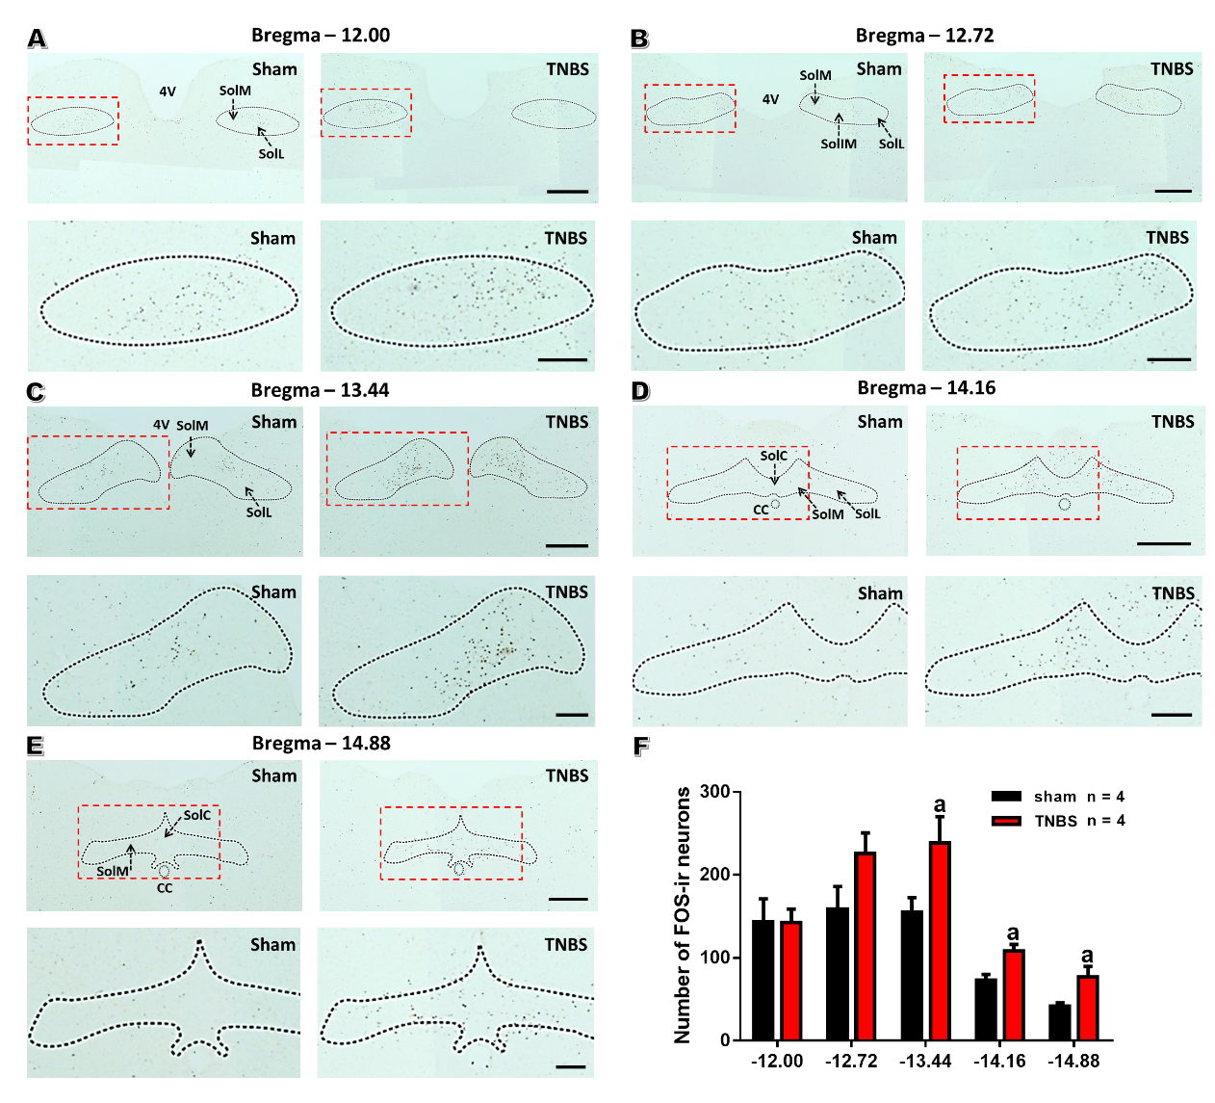
Figure 1 The number of FOS-expressing neurons is upregulated within the nucleus tractus solitarius in rats with chronic pancreatitis. A-E: Immunochemical staining of FOS within different coronal sections of nucleus tractus solitarius (NTS) in sham (left) and chronic pancreatitis (right) rats. The rectangles in the top panels were further magnified in the bottom panels. Bars = 500 μm in top panels and 200 μm in bottom panels. F: Histogram showing the qualification of FOS-expressing neurons within different parts of NTS in saline and trinitrobenzene sulfonic acid (TNBS)-treated rats. n = 4 rats per each group, unpaired t-test, ªP < 0.05, TNBS vs sham. 4V: 4th ventricle; CC: Central canal; SolIM: Nucleus of the solitary tract, intermedial part; SolM: Nucleus of the solitary tract, medial part; SolL: Nucleus of the solitary tract, lateral part; SolC: Nucleus of the solitary tract, commissural part; TNBS: Trinitrobenzene sulfonic acid.
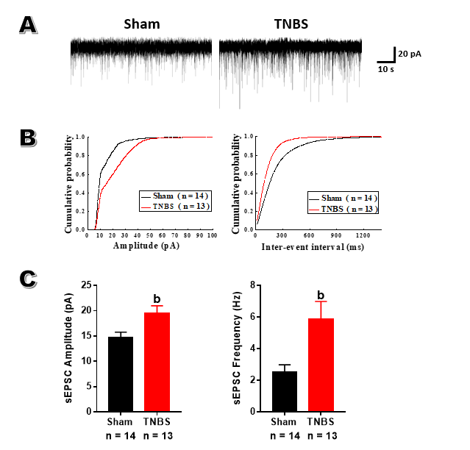
Figure 2 Rats with chronic pancreatitis have increased amplitude and frequency of spontaneous excitatory postsynaptic currents in the caudal nucleus tractus solitarius. A: Representative spontaneous excitatory postsynaptic currents (sEPSCs) recorded from a sham (left) rat and a trinitrobenzene sulfonic acid (TNBS)-treated (right) rat holding at -60 mV. B: Cumulative amplitude (left) and inter-event interval (right) histograms of sEPSCs recorded from sham and chronic pancreatitis (CP) rats. C: Summary plots showing the frequency (left) and the amplitude (right) of sEPSCs from sham and CP rats. Unpaired t-test, ^{b}P < 0.01, TNBS vs sham. sEPSC: Spontaneous excitatory postsynaptic currents; TNBS: Trinitrobenzene sulfonic acid.
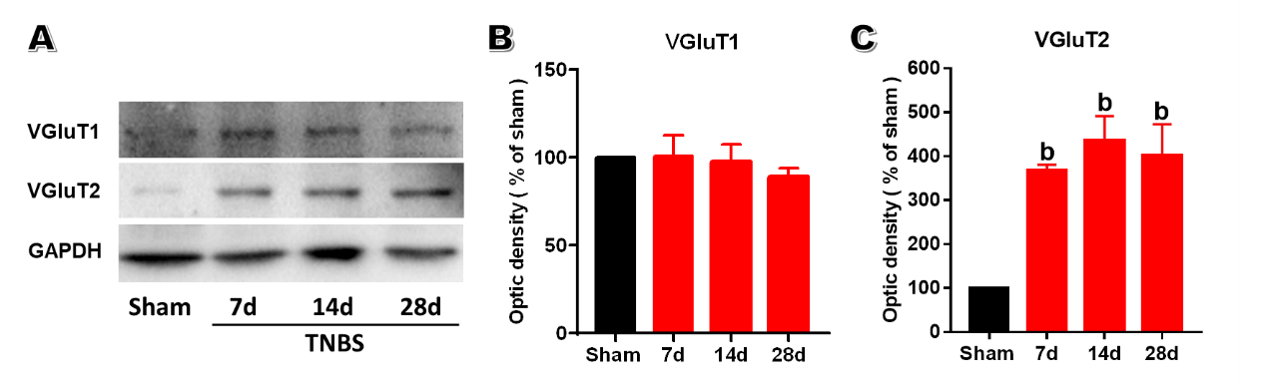
Figure 3 Trinitrobenzene sulfonic acid treatment upregulates the expression of vesicular glutamate transporter 2 within the caudal nucleus tractus solitarius. A: Representative western blot for VGluT1 and VGluT2 within caudal nucleus tractus solitarius (NTS) on post-operation day (POD) 7, 14 and 28. B: VGluT1 amount within caudal NTS showed no changes after TNBS treatment. C: VGluT2 amount within caudal NTS was significantly increased on POD 7, 14, and 28 after trinitrobenzene sulfonic acid (TNBS) treatment. n = 3 rats per each group, one-way ANOVA, ªP < 0.05, ^{b}P < 0.01, TNBS vs sham. TNBS: Trinitrobenzene sulfonic acid; VGluT1: Vesicular glutamate transporter 1; VGluT2: Vesicular glutamate transporter 2.

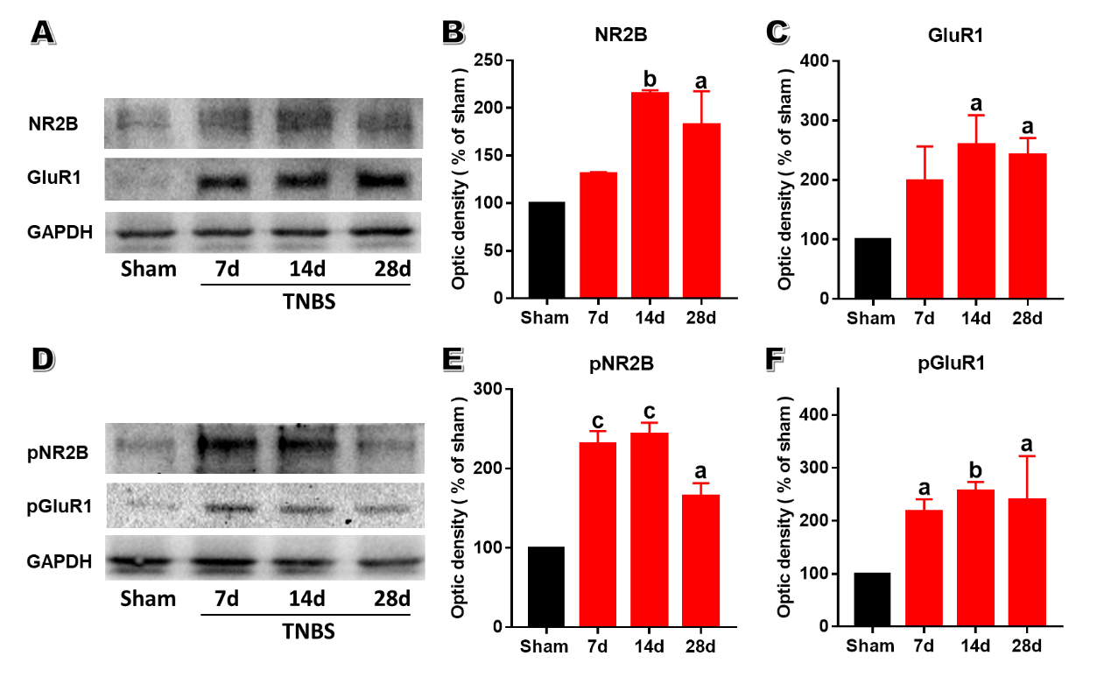
Figure 4 Trinitrobenzene sulfonic acid treatment upregulates the expressions of N-methyl D-aspartate receptor subtype 2B and α-Amino-3-hydroxy-5-methyl-4-isoxazolepropionic acid receptor subtype 1 within the caudal nucleus tractus solitarius. A: Representative western blot for NR2B and GluR1 within caudal nucleus tractus solitarius (NTS) on post-operation day (POD) 7, 14 and 28. B: The amount of NR2B within caudal NTS was significantly increased on POD 7, 14, and 28 after trinitrobenzene sulfonic acid (TNBS) treatment. C: The amount of GluR1 within caudal NTS was significantly increased on POD 7, 14, and 28 after TNBS treatment. D: Representative western blot for pNR2B and pGluR within caudal NTS after TNBS treatment. E: The amount of pNR2B within caudal NTS was significantly increased after TNBS treatment. F: The amount of pGluR1 within caudal NTS was significantly increased after TNBS treatment. n = 3 rats per each group, one-way ANOVA, ªP < 0.05, ^{b}P < 0.01, TNBS vs sham. GluR1:α-amino-3-hydroxy-5-methyl-4-isoxazolepropionic acid receptor subtype 1; NR2B: N-methyl-D-aspartate receptor subtype 2B; TNBS: Trinitrobenzene sulfonic acid.

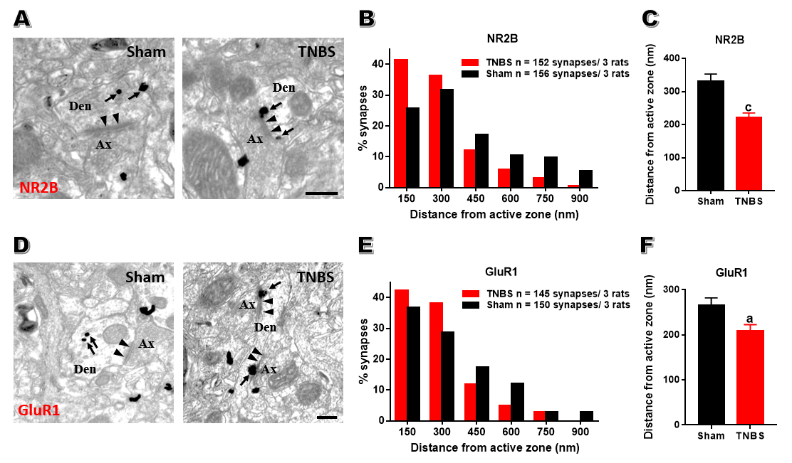
Figure 5 Trinitrobenzene sulfonic acid treatment accumulates postsynaptic N-methyl D-aspartate receptor subtype 2B and α-Amino-3-hydroxy-5-methyl-4-isoxazolepropionic acid receptor subtype 1 in the caudal nucleus tractus solitarius. A: Representative electron microscopy images showing immune-gold particles labeled N-methyl-D-aspartate receptor subtype 2B (NR2B) distributed in an asymmetric synapse within caudal nucleus tractus solitarius (NTS) of sham (left) and chronic pancreatitis (CP) (right) rats. B: Percentage of NR2B particles in 150 nm bins as a function of distance from the nearest edge of synapses. C: Averaged distances of NR2B from the edge of synapses of sham rats and CP rats. D: Representative electron microscopy images showing immune-gold particles labeled GluR1 distributed in an asymmetric synapse within caudal NTS of sham (left) and CP (right) rats. E: Percentage of α-amino-3-hydroxy-5-methyl-4-isoxazolepropionic acid receptor subtype 1 (GluR1) particles in 150 nm bins as a function of distance from the nearest edge of synapses. F: Averaged distances of GluR1 from the edge of synapses of sham rats and CP rats. Bar = 250 nm in A and D. ªP < 0.05, ^{c}P < 0.001, TNBS vs sham. Ax: Axon; Den: Dendrite; GluR1: α-amino-3-hydroxy-5-methyl-4-isoxazolepropionic acid receptor subtype 1; NR2B: N-methyl-D-aspartate receptor subtype 2B; TNBS: Trinitrobenzene sulfonic acid.
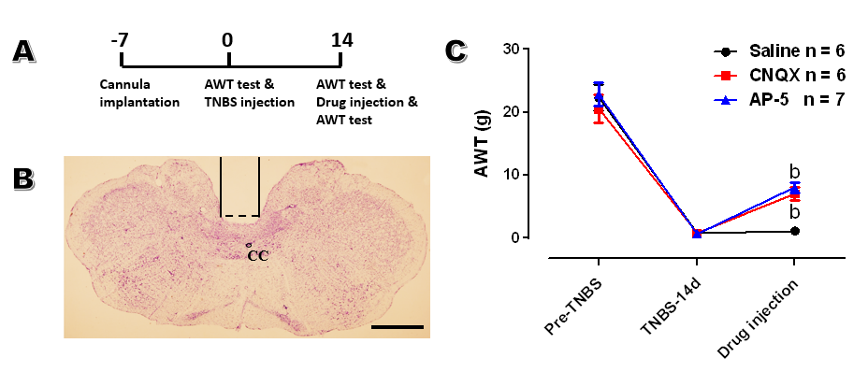
Figure 6 Administration of 6-cyano-7-nitroquinoxaline-2,3-dione and amino-5-phosphonopentaoic acid into the caudal nucleus tractus solitarius alleviates chronic pancreatitis induced visceral hypersensitivity. A: Schematic diagram of behavioral test. B: A representative section showing the site of cannula implantation within caudal nucleus tractus solitarius. Bar = 1 mm. C: Microinjection of 6-cyano-7-nitroquinoxaline-2,3-dione (CNQX) and amino-5-phosphonopentaoic acid (AP-5), instead of saline, increased the abdominal withdraw threshold in chronic pancreatitis rats on post-operation day 14. n = 6 rats in saline and CNQX-treated groups and 7 rats in AP5-treated group, one-way ANOVA, ^{b}P < 0.01, CNQX or AP5 groups vs saline group. AWT: Abdominal withdraw threshold; CC: Central canal; CNQX: 6-cyano-7-nitroquinoxaline-2,3-dione; AP-5: Amino-5-phosphonopentaoic acid; TNBS: Trinitrobenzene sulfonic acid.

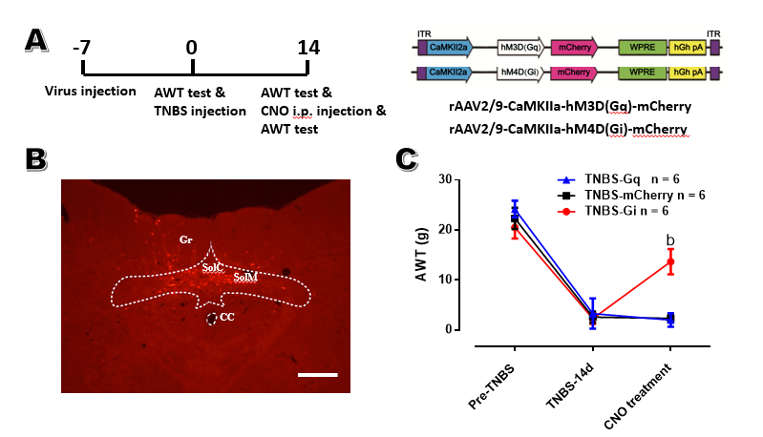
Figure 7 Inactivating excitatory neurons within the caudal nucleus tractus solitarius alleviates visceral hypersensitivity in rats with chronic pancreatitis. A: The schematic diagram of behavioral experiment (left) and rAAV2/9-CaMKIIa-hM4Di/hM3Dq-mCherry construct (right). B: A representative image showing the expression of hM4Di-mCherry was confined within the commissure and medial nuclei of caudal nucleus tractus solitarius (NTS). Bar = 0.4 mm. C: Inhibiting caudal NTS excitatory neurons via i.p. Clozapine-N-oxide injection significantly increased the abdominal withdraw threshold (AWT) in chronic pancreatitis rats, while activating these neurons did not influence the AWT. n = 6 rats for mCherry, Gq and Gi groups, one-way ANOVA. ^{b}P < 0.01, Gi vs mCherry. AWT: Abdominal withdraw threshold; CC: Central canal; CNO: Clozapine-N-oxide; SolM: Nucleus of the solitary tract, medial part; SolC: Nucleus of the solitary tract, commissural part; Gr: Gracile nucleus; TNBS: Trinitrobenzene sulfonic acid.

