Name of Journal: World Journal of Gastroenterology
Manuscript NO: 28625
Manuscript type: CASE REPORT

real case of primitive embryonal duodenal carcinoma in a young man

Barbieux J et al. Primitive embryonal duodenal carcinoma

Julien Barbieux, Riccardo Memeo, Vito De Blasi, Sebastian Suciu, Vanina Faucher, Gerlinde Averous, Catherine Roy, Jacques Marescaux, Didier Mutter, Patrick Pessaux

Julien Barbieux, Riccardo Memeo, Vito De Blasi, Jacques Marescaux, Didier Mutter, Patrick Pessaux, Hepato-Biliary and Pancreatic surgical unit, IRCAD-IHU, University of Strasbourg, place de l’Hôpital, 67091 Strasbourg, France

Sebastian Suciu, Department of Gastroenterology, NHC, University of Strasbourg, place de l’Hôpital, 67091 Strasbourg, France

Vanina Faucher, Catherine Roy, Department of Radiology, NHC, University of Strasbourg, place de l’Hôpital, 67091 Strasbourg, France

Gerlinde Averous, Department of Pathology, NHC, University of Strasbourg, place de l’Hôpital, 67091 Strasbourg, France

Author contributions: Barbieux J, Memeo R, De Blasi V, Suciu S, Marescaux J, Mutter D and Pessaux P designed and wrote the paper; Faucher V and Roy C analysed MRI and CT; Averous G performed the histology analysis.

Institutional review board statement: Not necessary in France for one report.

Informed consent statement: We have an informed consent.

Conflict-of-interest statement: All authors declare no conflict of interest in this manuscript.

Open-Access: This article is an open-access article which was selected by an in-house editor and fully peer-reviewed by external reviewers. It is distributed in accordance with the Creative Commons Attribution Non Commercial (CC BY-NC 4.0) license, which permits others to distribute, remix, adapt, build upon this work non-commercially, and license their derivative works on different terms, provided the original work is properly cited and the use is non-commercial. See: http://creativecommons.org/licenses/by-nc/4.0/

Manuscript source: Unsolicited manuscript

Correspondence to: Dr. Riccardo Memeo, Head of Hepato-Biliary and Pancreatic Surgery Department, 1, place de l’Hôpital, 67091 Strasbourg, France. drmemeo@yahoo.it

Telephone: +33-3-69550553

Fax: +33-3-69551741

Received: July 7, 2016
Peer-review started: July 11, 2016
First decision: July 29, 2016
Revised: August 5, 2016
Accepted: September 14, 2016
Article in press:
Published online:

Abstract
We reported the case of a young man suffering from a rare germ cell tumour. The patient was a 25-year-old man who was referred to our center for asthenia, stinging epigastric pain, and an iron deficiency anaemia. Gastroscopy has revealed a circumferential vegetating lesion on the second portion of the duodenum. The lesion was indurated at the third portion of the duodenum responsible for a tight stenosis. A CT-scan of the chest, abdomen, and pelvis and a pancreatic MRI showed a circumferential lesion with a bi-ductal dilatation (i.e., of the common bile duct and Wirsung’s duct) without metastatic localisation. The patient underwent a pancreaticoduodenectomy with lymph node dissection including all cellular adipose tissues of the hepatic pedicle from the hepatic common artery and of the retroportal lamina. Histological findings were suggestive of a duodenal embryonal carcinoma with pancreatic infiltration. This is the second published case highlighting the duodenal primitive localisation of an embryonal carcinoma with pancreatic infiltration.

Key words: Embryonal carcinoma; Germ cell tumour; Duodenum; Young male; pancreaticoduodenectomy

© The Author(s) 2016. Published by Baishideng Publishing Group Inc. All rights reserved.

Core tip: Duodenal embryonal carcinoma is a rare germ cell localisation. This lesion may be revealed by a chronic or acute haemorrhage. Our patient presented with an iron deficiency anaemia associated with asthenia and epigastric pain. Imaging studies and endoscopy showed a tight stenosis of the third portion of the duodenum with a circumferential lesion responsible for a common bile duct and Wirsung’s duct dilatation without any metastatic localisation. The patient underwent a pancreaticoduodenectomy and histological findings helped to identify a duodenal embryonal carcinoma with pancreatic infiltration.

Barbieux J, Memeo R, De Blasi V, Suciu S, Faucher V, Averous G, Roy C, Marescaux J, Mutter D, Pessaux P. real case of primitive embryonal duodenal carcinoma in a young man. World J Gastroenterol 2016; In press

INTRODUCTION
In young men aged between 15 and 35, testicular cancer is the leading cause of neoplasia with an incidence rate of 2.1 for 100000^{[1]}. It should be noted that about 5% of these patients may present with a metastatic localisation on the digestive tract^{[2]} The most frequent origin for embryonal carcinoma is testicular (33% of cases) as confirmed by the literature^{[1]}. The pineal gland, the mediastinal region, the digestive tract, the lungs, and the retroperitoneum could well be the primitive origin of an embryonal carcinoma^{[3]}.
Here, we reported the case of an embryonal duodenal carcinoma with pancreatic infiltration.

CASE REPORT
A 25-year-old Bulgarian man was referred to our center by his regular medical doctor for a strong asthenia, which lasted for the past 3 wk and stinging epigastric pain, which was paroxysmal with dorsal irradiation responsible for nocturnal awakening getting worse since one month.
The patient had neither lost weight recently nor did he present with anorexia.
Apart from a moderate active smoking, he did not have any significant surgical and medical history.
Clinical examination showed that the patient has a Body Mass Index of 19. Examination of the abdomen revealed an epigastric sensitivity without any abdominal mass. Bowel movements were regular; however, dark stools were noted for the last week. A digital rectal exam revealed neither mass nor blood. The patient was afebrile and presented with a marked skin pallor.
Biologically, the patient presented a haemoglobin at 6.8 g/dL in relation with an iron deficiency anaemia (serum iron: 2 μmol/L, mean corpuscular volume: 76.5 fL and ferritin: 4 μmol/L). This was the reason why he was transfused 4 units of packed red blood cells as soon as he was admitted to our department. There was no inflammatory syndrome (leukocytes: 8.88 Giga/L; C-reactive protein: 22.3 mg/L). Liver function test results showed a cytolysis (glutamic pyruvic transaminase: 218 U/L and glutamic oxaloacetic transaminase: 76 U/L) as well as an anicteric cholestasis (Gamma glutamyl transferase: 644 U/L; alkaline phosphatase: 507 U/L, total bilirubin: 2.7 μmol/L). Lipase was at 2591 U/L and quickly decreases. Tumoral markers were measured: carcinoembryonic antigen: < 1 μg/L, carbohydrate antigen 19-9: 17.2 kU/L, alpha foetoprotein: 2.1 μg/L, β human chorionic gonadotropin < 3 UI/L, lactate dehydrogenase: 117 U/l.
Rectoscopy performed until 40 cm from the anal margin did not show anything specific. Gastroscopy has revealed a circumferential vegetating lesion with a villous appearance on the second portion of the duodenum (Figure 1). This lesion became indurated and ulcerated at the third portion of the duodenum and was responsible for a tight stenosis. Biopsy findings were evocative of a slightly differentiated adenocarcinoma of biliopancreatic origin (cytokeratin 7+ and cytokeratin 20-).
A computerized tomography (CT) of the chest, abdomen, and pelvis showed a circumferential lesion thickening of up to 2cm at the level of the second and third portions of the duodenum with a bi-ductal dilatation (of the common bile duct and main pancreatic duct (Figure 2). An 8mm adenomegaly could be noted in a retropancreatic position. No secondary lesion was observed. Magnetic resonance imaging (MRI) of the pancreas and magnetic resonance cholangiopancreatography (MRCP) confirmed this duodenal tissue thickening spreading from the proximal part of the second portion of the duodenum up to the duodenojejunal flexure, which was accountable for pancreatic duct and bile duct upstream swelling without any secondary hepatic lesion (Figure 2). Some very short contact adenomegalies could also be observed there.
After a multidisciplinary meeting, pancreaticoduodenectomy was decided. Intraoperatively, examination of the abdominal cavity did not find any peritoneal carcinomatosis or any other tumoral lesions. Picking analysis of para-aortic lymph nodes and two frozen section examination at the level of the upper part of the mesenteric pedicle did not help to identify any sign of malignancy. A pancreaticoduodenectomy was performed with a pancreaticogastric anastomosis and a hepatico-jejunal anastomosis. Lymph node dissection included all cellular adipose tissues of the hepatic hilum from the common hepatic artery and the retroportal lamina (Figure 3). Histological findings were suggestive of a duodenal embryonal carcinoma with pancreatic infiltration rated T4N0 (0 out of 48 lymph node) M0 R0 (Figure 4A). Specimen cells expressed cytokeratine 7 (Figure 4B), CD30 (Figure 4C) and SALL4 (Figure 4D) in immunohistochemical staining.
In order not to undermine a primitive cancer, a testicular ultrasound and CT-scan of the head and neck were performed without any repeat finding of the tumoral lesion. The case was presented at the oncology staff in order to put forward an adjuvant chemotherapy after cryogenic sperm preservation.

DISCUSSION
Melanoma, renal, mammary, bronchopulmonary, gastric or testicular neoplasia^{[4]} represent the most frequent metastatic tumours at the level of the small bowel, and particularly at the level of the duodenum. However, in young men, a testicular origin is to be favoured due to the preferential epidemiology of these cancers in this population group^{[1]}. It should be noted that tumours with testicular germ cells are dichotomized between seminomas and non-seminomatous germ cell tumours such as embryonary carcinomas and teratomas^{[5]}. The sites of dissemination of testicular embryonary carcinomas which are most frequently mentioned are the lungs, the liver, and the retroperitoneal space. The digestive tract provides a rare but known dissemination area (5%)^{[1]}. Fu et al^{[6]} reported the case of a young patient with a symptomatic duodenal metastasis which induced low digestive bleeding. On the other hand, we did not highlight any acute haemorrhagic episode but rather an iron deficiency with chronic haemorrhagic suffusion. The literature shows that patients presenting with bowel metastasis of an embryonic cancer develop, in most cases, a haemorrhagic symptom (14 out 15 patients in the study by Fu et al^{[6]}) or a digestive occlusion^{[6,7]}. Tumoral dissemination by contiguity is the most frequently identified tumoral expansion mode at the expense of haematogenic or lymphatic pathways^{[6]}. This accounts for the pancreatic lesions found in our case.
A primitive duodenal tumour is a hypothesis which must be discussed because clinical and imaging examinations have not led to the identification of another primitive lesion. A duodenal primitive embryonal carcinoma was already described in a young man^{[8]}. The hypothesis of a retro-differentiation of adenocarcinoma cells at the level of embryonal ectodermal cells of a metaplasia or differentiation in trophoblastic precursor seems to explain the histology of this primitive embryonal duodenal tumour^{[9]}. As well as metastasis with choriocarcinoma of testicular origin, the tumoral cellular profile is not homogeneous^{[1]}. This accounts for the biopsy initial result matching with a limited sample of the tumoral lesion. This last one was evocative of an adenocarcinoma with a biliopancreatic profile of an embryonal carcinoma at the final review.
Regarding tumour markers, high rates of β human chorionic gonadotropin are frequently described with non-seminomatous tumours, particularly choriocarcinomas. The alpha foetoprotein seems rather ascending in case of a non-seminomatous lesion, particularly embryonal carcinomas with a yolk sac differentiation^{[5]}. We did not notice any modification of tumoral markers in our case as opposed to the case described by Küçüköner’s et al^{[8]}.

In conclusion, the onset of a strong anaemia in a young man requires endoscopic and imaging explorations in order to search for an embryonal tumoral lesion on the digestive tract since they are very frequently revealed by a chronic or acute haemorrhage.

COMMENTS
Case characteristics
A 25-year-old Bulgarian man was referred to our center for a strong asthenia, and stinging epigastric pain getting worse since one month.

Clinical diagnosis
Clinical examination showed that the patient has a marked skin pallor with epigastric sensitivity without any abdominal mass nor recently weigh lost or anorexia.

Differential diagnosis
A slightly differentiated adenocarcinoma of biliopancreatic origin or another germ cell tumour.

Laboratory diagnosis
The patient presented a haemoglobin at 6.8 g/dL in relation with an iron deficiency anaemia, associated with a cytolysis as well as an anicteric cholestasis.

Imaging diagnosis
Radiological exams showed a circumferential lesion thickening of up to 2 cm at the level of the second and third portions of the duodenum with a bi-ductal dilatation without any secondary lesion.

Pathological diagnosis
Histological findings were suggestive of a duodenal embryonal carcinoma with pancreatic infiltration associated with, in immunohistochemical staining, a specimen cells expression of cytokeratine 7, CD30 and SALL4.

Treatment
After a multidisciplinary meeting, pancreaticoduodenectomy was decided and performed.

Related reports
This is the second published case highlighting the duodenal primitive localisation of an embryonal carcinoma with pancreatic infiltration.

Experiences and lessons
A pancreatic tumour in a young man may not be a biliopancreatic origin and requires extensive investigations to not ignore the uncommon entities as a germ cell tumour.

Peer-review
This is an important case report of a most unusual embryonal tumour involving the duodenum and adjacent pancreas and needs publication.

REFERENCES
1 Vardaros M, Subhani M, Rizvon K, Gotlieb V, Mustacchia P, Freedman L, Garg V, Singh J, Siddiqui G. A case of gastrointestinal bleeding due to duodenal metastasis from a testicular choriocarcinoma. J Gastrointest Cancer 2013; 44: 234-237 [PMID: 22961707 DOI: 10.1007/s12029-012-9433-y]
2 Chait MM, Kurtz RC, Hajdu SI. Gastrointestinal tract metastasis in patients with germ-cell tumor of the testis. Am J Dig Dis 1978; 23: 925-928 [PMID: 568878 DOI: 10.1007/BF01072468]
3 Yokoi K, Tanaka N, Furukawa K, Ishikawa N, Seya T, Horiba K, Kanazawa Y, Yamada T, Ohaki Y, Tajiri T. Male choriocarcinoma with metastasis to the jejunum: a case report and review of the literature. J Nippon Med Sch 2008; 75: 116-121 [PMID: 18475033 DOI: 10.1272/jnms.75.116]
4 Köksal AS, Kayaçetin E, Torun S, Güneş ZE, Zengin NI. An elusive etiology of upper gastrointestinal bleeding in a young man: testis tumor. Surg Laparosc Endosc Percutan Tech 2013; 23: 354-356 [PMID: 23752011 DOI: 10.1097/SLE.0b013e31828e375c]
5 Rajpert-De Meyts E, McGlynn KA, Okamoto K, Jewett MA, Bokemeyer C. Testicular germ cell tumours. Lancet 2016; 387: 1762-1774 [PMID: 26651223 DOI: 10.1016/S0140-6736(15)00991-5]
6 Fu S, Avezbakiyev B, Zhi W, Kodali S, Rizvon K, Alaverdian A, Freedman L, Mejia J, Shahzad G, Gotlieb V. Germ cell cancer presenting as gastrointestinal bleeding and developing brain metastases: case report and review of the literature. Future Oncol 2012; 8: 1487-1493 [PMID: 23148621 DOI: 10.2217/fon.12.133]
7 Rodriguez-Lopez M, Velasco-López R, Mambrilla-Herrero S, Bailon-Cuadrado M, Plua KT, Diez-González LM, Blanco-Álvarez JI, Asensio-Díaz E, Gonzalo-Martín M, Pérez-Saborido B, Marcos-Rodríguez JL. Duodenal involvement by seminomatous tumors. Rev Esp Enferm Dig 2015; 107: 640-641 [PMID: 26437983 DOI: 10.17235/reed.2015.3646/2014]
8 Küçüköner M, Kaplan MA, İnal A, Uçmak F, Firat U, Işikdoğan A. Germ cell tumor in duodenum. Turk J Gastroenterol 2013; 24: 73-74 [PMID: 23794350 DOI: 10.4318/tjg.2013.0458]
9 Noguchi T, Takeno S, Sato T, Takahashi Y, Uchida Y, Yokoyama S. A patient with primary gastric choriocarcinoma who received a correct preoperative diagnosis and achieved prolonged survival. Gastric Cancer 2002; 5: 112-117 [PMID: 12111588 DOI: 10.1007/s101200200019]
P-Reviewer: Slomiany BL, Tian YT, Tovey FI S-Editor: Gong ZM
L-Editor: E-Editor:
Specialty type: Gastroenterology and hepatology
Country of origin: france
Peer-review report classification
Grade A (Excellent): A
Grade B (Very good): B, B
Grade C (Good): 0
Grade D (Fair): 0
Grade E (Poor): 0

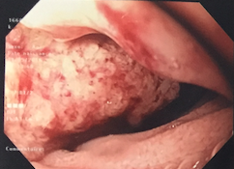

Figure 1 Gastroscopy shows a circumferential vegetating mass with a villous appearance on the second portion of the duodenum.

B
A

*
*

Figure 2 Magnetic resonance imaging. A: MRI, coronal T1 weighted MR image with contrast showing the duodenal tissue thickening spreading from the second duodenum proximal part up to the duodenojejunal flexure (white arrow). B: MRI, coronal T2 weighted showing the pancreatic duct and bile duct upstream swelling (white asterisks) without any secondary hepatic lesion. MRI: Magnetic resonance imaging.

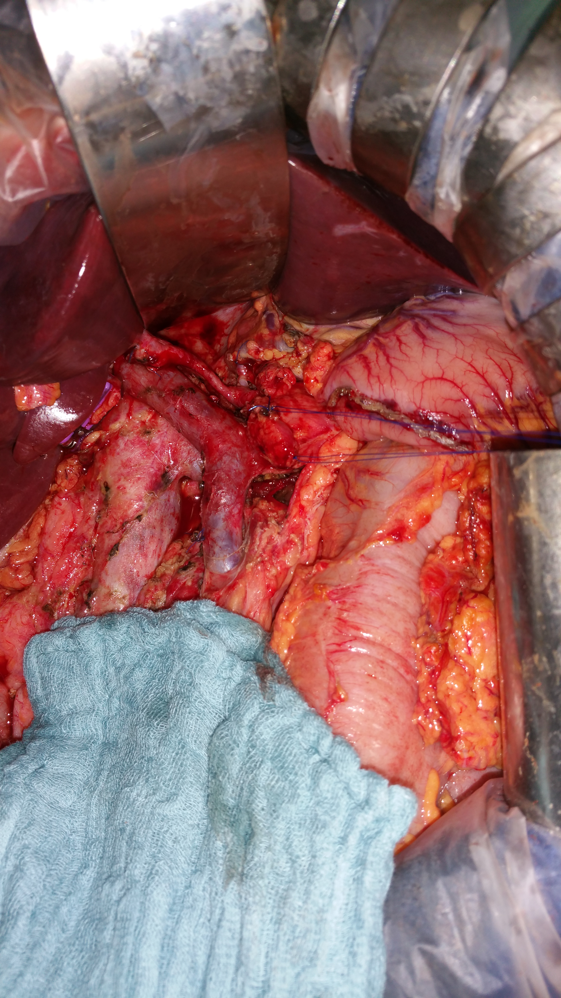
*

Figure 3 Intraoperative view of the pancreaticoduodenectomy showing lymph node dissection with excision of all cellular adipose tissues of the hepatic pedicle from the common hepatic artery (white arrow) and of the retroportal lamina (white asterisks).

B
C
D
A

Figure 4 Histological findings of the operative specimen showing an embryonal carcinoma: pleomorphic cell proliferation with marked cytonuclear atypia, granular or clear cytoplasm, arranged in nests or solid pattern, associated with a fibrous stroma and an abundant lymphocytic inflammatory infiltrate (A). Specimen cells express cytokeratine 7 (B), CD30 (C) and SALL4 (D) in immunohistochemical staining. A: H&E × 400; B: Cytokeratine 7 × 200; C: CD30 × 200; D: SALL4 × 200.

