Name of Journal: World Journal of Clinical Cases
Manuscript NO: 77231
Manuscript Type: CASE REPORT

Misdiagnosis of an elevated lesion in the esophagus: A case report

Ma XB et al. Endoscopic diagnosis and therapeutic strategy for ECS

Xing-Bin Ma, Huai-Yuan Ma, Xing-Fang Jia, Fei-Fei Wen, Cheng-Xia Liu

Xing-Bin Ma, Huai-Yuan Ma, Xing-Fang Jia, Cheng-Xia Liu, Department of Gastroenterology and Hepatology, Binzhou Medical University Hospital, Binzhou 256603, Shandong Province, China

Fei-Fei Wen, Department of Pathology, Binzhou Medical University Hospital, Binzhou 256603, Shandong Province, China

Author contributions: Ma XB and Ma HY reviewed the literature and contributed to manuscript drafting; Jia XF was the patient’s EUS and ESD surgeon; Wen FF was involved in pathology evaluation; Liu CX was responsible for revising the manuscript for important intellectual content; all the authors provided final approval for the version of the manuscript to be submitted.

Corresponding author: Cheng-Xia Liu, PhD, Doctor, Professor, Department of Gastroenterology and Hepatology, Binzhou Medical University Hospital, No. 661 Huanghe 2nd Road, Binzhou 256603, Shandong Province, China. phdlcx@163.com

Received: April 20, 2022
Revised: June 30, 2022
Accepted: August 15, 2022
Published online: September 26, 2022

Abstract
BACKGROUND
Esophageal carcinosarcoma (ECS) is a rare biphasic tumor and a type of esophageal malignancy, which presents as protruding or elevated lesions. ECS patients are often not hospitalized until they have severe dysphagia. ECS is easily misdiagnosed as a benign tumor due to its atypical characteristics under endoscopy. With the popularization of endoscopic treatment, these patients are often referred to endoscopic treatment, such as endoscopic submucosal dissection (ESD). However, there is a lack of consensus on the endoscopic features and therapies for ECS. Here, we report a case of ECS and discuss the value of endoscopic diagnosis and therapeutic strategies.

CASE SUMMARY
A 63-year-old man was admitted to the hospital with dysphagia. During the endoscopic examination, an elevated lesion was found with an erosive and hyperemic surface covered with white pseudomembranous inflammation. Endoscopic ultrasonography (EUS), biopsies, and enhanced thoracic computed tomography were performed, suggesting that it was a benign lesion and located within the submucosal layer. This lesion was diagnosed as a fibrovascular polyp with a Paris classification of 0-Ip. The patient was then referred to ESD treatment. However, the post-ESD pathological and immunohistochemical study showed that this lesion was ECS with a vertical positive margin (T1b stage), indicating that we made a misdiagnosis and achieved a noncurative resection. Due to the potential tumor residue, additional open surgery was performed at the patient's request. In the postoperative pathological study, no tumor remnants or metastases were discovered. The patient was followed for 1 year and had no recurrence.

CONCLUSION
ECS can be misdiagnosed at the initial endoscopy. EUS can help to identify the tumor stage. Patients with T1b stage ECS cannot be routinely referred to ESD treatment due to the high risk of metastasis and recurrence rate.

Key Words: Esophageal carcinosarcoma; Misdiagnosis; Endoscopic ultrasonography; Endoscopic submucosal dissection; T1 stage; Case report

©The Author(s) 2022. Published by Baishideng Publishing Group Inc. All rights reserved.

Citation: Ma XB, Ma HY, Jia XF, Wen FF, Liu CX. Misdiagnosis of an elevated lesion in the esophagus: A case report. World J Clin Cases 2022; 10(27): 9828-9833
URL: https://www.wjgnet.com/2307-8960/full/v10/i27/9828.htm
DOI: https://dx.doi.org/10.12998/wjcc.v10.i27.9828

Core Tip: Esophageal carcinosarcoma (ECS) is a rare type of esophageal malignancy. ECS commonly presents as a pedunculated characteristic (0-Ip), which is often misdiagnosed due to the lack of specific features. Endoscopic ultrasonography can help to evaluate whether ECS invasion is within the submucosal layer (T1 or T2 stage) but cannot further distinguish whether it is T1a or T1b stage. Due to the high risk of metastasis and recurrence based on the literature review, endoscopic submucosal dissection treatment cannot be routinely recommended for ECS patients with T1b stage disease.

INTRODUCTION
Patients routinely undergo endoscopic evaluation for dysphagia, during which protruding or elevated lesions are frequently found. Some of the lesions are presented as pedunculated lesions, including esophageal adenoma, inflammatory polyps, fibrovascular polyps, carcinosarcoma^{[1-3]}, etc. However, they lack specific features and have similar endoscopic ultrasonography (EUS) characteristics. Therefore, it is difficult to conclusively diagnose the lesion without the support of postsurgical pathology.
Herein, we report a rare case of esophageal carcinosarcoma (ECS), which was assessed as a benign tumor and treated by endoscopic submucosal dissection (ESD). Nevertheless, post-ESD pathology indicated that it was preoperatively misdiagnosed. Therefore, we systematically evaluated the endoscopic and clinicopathological characteristics of ECS and analyzed the feasibility of endoscopic treatment.

CASE PRESENTATION
Chief complaints
Dysphagia for 3 mo.

History of present illness
A 63-year-old man was admitted to the hospital with dysphagia for 3 mo. The patient can only swallow semi-solid food for 2 wk, with intermittent swallowing pain.

History of past illness
The patient was in good health in the past.

Personal and family history
The patient had no personal and family history.

Physical examination
The patient was in good condition. The physical examination was completely normal.

Laboratory examinations
Routine laboratory tests were all within the normal range.

Imaging examinations
During the endoscopic examination, an elevated lesion with an erosive and hyperemic surface covered with white pseudomembranous inflammation was found. It had a short peduncle connected to the mid-esophagus wall and was 30 mm × 40 mm in size. EUS revealed a lesion derived from the submucosal layer with an intact inherent muscle layer, and this lesion was hypoechoic and consisted of internal multicystic components. Ultrasonic elastography revealed that the lesion was blue–green, indicating a tough texture (Figure 1). Multiple biopsies showed necrosis and active fibroblast proliferation. An enhanced thoracic computed tomography scan showed a protuberant lesion in the middle of the esophagus, suggesting a benign tumor. A multidisciplinary consultation was performed, and we preliminarily diagnosed this lesion as a fibrovascular polyp.

FINAL DIAGNOSIS
The post-ESD pathological study showed that this lesion was composed of a malignant fibroblast apoptosis component and a basal-like squamous cell carcinoma (BSC) component, indicating ECS. The polypoid mass was predominantly composed of malignant fibrous histiocytoma with a vertical positive margin, horizontal negative margin, and no evidence of vascular or lymphatic invasion. Immunohistochemical (IHC) staining showed CK (-), vimentin (+), CD68 (+), β-catenin (+), p53 (+), S-100 (-), CD34 (-), SMA (-), desmin (-), Twist1 (+), ZEB1 (+), Snai2 (-), PDGFR alpha (-), and a Ki-67 index of 20%. BSC was observed in the neck of the tumor, and its vertical and horizontal margins were negative. IHC staining showed CK (+), E-cadherin (+), p53 (+), vimentin (-), S-100 (-), CD34 (-), CD68 (-), SMA (-), desmin (-), and a Ki-67 index of 30% (Figure 2).

TREATMENT
The following ESD treatment was successful with no obvious adhesion in the submucosal layer after the patient’s informed consent was obtained.

OUTCOME AND FOLLOW-UP
Due to the potential tumor residue, additional open surgery was performed at the patient's request. No tumor remnants or metastases were discovered in the postoperative pathological study. The patient was followed for 1 year and had no recurrence.

DISCUSSION
ECS is a rare biphasic tumor that accounts for 0.2%-2.8% of all esophageal malignancies. It is characterized by the presence of both malignant epithelial and mesenchymal components^{[4]}. ECS usually presents as a large intraluminal polypoid mass on the upper and middle esophagus, with a median diameter of 55-75 mm. The endoscopic features of this lesion may include a hyperemia surface, erosion, ulceration, brittleness, and easy bleeding, which lack specificity for endoscopic diagnosis^{[5]}.
The diagnosis of ECS mainly relies on pathological studies^{[4]}. However, untargeted endoscopic biopsies of this lesion usually reveal components of sarcoma, which makes it easily misdiagnosed. Efforts can be made to potentially improve the biopsy accuracy by targeting the root or peduncle as the epithelial cancer component always exceeds the mass in the range^{[6]}.
EUS evaluation of the lesion plays a role in the assessment before treatment. Although lacing specificity in diagnosis, EUS can provide information on invasion depth. According to a report from Taiwan^{[7]}, five of six ECS patients were correctly assessed on the invasion depth by EUS. However, all lesions were in the deep invasion (T2 stage). Our preoperative EUS showed that the origin of the ECS was derived from the T1 stage, which was proven by postoperative pathology. However, we also noticed that EUS could not further distinguish whether it was T1a or T1b stage. The reason could be that the echo of sarcoma that invaded the submucosa was similar to the original interstitial composition and therefore could not be distinguished by EUS.
Data on lymph node metastases of ECS at T1 stage are limited^{[7,8]}. In 2006, Sanada et al^{[9]} reviewed 57 cases of ECS reported in Japan between 1995 and 2004, among which one was a T1a stage case and 17 were T1b stage cases^{[9]}. Seven (41%) of the T1b stage cases were found to have lymph node metastasis compared with none of the T1a stage cases. In 2021, Chen et al^{[10]} reported that none of the ten ECS patients at T1 stage were found to have lymph node metastasis, with no report of T1 subtypes^{[10]}. Since lymph node metastasis is related to prognosis, a detailed assessment is required before treatment.
Data on the prognosis of ESD treatment for ECS in the T1 stage are also limited. One Korean case reported by Cha et al^{[11]} in 2014 is very similar to ours^{[11]}. The lesion located within the submucosal layer without evidence of metastasis was treated by ESD. The post-ESD pathological study reported ECS with a vertical positive margin (T1b stage). In contrast, the patient from this Korean study refused to receive additional surgery, and a recurrence was found during an endoscope examination 21 mo later. Two Chinese cases were also treated by ESD, and one case was followed by additional surgery. Unfortunately, neither of them had long-term follow-ups^{[12,13]}. Therefore, robust data on the prognosis of ESD for ECS are needed.

CONCLUSION
We report a rare case of ECS with BSC, which can be misdiagnosed due to the lack of specific characteristics. Targeted biopsies on the root or peduncle after observation by narrow-band imaging or iodine staining may potentially improve the diagnostic accuracy. EUS can help to evaluate the layer of the origin (T1 or T2 stage) but cannot further distinguish whether it is at the T1a or T1b stage. ESD treatment should not be routinely recommended to ECS patients with T1b stage disease due to the risk of metastasis and high recurrence rate.

REFERENCES
1 Tsai SJ, Lin CC, Chang CW, Hung CY, Shieh TY, Wang HY, Shih SC, Chen MJ. Benign esophageal lesions: endoscopic and pathologic features. World J Gastroenterol 2015; 21: 1091-1098 [PMID: 25632181 DOI: 10.3748/wjg.v21.i4.1091]
2 Tomita H, Miyakawa K, Wada S, Okamoto S, Morimoto T, Kishimoto K, Nakajima Y. The imaging features of protruding esophageal lesions. Jpn J Radiol 2016; 34: 321-330 [PMID: 26968999 DOI: 10.1007/s11604-016-0534-6]
3 Ha C, Regan J, Cetindag IB, Ali A, Mellinger JD. Benign esophageal tumors. Surg Clin North Am 2015; 95: 491-514 [PMID: 25965126 DOI: 10.1016/j.suc.2015.02.005]
4 Madan AK, Long AE, Weldon CB, Jaffe BM. Esophageal carcinosarcoma. J Gastrointest Surg 2001; 5: 414-417 [PMID: 11985984 DOI: 10.1016/s1091-255x(01)80071-8]
5 Cavallin F, Scarpa M, Alfieri R, Cagol M, Ruol A, Rugge M, Ancona E, Castoro C. Esophageal carcinosarcoma: management and prognosis at a single Italian series. Anticancer Res 2014; 34: 7455-7459 [PMID: 25503187]
6 Ishida H, Fujishima F, Onodera Y, Konno-Kumagai T, Maruyama S, Okamoto H, Sato C, Heishi T, Sakurai T, Taniyama Y, Kamei T, Sasano H. Esophageal Carcinosarcoma with Basaloid Squamous Cell Carcinoma: A Case Report and Review of the Literature. Tohoku J Exp Med 2019; 249: 255-263 [PMID: 31852851 DOI: 10.1620/tjem.249.255]
7 Kuo CJ, Lin TN, Lin CJ, Wu RC, Chang HK, Chu YY, Lien JM, Su MY, Chiu CT. Clinical manifestation of esophageal carcinosarcoma: a Taiwan experience. Dis Esophagus 2010; 23: 122-127 [PMID: 19473206 DOI: 10.1111/j.1442-2050.2009.00976.x]
8 Schizas D, Mastoraki A, Bagias G, Ioannidi M, Kanavidis P, Moris D, Tsilimigras DI, Spartalis E, Arkadopoulos N, Liakakos T. Carcinosarcomas of the esophagus: systematic review of a rare nosologic entity. J BUON 2018; 23: 1432-1438 [PMID: 30570870]
9 Sanada Y, Hihara J, Yoshida K, Yamaguchi Y. Esophageal carcinosarcoma with intramural metastasis. Dis Esophagus 2006; 19: 119-131 [PMID: 16643182 DOI: 10.1111/j.1442-2050.2006.00551.x]
10 Chen S, Shi Y, Lu Z, Wang M, Cong L, Yang B, Chen X, Cai J, Yang X. Esophageal Carcinosarcoma: Analysis of Clinical Features and Prognosis of 24 Cases and a Literature Review. Cancer Control 2021; 28: 10732748211004886 [PMID: 33998308 DOI: 10.1177/10732748211004886]
11 Cha RR, Jung WT, Oh HW, Kim HJ, Ha CY, Kim HJ, Kim TH, Ko GH. A case of metachronous development of esophageal squamous cell carcinoma in the patient with esophageal carcinosarcoma. Korean J Gastroenterol 2014; 64: 364-369 [PMID: 25530588 DOI: 10.4166/kjg.2014.64.6.364]
12 Jiang ZD, Zhang YS, Wang ZB, Gao B, Wang L, Zhang ZY, Yang XB. Endoscopic submucosal dissection for esophageal sarcomatoid carcinoma: a case report and literature review. Weichangbingxue 2016; 21: 767-768 [DOI: 10.3969/j.issn.1008-7125.2016.12.018]
13 Zhu Z, Zhu HH, Liu D, Yin J, Wang L, Chen L. Endoscopic submucosal dissection removed one case of esophageal sarcoma-like carcinoma. Weichangbingxue 2017; 23: 109-110 [DOI: 10.3969/j.issn.1007-1989.2017.01.024]

Footnotes
Informed consent statement: Written informed consent was obtained from the patient for the publication of this report and any accompanying images.

Conflict-of-interest statement: All the authors report no relevant conflicts of interest for this article.

CARE Checklist (2016) statement: The authors have read the CARE Checklist (2016), and the manuscript was prepared and revised according to the CARE Checklist (2016).

Open-Access: This article is an open-access article that was selected by an in-house editor and fully peer-reviewed by external reviewers. It is distributed in accordance with the Creative Commons Attribution NonCommercial (CC BY-NC 4.0) license, which permits others to distribute, remix, adapt, build upon this work non-commercially, and license their derivative works on different terms, provided the original work is properly cited and the use is non-commercial. See: https://creativecommons.org/Licenses/by-nc/4.0/

Provenance and peer review: Unsolicited article; Externally peer reviewed.

Peer-review model: Single blind

Peer-review started: April 20, 2022
First decision: June 19, 2022
Article in press: August 15, 2022

Specialty type: Medicine, research and experimental
Country/Territory of origin: China
Peer-review report’s scientific quality classification
Grade A (Excellent): 0
Grade B (Very good): B
Grade C (Good): C, C, C
Grade D (Fair): D
Grade E (Poor): 0

P-Reviewer: Mohamed SY, Egypt; Nakamura K, Japan; Suresh Kumar VC, United States; Villa E, United States S-Editor: Fan JR L-Editor: Wang TQ P-Editor: Fan JR

Figure Legends
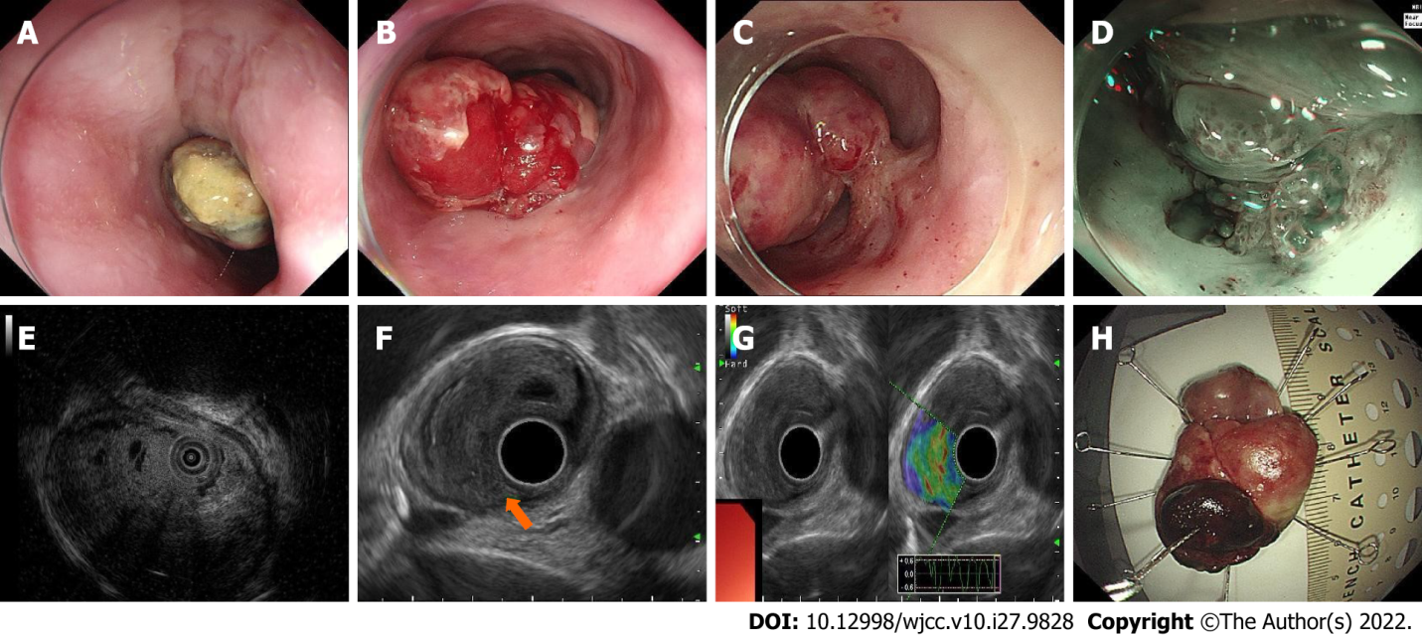
Figure 1 Endoscopic features of the lesion. A: The oral side of the esophageal carcinosarcoma (ECS). The surface was covered with white pseudomembranous inflammation; B: The body of the ECS. The surface was hyperemic and eroded; C: The short peduncle connected to the wall of the esophagus; D: The peduncle component revealed by narrow-band imaging; E: Ultrasonic mini-probe; F: Endoscopic ultrasonography revealed that the origin of the ECS was from the submucosal layer and the inherent muscle layer was clear; G: Ultrasonic elastography revealed that the lesion was blue–green, with a tough texture; H: Macroscopic findings of the resected specimen.

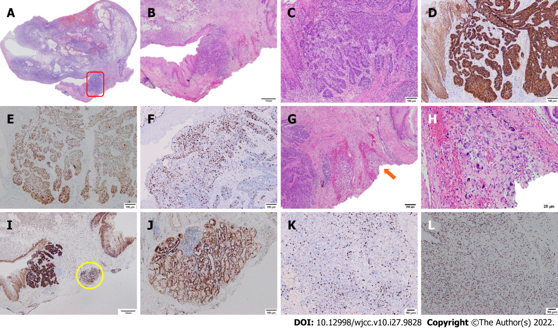
Figure 2 Histological and immunohistochemical findings of the esophageal carcinosarcoma. A: Histological mapping of the esophageal carcinosarcoma; B and C: Hematoxylin-eosin staining of the basal-like squamous cell carcinoma (BSC) component (red rectangle, B × 20, C × 100); D: β-catenin staining of the BSC component (positive, × 100); E: P53 staining of the BSC component (positive, × 100); F: Ki-67 staining of the BSC component (30%, × 100); G and H: Hematoxylin-eosin staining of the sarcoma component (orange arrow, G × 40, H × 400); I and J: Immunopositive carcinomatous cells for β-catenin are closely adjacent to the invasion depth (yellow circle, × 20, × 100); K: Ki-67 staining of the sarcoma component (30%, × 100); L: P53 staining of the sarcoma component (positive, × 100).

Published by Baishideng Publishing Group Inc
7041 Koll Center Parkway, Suite 160, Pleasanton, CA 94566, USA
Telephone: +1-925-3991568
E-mail: bpgoffice@wjgnet.com
Help Desk: https://www.f6publishing.com/helpdesk
https://www.wjgnet.com

© 2022 Baishideng Publishing Group Inc. All rights reserved.

