Name of journal: World Journal of Gastroenterology
ESPS Manuscript NO: 14060
Columns: ORIGINAL ARTICLE

Case Control Study
Pancreas-sparing duodenectomy with regional lymph node dissection for early-stage ampullary carcinoma: A case control study using propensity scoring methods

Liu B et al. Surgical treatment of early-stage ampullary carcinoma

Bin Liu, Jing Li, Yong-Jiu Zhang, Lu-Nan Yan, Sheng-Yi You,Wan-Yee Lau, Hao-Ran Sun, Shi-Yan Yan, Zhi-Qiang Wang

Bin Liu , Zhi-Qiang Wang, Department of Critical Care Medicine, General Hospital of Tianjin Medical University, Tianjin 300052, China

Jing Li, Department of Anesthesiology, General Hospital of Tianjin Medical University, Tianjin 300052, China

Yong-Jiu Zhang, Department of General Surgery, Urumuqi General Hospital of Lanzhou Military Region, PLA, Urumuqi 830000, Xinjiang Autonomous Region, China

Lu-Nan Yan, Division of Liver Transplantation, West China Hospital, Sichuan University, Chengdu 610041, Sichuan Province, China

Sheng-Yi You , Department of General Surgery, General Hospital of Tianjin Medical University, Tianjin 300052, China.

Wan-Yee Lau, Faculty of Medicine, The Chinese University of Hong Kong, Prince of Wales Hospital, Hong Kong, China

Hao-Ran Sun, Department of Radiology, General Hospital of Tianjin Medical University, Tianjin 300052, China

Shi-Yan Yan, Institute of Clinical Basic Medicine, China Academy of Chinese Medical Sciences, Beijing 100700, China

Author contributions: Liu B, Li J and Wang ZQ designed research; Zhang YJ, Yan LN, You SY, Sun HR treated patients and collected material and clinical data from patients; Liu B, Li J, and Yan SY performed the assays; Liu B, Li J, Yan SY and Wang ZQ analysed data; Liu B and Li J wrote the paper.

Supported by National Natural Science Foundation of China, Beijing, China, No. 81170453 and No. 81301025; grants from Tianjin City High School Science and Technology Fund Planning Project, Tianjin, China, No. 20120118.

Ethics approval: This study was approved by the Ethics Board at the General Hospital of Tianjin Medical University.

Informed consent: All study participants provided informed written consent prior to study enrollment.

Conflict-of-interest: The authors state that there is no conflict of interests related to this paper.

Data sharing: Dataset available from the corresponding author at (surgeryliubin@163.com). Participants gave informed consent for data sharing.

Open-Access: This article is an open-access article which was selected by an in-house editor and fully peer-reviewed by external reviewers. It is distributed in accordance with the Creative Commons Attribution Non Commercial (CC BY-NC 4.0) license, which permits others to distribute, remix, adapt, build upon this work non-commercially, and license their derivative works on different terms, provided the original work is properly cited and the use is non-commercial. See: http://creativecommons.org/licenses/by-nc/ 4.0/

Correspondence to: Dr. Zhi-Qiang Wang, Department of Critical Care Medicine, General Hospital of Tianjin Medical University, Tianjin 300052, China. surgeryliubin@163.com
Telephone: +86-22-60362636

Received: September 16, 2014
Peer-review started: September 18, 2014
First decision: October 29, 2014
Revised: November 16, 2014
Accepted: January 21, 2015

Article in press:
Published online:

Abstract
AIM: To investigate the outcomes of pancreas-sparing duodenectomy (PSD) with regional lymph node dissection vs pancreaticoduodenectomy (PD).

METHODS: Between August 2001 and June 2014, 228 patients with early-stage ampullary carcinoma (Amp Ca) underwent surgical treatment (PD, n = 159; PSD with regional lymph node dissection, n = 69). The patients were divided into two groups: the PD group and the PSD group. Propensity scoring methods were used to select patients with similar disease statuses. A total of 138 matched cases, with 69 patients in each group, were included in the final analysis.

RESULTS: The median operative time was shorter among the patients in the PSD group (435 min) compared with those in the PD group (481 min, P = 0.048). The median blood loss in the PSD group was significantly less than that in the PD group. The median length of hospital stay was shorter for patients in the PSD group vs the PD group. The incidence of pancreatic fistula was higher among patients in the PD group vs the PSD group. The 1-, 3-, and 5-year overall survival and disease-free survival for patients in the PSD group were 83%, 70%, 44% and 73%, 61%, 39%, respectively, and these values were not different than those of the patients in the PD group (P = 0.625).

CONCLUSION: PSD with regional lymph node dissection presents an acceptable morbidity in addition to its advantages over PD. PSD may be a safe and feasible alternative to PD in the treatment of early-stage Amp Ca.

Key words: Ampullary carcinoma; Early stage; Surgical treatments; Prognosis; Propensity scoring methods

© The Author(s) 2015. Published by Baishideng Publishing Group Inc. All rights reserved.

Core tip: The median operative time and hospital stay were shorter among the patients in the pancreas-sparing duodenectomy (PSD) group compared with those in the pancreaticoduodenectomy (PD) group. The median blood loss in the PSD group was significantly less than that in the PD group. The incidence of pancreatic fistula was higher among patients in the PD group vs the PSD group. The 1-, 3-, and 5-year overall survival and disease-free survival for patients in the PSD group were not different than those of the patients in the PD group. These data suggest that PSD with regional lymph node dissection may be a safe and feasible alternative for PD in the treatment of early stage of ampullary carcinoma.

Liu B, Li J, Zhang YJ, Yan LN, You SY, Lau WY, Sun HR, Yan SY, Wang ZQ. Pancreas-sparing duodenectomy with regional lymph node dissection for early-stage ampullary carcinoma: A case control study using propensity scoring methods. World J Gastroenterol 2015; In press

INTRODUCTION
The incidence of ampullary carcinoma (Amp Ca) has progressively increased over the last 30 years^{[1]}. Compared with pancreatic carcinoma or common bile duct carcinoma, Amp Ca has an earlier appearance of obstructive symptoms, more favorable histology, and a decreased inclination towards lymphatic or perineural invasion; therefore, it is associated with a higher likelihood of resectability and a more favorable prognosis^{[2]}.
Even though pancreaticoduodenectomy (PD) is still considered the only possible curative treatment for patients with Amp Ca^{[3]}, the complex anatomy and common blood supply of the pancreatico-duodenal region contribute to the technical difficulties and prolonged operative stress induced by PD^{[4]}. Compared with PD, pancreas-sparing duodenectomy (PSD) is less invasive and offers the potential to preserve the anatomical gastrointestinal passage and integrity of the pancreas for the treatment of various periampullary malignant tumors^{[5]}. According to the principle of damage control, a human tendency can be demonstrated towards subtle organ- preserving techniques. Thus, PSD has been introduced as a treatment option and offered as an alternative to PD in select cases of Amp Ca^{[6,7]}.
Unfortunately, lymph node metastases are present in up to 28% of patients with pT1Amp Ca^{[8]}. Thus, it is essential that PSD with regional lymph node dissection only be used in early-stage Amp Ca. Due to the uncertainty of the long-term results, the application of PSD for regional lymph node dissection in early-stage Amp Ca (pTis or pT1, N0 or N1, M0) patients remains controversial^{[9]}. We used propensity scoring methods to investigate the prognostic differences among patients with early-stage Amp Ca who were managed with PSD with regional lymph node dissection vs PD.

MATERIALS AND METHODS
Patient selection and study sign
From a retrospectively collected database, we identified 228 patients who underwent surgery (PD, n = 159; PSD with regional lymph node dissection, n = 69) for early-stage Amp Ca at the General Hospital of Tianjin Medical University from August 2001 to June 2014. We divided the patients with early-stage Amp Ca into two groups: the PD group and the PSD group. To reduce the presence potential confounders in this present study, the values of the propensity scores were used to adjust for differences between the two groups. A total of 138 matched cases, with 69 patients in each group, were included in the final analysis. This study was approved by the Ethics Board at the General Hospital of Tianjin Medical University and complied with the Declaration of Helsinki. The registration number (ChiCTR-OCH-14005198) was issued by the Chinese Clinical Trial Registry.
Early-stage Amp Ca was defined as a carcinoma directly centered on or associated with an in situ carcinoma of the ampulla or/and papilla^{[3]} that has not spread to the bile duct or pancreatic duct and invades the duodenal muscularis propria layer^{[10]}, as evidenced by postoperative pathology report. Cancer staging was performed using the 7th edition of the TNM staging system for ampullary carcinoma issued by the American Joint Committee on Cancer^{[11]}. All patients underwent chest radiography, contrast-enhanced computed tomography (CT) of the abdomen, endoscopic retrograde cholangiopancreatography/magnetic resonance cholangiopancreatography, and endoscopic ultrasonography for preoperative locoregional staging. Only patients in stages pTis, pT1, N0, N1, or M0 would be considered as candidates for the PSD group. Tumors of the duodenum, bile duct, or pancreatic were excluded in this study. In the control group, these patients matched with the PSD group for demographic data, tumor type，tumor size, tumor type, and TNM classification and underwent standard PD for early-stage Amp Ca during the same period.
The multidisciplinary team of this study reviewed the following data for each patient: demographics; laboratory blood tests; contrast-enhanced CT of the abdomen; magnetic resonance cholangiopancreatography; endoscopic retrograde cholangiopancreatography; endoscopic ultrasonography; operative details; resection margin status; presence of lymph node metastasis; peri-operative morbidity and mortality; vital status; and date of death or last follow-up. All operative procedures were consecutively performed by a senior surgeon with expertise in hepatobiliary and pancreatic surgery at our institution. All pathology specimens (formalin fixed, paraffin-embedded tissue blocks were retrieved from the archives of the pathology department) were reviewed by a pathologist. One pathologist who was blinded to the clinical and survival data re-evaluated all of the pathologic specimens and histopathologic findings.
The definitions of R0 resection, R1 resection, and specific complications, such as pancreatic fistula and delayed gastric emptying, have been described elsewhere^{[12-14]}. The Japan Pancreatic Society (JPS) system for the numbering of lymph node stations was adopted to accurately describe the operation and pathologic assessment^{[15]}. The technique used for standard PD and PSD with (Figures 1 and 2) regional lymph node dissection has been previously described elsewhere^{[16,17]}.

Follow-up protocol, survival and recurrence
All patients who completed follow-up were monitored postoperatively with routine blood tests, tumor markers (carbohydrate antigen 19-9 and carcinoembryonic antigen), chest radiography, endoscopic ultrasonography, and CT. Follow-up studies were performed every six months. Overall survival was defined as the time from surgical resection to death. Initial disease recurrence was determined using CT images and classified as locoregional (anastomotic site or regional or retroperitoneal lymph node) or distant (peritoneal, hepatic, or another organ) disease recurrence. Recurrence-free survival was defined as the time from surgical resection to the time when a recurrent tumor was first diagnosed^{[3]}.

Statistical analysis
To overcome the effects of patient background and to increase the robustness of this retrospective observational case-control study, matching was performed with the aim of selecting subsets of case and control groups with similar distributions of the observed covariates in this study. The data were expressed using frequencies and percentages for categorical variables and means and standard deviations for continuous variables. Continuous variables were compared by means of the Mann–Whitney test. Categorical variables were compared by the chi-square or Fisher exact test. Multivariate/ univariate analysis was conducted using the log-rank test to examine risk factors and associations with mortality. Survival time was censored at the date of last follow up if death had not occurred. Survival curves were estimated using Kaplan-Meier techniques. Statistical analysis was performed using commercially available software SPSS version 16.0 (SPSS, Inc, Chicago, Illinois).

RESULTS
From August 2009 to June 2014, the medical records of patients with Tis/T1 Amp Ca underwent PSD with regional lymph node dissection or standard PD during the same study period were retrospectively reviewed. After one-to one matching using propensity score analysis, 69 pairs of patients in each group were matched and compared. Among the propensity score-matched pairs, there were no significant differences in the demographic data or preoperative status of the patients between the two groups (detailed in Table 1).The clinical backgrounds of the two groups were thus successfully matched.
Intraoperative data are summarized in Table 2. The median operative time was shorter among patients in the PSD group (435 min) compared with those in the PD group (481 min, P = 0.048). The median blood loss in the PSD group was 351 mL, lower than that in the PD group (802 Ml, P = 0.031). As expected, patients requiring intra-operative blood transfusions in the PSD group were fewer than in the PD group (P = 0.027). To identify whether the patients were free of carcinoma, frozen section biopsies were performed for qualifying patients in both groups after the en block resection of the ampulla of Vater and the descending segment of the duodenum.
The median length of the hospital stay was shorter for patients in the PSD group (10 d) vs the PD group (18 d, P = 0.045). However, the median length of the ICU stay was not significantly different between the PSD group (3 d) and the PD group (4 d, P = 0.059). The hospital mortality rate was not significantly different between the PSD group (2.9%) and the PD group (4.3%, P = 0.081). Additionally, there was no significant difference in the reoperation rate between the PSD group (4.3%) and the PD group (7.2%, P = 0.064). Eight patients (3 in the PSD group vs 5 in the PD group) required reoperations due to abdominal/gastrointestinal bleeding associated with pancreatic leakage. Three patients undergoing PSD developed a pancreatic anastomotic leak (grade A, n = 2; grade C, n = 1), whereas 16 patients developed a pancreatic fistula (grade A, n = 4; grade B, n = 8; grade C, n = 4) after PD. The incidence of pancreatic fistula was higher among patients in the PD group (23.2%) vs the PSD group (4.3%, P = 0.037). Delayed gastric emptying was noted exclusively in the PD group (15 vs 6 in the PSD group, P = 0.045). Eight patients undergoing PD developed postoperative diabetes mellitus, whereas no cases of new-onset diabetes were observed in the PSD group (P = 0.041). There were no differences in the overall incidence of abdominal/ gastrointestinal bleeding, bile leakage, wound infection, sepsis, abdominal abscess, and cardiac events between the 2 groups (detailed in Table 3).
The median tumor size was not different among the patients in the PD group (3.0 cm) vs the PSD group (2.6 cm, P = 0.053). According to the 7th edition of the TNM staging system, there were 3 Tis and 66 T1 patients in the PSD group and 4 Tis and 65 T1 patients in the PD group. There were 49 N0 stage and 20 N1 stage patients in the PSD group, whereas 45 patients were N0 stage and 24, N1 stage in the PD group. The percentages of the positive nodes/evaluated nodes were 16.7% (18/108) and 17.6% (22/125) of the patients in the PSD and PD groups (P = 0.102), respectively. The most commonly involved nodes in both study groups were the posterior pancreaticoduodenal nodes (JPS LN13), followed by the anterior pancreaticoduodenal nodes (JPS LN17). Other lymph nodes with high metastatic potential were the right-sided inferior nodes of the hepatoduodenal ligament (JPS LN12), the infrapyloric node (JPS LN6), and the nodes around the superior mesenteric artery (JPS LN14) (detailed in Table 4). Histologic findings indicated that there were 27 intestinal carcinoma, 40 pancreatobiliary carcinoma and 2 mixed type carcinoma cases in the PSD group. By contrast, there were 24 intestinal carcinoma, 42 pancreatobiliary carcinoma, and 3 mixed type carcinoma cases in the PD group (showed in Figure 3). The histologic grades did not differ between the PSD and PD groups. There were 64 R0 resections and 5R1 resections in the PSD group, compared to 63 R0 resections and 6 R1 resections in the PD group. On multivariate analysis, the factors associated with an increased risk of lymph node metastasis included tumor size ≥ 1 cm (OR = 2.3; 95%CI: 1.3–4.0), histologic grade (OR = 3.7; 95%CI: 2.1–6.9)
After a mean follow-up of 45 mo (range, 4-70 mo), 16 (23.2%) of the patients developed tumor recurrence in the PSD group, compared to 14 (20.3%) in the PD group. The median time between surgery and the diagnosis of disease recurrence was 8.7 mo (range, 5.0-18.3 mo) in the PSD group and 10.2 mo (range, 5.2-15.4 mo) in the PD group. The main patterns of recurrence in these patients are shown in Table 5. Local regional recurrence was observed 7 in the PSD group vs 4 in the PD group; distant recurrence was observed 6 in the PSD group (hepatic 3, and lung 3) vs 4 in the PD group (hepatic 2, peritoneal 1, and lung 1). Local recurrences with distant metastases were observed 3 in the PSD group (hepatic 2, and lung 1) vs 6 in the PD group (hepatic 3, peritoneal 1, and lung 2). The 1-, 3-, and 5-year overall survivals and disease-free survivals for patients in the PSD group were 83%, 70%, 44%, and 73%, 61%, 39%, respectively, without any significant difference from the patients in the PD group (P = 0.625) (Figure 4A and 4B). Additionally, the median and 5-year survival for N1 patients in the PSD group were 19.8 mo and 20%, respectively, which was no different than the values among the N1 patients in the PD group (21.4 mo and 25.0%, respectively) (P > 0.05) (Figure 4D).

DISCUSSION
Early-stage Amp Ca (pTis or pT1, N0 or N1, M0) is characterized by a tumor limited to the mucosa of the ampulla or of the sphincter of Oddi, regardless of the presence or absence of lymph node metastasis. PD represents the curative procedure of choice for the majority of patients with Amp Ca. However, high operative mortality rates (15% to 23%) and morbidity rates (24% to 60%) of PD have been reported in the 1990s and in recent studies^{[18]}. Although PSD offers certain advantages over PD^{[19,20]}, this organ-preserving surgical procedure was mainly used for patients with periampullary adenomas^{[21]}. The exploration of less invasive, feasible and safe surgical approaches for the treatment of early-stage Amp Ca remains an important target for clinical research.
Recently, several studies have demonstrated that PSD with regional lymph node dissection is suitable for patients with early-stage Amp Ca. However, this surgical technique is challenging due to the uncertainty of tumor clearance, recurrence, and long-term survival. Therefore, the present study sought to examine the outcomes of patients undergoing PSD with regional lymph node dissection vs PD, as well as to identify factors predictive of recurrence in patients with early-stage Amp Ca.
Although the hospital mortality, recurrence rate, 3- and 5-year overall survival rates and disease-free survival following PD and PSD with regional lymph node dissection were not significantly different (P > 0.05) in this study, the incidence of pancreatic fistula was lower among patients in the PSD group (23.2%) vs the PD group (4.3%, P = 0.037). Hospital stays were also shorter among patients in the PSD group (10 d) vs the PD group (18 d, P = 0.045). Similar to previous studies^{[22,23]}, the advantages of PSD over PD in the present study included the following: shorter surgical time, less intra-operative bleeding, less intra-operative blood transfusion, more conserved intestinal function, preservation of pancreatic tissue, and allowance for better endoscopic follow-up.
Many factors have been proven to influence survival in the early stages of Amp Ca, including R0 resection, lymph node metastases, lymphatic invasion, tumor stage, tumor grade^{[24,25]}. Our multivariate analysis, however, indicated that lymph node metastasis is one of the most important independent indicators predicting Amp Ca recurrence and long term survival. Moreover, previous studies have demonstrated that lymph node metastases were present in 10%-28% of patients in the early stages of Amp Ca^{[8,26]}. In this study, lymph node metastases were present in 17%-18% of patients with early-stage Amp Ca. Our study, which is consistent with the current literature on PSD^{[17,27]}, demonstrated that radical resection with regional lymph node dissection is required for the surgical treatment of early-stage Amp Ca. The most commonly involved nodes were the posterior pancreaticoduodenal nodes (JPS LN13), followed by the anterior pancreaticoduodenal nodes (JPS LN17), in our study group.
In conclusion, even in early stages of Amp Ca, the rate of lymph node metastases is approximately 17%-18%. Lymph node metastases are one of the most important independently indicators predicting Amp Ca recurrence and long-term survival. Thus, radical resection is required for surgical treatments at the early stages of Amp Ca. PSD with regional lymph node dissection is less invasive, feasible and safer for the treatment of early-stage Amp Ca. This procedure provides an acceptable morbidity and mortality rate for early-stage Amp Ca when compared to PD.

COMMENTS
Background
The outcomes of pancreas-sparing duodenectomy (PSD) with regional lymph node dissection for early-stage ampullary carcinoma (Amp Ca) remain uncertain. The aim of this study was to investigate the outcomes of PSD with regional lymph node dissection vs pancreaticoduodenectomy (PD).

Research frontiers
Due to the uncertainty of the long-term results, the application of PSD for regional lymph node dissection in early-stage Amp Ca (pTis or pT1, N0 or N1, M0) patients remains controversial.

Innovations and breakthroughs
This is a novel study in that it addresses the median operative time and hospital stay were shorter among the patients in the PSD group compared with those in the PD group. The median blood loss in the PSD group was significantly less than that in the PD group. The incidence of pancreatic fistula was lower among patients in the PSD group vs the PD group. The overall survival and disease-free survival for patients in the PSD group were not different than those of the patients in the PD group. These data suggest that PSD with regional lymph node dissection presents an acceptable morbidity and provides advantages over PD.

Applications
PSD with regional lymph node dissection may be a safe and feasible alternative for PD in the treatment of early stage of Amp Ca.

Peer review
This is an interesting study that shows the largest number of patients with early stage of ampullary carcinoma (Amp Ca) in mainland China in this study. It suggests that PSD with regional lymph node dissection is less invasive, feasible and safer for the treatment of early-stage Amp Ca. This procedure provides an acceptable morbidity and mortality rate for early-stage Amp Ca when compared to PD.

REFERENCES
1 Albores-Saavedra J, Schwartz AM, Batich K, Henson DE. Cancers of the ampulla of vater: demographics, morphology, and survival based on 5,625 cases from the SEER program. J Surg Oncol 2009; 100: 598-605 [PMID: 19697352 DOI: 10.1002/jso.21374]
2 Klempnauer J, Ridder GJ, Pichlmayr R. Prognostic factors after resection of ampullary carcinoma: multivariate survival analysis in comparison with ductal cancer of the pancreatic head. Br J Surg 1995; 82: 1686-1691 [PMID: 8548242 DOI: 10.1002/bjs.1800821233]
3 Narang AK, Miller RC, Hsu CC, Bhatia S, Pawlik TM, Laheru D, Hruban RH, Zhou J, Winter JM, Haddock MG, Donohue JH, Schulick RD, Wolfgang CL, Cameron JL, Herman JM. Evaluation of adjuvant chemoradiation therapy for ampullary adenocarcinoma: the Johns Hopkins Hospital-Mayo Clinic collaborative study. Radiat Oncol 2011; 6: 126 [PMID: 21951377 DOI: 10.1186/1748-717X-6-126]
4 Nagai H, Hyodo M, Kurihara K, Ohki J, Yasuda T, Kasahara K, Sekiguchi C, Kanazawa K. Pancreas-sparing duodenectomy: classification, indication and procedures. Hepatogastroenterology ; 46: 1953-1958 [PMID: 10430376]
5 Konishi M, Kinoshita T, Nakagohri T, Takahashi S, Gotohda N, Ryu M. Pancreas-sparing duodenectomy for duodenal neoplasms including malignancies. Hepatogastroenterology ; 54: 753-757 [PMID: 17591055]
6 Poves I, Burdio F, Alonso S, Seoane A, Grande L. Laparoscopic pancreas-sparing subtotal duodenectomy. JOP 2011; 12: 62-65 [PMID: 21206106]
7 Ahn YJ, Kim SW, Park YC, Jang JY, Yoon YS, Park YH. Duodenal-preserving resection of the head of the pancreas and pancreatic head resection with second-portion duodenectomy for benign lesions, low-grade malignancies, and early carcinoma involving the periampullary region. Arch Surg 2003; 138: 162-18; discussion 168 [PMID: 12578411 DOI: 10.1001/archsurg.138.2.162]
8 Winter JM, Cameron JL, Olino K, Herman JM, de Jong MC, Hruban RH, Wolfgang CL, Eckhauser F, Edil BH, Choti MA, Schulick RD, Pawlik TM. Clinicopathologic analysis of ampullary neoplasms in 450 patients: implications for surgical strategy and long-term prognosis9 9 Park JS, Yoon DS, Kim KS, Choi JS, Lee WJ, Chi HS, Kim BR. Factors influencing recurrence after curative resection for ampulla of Vater carcinoma. J Surg Oncol 2007; 95: 286-290 [PMID: 17326125 DOI: 10.1002/jso.20665]
10 Ogawa T, Ito K, Fujita N, Noda Y, Kobayashi G, Horaguchi J, Koshita S, Kanno Y, Masu K, Ishii S. Endoscopic papillectomy as a method of total biopsy for possible early ampullary cancer. Dig Endosc 2012; 24: 291 [PMID: 22725127 DOI: 10.1111/j.1443-1661.2011.01214.x]
11 American Joint Committee on Cancer: AJCC cancer staging manual. 7th edition. New York: Springer-Verlag, 2010
12 Winter JM, Cameron JL, Campbell KA, Chang DC, Riall TS, Schulick RD, Choti MA, Coleman J, Hodgin MB, Sauter PK, Sonnenday CJ, Wolfgang CL, Marohn MR, Yeo CJ. Does pancreatic duct stenting decrease the rate of pancreatic fistula following pancreaticoduodenectomy? Results of a prospective randomized trial. J Gastrointest Surg 2006; 10: 1280-190; discussion 1290 [PMID: 17114014]
13 Yeo CJ, Barry MK, Sauter PK, Sostre S, Lillemoe KD, Pitt HA, Cameron JL. Erythromycin accelerates gastric emptying after pancreaticoduodenectomy. A prospective, randomized, placebo-controlled trial. Ann Surg 1993; 218: 229-37; discussion 237-8 [PMID: 8103982]
14 Bassi C, Dervenis C, Butturini G, Fingerhut A, Yeo C, Izbicki J, Neoptolemos J, Sarr M, Traverso W, Buchler M. Postoperative pancreatic fistula: an international study group (ISGPF) definition. Surgery 2005; 138: 8-13 [PMID: 16003309]
15 Isaji S, Kawarada Y, Uemoto S. Classification of pancreatic cancer: comparison of Japanese and UICC classifications. Pancreas 2004; 28: 231-234 [PMID: 15084962]
16 Pessaux P, Varma D, Arnaud JP. Pancreaticoduodenectomy: superior mesenteric artery first approach. J Gastrointest Surg 2006; 10: 607-611 [PMID: 16627229]
17 Chen G, Wang H, Fan Y, Zhang L, Ding J, Cai L, Xu T, Lin H, Bie P. Pancreas-sparing duodenectomy with regional lymphadenectomy for pTis and pT1 ampullary carcinoma. Surgery 2012; 151: 510-517 [PMID: 22033169 DOI: 10.1016/j.surg.2011.08.007]
18 Arkadopoulos N, Kyriazi MA, Papanikolaou IS, Vasiliou P, Theodoraki K, Lappas C, Oikonomopoulos N, Smyrniotis V. Preoperative biliary drainage of severely jaundiced patients increases morbidity of pancreaticoduodenectomy: results of a case-control study. World J Surg 2014; 38: 2967-2972 [PMID: 24952079 DOI: 10.1007/s00268-014-2669-x]
19 Parc Y, Mabrut JY, Shields C. Surgical management of the duodenal manifestations of familial adenomatous polyposis. Br J Surg 2011; 98: 480-484 [PMID: 21656714 DOI: 10.1002/bjs.7374]
20 Müller MW, Dahmen R, Köninger J, Michalski CW, Hinz U, Hartel M, Kadmon M, Kleeff J, Büchler MW, Friess H. Is there an advantage in performing a pancreas-preserving total duodenectomy in duodenal adenomatosis? Am J Surg 2008; 195: 741-748 [PMID: 18436175 DOI: 10.1016/j.amjsurg.2007.08.061]
21 Ramia-Angel JM, Quiñones-Sampedro JE, De La Plaza Llamas R, Gomez-Caturla A, Veguillas P. [Pancreas-preserving total duodenectomy]. Cir Esp ; 91: 466-468 [PMID: 22578472 DOI: 10.1016/j.ciresp.2012.02.029]
22 Al-Sarireh B, Ghaneh P, Gardner-Thorpe J, Raraty M, Hartley M, Sutton R, Neoptolemos JP. Complications and follow-up after pancreas-preserving total duodenectomy for duodenal polyps. Br J Surg 2008; 95: 1506-1511 [PMID: 18991295 DOI: 10.1002/bjs.6412]
23 Johnson MD, Mackey R, Brown N, Church J, Burke C, Walsh RM. Outcome based on management for duodenal adenomas: sporadic versus familial disease. J Gastrointest Surg 2010; 14: 229-235 [PMID: 19937193 DOI: 10.1007/s11605-]
24 Barauskas G, Gulbinas A, Pranys D, Dambrauskas Z, Pundzius J. Tumor-related factors and patient's age influence survival after resection for ampullary adenocarcinoma. J Hepatobiliary Pancreat Surg 2008; 15: 423-428 [PMID: 18670845 DOI: 10.1007/s00534-007-1313-7]
25 Qiao QL, Zhao YG, Ye ML, Yang YM, Zhao JX, Huang YT, Wan YL. Carcinoma of the ampulla of Vater: factors influencing long-term survival of 127 patients with resection. World J Surg 2007; 31: 137-43; discussion 144-6 [PMID: 17171495 DOI: 10.1007/s00268-006-0213-3]
26 Beger HG, Treitschke F, Gansauge F, Harada N, Hiki N, Mattfeldt T. Tumor of the ampulla of Vater: experience with local or radical resection in 171 consecutively treated patients. Arch Surg 1999; 134: 526-532 [PMID: 10323425 DOI: 10.1001/archsurg.134.5.526]
27 Duffy JP, Hines OJ, Liu JH, Ko CY, Cortina G, Isacoff WH, Nguyen H, Leonardi M, Tompkins RK, Reber HA. Improved survival for adenocarcinoma of the ampulla of Vater: fifty-five consecutive resections. Arch Surg 2003; 138: 941-98; discussion 941-98; [PMID: 12963649 DOI: 10.1001/archsurg.138.9.941]
P-Reviewer: Bradley EL, Sugiyama H S-Editor: Yu J
L-Editor: E-Editor:

Figure 1
Figure 1 The technique of pancreas-sparing duodenectomy. En bloc resection of the biliopancreatic junction and descending segment of duodenum.

Figure 2

Figure 2 Pancreaticojejunostomy, choledochojejunostomy, and end-to-end anastomosis of the duodenum are performed with pyloroplasty.

A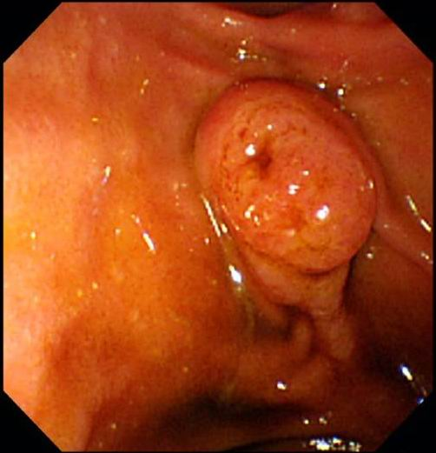 B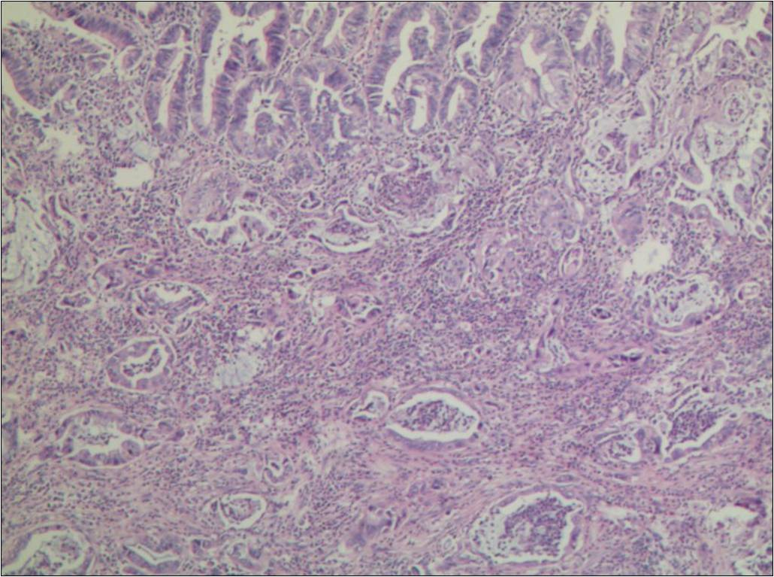
Figure 3 Duodenoscopic view of ampullary adenocarcinoma (A) and Histopathological features of the mixed type ampullary adenocarcinoma (B). A: A exposed-type tumor mass at the ampulla of Vater, with a normal ampullary orifice; B: Histopathological features of the mixed type ampullary adenocarcinoma. Both intestinal and pancreatobiliary growth pattern distributed (HE staining, × 200).

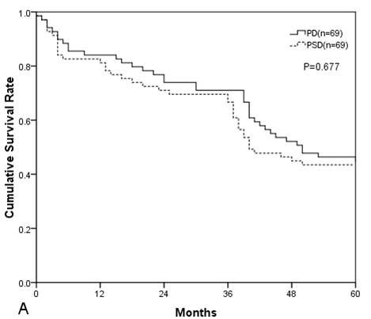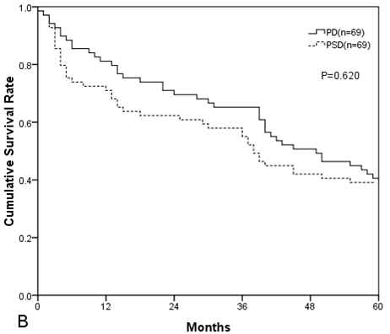
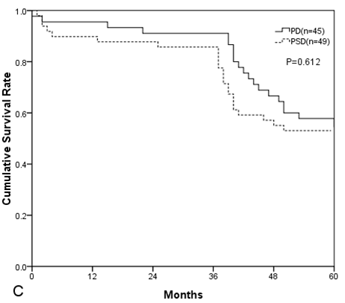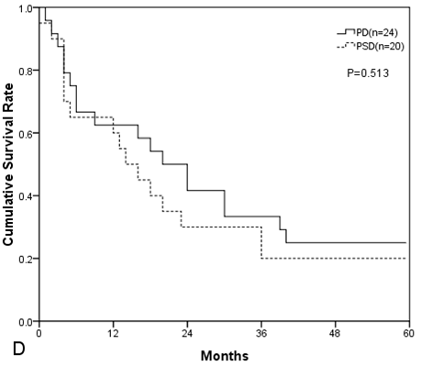
Figure 4 Kaplan–Meier survival analysis of all patients. A: Overall survival (P = 0.677); B: Disease-free survival (P = 0.62); C: Overall survival of N0 patients (P = 0.612); D: Overall survival of N1 patients (P = 0.513).

Table 1 Patient characteristics between study groups
Characteristic | PD group  (n = 69) | PSD group  (n = 69) | P
Age (yr) | 58.5 (41-79) | 62.1 (39-78) | 0.765
Gender, Male, n (%) | 36 (52.3) | 38 (55.1) | 0.681
Preoperative laboratory results
Hemoglobin (g/dL) | 11.7 (9.0-14.3) | 11.0 (9.3-14.5) | 0.663
Total bilirubin (mg/dL) | 7.1 (0.9-14.8) | 7.6 (0.6-15.1) | 0.701
Serum albumin (g/L) | 3.5 (2.3-5.6) | 3.7 (2.4-5.3) | 0.913
CA19-9 (ng/mL) | 33.8 (0.1-491) | 37.1 (0.1-463) | 0.594
CEA (ng/mL) | 1.8 (0.1-30.2) | 2.0 (0.1-31) | 0.787
Past medical history, n (%)
Hypertension | 21 (30.4) | 23 (33.3) | 0.604
Coronary artery disease | 15 (21.7) | 13 (18.8) | 0.837
Diabetes mellitus | 8 (11.6) | 9 (13.0) | 0.694
History of alcohol abuse | 6 (8.7) | 7 (10.1) | 0.668
History of tobacco use | 17 (24.6) | 19 (27.5) | 0.917
Myocardial infarction | 5 (7.2) | 4 (5.8) | 0.857
Peripheral vascular disease | 4 (5.8) | 4 (5.8) | 0.793
COPD | 2 (2.9) | 3 (4.3) | 0.634
Data are expressed as number of patients or median (range). ERCP: Endoscopic retrograde cholangiopancreatography; EUS: Endoscopic ultrasound; COPD: Chronic obstructive pulmonary disease; CA19-9: Carbohydrate antigen 19-9; CEA: Carcinoembryonic antigen; PD: Pancreaticoduodenectomy; PSD: Pancreas-sparing duodenectomy.

Table 2 Intra-operative characteristics between study groups
Characteristic | PD group  (n = 69) | PSD group  (n = 69) | P
Op. time (min) | 481 (312-798) | 435 (301-552) | 0.048
Blood loss (mL) | 802 (240-1900) | 351 (150-1000) | 0.031
Patients needed intraoperative blood transfusion, n (%) | 23 (33.3) | 7 (10.1) | 0.027
Data are expressed as number of patients or median (range). Op. time: Operation time; PD: Pancreaticoduodenectomy; PSD: Pancreas-sparing duodenectomy.

Table 3 Postoperative characteristics between study groups
Characteristics | PD group (n = 69) | PSD group  (n = 69) | P
Hospital stay (d), median(range) | 18 (8-60) | 10 (7-26) | 0.045
ICU stay (d), median(range) | 4 (2-15) | 3 (1-7) | 0.059
Hospital mortality, n (%) | 3 (4.3) | 2 (2.9) | 0.081
Reoperation, n (%) | 5 (7.2) | 3 (4.3) | 0.064
Postoperative complications, n (%)
Pancreatic leakage | 16 (23.2) | 3 (4.3) | 0.037
Grade A | 4 | 2 | 0.106
Grade B | 8 | 0 | 0.058
Grade C | 4 | 1 | 0.217
Delayed gastric emptying | 15 | 6 | 0.045
New onset diabetes mellitus | 8 | 0 | 0.041
Bile leak | 2 | 0 | 0.678
Abdominal bleeding | 9 | 5 | 0.721
Gastrointestinal bleeding | 6 | 4 | 0.661
Wound infection | 5 | 2 | 0.543
Sepsis | 2 | 1 | 0.608
Abdominal abscess | 4 | 2 | 0.334
Cardiac event | 3 | 0 | 0.329
Data are expressed as number of patients or median (range). ICU: Intensive care unit; PD: Pancreaticoduodenectomy; PSD: Pancreas-sparing duodenectomy.

Table 4 histopathologic characteristics between study groups
Characteristics | PD group  (n = 69) | PSD group  (n = 69) | P
Tumor size (cm) | 3.0 (1.5-5.0). | 2.6 (0.6-4.7) | 0.053
TNM classification: primary tumor
Tis | 4 | 3 | 0.071
T1 | 65 | 66 | 0.644
TNM classification: regional lymph nodes, n
N0 | 45 | 49 | 0.339
N1 | 24 | 20 | 0.417
Number of positive nodes/evaluated nodes of JPS system, n/n | 22/125 (17.6%) | 18/108 (16.7%) | 0.402
JPS LN6 | 16/2 | 13/2 | 0.248
JPS LN8 | 10/0 | 8/0 | 0.375
JPS LN12 | 20/3 | 18/3 | 0.194
JPS LN13  JPS LN14  JPS LN17 | 39/10  12/1  28/6 | 34/8  13/1  22/4 | 0.527  0.291  0.396
Histopathologic types
Intestinal carcinoma | 24 | 27 | 0.633
Pancreatobiliary carcinoma  Mixed type | 42  3 | 40  2 | 0.597  0.304
Histologic grade
G1 | 32 | 34 | 0.312
G2 | 37 | 35 | 0.407
R0 resection, n | 63 | 64
R1 resection, n | 6 | 5
Data are expressed as number of patients or median (range). The Japan Pancreatic Society (JPS) system for numbering of lymph node stations: LN6, The infrapyloric node; LN8, The nodes around the anterior aspect of the common hepatic artery; LN12, The right-sided inferior nodes of the hepatoduodenal ligament; LN13, The posterior pancreatoduodenal nodes; LN14, The nodes around the superior mesenteric artery; LN17,The anterior pancreatoduodenal nodes; PD: Pancreaticoduodenectomy; PSD: Pancreas-sparing duodenectomy.

Table 5 Recurrence and survival between study groups
Characteristic | PD (n = 69) | PSD (n = 69) | P
Recurrence rate, n (%) | 14 (20.3) | 16 (23.2) | 0.427
Time to recurrence (mo) | 10.2 (5.2-15.4) | 8.7 (5.0-18.3) | 0.518
Type of recurrence, n
Local recurrence | 4 | 7 | 0.409
Distant metastases | 4 | 6 | 0.331
Local recurrence and distant metastases | 6 | 3 | 0.497
Overall survival
1 yr | 81% | 83% | 0.617
3 yr | 71% | 70% | 0.735
5 yr | 46% | 44% | 0.591
Disease free survival
1 yr | 81% | 73% | 0.704
3 yr | 65% | 61% | 0.692
5 yr | 41% | 39% | 0.679
Data are expressed as number of patients or median (range). PD: Pancreaticoduodenectomy; PSD: Pancreas-sparing duodenectomy.

