Name of journal: World Journal of Gastroenterology
ESPS Manuscript NO: 10719
Columns: Case Control Study

Complete laparoscopic resection of the rectum using natural orifice specimen extraction

Hisada M et al. Complete laparoscopic resection of the rectum

Masayuki Hisada, Kenji Katsumata, Tetsuo Ishizaki, Masanobu Enomoto, Takaaki Matsudo, Kazuhiko Kasuya, Akihiko Tsuchida

Masayuki Hisada, Kenji Katsumata, Tetsuo Ishizaki, Masanobu Enomoto, Takaaki Matsudo, Kazuhiko Kasuya, Akihiko Tsuchida, Department of Digestive Surgery and Pediatric Surgery, Tokyo Medical University, Tokyo 160-0023, Japan

Author contributions: Hisada M and Katsumata K contributed equally to this work; Kasuya K and Tsuchida A designed research; Hisada M, Ishizaki T, Enomoto M and Matsudo T performed research; Hisada M and Katsumata K analyzed data; Hisada m and Katsumata K wrote the paper.

Correspondence to: Masayuki Hisada, MD, PhD, Department of Digestive Surgery and Pediatric Surgery, Tokyo Medical University, 6-7-1 Nishishinjuku, Shinjuku-ku, Tokyo 160-0023, Japan. m-hisada@tokyo-med.ac.jp

Telephone: +81-3-33426111 Fax: +81-3-33404575
Received: April 16, 2014 Revised: July 13, 2014
Accepted: August 13, 2014

Published online:

Abstract
Aim: To investigate how complete laparoscopic anterior resection with natural orifice specimen extraction (NOSE), as a novel minimally invasive surgery, compares to conventional laparoscopic surgery.

Methods: Twenty patients who underwent complete laparoscopic anterior resection with NOSE and 50 patients who underwent laparoscopic assisted anterior resection by the conventional method between 2011 and 2012 were studied. Selection for complete laparoscopic anterior resection with NOSE was decided on the basis of tumor size, localization of the tumor, and body mass index. Outcomes related to surgery, including operation time, postoperative wound pain, hospital stay after surgery, the number of totally dissected lymph nodes, postoperative complications (suture failure and wound infection), and anal function, were retrospectively reviewed. The anal function was assessed at 3 and 6 months after surgery using the Wexner fecal incontinence scoring system.

Results: Complete laparoscopic resection with NOSE was performed to completion in all 20 patients. There was no patient emergency which required conversion to conventional laparoscopic surgery or open surgery. The comparison between complete laparoscopic resection with NOSE and conventional laparoscopic surgery showed no significant differences in the maximal diameter of the tumor, number of totally dissected lymph nodes, bleeding volume, mean operation time, time to start of oral ingestion, postoperative hospital stay, and postoperative complications. On the other hand, with regard to pain after epidural anesthesia, the total usage of analgesic in this surgical technique was a mean of 1.85 ± 1.8 times, whereas it was 5.89 ± 2.86 in conventional laparoscopic surgery, showing a statistically significant difference (P < 0.001). The postoperative pain period was 1.9 ± 1.9 d in this surgical technique whereas it was 3.43 ± 1.41 d in conventional laparoscopic surgery, showing a significant difference (P < 0.004). In complete laparoscopic surgery with NOSE, the mean postoperative follow-up period was 20 mo (range: 12-30 mo). Neither local recurrence nor remote metastasis was observed during the follow-up period.

Conclusion: Complete laparoscopic anterior resection using NOSE does not require any incision and has excellent cosmetic properties with mitigated postoperative pain.

© 2014 Baishideng Publishing Group Inc. All rights reserved.

Key words: Complete laparoscopic surgery; Incisionless surgery; Natural orifice specimen extraction; Transanal specimen extraction; Less invasive surgery

Core tip: Natural orifice specimen extraction (NOSE) has been reported as a less invasive surgery to avoid the problems arising from even small incisions. In this study, we present details of surgical technique for NOSE and the outcomes of complete laparoscopic anterior resection using NOSE are compared with conventional laparoscopic anterior resection. Complete laparoscopic anterior resection using NOSE has more advantages in terms of cosmetic outcomes and mitigating postoperative pain as compared with conventional laparoscopic anterior resection. Based on our study, we consider complete laparoscopic anterior resection using NOSE as an acceptable and novel minimally invasive surgery.

Hisada M, Katsumata K, Ishizaki T, Enomoto M, Matsudo T, Kasuya K, Tsuchida A. Complete laparoscopic resection of the rectum using natural orifice specimen extraction. World J Gastroenterol 2014; In press

Introduction
With the recent advances in minimally invasive surgery, laparoscopic anterior resection for rectal cancer has become a common practice. However, an incision of about 5-6 cm is still made in the abdomen for resection of the lesion or insertion of the anvil head of the automatic anastomosis device. This incision, though small, causes risks of postoperative wound pain, infections, adhesions after surgery, or abdominal incisional hernia. For this reason, an even less minimally invasive surgical technique is required. In such a situation, natural orifice specimen extraction (NOSE) has been introduced as a less invasive surgery in order to solve the problems arising from small incisions. However, these surgical techniques have not yet become widespread.
Therefore, we have performed complete laparoscopic anterior resection in 20 patients through transanal extraction of the lesion without making any incision in the abdomen, and hereby describe the surgical techniques and outcomes of this treatment.

MATERIALS AND METHODS
The study was approved by the ethics committee of Tokyo Medical University Hospital and written informed consent was obtained from patients who would receive complete laparoscopic anterior resection with NOSE. Patients diagnosed with rectal cancer were selected for complete laparoscopic anterior resection with NOSE by several criteria. The indications for complete laparoscopic anterior resection with NOSE were as follows: (1) tumor located at distal side of sigmoid colon to upper side of rectum; (2) tumor diameter less than 5 cm and no serosal exposure as evaluated by computed tomography; (3) lymph node metastasis less than cN1; and (4) no bulky mesorectum as evaluated by a body mass index less than 30 kg/m². Massive tumor, surrounding lymph nodes depicted on CT, or obese patients were excluded. All operations were performed by a team which was proficient in various laparoscopic colorectal procedures at our hospital since 2004; NOSE surgery was performed since 2010. If drawing the resected bowel intracorporeally was impossible or critical damage to the residual rectum occurred during the drawing, the operative procedure was converted to conventional laparoscopic surgery using the double stapling technique or open surgery. All patients underwent oral magnesium citrate bowel preparation twice, 2 d before the operation. Twenty patients who underwent complete laparoscopic anterior resection with NOSE and 50 patients who underwent laparoscopic assisted anterior resection by the conventional method between 2011 and 2012 were studied. Parameters including the operation time, postoperative wound pain, hospital stay after surgery, the number of totally dissected lymph nodes, postoperative complications, and anal function were evaluated. The anal function was assessed at 3 and 6 mo after surgery using the Wexner fecal incontinence scoring system. The statistical differences were examined using the t-test and Fisher’s χ² test. A P value < 0.05 was considered to indicate a statistically significant difference. The statistical analysis software used was Dr. SPSS II for Windows.

Surgical techniques
Five ports were created (Figure 1), and a pneumoperitoneum was created at 8-10 mmHg. One 12 mm camera port was inserted in the umbilical region or its adjacent area, another 12 mm port was used for the lower right abdomen, and 5 mm ports for the right and left upper abdomen and lower left abdomen were created. The mesosigmoid adjacent to the right common iliac artery was exfoliated from the inside. Exfoliation was continued cephalad and the inferior mesenteric root was identified. For the treatment of the inferior mesenteric artery, high ligation was performed; however, in some cases, the left colic artery was preserved by low ligation depending on the stage of progression. The back side of the mesentery was exfoliated toward the outside as usual, and the lateral side of the sigmoid colon was exfoliated and communicated with the medial exfoliated layer. The descending colon should be manipulated as much as possible; otherwise the transanal extraction of the bowel becomes difficult or the tension after anastomosis may cause the risk of suture failure. At this time, determine the oral dissection line at 10 cm or more from the tumor as the guidelines indicate, in order to facilitate transanal extraction, and totally dissect the marginal artery in a preserving manner, confirming the blood flow in the reconstruction bowel. Dissect the mesentery along the superior rectal artery and vein (Figure 2), and confirm that the oral dissection line sufficiently reaches the pelvic floor.
Although it depends on the position of the tumor, exfoliate the rectum sufficiently measuring 5 cm or longer from the tumor toward the anus. Determine the dissection line of the bowel towards the anal side and perform the trimming treatment of the mesorectum.
The bowel should be closed at the tumor towards the anal side with a 1-0 loop needle. First insert the needle in the anterior wall of the bowel up to the seromuscular level, and turn the needle to the posterior wall of the bowel. Perform seromuscular suturing in the contralateral bowel, and perform the closing ligation through the loop. After tightening the loop, attach a Hem-o-lok clip to the thread on the needle side and tighten the bowel side for bondage (Figure 3). Perform rectal irrigation from the anus with 500 mL of physiological saline containing povidone-iodine, and then open the rectum by laparosonic coagulating shears (LCS) (Figure 4). Now, insert a nylon bag to protect the tumor from the 12 mm port in terms of implantation or infections, and pierce a 1-0 loop needle thread through it (Figure 5). In order to exteriorize the resected bowel, insert the straight grasping forceps transanally, followed by grasping a 1-0 loop thread, and drawing it into the residual rectum (Figure 6). In doing this, administer butyl scopolamine intravenously, if necessary, in order to prevent the residual rectum from developing a spasm. Remove the tumor and the reconstructed bowel from the body transanally, perform dissection of the tumor towards the oral side and treatment of the marginal artery, and by inserting the anvil head of the automatic anastomosis device, reposition the reconstructed bowel inside the body cavity (Figure 7). After sufficient irrigation of the rectal stump and pelvic cavity, laparoscopically perform purse-string suturing of the rectal stump with a 2-0 monofilament, then insert the anvil from the rectum and ligate for closure, keeping the central rod out (Figure 8a-b). When reefing of the rectal stump seems insufficient, occasionally additional reefing is performed with an end loop. Finally, after sufficient irrigation of the pelvic cavity, perform anastomosis with the single staple technique (SST) using an automatic anastomosis device.

Results
Information concerning the 20 patients undergoing this surgical technique is shown in Table 1. Patients consisted of 12 men and 8 women. No patient required conversion to conventional laparoscopic surgery or open surgery. The maximal diameter of the tumor ranged from 10 mm to 50 mm with a mean of 27 ± 9 mm. The comparison with conventional laparoscopic surgery is shown in Table 2. In laparoscopic surgery, it ranged from 10 mm to 90 mm with a mean of 38.5 ± 18 mm. Although there was no significant difference from this surgical technique, the tumor diameter was slightly smaller. The number of totally dissected lymph nodes was 17.7 ± 7.7 in this surgical technique, whereas it was 17.5 ± 8.8 in conventional laparoscopic surgery, showing no significant difference.
The bleeding volume ranged from 10 mL to 245 mL with a mean of 114 ± 72 mL. The bleeding volume in conventional laparoscopic surgery was a mean of 120 ± 56 mL, denoting no significant difference between this technique and conventional laparoscopic surgery. The mean operation time was 278 ± 39 min; the time required for purse-string suturing was a mean of 15 ± 4 min; the mean operation time in conventional laparoscopic surgery was 240 ± 77 min. There were no statistically significant differences between the techniques in procedure times.
The time to start of oral ingestion after surgery was 4 ± 1.4 d in this surgical technique whereas it was 4.3 ± 0.9 d in the conventional technique, showing no significant difference. Postoperative hospital stay was 11.8 ± 1.6 d in this surgical technique whereas it was 11 ± 3.2 d in conventional laparoscopic surgery, showing no significant difference.
Regarding postoperative analgesic, in both groups, 0.75% ropivacaine was used for epidural anesthesia, and when pain occurred, 15 mg pentazocine mixed in 100 mL of physiological saline was administered intravenously after 1 h. With regard to pain after epidural anesthesia, the total postoperative usage of analgesic in this surgical technique was a mean of 1.85 ± 1.8 times, whereas it was 5.89 ± 2.86 in conventional laparoscopic surgery, showing a significant decrease (P = 0.001). The postoperative pain period was 1.9 ± 1.9 d in this surgical technique whereas it was 3.43 ± 1.41 d in conventional laparoscopic surgery, showing a significant decrease (P = 0.004).
Postoperative complications in this surgical technique included suture failure in 1 patient, which was conservatively mitigated, and 1 patient each with ischemic enteritis in the anastomotic part and anal pain was observed early after the surgery, but these were conservatively mitigated, without occurrence of surgical site infection (SSI). In the conventional laparoscopic surgery cases, suture failure was found in 4 patients, and 1 of them underwent colostomy. SSI was observed in 8 patients. Postoperative follow-up in this surgical technique period ranged from 12 to 30 mo with a mean of 20 mo. Patients at stage 3a and above underwent postoperative chemotherapy. Neither local recurrence nor remote metastasis was observed during the follow-up period. In conventional laparoscopic surgery, the postoperative follow-up period ranged from 13 to 32 mo, during which time anastomotic recurrence and remote metastasis were found in 1 patient each. Since this surgical technique draws the tumor from the anus, those with a low T factor are selected, and there may be no difference in terms of radical cure between these surgical techniques, although the background factors may vary with patients.
Anal function was evaluated using the Wexner fecal incontinence scoring system. Evaluation at 3 mo after surgery was Score 6 in 1 patient, Score 1 in 2 patients, and Score 0 in the remaining 7 patients. The patient with Score 6 developed postoperative ischemic change in the anastomotic part, and was improved up to Score 1 about 6 months after surgery. At postoperative 6 months, only 1 patient had Score 1, and the other 9 had Score 0.
All patients underwent intraoperative cytodiagnosis and culture, but floating cancer cells or bacteria were not detected.

Discussion
Laparoscopic surgery has become widely accepted as a minimally invasive surgery. With the occasional adoption of surgical methods such as single port surgery, natural orifice translumenal endoscopic surgery, or NOSE, the latter two of which do not involve making an incision in the abdomen, minimally invasive surgery is expected to be further developed in the future. As for NOSE, the transvaginal technique has been described in terms of problems such as elasticity of the tissue or wound healing^{[1-5]}. However, reports on the transanal method such as the one reported here are still few. The reasons include a cumbersome procedure to transanally draw the lesion and to reconstruct it. Wolthuis et al^{[6]} reported that they transanally inserted the separation bag and drew the lesion for left colon cancer. However, it is also reported that the resected specimen gets folded in the bag by this method, making the diameter of the specimen larger than that of the rectum, leading to damages in the residual rectum or the anus which is the route to remove the tumor. To solve this problem, there is a report of a procedure to insert the wound retractor transanally and facilitate the extraction of the lesion^{[7]}. The surgical technique which we have devised and reported uses a 1-0 loop thread for closure of the tumor towards the anal side, using this as the supporting thread, and draws the tumor into the rectum, thereby inserting the tumor to be removed in the longitudinal direction against the rectal stump, leading to easy extraction. This method is contrary to the method of resecting the bowel after inversion as reported by Hara et al^{[8]} According to Katsuno et al^{[9]}, oral dissection is done after the tumor is extracted; thus it becomes possible to dissect directly after confirming the positional relation between the tumor and the vessels in the mesentery. After tumor resection, the anvil head is mounted in the reconstructed bowel extracorporeally, and is repositioned in the body cavity. Then, purse-string suturing of the dissected rectum is laparoscopically performed, and reconstruction using SST is performed. SST was reported to have a lesser risk of suture failure compared to the double staple technique (DST) in some of the literature; however, other reports described no difference between them. Even though there is no established opinion^{[10,11]} on this matter, it was considered advantageous for wound healing because no staple-on-staple anastomosis was involved. Distal margin was also considered advantageous because of homogeneity around the entire circumference.
Since this method necessitates bowel incision within the peritoneal cavity, intraoperative infections may occur. However, there is a report stating that bowel irrigation before opening the bowel can decrease the infection risk and intraoperative opening of the bowel does not lead to the risk of SSI^{[12,13]}.
To prevent local recurrence due to opening the bowel, we performed rectal irrigation from the anus with 500 mL of physiological saline containing povidone-iodine and confirmed by intraoperative cytodiagnostic procedures that there were no cancer cells in the irrigation outflow from the residual rectum.
Apart from that, we also covered the resected bowel with a nylon bag to reduce the risk further. In fact, in patients we have treated, pathogenic bacteria were not detected from the intraoperative irrigation fluid. With regard to intraoperative floating cancer cells, McKenzie et al^{[2]} reported that transvaginal NOSE does not pose a risk for tumor implantation, and Ooi et al^{[14]} stated that the protective barrier and specimen bag can reduce the risk of tumor implantation or local recurrence. We also perform extraction by covering the tumor with a nylon bag in order to completely prevent the risk of local recurrence, and no cancer cells were observed by the intraoperative cytodiagnostic procedures performed in all the patients. Operation time, bleeding volume, postoperative wound pain, postoperative hospital stay, the number of totally dissected lymph nodes, and postoperative complications were compared between this method and conventional laparoscopic surgery. There were no significant differences in bleeding volume, postoperative hospital stay, the number of totally dissected lymph nodes, and suture failure between both groups, indicating similar results as that from conventional laparoscopic surgery. On the other hand, in conventional laparoscopic surgery, the mean operation time was 38 min shorter, although this was not a statistically significant difference. The reason may be due to the time required for purse-string suturing of the rectal stump and the time to adequately manipulate the descending colon. However, the mean operating time gradually decreases with the increase in the number of treated cases, suggesting the existence of a learning curve. The postoperative complications of this surgical technique included ischemic enteritis of the anastomosis part and postoperative anal pain in 1 patient each, which were conservatively mitigated. SSI was observed in 8 patients in conventional laparoscopic surgery, whereas there were no occurrences in this surgical technique. Although no significant difference was observed in the incidence of SSI, it may become evident in the future with the accumulation of cases.
The indications for this method may require several conditions as described below so as to perform the extraction transanally.
Localization of the primary lesion is at the distal side of the sigmoid colon to the upper side of the rectum, the tumor diameter is less than 5 cm and there is no serosal exposure as evaluated by CT, there is a lesser metastasis of the lymph nodes, and there is no bulky mesorectum as evaluated by a body mass index less than 30 kg/m² are all indications for transanal extraction. Those with massive tumor or surrounding lymph nodes depicted on CT were excluded because of the difficulty of transanal extraction. Sufficient exfoliation and manipulation up to the splenic flexure are necessary to remove the tumor and the reconstructed bowel transanally out of the body, and if the sigmoid colon has a sufficient length, the surgery becomes much easier. If these conditions are not fulfilled, insufficient resection of proximal margin or damages to the mesentery of the reconstructed bowl due to excessive traction of the resected bowel may occur. If the resection line towards the anal side is 2 cm or more lower than the peritoneal reflection, laparoscopic purse-string suturing may be difficult in terms of the technique, and in such cases sufficient exfoliation of the rectum towards the anal side is necessary.
Due to these reasons, the difficulty level and the pros and cons of the surgery tend to be dependent on the localization of the tumor and the degree of progression. The best indication is for the patient with the tumor of less volume, localized in the vicinity of the rectosigmoid segment, and length of the sigmoid colon with sufficient margin.
Despite the existence of the above conditions, this method, compared to the conventional method, had significantly lower frequency of postoperative analgesic usage and shorter postoperative pain period as it does not involve creation of an incision. Even though a significant difference could not be established due to the small number of patients and as the complication of SSI was not observed, it can be inferred that there may be a sufficient advantage in not making any incision. With regard to the number of totally dissected lymph nodes or postoperative recurrence, no significant differences were observed, and with regard to radical cure and safety, this method was equivalent to the conventional method in these 20 patients. Therefore, we arrived at the conclusion that this method can be accepted as a minimally invasive surgery for rectal cancer or sigmoid colon cancer.
In conclusion, we have performed complete laparoscopic anterior resection using the natural orifice specimen extraction method in 20 patients with rectal cancer. This method does not require any incision in the abdomen, and has excellent cosmetic properties with mitigated postoperative pain. Therefore we consider it is justified to accept this as a novel minimally invasive surgery. This surgical technique may require several conditions, and it will be necessary to establish this technique and indications based on further examination and accumulation of more cases.

COMMENT
Background
Recently laparoscopic anterior resection for rectal cancer has become a common practice. However, a small incision is still made in the abdomen for resection of the tumor. This small incision causes postoperative wound pain, and has risks for infections, adhesions after surgery, or incisional herniation.

Research frontier
At present, natural orifice specimen extraction (NOSE) has been reported as a less invasive surgery in order to solve complications caused by creating incisions.

Innovations and breakthroughs
The present study showed that complete laparoscopic anterior resection with NOSE is the same as conventional laparoscopic anterior resection in safety and oncological outcome, does not require any incision in the abdomen, and has excellent cosmetic properties.

Application
NOSE for colorectal cancer can avoid making any incision to extract the specimen. The way to extract the specimen is the most important process in NOSE surgery. We describe an easy way to extract without causing residual rectum injury. This should allow NOSE surgery to be applied in treating various diseases.

Terminology
NOSE for colorectal cancer can avoid making incisions to extract the specimen. Complete laparoscopic anterior resection with NOSE is the same as conventional laparoscopic anterior resection in surgical outcomes, and had a significantly lower frequency of postoperative analgesic usage and shorter postoperative pain period, as it does not involve making any incision.

Peer review
This study reported the detailed surgical procedures and benefits of laparoscopic rectal surgery with the NOSE technique. This method as an advanced minimally invasive surgery seems to be quite attractive and may hold a high position among previously reported NOSE techniques.

References
1 Palanivelu C, Rangarajan M, Jategaonkar PA, Anand NV. An innovative technique for colorectal specimen retrieval: a new era of "natural orifice specimen extraction" (N.O.S.E). Dis Colon Rectum 2008; 51: 1120-1124 [PMID: 18481149 DOI: 10.1007/s10350-008-9316-2]
2 McKenzie S, Baek JH, Wakabayashi M, Garcia-Aguilar J, Pigazzi A. Totally laparoscopic right colectomy with transvaginal specimen extraction: the authors' initial institutional experience. Surg Endosc 2010; 24: 2048-2052 [PMID: 20108143 DOI: 10.1007/s00464-009-0870-z]
3 Choi GS, Park IJ, Kang BM, Lim KH, Jun SH. A novel approach of robotic-assisted anterior resection with transanal or transvaginal retrieval of the specimen for colorectal cancer. Surg Endosc 2009; 23: 2831-2835 [PMID: 19440794 DOI: 10.1007/s00464-009-0484-5]
4 Han FH, Hua LX, Zhao Z, Wu JH, Zhan WH. Transanal natural orifice specimen extraction for laparoscopic anterior resection in rectal cancer. World J Gastroenterol 2013; 19: 7751-7757 [PMID: 24282364 DOI: 10.3748/wjg.v19.i43.7751]
5 Wang Q, Wang C, Sun DH, Kharbuja P, Cao XY. Laparoscopic total mesorectal excision with natural orifice specimen extraction. World J Gastroenterol 2013; 19: 750-754 [PMID: 23430965 DOI: 10.3748/wjg.v19.i5.750]
6 Wolthuis AM, Meuleman C, Tomassetti C, D'Hooghe T, Fieuws S, Penninckx F, D'Hoore A. Laparoscopic sigmoid resection with transrectal specimen extraction: a novel technique for the treatment of bowel endometriosis. Hum Reprod 2011; 26: 1348-1355 [PMID: 21427115 DOI: 10.1093/humrep/der072]
7 Nishimura A, Kawahara M, Suda K, Makino S, Kawachi Y, Nikkuni K. Totally laparoscopic sigmoid colectomy with transanal specimen extraction. Surg Endosc 2011; 25: 3459-3463 [PMID: 21553173 DOI: 10.1007/s00464-011-1716-z]
8 Hara M, Takayama S, Sato M, Imafuji H, Takahashi H, Takeyama H. Laparoscopic anterior resection for colorectal cancer without minilaparotomy using transanal bowel reversing retrieval. Surg Laparosc Endosc Percutan Tech 2011; 21: e235-e238 [PMID: 22002283 DOI: 10.1097/SLE.0b013e3182297667]
9 Katsuno G, Fukunaga M, Nagakari K, Yoshikawa S, Ouchi M, Hirasaki Y, Azuma D. Natural orifice specimen extraction using prolapsing technique in single-incision laparoscopic colorectal resections for colorectal cancers. Asian J Endosc Surg 2014; 7: 85-88 [PMID: 24450353 DOI: 10.1111/ases.12063]
10 Kim HJ, Choi GS, Park JS, Park SY. Comparison of intracorporeal single-stapled and double-stapled anastomosis in laparoscopic low anterior resection for rectal cancer: a case-control study. Int J Colorectal Dis 2013; 28: 149-156 [PMID: 23014975 DOI: 10.1007/s00384-012-1582-8]
11 Marecik SJ, Chaudhry V, Pearl R, Park JJ, Prasad LM. Single-stapled double-pursestring anastomosis after anterior resection of the rectum. Am J Surg 2007; 193: 395-399 [PMID: 17320542 DOI: 10.1016/j.amjsurg.2006.12.008]
12 Bucher P, Wutrich P, Pugin F, Gonzales M, Gervaz P, Morel P. Totally intracorporeal laparoscopic colorectal anastomosis using circular stapler. Surg Endosc 2008; 22: 1278-1282 [PMID: 17943355 DOI: 10.1007/s00464-007-9607-z]
13 Maeda K, Maruta M, Hanai T, Sato H, Horibe Y. Irrigation volume determines the efficacy of "rectal washout". Dis Colon Rectum 2004; 47: 1706-1710 [PMID: 15540303 DOI: 10.1007/s10350-004-0659-z]
14 Ooi BS, Quah HM, Fu CW, Eu KW. Laparoscopic high anterior resection with natural orifice specimen extraction (NOSE) for early rectal cancer. Tech Coloproctol 2009; 13: 61-64 [PMID: 19288243 DOI: 10.1007/s10151-009-0460-z]

P-Reviewer: Fierbinteanu-Braticevici C, Ker CG, Matsuda A S-Editor: Ma YJ L-Editor: E-Editor:

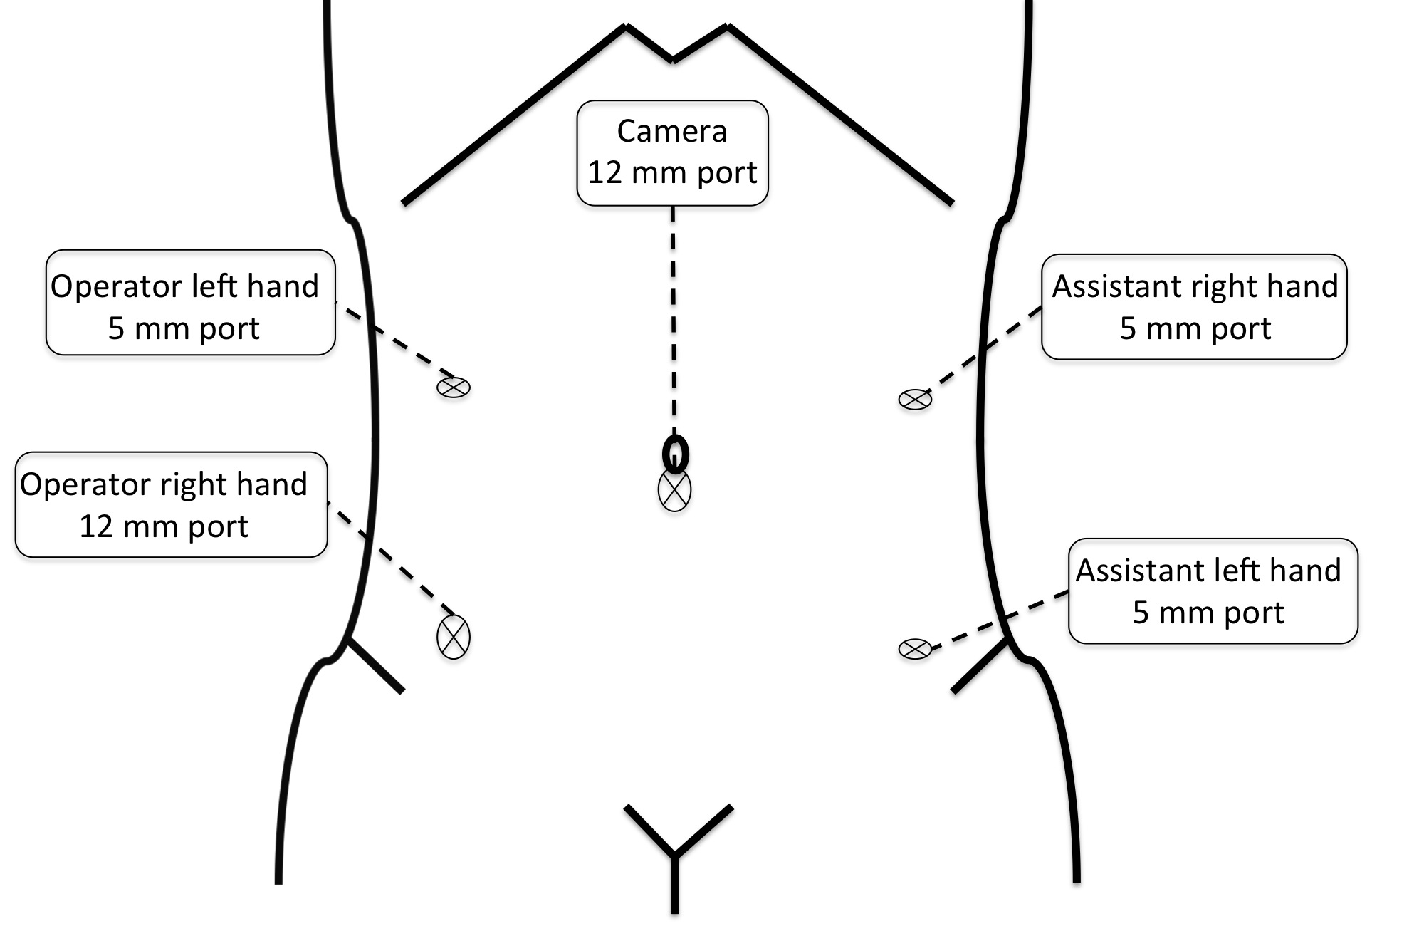
Figure 1 Port site.

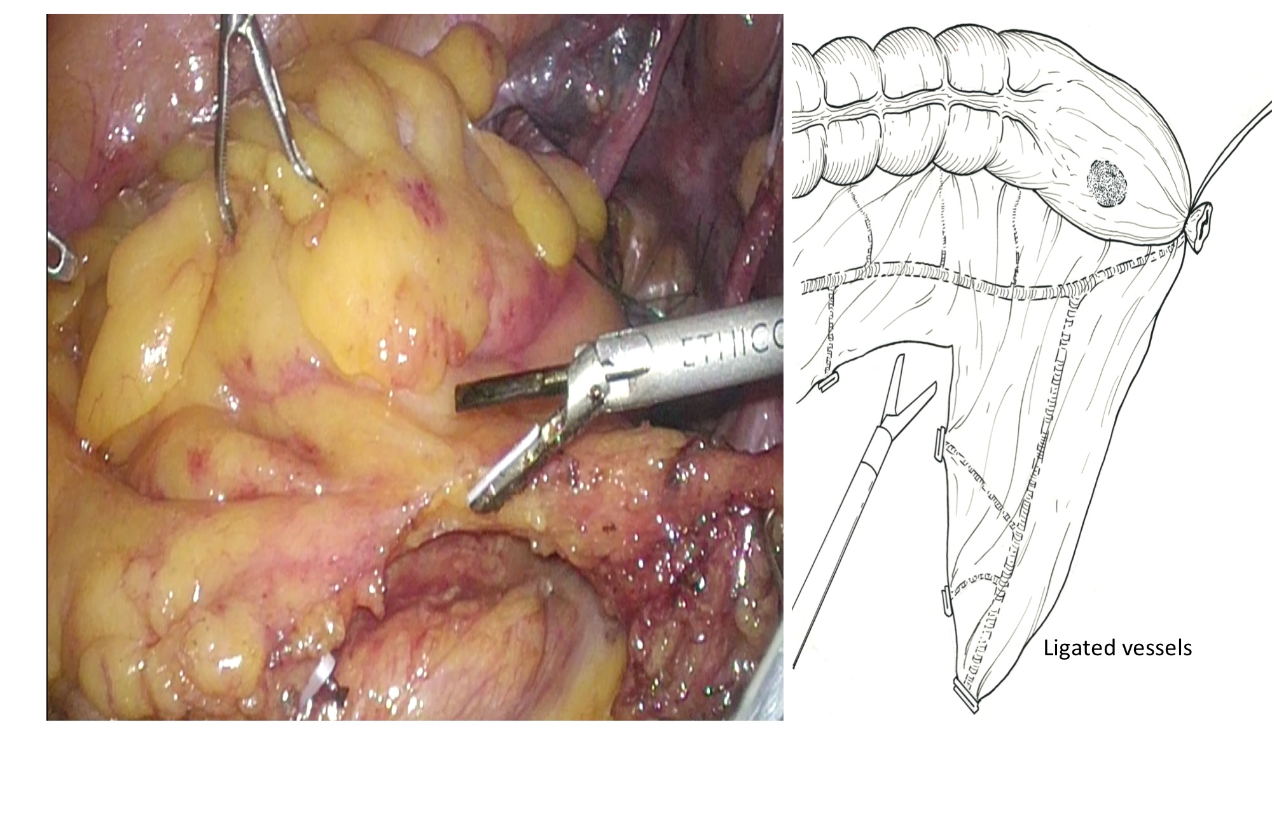
Figure 2 Dissect sigmoid colon mesentery.

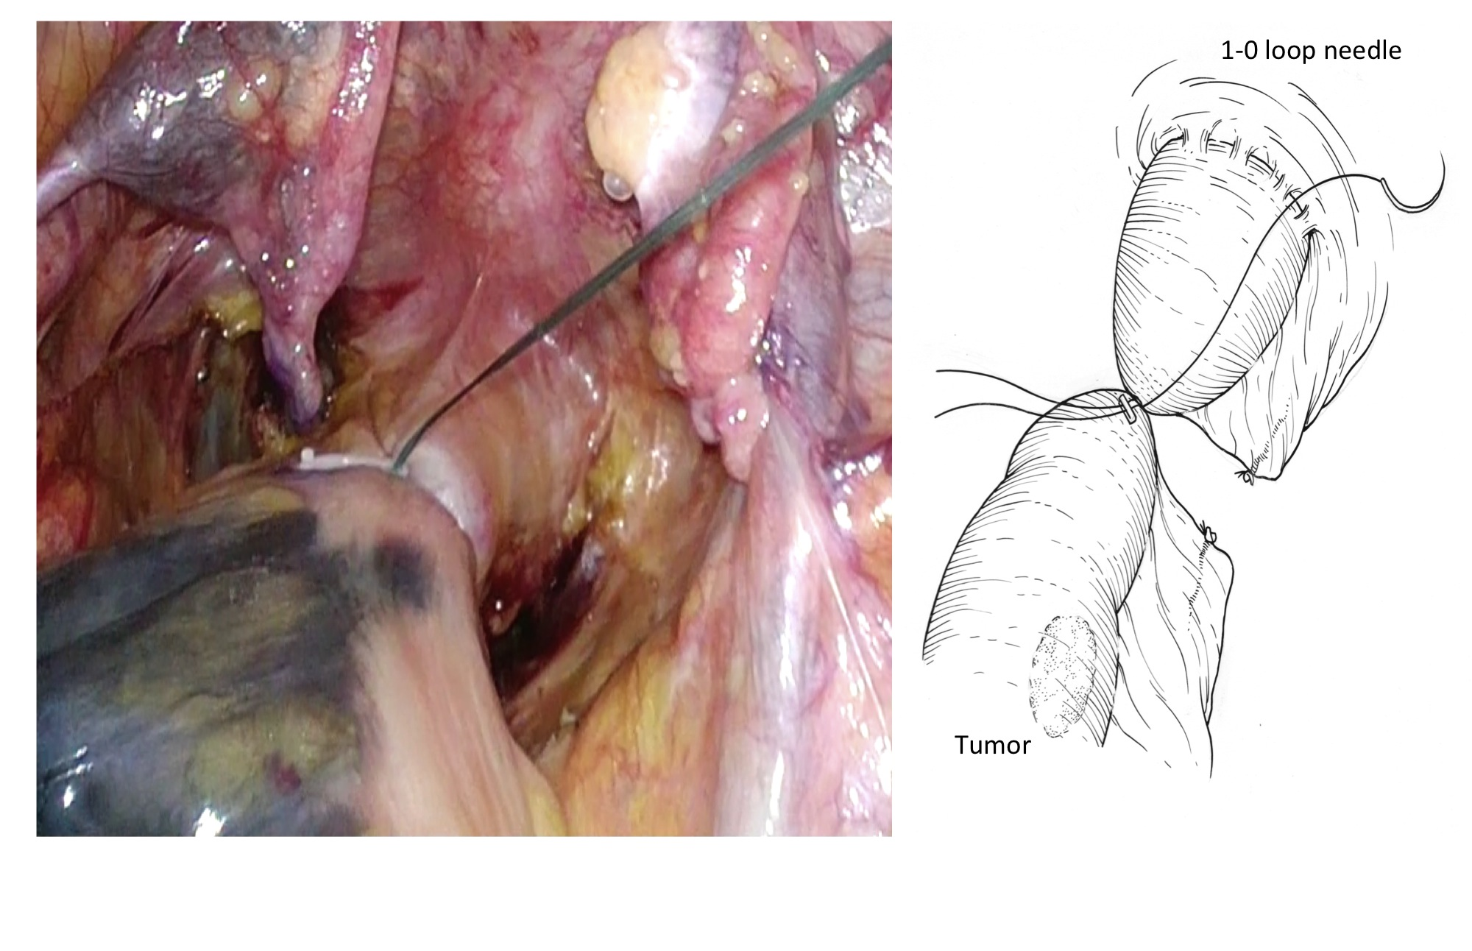
Figure 3 Bowel closure.

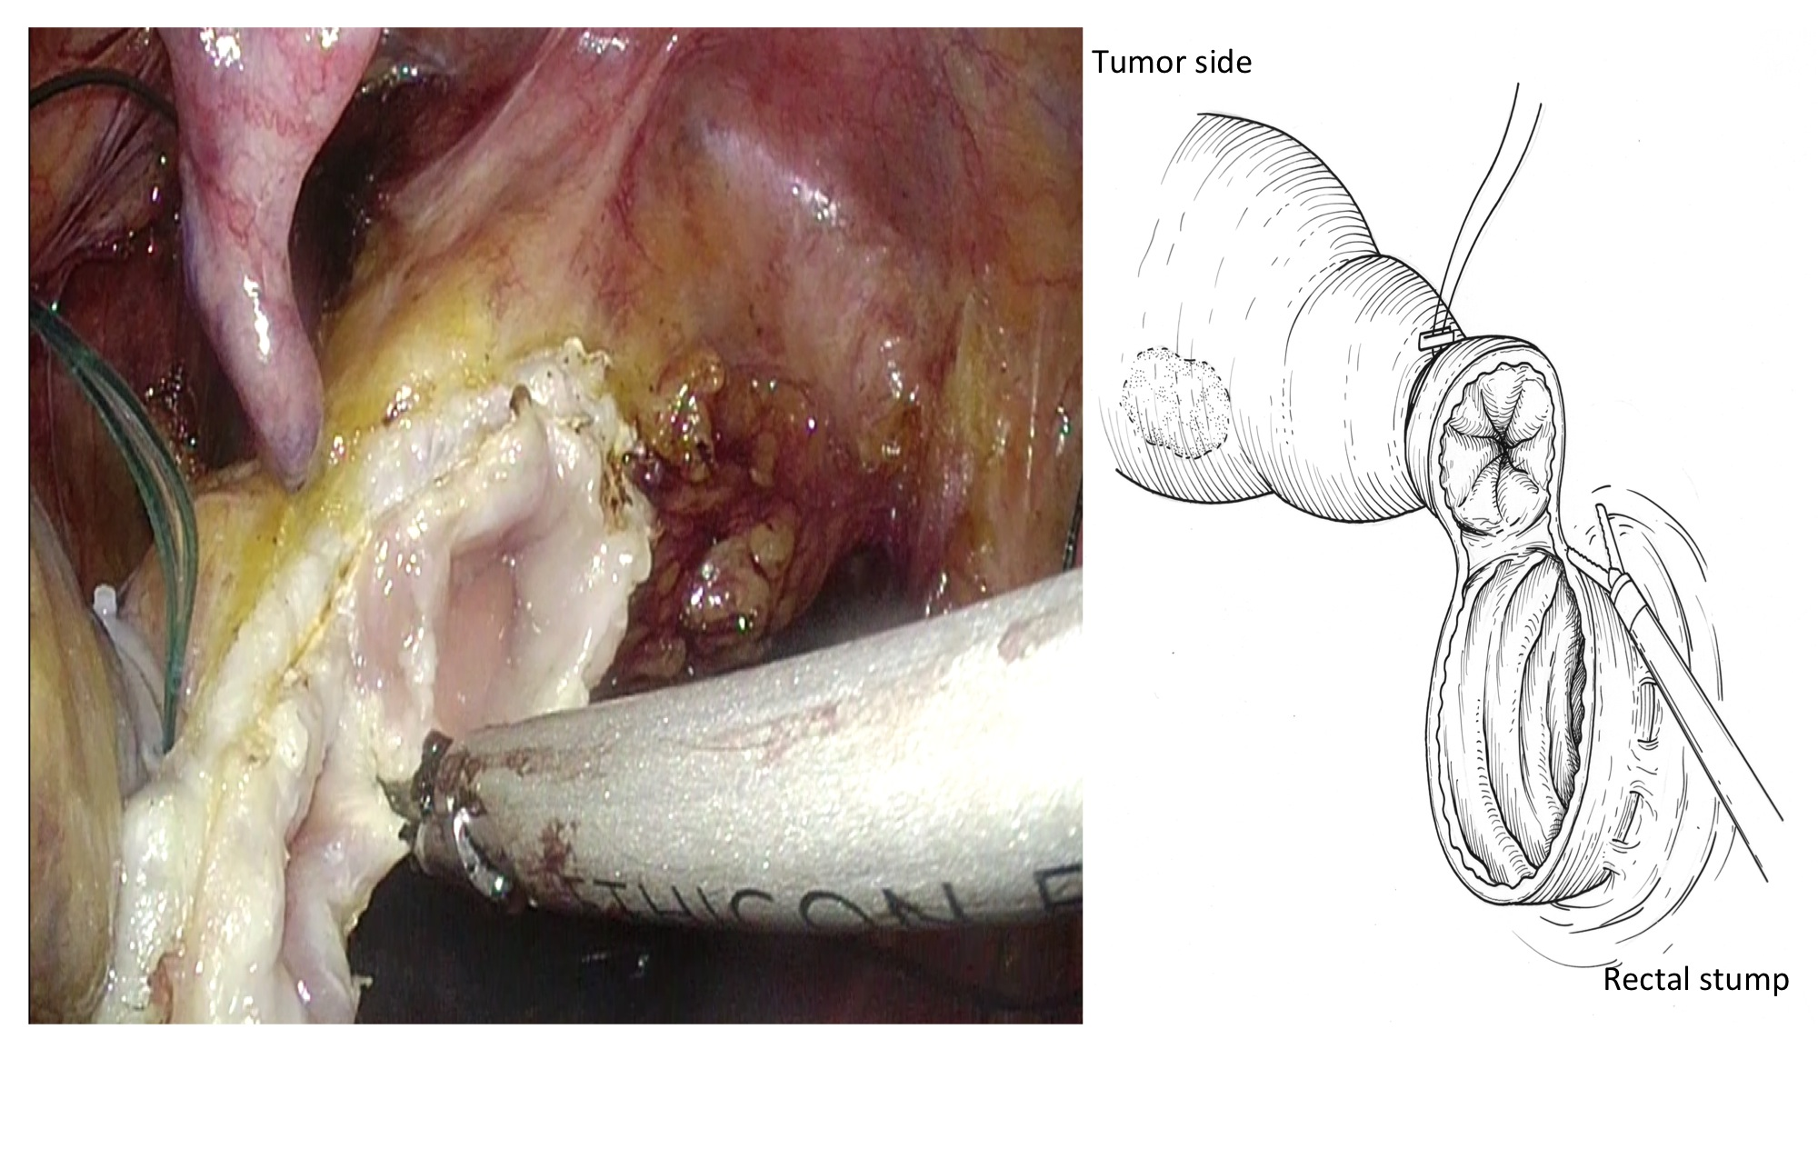
Figure 4 Open the rectum using laparosonic coagulating shears.

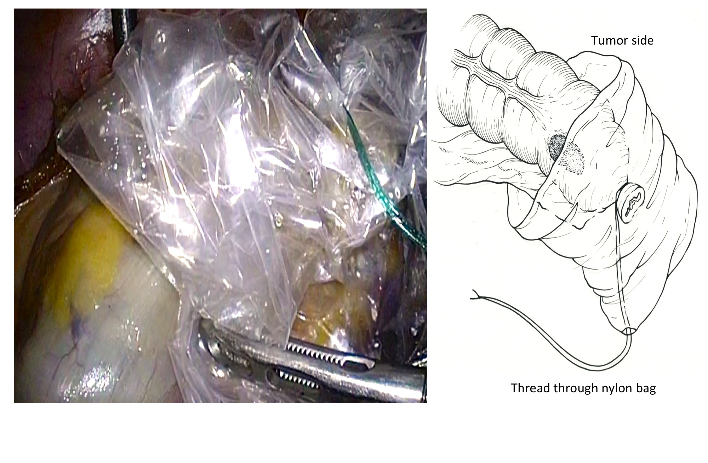

Figure 5 Protect the tumor using nylon bag tumor.

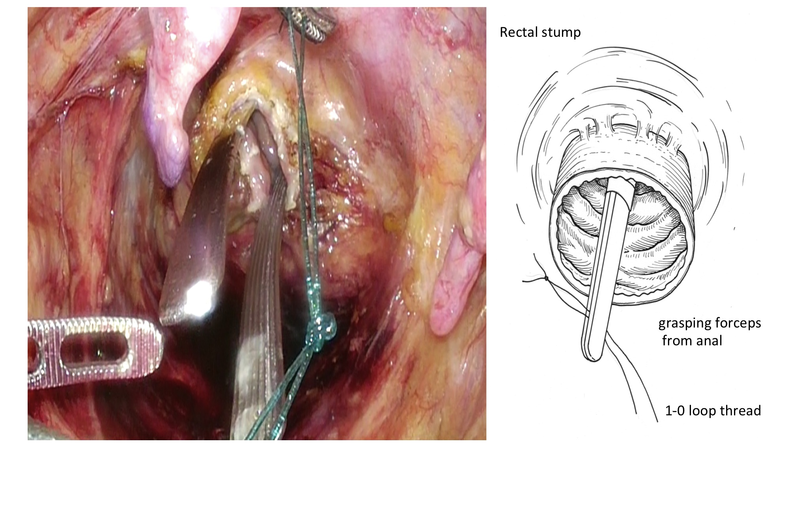
Figure 6 Grasping a 1-0 loop thread for drawing.

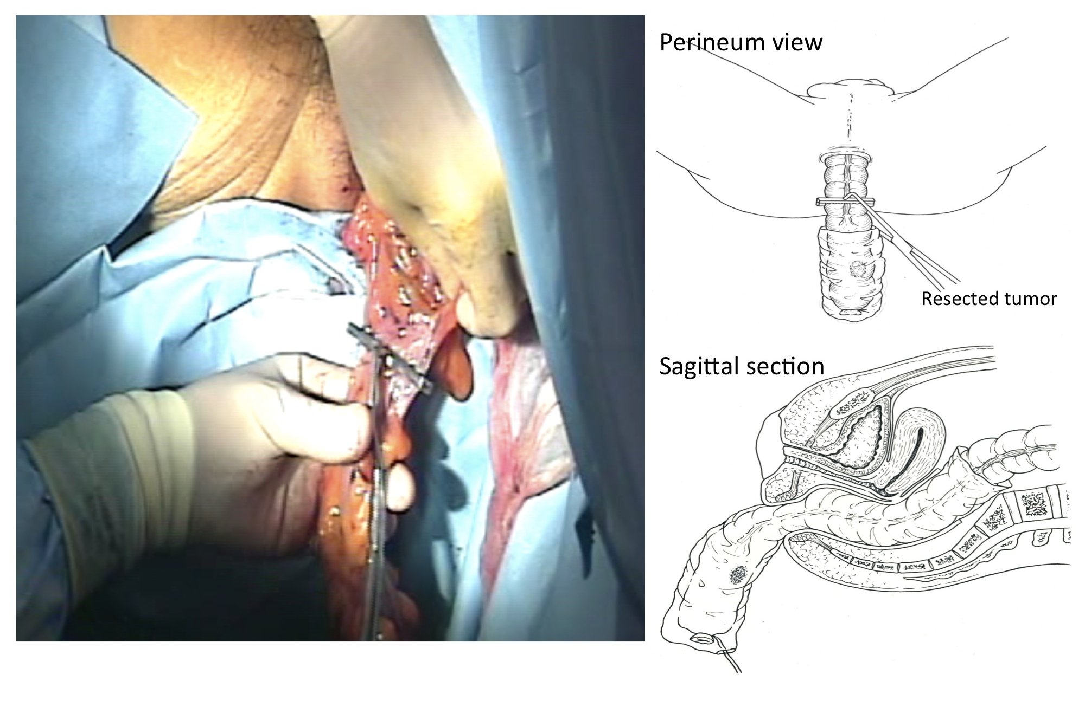
Figure 7 Removing the tumor transanally.

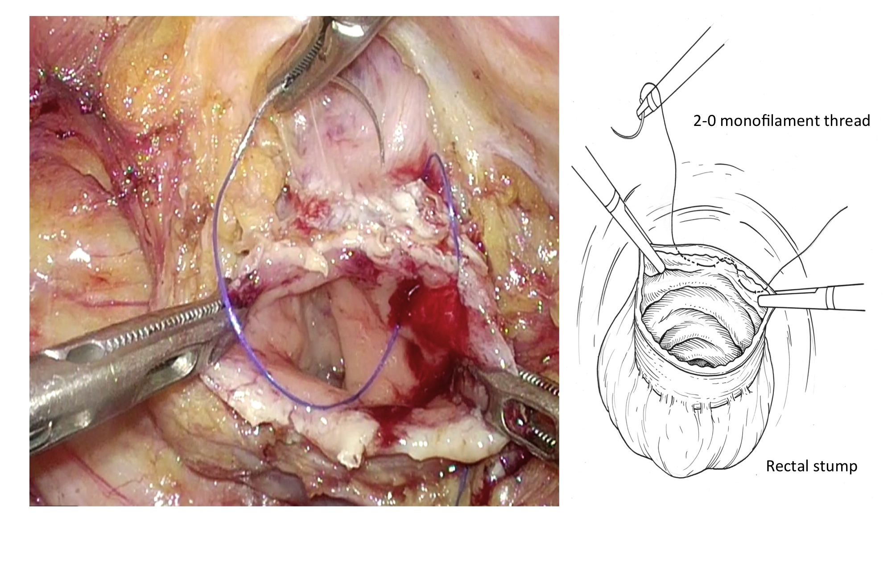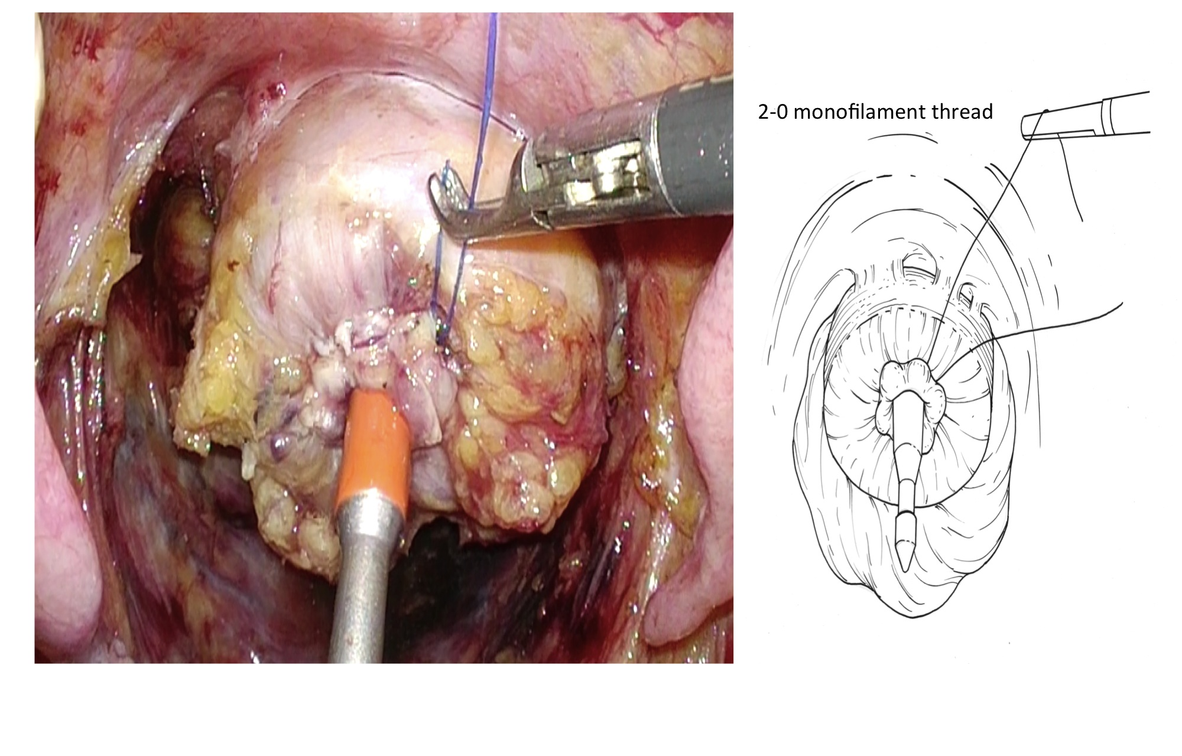
A B
Figure 8 Purse string suture of rectal stump (a) and Ligate for closure of rectal stump (b).

Table 1 Patients information
Case | Age | Gender | Tumor size (mm) | TNM stage | Operation time (min) | Suturing time (min) | Blood loss | Complication | Wexner incontinence score
 |  |  |  |  |  |  |  |  | 3 mo 6 mo
1 | 63 | F | 30 | T2N0 | 214 | 13 | 10 | ー | 0 | 0
2 | 72 | F | 22 | T1N0 | 252 | 20 | 90 | ー | 0 | 0
3 | 47 | F | 35 | T3N0 | 315 | 24 | 10 | anal pain | 0 | 0
4 | 70 | M | 38 | T3N0 | 343 | 20 | 150 | ischemic colitis | 6 | 1
5 | 62 | M | 20 | T1N0 | 312 | 23 | 228 | ー | 0 | 0
6 | 77 | M | 35 | T3N0 | 256 | 17 | 200 | ー | 1 | 0
7 | 65 | M | 38 | T3N1 | 260 | 13 | 35 | Leakage | 1 | 0
8 | 72 | F | 15 | T1N0 | 345 | 15 | 203 | ー | 0 | 0
9 | 65 | M | 26 | T2N0 | 262 | 13 | 27 | ー | 0 | 0
10 | 66 | M | 23 | T2N0 | 280 | 18 | 120 | ー | 0 | 0
11 | 70 | F | 20 | T1N0 | 247 | 13 | 118 | ー | 0 | 0
12 | 46 | M | 18 | T1N0 | 277 | 18 | 92 | ー | 0 | 0
13 | 56 | F | 22 | T1N0 | 250 | 14 | 30 | ー | 0 | 0
14 | 68 | F | 18 | T1N0 | 291 | 11 | 145 | Anastomotic ulcer | 0 | 0
15 | 57 | F | 33 | T2N0 | 267 | 8 | 95 | ー | 0 | 0
16 | 40 | M | 15 | T1N0 | 281 | 10 | 30 | ー | 0 | 0
17 | 65 | M | 22 | T1N1 | 355 | 9 | 245 | ー | 0 | 0
18 | 77 | M | 50 | T3N0 | 277 | 15 | 150 | ー | 0 | 0
19 | 63 | M | 35 | T3N0 | 215 | 13 | 192 | ー | 0 | 0
20 | 60 | M | 25 | T2N0 | 271 | 11 | 116 | ー | 0 | 0

Table 2 Comparison with conventional laparoscopic surgery
 | Conventional LAP | Complete LAP
Age | 66.3 ± 11 | 63.7 ± 9
Tumor size (mm) | 38.5 ± 18 | 27 ± 9
Dissected lymph node (count) | 17.5 ± 8.8 | 17.7 ± 7.7
Blood loss (ml) | 120 ± 56 | 114 ± 72
Operation time (min) | 240 ± 77 | 278 ± 39
Count of usage of analgesic (times) | 5.89 ± 2.86 | 1.85 ± 1.8ª
Term of pain （d) | 3.43 ± 1.41 | 1.9 ± 1.9 ª
Orally take （d) | 4.3 ± 0.9 | 4 ± 1.4
Hospital stay （d) | 11.2 ± 3.2 | 11.0 ± 3
Suture failure | 4 cases | 1 case
SSI | 8 cases | none
ªP < 0.05, complete laparoscopic surgery vs conventional laparoscopic surgery. SSI: surgical site infection; lap: laparoscopic.

