Name of Journal: World Journal of Clinical Cases
Manuscript NO: 61082
Manuscript Type: CASE REPORT

Successful reversal of ostomy 13 years after Hartmann procedure in a patient with colon cancer: A case report

Huang W et al. Longest time reversal of ostomy

Wang Huang, Zhen-Zhou Chen, Zheng-Qiang Wei

Wang Huang, Zhen-Zhou Chen, Zheng-Qiang Wei, Department of Gastrointestinal Surgery, The First Affiliated Hospital of Chongqing Medical University, Chongqing 400000, China

Author contributions: Huang W performed the case report and wrote the manuscript; Chen ZZ edited the manuscript; Wei ZQ supervised the work and edited the manuscript.

Supported by Chongqing Key Diseases Research and Application Demonstration Program (Colorectal Cancer Prevention and Treatment Technology Research and Application Demonstration), No. 2019ZX003.

Corresponding author: Zheng-Qiang Wei, MD, Doctor, Department of Gastrointestinal Surgery, The First Affiliated Hospital of Chongqing Medical University, No. 1 Youyi Road, Yuanjiagang, Yuzhong District, Chongqing 400000, China. 384535713@qq.com

Received: November 26, 2020
Revised: May 22, 2021
Accepted: May 25, 2021
Published online:

Abstract
BACKGROUND
The Hartmann procedure is currently recognized as a common, safe, and feasible surgical procedure. However, its reversal rate is low, and the optimal timing for Hartmann reversal surgery is controversial.

CASE SUMMARY
A 65-year-old man came to our hospital with a complaint of an intestinal fistula next to the stoma. The patient had undergone a Hartmann procedure 13 years prior. We performed colonoscopy, computed tomography, and other diagnostics before successfully reversing the stoma.

CONCLUSION
Although the optimal time for Hartmann procedure reversal is controversial, time may ultimately not be a factor in the success of reversal.

Key Words: Hartmann; Hartmann's procedure; Reversal; Time; Complications; Case study; Case report

Huang W, Chen ZZ, Wei ZQ. Successful reversal of ostomy 13 years after Hartmann procedure in a patient with colon cancer: A case report. World J Clin Cases 2021; In press

Core Tip: First, for acute intestinal obstruction in the left colon or rectum, Hartmann’s surgery is a safe and feasible treatment. Second, there is controversy about the time to reversal after Hartmann’s procedure. This case is the longest successful reversal in the world.

INTRODUCTION
Currently, colorectal cancer is one of the most common malignant tumors, having the third highest incidence among all malignancies and being the second leading cause of cancer-related mortality. Many colorectal cases are diagnosed as acute onset due to intestinal obstruction and/or perforation. The majority of the reported figures are approximately 30% for such presentation^{[1]}. However, colorectal obstruction accounts for approximately 80% of emergency cases related to colorectal cancer^{[1]}. The most common site of colorectal cancer obstruction is the sigmoid colon, and 75% of such tumors are located in the distal splenic flexure^{[2]}.
When colon cancer is complicated by intestinal obstruction, emergency surgery is often required, and Hartmann's procedure^{[3]} (proximal fistula, distal closure) is usually preferred. Currently, the Hartmann procedure is recognized as a common, safe, and feasible surgical method^{[4]}. However, after Hartmann, the long-term stoma state leads to a lower quality of life for the patient, and there are also complications such as parastomal hernia^{[5]}, stoma prolapse^{[6]}, stoma stenosis^{[6]}, and stoma infection^{[6]}. However, due to the locally advanced nature of most colorectal tumors, the possibility of tumor recurrence and metastasis after surgery is relatively high. Therefore, it is necessary to fully evaluate the characteristics of the tumor before considering the reversal surgery. Additionally, Hartmann procedure reversal is extremely difficult due to severe abdominal adhesions, difficulty in finding stumps, and changes in distal disuse, which have caused the time to perform reversal to be delayed. Moreover, the patient's bowel function may be affected after the reversal procedure, so often no such surgery is considered. Currently, the time to reversal after Hartmann's operation is the focus of controversy.
In this case study, we report a patient with a successful fistula reversal 13 years after undergoing Hartmann’s procedure.

CASE PRESENTATION
Chief complaints
A 65-year-old man was admitted to our hospital for “discovering a nodule adjacent to the stoma in April that had enlarged for 1 wk, and then ruptured 1 d prior”.

History of present illness
Four months ago, the patient accidentally found a small nodule on the right side of the colostomy that was approximately 0.5 cm in size without redness, swelling, or tenderness, and did not go to the doctor. Two months ago, the nodule enlarged, accompanied by redness, swelling, heat, and pain. After oral administration of cefdinir, he improved and did not take antibiotics regularly. One week ago, the patient had an enlarged nodule on the right side of the stoma, accompanied by a mass on the left side of the stoma that was approximately 4 cm × 3 cm in size, with redness, swelling, heat, pain, and a black mass of pus in the middle; intravenous infusion of cefoxitin did not alleviate symptoms. Three days ago, the nodule on the right side of the stoma ruptured, and a fistula of approximately 1.5 cm in size appeared, which caused a large amount of overflowing stool. A day ago, the mass on the left side of the fistula ruptured and released pus, so he went to our hospital.

History of past illness
Thirteen years ago, the patient underwent Hartmann surgery due to a sigmoid colon tumor with acute obstruction. Postoperative pathological diagnosis was stage II sigmoid colon adenocarcinoma (T4N0M0). Due to the patient's own reasons, he did not undergo regular treatment and not reverse the stoma in time. The patient was admitted to our hospital for paraostomy hernia and right inguinal hernia 3 years ago, and underwent tension-free inguinal repair and paraostomy hernia repair via an open operation. The abscess was cut for drainage 1 year ago due to a paraostomy abscess.

Physical examination
There was a 10-cm surgical scar (from the Hartmann surgical incision) on the right abdomen, a 15-cm surgical incision scar (paraostomy hernia repair incision) in the middle abdomen, and a 5-cm surgical scar on the right inguinal area. The colostomy port was located in the left lower abdomen. On the right side of the colostomy port, there was an abscess of approximately 5 cm × 5 cm in size. The skin was red, swollen, and hot. A middle ulcer was also found. The place where the mass overflowed with pus was located at the anterior upper pole of the iliac and was approximately 1.5 cm × 1.5 cm, at a depth of approximately about 2 cm, and there was pus outflow. On the left side of the stoma, there was a fistula of approximately 1.5 cm × 1.5 cm in size, located next to the belly button that had much stool overflow. A mass of approximately 5 cm × 3 cm was palpable in the left groin area, which was obvious when standing, soft in quality, and did not protrude into the scrotum.

Laboratory examinations
Routine blood markers and tumor markers were normal, but Calcitonin original was 0.53.

Imaging examinations
Enhanced computed tomography: The right sinus of the stoma was formed, which was the same as the intestinal cavity (red arrow), and the parastomal hernia can be seen (Figure 1A-C). The left side of the stoma had a suspicious sinus formation (yellow arrow), with surrounding soft tissue swelling (Figure 1D and E) and left inguinal hernia (green arrow). No tumor recurrence was seen (Figure 1F).

Colonoscopy: The proximal bowel (Figure 2A and B) was not significantly abnormal; the distal bowel (Figure 2C and D) was approximately 25 cm, and showed changes from disuse, with a large number of white mucus masses (The white mucus masses were formed by the absorption of water by intestinal fluid secreted by the colon).

Retrograde transanal digestive tract radiography: Front view (Figure 3A and B) and lateral view (Figure 3C and D) showed that the distal bowel was approximately 25 cm, with no bowel stenosis and a smooth bowel mucosa.

FINAL DIAGNOSIS
(1) Colostomy with infection; (2) parastomal hernia; (3) intestinal fistula; and (4) inguinal hernia.

TREATMENT
Although the patient had no fever after admission and the infection index was not high, the patient’s local infection was severe, and the left abscess was treated with incision and drainage. According to the results of drug sensitivity, ceftizoxime was given as an anti-inflammatory with nutritional support. With general care, including changing the dressing on the fistula, the patient's infection was gradually controlled and improved.
The patient has a large amount of leakage due to the intestinal fistula, which was a high-flow fistula^{[7]} that seriously affects the patient’s quality of life. According to the patient’s condition, the following treatment options were available: (1) Stoma displacement and stoma reconstruction; (2) proximal colostomy to address the abdominal wall where two stomas had formed; (3) Hartmann reversal; and (4) waiting and observation. After full communication, the patient, the patient's family, and the doctor unanimously decided to perform Hartmann's reversal. The patient underwent laparoscopic exploration under general anesthesia, lysis of intestinal adhesions, partial removal of the parastomal mesh, bowel resection and anastomosis, and abdominal sinus resection. A small incision in the right upper abdomen was first made. During the operation, it was found that abdominal adhesion was serious, no tumor recurrence was found, the distal bowel was located in the left paracolic sulcus (approximately 25 cm in length), and the distal bowel was changed due to disuse with obvious atrophy. There was also a mucus mass in the stump. To ensure a successful anastomosis, a 5-cm intestinal tube was removed from the stump and end-to-end anastomosis was performed. The inflation test was negative, so preventive stoma was not performed. Intraoperative bleeding was 200 mL, and the operation took 420 min.
After the operation, Escherichia coli and Enterococcus faecium were cultured in the abdominal drainage fluid of the patient, who had signs of peritonitis. According to the drug sensitivity test, piperacillin sodium and tazobactam sodium 4.5 g every 8 h (total 14 d) were given for anti-inflammatory. An incision infection occurred on the 6th day (Figure 4A), and the dressing was changed. On the 6th day after the operation, he developed exhaust and defecated on the 8th day. After active anti-infection treatment, he was discharged smoothly after the operation.

OUTCOME AND FOLLOW-UP
In the first 6 mo after surgery, regular follow-up visits were made every 3 mo in the outpatient clinic, and the patient’s intestinal function was assessed through the Ligament Augmentation and Reconstruction System (LARS) scale. Tumor markers were evaluated every 6 mo after surgery. Colonoscopy and computed tomography (CT) examinations were completed 1 year after surgery. Three months after surgery, bowel movements occurred 4 to 7 times a day, with stool irregularity. The LARS score was 21 points, which is considered mild LARS. Six months after surgery, the patient had a bowel movement once a day, with stool formation. The LARS score was 11 points, meaning no LARS. There were also normal tumor markers and CT prompts for incisional hernia and inguinal hernia formation (Figure 5), abdominal wounds (Figure 4B), abdominal wall hernia repair, and inguinal hernia repair. One year after the operation, the patient had a bowel movement once a day, with stool formation. The LARS score remained at 11 points, with no LARS, normal tumor markers, and normal colonoscopy results (Figure 6). Over the past year, the patient's psychological pressure has significantly decreased, as he can travel, visit friends, and have a bright mood, which has improved his quality of life.

DISCUSSION
According to reports in the literature, the incidence of colorectal cancer is increasing annually, with up to 40% of colorectal cancers developing acutely. Among them, most are caused by obstruction. The current common processing methods^{[3]} are: (1) Loop colostomy; (2) primary resection with end colostomy: Hartmann’s procedure; (3) endoscopic colonic stenting with self-expanding metallic stents; and (4) primary resection and anastomosis. Currently, Hartmann’s procedure is one of the main methods for treating left colorectal cancer with acute intestinal obstruction^{[2]}. In this case, the patient started with acute mechanical obstruction. Since colonic stent implantation was immature in China 13 years ago, doctors chose this safe and feasible method, which not only cured the intestinal obstruction, but was also more successful. The tumor was removed, and the patient had no tumor recurrence after the operation.
The rate of complications after receiving Hartmann’s procedure is as high as 51%^{[8]}. Common complications include incision infection, distal rectal stump dysfunction, and parastomal complications. In this case, the patient experienced stoma-related complications such as parastomal hernia^{[6]}, parastomal abscess, and intestinal fistula, which seriously affected the patient's quality of life and increased psychological pressure. According to the literature, the rate of parastomal hernia is as high as 58%. Stoma patients have poor mental health, body image, and physical and emotional function^{[5]}. In addition to the above-mentioned complications, the survival rate following Hartmann’s operation is lower^{[9]}; but fortunately, the patient in this case achieved R0 resection and no metastasis occurred after the operation.
In this case, the patient underwent Hartmann reversal, which decreased his psychological pressure and allowed him to better integrate into society. It is also because this case had two parastomal hernias and bilateral inguinal hernias on the abdominal wall. The patient’s abdomen was weak. If the stoma is displaced or two stomas are performed, the patient will still have stoma-related complications and the abdominal wall will be worse. Therefore, the team chose stoma reversal.
The reversal rate of Hartmann surgery is very low. As reported in the literature, the Hartmann reversal rate is 25.9%-61%^{[4,10-14]}, and most of the literature reports are less than 50%. According to the 2015 United States bowel cancer audit report, 95% of patients who received Hartmann surgery still had a stoma 18 mo later. Currently, the intervening time before performing Hartmann reversal is controversial. It has been reported in the literature that the average time interval between Hartmann surgery and Hartmann reversal is 11 mo^{[4]}, of which the longest fistula reversal time is 96 mo^{[4]}. The reversal time in this case was 156 mo, much longer than the time reported in the literature.
Previous studies have reported increased rates of complications with increased time to the reversal operation^{[12,14-16]}. They speculated that this was related to atrophy of the distal stump, and it is recommended to reverse it as soon as possible. Others have noted that complications can be reduced by clinical treatment and nutrition support^{[12,17-20]}. Finally, some believe that the length of reversal time does not affect postoperative complications or reversal rate^{[5,14,21,22]}. In this case, the reversal time was 156 mo, which proves that the interval length does not increase the risk of reversal. At the same time, the incidence of complications after Hartmann reversal is quite high. According to reports in the literature, the total incidence of complications after Hartmann reversal is 16.3% (3.6%-50%)^{[11]}. The most common postoperative complication is wound infection, with incidence rates ranging from 5% to 30% (average 12.5%)^{[12]}, followed by anastomotic failure, whose incidence rate is 4.2%^{[22]}. In this case, the complication was wound infection, but no serious complications were present such as cardiopulmonary complications, anastomotic leakage, or other related complications.
Technical difficulties for Hartmann reversal include pelvic adhesions^{[4]}, chronic pelvic infections^{[4]}, difficulty in identifying short rectal stumps^{[4]}, and failure of rectal stump anastomosis^{[11]}. Currently, the methods for Hartmann's reversal include: Traditional open surgery, laparoscopic surgery, and transostomy reversal. Studies have shown that using laparoscopic surgery for reversal is more beneficial than using traditional approaches^{[11]}. Additionally, laparoscopic surgery can reduce postoperative pain, aid in early recovery (early exhaust^{[23]}), lower overall morbidity and wound infection rates, and decrease the postoperative intestinal obstruction rate^{[24]}. However, as reported in the literature^{[25]}, incisional hernias also appeared in this case.

CONCLUSION
First, for acute intestinal obstruction in the left colon or rectum, Hartmann’s surgery is a safe and feasible treatment. Second, there is controversy about the time to reversal after Hartmann’s procedure. It is not possible to use conventional experience or treatment methods to make the patient lose the opportunity to reverse the fistula. As in this case, the longer interval did not increase reversal complications; of course, the opinions of the patients and the surgical team should also be integrated. This successful case is a boon for patients after Hartmann’s procedure, as it offers more choices.

ACKNOWLEDGEMENTS
We would like to express our gratitude to all those who contributed to the study.

REFERENCES
1 Pisano M, Zorcolo L, Merli C, Cimbanassi S, Poiasina E, Ceresoli M, Agresta F, Allievi N, Bellanova G, Coccolini F, Coy C, Fugazzola P, Martinez CA, Montori G, Paolillo C, Penachim TJ, Pereira B, Reis T, Restivo A, Rezende-Neto J, Sartelli M, Valentino M, Abu-Zidan FM, Ashkenazi I, Bala M, Chiara O, De' Angelis N, Deidda S, De Simone B, Di Saverio S, Finotti E, Kenji I, Moore E, Wexner S, Biffl W, Coimbra R, Guttadauro A, Leppäniemi A, Maier R, Magnone S, Mefire AC, Peitzmann A, Sakakushev B, Sugrue M, Viale P, Weber D, Kashuk J, Fraga GP, Kluger I, Catena F, Ansaloni L. 2017 WSES guidelines on colon and rectal cancer emergencies: obstruction and perforation. World J Emerg Surg 2018; 13: 36 [PMID: 30123315 DOI: 10.1186/s13017-018-0192-3]
2 Frago R, Ramirez E, Millan M, Kreisler E, del Valle E, Biondo S. Current management of acute malignant large bowel obstruction: a systematic review. Am J Surg 2014; 207: 127-138 [PMID: 24124659 DOI: 10.1016/j.amjsurg.2013.07.027]
3 Ansaloni L, Andersson RE, Bazzoli F, Catena F, Cennamo V, Di Saverio S, Fuccio L, Jeekel H, Leppäniemi A, Moore E, Pinna AD, Pisano M, Repici A, Sugarbaker PH, Tuech JJ. Guidelenines in the management of obstructing cancer of the left colon: consensus conference of the world society of emergency surgery (WSES) and peritoneum and surgery (PnS) society. World J Emerg Surg 2010; 5: 29 [PMID: 21189148 DOI: 10.1186/1749-7922-5-29]
4 Hallam S, Mothe BS, Tirumulaju R. Hartmann's procedure, reversal and rate of stoma-free survival. Ann R Coll Surg Engl 2018; 100: 301-307 [PMID: 29484943 DOI: 10.1308/rcsann.2018.0006]
5 Näsvall P, Dahlstrand U, Löwenmark T, Rutegård J, Gunnarsson U, Strigård K. Quality of life in patients with a permanent stoma after rectal cancer surgery. Qual Life Res 2017; 26: 55-64 [PMID: 27444778 DOI: 10.1007/s11136-016-1367-6]
6 Ambe PC, Kurz NR, Nitschke C, Odeh SF, Möslein G, Zirngibl H. Intestinal Ostomy. Dtsch Arztebl Int 2018; 115: 182-187 [PMID: 29607805 DOI: 10.3238/arztebl.2018.0182]
7 Kumpf VJ, de Aguilar-Nascimento JE, Diaz-Pizarro Graf JI, Hall AM, McKeever L, Steiger E, Winkler MF, Compher CW; FELANPE; American Society for Parenteral and Enteral Nutrition. ASPEN-FELANPE Clinical Guidelines. JPEN J Parenter Enteral Nutr 2017; 41: 104-112 [PMID: 27913762 DOI: 10.1177/0148607116680792]
8 Ermolov AS, Rudin EP, Novruzov NG, Upyrev AV, Mironov AS. [Complications after Hartman's operation]. Khirurgiia (Mosk) 2007: 11–14 [PMID: 18231090]
9 Biondo S, Kreisler E, Millan M, Fraccalvieri D, Golda T, Martí Ragué J, Salazar R. Differences in patient postoperative and long-term outcomes between obstructive and perforated colonic cancer. Am J Surg 2008; 195: 427-432 [PMID: 18361923 DOI: 10.1016/j.amjsurg.2007.02.027]
10 Horesh N, Lessing Y, Rudnicki Y, Kent I, Kammar H, Ben-Yaacov A, Dreznik Y, Tulchinsky H, Avital S, Mavor E, Wasserberg N, Kashtan H, Klausner JM, Gutman M, Zmora O. Considerations for Hartmann's reversal and Hartmann's reversal outcomes-a multicenter study. Int J Colorectal Dis 2017; 32: 1577-1582 [PMID: 28879552 DOI: 10.1007/s00384-017-2897-2]
11 van de Wall BJ, Draaisma WA, Schouten ES, Broeders IA, Consten EC. Conventional and laparoscopic reversal of the Hartmann procedure: a review of literature. J Gastrointest Surg 2010; 14: 743-752 [PMID: 19936852 DOI: 10.1007/s11605-009-1084-3]
12 Banerjee S, Leather AJ, Rennie JA, Samano N, Gonzalez JG, Papagrigoriadis S. Feasibility and morbidity of reversal of Hartmann's. Colorectal Dis 2005; 7: 454-459 [PMID: 16108881 DOI: 10.1111/j.1463-1318.2005.00862.x]
13 Tokode OM, Akingboye A, Coker O. Factors affecting reversal following Hartmann's procedure: experience from two district general hospitals in the UK. Surg Today 2011; 41: 79-83 [PMID: 21191695 DOI: 10.1007/s00595-009-4224-1]
14 Roque-Castellano C, Marchena-Gomez J, Hemmersbach-Miller M, Acosta-Merida A, Rodriguez-Mendez A, Fariña-Castro R, Hernandez-Romero J. Analysis of the factors related to the decision of restoring intestinal continuity after Hartmann's procedure. Int J Colorectal Dis 2007; 22: 1091-1096 [PMID: 17256137 DOI: 10.1007/s00384-007-0272-4]
15 Tan WS, Lim JF, Tang CL, Eu KW. Reversal of Hartmann's procedure: experience in an Asian population. Singapore Med J 2012; 53: 46-51 [PMID: 22252183]
16 Schmelzer TM, Mostafa G, Norton HJ, Newcomb WL, Hope WW, Lincourt AE, Kercher KW, Kuwada TS, Gersin KS, Heniford BT. Reversal of Hartmann's procedure: a high-risk operation? Surgery 2007; 142: 598-606; discussion 606-7 [PMID: 17950354 DOI: 10.1016/j.surg.2007.08.001]
17 Pearce NW, Scott SD, Karran SJ. Timing and method of reversal of Hartmann's procedure. Br J Surg 1992; 79: 839-841 [PMID: 1393489 DOI: 10.1002/bjs.1800790844]
18 Keck JO, Collopy BT, Ryan PJ, Fink R, Mackay JR, Woods RJ. Reversal of Hartmann's procedure: effect of timing and technique on ease and safety. Dis Colon Rectum 1994; 37: 243-248 [PMID: 8137671 DOI: 10.1007/BF02048162]
19 Khan AL, Ah-See AK, Crofts TJ, Heys SD, Eremin OJ. Reversal of Hartmann's colostomy. J R Coll Surg Edinb 1994; 39: 239
20 Fleming FJ, Gillen P. Reversal of Hartmann's procedure following acute diverticulitis: is timing everything? Int J Colorectal Dis 2009; 24: 1219-1225 [PMID: 19499234 DOI: 10.1007/s00384-009-0747-6]
21 Takahashi-Monroy T, Velasco L, Morales-Olivera JM. [Morbi-mortality of Hartmann's reversal procedure]. Cir Cir 2006; 74: 329-333 [PMID: 17224103]
22 Guerra F, Coletta D, Del Basso C, Giuliani G, Patriti A. Conventional Versus Minimally Invasive Hartmann Takedown: A Meta-analysis of the Literature. World J Surg 2019; 43: 1820-1828 [PMID: 30824963 DOI: 10.1007/s00268-019-04962-8]
23 Kwak HD, Kim J, Kang DW, Baek SJ, Kwak JM, Kim SH. Hartmann's reversal: a comparative study between laparoscopic and open approaches. ANZ J Surg 2018; 88: 450-454 [PMID: 28730630 DOI: 10.1111/ans.13979]
24 Celentano V, Giglio MC, Bucci L. Laparoscopic vs open Hartmann's reversal: a systematic review and meta-analysis. Int J Colorectal Dis 2015; 30: 1603-1615 [PMID: 26189028 DOI: 10.1007/s00384-015-2325-4]
25 Fiscon V, Portale G, Mazzeo A, Migliorini G, Frigo F. Laparoscopic reversal of Hartmann's procedure. Updates Surg 2014; 66: 277-281 [PMID: 25262377 DOI: 10.1007/s13304-014-0268-x]

Footnotes
Informed consent statement: The patient provided informed written consent for participation in this study, including sample collection and permission for their use in research.

Conflict-of-interest statement: The authors have no conflicts of interest to declare.

CARE Checklist (2016) statement: The authors have read the CARE Checklist (2016), and the manuscript was prepared and revised according to the CARE Checklist (2016).

Open-Access: This article is an open-access article that was selected by an in-house editor and fully peer-reviewed by external reviewers. It is distributed in accordance with the Creative Commons Attribution NonCommercial (CC BY-NC 4.0) license, which permits others to distribute, remix, adapt, build upon this work non-commercially, and license their derivative works on different terms, provided the original work is properly cited and the use is non-commercial. See: http://creativecommons.org/Licenses/by-nc/4.0/

Manuscript source: Unsolicited manuscript

Peer-review started: November 26, 2020
First decision: May 11, 2021
Article in press:

Specialty type: Medicine, research and experimental
Country/Territory of origin: China
Peer-review report’s scientific quality classification
Grade A (Excellent): 0
Grade B (Very good): 0
Grade C (Good): C
Grade D (Fair): 0
Grade E (Poor): 0

P-Reviewer: Wetwittayakhlang P S-Editor: Fan JR L-Editor: Wang TQ P-Editor:
Figure Legends
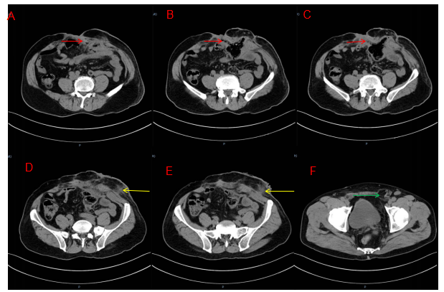
Figure 1 Enhanced computed tomography. A-C: The red arrow refers to the sinus formed by the intestinal fistula on the right side of the stoma; D and E: The yellow arrow is the suspicious sinus on the left side of the stoma; F: The green arrow is the left inguinal hernia.
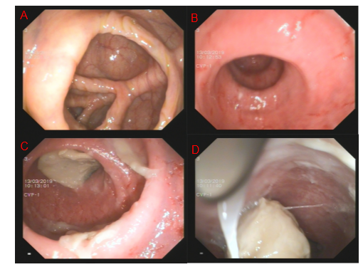
Figure 2 Colonoscopy. A: The ileocecal region; B: The proximal intestine; C and D: The distal intestine.
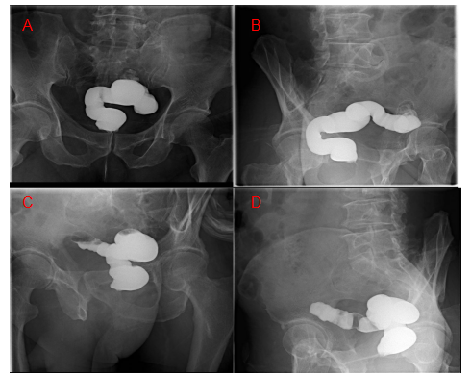
Figure 3 Pelvis films. A and B: Pelvic anterior films; C and D: Pelvic lateral films.
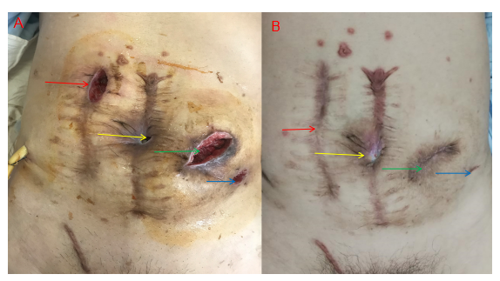
Figure 4 Postoperative wound. A: The wound on the 6th day after surgery. The red arrow is the small incision, the yellow arrow is the sinus on the right side of the stoma, the green arrow is the original fistula position, and the blue arrow is the left fistula of the stoma; B: The wound 6 mo after the operation. The yellow arrow is the sinus tract on the right side of the stoma, which has not healed, the green arrow is the location of the original stoma, which is an incisional hernia, and the blue arrow is the left fistula of the original stoma.
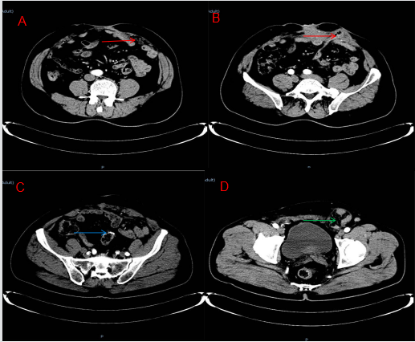
Figure 5 Re-examination at 6 mo showed no tumor recurrence. A and B: The red arrow is the incisional hernia; C: The blue arrow is the anastomosis; D: The green arrow is the left inguinal hernia, which is larger than before.
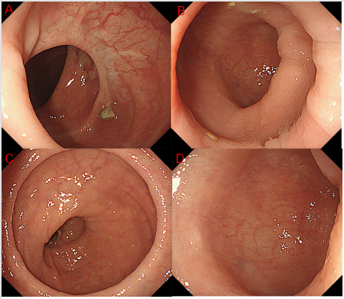
Figure 6 A colonoscopy was performed one year after surgery. A: The proximal end; B and C: The anastomoses; D: The distal end of the anastomosis.

