Name of Journal: World Journal of Gastrointestinal Endoscopy
Manuscript No: 46208
Manuscript Type: MINIREVIEWS

Colorectal endoscopic submucosal dissection in special locations

Kaosombatwattana U et al. Techniques, outcomes, and a review of the literature

Uayporn Kaosombatwattana, Takeshi Yamamura, Masanao Nakamura, Yoshiki Hirooka, Hidemi Goto

Uayporn Kaosombatwattana, Masanao Nakamura, Hidemi Goto, Department of Gastroenterology and Hepatology, Nagoya University Graduate School of Medicine, Nagoya 466-8560, Japan

Takeshi Yamamura, Yoshiki Hirooka, Department of Endoscopy, Nagoya University Hospital, Nagoya 466-8560, Japan

Uayporn Kaosombatwattana, Division of Gastroenterology, Department of Medicine, Faculty of Medicine Siriraj Hospital, Mahidol University, Bangkok 10700, Thailand

ORCID number: Uayporn Kaosombatwattana (0000-0001-8076-1659); Takeshi Yamamura (0000-0003-4994-016X); Masanao Nakamura (0000-0002-5444-143X); Yoshiki Hirooka (0000-0001-9639-7425); Hidemi Goto (0000-0001-8389-1416).

Author contributions: Kaosombatwattana U and Yamamura T contributed equally to this work; Kaosombatwattana U, Yamamura T, Nakamura M, Hirooka Y and Goto H designed the review; Kaosombatwattana U and Yamamura T performed literature review; Kaosombatwattana U and Yamamura T wrote the manuscript; Kaosombatwattana U, Yamamura T, Nakamura M, Hirooka Y and Goto H approved the manuscript.

Conflict-of-interest statement: All authors declare no personal or professional conflicts of interest, and no financial support from the companies that produce and/or distribute the drugs, devices, or materials described in this report.

Open-Access: This article is an open-access article which was selected by an in-house editor and fully peer-reviewed by external reviewers. It is distributed in accordance with the Creative Commons Attribution Non Commercial (CC BY-NC 4.0) license, which permits others to distribute, remix, adapt, build upon this work non-commercially, and license their derivative works on different terms, provided the original work is properly cited and the use is non-commercial. See: http://creativecommons.org/licenses/by-nc/4.0/

Manuscript source: Unsolicited manuscript

Corresponding author: Takeshi Yamamura, MD, PhD, Assistant Professor, Department of Endoscopy, Nagoya University Hospital, 65 Tsurumai-cho, Showa-ku, Nagoya 466-8560, Japan. tyamamu@med.nagoya-u.ac.jp
Telephone: +81-52-7442172
Fax: +81-52-7442180

Received: February 8, 2019
Peer-review started: February 10, 2019
First decision: February 19, 2019
Revised: March 17, 2018
Accepted: March 26, 2019
Article in press: March 26, 2019
Published online: April 16, 2019

Abstract
Colorectal endoscopic submucosal dissection (ESD) is considered one of the most challenging endoscopic procedures for novice endoscopists. When compared with the stomach, the colon and rectum have a narrower tubular lumen, greater angulation at the flexures, and a thinner muscle layer. These factors make endoscopic control and maneuverability difficult. ESD of the colorectum was considered more difficult than gastric and esophageal ESD. However, with learning from the experts, practicing, and selecting an appropriate technique, most of colorectal ESD could be performed successfully. Nevertheless, some colorectal locations are extremely specialized either from unique anatomy or given unstable scope position. Accordingly, the objective of this review was to provide endoscopists with an overview of the techniques and outcomes associated with ESD at these special colorectal locations. ESD at the discussed special locations of the ileo-colo-rectum was found to be feasible, and outcomes were comparable to those of ESD performed in non-special locations of the ileo-colo-rectum. Practice for skill improvement and awareness of the unique characteristics of each special location is the key to performing successful ESD.

Key words: Colorectal endoscopic submucosal dissection; Endoscopic submucosal dissection; Special locations

© The Author(s) 2019. Published by Baishideng Publishing Group Inc. All rights reserved.

Core tip: Colorectal endoscopic submucosal dissection (ESD) involving ileocecal valve, appendiceal orifice or anal canal is considered to be extremely challenging for novice ESD endoscopist. With well-prepared strategies and appropriate assisting devices, the successful procedures with less complications can be achieved. We made great efforts to review and summarize the currently proposed techniques to overcome these difficulties.

Citation: Kaosombatwattana U, Yamamura T, Nakamura M, Hirooka Y, Goto H. Colorectal endoscopic submucosal dissection in special locations. World J Gastrointest Endosc 2019; 11(4): 262-270
URL: https://www.wjgnet.com/1948-5190/full/v11/i4/262.htm
DOI: https://dx.doi.org/10.4253/wjge.v11.i4.262

INTRODUCTION
Colorectal endoscopic submucosal dissection (ESD) is considered one of the most challenging endoscopic procedures for novice endoscopists. When compared with the stomach, the colon and rectum have a narrower tubular lumen, greater angulation at the flexures, and a thinner muscle layer. These factors make endoscopic control and maneuverability difficult. However, with expert instruction, practice, and awareness of the potential pitfalls at each special colorectal location, most colorectal lesions can be managed by conventional ESD^{[1]}. The rectum is regarded as being the easiest location for beginner endoscopists, while the right-sided colon and lesions on the flexures are considered to be the most problematic locations^{[2]}. Moreover, some locations require special consideration given their unique anatomy. These “special” locations locate at both extreme portions of the colorectal part of the gastrointestinal system. Specifically, these areas include the ileocecal area (including the appendix) and the anorectal area (including the anal canal). Before ESD era, superficial tumors in these special locations required surgical treatment. Currently, most ESD centers are able to successfully manage lesions at these difficult to manage locations. The objectives of this review were to provide endoscopists with an overview of the techniques and outcomes associated with ESD at these special colorectal locations.

ESD AT THE ILEOCECAL VALVE AND TERMINAL ILEUM
Endoscopic treatment of lesions involving the ileocecal valve (ICV) is technically difficult due to poor endoscope maneuverability, abundant fatty tissue, and distinctive anatomic features^{[3]}. Endoscopic mucosal resection (EMR) is a basic technique that can be used to manage lesions at the ICV and terminal ileum. A prospective single-center study by Nanda et al^{[4]} reported that EMR for tumors involving the ICV achieved 94% clinical success for complete adenoma clearance. However, en bloc resection was achieved in 8.5% of cases, and tumor recurrence was observed in 17.5% of cases in that study. Previously, a surgical operation would be performed when EMR was not considered to be feasible. However, patients are at risk of decreased quality of life after ICV resection as the ICV plays important in bile acid absorption^{[5,6]}. The ICV also functions to prevent regurgitation of material from the cecum backward into the ileum, and it delays passage of ileal contents from the terminal ileum into the cecum. The development and implementation of ESD diminished the role of EMR and surgical resection of ileocecal lesions. The first case series of ESD for colorectal neoplasia involving ileocecal lesions included eight patients, and the en bloc resection rate was 75%^{[7]}. A single-center study that compared 38 lesions with ICV involvement to 132 cecal lesions found the en bloc resection rate to be similar to that of non-ICV lesions, but the procedure time was 37 min longer^{[8]}. The complication of most concern relative to ESD in the ICV area is post-ESD stricture. The Yoshizaki et al^{[8]} study did not describe any incidence of this complication; however, that study did not have any lesions with whole circumferential ICV involvement. Colorectal ESD involving the ICV for a submucosal tumor was also reported in one case^{[9]}. In that case, a 40-mm pedunculated lipoma was resected en bloc from the ileocecal area without complication. In short, ESD of lesions involving the ICV is feasible and safe, but it should be emphasized that the aforementioned procedures were all performed by experienced endoscopists. Generally, there was no consensus on the definition of experienced ESD endoscopists. However, the feasibility study on training colorectal ESD revealed that colorectal ESD could be performed safely and effectively when more than 100 colorectal ESD procedures have been reached^{[10]}.

TECHNICAL ASPECTS SPECIFIC TO ESD AT THE ICV AND TERMINAL ILEUM
It is essential to examine the ICV circumferentially in both the forward and retroflexed views (Figure 1), particularly when the inferior lip is involved. An endoscope with a smaller retroflexion radius is preferred. When necessary, the tip of the endoscope should be fitted with a transparent plastic cap to deflect mucosal folds and polyp tissue. The distal attachment also helps to increase endoscope stability, facilitate access, and visualization of the very distal ileum and the lips of the ICV. The procedure includes blocking the tumor from moving into the terminal ileum by injecting undiluted sodium hyaluronate (MucoUp®; Boston Scientific Corporation, Marlborough, MA, United States) into the submucosa in the terminal ileum. Starting from the ICV side is a more favorable approach. When fatty tissue is experienced during submucosal dissection (Figure 2), the electrocautery setting may need to be increased. Switching from FORCED COAG mode to ENDO-CUT I or SWIFT COAG mode will enhance cutting ability. Table 1 illustrates suggested settings for submucosal dissection on fatty tissue based on the authors’ experience using ERBE VIO 200/300 series (Erbe, Tuebingen, Germany). Nevertheless, be noted that the electrocautery setting depends on endoscopists’ preference. In proximal colon tumors with unstable scope position and that are difficult to reach with a conventional colonoscope, balloon-assisted ESD is an option that can help to maintain scope stability and improve maneuverability. Balloon-assisted ESD enhanced the en bloc resection and curative resection rates in proximal colon tumors^{[11]}.
A recent review collected and evaluated 17 cases of early ileal adenocarcinoma that were reported in the literature. Most of the tumors located < 10 cm from the IC valve, which suggested that they could be reached by a conventional colonoscope^{[12]}. ESD at the terminal ileum can be performed in a manner similar to that employed for colorectal ESD (Figure 3). However, very few cases of ESD performed at the terminal ileum have been reported^{[12,13]}, which makes it difficult to arrive at a conclusion regarding the outcome of ESD at this location. In the two immediately aforecited cases, the procedure was successfully accomplished without complications, and no luminal stricture or tumor recurrence was observed during the follow-up.

ESD AT THE APPENDICEAL ORIFICE
Colorectal tumors that involve the appendix were previously surgical candidates. Laparoscopic surgery is the mainstay of treatment after unsuccessful EMR and in cases where it is thought that EMR is unlikely to achieve successful en bloc resection. The cost of laparoscopic surgery is higher than the cost of endoscopic resection^{[14]}. In addition, Hon et al^{[15]} reported that the burden on patients, in terms of treatment time, time to normalize bowel function, and length of hospital stay, was significantly lower for ESD than for laparoscopic surgery. A retrospective single-center study comparing laterally spreading tumors (LSTs) proximal to the appendiceal orifice to those away from the appendiceal orifice showed similar ESD outcomes relative to en bloc resection rate, procedure time, and complications^{[16]}. Another larger retrospective study that included 76 lesions reported a 95% en bloc resection rate, with a 2.6% incidence of post-operative appendicitis^{[17]}.

TECHNICAL ASPECTS SPECIFIC TO ESD AT THE APPENDICEAL ORIFICE
Lesions located in the cecum that involve the appendiceal orifice can be challenging to treat by ESD (Figure 4) since they are frequently associated with submucosal fibrosis caused by excessive intestinal peristalsis and/or previous appendicitis. In addition, en bloc resection is often difficult given the narrow working space. These lesions tend to be visualized en face ahead of the endoscope. The tip of the operating knife is, therefore, often perpendicular to the dissection plane, which results in an inevitable risk of perforation^{[18]}. Moreover, the maneuverability of the endoscope is often hampered by paradoxical movements. Taken together, the procedures associated with and required for ESD of tumors involving the appendiceal orifice are extremely difficult.
Tashima et al^{[16]} proposed the following steps to achieve en bloc resection. Firstly, a thorough mucosal incision, including cutting of the muscularis mucosae, needs to be performed. This initial step broadens the narrow operating space and facilitates the resection of the lesion. Secondly, since the lesion could otherwise drop into the appendiceal cavity, an entire circumferential incision should be avoided prior to completion of the submucosal dissection. A small-caliber-tip transparent hood should be used to facilitate the submucosal insertion (Figure 5).

ESD AT THE ANAL CANAL
The rectum is divided into the upper rectum (Ra) and the lower rectum (Rb) by the peritoneal reflection. The lower rectum, given its proximity to the anal canal, has unique anatomical characteristics compared to the upper rectum^{[19-21]}. In this area, blood vessels from the rectal venous plexus are abundant and directly drain into the systemic circulation which bring about to a considerable risk of systemic bacteremia following endoscopic procedures^{[22,23]}. In addition, internal and external hemorrhoids, which are very common in general population, often exist in this area^{[24]}. So there is a higher risk of bleeding after endoscopic procedures^{[25]}. Moreover, the squamous epithelium below the dentate line is rich in sensory nerves, which increases the likelihood of pain during endoscopic procedures^{[20,23]}. Lastly, the narrow lumen proximal to the anal sphincter makes it difficult to maintain good visualization and obtain good scope operability. Accordingly, lesions in the lower rectum must be managed while keep these additional considerations in mind.
In the past, treatment for anorectal tumors located close to the dentate line was mainly transanal surgical resection, which was reported to be safe and effective^{[26]}. The advantage of transanal excision, including transanal endoscopic microsurgery (TEM), is the ability to achieve full-thickness resection, which serves as definitive treatment for invasive carcinomas. However, local recurrence rates ranging from 23% to 31% have been reported^{[26-28]}, and complications, such as temporary ileostomy, were necessary in some cases^{[29-31]}. Even though ESD is limited to submucosal and mucosal resection, it is a sufficient treatment method when lesions can be resected via the vertical margin according to the preoperative diagnosis. ESD has the additional advantages of minimal invasiveness and minimal use of anesthesia compared to TEM. Whether TEM or ESD is better for removing anorectal tumors remains a topic of debate. Several endoscopic centers recently reported success using ESD to manage lesions located close to the dentate line^{[25,32,33]} and lesions at the anal canal^{[34-37]}. Those findings revealed en bloc resection rates comparable to those observed in upper rectal tumors^{[32,33]}. However, lower curative resection rates and longer procedural times were observed in rectal tumors located closes to the dentate line^{[32]}. The main factor that contributes to non-curative resection in anorectal tumors is the presence of burning artifacts in the anal side that are caused by thermal damage.

TECHNICAL ASPECTS SPECIFIC TO ESD AT THE ANAL CANAL
Special measures for ESD of lesions located close to the dentate line have been proposed^{[32]}. A resection line at the anal side is determined under direct visualization of the tumor margin. To maintain a good visual field, a transparent hood is attached to the tip of the endoscope. It is necessary to approach the lesion with the ESD knives in a horizontal direction in order to minimize thermal injury to the muscle layer. This approach is proficient by positioning the lesion in line with the endoscope device port. To relieve pain during the procedure, 1% lidocaine (100 mg/10 mL) is added to the injection solution or is locally injected on the anal side of the lesion before submucosal injection with mixing solution. At the anal canal area, the submucosal layer is united tightly with mucosal epithelium by submucosal muscle strands (musculus submucosa ani), which are derived from longitudinal muscle of the rectum. Complete disunion of these submucosal muscle strands, and achieving access just superior to the muscularis propria layer is of utmost importance. Additionally, hemorrhoidal vessels vertically penetrate the muscle layer, and hemorrhoids develop in the middle of the submucosal layer. Submucosal dissection performed at the level just above the muscularis propria layer leads to shutting off the source of the blood supply into the hemorrhoids. When congested hemorrhoidal columns are observed, preventive hemostasis should be performed. If the dissecting level is too shallow or is contained to the middle submucosal layer, many hemorrhoidal vessels would be encountered and a substantial amount of time would be required to process them. Severe fibrosis is also more often observed with anorectal tumors^{[33,38]}. Scissor-type knives are beneficial for contending with the profuse fibrovascular submucosa at the anal canal. These scissor-type knives perform efficiently in severely fibrotic areas as well as they are effective to control bleeding (Figure 7). Last but not least, Carbon dioxide insufflation is necessities to prevent pneumoretroeritoneal and pneumomediastinum for rectal ESD^{[39]}.
Postoperative anal pain can be observed in 16%-18% of patients^{[33]}. Most patients can be managed conservatively by oral non-steroidal anti-inflammatory drugs or steroid suppositories. Pain usually subsiding within a few days. High-grade fever was observed in about 22% of patients in a retrospective study^{[32]}. This study also found that administration of prophylactic antibiotics could decrease the incidence of high-grade fever; however, the difference between groups did not achieve statistical significance^{[32]}. Experience from our institute regarding infectious complication of ESD involving the anal canal was correspondent to the above mentioned study. For postoperative bleeding, the risk was similar to that found in overall rectal ESD, and the presence of hemorrhoid was not associated with perioperative bleeding^{[32]}. Thus, careful prophylactic treatment of blood vessels with hemostatic forceps is the most effective strategy. A few cases of postoperative anal stenosis have been reported, and most of those were successfully and conservatively treated with bougie or balloon dilation^{[33]}. No anal sphincter dysfunction was observed after anorectal ESD^{[40]}.

CONCLUSIONS
ESD at the discussed special locations of the ileo-colo-rectum was found to be feasible, and outcomes were comparable to those of ESD performed in non-special locations of the ileo-colo-rectum. Practice for skill improvement and awareness of the unique characteristics of each special location is the key to performing successful ESD.

REFERENCES
1 Jeon HH, Lee HS, Youn YH, Park JJ, Park H. Learning curve analysis of colorectal endoscopic submucosal dissection (ESD) for laterally spreading tumors by endoscopists experienced in gastric ESD. Surg Endosc 2016; 30: 2422-2430 [PMID: 26423415 DOI: 10.1007/s00464-015-4493-2]
2 Hori K, Uraoka T, Harada K, Higashi R, Kawahara Y, Okada H, Ramberan H, Yahagi N, Yamamoto K. Predictive factors for technically difficult endoscopic submucosal dissection in the colorectum. Endoscopy 2014; 46: 862-870 [PMID: 25208032 DOI: 10.1055/s-0034-1377205]
3 Shafik AA, Ahmed IA, Shafik A, Wahdan M, Asaad S, El Neizamy E. Ileocecal junction: anatomic, histologic, radiologic and endoscopic studies with special reference to its antireflux mechanism. Surg Radiol Anat 2011; 33: 249-256 [PMID: 21184079 DOI: 10.1007/s00276-010-0762-x]
4 Nanda KS, Tutticci N, Burgess NG, Sonson R, Williams SJ, Bourke MJ. Endoscopic mucosal resection of laterally spreading lesions involving the ileocecal valve: technique, risk factors for failure, and outcomes. Endoscopy 2015; 47: 710-718 [PMID: 25763831 DOI: 10.1055/s-0034-1391732]
5 Hofmann AF, Poley JR. Role of bile acid malabsorption in pathogenesis of diarrhea and steatorrhea in patients with ileal resection. I. Response to cholestyramine or replacement of dietary long chain triglyceride by medium chain triglyceride. Gastroenterology 1972; 62: 918-934 [PMID: 5029077]
6 Cosnes J, Gendre JP, Le Quintrec Y. Role of the ileocecal valve and site of intestinal resection in malabsorption after extensive small bowel resection. Digestion 1978; 18: 329-336 [PMID: 750260 DOI: 10.1159/000198220]
7 Ishii N, Itoh T, Horiki N, Matsuda M, Setoyama T, Suzuki S, Uemura M, Iizuka Y, Fukuda K, Suzuki K, Fujita Y. Endoscopic submucosal dissection with a combination of small-caliber-tip transparent hood and flex knife for large superficial colorectal neoplasias including ileocecal lesions. Surg Endosc 2010; 24: 1941-1947 [PMID: 20112112 DOI: 10.1007/s00464-010-0883-7]
8 Yoshizaki T, Toyonaga T, Tanaka S, Ohara Y, Kawara F, Baba S, Tsubouchi E, Takihara H, Watanabe D, Ishida T, Hoshi N, Morita Y, Umegaki E, Azuma T. Feasibility and safety of endoscopic submucosal dissection for lesions involving the ileocecal valve. Endoscopy 2016; 48: 639-645 [PMID: 26990510 DOI: 10.1055/s-0042-102783]
9 Noda H, Ogasawara N, Tamura Y, Kondo Y, Izawa S, Ebi M, Funaki Y, Sasaki M, Kasugai K. Successful Endoscopic Submucosal Dissection of a Large Terminal Ileal Lipoma. Case Rep Gastroenterol 2016; 10: 506-511 [PMID: 27843426 DOI: 10.1159/000448886]
10 Yang DH, Jeong GH, Song Y, Park SH, Park SK, Kim JW, Jung KW, Kim KJ, Ye BD, Myung SJ, Yang SK, Kim JH, Park YS, Byeon JS. The Feasibility of Performing Colorectal Endoscopic Submucosal Dissection Without Previous Experience in Performing Gastric Endoscopic Submucosal Dissection. Dig Dis Sci 2015; 60: 3431-3441 [PMID: 26088371 DOI: 10.1007/s10620-015-3755-0]
11 Yamashina T, Hayashi Y, Sakamoto H, Yano T, Miura Y, Shinozaki S, Sunada K, Kawarai Lefor A, Yamamoto H. Balloon-assisted endoscopy facilitates endoscopic submucosal dissection of difficult superficial proximal colon tumors. Endoscopy 2018; 50: 800-808 [PMID: 29433147 DOI: 10.1055/s-0044-100720]
12 Takahashi K, Ito T, Sato T, Goto M, Kawamoto T, Fujinaga A, Yanagawa N, Saito Y, Sato K, Fujiya M. Endoscopic Submucosal Dissection for Depressed-type Early Adenocarcinoma of the Terminal Ileum. Intern Med 2017; 56: 1153-1156 [PMID: 28502928 DOI: 10.2169/internalmedicine.56.8101]
13 Sasajima K, Chinzei R, Takahashi M, Koushima Y, Watanabe H. Endoscopic submucosal dissection for an early ileal cancer. Gastrointest Endosc 2015; 81: 1031-2; discussion 1032-3 [PMID: 25805474 DOI: 10.1016/j.gie.2014.11.050]
14 Law R, Das A, Gregory D, Komanduri S, Muthusamy R, Rastogi A, Vargo J, Wallace MB, Raju GS, Mounzer R, Klapman J, Shah J, Watson R, Wilson R, Edmundowicz SA, Wani S. Endoscopic resection is cost-effective compared with laparoscopic resection in the management of complex colon polyps: an economic analysis. Gastrointest Endosc 2016; 83: 1248-1257 [PMID: 26608129 DOI: 10.1016/j.gie.2015.11.014]
15 Hon SS, Ng SS, Wong TC, Chiu PW, Mak TW, Leung WW, Lee JF. Endoscopic submucosal dissection vs laparoscopic colorectal resection for early colorectal epithelial neoplasia. World J Gastrointest Endosc 2015; 7: 1243-1249 [PMID: 26634040 DOI: 10.4253/wjge.v7.i17.1243]
16 Tashima T, Ohata K, Nonaka K, Sakai E, Minato Y, Horiuchi H, Matsuhashi N. Endoscopic submucosal dissection for laterally spreading tumors involving the appendiceal orifice. Surg Endosc 2017; 31: 5444-5450 [PMID: 28567695 DOI: 10.1007/s00464-017-5598-6]
17 Jacob H, Toyonaga T, Ohara Y, Tsubouchi E, Takihara H, Baba S, Yoshizaki T, Kawara F, Tanaka S, Ishida T, Hoshi N, Morita Y, Umegaki E, Azuma T. Endoscopic submucosal dissection of cecal lesions in proximity to the appendiceal orifice. Endoscopy 2016; 48: 829-836 [PMID: 27467815 DOI: 10.1055/s-0042-110396]
18 Iwai T, Hotta K, Imai K, Yamaguchi Y, Ito S, Kawata N, Tanaka M, Kakushima N, Takizawa K, Matsubayashi H, Ono H. Early cecal cancer adjacent to the appendiceal orifice successfully treated by endoscopic submucosal dissection. Gastrointest Endosc 2016; 83: 260-261 [PMID: 26255144 DOI: 10.1016/j.gie.2015.07.007]
19 Standring S, Gray H. Gray's anatomy: The Anatomical Basis of Clinical Practice, Expert Consult. 40th ed. Edinburgh: Churchill Livingstone/Elsevier, 2008: 1551
20 Duthie HL, Gairns FW. Sensory nerve-endings and sensation in the anal region of man. Br J Surg 1960; 47: 585-595 [PMID: 13818898 DOI: 10.1002/bjs.18004720602]
21 Goligher JC, Leacock AG, Brossy JJ. The surgical anatomy of the anal canal. Br J Surg 1955; 43: 51-61 [PMID: 13260590 DOI: 10.1002/bjs.18004317707]
22 Chen J, Li Y, Xi X, Qiao L, Yang M, Xia L, Zhou Y. Clinical Values of Preoperative Use of Antibiotics in Transanal Endoscopic Microsurgery. J Invest Surg 2017; : 1-7 [PMID: 28829669 DOI: 10.1080/08941939.2017.1356402]
23 Siddharth P, Ravo B. Colorectal neurovasculature and anal sphincter. Surg Clin North Am 1988; 68: 1185-1200 [PMID: 3194816 DOI: 10.1016/S0039-6109(16)44680-3]
24 Johanson JF, Sonnenberg A. The prevalence of hemorrhoids and chronic constipation. An epidemiologic study. Gastroenterology 1990; 98: 380-386 [PMID: 2295392 DOI: 10.1016/0016-5085(90)90828-O]
25 Nakadoi K, Tanaka S, Hayashi N, Ozawa S, Terasaki M, Takata S, Kanao H, Oka S, Chayama K. Clinical outcomes of endoscopic submucosal dissection for rectal tumor close to the dentate line. Gastrointest Endosc 2012; 76: 444-450 [PMID: 22817799 DOI: 10.1016/j.gie.2012.04.004]
26 Kiriyama S, Saito Y, Matsuda T, Nakajima T, Mashimo Y, Joeng HK, Moriya Y, Kuwano H. Comparing endoscopic submucosal dissection with transanal resection for non-invasive rectal tumor: a retrospective study. J Gastroenterol Hepatol 2011; 26: 1028-1033 [PMID: 21299616 DOI: 10.1111/j.1440-1746.2011.06684.x]
27 Sakamoto GD, MacKeigan JM, Senagore AJ. Transanal excision of large, rectal villous adenomas. Dis Colon Rectum 1991; 34: 880-885 [PMID: 1914721 DOI: 10.1007/BF02049701]
28 Winburn GB. Surgical resection of villous adenomas of the rectum. Am Surg 1998; 64: 1170-1173 [PMID: 9843338]
29 Kawaguti FS, Nahas CS, Marques CF, Martins BC, Retes FA, Medeiros RS, Hayashi T, Wada Y, de Lima MS, Uemura RS, Nahas SC, Kudo SE, Maluf-Filho F. Endoscopic submucosal dissection versus transanal endoscopic microsurgery for the treatment of early rectal cancer. Surg Endosc 2014; 28: 1173-1179 [PMID: 24232053 DOI: 10.1007/s00464-013-3302-z]
30 Park SU, Min YW, Shin JU, Choi JH, Kim YH, Kim JJ, Cho YB, Kim HC, Yun SH, Lee WY, Chun HK, Chang DK. Endoscopic submucosal dissection or transanal endoscopic microsurgery for nonpolypoid rectal high grade dysplasia and submucosa-invading rectal cancer. Endoscopy 2012; 44: 1031-1036 [PMID: 23012217 DOI: 10.1055/s-0032-1310015]
31 Guerrieri M, Baldarelli M, de Sanctis A, Campagnacci R, Rimini M, Lezoche E. Treatment of rectal adenomas by transanal endoscopic microsurgery: 15 years' experience. Surg Endosc 2010; 24: 445-449 [PMID: 19565297 DOI: 10.1007/s00464-009-0585-1]
32 Imai K, Hotta K, Yamaguchi Y, Shinohara T, Ooka S, Shinoki K, Kakushima N, Tanaka M, Takizawa K, Matsubayashi H, Oishi T, Ono H. Safety and efficacy of endoscopic submucosal dissection of rectal tumors extending to the dentate line. Endoscopy 2015; 47: 529-532 [PMID: 25502418 DOI: 10.1055/s-0034-1391078]
33 Tamaru Y, Oka S, Tanaka S, Hiraga Y, Kunihiro M, Nagata S, Furudoi A, Ninomiya Y, Asayama N, Shigita K, Nishiyama S, Hayashi N, Chayama K. Endoscopic submucosal dissection for anorectal tumor with hemorrhoids close to the dentate line: a multicenter study of Hiroshima GI Endoscopy Study Group. Surg Endosc 2016; 30: 4425-4431 [PMID: 26895899 DOI: 10.1007/s00464-016-4761-9]
34 Tamaru Y, Oka S, Tanaka S, Ninomiya Y, Asayama N, Shigita K, Nishiyama S, Hayashi N, Arihiro K, Chayama K. Early squamous cell carcinoma of the anal canal resected by endoscopic submucosal dissection. Case Rep Gastroenterol 2015; 9: 120-125 [PMID: 26034474 DOI: 10.1159/000382074]
35 Ito T, Morita S, Shimeno N, Uehara K, Imai Y, Inokuma T. The prospect of endoscopic submucosal dissection for early anal canal squamous cell carcinoma. Clin J Gastroenterol 2016; 9: 384-388 [PMID: 27738909 DOI: 10.1007/s12328-016-0690-3]
36 Sasaki A, Nakajima T, Egashira H, Takeda K, Tokoro S, Ichita C, Masuda S, Uojima H, Koizumi K, Kinbara T, Sakamoto T, Saito Y, Kako M. Condyloma acuminatum of the anal canal, treated with endoscopic submucosal dissection. World J Gastroenterol 2016; 22: 2636-2641 [PMID: 26937152 DOI: 10.3748/wjg.v22.i8.2636]
37 Tsuji S, Doyama H, Yamada S, Tominaga K, Ota R, Yoshikawa A, Kotake M, Ohno H, Kurumaya H. Endoscopic submucosal dissection of a squamous cell carcinoma in situ in the anal canal diagnosed by magnifying endoscopy with narrow-band imaging. Clin J Gastroenterol 2014; 7: 233-237 [PMID: 26183742 DOI: 10.1007/s12328-014-0481-7]
38 Tanaka S, Toyonaga T, Morita Y, Hoshi N, Ishida T, Ohara Y, Yoshizaki T, Kawara F, Umegaki E, Azuma T. Feasibility and safety of endoscopic submucosal dissection for lower rectal tumors with hemorrhoids. World J Gastroenterol 2016; 22: 6268-6275 [PMID: 27468216 DOI: 10.3748/wjg.v22.i27.6268]
39 Sato K, Itoh S, Shigiyama F, Kitagawa T, Maetani I. Pneumoretroperitoneum, pneumomediastinum and subcutaneous emphysema after colorectal endoscopic submucosal dissection (ESD) with air insufflation. J Interv Gastroenterol 2011; 1: 136-138 [PMID: 22163085]
40 Abe S, Sakamoto T, Takamaru H, Yamada M, Nakajima T, Matsuda T, Saito Y. Stenosis rates after endoscopic submucosal dissection of large rectal tumors involving greater than three quarters of the luminal circumference. Surg Endosc 2016; 30: 5459-5464 [PMID: 27126623 DOI: 10.1007/s00464-016-4906-x]

P-Reviewer: de Moura DTH, M'Koma AM, Richardson WS S-Editor: Dou Y L-Editor: A E-Editor: Wu YXJ

Specialty type: Gastroenterology and hepatology
Country of origin: Japan
Peer-review report classification
Grade A (Excellent): 0
Grade B (Very good): B, B, B
Grade C (Good): 0
Grade D (Fair): 0
Grade E (Poor): 0

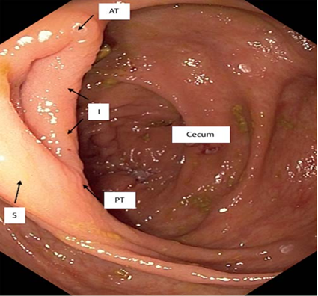
Figure 1 The ileocecal valve was divided into four sections: anterior angle, posterior angle, inferior lip, and superior lip. A: Anterior angle; P: Posterior angle; I: Inferior lip; S: Superior lip.

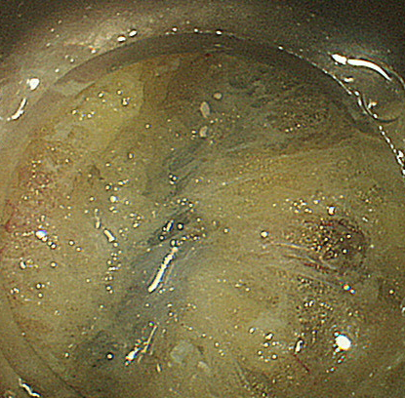
Figure 2 Submucosal fatty tissue around the ileocecal valve.

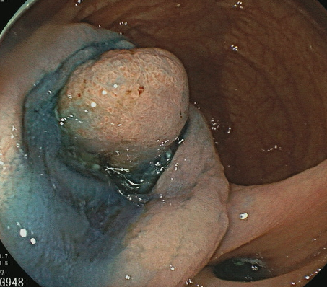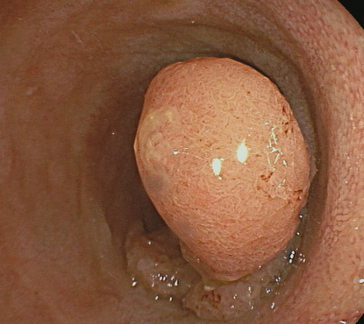
Figure 3 Endoscopic submucosal dissection in terminal ileal tumors. A: Terminal ileal tumor; B: Mucosal incision.

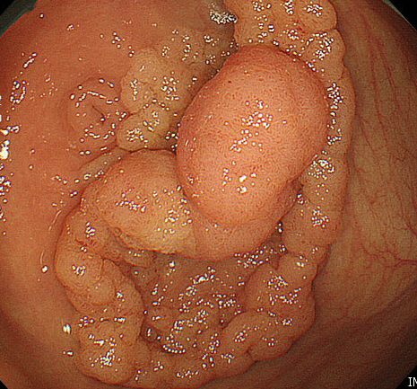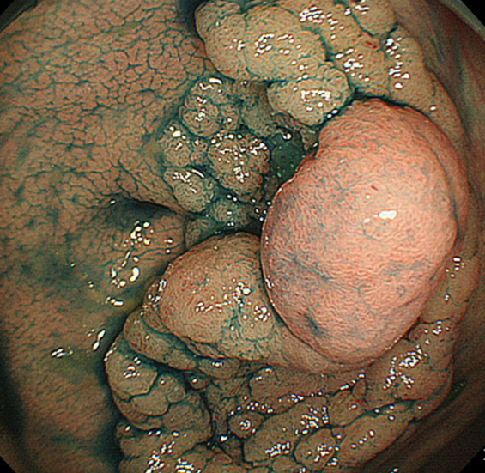
B
A
Figure 4 Laterally spreading tumor granular-nodular mix type involvement in the appendiceal orifice (arrow). A: Conventional white light image; B: Chromoendoscopy with indigo carmine.

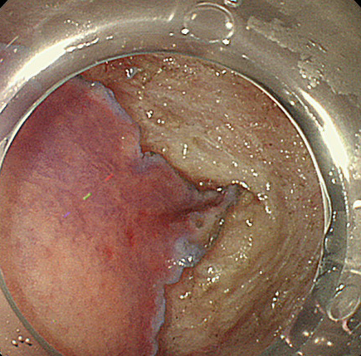
Figure 5 A transparent hood facilitates the endoscopic submucosal dissection of a lesion in close proximity to the appendix (arrow).

Figure 6 Rectal tumor involvement in the anal canal.

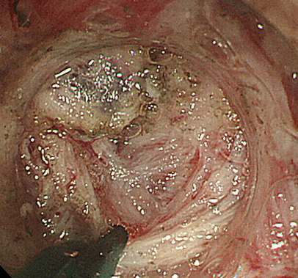
Figure 7 Severe submucosal fibrosis in the anal canal being managed with a scissor-type knife.

Table 1 Electrocautery setting for submucosal dissection in fatty tissue
Mode | Effect |  | Output (Watts) |  | Duration |  | Interval
 | General | Fatty tissue | General | Fatty tissue | General | Fatty tissue | General | Fatty tissue
Dry cut | 2 | 3-4 | 30 | 30-50
Endo cut i | 2 | 3-4 | None | None | 3 | 3 | 3 | 3
Forced coag | 2 | 3-4 | 30-40 | 30-50
Swift coag | 2 | 3-4 | 40-50 | 50

