Name of Journal: World Journal of Clinical Cases
Manuscript NO: 74305
Manuscript Type: CASE REPORT

Knot impingement after arthroscopic rotator cuff repair mimicking infection: A case report

Kim DH et al. Knot impingement after rotator cuff repair

Du-Han Kim, Jong-Hyuk Jeon, Byung-Chan Choi, Chul-Hyun Cho

Du-Han Kim, Jong-Hyuk Jeon, Byung-Chan Choi, Chul-Hyun Cho, Department of Orthopedic Surgery, Keimyung University Dongsan Hospital, Keimyung University School of Medicine, Daegu 42601, South Korea

Author contributions: Cho CH and Kim DH performed the conceptualization; Choi BC contributed to the investigation; Choi BC and Kim DH contributed to the data curation; Jeon JH wrote the original draft preparation; Cho CH wrote the review and editing, performed the supervision; Kim DH wrote the project administration; all authors have read and agreed to the published version of the manuscript.

Supported by National Research Foundation of Korea, No. 2021R1F1A1047546.

Corresponding author: Chul-Hyun Cho, PhD, Professor, Department of Orthopedic Surgery, Keimyung University Dongsan Hospital, Keimyung University School of Medicine, No. 1035 Dalgubeol-daero, Dalseo-gu, Daegu 42601, South Korea. oscho5362@dsmc.or.kr

Received: December 22, 2021
Revised: February 22, 2022
Accepted: March 27, 2022
Published online:

Abstract
BACKGROUND
Knot impingement as a complication after arthroscopic rotator cuff repair (ARCR) has been suggested as a cause of persistent pain with limited motion. We report on a case involving a patient who developed knot impingement after ARCR who complained of acute onset of pain with limited motion, which was confused with infection.

CASE SUMMARY
A 55-year-old female who complained of severe pain with limited motion of the right shoulder visited our emergency room. Passive range of motion could not be evaluated due to the patient’s severe pain. The patient had undergone ARCR using a suture-bridge technique at a local clinic four months ago for treatment of a small supraspinatus tear of the right shoulder. An erosive change of the undersurface of the acromion was observed on plain radiographs of the right shoulder, and a moderate amount of bursal fluid and synovial thickening with enhancement was observed by magnetic resonance imaging. Results of an analysis of the aspirated fluid showed that the WBC count was 3960 with 90% neutrophils. The arthroscopic view showed healing of the repaired supraspinatus tendon and loose suture threads and knots with severe subacromial bursitis were observed. Debridement of inflammatory tissues of the glenohumeral joint and subacromial space was performed for the removal of all suture materials. The patient’s symptoms subsided immediately after the surgical procedure.

CONCLUSION
Although the incidence of knot impingement is rare, the possibility of knot impingement after ARCR should be a consideration.

Key Words: Rotator cuff; Knot impingement; Shoulder; Infection; Arthroscopy; Case report

Kim DH, Jeon JH, Choi BC, Cho CH. Knot impingement after arthroscopic rotator cuff repair mimicking infection: A case report. World J Clin Cases 2022; In press

Core Tip: Arthroscopic rotator cuff repair (ARCR) is a procedure that is widely performed with satisfactory outcomes. Development of knot impingement as a rare complication after ARCR has been suggested as a cause of persistent pain with limited motion. Because of its rarity, knowledge regarding clinical features in patients with knot impingement after ARCR is limited. We suggest consideration of knot impingement after ARCR as a cause of acute shoulder pain.

INTRODUCTION
Determining the cause of acute joint pain in patients with no history of trauma can be challenging for the orthopedic clinician^{[1]}. Because the destruction of the involved joint can occur rapidly, a septic condition should be considered when making a diagnosis. However, making a differential diagnosis of infection from other problems that can induce acute joint pain is not always easy. Acute onset of shoulder pain is a relatively common symptom observed in the clinical setting. The most common causes of acute shoulder pain include calcific tendinitis, subacromial bursitis, and septic arthritis^{[1]}.
Arthroscopic rotator cuff repair (ARCR) is a procedure that is widely performed with satisfactory outcomes^{[2-5]}. Development of knot impingement as a complication after ARCR has been suggested as a cause of persistent pain with limited motion^{[6,7]}. To date, only 13 cases involving knot impingement after ARCR have been reported and most of the patients complained of insidious onset of pain during shoulder motion^{[6-8]}. Previous studies have focused on the pathogenesis of bone erosion on the acromial undersurface caused by suture knots^{[6-8]}. Because of its rarity, information regarding the clinical features in patients with knot impingement after ARCR is limited.
We report on a case involving a patient who developed knot impingement after ARCR who complained of acute onset of pain with limited motion, which was confused with infection. This report describes our experience with a rare case mimicking infection; successful management was achieved by arthroscopic removal of the knot.

CASE PRESENTATION
Chief complaints
A 55-year-old female who complained of severe pain with limited motion of the right shoulder visited our emergency room.

History of present illness
Development of pain had occurred two days ago; the pain was dull and continuous in nature regardless of shoulder motion.

History of past illness
The patient had undergone ARCR using a suture-bridge technique at a local clinic four months ago for treatment of a small supraspinatus tear of the right shoulder.

Personal and family history
The patient had no personal or family history.

Physical examination
Tenderness on the involved shoulder was observed and body temperature was 37.4 ºC. Her active range of motion was 45º of forward flexion, 30º of abduction, 25º of external rotation at the side, and buttock level of internal rotation at the back. Passive range of motion could not be evaluated because the patient was experiencing severe pain.

Laboratory examinations
According to the results of laboratory tests, the white blood cell count was 7920/μL (normal ranges, 4000-10000/μL) with 66.9% neutrophils. C-reactive protein (CRP) and erythrocyte sedimentation rate (ESR) were elevated at 8.4 mg/dL (normal ranges, 0.0-0.5 mg/dL) and 50 mm/hr (normal ranges, 0-25 mm/hr), respectively. Because a septic condition was suspected, aspiration was performed through the subacromial space and 2 cc of yellowish fluid with mucoid nature was obtained. Results of the fluid analysis showed that the WBC count was 3960 with 90% neutrophils.

Imaging examinations
An erosive change of the undersurface of the acromion was observed on plain radiographs of the right shoulder at 30º caudal tilting view (Figure 1). A moderate amount of bursal fluid and synovial thickening with enhancement was observed by enhanced magnetic resonance imaging (MRI) (Figure 2). In addition, an irregular erosive change of the undersurface of the acromion was also observed.

FINAL DIAGNOSIS
Although a definite diagnosis of infection was not indicated by these findings, because the possibility of infection could not be ruled out completely based on the clinical symptoms, the patient was scheduled to undergo emergency arthroscopic surgery.

TREATMENT
The arthroscopic view showed healing of the repaired supraspinatus tendon and loose suture threads and knots with severe subacromial bursitis were observed. Impingement of suture knots was observed at the undersurface of the acromion, resulting in erosion of subacromial bone (Figure 3). Debridement of inflammatory tissues of the glenohumeral joint and subacromial space was performed for removal of all suture materials.

OUTCOME AND FOLLOW-UP
The final culture from the aspirated bursal fluid showed no growth of organisms. The patient’s symptoms subsided immediately after this procedure. Completely restored range of motion without pain at rest or activity was observed at one-year follow-up after surgery.

DISCUSSION
Knot impingement has recently been described as a complication occurring after ARCR resulting in pain during motion; additional surgery may be necessary for removal of the suture knots^{[6,7]}. To date, only 13 cases involving knot impingement after ARCR have been reported^{[6-8]}. In 2010, Hotta and Yamashita^{[6]} first reported that acromial erosion was observed in nine of 434 (2.1%) patients who had undergone ARCR. They found an association between the knot position and the portion of osteolysis on the undersurface of the acromion; the patients no longer had symptoms after removal of the knots^{[6]}. They concluded that this complication might have been caused by knot impingement resulting from the knots of the suture thread^{[6]}. Park et al^{[8]} also reported that acromial erosion was observed in three of 221 (1.4%) patients with ARCR. Uchida et al^{[7]} recently reported two cases involving symptomatic knot impingement resulting in subacromial bone erosion.
Suggested causes of knot impingement after ARCR include the position of the knot, exposure of cancellous bone after acromioplasty, and stronger suture materials^{[6-8]}. Hotta and Yamashita^{[6]}, who reported observing knots on the top of the greater tuberosity in all cases involving knot impingement, suggested that the use of a knotless or suture-bridge repair technique may be helpful in prevention of symptomatic knot impingement during ARCR. However, Park et al^{[8]} reported that there was no difference in acromial erosion in high-profile knots made using a single row technique compared with a double row suture-bridge technique. Acromial erosion due to knot impingement may be the result of exposure of weak cancellous bone after acromioplasty^{[6,8]}. Anchor suture limbs have recently been replaced by strong braided nonabsorbable suture materials such as FiberWire (Arthrex, Naples, FL, United States), resulting in stronger knots without suture breakage during ARCR^{[8]}. However, these characteristics may contribute to development of knot impingement after ARCR. In our case, acromioplasty and ARCR were performed using suture anchors with strong braided nonabsorbable suture threads. Even though a suture-bridge technique was used in performance of ARCR, an association of knot impingement with loose suture threads and knots was confirmed.
Because of its rarity, there is a poor understanding of clinical features in patients with knot impingement. Although previous studies have not provided a detailed description, in most reported cases there was insidious development of symptoms, which were aggravated during shoulder motion such as overhead working and sports activities^{[6-8]}. Different clinical features were observed in the current study compared to previously reported cases. The patient visited the emergency room with a complaint of acute onset of severe pain and limited motion. Due to the clinical features with elevated ESR and CRP on laboratory tests and fluid collection and synovial thickening with enhancement on MRI there was concern of an infectious condition. Therefore, emergency arthroscopic surgery was performed for diagnostic and therapeutic intention. Erosive change of the acromial undersurface was observed on plain radiographs prior to arthroscopic surgery. However, the clinical features were more like an infection; therefore symptomatic knot impingement was not detected. Using arthroscopic findings we determined that knot impingement with suture threads might have been the cause of the patient’s pain. Conduct of further studies, including large numbers of patients, is needed in order to clarify the pathogenesis and clinical features of knot impingement after ARCR.
A review of the literature found that some shoulder problems such as calcific tendinitis, subacromial bursitis, chronic lymphocytic leukemia, small lymphocytic lymphoma, and deep vein thrombosis can mimic infection by presenting with acute onset of severe pain^{[1,9,10]}. Although the incidence is rare, the possibility of knot impingement should be considered for patients with acute pain and limited motion of the shoulder who have a history of ARCR.

CONCLUSION
To the best of our knowledge, this is the first report of knot impingement after ARCR mimicking infection with successful management by arthroscopic removal of the knot. We suggest consideration of knot impingement after ARCR as a cause of acute shoulder pain.

ACKNOWLEDGEMENTS
The authors thank Eun-Ji Jeon for her support.

REFERENCES
1 Ross G, Cooper J, Minos L, Steinmann SP. Acute calcific tendinitis of the shoulder mimicking infection: arthroscopic evaluation and treatment--a case report. Am J Orthop (Belle Mead NJ) 2006; 35: 572-574 [PMID: 17243407]
2 Oh SY, Jang YH, Chae IS, Kim SH. Prevalence and Clinical Impact of Acromial Cupping after Arthroscopic Rotator Cuff Repair: Does Acromioplasty Matter? Clin Orthop Surg 2021; 13: 520-528 [PMID: 34868502 DOI: 10.4055/cios21010]
3 Lee D, Lee KH, Jo YH, Joo IH, Lee HJ, Jeong SY, Lee BG. Correlation between Severity of Synovitis and Clinical Features in Rotator Cuff Tears. Clin Orthop Surg 2021; 13: 88-96 [PMID: 33747384 DOI: 10.4055/cios20002]
4 Kim H, Song HS, Kang SG, Han SB. Arthroscopic Capsular Repair without Relaying Sutures: 'Simple Sewing Technique'. Clin Shoulder Elb 2019; 22: 146-148 [PMID: 33330211 DOI: 10.5397/cise.2019.22.3.146]
5 Park JY, Lee JH, Oh KS, Chung SW, Choi Y, Yoon WY, Kim DW. Rotator cuff retear after repair surgery: comparison between experienced and inexperienced surgeons. Clin Shoulder Elb 2021; 24: 135-140 [PMID: 34488293 DOI: 10.5397/cise.2021.00073]
6 Hotta T, Yamashita T. Osteolysis of the inferior surface of the acromion caused by knots of the suture thread after rotator cuff repair surgery: knot impingement after rotator cuff repair. J Shoulder Elbow Surg 2010; 19: e17-e23 [PMID: 21070953 DOI: 10.1016/j.jse.2010.07.002]
7 Uchida A, Mihata T, Neo M. Subacromial bone erosion due to suture-knots in arthroscopic rotator cuff repair: A report of two cases. Asia Pac J Sports Med Arthrosc Rehabil Technol 2019; 16: 30-35 [PMID: 30984561 DOI: 10.1016/j.asmart.2018.11.006]
8 Park YE, Shon MS, Lim TK, Koh KH, Jung SW, Yoo JC. Knot impingement after rotator cuff repair: is it real? Arthroscopy 2014; 30: 1055-1060 [PMID: 24908257 DOI: 10.1016/j.arthro.2014.04.091]
9 Donovan A, Schweitzer ME, Garcia RA, Nomikos G. Chronic lymphocytic leukemia/small lymphocytic lymphoma presenting as septic arthritis of the shoulder. Skeletal Radiol 2008; 37: 1035-1039 [PMID: 18521594 DOI: 10.1007/s00256-008-0512-x]
10 Lisse JR, Thurmond-Anderle M, Davis CP. Deep venous thrombosis in intravenous cocaine abuse mimicking septic arthritis of the shoulder. South Med J 1991; 84: 278-279 [PMID: 1990471 DOI: 10.1097/00007611-199102000-00034]

Footnotes
Informed consent statement: Informed written consent was obtained from the patient for publication of this report and any accompanying images.

Conflict-of-interest statement: The authors declare that they have no conflict of interest.

CARE Checklist (2016) statement: The authors have read the CARE Checklist (2016), and the manuscript was prepared and revised according to the CARE Checklist (2016).

Open-Access: This article is an open-access article that was selected by an in-house editor and fully peer-reviewed by external reviewers. It is distributed in accordance with the Creative Commons Attribution NonCommercial (CC BY-NC 4.0) license, which permits others to distribute, remix, adapt, build upon this work non-commercially, and license their derivative works on different terms, provided the original work is properly cited and the use is non-commercial. See: https://creativecommons.org/Licenses/by-nc/4.0/

Provenance and peer review: Unsolicited article; Externally peer reviewed.

Peer-review model: Single blind

Peer-review started: December 22, 2021
First decision: February 21, 2022
Article in press:

Specialty type: Medicine, research and experimental
Country/Territory of origin: South Korea
Peer-review report’s scientific quality classification
Grade A (Excellent): 0
Grade B (Very good): B
Grade C (Good): C
Grade D (Fair): 0
Grade E (Poor): 0

P-Reviewer: Liu P, China; Roach CJ, United States S-Editor: Fan JR L-Editor: A P-Editor: Fan JR

Figure Legends
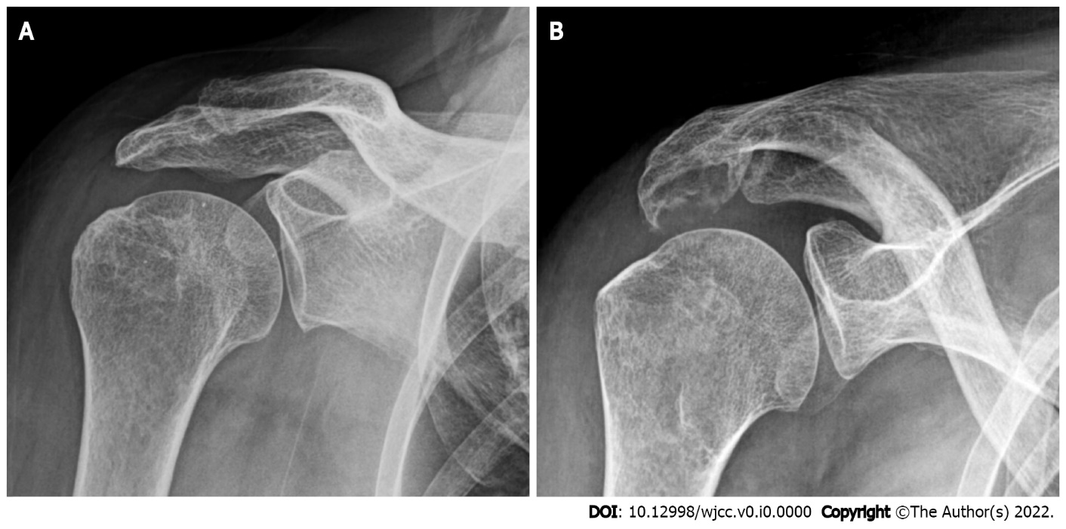
Figure 1 Plain radiographs of the right shoulder show erosive change of the acromion undersurface. A: Anteroposterior view; B: 30º caudal tilting view.

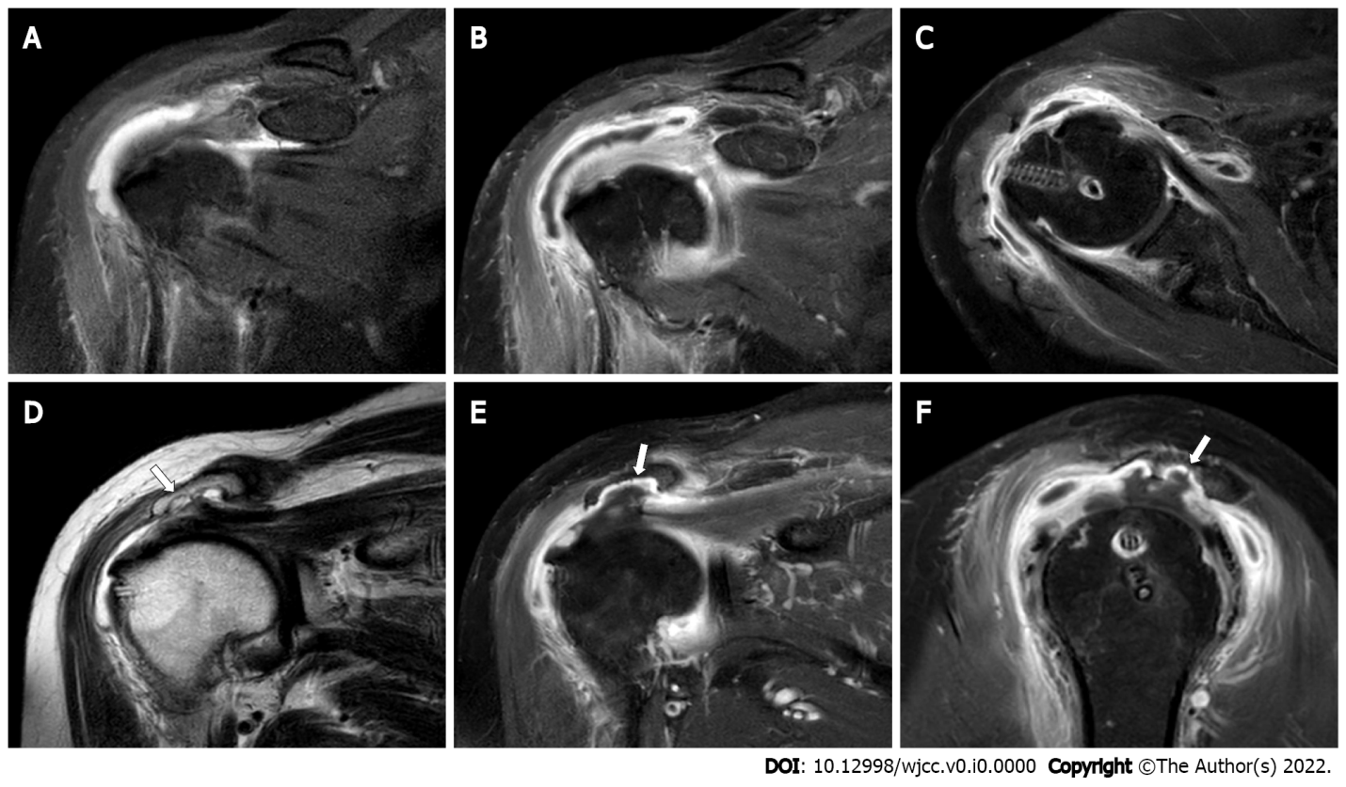
Figure 2 Magnetic resonance imaging. A-C: Coronal T2-weighted (A) and enhanced (B and C) magnetic resonance images show a moderate amount of bursal fluid and synovial thickening with enhancement; D-F: Coronal T1-weighted (D) and enhanced (E and F) images show irregular erosive change of the acromion undersurface (white arrows).

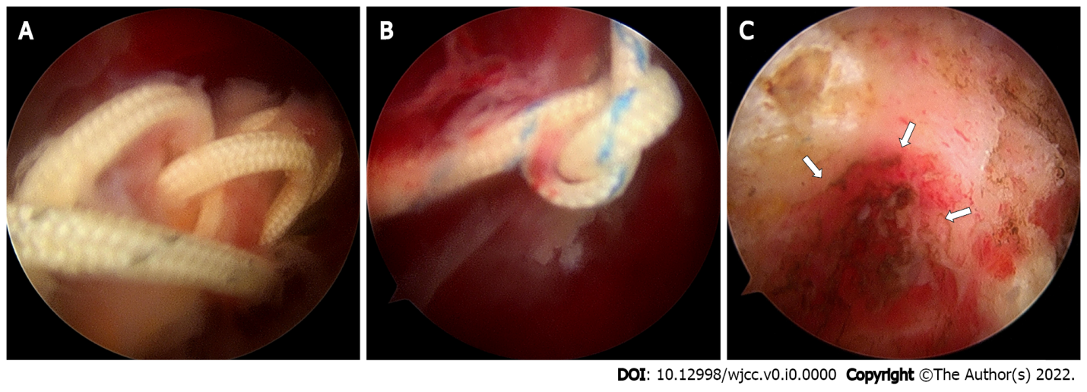
Figure 3 Arthroscopic findings. A: Loose suture threads; B and C: Suture knots (B) with severe subacromial bursitis, and irregular acromial erosion caused by suture knots (C) (arrows).

