Name of Journal: World Journal of Gastrointestinal Surgery
Manuscript NO: 64856
Manuscript Type: ORIGINAL ARTICLE

Retrospective Study
Optimal postoperative surveillance strategies for stage III colorectal cancer

Park MY et al. Optimal surveillance for CRC

Min Young Park, In Ja Park, Hyo Seon Ryu, Jay Jung, Minsung Kim, Seok-Byung Lim, Chang Sik Yu, Jin Cheon Kim

Min Young Park, Colon and Rectal Surgery, Asan Medical Center, Seoul 05505, South Korea

In Ja Park, Hyo Seon Ryu, Jay Jung, Minsung Kim, Seok-Byung Lim, Chang Sik Yu, Jin Cheon Kim, Colon and Rectal Surgery, Asan Medical Center and University of Ulsan College of Medicine, Seoul 05505, South Korea

Author contributions: Kim JC, Yu CS, and Lim SB guaranted the integrity of the study; Park IJ conceptualized the study; Park IJ and Park MY collected the data, edited the manuscript; Park MY did statistical analysis and prepared manuscript; Park IJ, Park MY, Ryu HS, Jung J, and Kim MS reviewed manuscript; all authors have read and approve the final manuscript.

Corresponding author: In Ja Park, MD, PhD, Doctor, Professor, Surgeon, Colon and Rectal Surgery, Asan Medical Center and University of Ulsan College of Medicine, No. 88 Olympic-ro, Songpa-gu, Seoul 05505, South Korea. ipark@amc.seoul.kr

Received: February 24, 2021
Revised: June 3, 2021
Accepted: August 2, 2021
Published online: September 27, 2021

Abstract
BACKGROUND
Optimal surveillance strategies for stage III colorectal cancer (CRC) are lacking, and intensive surveillance has not conferred a significant survival benefit.

AIM
To examine the association between surveillance intensity and recurrence and survival rates in patients with stage III CRC.

METHODS
Data from patients with pathologic stage III CRC who underwent radical surgery between January 2005 and December 2012 at Asan Medical Center, Seoul, Korea were retrospectively reviewed. Surveillance consisted of abdominopelvic computed tomography (CT) every 6 mo and chest CT annually during the 5 year follow-up period, resulting in an average of three imaging studies per year. Patients who underwent more than the average number of imaging studies annually were categorized as high intensity (HI), and those with less than the average were categorized as low intensity (LI).

RESULTS
Among 1888 patients, 864 (45.8%) were in HI group. Age, sex, and location were not different between groups. HI group had more advanced T and N stage (P = 0.002, 0.010, each). Perineural invasion (PNI) was more identified in the HI group (21.4% vs 30.3%, P < 0.001). The mean overall survival (OS) and recurrence-free interval (RFI) was longer in the LI group (P < 0.001, each). Multivariate analysis indicated that surveillance intensity [odds ratio (OR) = 1.999; 95% confidence interval (CI): 1.680–2.377; P < 0.001], pathologic T stage (OR = 1.596; 95%CI: 1.197–2.127; P = 0.001), PNI (OR = 1.431; 95%CI: 1.192–1.719; P < 0.001), and circumferential resection margin (OR = 1.565; 95%CI: 1.083–2.262; P = 0.017) in rectal cancer were significantly associated with RFI. The mean post-recurrence survival (PRS) was longer in patients who received curative resection (P < 0.001). Curative resection rate of recurrence was not different between HI (29.3%) and LI (23.8%) groups (P = 0.160). PRS did not differ according to surveillance intensity (P = 0.802).

CONCLUSION
Frequent surveillance with CT scan do not improve OS in stage III CRC patients. We need to evaluate role of other surveillance method rather than frequent CT scans to detect recurrence for which curative treatment was possible because curative resection is the important to improve post-recurrence survival.

Key Words: Colorectal cancer; Surveillance intensity; Survival; Recurrence

©The Author(s) 2021. Published by Baishideng Publishing Group Inc. All rights reserved.

Citation: Park MY, Park IJ, Ryu HS, Jung J, Kim M, Lim SB, Yu CS, Kim JC. Optimal postoperative surveillance strategies for stage III colorectal cancer. World J Gastrointest Surg 2021; 13(9): 1012-1024
URL: https://www.wjgnet.com/1948-9366/full/v13/i9/1012.htm
DOI: https://dx.doi.org/10.4240/wjgs.v13.i9.1012

Core Tip: This is a retrospective study to evaluate the association between surveillance intensity and recurrence and survival rates in patients with stage III colorectal cancer (CRC). The overall survival (OS) and recurrence-free interval (RFI) was longer in the low intensity group. Post-recurrence survival (PRS) did not change according to surveillance intensity. Therefore, frequent postoperative imaging studies do not improve OS or RFI in patients with stage III CRC. However, in high-risk patients, early detection of recurrence improves the chance of curative resection, which may improve PRS.

INTRODUCTION
In patients who undergo surgery for colorectal cancer (CRC), ongoing surveillance is recommended to detect and treat recurrences early, which improves the chances of curative treatment and thus overall survival (OS)^{[1]}. Surveillance also provides an opportunity to assess the quality of the primary surgery and detect metachronous tumors at an earlier stage.
CRC is the second most common cancer among Korean males and the fourth most common among females, and the third leading cause of cancer-related death in South Korea^{[2]}. The 5 year trend from 2013 to 2017 indicates that approximately 78% of CRC patients in Korea have resectable tumors with localized or regional disease is similar with that in United States^{[3]}. Despite high prevalence and mortality rates, patients with CRC represent the second largest group of 5 year cancer survivors. More than 90% of local recurrences appear within the first 5 years after surgery, and the most of them appear within 3 years after surgery^{[4,5]}. After radical surgery with curative intent, surveillance is recommended with the goal of improving OS and disease-specific survival by detecting recurrence or metachronous cancer at an early stage. Hypothetically intensive surveillance during recurrence-prone period could be useful to detect recurrence in early phase and thus improve the prognosis of these patients^{[6-8]} especially in patients with high risk of recurrence by early onset of proper treatment.
Although many clinical guidelines recommended surveillance method and schedule, optimal surveillance strategies have not been established to date, and systemic reviews and a randomized trial have provided inconclusive results regarding the survival benefits related to surveillance^{[9-11]}. Recent studies indicate that intensive surveillance does not significantly increase survival rates^{[12-14]}. However, studies examining recurrence rates report that intensive surveillance increases the frequency of curative surgery for the recurred lesion^{[15-18]}. Survival rates are higher for patients examined by computed tomography (CT) and detection of carcinoembryonic antigen^{[9,15]}. The lack of consistency between reports underscores the need to evaluate the survival benefits associated with intensive surveillance. In contrary, intensive surveillance without benefit in oncologic outcomes need to be carefully reconsidered because it would be burden of medical expense as well as for patients. In addition, previous study reported the false positive rates of the CT scan which is most commonly used in CRC surveillance^{[19]}. According to the study, CT scan showed false positive rate up to 28% for a patient with no actual recurrence. Therefore, CRC surveillance based on imaging studies requires not only a CT machine with sufficient performance but also well-trained radiologists who can make accurate readings. Furthermore, frequent CT scan resulted in sequelae of CT radiation exposure. Given these risks of intensive surveillance, unnecessary intensive surveillance should be avoided if the risk of recurrence is low or there is no survival benefit.
The purpose of the current study was to determine the association between surveillance intensity, the detection of recurrence, and survival rates. Additionally, this study investigated the effect of intensive surveillance on the outcome of curative treatment in patients with recurrent disease.

MATERIALS AND METHODS
Participants and clinical variables
Data from patients with pathologic stage III CRC who underwent radical surgery between January 2005 and December 2012 at Asan Medical Center, Seoul, Korea were retrospectively reviewed. Patients who underwent radical resection and elective surgery for primary CRC, as well as those treated with preoperative chemoradiotherapy (PCRT) followed by radical resection, were included. Patients with synchronous distant metastasis, synchronous cancer in another organ, cancer diagnosed within 5 years, inflammatory disease associated CRC, those who underwent local excision, and those with unknown staging status were excluded. Patients who were lost to follow-up surveillance were excluded from analyses as well. As a result, 1888 patients who met the criteria were included in the final analysis.
Patient characteristics analyzed included age, sex, pathologic differentiation, lymphovascular invasion (LVI), perineural invasion (PNI), circumferential resection margin (CRM) of rectal cancer (involving < 1 mm), PCRT, recurrence, treatment after recurrence, and survival. Postoperative surveillance included abdomino-pelvic CT (APCT) and chest CT (CCT).
This study was approved by the Institutional Review Board of Asan Medical Center, No. 2017-0955.

Surgical procedures and postoperative surveillance
The objectives of surgical treatment for colon cancer were ligation of feeding vessels at their roots, principal node removal, and achieving a sufficient resection margin for both proximal and distal margins. Surgery was performed according to the principle of total mesorectal excision for rectal cancer. Patients who received PCRT underwent surgical resection at 6–10 wk after completion of the chemoradiotherapy course. The majority of surgical procedures were carried out by one of seven experienced colorectal surgeons, and the remaining procedures were performed by colorectal fellows.
Adjuvant chemotherapy was recommended for pathologic stage III colon cancer patients and for stage II patients with risk factors such as preoperative obstruction, LVI, PNI, high tumor budding, and < 12 resected lymph nodes. In patients with rectal cancer, adjuvant chemotherapy was recommended for pathologic stage II and III patients or for those treated with PCRT regardless of pathologic stage. PCRT was indicated for patients who had clinical stage II or III cancer and for those with clinical stage I who were eligible for sphincter-saving surgery due to low lying rectal cancer and those who were not candidates for major surgery because of medical comorbidities.
All patients received postoperative follow-up examination consisting of a physical examination and serum carcinoembryonic antigen measurements every 3–6 mo. Abdominal, pelvic, and chest CT scans were performed every 6–12 mo. Patients with obstructive lesions underwent colonoscopy within 6 mo after surgical resection and every 2–3 years thereafter.

Definition of surveillance intensity
All patients were followed-up for approximately 5 years after surgery with APCT and CCT. Patients underwent surveillance every 6 mo at the outpatient clinic, including APCT every 6 mo and CCT every 12 mo on average. The number of expected imaging studies was two for APCT and one for CCT, with a total of three studies per year.
The average number of studies for each patient was calculated as the number of examinations during 5 years/60 mo of follow-up without recurrence, or the number of examinations until the first recurrence for patients who experienced recurrence. Patients who underwent more than the average number of studies per year (3) were categorized as high intensity (HI), whereas those who underwent less than three annual studies were categorized as low intensity (LI). Patients were categorized based on intensity of imaging studies to account for differences in risk-related surveillance.

Statistical analysis
Continuous variables were compared using a t-test and expressed as the mean and range. Categorical variables were compared using Pearson’s χ² test or Fisher’s exact test and expressed as numbers and percentages. Univariate analyses were performed to identify factors associated with survival. Factors with P < 0.1 on univariate analysis were included in a multivariate binary logistic regression analysis. OS, recurrence-free interval (RFI), and post-recurrence survival (PRS) were calculated using the Kaplan–Meier method^{[20]} and compared with the Cox-regression model^{[21]}. All statistical analyses were performed using SPSS for Windows, ver. 25.0 (SPSS Inc., Chicago, IL, United States), with P < 0.05 defined as statistically significant.

RESULTS
Patient characteristics
Of 1888 patients, 1024 were included in the LI group and 864 were included in the HI group. The demographic characteristics of the patients and the clinicopathological features of the tumors are shown in Table 1. Demographic characteristics did not differ between the LI group and the HI group. In terms of pathologic features, patients in the HI group had a higher T and N stage and included more risk factors such as a high degree of malignant differentiation, PNI, or positive CRM. The average number of APCT studies performed per year was 1.8-fold higher in the HI group than in the LI group, and CCT was performed at a 2.4-fold higher rate in the HI group than in the LI group (P < 0.001) (Table 1). In patients with rectal cancer, positive CRM was higher in the HI group than in the LI group (Supplementary Table 1).

Oncologic outcomes according to surveillance intensity
The number of APCT and CCT studies was significantly higher in patients who experienced recurrence than in those who did not (P < 0.001). Patients with recurrence were categorized into intra-abdominal and intra-thoracic according to site of recurrence. The number of APCT studies was higher in patients who experienced intra-abdominal recurrence, and the number of CCT studies was higher in patients who experienced intra-thoracic recurrence (P < 0.001) (Figure 1). Among patients with rectal cancer, 50 patients showed local recurrence, of which 21 (42%) were in the LI group and 29 (58%) were in the HI group. Analysis of APCT intensity in patients with rectal cancer showed no difference in the incidence of local recurrence according to APCT intensity (P = 0.860). Distant metastasis was confirmed in 509 patients, of which 193 were in the LI group and 316 were in the HI group. Curative treatment was possible in 143 patients, of which 48 were in the LI group and 95 were in the HI group. The curative resection rate according to surveillance intensity was higher in the HI group, although the difference was not statistically significant (25% vs 30%, P = 0.206).
The RFI was longer in the LI group than in the HI group (61 ± 33.95 mo vs 45 ± 28.35 mo, P < 0.001). In patients who experienced recurrence, the mean RFI remained longer in the LI group than in the HI group (23 ± 16.09 mo vs 19 ± 11.86 mo, P = 0.001). Both intra-abdominal RFI according to APCT intensity and intra-thoracic RFI according to CCT intensity were longer in the LI group than in the HI group (abdomen, 23 ± 16.38 mo vs 17 ± 11.39 mo, P < 0.001; chest, 26 ± 15.36 mo vs 20 ± 13.79 mo, P = 0.004) (Figure 2). The mean RFI in recurred patients did not differ significantly according to tumor location (colon, 22 ± 11.21 mo vs rectum, 20 ± 14.41 mo, P = 0.059).
Among patients who experienced recurrence, the mean PRS time did not differ according to surveillance intensity (35 ± 31.94 mo in the LI group and 34 ± 29.28 mo in the HI group; P = 0.802) (Figure 3). There was no difference in the PRS according to tumor location (colon, 29 ± 29.65 mo vs 37 ± 30.08 mo, P = 0.250; rectum, 36 ± 32.20 mo vs 33 ± 28.94 mo, P = 0.415). Curative resection was possible in 152 of all recurred patients, of which 51 (23.8%) were in the LI group and 101 (29.3%) were in the HI group (P = 0.160). Of the 51 patients in the LI group, seven (13.7%) had colon cancer and 44 (86.3%) had rectal cancer. In the HI group, 35 (34.6%) patients had colon cancer and 66 (55.4%) had rectal cancer. There was no difference in the rate of curative resection between surveillance intensity groups according to tumor location (colon, P = 0.673; rectum, P = 0.318). PRS according to the curative intent after recurrence was significantly longer in patients who underwent curative resection (54 ± 30.96 mo vs 27 ± 26.82 mo, P < 0.001).
The mean OS was significantly longer in the LI group (68 ± 31.89 mo) than in the HI group (58 ± 27.35 mo, P < 0.001) (Figure 4). Analysis of survival according to tumor location showed that OS was longer in the LI group regardless of tumor location (colon, 74 ± 27.84 mo vs 56 ± 23.66 mo, P < 0.001; rectum, 65 ± 33.58 mo vs 59 ± 29.12 mo, P = 0.001).

Factors associated with oncologic outcomes
Univariate analysis identified factors affecting OS. Age, sex, surveillance intensity, pathologic differentiation, pathologic T and N stages, LVI, PNI, and CRM in rectal cancer significantly affected OS (P < 0.05). In the multivariate analysis, age, sex, surveillance intensity, differentiation, pathologic T stage, LVI, PNI, and CRM in rectal cancer were significantly associated with OS (Table 2).
Univariate analysis of factors affecting RFI indicated that surveillance intensity, differentiation, pathologic T stage, pathologic N stage, LVI, PNI, and CRM in rectal cancer significantly affected RFI (P < 0.05). In the multivariate analysis, surveillance intensity, pathologic T stage, PNI, and CRM in rectal cancer were significantly associated with RFI. Among patients who experienced intra-abdominal recurrence, APCT intensity, differentiation, pathologic T stage, PNI, and CRM in rectal cancer were significantly associated with RFI. In patients with intra-thoracic recurrence, CCT intensity, differentiation, pathologic T stage, LVI, PNI, and CRM in rectal cancer were significantly associated with RFI (Table 3).
Univariate analysis of patients who experienced recurrence to identify factors affecting PRS showed that age, differentiation, LVI, PNI, and curative resection were significantly associated with PRS. Multivariate analysis showed that age, differentiation, PNI, and curative resection were significantly associated with PRS. In patients with intra-abdominal recurrence, age, differentiation, PNI, and curative resection were associated with PRS, whereas in patients with intra-thoracic recurrence, only sex and curative resection affected PRS (Table 4). The results of univariate and multivariate analyses of patients with rectal cancer were comparable to the results for all patients (Supplementary Table 1).

DISCUSSION
Existing guidelines recommend surveillance after primary surgery with a curative intent for CRC^{[22-26]}, although consistent guidelines are lacking. The European Society of Medical Oncology recommends abdominal and chest CT every 6 to 12 mo for 3 years, and then yearly for 2 years for patients with colon cancer; however, there are no imaging recommendations for patients with rectal cancer. The American Society of Clinical Oncology guidelines recommend abdominal and chest CT annually for 3 years, and every 6 to 12 mo for the first 3 years for high-risk patients. The National Comprehensive Cancer Network guidelines suggest an abdominal CT scan for high-risk patients with poorly differentiated cancer or those with perineural or venous invasion, although there are no guidelines regarding frequency. The American Society of Colorectal Surgeons guidelines recommend chest and abdominopelvic imaging annually for 5 years.
The Gruppo Italiano Lavoro per la Diagnosi Anticipata trial launched in 1998 found that an intensive surveillance program after curative treatment for CRC detects asymptomatic local or distant recurrences but does not affect OS^{[27]}. Similarly, the Follow-up After Colorectal Surgery randomized trial, the results of which were recently published, changed the original endpoint of unmeasured OS to a practical endpoint of surgical treatment of recurrence with curative intent^{[16]}. Several meta-analyses and prospective randomized trials showed no survival benefit associated with intensive surveillance^{[15,18]}. However, other studies showed an association between intensive surveillance and a significant reduction in mortality and increased OS^{[28,29]}.
In this study, patients were divided into LI and HI groups according to the number of imaging studies during the follow-up period. The average number of imaging studies was higher in patients with recurrence regardless of the location of recurrence. Patients in the HI group had higher pathologic T and N stages and were more likely to have risk factors such as LVI and PNI. This suggests a tendency to perform surveillance more frequently in patients with a high risk of recurrence. Among rectal cancer patients, 50 had local recurrence, most of which were lateral pelvic lymph node recurrence except in four patients with anastomosis recurrence. Among patients with local recurrence, 21 were in the LI group and 29 were in the HI group, and the detection rate of local recurrence did not differ between the two groups. Of the 50 patients with local resection, 16 underwent surgical resection, of which 10 achieved curative resection. Four patients (19%) in the LI group and six patients (21%) in the HI group were eligible for curative resection, and there was no difference according to surveillance intensity (P = 0.886) even after stratifying patients according to APCT intensity (P = 0.382). This result could be due to the small number of patients with local recurrence, of whom few underwent curative treatment. The remaining 17 patients received palliative treatment, such as chemotherapy or radiotherapy, and had a short-term follow-up because metastasis was unclear when first detected. In these patients, metastasis to distant lymph nodes or distant organs was found during follow-up, and the patients were not eligible for curative treatment. These results indicate that the current imaging surveillance guidelines, which is based on CT, may result in a missed local recurrence that can be treated with curative resection in approximately 35% of patients. The accuracy of CT scans for detecting recurrence is limited regardless of imaging frequency. Therefore, additional examinations or surgical treatment rather than short-term follow-up could improve the chances of curative resection in patients suspected of recurrence.
Survival analysis showed that OS and RFI were longer in the LI group than in the HI group, whereas PRS did not differ between the two groups. The shorter OS and RFI could be related to the higher aggressive biology of the HI group. Analysis of patients who did not experience recurrence showed that OS was approximately 10 mo shorter in the HI group than in the LI group. Although not statistically significant, the probability of curative resection of recurrent lesions was slightly higher in the HI group. Analysis of survival according to surveillance intensity after dividing patients based on initial tumor location (colon and rectum) did not show statistically significant differences between the groups. Pathologic risk factors, such as degree of differentiation, PNI, and LVI, had a greater effect on OS, RFI, and PRS than surveillance intensity. In particular, curative resection had a greater effect on PRS than surveillance intensity. The PRS of recurred patients was 2-fold longer in those who received curative resection than in those who did not (54 mo vs 27 mo, respectively). The results of multivariate analysis confirmed that curative resection improves PRS. However, when analyzing only patients who underwent curative resection, there was no difference in OS or PRS according to imaging intensity. This suggests that although imaging intensity itself does not improve OS or PRS, intensive surveillance can increase the possibility of curative resection, thereby improving PRS. Furthermore, the aggressive biology of the HI group may mitigate the benefit of curative resection of recurrence. Assessment of the effect of surveillance intensity on PRS may have been affected by the small number of patients who underwent curative treatment for recurrence in this study.
This study has several limitations. First, it was a retrospective, observational cohort study, and patients were not randomized. Surveillance intensity can vary according to the patient’s condition at the time of treatment, which may have resulted in selection bias. Second, the average surveillance schedule may have differed depending on the physician. Additional research is needed to determine the standard routine surveillance in our institution.

CONCLUSION
In conclusion, in patients with stage III CRC, frequent postoperative image studies alone do not improve OS and RFI. Curative resection is the most important factors to improve PRS and we need to find a way to increase curative treatment of recurrent disease via optimal surveillance. Therefore, role of other imaging modalities according to risk of recurrence would be evaluated rather than increasing surveillance frequency to improve oncologic outcomes.

ARTICLE HIGHLIGHTS
Research background
Optimal surveillance strategies for stage III colorectal cancer (CRC) are lacking, and intensive surveillance has not conferred a significant survival benefit.

Research motivation
Evaluating appropriate surveillance intensity would be helpful to improve oncologic outcomes or decrease un-necessary imaging studies during surveillance.

Research objectives
We examined the association between surveillance intensity and recurrence and survival rates in patients with stage III CRC.

Research methods
Data from patients with pathologic stage III CRC who underwent radical surgery between January 2005 and December 2012 at Asan Medical Center, Seoul, Korea were retrospectively reviewed. Surveillance consisted of abdominopelvic computed tomography (CT) every 6 mo and chest CT annually during the 5 year follow-up period, resulting in an average of three imaging studies per year. Patients who underwent more than the average number of imaging studies annually were categorized as high intensity (HI), and those with less than the average were categorized as low intensity (LI).

Research results
Among 1888 patients, 864 (45.8%) were in HI group. The HI group had more advanced T and N stage (P = 0.002, 0.010, each). A high degree of malignant differentiation was more common in the HI group than in the LI group (P = 0.027). Perineural invasion (PNI) was significantly more identified in the HI group (21.4% vs 30.3%, P < 0.001).
The mean overall survival (OS) and Recurrence-free interval (RFI) was longer in the LI group (P < 0.001, each). Multivariate analysis indicated that surveillance intensity was negatively associated with RFI [odds ratio (OR) = 1.999; 95% confidence interval (CI): 1.680–2.377; P < 0.001] and OS [OR = 1.531, 95%CI: 1.295–1.808; P < 0.001]. The mean post-recurrence survival (PRS) was significantly longer in patients who received curative resection (P < 0.001). Curative resection rate of recurrence was not different between HI (29.3%) and LI (23.8%) groups (P = 0.160). PRS did not differ according to surveillance intensity (P = 0.802).

Research conclusions
Frequent postoperative surveillance with CT scan alone do not improve OS and RFI. Curative resection is the most important factors to improve PRS and we need to find a way to increase curative treatment of recurrent disease via optimal surveillance.

Research perspectives
Role of other imaging modalities according to risk of recurrence would be evaluated rather than increasing surveillance frequency to improve oncologic outcomes.

REFERENCES
1 Taylor I. Quality of follow-up of the cancer patient affecting outcome. Surg Oncol Clin N Am 2000; 9: 21-25, vi [PMID: 10601521 DOI: 10.1016/S1055-3207(18)30165-0]
2 Lee BI, Hong SP, Kim SE, Kim SH, Kim HS, Hong SN, Yang DH, Shin SJ, Lee SH, Park DI, Kim YH, Kim HJ, Yang SK, Kim HJ, Jeon HJ; Multi-Society Task Force for Development of Guidelines for Colorectal Polyp Screening, Surveillance and Management. Korean guidelines for colorectal cancer screening and polyp detection. Clin Endosc 2012; 45: 25-43 [PMID: 22741131 DOI: 10.5946/ce.2012.45.1.25]
3 Miller KD, Nogueira L, Mariotto AB, Rowland JH, Yabroff KR, Alfano CM, Jemal A, Kramer JL, Siegel RL. Cancer treatment and survivorship statistics, 2019. CA Cancer J Clin 2019; 69: 363-385 [PMID: 31184787 DOI: 10.3322/caac.21565]
4 Böhm B, Schwenk W, Hucke HP, Stock W. Does methodic long-term follow-up affect survival after curative resection of colorectal carcinoma? Dis Colon Rectum 1993; 36: 280-286 [PMID: 8449134 DOI: 10.1007/BF02053511]
5 Kjeldsen BJ, Kronborg O, Fenger C, Jørgensen OD. The pattern of recurrent colorectal cancer in a prospective randomised study and the characteristics of diagnostic tests. Int J Colorectal Dis 1997; 12: 329-334 [PMID: 9457525 DOI: 10.1007/s003840050118]
6 Holm T, Cedermark B, Rutqvist LE. Local recurrence of rectal adenocarcinoma after 'curative' surgery with and without preoperative radiotherapy. Br J Surg 1994; 81: 452-455 [PMID: 8173929 DOI: 10.1002/bjs.1800810344]
7 Secco G, Fardelli R, Campora E, Rovida S, Martinoli C, Motta G. Results of postoperative follow-up vs no follow-up in colorectal cancer. Coloproctology 1990; 6: 362-368
8 Törnqvist A, Ekelund G, Leandoer L. The value of intensive follow-up after curative resection for colorectal carcinoma. Br J Surg 1982; 69: 725-728 [PMID: 7171973 DOI: 10.1002/bjs.1800691213]
9 Renehan AG, Egger M, Saunders MP, O'Dwyer ST. Impact on survival of intensive follow up after curative resection for colorectal cancer: systematic review and meta-analysis of randomised trials. BMJ 2002; 324: 813 [PMID: 11934773 DOI: 10.1136/bmj.324.7341.813]
10 Figueredo A, Rumble RB, Maroun J, Earle CC, Cummings B, McLeod R, Zuraw L, Zwaal C; Gastrointestinal Cancer Disease Site Group of Cancer Care Ontario's Program in Evidence-based Care. Follow-up of patients with curatively resected colorectal cancer: a practice guideline. BMC Cancer 2003; 3: 26 [PMID: 14529575 DOI: 10.1186/1471-2407-3-26]
11 Mant D, Gray A, Pugh S, Campbell H, George S, Fuller A, Shinkins B, Corkhill A, Mellor J, Dixon E, Little L, Perera-Salazar R, Primrose J. A randomised controlled trial to assess the cost-effectiveness of intensive vs no scheduled follow-up in patients who have undergone resection for colorectal cancer with curative intent. Health Technol Assess 2017; 21: 1-86 [PMID: 28641703 DOI: 10.3310/hta21320]
12 Rosati G, Ambrosini G, Barni S, Andreoni B, Corradini G, Luchena G, Daniele B, Gaion F, Oliverio G, Duro M, Martignoni G, Pinna N, Sozzi P, Pancera G, Solina G, Pavia G, Pignata S, Johnson F, Labianca R, Apolone G, Zaniboni A, Monteforte M, Negri E, Torri V, Mosconi P, Fossati R; GILDA working group. A randomized trial of intensive vs minimal surveillance of patients with resected Dukes B2-C colorectal carcinoma. Ann Oncol 2016; 27: 274-280 [PMID: 26578734 DOI: 10.1093/annonc/mdv541]
13 Wille-Jørgensen P, Syk I, Smedh K, Laurberg S, Nielsen DT, Petersen SH, Renehan AG, Horváth-Puhó E, Påhlman L, Sørensen HT; COLOFOL Study Group. Effect of More vs Less Frequent Follow-up Testing on Overall and Colorectal Cancer-Specific Mortality in Patients With Stage II or III Colorectal Cancer: The COLOFOL Randomized Clinical Trial. JAMA 2018; 319: 2095-2103 [PMID: 29800179 DOI: 10.1001/jama.2018.5623]
14 Smoragiewicz M, Lim H, Peixoto RD. Surveillance for asymptomatic recurrence in resected stage III colon cancer: does it result in a more favorable outcome? J Gastrointest Oncol 2015; 6: 268-273 [PMID: 26029453 DOI: 10.3978/j.issn.2078-6891.2015.019]
15 Jeffery M, Hickey BE, Hider PN. Follow-up strategies for patients treated for non-metastatic colorectal cancer. Cochrane Database Syst Rev 2019; 9: CD002200 [PMID: 31483854 DOI: 10.1002/14651858.CD002200.pub4]
16 Primrose JN, Perera R, Gray A, Rose P, Fuller A, Corkhill A, George S, Mant D; FACS Trial Investigators. Effect of 3 to 5 years of scheduled CEA and CT follow-up to detect recurrence of colorectal cancer: the FACS randomized clinical trial. JAMA 2014; 311: 263-270 [PMID: 24430319 DOI: 10.1001/jama.2013.285718]
17 Wang T, Cui Y, Huang WS, Deng YH, Gong W, Li CJ, Wang JP. The role of postoperative colonoscopic surveillance after radical surgery for colorectal cancer: a prospective, randomized clinical study. Gastrointest Endosc 2009; 69: 609-615 [PMID: 19136105 DOI: 10.1016/j.gie.2008.05.017]
18 Tjandra JJ, Chan MK. Follow-up after curative resection of colorectal cancer: a meta-analysis. Dis Colon Rectum 2007; 50: 1783-1799 [PMID: 17874269 DOI: 10.1007/s10350-007-9030-5]
19 Augestad KM, Rose J, Crawshaw B, Cooper G, Delaney C. Do the benefits outweigh the side effects of colorectal cancer surveillance? A systematic review. World J Gastrointest Oncol 2014; 6: 104-111 [PMID: 24834140 DOI: 10.4251/wjgo.v6.i5.104]
20 Adams K, Higgins L, Beazley S, Papagrigoriadis S. Intensive surveillance following curative treatment of colorectal cancer allows effective treatment of recurrence even if limited to 4 years. Int J Colorectal Dis 2015; 30: 1677-1684 [PMID: 26320020 DOI: 10.1007/s00384-015-2356-x]
21 Peto R, Pike MC, Armitage P, Breslow NE, Cox DR, Howard SV, Mantel N, McPherson K, Peto J, Smith PG. Design and analysis of randomized clinical trials requiring prolonged observation of each patient. II. analysis and examples. Br J Cancer 1977; 35: 1-39 [PMID: 831755 DOI: 10.1038/bjc.1977.1]
22 Benson AB, Venook AP, Al-Hawary MM, Cederquist L, Chen YJ, Ciombor KK, Cohen S, Cooper HS, Deming D, Engstrom PF, Grem JL, Grothey A, Hochster HS, Hoffe S, Hunt S, Kamel A, Kirilcuk N, Krishnamurthi S, Messersmith WA, Meyerhardt J, Mulcahy MF, Murphy JD, Nurkin S, Saltz L, Sharma S, Shibata D, Skibber JM, Sofocleous CT, Stoffel EM, Stotsky-Himelfarb E, Willett CG, Wuthrick E, Gregory KM, Gurski L, Freedman-Cass DA. Rectal Cancer, Version 2.2018, NCCN Clinical Practice Guidelines in Oncology. J Natl Compr Canc Netw 2018; 16: 874-901 [PMID: 30006429 DOI: 10.6004/jnccn.2018.0061]
23 Benson AB 3rd, Venook AP, Cederquist L, Chan E, Chen YJ, Cooper HS, Deming D, Engstrom PF, Enzinger PC, Fichera A, Grem JL, Grothey A, Hochster HS, Hoffe S, Hunt S, Kamel A, Kirilcuk N, Krishnamurthi S, Messersmith WA, Mulcahy MF, Murphy JD, Nurkin S, Saltz L, Sharma S, Shibata D, Skibber JM, Sofocleous CT, Stoffel EM, Stotsky-Himelfarb E, Willett CG, Wu CS, Gregory KM, Freedman-Cass D. Colon Cancer, Version 1.2017, NCCN Clinical Practice Guidelines in Oncology. J Natl Compr Canc Netw 2017; 15: 370-398 [PMID: 28275037 DOI: 10.6004/jnccn.2017.0036]
24 Argilés G, Tabernero J, Labianca R, Hochhauser D, Salazar R, Iveson T, Laurent-Puig P, Quirke P, Yoshino T, Taieb J, Martinelli E, Arnold D; ESMO Guidelines Committee. Electronic address: clinicalguidelines@esmo.org. Localised colon cancer: ESMO Clinical Practice Guidelines for diagnosis, treatment and follow-up. Ann Oncol 2020; 31: 1291-1305 [PMID: 32702383 DOI: 10.1016/j.annonc.2020.06.022]
25 Meyerhardt JA, Mangu PB, Flynn PJ, Korde L, Loprinzi CL, Minsky BD, Petrelli NJ, Ryan K, Schrag DH, Wong SL, Benson AB 3rd; American Society of Clinical Oncology. Follow-up care, surveillance protocol, and secondary prevention measures for survivors of colorectal cancer: American Society of Clinical Oncology clinical practice guideline endorsement. J Clin Oncol 2013; 31: 4465-4470 [PMID: 24220554 DOI: 10.1200/JCO.2013.50.7442]
26 Steele SR, Chang GJ, Hendren S, Weiser M, Irani J, Buie WD, Rafferty JF; Clinical Practice Guidelines Committee of the American Society of Colon and Rectal Surgeons. Practice Guideline for the Surveillance of Patients After Curative Treatment of Colon and Rectal Cancer. Dis Colon Rectum 2015; 58: 713-725 [PMID: 26163950 DOI: 10.1097/DCR.0000000000000410]
27 Johnson F, Virgo K, Grossmann E, Longo W, Fossati R. Colorectal cancer patient follow-up following surgery with curative intent: the GILDA trial. J Clin Oncol 2004; 22: 3645-3645 [DOI: 10.1200/jco.2004.22.90140.3645]
28 Laubert T, Bader FG, Oevermann E, Jungbluth T, Unger L, Roblick UJ, Bruch HP, Mirow L. Intensified surveillance after surgery for colorectal cancer significantly improves survival. Eur J Med Res 2010; 15: 25-30 [PMID: 20159668 DOI: 10.1186/2047-783x-15-1-25]
29 Rodríguez-Moranta F, Saló J, Arcusa A, Boadas J, Piñol V, Bessa X, Batiste-Alentorn E, Lacy AM, Delgado S, Maurel J, Piqué JM, Castells A. Postoperative surveillance in patients with colorectal cancer who have undergone curative resection: a prospective, multicenter, randomized, controlled trial. J Clin Oncol 2006; 24: 386-393 [PMID: 16365182 DOI: 10.1200/JCO.2005.02.0826]

Footnotes
Institutional review board statement: This study was approved by the Institutional Review Board of Asan Medical Center, No: 2017-0955.

Informed consent statement: Patients were not required to give informed consent to the study because the analysis used anonymous clinical data that were obtained after each patient agreed to treatment.

Conflict-of-interest statement: We have no financial relationships to disclose.

Data sharing statement: No additional data are available.

Open-Access: This article is an open-access article that was selected by an in-house editor and fully peer-reviewed by external reviewers. It is distributed in accordance with the Creative Commons Attribution NonCommercial (CC BY-NC 4.0) license, which permits others to distribute, remix, adapt, build upon this work non-commercially, and license their derivative works on different terms, provided the original work is properly cited and the use is non-commercial. See: http://creativecommons.org/Licenses/by-nc/4.0/

Manuscript source: Invited manuscript

Peer-review started: February 24, 2021
First decision: May 13, 2021
Article in press: August 2, 2021

Specialty type: Gastroenterology and hepatology
Country/Territory of origin: South Korea
Peer-review report’s scientific quality classification
Grade A (Excellent): 0
Grade B (Very good): B
Grade C (Good): 0
Grade D (Fair): 0
Grade E (Poor): 0

P-Reviewer: Hazafa A S-Editor: Fan JR L-Editor: A P-Editor: Wu RR

Figure Legends
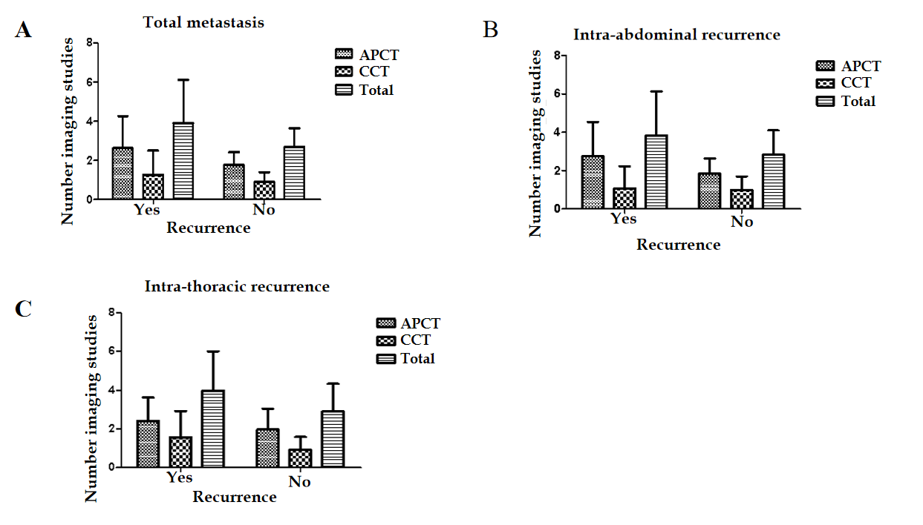
Figure 1 Number of imaging studies during surveillance period based on the development of recurrence. A: Mean number of abdomino-pelvic computed tomography (APCT) and chest computed tomography (CCT) studies were higher in the recurrence group (APCT, 2.63 ± 1.64 vs 1.77 ± 0.66; CCT, 1.27 ± 1.24 vs 0.91 ± 0.49; P < 0.001, each); B: In patients with intra-abdominal recurrence, mean number of APCT studies were higher in the recurrence group (APCT, 2.75 ± 1.79 vs 1.85 ± 0.79, P < 0.001; CCT, 1.09 ± 1.13 vs 1.00 ± 0.71, P = 0.060); C: In patients with intra-thoracic recurrence, mean number of APCT and CCT studies were higher in the recurrence group (APCT, 2.41 ± 1.21 vs 1.97 ± 1.09; CCT, 1.58 ± 1.34 vs 0.93 ± 0.66; P < 0.001, each). APCT: Abdomino-pelvic computed tomography; CCT: Chest computed tomography.

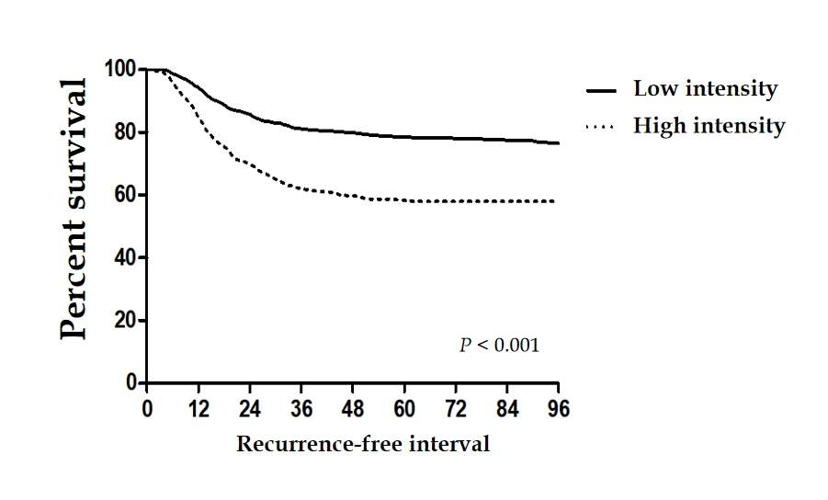
Figure 2 Kaplan–Meier analyses of recurrence-free interval according to surveillance intensity. Recurrence-free interval was significantly longer in low intensity group.

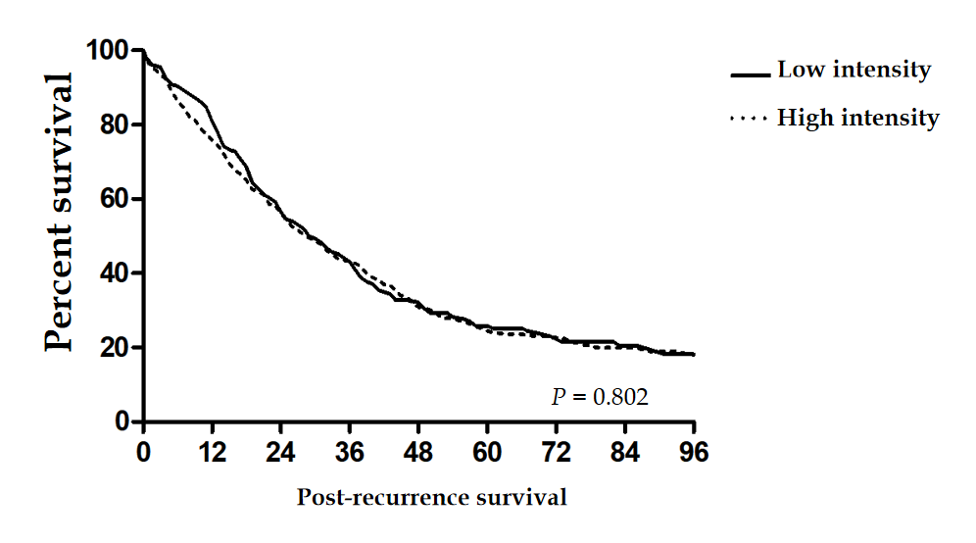
Figure 3 Kaplan–Meier analyses of post-recurrence survival according to surveillance intensity. Surveillance intensity did not show difference in post-recurrence survival.

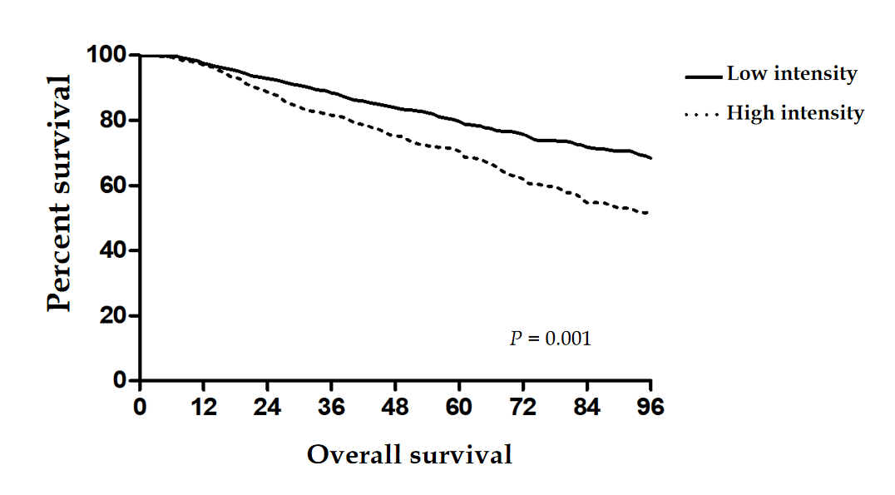
Figure 4 Kaplan–Meier analyses of overall survival according to surveillance intensity. High intensity group had lower overall survival rate than low intensity group.

Table 1 Demographic and clinical characteristics of participants according to surveillance intensity (n = 1888)
Variables | Surveillance intensity |  | P value
 | Lower intensity (n = 1024) | Higher intensity (n = 864)
Age, mean (IQR) | 60.0 (52.0–68.0) | 58.0 (50.3–67.0) | 0.178
Gender, n (%) |  |  | 0.502
Male | 607 (59.3) | 528 (61.1)
Female | 417 (40.7) | 336 (38.9)
Cancer site, n (%) |  |  | 0.795
Colon | 365 (35.6) | 303 (35.1)
Rectum | 659 (64.4) | 561 (64.9)
Differentiation, n (%) |  |  | 0.027
WD/MD | 945 (92.3) | 781 (90.4)
PD/SRC/MUC | 72 (7.0) | 82 (9.5)
Unknown | 7 (0.7) | 1 (0.1)
Total lymph nodes, n (%) |  |  | 0.001
< 12 | 129 (12.6) | 49 (5.7)
≥ 12 | 895 (87.4) | 815 (94.3)
(y) pT, n (%) |  |  | 0.002
0 | 12 (1.2) | 6 (0.7)
1 | 66 (6.4) | 36 (4.2)
2 | 126 (12.3) | 89 (10.3)
3 | 770 (75.2) | 660 (76.4)
4 | 50 (4.9) | 73 (8.4)
(y) pN, n (%) |  |  | 0.010
1c | 14 (1.4) | 8 (0.9)
1 | 735 (71.8) | 570 (66.0)
2 | 275 (26.8) | 286 (33.1)
Perineural invasion, n (%) | 219 (21.4) | 262 (30.3) | < 0.001
Lymphovascular invasion, n (%) | 371 (36.2) | 344 (39.8) | 0.110
Resection margin, n (%) |  |  | 0.004
Positive | 18 (1.7) | 41 (4.7)
Unknown | 7 (0.7) | 8 (0.9)
APCT, mean ± SD | 1.49 ± 0.47 | 2.67 ± 1.31 | < 0.001
CCT, mean ± SD | 0.62 ± 0.41 | 1.48 ± 0.91 | < 0.001
Total imaging studies, mean ± SD | 2.11 ± 0.58 | 4.14 ± 1.64 | < 0.001
IQR: Inter-quartile range; WD: Well differentiated; MD: Moderately differentiated; PD: Poorly differentiated; SRC: Signet ring cell type; MUC: Mucinous carcinoma; APCT: Abdomino-pelvic computed tomography; SD: Standard deviation; CCT: Chest computed tomography.

Table 2 Factors affecting overall survival of participants
Factors | Univariate |  | Multivariate
 | OR (95%CI) | P value | OR (95%CI) | P value
Age (yr) | 1.027 (1.019–1.035) | < 0.001 | 1.031 (1.023–1.039) | < 0.001
Sex | 0.704 (0.592–0.836) | < 0.001 | 0.711 (0.598–0.845) | < 0.001
Surveillance intensity | 1.650 (1.400–1.945) | < 0.001 | 1.531 (1.295–1.808) | < 0.001
Differentiation
WD/MD | Ref. |  | Ref.
PD/SRC/MUC | 1.832 (1.424–2.356) | < 0.001 | 1.660 (1.285–2.143) | < 0.001
(y) pT stage
0–2 | Ref. |  | Ref.
3–4 | 1.937 (1.491–2.516) | < 0.001 | 1.461 (1.111–1.921) | 0.007
(y) pN stage
1c | Ref. |  | Ref.
1 | 5.136 (0.721–36.571) | 0.102 | 4.754 (0.667–33.906) | 0.12
2 | 9.322 (1.308–66.457) | 0.026 | 7.067 (0.988–50.556) | 0.051
Lymphovascular invasion | 1.607 (1.365–1.891) | < 0.001 | 1.256 (1.057–1.491) | 0.01
Perineural invasion | 1.818 (1.535–2.154) | < 0.001 | 1.466 (1.224–1.755) | < 0.001
Resection margin¹ | 1.972 (1.360–2.860) | < 0.001 | 1.603 (1.097–2.341) | 0.015
¹Resection margin indicated circumferential resection margin, and were calculated with rectal cancer patients. OR: Odds ratio; CI: Confidence interval; Ref: Reference; WD: Well differentiated; MD: Moderately differentiated; PD: Poorly differentiated; SRC: Signet ring cell type; MUC: Mucinous carcinoma.

Table 3 Factors affecting recurrence-free interval of participants
Factors | Univariate |  | Multivariate
 | OR (95%CI) | P value | OR (95%CI) | P value
Age (yr) | 0.995 (0.987–1.002) | 0.165 | 0.999 (0.991–1.006) | 0.715
Sex | 0.907 (0.765–1.076) | 0.262
Surveillance intensity | 2.218 (1.870–2.632) | < 0.001 | 1.999 (1.680–2.377) | < 0.001
Differentiation
WD/MD | Ref. |  | Ref.
PD/SRC/MUC | 1.507 (1.151–1.974) | 0.003 | 1.287 (0.979–1.694) | 0.071
(y) pT stage
0–2 | Ref. |  | Ref.
3–4 | 2.118 (1.610–2.785) | < 0.001 | 1.596 (1.197–2.127) | 0.001
(y) pN stage
1c | Ref. |  | Ref.
1 | 2.737 (0.682–10.989) | 0.156 | 2.501 (0.621–10.063) | 0.197
2 | 5.260 (1.308–21.156) | 0.019 | 3.813 (0.943–15.413) | 0.060
Lymphovascular invasion | 1.460 (1.236–1.724) | < 0.001 | 1.143 (0.957–1.364) | 0.140
Perineural invasion | 1.949 (1.641–2.313) | < 0.001 | 1.431 (1.192–1.719) | < 0.001
Resection margin¹ | 2.192 (1.529–3.144) | < 0.001 | 1.565 (1.083–2.262) | 0.017
¹Resection margin indicated circumferential resection margin, and were calculated with rectal cancer patients. OR: Odds ratio; CI: Confidence interval; Ref: Reference; WD: Well differentiated; MD: Moderately differentiated; PD: Poorly differentiated; SRC: Signet ring cell type; MUC: Mucinous carcinoma.

Table 4 Factors affecting post-recurrence survival of participants
Factors | Univariate |  | Multivariate
 | OR (95%CI) | P value | OR (95%CI) | P value
Age (yr) | 1.015 (1.007–1.024) | < 0.001 | 1.015 (1.006–1.024) | 0.001
Sex | 0.824 (0.676–1.004) | 0.054 | 0.842 (0.688–1.032) | 0.098
Image intensity | 0.971 (0.799–1.179) | 0.767
Differentiation
WD/MD | Ref. |  | Ref.
PD/SRC/MUC | 2.632 (1.779–3.137) | < 0.001 | 2.072 (1.553–2.766) | < 0.001
(y) pT stage
0–2 | Ref.
3–4 | 1.146 (0.833–1.576) | 0.401
(y) pN stage
1c | Ref.
1 | 2.139 (0.300–15.256) | 0.448
2 | 3.363 (0.471–24.009) | 0.226
Lymphovascular invasion | 1.456 (1.204–1.760) | < 0.001 | 1.152 (0.940–1.412) | 0.174
Perineural invasion | 1.384 (1.141–1.677) | 0.001 | 1.284 (1.045–1.579) | 0.018
Resection margin¹ | 1.416 (0.966–2.075) | 0.075 | 1.266 (0.856–1.871) | 0.237
Curative resection | 0.296 (0.229–0.381) | < 0.001 | 0.331 (0.255–0.428) | < 0.001
¹Resection margin indicated circumferential resection margin, and were calculated with rectal cancer patients. OR: Odds ratio; CI: Confidence interval; Ref: Reference; WD: Well differentiated; MD: Moderately differentiated; PD: Poorly differentiated; SRC: Signet ring cell type; MUC: Mucinous carcinoma.

Published by Baishideng Publishing Group Inc
7041 Koll Center Parkway, Suite 160, Pleasanton, CA 94566, USA
Telephone: +1-925-3991568
E-mail: bpgoffice@wjgnet.com
Help Desk: https://www.f6publishing.com/helpdesk
https://www.wjgnet.com

© 2021 Baishideng Publishing Group Inc. All rights reserved.

