Name of Journal: World Journal of Gastroenterology
Manuscript NO: 79222
Manuscript Type: MINIREVIEWS

Current opinion on the regulation of small intestinal magnesium absorption

Chamniansawat S et al. Small intestinal magnesium absorption

Siriporn Chamniansawat, Nasisorn Suksridechacin, Narongrit Thongon

Siriporn Chamniansawat, Division of Anatomy, Department of Medical Sciences, Faculty of Allied Health Sciences, Burapha University, Muang 20131, Chonburi, Thailand

Nasisorn Suksridechacin, Biodiversity Research Centre, Thailand Institute of Scientific and Technological Research, Khlong Luang 12120, Pathum Thani, Thailand

Narongrit Thongon, Division of Physiology, Department of Medical Sciences, Faculty of Allied Health Sciences, Burapha University, Muang 20131, Chonburi, Thailand

Author contributions: Chamniansawat S wrote the manuscript; Suksridechacin N wrote the manuscript; Thongon N wrote and edited the manuscript.

Corresponding author: Narongrit Thongon, PhD, Associate Professor, Division of Physiology, Department of Medical Sciences, Faculty of Allied Health Sciences, Burapha University, 169 Long-Hard Bangsaen Road, Saensook, Muang 20131, Chonburi, Thailand. narongritt@buu.ac.th

Received: August 10, 2022
Revised: October 25, 2022
Accepted: November 18, 2022
Published online:

Abstract
Magnesium (Mg²⁺) has an important role in numerous biological functions, and Mg²⁺ deficiency is associated with several diseases. Therefore, adequate intestinal absorption of Mg²⁺ is vital for health. The small intestine was previously thought to absorb digested Mg²⁺ exclusively through an unregulated paracellular mechanism, which is responsible for approximately 90% of total Mg²⁺ absorption. Recent studies, however, have revealed that the duodenum, jejunum, and ileum absorb Mg²⁺ through both transcellular and paracellular routes. Several regulatory factors of small intestinal Mg²⁺ uptake also have been explored, e.g., parathyroid hormone, fibroblast growth factor-23, apical acidity, proton pump inhibitor, and pH-sensing channel and receptors. The mechanistic factors underlying proton pump inhibitor suppression of small intestinal Mg²⁺, such as magnesiotropic protein dysfunction, higher mucosal bicarbonate secretion, Paneth cell dysfunction, and intestinal inflammation, are currently being explored. The potential role of small intestinal microbiomes in Mg²⁺ absorption has also been proposed. In this article, we reviewed the current knowledge on the mechanisms and regulatory factors of small intestinal Mg²⁺ absorption.

Key Words: Hormone; Magnesium absorption; Paneth cells; Proton pump inhibitor; Regulation; Small intestine

Chamniansawat S, Suksridechacin N, Thongon N. Current opinion on the regulation of small intestinal magnesium absorption. World J Gastroenterol 2022; In press

Core Tip: Small intestinal epithelium absorbs digested magnesium (Mg²⁺) through both transcellular active and paracellular passive mechanisms. Several regulatory factors of small intestinal Mg²⁺ uptake have been reported. Parathyroid hormone and fibroblast growth factor-23 directly inhibit transcellular Mg²⁺ absorption in the duodenum, jejunum, and ileum. The apical proton triggers acid-sensing ion-channel 1a and purinergic P2Y₂ receptor activities, which stimulates mucosal bicarbonate secretion and induces MgCO₃ precipitation to suppress absorption. Omeprazole suppresses Mg²⁺ absorption in the duodenum, jejunum, and ileum.

INTRODUCTION
Magnesium (Mg²⁺) has an essential role in numerous cellular biochemical functions ranging from DNA structure stability and repairing, cell proliferation, neuronal excitability, bronchodilatation, vasodilatation, muscle contraction, myocardial excitability, bone hydroxyapatite formation, and anti-inflammatory function to exocrine and endocrine function of the pancreas^{[1]}. Mg²⁺ deficiency has been implicated in several diseases, such as Alzheimer’s disease^{[2]}, osteoporosis^{[3]}, hypertension^{[4]}, diabetes mellitus^{[5]}, and cancer^{[6]}. Therefore, its plasma level is tightly regulated within a narrow range (0.7–1.1 mmol/L) by the collaborative actions of intestinally digested Mg²⁺ absorption, bone and muscle Mg²⁺ storage, and excess renal Mg²⁺ excretion^{[1]}. The mechanism underlying regulation of transepithelial Mg²⁺ transport has been extensively explored in the renal tubular epithelium^{[1]}. However, few research articles on the mechanism and regulatory factors of intestinal Mg²⁺ absorption have been published.
Since dietary intake is the sole source of Mg²⁺ in humans, adequate intestinal absorption of Mg²⁺ is vital for normal Mg²⁺ balance. It was previously hypothesized that bulk Mg²⁺ uptake occurs in the small intestine through an unregulated paracellular pathway, whereas fine-tuning of colonic Mg²⁺ absorption occurs through a regulated transcellular mechanism^{[1,7,8]}. Colonic Mg²⁺ absorption can be modulated by dietary Mg²⁺ content and inulin fibers^{[7,9]} but not by hormones^{[1,7]}. In contrast, recent studies have provided new insights into the mechanisms and modulatory factors of small intestinal Mg²⁺ uptake. The aim of this article was to review the current knowledge of the mechanisms and regulatory factors of small intestinal Mg²⁺ absorption.

Mechanism of small intestinal Mg²⁺ absorption
The mechanism of small intestinal Mg²⁺ absorption is currently under debate. One research group has proposed that transient receptor potential melastatin 6 homodimer channel (TRPM6) mRNA expression and transcellular Mg²⁺ absorption were not present in the small intestine^{[1,7,8]}. However, a study from the same group showed positive immunofluorescence staining of TRPM6 protein in the absorptive cells along the brush border membrane of the villi in the duodenum^{[10]}. Another group has proposed that the small intestinal epithelium absorbs Mg²⁺ through transcellular active and paracellular passive transport mechanisms^{[11-13]}. In an Ussing chamber study, transport of transcellular and paracellular Mg²⁺ was detected in the duodenum, jejunum, and ileum^{[11-13]}. The proposed mechanism of small intestinal Mg²⁺ absorption is shown in Figure 1.

Transcellular Mg²⁺ absorption
Transcellular Mg²⁺ absorption occurs through mucosal Mg²⁺ uptake by TRPM6 and TRPM7 homodimer channel, both of which were markedly detected in the small intestinal epithelium of human and murine cells^{[10-14]}. In addition, recent mass spectrometric peptide sequence analysis confirmed the expression of TRPM6 and TRPM7 in the duodenum and jejunum^{[15]}. The channel activities of both homodimers of TRPM6 and of TRPM7 are negatively regulated by physiological Mg·ATP and Mg²⁺ levels^{[10,16-19]}. A recent study reported the expression of a heterodimer TRPM6/7 channel in the plasma membrane of duodenal and jejunal epithelium^{[15]}; therefore, Mg²⁺ enters the small intestinal epithelial cells through TRPM6/7, TRMP6, and TRPM7. However, the heterodimer TRPM6/7 channels do not respond to physiological intracellular Mg²⁺ and Mg·ATP^{[17,19]}; thus, continuous epithelial Mg²⁺ absorption can occur through the TRPM6/7 channel, regardless of intracellular Mg²⁺ and concentrations. Basolateral Mg²⁺ extrusion from the small intestinal epithelium occurs through cystathionine β-synthase domain divalent metal cation transport mediator 4^{[11-13,20]} by means of a sodium (Na⁺) gradient-dependent secondary active transport^{[20]}. However, mutation of cystathionine β-synthase domain divalent metal cation transport mediator 4 does not affect the plasma concentration in humans^{[21,22]}, suggesting that other Mg²⁺ extrusion mechanisms probably occur.

Paracellular Mg²⁺ absorption
It has been suggested that paracellular Mg²⁺ absorption is responsible for 90% of total intestinal Mg²⁺ uptake^{[23]}. Paracellular permeability is regulated by the paracellular claudin (Cldn) channel of the tight junction^{[24]}. In 1999, the first discovery of a paracellular channel at the tight junction was Cldn-19 or paracellin-1, which form a paracellular Mg²⁺ channel^{[25]}. It is thought that paracellular Mg²⁺ channels in epithelial tissues are formed by Cldn-16 and -19^{[25-27]}; mutations in these genes lead to severe hypomagnesemia. The small intestinal epithelium expresses Cldn-1–5, -7, -8, -12, and -15 but not -16 and -19^{[28,29]}. A previous study proposed that Cldn-7 and -12 modulated intestinal paracellular Mg²⁺ absorption^{[30]}. However, the processes involving Cldn-regulated paracellular Mg²⁺ absorption in the small intestine still must be elucidated.

Regulatory factors of small intestinal Mg²⁺ absorption
Hormones
In general, hormones mainly modulate the transcellular electrolyte transport to regulate epithelial electrolyte absorption or secretion. Hormonal regulation of small intestinal Mg²⁺ absorption also modulates transcellular Mg²⁺ absorption. A recent study reported that parathyroid hormone (PTH) and fibroblast growth factor-23 (FGF-23) systemically and directly inhibited transcellular, but not paracellular, Mg²⁺ absorption in the duodenum, jejunum, and ileum^{[13]}. There was no additional effect of PTH and FGF-23, suggesting that they acted through the same intracellular signaling molecule. Both PTH and FGF-23 activate their corresponding receptors that further stimulate the same protein kinase C pathway to suppress plasma membrane-associated TRPM6 expression (Figure 2). Since native TRPM6 primarily functions as a subunit of heteromeric TRPM6/7 channels^{[31]}, the suppression of plasma membrane TRPM6 probably suppresses plasma TRPM6/7 heterodimer expression. The suppression of plasma TRPM6 and TRPM6/7 activity leads to diminution of transcellular Mg²⁺ absorption^{[13]}. The inhibitory effect of PTH and FGF-23 could be nullified by Gö 6850^{[13]}, which inhibits the conventional (α, β1, β2, and γ) and novel (δ and ε) protein kinase C isoforms. However, the exact signaling pathway of PTH and FGF-23 inhibition of small intestinal transcellular Mg²⁺ absorption requires further study.
The proposed physiologically relevant magnesiotropic actions of PTH and FGF-23 are shown in Figure 3. During hypocalcemia, the parathyroid gland actively secretes PTH into the blood stream. PTH stimulates the bone resorption process, which increases plasma calcium (Ca²⁺), inorganic phosphate (Pi), and Mg²⁺ levels^{[32,33]}. PTH stimulates renal 1,25-dihydroxy vitamin D₃ [1,25(OH)₂D₃] production, which subsequently induces small intestinal Ca²⁺ absorption^{[34]}. PTH also activates renal tubular Ca²⁺ and Mg²⁺ reabsorption^{[32]}. Plasma Pi and PTH trigger bone-derived FGF-23 release, which acts as a negative feedback regulator to abolish 1,25(OH)₂D₃-induced intestinal Ca²⁺ absorption^{[33]}. PTH and FGF-23 synergistically suppress the small intestinal absorption of dietary Mg^{2+[13]} to prevent hypermagnesemia. PTH and FGF-23 downregulate the Na²⁺-dependent Pi cotransporters, (NaPi)-IIa and NaPi-IIc, and increase urinary Pi excretion^{[32]} to prevent hyperphosphatemia. Therefore, PTH and FGF-23 exert their calcemic effect by preventing hyperphosphatemia and hypermagnesemia.

Luminal acidity
The hypothesis that apical acidity and mucosal bicarbonate secretion (MBS) affect luminal Mg²⁺ solubility and intestinal Mg²⁺ absorption was previously proposed in 2014^{[11,35]}, which was confirmed in a recent review article^{[36]}. The luminal acidity along the entire human and rodent small bowel varies from pH 5.0–7.3^{[12,37]}. The luminal protons provide an appropriate environment for mineral absorption by stabilizing their ionized forms^{[38]}. The elevation of luminal pH led to a lower soluble Mg²⁺, which decreased from 79.61% of total luminal Mg content at pH 5.15% to 8.71% of total luminal Mg at pH 7.8^{[39]}. Therefore, luminal acidity enhances Mg²⁺ absorption in the human small intestine^{[40]} and epithelial-like Caco-2 monolayers^{[30,35]}. The MBS and luminal pH elevation diminished duodenal, jejunal, and ileal Mg²⁺ absorption^{[11,12]}.

pH-sensing channel and receptor
Small intestinal enterocytes are regularly exposed to strong gastric acid. When luminal protons are present in the duodenal lumen, the intestinal epithelium cells can directly detect and modulate their cellular response through the proton-sensing channels, e.g., the acid-sensing ion-channel 1a (ASIC1a) or proton-sensing receptors, such as ovarian cancer G protein-coupled receptor 1 (OGR1) and P2Y₂ purinoceptor^{[41-44]}.
OGR1, also known as GPR68, is expressed in the human small intestine, spleen, testes, brain, lungs, placenta, heart, and kidneys but not in the colon^{[44]}. OGR1 is a proton-sensitive receptor with pH values at half activation (pH_{0.5}) and full activation of 7.2 and 6.8, respectively^{[45-47]}. When the luminal pH decreases to 6.5, OGR1 activity is inactivated^{[45]}. Activation of OGR1 triggers the phospholipase C–protein kinase C signaling pathway to activate intestinal Mg²⁺ absorption^{[35]} (Figure 4).
ASIC1a is a proton-sensitive Ca²⁺ channel with a pH_{0.5} of 6.2^{[41,43]}. Activation of ASIC1a activates intracellular Ca²⁺ signaling and subsequently induces MBS. In the intestinal epithelium, luminal proton stimulates ASIC1a activity that further activates MBS in a Ca²⁺ signaling-cystic fibrosis transmembrane conductance regulator-dependent mechanism^{[35]} (Figure 4). Secreted bicarbonate has previously been found to reduce luminal protons^{[48]} and induce precipitation of luminal free Mg^{2+[49]}, thus reducing free soluble Mg²⁺ and suppressing intestinal Mg²⁺ absorption.
Purinergic regulation of luminal pH and electrolyte transport in the small intestine have been described^{[50-52]}. Duodenocytes regularly secrete ATP into its lumen. If luminal pH is low, luminal alkaline phosphatase activity is diminished and luminal ATP increases, which subsequently activates P2Y₂ purinoceptor. Simultaneously, P2Y₂ is a proton-sensitive receptor that is activated by luminal protons^{[42]}. Active P2Y₂ purinoceptors further activate MBS to increase luminal pH. A previous study showed that P2Y₂ activation induced MBS through a cystic fibrosis transmembrane conductance regulator- and Na⁺-HCO₃⁻ cotransporter-1-dependent mechanism, which subsequently suppressed intestinal Mg²⁺ absorption^{[53]} (Figure 5).

Proton pump inhibitor
Proton pump inhibitor (PPI)-induced hypomagnesemia (PPIH) and hypomagnesuria in humans have been reported since 2006^{[54-57]}. Intravenous Mg²⁺ supplementation or withdrawal of the PPI was able to rapidly normalize plasma and urinary Mg²⁺ levels in PPIH patients, though oral Mg²⁺ supplementation could not. Clinical assessments have reported that PPIH patients had normal renal Mg²⁺ handling^{[54,56,57]}. These findings suggest that PPIs could suppress intestinal Mg²⁺ absorption. Our group has extensively studied the underlying mechanisms of PPI-suppressed intestinal Mg²⁺ absorption for a decade^{[11,12,15,30,35,53,58,59]}. Our results suggest that PPIs mainly suppressed small intestinal Mg²⁺ absorption.
Omeprazole, the first introduced PPI, significantly suppressed total, transcellular, and paracellular Mg²⁺ absorption in the duodenum, jejunum, ilium, and colon of PPIH rats^{[11,12]}. Regarding the percent suppression of total Mg²⁺ absorption in the duodenum (81.86%), jejunum (70.59%), ileum (69.45%), and colon (39.25%), the small intestine is the segment most adversely affected by prolonged PPI administration. However, previous articles have proposed that PPIs mainly inhibit colonic Mg²⁺ absorption^{[36,60,61]}, but those study results remain controversial^{[60,61]}. They also proposed that colonic fermentation of dietary fibers probably increased serum Mg²⁺ and cured patients with PPIH^{[36]}. A previous study clearly showed that dietary inulin fibers significantly induced cecal and colonic fermentation, but not plasma Mg²⁺ levels, in control and PPIH mice^{[61]}. In contrast, dietary inulin fibers significantly induced renal Mg²⁺ excretion in PPIH mice^{[61]}, which should aggravate hypomagnesemia in PPIH. Therefore, the large intestine may not be a suitable intestinal segment that should be modulated to counteract PPIH.
The proposed mechanism of PPI-suppression of small intestinal Mg²⁺ absorption is shown in Figure 6. PPIs markedly suppress membranous TRPM7 and TRPM6/7^{[15]}. Membranous TRPM6-channel activity is suppressed by hyperphosphorylation at the T1851 residue and hyperoxidation at the M1755 residue^{[15]}. Phosphorylation of the T1851 residue of the TRPM6 protein induces TRPM6-channel suppression by intracellular free Mg²⁺ and activated 5 C-kinase 1^{[62]}. Oxidation of the M1755 residue in the TRPM6 protein also suppresses its channel permeability^{[63]}. Suppression of membranous TRPM6, TRPM7, and TRPM6/7 disrupts mucosal Mg²⁺ entry into the small intestinal epithelium and then inhibits transcellular Mg²⁺ absorption^{[11,12]}. Plasma FGF-23 was markedly increased in PPIH rats^{[12]}. The mechanism by which FGF-23 inhibits transcellular small intestinal Mg²⁺ absorption is described in the above section^{[13]}. Therefore, PPI-suppressed transcellular Mg²⁺ absorption is due, at least in part, to FGF-23.
PPIs suppress paracellular Mg²⁺ absorption (Figure 6). The small intestinal epithelium only expresses Cldn-1, -2, -3, -4, -5, -7, -8, -12, and -15^{[28,29]}. Overexpression of Cldn proteins and higher paracellular resistance have been demonstrated in the small intestines of PPIH rats^{[11,12]}. Paracellular tight junction width was significantly decreased in the small intestine of PPIH rats^{[58]}. PPIs also suppress epithelial paracellular Mg²⁺ permeability and cation selectivity^{[30,59]}. These results shed light on the mechanism of PPI-suppressed paracellular Mg²⁺ absorption in the small intestine.
PPI-induced small intestinal MBS (Figure 6) has been reported in humans^{[64]}, PPIH rats^{[11]}, and PPI-treated Caco-2 monolayers^{[35,53]}. PPIs have also been shown to significantly increase ASIC1a and P2Y₂ expression in PPI-treated epithelium^{[35,53]}. Active ASIC1a and P2Y₂ trigger MBS. Higher secreted bicarbonate in PPIH small intestines reduces free soluble Mg²⁺, which disrupts Mg²⁺ absorption (Figure 6). Inhibition of MBS significantly increases duodenal Mg²⁺ absorption in PPIH rats^{[11]}.
In addition to the change in magnesiotropic protein expression and function and MBS, PPIs have been shown to induce structural change in the absorptive epithelium of the small intestine^{[58]}. Prolonged PPI administration markedly decreased the villous length and absorptive area in the duodenal, jejunal, and ilial epithelium of PPIH rats. The underlying mechanism involves Paneth cell dysfunction in the small intestine^{[58]}. Paneth cells have an important role in host-microorganism homeostasis in the small intestine by providing antimicrobial -defensin peptides^{[65,66]}. Disruption of the secretory function of Paneth cells leads to infection and chronic inflammation of the small intestine^{[65,66]}. In PPIH rats, a reduction in secretory granules and metaplasia of Paneth cells occurs in the duodenum, jejunum, and ileum, suggesting Paneth cell secretory dysfunction^{[58]}. Chronic inflammation in the small intestinal epithelium leads to villous atrophy and reduction of the absorptive area in the small intestine of PPIH rats^{[58]}.

Gut microbiota
The potential role of gut microbiota in colonic Mg²⁺ absorption has previously been proposed^{[36]}. However, it is currently unknown how the small intestinal microbiome affects small intestinal Mg²⁺ absorption. Previous studies have shown that the small intestine is colonized by a complex gut microbiota community and is less numerous and diverse (approximately 10³–10⁷ microbial cells/gram) than in the colon (approximately 10¹² microbial cells/gram)^{[67]}. The dominant bacterial phyla in the small intestine are Streptococcus sp., Lactobacillaceae, and Enterobacteriaceae, whereas in the colon, the dominant phyla are Bacteroidaceae, Prevotellaceae, Rikenellaceae, Lachnospiraceae, and Ruminococcaceae^{[68,69]}. Prolonged PPI treatment can lead to gut microbiota dysbiosis, such as the reduction of Actinobacteria and Bifidobacteria spp., which are responsible for maintaining the mucosal barrier function^{[68]}.
Furthermore, long-term treatment with PPIs causes small intestinal bacterial overgrowth because of the loss of the gastric acid defensive barrier^{[70]}. The jejunal samples of small intestinal bacterial overgrowth patients regularly showed increased production of toxic agents, such as serum endotoxin and bacterial compounds that stimulate the secretion of proinflammatory cytokines^{[71]}. Apart from these findings, our previous study showed Paneth dysfunction and chronic inflammation in the small intestine of PPIH rats^{[58]}. From the perspective of relevant gut microbiota, Paneth cell defects have been found to be associated with increased Bacteroidetes and Enterococcus and decreased Bifidobacterium^{[72]}, whereas Bifidobacterium longum has been found to promote cell proliferation and expression of Lgr5 and Wnt3a in intestinal organoids and alleviate microbiota dysbiosis by regulating the functions of Paneth cells^{[73]}. It is also possible that the synthesis of gut microbiota metabolites could lead to changes in the absorptive surface in the gut and/or stimulate gene expression^{[74]}.
In the colon, bifidobacterial fermentation leads to acidification of the colon, which shows beneficial absorption of Mg^{2+[9,61,75]}. In humans, small intestinal microbiota can also ferment the available carbohydrates and induce intestinal acidification^{[76]}. In the human small intestine, a dominant bacterial phylum is Streptococcus sp.^{[77,78]}, which is an anaerobe that can ferment relatively simple carbohydrates at a high rate^{[79]}. According to the above, luminal acidity markedly induces small intestinal Mg²⁺ absorption. Therefore, small intestinal fermentation should induce small intestinal Mg²⁺ absorption.

CONCLUSION
Bulk absorption of digested Mg²⁺ occurs in the small intestine through transcellular active and paracellular passive mechanisms. PTH, FGF-23, luminal protons, ASIC1a, OGR1, P2Y₂, PPIs, and the microbiome have recently been proposed as regulatory factors of small intestinal Mg²⁺ uptake. However, the regulatory mechanism of small intestinal Mg²⁺ requires additional extensive studies.

REFERENCES
1 de Baaij JH, Hoenderop JG, Bindels RJ. Magnesium in man: implications for health and disease. Physiol Rev 2015; 95: 1-46 [PMID: 25540137 DOI: 10.1152/physrev.00012.2014]
2 Yamanaka R, Shindo Y, Oka K. Magnesium Is a Key Player in Neuronal Maturation and Neuropathology. Int J Mol Sci 2019; 20 [PMID: 31336935 DOI: 10.3390/ijms20143439]
3 Rondanelli M, Faliva MA, Tartara A, Gasparri C, Perna S, Infantino V, Riva A, Petrangolini G, Peroni G. An update on magnesium and bone health. Biometals 2021; 34: 715-736 [PMID: 33959846 DOI: 10.1007/s10534-021-00305-0]
4 Dominguez L, Veronese N, Barbagallo M. Magnesium and Hypertension in Old Age. Nutrients 2020; 13 [PMID: 33396570 DOI: 10.3390/nu13010139]
5 Pelczyńska M, Moszak M, Bogdański P. The Role of Magnesium in the Pathogenesis of Metabolic Disorders. Nutrients 2022; 14 [PMID: 35565682 DOI: 10.3390/nu14091714]
6 Trapani V, Wolf FI. Dysregulation of Mg²⁺ homeostasis contributes to acquisition of cancer hallmarks. Cell Calcium 2019; 83: 102078 [PMID: 31493712 DOI: 10.1016/j.ceca.2019.102078]
7 Groenestege WM, Hoenderop JG, van den Heuvel L, Knoers N, Bindels RJ. The epithelial Mg2+ channel transient receptor potential melastatin 6 is regulated by dietary Mg2+ content and estrogens. J Am Soc Nephrol 2006; 17: 1035-1043 [PMID: 16524949 DOI: 10.1681/ASN.2005070700]
8 Lameris AL, Nevalainen PI, Reijnen D, Simons E, Eygensteyn J, Monnens L, Bindels RJ, Hoenderop JG. Segmental transport of Ca²⁺ and Mg²⁺ along the gastrointestinal tract. Am J Physiol Gastrointest Liver Physiol 2015; 308: G206-G216 [PMID: 25477372 DOI: 10.1152/ajpgi.00093.2014]
9 Coudray C, Demigné C, Rayssiguier Y. Effects of dietary fibers on magnesium absorption in animals and humans. J Nutr 2003; 133: 1-4 [PMID: 12514257 DOI: 10.1093/jn/133.1.1]
10 Voets T, Nilius B, Hoefs S, van der Kemp AW, Droogmans G, Bindels RJ, Hoenderop JG. TRPM6 forms the Mg2+ influx channel involved in intestinal and renal Mg2+ absorption. J Biol Chem 2004; 279: 19-25 [PMID: 14576148 DOI: 10.1074/jbc.M311201200]
11 Thongon N, Penguy J, Kulwong S, Khongmueang K, Thongma M. Omeprazole suppressed plasma magnesium level and duodenal magnesium absorption in male Sprague-Dawley rats. Pflugers Arch 2016; 468: 1809-1821 [PMID: 27866273 DOI: 10.1007/s00424-016-1905-7]
12 Suksridechacin N, Kulwong P, Chamniansawat S, Thongon N. Effect of prolonged omeprazole administration on segmental intestinal Mg²⁺ absorption in male Sprague-Dawley rats. World J Gastroenterol 2020; 26: 1142-1155 [PMID: 32231419 DOI: 10.3748/wjg.v26.i11.1142]
13 Suksridechacin N, Thongon N. Fibroblast growth factor-23 and parathyroid hormone suppress small intestinal magnesium absorption. Physiol Rep 2022; 10: e15247 [PMID: 35385223 DOI: 10.14814/phy2.15247]
14 Schlingmann KP, Weber S, Peters M, Niemann Nejsum L, Vitzthum H, Klingel K, Kratz M, Haddad E, Ristoff E, Dinour D, Syrrou M, Nielsen S, Sassen M, Waldegger S, Seyberth HW, Konrad M. Hypomagnesemia with secondary hypocalcemia is caused by mutations in TRPM6, a new member of the TRPM gene family. Nat Genet 2002; 31: 166-170 [PMID: 12032568 DOI: 10.1038/ng889]
15 Kampuang N, Thongon N. Mass spectrometric analysis of TRPM6 and TRPM7 from small intestine of omeprazole-induced hypomagnesemic rats. Front Oncol 2022; 12: 947899 [PMID: 36110961 DOI: 10.3389/fonc.2022.947899]
16 Chubanov V, Gudermann T. TRPM6. Handb Exp Pharmacol 2014; 222: 503-520 [PMID: 24756719 DOI: 10.1007/978-3-642-54215-2_20]
17 Zhang Z, Yu H, Huang J, Faouzi M, Schmitz C, Penner R, Fleig A. The TRPM6 kinase domain determines the Mg·ATP sensitivity of TRPM7/M6 heteromeric ion channels. J Biol Chem 2014; 289: 5217-5227 [PMID: 24385424 DOI: 10.1074/jbc.M113.512285]
18 Fleig A, Chubanov V. TRPM7. Handb Exp Pharmacol 2014; 222: 521-546 [PMID: 24756720 DOI: 10.1007/978-3-642-54215-2_21]
19 Penner R, Fleig A. The Mg2+ and Mg(2+)-nucleotide-regulated channel-kinase TRPM7. Handb Exp Pharmacol 2007: 313-328 [PMID: 17217066 DOI: 10.1007/978-3-540-34891-7_19]
20 Yamazaki D, Funato Y, Miura J, Sato S, Toyosawa S, Furutani K, Kurachi Y, Omori Y, Furukawa T, Tsuda T, Kuwabata S, Mizukami S, Kikuchi K, Miki H. Basolateral Mg2+ extrusion via CNNM4 mediates transcellular Mg2+ transport across epithelia: a mouse model. PLoS Genet 2013; 9: e1003983 [PMID: 24339795 DOI: 10.1371/journal.pgen.1003983]
21 Parry DA, Mighell AJ, El-Sayed W, Shore RC, Jalili IK, Dollfus H, Bloch-Zupan A, Carlos R, Carr IM, Downey LM, Blain KM, Mansfield DC, Shahrabi M, Heidari M, Aref P, Abbasi M, Michaelides M, Moore AT, Kirkham J, Inglehearn CF. Mutations in CNNM4 cause Jalili syndrome, consisting of autosomal-recessive cone-rod dystrophy and amelogenesis imperfecta. Am J Hum Genet 2009; 84: 266-273 [PMID: 19200525 DOI: 10.1016/j.ajhg.2009.01.009]
22 Polok B, Escher P, Ambresin A, Chouery E, Bolay S, Meunier I, Nan F, Hamel C, Munier FL, Thilo B, Mégarbané A, Schorderet DF. Mutations in CNNM4 cause recessive cone-rod dystrophy with amelogenesis imperfecta. Am J Hum Genet 2009; 84: 259-265 [PMID: 19200527 DOI: 10.1016/j.ajhg.2009.01.006]
23 Quamme GA. Recent developments in intestinal magnesium absorption. Curr Opin Gastroenterol 2008; 24: 230-235 [PMID: 18301276 DOI: 10.1097/MOG.0b013e3282f37b59]
24 Meoli L, Günzel D. Channel functions of claudins in the organization of biological systems. Biochim Biophys Acta Biomembr 2020; 1862: 183344 [PMID: 32442419 DOI: 10.1016/j.bbamem.2020.183344]
25 Simon DB, Lu Y, Choate KA, Velazquez H, Al-Sabban E, Praga M, Casari G, Bettinelli A, Colussi G, Rodriguez-Soriano J, McCredie D, Milford D, Sanjad S, Lifton RP. Paracellin-1, a renal tight junction protein required for paracellular Mg2+ resorption. Science 1999; 285: 103-106 [PMID: 10390358 DOI: 10.1126/science.285.5424.103]
26 Konrad M, Schaller A, Seelow D, Pandey AV, Waldegger S, Lesslauer A, Vitzthum H, Suzuki Y, Luk JM, Becker C, Schlingmann KP, Schmid M, Rodriguez-Soriano J, Ariceta G, Cano F, Enriquez R, Juppner H, Bakkaloglu SA, Hediger MA, Gallati S, Neuhauss SC, Nurnberg P, Weber S. Mutations in the tight-junction gene claudin 19 (CLDN19) are associated with renal magnesium wasting, renal failure, and severe ocular involvement. Am J Hum Genet 2006; 79: 949-957 [PMID: 17033971 DOI: 10.1086/508617]
27 Hou J, Renigunta A, Gomes AS, Hou M, Paul DL, Waldegger S, Goodenough DA. Claudin-16 and claudin-19 interaction is required for their assembly into tight junctions and for renal reabsorption of magnesium. Proc Natl Acad Sci U S A 2009; 106: 15350-15355 [PMID: 19706394 DOI: 10.1073/pnas.0907724106]
28 Fujita H, Chiba H, Yokozaki H, Sakai N, Sugimoto K, Wada T, Kojima T, Yamashita T, Sawada N. Differential expression and subcellular localization of claudin-7, -8, -12, -13, and -15 along the mouse intestine. J Histochem Cytochem 2006; 54: 933-944 [PMID: 16651389 DOI: 10.1369/jhc.6A6944.2006]
29 Garcia-Hernandez V, Quiros M, Nusrat A. Intestinal epithelial claudins: expression and regulation in homeostasis and inflammation. Ann N Y Acad Sci 2017; 1397: 66-79 [PMID: 28493289 DOI: 10.1111/nyas.13360]
30 Thongon N, Krishnamra N. Apical acidity decreases inhibitory effect of omeprazole on Mg(2+) absorption and claudin-7 and -12 expression in Caco-2 monolayers. Exp Mol Med 2012; 44: 684-693 [PMID: 22940736 DOI: 10.3858/emm.2012.44.11.077]
31 Chubanov V, Ferioli S, Wisnowsky A, Simmons DG, Leitzinger C, Einer C, Jonas W, Shymkiv Y, Bartsch H, Braun A, Akdogan B, Mittermeier L, Sytik L, Torben F, Jurinovic V, van der Vorst EP, Weber C, Yildirim ÖA, Sotlar K, Schürmann A, Zierler S, Zischka H, Ryazanov AG, Gudermann T. Epithelial magnesium transport by TRPM6 is essential for prenatal development and adult survival. Elife 2016; 5 [PMID: 27991852 DOI: 10.7554/eLife.20914]
32 Leaf DE, Christov M. Dysregulated Mineral Metabolism in AKI. Semin Nephrol 2019; 39: 41-56 [PMID: 30606407 DOI: 10.1016/j.semnephrol.2018.10.004]
33 Zofková I, Kancheva RL. The relationship between magnesium and calciotropic hormones. Magnes Res 1995; 8: 77-84 [PMID: 7669510]
34 Khuituan P, Teerapornpuntakit J, Wongdee K, Suntornsaratoon P, Konthapakdee N, Sangsaksri J, Sripong C, Krishnamra N, Charoenphandhu N. Fibroblast growth factor-23 abolishes 1,25-dihydroxyvitamin D₃-enhanced duodenal calcium transport in male mice. Am J Physiol Endocrinol Metab 2012; 302: E903-E913 [PMID: 22275752 DOI: 10.1152/ajpendo.00620.2011]
35 Thongon N, Ketkeaw P, Nuekchob C. The roles of acid-sensing ion channel 1a and ovarian cancer G protein-coupled receptor 1 on passive Mg2+ transport across intestinal epithelium-like Caco-2 monolayers. J Physiol Sci 2014; 64: 129-139 [PMID: 24375028 DOI: 10.1007/s12576-013-0301-8]
36 Gommers LMM, Hoenderop JGJ, de Baaij JHF. Mechanisms of proton pump inhibitor-induced hypomagnesemia. Acta Physiol (Oxf) 2022; 235: e13846 [PMID: 35652564 DOI: 10.1111/apha.13846]
37 Nugent SG, Kumar D, Rampton DS, Evans DF. Intestinal luminal pH in inflammatory bowel disease: possible determinants and implications for therapy with aminosalicylates and other drugs. Gut 2001; 48: 571-577 [PMID: 11247905 DOI: 10.1136/gut.48.4.571]
38 Evenepoel P. Alteration in digestion and absorption of nutrients during profound acid suppression. Best Pract Res Clin Gastroenterol 2001; 15: 539-551 [PMID: 11403545 DOI: 10.1053/bega.2000.0197]
39 Ben-Ghedalia D, Tagari H, Zamwel S, Bondi A. Solubility and net exchange of calcium, magnesium and phosphorus in digesta flowing along the gut of the sheep. Br J Nutr 1975; 33: 87-94 [PMID: 234736 DOI: 10.1079/bjn19750011]
40 Heijnen AM, Brink EJ, Lemmens AG, Beynen AC. Ileal pH and apparent absorption of magnesium in rats fed on diets containing either lactose or lactulose. Br J Nutr 1993; 70: 747-756 [PMID: 8297913 DOI: 10.1079/bjn19930170]
41 Dong X, Ko KH, Chow J, Tuo B, Barrett KE, Dong H. Expression of acid-sensing ion channels in intestinal epithelial cells and their role in the regulation of duodenal mucosal bicarbonate secretion. Acta Physiol (Oxf) 2011; 201: 97-107 [PMID: 20969730 DOI: 10.1111/j.1748-1716.2010.02207.x]
42 Holzer P. Taste receptors in the gastrointestinal tract. V. Acid sensing in the gastrointestinal tract. Am J Physiol Gastrointest Liver Physiol 2007; 292: G699-G705 [PMID: 17122365 DOI: 10.1152/ajpgi.00517.2006]
43 Holzer P. Acid-sensitive ion channels and receptors. Handb Exp Pharmacol 2009: 283-332 [PMID: 19655111 DOI: 10.1007/978-3-540-79090-7_9]
44 Xu Y, Casey G. Identification of human OGR1, a novel G protein-coupled receptor that maps to chromosome 14. Genomics 1996; 35: 397-402 [PMID: 8661159 DOI: 10.1006/geno.1996.0377]
45 Ludwig MG, Vanek M, Guerini D, Gasser JA, Jones CE, Junker U, Hofstetter H, Wolf RM, Seuwen K. Proton-sensing G-protein-coupled receptors. Nature 2003; 425: 93-98 [PMID: 12955148 DOI: 10.1038/nature01905]
46 Seuwen K, Ludwig MG, Wolf RM. Receptors for protons or lipid messengers or both? J Recept Signal Transduct Res 2006; 26: 599-610 [PMID: 17118800 DOI: 10.1080/10799890600932220]
47 Mohebbi N, Benabbas C, Vidal S, Daryadel A, Bourgeois S, Velic A, Ludwig MG, Seuwen K, Wagner CA. The proton-activated G protein coupled receptor OGR1 acutely regulates the activity of epithelial proton transport proteins. Cell Physiol Biochem 2012; 29: 313-324 [PMID: 22508039 DOI: 10.1159/000338486]
48 Allen A, Flemström G. Gastroduodenal mucus bicarbonate barrier: protection against acid and pepsin. Am J Physiol Cell Physiol 2005; 288: C1-19 [PMID: 15591243 DOI: 10.1152/ajpcell.00102.2004]
49 Kurita Y, Nakada T, Kato A, Doi H, Mistry AC, Chang MH, Romero MF, Hirose S. Identification of intestinal bicarbonate transporters involved in formation of carbonate precipitates to stimulate water absorption in marine teleost fish. Am J Physiol Regul Integr Comp Physiol 2008; 294: R1402-R1412 [PMID: 18216137 DOI: 10.1152/ajpregu.00759.2007]
50 Akiba Y, Mizumori M, Guth PH, Engel E, Kaunitz JD. Duodenal brush border intestinal alkaline phosphatase activity affects bicarbonate secretion in rats. Am J Physiol Gastrointest Liver Physiol 2007; 293: G1223-G1233 [PMID: 17916646 DOI: 10.1152/ajpgi.00313.2007]
51 Dong X, Smoll EJ, Ko KH, Lee J, Chow JY, Kim HD, Insel PA, Dong H. P2Y receptors mediate Ca2+ signaling in duodenocytes and contribute to duodenal mucosal bicarbonate secretion. Am J Physiol Gastrointest Liver Physiol 2009; 296: G424-G432 [PMID: 19074643 DOI: 10.1152/ajpgi.90314.2008]
52 Kaunitz JD, Akiba Y. Purinergic regulation of duodenal surface pH and ATP concentration: implications for mucosal defence, lipid uptake and cystic fibrosis. Acta Physiol (Oxf) 2011; 201: 109-116 [PMID: 20560899 DOI: 10.1111/j.1748-1716.2010.02156.x]
53 Thongon N, Chamniansawat S. The inhibitory role of purinergic P2Y receptor on Mg²⁺ transport across intestinal epithelium-like Caco-2 monolayer. J Physiol Sci 2019; 69: 129-141 [PMID: 30032468 DOI: 10.1007/s12576-018-0628-2]
54 Epstein M, McGrath S, Law F. Proton-pump inhibitors and hypomagnesemic hypoparathyroidism. N Engl J Med 2006; 355: 1834-1836 [PMID: 17065651 DOI: 10.1056/NEJMc066308]
55 Broeren MA, Geerdink EA, Vader HL, van den Wall Bake AW. Hypomagnesemia induced by several proton-pump inhibitors. Ann Intern Med 2009; 151: 755-756 [PMID: 19920278 DOI: 10.7326/0003-4819-151-10-200911170-00016]
56 Cundy T, Dissanayake A. Severe hypomagnesaemia in long-term users of proton-pump inhibitors. Clin Endocrinol (Oxf) 2008; 69: 338-341 [PMID: 18221401 DOI: 10.1111/j.1365-2265.2008.03194.x]
57 Shabajee N, Lamb EJ, Sturgess I, Sumathipala RW. Omeprazole and refractory hypomagnesaemia. BMJ 2008; 337: a425 [PMID: 18617497 DOI: 10.1136/bmj.39505.738981.BE]
58 Chamniansawat S, Kampuang N, Suksridechacin N, Thongon N. Ultrastructural intestinal mucosa change after prolonged inhibition of gastric acid secretion by omeprazole in male rats. Anat Sci Int 2021; 96: 142-156 [PMID: 32931001 DOI: 10.1007/s12565-020-00572-w]
59 Thongon N, Krishnamra N. Omeprazole decreases magnesium transport across Caco-2 monolayers. World J Gastroenterol 2011; 17: 1574-1583 [PMID: 21472124 DOI: 10.3748/wjg.v17.i12.1574]
60 Lameris AL, Hess MW, van Kruijsbergen I, Hoenderop JG, Bindels RJ. Omeprazole enhances the colonic expression of the Mg(2+) transporter TRPM6. Pflugers Arch 2013; 465: 1613-1620 [PMID: 23756852 DOI: 10.1007/s00424-013-1306-0]
61 Hess MW, de Baaij JH, Gommers LM, Hoenderop JG, Bindels RJ. Dietary Inulin Fibers Prevent Proton-Pump Inhibitor (PPI)-Induced Hypocalcemia in Mice. PLoS One 2015; 10: e0138881 [PMID: 26397986 DOI: 10.1371/journal.pone.0138881]
62 Cao G, Thébault S, van der Wijst J, van der Kemp A, Lasonder E, Bindels RJ, Hoenderop JG. RACK1 inhibits TRPM6 activity via phosphorylation of the fused alpha-kinase domain. Curr Biol 2008; 18: 168-176 [PMID: 18258429 DOI: 10.1016/j.cub.2007.12.058]
63 Cao G, Lee KP, van der Wijst J, de Graaf M, van der Kemp A, Bindels RJ, Hoenderop JG. Methionine sulfoxide reductase B1 (MsrB1) recovers TRPM6 channel activity during oxidative stress. J Biol Chem 2010; 285: 26081-26087 [PMID: 20584906 DOI: 10.1074/jbc.M110.103655]
64 Mertz-Nielsen A, Hillingsø J, Bukhave K, Rask-Madsen J. Omeprazole promotes proximal duodenal mucosal bicarbonate secretion in humans. Gut 1996; 38: 6-10 [PMID: 8566861 DOI: 10.1136/gut.38.1.6]
65 Bevins CL, Salzman NH. Paneth cells, antimicrobial peptides and maintenance of intestinal homeostasis. Nat Rev Microbiol 2011; 9: 356-368 [PMID: 21423246 DOI: 10.1038/nrmicro2546]
66 Lueschow SR, McElroy SJ. The Paneth Cell: The Curator and Defender of the Immature Small Intestine. Front Immunol 2020; 11: 587 [PMID: 32308658 DOI: 10.3389/fimmu.2020.00587]
67 El Aidy S, Merrifield CA, Derrien M, van Baarlen P, Hooiveld G, Levenez F, Doré J, Dekker J, Holmes E, Claus SP, Reijngoud DJ, Kleerebezem M. The gut microbiota elicits a profound metabolic reorientation in the mouse jejunal mucosa during conventionalisation. Gut 2013; 62: 1306-1314 [PMID: 22722618 DOI: 10.1136/gutjnl-2011-301955]
68 Bruno G, Zaccari P, Rocco G, Scalese G, Panetta C, Porowska B, Pontone S, Severi C. Proton pump inhibitors and dysbiosis: Current knowledge and aspects to be clarified. World J Gastroenterol 2019; 25: 2706-2719 [PMID: 31235994 DOI: 10.3748/wjg.v25.i22.2706]
69 Donaldson GP, Lee SM, Mazmanian SK. Gut biogeography of the bacterial microbiota. Nat Rev Microbiol 2016; 14: 20-32 [PMID: 26499895 DOI: 10.1038/nrmicro3552]
70 Fujimori S. What are the effects of proton pump inhibitors on the small intestine? World J Gastroenterol 2015; 21: 6817-6819 [PMID: 26078557 DOI: 10.3748/wjg.v21.i22.6817]
71 Bures J, Cyrany J, Kohoutova D, Förstl M, Rejchrt S, Kvetina J, Vorisek V, Kopacova M. Small intestinal bacterial overgrowth syndrome. World J Gastroenterol 2010; 16: 2978-2990 [PMID: 20572300 DOI: 10.3748/wjg.v16.i24.2978]
72 Riba A, Olier M, Lacroix-Lamandé S, Lencina C, Bacquié V, Harkat C, Gillet M, Baron M, Sommer C, Mallet V, Salvador-Cartier C, Laurent F, Théodorou V, Ménard S. Paneth Cell Defects Induce Microbiota Dysbiosis in Mice and Promote Visceral Hypersensitivity. Gastroenterology 2017; 153: 1594-1606.e2 [PMID: 28865734 DOI: 10.1053/j.gastro.2017.08.044]
73 Zhou C, Fang X, Xu J, Gao J, Zhang L, Zhao J, Meng Y, Zhou W, Han X, Bai Y, Li Z, Zou D. Bifidobacterium longum alleviates irritable bowel syndrome-related visceral hypersensitivity and microbiota dysbiosis via Paneth cell regulation. Gut Microbes 2020; 12: 1782156 [PMID: 32584650 DOI: 10.1080/19490976.2020.1782156]
74 Cashman K. Prebiotics and calcium bioavailability. Curr Issues Intest Microbiol 2003; 4: 21-32 [PMID: 12691259]
75 Schuchardt JP, Hahn A. Intestinal Absorption and Factors Influencing Bioavailability of Magnesium-An Update. Curr Nutr Food Sci 2017; 13: 260-278 [PMID: 29123461 DOI: 10.2174/1573401313666170427162740]
76 Zoetendal EG, Raes J, van den Bogert B, Arumugam M, Booijink CC, Troost FJ, Bork P, Wels M, de Vos WM, Kleerebezem M. The human small intestinal microbiota is driven by rapid uptake and conversion of simple carbohydrates. ISME J 2012; 6: 1415-1426 [PMID: 22258098 DOI: 10.1038/ismej.2011.212]
77 Booijink CC, El-Aidy S, Rajilić-Stojanović M, Heilig HG, Troost FJ, Smidt H, Kleerebezem M, De Vos WM, Zoetendal EG. High temporal and inter-individual variation detected in the human ileal microbiota. Environ Microbiol 2010; 12: 3213-3227 [PMID: 20626454 DOI: 10.1111/j.1462-2920.2010.02294.x]
78 Hayashi H, Takahashi R, Nishi T, Sakamoto M, Benno Y. Molecular analysis of jejunal, ileal, caecal and recto-sigmoidal human colonic microbiota using 16S rRNA gene libraries and terminal restriction fragment length polymorphism. J Med Microbiol 2005; 54: 1093-1101 [PMID: 16192442 DOI: 10.1099/jmm.0.45935-0]
79 Holt JG. Genus Streptococcus In: Bergy DH, Holt JG, Krieg NR, Sneath PH (eds). Bergey’s Manual of Determinative Bacteriology. Lippincott Williams & Wilkins: Baltimore, MD, 1994: 523

Footnotes
Conflict-of-interest statement: All authors report no relevant conflicts of interest for this article.

Open-Access: This article is an open-access article that was selected by an in-house editor and fully peer-reviewed by external reviewers. It is distributed in accordance with the Creative Commons Attribution NonCommercial (CC BY-NC 4.0) license, which permits others to distribute, remix, adapt, build upon this work non-commercially, and license their derivative works on different terms, provided the original work is properly cited and the use is non-commercial. See: https://creativecommons.org/Licenses/by-nc/4.0/

Provenance and peer review: Invited article; Externally peer reviewed.
Peer-review model: Single blind

Corresponding Author’s Membership in Professional Societies: The Physiological Society of Thailand, No. 376.

Peer-review started: August 10, 2022
First decision: October 20, 2022
Article in press:

Specialty type: Gastroenterology and hepatology
Country/Territory of origin: Thailand
Peer-review report’s scientific quality classification
Grade A (Excellent): 0
Grade B (Very good): B
Grade C (Good): C
Grade D (Fair): 0
Grade E (Poor): 0

P-Reviewer: Tuo BG, China; Wu LH, China S-Editor: Fan JR L-Editor: Filipodia P-Editor: Fan JR

Figure Legends
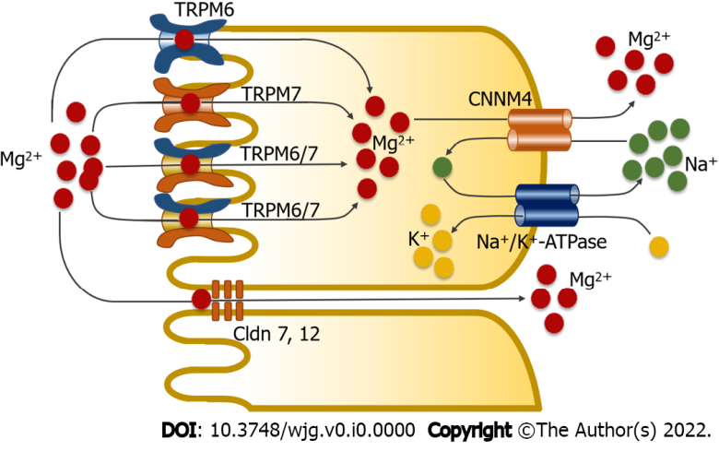
Figure 1 Magnesium absorption in the small intestine through two absorption pathways. The transcellular transport mechanism involves magnesium (Mg²⁺) influx into enterocytes through the transient receptor potential melastatin 6 homodimer channel (TRPM6), transient receptor potential melastatin 7 homodimer channel (TRPM7), and transient receptor potential melastatin 6/7 heterodimer channel (TRPM6/7). Cystathionine β-synthase domain divalent metal cation transport mediator 4 (CNNM4) mediates basolateral Mg²⁺ extrusion by means of secondary active transport. In the paracellular mechanism, Mg²⁺ moves through tight-associated paracellular pores of Claudin 7 (Cldn 7) and Claudin 12 (Cldn 12).

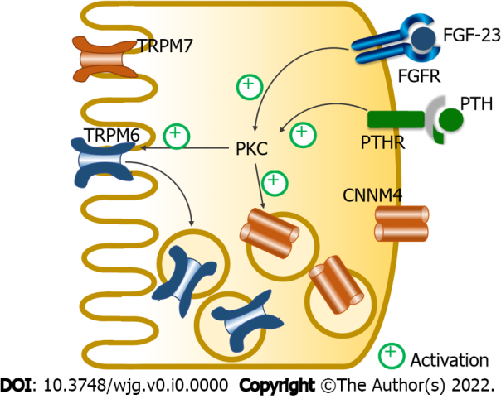
Figure 2 Fibroblast growth factor-23 and parathyroid hormone regulate magnesium absorption in the small intestine. Fibroblast growth factor-23 (FGF-23) and parathyroid hormone (PTH) act through their corresponding receptors to suppress magnesium absorption in the protein kinase C (PKC)-dependent pathway; they suppressed membrane transient receptor potential melastatin 6 homodimer channel (TRPM6) expression, which leads to the suppression of membrane transient receptor potential melastatin 6/7 (TRPM6/7) expression. FGF-23 and PTH also increase cytosolic cystathionine β-synthase domain divalent metal cation transport mediator 4 (CNNM4) expression. TRPM7: Transient receptor potential melastatin 7 homodimer channel; FGFR: Fibroblast growth factor receptor; PTHR: Parathyroid hormone receptor.

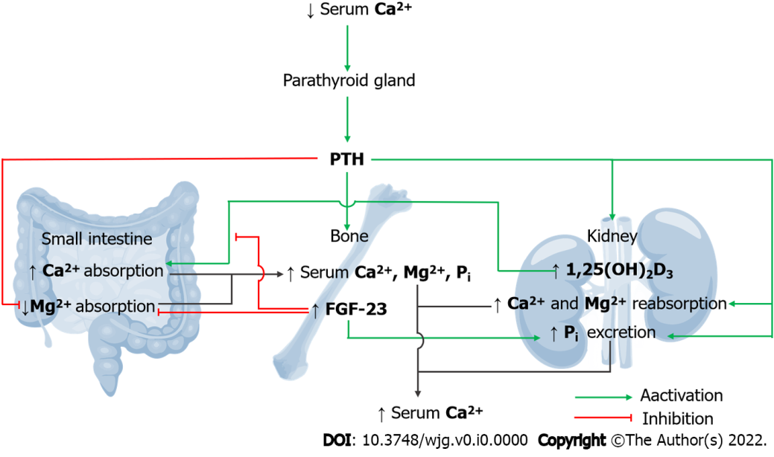
Figure 3 Integrated magnesiotropic action of fibroblast growth factor-23 and parathyroid hormone. Parathyroid hormone (PTH) stimulates the bone resorption process, which increases plasma calcium (Ca²⁺), inorganic phosphate (P_{i}), and magnesium (Mg²⁺) levels. PTH stimulates the release of 1,25-dihydroxy vitamin D₃ (1,25(OH)₂D₃) to subsequently induce small-intestinal Ca²⁺ absorption. PTH also activates renal tubular Ca²⁺ and Mg²⁺ reabsorption. Plasma Pi and PTH trigger the release of fibroblast growth factor-23 (FGF-23) to abolish 1,25(OH)₂D₃-induced intestinal Ca²⁺ absorption. PTH and FGF-23 synergistically suppress small intestinal absorption of dietary Mg²⁺. PTH and FGF-23 induce urinary P_{i} excretion.

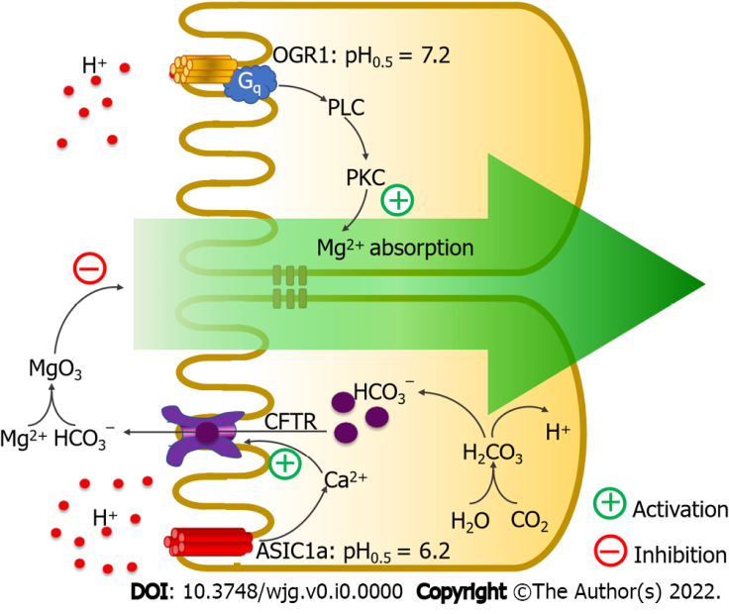
Figure 4 Ovarian cancer G protein-coupled receptor 1 and acid-sensing ion-channel 1a modulate intestinal magnesium absorption. Activation of ovarian cancer G protein-coupled receptor 1 (OGR1) triggers the phospholipase C (PLC)–protein kinase C (PKC) signaling pathway to activate intestinal magnesium (Mg²⁺) absorption. Activation of acid-sensing ion-channel 1a (ASIC1a) activates intracellular calcium (Ca²⁺) signaling to induce mucosal bicarbonate secretion in a cystic fibrosis transmembrane conductance regulator (CFTR)-dependent mechanism. Secreted bicarbonate (HCO₃⁻) reduces free soluble Mg²⁺ and suppresses intestinal Mg²⁺ absorption. H: Hydrogen.

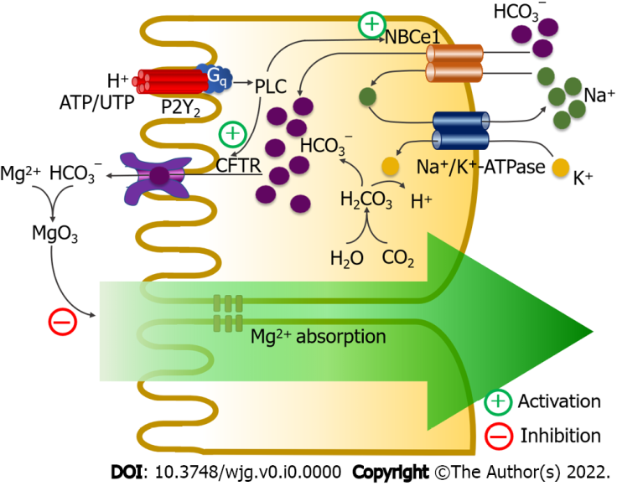
Figure 5 P2Y₂ purinoceptors modulate intestinal magnesium absorption. Activation of P2Y₂ purinoceptor stimulates luminal cystic fibrosis transmembrane conductance regulator and basolateral Na⁺-HCO₃⁻ cotransporter-1 (NBCe1) activities through a phospholipase C (PLC)-dependent mechanism. Active cystic fibrosis transmembrane conductance regulator (CFTR) and Na⁺-HCO₃⁻ cotransporter-1 induce mucosal bicarbonate (HCO₃⁻) secretion, which reduces luminal free magnesium (Mg²⁺) and suppresses Mg²⁺ absorption. Ca²⁺: Calcium; H: Hydrogen; K: Potassium; Na⁺: Sodium.

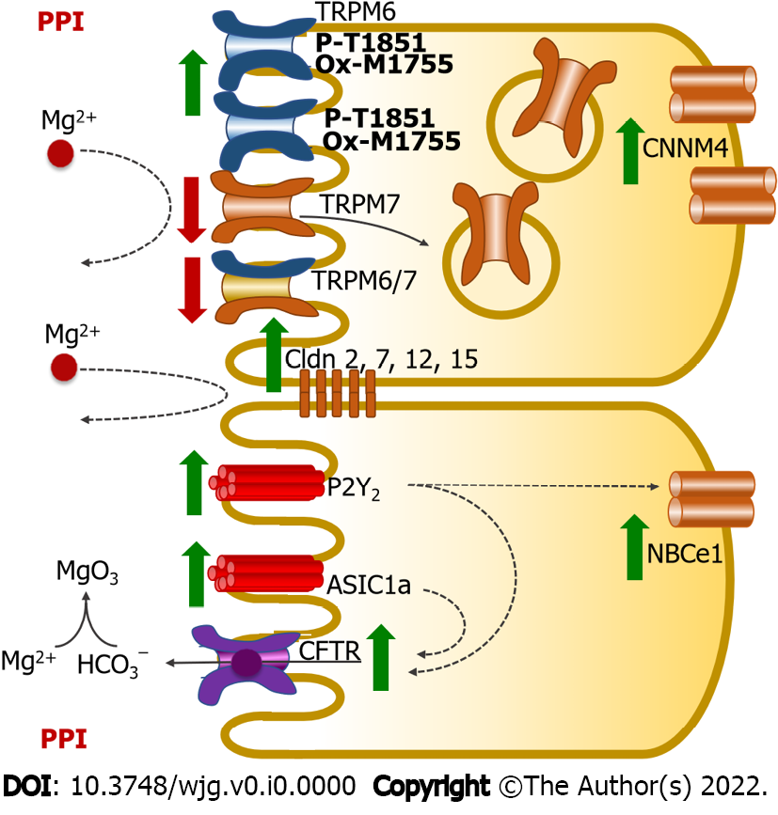
Figure 6 Mechanism of proton pump inhibitor-suppressed small intestinal magnesium absorption in proton pump inhibitor-induced hypomagnesemia rats. Proton pump inhibitor (PPI) suppresses membrane transient receptor potential melastatin 7 homodimer channel (TRPM7) and transient receptor potential melastatin 6/7 homodimer channel (TRPM6/7) expression but increases membrane transient receptor potential melastatin 6 homodimer channel (TRPM6) and cystathionine β-synthase domain divalent metal cation transport mediator 4 (CNNM4) expression. PPI induces phosphorylation of the T1851 residue and oxidation of the M1755 residue of the membrane TRPM6 channel, which reduces their channel permeability. These PPI effects reduce transcellular magnesium (Mg²⁺) absorption. Overexpression of claudin 2 (Cldn2), claudin 7 (Cldn7), claudin 12 (Cldn12), and claudin 15 (Cldn15) reduces paracellular permeability, which suppresses paracellular Mg²⁺ absorption. PPI also enhances P2Y₂- and acid-sensing ion-channel 1a (ASIC1a)-suppressed intestinal Mg²⁺ absorption. CFTR: Cystic fibrosis transmembrane conductance regulator; HCO₃⁻: Bicarbonate; NBCe1: Na⁺-HCO₃⁻ cotransporter-1.

