Name of Journal: World Journal of Clinical Cases
Manuscript NO: 60573
Manuscript Type: CASE REPORT

Duplication of 19q (13.2-13.31) associated with comitant esotropia: A case report

Feng YL et al. Duplication of 19q associated with esotropia

Yue-Lan Feng, Ning-Dong Li

Yue-Lan Feng, Ning-Dong Li, Department of Ophthalmology, National Center for Children's Health, Beijing Children’s Hospital, Capital Medical University, Beijing 100045, China

Yue-Lan Feng, Department of Ophthalmology, First Hospital Affiliated to Baotou Medical College, Baotou 014010, Inner Mongolia Autonomous Region, China

Author contributions: Feng YL and Li ND conducted a clinical examination of the patient and drafted the manuscript; All authors read and approved the final manuscript.

Corresponding author: Ning-Dong Li, MD, Doctor, Department of Ophthalmology, National Center for Children's Health, Beijing Children’s Hospital, Capital Medical University, No. 56 South Lishi Road, Xicheng District, Beijing 100045, China. lnd30@163.com

Received: November 4, 2020
Revised: December 23, 2020
Accepted: March 11, 2021
Published online: July 16, 2021

Abstract
BACKGROUND
Comitant esotropia is the most common form of strabismus. It is caused by heterogeneous environmental and genetic risk factors. The pure duplication of the long arm of chromosome 19 is a rare abnormality. Only 8 patients with partial trisomy of the long arm of chromosome 19q have been reported to date. Here, we describe a girl with pure duplication of 19q, who was diagnosed with congenital esotropia, microcephaly, and gallbladder agenesis.

CASE SUMMARY
The patient was diagnosed with esotropia when she was 1-year-old. The Krimsky method showed +50 prism diopters in the primary gaze position. No additional abnormal findings were observed following slit lamp and fundus examination, but the features of the full-field electroretinogram showed a decreased amplitude and increased implicit times. Magnetic resonance imaging showed ventriculomegaly with thinning of the corpus callosum and splenium in her brain. A 4.42 Mb mosaic duplication within 19q13.2-q13.31 region (chr19:39,343,725 to 43,762,586) was detected by microarray comparative genomic hybridization.

CONCLUSION
Strabismus is reported in many live borns with pure duplication of 19q. This important clinical characteristic indicates that the candidate genes fundamental for this phenotype may be narrowed to genes within the 19q13.3-q13.31 region. There were two candidate genes observed that may contribute to the comitant esotropia phenotype, namely XRCC1 (19:43,543,311) and SMG9 (19:43,727,991).

Key Words: Duplication; 19q; Esotropia; Strabismus; XRCC1; SMG9; Case report

©The Author(s) 2021. Published by Baishideng Publishing Group Inc. All rights reserved.

Citation: Feng YL, Li ND. Duplication of 19q (13.2-13.31) associated with comitant esotropia: A case report. World J Clin Cases 2021; 9(20): 5526-5534
URL: https://www.wjgnet.com/2307-8960/full/v9/i20/5526.htm
DOI: https://dx.doi.org/10.12998/wjcc.v9.i20.5526
Core Tip: The pure duplication of 19q is a rare chromosome abnormality that may affect a number of genes. Patients with 19q abnormality show a complicated syndrome such as developmental delay, dysmorphic features, and clinical nurse specialist malformations. To date, only 8 patients with partial trisomy of 19q have been reported. Here, we describe a girl with pure duplication of 19q, who was diagnosed with congenital esotropia, microcephaly, and gallbladder agenesis.

INTRODUCTION
Comitant esotropia is a very common form of childhood strabismus with a prevalence of approximately 2.5% among White populations of European ancestry and 0.5% among Africans and Asians^{[1]}. It is frequently noted in infancy or early childhood as the angle of esotropia misalignment between the two eyes remains relatively constant with changes in gaze direction. Comitant esotropia is often accompanied by amblyopia (uniocular visual neglect), a leading cause of visual impairment in children and young adults.
The pathogenesis of comitant esotropia remains largely unknown. Although many studies based on family trio and twins have demonstrated a genetic contribution to strabismus^{[2-5]}, there are limited data supporting Mendelian segregation. Parikh et al^{[6]} reported the results of linkage analysis in a large family with non-syndromic strabismus with presumed autosomal recessive inheritance, which has been identified as the first susceptibility locus on chromosome 7p22.1^{[6]}. Another study on 55 Japanese families including at least two members with comitant strabismus revealed that the loci at chromosomes 4q28.3 and 7q31.2 showed a significant evidence of linkage^{[7]}, which focuses on the chromosomal loci down to WNT2 and MGST2^{[8]}. Beyond this, the genetic contributions to comitant strabismus remain undeﬁned.
Duplication of 19q is a rare chromosome abnormality that may affect a number of genes. To date, only 8 patients with partial trisomy of 19q have been reported^{[9-16]} (Table 1). We found that strabismus was present in some of these cases, indicating that the pathogenic genes fundamental for the strabismus phenotype might be associated with chromosome 19q duplications.
We present a girl with 19q duplication (13.2-13.31), who was diagnosed with microcephaly, comitant esotropia, developmental delay, and gallbladder agenesis. We used conventional G-band karyotyping and array comparative genomic hybridization (aCGH) to explore the potential correlation between the phenotype and the genetic disorder.

CASE PRESENTATION
Chief complaints
An 18-mo girl accompanied by her father and mother, presented to the Ophthalmology Department in August 2018. Her parents complained about her strabismus for more than 6 mo (Figure 1A).

History of present illness
The parents complained about her strabismus.

History of past illness
The patient was born at 39 wk as the first fetus of her healthy, non-consanguineous parents and was delivered via Cesarean section. When she was born, the Apgar score was 6 at 1 min and 8 at 5 min. She was diagnosed with microcephaly and developmental delay because her body weight, length, and head circumference were 2140 g (3rd percentile), 43 cm (3rd percentile), and 30 cm (25th percentile), respectively. She was also found to have gallbladder agenesis upon B-scanning ultrasonic examination.

Personal and family history
The absence of this duplication in her parents involved in the chromosomal and aCGH analyses indicated that the 4.42 Mb duplication was a de novo rearrangement in this affected patient.

Physical examination
The Krimsky method showed +50 prism diopters in the primary gaze position. Cycloplegic refraction showed +3.50 D sph in the right eye and +3.25 D sph in the left eye. No additional abnormal findings were observed following slit lamp and fundus examination, but the features of the full-field electroretinogram (FF-ERG) showed a decreased amplitude and increased implicit times.

Laboratory examinations
A normal karyotype (46, XX) was revealed at the 550-band resolution using the conventional G-band karyotyping with her peripheral blood (Figure 2). However, a 4.42-Mb mosaic duplication within the 19q13.2–q13.31 region (chr19:39,343,725 to 43,762,586 ) was detected by aCGH (MACArray Karyo 1440 BAC-chip; Macrogen, Seoul, Korea) (Figure 3), which was further confirmed by fluorescence in situ hybridization using the RP11-264N23 (19q13.2) probes (Empire Genomics LLC, Buffalo, NY, United States) on both interphase and metaphase spreads presenting a mosaic ratio of 92% (46 cells) in 50 examined cells and only 8% (4 cells) with a normal karyotype (Figure 4). The absence of this duplication in her parents involved in the chromosomal and aCGH analyses indicated that the 4.42 Mb duplication was a de novo rearrangement in this affected patient.

Imaging examinations
Magnetic resonance imaging showed ventriculomegaly with thinning of the corpus callosum and splenium in her brain (Figure 1B and C).

FINAL DIAGNOSIS
The final diagnosis of the presented case was congenital esotropia, microcephaly, and gallbladder agenesis.

TREATMENT
She underwent bilateral medial rectus recession of 6.0 mm at the age of 18 mo. Forced duction tests were performed intraoperatively and showed no mechanical force or restriction of the extraocular muscles.

OUTCOME AND FOLLOW-UP
Her postoperative measurement was 10Δ esotropia (Krimsky) after 1 mo. Extraocular muscles movement were normal.

DISCUSSION
Pure duplications of 19q are rare, and as previously reported in the literature, only 8 cases were live born. To our knowledge, the patient described in this study is the second confirmed case of mosaicism involving duplication of the 19q region. In 2010, Hall et al^{[9]} reported the first case of mosaic trisomy in 19q13.11q13.2 with obesity, macrocephaly, and global developmental delay. Psychomotor or mental retardation is a common feature in these live borns. In addition, microcephaly was described in 3 of 8 cases^{[9,13,16]}. Three patients had alterations in the corpus callosum^{[9,12,14]}, consistent with our case. The duplication region 19q13.2–13.31 in this case contained 27 OMIM Morbid genes (Figure 5), but only Plekhg2 is currently known to have a phenotype associated with leukodystrophy and acquired microcephaly. Edvardson et al^{[17]} reported 5 children from two unrelated consanguineous Palestinian families with a severe neurodevelopmental disorder. The children presented in infancy with delayed psychomotor development, hypotonia, and postnatal progressive microcephaly. Brain imaging of all patients showed a similar pattern of abnormal white matter, consistent with leukodystrophy. Finally, it was inferred that abnormality of pleckstrin homology domain containing, family G member 2 expression might cause microcephaly, abnormal white matter, and developmental delay. Thus, it is not surprising that our patient presented with those clinical features, and our findings evidently further confirm the genotypic and phenotypic links of this gene abnormality^{[18,19]}.
Comitant esotropia is another special feature that was described in 3 of these live born. Bhat et al^{[10]} reported the first case of small de novo duplication of 19q (13.3-13.4) with comitant esotropia, and our patient was also found to have esotropia in 19q (13.2-13.31). These important clinical characteristics may indicate that the candidate genes fundamental for these phenotypes could be narrowed to the genes within the 19q13.3-q13.31 region. There were two candidate genes observed that may contribute to the comitant esotropia phenotype, XRCC1 (19:43,543,311) and SMG9 (19:43,727,991). XRCC1 is a molecular scaffold protein that assembles multiprotein complexes involved in DNA single-strand break repair^{[10]}. The XRCC1 protein complexes are important for normal neurological function. Hoch et al^{[20]} showed that biallelic mutations in human XRCC1 were associated with ocular motor apraxia, axonal neuropathy, and progressive cerebellar ataxia. The SMG9 gene encodes an essential component of nonsense-mediated mRNA decay. Shaheen et al^{[21]} reported two unrelated consanguineous families of Arab origin in which 5 patients had a heart and brain malformation syndrome, including hypertelorism, small eyes, and poor vision. Further analyses of the gene network showed that two genes (ubiquitin A-52 and ribosomal protein S27A) can either interact with XRCC1 or SMG9, which are important candidates associated with comitant esotropia, suggesting the potential roles of their interactions during eye development (Figure 6).
Although it is still unclear how the copy number change affects the actions of XRCC1 and SMG9 or their interactions, the genetic evidence shows that these two genes are associated with eye development, and the possible duplication may determine an overexpression of some or all of these genes, leading to an imbalanced eye development.

CONCLUSION
To conclude, the present patient provides further support for a distinct 19q duplication phenotype comprising developmental delay, microcephaly, thinning of the corpus callosum, and esotropia. The other phenotypic features are more variable, such as gallbladder agenesis and the moderately subnormal results of the FF-ERG stimulus threshold testing, which were not observed in previous case reports. There is a possibility that mosaicism may, in itself, cause the phenotype rather than the sole effect of 19q anomalies. Clinical evaluation of additional patients will be required to further delineate this phenotype.

REFERENCES
1 Lin S, Li FJ, Wang LH. [Comparative measurements of exodeviations in intermittent exotropia]. Zhonghua Yan Ke Za Zhi 2013; 49: 609-614 [PMID: 24257356]
2 Chia A, Lin X, Dirani M, Gazzard G, Ramamurthy D, Quah BL, Chang B, Ling Y, Leo SW, Wong TY, Saw SM. Risk factors for strabismus and amblyopia in young Singapore Chinese children. Ophthalmic Epidemiol 2013; 20: 138-147 [PMID: 23713916 DOI: 10.3109/09286586.2013.767354]
3 Paul TO, Hardage LK. The heritability of strabismus. Ophthalmic Genet 1994; 15: 1-18 [PMID: 7953247 DOI: 10.3109/13816819409056905]
4 Wilmer JB, Backus BT. Genetic and environmental contributions to strabismus and phoria: evidence from twins. Vision Res 2009; 49: 2485-2493 [PMID: 19679148 DOI: 10.1016/j.visres.2009.08.006]
5 Matsuo T, Hayashi M, Fujiwara H, Yamane T, Ohtsuki H. Concordance of strabismic phenotypes in monozygotic vs multizygotic twins and other multiple births. Jpn J Ophthalmol 2002; 46: 59-64 [PMID: 11853715 DOI: 10.1016/s0021-5155(01)00465-8]
6 Parikh V, Shugart YY, Doheny KF, Zhang J, Li L, Williams J, Hayden D, Craig B, Capo H, Chamblee D, Chen C, Collins M, Dankner S, Fiergang D, Guyton D, Hunter D, Hutcheon M, Keys M, Morrison N, Munoz M, Parks M, Plotsky D, Protzko E, Repka MX, Sarubbi M, Schnall B, Siatkowski RM, Traboulsi E, Waeltermann J, Nathans J. A strabismus susceptibility locus on chromosome 7p. Proc Natl Acad Sci U S A 2003; 100: 12283-12288 [PMID: 14519848 DOI: 10.1073/pnas.2035118100]
7 Shaaban S, Matsuo T, Fujiwara H, Itoshima E, Furuse T, Hasebe S, Zhang Q, Ott J, Ohtsuki H. Chromosomes 4q28.3 and 7q31.2 as new susceptibility loci for comitant strabismus. Invest Ophthalmol Vis Sci 2009; 50: 654-661 [PMID: 18824738 DOI: 10.1167/iovs.08-2437]
8 Zhang J, Matsuo T. MGST2 and WNT2 are candidate genes for comitant strabismus susceptibility in Japanese patients. PeerJ 2017; 5: e3935 [PMID: 29062608 DOI: 10.7717/peerj.3935]
9 Hall CE, Cunningham JJ, Hislop RG, Berg JN. A boy with supernumerary mosaic trisomy 19q, involving 19q13.11-19q13.2, with macrocephaly, obesity and mild facial dysmorphism. Clin Dysmorphol 2010; 19: 218-221 [PMID: 20616706 DOI: 10.1097/MCD.0b013e32833bff06]
10 Bhat M, Morrison PJ, Getty A, McManus D, Tubman R, Nevin NC. First clinical case of small de novo duplication of 19q (13.3-13.4) confirmed by FISH. Am J Med Genet 2000; 91: 201-203 [PMID: 10756343]
11 Qorri M, Oei P, Dockery H, McGaughran J. A rare case of a de novo dup(19q) associated with a mild phenotype. J Med Genet 2002; 39: E61 [PMID: 12362043 DOI: 10.1136/jmg.39.10.e61]
12 Palomares Bralo M, Delicado A, Lapunzina P, Velázquez Fragua R, Villa O, Angeles Mori M, Luisa de Torres M, Fernández L, Pérez Jurado LA, López Pajares I. Direct tandem duplication in chromosome 19q characterized by array CGH. Eur J Med Genet 2008; 51: 257-263 [PMID: 18342596 DOI: 10.1016/j.ejmg.2008.01.003]
13 Quack B, Van Roy N, Verschraegen-Spae MR, Klein F. Interstitial deletion and ring chromosome derived from 19q. Proximal 19q trisomy phenotype. Ann Genet 1992; 35: 241-244 [PMID: 1296524]
14 Zung A, Rienstein S, Rosensaft J, Aviram-Goldring A, Zadik Z. Proximal 19q trisomy: a new syndrome of morbid obesity and mental retardation. Horm Res 2007; 67: 105-110 [PMID: 17057406 DOI: 10.1159/000096419]
15 Lugli L, Malacarne M, Cavani S, Pierluigi M, Ferrari F, Percesepe A. A 12.4 Mb direct duplication in 19q12-q13 in a boy with cardiac and CNS malformations and developmental delay. J Appl Genet 2011; 52: 335-339 [PMID: 21369844 DOI: 10.1007/s13353-011-0033-5]
16 Rim JH, Kim JA, Yoo J. A Novel 1.13 Mb Interstitial Duplication at 19q13.32 Causing Developmental Delay and Microcephaly in a Pediatric Patient: the First Asian Case Reports. Yonsei Med J 2017; 58: 1241-1244 [PMID: 29047251 DOI: 10.3349/ymj.2017.58.6.1241]
17 Edvardson S, Wang H, Dor T, Atawneh O, Yaacov B, Gartner J, Cinnamon Y, Chen S, Elpeleg O. Microcephaly-dystonia due to mutated PLEKHG2 with impaired actin polymerization. Neurogenetics 2016; 17: 25-30 [PMID: 26573021 DOI: 10.1007/s10048-015-0464-y]
18 Caldecott KW. Single-strand break repair and genetic disease. Nat Rev Genet 2008; 9: 619-631 [PMID: 18626472 DOI: 10.1038/nrg2380]
19 Caldecott KW. XRCC1 and DNA strand break repair. DNA Repair (Amst) 2003; 2: 955-969 [PMID: 12967653 DOI: 10.1016/s1568-7864(03)00118-6]
20 Hoch NC, Hanzlikova H, Rulten SL, Tétreault M, Komulainen E, Ju L, Hornyak P, Zeng Z, Gittens W, Rey SA, Staras K, Mancini GM, McKinnon PJ, Wang ZQ, Wagner JD; Care4Rare Canada Consortium, Yoon G, Caldecott KW. XRCC1 mutation is associated with PARP1 hyperactivation and cerebellar ataxia. Nature 2017; 541: 87-91 [PMID: 28002403 DOI: 10.1038/nature20790]
21 Shaheen R, Anazi S, Ben-Omran T, Seidahmed MZ, Caddle LB, Palmer K, Ali R, Alshidi T, Hagos S, Goodwin L, Hashem M, Wakil SM, Abouelhoda M, Colak D, Murray SA, Alkuraya FS. Mutations in SMG9, Encoding an Essential Component of Nonsense-Mediated Decay Machinery, Cause a Multiple Congenital Anomaly Syndrome in Humans and Mice. Am J Hum Genet 2016; 98: 643-652 [PMID: 27018474 DOI: 10.1016/j.ajhg.2016.02.010]

Footnotes
Informed consent statement: Consent was obtained from relatives of the patient for publication of this report and any accompanying images.

Conflict-of-interest statement: The authors declare that they have no conflicts of interest.

CARE Checklist (2016) statement: The authors have read the CARE Checklist (2016), and the manuscript was prepared and revised according to the CARE Checklist (2016).

Open-Access: This article is an open-access article that was selected by an in-house editor and fully peer-reviewed by external reviewers. It is distributed in accordance with the Creative Commons Attribution NonCommercial (CC BY-NC 4.0) license, which permits others to distribute, remix, adapt, build upon this work non-commercially, and license their derivative works on different terms, provided the original work is properly cited and the use is non-commercial. See: http://creativecommons.org/Licenses/by-nc/4.0/

Manuscript source: Unsolicited manuscript

Peer-review started: November 4, 2020
First decision: December 21, 2020
Article in press: March 11, 2021

Specialty type: Medicine, research and experimental
Country/Territory of origin: China
Peer-review report’s scientific quality classification
Grade A (Excellent): A
Grade B (Very good): 0
Grade C (Good): C
Grade D (Fair): 0
Grade E (Poor): 0

P-Reviewer: Noviello C, Sugimura H S-Editor: Fan JR L-Editor: Filipodia P-Editor: Li JH
Figure Legends
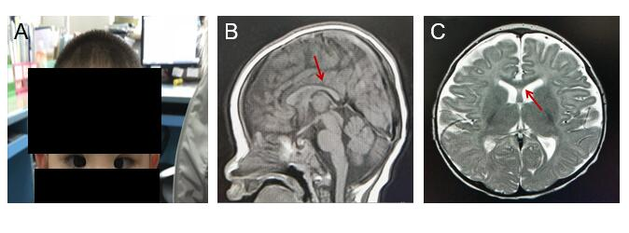
Figure 1 The examination of the patient. A: Patient has microcephaly and congenital esotropia; B: Corpus callosum and splenium are thin; C: Ventricle is dilated.
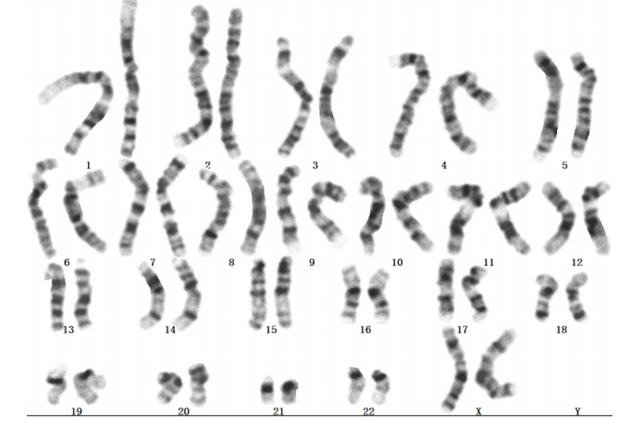
Figure 2 G-banded analysis at the 550-band level shows a normal karyotype, 46, XX (20).
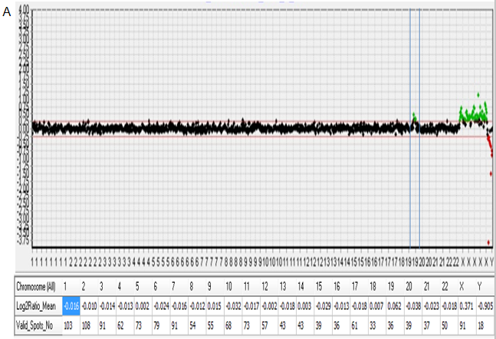
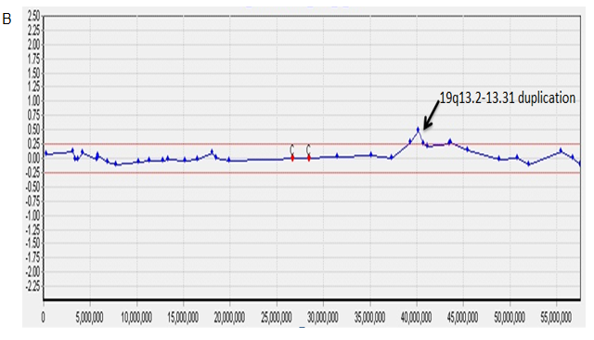
Figure 3 Array comparative genomic hybridization analysis performed suggests a mosaic gain of 19q. A: Array comparative genomic hybridization (aCGH) data profile in whole chromosomes. A dot represents a bacterial artificial chromosome clone, the X-axis represents the chromosome number (1-22, X,Y), and the Y-axis represents the log2 T/R signal ratio value. The table below the graph represents the average log2 T/R signal ratio value for each chromosome. Green dots represent a copy number gain (log2 T/R signal ratio value > 0.25) and duplication on chromosome 19; B: aCGH profile from chromosome 19 shows a duplication on the long arm. The size of the duplication fragment was estimated to be 4.42 Mb (chr19:39,343,725-43,762,586).
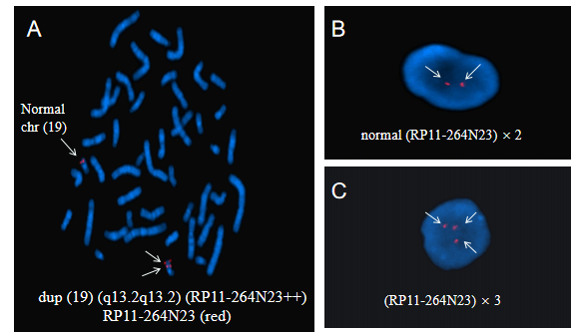
Figure 4 Fluorescence in situ hybridization with the 19q13.2-specific region probe (red). A: Arrow indicates a dup (19) (q13.2q13.2) chromosome [46,XX.ish dup (19) (q13.2q13.2) (RAI1++)] in metaphase fluorescence in situ hybridization (FISH); B: In interphase FISH, two arrows indicate a normal signal probe (RP11-264N23) × 2; C: In interphase FISH, three arrows indicate a duplication of the probe (RP11-264N23) × 3.
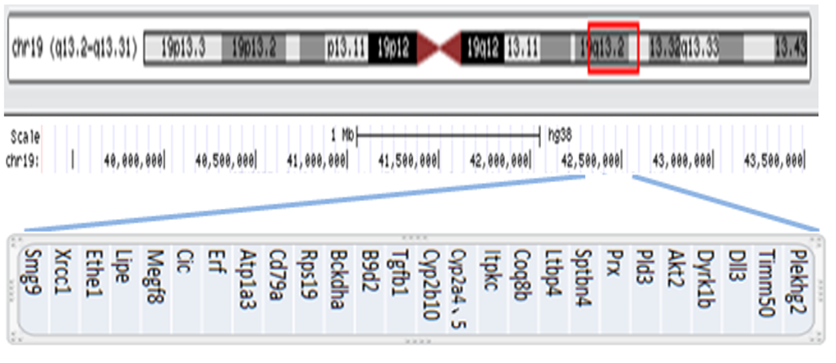
Figure 5 Genomic coordinates for the 19q13.2-q13.31 gain are chr19:39,343,725-43,762,586 (hg38), estimated to be 4.42 Mb. This duplication includes 27 OMIM Morbid genes: Plekhg2, Timm50, Dll3, Dyrk1b, Akt2, Pld3, Prx, Sptbn4, Ltbp4, Coq8b, Itpkc, Cyp2a4, Cyp2a5, Cyp2b10, Tgfb1, B9d2, Bckdha, Rps19, Cd79a, Atp1a3, Erf, Cic, Megf8, Lipe, Ethe1, Xrcc1, and Smg9 (hg38 database, http://genome.ucsc.edu).
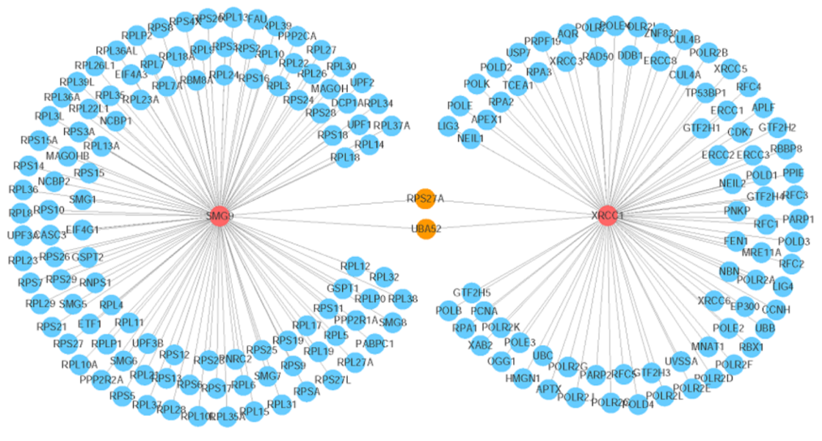
Figure 6 Visualization of the gene network that interacts with the SMG9 and XRCC1 genes. The red circles indicate the query genes (SMG9 and XRCC1), the orange circles represent the genes that interact with both of the two query genes, and the blue circles denote the other interacting genes. The line thickness indicates the strength of the interaction (interaction score).

Table 1 Summary of clinical features comparing live borns with trisomy 19q
 | Present case | Hall et al^{[9]} | Bhat et al^{[10]} | Qorri et al^{[11]} | Palomares et al^{[12]} | Quack et al^{[13]} | Zung et al^{[14]} | Lugli et al^{[15]} | Rim et al^{[16]}
Sex | F | M | M | F | F | M | M | M | M
Age | 18 mo | 5 yr | 18 mo | 27 mo | 15 mo | 3 yr | 14 yr | 36 mo | 5 yr
Dup (19) | Mos q13.2q13.32 | Mos q13.11q13.2 | q13.3q13.4 | q13.1q13.3 | q12q13.2 | q11.05q13.2 | q12q13.2 | q12q13.2 | 19q13.32
Developmental delay | + | + | + | + | + | + | + | + | +
Growth retardation | + | - | + | - | - | - | - | - | +
Craniofacial findings | Microcephaly, esotropia | Macrocephaly | Microcephaly, strabismus | Slightly higher palate | Microcephaly, strabismus | Macrocephaly | Macrocephaly | - | Microcephaly
Heart | - | - | + | - | - | - | - | + | -
Genitourinary and gastrointestinal findings | Gallbladder agenesis | Bilateral urinary reflux | Bilateral inguinal hernia | - | - | - | - | - | -
Brain | Thinning of the corpus callosum, Bilateral ventricle dilation | Corpus callosum  agenesis | - | - | Thinning of the corpus callosum and splenium | - | Cortical atrophy agenesis of the corpus callosum | + | -
Seizures | - | - | - | - | - | - | + | + | -
Skeletal | Hypotonia | - |  | - | - | - | - | - | -
Visual/auditive findings | + | - | - | - | - | - | - | - | -
Other | - | - | - | Crease between the 1st and 2nd toe | Hypotonia | Obese | Obese | - | -
Method | aCGH, FISH | aCGH | FISH | FISH | CGH | FISH | CGH | FISH, CGH | aCGH
+: Presence of the feature; -: Absence of the feature; aCGH: Array comparative genomic hybridization; FISH: Fluorescence in situ hybridization.

Published by Baishideng Publishing Group Inc
7041 Koll Center Parkway, Suite 160, Pleasanton, CA 94566, USA
Telephone: +1-925-3991568
E-mail: bpgoffice@wjgnet.com
Help Desk: https://www.f6publishing.com/helpdesk
https://www.wjgnet.com

© 2021 Baishideng Publishing Group Inc. All rights reserved.

