Name of Journal: World Journal of Clinical Cases
Manuscript NO: 87219
Manuscript Type: CASE REPORT

Warthin-like papillary renal cell carcinoma: A case report

Li XF et al. Warthin-like papillary renal cell carcinoma

Xiu-Feng Li, Zheng-Jiang Wang, Heng-Ming Zhang, Mai-Qing Yang

Xiu-Feng Li, Zheng-Jiang Wang, Heng-Ming Zhang, Mai-Qing Yang, Department of Pathology, Weifang People's Hospital (First Affiliated Hospital of Weifang Medical University), Weifang 261041, Shandong Province, China

Author contributions: Li XF and Yang MQ designed the study; Wang ZJ and Zhang HM conducted the study; Li XF and Yang MQ wrote the manuscript; All authors have read and approved the final manuscript.

Supported by the Natural Science Foundation of Shandong Province, No. ZR2021MH261.

Corresponding author: Mai-Qing Yang, PhD, Chief Doctor, Department of Pathology, Weifang People's Hospital (First Affiliated Hospital of Weifang Medical University), No. 151 Guangwen Street, Kuiwen District, Weifang 261041, Shandong Province, China. qqq387@163.com

Received: July 30, 2023
Revised: September 26, 2023
Accepted: October 8, 2023
Published online: October 26, 2023

Abstract
BACKGROUND
Warthin-like papillary renal cell carcinoma (WPRCC) has been described as a rare pathological subtype of papillary renal cell carcinoma in the 2022 World Health Organization Classification of the Urinary and Male Reproductive System. Herein we report a case of WPRCC in the left kidney.

CASE SUMMARY
Physical examination of a previously healthy 47-year-old woman revealed a lump in her left kidney, 4.5 cm × 3.5 cm × 3.5 cm in size. Based on the clinical information, imaging data, histmorphological features, and immunohistochemistry results, the pathological diagnosis was WPRCC in left kidney.

CONCLUSION
Resection of the mass in the left kidney was performed and her postoperative course was uneventful.

Key Words: Papillary renal cell carcinoma; Warthin-like; Clinicopathologic features; Case report

©The Author(s) 2023. Published by Baishideng Publishing Group Inc. All rights reserved.

Citation: Li XF, Wang ZJ, Zhang HM, Yang MQ. Warthin-like papillary renal cell carcinoma: A case report. World J Clin Cases 2023; 11(30): 7450-7456
URL: https://www.wjgnet.com/2307-8960/full/v11/i30/7450.htm
DOI: https://dx.doi.org/10.12998/wjcc.v11.i30.7450

Core Tip: It is important to prevent the misdiagnosis of this tumor as another type of renal tumor. Morphological and immunohistochemical features may be useful for diagnosing primary Warthin-like papillary renal cell carcinoma.

INTRODUCTION
Renal cell carcinoma (RCC) is a highly heterogeneous group of tumors comprising about 24 subtypes recognized in the latest World Health Organization (WHO) classification. It is characterized by papillary or tubulopapillary structures. Warthin-like papillary renal cell carcinoma (WPRCC) is described as a rare pathological subtype of PRCC in the 2022 WHO classification system^{[1]}. Therefore, its clinicopathological features and prognosis need to be summarized and analyzed in additional cases.

CASE PRESENTATION
Chief complaints
A woman (47 old) presented with abdominal distension for 3 d. Computed tomography (CT) revealed a high-density mass in the left kidney. However, the patient did not present with any relevant symptoms. She was admitted to our hospital for surgical treatment.

History of present illness
The patient had no additional illness.

Past history of illness
The patient was previously in good health.

Personal and family history
Personal history, family histories, medication history, social history, and allergy history were negative.

Physical examination
Physical examination showed normalities.

Laboratory examinations
Laboratory examinations showed no abnormalities. Serum alkaline phosphatase level was 54 U/L (normal 34-150 U/L), serum glutamic-oxalacetic transaminase (SGOT) level was 16 U/L (normal 0-35 U/L), glutamic-pyruvic transaminase (SGPT) was 18 U/L (normal range, 0-40 U/L), and SGOT/SGPT was 0.93.

Imaging examinations
Chest CT was normal. Abdominal CT showed no liver, gallbladder, pancreas, spleen, and right kidney abnormalities. Contrast-enhanced CT showed a slightly high-density lesion in the left kidney, approximately 4.7 cm × 3.8 cm in size (Figure 1). There was no evidence of metastasis to other organs. The preoperative diagnosis was renal cancer.

FINAL DIAGNOSIS
Primary Warthin-like papillary renal cell carcinoma.

TREATMENT
A laparoscopic resection of the left renal mass was performed. After surgery, the patient did not receive any postoperative radiotherapy or chemotherapy and recovered well. The resected renal specimen was 5 cm × 5 cm × 3 cm in size, adjacent to the renal capsule and 0.3 cm away from the broken end of the kidney, a mass with a volume of 4.5 cm × 3.5 cm × 3.5 cm was observed, and the section was sallow and medium in quality. The tumor mass was completely resected with no residual tumor at the resection margin. The resected tissues were fixed with 10% neutral-buffered formalin, then embedded into tissue paraffin blocks, cut into 4 μm thick sections. The sections were stained with hematoxylin and eosin to observe the tissue morphology.
Appropriate tissue sections were selected for immunohistochemical staining with ready-to-use primary antibodies against broad-spectrum cytokeratin (CK), CK7, P504S, pair box gene-8 (PAX-8), Vimentin, transcription factor binding to IGHM enhancer 3 (TFE3), Succinate dehydrogenase (SDHB), fumarate hydratase (FH), CD10, RCC marker, CD15, CD117, carbonic anhydrase IX (CAIX), E-Cadherin, CK20, thyroid transcription factor-1 (TTF-1), mutL homolog 1 (MLH1), mutS homolog 2 (MSH2), CD3, CD20, mutS homolog 6 (MSH6), postmeiotic segregation increased 2 (PMS2), Ki-67 (Maixin, Fuzhou, China). Immunohistochemistry was performed using EnVision method and simultaneously stained with colloidal iron.
For testing chromosomes 7 and 17, a kit was purchased from Kanglu Biotechnology Co., Ltd. (Wuhan, China). The testing steps were carried out according to the manufacturer’s instructions on tissue 4 μm thick. Fluorescence in situ hybridization signals were observed using a fluorescence microscope equipped with appropriate filters to visualize the intense yellow–green hybrid signals of the counterstained nuclei. Cases with average copy numbers of CEP7 and CEP17 ≥ 10% were defined as CEP7 and CEP17 amplifications, respectively.
Microscopically, the boundary between the tumor and surrounding normal renal tissue was clear, the tumor was distributed in sheets, and lymphoid cell infiltration was observed in the tumor stroma (Figure 2A). The tumor cells were arranged in glandular or tubular forms, with more lymphocyte infiltrates in the interstitial area, lymphatic follicle formation, and no fibrous septa. The tumor cytoplasm was eosinophilic, the tumor nucleus was medium-sized, the nucleoli could be seen, and the middle and upper parts of the cell were located in the nucleus (Figure 2B). The tumor invaded the renal capsule, but there was no clear cancer thrombus in the vasculature or nerves.
Immunohistochemically, the tumor cells were positive for CK, CK7, P504S, PAX-8, Vimentin, TFE3, SDHB, FH; partial expression of CD10, RCC marker, and CD15; negative expression of CD117, CAIX, E-cadherin, CK20, and TTF-1; and the tumor mesenchymal lymphocytes expressed CD3 (T lymphocytes) and CD20 (B lymphocytes). Mismatch repair proteins (MLH1, MSH2, MSH6, and PMS2) were not lost. The Ki-67 index of the tumor cells was approximately 2%. Colloidal iron staining results were negative (Figure 3). This patient showed a gain in chromosomes 7 and 17 (Figure 4).

OUTCOME AND FOLLOW-UP
Follow-up 8 mo, there wasn’t any evidence of recurrence or other metastatic diseases. The patient had three follow-up visits since the treatment of the primary tumor until now, and the results of three examinations, such as chest and abdominal CT, laboratory examinations were normal. No tumor cells were found in postoperative urine exfoliative cytology examination.

DISCUSSION
After clear cell RCC, PRCC is the second most common type of RCC, accounting for approximately 13%-20% of epithelial renal tumors, most of which occur in adults^{[2]}. Recently, several new tumor types with papillary features have emerged, including papillary renal neoplasms with reversed polarity, biphasic hyalinizing psammomatous RCC, biphasic squamoid/alveolar RCC, thyroid-like follicular RCC, and RCC with different molecular changes^{[3,4]}.
Carcinomas resembling benign Warthin tumors have been reported in the salivary and thyroid glands, but rarely in the kidneys^{[5,6]}. Therefore, WPRCC is considered a rare variant of PRCC as cytoplasmic eosinophilic PRCC is very similar to eosinophilic PRCC, with the main difference being the presence of dense lymphoid interstroma in the former. Table 1^{[7]} summarized the clinicopathological features of all patients. Of the patients with primary WPRCC included in our previous study, 3 were female and 9 were male. The patient age varied widely, ranging from 14–76 years (mean age: 57.7 years) (one not available). The diameters of the tumors ranged from 1.0–22 cm (mean diameter: 6.8 cm) (one not available)^{[7]}.
Current available data suggest that specific tumor-infiltrating lymphocyte phenotypes may have prognostic and/or therapeutic value; meanwhile, the characteristics of RCC remain unclear^{[8,9]}. Tumor-infiltrating and peritomatous lymphocytes are common in cancers associated with Lynch syndrome (LS), an inherited cancer syndrome caused by mutations in the DNA mismatch repair (MMR) protein. To determine whether WPRCC is related to LS, the above study also observed the expression of four MMR proteins (MSH2, MSH6, PMS2, and MLH1), as there are dense lymphocytes in the interstitium of WPRCC. The results showed that only one case had MSH2 and MSH6 deletions, and continued MLH1 promoter methylation and BRAF V600E mutation analyses of the deletion cases revealed no abnormalities. This suggests that there is no correlation between WPRCC and LS^{[7]}. No loss in MMR protein expression was observed.
Skenderi et al^{[7]} performed molecular genetic analyses on 9 of 11 cases of WPRCC and found that 5 patients showed significant variation, ranging from single chromosome loss to complex genome rearrangement, while only one of these five patients showed an increase in chromosomes 7 and 17, which was basically the same as the cases we reported and considered characteristic of PRCC.
Some tumors with similar histological characteristics, such as renal eosinophilic adenoma, FH-deficient RCC, renal clear cell carcinoma, and chromophobe RCC, must be distinguished from WPRCC. Renal eosinophilic adenoma is a benign tumor with a common star-shaped scar, and the significant difference between CD117 and vimentin in the two types of tumors is helpful in differentiating them. FH-deficient RCC often shows a mixture of papillary, cribriform, tubular and cystic structures, and cancer cells often show characteristic perinucleolar halos. Immunohistochemical staining of FHs is helpful in differentiating them. In chromophobe RCC, the tumors are lamellar, and adenoid, with thick-walled blood vessels in the tumor stroma; CD117 and colloidal iron are positively expressed, and vimentin is negatively expressed in chromophobe RCC, which could be used to distinguish WPRCC^{[1]}.
Complete surgical resection of renal WPRCCs is feasible. All 11 patients underwent surgery alone. Definitive histopathological prognostic factors of renal WPRCC have not been fully clarified due to its rarity. Of the 11 patients, 3 cases of WPRCC have metastatic potential, and additional cases should be studied. In our case, the patient underwent only surgery and survived without recurrence for 8 mo after surgery.
Papillary tumors are more likely to be bilateral and multifocal, especially when accompanying trisomy 7 and/or trisomy 17, the patient of our case had three follow-up visits since the treatment of the primary tumor until now, and the results of three examinations, such as chest and abdominal CT, laboratory examinations were normal. Due to the short follow-up time, we need to follow up this case more closely in the future.

CONCLUSION
In summary, WPRCC is a rare PRCC, and careful assessment of its histological features and immunohistochemistry enables an efficient diagnosis. An accurate diagnosis is crucial for treatment and prognostic assessment. Complete surgical resection is the treatment of choice.

REFERENCES
1 Moch H, Amin MB, Berney DM, Compérat EM, Gill AJ, Hartmann A, Menon S, Raspollini MR, Rubin MA, Srigley JR, Hoon Tan P, Tickoo SK, Tsuzuki T, Turajlic S, Cree I, Netto GJ. The 2022 World Health Organization Classification of Tumours of the Urinary System and Male Genital Organs-Part A: Renal, Penile, and Testicular Tumours. Eur Urol 2022; 82: 458-468 [PMID: 35853783 DOI: 10.1016/j.eururo.2022.06.016]
2 Akhtar M, Al-Bozom IA, Al Hussain T. Papillary Renal Cell Carcinoma (PRCC): An Update. Adv Anat Pathol 2019; 26: 124-132 [PMID: 30507616 DOI: 10.1097/PAP.0000000000000220]
3 Lobo J, Ohashi R, Amin MB, Berney DM, Compérat EM, Cree IA, Gill AJ, Hartmann A, Menon S, Netto GJ, Raspollini MR, Rubin MA, Tan PH, Tickoo SK, Tsuzuki T, Turajlic S, Zhou M, Srigley JR, Moch H. WHO 2022 landscape of papillary and chromophobe renal cell carcinoma. Histopathology 2022; 81: 426-438 [PMID: 35596618 DOI: 10.1111/his.14700]
4 Maughan BL. Start of a New Era: Management of Non-Clear Cell Renal Cell Carcinoma in 2022. Curr Oncol Rep 2022; 24: 1201-1208 [PMID: 35438388 DOI: 10.1007/s11912-022-01269-1]
5 Ishibashi K, Ito Y, Masaki A, Fujii K, Beppu S, Sakakibara T, Takino H, Takase H, Ijichi K, Shimozato K, Inagaki H. Warthin-like Mucoepidermoid Carcinoma: A Combined Study of Fluorescence In Situ Hybridization and Whole-slide Imaging. Am J Surg Pathol 2015; 39: 1479-1487 [PMID: 26457352 DOI: 10.1097/PAS.0000000000000507]
6 Yeo MK, Bae JS, Lee S, Kim MH, Lim DJ, Lee YS, Jung CK. The Warthin-Like Variant of Papillary Thyroid Carcinoma: A Comparison with Classic Type in the Patients with Coexisting Hashimoto's Thyroiditis. Int J Endocrinol 2015; 2015: 456027 [PMID: 25983754 DOI: 10.1155/2015/456027]
7 Skenderi F, Ulamec M, Vanecek T, Martinek P, Alaghehbandan R, Foix MP, Babankova I, Montiel DP, Alvarado-Cabrero I, Svajdler M, Dubinský P, Cempirkova D, Pavlovsky M, Vranic S, Daum O, Ondic O, Pivovarcikova K, Michalova K, Hora M, Rotterova P, Stehlikova A, Dusek M, Michal M, Hes O. Warthin-like papillary renal cell carcinoma: Clinicopathologic, morphologic, immunohistochemical and molecular genetic analysis of 11 cases. Ann Diagn Pathol 2017; 27: 48-56 [PMID: 28325361 DOI: 10.1016/j.anndiagpath.2017.01.005]
8 Jiang Y, Chen M, Nie H, Yuan Y. PD-1 and PD-L1 in cancer immunotherapy: clinical implications and future considerations. Hum Vaccin Immunother 2019; 15: 1111-1122 [PMID: 30888929 DOI: 10.1080/21645515.2019.1571892]
9 Massari F, Santoni M, Ciccarese C, Santini D, Alfieri S, Martignoni G, Brunelli M, Piva F, Berardi R, Montironi R, Porta C, Cascinu S, Tortora G. PD-1 blockade therapy in renal cell carcinoma: current studies and future promises. Cancer Treat Rev 2015; 41: 114-121 [PMID: 25586601 DOI: 10.1016/j.ctrv.2014.12.013]

Footnotes
Informed consent statement: The patient gave consent for her medical record to be used for educational and publication purposes.

Conflict-of-interest statement: All the authors have no conflicts to declare.

CARE Checklist (2016) statement: The authors have read the CARE Checklist (2016), and the manuscript was prepared and revised according to the CARE Checklist (2016).

Open-Access: This article is an open-access article that was selected by an in-house editor and fully peer-reviewed by external reviewers. It is distributed in accordance with the Creative Commons Attribution NonCommercial (CC BY-NC 4.0) license, which permits others to distribute, remix, adapt, build upon this work non-commercially, and license their derivative works on different terms, provided the original work is properly cited and the use is non-commercial. See: https://creativecommons.org/Licenses/by-nc/4.0/

Provenance and peer review: Unsolicited article; Externally peer reviewed.
Peer-review model: Single blind

Peer-review started: July 30, 2023
First decision: September 19, 2023
Article in press: October 8, 2023

Specialty type: Medicine, research & experimental
Country/Territory of origin: China
Peer-review report’s scientific quality classification
Grade A (Excellent): 0
Grade B (Very good): B
Grade C (Good): C
Grade D (Fair): 0
Grade E (Poor): 0

P-Reviewer: Taheri S, Iran S-Editor: Liu JH L-Editor: A P-Editor: Zhao S

Figure Legends
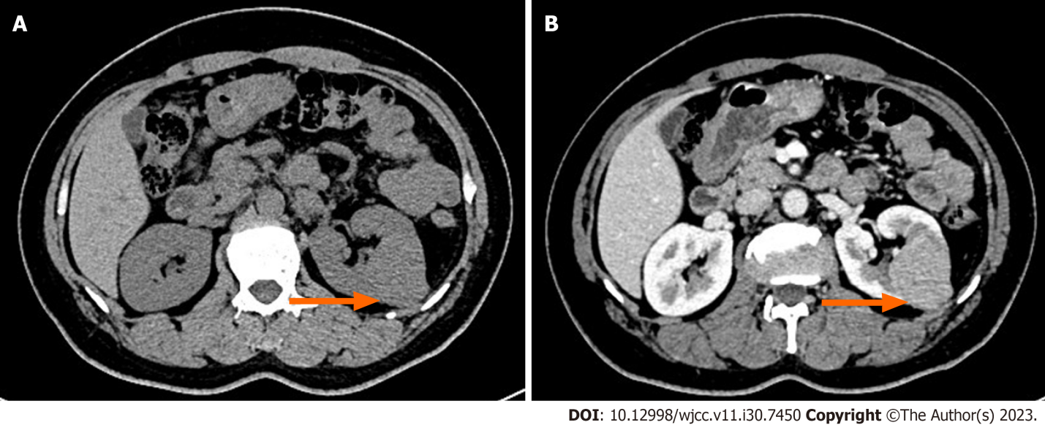
Figure 1 Computed axial tomography of the abdomen and pelvis. A and B: Computed tomography scan showing a slightly high-density lesion in the left kidney, approximately 4.7 cm × 3.8 cm in size, with continuous and significant enhancement on the enhanced scan.
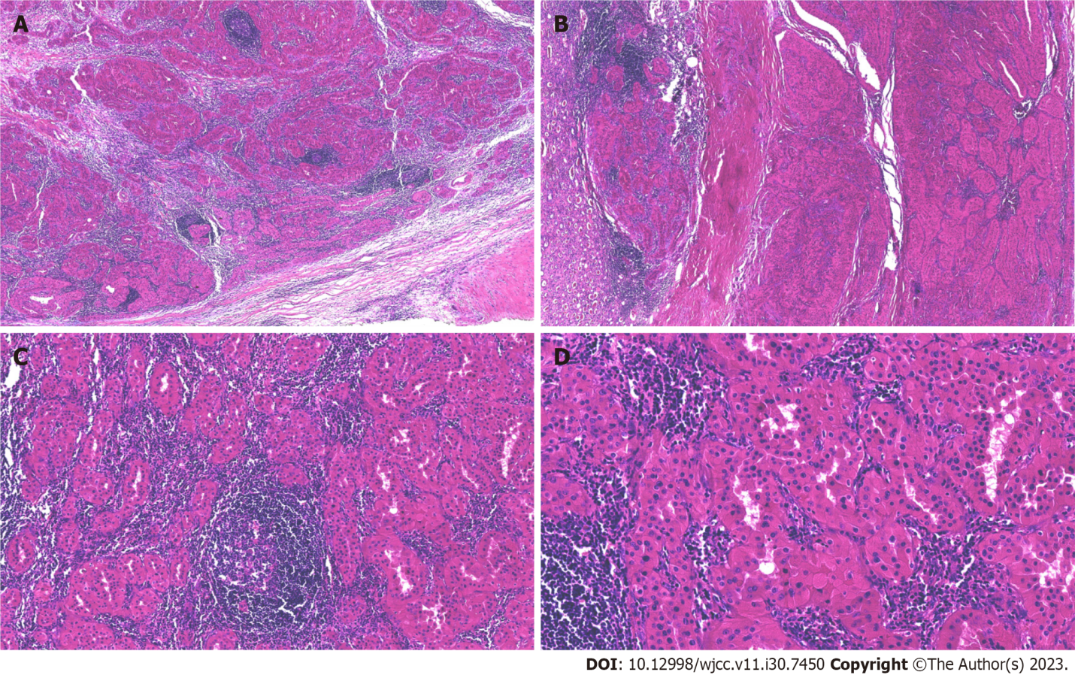
Figure 2 Histological features associated with Warthin-like papillary renal cell carcinoma. A and B: The boundary between the tumor and the surrounding normal renal tissue is clear, the tumor is distributed in sheets, and lymphoid cell infiltration is observed in the tumor stroma (hematoxylin and eosin, × 40); C: The tumor cells are arranged in glandular or tubular form, with more lymphocyte infiltrates in the interstitial area, lymphatic follicle formation, and no fibrous septa (hematoxylin and eosin, × 100); D: The tumor cytoplasm is eosinophilic, the tumor nucleus is of medium size, nucleoli are seen, and the middle and upper part of the cell in the nucleus was located (hematoxylin and eosin, × 200).
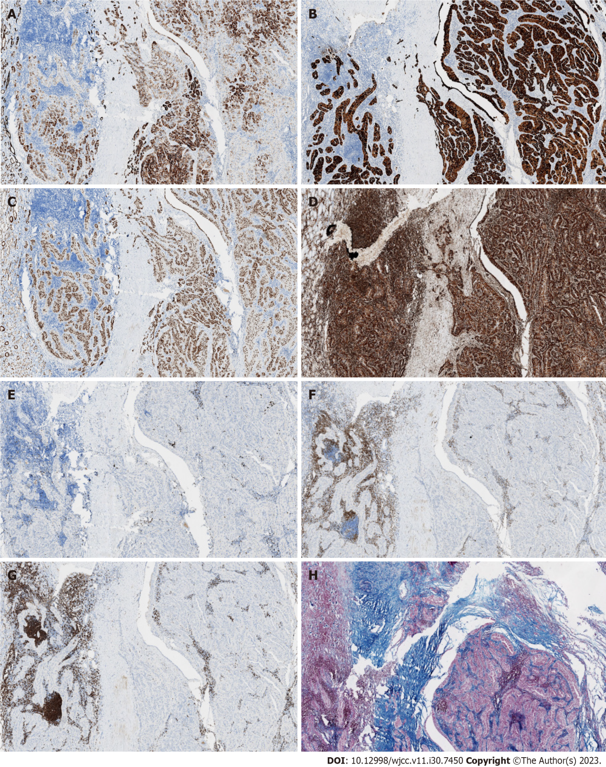
Figure 3 Immunohistochemistry of Warthin-like papillary renal cell carcinoma. A-D: Immunohistochemical staining for CK7, P504S, PAX8 and Vimentin is diffuse in the tumor cells (× 100); E: The Ki-67 index of tumor cells is approximately 2% (× 100); F: Tumor mesenchymal lymphocytes partially expressed CD3 (× 100); G: Tumor mesenchymal lymphocytes partially expressed CD20 (× 100); H: Colloidal iron staining was negative (× 100).
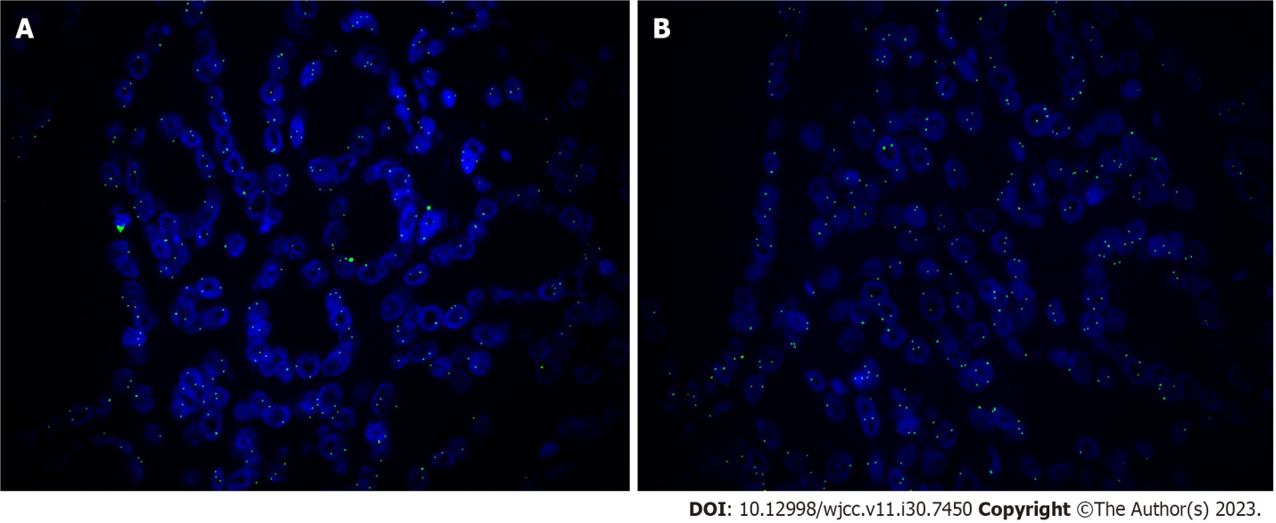
Figure 4 Fluorescence in situ hybridization of chromosomes 7 and 17 in the nucleus of renal cell carcinoma. A: Fluorescence staining shows the triploid of chromosomes 7 (× 100); B: Fluorescence staining shows the triploid of chromosomes 17 (× 100).
Table 1 Clinicopathological characteristics of patients with warthin like papillary renal cell carcinoma
Case | Age | Sex | Site | Size (cm) | Copy number variations of chromosomes |  | Follow-up (mo)
 |  |  |  |  | Gains | Loss
1^{[7]} | 48 | M | NS | 1.0 | None | None | 1 mo later died of other disease
2^{[7]} | 64 | M | NS | 6.0 | 5 | 1, 3, Y | 9 mo later died of the disease
3^{[7]} | 69 | F | NS | 3.0 | None | None | Alive and well 12 mo
4^{[7]} | 76 | M | NS | 22 | None | None | 12 mo later died of the disease
5^{[7]} | 45 | M | NS | 2.8 | Not analyzable | Not analyzable | Alive and well 108 mo, then lost
6^{[7]} | 64 | M | NS | 14.5 | None | None | Lost to follow up
7^{[7]} | 14 | M | NS | 12.5 | None | 1, 14, 18, 22 | 36 mo later died of the disease
8^{[7]} | NA | M | NS | NA | 1, 2, 5, 21 | 1, 3, 14, 15, Y | Lost to follow up
9^{[7]} | 59 | M | NS | 2.5 | 7, 8, 12, 17 | None | Alive and well 108 mo
10^{[7]} | 74 | F | NS | 4.2 | None | X | Alive and well 132 mo
11^{[7]} | 75 | F | NS | 1.5 | Not analyzable | Not analyzable | Alive and well 10 mo
12 (Present case) | 47 | M | L | 4.5 | 7, 17 | Not analyzable | Alive and well 8 mo
NA: Not available; M: Male; F: Female; L: Left; NS: Not stated.

Published by Baishideng Publishing Group Inc
7041 Koll Center Parkway, Suite 160, Pleasanton, CA 94566, USA
Telephone: +1-925-3991568
E-mail: bpgoffice@wjgnet.com
Help Desk: https://www.f6publishing.com/helpdesk
https://www.wjgnet.com

© 2023 Baishideng Publishing Group Inc. All rights reserved.

